Network Operating System and Services
Coursework 2
Configure and manage Virtualised network
Table of contents
Table of figures 3
Abstract 5
Introduction 6
I – Swansea Network 7
A. Network configuration and AD DS setup 7
B. Configuring Internet access on the server 9
C. DHCP 12
D. Routing and Remote Access 13
E. VPN 14
F. DNS 18
G. User creation 20
II – Cardiff Network 21
A. DHCP server and network configuration on debian 21
B. VPN 23
C. DNS configuration 24
D. Active directory from Ubuntu 25
E. Shared folder 27
F. Website creation 28
G. Remote Desktop Services and User Access Setup 30

Table of figures
Figure 1 - Firewall Profiles Reactivated 7
Figure 2 - New ICMPv4 Inbound Rule Created 7
Figure 3 - Adding AD DS Required Features 8
Figure 4 - AD DS Installation Completed 8
Figure 5 - DNS Forwarder Configuration in Server Manager 9
Figure 6 - Creating a Custom NAT Network in VirtualBox 9
Figure 7 - Successful Internet Connection, Ping Test Passed 10
Figure 8 - Updating Network Configuration on the Server 10
Figure 9 - DNS Forwarder Configuration 11
Figure 10 - Domain and Forest 11
Figure 11 - Installing DHCP and Configuring the Scope in Server Manager 12
Figure 12 - DHCP Scope 12
Figure 133 - Client Machine Receiving DHCP IP Address 13
Figure 144 - Configuring VPN IP Address Pool in RRAS 13
Figure 155 - Successful Internet Connectivity 14
Figure 166 - Configuring Destination Address 14
Figure 177 - VPN Connection Properties 15
Figure 18 - Installing PPTPD and Dependencies on Debian 15
Figure 19 - Editing pptpd.conf to Define IP Address Pools 16
Figure 20 - Configuring Static Routes 16
Figure 21 - Routing and Remote Access Interface Error – Incorrect IP 17
Figure 22 - Successful VPN Connection After IP Correction 17
Figure 23 - Successful Ping from S-DC to Ubuntu 18
Figure 24 - Ping Test from Windows Client to Ubuntu 18
Figure 255 – DNS listening interfaces configuration 19
Figure 266 - Configuring DNS Server Option in DHCP Scope 19
Figure 277 - Setting External DNS Forwarders in DNS Manager 19
Figure 28 - Disabling Password requirement via Group Policy 20
Figure 29 - Creating a New User in Active Directory 20
Figure 30 – DHCP server config 21
Figure 31 - Network Settings for IP Forwarding and Security 21
Figure 32 – Saving firewall rules 22
Figure 33 – Ping test from Client debian 22
Figure 34 – NAT config 23
Figure 35 – Windows server network settings 23
Figure 36 - Ping test 23
Figure 37 - DNS config 24
Figure 38 - Active directory 24
Figure 39 - Domain name resolution on Windows Server (nslookup) 25
Figure 40 - Active directory from ubuntu client 25
Figure 41 – Joining the active directory from ubuntu 26
Figure 42 -Successful Active Directory user login on Ubuntu client 26
Figure 43 – disk management and new disk created 27
Figure 44 – setting permissions on the Swansea folder 27
Figure 45 - Access the "Swansea" folder from Windows Client 27
Figure 46 - Access the "Swansea" folder from Ubuntu Client 28
Figure 47 - Creating a New Website in IIS 28
Figure 48 - Website Content 29
Figure 49 – Website from S-DC 29
Figure 50 - Website from Windows client 29
Figure 51 - Installing Remote Desktop Services 30
Figure 52 - Publishing RemoteApp Programs 30
Figure 53 - Enabling Windows Authentication for the Website 30
Figure 54 - Resolving Windows Authentication Issue for SDC 31
Figure 55 - Website Authentication 31
Figure 56 - Configuring HTTP Redirect for RDS Web Access 31
Figure 57 - RD Web Access Portal Display 32
Figure 58 - Authorizing Cardiff Domain Users for RDS 32
Figure 59 - Success Adding Windows AD Users 32
Figure 60 - Automating User Creation on Debian Server 33
Figure 61 - Confirmation of User Creation on Debian 33

Abstract
This coursework is the continuation of the Coursework 1. It is structured as a practical implementation. We use the same topology that we implemented in Coursework 1. We will focus on the configuration and the security of the virtualized network environment. We will apply appropriate network policies, routing protocols, and packet filtering within core TCP/IP services. Additionally, we will implement file sharing, issue certificates, draft security practices and critical failover/redundancy strategies to enhance network security.
The first part is setting up essential network services on both Swansea and Cardiff Networks: routing, VPN configuration, DHCP services, and DNS. This requires the installation and the configuration of a Routing and Remote Access Service (RRAS), the creation of site-to-site VPN connectivity, and the implementation of domain structures with appropriate user and security policies.
The second part is to test the network. We will conduct connectivity tests and if it is not fully operational, we will troubleshoot it. And the final part is to configure IIS server, shared file access, and remote desktop services.
Through these tasks, this coursework helps us to develop different skills in network configuration, and troubleshooting. We learn about the essential network services and how to manage them.

Introduction
Organizations demand high-performance and adaptable network infrastructures to ensure communication and security. This report explores different steps required to configure, secure, and manage a virtualized network environment. From the Coursework 1, this assessment delves into the practical aspects of network configuration, with the deployment of different services such as routing, DHCP, DNS, VPN, and remote access. Furthermore, this coursework includes some testing network connectivity or troubleshooting issues to optimise performance. The goal is to establish a fully operational and secured network.

I – Swansea Network

Network configuration and AD DS setup
I reactivated all firewall profiles (Domain, Private, and Public) in Windows Defender Firewall with Advanced Security. After that, we created a new inbound rule allowing ICMPv4 traffic. This rule enables ping requests, which are useful for network diagnostics and connectivity testing.
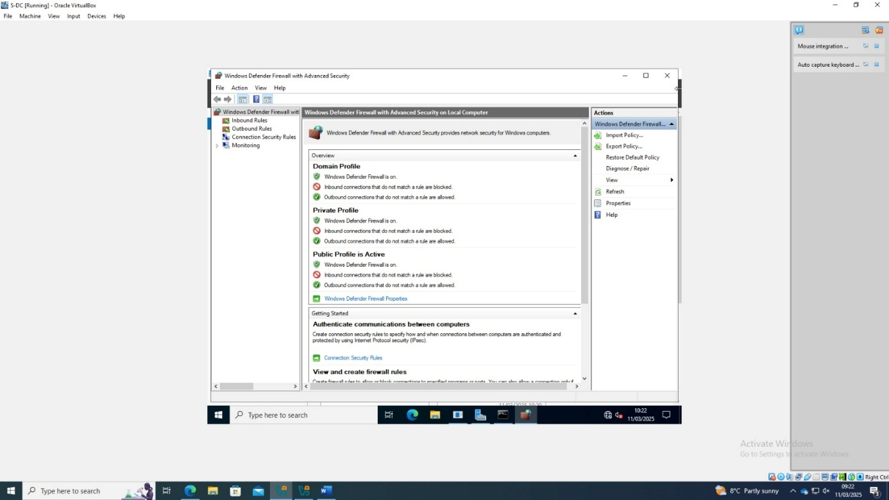
Figure 1 - Firewall Profiles Reactivated
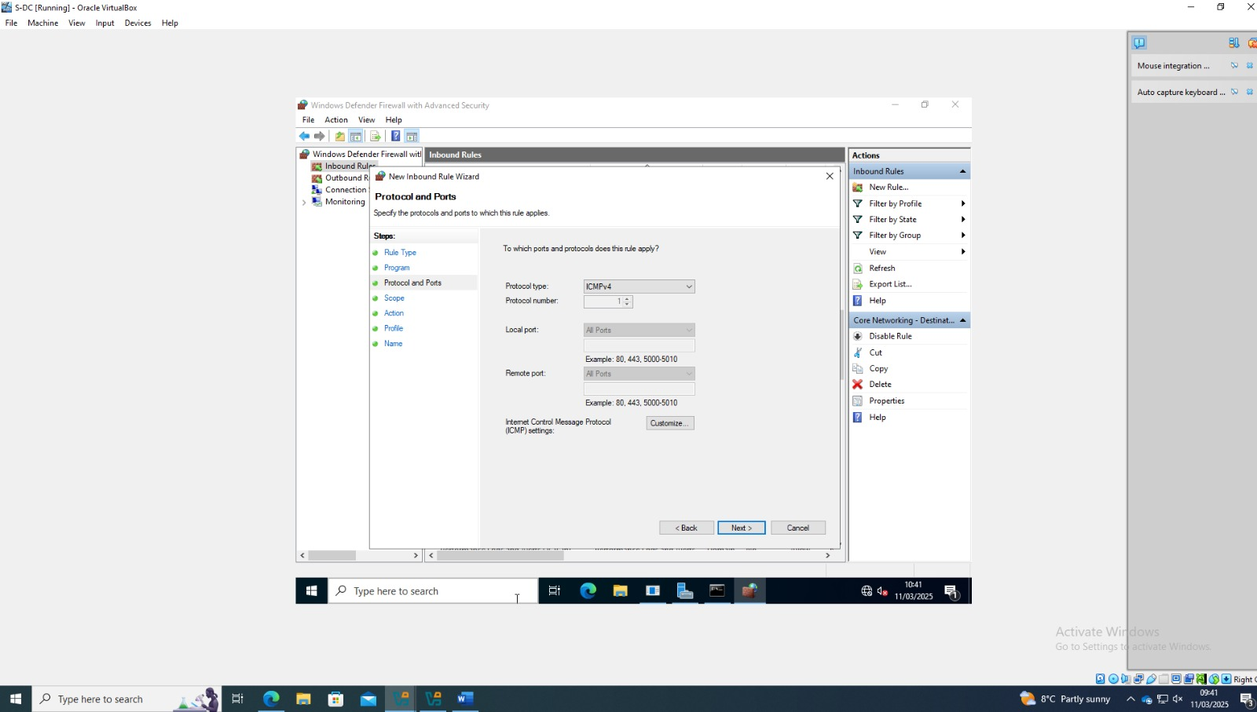
Figure 2 - New ICMPv4 Inbound Rule Created

I installed the Active Directory Domain Services (AD DS) role on the server via the Server Manager. During the process, the required features for AD DS were selected automatically.
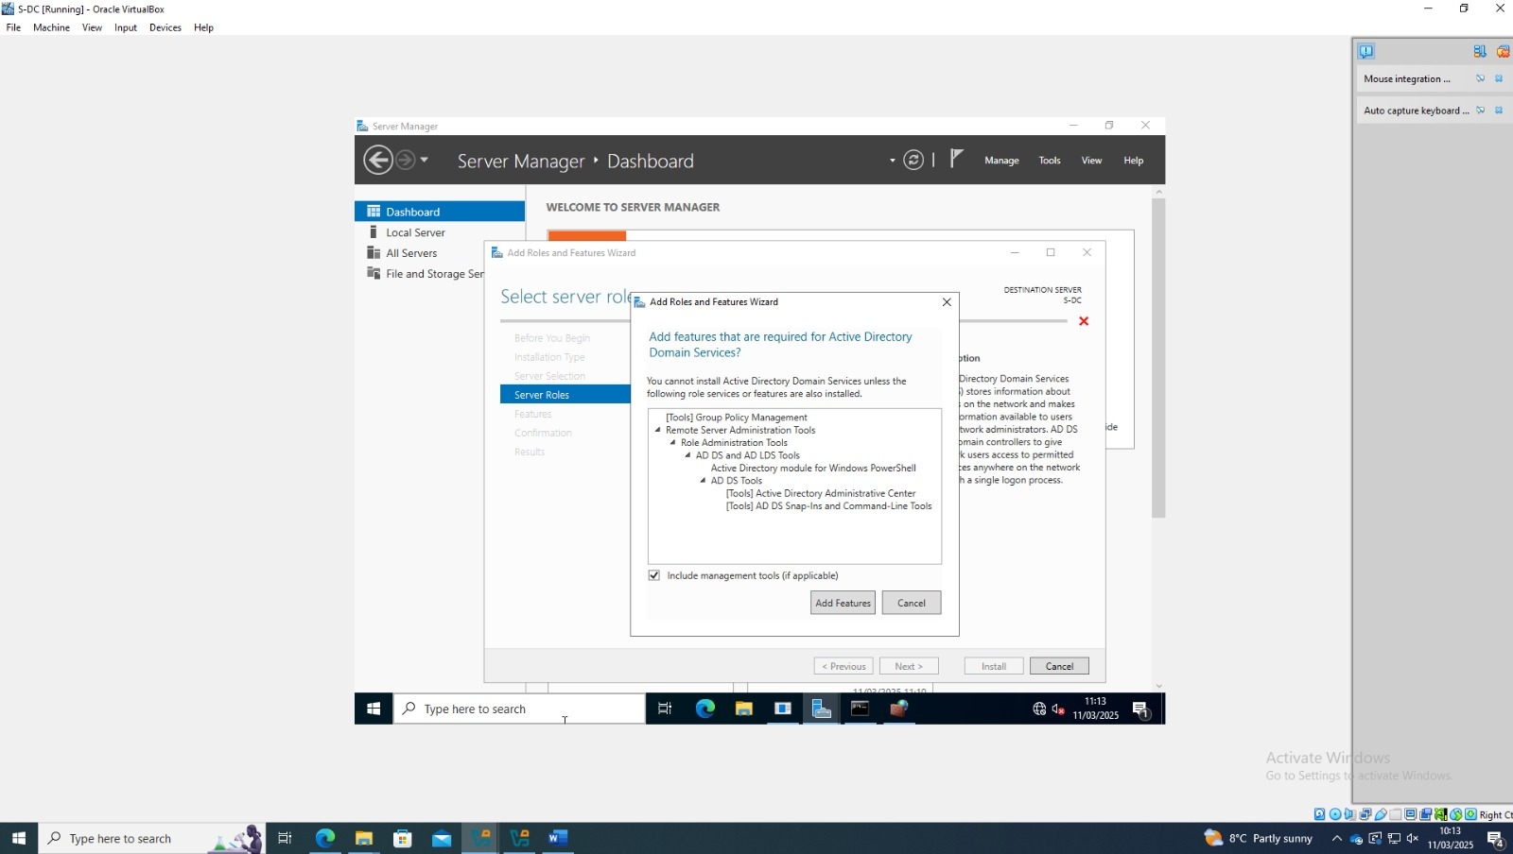
Figure 3 - Adding AD DS Required Features
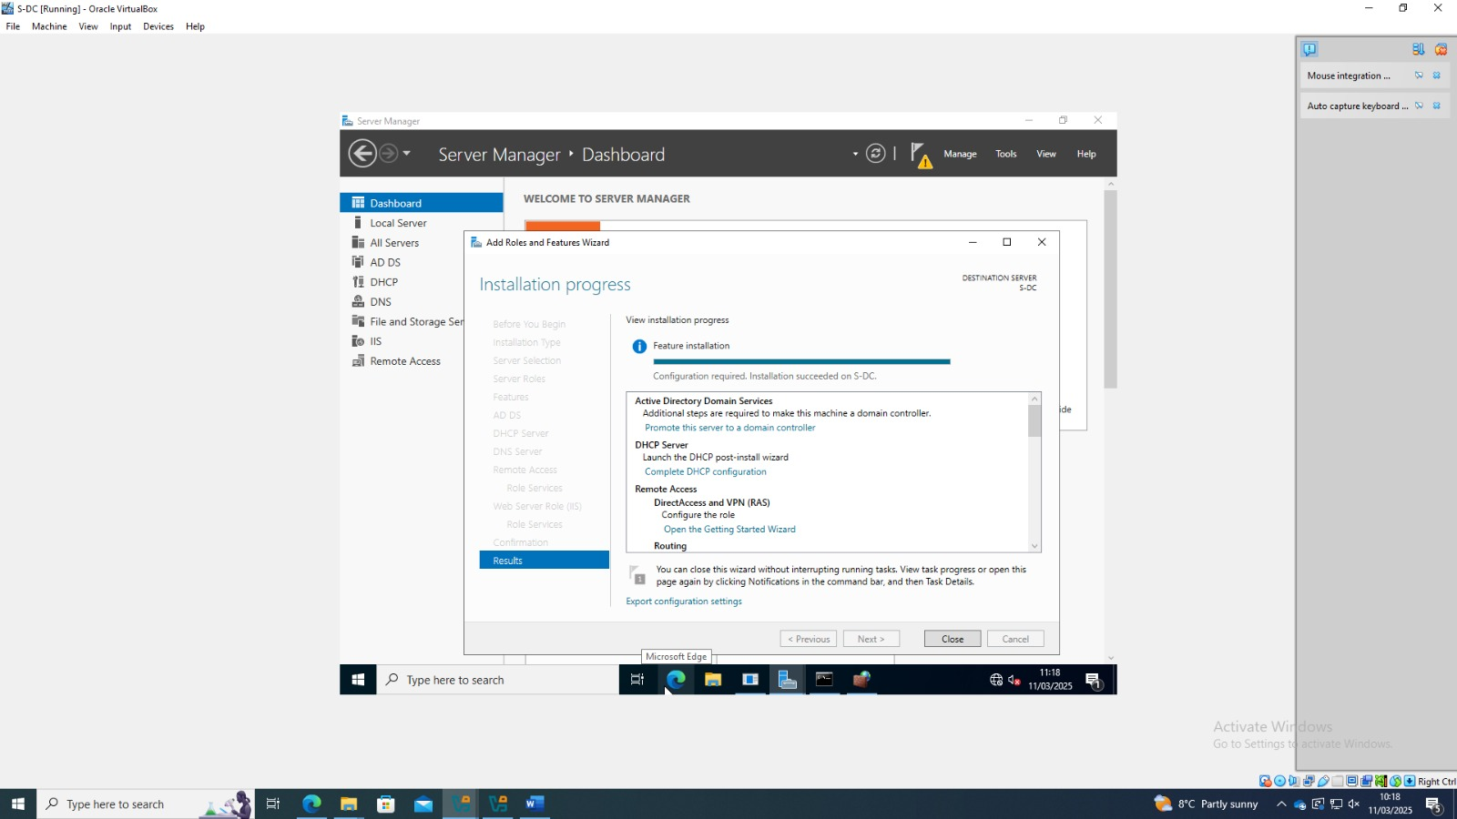
Figure 4 - AD DS Installation Completed

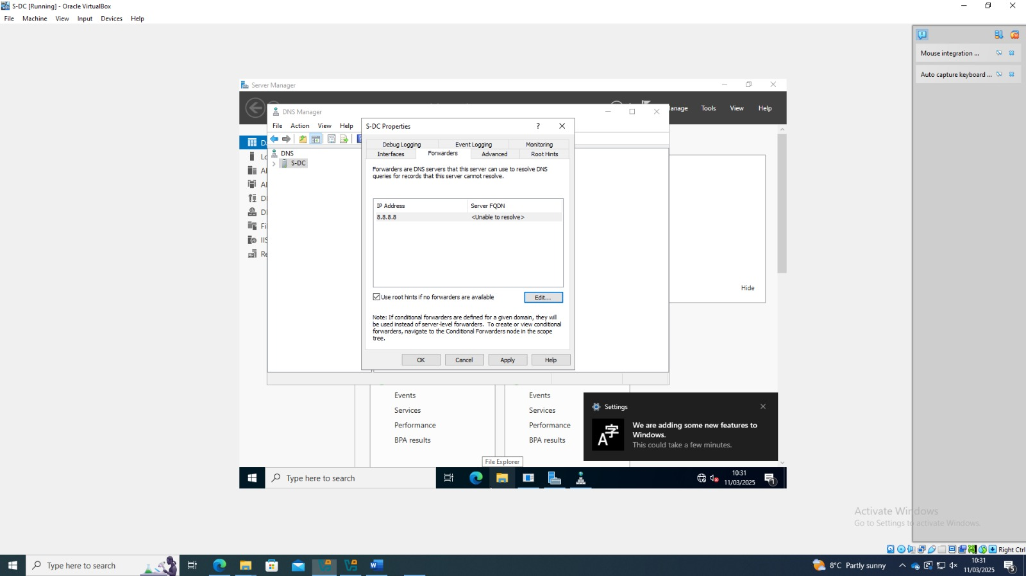
Figure 5 - DNS Forwarder Configuration in Server Manager
After installing the AD DS role, we configured the DNS settings. In the "Forwarders" tab of the DNS Manager, we attempted to add a public DNS server, 8.8.8.8. However, the server was unable to resolve the FQDN.

Configuring Internet access on the server
Initially, the server did not have access to internet, as ping requests to 1.1.1.1 and google.com failed. This indicated that there was no internet access or that DNS resolution was not functioning properly.
To resolve this, I manually added a custom NAT network in VirtualBox. This step allowed the server to obtain an external connection, enabling internet access.
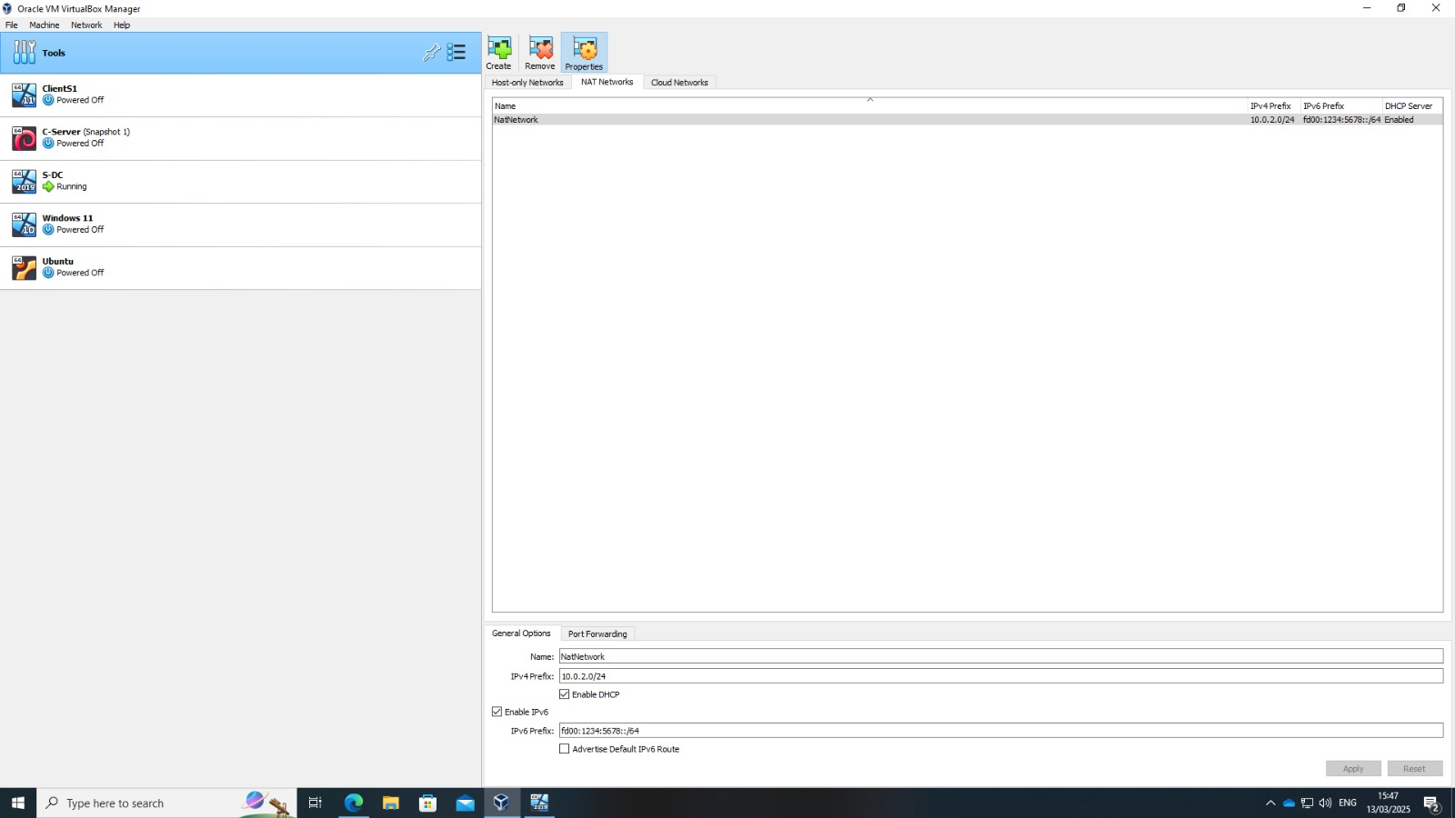
Figure 6 - Creating a Custom NAT Network in VirtualBox

Now it pings.
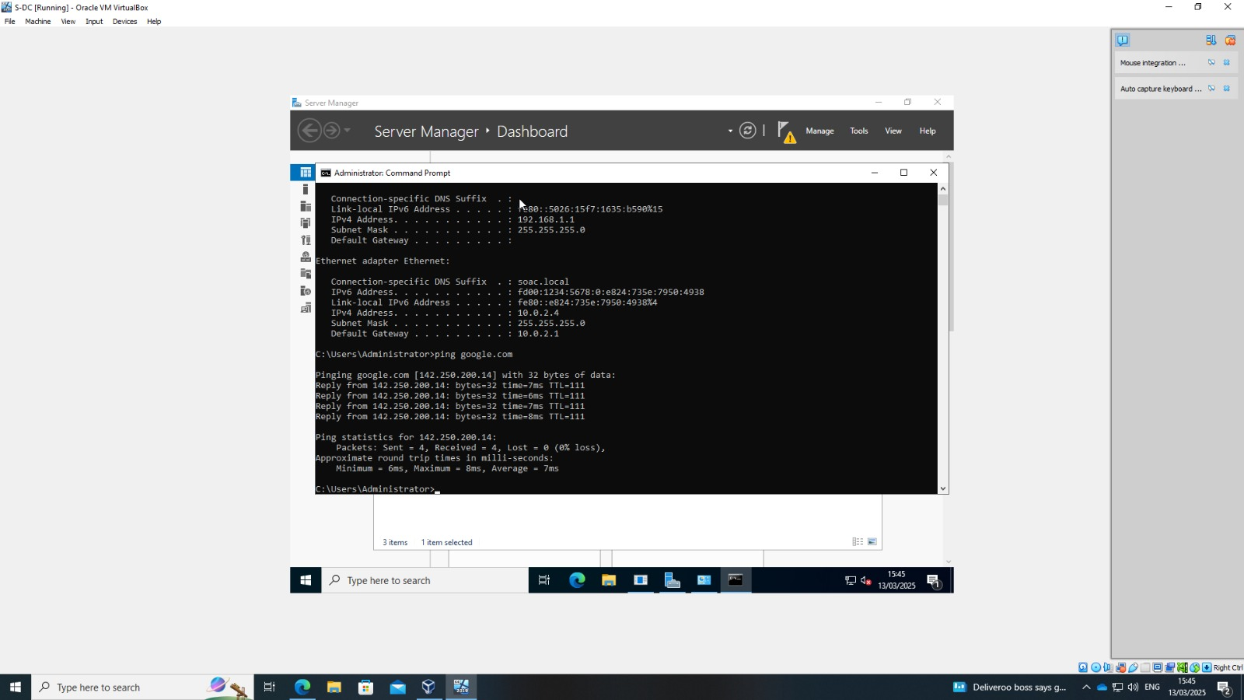
Figure 7 - Successful Internet Connection, Ping Test Passed
After applying the changes, I reconfigured the network settings on the server, ensuring that it could obtain an IP address automatically. Finally, I tested the connectivity again by pinging google.com, which was now successful, confirming that the server had a functional internet connection.
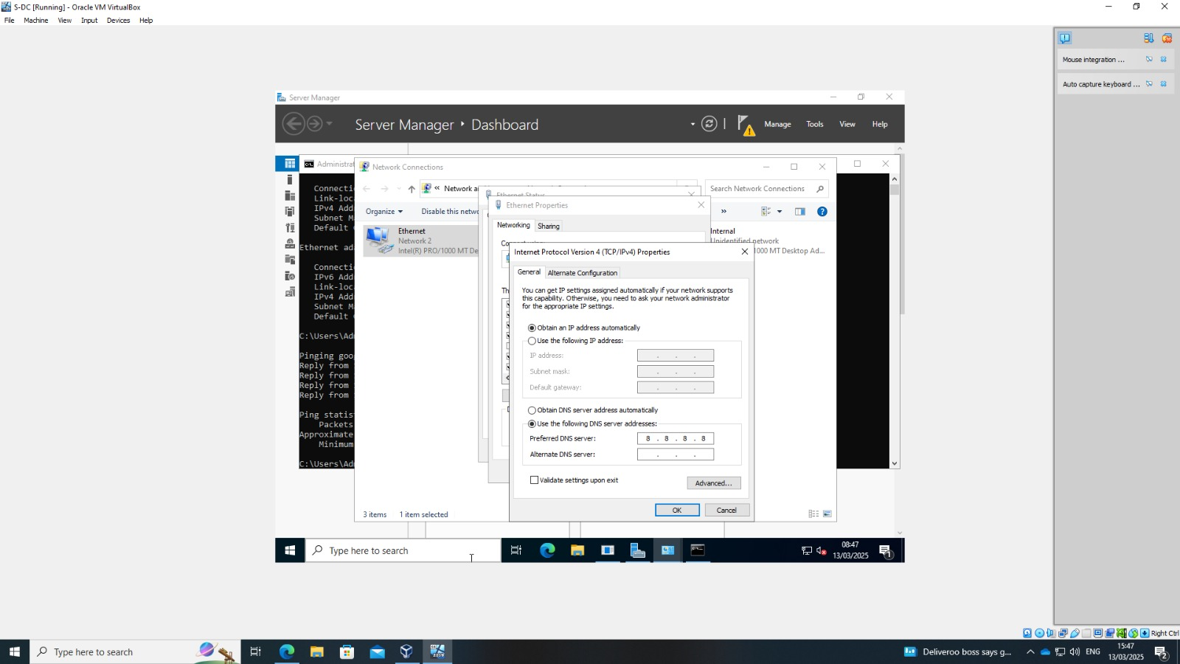
Figure 8 - Updating Network Configuration on the Server

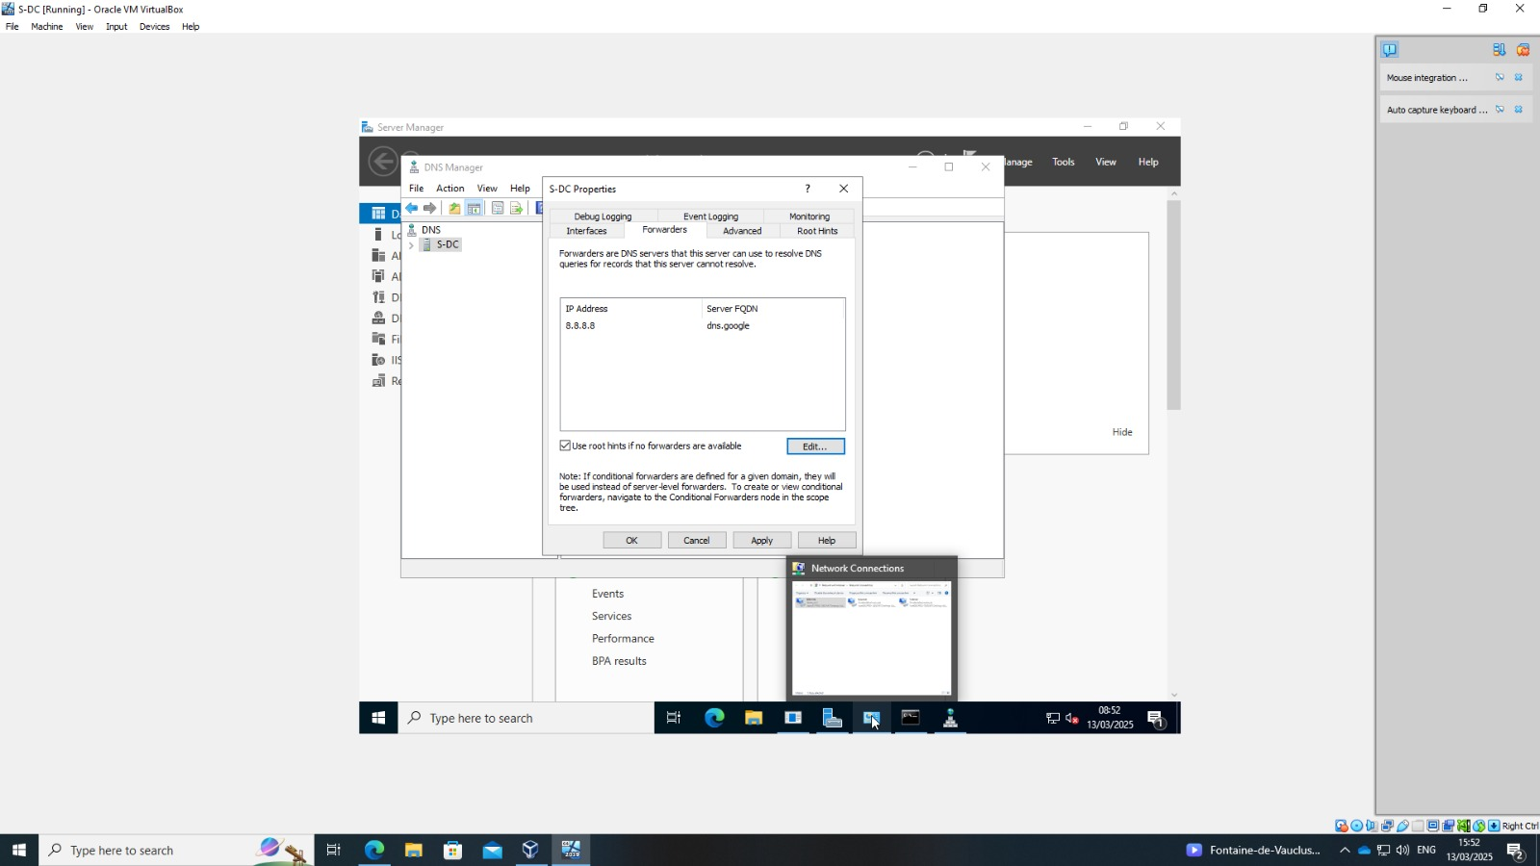
Figure 9 - DNS Forwarder Configuration
The server is part of the domain floriana.acca, verifying that the Active Directory Forest was successfully created.
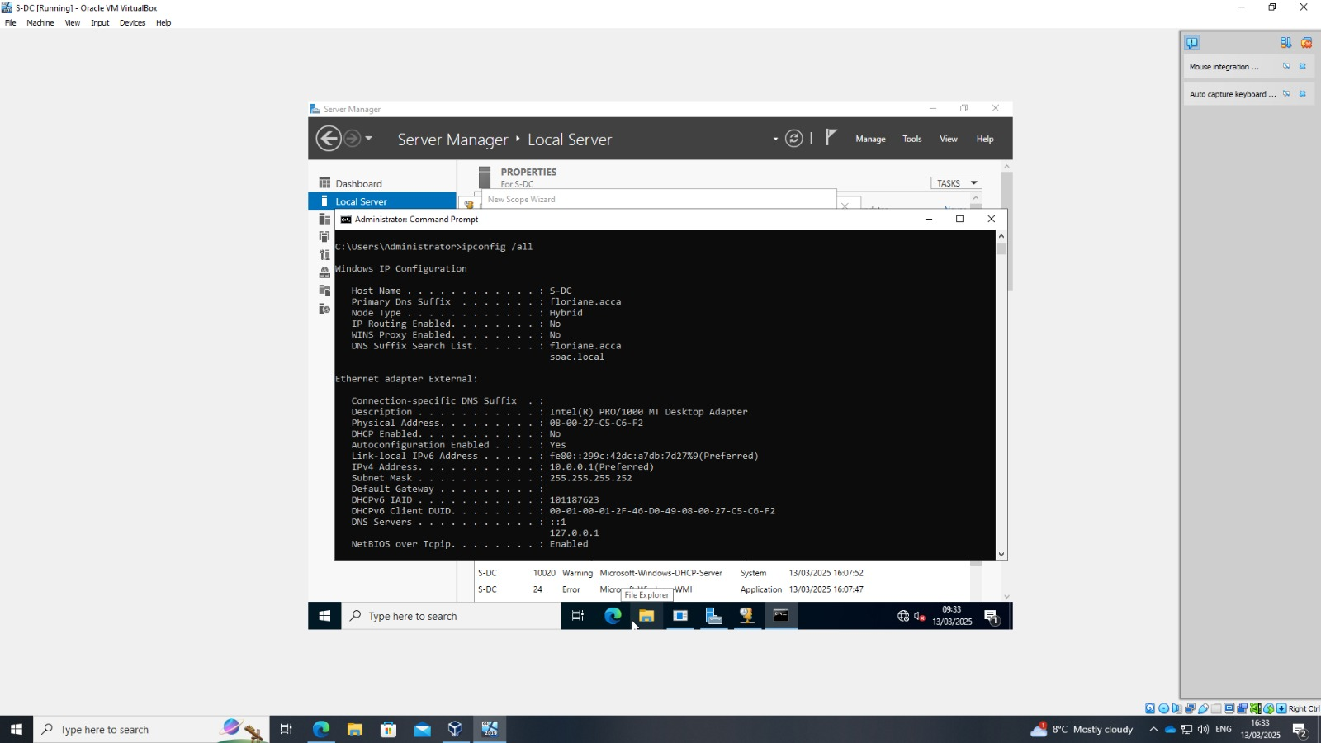
Figure 10 - Domain and Forest

DHCP
In this setup, a DHCP (Dynamic Host Configuration Protocol) server was configured to dynamically assign IP addresses to client devices within the network.
When I added server roles and features, I selected the DHCP Server feature. After installation, via Server Manager, a new DHCP scope was created. This scope defines the range of IP addresses that will be assigned to client machines dynamically (from 192.168.1.10 to 192.168.1.100).
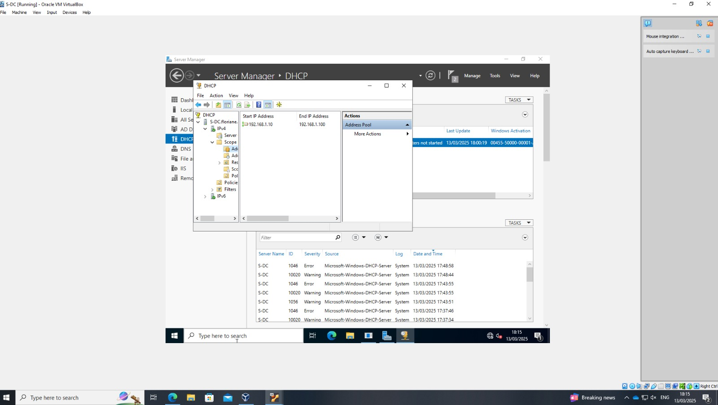
Figure 11 - Installing DHCP and Configuring the Scope in Server Manager
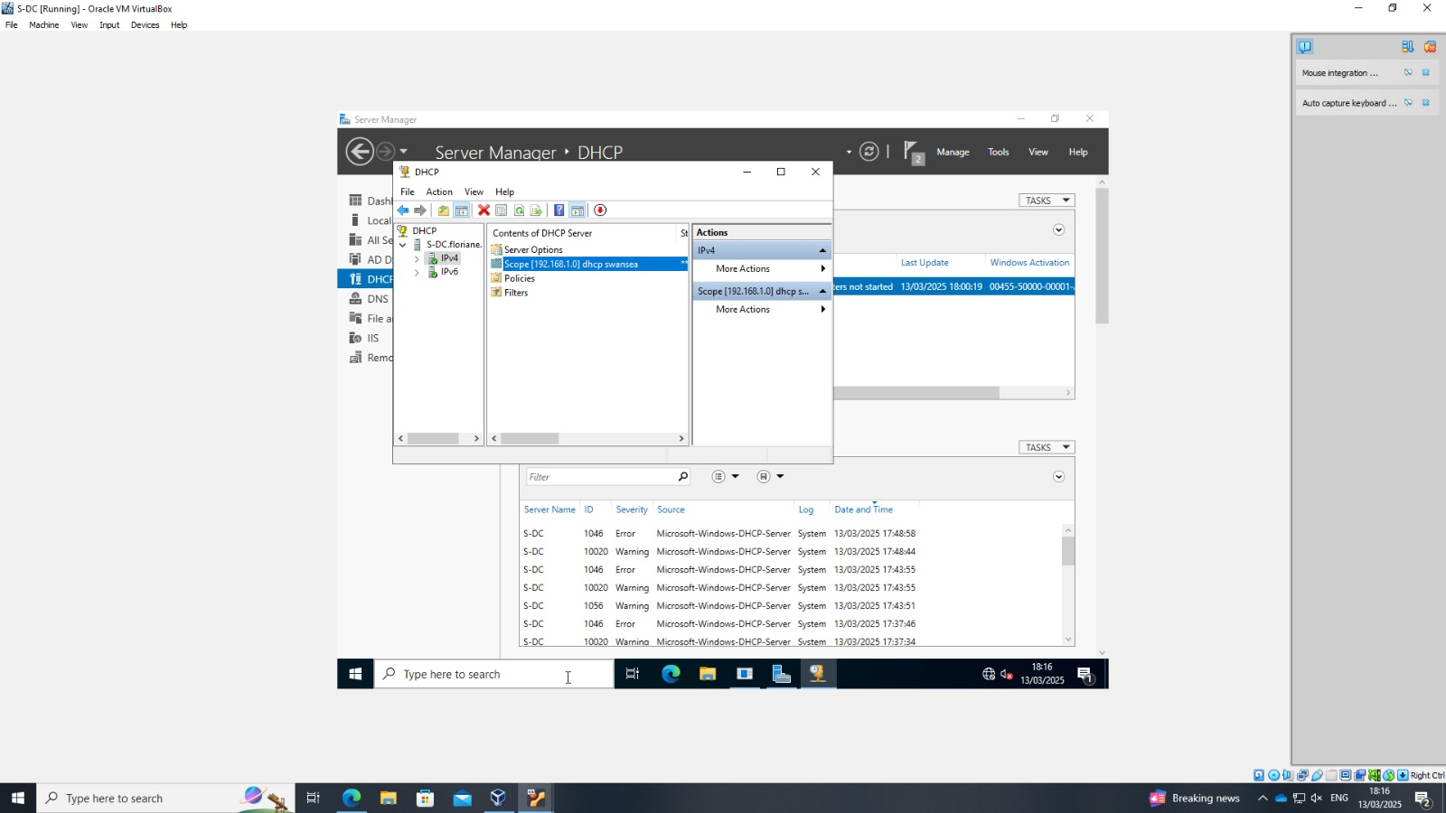
Figure 12 - DHCP Scope
After configuration, the client was tested to ensure it was receiving an IP address from the DHCP server. Using the ipconfig command, we confirmed that the client obtained an IP address from the defined range, along with the correct subnet mask and default gateway.
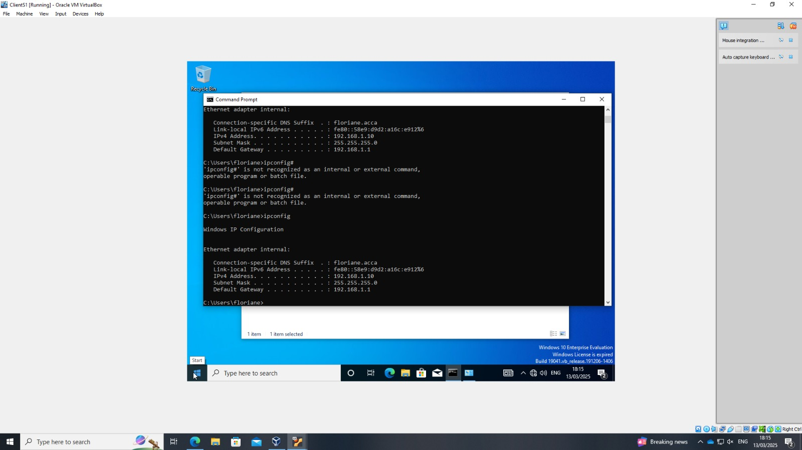
Figure 133 - Client Machine Receiving DHCP IP Address

Routing and Remote Access
Routing and Remote Access Service (RRAS) was configured to enable VPN clients to connect to the network and access the internet through the server.
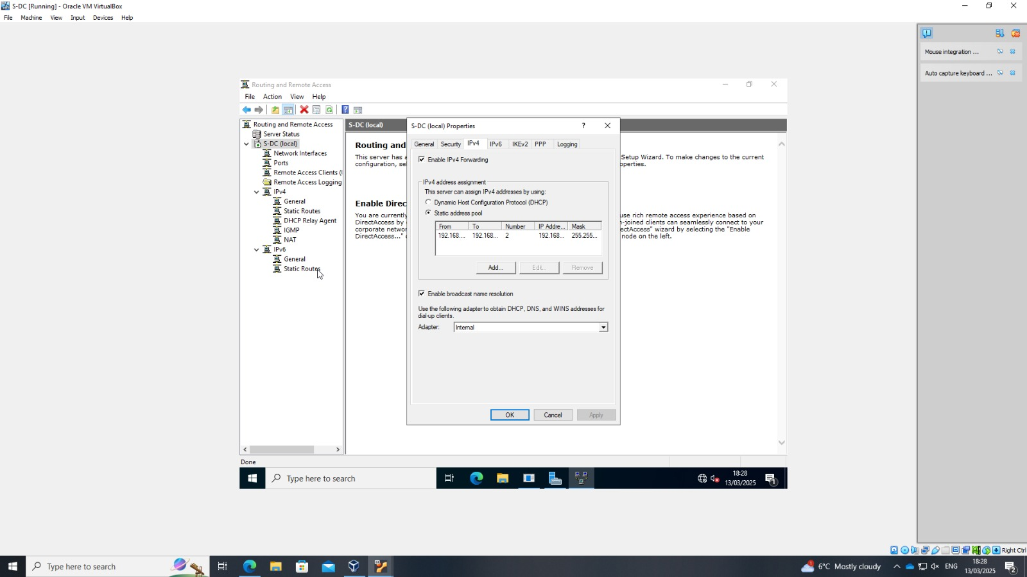
Figure 144 - Configuring VPN IP Address Pool in RRAS
After the configuration, the client machine connected to the VPN. To test the connection, a ping test was performed to 1.1.1.1, confirming that the client had internet access through the VPN.
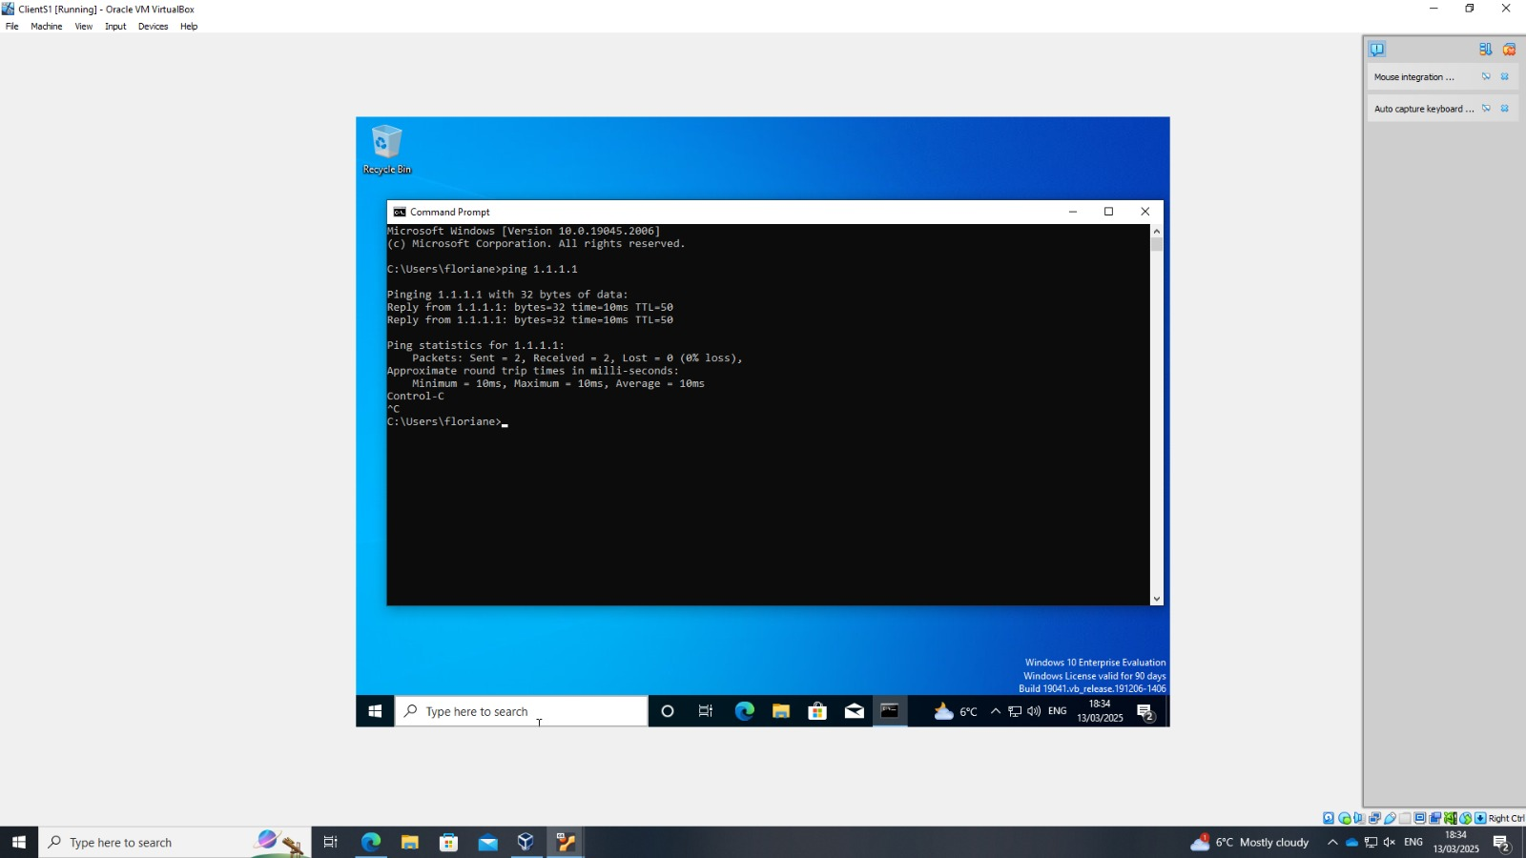
Figure 155 - Successful Internet Connectivity
The successful internet access on the VPN client is due to NAT being enabled on the server. The server acts as a gateway. It forwards traffic from VPN clients to external networks, ensuring they can access the internet while being part of the private network.

VPN
I configured a VPN demand-dial interface on a Windows Server. First, I specified the destination IP address for the remote router (10.0.0.2). Afterward, I accessed the VPN interface properties to adjust the connection settings.
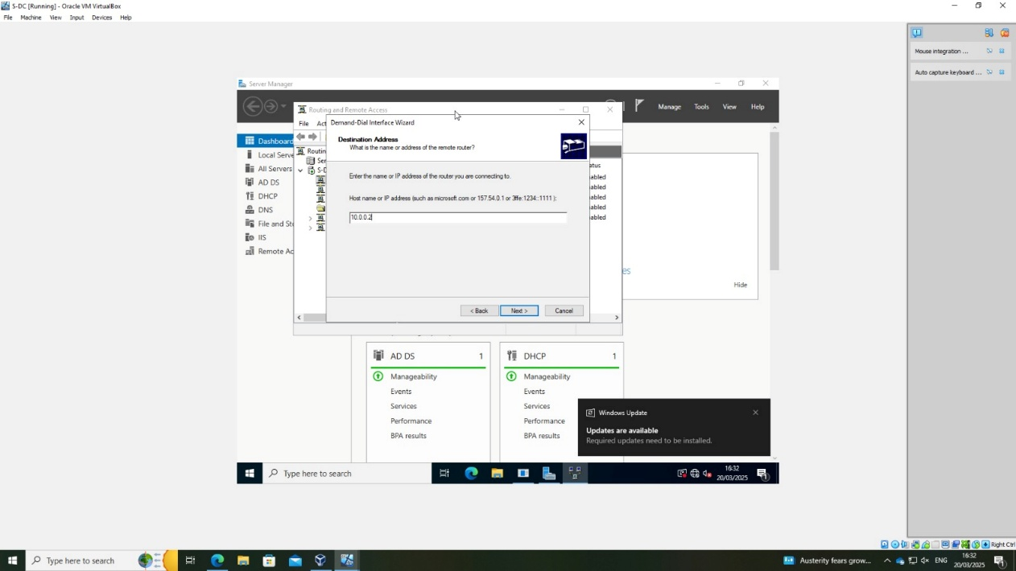
Figure 166 - Configuring Destination Address
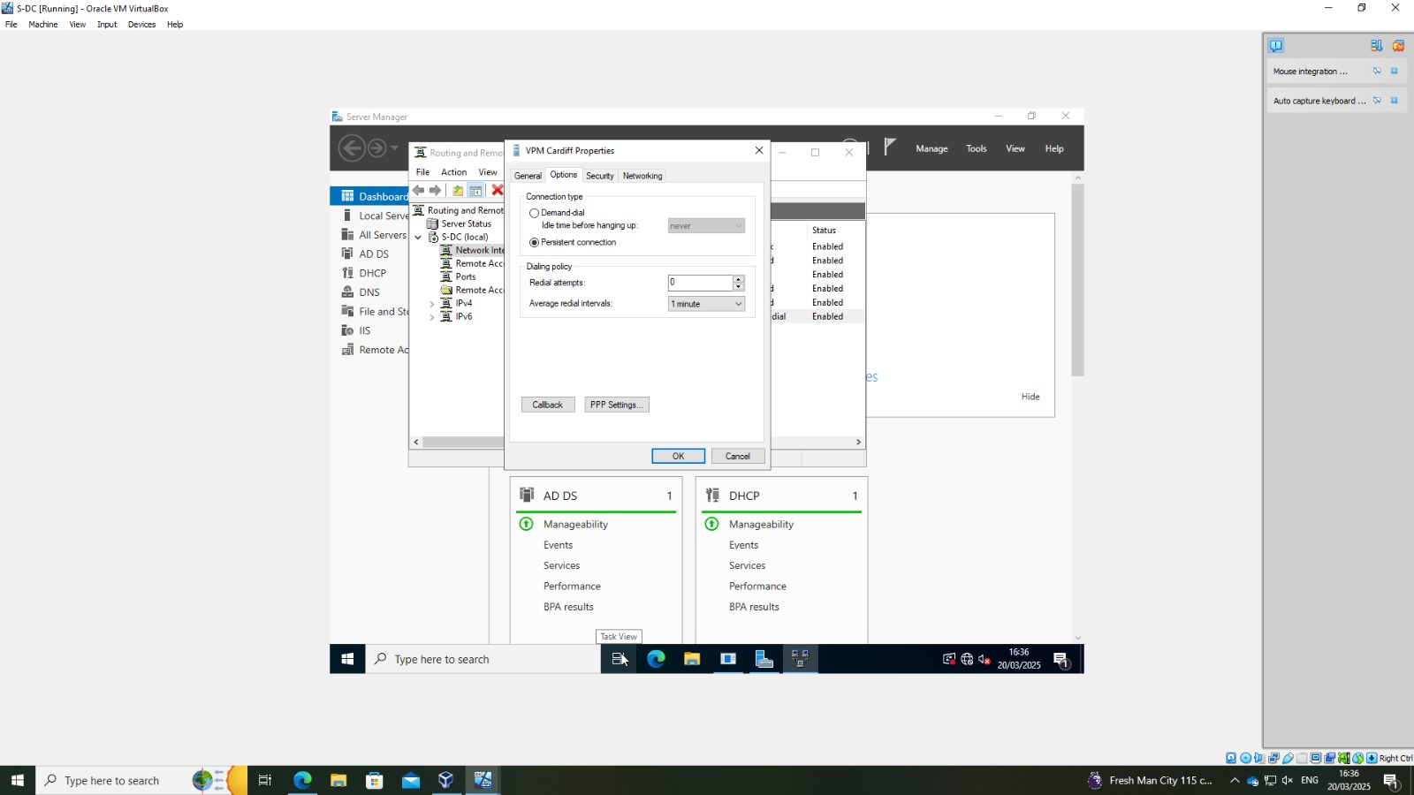
Figure 177 - VPN Connection Properties
I set up IP pools using pptpd on the Debian server. The configuration included defining a range of IP addresses in /etc/pptpd.conf and static routes in /etc/ppp/ip-up.d/route.
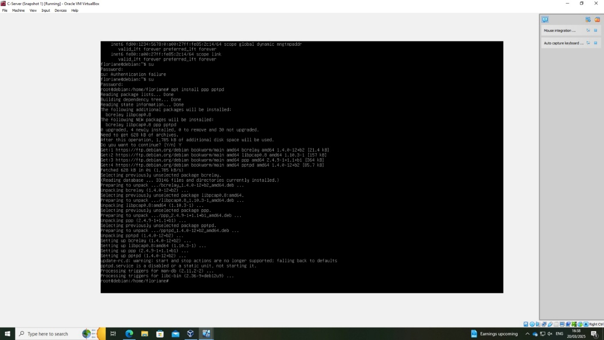
Figure 18 - Installing PPTPD and Dependencies on Debian
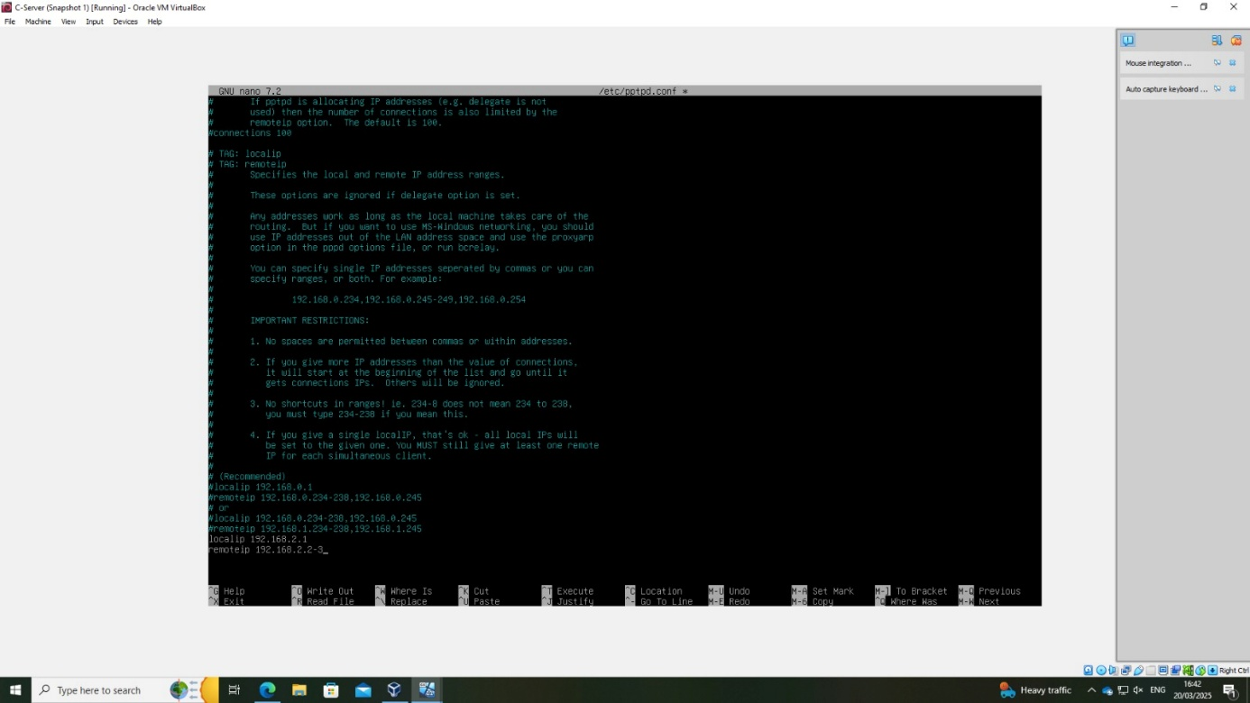
Figure 19 - Editing pptpd.conf to Define IP Address Pools

Figure 20 - Configuring Static Routes
At first, the VPN connection failed due to incorrect IP pool configuration. After correcting it, the interface connected successfully and ping tests between networks worked, confirming proper routing and VPN setup.

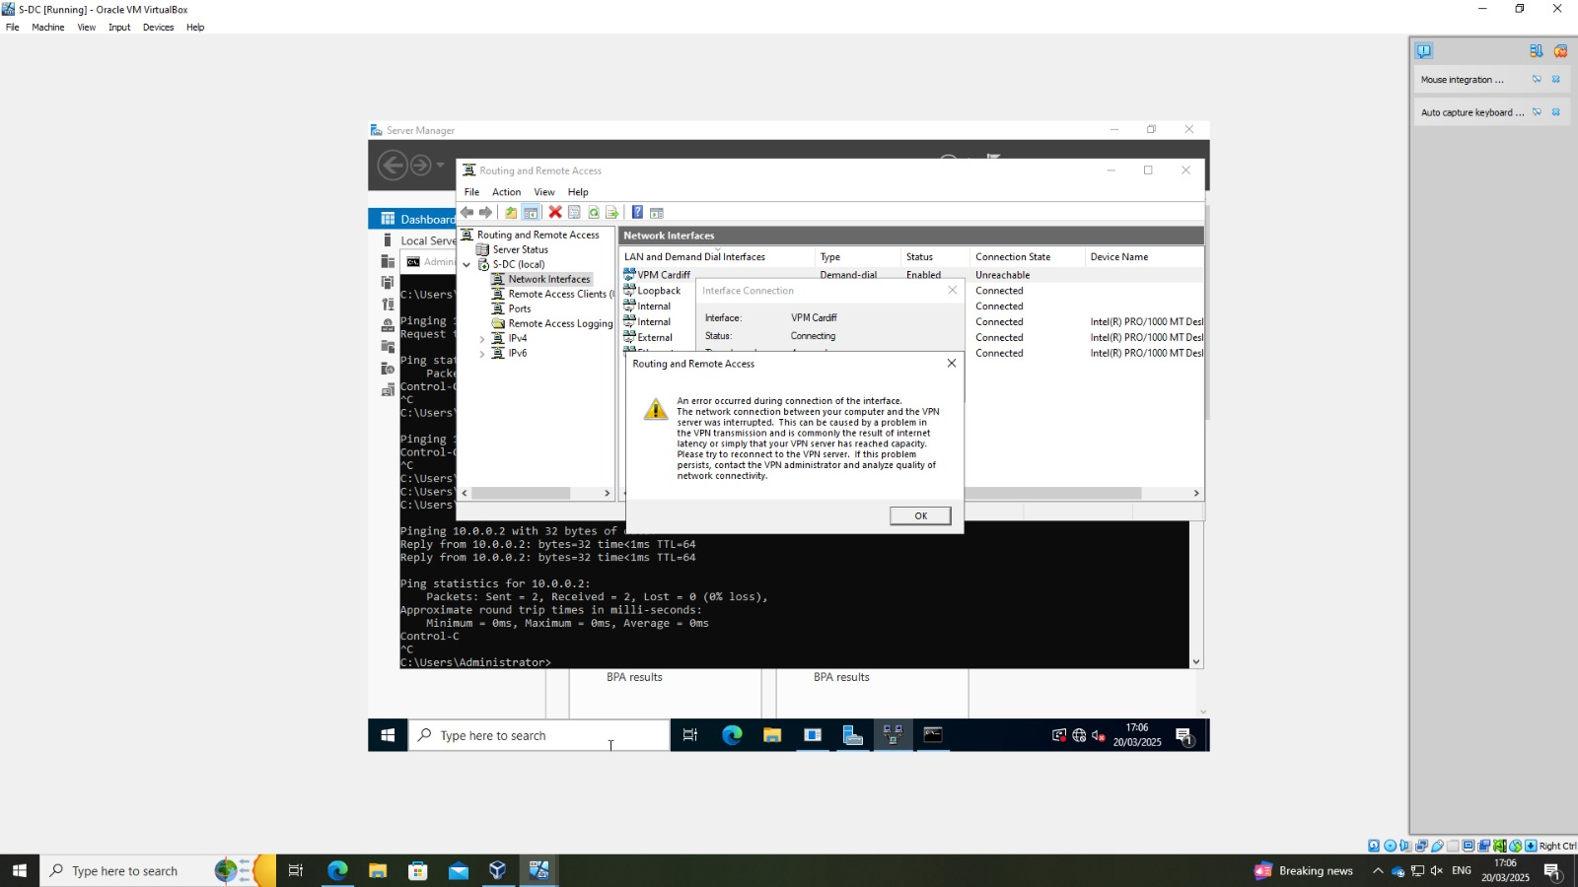
Figure 21 - Routing and Remote Access Interface Error – Incorrect IP
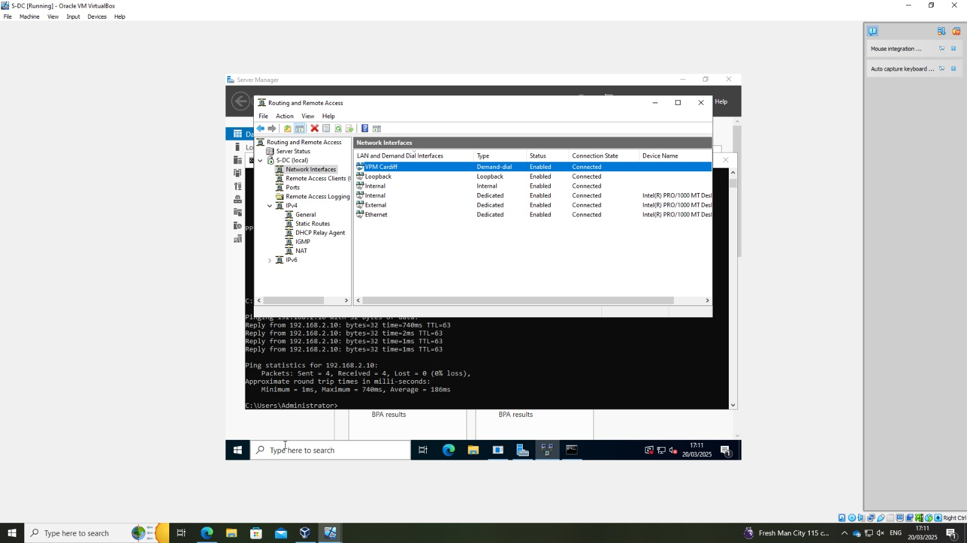
Figure 22 - Successful VPN Connection After IP Correction
Ping tests to verify VPN connectivity:
- The Windows Server (SDC) successfully pinged the Debian client (192.168.2.10).
- The Windows client (ClientS1) also successfully pinged the Debian client, confirming end-to-end communication across the VPN tunnel.
These tests confirm that routing between sites works correctly and that all machines connected to the VPN can communicate with each other.
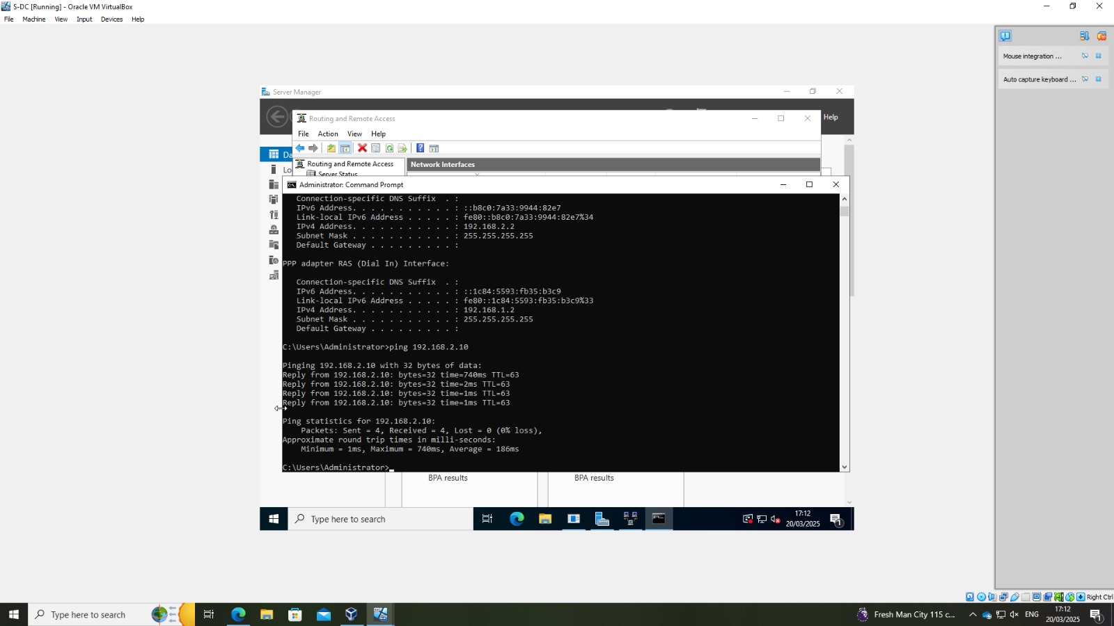
Figure 23 - Successful Ping from S-DC to Ubuntu
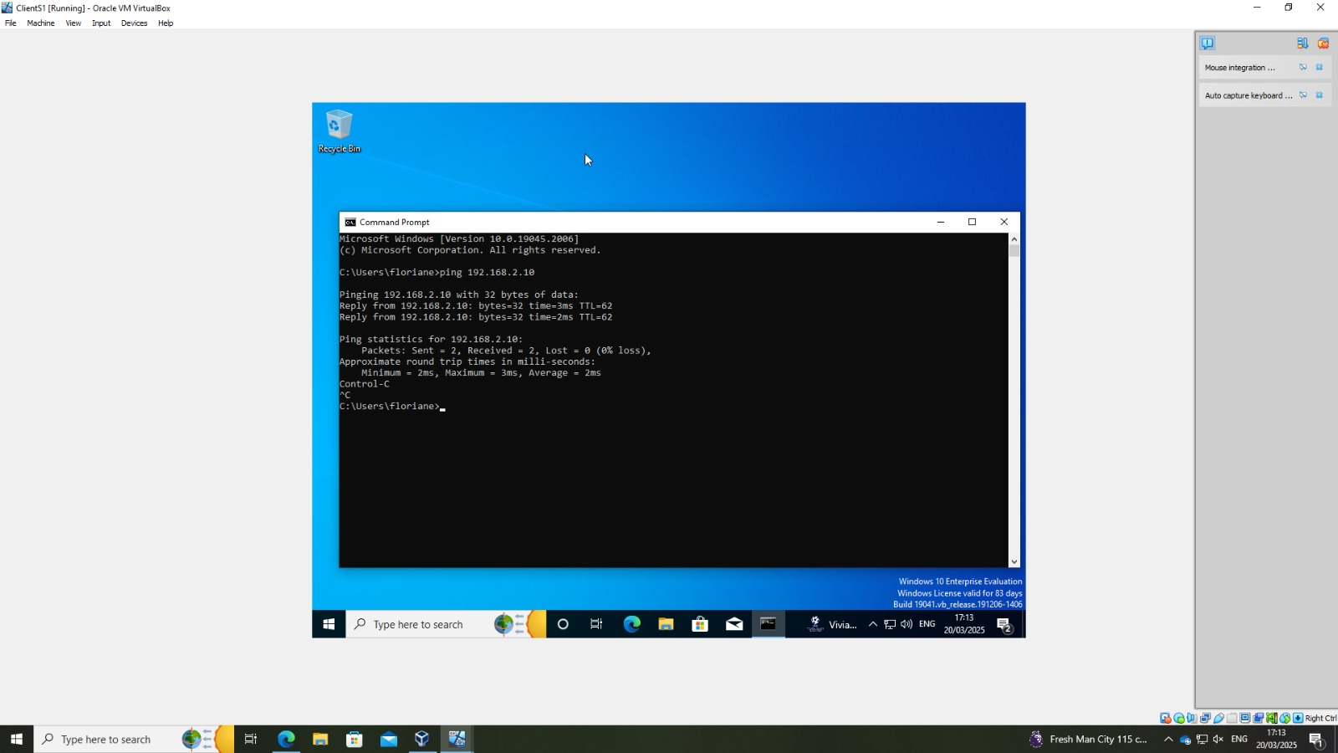
Figure 24 - Ping Test from Windows Client to Ubuntu

DNS
I configured the DNS server to respond on all network interfaces, ensuring it can process DNS requests from any connected client. External DNS forwarders (8.8.8.8 and 1.1.1.1) were also added to enable resolution of internet domain names. On the DHCP side, we specified the local DNS server (192.168.1.1) in the scope options so that clients receive the correct DNS settings automatically.
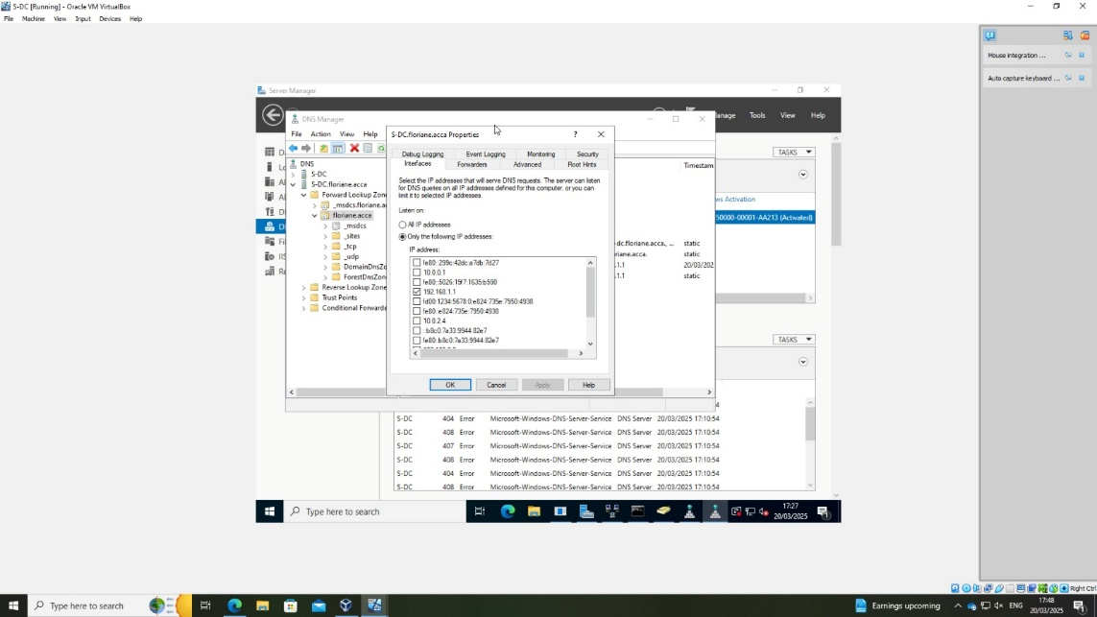
Figure 255 – DNS listening interfaces configuration
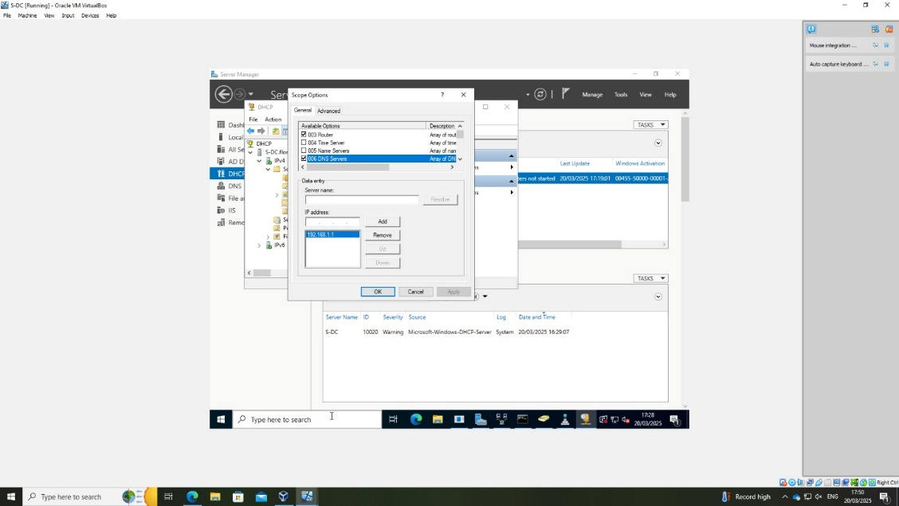
Figure 266 - Configuring DNS Server Option in DHCP Scope
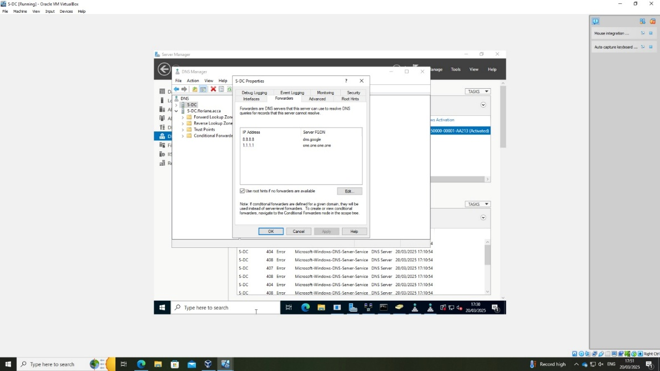
Figure 277 - Setting External DNS Forwarders in DNS Manager
I modified the default password policy to make it less restrictive.
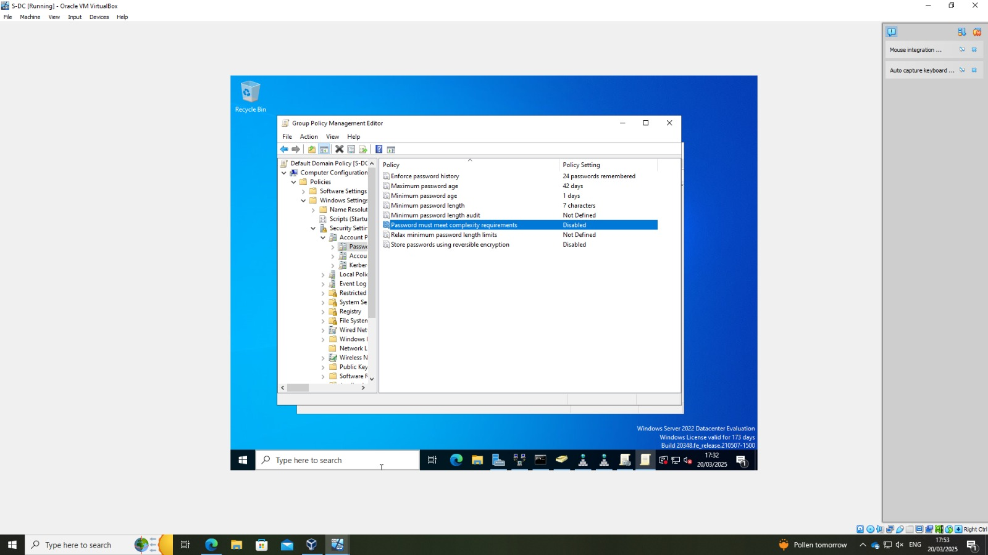
Figure 28 - Disabling Password requirement via Group Policy

User creation
I created a new user account named Floriane Agogue in Active Directory using the Server Manager.
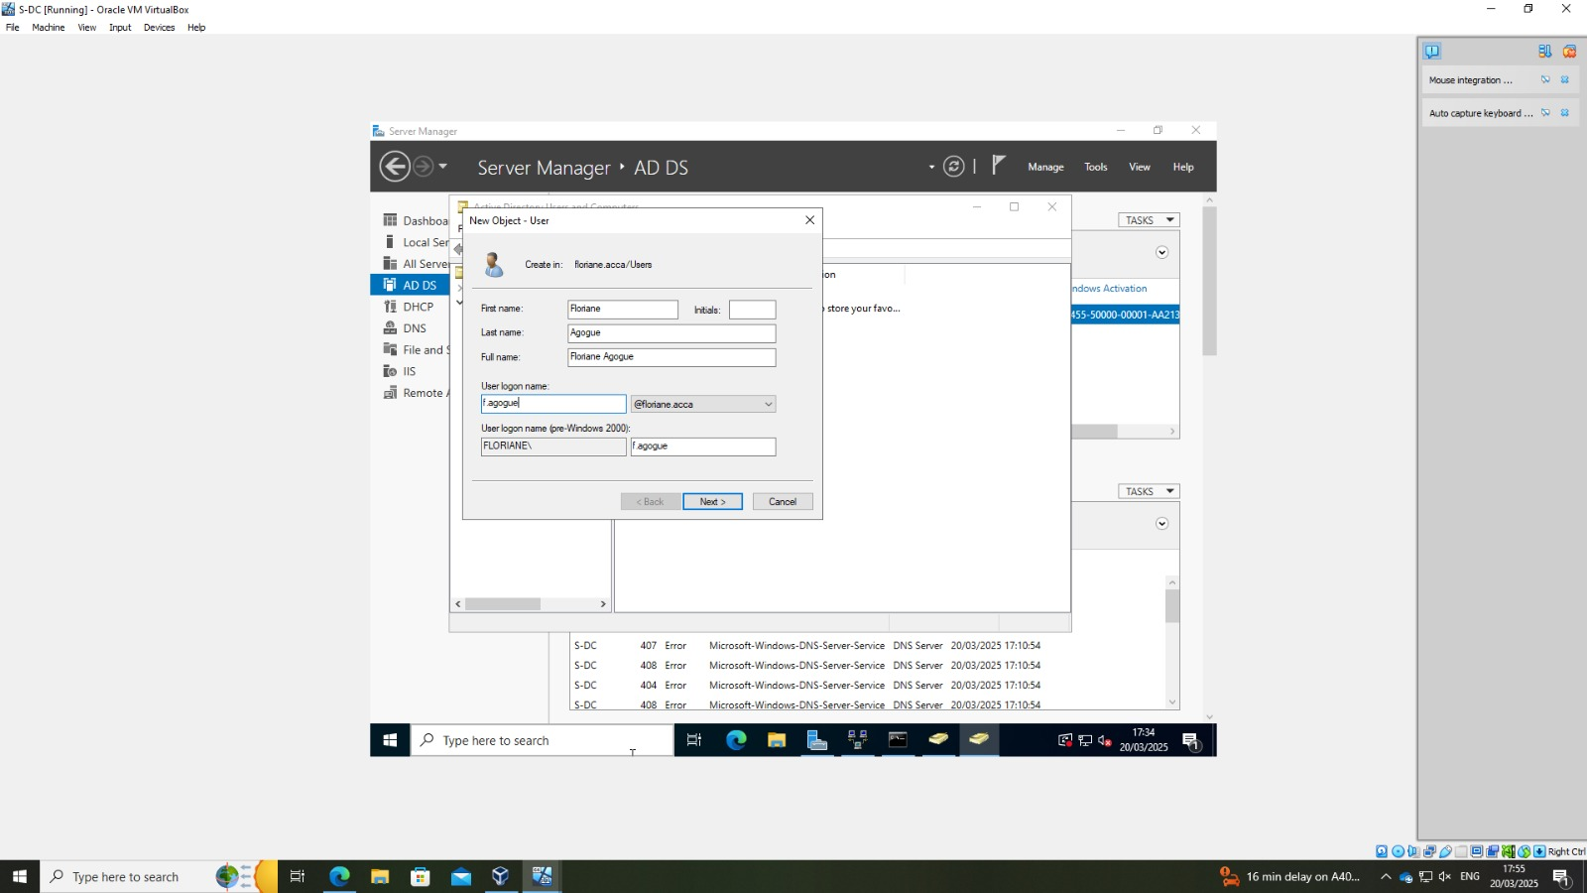
Figure 29 - Creating a New User in Active Directory

II – Cardiff Network

DHCP server and network configuration on debian
In this configuration file, the DHCP server is being set up to assign IP addresses to clients on the VPN or local network.
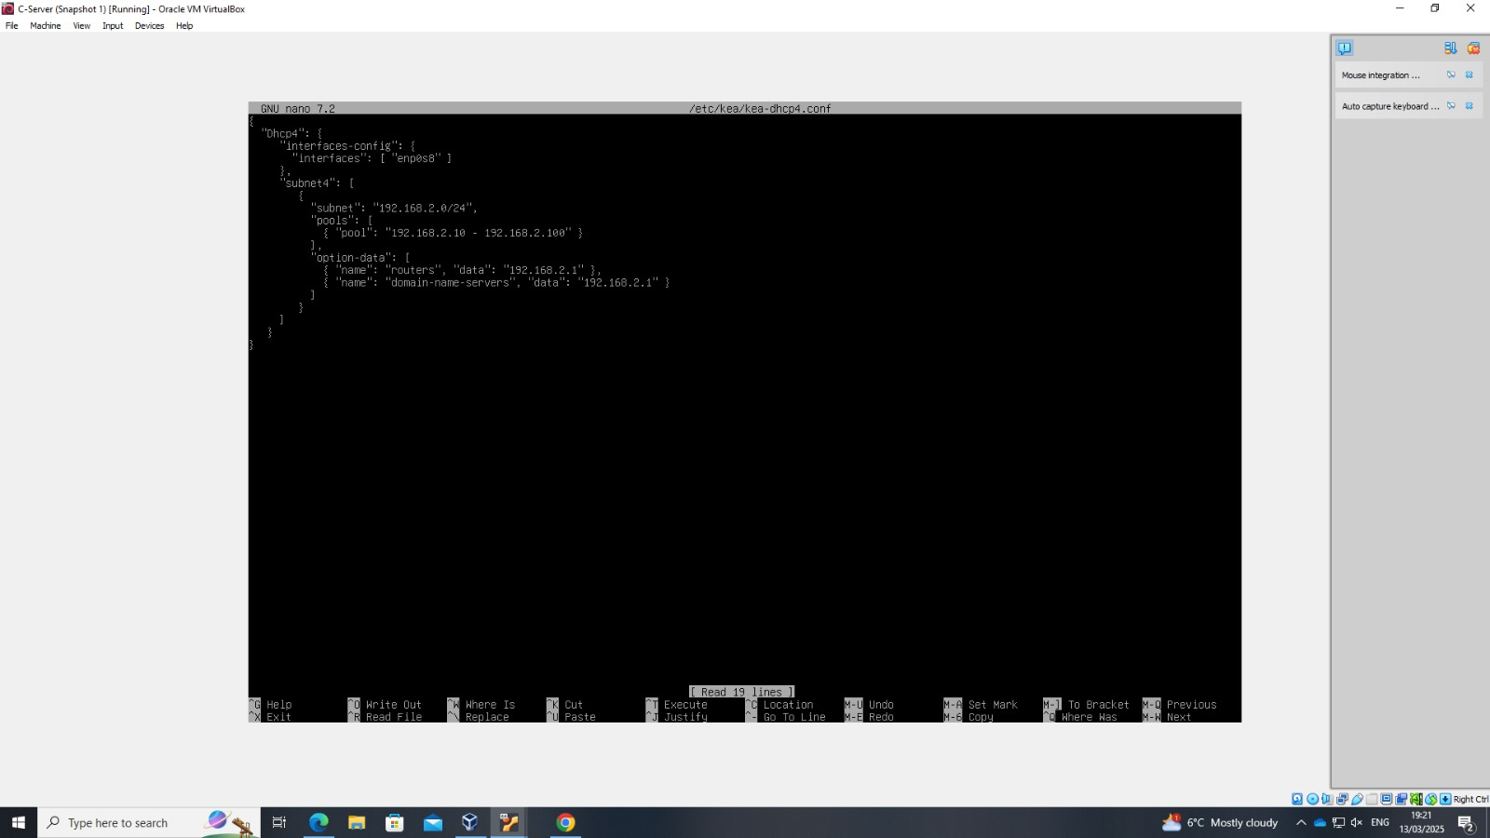
Figure 30 – DHCP server config
The system's kernel parameters are being adjusted to enable routing. These modifications prepare Debian server to act as a router.
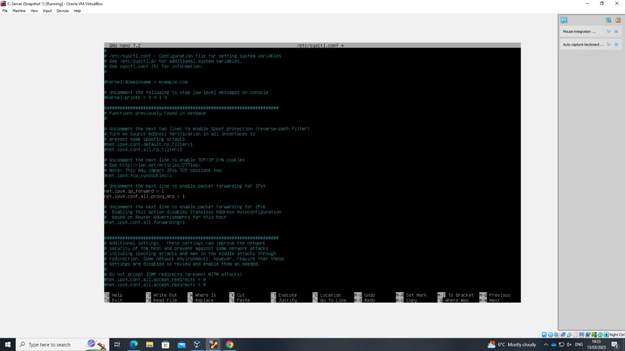
Figure 31 - Network Settings for IP Forwarding and Security
During the installation of iptables-persistent, the system prompts to save the current IPv6 firewall rules.
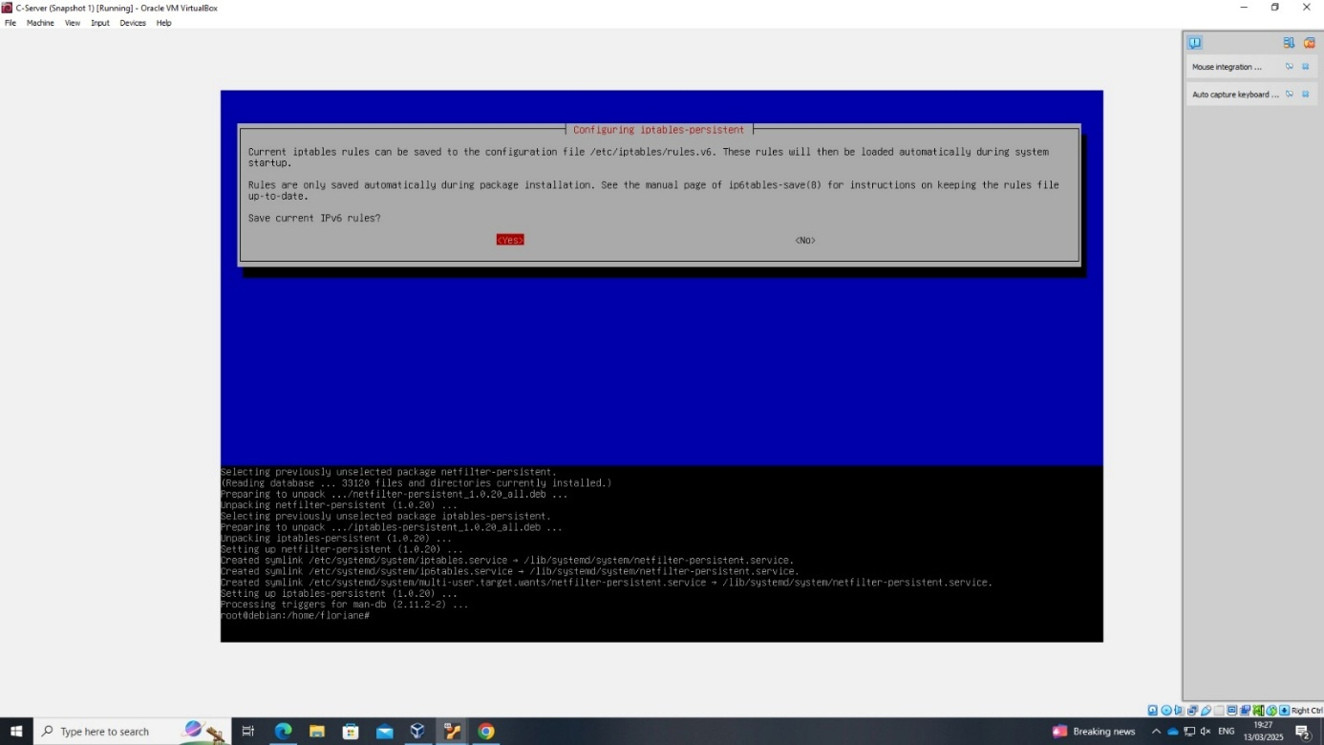
Figure 32 – Saving firewall rules
From the client machine, I did different ping tests. Ping 1.1.1.1 is successful, it confirms that internet access is working properly.
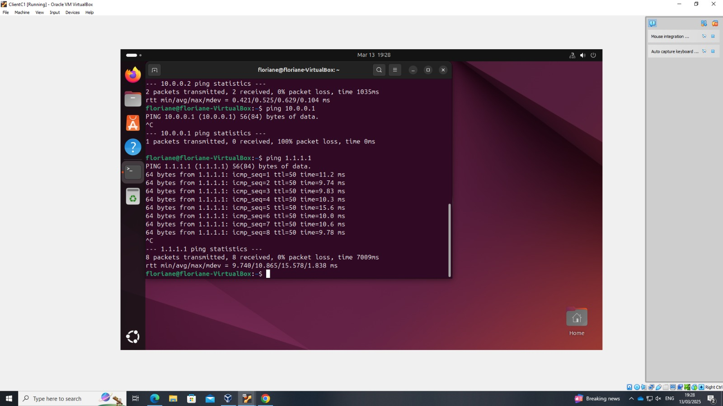
Figure 33 – Ping test from Client debian

VPN
In this step, NAT is configured on the Debian VPN server. It allows internal LAN clients to send traffic to external networks, such as the internet, through the Debian VPN server.
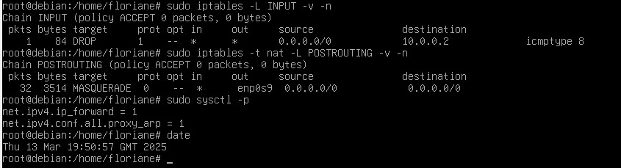
Figure 34 – NAT config
Two network interfaces are configured on the Windows Server. The internal network interface is assigned the IP address 10.0.0.2, which connects to the local LAN. The external network interface is configured with the IP address 192.168.2.1, providing access to external networks.
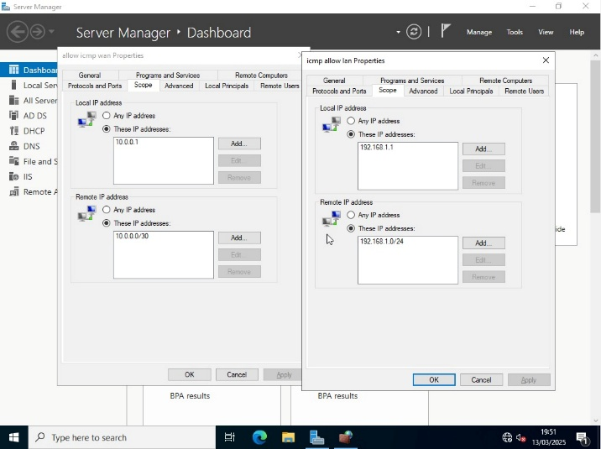
Figure 35 – Windows server network settings
Different ping tests are performed from the linux client to check network connectivity across different segments of the network.
- The first ping 10.0.0.2 is unsuccessful, this confirms that the client is unable to reach the internal LAN interface, as expected given the firewall restrictions.
- The second test pings 192.168.1.10, it’s successful, the client can communicate with Windows client through the configured router and VPN server.
- The next ping is 192.168.1.1. This is also successful.
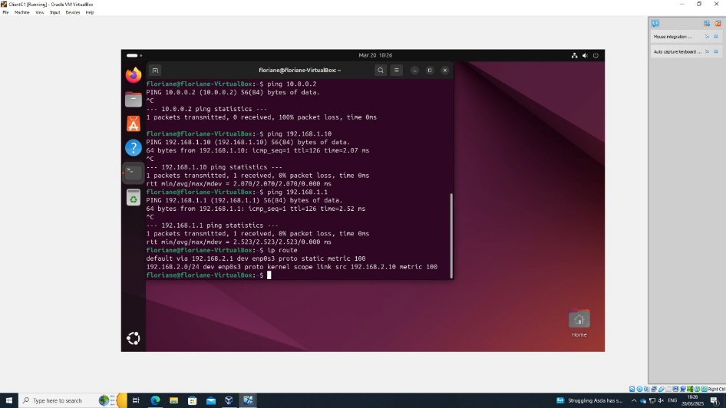
Figure 36 - Ping test

DNS configuration
The /etc/resolv.conf file specifies multiple DNS servers to resolve domain names within the local forest and external domains.
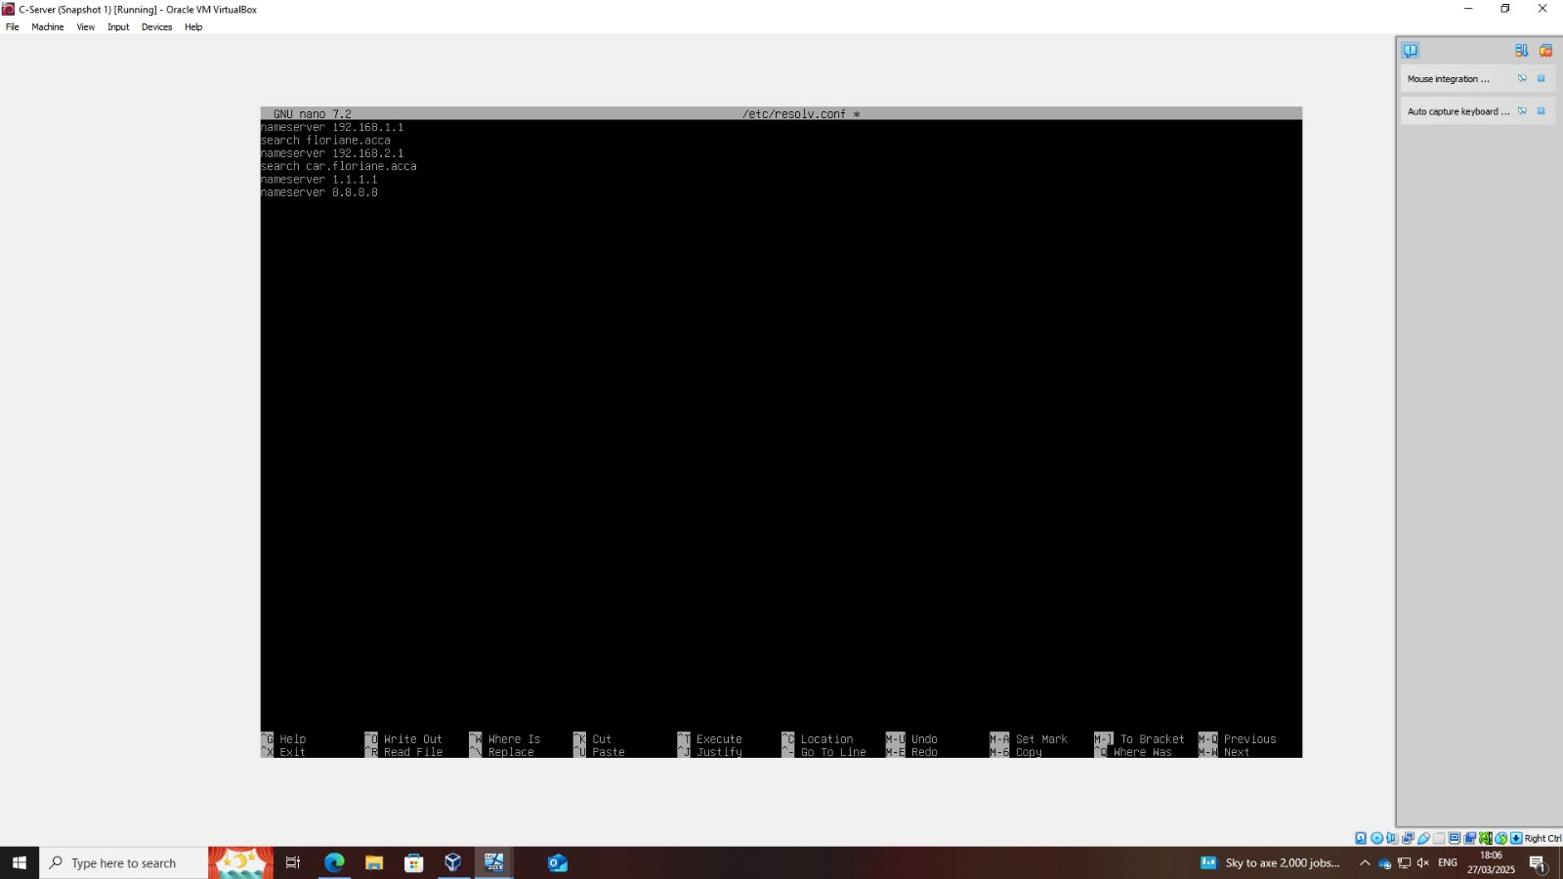
Figure 37 - DNS config
The server is set up as an Active Directory Domain Controller. The realm is configured as FLORIANE.ACCA, which corresponds to the domain forest. With this configuration, Debian functions as an Active Directory Domain Controller, capable of managing users, domains, and policies within the forest.
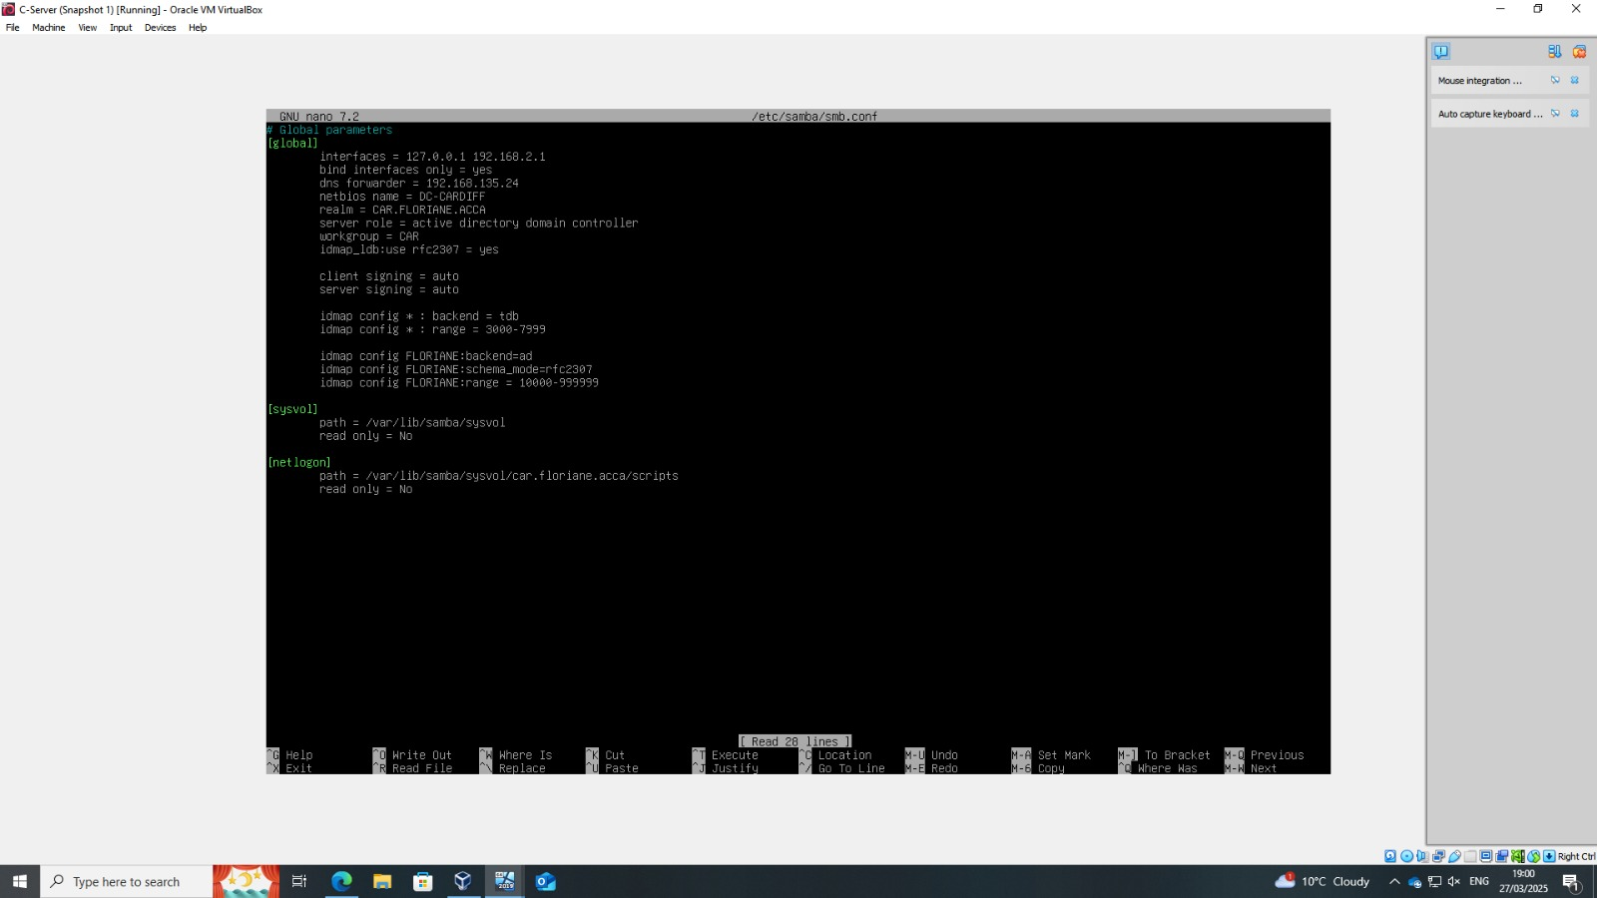
Figure 38 - Active directory
On windows server, the command nslookup is used to verify DNS name resolution. The Debian Active Directory and DNS services are correctly configured and operational.
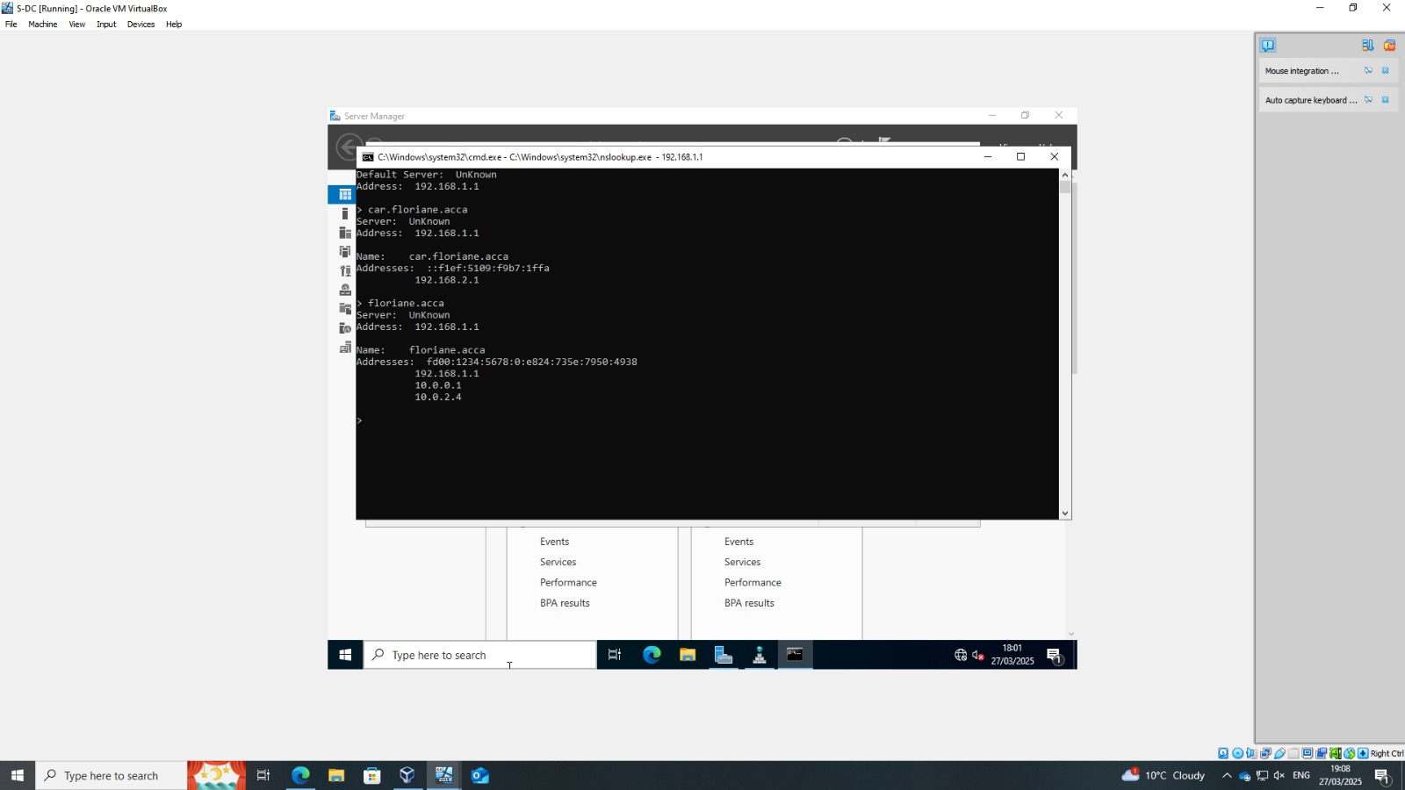
Figure 39 - Domain name resolution on Windows Server (nslookup)

Active directory from Ubuntu
In this step, the ubuntu client attempts to discover the Active Directory domain managed by the Debian server. This confirms that the Active Directory domain is visible from Ubuntu and that the necessary packages for domain integration are identified.
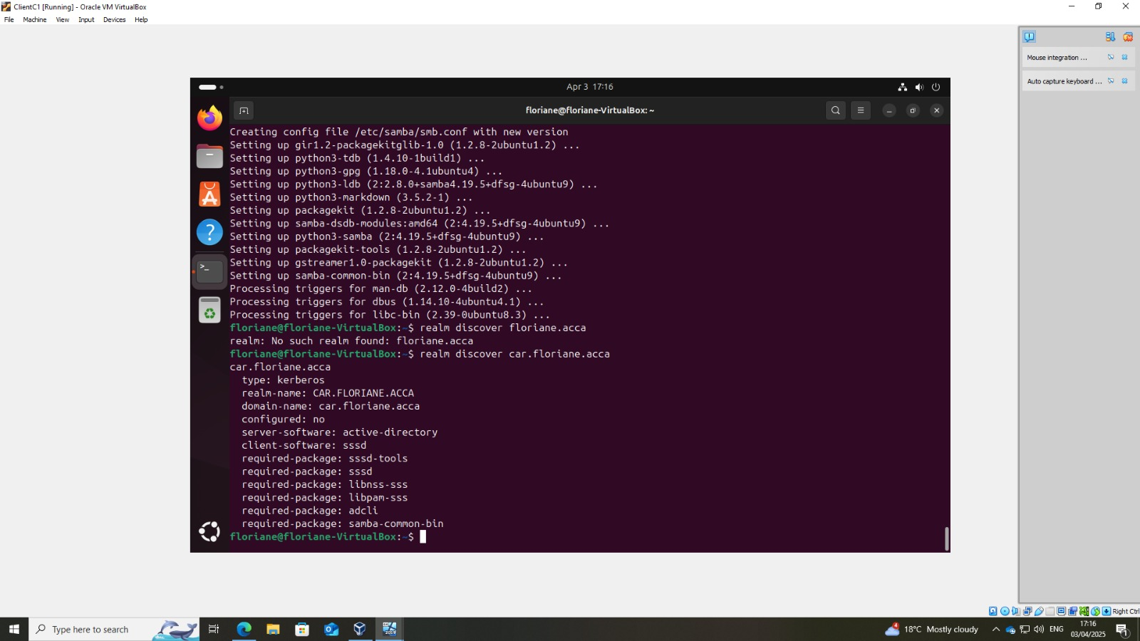
Figure 40 - Active directory from ubuntu client
I join the Active Directory domain using the realm join command. Some verifications are done (id command to check the domain user's group membership and ID mapping and realm list command to confirm domain configuration and login settings). The Linux client is now integrated into the Active Directory domain, allowing centralized authentication and user management.
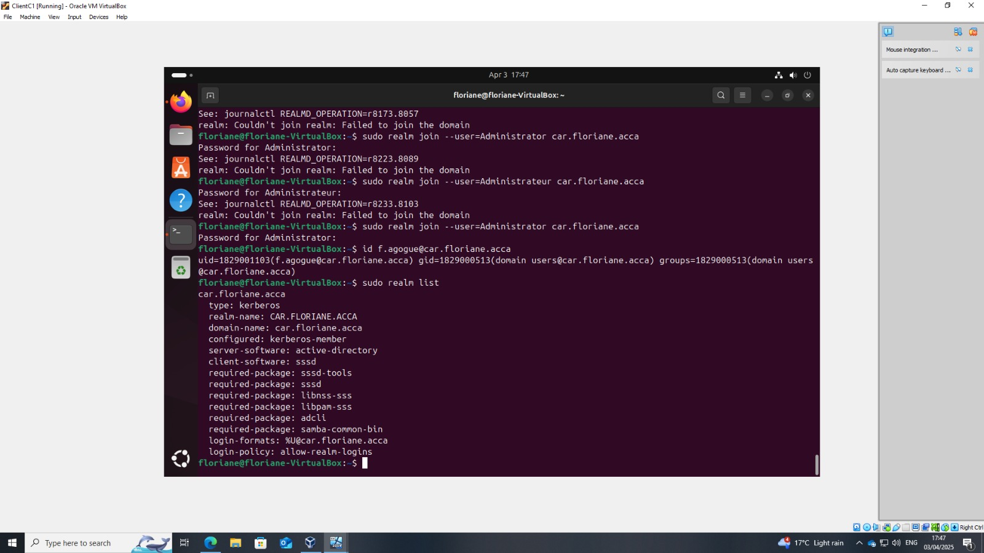
Figure 41 – Joining the active directory from ubuntu
This confirms that Ubuntu is successfully integrated into the Active Directory domain.
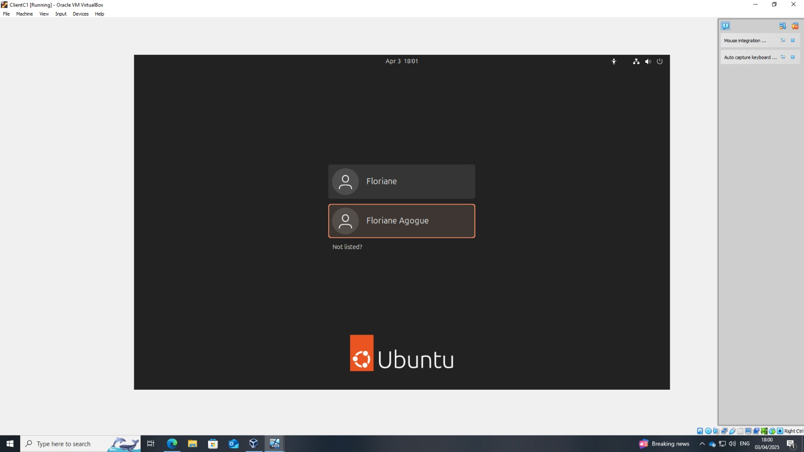
Figure 42 -Successful Active Directory user login on Ubuntu client

Shared folder
It shows the disk management console. A new volume has been created. This partition is ready to be used for data storage and sharing purposes.
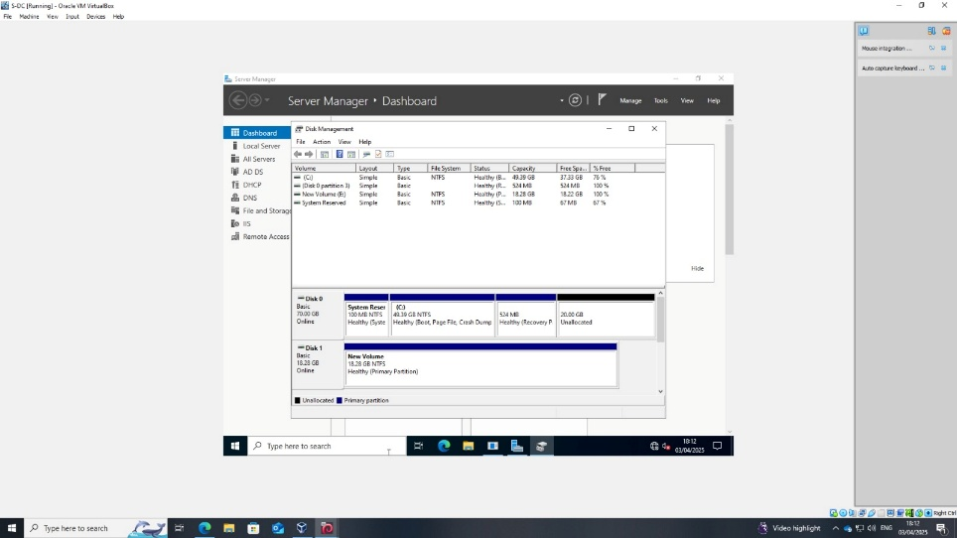
Figure 43 – disk management and new disk created
This is the security settings for the "Swansea" folder. Permissions are configured to allow access to "domain users" and "administrators".
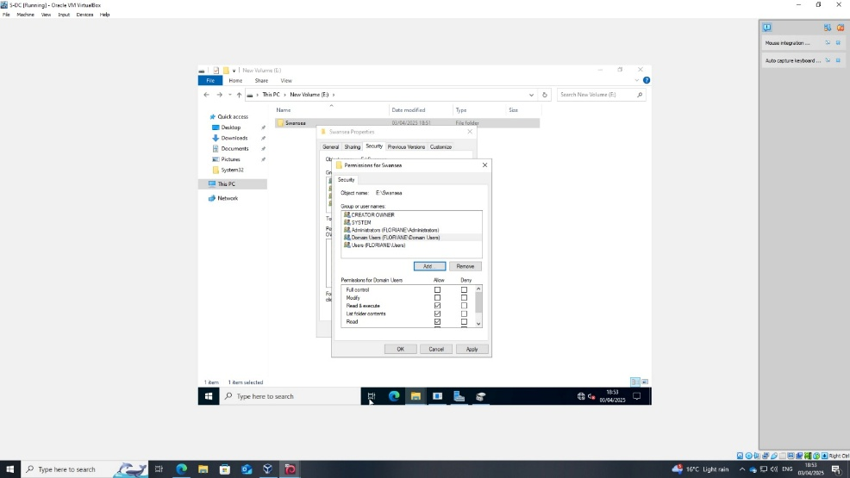
Figure 44 – setting permissions on the Swansea folder
The Windows client is successfully accessing the "Swansea" shared folder over the network.
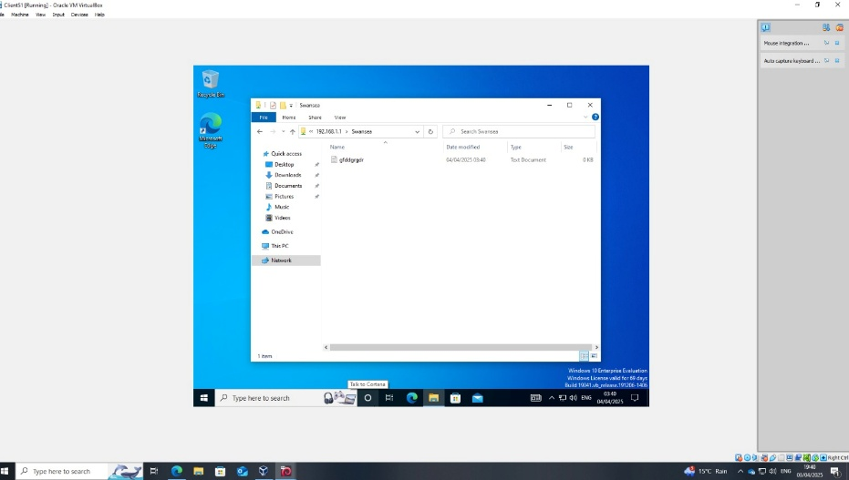
Figure 45 - Access the "Swansea" folder from Windows Client
The file appears successfully on Ubuntu client.
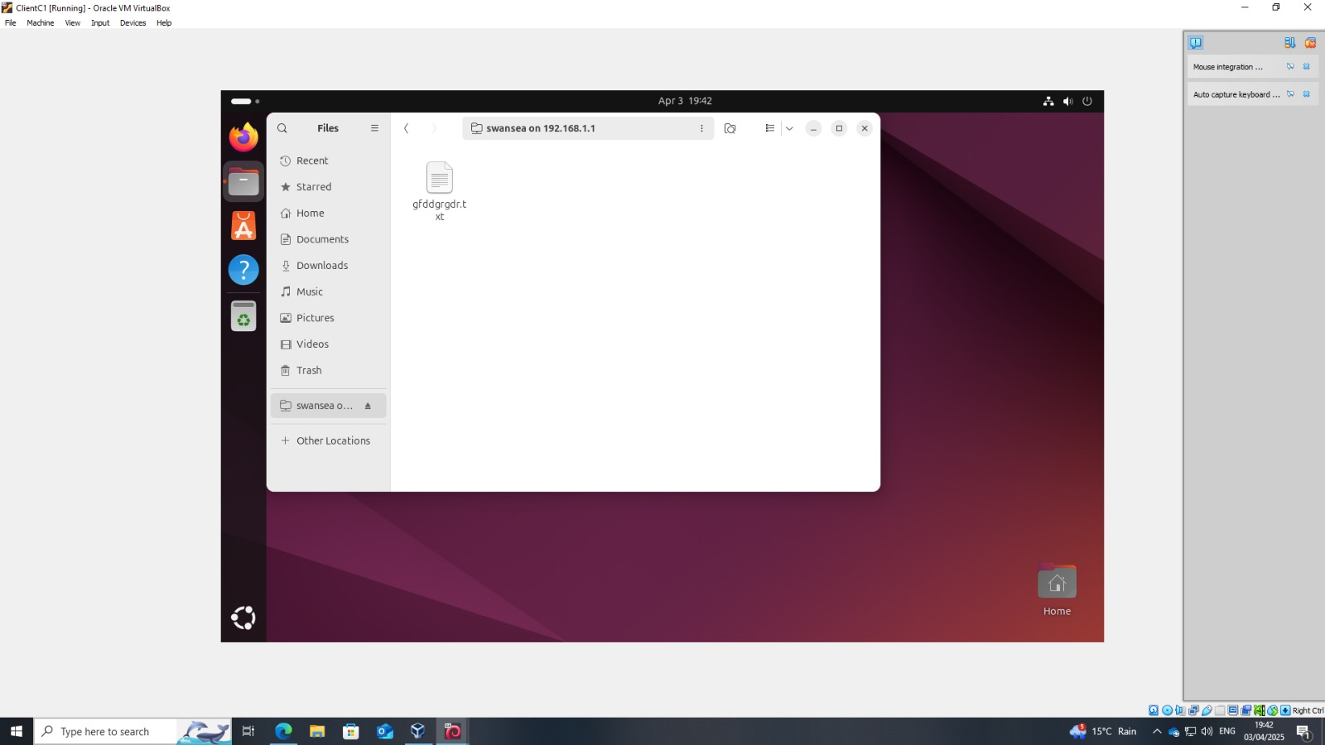
Figure 46 - Access the "Swansea" folder from Ubuntu Client

Website creation
This is the creation of a new website in IIS Manager on Windows Server.
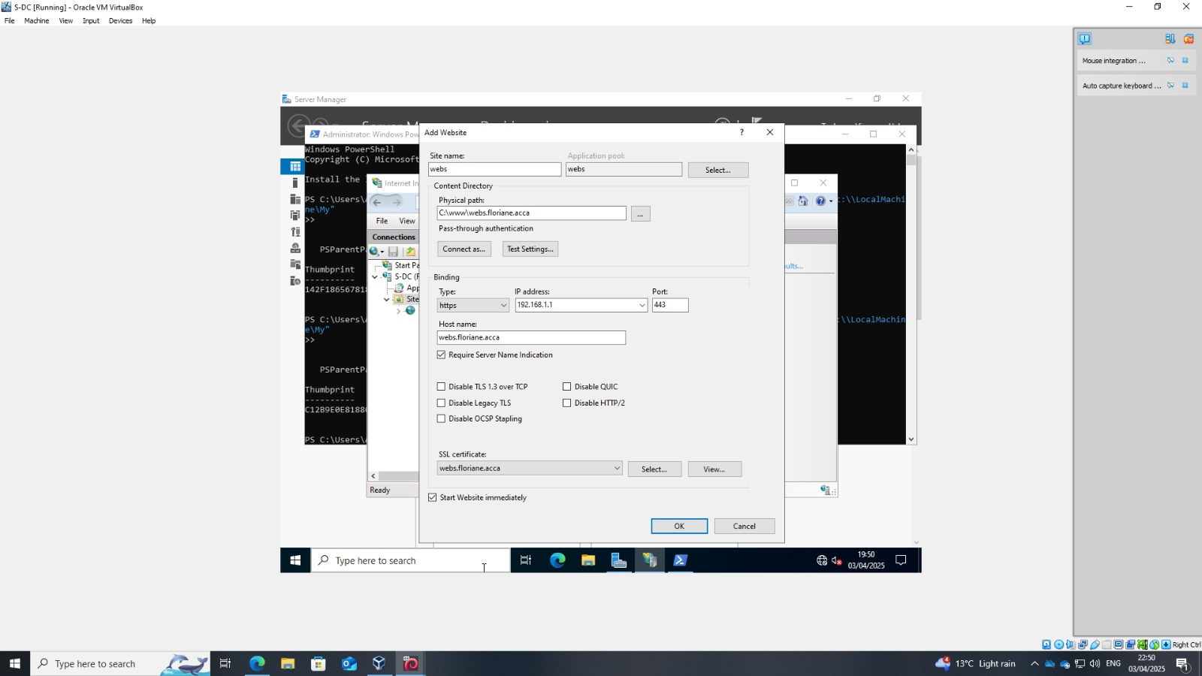
Figure 47 - Creating a New Website in IIS
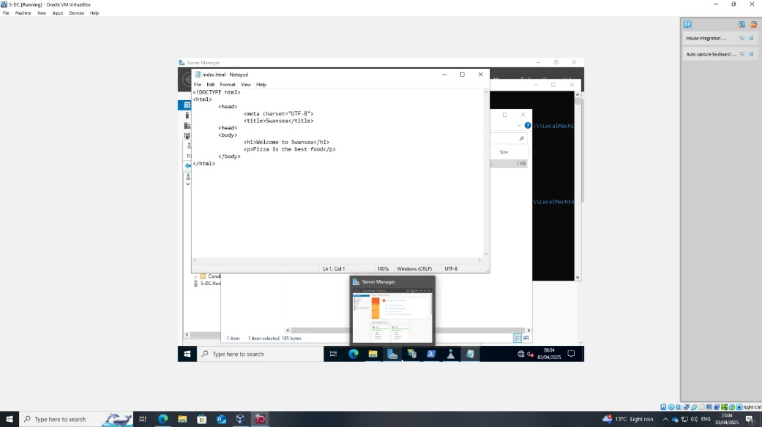
Figure 48 - Website Content
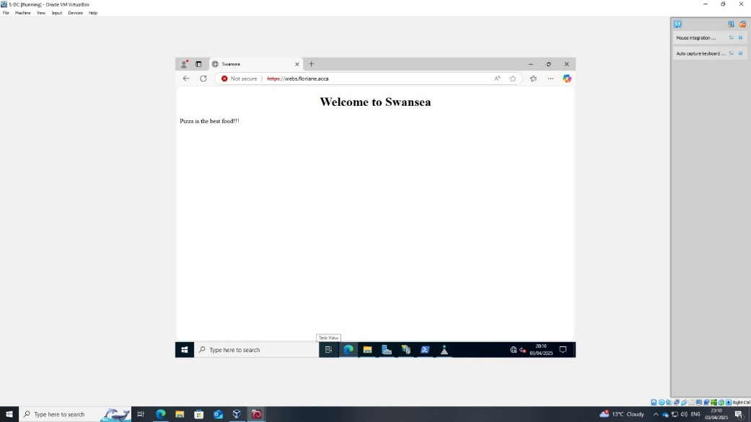
Figure 49 – Website from S-DC
The screenshot below shows the website being accessed remotely from the Windows client.
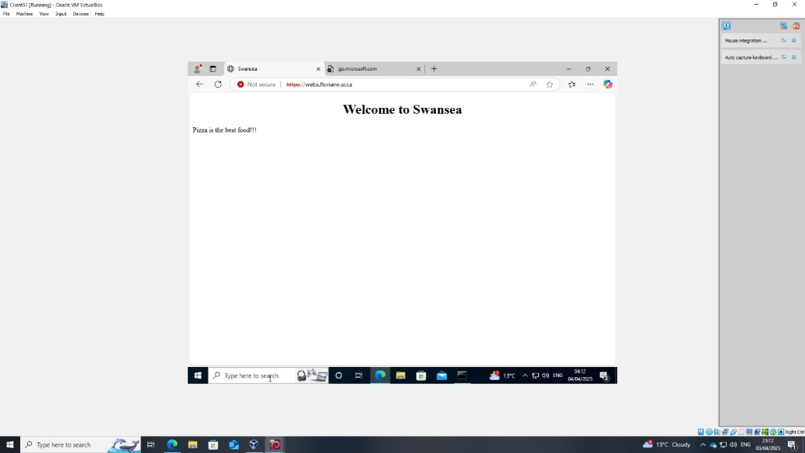
Figure 50 - Website from Windows client

Remote Desktop Services and User Access Setup
This is the installation progress of Remote Desktop Services roles on the Windows Server.
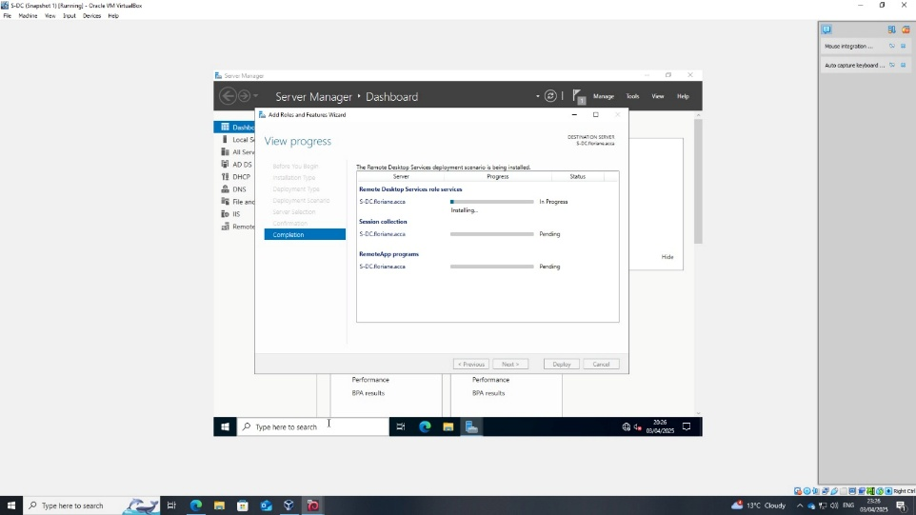
Figure 51 - Installing Remote Desktop Services
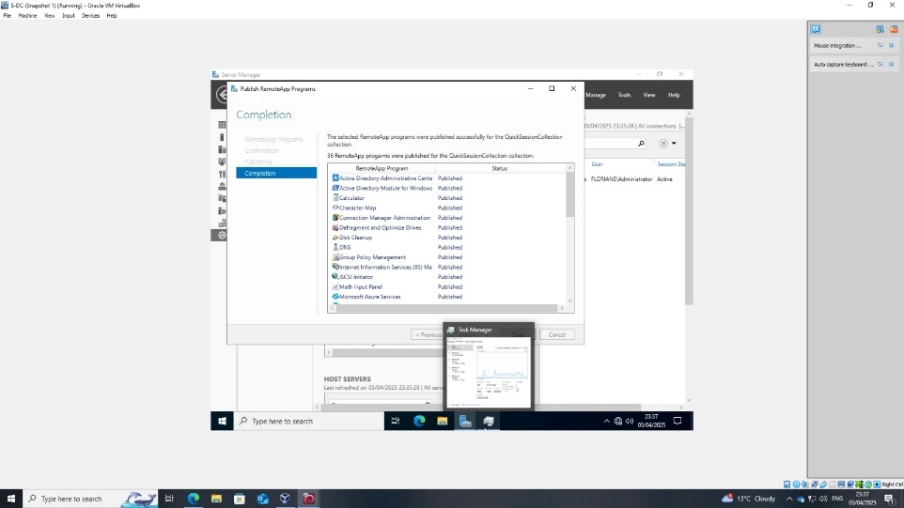
Figure 52 - Publishing RemoteApp Programs
Windows Authentication is enabled, ensuring that users must authenticate with their domain credentials to access the website, increasing security by preventing anonymous access.
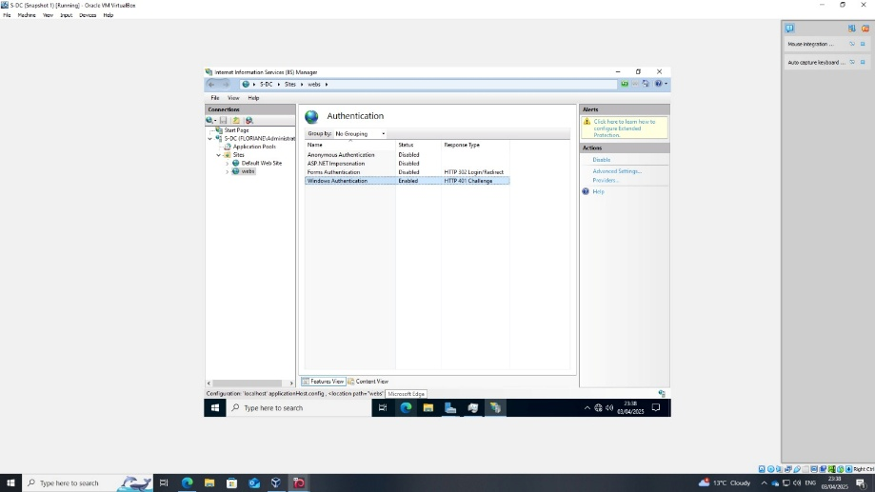
Figure 53 - Enabling Windows Authentication for the Website
This screenshot shows a PowerShell command adding a registry key to disable the loopback check. This fix allows the server to successfully authenticate itself when accessing its own services locally.
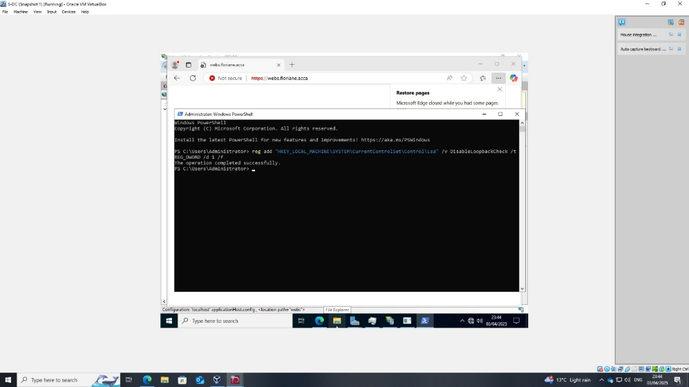
Figure 54 - Resolving Windows Authentication Issue for SDC
Here, when accessing the secured website https://webs.floriane.acca, a Windows Security prompt appears, asking for domain credentials (Administrator, domain: FLORIANE), confirming that Windows Authentication is properly enforced on the server.
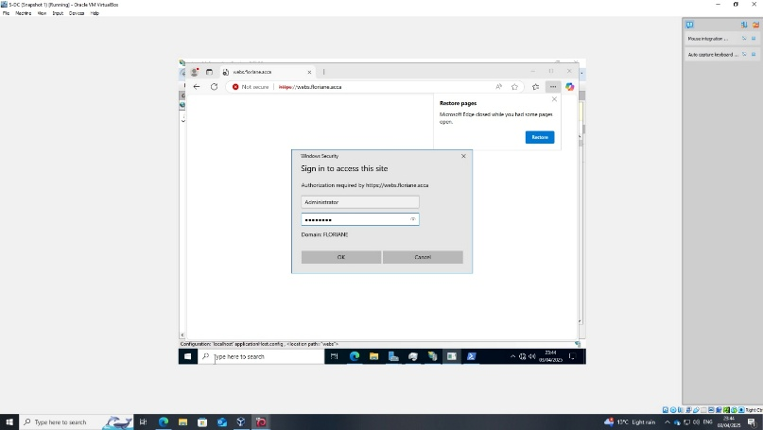
Figure 55 - Website Authentication
This is the IIS configuration where an HTTP Redirect is set to send users from the default site to the RD Web Access portal (/RDWeb).
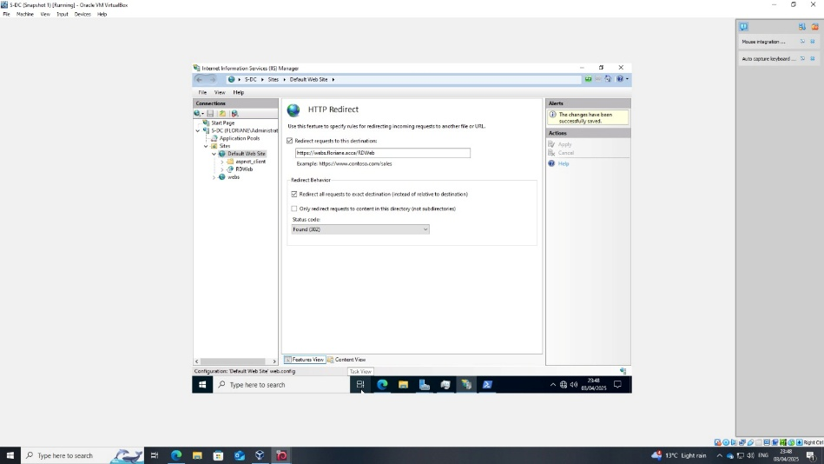
Figure 56 - Configuring HTTP Redirect for RDS Web Access

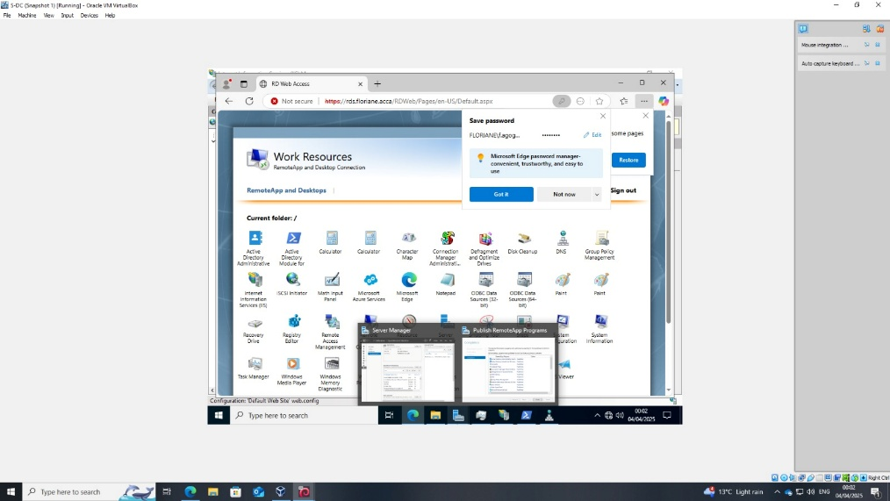
Figure 57 - RD Web Access Portal Display
This allows users from both domains to log into the Remote Desktop environment.
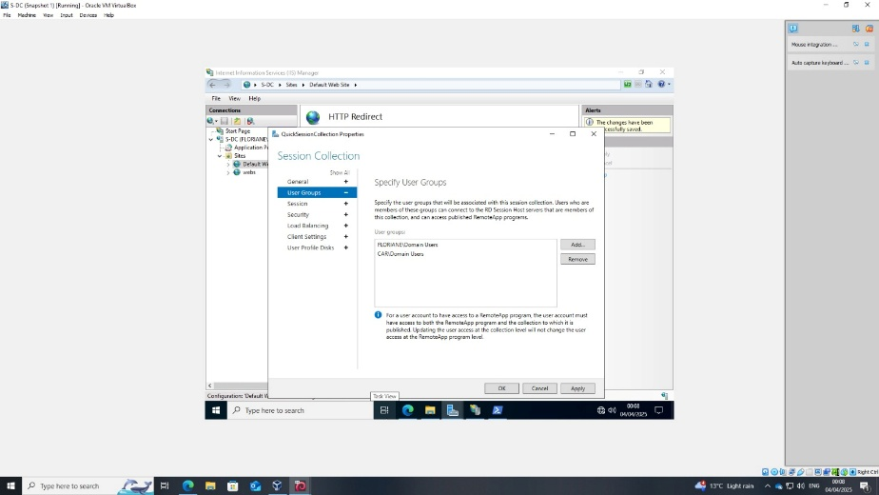
Figure 58 - Authorizing Cardiff Domain Users for RDS
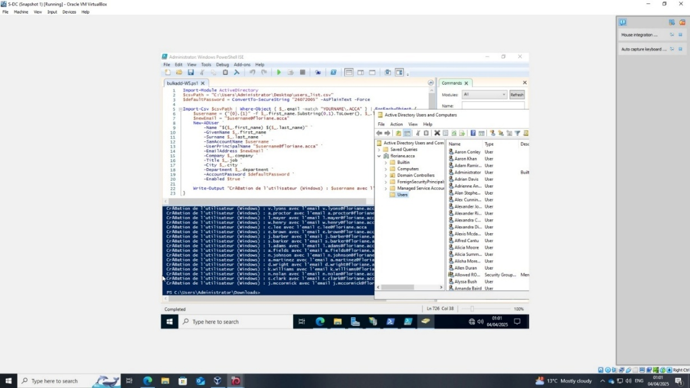
Figure 59 - Success Adding Windows AD Users
This Linux terminal screenshot shows a Bash script (buildad50.sh) written to create Samba users on a Debian server using a CSV file as input. It parses the file and automatically creates users with details like username, email, and department.
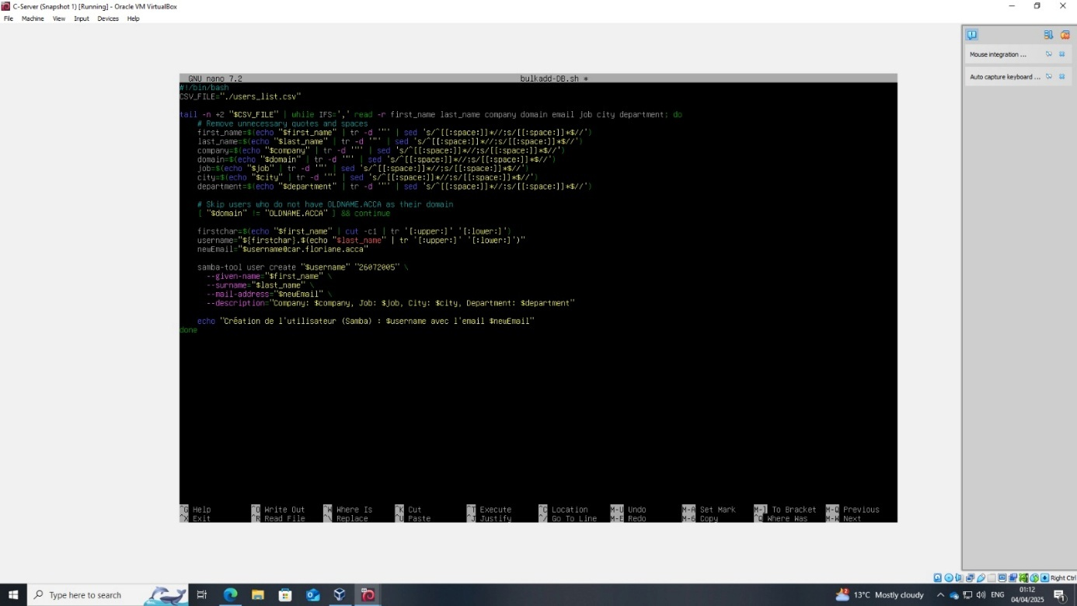
Figure 60 - Automating User Creation on Debian Server
This confirms that the Samba users have been successfully created on the Debian server, including the user’s email addresses. This shows that the Linux-side automation of accounts is working properly.
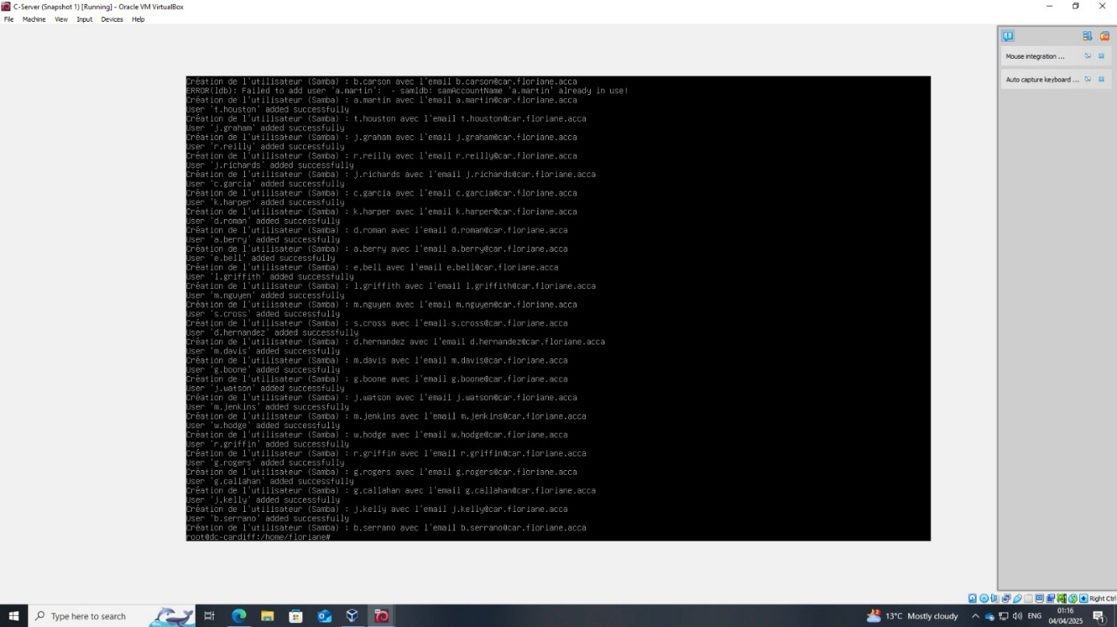
Figure 61 - Confirmation of User Creation on Debian

