Chloe Dacosta (P150098)
Surface Pattern Design
Word Count: 5361
Dissertation Supervisor: Julia Lockheart
Module Code: M6X01791
How are contemporary technologies being used to further traditional textile practices in the 21st century?

Contents

Introduction………………………………………………………………………………………………………………….2-4

Chapter One
What is textiles?
Traditional textile practice
Women’s work in textiles………………………………………………………………………………………………5-12

Chapter two
Textiles in the digital age……………………………………………………………………………………..13-16

Conclusion……………………………………………………………………………………………………………………..17

Bibliography……………………………………………………………………………………………………18-19

List of illustrations………………………………………………………………………………………………..19

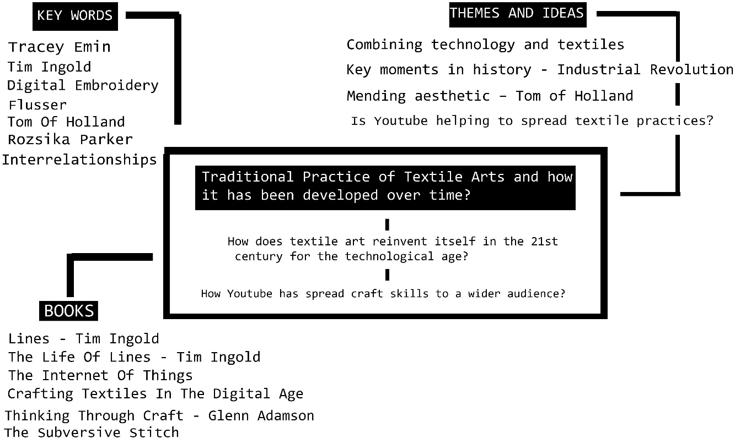

How are contemporary technologies being used to further traditional textile practices in the 21st century?

To provide a knowledgeable understanding of how textiles art has developed over time, this dissertation aims to examine how artists have questioned this change as well as evolving with it. In order to establish an informed understanding, this writing will consider how artists have been shaped by the technological world and how this has altered and influenced the way in which they approach their work. An area of great importance is the work of artists who do not appear to have become accustomed to technological change and that continue to conserve the values of the past in the way that they approach their work.

This writing will commence with an insight into the textile art movement and the arrival of technology and how it reinvented the way in which design began transforming. The theories and beliefs of Tim Ingold will be examined to create context, drawing on Ingold’s statements about interconnected lines and the interrelationship that they have to everything.

In Women’s Work: The First 20,000 Years 1995, Barber asks what is the history and relationship between women and textiles. Chapter one looks at the histories of craft to consider, along with defining, exactly why there is this distinguished link between the two. Alongside that of Parker (2012), who throughout her book The Subversive Stitch encourages you to embark on an in-depth journey, bringing the history of embroidery and social history of women all together; Chapter one will draw on ideas that ensure the subversive potential of cloth continues to be crucial to thinking and making.

In order to establish an informed understanding of where textiles are heading, main research findings will be outlined and presented on where it first started, before a critical discussion on where it could possibly be heading. As a textile’s student, it is important for me to understand the true meaning and context behind certain textiles processes in order to further my position as a surface pattern designer.

Traditionally, textile designers and makers worked in an intricate and highly complex environment where processes, materials and technology interrelate and interchange on various levels. And so, many textile designers in this digital era find themselves at a confusing crossroad, to abandon their craft skills fundamental to their practice, or to embrace the use of digital processes in their work. With this, there is great importance in addressing the ideas around textile designers and how they utilize and apply knowledge of craft in their work, especially regarding the enthusiastic and fast increase in digital technologies. For example, the development in digital technology commands textile artists to embrace and adopt new ways of communicating through visuals to convey something of importance.

However, it is possible for these technologies to limit and constrict the creativity, whilst disregarding the connection between the designers and the hand. By embracing the digital tools and neglecting traditional practice, the design process can become faster and somewhat easier, but may lack personality and individuality of a designer. Unwillingly, this could lead to designs without depth and originality, prompting more uniform and expected characteristics. It is crucial for textile designers to contemplate adopting an approach which accommodates and manages technology with caution. According to Nimkulrat (2016), this is known as “designing through making”. This process enables the individual to be creative and still maintain individuality in the product, this will be further discussed throughout Chapters 1 & 2.

It is evident that design relies not entirely on techniques and methods, but additionally, on necessary ways that are fundamental to conceptualizing and improving the textiles design area. New advances towards textile design are continually being predicted, as a result not only are the “how’s” and “what’s” of design being questioned, but also “why”. In The Handbook of Textile Culture (2015) Jefferies argues that design is even more significant to human life in the twenty-first century than at any other period. And so, traditional interpretations of designs through methods and disciplines are quickly vanishing and challenging the complexities of our lives, design essentially should be transdisciplinary. This meaning that design must acknowledge and accommodate that of technology, leading to reinvented and the reinvigoration of traditional textile crafts. Perhaps the focus being on the collaboration in the design of textiles, however all areas of the design practice should respond and accept this development. Change and development defines the modern world that textile makers and designers have adapted, and therefore, overtime objects and processes around us have flourished in response to the adaptation of new technologies. Therefore, with a broad knowledge and understanding, textile designers are greatly adaptable, demonstrated in their design approaches.

CHAPTER ONE:
WHAT ARE TEXTILES?
WHAT IS TRADITIONAL TEXTILE PRACTICE?
WOMENS WORK IN TEXTILES

Cambridge Dictionary defines textiles as a cloth made by hand or machine, essentially it refers to materials produced from fibres, threads and filaments which are made naturally or have been somewhat manufactured. Textiles are very broad, referring to any material that can be turned into fabric buy means of construction such as knitting, weaving and felting. In the same way that textiles play an important role in our everyday life, it is important to understand where it all started. Needlework, alongside other handicrafts, is a crucial part of human practices and more specifically, the female practice. With minor exceptions, needlework is predominately women’s work. Using textiles is an essential role in women’s culture, but often disregarded, needlework offers means of documenting history.

Homo-Faber otherwise known as man who makes is a term which means that we belong to anthropoids who manufacture rather than homo-sapiens – man who knows (Flusser, 2015). But what about women?

Flusser suggests that if we wish to comprehend the past and present, or to predict the future, we must ask in depth questions on how things are and were created. Perhaps the craft most related to making is Textiles, an ancient craft dating back almost to the beginning of mankind. In Old Mistresses: Women, Art and Ideology 2013, Pollock examined why painting by women happens to be so singled out from paintings created by men, and so why women’s art in all its divergence and diversity has been characterized as homogenous. In fact, when women paint, the work is considered as homogenously feminine, despite that it is recognized and acknowledged to be art. However, when women embroider, essentially decorating cloth by sewing patterns on to with thread, it is not at all seen as art, but in fact seen as an expression of femininity, fundamentally it is classified as craft. And so, throughout this chapter it will become apparent as to why females in the textile industry weren’t acknowledged and recognised for their hard work.

In Art in Needlework 2016, Day states that “Embroidery is enrichment by means of the needle. To embroider is to work on something: a groundwork is presupposed”. In short, essentially embroidery is the decoration of material woven in thread by means of thread. This is clearly shown in (fig.1 below), displaying Emin’s pre-purchased tent which she added her applique and embroidery to. Embroidery has become undeniably associated with the stereotypes of femininity, in The Second Sex 2014, Beauvoir stated, “It is evident that woman’s “character”- her convictions, her values, her wisdom, her morality, her tastes, her behaviour – are to be explained by her situation”. In making this comment, Beauvoir is suggesting that femininity, the behaviour in which women are expected and envisioned to act, is intrinsically formed by society.

Whilst it is true that most women embroider, however, only once a woman shifts on the social scale is her “work” considered and recognised as work. In The Subversive Stitch 2012, Parker compares the eighteenth century ideology of embroidery, against that of the nineteenth century; and in sequence this reveals the appalling outlook of attitudes towards embroidery and social climate. With regards to the eighteenth century, it declared embroidery to be a natural expression of femininity, whilst allowing women to achieve some contentment in doing so, it was a source of creative pleasure. Whereas, in the nineteenth century if embroidery wasn’t performed as a selfless moral duty, it was regarded as redolent of aristocratic decadence.

Parker (2012) indicates that the art/craft hierarchy is leading to believe that art made with threads and art made with paint are inherently different and unequal. In fact, the only real dissimilarities between the two are essentially where they are made and who makes them. Embroidery first was predominantly made in domestic surroundings, commonly by women for adoration and love. However, with regards to paintings, they were produced primarily by men, in a public environment generally for money. It is clear to see there are great differences between embroidery and painting, different surroundings for production and most certainly different receptions and views. At this point rather than acknowledging that painting and needle work is distant but of equal rights, embroidery and crafts were considered with less artistic significance.

For the most part, the classification of embroidery is a troublesome task. Consequently, to describe embroidery as “art” is insufficiently differentiating between that and painting. Failing to comply with the imperative regulations associated with craft, embroidery alternatively cannot be defined as “craft”, as it is seemingly pictorial. Certainly, women have referred to embroidery as “work”, although an appropriate term, it tends to ratify the stereotypical perception that patience and perseverance go into embroidery, but effectively not much else. Parker (2012) states “I have decided to call embroidery art because it is undoubtedly, a cultural practice involving iconography, style and a social function”. However, what is most important is the link made by Parker in The Subversive Stitch, indicating the relationship between the feminine ideal and embroidery, dating back from the Middle Ages to the present. Above all, Parkers thesis is based on the notion that embroidery has become identified and associated with stereotypes regarding femininity, but more importantly to understand the history of embroidery is to understand the history of women.

Nineteenth-century writers praised embroidery, declaring it to be an art form which was unappreciated. Many helped raise the status of women by pressing that its true value needed to be recognized and remembered. Contemporary technologies have always had a direct impact on textile practices. According to Wilson (2001) the history of textiles is intrinsically linked to the development of the machine age otherwise known as the Industrial Revolution. She identifies that in 1782 the steam engine was invented and that commenced the start of the Industrial Revolution. Prior to this invention, the production of textiles had been domestic only, where textiles were being knitted, spun and woven within the home (Wilson, 2001, p.10). However, by the nineteenth century there was a wide range of new inventions that took textiles into mass production. Consequently, with that, the increased development of man-made fibres and technological advances have led and remain leading to additional modern applications and processes. However, it is interesting to note that regardless of the technologies, the actual processes of textile manufacture remain very much the same.

When it comes to the history of women and textiles, it is more about the message embedded within the textiles than the mending or sewing itself. In fact, before females could speak freely and publicly, they used the stitches themselves to convey a message of protest. In the 1970s embroidery and knitting were paramount to second wave feminism and the take down of traditional male centred art institutions. In this era there was an abundance of radical changes with the way in which art was being addressed. In fact, women were interested in how they could use their history of creative knowledge to create art using materials that had been somewhat pushed away from male dominated schools.

Originating in Australia, the movement entitled “Women’s Domestic Needlework” was an organization where women could come together and exchange education and knowledge of needlework (Sufret, 2016). It was predominantly about reclaiming women’s knowledge of needlework and making sure it was acknowledged as a rightful art practice, which similarly draws on the same views as Parker in The Subversive Stitch 2012. Throughout this period, women would document and record different materials and stitches communicated through regular meetings. Groups like these helped women and families to communicate whilst making a connection to the heritage of female labour. Environments like these also helped spread the importance of communication and love behind the textiles. Whilst women stitched to connect, their children, who would usually be in surrounding areas would essentially pick up on these skills just by being in their presence. Then theoretically, they would take on this practice throughout their lives, waiting to pass it on to the next generation of females. The most pleasing aspect of women engaging with textiles is the acknowledgement it brings to us, looking back through history and realising this is where we come from.

Indeed, while nineteen-seventy’s feminists declared a new power for female sexuality, Parker (2012) states, “We wanted women to be free to express a broad spectrum of affects and ways of being without fear of being shamed”. This was a notion taken up by Tracey Emin in Everyone I Have Ever Slept with 1963 – 1995 (see Fig. 1 below). Often seen as taboo breaking, Emin publicized and broadcasted her experiences by exhibiting her embroidery and the response was not so easily received. Emin’s work was not seen as evidence of diversity for women’s work but rather as feminine and ballsy. In fact, this explains why feminists of this time wanted female artists to receive the recognition that they abundantly deserved. Certainly, the work of this era was compelling and crucial; providing ways that simultaneously subverted and paid homage to women of previous generations. With few artists painting, printing and knitting dialogue on to their work, many chose to sew, a time consuming, complex approach. However, lacking impulsive scribbles and pen marks, this technique of applique and embroidery is rigorous and precise, with little room for mistake.
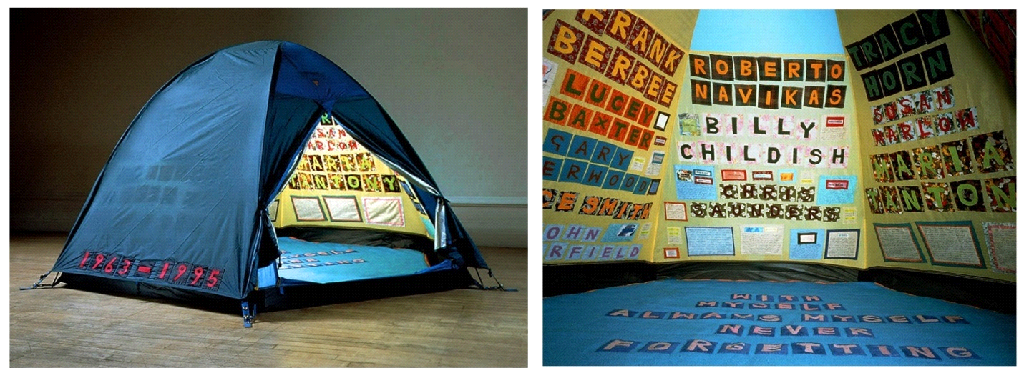
Fig. 1. Everyone I Have Ever Slept With 1963 – 1995.
Emin’s stitch work often appears to depict a terribly clear and concise linguistic approach, which may leave her audience with no further questions. In addition to this, her work articulates specifics about herself that not many artists would want to share with the world, but rather keep to themselves. This can be seen clearly in Everyone I Have Ever Slept with 1963 – 1995 (fig. 1 above). This installation piece evokes certain ideas that don’t necessarily need to be conveyed in a sexual way, in fact it is much less literal by referring to everyone she had ever shared a bed with. It is less about sexual intimacy, but further about human intimacy. Furthermore, the audience experience which required viewers to enter the tent via the small opening was an intimate affair and placed a special sort of emphasis on the emotional and sentimental involvement achieved from sleeping next to someone. The entire experience of viewing this piece of work by crawling into the interior suggests that the audience are being somewhat invited to experience a private and voyeuristic encounter. Due to embroidery being a slow and considered process, each name on the interior walls of the tent reflects on the labour in which was involved to create it, not only in the making of the work, but in the making of the relationships with whom was noted inside of the tent walls.


Fig. 2. Everyone I Have Ever Slept With (detail) 1963 – 1995.

With regards to Emin’s work, it is rather autobiographical, she uses herself and her experiences as a subject which underpins the notion and beliefs that Parker implied in The Subversive Stitch 2012. In order to fully interpret the meaning of the work, is to look deeper and make connections, for example; the fabrics used are reminiscent of the past and to that of her grandmothers who she mentions as being one of the names embedded within the tent’s interior. The appliqued letters (see example in Fig. 2 above) are signifying that of traditional patchwork quilts, suggesting a feminine homage to the past. Even though Emin rejects any assumptions of her work being a benefit for feminists, her boldness and ability to be vulnerable and truthful has contributed to any discrepancies between the way men and women are able to critically engage with subjects such as addiction, gender roles and sexual relations. The knowledge that cloth and stitch can communicate a story is not a new concept.

In Embroidering Lives: Women’s Work and Skill 1999, Wilkinson-Weber states “Women make the finest, as well as the crudest work”. This similarly reflects and draws on elements of Emin’s work which explores raw, indecent and somewhat offensive components. In addition to the manufacturing of work, Emin does not personally stitch some of the larger works herself, instead she employs anonymous craftsman to carry out these tasks (Moran, 2014, p. 38). Whilst these systems are indeed in place for painters and artists within the fine art world, this may sit a little uneasy within the world of craft and textiles.
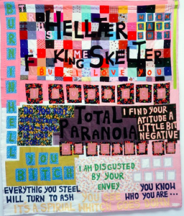
Fig.3. Helter Skelter 2001

In Emin’s larger quilt works you can note the reversal of letters, alongside misspelt words (see fig. 3 above), these appear to be on purpose and predetermined for a defining reason. Somewhat more noticeable because rendered on to cloth, the fabric itself is infused with history and the mistakes are read with a substantial intent. As a result of Emin’s rawness and ability to disclose her emotional journey through textile processes successfully, she has great appeal to an audience. In fact, her work is suggestive of outbursts, the misspelled dialogues and deliberate arrangement of fabrics leave a long-lasting impression.

With the significance of featuring writing as a notable part of her work, whether it be in embroidery, drawings or installations, Emin softens the boundaries between visual art and literature, this hybrid invites her audience to consider thinking outside the lines of art and to create ideas of interpretation that include all elements of her work. Emin maintains possession of her own stories, the way she represents and reworks them upholds her identity as an artist. Emin’s work has clear intent when regarding the placement and misspelling of words, or does it? Somewhat seen as a constant mind game when viewing the pieces, Emin’s explosive nature when creating art work considers the idea that these words or phrases are indeed spelt wrong by mistake. On the other hand, maybe these works are purposely misspelt to give a desired purpose or intention. Either way, it is a continuous debate.

Parker (2012) calls upon the complexities that embroidery embodies, it serves us with the potential to repair; materials being brought back to life. Such as the process of embroidery is to enhance and visually elevate the required cloth, it is also used as a discipline in textiles known as mending aesthetic; to see the beauty in the broken, to repair and wear. The "Visual Mending Programme" established by Tom Van Deijnen also known as Tom of Holland, is a concept that seeks to highlight the art of craftsmanship, especially regarding the ever so rapid fashion throwaway culture (Holland, n.d.). The purpose of this scheme is that by exploring the start and end story behind the garment, as well as the repair process; it reinforces the connection between the person who ends up wearing that garment and in time hopefully leading to a longer life of being warn. As Holland comments:

It is now possible to buy very cheap clothes, which get thrown out when there’s a small hole or button missing. This is something I highlight with the Visible Mending Programme. I’d like to go back to an older mind-set, where clothes were expensive, and you looked after and repaired them until they were completely threadbare (The New Craftsmen, n.d.).

Typically, when garments need repair, the process relies on the stitches being concealed and covered, but the aim of Holland's programme is for the stitches and repairs to be an artistic badge of honour; to enhance, turning the new and perfect to the old and imperfect. In fact, Holland's unhurried practice concentrates on the importance of handmade, focusing on the constant conversation between the creation and mending of textiles (https://tomofholland.com/, n.d.). Similarly, the link between Emin’s work and Holland’s is the constant conversation within the art and the overall audience experience. When comparing the two, you can see clear similarities but also distinct differences. Both styles of work embody the notion of meaning and the idea around concealing certain personal elements, but openly displaying and showing off others. However, Emin’s work, unlike Holland’s has use of dialogue. Emin’s approach is a lot less thought out because of the style of the work, for example her misspelt words, or so this is how she embodied the words to be perceived is not considered to be a slow thought out process. Whereas Holland’s slow and considered mending of the textiles are part of the “slow movement” which links further on in Chapter Two.

In addition to this programme, Holland's aim is to create an extensive awareness of sustainability, environmental concerns and social issues throughout his work. Although this particular programme was established by Holland, this idea of embracing the perfectly imperfect has been around for quite some time with many others using this exact mind-set. In Visible Mending: Artful Stitchery to Repair and Refresh Your Favourite Things 2018, Cardon stresses the importance of knowledge alongside technique. This book offers step by step guidance and techniques on hand embroidery, patching, darning and mending by machine. Cardon (2018) states "My goal is to provide a technique book for people who have never sewn before and an inspiration book for people who have been sewing all their lives". The concept behind this style of book is as considerate as is the mending itself.

Indeed, in addition to this, Celia Pym an artist who works heavily with darning and textiles, possesses the same approach and outlook with her work; it is less about mending the garment but the process. The holes within the clothes and people’s personal attachments to them are explored as stories, and so, the mends become part of a somewhat history for the garment and similarly, the person who wears it. In Slow Stitch: Mindful and Contemplative Textile Art 2015, it can be shown that Pym’s approach is based on meaning and how meaning implied with restoring the garment can form a relationship with one another. For instance, if the garment needing restoration had been property of a loved one who has passed away, repairing it would allow the connection and relationship to last longer. And so, essentially, the act of mending is a form of remembrance and appreciation.
Textiles and these artistic processes mentioned are less about the creation and intrinsically about the unpicking and understanding of the journey. Looking at old textiles is like reading them as a narrative, illustrating the journey they’ve been on. A beautifully made textiles piece has no value if there is no meaning, value or story behind it. Consequently, mending is about others, looking after and taking care; whether it be a textiles piece or a physical being.

CHAPTER TWO:
TEXTILES IN THE DIGITAL AGE

With underlying connections to ideas of sustainability, reflection, and appreciation this process of mending is a very important approach that can be described as “slow” (Wellesley-Smith, 2015, p. 16). For example, in this case the idea around a Slow Movement has been enforced on many things, but it fully investigates the idea of slowing down the pace of life itself. She states “It is a philosophy that embraces local distinctions and season rhythms, and one that encourages thinking time” (Wellesley-Smith, 2015, p. 2). This slow approach is seen as a form of celebration of process, work that embodies reflection at its core and will therefore form a deeper emotional connection and commitment to it. This clearly links and reflects the same principles that Holland represents in his “visual mending programme”. This concept is central to Pym’s artistic practice as well; by investing time in repairing something it gives an emotional response and attachment to it, and it becomes personal in a completely new way. Based on the ideas of Wellesley-Smith, it appears the thread that pulls these ideas of framework together is the rooted notion of process, the slower the process the more valuable. Without a doubt, by practising this approach the creative process can offer meaningful engagement with materials and give greater knowledge on social context of textile making and production. However, as important as the understanding of how things are made, where and why play a big part in this understanding. Gauntlett quotes:

“Making is connecting”. It’s a perfectly simple phrase, of course. But having spent some time thinking about people making things, and people connecting with others – making and connecting – I realised that it was meaningful, and more pleasing, to note that these are one and the same process: making is connecting (Gauntlett, 2013, p. 1).

There are three main principles that help back this statement; making is connecting because you have to physically and mentally connect materials and ideas together in order to create something new; making is connecting because steps of creativity have an engagement with social involvement and therefore connect us with people; and finally making is connecting because through making and subsequently sharing it with the world, increases the engagement between social and physical settings (Wellesley-Smith, 2015, p. 20). In Making is Connecting 2013, Gauntlett’s theory is suggestive of a world where people, specifically young people have a portal to express via the internet and the use of new technologies. By making this point, he is highlighting the connection between new technology and young people by means of social networking and YouTube. Throughout the book a strong point is being made, emphasising how powerful the World Wide Web is. In Making is Connecting 2013, Gauntlett states “I’ve always liked making things, but they didn’t have an audience”. Nonetheless, what is most important is that throughout the book Gauntlett seeks to comprehend how creativity that puzzles the industry, undeniably helps aid the social links and therefore generating wider knowledge and understanding. Globally it is becoming easier to access ways of learning without the use of books, the internet, specifically You Tube is undeniably great for step by step teaching of textile practices. Combing both textiles practices and technology is a great thing, why does one have to outweigh the other?

In Making (2013), Ingold states that technology is much more than use of objects, it negotiates with the knowledge of how, when and where these objects can be used, and the expertise involved to use them sufficiently. With use of specific tools traditionally being determined from one generation through to the next, Ingold highlights the importance of consciousness. In the same way that human beings adapt to their environment, they retain and release certain aspects as well. In Lines (2007) Ingold’s key idea discussed is that everything we do, whether it be walking, weaving, drawing or writing all proceed along lines; throughout the book Ingold differentiates between the types of lines and how they relate to one another. If we look beyond textiles as physical process, it becomes apparent how thinking and doing all proceed along lines also. Bourgeois (2015), equally draws on interweaving and personal narrative throughout her work. The idea of “lines” is central to her artistic practice, but Bourgeois uses a spider and its web to reference the idea of relationship and interweaving.

Artist Louise Bourgeois was widely considered as one of the most significant artists in the 20th and 21st century due to her creative, meaningful body of work. Her recognisable sculptures are representations of her mother and how these certain elements of material and thread bind mother and child together. In Spider (Cell) (fig.3 below) shows an example of a reoccurring motif throughout Bourgeois’ body of work which depicts that of her mother. For Bourgeois, spiders embodied a complicated and often contradictory mix of being both fierce and fragile, with the capability of being both protectors and predators.
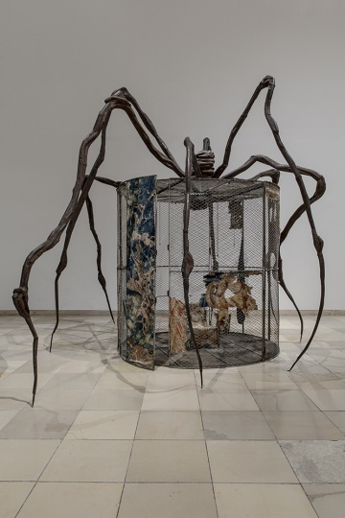
Fig.4. Spider (Cell) 1997

Bourgeois created many variations of spiders, but this one was unique. This installation entitled Spider (Cell) 1997 (Fig.4 above) was the first time where the web of the spider is identified as an enclosure. Similar to Emin’s Everyone I Have Ever Slept With 1963, this piece prompted viewers to enter and experience the work from the inside. The cage was large enough for viewers to sit within the walls, underneath the spider’s protection. The walls of the cage were draped in tapestries, paying homage to her mother who was a tapestry restorer. There is a clear correlation between Bourgeois and Emin with the way in which they approach their work. With use of certain elements depicting different meanings throughout their body of work, the underlying concept of Ingold’s interweaving is very prominent. There are clear connections as to where their work was inspired and started from.

Thus far, the importance of embroidery in textiles has been discussed but the significance and direction that it is heading has not. Engineering textiles today is demolishing preconceived decade old notions of intensive labour and strenuous factory industry work in which men and women toiled over machinery (Nimkulrat, 2016, p. p32). Instead, the direction of production has been replaced by computer directed programmes which can be much more precise and efficient. Advances in technologies now allows you to produce embroidery and other traditional textile practices, but digitally. As a result, machines have become highly sophisticated and accurate, enabling for quicker results.

In Crafting Textiles in the Digital Age 2016, Walton states that our hands will continue to be a fundamental part in the process of textiles and the craftsmanship will not be forgotten about, despite the technological developments. Within the last thirty years the way of translating embroidery in to something that was once a beautifully slow process, is now the opposite. Additionally, in Abstracting Craft: The Practiced Digital Hand 1998, McCullough states that “Hands show life most when at work. They don’t just hold: they grasp, they pinch, they press, they guide”. Technically he is correct, the hand works quicker and more precisely than the eye. Hands are designed to work, they are versatile and work not only in a physical way, but also experimental. The method and approach of hands is personal, contextual and indescribable.

As a surface pattern design student it is important for me to use my knowledge of traditional practices but to learn how to incorporate these appropriately within the technological world in which we live.

Conclusion

Due to advances in textiles and machinery, the meaning of why textiles are being used is becoming less and less sentimental. Essentially, machines are doing everything for us, but the idea behind mending and other textile-based processes is that it is done with others in mind; a much more personal and thoughtful practice. With all this evidence the experience of creating textiles is more important than the creation of the thing itself, understanding of disciplines and ideas play a massive component in the creation. This point however is not entirely new, many books alongside Women’s Work: The First 20,000 Years 1995, already share this information. There are a lot people interested in textiles that come from education where “making” is unappreciated. Barber (1995) made a strong point in this book of expressing the importance of hand crafts and how they need to be fully appreciated, however this is not something that can be accurately predicted with reference to the future.

Whether you are communicating a narrative or weaving a story, the underlying notion that everything we do is somewhat conducted by lines is the centre of our world. Without even making the conscious decision, it is unquestionable that whatever we do from making that connection. The fact that technology is a fundamental part of the work is undeniable, but the use of stitch however remains firmly at the centre of our lives today. In terms of looking forward, the question should not be what technology can do for us, but what traditional hand practices can do for others.

Bibliography

Barber, E.J.W. (1995) Women’s Work: The First 20,000 Years. New York: Norton.

Beauvoir, S. (2014) The Second Sex. London: Random House.

Cardon, J. (2018) Visible Mending: Artful Stitchery to Repair and Refresh Your Favorite Things. Martingale.

Day, L. (2016) Art in Needlework: A Book about Embroidery. Sai EPublications.

Deepwell, K. (1995) New Feminist Art Criticism: Critical Strategies. New York: University of Manchester Press.

Deijnen, T. (2018) Tom of Holland. Available at: https://tomofholland.com/ (Accessed: 13th November).

Gauntlett, D. (2013) Making is Connecting: The Social meaning of creativity, from DIY and knitting to YouTube and Web 2.0. Cambridge: Polity Press.

Ingold, T. (2007) Lines: A Brief History. Abingdon: Routledge Classics.

Ingold, T. (2013) Making: Anthropology, Archaeology, Art and Architecture. Abingdon: Routledge Classics.

Jefferies, J. (2015) The Handbook of Textile Culture. Bloomsbury Publishing.

Johnston, F (2018) Meet Celia Pym – Knitwear’s Own ‘Damage Detective”. Available at: https://www.ft.com/content/2223502c-130a-11e8-940e-08320fc2a277 (Accessed: 17th November 2018).

Leslie, C. (2007) Needlework Through History: An Encyclopedia. Connecticut: Greenwood Publishing.
McCullough, M. (1998) Abstracting Craft: The Practiced Digital Hand. Massachusetts: MIT Press.

Nimkulrat, N. and Walton, K. (2016) Crafting Textiles in the Digital Age. New York: Bloomsbury Publishing.

Parker, R. (2012) The Subversive Stitch: Embroidery and the Making of the Feminine. London: I.B Tauris.

Pollock, G. and Parker R. (2013) Old Mistresses: Art and Ideology. London: I.B Tauris.

Sufret, W. (2016) ‘A Brief History Of Women Changing The World With Textiles’, I-D, 14th November. Available at: https://i-d.vice.com/en_au/article/papevm/a-brief-history-of-women-changing-the-world-with-textiles (Accessed 12th November 2018).

Wellesley-Smith, C. (2015) Slow Stitch: Mindful and Contemplative Textile Art. Batsford Publishing.

Wilson, J. (2017) FRAY: Art and Textile Politics. University of Chicago press.

List of illustrations

FIG 1 Emin, T. (1963) Everyone I Have Ever Slept with [Installation] Available at: http://ceblog.sva.edu/traceyemin/ (Accessed: 16th November 2018).

FIG 2 Emin, T. (1963) Everyone I Have Ever Slept With [installation] Available at: https://www.saatchigallery.com/artists/artpages/tracey_emin_4.htm (Accessed: 25th November 2018).

FIG 3 Emin, T. (2001) Helter Skelter [Quilt] Available at: https://www.jessicahemmings.com/tracey-emin-stitching-extreme/ (Accessed: 29th November 2018).

FIG 4 Bourgeois, L. (1997) Spider [Installation] Available at: https://www.moma.org/audio/playlist/42/684 (Accessed: 23rd November 2018).

