‘Circus Eruption’ – Project Report

Paul M Lawrence (P152216) Undergraduate Student, Mcomp Computer Networks
University of Wales Trinity St David, Swansea, Mount Pleasant Campus
plawrence.152216@student.uwtsd.ac.uk

Abstract – This report is a review of the project management processes and procedures implemented within the computer network development project for ‘Circus Eruption’ and the industry standard project management methodologies that were followed. Along with analysis of environmental sustainability, ethical and legal issues within modern technology.

Keywords-component; Project Management, Risk Management, Ethics and Law, Environmental Sustainability, Quality Assurance

Introduction to the Project Report
Following on from the Project Initiation Document (PID) [1] for the development of a low cost, low maintenance, moderately secure network for the charity ‘Circus Eruption’ [2] and also the network prototype presentation that included simulation modelling and practical configuration of the proposed network, a final report has been prepared analysing the project management techniques that were utilised, along with sustainability issues, quality assurance, ethical issues and laws that need to be considered during a projects lifecycle in accordance with the PRojects IN Controlled Environments 2 (PRINCE2) [3] project management methodology.

Monitoring of the project from start to finish included; foreseeing, analysing, planning, and testing the practical and/or social aspects of the project that could inherently delay and/or prevent the completion of the project. The industry standard project management strategies and tools implemented by the ‘Circus Eruption’ project team, to overcome known technology development project issues will be reviewed in detail within this report.

Risk Management
The project team for the ‘Circus Eruption’ network implemented a risk identification and management strategy [4] by identifying and analysing the potential risks to the project that were then modelled within a risk probability matrix [5] shown in figure 1, the matrix was then used to mitigate or minimise the identified risks. The team believed a risk probability matrix would be more accurate and appropriate due to the bespoke nature of the project and the limited available data as opposed to a risk exposure calculation model.

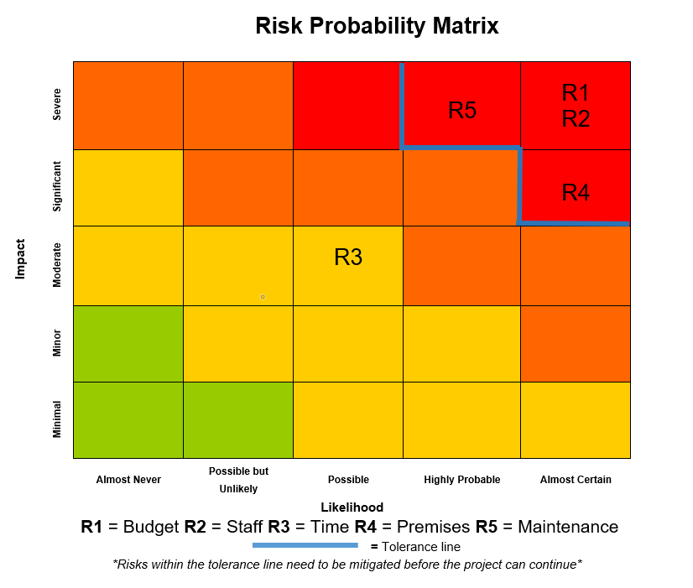
Figure 1:‘Circus Eruption’ Project Risk Probability Matrix (Appendix-A) [6]
The risks the team identified that were above the tolerance line within the matrix were immediately further analysed to find a mitigation solution and/or a solution to minimise certain risks within the project before the project could continue, also possible risks with a moderate impact were briefly analysed:

- Budget: There was no budget for this project because the company was a charity and did not have any available funds. This was an issue because the physical networking equipment would need to be acquired via a business donor or through multiple charitable donations, this was a severe risk within the project because without the hardware the project could not go any further. In order to mitigate and/or reduce this risk the team planned to start fundraising by utilising the existing volunteers at ‘Circus Eruption’ and also soliciting donations from local companies immediately. Charitable donations were fortunately acquired early in the project from a local university located in Swansea ‘UWTSD’.

- Staff: This technical project relied on skilled professionals that would have to volunteer due to the budget constraints, without these volunteers the project would not be able to proceed, this was categorised as a severe, almost certain risk to the project because without skilled staff to design and implement the network the project could not continue. To mitigate this risk, two university students were approached who had the skills required to design and implement this project whom were willing to volunteer their time.

- Time: The project needed to be delivered to the client within an allocated time of 6 months, this would not have been an issue for the project team if they were working on the proposed network full time, but because the project team were volunteers, they had other commitments, this meant they could only work on the project part time which then became a moderate risk to the project not being delivered to the client on time. The risk was categorised as moderate because the client understood that this was a project run by volunteers, so completion of the project was more important than the delivery date. To minimise this risk ‘Gantt’ and ‘Pert’ charts were created (refer to the Project Initiation Document [1] for these charts) to allocate the volunteer networking team time slots to work on the project and complete mile stone tasks in order for the project to be completed and delivered on time.

- Charity premises: This significant, almost certain risk was identified after meeting with the client and learning that the charity is currently in a temporary premise in which they would certainly have to move to a new location momentarily. The new premises would also be temporary. To mitigate this risk the design of the network had to encompass a mobile solution that could be easily transported and then setup at a new location with no additional configuration/installation.

- Maintenance: Maintenance of the network was identified as a severe, highly probable risk because there would not be a full-time network administrator at the charity premises, therefore a complicated network could be prone to configuration issues that would need to be maintained regularly, this type of network would experience downtime without a permanent network administrator. To mitigate this risk the team decided to design a basic network configuration that would meet the client’s needs but also be self-sufficient, that would only need intermittent remote administration from a part time volunteer.

Implementing risk identification and management for industry projects is a vital strategic tool that all professional project managers must implement and monitor to overcome and/or minimise potential issues that may arise that could affect the completion of a project.

Environmental Sustainability
Within modern day project development, it is imperative that the project manager considers the environmental impact that their project may have on the planet and reduce the projects/products carbon footprint to an acceptable level or their company may incur fines by the government of the country in which the project has been implemented and/or be shutdown.

This is more pertinent in recent years with the emergence of the Paris accord agreement of 2016 [7] in which 196 countries from around the world pledged to reduce their carbon footprint with the goal of reducing global temperatures to an acceptable level of 2℃ between the decade of 2020-2030 and then furthermore thereafter shown in figure 2.

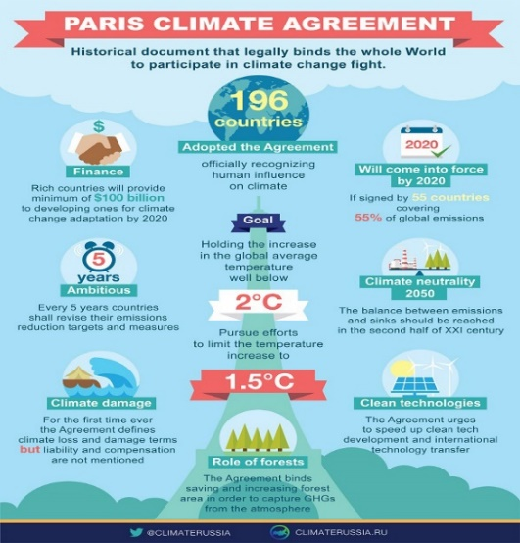
Figure 2: Paris Accord Climate Agreement 2016 Emissions Targets [8]
Therefore, companies around the globe i.e. datacentres, hardware manufacturers etc are having to design innovative sustainability measures into there businesses/products to meet the carbon reduction targets within their countries in accordance with new legislation and International Standards Organization (ISO) 14001 – Environmental Management [9].

The project team at ‘Circus Eruption’ did not have to contend with the environmental issues previously discussed because the project they delivered was a small mobile network consisting of six internetworking devices that consume a small amount of electricity that would only be operational during ‘Circus Eruption’ business hours. The project team thought it would be pertinent to first research, analyse and possibly implement sustainability measures within their product to contribute to global environmental sustainability.

Environmental sustainability can be broken down into three orders; 1st, 2nd and 3rd these orders can both have a positive or negative impact on the environment depending on the industry. They encompass the three pillars of sustainability [10] that include the interaction between social, economic and environmental activities to achieve sustainability shown in figure 3. [11][12]

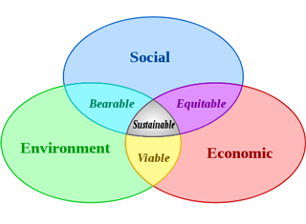
Figure 3: Three Pillars of Sustainability [13]
Within Information Technology (IT) the effects of these orders can be analysed as follows [14] [15]:

First Order: This order is negative because it involves the industrial production of the physical components within IT i.e. the production of steel, the mining of materials, waste materials as a bi-product and the generation of electricity to power the devices. All these activities produce a high volume of carbon into the earth’s atmosphere. [16]

This first order impact on the planet could be significantly reduced by recycling products and using green energy i.e. wind farms, tidal power, solar power to produce electricity.

Second Order: This order in IT is positive because it reduces the need for travelling both socially and for business i.e. shopping, meetings, conferences, working from home etc. Also, automation within IT makes modern technological products more energy efficient i.e. smart buildings, production lines, electric cars etc. These innovations offset the impact of the first order of sustainability within IT. [17]

In the advent of automation and machine learning; power plants, cities and electric cars are becoming a lot more efficient, as the technology develops and becomes more standardised, automation will significantly reduce large cities carbon footprint in the future.

Third Order: The third order of sustainability is a result of social behaviours that transpires from the first and second order of sustainability i.e. people who work remotely via the Internet may travel abroad more on holiday whilst working because they have the flexibility of movement, this by-product of the 1st and 2nd order would have a negative effect on the environment. Also, cities may get heavily populated as people move to get higher paid jobs within the IT industries in which these corporations are located, this would cause higher pollution and overcrowding in these areas thus also having a negative effect on sustainability. [18]

After the project team analysed the orders of sustainability to see if they could implement measures to contribute to global environmental sustainability, they realised that if they allowed remote connections to their network they could have a positive effect on the 2nd order of sustainability by reducing travel for volunteers.

They also advised their client about using energy saving modes within their end devices and installing solar panels to power their facility via a government scheme. This business approach would reduce ‘Circus Eruption’s’ overall running costs and carbon footprint. The project team also utilised the internetworking devices energy saving modes to further reduce carbon emissions and used second hand products which is another contributing factor to carbon reduction targets (recycling) previously discussed. All these subtle changes contribute to the 1st order of sustainability.

Regarding the 3rd order of sustainability the team suggested to the client they implement a ‘Cycle To Work Scheme’ [19] to encourage the youngsters and volunteers at the charity to get fitter whilst contributing to global environmental sustainability.

Ethics and Legal
Ethical and legal issues pertaining to a specific industry must be researched before undertaking a project. Within technological development projects, there are many ethical and legal laws surrounding the storage of personal data, the security of that data and the safe guarding of vulnerable adults and children whom use the product i.e. social media, educational software etc. Also, UK based IT professionals must adhere to the British Computer Society (BCS) ethical code of conduct [20] within the UK or the Institute of Electrical and Electronics Engineers (IEEE) ethical code of conduct [21] within other countries. [22] [23]

A summary of the BCS code of conduct are as follows [20]:

- Public interest: All BCS professionals should hold a high esteem for privacy, security and welfare of others. Must never discriminate in any form and always promote knowledge within IT through equal opportunities. Third party contractor’s rights should always be considered and upheld.

- Professional Competency and Integrity: Professionals should only undertake work that they are competent and qualified to do so, understand legislation pertaining to the country that they work, should always respect peers’ points of view, and continue to gain knowledge throughout there careers.

- Duty to Relevant Authority: Employees/Contractors should carry out their work thoroughly and professionally to the best of there ability, seek to avoid conflict with the related industries authorities. They should accept professional accountability for their work and the work of others conducted under their direction. Protect intellectual property, in addition never use it for personal gain and never mislead or misrepresent information/product that others have a lack of knowledge.

- Duty to the Profession: Never bring the industry that you work into disrepute, always act with integrity inside and outside of your job role to uphold the reputation of the BCS, encourage professional development of others and always report a conviction of a criminal offence or bankruptcy.

As of May 2018, the European Union (EU) will impose a new data protection law called the General Data Protection Regulation (GDPR) [24], this new piece of legislation overhauls the existing data protection acts within the UK and creates a standard model for data protection throughout the EU.

Key points within the GDPR principles are briefly summarised as an example of the new legislation [24] [25]:

- Article 17: ‘Right to be Forgotten’; This principle allows end users to be able to request an Internet technology company who houses their personal information the right for that data to be deleted.

- Article 5: ‘Data Protection Principles’; This principle outlines how data should be lawfully managed by controllers (company’s) and processors (third party data collection companies). The data should be accurate, relevant and adequate for the purpose in which it is being stored. The data should also incorporate the Confidentiality, Integrity and Availability (CIA) model by controllers and processors.

- Article 32: ‘Security of Processing’; This principle outlines that all personal data should be encrypted, highly secure and redundant in the event data is lost.

- Article 22: ‘Profiling’; This principle outlines restrictions that govern automated decisions by companies based on individual personal data for directly targeting end users for marketing purposes

- Article 20: ‘Data Portability’; This principle allows end users the right to request that their personal data can be transferred in human readable form one company to the next i.e. Facebook to Instagram.

Strict fines can be imposed on companies who break the new GDPR law that range from 2-4% of annual company turnover or a maximum of €10-20 million depending on which of these two factors is highest shown in figure 4. [26] [24]

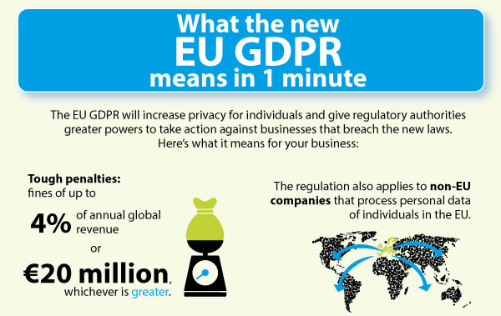
Figure 4: GDPR Business Overview [27]
The project team designing the ‘Circus Eruption’ mobile network needed to consider the personal data that would be stored on the server within the network and the client in which they were designing it for (charity) in relation to the new GDPR legislation and BCS code of conduct so that they could create a data protection policy for the client and an ethical code of conduct for the volunteer administrator .

‘Circus Eruption’ work with children and vulnerable adults therefore the project team were required to make the client aware of the data protection laws they needed to adhere to within the data protection policy whilst storing personal information of this demographic on the network. The project team advised the client to get written consent to store personal data from the guardians of the children/vulnerable adults that attend the charities workshops and to outline what personal information would be stored, for what purpose and for how long. A full copy of the data protection policy was provided to the client along with the new GDPR legislation.

The project team also advised the client not to store personal information on the network until the network could be further secured because the network was only moderately secure and did not encompass a hardware firewall [28] with encryption standards [29] , this security flaw within the proposed network was in contradiction of the GDPR guidelines. [25]

The client advised the project team that additional fundraising would be put in place to purchase a hardware firewall at a later date so that personal information could be stored on the network more securely to safeguard personal data to streamline the charities day-to-day operations.

Quality Assurance
Quality assurance (QA) is a fundamental element within a project, if this component is overlooked within a development project it can have a negative impact not only on the product being produced for clients and/or end user but on a business’s reputation. [30]

Within the development of a new product the project manager should assign an external member from the project within the company as the QA controller who has the equivalent experience of the target audience the product is aimed at, implementing an external QA controller removes any bias from the QA process. [31]

Within the technology industry there are strict QA standards that must be followed during a development projects life cycle, established by the ISO, these standards regarding QA are ISO 9000 [32], 9001[33] and ISO/IEC 90003 (software engineering) [34].

The ‘Circus Eruption’ project team followed these guidelines by installing a QA controller ‘Sue Maw’ to test the prototype network and supervise the benchmarking techniques that were utilised within the network development cycle [31] of the protype network shown in figure 5. The network benchmarking results can be viewed later in this report.

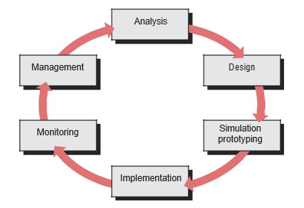
Figure 5: Network Development Lifecycle [31]
The team also made a request to the stakeholders (donors) that they provide Cisco hardware because Cisco are highly regarded as the best network manufacturer in the world who supply the highest quality products [35]. UWTSD obliged and donated the needed Cisco hardware. On first inspection of the hardware it was undamaged and only 2 years old, a QA audit inspection sheet was produced depicting this and further QA tests carried out after this point [36].

The Cisco managed layer-2 switches and router interfaces support 100 MB/s throughput, the Access Point (AP) supports 2.4 GHz of frequency with 65MB of throughput, the cable used was catergorie-5 (CAT5) that also supports 100MB/s of throughput, these metrics are adequate for the network requirements of the client which were estimated to be 50MB/s [37][38] .

The managed switches were also configured to create Virtual Local Area Networks (VLAN) [39] this was important to generate multiple broadcast domains to contend with ethernets [40] inherit vulnerability of a contention-based media that uses Carry Sense Multi Access – Collision Detection (CSMA-CD) of frames [41]. Implementing VLAN’s mitigates this issue and utilises all the bandwidth available to prevents frame loss, latency and provide a high level of Quality of Service (QoS) [42]. Because the client could not obtain layer-3 switches due to budget constraints, a router on a stick design [43] model was implemented for the proposed network shown in figure 6 to securely route packets around the network. The project development team understood that using this design model would create a bottleneck [44] at the router causing latency which could potentially become a quality issue within the product, this key section of the network would be further analysed using metric benchmarking software to measure the overall throughput and delay of network packets at the bottleneck.

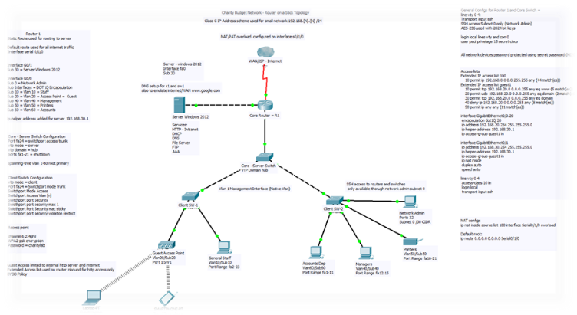
Figure 6: Network Design for ‘Circus Eruption’; Router-on-a-Stick (Appendix-B) [45] [46]
As discussed previously in the report a basic network architecture and configuration was implemented that met the clients needs to reduce the probability of network failure because there is not a permanent network administrator within the premises.

The benchmarking was carried out on the proposed network in laboratory conditions from the Windows 10 end devices, across the wired portion of the network that was routed through the bottleneck to analyse the reduction of throughput and delay within the network, discussed earlier in the report shown in figure 7.

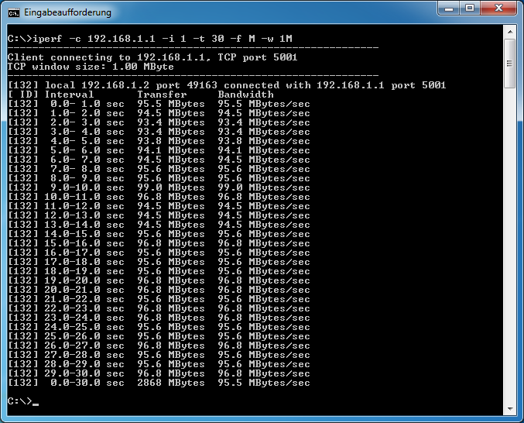
Figure 7: Windows 10 Client – ‘Circus Eruption’ Network Benchmarking [47][48]
The benchmarking results of the network depicts a 95MB/s throughput within a laboratory setting with an average of 200th of a second delay, to emulate real world traffic a further 20% can be subtracted to give a more realistic average throughput of 77MB/s and delay of 240th of a second, this result is still 22MB/s above the estimated requirements of the client with just under a quarter of a second delay. The bottleneck quality issue identified earlier in the report only accounted for a 23% reduction of throughput which was still within the tolerance previously identified. Further benchmarking will be carried out at the client’s premises on the wired/wireless segment of the network with real traffic once the network is installed at the client’s premises to confirm the test results within a live environment.

Using the laboratory benchmarking results along with the known quality of the Cisco hardware devices after testing, the project team and QA controller were satisfied with the final product and happy to deliver it to the client.

Conclusions
Project development has many aspects that all need to be identified, analysed and monitored using industry standard planning methodologies and models by a project manager to successfully manage a project to completion, without these project management tools/methodologies complex projects could over run, fail due to unidentified risks or go over budget, all these scenarios would cost a company a lot of money, this is why project management is so important to companies within modern day industry projects.

Future considerations for the charity at ‘Circus Eruption’ going forward; would be to implement a highly efficient 1GB/s enterprise network that would incorporate high levels of encryption, Bring Your Own Device (BYOD), Mobile Device Management (MDM), Layer-3 switches, redundancy and Cisco ASA firewalls with multiple Access Points that volunteers/employees could connect to remotely through a Virtual Private Network via the Internet 24 hours a day, this design could only be implemented once the client finds a permanent premises and has a budget for a large network. This network could also securely store all personal data required by the charity to streamline the day-to-day running of the charity shown in figure 7.

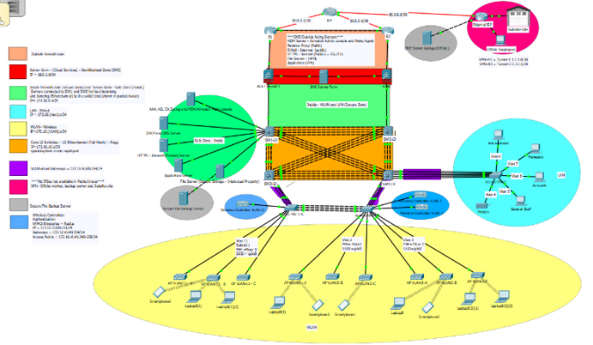
Figure 8: Future Enterprise Network for 'Circus Eruption' (Appendix-C) [45] [46]

References
[1] P. U. Lawrence, “‘Circus Eruption’ - Project Initiation Document,” Swansea, 2017.
[2] Circus-Eruption, “Circus Eruption,” circuseruption.com, 2018. [Online]. Available: http://www.circuseruption.co.uk/. [Accessed: 09-Apr-2018].
[3] AXELOS, “PRINCE2 Information,” Prince2.com, 2015. [Online]. Available: https://www.prince2.com/eur.
[4] M. Uzzafer, “A new dimension in software risk managment,” World Acad. Sci. Eng. Technol., vol. 64, pp. 340–344, 2010.
[5] Dumbravă, “Using Probability–Impact Matrix in Analysis and Risk Assessment Projects,” J. Knowl. Manag. Econ. Inf. Technol., no. December, pp. 76–96, 2013.
[6] P. U. Lawrence, “Risk Probabilty Matrix,” vol. 1, no. 1, p. 1, 2018.
[7] UN News Centre, “‘ Today is an historic day ,’ says Ban , as 175 countries sign Paris climate accord,” www.un.org, 2016.
[8] “Paris Agreement Clears Final Hurdle to Begin New Era of Global Climate Action | World Resources Institute,” wri.org, 2016. [Online]. Available: http://www.wri.org/blog/2016/10/paris-agreement-clears-final-hurdle-begin-new-era-global-climate-action. [Accessed: 09-Apr-2018].
[9] I. Heras-Saizarbitoria, K. Dogui, and O. Boiral, “Shedding light on ISO 14001 certification audits,” J. Clean. Prod., vol. 51, pp. 88–98, 2013.
[10] R. AL Shayeb, “The three pillars of sustainability,” Washington, vol. 307483, pp. 10–11, 2013.
[11] R. K. Singh, H. R. Murty, S. K. Gupta, and A. K. Dikshit, “An overview of sustainability assessment methodologies,” Ecol. Indic., vol. 9, pp. 189–212, 2008.
[12] R. J. Baumgartner and D. Ebner, “Corporate sustainability strategies: Sustainability profiles and maturity levels,” Sustain. Dev., vol. 18, no. 2, pp. 76–89, 2010.
[13] H. Hubbard, “Social Sustainability | Sustainable Indiana,” sustainindiana.org, 2014. [Online]. Available: http://sustainindiana.org/2014/10/16/social-sustainability/. [Accessed: 09-Apr-2018].
[14] S. U. Mau, “Orders of Sustainability within IT,” moodle.uwtsd.ac.uk, vol. 1, no. 1, p. 10, 2018.
[15] A. Beattie, “The Three Pillars of Corporate Sustainability | Investopedia,” Investopedia, 2015. [Online]. Available: http://www.investopedia.com/articles/investing/100515/three-pillars-corporate-sustainability.asp.
[16] C. Greenberg, Rachel, “The Environmental Impact of Manufacturing from the Industrial Revolution to Automation and Everything In Between - Transportation Management Company | Cerasis,” cerasis, 2014. [Online]. Available: http://cerasis.com/2014/09/08/manufacturing-and-the-environment/. [Accessed: 09-Apr-2018].
[17] Tufts, “Energy Efficient Technology - Office of Sustainability,” http://sustainability.tufts.edu, 2018. [Online]. Available: http://sustainability.tufts.edu/energy-efficient-technology/. [Accessed: 09-Apr-2018].
[18] morethangreen, “environmental, cultural, social and economic sustainability | more than green,” morethangreen.es, 2018. [Online]. Available: http://www.morethangreen.es/en/ideology/four-sustainabilities-cultural-economic-social-environmental-sustainability/#sthash.GpuPu6GX.dpbs. [Accessed: 09-Apr-2018].
[19] S. Swift, M. Green, J. Hillage, and V. Nafilyan, “Impact of the cycle to work scheme: evidence report,” Inst. Employ. Stud., no. June, 2016.
[20] British Computer Society, “Code of conduct | Membership | BCS - The Chartered Institute for IT,” bcs.org, 2018. [Online]. Available: http://www.bcs.org/category/6030. [Accessed: 09-Apr-2018].
[21] “IEEE CODE OF CONDUCT,” ieee.org, vol. 1, no. 1, p. 3, 2014.
[22] P. A. E. Brey, “Anticipating ethical issues in emerging IT,” Ethics Inf. Technol., vol. 14, no. 4, pp. 305–317, 2012.
[23] C. Park and T. Wang, “Big Data and NSA Surveillance -- Survey of Technology and Legal Issues,” in 2013 IEEE International Symposium on Multimedia, 2013, pp. 516–517.
[24] The European Parliment and The Council of the European Union, GDPR. 2016.
[25] ico, “GDPR Regulations,” ico.org.uk, vol. 1, no. 1, p. 20, 2018.
[26] ITgovernence, “GDPR Penalties,” itgovernance.co.uk, 2017. [Online]. Available: https://www.itgovernance.co.uk/dpa-and-gdpr-penalties. [Accessed: 09-Apr-2018].
[27] ITgovernence, “EU GDPR Infographic: What the new Regulation means in 1 minute – IT Governance Blog,” itgovernence.co.uk, 2016. [Online]. Available: https://www.itgovernance.co.uk/blog/eu-gdpr-infographic-what-the-new-regulation-means-in-1-minute/. [Accessed: 09-Apr-2018].
[28] M. D. Grammatikakis et al., “Security effectiveness and a hardware firewall for MPSoCs,” in Proceedings - 16th IEEE International Conference on High Performance Computing and Communications, HPCC 2014, 11th IEEE International Conference on Embedded Software and Systems, ICESS 2014 and 6th International Symposium on Cyberspace Safety and Security, 2014, pp. 1032–1039.
[29] D. G. Messerschmitt, “Encryption Algorithms,” Comput. Eng., no. January 2005, pp. 367–372, 1999.
[30] A. Amaral and M. J. Rosa, “Recent trends in quality assurance,” Qual. High. Educ., vol. 16, no. 1, pp. 59–61, 2010.
[31] C. M. Lopez Cabrera and L. a. Meyer, “Quality assurance and quality control,” IPCC Good Pract. Guid. Uncertain. Manag. Natl. Greenh. Gas Invent., pp. 1–17, 2000.
[32] K. Teeluckdharry, “ISO 9000: Quality Systems Handbook,” Biomed. Instrum. Technol., vol. 42, no. 1, pp. 23–23, 2008.
[33] ISO; Organizacion Internacional de Normalización, “Iso 9001 (2015),” Iso, vol. 9001, p. 33, 2005.
[34] Software and Systems Engineering Standards Commitee, “IEEE Standard Adoption of ISO/IEC 90003:2014, Software Engineering – Guidelines for the Application of ISO 9001:2008 to Computer Software,” IEEE Std 90003-2015. 2015.
[35] Cisco, “Approach to Quality - Cisco,” cisco.com, 2018. [Online]. Available: https://www.cisco.com/c/en/us/about/approach-quality.html. [Accessed: 09-Apr-2018].
[36] E. Alfnes, H. Dreyer, and J. O. Strandhagen, “The operations excellence audit sheet,” IFIP Int. Fed. Inf. Process., vol. 257, pp. 129–141, 2008.
[37] D. L. Hansen, B. Shneiderman, and M. A. Smith, “Calculating and Visualizing Network Metrics,” in Analyzing Social Media Networks with NodeXL, 2011, pp. 69–78.
[38] P. Michaud, “Demystifying multicore throughput metrics,” IEEE Comput. Archit. Lett., vol. 12, no. 2, pp. 63–66, 2013.
[39] Cisco, “Understanding VLAN Trunk Protocol (VTP),” Cisco, 2007.
[40] C. E. Spurgeon, Ethernet: The definitive guide, vol. 40, no. 2–3. 2000.
[41] W. Xiaofan, P. H. J. Chong, and L. W. Yie, “Performance comparison of CSMA/CD, CSMA/CA, CSMA/RI, CSMA/PRI and CSMA/PR with BEB,” in Proceedings of the 2010 5th IEEE Conference on Industrial Electronics and Applications, ICIEA 2010, 2010, pp. 1843–1848.
[42] C. Aurrecoechea, A. T. Campbell, and L. Hauw, “A survey of QoS architectures,” Multimed. Syst., vol. 6, no. 3, pp. 138–151, 1998.
[43] T. Praktikum and D. Teori, “Inter - VLAN Routing,” www.google.com, pp. 1–34, 2015.
[44] P. Sun, Y. Chen, Y. Zhu, X. Fu, B. Deng, and X. Li, “Dimension reduction of network bottleneck bandwidth data space,” in Proceedings - IEEE INFOCOM, 2010.
[45] P. U. Lawrence, “Packet Tracer Network Simulation,” 2018.
[46] Systems Cisco, “Cisco Packet Tracer - Networking Academy,” Cisco Press, vol. 1, no. 2, pp. 1–3, 2010.
[47] P. U. Lawrence, “Windows Command Prompt Netwrok Benchmarking,” 2018.
[48] Microsoft, “Windows Command Prompt Network Performance Benchmarking Tool,” microsoft.com, vol. 1, no. 1, p. 1, 2014.

Bibliography
Odom, Wendell CCNA ‘Routing and Switching’ 200-105 official cert guide cisco press (2016)
ISBN-10: 1-58720-580-7

Bruno, Anthony; Jordan, Steve CCDA ‘Cisco Network Design’ 200-310 official cert guide (2016)
ISBN-10: 1-58714-454-9

Hucaby, David CCNA ‘Wireless’ 200-355 official cert guide (2016)
ISBN-10: 1-58714-457-3

Santos O, Stuppi J, Cisco CCNA security 210-260 official cert guide (2016)
ISBN: 1587205661

Horine, Gregg Project Management Absolute Beginners Guide, Fourth Edition (2017)
ISBN-10: 0-7897-5675-7

Appendix-A

Appendix-B

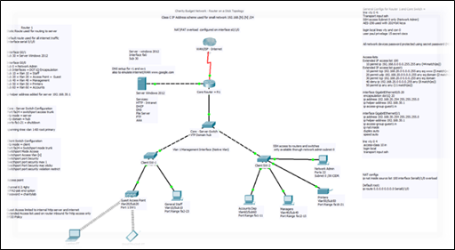

Appendix-C



