

STUDENT NAME: Nishtha Savaliya
STUDENT ID NUMBER: 2530041

PROGRAMME: MASTER OF BUSINESS ADMINISTRATION

MODULE: STRATEGIC MANAGEMENT
MODULE CODE: LCMB7003

LECTURER: Dr Ghulam Mujtaba

ASSIGNMENT TITLE: Assessment component- Individual report

SELECTED COMPANY: PEPSICO

SPECIFIC PRODUCT: Walkers Ready Salted Crisps
MARKET: UK

Table of Contents
1. Organisational Context and Overview 3
2. External and Internal Analysis 3
2.1. Critically examine the external factors using PESTEL to identify opportunities and threats 3
2.2. Assess the organisation’s internal environment using VRIO to identify strengths and weaknesses 6
2.3. Perform a SWOT analysis for PepsiCo for Walkers Ready Salted Crisps 9
3. Comprehensive and holistic view of PepsiCo- Walkers Ready Salted Crisps 11
3.1. Current CSR Strategy and Alignment with Business Objectives 11
3.2. Balanced Scorecard for Walkers Ready Salted Crisps 12
4. Strategic Choices and Implementation 15
4.1 Business-Level Strategic Choices 15
4.2 Porter’s Five Forces and Recommended Strategy 16
4.3 Delivering Optimum Performance and Competitive Advantage 17
4.4 Implementation Challenges and Solutions 17
Section 2: Reflective Writing 18
References 21

1. Organisational Context and Overview
It is an international company dealing in foods and beverages, with its products and services being provided under a diverse range of brands. It came to existence in its current form in 1965, and since then has grown to become one of the leading companies in the world, catering to customers from over 200 countries. PepsiCo had almost $94 USD billion in net revenue in 2025. It has Pepsi-Cola, Lay's, Doritos, Cheetos, Gatorade, Mountain Dew, Quaker and SodaStream, among others (Pepsico.com, 2026).
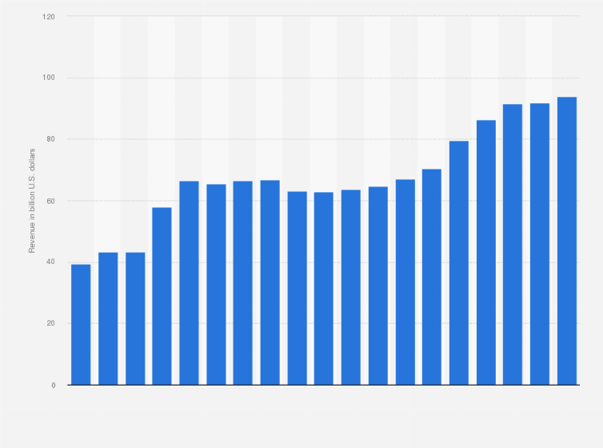
Figure 1: Net revenue growth of PepsiCo
(Source: Statista, 2025a)
The mission of PepsiCo is “to Create more smiles with every sip and every bite, serving more consumers, more occasions, more touchpoints.” The mission statement of PepsiCo reveals that it is a consumer-centric organization that emphasizes expanding the presence and relevancy of its food and beverages. The vision of the company is to develop into a best-in-class and admired global food and beverages company with sustainability at the core of its business strategies. PepsiCo aims at being a global leader in beverages and convenient foods with Pepco Positive (pep+) (Pepsico.com, 2026). Apart from that, in global business expansion segmentation, the company has generated around 44% of the overall global reach function which evolved the business market towards ‘Europe, Middle East, and Africa (EMEA) division’ expanding from the UK (Statista, 2025b).
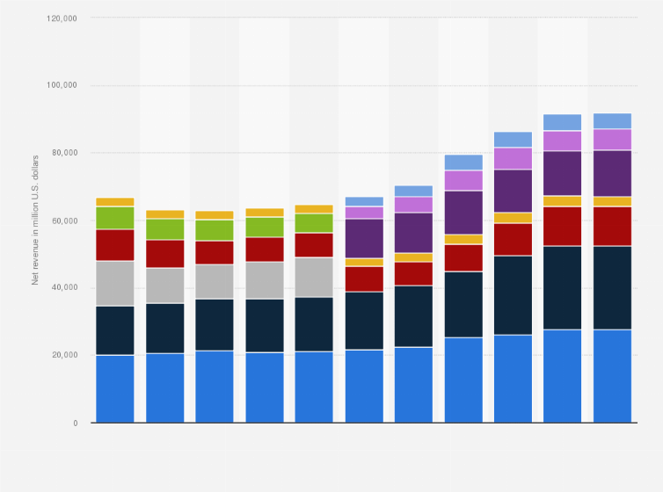
Figure 2: Global reach structure of PepsiCo
(Source: Statista, 2025b)
The business model of the company involves the development, production, marketing, sale, and distribution of a range of complementary products in the form of convenient foods and beverages. The value is created with the help of powerful brands, customer relationships, quality products, innovation, and wide distribution. Moreover, the sustainable practices have become an integral part of the business model of PepsiCo thanks to pep+, which means that they are aimed at ensuring resiliency and growth (Pepsico.com, 2026).
Walkers Ready Salted Crisps is one of the products that compete in the competitive market segment of convenient foods and savory snacks in the UK. Competition includes aspects such as brand awareness, taste, price, quality, range of products, innovations, distribution, shelf space, packaging and promotion. The main international competitors for PepsiCo in the food and beverages business include Mondelēz International, Nestlé, Mars, Kraft Heinz and Campbell's (Pepsico.com, 2026). The position of Walkers Ready Salted Crisps in the market is facilitated by PepsiCo’s organizational resources, brand portfolio and distribution. However, Walkers Ready Salted Crisps compete with branded products and store brands. Hence, the position of the product in the market needs to be maintained by PepsiCo through exploitation of Walkers’ brand and price competition among others.

2. External and Internal Analysis

2.1. Critically examine the external factors using PESTEL to identify opportunities and threats
Factors | Description | Impact
Political | - 25% is the corporate tax of the UK as of 2026 (Tradingeconomics.com, 2026)  - In the year 2026, the VAT rate is 20% taken by the government of the UK (Tradingeconomics.com, 2026). | This factor is negatively impacting the business performance of PepsiCo for its specific product Walkers Ready Salted Crisps because they have to give high corporate and sale tax to the UK’s government.
Economic | - In 2026, the GDP rate of the UK has been decreased by 8% in comparison to previous year 2025 (Statista.com, 2026).  - In the year 2026, the inflation rate has been decreased by 2.6% (Statista.com, 2026).  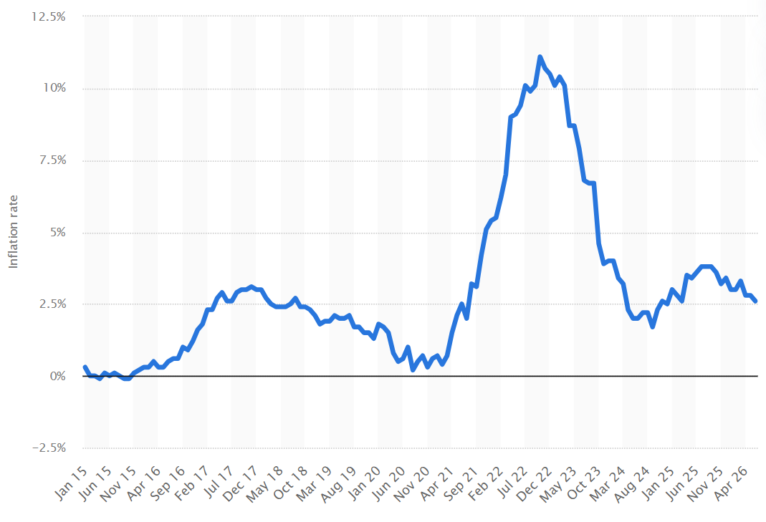  Figure 3: Current inflation rate of the UK  (Source: Statista.com, 2026) | It is negatively impacting the economic performance of PepsiCo for its specific product Walkers Ready Salted Crisps.
Social | - 4.9% is the unemployment rate of the UK as of 2026 (Tradingeconomics.com, 2026).  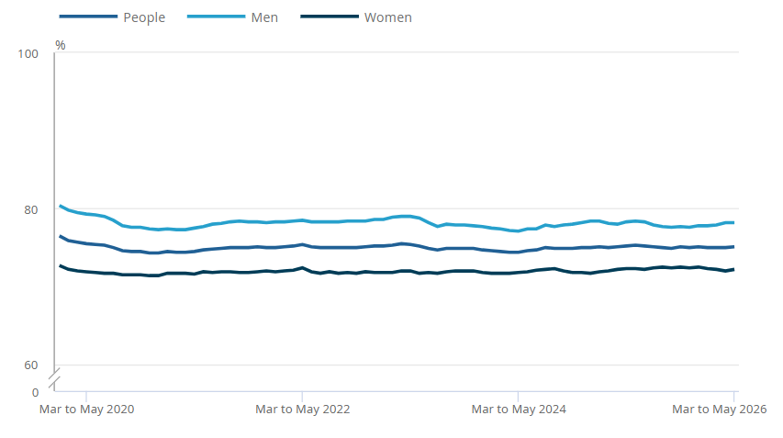  Figure 4: Ratio of unemployment in the UK  (Source: Ons, 2026)  - In the year 2024, 69,281,437 is the population rate of the UK as of now (Statista.com, 2026). | This factor is impacting PepsiCo for its product Walkers Ready Salted Crisps as it is creating opportunity for them to gain access to talented and experienced employees for its market growth.
Technological | - The government of the UK has invested £13.5 billion for developing the technical performance of the industry (Itpro.co.uk, 2021) | It is mainly impacting positively to the market growth and maintaining market competition for PepsiCo through its specific product Walkers Ready Salted Crisps by selling its product through online with secure online payment mode and quick shipment an delivery of the product on time.
Legal | - Equality Act 2010 (Legislation.gov.uk, 2026)  - Health and Safety at Work etc. Act 1974 (Legislation.gov.uk, 2026)  - The UK government has integrated the HFSS regulations for ensuring less healthy products advertisement ban and restricting the legal structures of process management for health and safety by underpinning ‘Food (Promotion and Placement) (England) Regulations 2021’ (Gov, 2023). | It is positively impacting this company as they are providing equal and fair treatment to its employees. Along with that, PepsiCo is providing healthy and safe working environment to its employees.
Environmental | - Environmental Protection Act 1990 (Legislation.gov.uk, 2026)  - Inclusion of ‘Extended Producer Responsibility (EPR) scheme’ (EPR) as the packaging regulation of the UK 2026 to restricting the overall multi-layered packaging structure of companies who manufactured crips (Gov, 2025). Recyclability Assessment Methodology (RAM) classification, develop baseline materials usage according to the government process protection have also been started as evolved by the UK government. | This factor is positively impacting this company as they are maintaining guidelines related to environmental protection through sustainable production of Walkers Ready Salted Crisps.
Table 1: PESTLE Analysis
From the table above, it is clear that there are threats and opportunities for Walkers Ready Salted Crisps in the UK market. High tax rates and low GDP are threats, while low inflation rates pose economic opportunities. The large population and employment rate, coupled with technological investments, offer potential for growth. Legal and environmental issues, however, pose both opportunities and costs.

2.2. Assess the organisation’s internal environment using VRIO to identify strengths and weaknesses
Internal resource/capability | Valuable | Rare | Costly to imitate | Organised to exploit | Competitive implication | Strength / Weakness
Walkers Ready Salted Crisps brand recognition | Yes – high level of familiarity aids customer loyalty, repeat purchases and presence within the UK crisps market. | Yes – there are no comparable crisps brands that have an established presence within the UK market. | Yes – brand legacy and the built-up associations are costly and time-consuming to replicate. | Yes – PepsiCo backs Walker’s Ready Salted Crisps via marketing, brand management and distribution strategies. | Competitive advantage is sustained | Major strength
PepsiCo financial resources | Yes – adequate resources are available for advertisement, innovation, and production investment. | No – there are other food companies that have financial resources too. | No – other major competitors have access to capital and invest extensively. | Yes – PepsiCo can invest in manufacturing, marketing, and distribution. | Competitive parity | Strength, but not distinctive
UK distribution and retailer relationships | Yes – wide availability becomes especially relevant in case of regularly bought snacks. | Partly – rival companies possess logistics systems, though the entrenched status of Walkers Ready Salted Crisps provides it with substantial distribution capacity. | Partly – it takes time to develop such distribution capabilities. | Yes – PepsiCo possesses sales and logistics competencies. | Temporary competitive advantage | Strength
Simple Ready Salted product proposition | Yes – the taste is recognizable for consumers who want something that tastes traditionally crispy. | No – products of the same kind have been available from various other companies and retailers. | No – the underlying idea of the product can be duplicated rather easily. | Yes – Walker’s Ready Salted Crisps can produce and distribute it effectively. | Competitive parity | Potential weakness
Manufacturing scale and operational capabilities | Yes - scale may help to increase availability, consistency, and efficiency of manufacturing. | Partly - big companies are able to run effective manufacturing systems too. | Partly - attaining similar scale is costly and requires experience and supplier contacts. | Yes - PepsiCo has its own systems and experience. | Temporary advantage/parity | Strength
Table 2: VRIO Analysis
(Source: Self Developed)
According to the VRIO evaluation, the most significant internal strength of Walkers Ready Salted Crisps is its strong brand positioning in the UK. The brand name of the company has earned recognition and market presence over a long period of time, and so is much more valuable than the actual taste of the product. Other companies can produce the same type of crisps, but building up the brand legacy and the same degree of consumer recognition would take time. Thus, brand equity can potentially be a source of competitive advantage for the company. The strong financial condition of the parent company and its manufacturing and marketing capabilities provide another strength to the product. All these resources give the company the ability to invest in manufacturing, promotion, innovation and branding activities. However, financial resources are not rare, since other food and snacks manufacturers can invest money as well. The other important strength is the distribution and retailer connections. Ready Salted is a product that is commonly bought and hence availability may be an important factor influencing the choice of the product. Availability of the product could be guaranteed because of the well-structured distribution channels and good connections with retailers in the UK, which are enjoyed by PepsiCo and Walkers. Even though this advantage could be easily copied by the competitors in the future, it might take some time to achieve. The main weakness of the company is the lack of uniqueness of its Ready Salted product. The taste of the product is simple and it can be replicated by branded competitors and supermarket own label products. In general, the VRIO framework indicates that PepsiCo is internally well-positioned to assist in the development of Walkers Ready Salted Crisps in the UK. Brand equity stands out as the clear potential sustained competitive advantage, with distribution, size and marketing strengthening competitive advantage. On the other hand, low rarity and imitability at product level forms a weakness.

2.3. Perform a SWOT analysis for PepsiCo for Walkers Ready Salted Crisps
SWOT Factor | Description and Critical Analysis
Strengths | Strong brand name: One of the main advantages of the Walkers Ready Salted Crisps product is its recognizable brand name in the UK market segment of crisps. In accordance with the VRIO framework, Walkers' brand name is valuable, relatively rare, and it is hard for other firms to imitate this brand name because of its reputation and associations formed over time. High recognition may result in the creation of loyalty and repurchasing behavior and help the product compete against other branded and supermarket own brands.  Financial resources: Financial resources that PepsiCo possesses constitute another strength because these resources allow the company to spend money on advertising, production, and distribution (Pepsico, 2025).  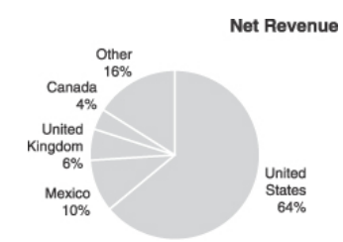  Figure 5: Stable financial resource for internationalisation  (Source: Pepsico, 2025)  Although financial resources are common to many other large multinationals, these resources help the company react to the changing environment and strengthen the competitive advantage of Walkers Ready Salted Crisps.  Distributed and existing relations with retailers: Finally, PepsiCo also has a high level of distribution and established relations with UK retailers. As crisp is the product which is often bought by consumers, it is important to be distributed well in order to preserve sales.  Production and operations capabilities: PepsiCo has the scale, expertise, and supplier base that will facilitate effective production, quality and availability of their products. This will help the company better meet customer demand in the UK snack market.
Weaknesses | Product differentiation: The lack of differentiation of the Ready Salted product offering is an important weakness identified using the VRIO analysis. The flavour of ready salted chips is common and available among the products offered by competing snack producers.  Dependence on the brand: The competitive advantage held by the Walkers Ready Salted Crisps highly relies upon the Walkers brand’s strength since the basic product is easy to replicate. Thus, if consumers lose their loyalty to the brand, or if there are more attractive propositions by competitors, then the product may become susceptible to substitution.  Imitability of financial and operational resources: Even though the financial, production, and marketing capabilities of PepsiCo are strengths of the firm, many large food producers have comparable strengths.  Compliance costs: Complying with UK employment, health and safety and environmental standards may involve costs.
Opportunities | Large UK consumer market: The large number of UK consumers revealed from the PESTLE analysis gives Walkers Ready Salted Crisps a significant potential market of consumers. With their experience and distribution channels, PepsiCo would be able to reach these consumers.  Technological advancement and e-commerce: Technology investment in the UK gives PepsiCo a chance to improve its digital marketing and online sales. This is because most customers can buy products through the websites of the supermarkets.  Less inflationary pressure: From the results of the PESTLE analysis, decreasing inflation can present PepsiCo with an economic opportunity by relieving them from pressure on production cost and consumer spending.  Labour availability: The discovered unemployment rate gives PepsiCo opportunities to hire skilled employees for the various processes involved.  Recycling and sustainable production: Another benefit from environmental legislation is that there is potential for PepsiCo to enhance its sustainable manufacturing process and recycling efforts. Effective recycling and minimization of packaging could result in increased brand image among eco-friendly UK customers.
Threats | Higher taxes: From the PESTLE analysis, we learn that UK corporate taxation and value added tax are economic factors that affect businesses running their operations in the country. Taxes might increase financial pressure and affect profit margins in light of production, distribution, and marketing expenses.  Poor economic growth: Poor economic growth, which will result in reduced GDP growth, is a threat because poor economic performance is likely to lead to reduced consumer confidence and decreased levels of spending. Consumers facing financial pressure are likely to go for supermarket own brand crisps as opposed to Walkers.  Competitive threats and ease of imitation: The ready salted crisps have been observed to be easily replicable by competitors, posing significant competition by branded rivals and supermarket own labels.  Environmental laws: Although laws give an opportunity for demonstrating good corporate practices, compliance with laws is a threat in light of higher costs of production, employment, packaging, and management of waste.  Rising consumer expectations: Changing consumer expectations and demands for sustainable and responsible production can be a threat to the product.
Table 3: SWOT Analysis of PepsiCo- Walkers Ready Salted Crisps
(Source: Self Developed)

3. Comprehensive and holistic view of PepsiCo- Walkers Ready Salted Crisps

3.1. Current CSR Strategy and Alignment with Business Objectives
The implementation of CSR needs to be incorporated within the corporate strategy as opposed to being viewed as an isolated philanthropic practice. According to Fatima and Elbanna (2023), the implementation of CSR entails adopting an integrative perspective with regard to organisational and context considerations. This is significant for PepsiCo since sustainability, staff members, consumers and efficient use of resources influence the competitiveness of Walkers Ready Salted Crisps. Another important domain of CSR is environmental sustainability. From the PESTLE analysis, it has been determined that there are opportunities and costs associated with environmental laws and recycling. PepsiCo can respond to such issues with sustainable packaging, waste management, efficient use of resources and responsible production. This is especially true for Walkers since it involves individual packaging of the product.
Furthermore, CSR involves the innovation aspect too. As opined by Anzola-Román et al., (2024), CSR orientation may affect innovative performance, however, organisational practices will influence this process. It means that PepsiCo needs to convert its sustainability initiatives into practices that will cover the area of products' development, manufacturing and packaging. Investing in innovation in packaging, energy efficiency and waste reduction will allow Walkers to meet environmental expectations and improve operational performance at the same time. As per the most effective ways of sustainability structure management by the company, around £13 million upgradation to invest on the ‘Coventry Doritos plant—Europe’s largest tortilla chip factory’ has been estimated by that ‘cutting greenhouse gas emissions by over 700 tonnes annually’ would be balanced through the firm as their sustainability functions (Grocerygazette, 2025).
It is important due to the fact that, according to the VRIO analysis, Ready Salted is quite easy to copy. Employees constitute yet another critical component. Adherence to the requirements of the Equality Act 2010 and Health and Safety at Work Act 1974 will help ensure equal treatment and safety of the workplace. However, CSR should not be reduced to mere compliance with legislation. Yassin and Beckmann (2025) point out the connection between CSR and employee-related results. Thus, employee development, diversity and wellbeing along with safe working conditions will enhance their engagement and productivity.
However, CSR also poses a strategic dilemma. Sustainability efforts may involve significant investment of money and raise immediate costs. Thus, PepsiCo needs tangible results that would prove whether CSR operations enhance environmental performance and efficiency, employee performance and client perception. The integration of CSR into performance management through Balanced Scorecard could solve the problem.

3.2. Balanced Scorecard for Walkers Ready Salted Crisps
The Balanced Scorecard (Kaplan & Norton, 1992) is a term that represents a holistic approach to performance through the integration of both financial and non-financial metrics. As noted by Suárez-Gargallo and Zaragoza-Sáez (2023), the Balanced Scorecard continues to be relevant in today’s world as a strategy management tool. The use of the concept in measuring the performance of business entities (Bahri and Al Faruqy, 2023). The four dimensions of this concept may link financial objectives of PepsiCo with customer value and internal processes.
Perspective | Objectives | Key Performance Indicators (KPIs) | Targets | Strategic initiatives
Financial | Maximize sales and profits for Walkers Ready Salted Crisps with the lowest manufacturing and distribution costs possible. Safeguard performance from the threat of taxation, economic instability and competitive pricing issues. | Sales revenue in the UK; sales revenue growth; profit margin; cost of manufacture per unit; distribution costs; returns on sustainability investments. | Make sustained revenue growth each year; improve margins; lower unnecessary manufacturing and distribution costs around 6% within 2027. | Enhance manufacturing effectiveness; optimize logistics; use promotions; maximize online sales; invest sustainably.
Customer | Maintain brand identity and customer loyalty through increased consumer satisfaction. Increase differentiation from other brands and supermarket private labels. | Customer satisfaction; repeat purchase frequency; UK market share; brand recognition; customer complaints; digital interaction. | Maintain high brand recognition; increase customer satisfaction and loyalty; defend or increase market share almost 42% within December, 2026. | Undertake consumer research; improve digital marketing; maintain high product quality; increase customer interaction; promote sustainability efforts.
Internal Business Processes | Enhance manufacturing efficiency, product quality, availability, environmental performance, and distribution effectiveness. | Manufacturing efficiency; waste produced per unit; environmental sustainability of packaging; defect rate of the product; delivery effectiveness; product availability; energy usage. | Decrease waste and energy intensity every year; ensure high product availability and quality; increase sustainability of packaging; demonstrate high delivery with 15% more in next 6 months. | Adopt high-tech manufacturing techniques; optimize logistics; upgrade quality control mechanism; adopt eco-friendly packaging; enhance the recycling and waste management process.
Learning and Growth | Empower employees by enhancing their skills, engaging them, and fostering innovations while providing a safe and inclusive working environment. | Employee Engagement; Employee Turnover; Hours of Training; Workplace Incidents; Employee Innovation Participation; Diversity Measures. | Increase employee engagement and retention; provide more training; lower workplace incidents; increase employee innovation participation within June of 2027. | Offer technical and sustainable training; employee development programs; workplace well-being programs; diversity and inclusion practices; foster employee innovation.
Table 4: Balanced Scorecard for PepsiCo – Walkers Ready Salted Crisps
(Source: Self Developed)
The financial aspect is vital for PepsiCo as the company will require Walkers Ready Salted Crisps to be able to earn a profit in the future. From the results of the previous SWOT analysis, it is evident that economic factors and taxation may be considered as threats. Therefore, it is necessary for PepsiCo to ensure that revenue increase will be achieved without additional expenses for manufacturing, logistics and sustainability. In this way, operational effectiveness and supply chain optimization can save margins without the use of increased prices. The customer perspective is critical for the company as brand equity is its key VRIO resource. The internal business process perspective links capabilities with CSR. The manufacturing capacity and logistics networks of PepsiCo are strengths identified in the analysis, but environmental responsibilities force them to turn these processes into sustainable ones. Measuring wastes, energy usage, packaging sustainability, and quality and delivery of products would help PepsiCo strive for efficiency and sustainability. Lastly, learning and growth is the basis of other perspectives. Competencies of the employees are needed for operating technologies, ensuring quality and implementing sustainability measures. Employment oriented toward CSR can further enhance employee engagement and retention, according to Yassin and Beckmann (2025). Innovativeness must be fostered since organizational practices can enhance the connection between CSR orientation and innovative performance.

4. Strategic Choices and Implementation

4.1 Business-Level Strategic Choices
Cost leadership means gaining competitive advantage through reduced operating costs so as to enable the organisation to compete on the basis of price or create better margins. Cost leadership may be pertinent to Walkers since PepsiCo is capable of mass production, has supplier connections and efficient distribution mechanisms. As shown by Naseer et al., (2026), the effects of cost leadership are dependent on the capabilities of the organisation meaning that a cost-based strategy has to be in line with the resources of the organisation. Economies of scale, automation, optimization of supply chain and minimization of waste will ensure reduced cost per unit of production and distribution of Ready Salted Crisps. Cost efficiency is strategically significant in the competitive UK market environment especially when consumers can buy own-brand products from supermarkets.
In addition, differentiation could be made possible through the creation of distinct values which the customers find superior to other options. Walkers can use such things as brand reputation, quality, packaging, experience, availability, sustainability, and marketing for differentiation without necessarily having to differentiate in taste. This is because the previous VRIO assessment indicates that the ready salted crisps are very easy to copy. Innovation can assist in creating differentiation. Farida and Setiawan (2022) link business strategies and innovations to competitive advantages, noting the significance of organisational performance and innovation capability. Thus, PepsiCo can use its money power together with innovations in its products, packaging, production, and marketing.

4.2 Porter’s Five Forces and Recommended Strategy
Porter’s Five Forces is a structured approach to understanding industry competition and making strategic decisions. Pangarkar and Prabhudesai (2024) state that using Five Forces can enable organizations to make strategic decisions based on competitive industry environment.
Porter’s Force | Assessment for Walkers Ready Salted Crisps | Strategic implication
Competitive rivalry – High | KP Snacks, Pringles, Golden Wonder, Kettle and Burts are the key crips developing market competitors of PepsiCo while emphasising their business process in the UK. Although, Walkers faces competition from well-established branded crisp producers as well as supermarket branded crisp producers. The products will compete on the basis of price, quality, flavor, branding, distribution, and promotion. | The differentiation is necessary for maintaining brand loyalty and minimizing price competition.
Threat of new entrants – Moderate | Crisp manufacturing and ready salted seasoning can be duplicated; however, creating manufacturing economies of scale, nation-wide distribution, retailer connections, and strong brand awareness involves substantial costs. | PepsiCo must leverage its existing brand equity and distribution power through Walkers to create competitive entry barriers.
Buyer power – High | According to the overall customers engagement and formal ways management segmentation, KP Snacks currently increased their customers engagement rate around 4.4% as per the recent competitive segmentations as well as sales revenue have grown £654 million (Thegrocer, 2025). Whether, PepsiCo’s operating actions become minimal as per the competitive structure management segment. Additionally, UK customers have multiple option-based purchasing power, and they can even provide private label products. Switching is easy for consumers because switching costs are minimal. | Customer loyalty and differentiation help to insulate the brand from price sensitivity among consumers.
Supplier power – Low to Moderate | Walkers Crisps have currently more than direct engagement with the 80 British potato farmers as well as across 10 sites-based business expansions in the UK to collaboratively emphasising their sustainable business areas more accurately (Potatopro, 2026). The purchasing size of PepsiCo gives them negotiating ability, though potato, cooking oil, energy, packing and transport prices could influence the manufacturing process. | Diversification in procurement, strong business partnerships and effective supply chain management could help in controlling cost risk.
Threat of substitutes – High | Ready Salted Crisps can be substituted by other crisp flavors, other competing brands as well as other categories of snacks. | Differentiation, quality, convenience and innovation are necessary for sustaining customer preference.
Table 5: Porter’s Five Forces Analysis of Walkers Ready Salted Crisps
(Source: Self Developed)

4.3 Delivering Optimum Performance and Competitive Advantage
The differentiation strategy recommended will increase its efficiency as a result of strengthening the link between brand equity, innovation and customer loyalty. The existing brand equity of Walkers is a resource that is difficult to copy by the competitors quickly. Therefore, PepsiCo should further focus on branding and developing relations with customers without engaging in price wars. Another chance for differentiation can come from digitalization. According to Miller and Wang (2024), approaches related to digitization of a product influences the differentiation strategy. Even though crisps cannot be digitized like information products, the customer relation can be digitized using social media and digital campaigns.
It is especially important to apply social media for analysis of competitive environment. In this case, it would be useful to use the combination of social media analytics and analysis of Porter's Five Forces (Kumar and Nanda, 2022). PepsiCo would be able to analyze consumers' comments, preferences and responses to identify trends and compare different offers of rival snacks. Moreover, Xiao et al. (2022) addresses the potential of visual content in differentiating marketing strategy. Thus, visually differentiating digital campaigns and communication about the brand through packaging would enhance brand identity of Walkers through social media. Differentiation should be combined with sustainability initiatives. Improvements in packaging, waste management and manufacturing processes could help PepsiCo to implement its CSR strategies and differentiate Walkers among environmentally conscious consumers. At the same time, these improvements would decrease the cost of waste management and create link between differentiation and cost efficiency. Instead of lowering prices in order to compete with own-label products of supermarkets, Walkers could emphasize quality of its offer, responsible production, wide distribution and unique communication of its brand.

4.4 Implementation Challenges and Solutions
Implementation poses certain problems. First, differentiation implies ongoing costs associated with marketing, innovation, packaging, and technology. Such expenses might affect short-term financial results, especially with regard to taxes and economic issues. PepsiCo should focus on projects based on the results measured with the help of such KPIs as sales growth, market share, customer loyalty, marketing return on investment and production cost per unit. Secondly, differentiation is susceptible to imitations made by competitors. Packaging innovations, sustainability programs, and promotional activities can be imitated by competitors. Thirdly, price sensitivity among consumers may lead to the failure of premium differentiation in case of poor economic situation. PepsiCo needs to use different pack sizes, promotional activities, and effective production instead of harming brand equity by lowering prices permanently. Fourthly, implementation of sustainability measures may be costly and difficult to organize. Changes in packaging, manufacturing, and supply chain management may imply expenditures and organization of processes. Implementation in phases, piloting, and performance measurement may minimize such risks. Finally, PepsiCo should achieve strategic alignment of marketing, manufacturing, distribution, sustainability and employees. Farida and Setiawan (2022) demonstrate that performance and innovation play a role in the relationship between business strategy and competitive advantage.

Section 2: Reflective Writing
Gibbs Reflective model
Description
In this assessment, I analysed PepsiCo, particularly focusing on Walkers Ready Salted Crisps and its positioning in the UK beverages industry. I started with an analysis of the history of the organization, mission, vision, business model, environmental factors of the organization, competition, and market positioning. Then I carried out the external and internal analysis of the organization, employing the PESTLE, VRIO, and SWOT models. I further discussed the CSR strategy of PepsiCo and used Balanced Scorecard approach for financial, customer, internal business process, and learning and growth perspective.
Feelings
In the initial stages of the assessment, I felt somewhat intimidated due to the fact that the assignment involved combining a number of strategic management theories while focusing on Walkers Ready Salted Crisps. It was difficult for me at first to know what type of data to consider because of the global nature of PepsiCo and its broad range of products. However, as I continued with my research, I got better at differentiating company-wide data from that relating to Walkers Ready Salted Crisps. Using various models including PESTLE, VRIO and SWOT allowed me to systematize the data.
Evaluation
My experience with the process of research and analysis was beneficial since it enhanced my knowledge about the ways in which various strategic management models can be used together for analysing an organisation. The first good thing was that I used PESTLE, where I was able to categorize all the external factors and determine the opportunities and threats for Walkers Ready Salted Crisps. The other good thing was that I was able to apply VRIO, and thus consider whether resources available to PepsiCo would allow for any competitive advantage. Balanced Scorecard proved especially helpful since it allowed to broaden the scope of analysis by looking at aspects other than financial. I examined the role that customer satisfaction, internal processes, human resource development, and financial goals have on organizational performance. Looking into CSR helped to examine the role of social and environmental responsibilities in achieving other business goals. At the same time, I encountered certain challenges. PepsiCo functions in many countries and different products, so sometimes the information available referred to the whole company rather than the chosen product (Walkers Ready Salted Crisps). It was necessary to evaluate whether the data available was relevant for the product in question.
Analysis
From the process of strategic analysis, I was able to learn that good strategic analysis is more than gathering information and putting it in the context of a framework. I needed to make sense of what I was seeing and how the internal resource was related to the external pressure and strategy itself. For instance, PESTLE analysis taught me that such issues as economy, politics, technology, society, law and environment could simultaneously provide an opportunity and a threat. From that experience I understood that a certain development should not be regarded as either positive or negative without looking at PepsiCo’s reaction to it strategically. Similarly, VRIO analysis taught me that the possession of valuable resource does not automatically mean a competitive advantage. I have also realized that SWOT analysis would be made much more effective through basing the conclusions reached on existing prior external and internal analysis rather than generating them in isolation. Indeed, strategic analysis tools also helped me link the present situation at PepsiCo to potential future strategies. This process enhanced my skills in moving beyond mere description into analysis by thinking about why certain aspects were important, their impact on Walkers Ready Salted Crisps, and what strategies PepsiCo might adopt as a result.
Conclusion
As a result of carrying out this assessment, I have realized that strategic management entails a comprehensive knowledge of the organization and the environment. I have gained knowledge on how the use of frameworks such as PESTLE, VRIO, SWOT, and Balanced Scorecard among others will help to make structured decisions. Additionally, I have realized the need to select appropriate and relevant data as opposed to any data that is related to the company as a whole regardless of relevance. It helped me to differentiate issues at a corporate level from issues at a product level since Walkers Ready Salted Crisps was the focus of the assessment.
Action Plan
In order to undertake future assessments, I will construct a more structured research approach prior to the process of writing. This will involve understanding what is required for each part of the assessment and gathering evidence that supports this from credible academic, governmental, industry and organisational resources. I will also ensure that the evidence is recent, where necessary, and that key facts are checked through various credible sources. In applying frameworks for strategy, I will pay greater attention to analysing the consequences of each point found, rather than just classifying the information. I will also make sure that the connection between the frameworks is clear in order to formulate logical recommendations.

References
Anzola-Román, P., Garcia-Marco, T. and Zouaghi, F., 2024. The influence of CSR orientation on innovative performance: is the effect conditioned to the implementation of organizational practices?. Journal of Business Ethics, 190(1), pp.261-278.
Bahri, E.S. and Al Faruqy, M.Z., 2023. The Measurement Model of Business Entity Performance with Balanced Scorecard Approach. Journal of Multi-Disciplines Science (Icecomb), 1(1), pp.9-15.
Farida, I. and Setiawan, D., 2022. Business strategies and competitive advantage: the role of performance and innovation. Journal of open innovation: Technology, market, and complexity, 8(3), p.163.
Fatima, T. and Elbanna, S., 2023. Corporate social responsibility (CSR) implementation: A review and a research agenda towards an integrative framework. Journal of business ethics, 183(1), pp.105-121.
Gov, 2023. Restricting promotions of products high in fat, sugar or salt by location and by volume price: implementation guidance. [Online] Available at:<https://www.gov.uk/government/publications/restricting-promotions-of-products-high-in-fat-sugar-or-salt-by-location-and-by-volume-price/restricting-promotions-of-products-high-in-fat-sugar-or-salt-by-location-and-by-volume-price-implementation-guidance>[Accessed on 12th August, 2026]
Gov, 2025. Closed loop packaging waste: EPR for packaging. [Online] Available at:<https://www.gov.uk/guidance/extended-producer-responsibility-for-packaging-closed-loop-recycling>[Accessed on 12th August, 2026]
Grocerygazette, 2025. PepsiCo fires up sustainability with new ovens at Walkers site. [Online] Available at:<https://www.grocerygazette.co.uk/2025/05/16/pepsico-electric-ovens-walkers/>[Accessed on 12th August, 2026]
Itpro.co.uk, 2021. UK tech sector investment hits record £13.5 billion in 2021. [Online]. Available at: https://www.itpro.co.uk/business-strategy/startups/360929/2021-uk-tech-sector-investment-record [Accessed on 26/07/26]
Kumar, V. and Nanda, P., 2022. Approaching Porter's five forces through social media analytics. International Journal of Services Operations and Informatics, 12(2), pp.184-200.
Legislation.gov.uk, 2026. Environmental Protection Act 1990 [Online]. Available at: https://www.legislation.gov.uk/ukpga/1990/43/contents [Accessed on 26/07/26]
Legislation.gov.uk, 2026. Equality Act 2010 [Online]. Available at: https://www.legislation.gov.uk/ukpga/2010/15/contents [Accessed on 26/07/26]
Legislation.gov.uk, 2026. Health and Safety at Work etc. Act 1974 {Online]. Available at: https://www.legislation.gov.uk/ukpga/1974/37/contents [Accessed on 26/07/26]
Miller, C.D. and Wang, R.D., 2024. Product digitization and differentiation strategy change: Evidence from the book publishing industry. Strategic Management Journal, 45(7), pp.1241-1272.
Naseer, M.M., Hussain, N., Khan, S.A. and Nicolò, G., 2026. The ESG Emissions Paradox: Capability‐Contingent Effects of Research and Development and Cost Leadership in Asia. Business Strategy and the Environment, 35(2), pp.3077-3092.
Ons, 2026. Employment in the UK: July 2026. [Online] Available at:<https://www.ons.gov.uk/employmentandlabourmarket/peopleinwork/employmentandemployeetypes/bulletins/employmentintheuk/july2026>[Accessed on 12th August, 2026]
Pangarkar, N. and Prabhudesai, R., 2024. Using Porter's Five Forces analysis to drive strategy. Global Business and Organizational Excellence, 43(5), pp.24-34.
Pepsico, 2025. PepsiCo 2024 10-K Filing-2025-02-03-18-25. [Online] Available at:<https://investor.pepsico.com/docs/default-source/investors/q4-2024/q4-2024-form-10k_kgcva0jf89d2927o.pdf>[Accessed on 12th August, 2026]
Pepsico.com, 2026. About PepsiCo [Online]. Available at: https://www.pepsico.com/about [Accessed on 26/07/26]
Pepsico.com, 2026. About PepsiCo [Online]. Available at: https://www.pepsico.com/docs/pepsico-5v9wci20/media/Files/investors/pepsico-2025-annual-report.pdf [Accessed on 26/07/26]
Pepsico.com, 2026. Our Mission [Online]. Available at: https://www.pepsico.com/about/mission [Accessed on 26/07/26]
Pepsico.com, 2026. PepsiCo Announces Timing and Availability of Second-Quarter 2026 Financial Results [Online]. Available at: https://www.pepsico.com/newsroom/press-releases/2026/pepsico-declares-quarterly-dividend-q2-2026 [Accessed on 26/07/26]
Potatopro, 2026. PepsiCo UK. [Online] Available at:<https://www.potatopro.com/companies/pepsico-uk>[Accessed on 12th August, 2026]
Statista, 2025a. Revenue of PepsiCo from 2007 to 2025. [Online] Available at:<https://www.statista.com/statistics/233378/net-revenue-of-pepsico-worldwide/?srsltid=AfmBOooD7H2Xc2YDvXrPiyVs_aNkepaoi8mczK6quc4V4gjhySIZd0xP>[Accessed on 12th August, 2026]
Statista, 2025b. PepsiCo's net revenue worldwide from 2014 to 2024, by division. [Online] Available at:<https://www.statista.com/statistics/532389/global-net-revenue-of-pepsico-by-division/?srsltid=AfmBOop-MNml9Y1BTJ4heA_97q1k8C9JJYSR6kPe1VZ3FqB1tDcHDR3y>[Accessed on 12th August, 2026]
Statista.com, 2026. Estimated population of the United Kingdom from 1871 to 2023 [Online]. Available at: https://www.statista.com/statistics/281296/uk-population/ [Accessed on 26/07/26]
Statista.com, 2026. United Kingdom: Inflation rate from 1986 to 2026 [Online]. Available at: https://www.statista.com/statistics/270384/inflation-rate-in-the-united-kingdom/ [Accessed on 26/07/26]
Statista.com, 2026. United Kingdom: Real gross domestic product (GDP) growth rate from 2016 to 2026 [Online]. Available at: https://www.statista.com/statistics/263613/gross-domestic-product-gdp-growth-rate-in-the-united-kingdom/ [Accessed on 26/07/26]
Suárez-Gargallo, C. and Zaragoza-Sáez, P., 2023. A comprehensive bibliometric study of the balanced scorecard. Evaluation and Program Planning, 97, p.102256.
Thegrocer, 2025. KP Snacks reports growth and higher profits. [Online] Available at:<https://www.thegrocer.co.uk/news/kp-snacks-attributes-growth-and-higher-profits-to-solid-brand-performance/710206.article>[Accessed on 12th August, 2026]
Tradingeconomics.com, 2026. United Kingdom Corporate Tax Rate [Online]. Available at: https://tradingeconomics.com/united-kingdom/corporate-tax-rate [Accessed on 26/07/26]
Tradingeconomics.com, 2026. United Kingdom Unemployment Rate [Online]. Available at: https://tradingeconomics.com/united-kingdom/unemployment-rate [Accessed on 26/07/26]
Xiao, X., Fang, C., Lin, H. and Chen, J., 2022. A framework for quantitative analysis and differentiated marketing of tourism destination image based on visual content of photos. Tourism Management, 93, p.104585.
Yassin, Y. and Beckmann, M., 2025. CSR and employee outcomes: a systematic literature review. Management Review Quarterly, 75(1), pp.595-641.

