Data Security Governance and Compliance (ACCA7028)

Name: Md. Sadikur Rahman Chowdhury
Student ID: 2512666
Submission Date: 8 January 2026

Title: Apply the principles and practices of Data security, Governance and Compliance based on a given scenario.
Abstract
The given assignment will analyse the principles and practices related to data security, governance, and compliance within the framework of NatureGreen (NG) a global Organisation that is struggling with the complicated issues of information assets protection. Since NG becomes more and more dependent on digital technologies, such as cloud technology and mobile devices, the company gains exposure to the risks of data breaches, theft of intellectual property, and sensitive customer data security. The study examines the major security models, including the ISO 27001 and ITIL, to suggest custom approaches to improving the security position of NG. It incorporates the formulation of extended security policies and risk management procedures and adherence to international data protection rules such as the GDPR and CCPA. Also, the assignment criticizes the necessity of regular changes in the security regulations and standards with regard to changing cyber threats. Finally, the study highlights the importance of a strong security, governance, and compliance policy when it comes to making sure that NG is resilient to new threats and that its activities do not cause people to lose confidence in it.

- Introduction
In the modern digital environment, data security, data governance, and data compliance are the cornerstones of securing information assets of the organization. Data protection refers to the process of ensuring that data is not lost, altered, or destroyed by oral, physical, or through external means. Governance helps in policies and procedures involving data management whereas compliance upholds compliance with legal and other necessary interventions. The relevance of these principles is growing because firms have more and more turned to digital infrastructure and are more susceptible to cybercrimes and threats, data breaches, regulation, etc.
To a global company such as NatureGreen (NG), these principles are highly critical. Having a global footprint and depending on cloud computing and mobile solutions, the operations of NG are susceptible to various threats in terms of security. These are safeguarding of intellectual property, handling of personal information, and adherence to the data protection laws in different jurisdictions.
The given assignment is intended to analyze the ways NG can integrate the best practice in data security, governance, and compliance to overcome these obstacles. By conducting the research on the topical security frameworks, including ITIL and ISO 27000, the assignment will suggest a customized model to improve the security posture of NG. This will be based on the development of policies, risk management procedures, and compliance procedures which will guarantee the continued resilience of NG to the changing threats.

2. Case Study Overview
2.1 Background of NatureGreen
NatureGreen (NG) is a popular international brand that is credited to advocating healthy lifestyle by manufacturing high quality products. NG enjoys a robust global presence with operations in a wide variety of markets where it has been serving millions of customers across the globe. The company uses highly developed cloud services to provide IT solutions to its workers and clients, and almost 95-percent of its network is wireless. This is the technological foundation and it is used to expand the online /social media coverage of NG that in turn boosts its brand strength. Nonetheless, the growing use of online platforms has created additional security threats as well. The introduction of bring-your-own-device (BYOD) in NG coupled with the fear of copyright infringement and intellectual property theft as well as sensitive customer information privacy has underscored the importance of tightening its grip in terms of governance and safeguards. With the company those are facing these challenges, security of sensitive information and conforming to the changing regulatory guidelines has taken center stage.
2.2 Analysis of the Current Situation of NG.
NatureGreen (NG) experiences a serious issue in terms of data security, data governance, and compliance. Being a worldwide corporation and having a big customer base and a presence online, the company is subject to a plethora of cyber threats, such as data breach and unauthorized access. These risks are only aggravated by the growing habilitation of personal devices (BYOD policies) in the workforce, since the issue of securing personal devices besides corporate systems is complicated. Moreover, the intellectual property of NG worth billions of dollars needs to have the strongest mechanisms of protection against unauthorized exploitation and theft.

2.3 NG’s Operational Context
NG uses cloud services mostly and these services offer flexibility and scalability to its workforce spread across the world. The use of cloud infrastructure found in this case and a wireless network that covers 95 percent of its operations make access to it more attainable and make it more susceptible to cyber-attacks. Since employees and clients can use personal devices to enter NG network, the company has challenges in implementing the same level of security checks and adherence to various data protection regulations in different locations.

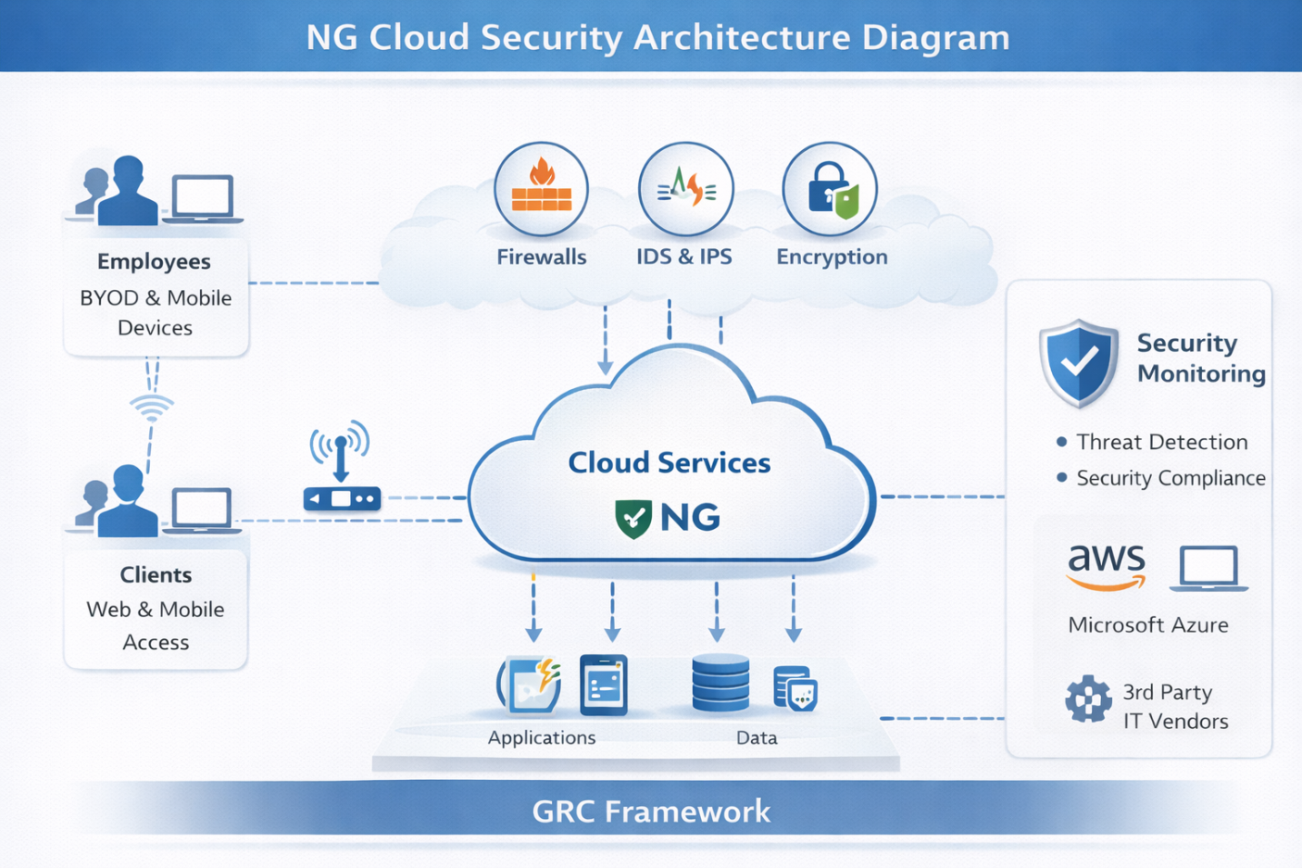
Fig.1-: NG Cloud security architecture diagram

3. Studies on Security Frameworks and Models.
3.1 The introduction to the security frameworks and models
Organizations in the information security environment have partnered with proven structures and frameworks to manage risks in a systematic manner so as to address compliance, as well as enhance their overall security stance. The two most popular frameworks are the Information Technology Infrastructure Library (ITIL) and the ISO 27000 family, in particular, ISO 27001, and ISO 27002.
ITIL is a collection of best practices that aims at aligning the IT services to suit the needs of the business and providing continuous improvement in the services. The framework of ITIL has a process of Security Management that makes sure every IT service of the company is aligned to security needs of the organization.
• ISO 27000 is a series of information security management standards. The most majority of the standards under the ISO 27001 standard has a guideline on how to introduce a system of Information security management (ISMS) to ensure that an organization secures its sensitive information, ensures business continuity, and regulatory compliance.
3.2 Analysis of how they have been applied in Real world.
These frameworks are normally used in real life situations to develop security policies, risk management, and ensure that data protection laws are maintained. As an example, information security risks are mitigated by adopting ISO 27001 by multinational organizations operating globally. To give a good example, Amazon Web Services (AWS) conforms to ISO 27001 in an attempt to make its cloud service to conform to high security standards.
On the same note, the ITIL is a popular tool in huge enterprises to make IT service provisioning smoother. Companies such as Barclays in the financial sector have adopted ITIL process into its IT governance and security management to ensure that it delivers its services in the best way possible and also to secure the protection of its information.

3.3 Diagrams and Charts
The following are some of the diagrams which can illustrate the main elements of these frameworks: Importantly, the ITIL Framework Diagram illustrates the most crucial concrete phases of the service lifecycle, specifically; attention is paid to security management processes, namely, Risk Management, Incident Management and Change Management.
• ISO 27001 ISMS Model: A flow chart illustrating the cycle of an ISMS implementation such as planning, implementation, monitoring, and continuous improvement processes, as well as the areas, in particular, risk assessment and control objectives.
These frameworks include defined methodologies through which organisations use to protect information, promote compliance, and actively deal with security risks in a well-organized way.

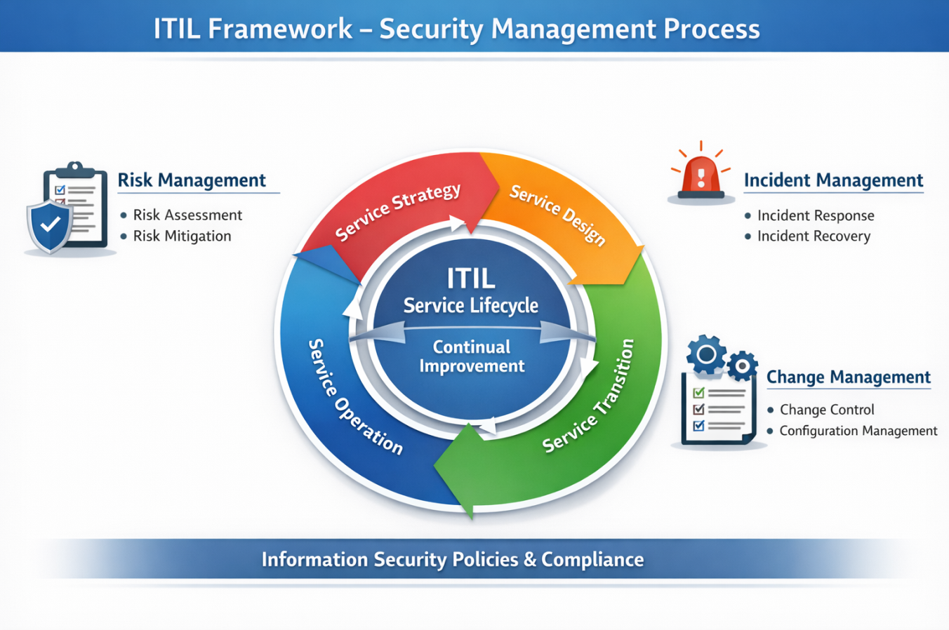
Fig-2: ITIL Framework - Security Management Process.
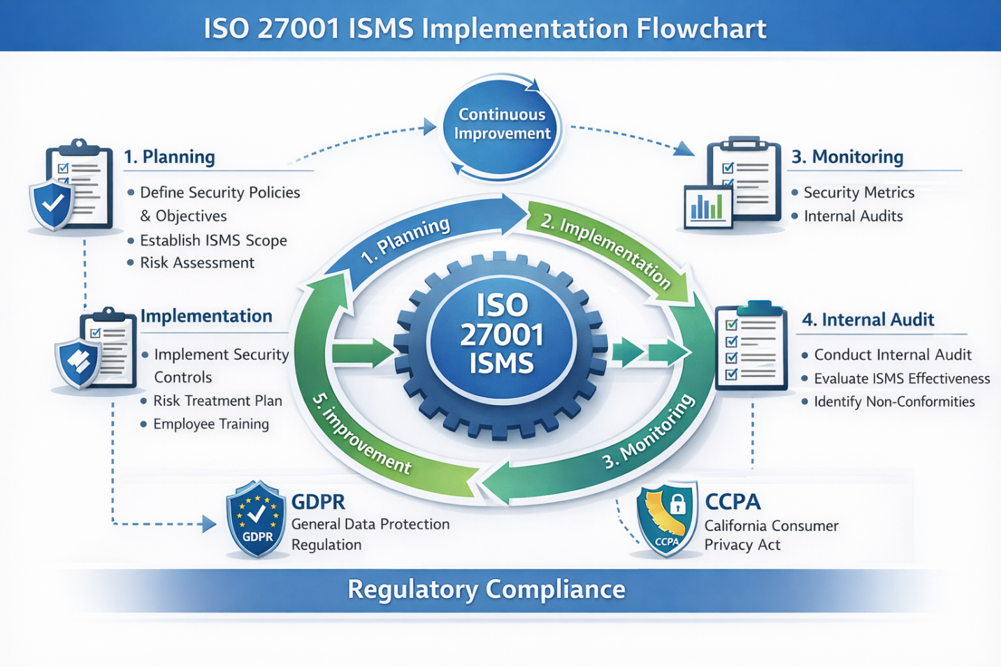
Fig.3: ISO 27001 ISMS Implementation Flowchart

4. Strategizing the Security, Governance and Compliance of Approach of NG
4.1 Compliance (Laws and Ethics)
4.1.1 Introduction to the Compliance Requirements That Are Important to NG.
Being a multinational company, NatureGreen (NG) will have to go around an intricate landscape of data protection regulations and laws to adhere to its operation. The General Data Protection Regulation (GDPR) has become one of the foundations of data safety in companies that process personal information about people in the European Union (EU). The GDPR establishes high standards of regulations in the collection, processing and storage of personal information, creating an explicit consent to the information contained in the data, and the ability to access, and erase personal data, and data security throughout its lifecycle. Considering that NG operates on an international level, it should also adhere to the local data protection laws including the California Consumer Privacy Act (CCPA) which offers the same data rights to California residents and the Data Protection Act 2018 in the UK.

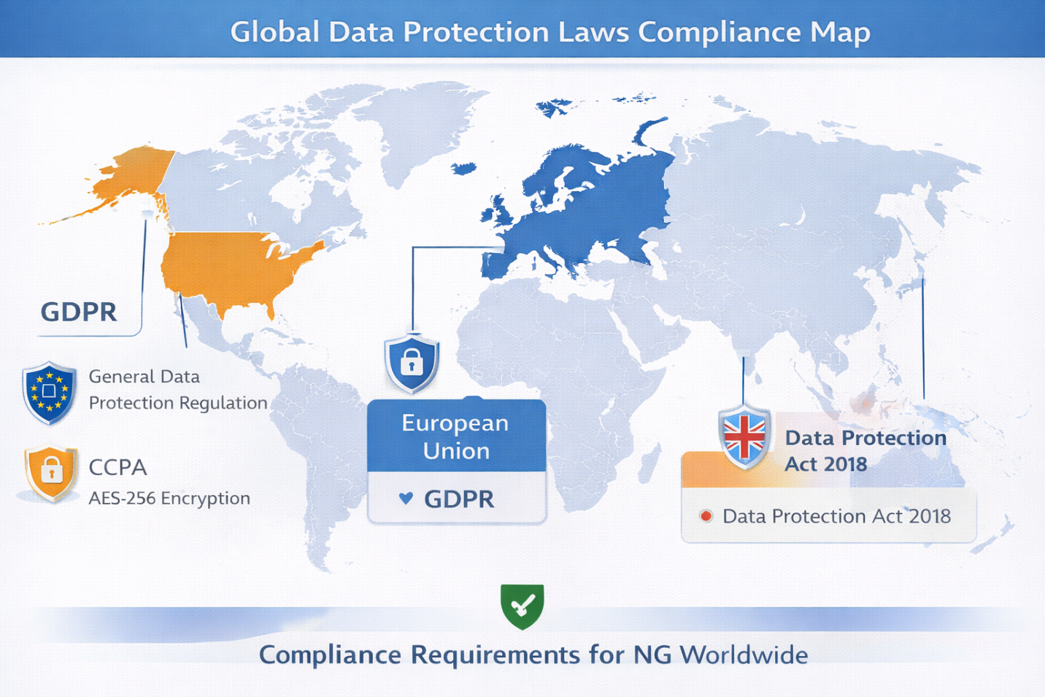
Fig.-4: Compliance Map of Data Protection Laws around the World

4.1.2 Data Security and Privacy Ethical consideration.
Besides legal adherence, NG should employ powerful data handling ethics. It involves making sure that there is transparency concerning the data collection practices and makes the customers aware of their rights as well as putting in place measures which safeguard the information about them (the customers) so as to ensure that there is no unauthorized access or abuse of their information. Ethics are also involved in keeping data subjects treated fairly, in confidence and not in defrauding them with the purpose of making profit. The data governance approach of NG needs to value the privacy as a paramount right in facilitating trust and ensuring alignment with the values of fairness, accountability and transparency

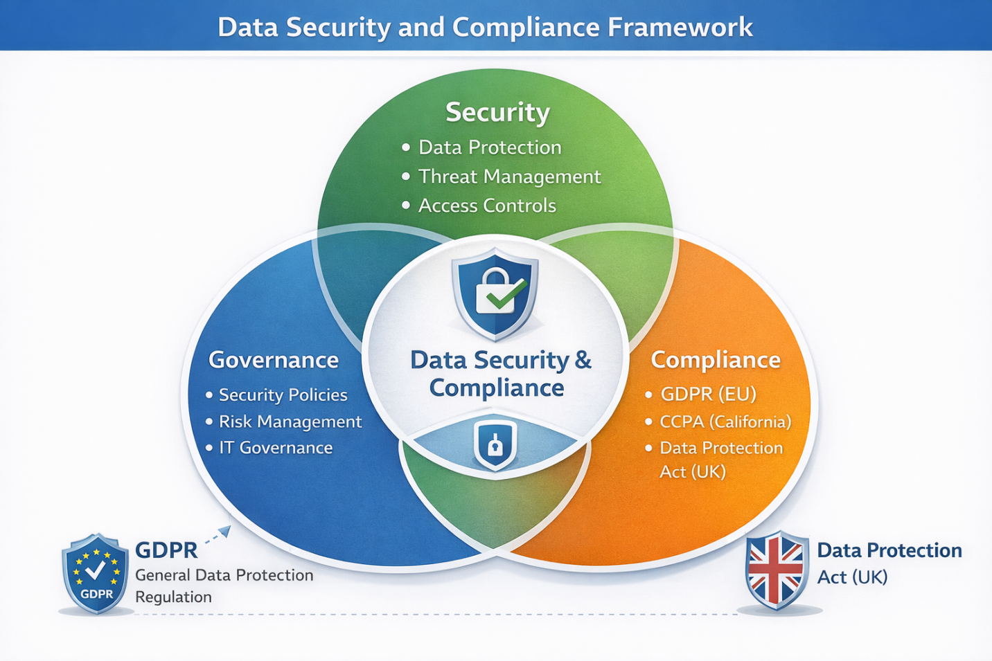
Fig.-5: Data Security and Compliance Framework Venn diagram

4.2 Security Governance and Strategy planning.
4.2.1 Governance Model(s) to Explain the Management of Security and Compliance.
Governance models play a big role in the security management processes within an organization towards compliance. One of the most popular models is the Governance, Risk, and Compliance (GRC) framework that combines security and risk management with compliance into a single model. GRC assists organizations in specifying responsibilities and roles, risk assessment, and introduction of policies to alleviate security risks and secure compliance to the regulatory standards. Corporate Governance is another model that has been shown to be efficient and focuses on watchdogs on the top organizational levels and where security became and remains a part of corporate strategy.

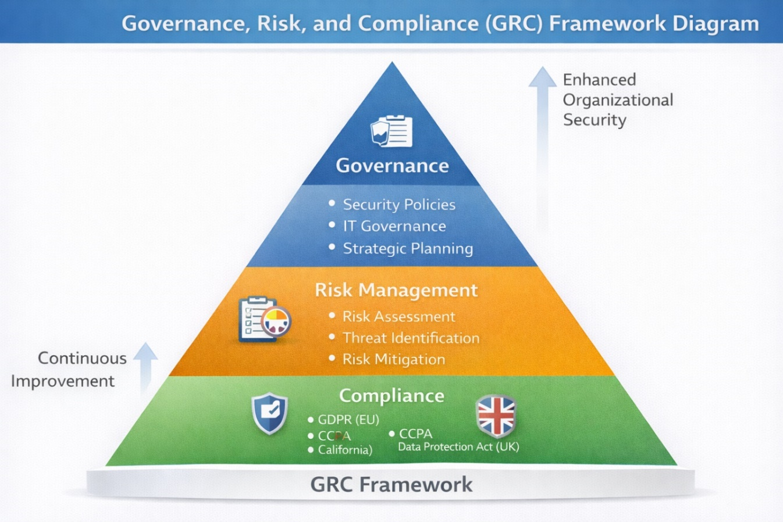
Fig.-6: Governance, Risk and Compliance Framework Diagram

4.2.2 Strategic Planning Processes NG needs to embrace.
The strategic planning process that NG should adopt should bring security and compliance goals in line with the business goals. This involves the establishment of a clear vision of security, key performance indicators (KPIs), and regular review of security policies and practices to adapt to the new threats. NG needs to consider implementing a risk-based approach of security and allocating resources in order of priority of the most critical vulnerabilities. Additionally, the strategic plan should include continuous monitoring and standard audit in order to guarantee the effectiveness of security precautions and adherence to regulations.
4.3 Security Policies
4.3.1 Development of Security Policies to support the needs of the people
In the case of NatureGreen (NG), the importance of the development of extensive security policies must be considered to safeguard the sensitive data and make sure that the organization will adhere to the international standards. The policies must cover such crucial areas like Data protection, access control and incident response. In particular, the policies that will be introduced by NG must control the application of personal devices (BYOD), encrypt data in transit and rest, and describe secure communication patterns regarding remote employees. As well, policies must have stipulated rules of employee conduct, which declare a given behavior as acceptable when using a company resource, and detail what happens when a policy is violated.
4.3.2 The Risk Management Strategies and the Value of Policy Enforcement.
The issue of risk management is a critical component that helps in detecting, analyzing, and eliminating security risks. Regular risk assessment should be performed by NG to determine the possible vulnerability and threats and mitigate the risks with the appropriation of such strategies as defense in depth and multi-factor authentication. There is no value of overstating the significance of policy enforcement, as it will be used to ensure all employees comply with the practices of established security practices. This may be implemented by conducting a continuous training, automated surveillance and periodic audits which will assist in ensuring a compliant and safe environment within the organization.
4.4 Risk Management
4.4.1 The discussion of the possible security threats at NG.
The operations of NatureGreen (NG) abroad, the use of cloud services, and the incorporation of personal devices into the network are all factors, which expose the organization to numerous possible security risks. Data breaches and computer attacks are very dangerous especially with the accumulated bulk of sensitive customer and intellectual property information stored on different platforms. Also, the BYOD policy poses weaknesses where individual devices may lack adequate security controls as those of business-owned devices. Data interception or unauthorized access is also another danger further increased by the use of wireless networks. Vendor risks are also common as the dependence of NG on the services offered by other vendors subjects it to vulnerabilities of the vendor security practices.
4.4.2 Risk Mitigation measures proposed.
NG needs to undertake an integrated risk management framework in order to curb such risks. These will involve regularly checking on the vulnerability, using multi-factor authentication to access data, and the use of data encryption technologies. Security best practices have to be trained to employees especially when it comes to use of devices and handling data. NG must also develop strong incident response procedures that encourage quick response of any breach or security threat in order to limit the damage and recover within a short duration. Regulated audits and supervision should be able to reveal the possible problems before it gets out of proportion.
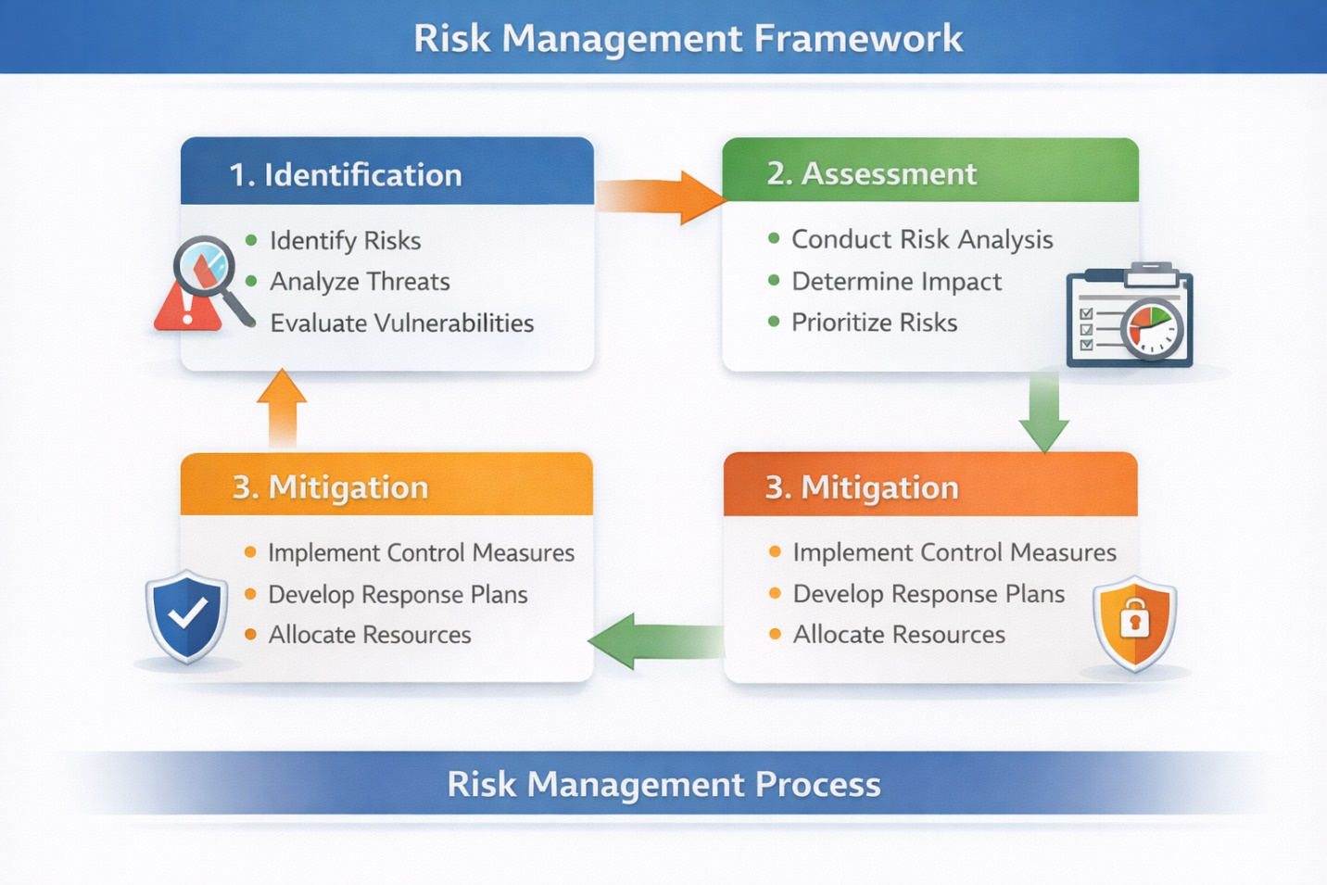
Fig.-7: Risk Management Framework- Flowchart

4.5 Security Management Models and Practices.
4.5.1 Security Management Practices that are recommended to be adopted by NG.
In the case of NatureGreen (NG), defense in depth strategy will be necessary as a means of removing different security threats. In this approach, there are several security steps, including firewalls, intrusion detection systems, and encryption, implemented to mitigate the external and internal threats. Also, NG must adopt multi-layered security measures which would encompass access control mechanism, multi-factor authentication as well as limited privilege policies to control access on the basis of roles and responsibilities. The frequent security audits and pen testing are essential to have the vulnerabilities detected and mitigated in time to have a strong defense to counter the threats that develop.
Fig.-8: Multi-layered Security Approach Diagram

4.6 Contingency Planning
4.6.1 Security Breach or Failure Contingency Measures.
NatureGreen (NG) needs to develop a detailed contingency planning strategy that would take swift action in case of a security breach or system breakdown. This has to encompass an incident response plan that is well defined and covers roles, duties and communication guidelines in case of a breach. NG must provide backup systems to facilitate business continuity and disaster recovery processes that would consider fast recovery of essential services. Regular simulations and exercises must also be carried out to train employees on security disaster. As well, NG ought to prosecute data recovery measures, whereby sensitive information is promptly recoverable and in full suitability to the privacy laws.
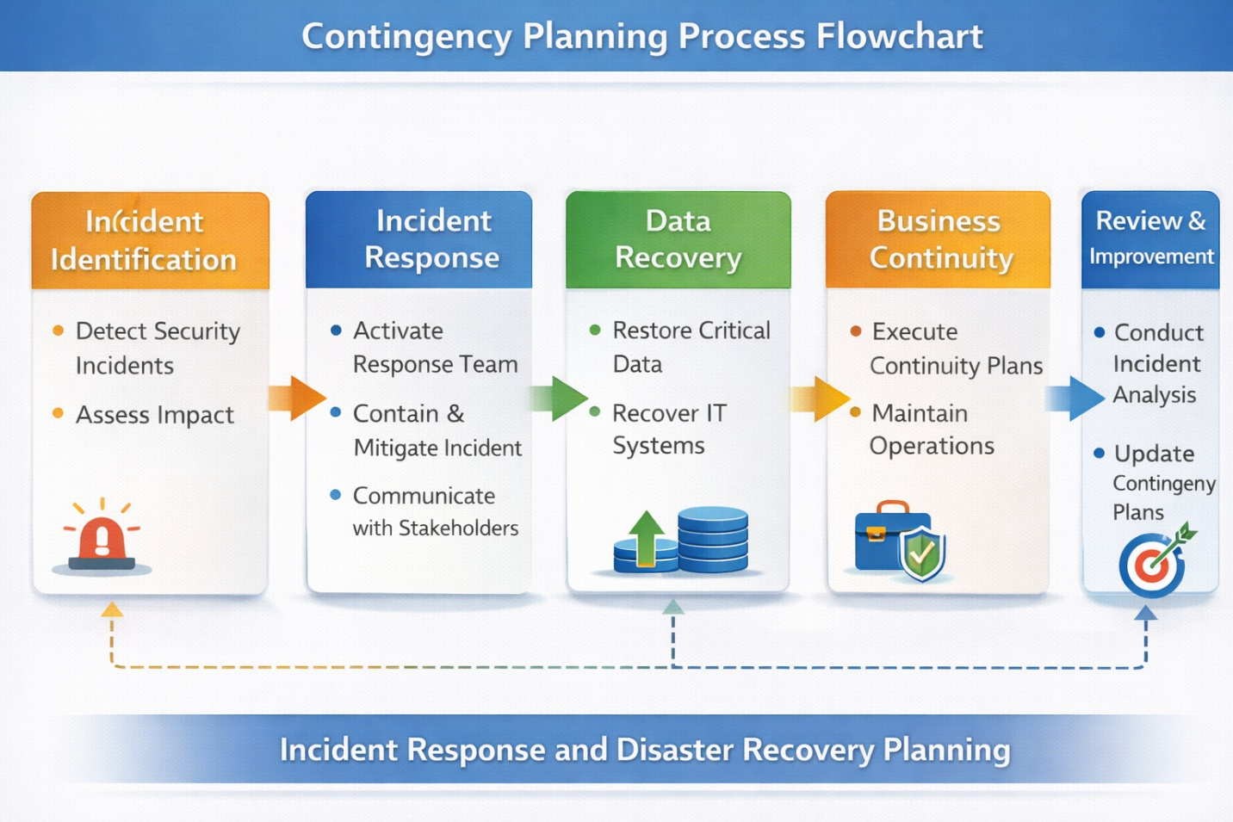
Fig.-9: Process flow ML. Contingency Planning Process

4.7 Protection Mechanisms
4.7.1 Protection mechanisms in terms of technology and procedures.
NatureGreen (NG) needs to use a mixture of technical and procedural protection solutions that will ensure that their data and intellectual property is secure. At the technical level, data on rest and in transit should be encrypted; firewalls, intrusion detection systems (IDS), and multi-factor authentication (MFA) have to be used to regulate access. Procedurally, NG must institute the strict access control measures that are applied to the admission of sensitive information to authorized personnel only. Besides, there should be periodic audits and surveillance in order to identify unauthorized access or anomalies. Training of the employee and measures to ensure safe handling of data are necessary to avoid unintended data loss or breach.
4.8 Service level agreements (SLAs)
4.8.1 Definition of SLAs of Security Services, Between the Roles of NG and Third-Party Vendors
In order to have expected outcomes on security services, NatureGreen (NG) ought to create Service Level Agreements (SLAs) with the stakeholders within the organization and third-party vendors. Such SLAs must describe certain security performance indicators, such as uptimes, security incident response time, and protection of the data. The roles of NG should involve looking after the integrity of the system, the encryption of the data, and guaranteeing the frequent security audits. Third-party vendors, especially coworkers that deal with cloud services or data that require high security, shall be held responsible in ensuring that they meet the security requirements, as well as responding to security incidents in a timely manner. There should also be SLA consequences in case of failing to meet or breaching them.
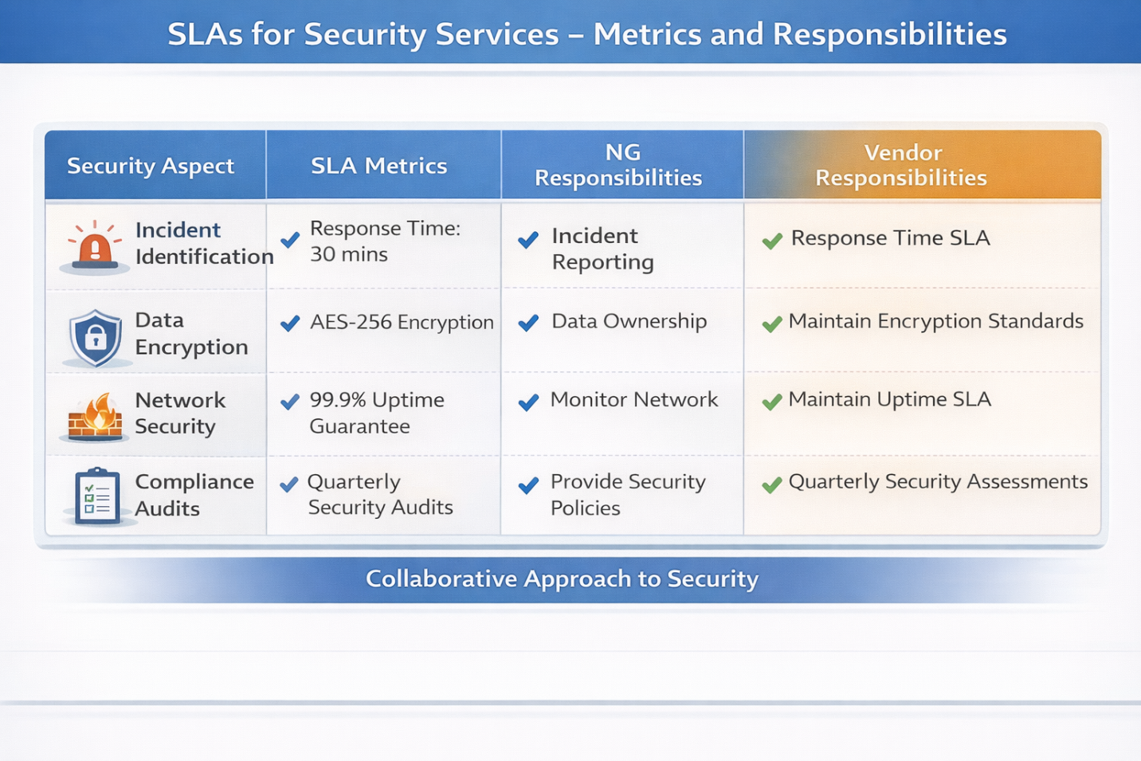
Fig.-10: SLAs at Security Services Metrics and responsibilities
5. Opposition to the Requirement of Preferred Revised Regulations and Standards.
5.1 The necessity to update security regulations and standards on a regular basis.
Organizations are it is important to keep changing their security regulations and standards in line with the constantly changing environment of Cybersecurity. With ever-changing and ever-introduction of new tools and platforms due to technological advances and perpetrators expanding their arsenal of skills and tools to commit crimes, regulatory systems should be flexible and adaptable. Periodically updating the security standards would make sure that they effectively represent the best practice of the time, prevent emerging threats, and adapt to new legal and ethical necessities.
5.2 Developing Cyber Threats and Technological Developments that Require Change.
Technological innovation leads to some new vulnerabilities emerging on a daily basis. There are other attack surfaces that have not been considered before because of the introduction of cloud computing, IoT devices, and AI. The complexity and pervasiveness of cyber threats are growing due to crashes like Ransomware, phishing, and data breaches. These dynamic threats emphasize the factor of real-time adjustment of compliance and security regulations as solutions to new areas of risks.
5.3 Advantages of remaining abreast with the Security Trends and Regulations.
Keeping abreast with current trends in security and regulatory developments has a number of important advantages to organizations. It will enable them to comply with the law, reduce risks related to cyber-attacks, and secure sensitive information. Moreover, the new security practices will boost the trust and reputation of the organization, creating better relations with the customers, partners, and regulatory agencies. Periodic reconsideration of security structures also pre-empts organizations to act proactively against emerging threats as opposed to acting in a reactive manner.

6. Assumptions Made
The following are the assumptions made in the performance of designing security approach on NG:
When developing the security strategy of NatureGreen (NG), one made a number of assumptions to guarantee the efficacy of strategies offered. These include:
1. The infrastructure used by NG is largely dependent on the cloud services: This supposition is premised on the international character of this firm and high level of usage clouds usage as service providers.
2. NG employs the policy of bring-your-own-device (BYOD): It is believed that a substantial part of the NG workforce accesses company resources with their personal equipment, and this policy presents an even greater focus of threat.
3. The emphasis is laid on regulatory compliance: It has been assumed that NG has to work in areas, in which the compliance with the regulations, like the GDPR, CCPA, and other regulations in data protection are necessary.
4. The intellectual property of NG is valuable: It is assumed that intellectual property of NG is one of the key resources of the company, and its security is very important to the competitive advantage of the organization.
5. NG has a distributed workforce: This consideration considers the possibility of employees working remotely or in different areas across the world and in which case, there will be need of maintaining secure methods of access.
6.2 Reason why These Assumptions are required/ relevant.
The assumptions are essential, as they help reveal the design of the security framework, which is centered on cloud security, managing, protecting data, and safeguarding intellectual property together with ensuring the security of remote access. The proposed security approach would not help NG to mitigate the fundamental vulnerabilities and operational realities without putting into consideration these factors.
7. Conclusions
This assignment explored why data security, governance, and compliance are important issues at NatureGreen (NG). It discussed applicable security systems, including ITIL and ISO 27000 and offered customized policies and risk management plans to secure the data and intellectual property of NG. The main lesson of the case brings a significant focus on the symbolism of a multi-layered approach toward security, the frequent revision of the compliance standards, and the use of solid incident response strategies by NG. Every organization needs an effective security strategy that offers defense against emerging threats, as well as, regulatory compliance, developing trust, and business sustainability in the long run.

8. References:
1. Westerman, G., & Bonnet, D. (2015). The future of IT governance: Flexing to the fast-paced technological change. Sloan Management Review, 56 ( 3 ), 1-12. https.mit.edu/article/predicting-the-future-of-it-governance/
2. Baskerville, R. L., & Siponen, M. (2002). Paradigm shift in information security. Information Systems Journal, 12(2), 103-120. https://ai|>Information Systems Journal, 12(2), 103-120. https://doi.org/10.1365-2575.2002.00126.x.
3. Somers, T. M., & Nelson, K. (2001). The variation of critical success factors on the phases of the enterprise resource planning implementations. Proceedings of the 34 th Hawaii International Conference on system sciences, 1-10. https:doi.org/10.1109/HICSS. 2001.926226.
4. AlHogail, A. (2015). Information security governance in adopting cloud computing: Evidence of Saudi Arabia. International Journal of Information Management, 35(3), 312-318. https: doi.org/10.1016/j.ijinfomgt.2015.01.005.
5. Gupta, A., & Sharman, R. (2004). IT governance: A model of a changing technological environment. Journal of Information Technology, 19 (4), 234-248. https://doi.org/10.1057. palgrave.jit. 2000044.
6. Dhillon, G., & Backhouse, J. (2001). Future trends on IS security studies: Deep into socio-organizational views. Information Systems Journal, 11(2) 127-153. https://doi.org/10.1046/j.1365-2575.2001.00115.x.
7. Peltier, T. R. (2016). Success of security issues within the organization: A risk management strategy. Information Systems Management, 33(1), 52-60. https://doi.org/10.1080/10580530.2016.1126143.
8. Reiter, S. (2020). Cybersecurity risk governance: Towards a more integrated operation. International Journal of Cybersecurity, 9(4), 210-228. https: doi.org/10.1002/j.1992-1041.2020.00004.x.
9. Hong, S., & Lee, J. (2015). The policies of information security and how organizational governance can help reduce risk. Journal of Cyber Security Technology, 1 (2), 59-76. doi:10.1080/23742917.2015.1062069.
10. Ross, J. W., Beath, C. M., & Goodhue, D. L. (2017). The strategic importance of IT of the digital age. Anonymous, Journal of Strategic Information Systems, 26(4), 228-244. https://doi.org/10.1016/j.jsis.2017.08.003.
11. Turel, O., & Roman, G. (2019). Digital business ethical concerns: The management of corporate image and security threats. Journal of Business Ethics, 154(3), 605-619. doi.org/10.1007/s10551-019-04355-5.
12. Willcocks, L. P., & Feeny, D. F. (2006). IT outsourcing governance: How contracts and relational governance apply in IT outsourcing. Information systems management, 23(3), 17-31. https: 10.1080/10580530600782055.
13. Choi, M., & Park, M. (2018). IT security and its management: The cybersecurity governance. Computers & Security, 75, 119-134.
14. He, W., & Xu, L. D. (2014). Information systems security risk management: Research agenda. Computers in Industry, 65(2), 7281. doi.org/10.1016/j.compind.2013.09.003.
15. De Haes, S., & Van Grembergen, W. (2009). Enterprise IT governance: Realising strategic alignment and value. Information Systems Management, 26(4) 227-245, p. 10.1080/10580530903297368.

