Foreign languages & cultural awareness
Hofstede Model
Student Number: 2120533
Ruksana Begum

Executive summary
Communication in the office for a leader may be hampered by managing relationships and diversity. In today's highly varied globe, it is essential to comprehend the cultural distinctions among other cultures. Due to the fact that every nation and culture has a different view of equality, leadership, and communication, communication between these many cultures may be challenging. Because culture encompasses so many aspects of what makes a person who they are, it is crucial to identify and appreciate these differences in order to have a more harmonious experience in the hospitality business. Culture is highly essential in any industry, including the hospitality sector. The study will concentrate on the USA and Japan, two nations that have certain similarities yet differ significantly when compared across the six characteristics identified by Hofstede.
Introduction
An individual's leadership, work, and life styles may change depending on their place of origin (Minkov, 2021). Power distance, individualism, masculinity, uncertainty avoidance, long-term orientation, and indulgence are the six categories into which each country is broken down by Geert Hofstede (2001), a Dutch researcher who conducted a study of forty different nations to ascertain their habits. The report will demonstrate how each nation is given a score based on its behaviors and culture.
Country A
United States of America USA
Cultural diversity is present in the United States. The majority of Americans are either first-generation immigrants or the offspring of immigrants from all over the world. For tourists from other countries, this diversity might be comfortable, but it can also make it challenging to distinguish between "typical American" cultural traditions. In principle, everyone should have an equal chance of success, despite the fact that there are significant economic, social, and cultural variations across the United States. Americans have a tendency to be quite casual, in part owing to their feeling of egalitarianism. Americans often get the impression of being rushed.
Hofstede Model to examine USA
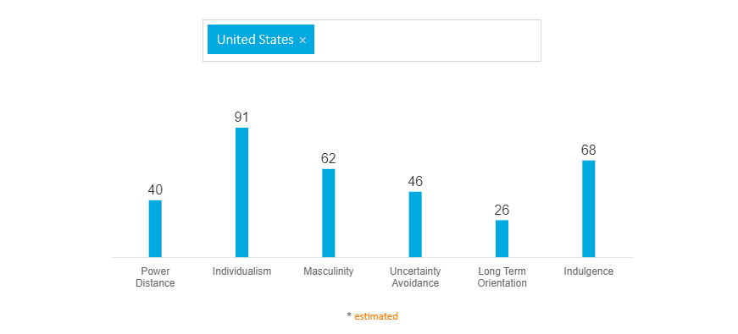
Figure 1: Hofstede cultural dimension, USA

The cultural motivators of many nations have been modeled using Geert Hofstede's categories that reference culture (Escandon-Barbosa, 2022). Out of a possible 100 points, the United States received a score of 40 for individuality and power distance, 62 for masculinity, 46 for uncertainty avoidance, 26 for long-term orientation, and 98 for indulgence.
Country B Japan
Japan is a culturally rich nation, and the Japanese people at first look seem to be among the most racially and socially homogeneous people groupings in the whole globe. In addition to ethnic differences, there are also cultural differences across the areas, the majority of which have persisted for a very long period but are not immediately apparent to a foreign visitor. “In accordance with Article 20 of the Japanese Constitution, minorities' religions including Christianity, Islam, Hinduism, and Sikhism are permitted to be practiced.”
Hofstede Model to Examine Japan
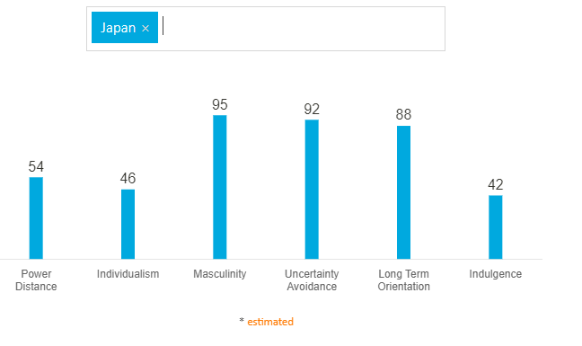
Figure 2: Hofstede cultural dimension, Japan

Japan scored out of 100, 54 in Power distance, 46in individualism, 95 in masculinity, 92 in uncertainty avoidance, 88 in long-termorientation,and, 42 in indulgence.
The level of acceptance of the disparity in power between higher and lower ranked persons in your society is known as the power distance. With numerous 54, Japan has middle to high ranking. As a result, Japanese workers are more inclined to follow their managers' instructions and refrain from challenging them. The US received a score of 40. Power distance is the one thing that Japan and the US have in common. Both in America and Japan, there are many of people who obey their superiors and respect them. This is the sole aspect of our cultures that we share in common with theirs.
Uncertainty Avoidance:
In Japanese culture, change is questioned and not given much respect. Americans are accustomed to change and undergo frequent change, but the United States scored 46, which is the exact reverse. People's job and personal lives are continuously changing, which keeps them on their toes and distinguishes one person from the next (Huang, 2019).
Individualism
The degree of individuality that a society maintains among its members, which is another way of saying that people are distinct, is the next dimension. Individualist societies are ones where individuals exclusively think about themselves and their family. With a score of 91, the United States receives the highest ranking among all nations. Japan only scored 46 out of 100 persons, whereas Americans place a high priority on independence.
Masculinity
The component of masculinity predicts that success, accomplishment, and competitiveness will be the driving forces in society. This is a habit that develops in childhood and lasts into adulthood. A low score in this area indicates that quality of life and compassion for others are the prominent societal ideals. Having a high quality of life is a measure of success in a feminine culture, and standing out from the crowd is not admired.In terms of masculinity, Japan scored 95 while the United States earned 62. 62 is a high figure for the US, but given the way Americans go about their daily lives, this is to be anticipated. The "I can do mentality" and "let's get it done attitude" are prevalent among Americans, thus that would suit with our culture. Japan has a larger percentage than we do because people there are more driven by their occupations and depend on them. Japan has such a large population that its citizens must labor long hours and create goods to maintain their employment, making it a manly nation (Satam, 2019).

Long term orientation
Moving on to long-term orientation, which is how every community must preserve some linkages to its history while addressing issues of the present and the future, civilizations place a varied emphasis on these two existential aspirations. Japan received an 88, while the United States received an extremely low score of 26. Due to Americans' propensity to research new information and confirm its veracity, this is taken into account (Minkov, 2021). The Japanese, on the other hand, consider their life to be a relatively brief period in the great history of humanity and hold the view that all one can do is their best in the present.
Indulgence:
Finally, Japan scored 42 while the United States received a score of 68. This dimension defines indulgence as the degree to which people attempt to restrain their urges and wants. The low score of 42 for Japan indicates that their culture has a propensity for cynicism and pessimism. People enjoy working as long as they have downtime, which is why the two nations I selected are so dissimilar (Heydari¸2021).
Do and Don’ts
Do:
Appreciate cultural differences; learn about them to have a better understanding of the nation; and keep in mind that whereas American societies like to work hard and play hard, Japanese society prefers to work hard all the time. People like treating themselves to the newest technologies and recreational pursuits.
Don’t:
Never make the assumption that one culture is better to another; stop using stereotypes; and refrain from imposing cultural standards.
Conclusion
The values, attitudes, and actions of individuals and groups are greatly influenced by culture. Everything that we do is affected by it, including how we connect with others and how we view the world.
References
Escandon-Barbosa, D., Ramirez, A. and Salas-Paramo, J., 2022 The Effect of Cultural Orientations on Country Innovation Performance: Hofstede Cultural Dimensions Revisited? Sustainability, 14(10), p.5851.
Heydari, A., Laroche, M., Paulin, M. and Richard, M.O., 2021 Hofstede's individual-level indulgence dimension: Scale development and validation. Journal of Retailing and Consumer Services, 62, p.102640.
Huang, S.S. and Crotts, J., 2019 Relationships between Hofstede's cultural dimensions and tourist satisfaction: A cross-country cross-sample examination. Tourism management, 72, pp.232-241.
Minkov, M. and Kaasa, A., 2021 A test of the revised Minkov-Hofstede model of culture: mirror images of subjective and objective culture across nations and the 50 US states. Cross-Cultural Research, 55(2-3), pp.230-281.
Satam, H. and Wisam, H., 2019 Hofstede’s Cultural Dimensions (Masculinity Vs. Femininity) And Its Impact On Earnings Management. (35), p.2953.

