ADVANCED CONSTRUCTION AND CIVIL ENGINEERING TECHNOLOGY
ACBA: 6004
STUDENT: 1910146

Contents
Introduction …………………………………………………………………………………………………………….…… pg. 3
- Task 1-Design and construction of the substructure and deep basement works, waterproof measures and consideration of neighbouring buildings............................ pg. 4
Task 1 continued …………………………………………………………………………..………………… pg. 5
Task 1 continued …………………………………………………………………………..………………… pg. 6
Task 1 continued …………………………………………………………………………………………….. pg. 7
Task 1 continued …………………………………………………………………………………………….. pg. 8
Task 1 continued ……………………………………………………………………………………….……. pg. 9
Task 1 continued …………………………………………………………………………………………… pg. 10

- Task 2 – Structural Frame ………………………………………………….…………………………………... Pg. 11
Task 2 continued …………………………………………………………………………………………… Pg. 12
Task 2 continued ………………………………………………………………………………………….. pg. 13
Task 2 continued ………………………………………………………………………………………….. pg. 14

- Task 3 ……………………………………………………………………………………………………………………. pg. 15
  - External envelope ………………………………………………………………………………………. pg. 15
External envelope continued ……………………………………………………………… pg. 16
External envelope continued …………………………………………………………….. pg. 17
External envelope continued …………………………………………………….……….. pg. 18
3.2. Roof …………………………………………………………………………………………………………. .pg. 18
Roof continued ………………………………………………………………………………….. pg. 19
- Conclusion …………………………………………………………………………………………………………….. pg. 19
References ………………………………………………………………………………………………………………..… pg. 20
References continued …………………………………………………………………………………. pg. 21
References continued …..……………………………………………………………………………… pg. 22
References continued ………………………………………………………………….………………. pg. 23
References continued …………………………………………………………………….……………. pg. 24

Introduction
The following report will aim to evaluate and explore the possibility of using an existing 1970’s site to construct a new large mixed used tower block.
As part of the report there will be three specific tasks explored, the first to make recommendations for the substructure and basement works, including waterproof measures while also considering implications to neighbouring buildings.
Task two will make recommendations for the structural frame taking in to account the proposed buildings purpose for use, adaptable and flexible.
Task three will make recommendations for the external envelope and roof covering, with considerations such as aesthetics and efficiency as well as conforming to local planning guides.

1.0 Task 1 - Design and construction of the substructure and deep basement works, waterproof measures and consideration of neighbouring buildings.

There are two basic considerations for this project type that could be considered, firstly that an excavation cannot be made without causing movement to the surrounding ground and secondly how the basement will be constructed. In terms of the ground movement due to excavations it is critical to determine the maximum movement, as these will not only depend on engineering considerations but also the economics of the project, (Burland, 2004).
As there are many possible foundation and substructure designs that could be considered for this type of project, each having both positives and negatives, under BS 5930:2015+A1:2020 it would be necessary to carry out a ground investigation (British standard institution, 2022) to establish what is beneath the surface, and dependent on these conditions will help determine what would be deemed a suitable foundation for the building, it may also be necessary to investigate the water table.
As part of the ground investigation and in order to determine what is beneath ground level, it is possible to check for any bore-hole data that may have been previously done in or around the area of the site. Fig 1 shows the proposed location of the site, while figure 2 is showing locations of the borehole locations nearest the proposed site. Bore-hole reference ST17NE128, (British geological survey, 2022).
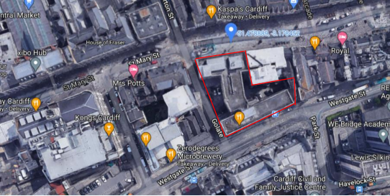

Fig 1. (Site location outlined in red).

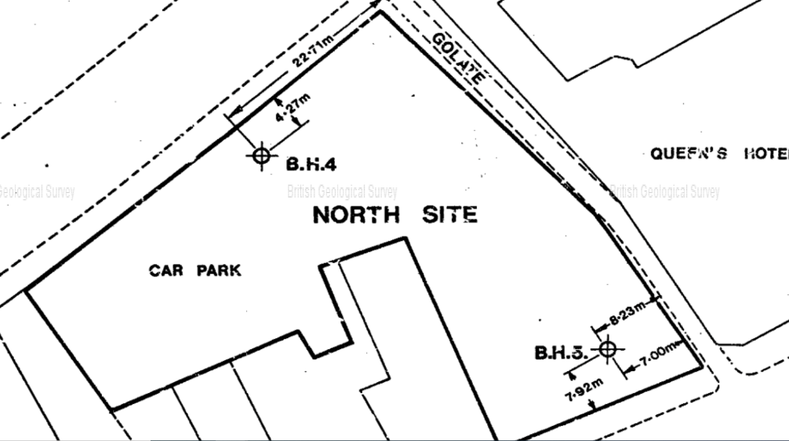

Fig 2 (Showing locations of boreholes near site location BGS (2020)).

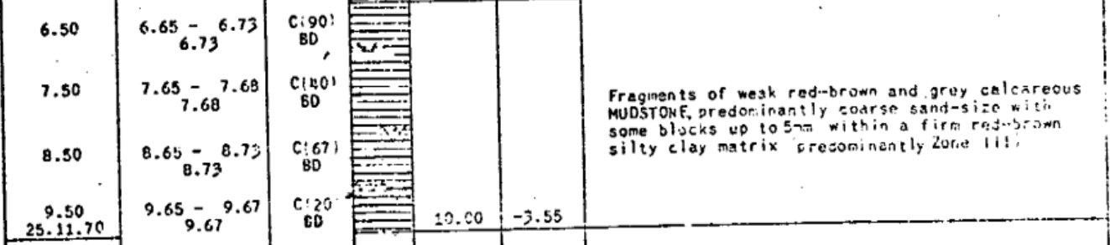
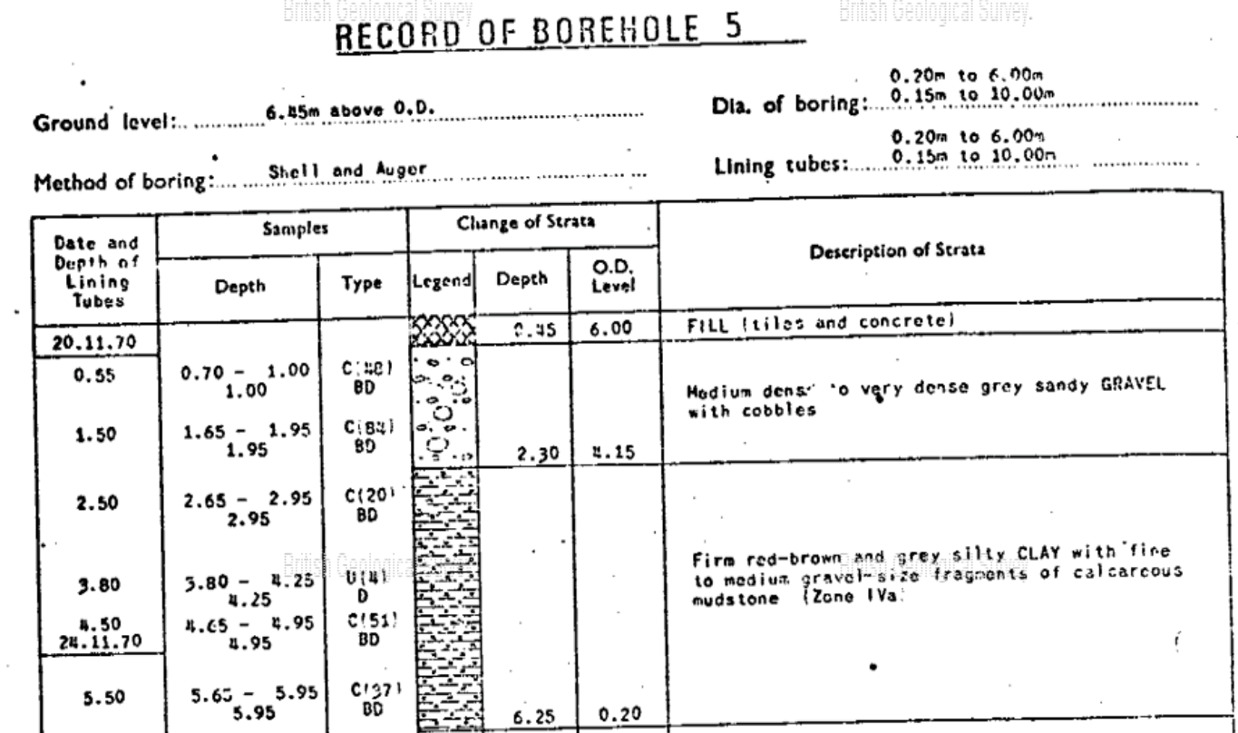
As you can see from figure three below, the ground configuration around the site is made up of Medium dense to very dense sandy gravel with cobbles down to almost three meters, then the data is showing a mixture of mudstone and clay down to ten meters.
Fig 3 (showing data from borehole 5 BGS (2022))

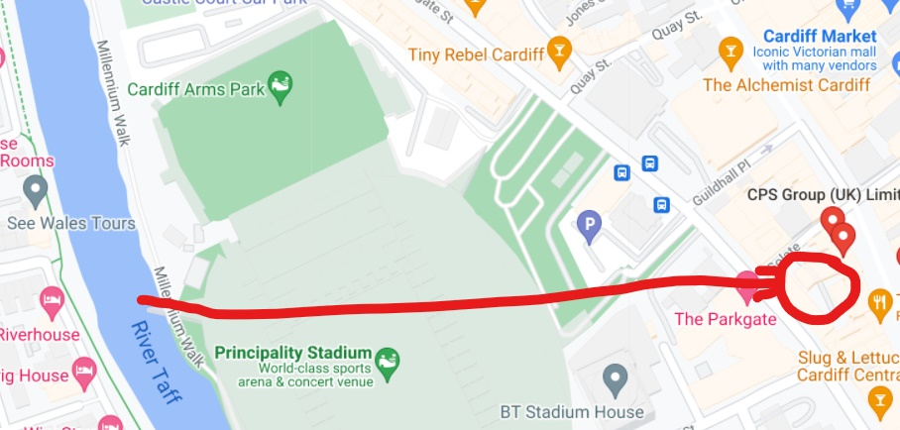
The image below shows the location of the site and its close proximity to the River Taff, while also being close to where the River Seven runs in to the Bristol Channel. Due to this it would be necessary to investigate the water table, and dependant on the results of this investigation will deem if there is an issue with water that will need to be addressed.
As with a ground investigation the use of bore holes could be used to identify water levels as well as the ground make up.
As you can see from fig.4 below, from bore hole five, reference ST17NE128, British geological survey (2022), it shows that water was detected at just below four meters.

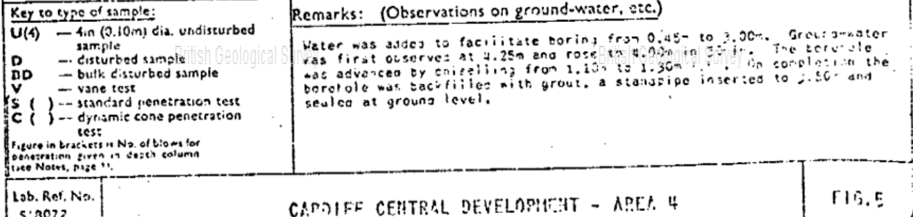
Fig 4. (Showing water present at borehole test. BGS (2022))

As there is ground water identified close to the site it could be assumed that there will also be water directly on the proposed site at the same depth as the borehole data showed. Therefore due to the depth of the basement required to incorporate the four stories, it is assumed this will reach the water table. In this instance it would be critical to eliminate the groundwater before any construction work begins (Powers et al, 2007), this is required to be done because the water in the ground increases pressures and can add substantial load to the lateral earth pressures to the sides of the excavation, while also any water pressure at the base of the excavation could cause an upward force Nicholson, (2015). These forces and pressures, if not dealt with correctly could result in the failure and flooding of the excavation.
The ground water can be eliminated through a variety of ways, one option would be to use deep well pumps, option two would be the use of shallow well pumps and option three would be a multi stage well point system. Which system to be used could depend on a few factors such as total over all depth. Punmia et al (2005) suggests for excavations that exceed a depth of over sixteen meters deep, it is preferable to use the deep well pump system, a multi-point system would be used if the excavations are more than six meters below the water table, whereas a shallow well system could be used up to a maximum depth of ten meters.
The use of a multi stage well point system for deep excavations can also be more cost effective than the deep well alternative. (Punima et al, 2005)
The subsequent water that is removed could then be diverted to the nearest/most appropriate watercourse or alternatively re-used for purposes such as a vehicle cleaning station.
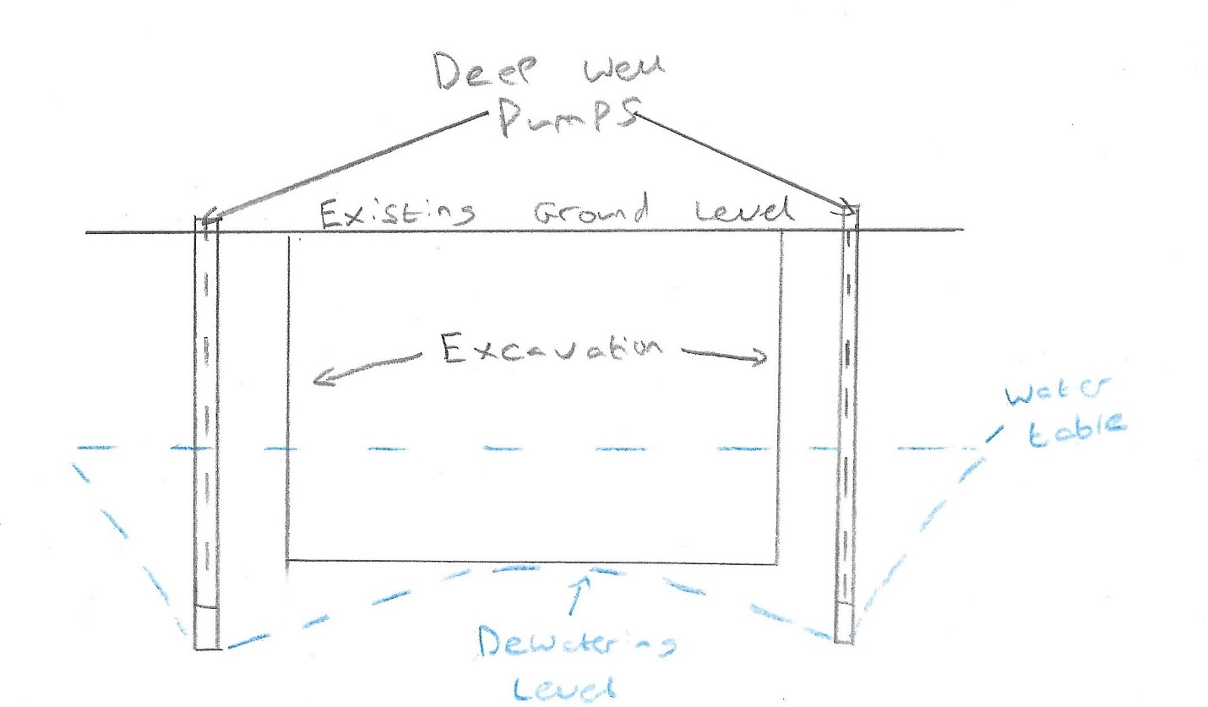
Fig 5 shows a deep well system and fig 6 shows a multi stage well point system design.

(Fig 5. Deep well system)

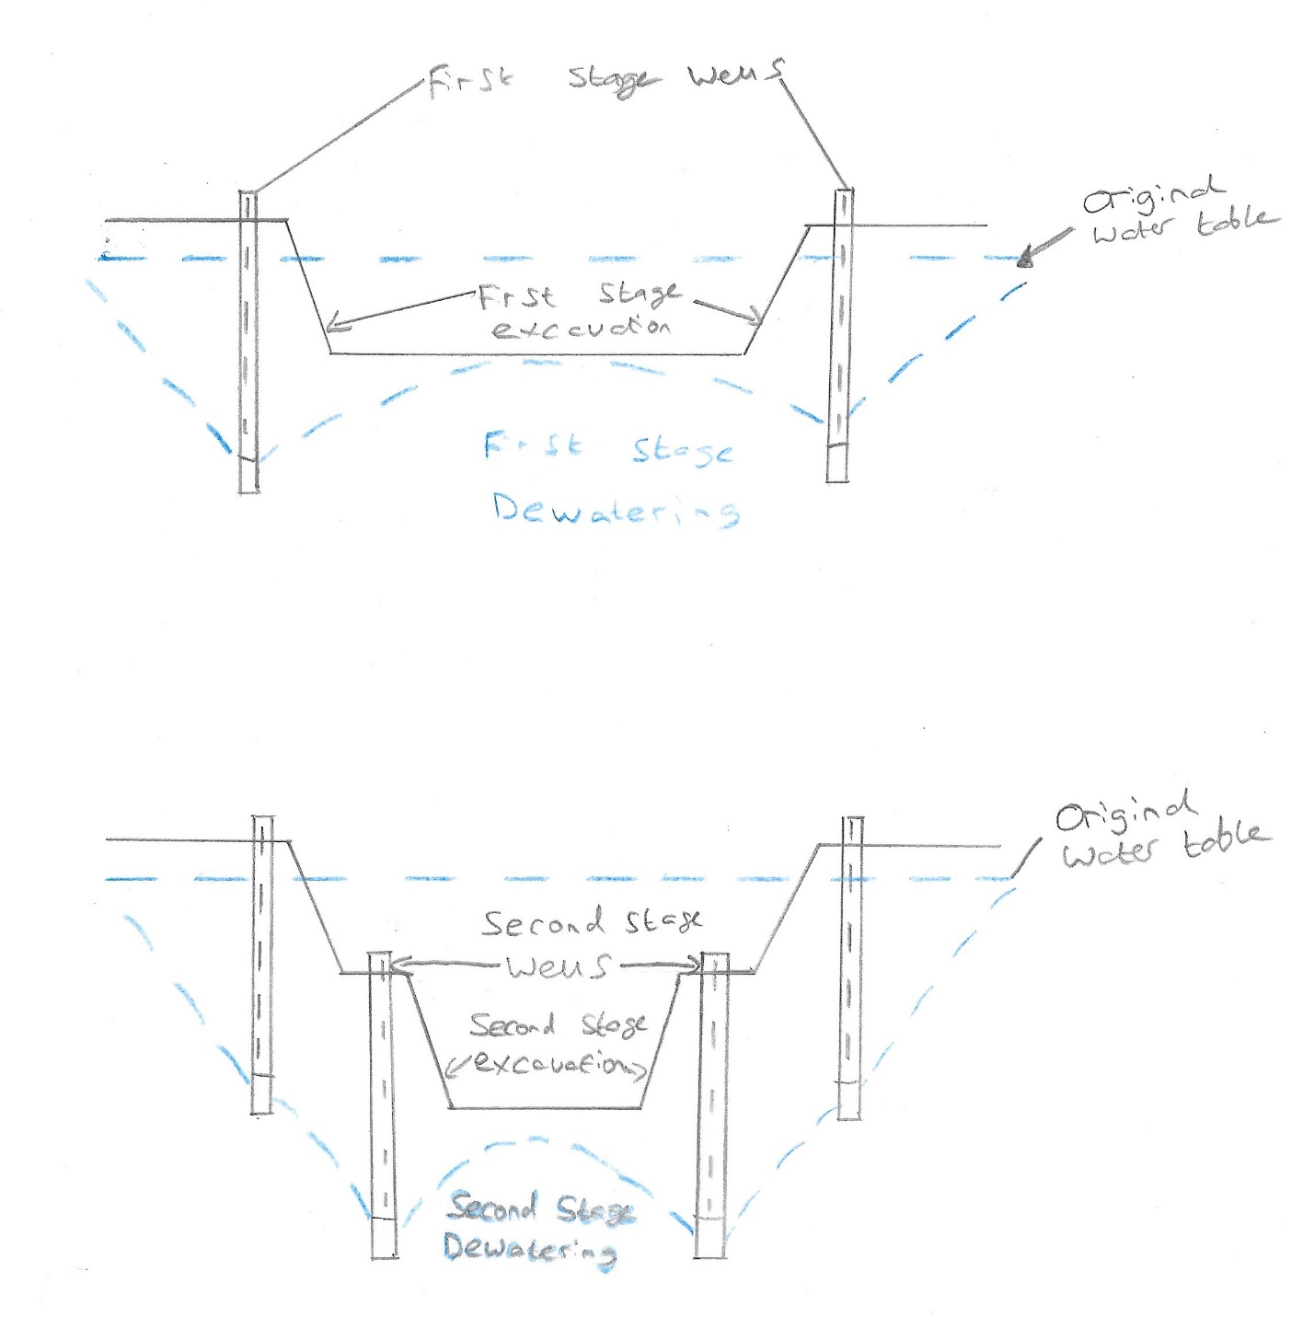
(Fig 6. Multi stage well point system.)

Once the ground water level has been successfully reduced it will then be possible to begin construction of the basement. As it can be considered as a deep basement (Basement information centre, 2022,) the design and construction of the retaining walls and support system will require careful consideration, design and the monitoring of performance, for this build this is extremely important as it is classed as an urban area with other buildings in close proximity which could be affected (Tan et al, 2008). Due to this the ideal method would ideally be one that produces low vibration and noise.
Possible Options for this project could be Secant piles, diaphragm walls, king post walls and sheet pile walls, (Balfour Beatty, 2022). Each have their advantages for a project of this type, such as secant piles and diaphragm walls will cause little to no vibration with only the noise of the machines required for install (Marlapalle et al, 2018). Though as this project requires a high level of waterproofing as there is to be a spa/gymnasium and plant room as part of the basement along with the carpark, and the proposed project is within very close proximity to neighbouring buildings and due to the size of the overall building, the option recommended would be the diaphragm wall.
A diaphragm wall offers good load stability (Wharmby, 2010), it will cause minimum disruption to the neighbouring buildings and with a water bar added along the joints these together provide excellent water tightness.
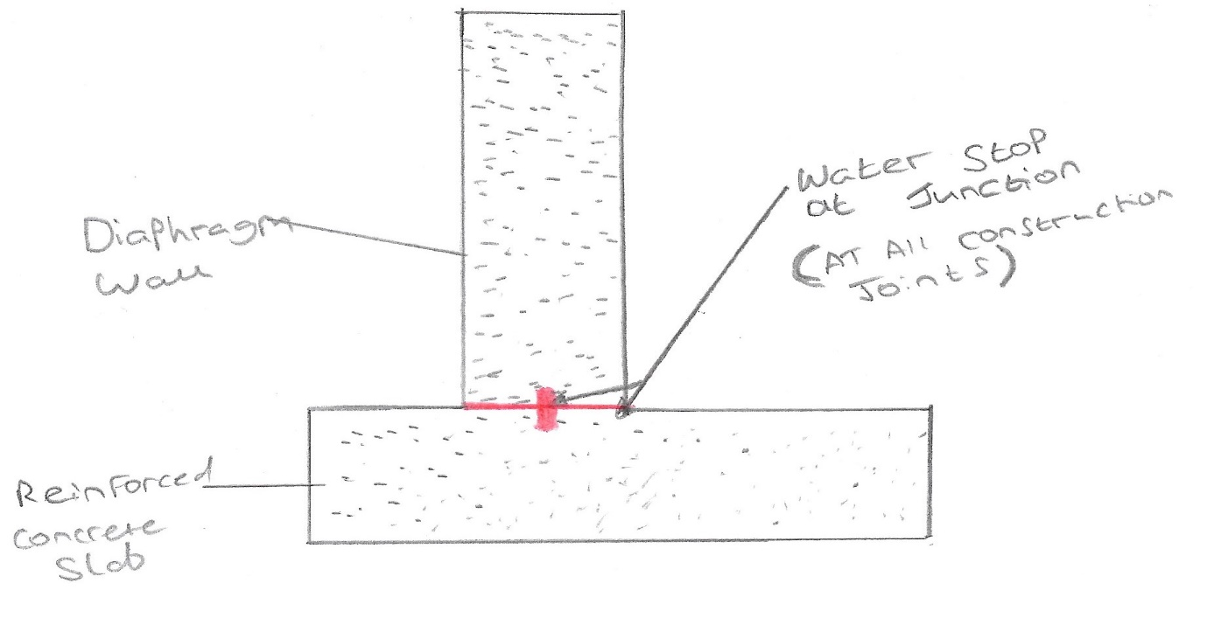
(Fig 7. Showing Water stop/bar at a junction)

The depth of the diaphragm wall should go to a depth below the finished floor level in order to avoid water ingress. It should be noted that even using the diaphragm wall which could be seen as the best solution for waterproofing due to it having the least amount of vertical construction joints of all retaining wall systems, that no retaining walls can be assumed to be fully water tight, (Larisch, 2016). Due to this in line with Approved Document C the use of BS 8102 is recommended for the design for further waterproof measures.
Under BS 8102 there are three types of basement waterproofing:
- “Type A” (barrier protection) which requires a tanking membrane
- “Type B” (structurally integral protection) relies on the quality of the concrete structure only and is not suitable for all applications
- “Type C” (drained protection) allows water into the structure, but collects it and drains it away from the occupied areas.

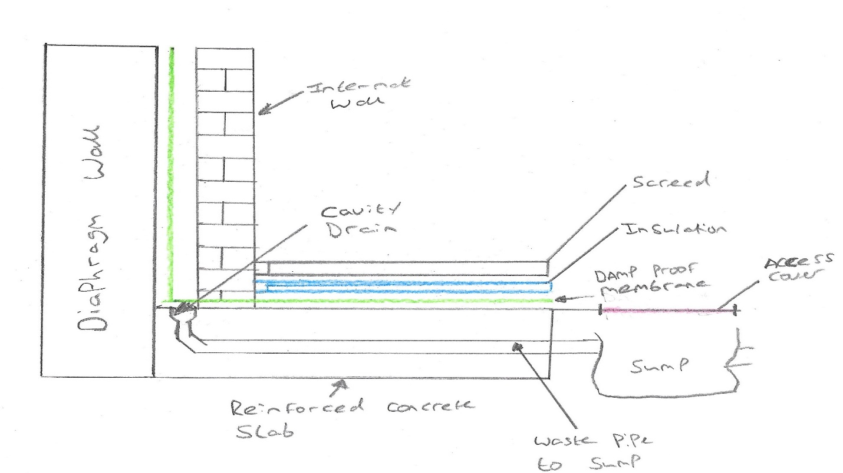
As previously mentioned, Larisch (2016) believes no retaining wall system is completely waterproof, due to this it is recommended that the use of Type C under BS 8102 is used along with the diaphragm wall.
(Fig 7.1 Cavity drain)

It is recommended that for the foundations and basement construction, the use of the construction method ‘Top Down’ be utilised. This method has many advantages such as allowing savings in terms of lead time, due to simplified working procedures, greater safety and improved efficiency of excavation (Ji et al, 2019). The foundations recommended for this project would be bored piles, as noise and vibration is relatively low thus reducing disturbance to adjacent piles or structures, a pile of any length can go into any soil type down to suitable bearing material, there is no need to excavate large areas, high bearing capacity can be achieved with potentially greater economics (Ground engineering Ltd, 2017, Centrum, 2018, Pile tech, 2021)

Even
cast in-place concrete diaphragm walls with very low permeability can’t be considered
completely water tight despite having the least number of vertical construction joints of all
embedded retaining wall systems.
Even
cast in-place concrete diaphragm walls with very low permeability can’t be considered
completely water tight despite having the least number of vertical construction joints of all
embedded retaining wall systems.
Even
cast in-place concrete diaphragm walls with very low permeability can’t be considered
completely water tight despite having the least number of vertical construction joints of all
embedded retaining wall systems.

2.0 Task 2 – Structural Frame
For the proposed project, the layout of the plot lends itself to an ‘L’ shaped building to fit nicely around the adjoining building and to make most of the available space. (See figs 8, 9)

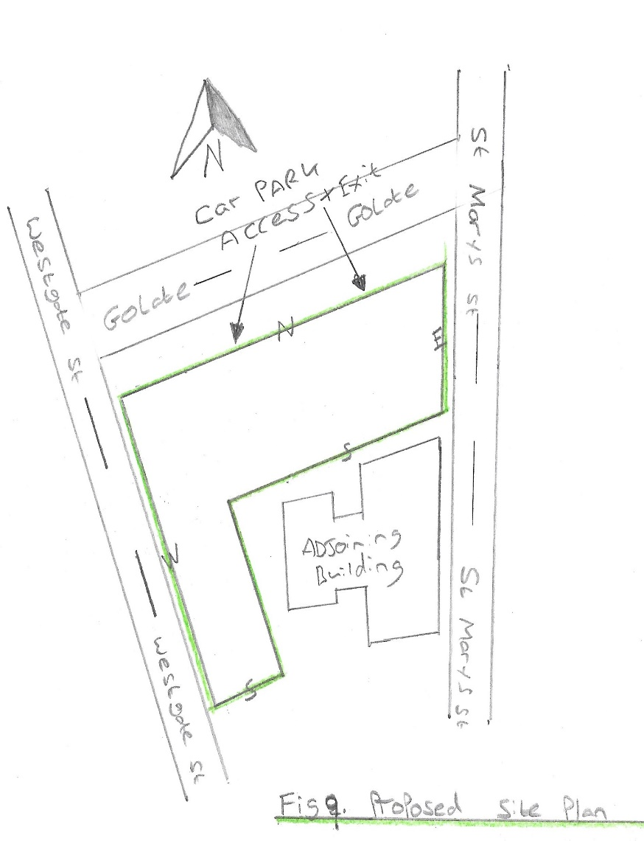
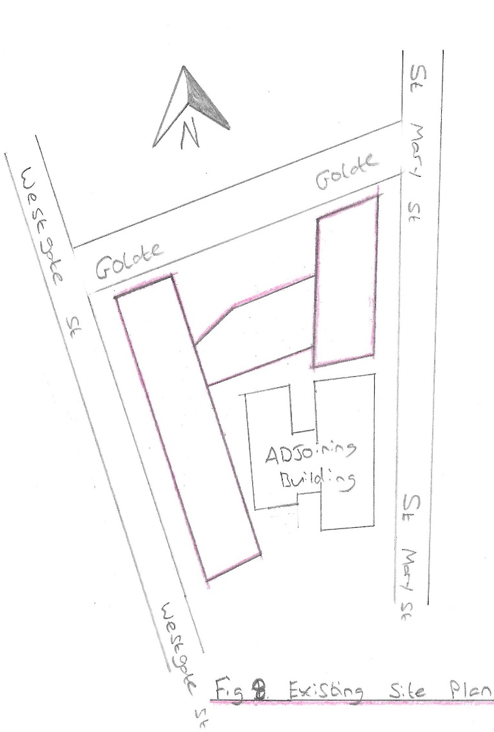

As the proposed building is to be a multi-storey building with 16 floors above ground level, it is classed as a high rise building. Any building over 18metres high or with over 7 stories, whichever comes first is classed as a high rise building, (Gov.UK, 2021), and under the Cardiff City supplementary planning guide (SPG) tall buildings are considered to be those of 8 storeys or more or higher than 25 metres. When thinking about what frame to use for this type of build it may be necessary to consider the weather in particular the wind (Rajmani, 2015), (see fig.10) and even possibly the snow fall (See fig 11) when considering the weight of a building.
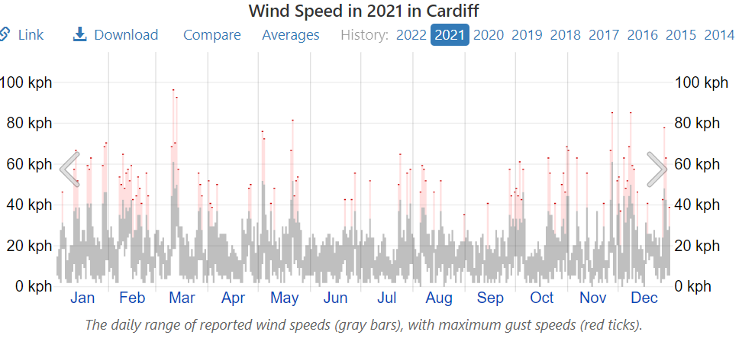
Fig 10. Wind speed in Cardiff during 2021. (Weather spark.com 2022).
As you can see the wind speed in Cardiff throughout a yearly period can vary with the daily range being relatively low, though the maximum gust speeds that can occur are significantly higher. The wind direction itself comes predominantly from the west (Weather spark, 2022), if the wind was to add any extra forces to the building this would be counteracted by the supporting north elevation.
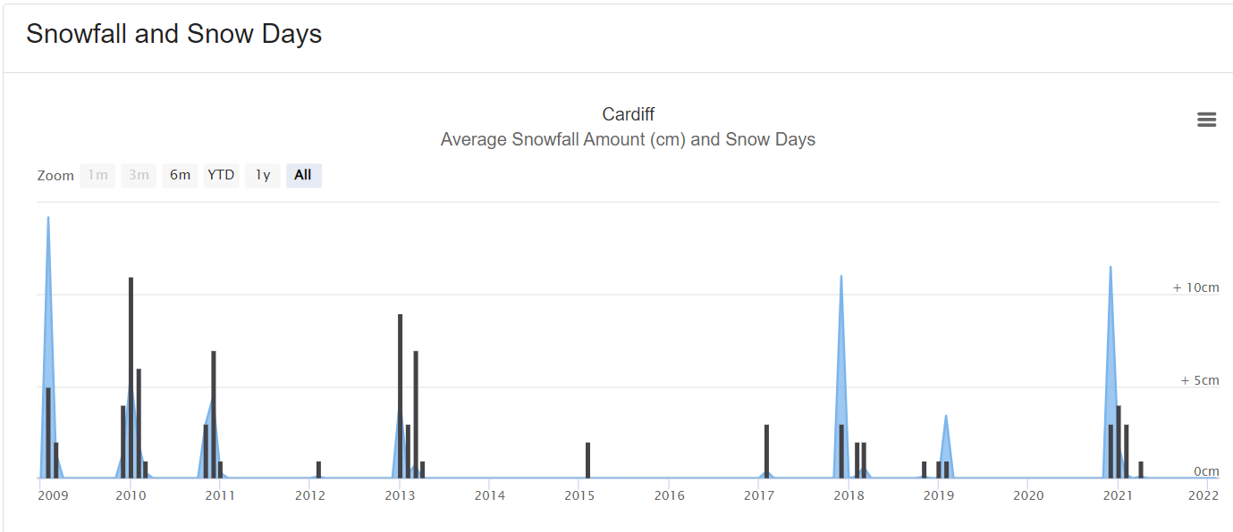
Fig 11. Average snowfall since 2009. (World weather online 2022).
From the data above it shows that snow fall in Cardiff is very minimal throughout a year, though it is possible to have heavy snowfall on some occasions therefore this would need to be considered when designing the building due to extra weight as well as the design of the roof to be considered also.
There are three common materials used for constructing structures, these are steel, concrete and timber, with all three having great reasoning as why they should be used. For this project a reinforced concrete frame would be recommended. Reinforced concrete (RC) frame structures are built from concrete which encloses steel bars also known as rebar, the advantage of using this for the frame is because the concrete is very strong in compression and the rebar is very strong in tension. While concrete is fairly inexpensive compared to steal and easy to produce on site. (Yakut, 2004).
Due to the many floors and height of the building including apartments there are also many other positives and advantages to using an RC frame. Taking safety in to consideration and especially fire safety, concrete is one of the best fire resistant materials offered to the construction industry which was classified as an A1 material under BS EN13501-1:2007-A1:2009 (NBS, 2007).
This is due to such qualities as being able to act as a fire shield allowing a safer way of escape for occupants, there is no need for additional paints or coatings as is needed with steel frames which if not applied correctly or in the right conditions, can cause the coating to peel off, or how the coatings fire resistance remains over a long period of time (Chen, 2015), thus causing major problems.
RC has great toughness in a fire, reducing the risk of structural collapse. It also as the added bonus of being generally easier to repair than other materials after fire damage allowing the building to get back to use sooner.
As the use of the building is to also be multipurpose with floors 0 to 6 to be designated for use as offices there is a need for this space to be flexible and easily adapted for change of use or purpose. To achieve this flexibility the number of columns in the office spaces would need to be minimal, the use of reinforced concrete columns and beams with pre-stressed concrete slabs would be able to provide this. (Rafal et al, 2017).
The RC columns on the floors 0 to 6 will need to be of a larger size and with more reinforcement in order to achieve the large span required for the office spaces (Guowei, 2000). These columns can also continue down the basement levels as the car parking will require large spacing, with the gym and spa also benefiting from this space.
Another factor to consider due to the multi occupancy of the building is the need for multiple egress and access points while also taking in to consideration disabled access under Building Regulations 2010, Approved Document M Volume 1 2015 edition. (NBS, 2015).
The building will house stair wells and lift shafts located at the south and east corners of the building with the main core being located centrally, using the voids as risers for the M+E services with access available for maintenance (Law Insider, 2022). The use of shear walls will be integrated to the building which will add stability and reduce any possible movement or damage from adverse weather conditions.

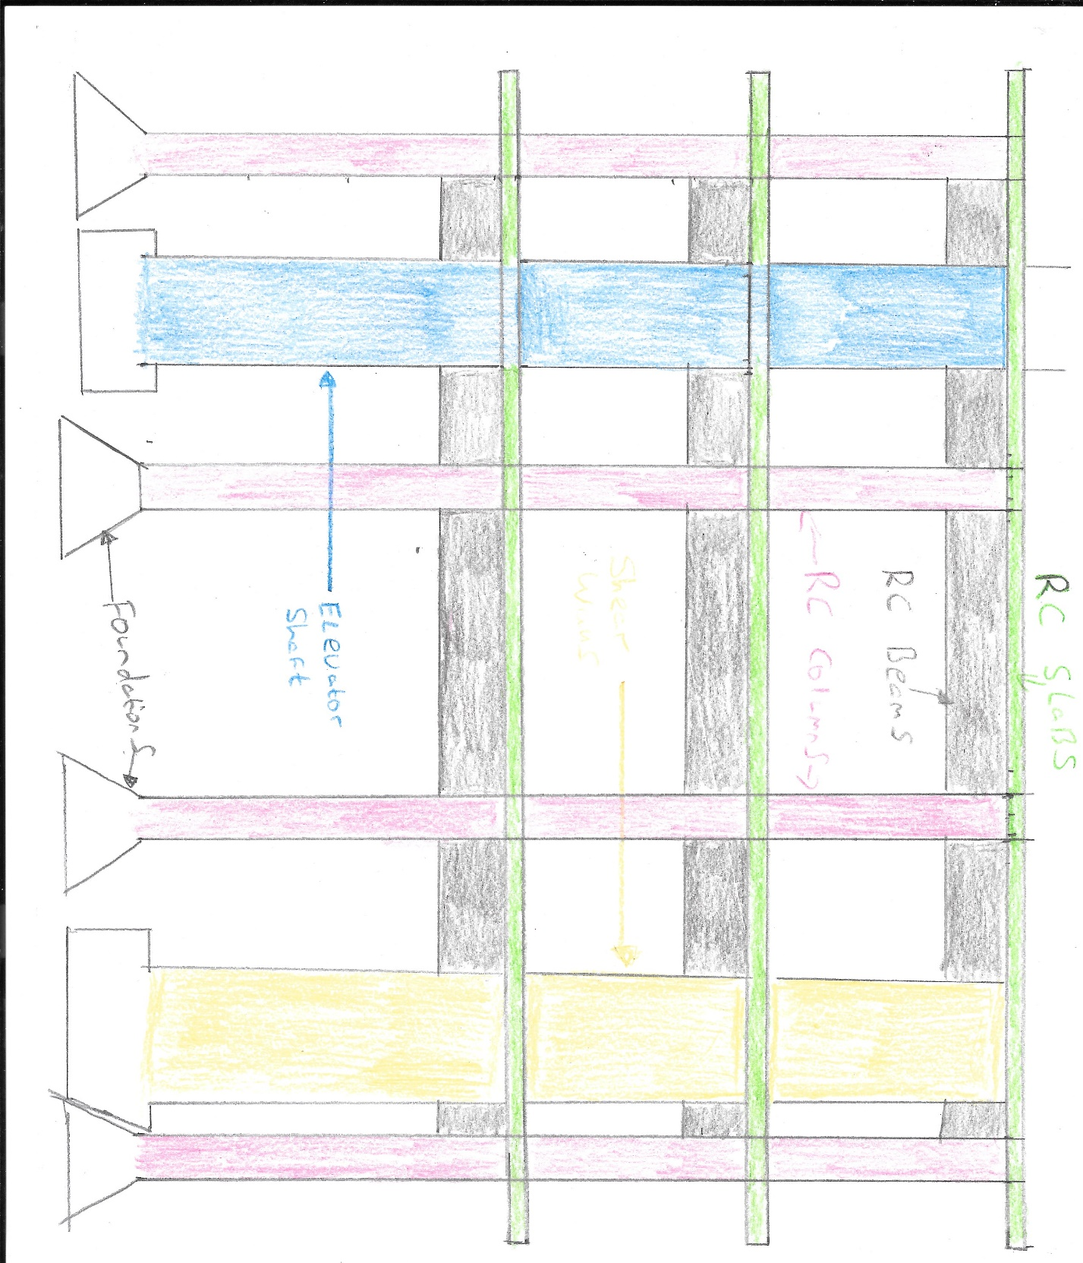
(Fig 12. Example of Reinforced concrete frame elevation)

3.0 Task 3 - Make recommendations for weathering the external envelope. This should consider both the wall cladding and roof coverings.

3.1 External Envelope
When considering a buildings external envelope there are many considerations to take in to account. These options identified by (Arnold, 2016) are:
- Fire safety
- Thermal performance
- Moisture protection
- Provision of light
- Acoustic performance
- System maintainability
- Material durability
Fire safety in buildings and the materials used for the building envelope plays major role in the projects design. After the Great Fire of London the London Building Act 1667 restricted the use of combustible materials on the exterior of buildings, yet in 2006 a minor change was made allowing combustible materials to be used on the outside of tall buildings (Jones et al, 2021).
Following on from the Grenfell Tower tragedy in London an adjustment was then made to the Building Regulations 2010, prohibiting the use of combustible materials on the external faces of high rise buildings (Jones et al 2021, Calabrò et al et al 2021).
As the proposed project is a high rise building and its multipurpose use, including rentable apartment’s fire safety would be of upmost importance, along with the other considerations previously mentioned. Other factors to consider due to the buildings location would be the City Centre Design Guide and in particular the ‘Tall Buildings Design Guide 2017’.
The Requirement B4 (1) of the Building Regulations states that:
‘The external walls of the building shall adequately resist the spread of fire over the walls and from one building to another, having regard to the height, use and position of the building.’
Under Approved Document B a building over 18m above ground level insulation products should be of limited combustibility, and under the Euro class system materials meeting A2 or better should be used on buildings over 18m high (Rockwool LTD, 2018, Building Regulations, 2010). (See fig13)

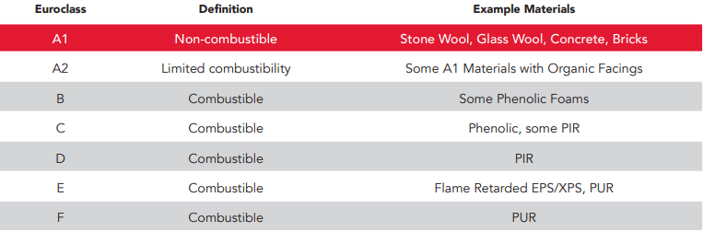
Fig13. Showing Euro class Classifications. (Rockwool LTD, 2018).

Taking into consideration all of the factors required for the building envelope, it is recommended that the use of an aluminium rain screen cladding system is used. This system allows water/rain to pass through the joints and down a cavity, and with openings such as window sills, are formed to direct water to these opening and down the cavity, this can help prevent staining to the panels mitigating the chances of the building looking unsightly, as the panels can be aesthetically pleasing with crisp lines and can be installed without visible fixings (FIRST IN ARCHITECTURE, 2022). Benefits of a rain screen cladding system identified by (CPD, 2017) are:
- Good thermal performance, allowing very efficient envelopes to meet environmental standards
- Easier and quicker to install that other methods, in doing so reducing time and cost
- Lightweight, durable, cost effective with options of colour choices.
In conjunction with the aluminium rain screen cladding it is important as part of the application that the insulation used also has minimal to no combustibility, therefore an insulation such as the Rocksilk slab would be recommended as it has an A1 rating (Knauf insulation, 2022), it is made with a water repellent additives and has good acoustic performance. (CCF 2022).
As there is to be a cavity for the runaway of water it would also be recommended to use fire stop cavity barriers at junctions to each floor horizontally and party walls, as detailed in Approved Document B. (Knauf Insulation, 2022).
It also needs mentioning that as the building is RC frame and due to the spacing of the columns to allow open space, the use of a steel frame system (SFS) would be recommended to fix the rains screen cladding to.

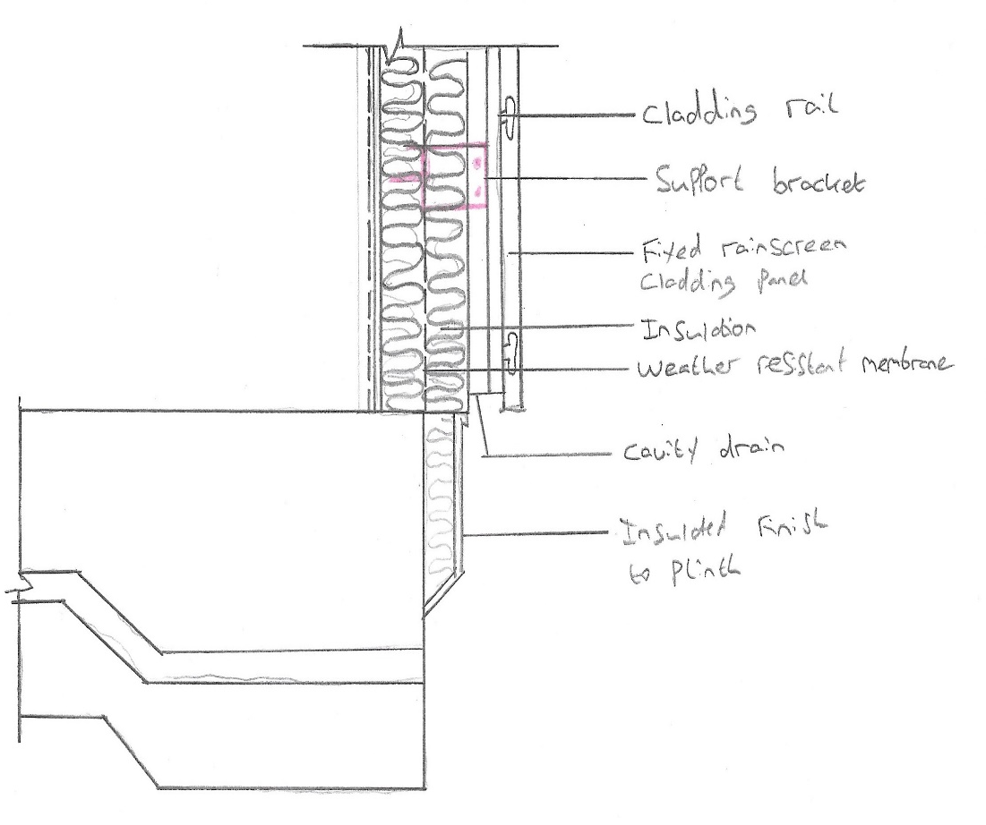

(Fig 14. Rainscreen cladding foundation detail)

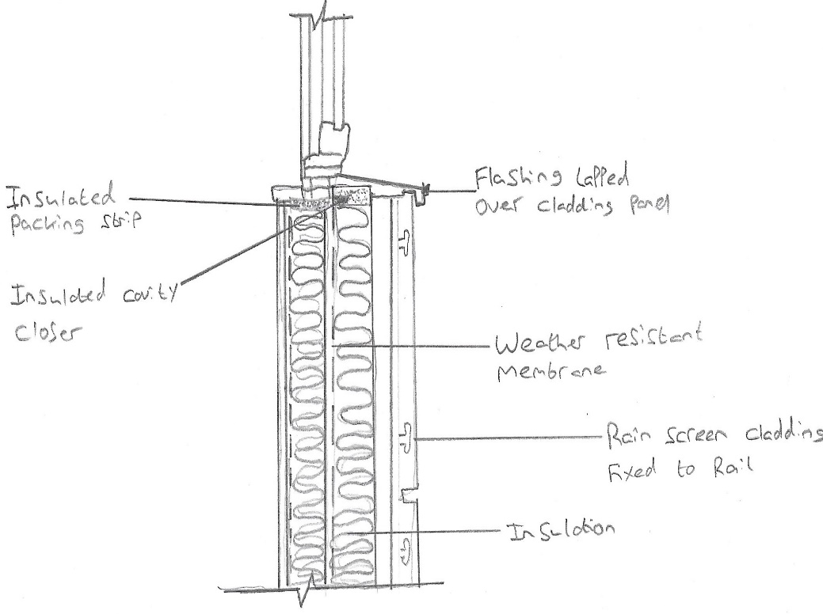

(Fig 15. Rainscreen cladding Window sill detail)
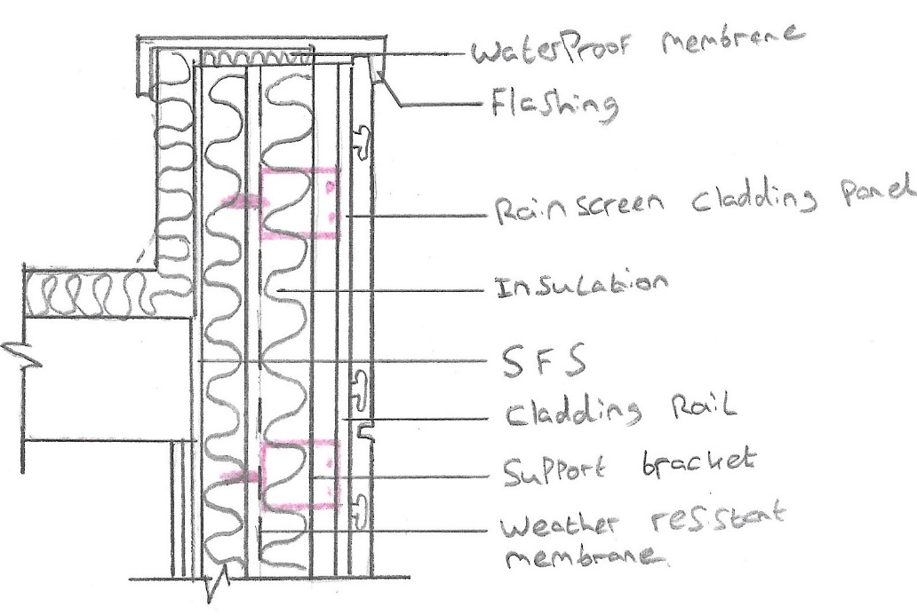

(Fig 16. Rainscreen cladding roof detail)

3.2 Roof
In order for a building to have low energy it requires high thermal protection, therefore when considering what roof to use, to go towards a low energy building the roof must effectively reduce heat loss (Kraus et al, 2019). Misar et al, (2017) suggest flat roofs can be highly affected by outdoor climatic conditions, though the roof structure is very important to the resilience and endurance of a buildings structure as a whole. A common roof structure over the last 20 years (Misar et al, 2017) and the roof recommended for this project is the inverted roof.
This is where the thermal insulation layer is positioned above the waterproofing system (Gorse et al, 2020), which is loaded with surface protection layers such as ballast or paving (Frank et al, 2018). CPD (2016), believes Inverted roofs are able to surpass Building regulations part L requirements with many advantages such as:
- Shields the waterproofing from UV radiation and impact damage
- Eliminates the risk of condensation within the roof construction by allowing the waterproof layer to act as a vapour barrier
- The possibility to reduce the urban heat island effect
- The ability to maintain waterproofing at an even temperature close to the interior of the building.
Building regulations part L is concerned with the energy performance of buildings by restricting heat losses and excessive solar gains, (RICS, 2022).
A fundamental layer to the thermal performance of an inverted roof is the water infiltration layer, reducing heat loss due to the rainwater cooling effect. It is crucial to understand the role of an inverted roof during the design phase and how to correctly account for their presence through U-value calculations (RIBA CPD, 2020). It is also important to consider the type of insulation for the inverted roof. Extruded polystyrene (XPS) insulation boards are an ideal choice due to their supreme levels of low water absorption, strength and outstanding thermal performance.
Another design advantage of an inverted roof is its ease of use and option for green roofs and blue roofs.
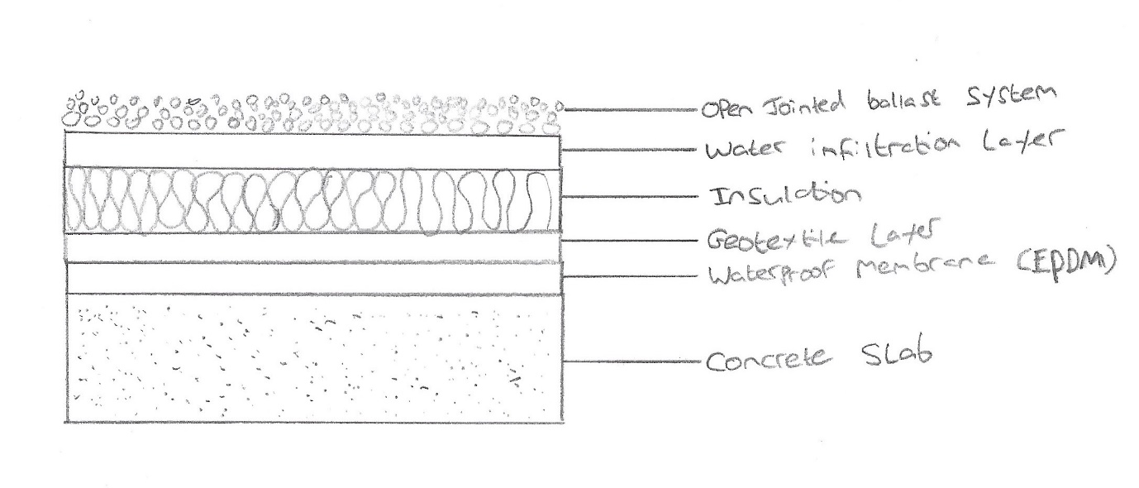
(Fig 17. Inverted roof makeup)

4.0 Conclusion
This paper set out to provide recommendations for specific tasks for a significant multi story building with a deep basement in a city centre. Considerations were made of neighbouring buildings and to use construction methods that would make zero to minimal impact on said buildings. The recommendation of an RC frame due to its advantages in fire safety and the widespan between columns that can be utilised for large open spaces which in turn lends itself to the ease of change of purpose. The use of the SPG for Cardiff was used when considering the aesthetic of the building to ensure the recommendations were in line with the guidance in said document and the look of the building would fit the landscape. The roof recommended considered the loss of heat and overall performance, while also having the potential for the roof to be used as either a green or blue roof.

References
Balfour Beatty (2022). Ground Engineering. RETAINING WALLS. Available at: https://www.balfourbeatty.com/media/28633/retaining-walls-web.pdf. [Accessed 08 February 2022]

British Standards Institution, (2022). Code of practice for ground investigations. BS 5930:2015+A1:2020. Available at: https://shop.bsigroup.com/products/code-of-practice-fro-ground-investigations/standard. [Accessed 31 March 2022].

British Geological Survey, (2022). Available at: scans.bgs.ac.uk/sobi_scans/boreholes/378372/images/10693407.html. [Accessed 29 January 2022]

British Geological Survey, (2022). Available at: scans.bgs.ac.uk/sobi_scans/boreholes378372/images/10693413.html. [Accessed 29 January 2022].

Calabrò, E., Peron, F. and Meggers, F.J., (2021), November. Trent Brick Panel: innovative envelope system designed according latest UK national fire and energy performance regulations. In Journal of Physics: Conference Series (Vol. 2069, No. 1, p. 012203). IOP Publishing.

CCF, (2022). Knauf Insulation Rocksilk Rainscreen Slab. Available at: https://www.ccfltd.co.uk/rainscreen-insulation/knauf-insulation-rocksilk-rainscreen-slab-1200mm-x-600mm-x-50mm/p/238563. [Accessed 16 March 2022].

Centrum, (2018). What are the differences between bore piles and drive piles? Available at: https://www.cetrumpile.co.uk/what-are-the-differences-between-bore-piles-and-driven-piles/. [Accessed 31 March 2022].

City of Cardiff Council (2017). Tall Buildings. Supplementary Planning Guidance. Available at: https://www.cardiff.gov.uk/ENG/resident/Planning/Planning-policy/Supplementary-Planning-Guidance/Documents/Tall%20Buildings.pdf. [Accessed 15 March 2022]

Chen, S., Jiang, L., Usmani, A., Li, G.Q. and Jin, C., (2015). Damage mechanisms in cementitious coatings on steel members under axial loading. Construction and Building Materials, 90, pp.18-35.

CPD 3 (2016). Introduction to inverted roofs. Available at: https://www.building.co.uk/cpd/cpd-3-2016-introduction-to-inverted-roofs/5080480.article. [Accessed 30 March 2022]

CPD 7 (2017). Rain screen cladding. Available at: https://www.building.co.uk/cpd/cpd-7-2017-rainscreen-cladding/5087063.article. [Accessed 15 March 2022].

Francke, B. and Geryło, R. (2018) ‘Inverted roof insulation kits and their durability’, MATEC web of conferences, 163, p. 8005–. doi:10.1051/matecconf/201816308005.

Gorse, C., Johnston, D., Pritchard, M. (2020). ‘Inverted roof’ A Dictionary of Construction, Surveying, and Civil Engineering. 2nd edn. Oxford University Press.

Gov.UK (2021). Buildings included in the new more stringent regulatory regime: factsheet. Available at: https://www.gov.uk/government/publications/building-safety-bill-factsheets/buildings-included-in-the-new-more-stringent-rugulatory-regime-factsheet. [Accessed 06 March 2022]

Ground Engineering LTD, (2017). Bored piles and their advantage in the construction of a vertical building. Available at: https://medium.com/@groundengineeringltd/bored-piles-and-thier-advantage-in-the-construction-of-a-vertical-building-7db534321ce0. [Accessed 29 March 2022].

Guowei, M., & Hong, H., & Zhou, Y. (2000). Assessment of structure damage to blasting induced ground motion. Engineering Structures - ENG STRUCT. 22. 1378-1389. 10.1016/S0141-0296(99)00072-3.

Institution of Structural Engineers (Great Britain) and Burland, J.B., (2004). Design and construction of deep basements including cut-and-cover structures. The Institution.

Ji, X., Ni, P., Zhao, W. and Yu, H., (2019). Top-down excavation of an underpass linking two large-scale basements in sandy soil. Arabian Journal of Geosciences, 12(10), pp.1-13.

Jones, N., Peck, G., McKenna, S.T., Glockling, J.L., Harbottle, J., Stec, A.A. and Hull, T.R., (2021). Burning behaviour of rainscreen façades. Journal of hazardous materials, 403, p.123894.

Kraus, M. and Juhásová Šenitková, I., (2019). Assessment of the Sustainability of the Flat Roof Systems. 19th International Multidisciplinary Scientific GeoConference SGEM 2019, 19(6.2), pp.387-394.

Knauf Insulation (2022). Rainscreen Façade System Solutions. Design out Risk with Rocksilk Rain screen Slab. Available at: https://www.knaufinsulation.co.uk/rainscreen-solutions. [Accessed 16 March 2022]

Knauf Insulation (2022). Rainscreen Façade Systems – Technical Detail. Rainscreen Façade Systems. Rainscreen cladding and curtain wall systems. Available at: https://www.knaufinsulation.co.uk/rainscreen-facade-systems/technical-detail. [Accessed 16 March 2022].

Larisch, D, M. (2016). Modern concrete technology and placement methods and their influence on waterproofing performance of diaphragm walls. Available at: https://www.researchgate.net/publication/3089311392_modern_concrete_technology_and_placement__methods_and_thier_influence_on_waterproofing_performance_of_diaphragm_walls. [Accessed 05 March 2022}.

Marlapalle, V., Khot, S.A. and Mhaskar, M., (2018). Analysis and design of secant piles.

MISAR, I. and NOVOTNÝ, M., 2017. Defects and behaviour of inverted flat roof from the point of building physics. Les Ulis: EDP Sciences.

NBS.com (2007). BS EN 13501-1:2007 Fire classification of construction products and building elements. Classification using data from reaction to fire tests (+A1:2009). Available at: https://www.thenbs.com/publicationindex/documents/details?pub=bsi&docid=291252. [Accessed 06 March 2022].

NBS.com (2015). The Buildings Regulation 2010. Access to and use of Buildings. Approved document M. Available at: https://assets.publishing.service.gov.uk/government/uploads/system/uploads/attachment_data/file/540330/br_pdf_ad_m1_2015_with_2016_amendments_v3.pdf. [Accessed 09 March 2022].

Nicholson, P, G., (2015). Objectives and Approaches to Hydraulic Modification, Soil Improvement and Ground Modification Method. Butterworth-Heinemann, Pages 151-187, ISBN 9780124080768.

Pile Tech (2021). Bored piled foundation – Advantages, disadvantages & techniques. Available at: https://www.piletech.co.uk/bored-pile-foundation/. [Accessed 29 March 2022]

Powers, J.P., Corwin, A.B., Schmall, P.C. and Kaeck, W.E., (2007). Construction dewatering and groundwater control: new methods and applications. John Wiley & Sons.

Punmia, B, C., Jain, A, K., Jain, A, K. (2005). Soil Mechanics and Foundations. 16th Edition. Drainage and Dewatering. Pages 269-271. Laxmi Publications.

Ribacpd.com, (20200. The importance of Water Flow Reducing Layer in an Inverted Flat Roof. Available at: https://www.ribacpd.com/articles/ravago-building-solutions/2540/the-importance-of-water-flow-reducing-layer-in-an-inverted-flat-roof/200034/. [Accessed 31 March 2022].

Rafal Szydlowski and Barbara Labuzek (2017) IOP Conf. Ser.: Mater. Sci. Eng. 245 022065

Rajmani, A. and Guha, P., (2015). Analysis of wind & earthquake load for different shapes of high rise building. International Journal of Civil Engineering and Technology, 6(2), pp.38-45.

RICS, (2022). Part L of the Building Regulations. Available at: https://www.isurv.com/info/35/part_l_of_the_building_regulations. [Accessed 30 March 2022].

Rockwool LTD, (2018). High Rise Buildings with a Floor Level above 18m. Meeting the guidance within the requirements of Approve Document B Volume 2. Available at: https://www.walls-and-ceilings.co.uk/pub/media/wysiwyg/routes-to-compliance---in-high-rise-buildings-above-18m.pdf. [Accessed 15 March 2022].

Tan, Y.C., Chow, C.M., (2008), March. Design of retaining wall and support systems for deep basement construction–a Malaysian experience. In Seminar on “deep excavation and retaining walls”, jointly organised by IEM-HKIE, Malaysia (Vol. 24).

The Basement Information Centre, (2022). Types of basements. Available at: https://www.basements.org.uk/TBIC/Basements/Types-of-Basements.aspx. [Accessed 19 March 2022]

The Building Regulations 2010, (2020). Approved Document B. Volume 2 – Buildings other than dwelling houses.

The Law Insider, (2022). Building Core definition. Available at: https://www.lawinsider.com/dictionary/building-core. [Accessed 09 March 2022].

Weather spark.com. (2022). 2021 weather history in Cardiff. Available at:https://weatherspark.com/h/y/37834/2021/historical-weather-during-2021-in-cardiff-united-kingdom#figures-windspeed. [Accessed 06 March 2022].

World weather online. (2022). Cardiff climate weather averages. Available at:https://www.worldweatheronline.com/Cardiff-weather-averages/Cardiff/gb.aspx. [Accessed 06 March 2022].

Wharmby, N. (2010). Diaphragm & Secant Pile Walls. Available at: https://fcc.thewebpractice.co.nz/Resources/Diaphragm_Secant_pile_walls_ (Wharmby_SESoc_2010).pdf. [Accessed 08 February 2022].

Yakut, A., (2004). Reinforced concrete frame construction. World Housing Encyclopedia, Summary Publication, pp.9-1.

