

A Study of Turntables used for 3D imaging Radars

by
Robbie Young

Supervisor: Steve Mosey

Project submitted as part of the requirements for the award of
BSc (Hons) Computing (stream)
BEng (Hons) Electrical and Electronics Engineering
etc (Embedded Electronic Systems-Independent Project (ACCA6020 - EES)

September 2024

Turntables used for 3D imaging Radars

Contents
- Introduction
- Main objective
- Aims
  - 3D Imaging
  - Function of turntable
- Turntable/ resources
  - Motor
    - Types
      - Stepper motor
      - Linear motor
      - Servo motor
  - Encoders
  - Control PCB
    - PCB
    - Programming language
  - Slip ring
    - Types
      - Hollow shaft
      - Pancake
  - Raw data
  - Control signal
    - RF Transmitter
    - Optical encoder
    - Power supply
    - ADC
  - RF rotary joint
    - Contact
    - Non-contact
  - RF components
    - Spectrum analyser
    - Signal generator
    - RF cables
- Plan
  - Safety measures

Introduction
The idea behind the project is to be able to take 2D images of the electromagnetic and magnetic fields produced by a radar to create a 3D image, whist being able to produce one cheaper than industry. A company ordered 3 bigger turn tables than the one I plan on producing, at a cost of almost 4 million pounds [1]. Where this is a very large expense, planning for a budget this big isn’t viable for one person. The design of the turntable should be kept a lot lower. The drawback of this is that quality and accuracy will go down. However, it will be more affordable. Turntables have been made for slightly different applications, as can been seen by this company Macton [2] who have made bigger turntables for using in radar applications. Macton lists the benefits of using a turntable compared to traditional methods, the first is being able to speed up the process of testing, where a turntable can move antenna, it makes it much faster and more precise when testing, thus decreasing the manpower and cost. An automatic turntable could also help with the complicated maths behind 2D to 3D modelling making a computer and turntable the best way to test radars.

Main objective
My main objective is to get a working turntable prototype around 50CM in diameter. The secondary objective is for it to be capable of doing the complicated maths to producing a 3D image from 2D data.

Aims

3D imaging
The aim of this is to get to a stage where 3D imaging from the 2D data is possible. This isn’t a new principle as two ([3] and [4]) academic papers have been produced. Principles of 3D turntable radar imaging [3] shows the complicated maths behind making the image work. Whist [4] shows how it can be done practically. Hence the need for a turntable.

Function of turntable
The function of the turntable is rotating the receiver from looking directly at the emitting radar to 90 degrees. Allowing the user to read the electrical and magnetic field from the antenna, the reason for the 90 degrees is the electrical and magnetic field are at 90 degrees to one another, meaning to read them you must turn 90 degrees. The design of the turntable is important, as it needs to rotate at a set speed compared to the frequency of the antenna, so that a cut can be taken from the emission of the antenna, allowing for the measurement to be read and then converted into a 3D image.

Turntable/ Resources

motors
Using a DC motor that can be controlled by a PCB will be important as controlling the speed and direction of the turntable is essential. Being able to control the speed of the motor will allow for different frequencies to be used allowing for different antenna to be tested. The three types of motor below will be best to control the movement of the turntable.

types

Stepper motor
Stepper motors are useful in many different applications and could be applied here, however the stepper motor drawback is very important to consider for a turntable. A stepper motor works by rotating in steps. The reason this is a drawback is because for a turntable smooth as possible movement is wanted, making a stepper motor less practical.

Linear motor
Linear motors are also a good option for a turntable as they can produce constant speed without the jitter of a stepper motor making it more practical.

Servo motor
Servo motors are the best option as they can do what a linear motor does, however it is controlled by a PCB and can take and give feedback to the PCB and/or sensors. The downside to servo motors is that they are much more expensive and would increase the production cost.

Encoders
Encoders allow for the motor to be controlled, as they can act as a sensor and give information back to the motor, the information given is usually its position allowing for a servo motor to know its location and how much further it must turn to be in the correct position.

control PCB

PCB
The PCB doesn’t have to do anything special; I want the PCB to control the motors rotation speed and direction, as well as communicating with a computer that does the calculation on how fast it must turn and when.

Programming Languages
There are many different program languages that could be used a to run a PCB, as well as the complicated maths behind converting the 2D image to 3D these options include, C, C++, Python and MATLAB these 4 are mostly going to be used as most MATLAB and Python can cope with the complicated maths and have the right structure to do them, whereas C and C++ can run PCB controlling the microcontroller for the motor.

Slip ring
A slip ring is required for the antenna to sit on top of the turntable, as a slip ring will allow power and communication signals to move from the stationary control system to the rotating antenna without any cables getting caught preventing damage.

Types
There are two types of slip ring that can be used, the first is hollow, which has a hollow centre with a brush going around the outside, allowing for communication with a controller. And pancake, which is two rotating discs which allow for communication via a brush between the two plates.

Hollow shaft
A hollow shaft will be more practical for two reasons, the first is with the centre being hollow a RF rotary joint can be fed through the middle decreasing the overall surface area for the slip ring. The second reason is that they are easy to set up and be accessed a lot easier if any changes were need.

Pancake
A pancake could also work, however is harder to set up and would be two moving parts rather than one, making it more work and time consuming to set up.

Raw Data
Raw data from the antenna would be stored on a computer for analysis after testing. During test a spectrum analyser would be used to read the data.

Control Signals

RF transmitter
The RF transmitter would emit a set value by a signal generator, this would allow for testing of the turntable, as values can be preset to test the accuracy.

Optical encoder
An optical encoder could be used as part of a control signal, also it would allow for more control over the turntable’s movement, as it a digital position reader.

Power Supply
A source of power is going to be needed, whether this is a power supply or the easier and more likely option, a main converter to the correct voltage along with a control board, as it is likely that the motors and PCB will require two different voltages.

ADC
An analog to digital converter might be needed to convert the analog RF signal to digital storage of a PC. There is an option of buy one as they are not overly expensive. ADC might also be required for the optical encoder.

RF Rotary Joint
An RF rotary joint will be used, this way the RF signal from the antenna can be passed through the turntable without cable getting tangled. RF rotary joints are very sensitive, can be easily broken, leak RF and are expensive. There are two types of RF joint these are contact and non- contact.

Contact
Contact have high bandwidth but a lower life expectancy.
Non-contact
Non- contact has a lower bandwidth, but a better life expectancy, making the decision on which one to use dependent on the RF input.

RF components

Spectrum analyser
A spectrum analyser will be needed to read the signal coming from the antenna and to do analysis of it to determine/ make a 2D model, of both electrical and magnetic bands produced by the emitting antenna.

Signal generator
A signal generator will be used to generate the signal going to the transmitter which will produce the electrical and magnetic fields.

RF cables
RF cables can be sourced and will be used between all RF components to prevent loss along the cables allowing for a better reading.

Plan
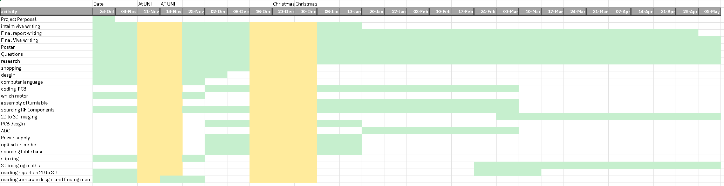

Safety measures
Electrical shocks, being hit by the turntable and RF burns are all possible, however limiting factors can be put in place to ensure that none of those happen. To prevent RF burns two things can be done, the first is a low power antenna, which would prevent any damage, secondly simulation can be done to simulate the results of the antenna patterns, which could then inform the movement of the turn table later, preventing any safety problems.

Appendix
[1] https://www.airforce-technology.com/news/chess-dynamics-secures-orders-for-military-radar-turntables/?cf-view
[2] https://www.macton.com/emi-rfi-emc-radar-turntables
[3] Qiao, Z. and Lopez, J.X. (2012) (PDF) principles of 3D turntable radar imaging. Available at: https://www.researchgate.net/publication/261337614_Principles_of_3D_turntable_radar_imaging (Accessed: 28 October 2024).
[4] Lu, X. et al. (2017) High resolution turntable radar imaging via two dimensional deconvolution with matrix completion, MDPI. Available at: https://www.mdpi.com/1424-8220/17/3/542 (Accessed: 28 October 2024).

