

Task 1 – Reading Task Template
Upload your photo of your A3 in-class notes here:
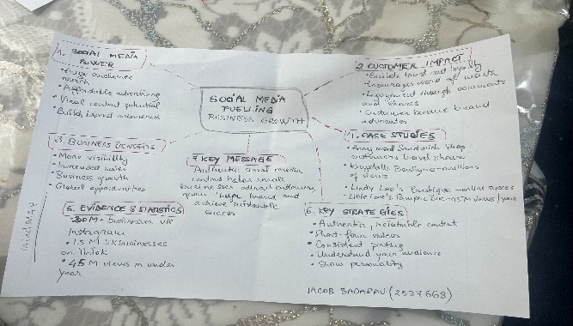

1. Answer these questions using the sentence starters below
a. What is the main idea of the text?
The central message is that social media platforms like TikTok, Instagram, and Facebook are valuable tools for the growth of small businesses.
b. What are two key points?
Firstly, social media attracts more customers to small businesses, helping to increase their sales.
Secondly, posting genuine and relatable content helps to gain customers’ trust, encouraging them to support these businesses.
c. What part of the text did you find most important? Why?
The most significant section was the example of Little Love’s Pamper Bus, as it clearly illustrates how social media can rapidly expand a small business’s reach and success.
d. Was anything unclear or difficult to understand?
I found it a bit confusing to understand exactly how social media can lead to such quick success for small businesses.
e. How did your group help you understand the text better?
Our group improved my understanding by talking through the main ideas, exchanging different perspectives, and explaining the parts I found confusing.
3. One sentence reflection
Question: What did you find challenging about this task?
The most difficult aspect was understanding the large figures and data related to social media impact on businesses.

