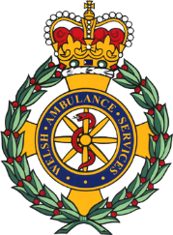

MSc Digital Skills for the Health and Care Professions
BMDS7006. Cohort 2

System Improvement Programme.
Fiona Maclean 2211936

Introduction
The Welsh Ambulance Services NHS Trust (WAST) is the national ambulance service for Wales, serving a population of around 3 million. Commissioned by Local Health Boards (LHBs) and formally accountable to the Welsh Government, WAST plays an integral part in the unscheduled care system.
Within WAST there are several directorates including Operations, Partnerships & Engagement, Strategy Planning & Performance, Digital Services and Quality, Safety & Patient Experience. All having their own areas of responsibility, each directorate has a local delivery plan which is aligned to WASTs’ Integrated Medium Term Plan (IMTP). A requirement by Welsh Government for all Health Boards and Trusts in NHS Wales, which set out organisational plans for the next three years and how they will be achieved.
As a public healthcare service, WAST provides a range of services which advises, supports, and signposts the population of Wales, however the three key patient care pathways are:
- NHS 111 Wales (formerly NHS Direct Wales),
- Non-Emergency Patient Transport Service (NEPTS)
- 999 Emergency Service

NHS 111 Wales is a free 24-hour telephony and web-based health information and advice service, offering support to those requiring urgent advice and access to urgent primary care.
NEPTS transports over 1.3 million patients, who require non-urgent treatment and have a specific medical need, to any of the 200 treatment centres across Wales and England.
Responding to a diverse range of communities across challenging landscapes, the 999 emergency service attends to more than 250,000 emergency calls a year and over 50,000 urgent calls, using front-line ambulances, including Rapid Response Vehicles (RRVs), and cycle response units in pedestrianised urban areas of South East Wales.
In 2006 at the request of the National Assembly for Wales, an inquiry was carried out to examine several issues relating to the Trust. The Inquiry report outlined the crucial challenges WAST faced as an ambulance service, the growing public concern, and how all stakeholders should be informed of the strategic plans to transform the service into a modern ambulance service. Recommendations of the Inquiry also highlighted the public engagement opportunities that were available to WAST, including how they could inform the public about the appropriate use of 999 and what to expect when calling (Auditor General for Wales, 2006).
Following the Inquiry recommendations, and the transfer of NHS Direct Wales into WAST in 2007, an all-Wales Patient and Public Involvement (PPI) team was formed. Adopting the National Principles for Public Engagement in Wales (2011), a baseline mapping exercise was undertaken by the PPI team with key stakeholders both internally and externally, to gauge levels of engagement and their understanding of WAST’s role. Following the introduction of the Equality Act (2010) which replaced all previous anti-discrimination laws, and the Public Sector Equality Duty (2011), which requires all public bodies to engage with groups that are covered by the Duty including age, disability, sex, race, and sexual orientation, dedicated work streams were developed within the PPI team. The purpose was to engage with communities to capture their experiences, identify barriers and encourage them to get involved as equal partners to help shape service improvement within WAST.
To provide evidence and assurance to key stakeholders of WAST’s engagement activity with communities, in 2016 an internal web-based Trust Engagement Directory was launched. However due to poor IT infrastructure (with some ambulance stations only having one shared IT terminal for staff to access), only a desktop version being available, lack of staff awareness, not being user friendly and time consuming to complete, staff buy in, and completion uptake was extremely low, which contributed to the decommission of it in 2019.
The following root cause analysis diagram illustrates more detailed causes of the existing business problem:
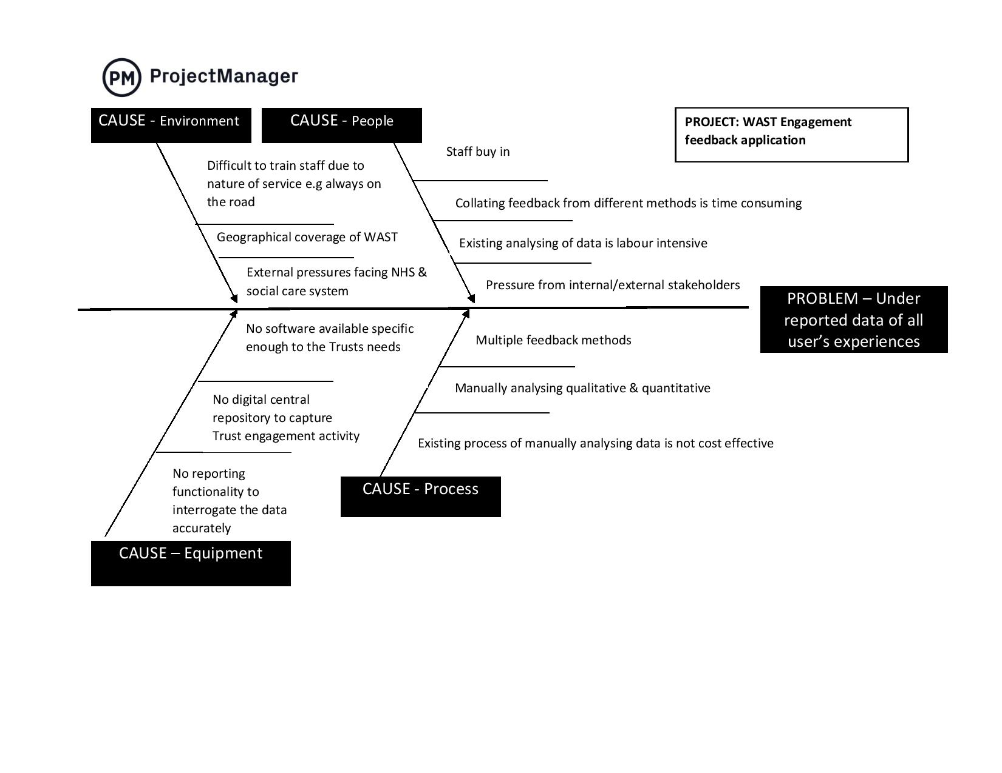

Currently, the Patient Experience & Community Involvement (PECI) team (formerly PPI) manually analyse quantitative and qualitative data that they collect from multi channels; online, email, face to face and patient stories. However using this process to report themes, trends, and experiences to internal key stakeholders and commissioning health boards and Welsh Government proves time-consuming, costly, and very labour-intensive. Since the decommissioning of the Trust Engagement Directory, wider Trust engagement activity carried out by staff and volunteers is also no longer being captured so data of patient's experiences is underreported. However, the IT infrastructure within WAST has significantly improved following investment, with all WAST staff and volunteers now having individual access to iPad’s.

Justification
In this assignment, justification will be given to explain why using a digital application to collect, analyse and report real time feedback from across the Trust, can contribute to improving patient experiences and help shape service improvement.
‘Users’ for this purpose will be defined as service users, carers and family members.
‘Feedback’ will include both qualitative and quantitative data (experiences, narratives, observations).
Whilst users’ perceptions and personal experiences will be included under the generic term ‘feedback’, user ‘satisfaction’ shall be excluded as they are two different concepts as argued by Bull (2021) “patient-reported satisfaction measures are outdated, and that Patient Reported Experience Measures (PREMs) are a better means of gaining insight into the aspects of healthcare that patients truly value” (para.4).
Currently three options are available:
- Do nothing
- Procure off the shelf digital package
- Go out to tender for a bespoke digital application
As the unscheduled care system recovers from the pandemic and continues to face significant pressures, which often leads to poor patient outcomes and experiences, it is vital that health and social care organisations work collaboratively. As outlined in A Healthier Wales: our Plan for Health and Social Care, working across organisational and geographical boundaries to deliver a more seamless coordinated and whole system approach will enable better patient experiences. (Welsh Government, 2020).
Despite the PECI Team capturing experiences from across Wales, the data only represents a small proportion of users' experiences. Whilst this would not skew any data, as wider Trust engagement activity and experiences are under reported, since the decommissioning of the Trust Engagement Directory, ‘Do nothing’ is not an option. Whilst options two and three are valid, providing it meets budget requirements, option three would be the preferred option to ensure the application is fit for purpose based on WASTs’ requirements.
By implementing a bespoke digital application to collect all Trust feedback data, analyse and report in real time, this will help formulate a broader picture and in-depth understanding of what it is like to be a user of WAST within each health board area. Supporting executive teams in their decision-making about future service improvements and encourage value-based healthcare. The data will also assist in identifying the quality of services being delivered when reporting against Emergency Ambulance Service Commissioners (EASC) Quality Indicators and the Health and Social Care (Quality & Engagement) Wales) Act (2020).

Aim
Implement a bespoke digital application to collect and analyse feedback, reporting in real time, users’ experiences of WASTs’ three patient care pathways.
Objectives
- Deliver a cloud-based, user-friendly application, that is compatible with existing hardware to allow 3,500 staff and volunteers to self-populate engagement activity and feedback.
- Display real time high-level feedback dashboards, at local health board and all Wales level.
- Roll out to WAST and incrementally to each of the seven health boards using a PDSA cycle as a test of change. If successful, full roll out to be achieved by 31st March 2023.

