

Applied Computing

Wales Institute of Science and Art (WISA)

Advanced Networking (ACCA5024)

Lab 7: Basic Routing Configurations



n.kaliyamurthy@uwtsd.ac.uk 1

Design the topology and execute basic configuration as stated below
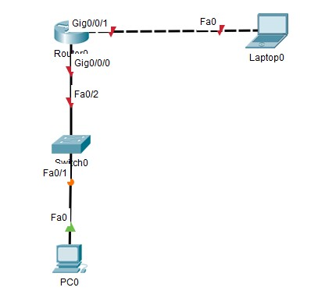
Device | Interface | IP Address | Subnet Mask | Default  Gateway
Router 0 | G0/0/0 | 192.168.0.1 | 255.255.255.0 | N/A
 | G0/0/1 | 192.168.1.1 | 255.255.255.0 | N/A
PC0 | NIC | 192.168.1.3 | 255.255.255.0 | 192.168.1.1
Laptop0 | NIC | 192.168.0.3 | 255.255.255.0 | 192.168.0.1

Tasks:
- Set Up the Topology and Initialize Devices
- Configure Devices and Verify Connectivity
Assign static IPv4 information to the PC interfaces.
Configure basic router settings.
Verify network connectivity.
Configure the router for SSH.
- Display Router Information
Retrieve hardware and software information from the router.
Interpret the output from the startup configuration.
Interpret the output from the routing table.
Verify the status of the interfaces.

Cable the network as shown in the topology
Initialize and reload the router and switch
Configure Devices and Verify Connectivity
Configure the IP address, subnet mask, and default gateway settings on PC0 and Laptop0.
Configure the router
- Hostname R0
- Disable DNS lookup
- Require that a minimum of 10 characters be used for all passwords.
- Assign cisco12345 as the privileged EXEC encrypted password.
- Assign ciscoconpass as the console password, establish a timeout, enable login, and add the logging synchronous command. The logging synchronous command synchronizes debug and Cisco IOS software output and prevents these messages from interrupting your keyboard input.
- Assign ciscovtypass as the vty password, establish a timeout, enable login, and add the logging synchronous command.
- Encrypt the clear text passwords.
- Create a banner that warns anyone accessing the device that unauthorized access is prohibited.
- Configure an IP address and interface description. Activate both interfaces on the router.
- Save the running configuration to the startup configuration file.
Verify network connectivity.
- Ping PC-B from a command prompt on PC-A.
- Remotely access R1 from PC-A using Telnet.
Configure the router for SSH access.
- Enable SSH connections and create a user in the local database of the router.
- Remotely access R1 from PC-A using SSH.
Establish an SSH session to R1.
From PC-B, open an SSH session to R1 at IP address 192.168.0.1 and log in Retrieve important hardware and software information. (Write the commands and the output)

Name of the IOS image that the router is running?
Cisco IOS Software [Everest], ISR Software (X86_64_LINUX_IOSD-UNIVERSALK9-M), Version 16.6.4,RELEASE SOFTWARE (fc3)

Non-volatile random-access memory (NVRAM) does the router have?
32768K bytes

How much Flash memory does the router have?
3207167K bytes

What is the boot process for the router on the next reload?
Configuration register is 0x2102

How are passwords presented in the output?
encrypted

What code is used in the routing table to indicate a directly connected network?
C

How many route entries are coded with a C code in the routing table?
2

What command changed the status of the Gigabit Ethernet ports from administratively down to up?
no shutdown

