Name: Chloe Hitchings
CIPD Membership Number: 88554053
Wordcount: 2319

Part 1

- With reference to typical activities and behaviours, appraise what it means to be a ‘people professional’. (AC 1.1)

The term ‘people professional’ (PP) refers to an employee that is working within the human resources (HR) function at any level and can be in specialist or generalist roles. The typical activities and roles of a PP depend upon their job role within the organisation, director, managerial and business partner level tend to focus on more strategic HR work and changing culture, referred to as transformational activities (Armstrong and Taylor, 2020, p.106). Whereas administrator and advisory level tend to complete transactional activities which cover activities across the employee life cycle. Including recruitment, employee relations, employee wellbeing, managing diversity and inclusion, learning and development and administration (Armstrong and Taylor, 2020, p.95).

People professionals use the CIPD’s Profession Map (2023) as a standard for practice, values, and behaviours. Due to the nature of work, there is an emphasis on ethics and evidence-based decision-making so that PPs can be fair and consistent throughout all situations based on effective and researched behaviours. Some of these behavioural areas include ethical practice, valuing people, insights focused and situational decision-making. Another behaviour is passion for learning, which refers to PPs seeking to continue their development to stay current with their knowledge.

The perception of people professionals from an employee perspective can sometimes be negative as PPs are involved with a lot of formal processes such as redundancies and big business decisions. The focus of the PP role within a human resources department is to act as a support function and to provide guidance to employees and management regarding anything people and workplace related (Armstrong and Taylor, 2020, p.105). Another purpose of this role is to promote a positive culture and to implement people practices that are centred around the employees within their organisation based on their needs. These practices and the implementation of policies help PPs to contribute to a more positive workplace culture and they also role model positive behaviours in the workplace (Waite et al, 2021). PPs face challenging situations within their roles mostly to do with conflict management, however this can be overcome by continuous improvement of processes (Eichfeld et al, 2017). By contributing to a positive working culture, it can help with employee engagement, retention of staff and overall help to contribute to the outcome of the organisations’ KPIs. If its employees are happy then they are more than likely to be productive and contribute to the overall success of the organisation.

- Discuss how ethical values underpin the work of a people professional, including two examples of how ethical values might be applied in a people practice context. (AC 1.2)

According to the CIPD (2023), ethical values act as a moral compass and determine how individuals make decisions. However, PPs can still act immorally and go against ethical values within an organisation (Lawton, 1988). Ethical values are a part of the core behaviours that a PP should use during practice on the CIPD Profession Map (2023). When a PP bases decisions using ethical values and role models this behaviour to the organisation, it helps to promote these ethical behaviours (Waite et al, 2021, p.70).

There are multiple ethical perspectives that a PP can consider during their decision-making including Deontology and Utilitarianism perspectives. The Deontological theory promotes duty and the focus of people by promoting equality for all by doing the ‘right’ thing (Waite et al, 2021, p.70). Its application in the people practice profession could be through the implementation of policy within the organisation for all employees to follow. By implementing policies for all employees such as an absence and disciplinary policy, all employees have the same set of rules to follow. Failure to abide to policy could lead to disciplinary action. A problem arises when people aren’t treated the same for exhibiting the same behaviours, this could be due to discrimination against protected characteristics and leading to inequality and going against the Equality Act (2010). A PP could be faced with two values going against each other (Singh and Mishra, 2018) such as ones’ freedom of speech going against someone’s privacy.

Another ethical perspective is the Utilitarianism perspective which believes that decisions should be based on maximising happiness and are justified when they result in the greatest good for the highest number of people (Armstrong and Taylor, 2020). An example of this in a people practice context could be through implementing well-being initiatives in the workplace, such as providing more mental health support for employees and training for line managers. These initiatives would help employees by prioritising their mental health and in turn it could help the organisation by reducing employee’s stress levels and increase productivity and engagement. However, each individual person within an organisation has differing opinions as to what would make them happier, some people may prefer a monetary reward. It would be harder to objectively assess whether these types of actions benefit the organisation and its employees (Singh & Mishra, 2018).

- Consider the importance of people professionals being able to influence others and ensure that the ‘people practice voice’ is heard in an organisation, through informed, clear and confident communication. (AC 1.3)
It is essential for a people professional (PP) to be influential within their organisation to fulfil their purpose as a support function as their work is largely through others such as managers (Taylor and Woodhams, 2022, p.161). PPs main goal is to influence positive change and to clearly express the value of the potential changes. They have an obligation to act ethically as they follow a code of conduct as seen through the CIPD’s code of conduct. By implementing policy and procedures within an organisation, it can influence its employees to act in an ethical manner and to guide and advise them through challenging situations. However, there can be resistance to change, as some employees may not see the benefit of the advice and would rather continue to follow their own personal values. It is importance for PPs to challenge and speak up when they need to use their professional expertise to influence situations (Waite et al, 2021, p.77), as showing courage professionally is a part of the behaviours on the CIPD Profession Map (2023).
PPs influence employees to consider different perspectives so that they can see the bigger picture. They need to ensure that they are informed on their area of practice so that they can present their ideas and guidance in a clear and confident manner to add value through knowledge. Continuous professional development (CPD) would help PPs to progress their development needs (CIPD, N.D. a). PPs need to stay up to date with their training so that their practices and knowledge are current with any legislation changes. If a PP is a part of the CIPD community, they have access to factsheets and research which are useful for PP’s when making informed decisions knowing that it is backed by objective research.
PPs must understand the importance of power dynamics, their communication style and non-verbal communication. There is a certain degree of power that is held within this position, so it is important to voice opinions and express concern when it is needed (Taylor and Woodhams, 2022, p.77). HR representation on the senior leadership team is very influential for decision-making. PPs must think about their message and how they are going to convey it clearly (Yemm, 2008). There are certain skills that one must possess to be influential through their communication by being assertive within the position by having the knowledge to speak clearly without being passive and aggressive.

- For each of the situations below (a & b), provide an example of an issue that would cause you to raise the matter to a manager (or other authority) - and describe how you would do this.
a) where you consider something to be unethical (whether or not it is illegal),
b) where you believe something contravenes legislation. (AC 1.4)

Employers should build a culture of openness and having an outlet for employees to share their voice and opinions, which leads to a trusting working relationship (Young, 2024). The employee voice allows employees to express matters that are important, and they should be encouraged to speak up if they wish to raise concerns regarding the organisation and its people.
An unethical situation that has arisen in a previous role was that an employee accepted a gift from a supplier of the organisation. After checking the company policy and completing research regarding the Bribery Act (2010), I found that this would be classed as bribery by accepting gifts and it could have been a conflict of interest due to her job role. I brought this to my line manager’s attention and to go with a more informal route due to the aspect of the case. The employee did not realise that it was a form of bribery and thought that it was just a gesture of good will. As a team we decided to debrief the team on our bribery policy in the workplace to prevent this from occurring again.
Being in male dominated industry working in the construction sector, there is a very obvious gender difference within this area of work. An example of an issue that could arise in this sector that contravenes legislation could be the preferential treatment of a male over a female worker regarding their opportunity to progress and being treated unfairly. According to the Equality Act (2010), it is unfair to discriminate in the workplace. If I was to experience this in my workplace, I would ensure that I gathered all of the information in relation to the event that occurred including dates, times and write a statement of what happened. I would speak to a member of management as soon as possible to raise this so that I can clearly explain what happened and also request action to be taken against this individual formally through a disciplinary process.

5) Discuss two theories or models relating to human and business benefits of people at work feeling included, valued and fairly treated, concluding your discussion with a summary of your own view of these benefits.
Organisations promoting inclusion, equality and value in the workplace can be beneficial for decision making as the organisation opens themselves up to people with different experiences and backgrounds that could bring a differing perspective to the table (CIPD, 2022). Evidence shows the benefit of having a diverse workplace for the organisation and it can lead to increased productivity, engagement, reputation, and organisational results (CIPD, 2022). There are many theories that look at engagement and motivation so that organisations can add value by prioritising its employee’s needs and drives.
Maslow’s Hierarchy of Need (1954) is a theory of motivation that proposes that individuals need to fulfil certain needs before their can progress onto a higher level and reach self-fulfilment. This includes differing levels such as self-esteem needs, safety, social, physiological, and self-actualisation need (Waite et al, 2021, p.168). This suggests that to stay motivated, employers need to fulfil their employee’s needs to move them up towards being motivated by higher level needs. Employee’s behaviours are motivated by unsatisfied needs (Armstrong and Taylor, 2020, p.249) so if an organisation considers these needs and implements changes to address these, it could lead to higher levels of performance (Bailey et al, 2015). This theory is a very popular theory, however, there is low empirical data to support it as it fails to address cultural differences (Osemeke and Adegboyega, 2017).
Another theory of motivation, specifically job satisfaction, is the Hertzberg Motivation-Hygiene Theory (1966), this shows how some factors will motivate employees in the workplace whereas ‘hygiene’ factors only satisfy or dissatisfy employees. Motivating factors include recognition, achievement, interesting and meaningful work, and advancement. Hygiene factors include salary, job security, policy, and practice. When an employee has a pay increase, this increases their job satisfaction, but it wouldn’t necessarily increase their motivation to work harder or increase their engagement in their role (Waite et al, 2021, p.170). More modern research shows that extrinsic factors such as the hygiene factors in this theory have impacted their employee’s job satisfaction (Yusoff et al, 2013).
I would say that these theories show a valuable insight into the driving forces of employees and highlight that meeting employees’ needs are crucial to creating an inclusive workplace where everyone feels valued. If organisations aspire to achieve their employees’ needs, they will have a much more positive workplace, and this will then increase employee wellbeing, increased engagement, and reduced workplace conflict.

6) Discuss two ways in which a people professional can build inclusivity into a people practice initiative at the design stage, and two ways of checking inclusivity after a people practice initiative is implemented. (AC 2.2)
Creating a safe working environment where employees are valued and belong is an integral part of people leadership (CIPD, 2022). Inclusivity ensures that employees are treated equally, regardless of their gender, age, ethnicity, cultural differences. It is important for people professionals to implement practices that contribute to positive and inclusive cultures so that its employees can feel respected and valued and that they have a voice (CIPD, 2022)
One way to build inclusivity in the design stage of people practices is to enable that it is imbedded into its core behaviours. Organisations should evaluate their policies and procedures to support inclusion for all employees (CIPD, 2022b). Specific policies could be implemented to ensure that support is given to help certain groups of individuals for example, for Welsh speakers and flexible working. This could be implementing a diversity and inclusion policies to reiterate the organisation’s stance on ensuring a diverse and inclusive workplace. To create more inclusivity in the workplace, organisations could also set up feedback measures to understand what their employees need whilst in the design stage of their policies through surveys. The feedback gained from the surveys could identify areas for improvement and to help to tailor the policies specifically to employees.
After implementation, it is important that organisations gain feedback regarding its inclusivity measures to ensure that they have fulfilled their purpose. Organisations could speak to diversity groups within the organisations that the policy would impact. For example, at PwC, there are four main networks for inclusivity that they gain feedback from (Armstrong and Taylor, 2020, p.368). Feedback could be gained through focus groups to gain qualitative data to understand whether they have felt a positive change regarding inclusivity. This method provides a deeper understanding of problems or issues that employees experience in their own words (CIPD, 2023). However, some individuals may be more outspoken in a focus group, so it can be harder to gain feedback from all individuals (Taylor and Woodhams, 2022, p.129). A way that this could show an impact is by reviewing metrics and data regarding diversity and inclusion to monitor progress. It can provide inclusion data such as the percentage of minorities in the workforce so that organisations can utilise this data to compare to after the implementation of an initiative to see whether it has had an effect. However, it is hard to measure the causation and whether other external factors affect these results.

References
- Armstrong, M. and Taylor, S. (2020). Armstrong’s Handbook of Human Resource Management Practice. 15th ed. London: Kogan Page.
- Bailey, C., Madden, A., Alfes, K. and Fletcher, L. (2017). The Meaning, Antecedents and Outcomes of Employee Engagement: A Narrative Synthesis. International Journal of Management Reviews, 19(1), pp.31–53.
- Bribery Act 2010, c. 23. Available at: https://www.legislation.gov.uk/ukpga/2010/23/contents.
- CIPD (2022). Five Actions You Can Take to Foster Inclusion. [online] CIPD. Available at: https://www.cipd.org/uk/knowledge/guides/five-actions-fostering-inclusion/.
- CIPD (2022b). CIPD | Equality, Diversity and Inclusion in the Workplace | Factsheets. [online] CIPD. Available at: https://www.cipd.org/uk/knowledge/factsheets/diversity-factsheet/.
- CIPD (2023). Ethical Practice and the Role of People Professionals. [online] CIPD. Available at: https://www.cipd.org/uk/knowledge/factsheets/ethics-role-hr-factsheet/.
- CIPD. (2024). CIPD | How to use the Profession Map. [online] Available at: https://prod.cipd.co.uk/uk/the-people-profession/the-profession-map/how-it-works/.
- Eichfeld, A., Golding, D., & Hamilton, D. (2017). Continuous improvement—make good management every leader’s daily habit. McKinsey& Company.
- Equality Act 2010, c. 15. Available at: https://www.legislation.gov.uk/ukpga/2010/15/contents.
- Herzberg, F. (1966). Work and the nature of man. Cleveland, OH: World Publishing Company.
- Jake Young (2024). Employee Voice. [online] CIPD. Available at: https://www.cipd.org/uk/knowledge/factsheets/voice-factsheet/.
- Lawton, A (1998) Ethical Management for the Public Services, Open University Press.
- Maslow, A. H. (1954). Motivation and personality. Harpers.
- Osemeke, M. and Adegboyega, S. (2017). Critical review and comparism between maslow, herzberg and mcclelland’s theory of needs. Funai Journal of Accounting, [online] 1(1), pp.161–173. Available at: https://www.fujabf.org/wp-content/uploads/2018/01/Critical-Review-and-Comparism-between-Maslow-Herzberg-and-McClellands-Theory-of-Needs.pdf.
- Singh, A.K. and Mishra, N.K. (2018). ETHICAL THEORY & BUSINESS - A study based on Utilitarianism and Kantianism. International Journal of Humanities and Social Development Research, 2(1), pp.107–124. doi:https://doi.org/10.30546/2523-4331.2018.2.1.107.
- Taylor, S. and Woodhams, C. (2022) Studying Human Resource Management. 3rd edn. Great Britain and United States: Kogan Page.
- Yusoff, W.F.W., Kian, T.S. and Idris, M.T.M. (2013). Herzberg’s Two-Factor Theory on Work Motivation: Does it Works for Todays Environment? [online] ResearchGate. Available at: https://www.researchgate.net/profile/Shen-Kian-Tan/publication/262639924_Herzberg.

Name: Chloe Hitchings
CIPD Number Membership: 88554053
Wordcount: 1,227

Part Two – Professional Review
Workplaces are everchanging and individuals need to be more competitive against their peers by upskilling themselves to stay up with current trends. This is due to job security being based on skill set and knowledge rather than the individuals themselves (Waite et al, 2021). Continuous Professional Development (CPD) allows individuals to stay up to date and track their personal progress not only in work but also in their personal life. The CIPD (N.Da) identifies six stages of CPD which include planning, acting, reflection, application, sharing and impact. This following review demonstrates my personal commitments adding to my professional and personal development.

Working Inclusively and Building Positive Relationships (AC 2.3)
According to CIPD (2022), inclusion is the practice of including people in a way that is fair for all and to valuing difference. After reflecting on some of the core behaviours of a people professional (N.Db) as evidenced in appendix 1,2 and 3, I would say that I am inclusive and have been since childhood and throughout my academic and working career. I ensure to treat others how I would like to be treated by including everyone. In a professional manner, I think that being inclusive and building relationships with others is crucial in creating a positive working environment and it can also help to improve your work by having the relationship to collaborate with others. I have great relationships with my surrounding team and wider departments, and I achieved this by actively listening and engaging with others by show genuine care, showing an interest shows that you are making a conscious effort to get to know others. By building these relationships, I have found that it unlocks a level of trust and collaboration with others, they feel free to express themselves and their thoughts without judgement. Previously managing numerous individuals, I have found that gaining other perspectives has been helpful when problem solving in the workplace and improving process. It is important to value difference and embrace diversity as a differing perspective can be brought up that I personally wouldn’t have thought of. I would like to continue to improve upon my communication skills with others so that I can communicate concisely to provide clear messages to avoid misinterpretation.

Evolving Role of a People Professional (AC 3.1)
The role of a people professional (PP) has drastically evolved due to advancements in technology such as AI and automation and since the COVID-19 pandemic hit. There is more of a focus for people practices being more meaningful and inspirational by collaborating and creating a better employee experience (Komm et al, 2021). The CIPD People Profession 2030 report (2020), reported that the role of a PP will shift toward changing organisational structure including process and systems, prioritise diversity and inclusion and work to improving internal relationships.
Based on these reports, the proposed impact on my current role would be large but I see it as an opportunity for me to grow and develop into a more advisory or strategic role which is my aspiration to achieve and why I am completing my CIPD Level 5. My personal development plan (PDP) reflects some of these trends as I believe that it is important to stay up to date with my learning so that I can add value through knowledge and upskilling myself. For example, by increasing my knowledge regarding technology, system use and automation, I can become more efficient in my current role as a HR Coordinator and can share my learning with my wider team. This would also provide the capacity so that I can contribute to more meaningful tasks and gain valuable experience to progress towards my goals. My CPD will be constantly evolving as I am open to learning new skills to improve my development.

Strengths, Weaknesses and Development Needs (AC 3.2)
Reflection is a crucial tool for individuals to understand themselves further by looking back at past experiences and behaviours. It can be used in learning and development purposes to identify success and failures and how you can develop in the future toward personal growth. Smith’s (2020) Reflective Cycle shows the process of reflection by helping individuals to make sense of situations to understand what you have learnt from the experience. On this basis, I have collated feedback from peers using 360 feedback forms and personal feedback using the CIPD Self-Assessment Tool and I have gained valuable feedback regarding my performance own behaviours from other’s objective perspectives which is essential for my continuous professional development. I have identified numerous areas for development that I aim address using specific measures to gain more understanding and skill.

Strengths | Weaknesses
- Communication with others  - Celebrating success  - Respectful and inclusive  - Takes criticism well  - Reliable  - Team worker and collaborates with others  - Attention to detail | - Lack motivation on administrative tasks  - Time management  - Prioritisation  - Confidence in ability  - Hesitance whilst decision making  - Improve upon conversing professionally and concisely

Personal Development Plan (AC 3.2 & 3.3)
What do I want to improve upon? | What do I have to do? | What support and resources will I need? | How will I measure success? | Target Date for review or completion
Improve prioritisation /managing time and motivation | Utilise delegation if I cannot achieve tasks within time frame.  Identify urgent tasks to prioritise.  Identify when I am most energetic to complete more lengthy tasks. | Team Support to delegate,  Online course for Time Management, Prioritisation and Productivity – Udemy course,  CIPD – factsheets on employee engagement and motivation. | Time based activities to track progress, Online Course Assessment,  360 Feedback and Self-reflection exercise. | June 2024.
Widen knowledge in HR to gain confidence and improve decision making. | Continuous research and putting knowledge gained throughout CIPD Level 5 course to put this into practice. | Set up a learning plan with Line Manager to understand learnings in real life application,  University Resources - workshops and lectures and reading material, Shadow peers at some capacity to gain further experience, CIPD Learning Plan (appendix 4) technology, ethical practice, employee wellbeing factsheets. | Feedback from colleagues regarding my behaviour in these situations,  Passing CIPD Level 5 course. | March 2025 (Course end).
 | Improving decisiveness and decision-making abilities within my role. | CIPD Learning Plan – Situational decision-making online course.  CIPD Learning plan Action – explore other techniques.  CIPD Critical Thinking Podcast | Line manager feedback, complete CIPD learning plan and continuing self-reflections. | Continuous learning – July 2024.
Improve Communication Skills and Professional Speech | Attend training and workshops for improving professional qualities. | Techniques provided,  feedback from colleagues. | Self-reflection, course outcome, peer feedback. | September 2024.
Increase knowledge regarding workplace technology | Improving learning regarding IT systems, Microsoft packages system training. Understand the use of AI and automation in the workplace. | CIPD Podcast ‘Is your organisation ready for the Chat GBT of things’, CIPD Fact sheets regarding AI and automation technologies and other included on learning plan. In house training on new hr system and Microsoft packages. | CIPD learning plan and completing self-reflections. Successful upload of data into the new HR system. Successful completion of internal and external training. | June 2024

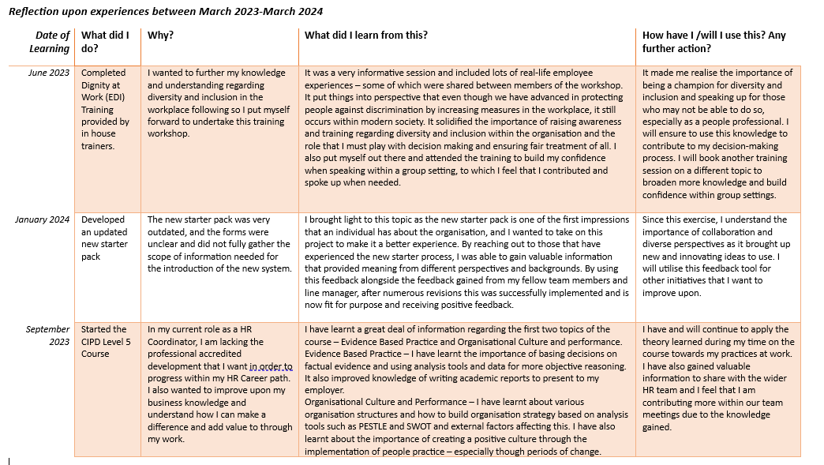
Previous Learning Reflections (AC 3.4)

Appendices

Appendix 1

Self-Assessment against Ethical Practice (associate level)
 | Profession Map Standard | Perform well  Score 30 | Perform satisfactorily  Score 20 | Requires further development  Score 10 | Reason for judgement
1 | Make responsible choices about your work, applying professional principles and values | X |  |  | I ensure to act professionally within my workplace and whilst communicating with others via all communication channels – I have also recently received positive feedback about this. I also ensure to remain impartial so that my personal values are not reflected within my work.
2 | Consider the purpose and implications of actions, decisions and people practices for all stakeholders | X |  |  | I am empathetic and have high levels of emotional intelligence to understand how my actions and practices affect or may affect others positively or negatively.
3 | Raise concerns about people practices and policies which are not consistent with values or legislation |  |  | X | Being relatively new to the HR profession there is room for improvement regarding my employment law/legislation knowledge as it is at the basic level. Currently working towards my CIPD Level 5 which covers this area.
4 | Provide explanations and reasons for the choices you make and the advice you provide |  |  | X | I am an effective communicator and try to be as concise as I can whilst communication decisions. I haven’t fully had the opportunity to advisor within this role but am looking to develop within this area in the new future.
5 | Demonstrate professionalism and consistency in what you say and do in order to build trust | X |  |  | I believe that fairness is important, so I follow policy and share this knowledge with others as I value consistency. I have recently received positive feedback from a new starter that I am very professional within my role as a PP.

Appendix 2

Self-Assessment against Valuing People (associate level)
 | Profession Map Standard | Perform well  Score 30 | Perform satisfactorily  Score 20 | Requires further development  Score 10 | Reason for judgement
1 | Build a sense of team spirit and purpose | X |  |  | I enjoy collaborating and working as a part of a team as it brings a sense of belonging and unity. I value and welcome differing perspectives and welcome challenge from others. I work in a small team, and we rely on each other to motivate and build each other’s spirit.
2 | Treat people fairly and considerately in your work | X |  |  | It is a right for everybody to be treated fairly and I believe that should also apply in the workplace. I follow policy and ensure that everyone is treated as equals.
3 | Enable others to develop skills and capabilities to be their best at work |  | X |  | In my previous role as a manager, I was a champion for my teams learning and development so that we could be a stronger team as a collective and play to each other’s strengths. I would like to get the opportunity to do this within a HR capacity.
4 | Coach and advise others in the business |  | X |  | Again, in my current role I do not advice as often as I would like. However, if somebody come to me for advice then I will gladly help as much as I can or signpost them to other places or people that they could gain the advice from.
5 | Enable people to have a voice when designing and delivering solutions which impact them | X |  |  | I have recently developed an updated new starter pack using new starter feedback and exit interview feedback to tailor this to my organisation. It is beneficial and efficient to gain feedback from those who the change is going to be directly impacted or has experienced. I value differing perspectives as it could bring a solution that I did not consider.
6 | Take into account the wellbeing of others in the design and delivery of your work |  | X |  | My current role is very reactive and most of my workload is time sensitive. I try to delegate where I can but sometimes some work can take longer than expective. This is an area that I need to develop as I feel that sometimes it is out of my control.

Appendix 3

Self-Assessment against Working Inclusively (associate level)
 | Profession Map Standard | Perform well  Score 30 | Perform satisfactorily  Score 20 | Requires further development  Score 10 | Reason for judgement
1 | Get to know people as individuals so you can work together more effectively | X |  |  | I always receive feedback that I am very welcoming and that I make people feel included in the workplace. It is in my nature to build relationships with others even just by being polite and acknowledging others to build positive relationships. I have gotten to know my surrounding team better and understand how we can utilise each other’s skills to be efficient.
2 | Actively seek and listen to diverse views and opinions |  | X |  | I welcome feedback from others and will always welcome criticism. I also enjoy being challenged and other perspectives being given to me. I haven’t gotten much opportunity to do this with the wider workforce in my role, but this is something that I would like to achieve in the future.
3 | Build purposeful working relationships with and collaborate with wider colleagues | X |  |  | Again, I believe that collaborating with the wider business is extremely beneficial as they could open pathways and opportunities that you may not have come across within your function. I always make the effort to build relationships with those that I encounter within the business and have built a positive rapport with many employees.
4 | Readily share your knowledge and expertise with others to solve problems | X |  |  | I am extremely open to share the knowledge that I have and gain to others to help to problem solve. I would hope that others would return the favour one day and share knowledge with me if it was needed. I have also brought things to the teams’ attention that I have been learning during my CIPD Level 5 which has been beneficial.
5 | Support others to resolve conflict and build trust before issues escalate |  |  | X | I haven’t had a lot of experience in this area due to lack of training and expertise with handling hard conversations and mediation training. This is something that I am open to learn in the future to broaden my knowledge.

Appendix 4
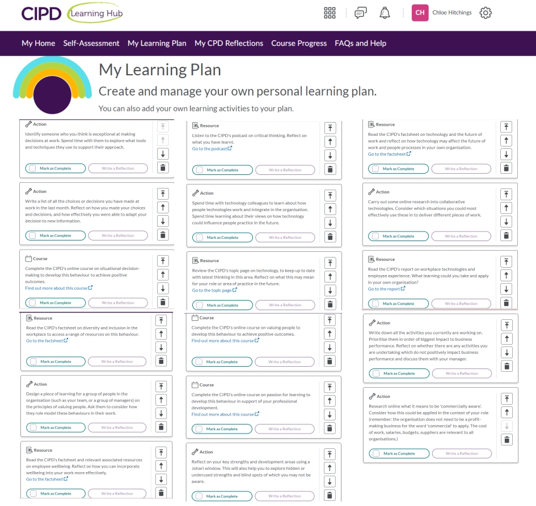

References
- CIPD (2022). CIPD | Equality, Diversity and Inclusion in the Workplace | Factsheets. [online] CIPD. Available at: https://www.cipd.org/uk/knowledge/factsheets/diversity-factsheet/#Whatis.
- CIPD (n.d. a). What Is Continuing Professional Development (CPD). [online] CIPD. Available at: https://www.cipd.org/uk/learning/cpd/about/.
- CIPD (n.d. b). CIPD | The Profession Map / Core Behaviours. [online] CIPD. Available at: https://www.cipd.org/uk/the-people-profession/the-profession-map/explore-the-profession-map/core-behaviours/.
- CIPD. (2020). CIPD | People Profession 2030 future trends. [online] Available at: https://www.cipd.org/uk/knowledge/reports/people-profession-2030-future-trends?_gl=1.
- Komm, A., Pollner, F., Schaninger, B. and Sikka, S. (2021). The new possible: How HR can help build the organization of the future. [online] McKinsey & Company. Available at: https://www.mckinsey.com/capabilities/people-and-organizational-performance/our-insights/the-new-possible-how-hr-can-help-build-the-organization-of-the-future.
- Smith, J A (2020) Reflective Practice, Exeter: Exeter University
- Waite, K., Beevers, K., Small, N., Tomlinson, K. and Hussain, S. (2021) People Practice: A Complete Guide. London, United Kingdom; New York, Ny: Kogan Page.

