Level 5 Assessment Specification
Programme: BSc Health and Social Care
Module: Changemakers: Creativity and Value Creation
Module Code: BMHP5014
Assignment Title: Component 2: Written Assignment (Report)

Cervical Screening Young Women between (25-30) Years old

Student Name: Lazara Laureana Guillen Pedroso
Student ID Number: 2329253
Lecturer Name: Alice Clayton

Contents
Section 1 4
Section 2 6
2.1 Introduction 6
2.2 What is cervical screening test and how to book 6
2.3 Why this innovation matters Now? 7
2.4 Target Audience and Impact 7
2.5 Technology Integration and Accessibility 8
2.6 Implementation Plan 8
2.7 Value, Feasibility and Recommendations 8
2.8 Call and Action 9
References 10

Section 1
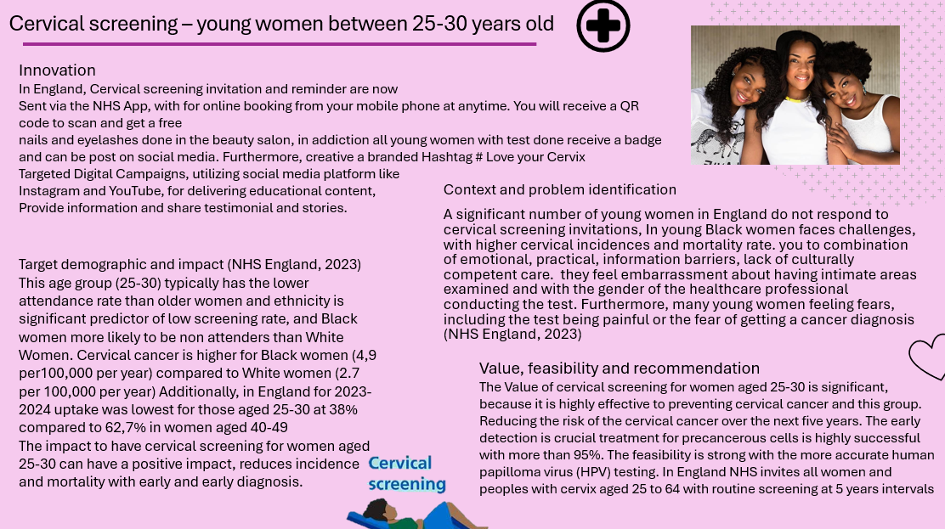
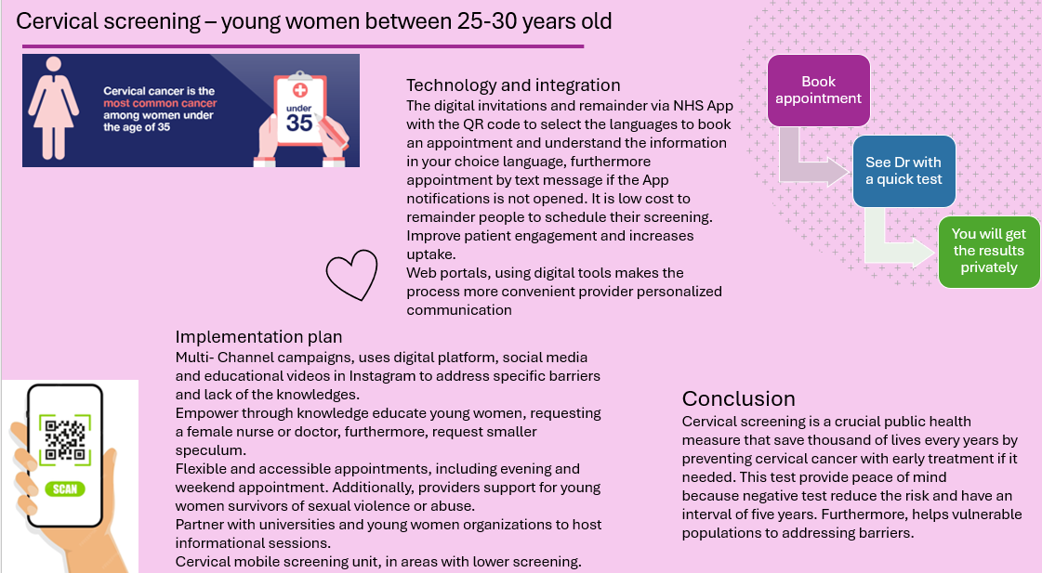

Section 2

2.1 Introduction
I have read a lot of information and seem far many families, friends and neighbours, who do not respond to cervical screening invitation and never booking appointments to do the test. According to Statist Research Department (2023 ) one women dies from cervix cancer every 2 minutes, adding up to over 270,000 deaths globally per year. Additionally cervical cancer prevention behaviours in young Black women are affected and shaped by factors including low knowledges of risks and prevention, low perceived risk. Furthermore, significant combination of emotional, practical, and information barriers such as structural racism, fatalist attitude toward health and distrust in the healthcare. Therefore, Black women have the highest amount of death rate (Gyan et al.,2023)

2.2 What is cervical screening test and how to book
Cervical screening test is a procedure to check the health of the cervix, It is not a test for cancer, it is a test to help to prevent cervical cancer by detecting and treating cell changes and check for the Human Papillomavirus (HPV) that could lead to cancer (NHS England, 2023) The test is a quick and simple screening process offered to women and people with a cervix between 25 to 64 aged. You will be sent an invitation and remainder through the NHS App, by text or by letter. In addiction your invitation will tell you where you can go for cervical screening and how to book. You receive a QR code to scan and see the full information in different languages. Therefore, you can select you prefer one and making easier book from your mobile phone anytime and anywhere.
Additionally, all young women with the cervical screening done in this period, will receive a free appointment to a beauty salon to have their nails and eyelashes done free. Moreover, all young women receive a badge, and they can show on social media utilizing platform like Instagram, YouTube and create a branded hashtag Love Your Cervix and Stop Cancer Before it Starts.

2.3 Why this innovation matters Now?
Cervical screening test innovation matters and is crucial now, because it is key to achieving the potential elimination of cervical cancer as public health issues. Furthermore, to detect potential health disorders or diseases in people who do not have any symptoms of diseases. My innovation goal is early detection, lifestyles changes or surveillance, overcoming barriers to participation addressing many young women fairs. Additionally, encourage young women to have the test done. Moreover, with the concerns open Instagram page to share testimonials and stories about the screening process, facility and benefit to reduce the risk of disease, or detect it early enough to treat it most effectively. In addition, innovation is vital to maximize the reach and effectiveness of screening programs, saving thousands of lives and making the elimination of cervical cancer a tangible reality (Rodriguez, 2021)

2.4 Target Audience and Impact
The primary demographic for cervical screening in young women audiences varies by country generally beginning in their early to mid-twenties. In the UK the target audience is women and people with a cervix aged 25 to 64 years including trans men who are registered with General Practitioner. From 2022 to 2023, of 4.62 million individuals invited for their cervical screening test in the UK, only 3.43 million were screened (NHS, 2023). Having a decrease of 2% comparing with the screening in 2021 present that almost one third (30%). Women aged 25 to 30 years are less likely to attend to their screening appointments Moreover, In England for 2023- 2024 uptake was lowest for those aged 25 to 30 years at 38% compared to 62,7% in women aged 40- 49 years (NHS England, 2023)
For women aged 25- 30 years cervical screening have a significant positive impact, It is highly effective in preventing cervical cancer by detecting precancerous cell changes that can be treated before they develop into cancer, and the issues can be addressed and managed. Furthermore, the early detection reduces incidence and mortality, the screening programme is estimated to save lives and high participation rates are the key to this success
(Bolarinwa and Holt, 2023)

2.5 Technology Integration and Accessibility
The digital invitations and remainder of cervical screening via NHS App, QR code to book an appointment from the phone, select the information in your language accessible to everyone with Furthermore, text messages if the App notification is not opened. Also use Web portals making very low cost to remaining people to schedule their screening. Additionally, the use of digital tools makes the process more convenient, giving clear information to the procedure and benefit improving patients’ engagement and increase uptake

2.6 Implementation Plan
An implementation plan for cervical screening program targeting women aged 25 to 30 years in the UK focus on addressing specific barriers like fear, embarrassment and accessibility using combination of education. Therefore, multi- channel campaigns, use of digital platform such as the NHS App for invitations and remainder. Moreover, use social media and educational videos on Instagram to address specific barriers and lack of the knowledge. Additionally empower through knowledge educate young women they can requesting a female nurse or doctor and request small speculum for the procedure. In addiction the flexibility and accessible appointments including evening and weekend and provides support for young women survivors of sexual violence or abuse (Johnson et al.,2025)
Working in partner with universities and organizations to host informational sessions and quality control with effective programmes the structured call and recall systems.

2.7 Value, Feasibility and Recommendations
Cervical screening is highly valuable, feasible public health intervention, the use of human papillomavirus (HPV) testing, which significantly reduces the incidence and mortality from cervical cancer. The value of cervical screening for young women aged 25 to 30 is significantly high effective at preventing cervical cancer in this group reducing the risk the risk of cervical cancer over the next five years. Moreover, the early detection can find cancer at an early, allows for timely intervention, treatment for precancerous cells is highly successful with more than 95% of effectivity. In addition, screening is considered a highly cost- effective public health strategy using HPV DNA testing with longer intervals, disease prevention combined with HPV vaccination, screening is a core component of the World Health Organization’s (WHO) global strategy to eliminate cervical cancer.
The feasibility is strong especially with the transition to more accurate human papillomavirus (HPV) testing, However, depend on effective public outreach to control and maintain high rate of participation.
In the UK, cervical screening is recommended for all women and people with a cervix between the ages of 25 and 64 with the invitations sent starting at 24.5-year-old with routine screening at 5 years intervals. (Zheng And Wang, 2023)

2.8 Call and Action
I would like you take control of your health. If you have received an invitation letter, text or notification vis NHS App, please act now. Book an appointment, don’t wait, it is a quick test. Additionally, support is available is essential you know your risk, stop cancer before it starts because by attending your screening, you are giving yourself the best possible protection against cervical cancer.

References
Bolarinwa, O.A. and Holt, N. (2023) ‘Barriers to breast and cervical cancer screening uptake among Black, Asian, and Minority Ethnic women in the United Kingdom: evidence from a mixed-methods systematic review’, BMC health services research, 23(1). Available at: https://doi.org/10.1186/s12913-023-09410-x.
Cofie, L.E., Whitt, O. and Bhagat, N. (2024) ‘Personal Networks and Cervical Cancer Screening among Black Immigrant Women’, Journal of racial and ethnic health disparities [Preprint]. Available at: https://doi.org/10.1007/s40615-024-02231-6.
Cyriac, Jissy; Jenkins, Gregory; Strelow, Brittany A; O’ Laughlin, Danielle.; Stevens, Joyn. ; MacLoughlin, Kathy L; Njeru, Janew. (2025) ‘A cross-sectional analysis of factors associated with cervical cancer screening in a large Midwest primary care setting’, BMC women’s health, 25(1). Available at: https://doi.org/10.1186/s12905-025-03741-z.
Department of Health and Social Care (2023) NHS Constitution for England. Available at: https://www.gov.uk/government/publication (Accessed: 2 January 2024)
Gyan, Kayoll; Cantor Phyllis F; Jones, Cherice Escobar; Effiong, Deborah; Nyabisi, Emma; Inam, Mariam; Wamai, Richaed. (2023) ‘TOWARDS AN EQUITABLE CERVICAL CANCER SCREENING APPROACH: UNDERSTANDING CERVICAL CANCER SCREENING BARRIERS AND FACILITATORS AMONG BLACK IMMIGRANT WOMEN’, Oncology nursing forum, 50(2), pp. 6–920.
Johnson, A.J. et al. (2025) ‘Cervical cancer prevention behaviors in young Black women’, Women’s health (London, England), 21, p. 17. Available at: https://doi.org/10.1177/17455057251326008.
National Health Service (2023) Public Health England Available at: https://www.nhs.uk/cervical (Accessed: 1 July 2025)
National Health Service (2021) NHS Trust Cervical Screening. Available at: https://www.nhs.uk/programme (Accessed: 26 April 2021)
Nygård, M. and Nygård, S. (2023) ‘The Future of Cervical Cancer Prevention: From “One-Size-Fits-All” to Personalized Screening’, Journal of personalized medicine, 13(2), p. 161. Available at: https://doi.org/10.3390/jpm13020161.
Rodriguez, N.M. (2021) ‘Participatory innovation for human papillomavirus screening to accelerate the elimination of cervical cancer’, The Lancet global health, 9(5), pp. e582–e583. Available at: https://doi.org/10.1016/S2214-109X(20)30522-2.
Strelow, Brittany; Steven, Joy; Fink Stephanie; Cole Kristin; O’ Laughlin, Danielle. (2025) ‘Improving access to cervical cancer screening: The impact of a Saturday pap smear clinic’, Journal of medical screening, 32(2), pp. 102–105. Available at: https://doi.org/10.1177/09691413241281653.
Williams, Camille; Goulbourne, Elaine; Gyansa, Elijah; Hashi, Ayan; Khalil, lelf, Kham, Rumaisa; Rabel Jeudy, Patricia, Heisey, Ruth; Lofter, Aisha. (2025) ‘Initiatives to increase breast and cervical cancer–related knowledge, screening, and health behaviours among Black women’, Canadian journal of public health, 116(1), pp. 10–15. Available at: https://doi.org/10.17269/s41997-024-00953-y.
Zheng, F. and Wang, K. (2023) ‘The impact of social media on guideline-concordant cervical cancer–screening: insights from a national survey’, Public health (London), 223, pp. 50–56. Available at: https://doi.org/10.1016/j.puhe.2023.07.025.

