Weston woods
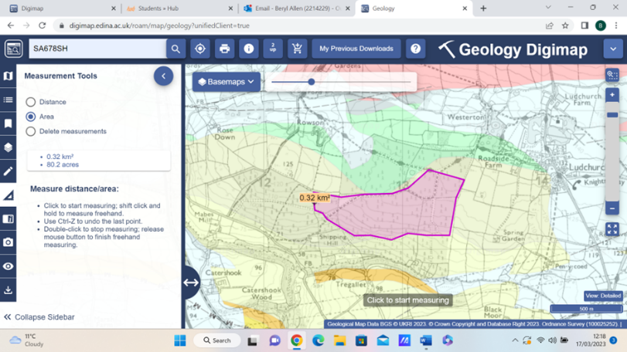
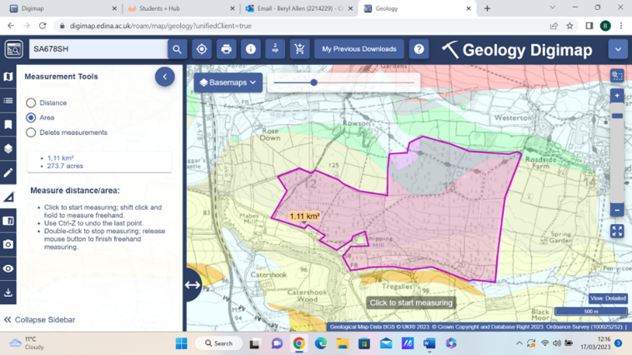
This is a brief history of weston woods, it was planted in 1948 after the Second World War, a lot of marginal farmland was taken over by the Forestry Commission and planted, this was done after the second world war, more homegrown timber was needed for the future .A lot of the timber was grown in the woods was to be used in the mining industry for pit props. The total area of the wood is just over 270 acres as you can see in the map provided from digimaps the wood are landlocked there are no roads going through this large block of woods only two footpaths and bridleways. This is the largest solid block of woodland in Pembrokeshire. It was owed for a number of years by the Forestry Commission but is now in private ownership, so over the last 30 years the has been a deterioration of the footpaths and bridleways going through the forestry so it is not been used as much over the past years until it was discovered during COVID, it now has a few more visitors, used to mainly walking their dogs the woods have enjoyed a quiet time to mature on the environment has not changed much over the years this has allowed the animal population birds to have peace and quiet so it is a diverse habitat .Beginning of this year as you can see in the second map 80 acre block was cut out of the centre of the Woodlands this is what I am going to do my. This is where I am going to do my bird survey to see how this will affect the environment and habitat and type of birds that use the woods.
The objectives.
There has been no bird surveys or habitat done on this forestry in the past. This is why I propose to do a survey over a number of years to see how see habitat and bird population will change or could change, from this large block of wood being cut down, it is going to be replanted at the end of this year so this will also have impact on the type bird.
Aims of the Research
To identify the type of birds that are in the woods.
To count the number of birds in the woods
To see the environmental damage
To see the habitat on this site this will determine what type of mammals and birds.

To identify the type of birds that are in the woods.
This would be carried out in a number of ways with hides put at certain places in the woods, also cameras would be placed in the woods to count the birds .
To count the number of birds in the woods
to count the birds a number of visit would be counted out at the same time every week and in the hides to count the different types and numbers.
To see the environmental damage.
A survey can be carried out to see the environmental damage to the site, this can be done with a site visit and walk to see what fauna and fora are left. A soil sample taken from a number of places on site to see the soil type and ph.
To see the habitat on this site this will determine when you type of mammals and birds.
Survey of the site will determine what type of trees are left there for the birds live in and food. The environment of the site EG what type of grasslands and how wet the land is will determine the environment for what mammals that live there these will determine what types of birds live on sites.

Passive and Non-Passive
There are two types of survey that can be done at this site. A Passive survey means that you can get a large quantity of data in a short period of time on this site. This type of survey is more popular with some investigations due to the amount of data which can be collected.
To collect the data, you use nets, monitor the birds in the nets, counting the number of birds in an area. You would need some help to carry out this type.
You could mark young birds that have hatched, over the spring and this would give a base line to see how many may returned to the woods in years to come
You need to produce a field data sheet this will give you the location, also putting on the data sheet certain things like the grid reference, time of day, weather conditions and the number of people on site.
The size of mist netting varies according to what type of birds in the survey. The smaller breeds are captured with 32 - 38 nets. This will allow more care of the smaller birds. For larger breeds of bird like Hawks or Owls, mesh nets must be used, the size is 127 MM net. The height and diameter can vary depending upon the net height, the misty areas can be from 1.2 - 2.6 meters and the length 10 meters.
A tool kit with a number of black bags with numbers on them. These bags will not show any light, which will help cause any distress to the birds while weigh them and tagging.
The nets are used in the early morning to view the birds as they leave the roost sight. Will also help you use cameras at a later .time
Carry this out over a number weeks and at the same time and day creates a fair survey.
Training is required for this, as you can damage or hurt the birds when you take them out of the nets.
The method is to mark the young birds on the site, using colourless leg band, using numbers and a letter is to l determine where the birds has been born and year.
This information will allow anybody to see where these birds have come from, if they are caught again or unfortunately if they are found dead.
The colourless band is used on the leg band, as the use of bright colours can cause other affects. The Males could be more attractive to the females
Carrying out these surveys on sites at a regular basis every year shows how certain breeds on the sites are decreasing or increasing.
This can also show how the biodiversity of the site is changing over a period of time.
This could therefore affect the overall numbers of these breeds of bird, there numbers and species in these sites. In some ways determining the overall changes biodiversity in these areas. Furthermore, showing environmental changes that are curing in nature as a fast pace.

Non-Passive surveying.
The site in question would have to have certain data position, aerial photographs and maps of the site.
This method takes a longer amount of time and dedication. The people who are carrying out the surveys, must visit the site many times over a period of weeks or months. Collecting this data.
Surveying the site over a longer period of time, on the same days preferably also, the same time every week for a number of months.
There is a number of ways of doing this, using hives, to motion activity on the site. The motion activated cameras that can be placed around the nets and area. Adding a designated spaces and positions where the birds are travelling back to the roosting places to sleep. Also, finding a location on the site that you cannot be seen by the birds will help gather data, using that position every time preferably same time every visit, allowing for minimal disruption.
The field data sheets will record weather, location, time and position. Identifying the species of all the birds you are surveyor on site is paramount, needing to know the type of birds and a shorted name and characteristic, this will also be recorded in field on the data sheets. All the evidence you have collected needs to be entered accurately onto a data sheet and then onto a Word document or PowerPoint so that the information is correct
The surveyor must have a good knowledge use of identifying the type of birds that are on the site. The advantage of a non-passive survey is that the birds do not have any distress caused to them.
To collect this data the use of camera is required. There are several types of cameras available that will collect photographs in the dark.
If looking at nocturnal birds, these cameras will give you data over a period of time. This allowing the surveyor to view cameras when , visiting the site to collect data from the camera. Adding a designated spaces and positions where the birds are travelling back to the roosting places to sleep. There is no real training needed on the camera devices, accept how to use them.
The non passive method is the best for the site in question, it is a rather large area to cover and would not give a true reading of what type of birds on the sit, If using s Passive one. Non passive will take longer too survey the site this would give a better data four a Word document or an excel sheet which then could be put into a PowerPoint or a PDF.

After collecting the data from cameras on site highlighted in blue dots on the map. surveys carried out in hides, that are marked with yellow dots on the site these
can be analysed, these can be the first instalments on a data based. That can be carried on over a number of years to see how environment and habitat on the site matures and how's the flora and fora changes, this would also give an indication of type of birds and numbers of breeding pairs not on the site, the survey can be carried out over a 10 years period . To see how the growth of the new trees will also affect the habitat, environment and number of birds and the population. Below is a hypothetical data sheet of how it would be displayed, using month and bird names. Other factors can be added later to show more factors to support the data.
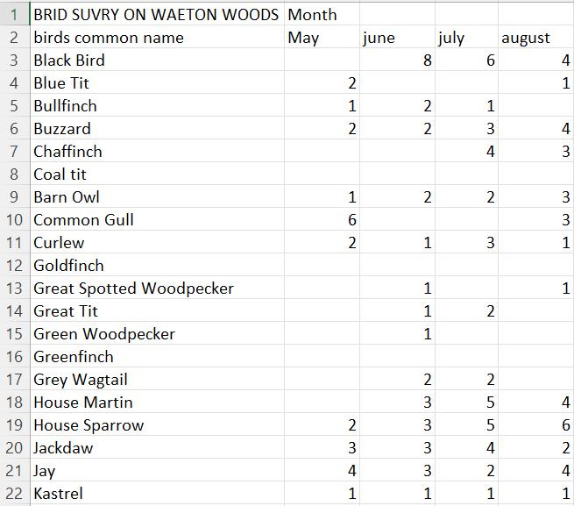
Bibliography
For all images Digi maps was used.

