Module name: Mental Disorders and Psychopathology
Module code: BMHP6006
Student name: Comfort Bentil
Student ID:2008733
Lecturer name: Bianca Sanfilippo

Table of Contents
Introduction 4
Generalized anxiety disorder 4
Classification of the Generalized Anxiety Disorder 4
The most affected person by GAD in the U.K. 5
Causes of anxiety 6
Signs and symptoms 7
When anxiety can be diagnosed 7
Measurement of rehabilitation 7
Treatment interventions 8
Recommendations for improving anxiety 8
Principles of care for people with generalised anxiety disorder (GAD) 8
Schizophrenia 9
Definition 9
Data on people affected by schizophrenia in the UK 9
Schizophrenia classification 9
Aetiology or causes of schizophrenia 9
Signs and symptoms 10
Diagnosis 10
Prevention of schizophrenia 11
Treatment of schizophrenia 11
A measure of rehabilitation in schizophrenia, 11
Guidance and the principle of care NICE 12
Recommendations for Schizophrenia Treatment 12
Autism 14
Definition 14
Classification of autism 14
The percentage of children with autism in the U.K. 14
Causes of autism 14
Symptoms and signs 15
Diagnosis 15
Autism assessment 15
Current treatments 16
Measures of rehabilitation 16
Recommendations for improvement 17
Excellent care principles and guidance 17
References 19
Appendix 23

Introduction
In this report, the analysis of the three various mental disorders is going to be discussed. This analysis will be based mainly on the definition of these disorders, their causes, the criteria for diagnosis, the people vulnerable to those disorders, the treatment, and the various interventions that should be put in place when the disorders occur in an individual. The disorders that are focused on in this discussion are generalised anxiety disorder, schizophrenia, and autism.

Generalized anxiety disorder
A person with generalised anxiety disorder (GAD) worries nonstop and is unable to stop. When worrying occurs most days and for at least six months, doctors diagnose GAD. Anxiety is adaptive, just like fear. Like how terror prepares us for danger, anxiety awakens the sympathetic nervous system and accomplishes the same (Stein et al., 2015).

Classification of the Generalized Anxiety Disorder
The variety of things or circumstances that cause dread, anxiety, or evasive behaviour, as well as the cognitive functioning of ideation, vary across depression and anxiety. The following subcategories of anxiety disorders are recognised by the DSM-5:
Specific Phobia
- Agoraphobia
- Social Anxiety Disorder (Social Phobia)
- Panic attack
- Panic Attack (Specifier)
Generalized anxiety disorder (GAD)
There are many different types of specific phobias, and several individuals all around the world experience them. Here are a few instances of the most prevalent phobias (Andrews et al., 2010).
- Nyctophobia: fear of the dark
- Acrophobia is a fear of heights.
- Aerophobia is the fear of flying.
- Agoraphobia is the fear of open spaces or crowds.
With a few significant exceptions, social phobias are very similar to specific phobias. A person is identified as having a social phobia if they (Seo et al., 2015):
- Marked worry or panic that is out of context for possible scrutiny in social circumstances
- Active aversion to unfavourable evaluations, including embarrassment or humiliation
Agoraphobia
The fear of being exposed in public might make patients avoid specific activities or social settings, such as shopping or perhaps even driving (Kerns et al., 2012).

The most affected person by GAD in the U.K.
According to (National Collaborating Centre for Mental Health (Great Britain), 2011) GAD is a widespread ailment. In the UK, the illness affects more women than men and is more prevalent in adults between the ages of 35 and 55. In this regard, individuals who are employed make up a larger portion of the GAD-affected population in the UK. The Workplace Health Report: 2022, published this year by the professionals at Champion Health, detailed the effects of anxiety on UK workers.
- Every week, six out of every hundred people in England will be diagnosed with generalised anxiety disorder (GAD).
- Over 8 million people in the UK are dealing with anxiety disorders right now (Mental Health UK).
- An estimated 822,000 people experience stress, despair, or anxiety while working each year (Health and Safety Executive).

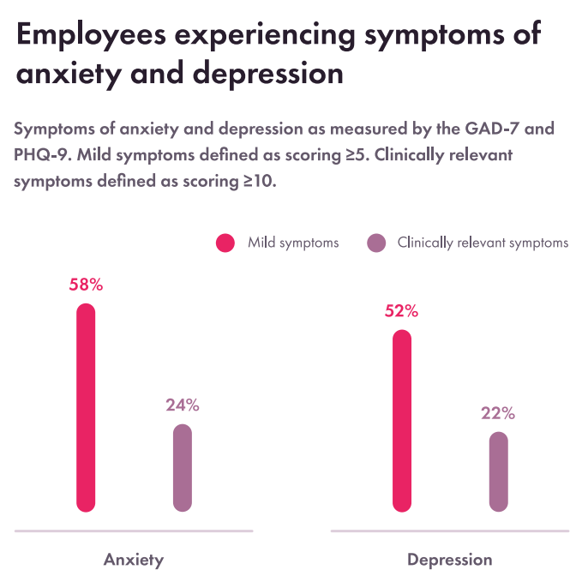

Causes of anxiety
a) biological causes
- Low levels of GABA, a neurotransmitter that lowers activity in the central nervous system, are a factor in anxiety due to neurotransmitter imbalance.
- There is evidence that an anxiety disorder's predisposition is inherited. There is proof, for instance, that those with genetically smaller hippocampus are more prone to anxiety problems after experiencing a stressful experience (Shri et al., 2010).
- Stress anxiety disorders can develop in reaction to life pressures including money problems, anxiety about other relationship issues, and worry regarding chronic physical sickness. GAD is typical in this regard.
- Traumatic incidents, i.e., going through any of a wide variety of situations that leave the person or viewer with strong negative emotions like "fear, helplessness, or terror,"
- Upbringing: Persistent criticism and overbearingly meticulous parents might make their kids anxious (Bandelow et al., 2017).

Signs and symptoms
- Typical anxiety symptoms and indicators include feeling tense, anxious, or apprehensive.
- experiencing weakness or exhaustion, a sensation of approaching danger, dread, or gloom, and being unable to focus on or concentrate on anything but the current worry.

When anxiety can be diagnosed
Your doctor must be aware of your symptoms and situation for the right diagnosis to be determined. If you have experienced symptoms for at least six months, your chances of being diagnosed with GAD are higher (Seligman et al., 2011).

Measurement of rehabilitation
A simple survey, like the PHQ-9, which can be completed online for free, aids in diagnosis and determines the severity of conditions like depression. The PHQ-9 is a screening tool that can help with assessment and gauge the severity of issues to determine how effectively a care strategy is working (Adhikari et al., 2021).

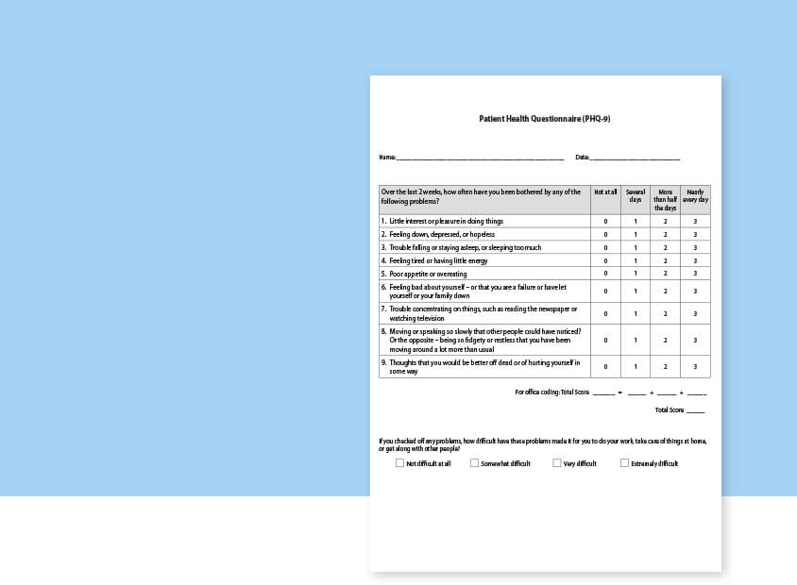

Treatment interventions
- Medications- The most popular medications for treating depression, serotonin reuptake inhibitors (SSRIs), are usually thought of as the primary line of treatment for anxiety disorders (Mustian et al., 2012).
- Psychotherapy
- CBT stands for cognitive-behavioural Research has demonstrated that cognitive-behavioural treatment (CBT) can be quite successful in treating a variety of generalised anxiety disorders, including social phobia and anxiety attacks.
- Anxiety management instruction- Anxiety management training, which could include methods like deep relaxation, improving sleep hygiene, aerobic activity, meditation, and lowering coffee intake (Stubbs et al., 2017).
- Group counselling- CBT may also be partially delivered in group settings, which encourage experience-exchanging, a perception of approval from others, and engaging with behavioural problems in a safe setting.

Recommendations for improving anxiety
It is advised that complementary therapy be employed in the treatment of anxiety disorders. Herbs, diet, exercise, and mind-body practises all have the potential to lower anxiety. You may unwind and lessen your anxiety by using progressive muscle relaxation, breathing exercises, relaxation techniques, meditating, and self-hypnosis (Price et al., 2015).

Principles of care for people with generalised anxiety disorder (GAD)
Information and assistance for those who have GAD, their loved ones, and caregivers
When working with people who have GAD, establish a rapport and be open, engaging, and non-judgmental.
- Examine the person's anxieties to better understand how GAD affects them.
- Stepped-up care for GAD patients
A stepped-care approach is used to organise the provision of treatments and aid people with GAD, their families, caregivers, and practitioners in selecting the most suitable therapy (Wong et al., 2016).

Schizophrenia

Definition
Schizophrenia is a psychotic mental illness marked by impaired emotional response and a breakdown of thinking processes. Though thought to primarily disrupt cognition, the disease frequently exacerbates long-term issues with behaviour and mood (Van et al., 2010).

Data on people affected by schizophrenia in the UK
Approximately 24 million individuals have been given the diagnosis of schizophrenia worldwide; in the UK, that number is already over 685,000, more than 1% of the total. The expense of schizophrenia is significant. Nearly "30% of all expenditure upon adult emotional stability in the NHS" was attributed to it in 2012, with 11.8 million GBP spent on it in England only (Evans et al., 2014).

Schizophrenia classification
Schizophrenia with paranoia
This is the schizophrenia subtype that is most prevalent. It could take even longer than other varieties to mature. Symptoms could include hallucinations and/or delusions, although the conversation and thinking may not change.
Hebephrenia and schizophrenia
In most cases, this type of schizophrenia, also known as "disoriented schizophrenia," develops between the ages of 15 and 25. Disorganized thought patterns, together with brief delusions and hallucinations, are signs (Silva et al., 2014).
Schizophrenia with catatonia
The rarest kind of schizophrenia is characterised by peculiar, constrained, and sudden movements. You could fluctuate between getting highly active and remaining quite motionless at times. Someone may not even speak much and may simply imitate the gestures and words of others.

Aetiology or causes of schizophrenia
The onset of schizophrenia is influenced by both hereditary and environmental factors.
- Genetic factors: Having another first-degree relative with schizophrenia increases the risk of acquiring the illness by 6.5%; those who have had a brief psychosis and have a family history of schizophrenia have a 20–40% likelihood of receiving a diagnosis one year later (Gejman et al., 2010).
- Environmental factors—Factors inside this environment that have been linked to the emergence of schizophrenia include habitational surroundings However, after controlling for drug usage, ethnicity, and size of social group, it has repeatedly been shown that growing up or staying in such an urban environment increases the risk of schizophrenia by a factor of two (Pettersson et al., 2011).

Signs and symptoms
Although there are many varied warning signs and symptoms, they frequently involve hallucinations, loss of coordination, and a diminished ability to operate. Some indications include
- Delusions. These are false beliefs that are not grounded in reality. For instance, you experience harassment or a sense of menace when certain actions or words are directed against you.
- Hallucinations. They often include hearing or seeing intangible things.
- Unorganized thinking (speech) Chaos in speech suggests chaos in the mind. Questions may include answers that are partially or completely unrelated, which might make dialogue difficult.
- extreme disorganisation or unusual motor activity This may manifest in a variety of ways, ranging from naiveté to sudden anxiety. If behaviour is not directed toward a specific objective, tasks are challenging to execute.

Diagnosis
The following criteria are suggested by the DSM-5 for making a schizophrenia diagnosis:
A pair (or more) of the following, each present for a substantial amount of time during a month (or less if successfully treated),
- Delusions.
- Hallucinations.
- uncoordinated speech (e.g., frequent derailment or incoherence).
- catatonic or utterly chaotic conduct
- negative signs (i.e., diminished emotional expression or avolition).

Prevention of schizophrenia
- Public health initiatives might target certain macroeconomic variables, such as immigration, culture, or poverty, that have previously been associated with a greater prevalence of schizophrenia in particular populations (Pettersson et al., 2011).
- Promotion of health services: Population-wide policies should encourage the use of services that support natural development overall, including learning and memory and safe deliveries.

Treatment of schizophrenia
Psychosis cannot be cured. Maximizing functionality and managing the condition are the objectives.
Antipsychotic medicine, which can lessen the positive signs of psychosis in roughly 7–14 days, is the first-line psychological treatment for schizophrenia (Kane et al., 2010).
The use of psychosocial therapies
- Numerous psychosocial therapies, such as family therapy, may indeed be helpful in the treatment of schizophrenia.
- Firmly promoting community therapy... ACT is a thorough and thoroughly integrated method for providing community mental health services. Outpatients who experience severe functional challenges in a number of important areas of their lives due to the symptoms of their mental illness are helped by ACT programmes.

A measure of rehabilitation in schizophrenia,
Scales that quantify the positive and negative symptoms of the condition are still the main tools used by clinical practitioners and academics to evaluate and diagnose schizophrenia. The scales are primarily used to assess a patient's response to therapy and monitor the degree of their positive and negative symptoms. However, despite the fact that these measures are often employed, there are variations in the accuracy and general usefulness of each scale (Kluwe et al., 2013).

Guidance and the principle of care NICE
The following recommendations should be followed to enhance the quality of care for anyone with psychosis or schizophrenia who uses mental health services:
- Collaborate with those who have schizophrenia and their caregivers.
- provide support, care, and therapy in a hopeful and upbeat environment.
- When working with patients who have schizophrenia or psychosis, medical personnel should make sure they are proficient in evaluation abilities for individuals from various racial and cultural origins (Kendall et al., 2013)
- using sickness explanation models for individuals with a variety of racial and cultural origins

Recommendations for Schizophrenia Treatment
The guidelines listed below can be used to treat cases of schizophrenia and manage the condition if it is present in a person.
Interventions in the token economy
Although modified for shorter stays and less rigorous treatment programs, token economy programmes for schizophrenia (based on operant conditioning) are frequently used in long-term care settings such as long-stay medical centres and assisted-living facilities (Kreyenbuhl et al., 2010).
Assisted employment
When it comes to hiring people with impairments, there is prejudice. Employing people with schizophrenia in real jobs that pay real wages while also providing them with unwavering support is known as "planned operations for schizophrenia." This lessens poverty, which frequently makes the illness worse.
Cognitive Rehabilitation Therapy (CRT)
Is a form of cognitive rehabilitation treatment that was created to enhance neurocognitive skills including executive performance, scheduling, flexibility, and learning and memory (Keating et al., 2017). These skills all contribute to better cognitive competence. Schizophrenia has been successfully treated with CRT in some cases.

Autism

Definition
A neurological condition known as autism spectrum disorder affects how a person understands and relates to others, which can cause problems with communication and social communication. Another characteristic of the condition is restricted and recurrent social behaviour. The term "spectrum" describes the wide variety of symptoms and severity of autism spectrum disorder (Rutter et al., 2011).

Classification of autism
Disorder Asperger's
Individuals with Asperger syndrome typically have milder symptoms of autism. They may experience social difficulties and exhibit strange habits and interests.
Pervasive Developmental Disorder
This syndrome is often referred to as "atypical autism" or PDD-NOS. These people frequently exhibit milder signs of autism disorder than other autistic people do. Only communication and social problems might be caused by the symptoms (Anderson et al., 2011).

The percentage of children with autism in the U.K.
Over 7 million community college children were the subject of a study undertaken by Newcastle University researchers in association with the Institute of Psychiatry at the University of Cambridge and Maastricht University. They found that the number of UK children on the autism spectrum is substantially greater than previously believed, at about one in 57 (1.76%). According to earlier estimations of the prevalence of autism in the UK made by the same study team in Cambridge using data from a school-based survey, one in 64 kids (1.57%) were thought to be autistic (Taylor et al., 2013). The new study reveals a marked rise in the incidence of autism in England, based on educational statistics that often understate the real number of kids who fit the criteria for a diagnosis.

Causes of autism
Variations in the brain cause developmental disability, sometimes known as autism spectrum disorder (ASD). Some ASD individuals have a distinguishing characteristic, such as a hereditary condition. Other unknown elements still exist. It is believed that ASD is caused by a number of underlying factors that combine to change how people generally develop. We still don't fully understand these elements' effects on individuals with ASD (Griffith et al., 2012).

Symptoms and signs
Social interaction and communication
- A person with an autism spectrum condition may have difficulty conversing and communicating, which may involve any of the following symptoms, whether they are a kid or maybe an adult:
- occasionally does not respond when called by name or appears to be deafeningly deafen
- rather than being hugged and caressed, wants to play by themselves and retreat into their own world (Russell et al., 2015).
Habits of conduct
- A child or adult with autism spectrum disorder may exhibit any of the following symptoms in addition to restricted, repetitive patterns of behaviour, interests, or hobbies:
- performs repetitive movements such as rocking, spinning, or hand flapping.
- demonstrates behaviours that might result in self-harm, including biting or head-bashing (Charman et al., 2011).

Diagnosis
It may be difficult to identify ASD because there is no medical test, such as a clinical examination. Doctors take the child's behaviour and developmental stage into account when making a diagnosis. A child with ASD can be diagnosed as young as 18 months old. By the age of two, a reliable diagnosis provided by an experienced professional can be accepted. However, many children don't receive a conclusive diagnosis until they are much older. Some people are not diagnosed until they are adults or adolescents (Jonathan et al., 2010).

Autism assessment
How to obtain a diagnosis of autism
Someone like a general practitioner (GP) or SENCO personnel at the children's school needs to recommend you for an evaluation.
What happens during an autism evaluation?
For young people
The evaluation group could:
- Inquire about the growth of your child, such as when they began talking.
- Keep an eye on your interactions with your child and how they play.
- read any correspondence from their doctor, nursery, or school.

Current treatments
- Medications. Specific medications can control symptoms but cannot change the fundamental issues with autism spectrum disease. For instance, some drugs may be suggested if your kid is hyperactive; serious behavioural problems may occasionally be treated with antipsychotic drugs, and anxiety may be addressed with antidepressants (Jiang et al., 2022). All doctors should be notified of any prescription medications or nutritional supplements that your child is taking.

Measures of rehabilitation
Autism can be treated with a variety of therapies. Although this is mostly applied in rehabilitation practices, behavioural therapy is one type of therapy.
- treatments for communication and behavior. Several approaches are used to treat the wide range of social, linguistic, and behavioural difficulties connected to autism spectrum disorder. Some programmes place a strong emphasis on teaching new information and getting rid of bad behaviours. Applied behaviour analysis (ABA) can help kids acquire new skills and generalise them to a range of environments using a reward-based incentive system (Hardy et al., 2013).
- Children with autism spectrum disorder often benefit from educational therapy programmes with a rigid structure. Effective programmes often incorporate a group of experts and a variety of activities to improve social skills, interaction, and behaviour.
- Family counselling. Parents and other relatives may be able to interact with and engage with their kids in ways that encourage social skills, control problem behaviours, and impart communicative and everyday life skills.
- Occupational therapy can offer function and quality of life; physical therapy can enhance movement and coordination; and speech therapy can help your kid communicate more effectively, depending on what they require (Kagohara et al., 2010).

Recommendations for improvement
Examples of complementary and alternative therapies that, when combined with evidence-based treatments, may be beneficial include:
- Innovative treatments. Some parents decide to add art therapy or relaxation techniques, which aim to lessen a child's sensitivity to touch or sound, in addition to educational and medical assistance. When combined with other medications, these therapies could be beneficial in certain cases.
- Treatments using the senses These treatments are predicated on the unsubstantiated hypothesis that individuals with autism spectrum disorder have sensory processing issues that make it difficult for them to tolerate or comprehend sensory data, including touch, balance, and hearing. Massage (Hardy et al., 2013). Although massage may be soothing, there isn't adequate data to say if it helps with autism spectrum disease symptoms.
- Horse or pet therapy Pets may be a source of amusement and friendship, but further study is required to understand whether animal interaction helps with the symptoms of autism spectrum disease.

Excellent care principles and guidance
Ensure that all autistic youngsters and young people, independent of their cognitive prowess or any coinciding diagnoses, have unlimited access to healthcare, including services for mental illness.
According to the NICE recommendations on autism in children and adolescents, a local autism cross-strategy group should manage the overall design and creation of community-based services (encompassing health, mental wellbeing, and intellectual disabilities) for autistic young people (Lauritsen et al., 2013).
The following interventions and attention are suggested in this recommendation for autistic adolescents and children who already have special needs, and local autism groups should offer (or coordinate) them: Youth and children who are in foster care
- People who are immigrants
- People who have lost talents

References
Adhikari, S. et al. (2021) “Prevalence of anxiety, depression, and perceived stigma in healthcare workers in Nepal during later phase of first wave of COVID-19 pandemic: A web-based cross-sectional survey,” Cureus. Available at: https://doi.org/10.7759/cureus.16037.
Anderson, J.S. et al. (2011) “Functional Connectivity Magnetic Resonance Imaging Classification of Autism,” Brain, 134(12), pp. 3742–3754. Available at: https://doi.org/10.1093/brain/awr263.
Andrews, G., Hobbs, M. J., Borkovec, T. D., Beesdo, K., Craske, M. G., Heimberg, R. G., Rapee, R. M., Ruscio, A. M., & Stanley, M. A. (2010). Generalized worry disorder: A review of DSM-IV generalized anxiety disorder and options for DSM-V. Depression and Anxiety, 27(2), pp.134–147. Available at: https://doi.org/10.1002/da.20658
Bandelow, B. et al. (2016) “Biological markers for anxiety disorders, OCD and PTSD: A consensus statement. part II: Neurochemistry, neurophysiology and neurocognition,” The World Journal of Biological Psychiatry, 18(3), pp. 162–214. Available at: https://doi.org/10.1080/15622975.2016.1190867.
Charman, T. et al. (2010) “IQ in children with autism spectrum disorders: Data from the Special Needs and Autism Project (SNAP),” Psychological Medicine, 41(3), pp. 619–627. Available at: https://doi.org/10.1017/s0033291710000991.
Choi, J, et al. (2014). Measuring motivation in schizophrenia: is a general state of motivation necessary for task-specific motivation? Schizophrenia research, 153(1-3), pp.209-213.
Evans-Lacko, S. et al. (2014) “Effect of the time to change anti-stigma campaign on trends in mental-illness-related public stigma among the English population in 2003–13: An Analysis of Survey Data,” The Lancet Psychiatry, 1(2), pp. 121–128. Available at: https://doi.org/10.1016/s2215-0366(14)70243-3.
Gejman, P.V., Sanders, A.R. and Duan, J. (2010) “The role of genetics in the etiology of schizophrenia,” Psychiatric Clinics of North America, 33(1), pp. 35–66. Available at: https://doi.org/10.1016/j.psc.2009.12.003.
Goff, D.C. (2020) “The pharmacologic treatment of schizophrenia—2021,” JAMA [Preprint]. Available at: https://doi.org/10.1001/jama.2020.19048.
Green, J. et al. (2010) “Parent-mediated communication-focused treatment in children with autism (PACT): A randomised controlled trial,” The Lancet, 375(9732), pp. 2152–2160. Available at: https://doi.org/10.1016/s0140-6736(10)60587-9.
Griffith, G. M., Fletcher, R., & Hastings, R. P. (2012). A national UK census of Applied Behavior Analysis school provision for children with autism. Research in Autism Spectrum Disorders, 6(2), 798–805. Available at: https://doi.org/10.1016/j.rasd.2011.10.014
Hardy, M.W. and LaGasse, A.B. (2013) “Rhythm, movement, and autism: Using rhythmic rehabilitation research as a model for autism,” Frontiers in Integrative Neuroscience, 7. Available at: https://doi.org/10.3389/fnint.2013.00019.
Insel, T.R. (2010). Rethinking schizophrenia. Nature, 468(7321), pp.187-193.
Jiang, C.-C. et al. (2022) “Signalling pathways in autism spectrum disorder: Mechanisms and therapeutic implications,” Signal Transduction and Targeted Therapy, 7(1). Available at: https://doi.org/10.1038/s41392-022-01081-0.
Kagohara, D.M. (2010) “Is video-based instruction effective in the rehabilitation of children with autism spectrum disorders?,” Developmental Neurorehabilitation, 13(2), pp. 129–140. Available at: https://doi.org/10.3109/17518420903329281.
Kane, J.M. and Correll, C.U. (2010) “Past and present progress in the pharmacologic treatment of schizophrenia,” The Journal of Clinical Psychiatry, 71(09), pp. 1115–1124. Available at: https://doi.org/10.4088/jcp.10r06264yel.
Keating, D. et al. (2017) “Pharmacological guidelines for schizophrenia: A systematic review and comparison of recommendations for the first episode,” BMJ Open, 7(1). Available at: https://doi.org/10.1136/bmjopen-2016-013881.
Kendall, T. et al. (2013) “Recognition and management of psychosis and schizophrenia in children and young people: Summary of nice guidance,” BMJ, 346. Available at: https://doi.org/10.1136/bmj.f150.
Kerns, C.M. and Kendall, P.C. (2012) “The presentation and classification of anxiety in autism spectrum disorder.,” Clinical Psychology: Science and Practice, 19(4), pp. 323–347. Available at: https://doi.org/10.1111/cpsp.12009.
Kluwe-Schiavon, B. et al. (2013) “Executive functions rehabilitation for schizophrenia: A critical systematic review,” Journal of Psychiatric Research, 47(1), pp. 91–104. Available at: https://doi.org/10.1016/j.jpsychires.2012.10.001.
Kreyenbuhl, J. et al. (2009) “The Schizophrenia Patient Outcomes Research Team (port): Updated treatment recommendations 2009,” Schizophrenia Bulletin, 36(1), pp. 94–103. Available at: https://doi.org/10.1093/schbul/sbp130.
Lauritsen, M.B. (2013) “Autism spectrum disorders,” European Child & Adolescent Psychiatry, 22(S1), pp. 37–42. Available at: https://doi.org/10.1007/s00787-012-0359-5.
Lord, C. and Jones, R.M. (2012) “Annual research review: Re-thinking the classification of Autism Spectrum Disorders,” Journal of Child Psychology and Psychiatry, 53(5), pp. 490–509. Available at: https://doi.org/10.1111/j.1469-7610.2012.02547.x.
Mustian, K.M. et al. (2012) “Exercise recommendations for cancer-related fatigue, cognitive impairment, sleep problems, depression, pain, anxiety, and physical dysfunction—a review,” Oncology & Hematology Review (US), 08(02), p. 81. Available at: https://doi.org/10.17925/ohr.2012.08.2.81.
National Collaborating Centre for Mental Health UK. (2011) Common Mental Health Disorders: Identification and Pathways to Care. British Psychological Society (UK).
Pettersson-Yeo, W. et al. (2011) “Dysconnectivity in schizophrenia: Where are we now?” Neuroscience & Biobehavioral Reviews, 35(5), pp. 1110–1124. Available at: https://doi.org/10.1016/j.neubiorev.2010.11.004.
Price, R.B. et al. (2015) “Empirical recommendations for improving the stability of the dot-probe task in clinical research.,” Psychological Assessment, 27(2), pp. 365–376. Available at: https://doi.org/10.1037/pas0000036.
Russell, G. et al. (2015) “Changes in diagnosis rates and behavioural traits of autism spectrum disorder over time,” BJPsych Open, 1(2), pp. 110–115. Available at: https://doi.org/10.1192/bjpo.bp.115.000976.
Rutter, M.L. (2011) “Progress in understanding autism: 2007–2010,” Journal of Autism and Developmental Disorders, 41(4), pp. 395–404. Available at: https://doi.org/10.1007/s10803-011-1184-2.
Seligman, L.D. and Ollendick, T.H. (2011) “Cognitive-behavioral therapy for anxiety disorders in Youth,” Child and Adolescent Psychiatric Clinics of North America, 20(2), pp. 217–238. Available at: https://doi.org/10.1016/j.chc.2011.01.003.
Seo, J.-G. and Park, S.-P. (2015) “Validation of the generalized anxiety disorder-7 (GAD-7) and Gad-2 in patients with Migraine,” The Journal of Headache and Pain, 16(1), pp. 1–7. Available at: https://doi.org/10.1186/s10194-015-0583-8.
Shri, R. (2012) “Anxiety: Causes and Management”, The Journal of Behavioral Science, 5(1), pp. 100–118. Available at: https://so06.tci-thaijo.org/index.php/IJBS/article/view/2205 (Accessed: 11 December 2022).
Silva, R.F. et al. (2014) “The tenth annual MLSP competition: Schizophrenia Classification Challenge,” 2014 IEEE International Workshop on Machine Learning for Signal Processing (MLSP), pp. 1–6. Available at: https://doi.org/10.1109/mlsp.2014.6958889.
Stein, M.B. and Sareen, J. (2015) “Generalized anxiety disorder,” New England Journal of Medicine, 373(21), pp. 2059–2068. Available at: https://doi.org/10.1056/nejmcp1502514.
Stubbs, B. et al. (2017) “An examination of the anxiolytic effects of exercise for people with anxiety and stress-related disorders: A meta-analysis,” Psychiatry Research, 249, pp. 102–108. Available at: https://doi.org/10.1016/j.psychres.2016.12.020.
Taylor, B., Jick, H. and MacLaughlin, D. (2013) “Prevalence and incidence rates of autism in the UK: Time Trend from 2004–2010 in children aged 8 years,” BMJ Open, 3(10). Available at: https://doi.org/10.1136/bmjopen-2013-003219.
Van Os, J., Kenis, G. and Rutten, B.P. (2010) “The environment and schizophrenia,” Nature, 468(7321), pp. 203–212. Available at: https://doi.org/10.1038/nature09563.
Wong, S.Y. et al. (2016) “Mindfulness-based Cognitive Therapy v. group psychoeducation for people with generalised anxiety disorder: Randomised controlled trial,” British Journal of Psychiatry, 209(1), pp. 68–75. Available at: https://doi.org/10.1192/bjp.bp.115.166124.

Appendix


