3/18/2019
Raoul Chappell (P151140)
Uwtsd
Forces in Whitewater kayaking

Abstract
This is a report into the forces in whitewater kayaking. After researching whitewater kayaking some calculations were used to calculate the forces experienced by both the athlete and the equipment, during storage, transport and use. These calculations were then applied to the current world record for the highest waterfall descended successfully in a kayak. This was completed so that there may be evidence that a higher waterfall could be run successfully without causing permanent damage.

Table of Contents
Abstract 1
1) Introduction 3
1.1 Disclaimer 3
2) Areas of forces 4
2.1 Assumptions 4
2.2 storage 4
2.3 Transport 5
2.4 During use 5
2.4.1 Whitewater rapids 5
2.4.2 Waterfalls 9
2.4.3 World record (Palouse falls) 11
3) Recommendations 13
4) Conclusion 14
Bibliography 15

Figures
Figure 1 (Hansen, 2017) 4
Figure 2 (Snowland, 2019) 5
Figure 3(Moore, 2011) 5
Figure 4 (Mussell, 2012) 6
Figure 5 (Daily Mail Reporter, 2009) 11

Introduction
This is a report into the forces in whitewater kayaking. In order to calculate the forces research into whitewater kayaking was completed to find what kayaks are designed to withstand including articles, videos and websites.
Whitewater kayaking is an extreme sport that involves athletes navigating their kayak through fast and turbulent water. There are two main types of whitewater kayaking there is waterfall kayaking where the main focus of the run is waterfalls when doing this sort of kayaking athletes will tend to run pool drop rivers such as the Rio Claro, Agua Azul or Etive this way the athletes can practise their techniques and learn to run bigger and bigger waterfalls.
The other main type of whitewater kayaking is big river kayaking where the main focus is on big rapids. Where the athletes can learn to “Read the River” this is a technique used when scouting or running a rapid it involves watching the water, how it moves and how it changes the reason for this is to find the best line down a rapid avoiding hazards, for example if there is a lot of water pushing up against a rock or cliff face, but there is only a small or no reaction wave, then the water is likely flowing underneath it through an undercut or siphon this is a key skill in kayaking. In order to do this kayaker will tend to run big rivers such as the middle Guil, Ottawa or Stikine.
the current world record for highest waterfall ever run was analysed to determine if it was possible to break it without causing permanent damage to the Kayaker.

Disclaimer
the values calculated in this report are approximate multiple assumptions have been made in order to simplify the calculations and, therefore should not be used in any situation where harm could come to the user or anyone else.

Areas of forces
There are three main areas of a kayaks use that load force onto it these being storage loading on vehicles and during use. The forces and how they affect the kayak are listed below.

2.1 Assumptions
- Average length of a whitewater kayak is nine foot
- The average weight of a kayak is twenty kilograms
- The average weight of a regular whitewater kayaker icluding any gear he is wearing is eighty kilograms (70 paddler 10 kit)

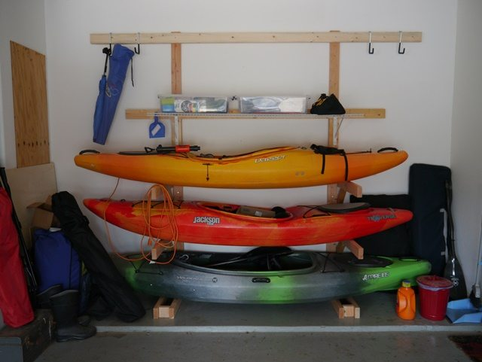
2.2 storage
Figure 1 (Hansen, 2017)

The majority of kayaks are stored on wall mounted racks with two beams supporting the kayak approximately equidistant from the centre the weight of the kayak can cause elastic and in worse cases plastic deformation of the kayak. In some cases this is very minor and doesn’t need repair in others however need to be reshaped this is done relatively easily using hot water and something to reshape the plastic with (usually a stick or broom handle). The disadvantage of reshaping the kayak like this on a regular basis apart from the time and effort to do it is that the repeated heating and reshaping causes weak points within the plastic these could lead to the plastic thinning and or splitting.
Assuming the average length of a modern whitewater kayak to be 9ft and the support beams are placed 6ft apart (each 3ft from the centre of mass) then we can calculate the forces being applied to the kayak.$$upwards forces≡downwards forces$$
$$downwards forces=m×a$$
$$downwards forces=m×g$$
$$downwards forces=20×9.81$$
$$downwards forces=196.2N$$
$$∴upwards forces=196.2N$$
$$upwards force from each beam=196.2÷2$$
$$upwards force from each beam=98.1N$$

2.3 Transport
During transport much like during storage kayaks are supported on a roof rack and strapped down assuming a tension in each of the straps to be approximately 150N. The force acting on the kayak from the tension in the straps and gravity can be calculated.
$$Force acting on the kayak=98.1+150$$
$$Force acting on the kayak=248.1N$$
Over-tensioning in the straps can cause plastic deformation or splitting in the hull of the kayak

2.4 During use
A further list of assumptions has been made for the following situations
- The paddler has a mass of 70 kg
- The equipment they are wearing has a mass of 10kg
- The kayak has a mass of 20kg
- Waterfalls will be considered as free fall from the full height of the falls forward momentum is small enough to be neglected.
- The conservation of energy is complete and 100% efficient from one form to another
- Water is considered to be an incompressible substance
- Submersion depth is proportional to the impact velocity
- Deceleration is constant and uniform
- The bottom pool of a waterfall is a flat calm body of water

2.4.1 Whitewater rapids
Whilst kayaking down whitewater rapids there are many different forces acting on the boat and paddler at any time such as the water flowing down the river, the paddler propelling the boat through the water or impacts on rocks. For this section we are assuming a flow rate of 15m³/s with a velocity of 5m/s

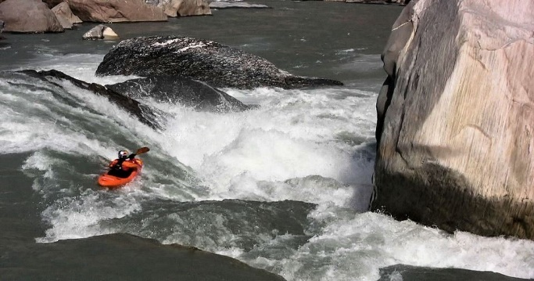
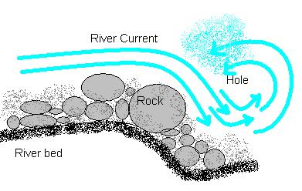
2.4.1.1 stoppers/holes
Figure 2 (Snowland, 2019)
Figure 3(Moore, 2011)

Stoppers are a river feature that are caused by the shape of the riverbed. Most stoppers are caused by rocks or other debris but can also be caused by erosion of softer material on the riverbed. In a stopper the water close to the surface flows back upstream then when it hits the water moving down river it either gets recirculated or flows out downstream past the “towback” this is the line beyond which the water either flows downstream or gets recirculated. This recirculation is what makes stoppers dangerous. Some kayakers have said that hitting a big stopper can be like hitting a brick wall.
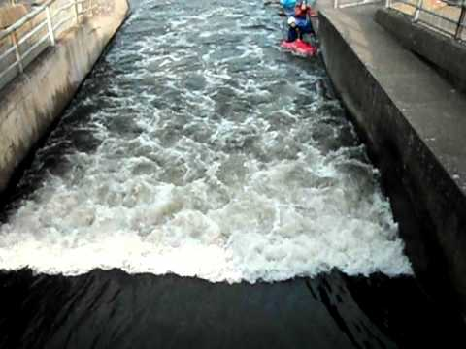
There are a few different types of stopper and therefore a few things to look out for when scouting a rapid. Firstly, if the ends are walled in it is usually unsafe this is because the best way to get out of a stopper is to paddle out one end or the other. There are exceptions to this for example inlet gate at Nottingham white-water course (pictured below)
Figure 4 (Mussell, 2012)
The second feature to look for is the shape of the stopper it is very rare to get a flat stopper even most manmade stoppers (from dams or weirs) are now rounded or angled to push anything stuck in it towards the bank. If the middle of the stopper is the furthest upstream then it is safer because the flow pushes things out of the stopper, however if the middle is the furthest downstream part of the stopper the stopper pulls things into the middle (usually the biggest part of the stopper) this is less safe. Angled stoppers are harder to judge the angle direction and what the stopper is feeding towards need to be taken into consideration.
The last and most important feature is the towback length and the depth of the recirculation if paddling to the end of the stopper is not possible the next best way out of the stopper is the water flowing underneath the recirculating wave or off the back of the stopper. If the towback length is short enough that the paddler can reach the paddle past the towback line or into the water flowing downstream underneath the recirculation then the stopper is fairly safe. This is what makes some very small stoppers from weirs or dams very dangerous. This is explained in more detail in a YouTube video link below
https://www.youtube.com/watch?v=XsYgODmmiAM
(Kern, 2013)

2.4.1.1.1 Small stopper (1 meter tall 3 meters wide 0.5m towback length)
$$Volume=L×W×H$$
$$Volume=0.5×3×1$$
$$Volume=1.5m^{3}$$
Because the stopper is a recirculating feature approximately half of this water is actually flowing upstream.
$$Volume of water flowing upstream=\frac{Volume}{2}=\frac{1.5}{2}$$
$$Volume of water flowing upstream=0.75m^{3}$$
Because the stopper as a whole is not moving either upstream or downstream the velocity of the water flowing upstream must equal that flowing downstream at five meters per second.
$$density of water=1000kg/m^{3}$$
$$∴0.75m^{3}=750kg$$
$$KE=1/2mv^{2}$$
$$KE=0.5×750×5^{2}$$
$$KE=9375J$$
However, a kayaker would only hit a small section of the stopper assuming a paddler height of 1m and width of 0.5m
$$impact area=1×0.5$$
$$impact area=0.5m^{2}$$
With an impact area of 0.25m² the mass of water flowing upstream would be
$$Volume of water flowing upstream against paddler=0.5×0.5$$
$$Volume of water flowing upstream against paddler=0.25m^{3}$$
$$mass of water flowing upstream against paddler=250kg$$
$$KE=0.5×250×5^{2}$$
$$KE=1562.5J$$
$$v^{2}=\frac{3125}{0.5×100}$$
$$v=\sqrt{62.5}$$
$$v=7.91m/s$$
This means the paddler would have to be traveling faster than 7.91m/s to avoid being recirculated in the stopper

2.4.1.1.2 Large stopper (approximately 3m tall 25m wide 5m towback)
$$Volume=L×W×H$$
$$Volume=5×25×3$$
$$Volume=375m^{3}$$
$$Volume flowing upstream=187.5m^{3}$$
$$KE=0.5×187500×5^{2}$$
$$KE=2343750J$$
However as previously mentioned the kayaker would only impact a small section of this stopper. As the size of the kayaker has not changed
$$volume of water flowing upstream against paddler=0.5×5$$
$$Volume of water flowing upstream against paddler=2.5m^{3}$$
$$mass of water flowing upstream against paddler=2500kg$$
$$KE=0.5×2500×5$$
$$KE=31250J$$
$$v^{2}=\frac{31250}{0.5×100}$$
$$v^{2}=625$$
$$v=25m/s$$
This means the paddler wold have to be traveling faster than 25m/s that’s more than 55mph and therefore not possible in a conventional kayak.

2.4.2 Waterfalls
With the progression in the sport and the prevalence of top athletes kayaking videos being seen worldwide, more and more paddlers are running waterfalls. These waterfalls range in height from 1-2ft run as club trips with younger less experienced paddlers to 100+ft for highly experienced paddlers. This section of the report will look into the range of a fairly experienced paddler
Falls of the fuller (river Mellte, Wales) – 20ft
$$GPE=mgh$$
$$GPE=100×9.81×6.096$$
$$GPE=5980.176J$$
$$GPE=KE$$
$$5980.176=0.5×100×v^{2}$$
$$v^{2}=\frac{5980.176×2}{100}$$
$$v=\sqrt{\frac{5980.176×2}{100}}$$
$$v=10.93633942{ms}^{-1}$$
Now that the final velocity before impact has been calculated the force of deceleration can be calculated. In order to do this practical test data was collected, from this it is known that running a 20ft (6.096m) waterfall results in a submersion of approximately 7.5ft (2.3m) from the point where the kayak touches the water. It is at this point that the kayak and paddler
$$v^{2 }=u^{2}+2as$$
$$0^{2}=10.93633942^{2}+2×a×2.3$$
$$a=\frac{0^{2}-10.93633942^{2}}{2×2.3}$$
$$a=-26.0007625{ms}^{-2}$$
$$F=ma$$
$$F=100×-26.0007625$$
$$F=-2600.07625N$$
$$F=-2600.08N$$
$$s=\frac{u+v}{2}×t$$
$$t=0.4206160602s$$
$$t=0.42062s$$
In terms of G forces this equates to 2.65G for 0.42s
Ram falls (Alberta, Canada) – 100ft
$$GPE=mgh$$
$$GPE=100×9.81×30.48$$
$$GPE=29900.88J$$
$$GPE=KE$$
$$29900.88=0.5×100×v^{2}$$
$$v^{2}=\frac{29900.88×2}{100}$$
$$v=\sqrt{\frac{29900.88×2}{100}}$$
$$v=24.45439838{ms}^{-1}$$
Now that the final velocity before impact has been calculated the submersion depth can be calculated. Assuming the submersion depth is proportional to the impact velocity.
$$\frac{Ram falls velocity}{Falls of the fuller velocity}=coefficient of propotionality$$
$$\frac{24.45439838}{10.936}=2.2361373792977$$
$$2.2361373792977×2.3=5.143115972m$$
Finally, the force of deceleration can be calculated.
$$v^{2 }=u^{2}+2as$$
$$0^{2}=24.45439838^{2}+2×a×5.14$$
$$a=\frac{0^{2}-24.45439838^{2}}{2×5.14}$$
$$a=-{58.13767407ms}^{-2}$$
$$F=ma$$
$$F=100×-58.1729183$$
$$F=-5813.767407N$$
$$F=-5813.77N$$
$$s=\frac{u+v}{2}×t$$
$$t=0.4206291148s$$
$$t=0.42063s$$
This equates to 5.92G for 0.42062s
With the advancement of the sport and the increasing number of high-profile kayakers posting videos of their latest adventures the limits of what “regular kayakers” do is being increased every week as a result of this these values will continue to increase. With the increase in the number of people running bigger and bigger waterfalls it would be interesting to see if the industry comes up with a way to reduce the amount of force acting on the kayaker enabling them to run bigger waterfalls more safely.

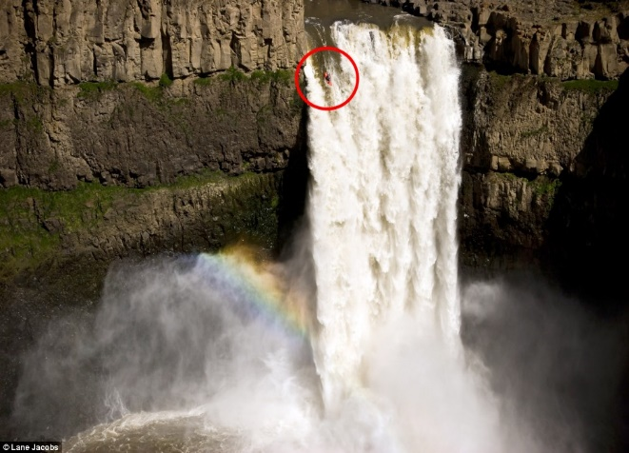
2.4.3 World record (Palouse falls)
Figure 5 (Daily Mail Reporter, 2009)

On April 21st, 2009 Tyler Bradt completed the first successful descent of Palouse falls in Washington, USA setting an unofficial world record in the process. The reason the record isn’t officially recognised is that when the river flow rate rises and falls so does the height of the falls but not uniformly therefore there is no way to definitively say it is/ is not a world record. However, Tyler and his team measured the falls to be 198ft (60m) tall this height will be used to calculate the forces experienced. (Daily Mail Reporter, 2009)
𝑚𝑎𝑠𝑠 𝑜𝑓 𝑝𝑎𝑑𝑑𝑙𝑒𝑟+𝑚𝑎𝑠𝑠 𝑜𝑓 𝑘𝑖𝑡+𝑚𝑎𝑠𝑠 𝑜𝑓 𝑏𝑜𝑎𝑡=100𝑘𝑔
𝐺𝑃𝐸=𝑚𝑔ℎ
𝐺𝑃𝐸=100×9.81×60
𝐺𝑃𝐸=58860𝐽
𝐺𝑃𝐸=𝐾𝐸
∴ 𝐾𝐸=58860𝐽
$$58860=0.5×100×v^{2}$$
$$v^{2}=1177.2$$
$$v=34.31{ms}^{-1}$$
Now that the final velocity before impact has been calculated the depth of submersion can be calculated. From practical test data it is known that running a 20ft (6.096m) waterfall results in a submersion of approximately 7.5ft (2.3m) from the point where the kayak touches the water, therefore, from these calculations the submersion depth of the Palouse falls descent can be calculated assuming the submersion depth is proportional to the impact velocity.
$$\frac{Palouse falls velocity}{falls of the fuller velocity}=coefficient of propotionality$$
$$\frac{34.31}{10.936}=3.13734455$$
$$3.13734455×2.3=7.22m$$
Finally, we can use the depth of submersion to calculate the decelerating force on the Kayak(er)
$$v^{2}=u^{2}+2as$$
$$a=\frac{v^{2}-u^{2}}{2s}$$
$$a=\frac{0^{2}-{34.31}^{2}}{2×7.22}$$
$$a=81.52189058 ms^{-2}$$
$$F=ma$$
$$F=100×81.52189058$$
$$F=8152.189058N$$
$$s=\frac{u+v}{2}×t$$
$$t=0.4208685514s$$
$$t=0.42087s$$
In terms of G forces this equates to over 8.3G of deceleration for 0.42087s
The Palouse falls descent was a success despite the large forces acting upon the kayak and Tyler Bradt. Since Bradt’s descent another kayaker has attempted to run the falls however another kayaker (Rafa Ortiz) has attempted to run the falls, however, he was ejected from his boat during the landing and therefore his attempt does not count. In terms of whether this could be beaten, it has been reported that humans can sustain values just smaller than this and with training much higher than this as well (Voshell, 2004), Because of this it may be possible for this record to be broken however it may take some G force specific training.

Recommendations
For future research
It is recommended that air resistance is taken in to account and that a way to determine the density of the aerated water. This would result in a much slower deceleration than those calculated and therefore a lower force. This may result in evidence to prove that it is possible to run something bigger than Palouse falls successfully.
It is also recommended that further practical research is done into thesubmersion depth of whitewater kayaks falling from different heights. This would result in more accurate practical data and therefore more accurate calculations.

Conclusion
In conclusion whitewater kayaking is an extreme sport and will therefore, involve large forces being experienced by both the athlete and the equipment, however, as the sport has progressed so has the equipment. This may lead to a new world record in the future or previously un-runnable rivers becoming runnable

Bibliography
Daily Mail Reporter, 2009. Pictured: The record-breaking kayaker who risked life and limb in a 186ft waterfall drop. Daily Mail, 29 July.
Hansen, G., 2017. Adventures in Storing Your Kayak Gear. [Online]
Available at: https://www.dbpmagazineonline.com/2017/07/20/adventures-storing-kayak-gear-greg-hansen/
[Accessed 29 March 2019].
Kern, E., 2013. Fatal Currents - Low Head Dam Presentation, s.l.: Youtube.
Moore, M. T., 2011. River Talk: Window Shades. [Online]
Available at: https://marietylermoore.wordpress.com/2011/04/15/167/
Mussell, D., 2012. HPP Mark and Matt on inlet gate, Nottingham: Youtube.
Snowland, 2019. Indus river kayaking. [Online]
Available at: http://snowland.com.pk/tripsnholy/indus-river-kayaking/
Voshell, M., 2004. High Acceleration and the Human Body, s.l.: s.n.

