Electromagnetic Radiation (ACDC5009)
BEng Embedded Electronics
Design and Analysis of Electromagnetic Systems

Benjamin Scott (2306925)
2306925@student.uwtsd.ac.uk

Contents
Waveguide antenna with Pec 3
The Maths 4
Cut off frequency 4
Port Field Display 5
Port 1 5
Port 2 6
Field overlay 7
Waveguide antenna with PEC and Teflon 9
The Maths 10
Cut off Frequency 10
Port Field Display: 11
Port 1 11
Port 2 12
Field overlay 13
Comparison of Waveguide results 14
The Design specifications for the Dipole antenna 15
The Maths 15
How the author made the dipole antenna 16
The results 19
Radar Systems for UAV Detection: Design, Challenges, and Societal Implications 22
Introduction 22
Literature review 22
Discussion 23
Security: 23
Privacy Concerns: 23
Stricter Rules: 23
Legal Issues: 23
Conclusion 23
Figures 24
Further Reading 26

Waveguide antenna with Pec
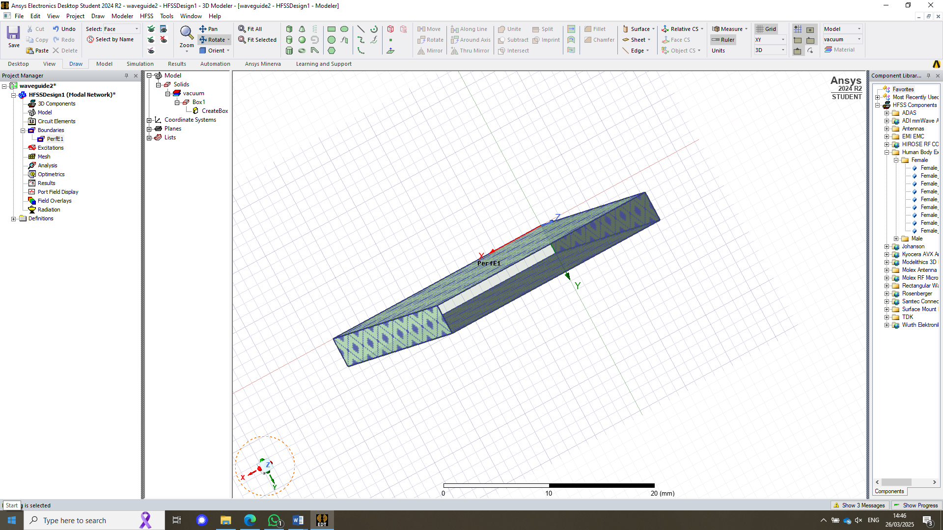
Figure 1 -waveguide made from Pec with a vacuum centre
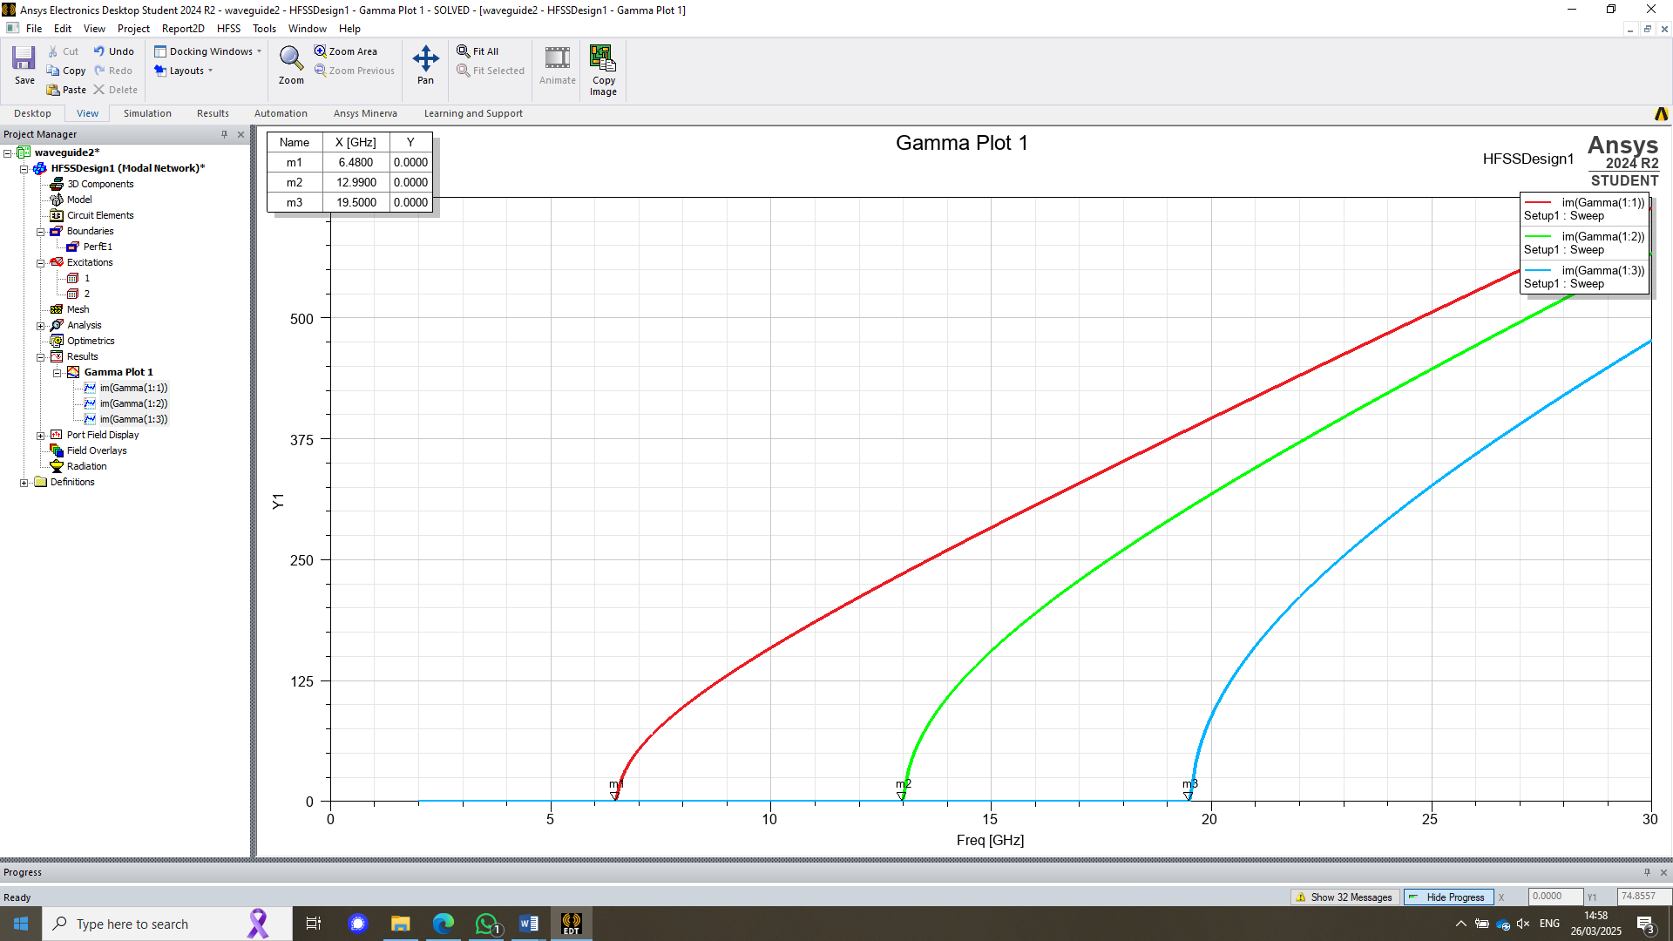
Figure 2 - cut off frequency graph

The Maths

$a= first two numbers of the student ID$ so A = 23mm
$b=$ $\frac{3rd and 4th number of the student ID}{2}$ so b = $\frac{06}{2}$ = 3mm
the frequency sweeps are from 2GHz to 30GHz.

Cut off frequency
The cut off frequency can be calculated using the following equation:
$f_{c}=\frac{c}{2}\sqrt{{\left(\frac{m}{a}\right)}^{2}+{\left(\frac{n}{b}\right)}^{2}}$
Figure 3 - Cut off frequency calculation (Jacobs, 2025)
Where:
$f_{c}$ – cut off frequency
m- number of modes
n- number of half-wavelength variations in the height of the waveguide.
a- width of the rectangular waveguide
b- height of the rectangular waveguide
c-Velocity of light

where M = 1:
$f_{c}=\frac{3X10^8}{2}\sqrt{{\left(\frac{1}{0.23}\right)}^{2}+{\left(\frac{0}{0.04}\right)}^{2}}$ = 6.52GHz

where M = 2:
$f_{c}=\frac{3X10^8}{2}\sqrt{{\left(\frac{2}{0.23}\right)}^{2}+{\left(\frac{0}{0.04}\right)}^{2}}$ = 13GHz

where M = 3:
$f_{c}=\frac{3X10^8}{2}\sqrt{{\left(\frac{3}{0.23}\right)}^{2}+{\left(\frac{0}{0.04}\right)}^{2}}$ = 19.5GHz

Port Field Display

Port 1
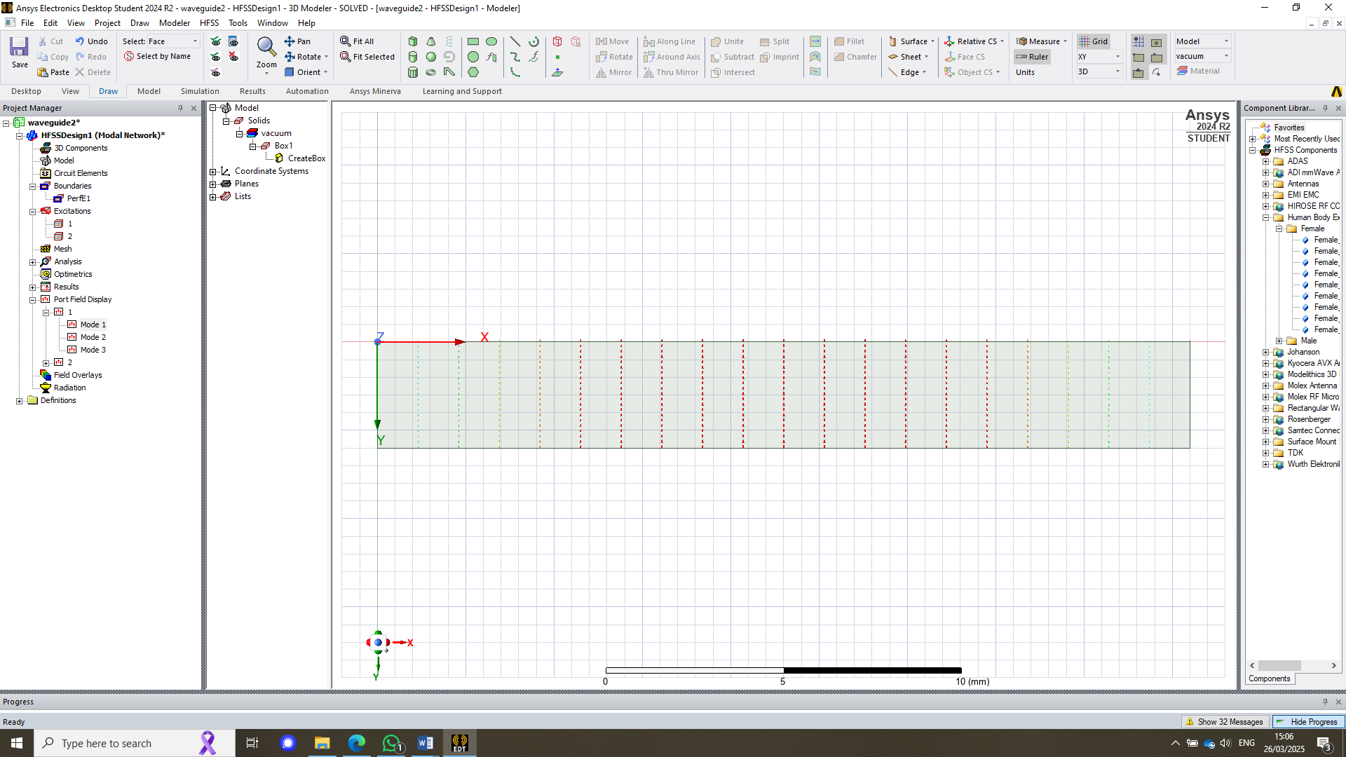
Figure 4 - Port 1 Mode 1
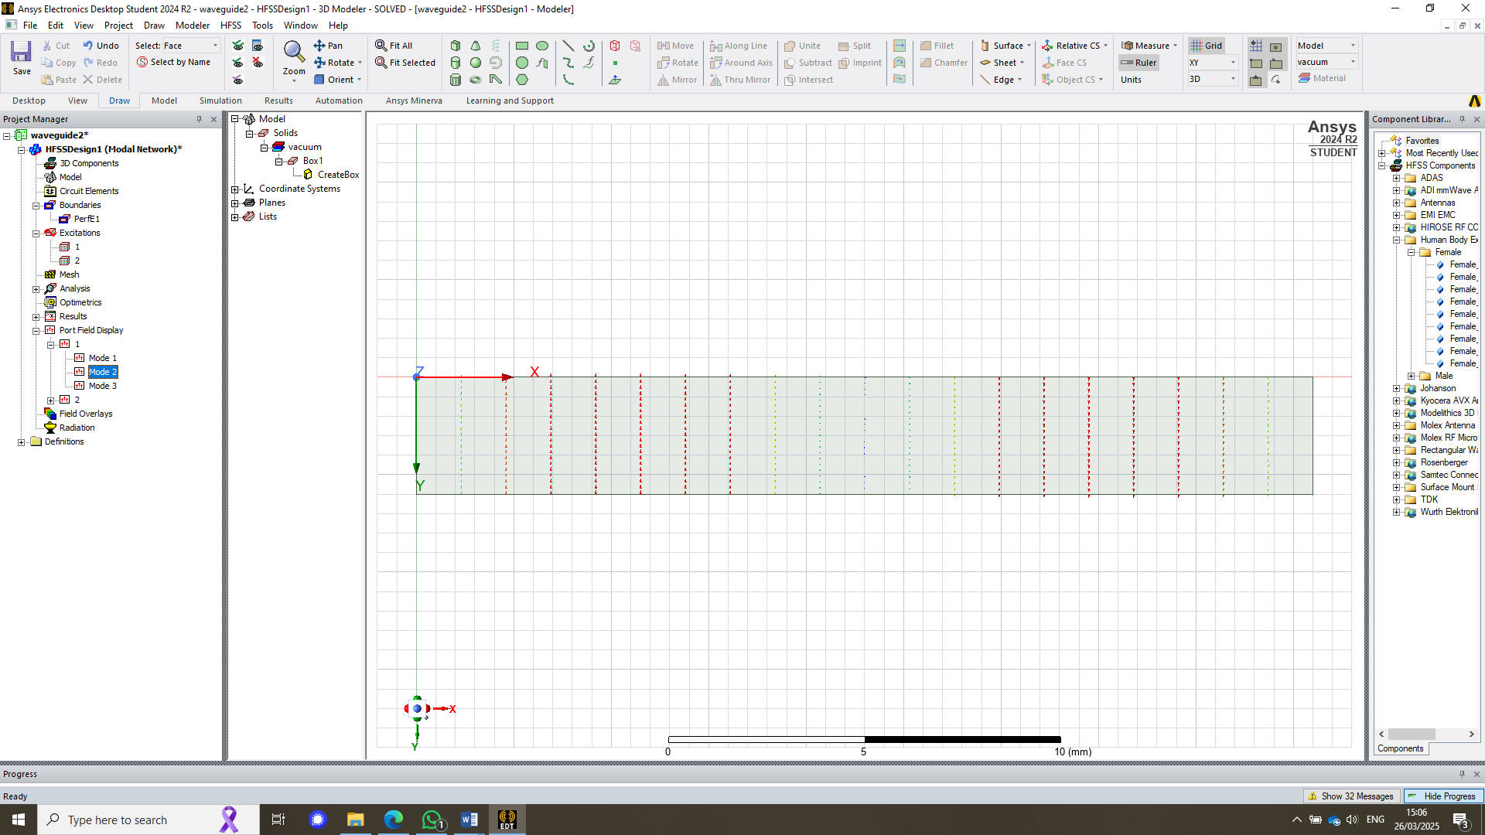
Figure 5 - Port 1 Mode 2
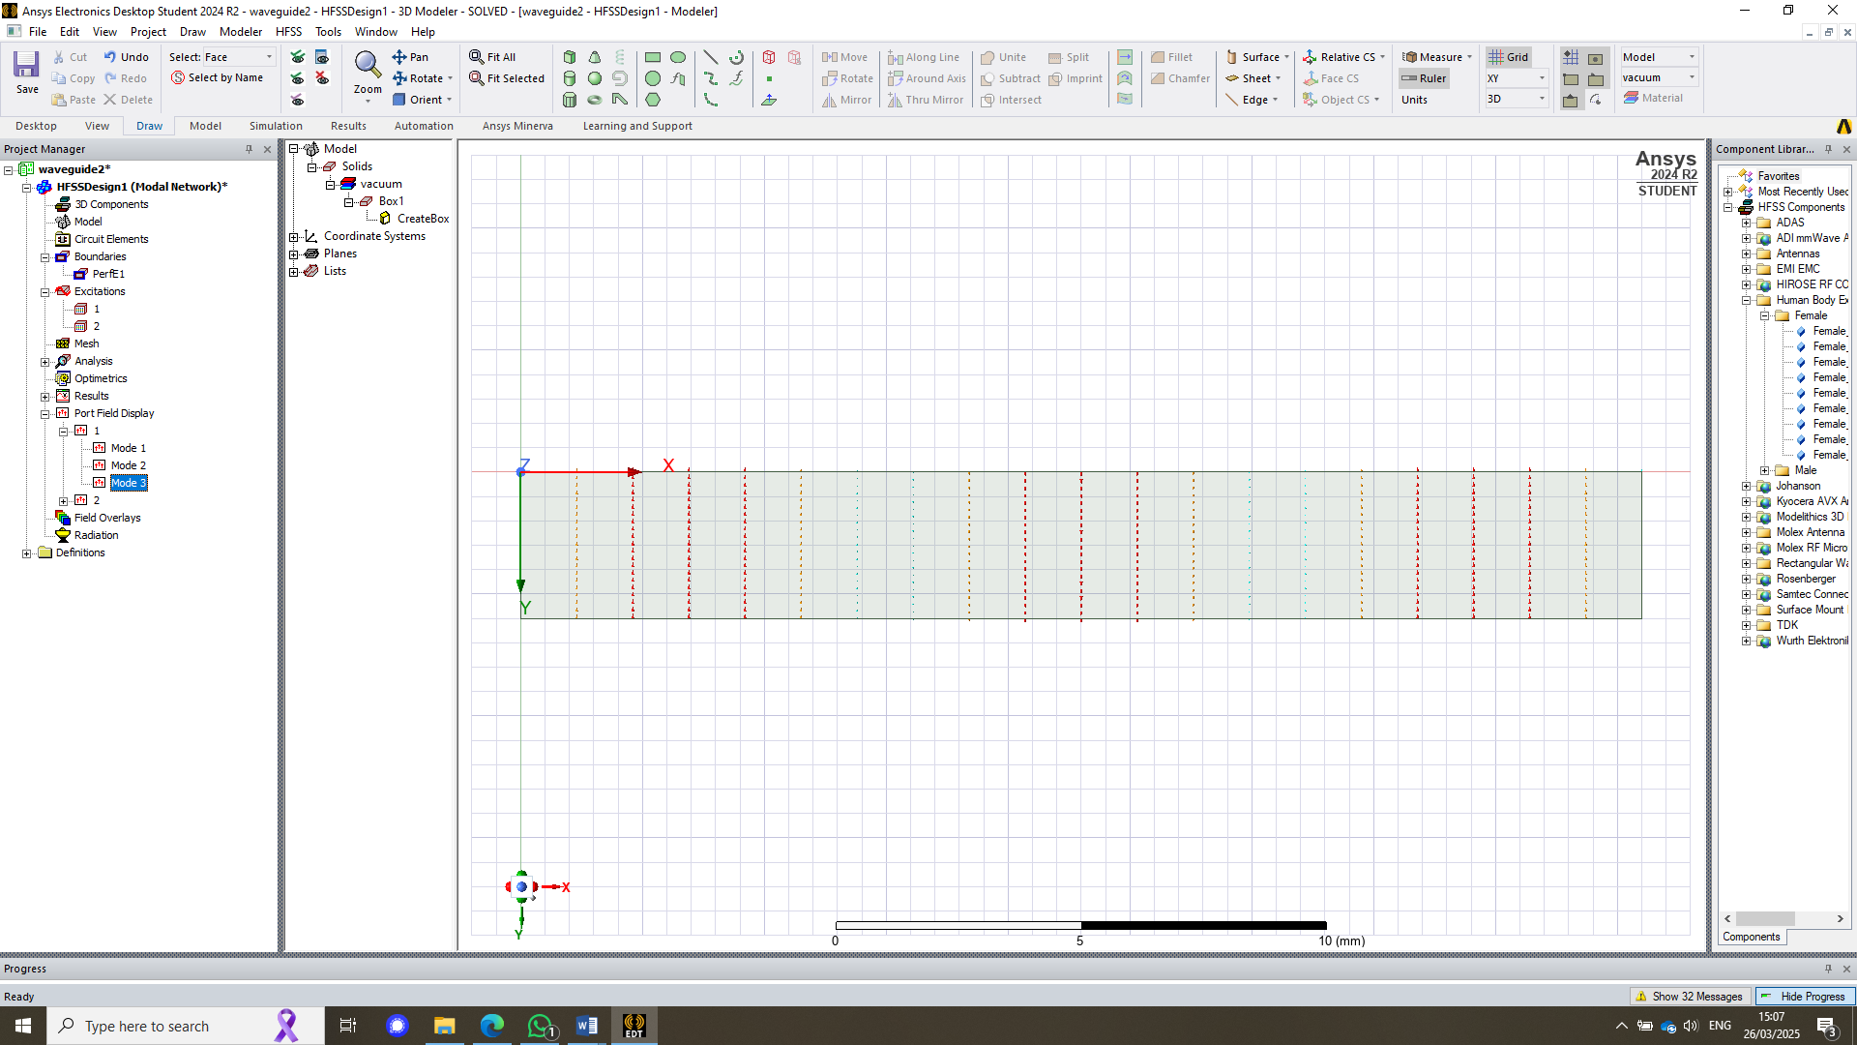
Figure 6 - Port 1 Mode 3

Port 2
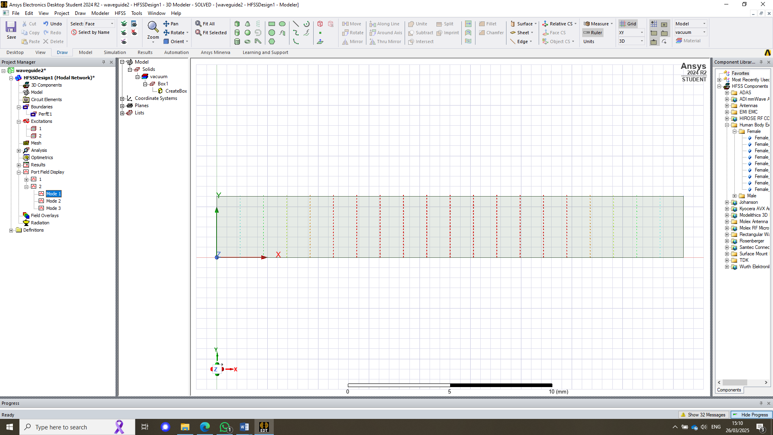#
Figure 7 - Port 2 Mode 1
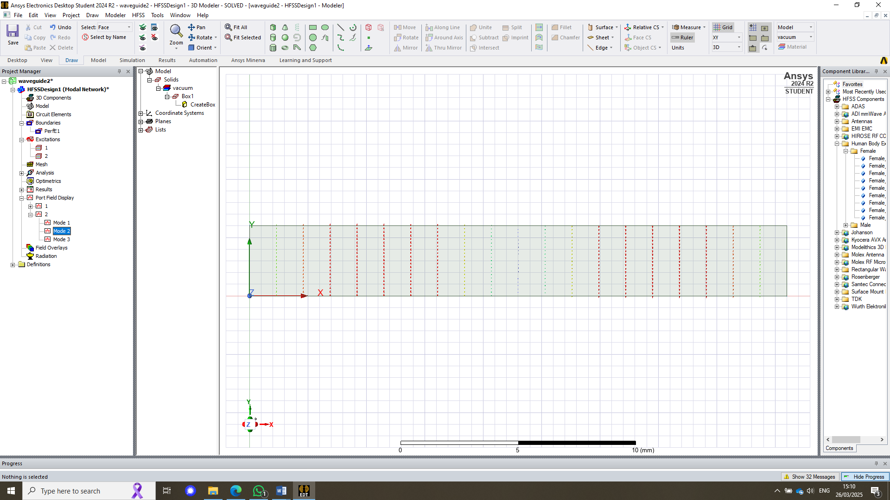
Figure 8 - Port 2 Mode 2
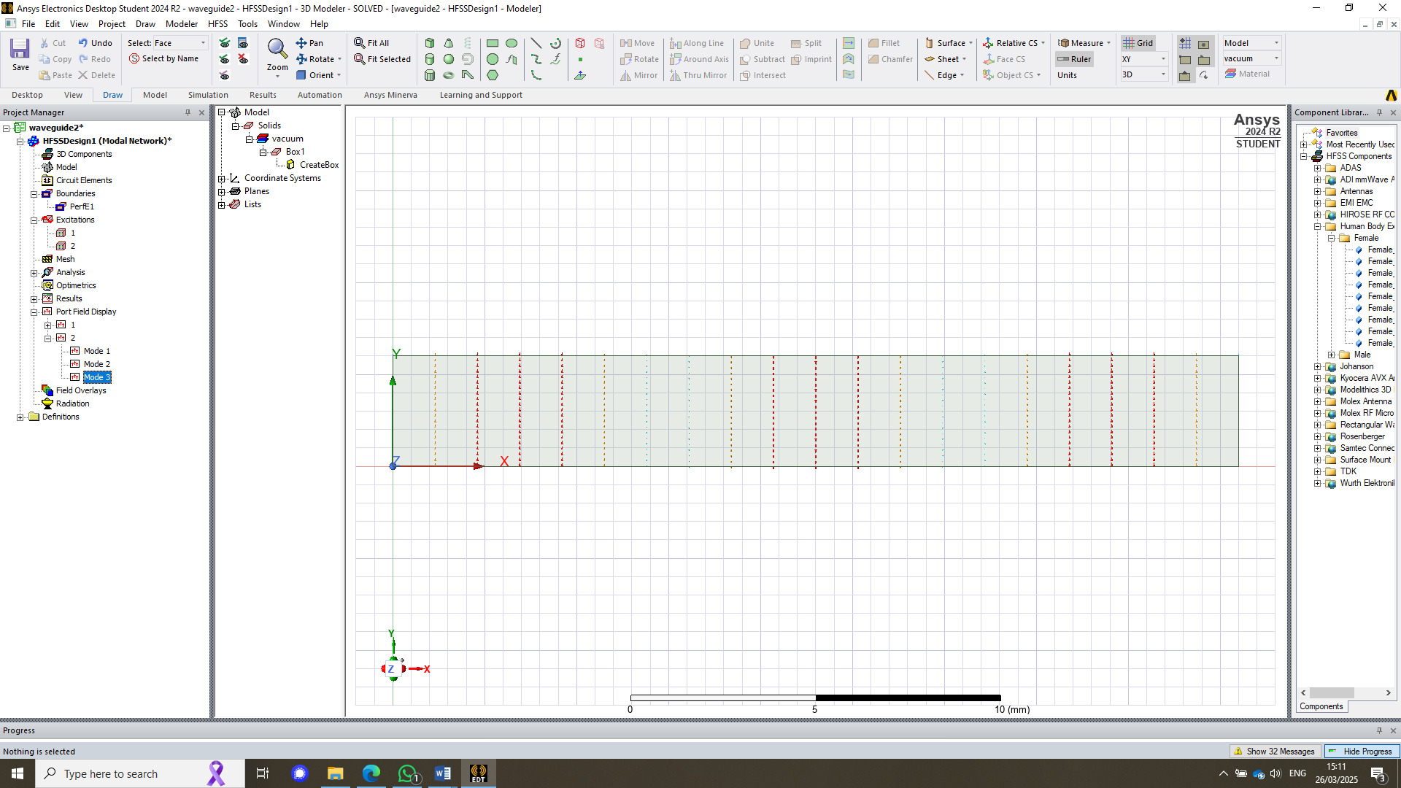
Figure 9 - Port 2 Mode 3

Field overlay

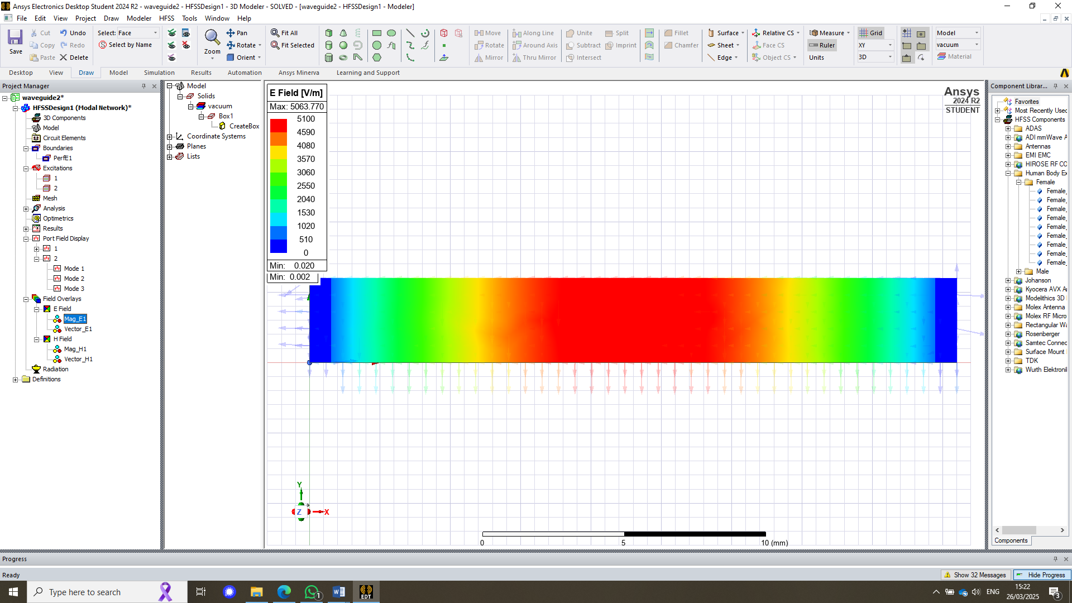 | 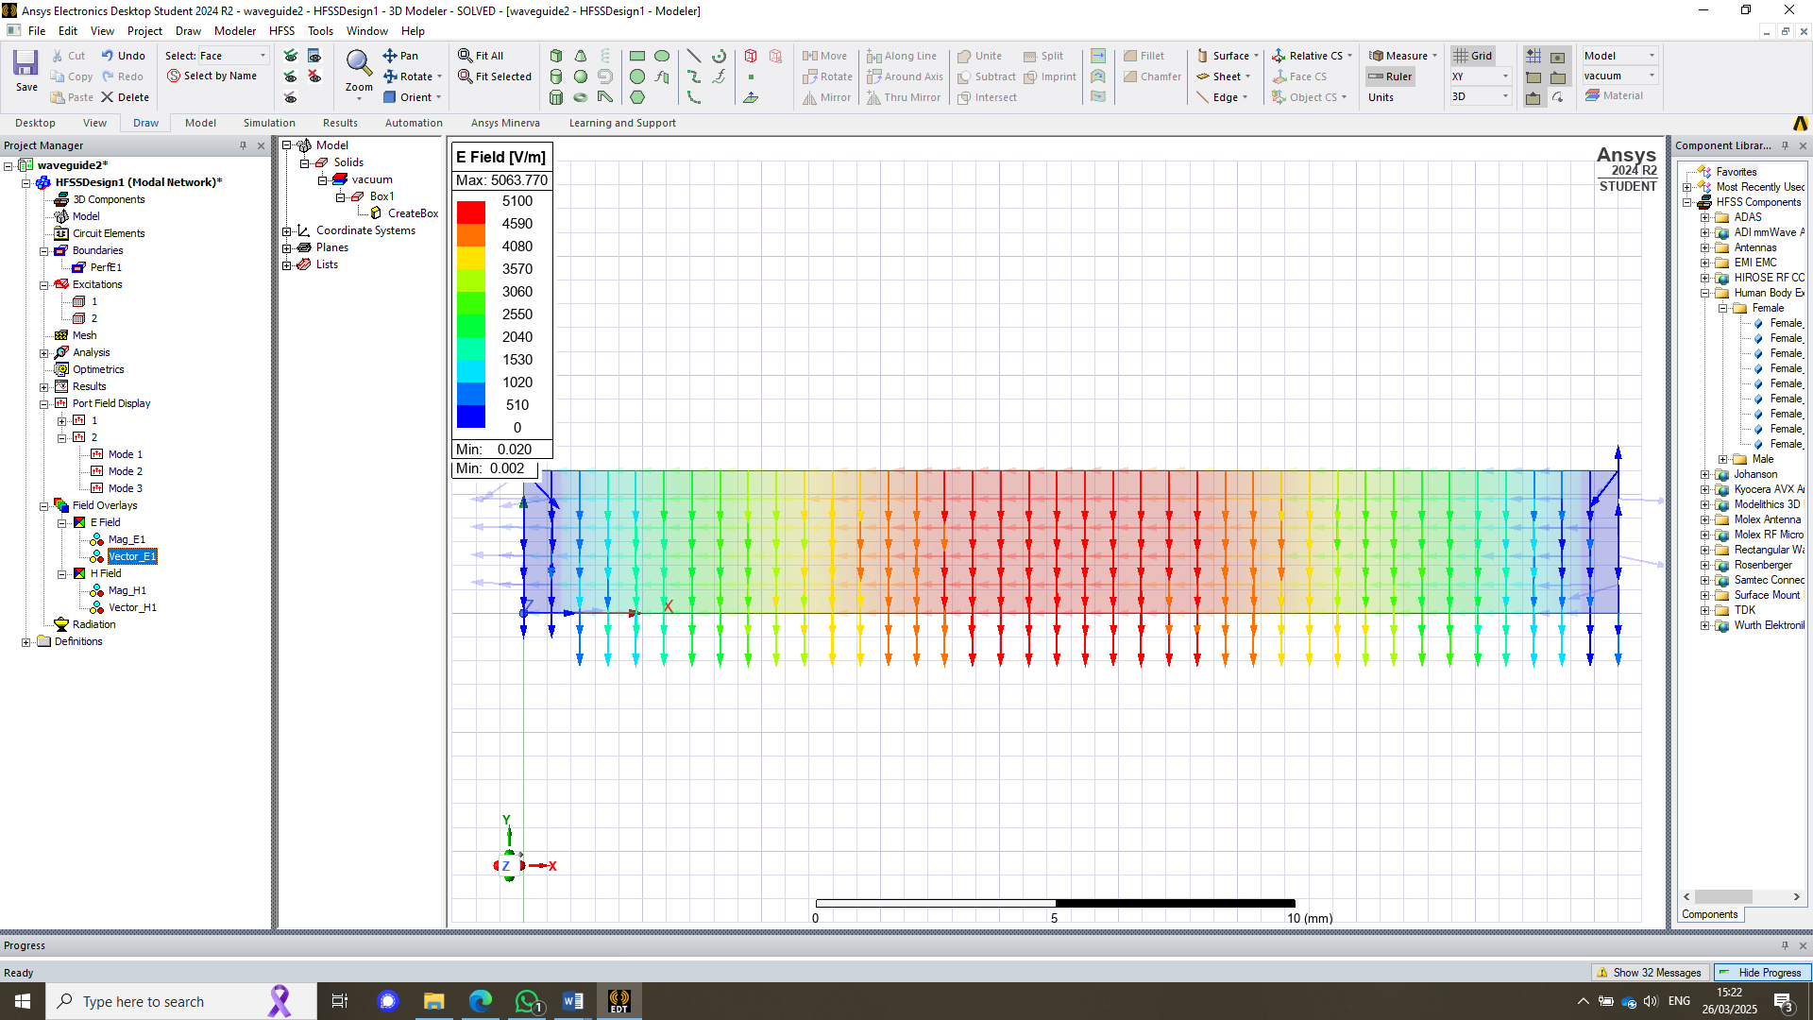
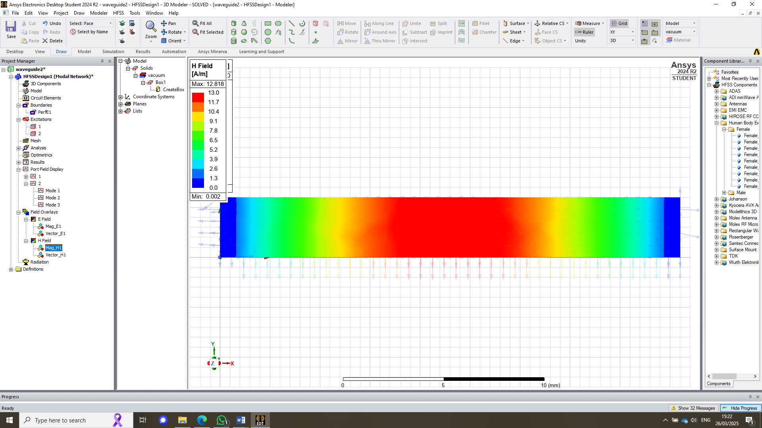 | 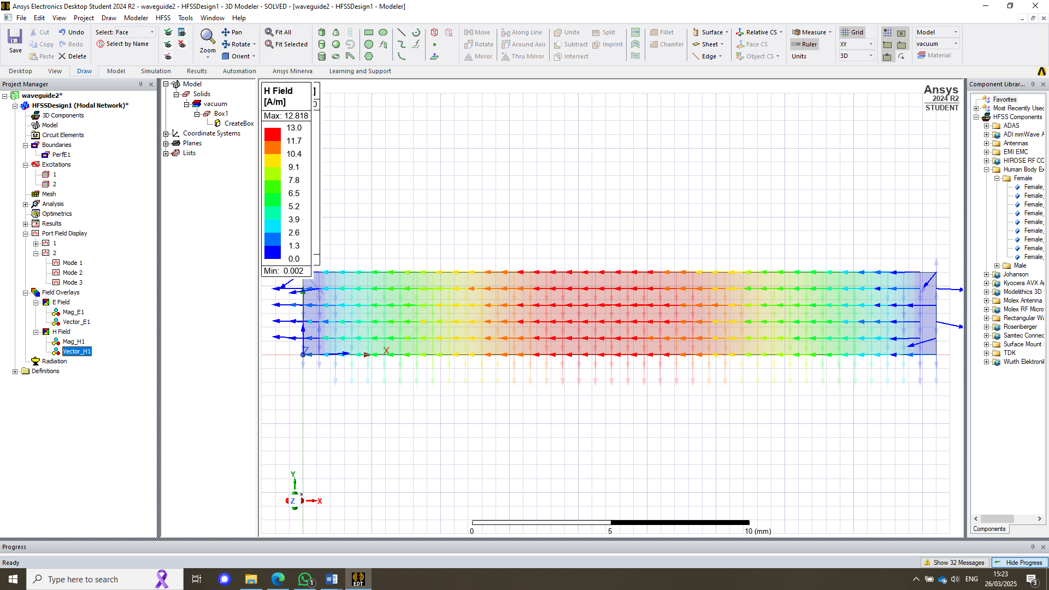
Figure 10 - Magnitude and Vector for the E and H field for mode 1

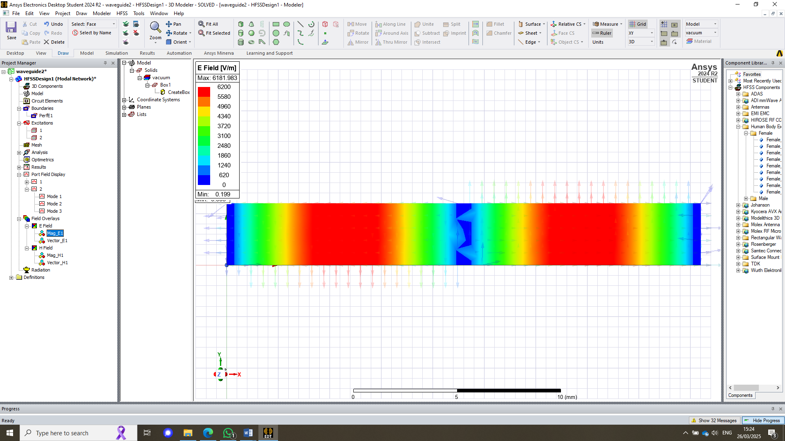 | 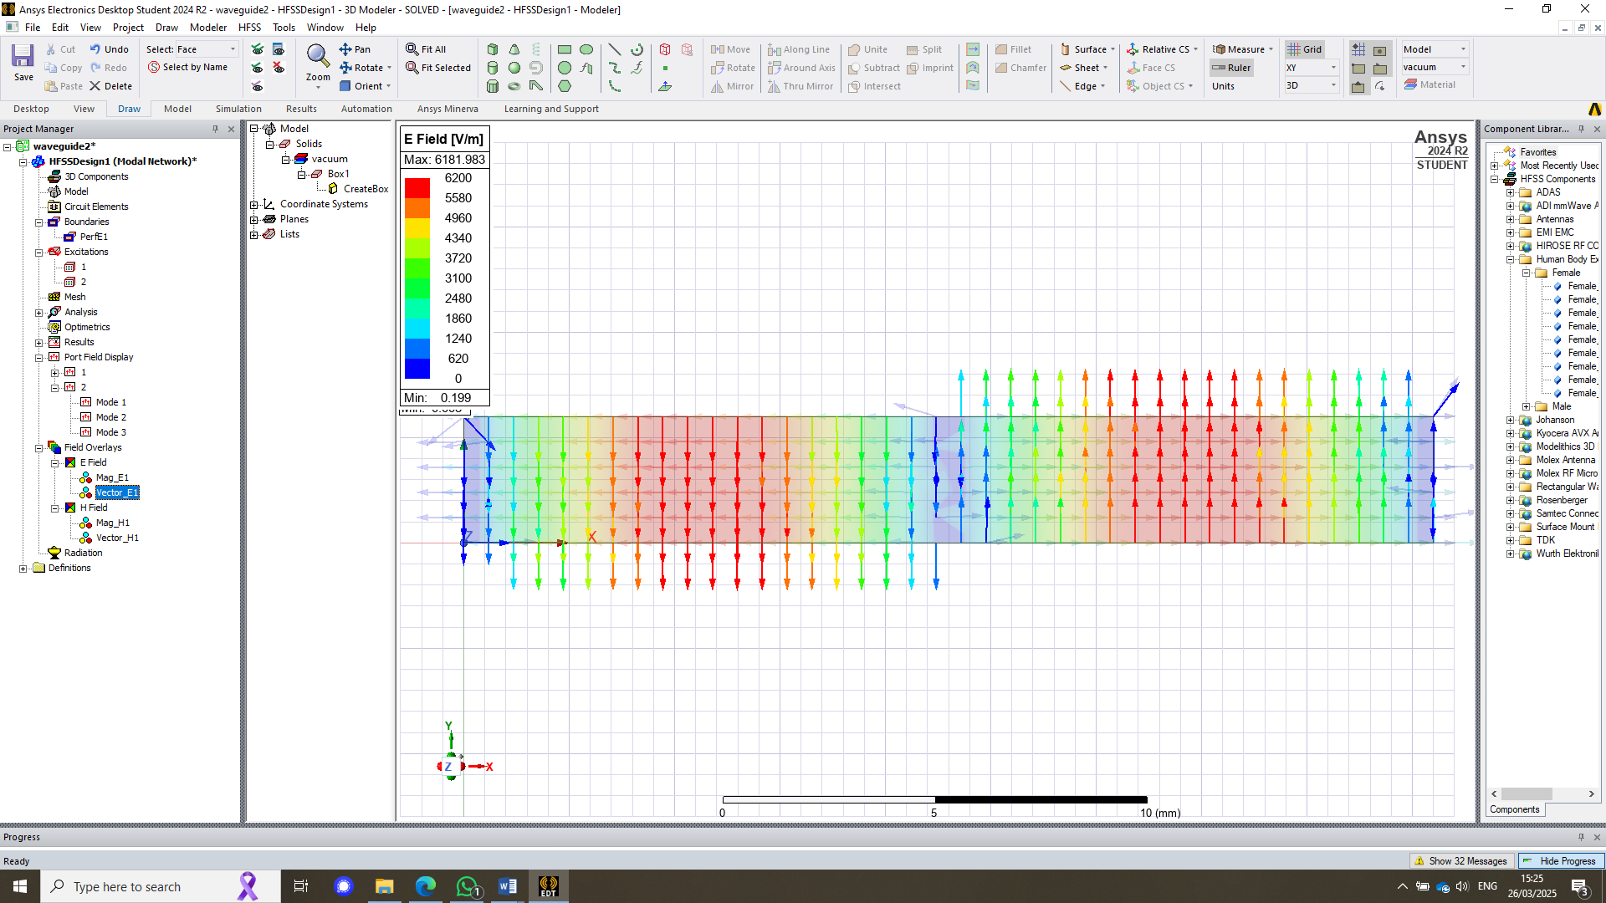
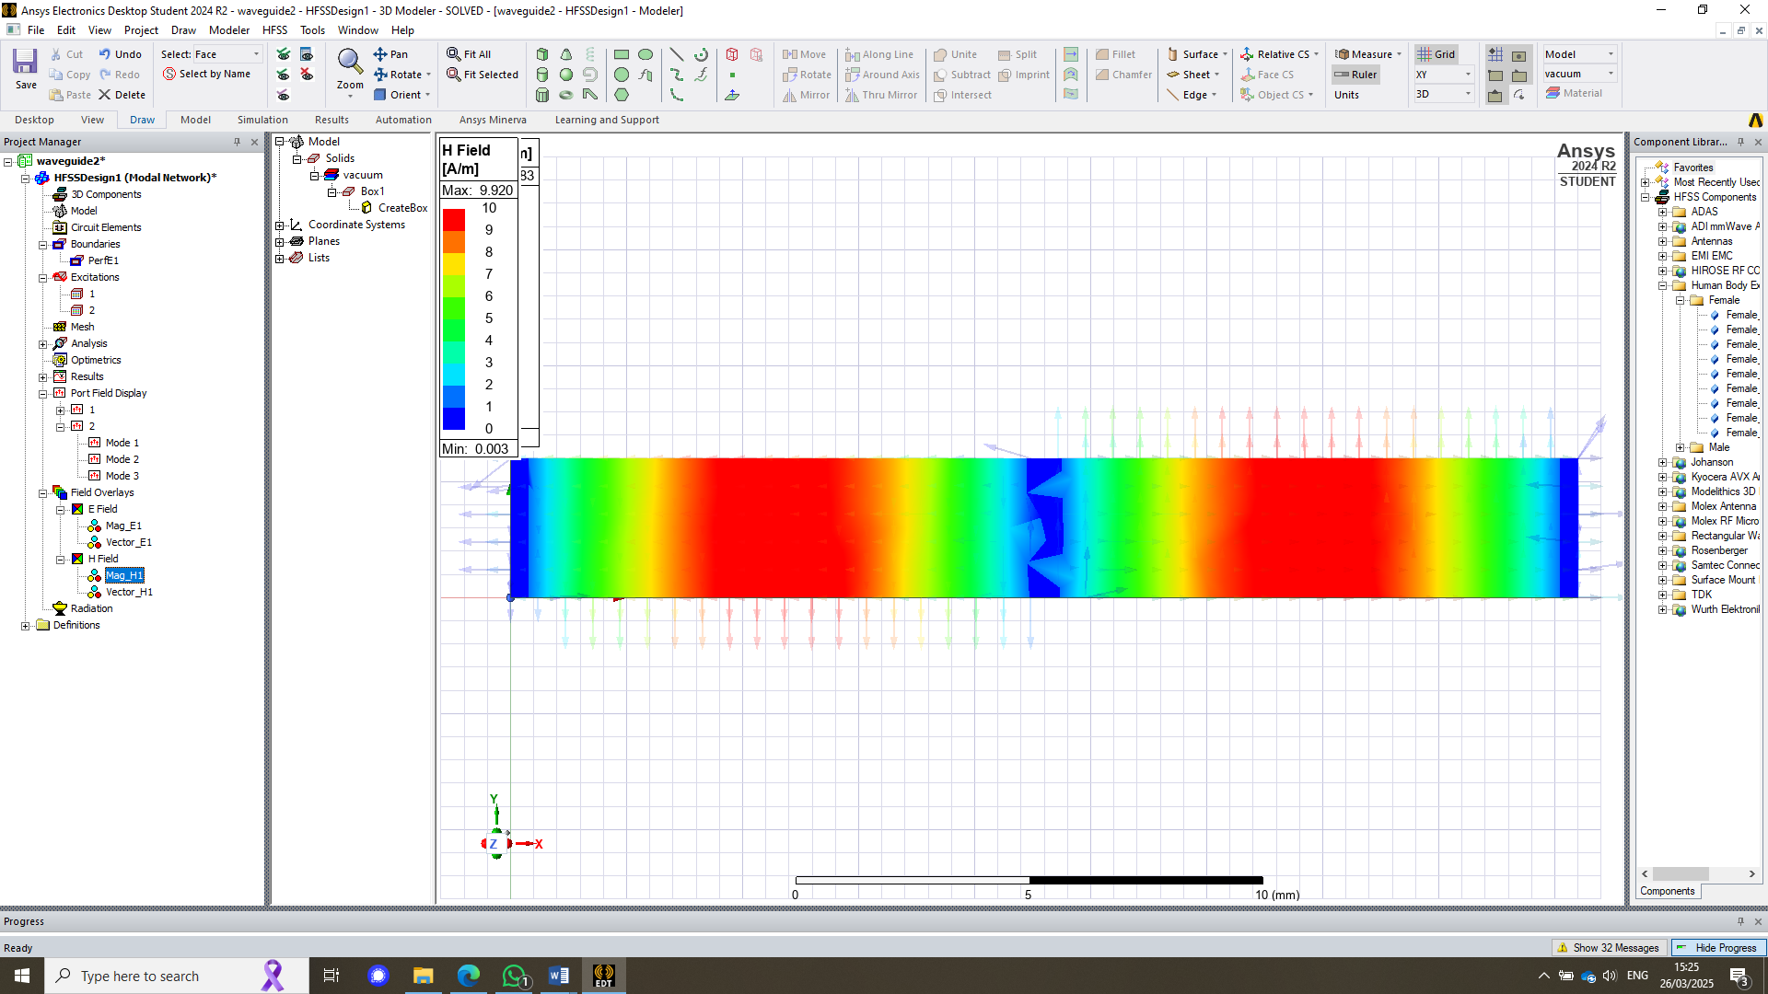 | 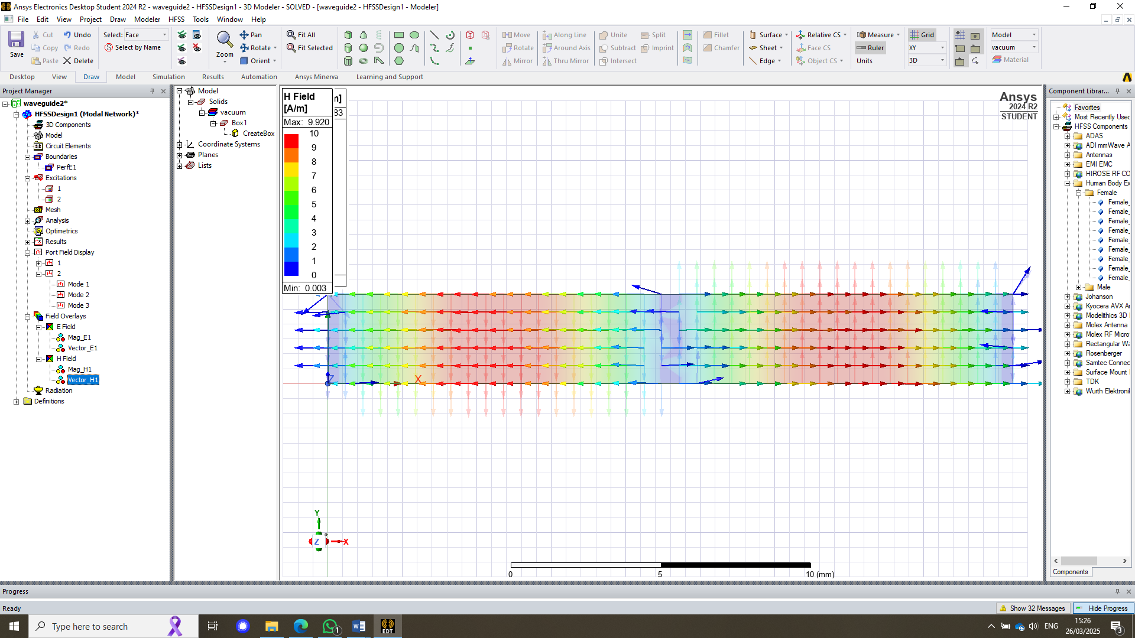
Figure 11 - Magnitude and Vector for the E and H field for mode 2
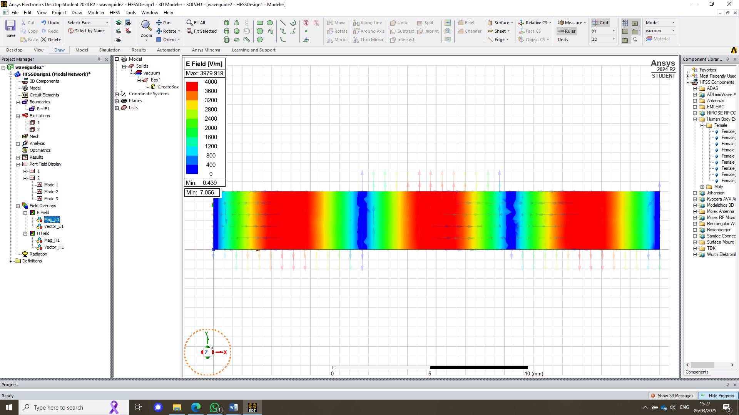 | 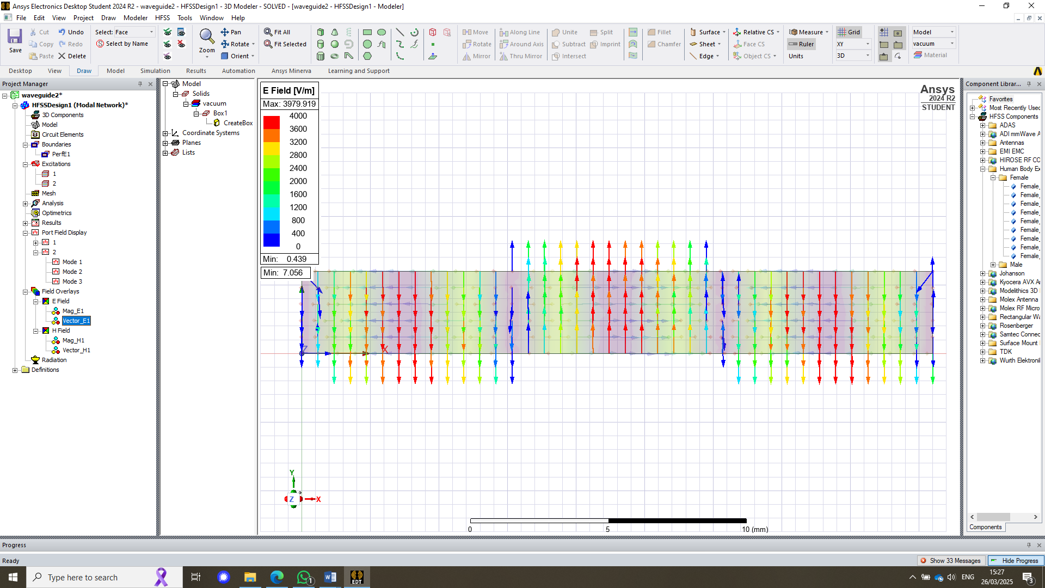
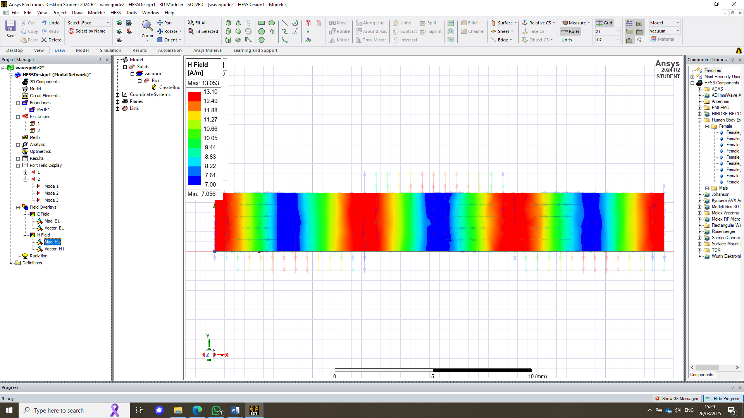 | 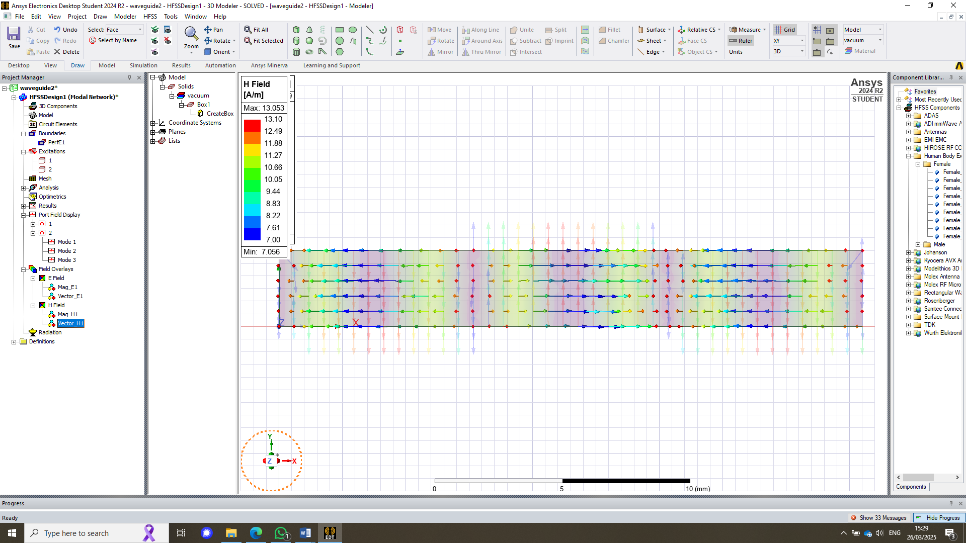
Figure 12 - Magnitude and Vector for the E and H field for mode 3
Figures 10, 11, and 12 show field overlays for the waveguide, illustrating how the magnitude and vectors of the electric (E) and magnetic (H) fields change across the three modes.

Waveguide antenna with PEC and Teflon

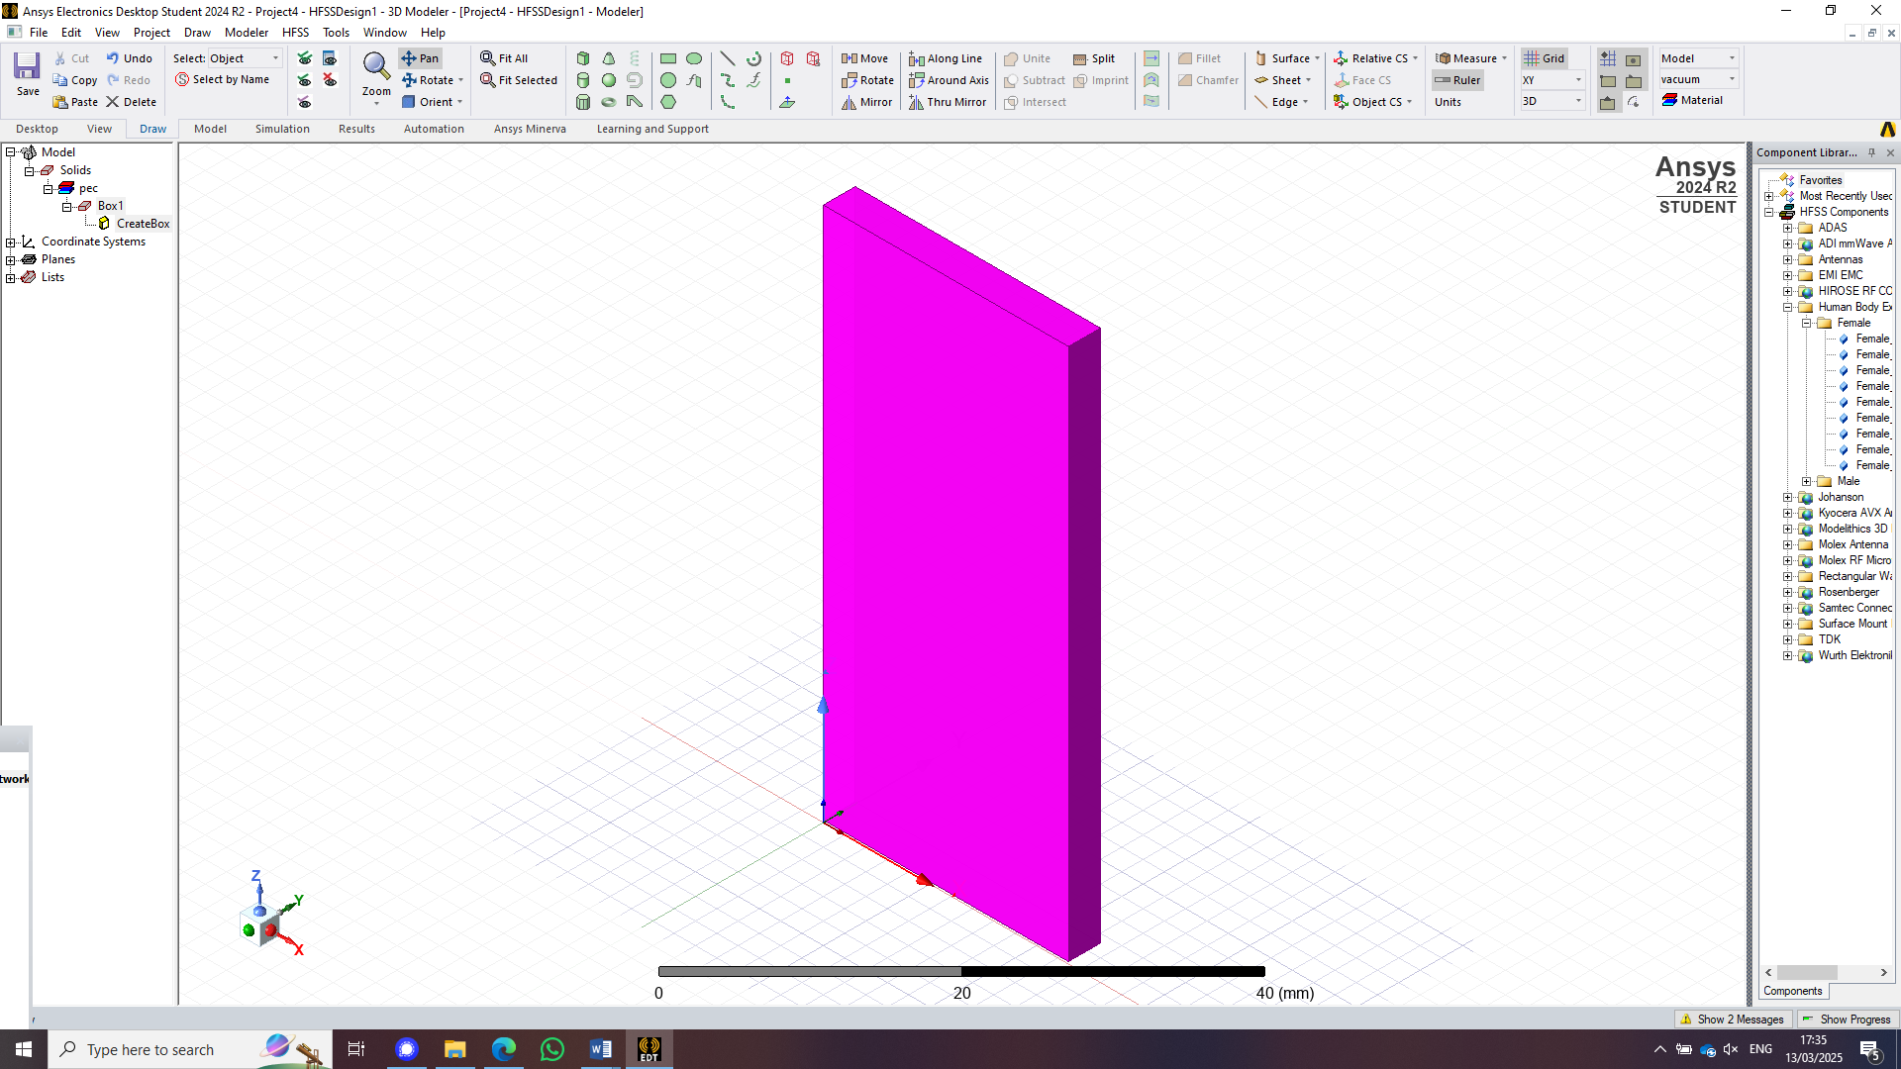
Figure 13 - waveguide made from waveguide with PEC wall filled with Teflon
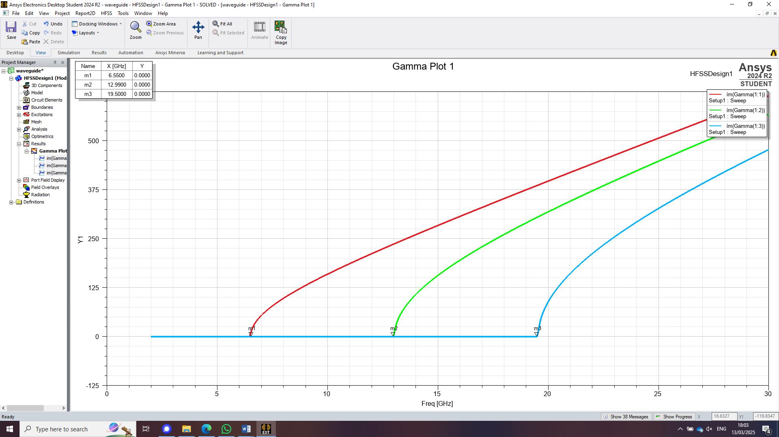
Figure 14 - cut off frequency graph

The Maths

Cut off Frequency

The cut-off frequency for a waveguide with Teflon (relative permittivity ϵr=2.1 ,relative permeability μr=1 can be calculated using the following equation:

$$f_{c}=\frac{c}{\sqrt{2.1 x 1 }}\sqrt{{\left(\frac{m}{a}\right)}^{2}+{\left(\frac{n}{b}\right)}^{2}}$$
Figure 15 - Cut off frequency (Jacobs, 2025)
Where:
$f_{c}$ – cut off frequency
m- number of modes (1,2,3)
n- number of half-wavelength variations in the height of the waveguide. (0)
a- width of the rectangular waveguide (in m)
b- height of the rectangular waveguide (in m)
c-Velocity of light (3x10^8)

Substituting c=3×108c = 3 \times 10^8c=3×108 m/s and adjusting for Teflon:
$\frac{3X10^8}{\sqrt{1 x 2.1}}$ = 2.07x10^8
This means value has to then replace the speed of light due to the relative permeability and relative permittivity not being ideal conditions, as before.
where M = 1:
$f_{c}=\frac{2.07x10^8}{2}\sqrt{{\left(\frac{1}{0.23}\right)}^{2}+{\left(\frac{0}{0.04}\right)}^{2}}$ = 4.5GHz

where M = 2:
$f_{c}=\frac{2.07x10^8}{2}\sqrt{{\left(\frac{2}{0.23}\right)}^{2}+{\left(\frac{0}{0.04}\right)}^{2}}$ = 9GHz

where M = 3:
$f_{c}=\frac{2.07x10^8}{2}\sqrt{{\left(\frac{3}{0.23}\right)}^{2}+{\left(\frac{0}{0.04}\right)}^{2}}$ = 13.5GHz

Port Field Display:

Port 1
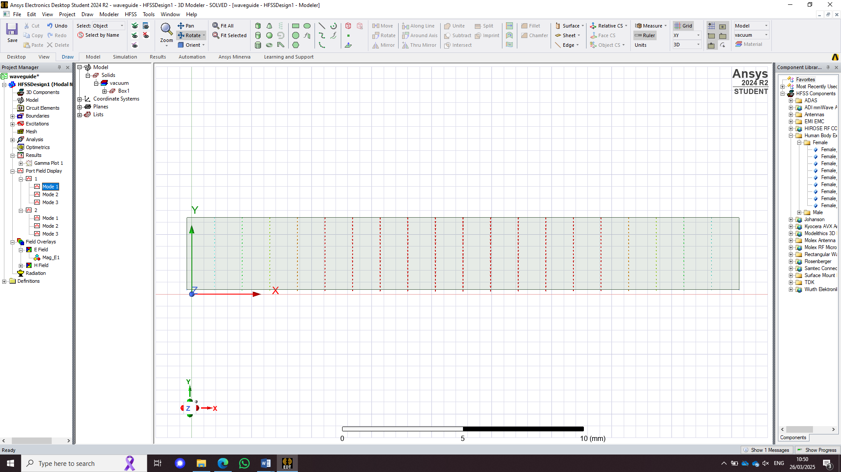
Figure 16 - Port 1 Mode 1
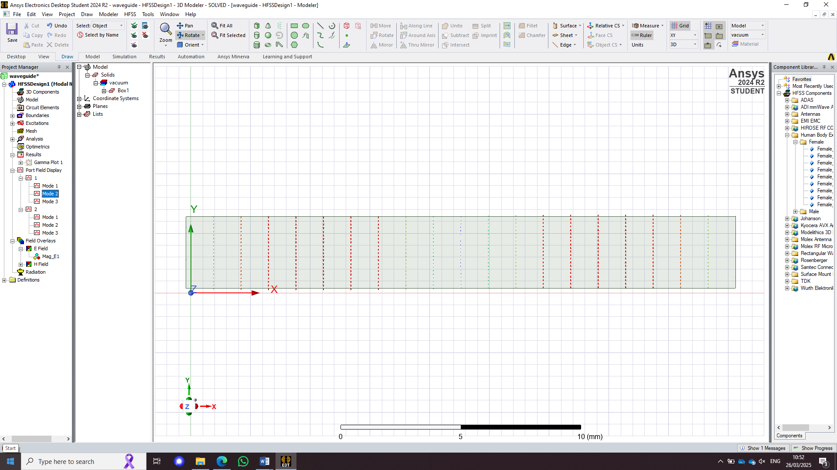
Figure 17 - Port 1 Mode 2
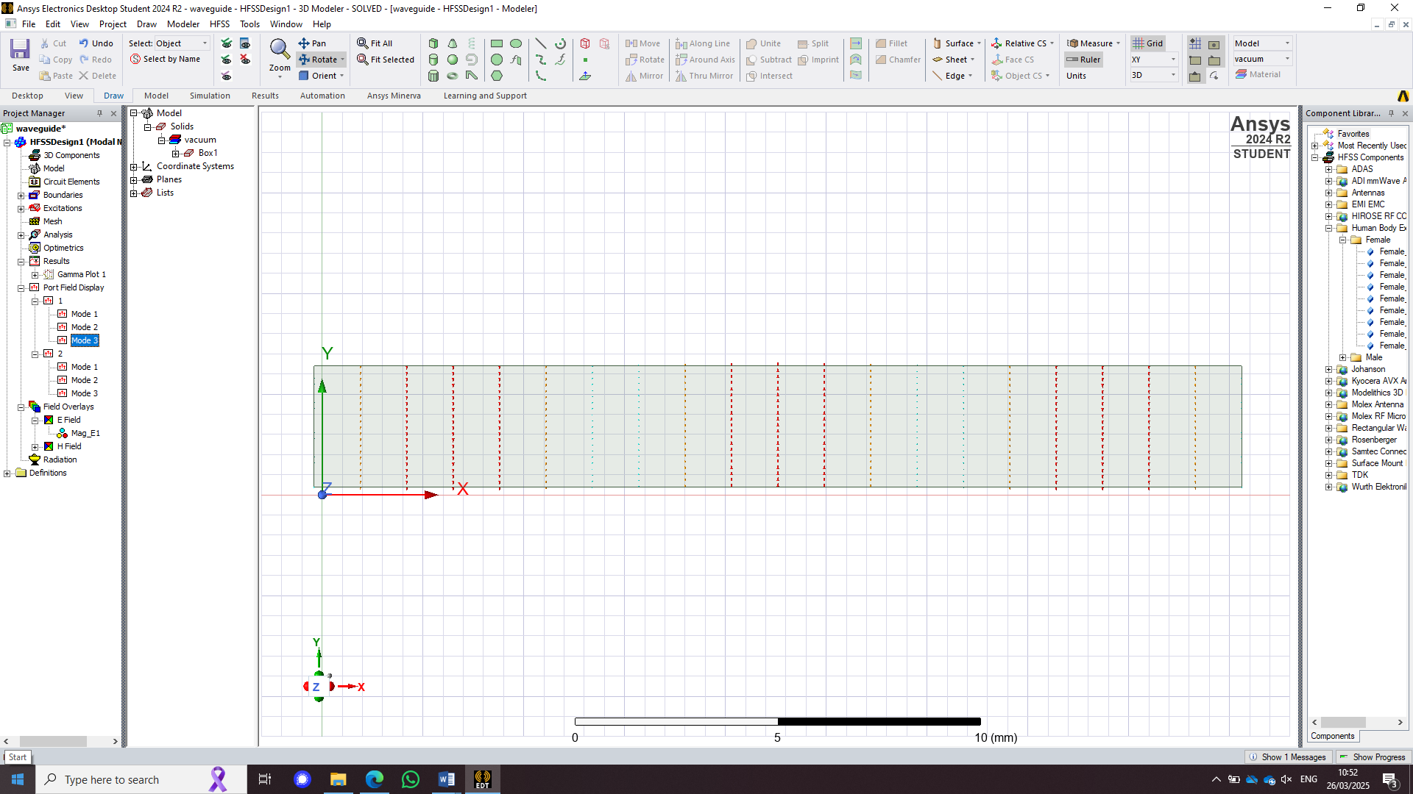
Figure 18 - Port 1 Mode 3

Port 2
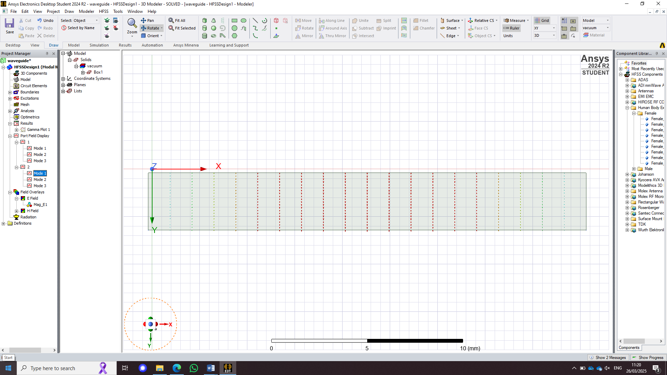
Figure 19 - Port 2 Mode 1
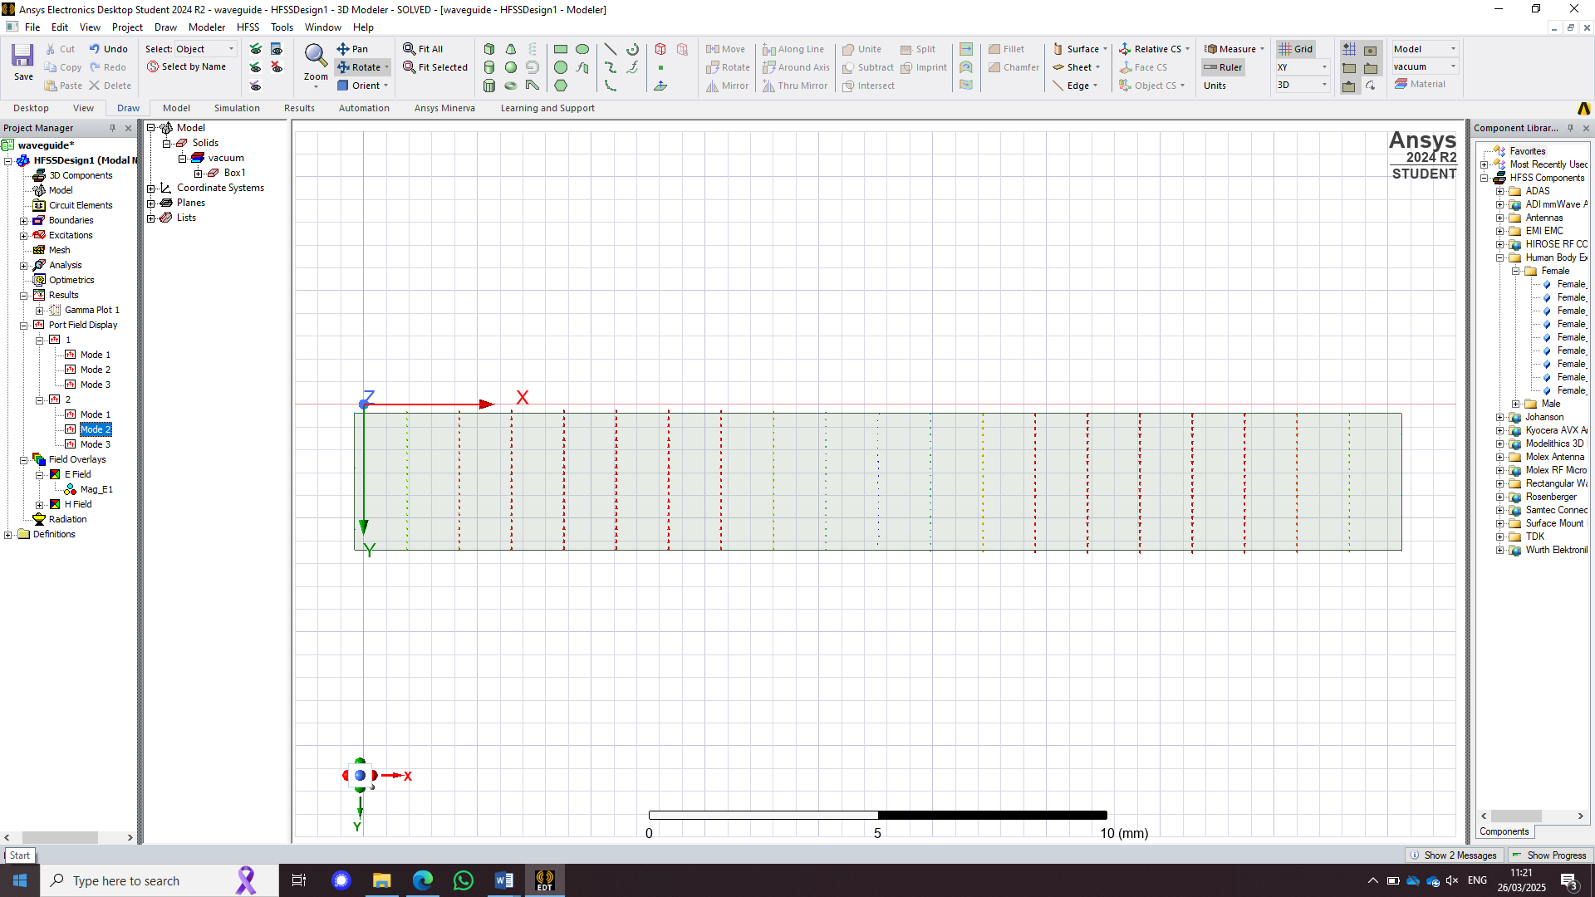
Figure 20 - Port 2 Mode 2
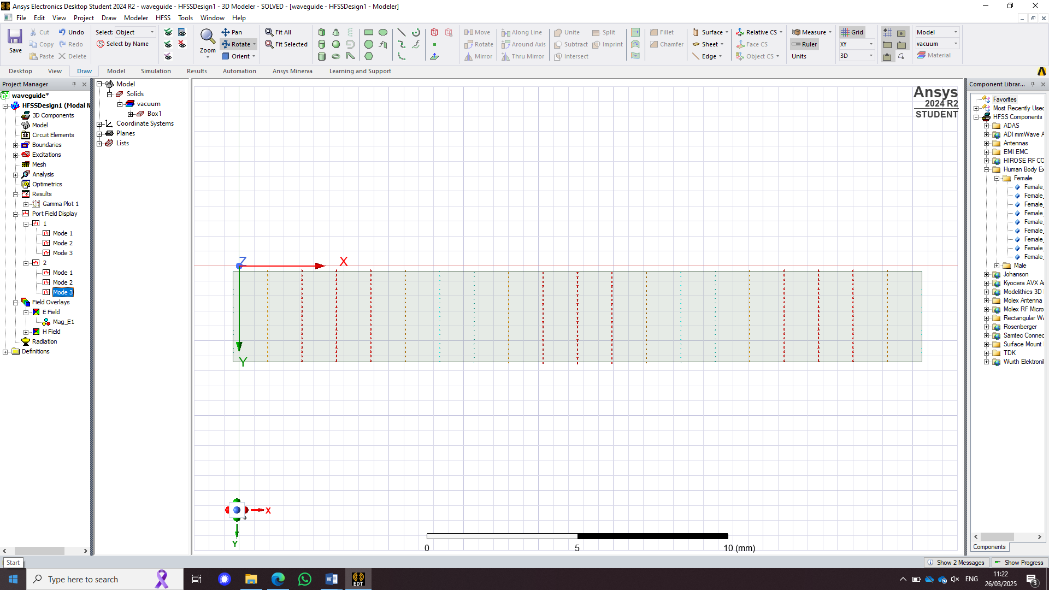
Figure 21 - Port 2 Mode 3

Field overlay
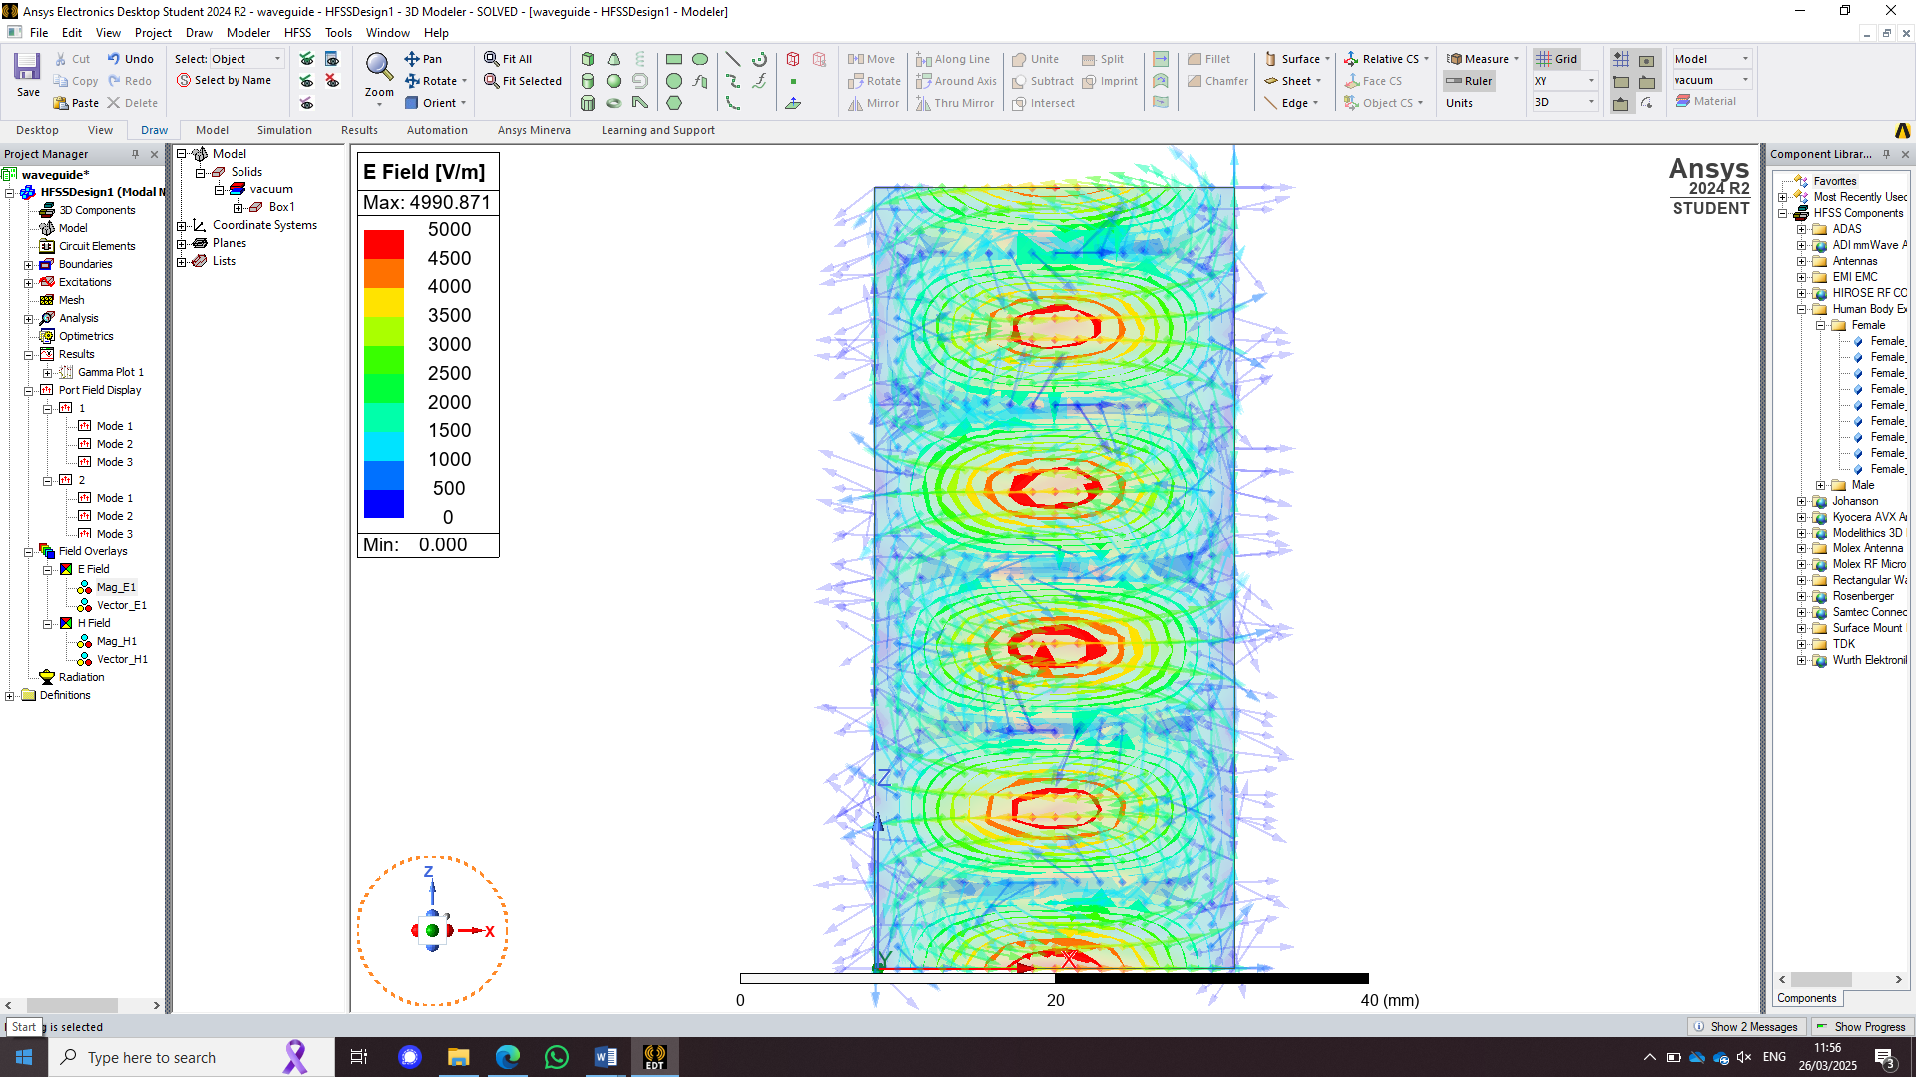 | 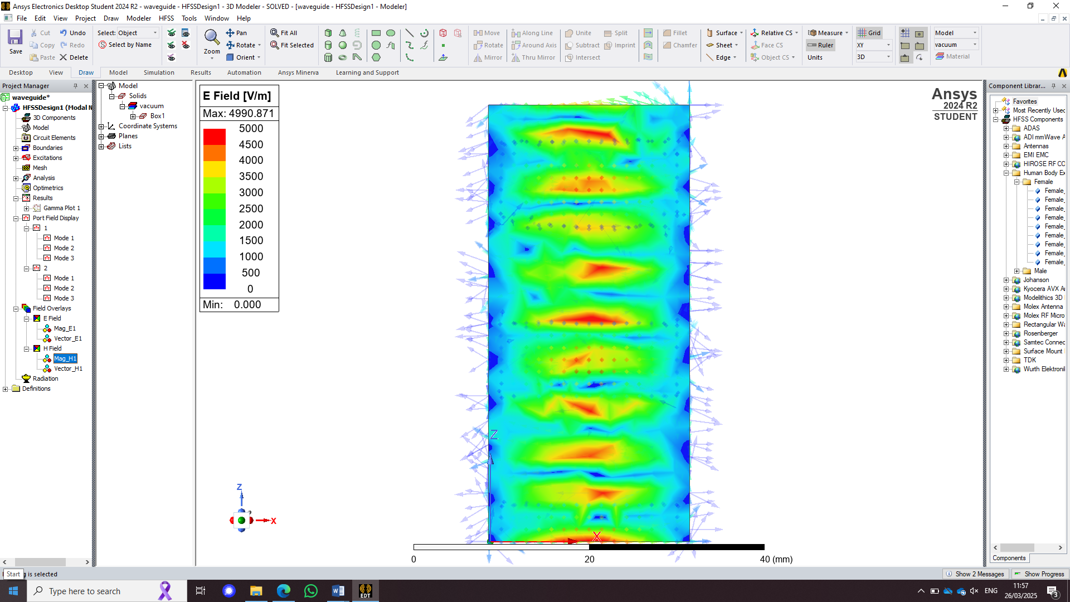
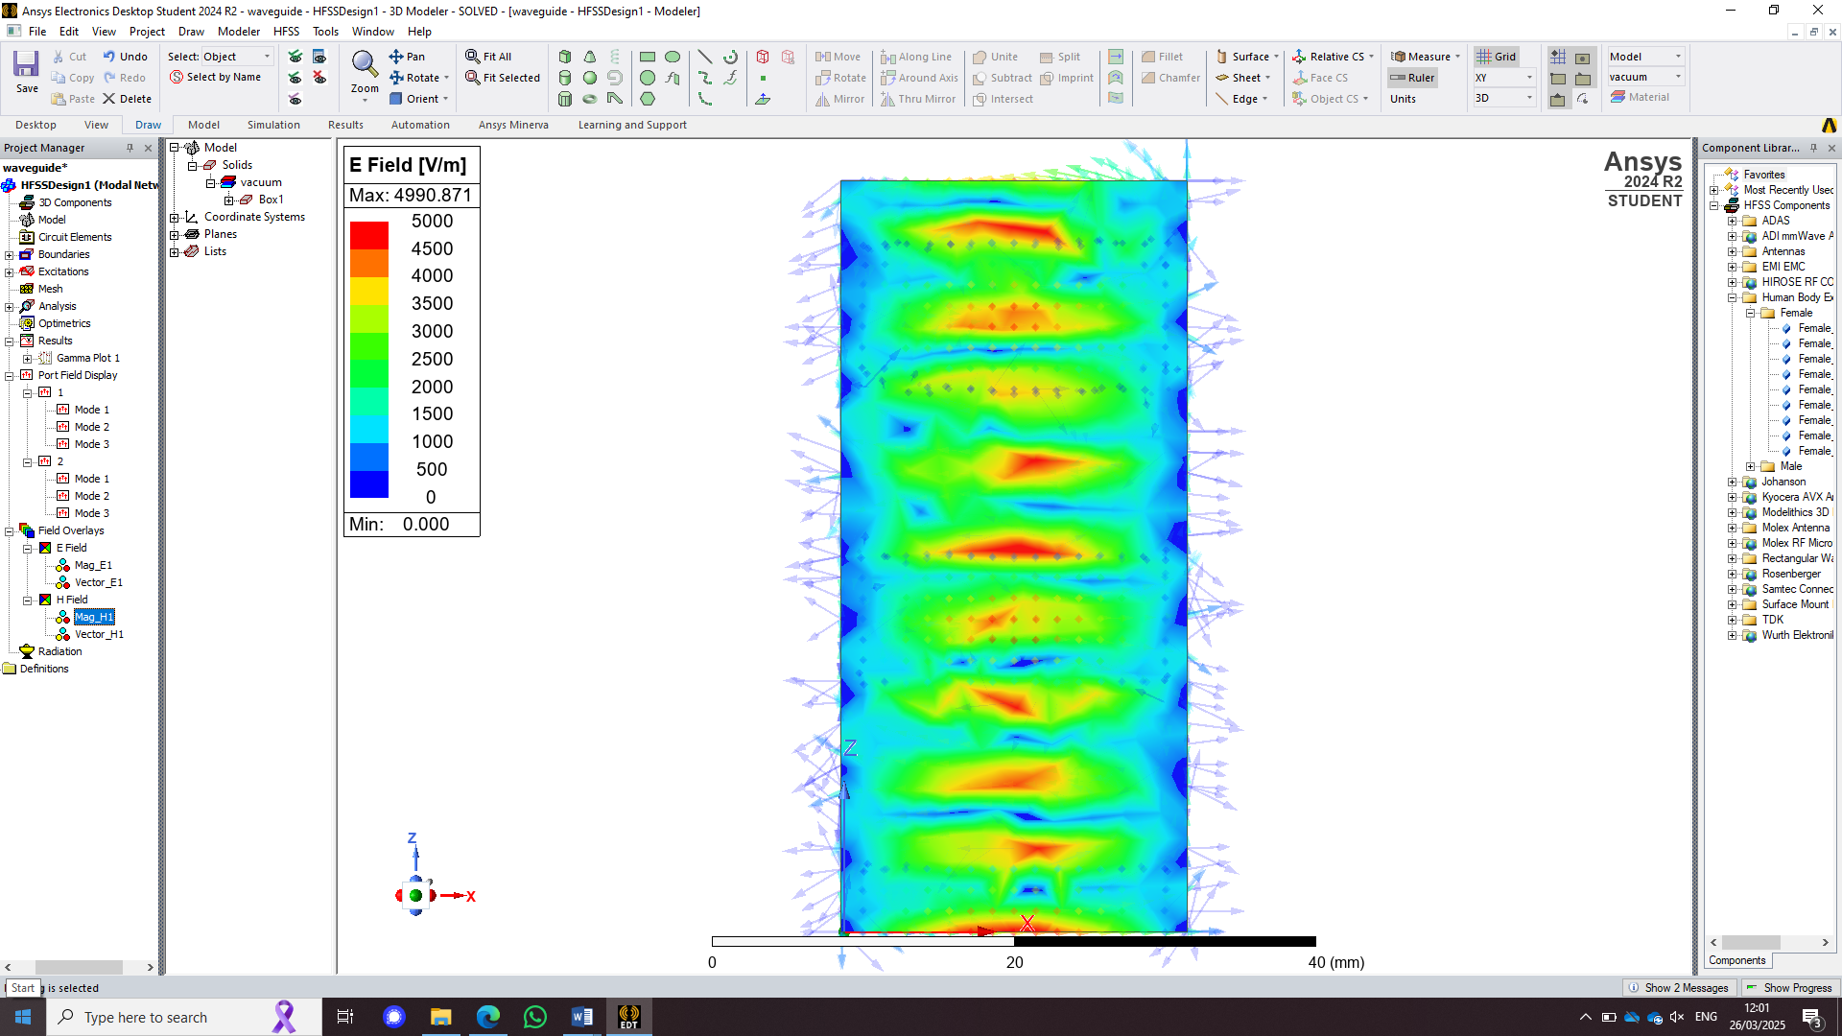 | 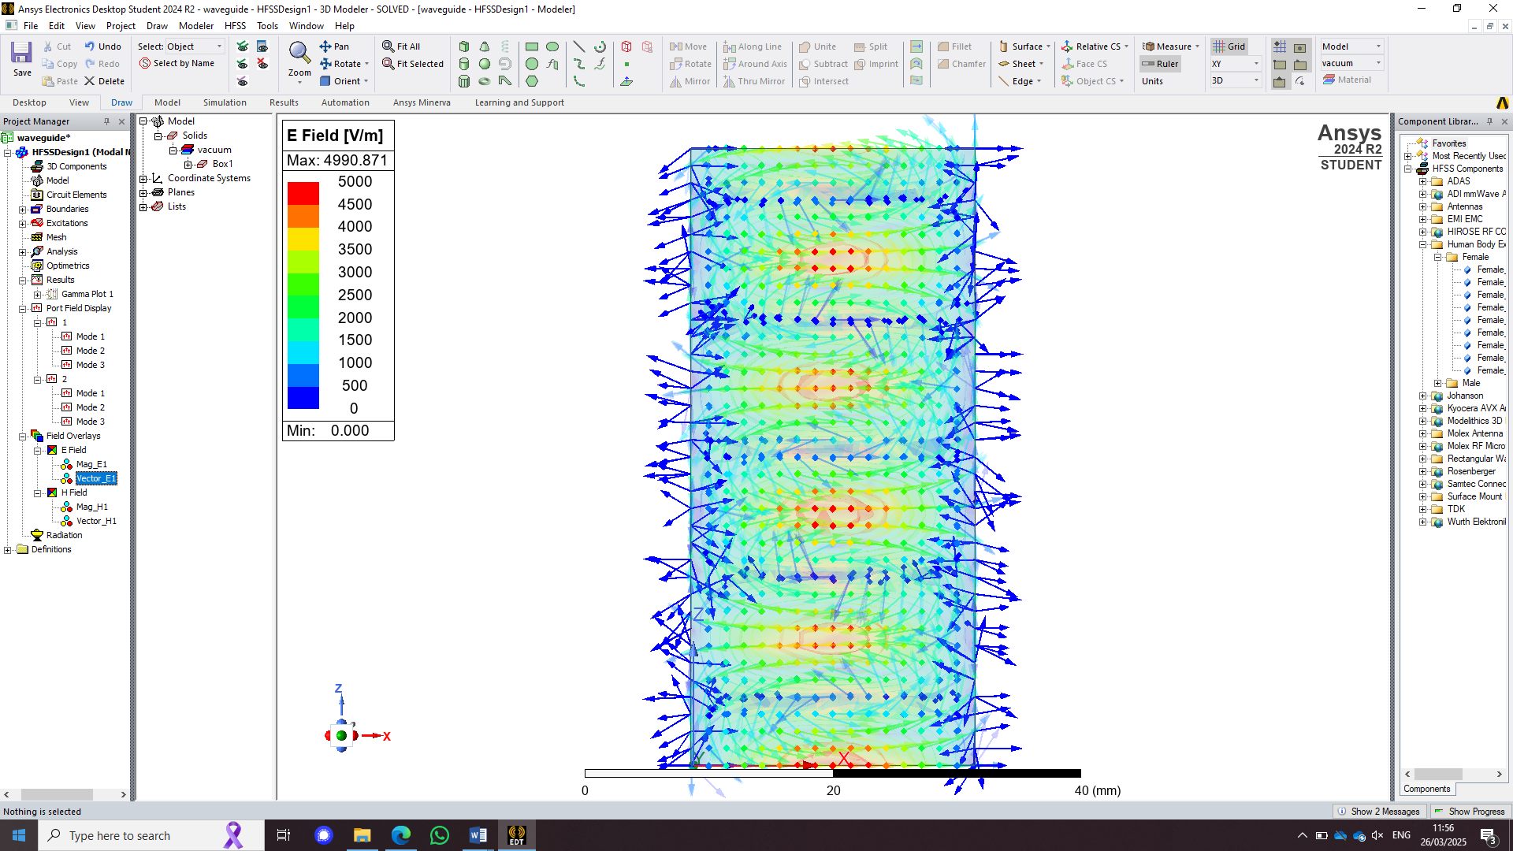
Figure 22 - Magnitude and Vector for the E and H field for mode 1
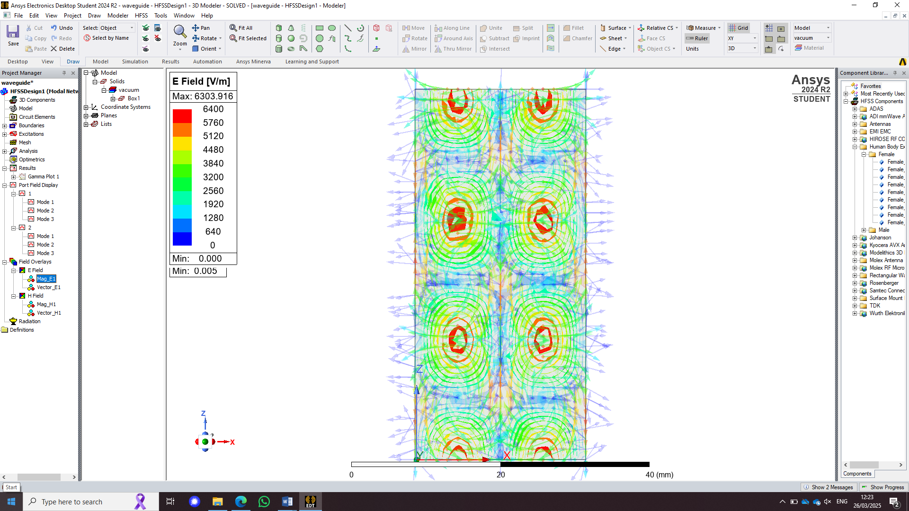 | A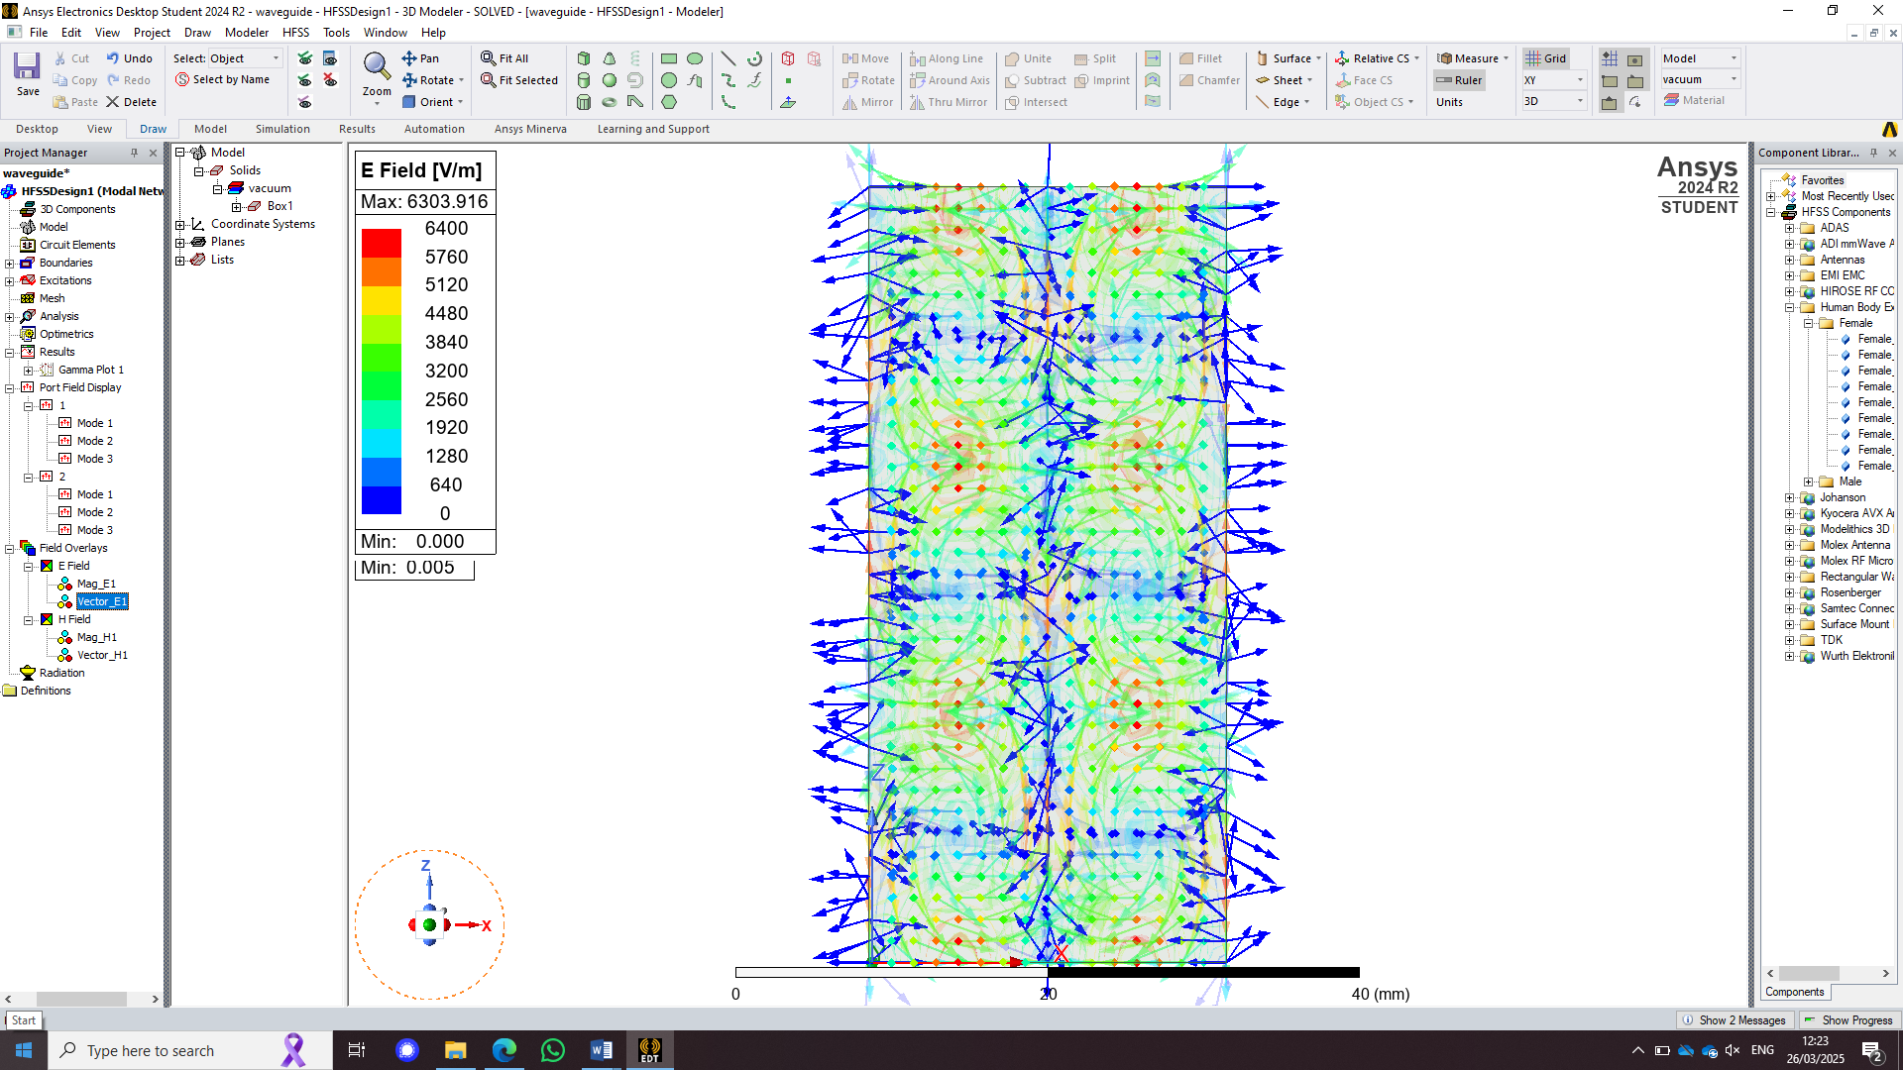
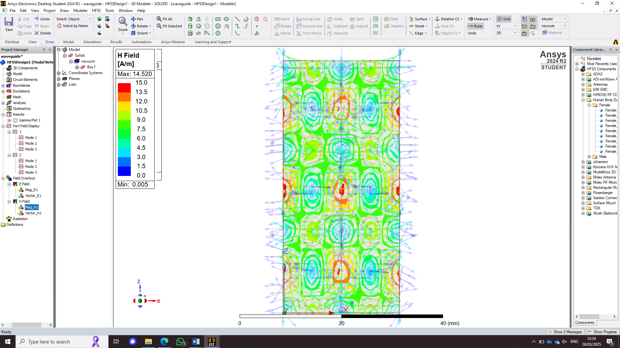 | 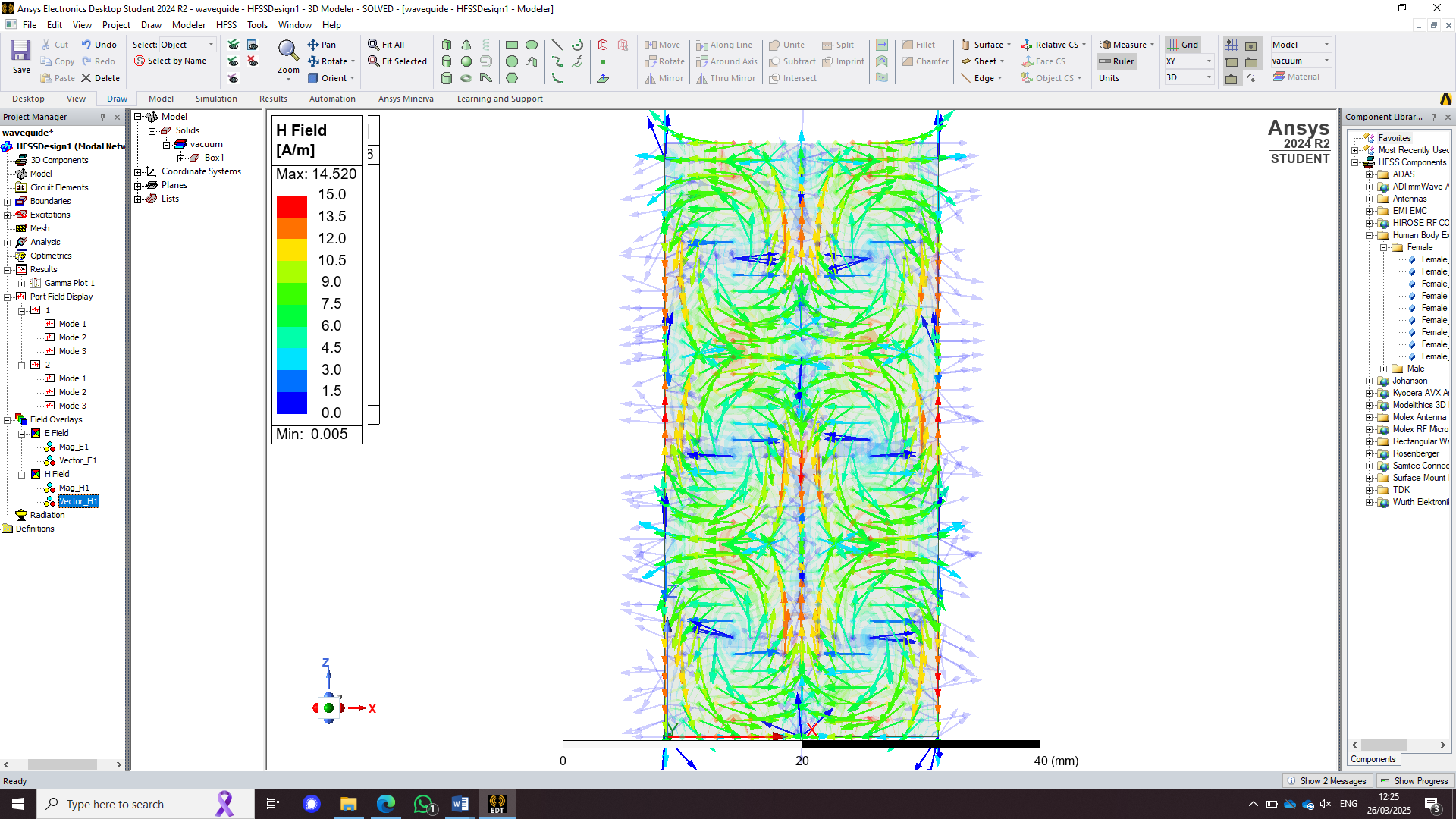
Figure 23 - Magnitude and Vector for the E and H field for mode 2
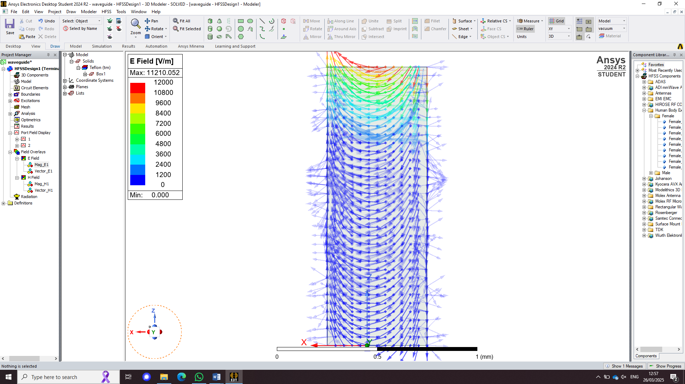 | 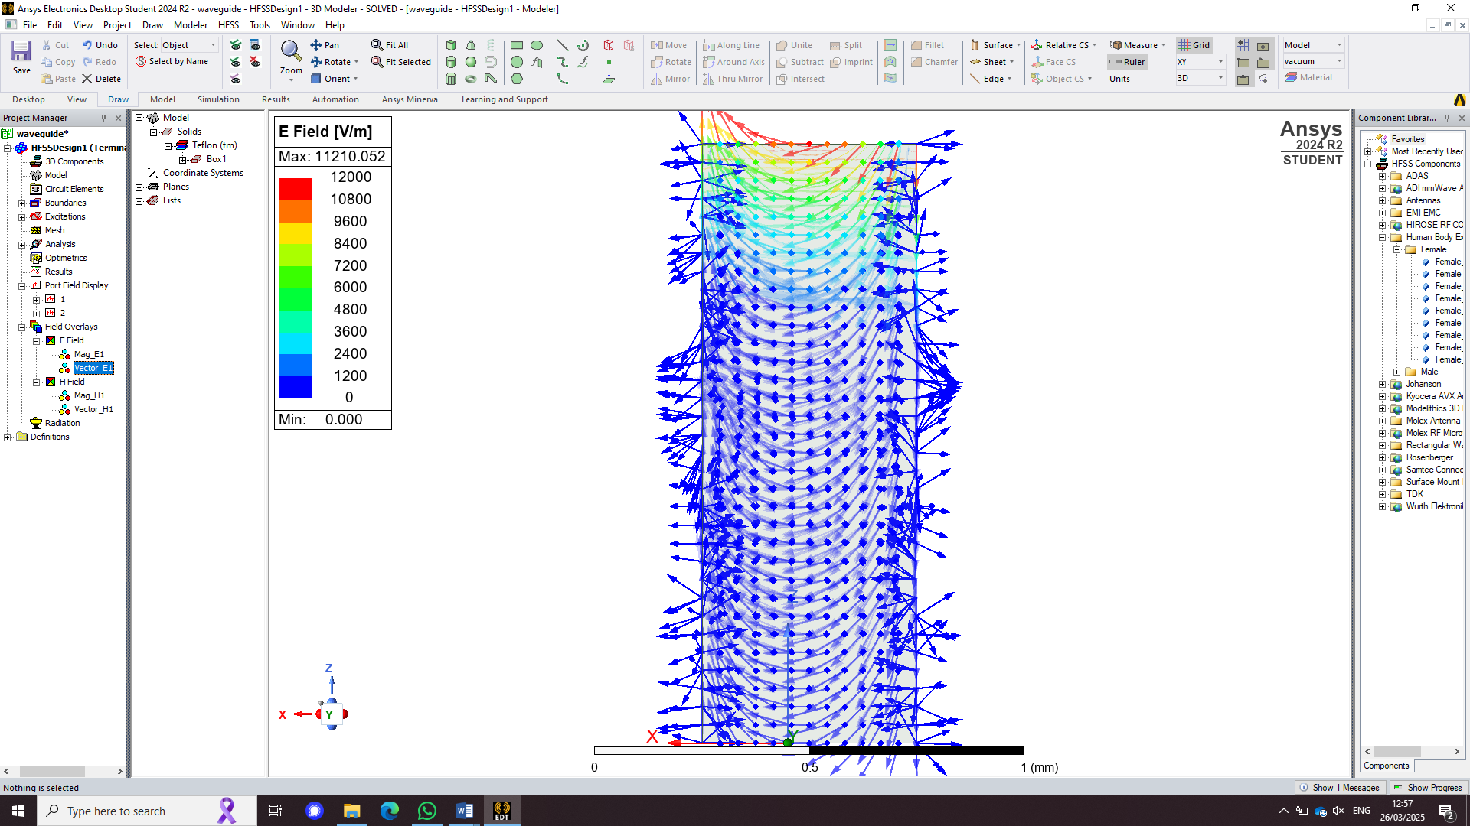
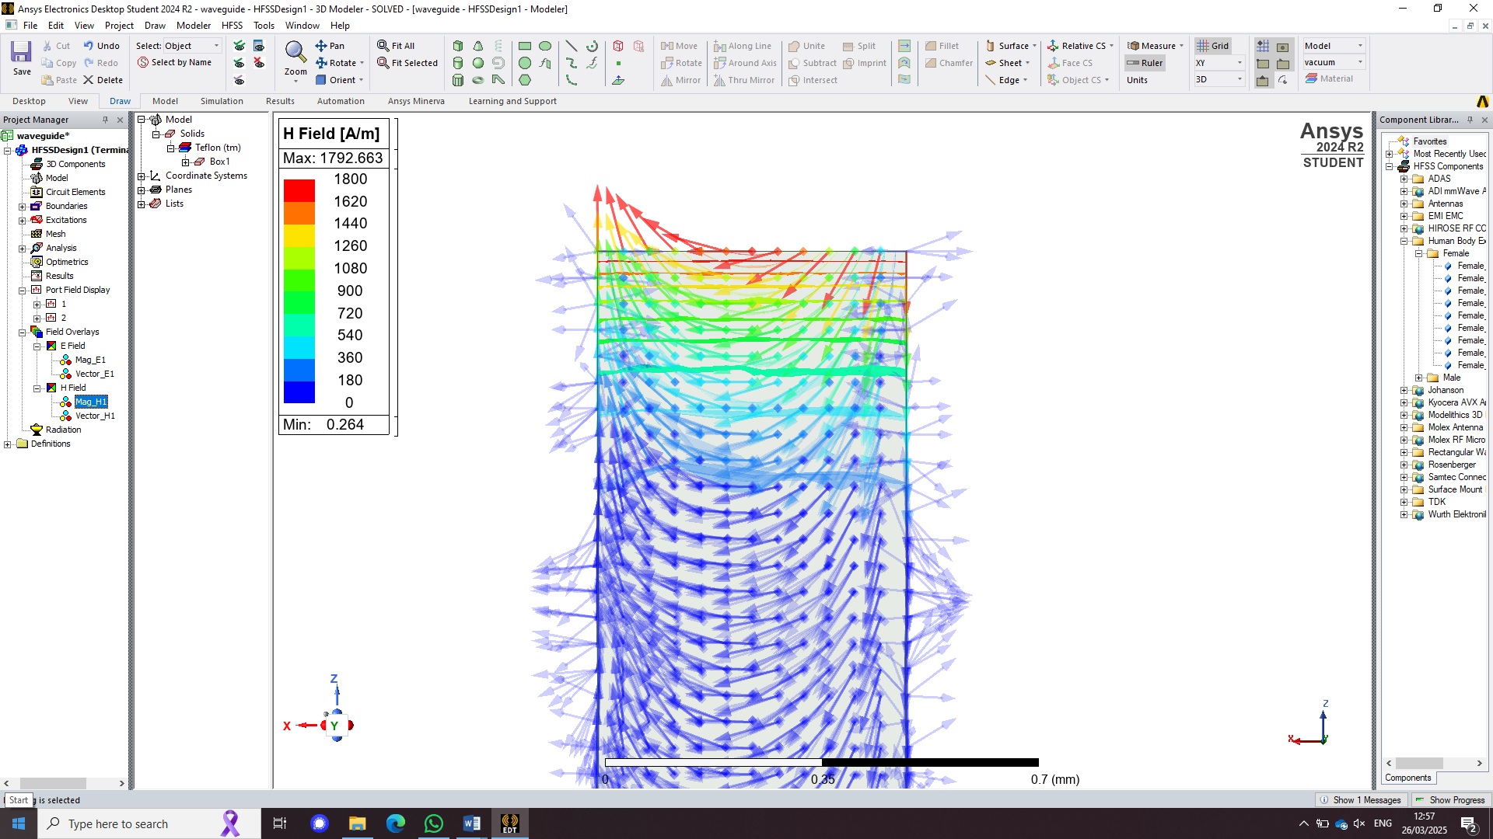 | 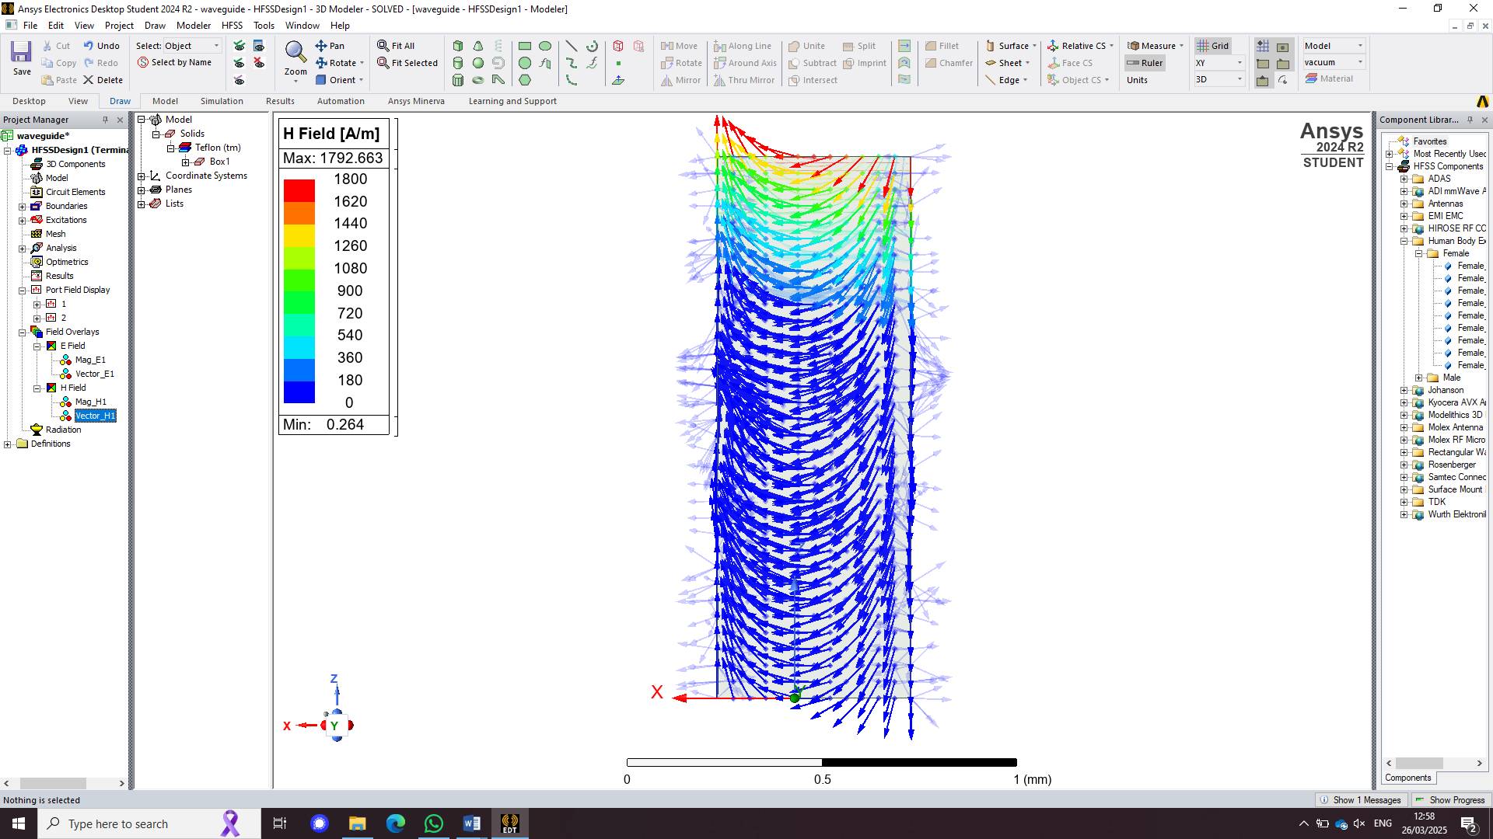
Figure 24 - Magnitude and Vector for the E field for mode 3
Figures 22, 23, and 24 depict field overlays, showing how the electric (E) field and magnetic (H) field vectors behave across the three modes, as affected by the Teflon-filled waveguide.

Comparison of Waveguide results

As can be seen above, changing the material of a waveguide strongly effects the output. There are increased losses when the material is no longer a perfect conductor which means that when the material conditions aren’t ideal, the results reflect this. However, the port field display for both guides are comparable as the 3 modes can easily be seen.

The Design specifications for the Dipole antenna
The design specifications entail that the dipole has to have a radius of 1mm, be designed with a port impedance of 50 Ohm and for the wavelength to be calculated as shown below.
The total wavelength ( $λ$ ) of the antenna is taken from the first three numbers of the authors student number, 2306925. = 230mm wavelength.
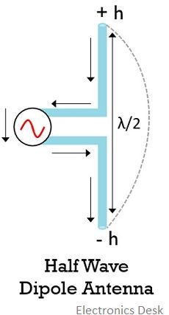
Figure 25 - halfwave dipole (Y, n.d.)
As the author is creating a half wave dipole they need to have the $λ$ equalling 115mm (230/2), found from the equation in figure 1. This means that each side of the dipole needs to be 57mm to ensure that the length is correct.

The Maths
Next, the desired frequency is calculated using the equation in figure 2:

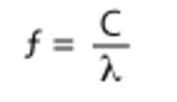
Figure 26 - frequency calculation (Helmenstine, 2021)
We must use the above equation to work out the operating frequency, but first it needs to be understood.
f is the frequency (the value that’s being calculated)
c is the speed of light (3x10^8)
λ is the wavelength (230mm)
This means that to find ‘f’, the author has done 3x10^8/230mm = 1.304×10^9Hz which means that the operating frequency for the antenna is 1.3GHz.
This means the frequency associated with a wavelength of 230 mm is 1.3 GHz.

How the author made the dipole antenna
The dipole was created using CST, where the first monopole was designed with all variables set to meet the design specifications. It was then flipped along the X-axis to form the full dipole.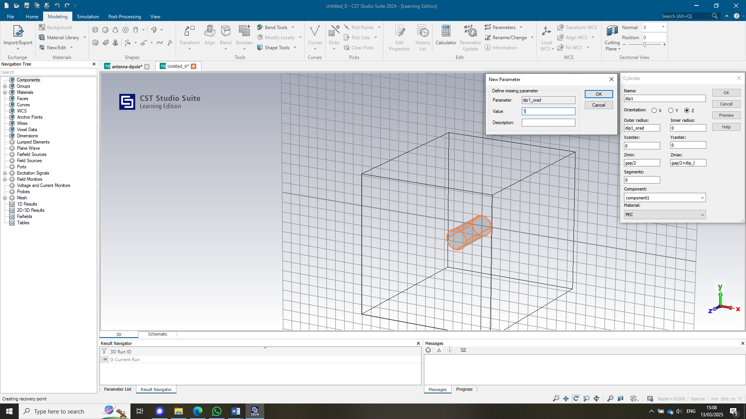
Figure 27 - Dipole creation
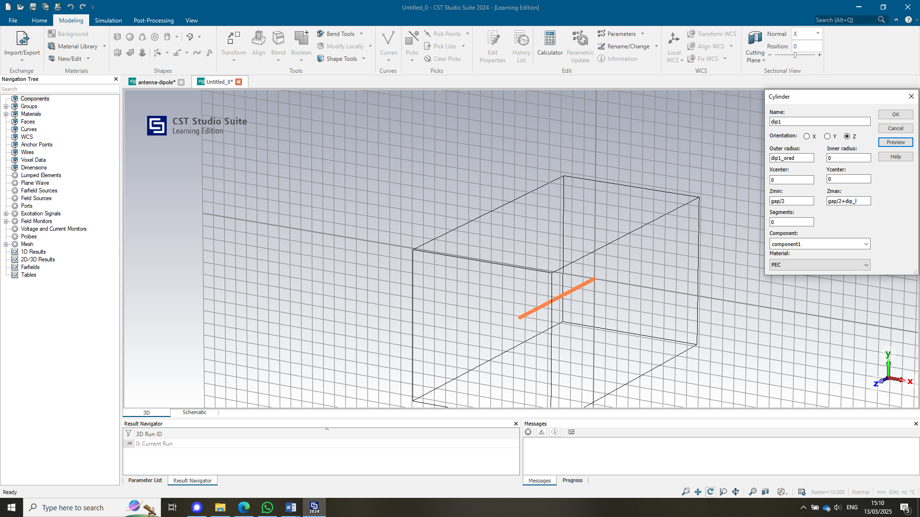

Figure 28 - First monopole

Then, the dipole is flipped and copied along the x axis 180 degrees to make the half wave dipole.
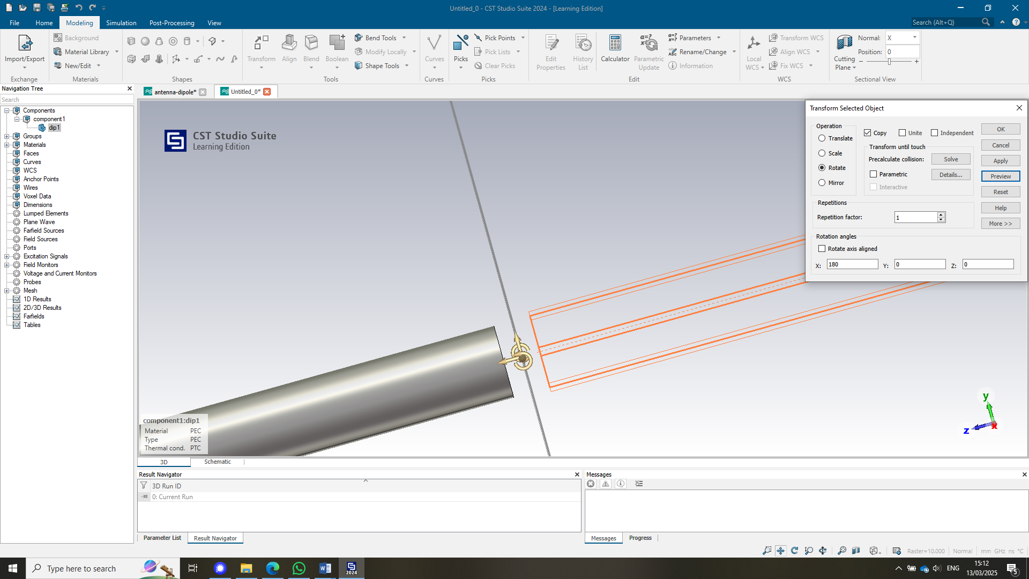
Figure 29 - flipping the monopole to make a dipole
Next, the centre of each port is selected and converted into a discrete edge port with a 50-ohm impedance. This ensures proper signal matching and minimizes reflection for accurate simulation of the antenna’s performance.
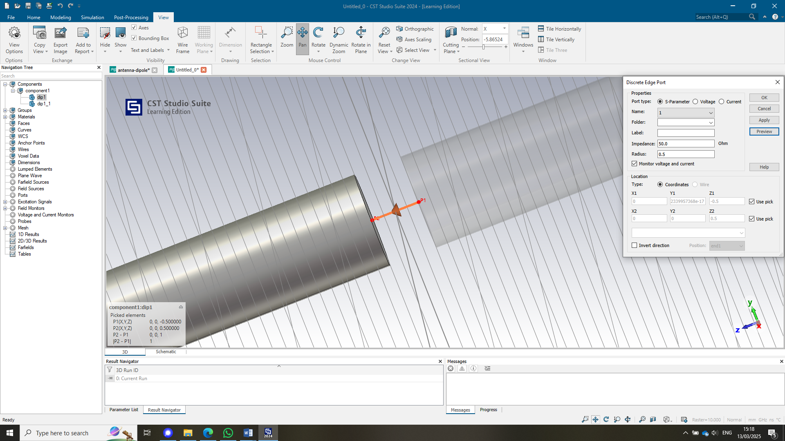

Figure 30 - creating a port

Then, the different boundary conditions are set to make sure that the results of the test are trustworthy and reliable. The target frequency is 1.3 so 1 and 1.6 are selected.

Figure 31 - frequency range
The minimum and maximum frequency range are set around 1.3 to ensure that the simulation captures the desired frequency spectrum. By defining this range, you focus the analysis on frequencies close to 1.3, allowing for more accurate results within that specific range.

Figure 32 - background properties
Ensures all values are 0 In the background
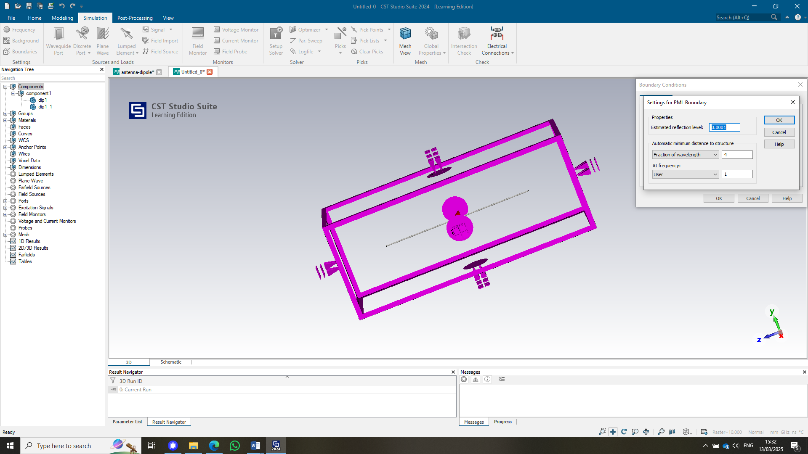
Figure 33 - setting a PML field
When setting up the PML boundary around the dipole, it ensures that outgoing electromagnetic waves are absorbed, preventing reflection from the simulation boundaries. The 'at frequency' is set to 'user' with a value of 1 to ensure the simulation runs at the desired frequency.
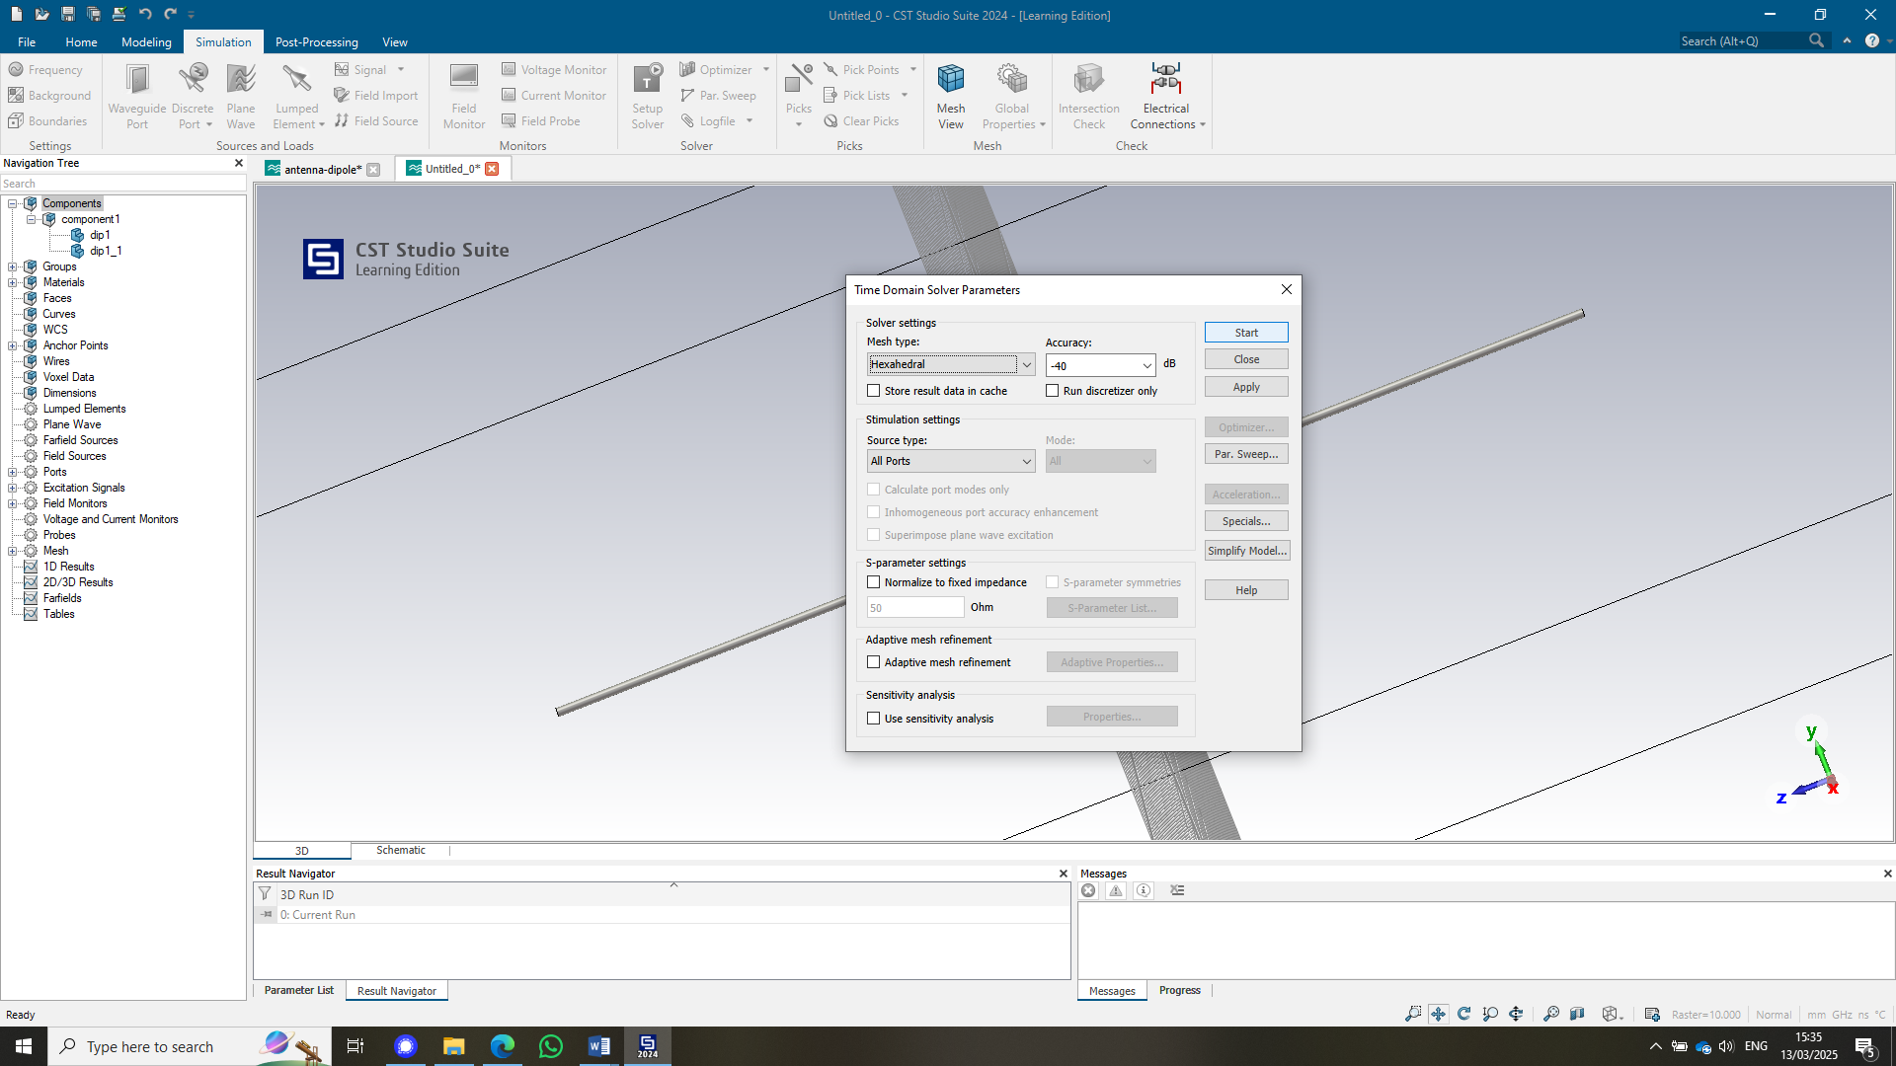
Figure 34 - running the simulation
Finally, the set-up solver is pressed and time domain solver is selected. Then start is pressed and the results are simulated.

The results
Below are the S parameters for the length 115mm
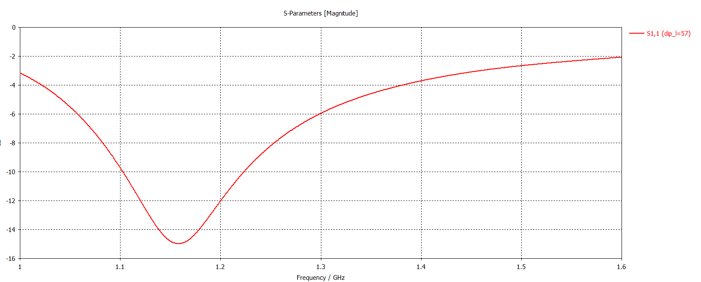
Figure 35 - S parameter for 115mm
The graph indicates that the desired operating frequency has not been achieved yet. With the current length, the frequency is 1.15 GHz, which is lower than the calculated 1.3 GHz. In order to adjust the frequency to the desired value, the author performed a frequency shift. This was done by dividing the achieved frequency (1.15 GHz) by the required frequency (1.3 GHz), resulting in a ratio of approximately 0.8846. To adjust the length of the dipole antenna accordingly, this ratio is then multiplied by the current length of the antenna (57 mm). Performing this calculation (57 mm * 0.8846) gives a new length of approximately 50.42 mm.
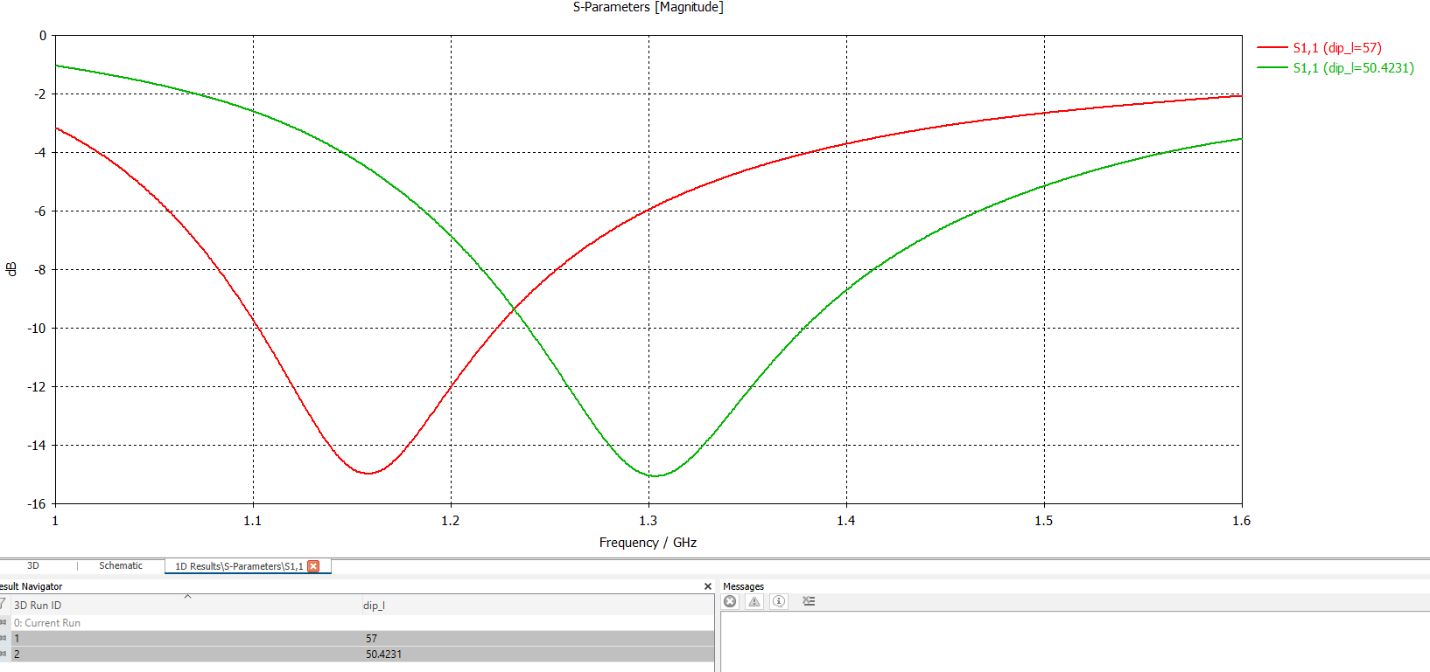
Figure 36 - comparison of S parameters with updated length.
The length of a dipole antenna plays a crucial role in determining its resonant frequency because it is directly related to the wavelength of the electromagnetic wave the antenna is designed to transmit or receive. When adjusting the antenna's length, it effectively tunes the antenna to a specific frequency. As demonstrated, when the length of the antenna is changed, it shifts the operating frequency to the desired value, 1.3 GHz. This happens because the wavelength and frequency are inversely proportional. (N/A, n.d.) A longer dipole antenna corresponds to a lower frequency, while a shorter antenna corresponds to a higher frequency.

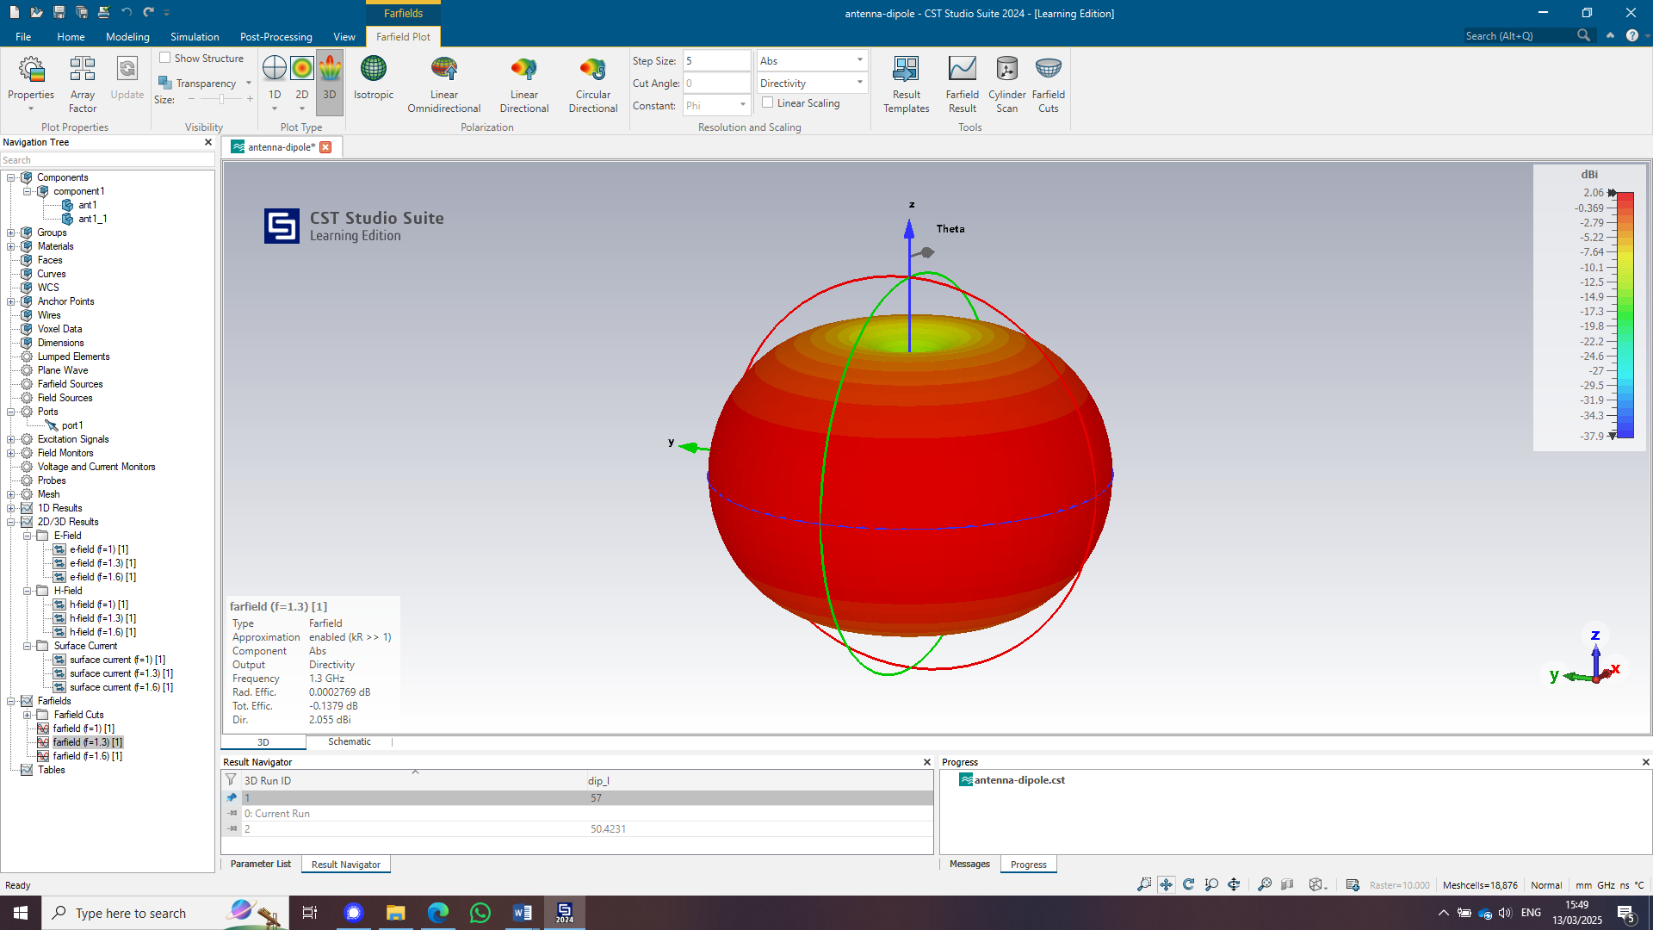
Figure 37 - field plot
Above is the radiation pattern of the antenna. As shown, the antenna is highly omnidirectional. This means that the pattern is distributed in an even pattern around the antenna and has a high strength. This radiation pattern that distributes its signal evenly in all directions, ensuring uniform signal strength across a 360-degree horizontal plane. (Ham Radio FAQ, 2023)
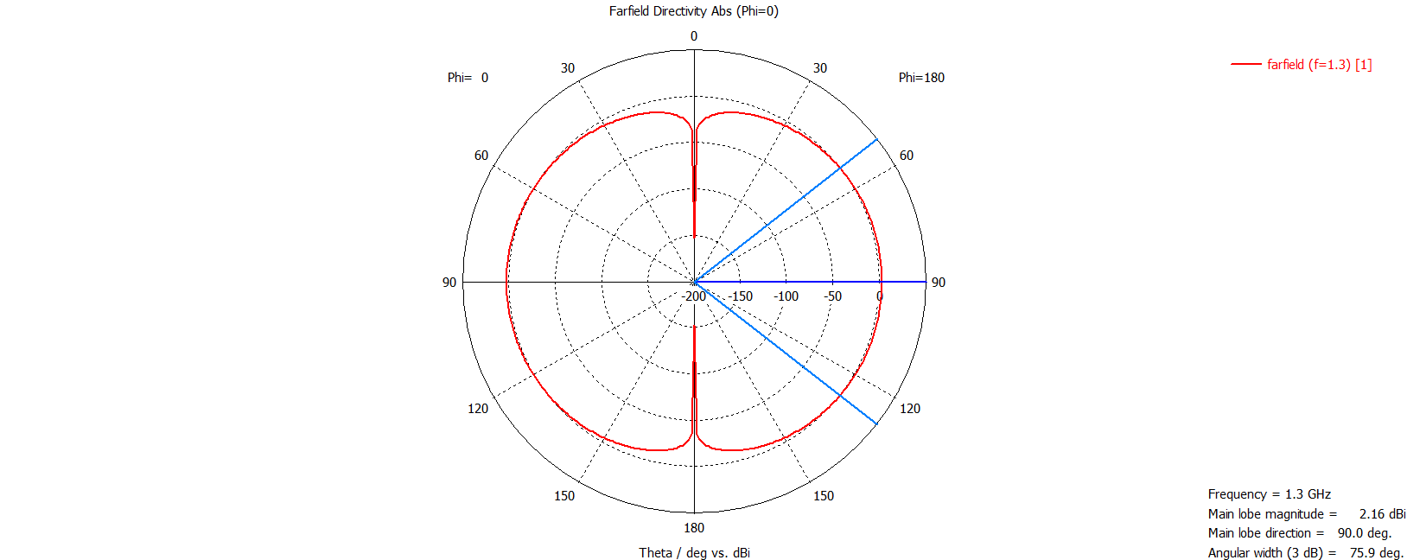
Figure 38 - Theta graph
The above graph shows the field pattern split down the middle along Theta. To further visualize, imagine the field diagram is divided along the z-plane, with a view of the middle portion of the diagram. This perspective reveals how the radiation pattern behaves in a vertical plane, typically showing the signal's distribution both above and below the antenna. (Greiner, 2015)

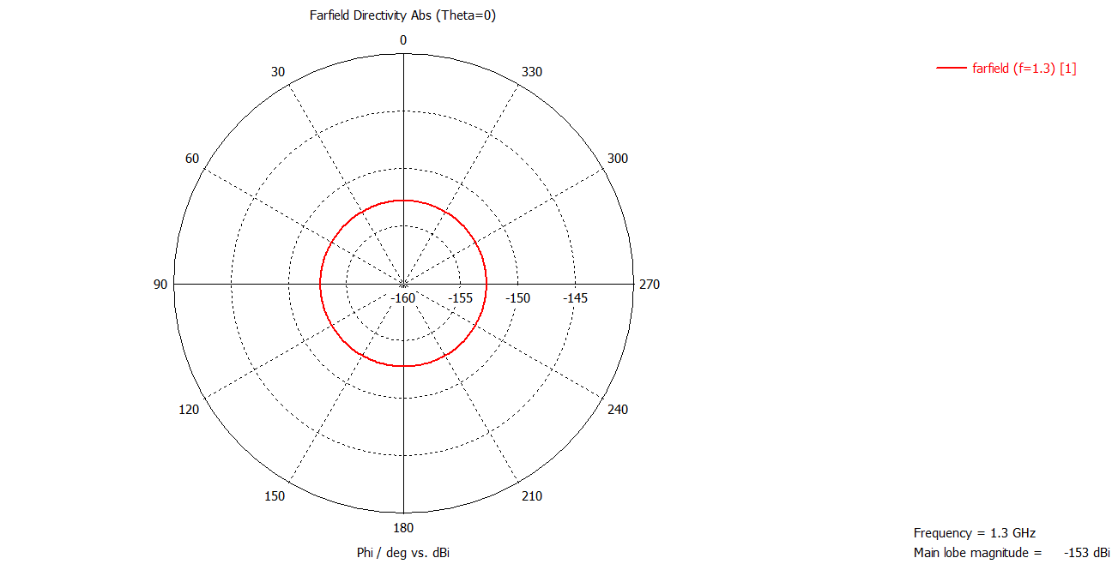
Figure 39 - Phi Graph
This diagram shows a top-down view of the field plot, where the radiation pattern of the antenna is uniform and exhibits no directionality. The field is evenly distributed in all directions, demonstrating the antenna's omnidirectional nature. This means that the signal strength remains constant across the entire horizontal plane, with no preference for any specific direction. (Greiner, 2015)

Radar Systems for UAV Detection: Design, Challenges, and Societal Implications

Introduction
The author will be describing recent technological advancements that help radar to detect drones and they will consider societal impacts of implementing those systems. The author will propose improvements or solutions that could enhance radar effectiveness for drone detection, drawing on recent developments in radar technology while conducting a detailed study where they present their findings.

Literature review
Unmanned aerial vehicles or UAV are increasingly common on the modern-day battlefield. This means that there is a requirement to be able to find, track and trace these UAVs so that both military and civilian operations can continue to take place. UAVs can be used for malicious intent such as flying over airports and causing disruption (Melville, 2023)or potentially life-threatening actions such as attaching explosive ordinance underneath and flying into soldiers or points of interest. (Axe, 2025)
Radar has been used for tracking since the 1930s so is by no means a new concept. (Skolnik, 2025)It has multiple very usefully techniques that are used by police, airports and the military. From traffic cameras to measure drivers’ speeds (How do Radar Guns Work, n.d.), tracking planes coming into land (Wikipedia, n.d.)and missile tracking systems (THALES, 2024)). This means that there is definitely the capability to be able to improve and adapt current equipment to track UAVs.
To understand how a UAV can be tracked by radar, there must first be an understanding of how a radar works. Initially, a transmitter, such as an antenna,sends out a signal into the environment. Then a receiver records all the reflected signals and works out what’s being seen, how far away it was and depending on complexity, the speed the object is moving. When the signal reaches the receiver, the object it detects will have something called a Radar cross section, RCS. This refers to the perceived ‘size’ of the object that has been detected, for a UAV this pattern is often comparable to the size of a bird. (Samiur Rahman)
An advancement that has taken place in recent years that can be used in drone detection is the development of Convolutional Neural Networks or CNNs (Vladislav Semenyuk, 2025)The CNN would require training data of hundreds of recorded known RCS of UAVs that are used to train the CNN to be able to correctly identify them in practice. (Jenifer Darling Rosita, 2022)When a system that has been trained correctly receives a RCS of a drone it will be able to identify it correctly without any risk of human error.
Another way that UAVs can be tracked is by using a Phase-Interferometric Doppler Radar. This system works by sending out a signal, measuring the received reflections from the drone where it then compares the ‘phase shift’ of the reflected signal to the original signal, the system then from this comparison is able to work out the speed and direction. The shift in the phases is called the doppler shift, comparable to the change in pitch you hear when a car passes you. (Michael Jian)
Another technique that could be used is a Phased array radar. The technique works by having different sections in a pattern that have 360 degrees of detection. The radar can either send out CW or pulsed waves and receive the signal which will have a phase shift as described above. This is highly efficient has it has a full coverage which would allow for the drones to always be detected once they are in range. (Alan J. Fenn, 2000)

Discussion
The above techniques are only an introduction to the range of radars that could be used for UAV detection. However, the impact from them all remains constant, as listed below

Security:
Improved detection helps prevent crime, terrorism, and attacks using drones, keeping people and infrastructure safer. If a drone can be spotted, a response can be actioned to make sure that there is no damage caused.

Privacy Concerns:
Radar can lead to more surveillance, which might feel like an invasion of privacy for people, especially in public spaces.

Stricter Rules:
Radar detection could lead to tighter laws controlling where and how drones can be used, which might limit personal or business drone use.

Legal Issues:
The use of radar could raise questions about how much control authorities should have over tracking drones and who can monitor them.

Conclusion
To conclude, the advancement of radar technologies for drone detection offers significant potential for enhancing security in both military and civilian contexts. Techniques such as Convolutional Neural Networks (CNNs), Phase-Interferometric Doppler Radars, and Phased Array Radars show that drone detection is possible and that these technologies can be crucial in preventing malicious activities, such as drone-based attacks or disruptions in sensitive areas like airports, military bases, and public events.
However, as these systems become more widespread, societal concerns must also be addressed. The implementation of radar detection for UAVs could lead to heightened surveillance, raising privacy concerns for individuals, especially in public spaces. Furthermore, stricter regulations may limit personal or business drone use, affecting industries that rely on drones for delivery, photography, and other applications. Legal issues surrounding the control and monitoring of drone activities could also emerge, necessitating clear guidelines to balance security with individual rights.
Overall, while radar technology has the potential to enhance safety and security, it is vital to consider and mitigate its societal impacts through thoughtful regulation and transparent discussions to ensure that technological advancements align with the principles of privacy, freedom, and security.

Figures
Figure 1 -waveguide made from Pec with a vacuum centre 3
Figure 2 - cut off frequency graph 3
Figure 3 - Cut off frequency calculation (Jacobs, 2025) 4
Figure 4 - Port 1 Mode 1 5
Figure 5 - Port 1 Mode 2 5
Figure 6 - Port 1 Mode 3 5
Figure 7 - Port 2 Mode 1 6
Figure 8 - Port 2 Mode 2 6
Figure 9 - Port 2 Mode 3 6
Figure 10 - Magnitude and Vector for the E and H field for mode 1 7
Figure 11 - Magnitude and Vector for the E and H field for mode 2 7
Figure 12 - Magnitude and Vector for the E and H field for mode 3 8
Figure 13 - waveguide made from waveguide with PEC wall filled with Teflon 9
Figure 14 - cut off frequency graph 9
Figure 15 - Cut off frequency (Jacobs, 2025) 10
Figure 16 - Port 1 Mode 1 11
Figure 17 - Port 1 Mode 2 11
Figure 18 - Port 1 Mode 3 11
Figure 19 - Port 2 Mode 1 12
Figure 20 - Port 2 Mode 2 12
Figure 21 - Port 2 Mode 3 12
Figure 22 - Magnitude and Vector for the E and H field for mode 1 13
Figure 23 - Magnitude and Vector for the E and H field for mode 2 13
Figure 24 - Magnitude and Vector for the E field for mode 3 14
Figure 25 - halfwave dipole (Y, n.d.) 15
Figure 26 - frequency calculation (Helmenstine, 2021) 15
Figure 27 - Dipole creation 16
Figure 28 - First monopole 16
Figure 29 - flipping the monopole to make a dipole 17
Figure 30 - creating a port 17
Figure 31 - frequency range 18
Figure 32 - background properties 18
Figure 33 - setting a PML field 18
Figure 34 - running the simulation 19
Figure 35 - S parameter for 115mm 19
Figure 36 - comparison of S parameters with updated length. 20
Figure 37 - field plot 20
Figure 38 - Theta graph 21
Figure 39 - Phi Graph 21

References
Alan J. Fenn, D. H. (2000). The Development of Phased-Array Radar Technology. massachuetts: LINCOLN LABORATORY JOURNAL.
Axe, D. (2025, January 31st). Ukraine’s New Drone Bomber Flies 1,200 Miles With A 550-Pound Bomb—And Returns To Base. Retrieved from Forbes: https://www.forbes.com/sites/davidaxe/2025/01/31/ukraines-new-drone-bomber-flies-1200-miles-with-a-550-pound-bomb-and-returns-to-base/
Greiner, S. (2015, February 10th). Antenna Gain and Radiation Patterns Explained. Retrieved from www.mpantenna.com: https://www.mpantenna.com/antenna-gain-and-radiation-patterns/
Ham Radio FAQ. (2023, August 1). What is an omnidirectional antenna and how does it work? Retrieved from Ham radio FAQ: https://hamradiofaq.com/kb/technical-aspects-and-equipment/what-is-an-omnidirectional-antenna-and-how-does-it-work/
Helmenstine, A. (2021, May 16th). Wavelength to Frequency Calculation and Equation. Retrieved March 27th, 2025, from Science Notes: https://sciencenotes.org/wavelength-to-frequency-calculation-and-equation/
How do Radar Guns Work. (n.d.). Retrieved March 26th, 2025, from Science Struck: https://sciencestruck.com/radar-guns-how-they-work
Jacobs, S. (2025, January 17th). Electromagnetic Radiation (ACDC5009) Lecture - 5. Retrieved March 26th , 2025, from Moodle, UWTSD: N/A
Jenifer Darling Rosita, W. S. (2022). Multi-Objective Genetic Algorithm and CNN-Based Deep Learning Architectural Scheme for effective spam detection, 3. (KeAi) Retrieved March 26th, 2025, from ScienceDirect: https://www.sciencedirect.com/science/article/pii/S266660302200001X
Melville, T. (2023, May 14th). 'Suspected drone' disrupts Gatwick Airport flights. Retrieved from BBC news: https://www.bbc.co.uk/news/uk-england-sussex-65591023
Michael Jian, Z. L. (n.d.). Drone Detection and Tracking. Virginia: Ancortek Inc. Retrieved March 26th, 2025, from https://ieeexplore.ieee.org/stamp/stamp.jsp?tp=&arnumber=8378723
N/A. (n.d.). Vibrations and Waves - Lesson 2 - Properties of a Wave. Retrieved March 13th, 2025, from the physics classroom: https://www.physicsclassroom.com/class/waves/Lesson-2/The-Wave-Equation
Samiur Rahman, D. A. (n.d.). In-flight RCS measurements of drones and birds at K-band and W-band . Scotland : SUPA School of Physics and Astronomy, University of St Andrews,.
Skolnik, M. I. (2025, March 21st). History of radar. Retrieved from Britannica: https://www.britannica.com/technology/radar/History-of-radar
THALES. (2024, July 15th). HYPERSONIC DEFENCE Chapter 3 DETECTION-IDENTIFICATION-TRACKING. Retrieved from THALES: https://www.thalesgroup.com/en/worldwide/defence/magazine/hypersonic-defence-chapter-3-detection-identification-tracking
Vladislav Semenyuk, I. K. (2025, July). Advances in UAV detection: integrating multi-sensor systems and AI for enhanced accuracy and efficiency. International Journal of Critical Infrastructure Protection, 49, 14. Retrieved March 26th, 2025, from https://www.sciencedirect.com/science/article/pii/S1874548225000058
Wikipedia. (n.d.). Airport surveillance radar. Retrieved March 26th, 2025, from Wikipedia: https://en.wikipedia.org/wiki/Airport_surveillance_radar
Y, R. (n.d.). Half Wave Dipole Antenna. Retrieved March 13th, 2025, from electronics desk: https://electronicsdesk.com/half-wave-dipole-antenna.html#Construction

Further Reading

The development of phased-array radar technology
Vision‐Based UAV Detection and Tracking Using Deep Learning and Kalman Filter - Alshaer - 2025 - Computational Intelligence - Wiley Online Library
Advances in UAV detection: integrating multi-sensor systems and AI for enhanced accuracy and efficiency - ScienceDirect
Advanced Radar Technology: The Perfect Choice for Drone Detection - NQDefense
[1808.05756] Fast and Accurate, Convolutional Neural Network Based Approach for Object Detection from UAV
Convolutional Neural Networks for Drone Model Classification - University of Birmingham
[2211.10038] A Survey on Detection, Tracking, and Classification of Aerial Threats using Radars and Communications Systems

