Nick Hinder
P148207
Application Design & Development

Part A

What is the difference between a class and an object?
A class is a schema for objects that are instances of it. A class forms the structure of the object such as its attributes, properties, methods and constructors whereas an object is a single, concrete version of the class. A class describes a thing, whereas an object of that type of class is actually a version of the thing described.

What are the important implications of inheritance and polymorphism in the development of large applications?
Through usage of inheritance and polymorphism we are able to produce code in such a way that we can reduce the amount of work required for future development, allowing the system to be more expandable.
We can create our code in such a way that we can create reusable components or even abstract components that can be used in lieu of more concrete or specific versions. This allows a great deal more flexibility, for example a system may deal with both Students and Lecturers; both could be a class in their own right, however both likely share a number of features, therefore we could actually use a base class of Person as both a student and a lecturer are a person. This way it would be possible to access the shared elements of these classes without needing to deal with the more specific elements.

When should we use an interface instead of a class?
Whilst abstract classes allow for the polymorphism described above, there are times when this is not quite appropriate. A class can only inherit from one base class, this means there may be some occasions where a part of a class cannot be part of the base class, despite being a part of most of the other classes that inherit from the base class, as to be part of the base class it must be implemented in each class that inherits from it.
It is however possible to implement multiple interfaces; an interface is a contract that dictates every class that implements it must provide an implementation for the components of the interface.
For example a document class could be used to hold the information regarding a document, however not all documents have the same behaviours as others, so using interfaces it is possible to implement different behaviours on a document. For example it would be possible to provide either a IWriteable or IReadOnly to the document to provide and control the save functionality for a document.

What are the benefits and drawbacks of applying the Dependency-Inversion principle?
The dependency inversion principle states that high level classes should not be dependant on a low level class; rather it should depend on an abstraction of a low level class. This principle often utilises a interfaces as a method of defining more solid implementations of abstract behaviours; this allows code to be produced in a way that if the low level object it relies upon needs to be changed, this does not mean a change to the code as a whole. For example when reading data from a datasource, the call to read can remain the same whilst through implementing different interfaces that call can be overridden with code specific to the type of datasource being read.
The benefit is that rather than writing multiple datasource objects each with their own functionality, it is possible to write one datasource object but implement an ISQLLiteConnection interface or an IOracleConnection interface to allow the specific code to be carried out. This means that at a higher level, it does not matter what connection was used to read the data; all that matters is what data was read.
Whilst this is a major advantage, it is worth noting that this is a more complex approach to implementing a system and doing so may not be worth the time invested in it. This principle is best used when there are multiple different implementations of a class and in time these are liable to be changed or more implementations added. Usage of this principle can impact the complexity and timescales of a project; for simple projects the overhead of this can be unjustifiable.

Part B

Exercise 1:
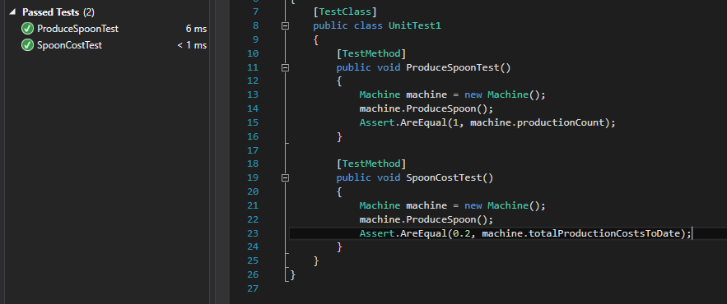
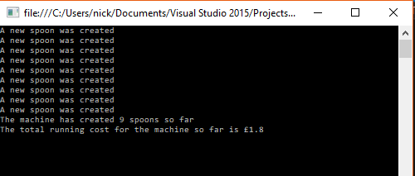
The two images below demonstrate the testing of this exercise. On the left is the output when run, this correctly reflects the expected behaviour. On the right are the unit tests for this exercise; the test window displays the successful test results, confirming that the code is indeed behaving as expected.

Exercise 2:
The images below demonstrate the testing of this exercise. The first image are the unit tests for this exercise; the test window displays the successful test results, confirming that the code is indeed behaving as expected. The following images are test examples that demonstrate that the code works for both overlapping and non overlapping values.
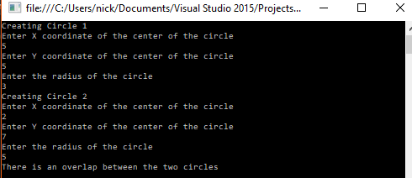
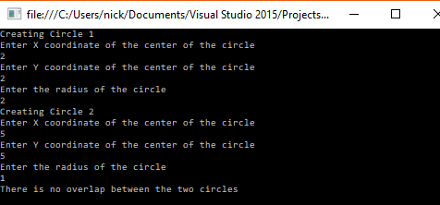
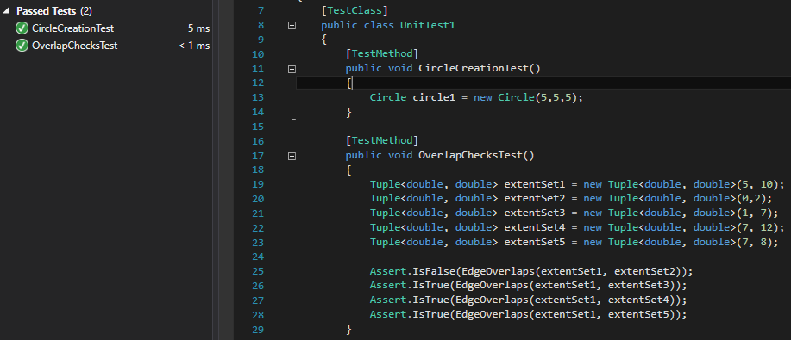

Exercise 3:
The following image shows the unit tests demonstrating the code works as expected.
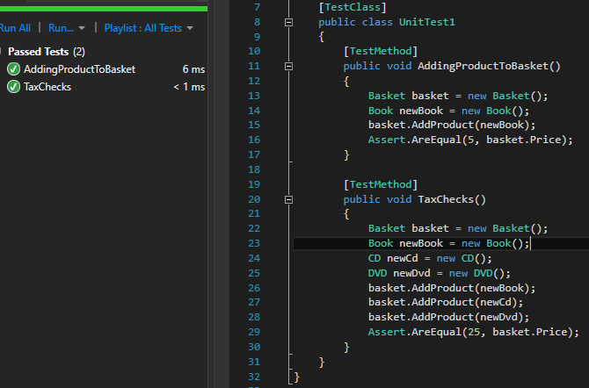

Part C
The following image is a UML diagram that details the structure of the program. The user class is the base class for the tester, admin and developer classes each of which implements a combination of the iTester and iDeveloper interfaces. The IReportPrinter interface is implemented by both the XMLReportPrinter and the ConsoleReportPrinter classes.
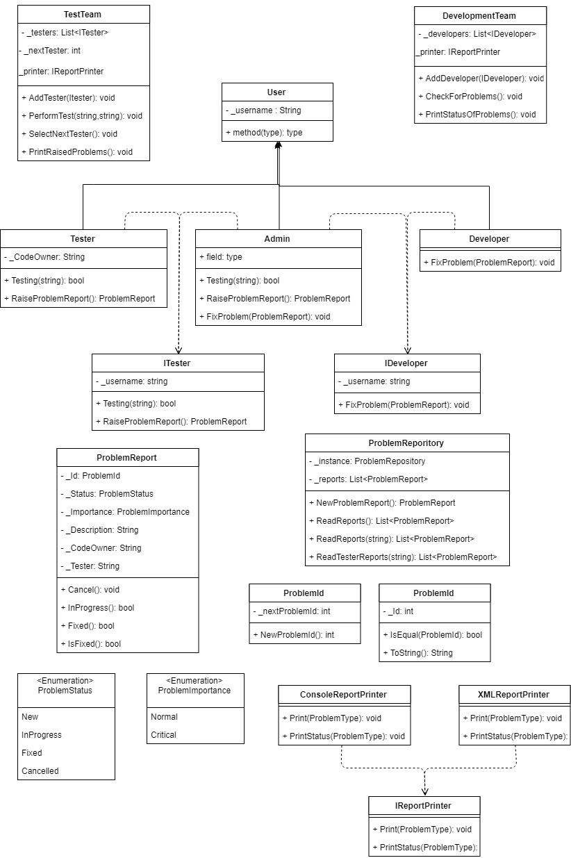

Part D
When testing code there are a number of different methodologies that can be used to improve the efficacy of the testing and reduce the potential for issues to be missed during testing stages.
The most common method of testing is black box testing; this is most commonly manual testing where the tester will perform a specific action whilst expecting an appropriate result from the action; when the result deviates from that expectation it is noted and investigated further. This method allows testers to approach the system in a ‘user-like’ manner, where they do not need to know what the code does, only the actions required to get a desired result. This testing, whilst simple, can be structured into test plans to cover all features of a system so as to allow it to be tested as fully as possible.
As an extension of black box testing there is white box testing; this is most commonly used by developers, especially during development. White box testing is black box testing with the addition of being able to understand and investigate the code for the cause of issues.
A more modern, yet powerful and popular, form of testing is that of Unit testing. Unit tests are automated tests that are developed alongside a system that test operations, these tests are intended to be small, self contained tests that test a specific operation. Unit tests are set up to replicate the small sections of code and assert whether expected results and conditions are met. These Unit tests can be run at any time, but can be hooked up to automatically run on build; this means that a developer can immediately test all the set up tests after making changes to observe whether the changes have impacted any of the parts of the system. There has been a rise in the popularity of Test Driven Development (TDD) whereby developers would first create the unit tests for the functionality, then create the actual code using these tests as guidelines. This practice ensures that the system is closely coupled with its tests and the vast majority of the system should be fully testable via these unit tests.
There are other forms of autonomous testing, however Unit testing is the de facto standard. Different forms of autonomous testing exist for other purposes such as Selenium for testing the front end of a system.
Ultimately the final and most important test is User Acceptance Testing (UAT) which entails the client performing tests on the system (most likely using black box testing methods) until they are happy to formally accept that the system is in an appropriate working condition.

