A Technical Report Detailing
the Material Selection
and Manufacturing Processes
for a Piston

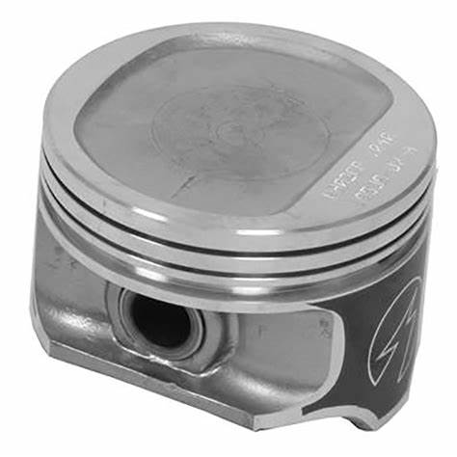

Aeddan Senior 2205394
Contents Page
Page 1 Introduction
Page 2 Material Properties
Page 4 Material Selection
Page 5 Manufacturing Processes
Page 7 Conclusion
Page 8 References
Page 9 Technical Drawings

Introduction

This is a technical report on finding the best material for manufacturing a piston and the manufacturing processes the material will go through to become a piston. The properties of many materials will be considered, looking at both advantages and disadvantages, before a final decision will be made with reasons as to why that material has been chosen. Following this there will be an analysis of processes the material will have to go through before the piston has finished being manufactured and is ready to be sold. Finally, there will be technical drawings of a piston as well as the piston assembled to a connecting rod using a gudgeon pin.

Material Properties

There are several materials that could be used to manufacture a piston; The properties that the material should have may vary depending on the funtion of the piston and the budget of the manufacturer. A piston shoud have the following properties to function properly; a piston should be strong because the engine is putting a lot of preasure on the piston, a piston needs to made out of a material that has a high melting point so that the piston can withstant the heat of the engine, also for a piston to function well it needs to be lightweight to help reduce the fuel consumption used by the engine. Also a piston needs to be corrosion resistant so that the piston does not scratch, leading to further damage and a piston needs to be made from a material that does expand easily, otherwise it may get jammed in the cylinder.
Ranger Caradoc suggests many materials that are suitable such as:
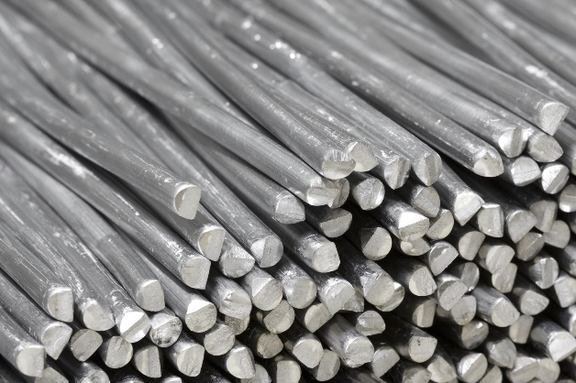
Aluminium:
Aluminium is commonly used for pistons for many reasons. Firstly Aluminium has a high melting point, above 660®C, making it suitable for when the engine has been running and becomes very hot. Aluminium is also corrosion resistant. Therefore, the surface of pistons made of aluminium will not be damaged by any fluids or oils that may leak from elsewhere in the engine and won’t stop the engine from working properly. However, this is only because of the aluminium oxide that is protecting the aluminium from reacting with more oxygen or other substances. While the piston is going from top dead centre to bottom dead centre the aluminium oxide could rub off, allowing the aluminium to react with anything that is in the engine. Generally, an aluminium/silicon alloy is used instead. Small amounts of other metals may also be present. DeanGroup says that aluminium is lightweight. This can be very helpful when changing pistons or checking if the piston hasn’t broken as if it is dropped on to your foot there won’t be as serious damage as a much heavy piston. A lightweight piston can also help with lowering fuel consumption, resulting in less money needed to run the engine. This is because less fuel will be needed to overcome the inertia of the piston. Aluminium has a low dimensional tolerance, making it easier and quicker to produce the parts, like a piston, and assemble it to whatever it needs to be assembled to, for example a gudgeon pin and connecting rod. Aluminium can be made into very complex shapes very easily with machinery, which is very useful with the shape and nature of a piston.
Figure 1: Aluminium from; DeanGroup (2022) Aluminium: A sustainable and efficient metal, Dean Group International. Available at: https://www.deangroup-int.co.uk/aluminium-a-sustainable-and-efficient-metal/ (Accessed: March 17, 2023).

Steel:
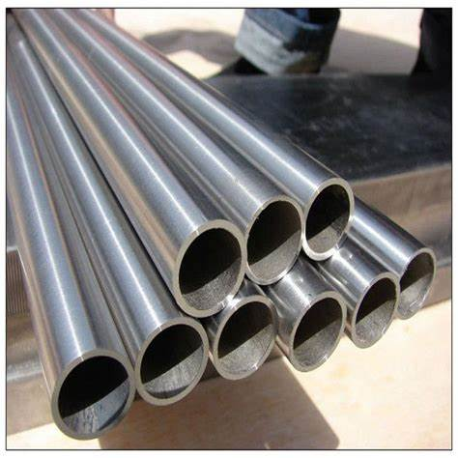
Steel has a high tensile strength in comparison to other metals, meaning it has a better chance of holding together. In other words, has a much less chance of breaking while the engine is running. It is extremely important that small bits do not get into the engine as it can damage other parts of the engine and cause severe damage if not sorted out quickly. The ductility of steel is very useful for products like a piston. Steel can be changed to fit the shape of anything that it needs to be made into very easily. Steel is very durable with a high hardness and is long lasting with resistance to external wear and tear. This is very important for a piston because an engine does not want anything inside to break causing damage to other parts of the engine. Certain Steels are rust resistant. This is very important for any part in an engine as it needs to last a long time. This is also true for a piston as it is in the centre of the engine so if it were to corrode the piston could fall apart and damage another part of the engine causing severe damage. Steel is very heavy and has a quite high density in comparison to other materials so things like the fuel consumption would be high and the risk of injury is higher for the metal is dropped. However, steel is quite cheap and is generally easily accessible, meaning a piston can be made cheaply and many can be made soon after being required for an engine.
Figure 2: Steel from; China Good Quality Stainless Steel Sheet Supplier (2020) Round steel tubing, stainless steel round tube, stainless steel pipe, Shandong Langnai Matel Product Co.,Ltd. Available at: https://www.stainlessplainsheet.com/china-304_food_grade_stainless_steel_welded_tube_10mm_20mm_30mm_40mm_aisi_304l_polish_stainless_steel_pipe-12669668.html (Accessed: March 17, 2023).

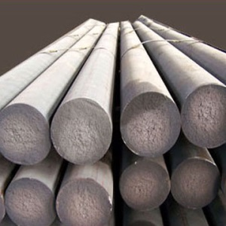
Cast Iron:
Cast iron typically has a high hardness, which leads to having a high resistance to abrasion and indentation. This means that cast iron is resistant to wear and tear which is very important for a piston as any bit that break off the piston can damage the rest of the engine resulting in damage that could result in an unrepairable engine. Cast iron isn’t vey ductile, which can be a problem because if anything needs to be able to bend or stretch easily without breaking, it can’t easily if it is made of cast iron. Cast iron isn’t very malleable either, so has a similar issue. However, cast iron does have a high tensile strength. This means that cast iron can withstand a lot of stress before it brakes and falls apart. Cast iron has a very good castability. This means it is easily poured into a mold of any shape. This can be very helpful when making a piston as the mold can be used to make an infinite amount. Cast iron is unfortunately not very corrosive resistant, and can be brittle and can break easily. This is not very convenient for a piston as a piston us under a lot of force and pressure. Therefore, the engine is at risk of being damaged if the piston brakes.
Figure 3: Cast Iron from; Cast iron material cast iron material supplies ASTM A48-76 Rond bar square bar (2022) Solerany The Restaurant. Available at: https://solerany.com/cast-iron-material.html (Accessed: March 17, 2023).

Material Selection

Making a final decision as to what material a product should be is vital. This is because some materials can work well for a given product where other materials do not. There are many materials that can be used to manufacture a piston, however only a few materials are actually used. When thinking about the material that is going to be used, the price that is paid for the material that is going to be used needs to be as low as possible compared to the price that the pistons is sold for. This is important as without a profit the product would not be a success.
How accessible a material is is also very important because if there is not enough material to make the pistons that are required than the customers may go elsewhere which have the pistons of that material. In an engine a piston can be under a lot of stress and pressure, this means that a suitable material for a piston needs to have a good toughness, strength and high hardness. A piston without these could end up being damaged which could lead to further damage in the engine if not dealt with as soon as possible. A piston should also be rust resistant and corrosion resistant. This is because if part of the piston snaps off or brakes off, that part could scratch the rest of the engine causing severe wear to the engine. While a piston in in an engine, it is possible for it to chance shape slightly. This means if the material isn’t very ductile, then it’s possible for the piston to break which can also cause damage to the rest of the engine. Fuel consumption is a massive problem at the moment as it helps polute the environment and means it is more expensive to run a car if it is heavier. This means a material that is lightweight material is more suitable to reduce the fuel used to run an engine. A lighter piston also reduces the risk of injury if dropped. After being used an engine can be seriously hot. This means if there is anything made out of a material with a low melting point, it will have a high chance of melring when the engine is running This is why a piston needs to be made out of a material that has a highmelting point so that it can withstand the heat that engines can reach. Being able to manufacture a product quickly is really important for keeping up with demand. This is why a material having a low dimensional tolerance is very helpful. This allows a piston to be made quickly and easily.
After looking at many materials, and looking at the strengths and weaknesses of them it suggests that steel is very suitable for manufacturing a piston because it is easy to access a mass amout of steel quickly. Aluminium and cast iron are more dificult to access than steel. Steel is also very tough and strong meaning wont brake easily, whereas cast iron is brittle so will break easily. As a result of steel being easily accessable, the price is lower than a material that is more dificult to acces. For example Aluminium.

Manufacturing Proccess

There are many proccesses that a material can go through to become a piston. These include:

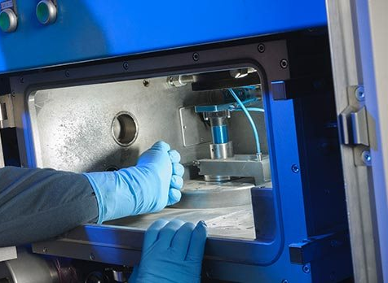
3D Printing:
3D printers can print complex shapes, which is very suitable for pistons, because there are various different parts of a piston that stick out in awkward ways and parts that need to have holes in them. For example the holes for the gudgeon pin. 3D printers can also print on demand, which can be very useful because you don’t need to store the excess products anywhere which can save money and space. 3D printers usually involve plastics. This means that the products that are manufactured from 3D printers are normally significantly lighter than products made from metals of the same size. 3D printing leaves minimal waste, meaning a product that has a lot of air space wont leave wasted material. This significantly helps the environment and results in better use of money. 3D printers can only print within a certain size. This makes them not very suitable for printing big objects. This could also lead to unfinished products if the product is on the edge of being too big for the printer.
Figure 4: 3d printer from What are the advantages and disadvantages of 3D printing? (no date) TWI. Available at: https://www.twi-global.com/technical-knowledge/faqs/what-is-3d-printing/pros-and-cons (Accessed: March 18, 2023).

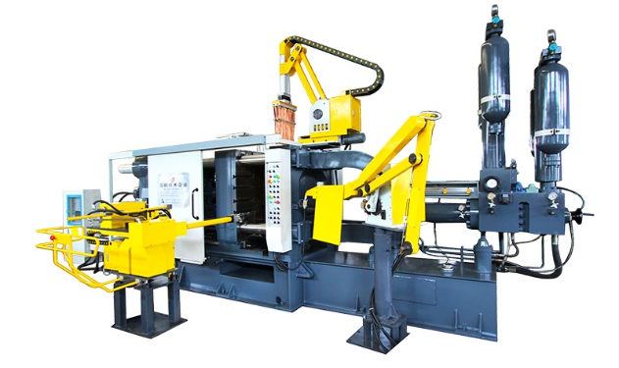
Casting:
In casting proccesses, complex shapes can be made. This is useful for pistons because they have parts sticking out in places. For example where the piston can be assembled to a connecting rod using a gudgeon pin. The size and the weight of the products manufactured using casting almost don’t have a limit for size and mass. This can be really usefull when manufacturung bigger and heavier products. Casting can utilise small components of a material on the next piece to be produced. This is very useful for saving materials and money every bit of material will be used and less money will need to put in to buy more material. The accuracy of dimensions is quite low with casting, which can lead to faulty products. This is a problem for pistons because eif they are two big, they will jam in the engine. However if the piston is too small then fuel may escape the engine.
Figure 5: A casting machine from: LH- 550T aluminum alloy pressure die casting machine (2020) Lh- 550t Aluminum Alloy Pressure Die Casting Machine. Available at: https://www.diecastingmachinechina.com/Lh-550t-Aluminum-Alloy-Pressure-Die-Casting-Machine-pd77891677.html (Accessed: March 18, 2023).

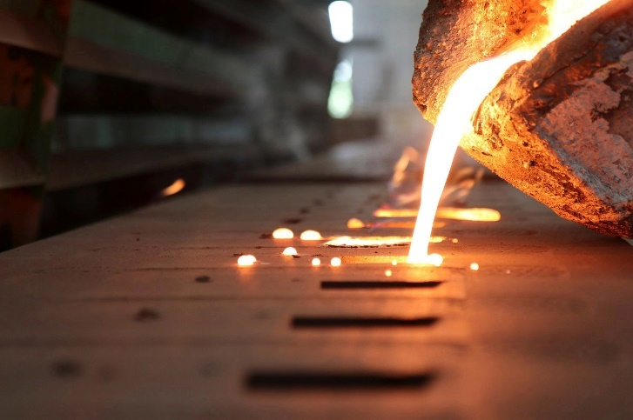
Forging:
Products manufacured using forging tend to be stronger as the machine can align the grain of the metal in one direction. This is very useful when manufacturing a piston because pistons need to withstand a lot of pressure while the engine is running. Forging can also increase the resistance to wear and tear. This is also important for a piston because if a piston were to break the engine would be at risk of damage. The accuracy in dimensions is also very good. This can help the safety of an engine as the piston is less likely to jam or allow fluids past it. Forging is a dangerous process. This means that if something were to go wrong, it could lead to serious consequences. For example the whole proccess being abandoned.
Figure 6: Forging from: Creativemedia (2022) What is the difference between casting and forging?, Schaumburg Specialties. Available at: https://schaumburgspecialties.com/blog-what-is-the-difference-between-casting-and-forging/ (Accessed: March 18, 2023).

Conclusion
In conclusion, there are many materials that are suitable for a piston, and many manufacturing proccesses that can be used to make the piston. Therefore deciding which ones to use can have vital impacts on whether the piston is a success by selling and functioning efficiently and successfully or failing by not selling or breaking the engine completely.

References
Piston styles (2019) Piston Styles. AUTOSALES, INCORPORATED dba Summit Racing Equipment | Trademarks. Available at: https://help.summitracing.com/app/answers/detail/a_id/5017/~/piston-styles (Accessed: March 14, 2023).
Wheway, J. (2018) The best materials for manufacturing hydraulic cylinders and Pistons, The Best Materials For Manufacturing Hydraulic Cylinders And Pistons. John Wheway. Available at: https://blog.rangercaradoc.com/the-best-materials-for-manufacturing-hydraulic-cylinders-and-pistons (Accessed: March 17, 2023).
DeanGroup (2022) Aluminium: A sustainable and efficient metal, Dean Group International. Available at: https://www.deangroup-int.co.uk/aluminium-a-sustainable-and-efficient-metal/ (Accessed: March 17, 2023).
thyssenkrupp Materials (UK) Ltd (2022) What are the properties of aluminium? - thyssenkrupp materials (UK), Materials UK. Available at: https://www.thyssenkrupp-materials.co.uk/properties-of-aluminium (Accessed: March 17, 2023).
China Good Quality Stainless Steel Sheet Supplier (2020) Round steel tubing, stainless steel round tube, stainless steel pipe, Shandong Langnai Matel Product Co.,Ltd. Available at: https://www.stainlessplainsheet.com/china-304_food_grade_stainless_steel_welded_tube_10mm_20mm_30mm_40mm_aisi_304l_polish_stainless_steel_pipe-12669668.html (Accessed: March 17, 2023).
Engineering Discoveries (2020) What are the properties of steel?, Engineering Discoveries. Available at: https://engineeringdiscoveries.com/what-are-the-properties-of-steel/ (Accessed: March 17, 2023).
Cast iron material cast iron material supplies ASTM A48-76 Rond bar square bar (2022) Solerany The Restaurant. Available at: https://solerany.com/cast-iron-material.html (Accessed: March 17, 2023).
What are the advantages and disadvantages of 3D printing? (no date) TWI. Available at: https://www.twi-global.com/technical-knowledge/faqs/what-is-3d-printing/pros-and-cons (Accessed: March 18, 2023).
LH- 550T aluminum alloy pressure die casting machine (2020) Lh- 550t Aluminum Alloy Pressure Die Casting Machine. Available at: https://www.diecastingmachinechina.com/Lh-550t-Aluminum-Alloy-Pressure-Die-Casting-Machine-pd77891677.html (Accessed: March 18, 2023).
J, R. (2023) Advantages and disadvantages of forging, Thepipingmart Blog. Available at: https://blog.thepipingmart.com/other/advantages-and-disadvantages-of-forging/ (Accessed: March 18, 2023).
Creativemedia (2022) What is the difference between casting and forging?, Schaumburg Specialties. Available at: https://schaumburgspecialties.com/blog-what-is-the-difference-between-casting-and-forging/ (Accessed: March 18, 2023).

