
Name :Renata Balogh
Student number 2024 0767 32

Task 1 – Concept Map
Create a concept map that outlines the relationship between creativity, value creation, and health and social care improvement. Within the concept map explain how these concepts interact in a health and social care context (250 words).
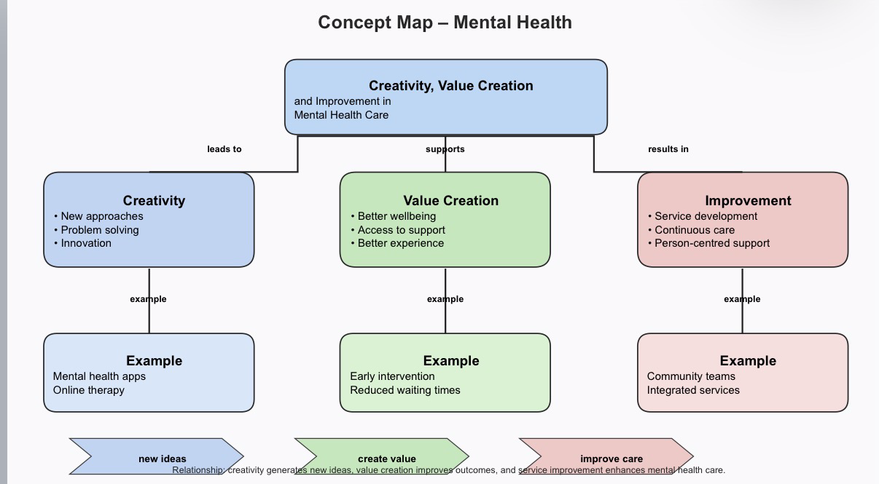
Please refer to week 1 content
This concept map illustrates the relationship between creativity, value creation and improvement in mental health care. Creativity involves generating new ideas and innovative approaches to address complex challenges within mental health services. For example, digital tools such as mental health apps and online therapy platforms demonstrate how creative thinking can improve access to care.

Creativity contributes directly to value creation by improving patient outcomes, increasing efficiency, and enhancing patient experience. In mental health care, value is created when services become more accessible, waiting times are reduced, and individuals receive timely and appropriate support. Early intervention is a key example, as it can prevent conditions from worsening and improve overall wellbeing.

Value creation leads to improvement in health and social care services. Continuous development, evaluation, and adaptation of services ensure that care remains effective and patient-centred. For instance, community mental health teams and integrated care services provide more coordinated and personalised support for individuals.

Overall, the concept map shows that creativity, value creation, and improvement are interconnected. Creativity generates new ideas, value creation ensures these ideas benefit patients, and improvement focuses on applying these ideas in practice to enhance the quality of care. This relationship is essential for delivering effective and responsive mental health servi

Task 2 - Self-Reflection of Group Activity
Complete a self-Reflection on the Convergent/Divergent paperclip thinking class activity using a reflective model (250 words, 1 source)

During the group activity in Part 1, I found the task slightly more difficult than I initially expected. At first, it seemed simple to connect the paperclips together, and we were able to link them quickly. However, the main challenge was ensuring that the clips were arranged neatly and evenly. Although they were connected, they did not look well-aligned, which affected the overall appearance of the structure.

Because of this, we had to spend a lot of time adjusting the clips. We rotated them, repositioned them, and in some cases completely took the chain apart and rebuilt it from the beginning. Often, we only realised after finishing that the clips were not evenly placed, which meant we had to repeat the process. This required patience, attention to detail, and good communication within the group.

This experience helped me understand that even simple tasks can become more complex when quality and presentation are important. It also showed the importance of not rushing and taking time to review the final outcome. In addition, the activity demonstrated how teamwork and problem-solving skills are essential when facing practical challenges.

Overall, I learned that persistence and careful observation are key to improving results, and that working collaboratively can lead to better solutions.

Task 3 - Case Study of a UK innovation
Write a concise case study analysis of an innovative project or initiative within the NHS or UK social care. Focus on how creativity was used to drive change and the value it created for patients or service users (400 words, 2 sources).
An important example of innovation in the UK health and social care system is the development of the NHS App. This digital tool was introduced to improve access to healthcare services and support patients in managing their own health more independently. The NHS App allows users to book GP appointments, order repeat prescriptions, view their medical records, and access trusted health information.

Creativity played a key role in the development of the NHS App, as it required new ways of thinking about how healthcare services are delivered. Instead of relying only on traditional face-to-face appointments, the NHS used digital technology to create a more flexible and accessible system. This innovation was particularly important during the COVID-19 pandemic, when remote access to healthcare became essential.

The app demonstrates how creative solutions can drive change by making services more efficient and patient-centred. For example, patients no longer need to call GP surgeries for simple requests, which reduces waiting times and administrative pressure on staff. This allows healthcare professionals to focus more on patients with complex needs, improving overall service quality.

The value created by the NHS App is significant for both patients and the healthcare system. For patients, it provides convenience, quicker access to services, and greater control over their own health. It also improves communication between patients and healthcare providers. For the NHS, the app helps reduce workload, saves time, and supports more efficient use of resources.

However, there are also some challenges. Not all patients have access to digital devices or the skills needed to use the app, which may increase inequalities in healthcare access. Therefore, it is important that digital innovations are supported by inclusive strategies, such as offering alternative options and providing digital support for vulnerable groups.

In conclusion, the NHS App is a strong example of how creativity and innovation can improve health and social care services. It shows how digital solutions can enhance efficiency, accessibility, and patient experience, while also highlighting the importance of ensuring equal access for all users.

Task 4 - Research Task
Identify a current issue in health and social care (e.g. e.g., mental health stigma, access to care for vulnerable populations). Find two pieces of academic research (journal articles) that explain the reason for this problem. Paraphrase the findings of each article (300 words, 2 sources).
A current issue in health and social care is that some people cannot easily access healthcare services. This is especially true for people with low income and people from ethnic minority groups. This problem can lead to worse health and a lower quality of life.

Marmot et al. (2020) explain that social and economic inequality is a main reason for health differences in the UK. People who live in poor areas often have long waiting times and fewer healthcare services. They may also have money problems, which makes it harder to travel or take time off work to see a doctor. Because of these barriers, people may not get help early, and their health can become worse over time. This also puts more pressure on the NHS because more people need urgent care later.

Bleich et al. (2012) also found that people with lower income and education levels are less likely to seek medical help early. This can be because they do not have enough knowledge about health, or they worry about costs. Some people may also have had bad experiences with healthcare before, so they avoid going again. In addition, language barriers and discrimination can make it harder for some groups to understand information or feel comfortable asking for help.

In conclusion, access to healthcare is affected by social and economic factors, not just health needs. To improve this problem, healthcare services need to be easier to access, information should be clear, and more support should be given to vulnerable groups. This can help reduce health inequalities and improve overall public health.

Task 5 - Podcast
Record a two-minute Podcast introducing your idea for component 2 using https://www.rev.com/onlinevoicerecorder The MP3 audio must be downloaded and embedded as a file (see guidance video on how to do this here: https://www.youtube.com/watch?v=D21isId0agw) or an accessible OneDrive link if using a chromebook (make accessibility – anybody) before inserting into your portfolio. Check the accessibility of the link before submitting.
Please refer to week 4 & 6 content.

Podcast
I chose this idea because appointment delays are a serious problem in the UK health and social care system. Many patients have to wait a long time to see a GP or specialist, which can make their health worse and cause stress.

I also chose CareConnect UK because it is a simple and realistic solution. It helps patients get the right care faster and reduces pressure on healthcare staff. I think this innovation is important because it can improve access to services, especially for vulnerable people.

Overall, this idea can make the healthcare system more efficient and help both patients and professionals.
Task 6 - NHS Leadership Framework Analysis
Write a short summary (200 words) explaining the key components of the NHS Leadership Framework. Then, choose one component and describe (150 words) how a leader might use it to encourage creativity and improve care in the NHS (2 sources).

The NHS Leadership Framework outlines the key skills and behaviours required for effective leadership in health and social care. It focuses on improving patient care, promoting teamwork, and supporting continuous improvement within healthcare services. The framework is built around several core domains, including demonstrating personal qualities, working with others, managing services, improving services, and setting direction.

One important component is demonstrating personal qualities, which includes self-awareness, integrity, and resilience. Leaders are expected to reflect on their own practice, manage their emotions, and act as role models for others. Another key component is working with others, which highlights the importance of communication, collaboration, and building strong professional relationships. Effective teamwork is essential in health and social care, as it ensures coordinated and safe care for patients.

The framework also includes managing and improving services, which focuses on using resources efficiently and continuously enhancing the quality of care. Leaders are encouraged to identify problems, evaluate outcomes, and implement changes that benefit patients. Finally, setting direction involves making informed decisions, creating a clear vision, and guiding teams towards shared goals.

One component that can strongly encourage creativity is improving services. A leader can use this by encouraging staff to share new ideas, reflect on current practices, and identify areas for improvement. For example, a nurse leader might introduce regular team discussions where staff can suggest innovative ways to reduce waiting times or improve patient experience.

By supporting open communication and valuing staff input, leaders can create a positive environment where creativity is encouraged. This can lead to practical changes, such as new care approaches or more efficient processes, ultimately improving patient outcomes. Therefore, effective leadership within the NHS is essential for driving innovation and delivering high-quality care.

Task 7 - Self-Reflection Journal Entry
Write a short journal entry about what you learned in this module. Focus on how your understanding of creativity and value creation withing H&SC has changed and how it has informed your professional practice (200 words).
Please refer to week 9 content.

During this module, I developed a deeper understanding of creativity and value creation within health and social care. At the beginning, I thought creativity was mainly about new ideas, but I have learned that it also involves problem-solving, improving services, and adapting to challenges in practice.

Through the different tasks, especially the group activity and case study, I realised that creativity is essential for improving patient care. For example, small changes in how tasks are approached can lead to better outcomes and more efficient services. I also learned that value creation is not only about saving time or money, but about improving the quality of care and patient experience.

This module has also helped me understand the importance of teamwork, communication, and reflection. Working with others showed me that different perspectives can lead to better solutions. Reflecting on my own work allowed me to identify areas where I can improve, such as paying more attention to detail and not rushing tasks.

In my future professional practice, I will apply this knowledge by being more open to new ideas and continuously reflecting on my work. I will aim to contribute to improving care by using creative approaches and focusing on delivering the best possible outcomes for patients.
Reference List
NHS Leadership Academy (2013) Healthcare Leadership Model.
Available at: https://www.leadershipacademy.nhs.uk/resources/healthcare-leadership-model/
(Accessed: 17 March 2026).

West, M., Eckert, R., Steward, K. and Pasmore, B. (2014) Developing Collective Leadership for Healthcare. London: The King’s Fund.
Available at: https://www.kingsfund.org.uk/publications/developing-collective-leadership-health-care
(Accessed: 17 March 2026).

Marmot, M., Allen, J., Boyce, T., Goldblatt, P. and Morrison, J. (2020) Health Equity in England: The Marmot Review 10 Years On. London: Institute of Health Equity. Available at: http://www.instituteofhealthequity.org/resources-reports/marmot-review-10-years-on (Accessed: 17 March 2026).

Bleich, S.N., Özaltin, E. and Murray, C.J.L. (2012) ‘How does satisfaction with the health-care system relate to patient experience?’, Bulletin of the World Health Organization, 90(4), pp. 271–278. Available at: https://www.who.int/bulletin/volumes/90/4/11-096503/en/ (Accessed: 17 March 2026)

NHS (2023) The NHS App. Available at: https://www.nhs.uk/nhs-app/

Health Education England (2020) The Topol Review: Preparing the healthcare workforce to deliver the digital future.

World Health Organization (2022) Mental health: strengthening our response.
Available at: https://www.who.int/news-room/fact-sheets/detail/mental-health-strengthening-our-response
(Accessed: 17 March 2026).

National Institute for Health and Care Excellence (NICE) (2022) Mental wellbeing at work.
Available at: https://www.nice.org.uk/guidance/ng212
(Accessed: 17 March 2026).

