Module name: Sustainable Hospitality & Tourism
Management
Module code: BMIH5006
Assignment title: Report
Student name: Ioana Dobre
Student number: 2224087

I confirm that I have not used any AI tools in the research and creation of this
assignment. I confirm that I have not presented any AI generated materials as my own
work. I confirm I have copies of my drafts, notes, and other resources I used, which I
may be asked to provide in evidence.

Executive Summary
The application of green practices has become one of the main trends across all industries, and the hospitality industry is not an exception. The report analyzes the green practices being incorporated by Marriott International, and emphasis was put on the energy efficiency programs. Advanced Energy Management systems, HVAC systems, and LED lighting have been integrated by Marriott with the aim of optimizing energy usage and reducing carbon emissions. The commitment to sustainability by Marriott has been observed through its aim of reducing carbon emissions by 30% by 2025. The report also highlights the benefits received by the hotel, like enhanced reputation, reduction in cost, and positive impact towards the environment through the application of greener practices.
The report successfully illustrates the challenges being faced, including the high cost of staff training, high initial expenditure, and so on. Overcoming these obstacles, Marriott's energy-saving techniques greatly help to preserve the environment by lowering greenhouse gas emissions and resource conservation. The report provides recommended measures for enhancing sustainability initiatives, including encouraging eco-friendly behaviours of the guests, increasing the application of renewable energy sources, and so on. The continuous focus demonstrated by Marriott towards incorporation of green practices plays a pivotal role in making their competitive edge better, and also contributes towards making the hospitality industry more sustainable.
Table of Contents
1.0 Introduction 3
2.0 Main Findings 3
2.1 Identification of the Green Practice Initiative: Energy Efficiency Programs 3
2.2 Analysis of the benefits of the energy efficiency programs 5
2.3 Analysis of Challenges associated with implementation 7
2.4 Analysis of benefits for the environment 7
3.0 Recommendations 8
4.0 Conclusion 8
Reference List 9

1.0 Introduction
Green practices within the hospitality industry are identified as environment-friendly activities or initiatives that have a favourable impact on the conservation of the environment, including reduction of waste, conservation of water, sustainable sourcing, and so on (Fernández-Robin et al. 2019). These practices are crucial for hotels as they assist in reducing the overall carbon footprint as well as gaining the attention of environment friendly travellers. As per the viewpoint of Pham et al. (2019), in the modern era, awareness regarding the adoption of eco-friendly practices has been enhanced within the hospitality industry due to the demands of the customers and the regulatory pressure. Operational efficiency, cost reduction, and many other aspects can be achieved by the hospitality industry through the implementation of greener practices, therefore preserving a sustainable future for the industry.
The hotel that will be selected for the report will be the “Marriott International”. Marriott International may be identified as one of the reputed global hospitality companies, having over 7000 properties across 131 nations (marriott.com, 2024). The headquarters of the hotel is located in Bethesda, Maryland. As per the report of 2023, the company has generated a revenue of “23.71 billion US dollars”, and has observed an increase from the preceding year (statista.com, 2023). They have shown their great focus on attaining sustainability through different activities like waste reduction, energy efficiency, and thereby trying to have a positive impact on the planet and society.

Figure 1: Logo of Marriott International
(Source: marriott.com, 2024)
The report will be focused on the demonstration of the application of greener practices and different sustainability measures within the daily operations of Marriott International. The benefits that the greener practices have on the reputation and overall success of the hotel will also be explored through the discussion of evidence and facts.

2.0 Main Findings

2.1 Identification of the Green Practice Initiative: Energy Efficiency programs
The energy efficiency activities of “Marriott International” emphasise the application of advanced energy management systems along with the utilization of LED lights. These strategies have allowed the management and energy monitoring to be effective, and thus optimisation of energy usage is achieved (Sanvitale, 2020). Marriott International has also been observed to be associated with energy-saving projects by setting annual targets for each hotel and promoting localized energy conservation practices. Furthermore, Marriott International focuses on the integration of smart building technologies, HVAC systems, and other innovative equipment to reduce the overall consumption of energy (Ningsih, 2024).
Other hospitality brands have effectively implemented similar energy-saving strategies. The “LightStay program” by the Hilton Hotels that began in 2011 has been able to save over seventy-four million dollars by cutting down on waste by 19% and carbon emissions by 7.8% (Foster et al. 2019).
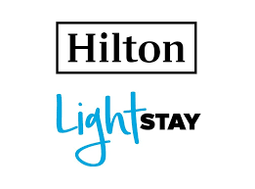
Figure 2: Lightstay program by Hilton
(Source: gstcouncil.org, 2023)
Recent reports demonstrated that Marriott remains determined to conserve energy. For instance, in its 2023 sustainability report, Marriott proposed a commitment to the goal of cutting carbon intensity by 30 per cent by the end of 2025, which is evidence of the company’s aspirations in the sphere of energy management (marriott.com, 2024).
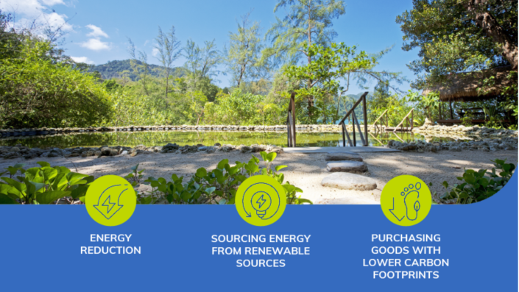
Figure 3: Strategies to reduce carbon footprint by Marriott
(Source: gtm.uk.com, 2024)

2.2 Analysis of the benefits of the energy efficiency programs
The application of energy-efficient programs has become an integral portion of the operations of Marriott International. This has played a pivotal role in the conservation of resources and the reduction of the carbon footprint (Jones and Comfort, 2019). By assessing the role of greener practices and energy conservation in making the guests satisfied, the hotel has gained a reputation across the globe over a long period of time.
The energy efficiency initiatives adopted by Marriott International have caused the optimisation of the consumption of resources across all the properties. Through the application of innovative and advanced energy conservation tools and mechanisms, the hotel has been successful in terms of reducing the overall consumption of energy over the years (Eschenbrenner et al., 2023). As per the reports, the goal set by Marriott to cut the carbon footprint by 2025 by 30% demonstrates the ambitions that they have for achieving energy efficiency.
Conservation of water has also been emphasised by Marriott. Different water saving technologies have been integrated by Marriott International. As per reports, a 25% reduction in the water intensity has been achieved in 2022 as compared to 2016 (Sarode, 2022). This also demonstrates the hotel's commitment towards conservation of resources.
The energy efficiency programs of Marriott International are directly proportional to the reduction of the carbon footprint of the company. The application of renewable energy sources has been instrumental in conserving energy. For instance, Marriott International 2021 said it is committed to making 100% of its properties derive their energy from renewable sources by 2025 (Abou Amer et al. 2023). This commitment also evidences the company’s adherence to the climate change initiatives being pursued around the world as well as advancing towards positioning the company’s vision as a leading sustainable hospitality business.
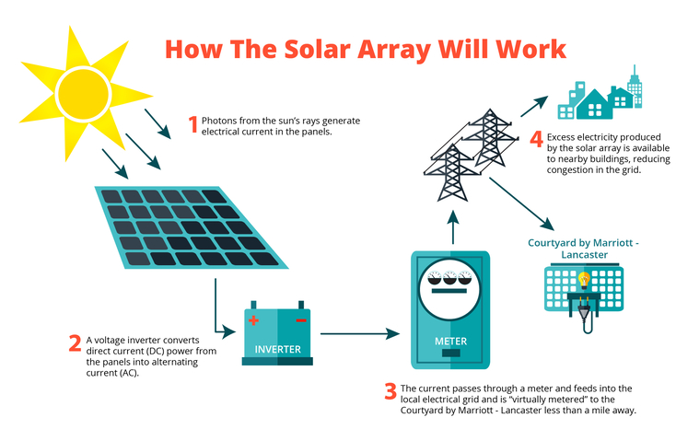
Figure 4: Application of Renewable energy in Marriott
(Source: hospitalitytech.com, 2024)
Energy-efficient technology helps to lower even further the greenhouse gas emissions related to hotel operations. According to Cingoski and Petrevska (2018), hotels implementing energy-efficient policies might save carbon emissions by up to 50%. Marriott's major contribution to world sustainability initiatives is shown by the prevention of millions of metric tons of carbon dioxide emissions resulting from its application of energy-efficient policies throughout its worldwide portfolio.
Operational efficiency has also been observed to be improved through the application of energy efficiency initiatives. One of the key initiatives has been the “Marriott Sustainability and Social Impact Platform”, and this has caused different energy-effective HVAC systems to be installed across different properties under Marriott International across the globe (hospitalitynet.org, 2023).
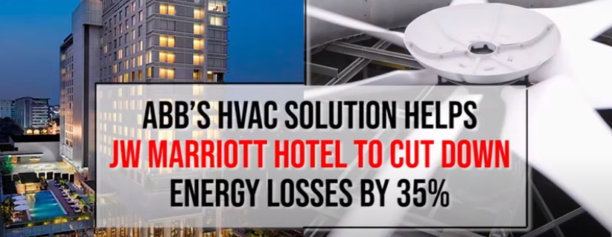
Figure 5: Application of HVAC for energy conservation in Marriott
(Source: new.abb.com, 2022)
Marriott has also inclined towards intensive application of the Smart Building technologies. For example, they have implemented automatic lighting systems and smart thermostats that maximize energy use according to occupancy, greatly reducing wasteful consumption (Abdelmoaty and Soliman, 2020). The collaboration of Marriott with ClearSky has assisted them in acquiring a tool that is responsible for monitoring energy usage, and thus, the utility expenses have been able to be reduced.
As per 2023 reports, Marriott has achieved significant savings due to the application of energy-saving measures. For example, by installing energy-saving equipment across all the European properties, Marriott was able to achieve a reduced consumption of energy by 10%, which assisted in saving millions of dollars annually (prnewswire.com, 2023a). It has also been observed that Marriott’s energy consumption has reduced by up to 30% per square meter since the initiation of the more comprehensive range of energy-efficient practices.
These initiatives not only increase operational efficiency by means of cost control but also strengthen the environmental sustainability of the brand, therefore complementing growing customer demand for environmentally friendly procedures (prnewswire.com, 2023b). Reducing energy-related costs has allowed Marriott to reinvest the savings into guest services and other technical enhancements, thereby building a competitive edge in the market.

2.3 Analysis of Challenges associated with implementation
Initial Cost and Investment
There are large initial costs when it comes to applying energy efficiency measures at Marriott International, specifically where acquiring properties with new technologies and upgrading its older buildings are required to be considered. Marriott’s transition towards sustainable operations entails expenditure on energy efficient lighting installations as well as “Heating, Ventilation, and Air Condition (HVAC) systems” and smart building infrastructure (Nocera et al. 2019). For example, making the properties through energy-efficient systems requires an expenditure of approximately “$1 million” per property, depending on the location and size of the property. Although these technologies allow the operation of the hotel to be sustainable, financial success remains a major concern in areas with lower margins of profit. As per one of the reports, the investment in the installation of solar panels with hotels is approximately “$250,000”, which is huge (Cingoski and Petrevska, 2018).
Staff Training and Management
Training of the staff plays a pivotal role in terms of making the energy efficient systems to be applied effectively. Training of the staff can also be expensive, because it requires constant training courses and obtaining new certifications. Additionally, there is the need to get management commitment as managers must understand sustainability and support it over the long term. Without proper leadership and support from the upper management, the application of green initiatives may be unsuccessful. As per one of the reports by Marriott’s sustainability team, the “Serve 360” strategy was effective due to support from the executive teams and thus was aligned with the overall operational goals (serve360.marriott.com, 2023).
Cost-effectiveness and Realism
Energy-efficient solutions might have a high initial cost, but these costs are frequently compensated over time by long-term cost reductions (Warne and Thompson, 2022). Over time, energy-efficient buildings can result in significant savings by lowering operating expenses by up to 25%. According to Blanchard et al. (2024), hotels that made energy-efficient technology investments experienced a return on investment (ROI) in three to five years, mostly due to lower power bills. However, Marriott's capacity to adjust to changing environmental rules, frequent technology improvements, and regular maintenance will determine the long-term success of these programs. Achieving cost-effectiveness may be less achievable in areas with less favourable energy policies, thereby creating more difficulties for application.

2.4 Analysis of benefits for the environment
The energy efficiency initiatives of Marriott have caused the greenhouse gas emission to be reduced. As per the sustainability report of 2023, a 30% reduction per square meter energy intensity reduction was achieved by the hotel across all the properties. This reduction has caused the CO2 emission to be reduced, which has allowed them to move forward towards their commitment of reducing emissions by 30% by 2025 (En-in.ecolab.com, 2023a).
Different benefits are being received by the environment due to reduced consumption of energy. Reduced energy consumption results in decreased emissions of adverse gasses, including nitrogen oxides and sulfur dioxide, that are known to have detrimental impacts on air quality and wildlife. Furthermore, the utilization of renewable energy sources by Marriott also decreases the pressure on the depletion of non-renewable resources and decreases in the destruction of habitats associated with fossil fuel exploration (En-in.ecolab.com, 2023b). Through the application of renewable energy sources, Marriott has been successful in terms of reducing its environmental footprint and thus contributing to a cleaner and healthier ecosystem.

3.0 Recommendations
Marriott may improve its sustainability initiatives by growing the usage of renewable energy sources and widening energy efficiency programs including smart energy management systems all around its buildings. Establishing quantifiable environmental targets such as net-zero carbon emissions by 2030 would compel responsibility. Marriott might also include visitors by encouraging environmentally beneficial behaviours such cutting water consumption, running towel and linen reuse programs, and providing rewards for sustainable choices. Including sustainability instructional resources in guest rooms and common spaces would also increase awareness among visitors and inspire more ecologically sensitive behaviour.

4.0 Conclusion
It has been inferred that Marriott International's energy efficiency initiatives show a great dedication to sustainability, therefore enhancing the operational effectiveness of the business as well as the surroundings. Marriott has greatly lowered its carbon footprint and energy usage by implementing smart building technology, renewable energy sources, and advanced energy management systems. These green projects not only help to preserve natural resources but also fit Marriott's brand image and competitive advantage as customer demand for environmentally friendly hotels is rising. Although there are significant upfront costs and employee training requirements associated with implementing energy-efficient technology, the long-term advantages exceed the drawbacks. By using less energy, Marriott has already seen cost savings and operational advantages that enable investments in other business divisions. Furthermore, the environmental benefits, like the decrease in greenhouse gas emissions and the preservation of resources, showcase Marriott's contribution to the advancement of global sustainability. The report has thus been successful in terms of demonstrating the green practices being integrated by Marriott, and recommendations have also been provided to improve the strategies and initiatives to make the success long-term.

Reference List
Abdelmoaty, G.A. and Soliman, S.A.E.M., 2020. Smart Technology Applications in Tourism and Hospitality Industry of The New Administrative Capital, Egypt. Journal of Association of Arab Universities for Tourism and Hospitality, 19(2), pp.102-129.
Abou Amer, A., Mohamad, D. and Roosli, R., 2023. The Impact of Green Energy & Water Practices on the Development of Sustainable Tourism: A Case Study of 5-Star Hotels in Hurghada and Mecca. Planning Malaysia, 21.
Blanchard, L., Ray, S., Law, C., Vega-Sala, M.J., Bidonde, J., Bridge, G., Egan, M., Petticrew, M., Rutter, H. and Knai, C., 2024. The effectiveness, cost-effectiveness and policy processes of regulatory, voluntary and partnership policies to improve food environments: an evidence synthesis. Public Health Research, 12(8), pp.1-173.
Cingoski, V. and Petrevska, B., 2018. Making hotels more energy efficient: the managerial perception. Economic research-Ekonomska istraživanja, 31(1), pp.87-101.
Cingoski, V. and Petrevska, B., 2018. Making hotels more energy efficient: the managerial perception. Economic research-Ekonomska istraživanja, 31(1), pp.87-101.
En-in.ecolab.com, 2023, Marriott: Sustainability Goals for 2025 and Beyond [Accessed from: https://en-in.ecolab.com/stories/marriott-sustainability-goals-for-2025-and-beyond#:~:text=Marriott%20has%20ambitious%202025%20sustainability,to%20landfill%20by%2045%20percent] [Accessed on: 14.10.2024]
Eschenbrenner, B., Zlatic, A., Bechtel, M., Collins, B., Straley, C. and Gubbels, G., 2023. Marriott International: A Managerial Strategic Audit.
Fernández-Robin, C., Celemín-Pedroche, M.S., Santander-Astorga, P. and Alonso-Almeida, M.D.M., 2019. Green practices in hospitality: A contingency approach. Sustainability, 11(13), p.3737.
Foster, D., Ricaurte, E. and Farrar, L., 2019. Calculating Hotel Industry Impact: The Case of Hilton Lightstay.
gstcouncil.org, 2023, Hilton LightStay Standard is Now a GSTC-Recognized Standard [Accessed from: https://www.gstcouncil.org/hilton-lightstay-gstc-recognized-standard/] [Accessed on: 15.10.2024]
gtm.uk.com, 2024, Charting a greener future: Marriott’s path to net-zero emissions [Accessed from: https://gtm.uk.com/charting-a-greener-future-marriotts-path-to-net-zero-emissions/] [Accessed on: 13.10.2024]
hospitalitynet.org, 2023, Improving Hotels' Operation Efficiency: A Data-Based Process Optimization Approach [Accessed from: https://www.hospitalitynet.org/opinion/4120252.html] [Accessed on: 15.10.2024]
hospitalitytech.com, 2024, First Marriott Property to Be 100% Solar Powered Now Operational [Accessed from: https://hospitalitytech.com/first-marriott-property-be-100-solar-powered-now-operational] [Accessed on: 14.10.2024]
Jones, P. and Comfort, D., 2019. Sustainable development goals and the world’s leading hotel groups. Athens Journal of Tourism, 6(1), pp.1-14.
marriott.com, 2024, Marriott Sustainability Goals by 2025 [Accessed from: https://www.marriott.com/content/dam/marriott-digital/si/us-canada/hws/d/dends/en_us/document/assets/si-dends-dends-sustainabilty-flyer-37673.pdf] [Accessed on: 14.10.2024]
marriott.com, 2024, We Are Marriott International [Accessed from: https://www.marriott.com/marriott/aboutmarriott.mi] [Accessed on: 14.10.2024]
new.abb.com, 2022, ABB’s HVAC solution helps JW Marriott Hotel to cut down energy losses by 35% [Accessed from: https://new.abb.com/news/detail/87127/abbs-hvac-solution-helps-jw-marriott-hotel-to-cut-down-energy-losses-by-35] [Accessed on: 13.10.2024]
Ningsih, P.S.A.P., 2024. Implementation of Green Action in an Effort to Support Environmental Awareness in the Food and Beverage Department at the Bloomington Normal Marriott Hotel & Conference Center (Doctoral dissertation, Politeknik Negeri Bali).
Nocera, F., Giuffrida, S., Trovato, M.R. and Gagliano, A., 2019. Energy and new economic approach for nearly zero energy hotels. Entropy, 21(7), p.639.
Pham, N.T., Tučková, Z. and Jabbour, C.J.C., 2019. Greening the hospitality industry: How do green human resource management practices influence organizational citizenship behaviour in hotels? A mixed-methods study. Tourism management, 72, pp.386-399.
prnewswire.com, 2023, Marriott International Announces Ambition To Go Net-Zero [Accessed from: https://www.prnewswire.com/news-releases/marriott-international-announces-ambition-to-go-net-zero-301382602.html] [Accessed on: 13.10.2024]
Sanvitale, A.L., 2020. Corporate Social Responsibility in the Hotel Industry: A Study of Marriott International and Odyssey Hotel Group.
Sarode, M.A., 2022. Start-Up Hotels And Environment Sustainability-Benefits And Strategy. Journal of Positive School Psychology, pp.12041-12044.
serve360.marriott.com, 2023, Environmental, Social, and Governance Progress [Accessed from: https://serve360.marriott.com/wp-content/uploads/2023/06/Marriott-2023-Serve-360-ESG-Report-accessible.pdf] [Accessed on: 14.10.2024]
statista.com, 2023, Revenue of Marriott International worldwide from 1999 to 2023 [Accessed from: https://www.statista.com/statistics/266279/revenue-of-the-marriott-international-inc-hotel-chain/] [Accessed on: 15.10.2024]
Warne, S.J. and Thompson, M., 2022. Future approaches to evaluating tourism in the developing world: Assessing realism in the Solomon Islands. Journal of Hospitality and Tourism Management, 50, pp.391-399.

