Student Name: | Daniela Florentina Haraga
Student Number: | 1806476
Module No: | BMSW5106_LON
Module Title: | Knowledge and Information Management Skills for the Workplace
Lecturer: | Mohamed Kalam

KNOWLEDGE AND INFORMATION MANAGEMENT SKILLS FOR THE WORKPLACE

Executive Summary
The study claims to identify the case of Sainsbury in managingknowledgeassets to benefit their business in achieving goals and objectives. Taking into account the perception of knowledge assets of Sainsbury retail business, there have been identified four categories on the basis of which the company manages their knowledge assets to favour their decision making. Aligning the business practices regarding knowledge management and other aspects of business by Sainsbury organisation in the UK market to that with the intellectual property rights it could be stated that the company plans to achieve objectives through these legal perspectives. In other words, the major purpose of the intellectual property right lies in the fact that it enables the company to stimulate creativity and retain their uniqueness in the market by addressing their customers with relevant products and services. This study would provide the categorisation of knowledge as on the basis of their actual and potential nature.

Table of Contents
Introduction 5
Company background 5
Explanation of the relationship between data, information and knowledge 5
Explanation between organisational knowledge and individual knowledge 7
Application of analysis and modelling techniques for identification of knowledge assets 8
Evaluation of actual and potential knowledge assets 16
Requirement for the creation, storage, application and integration of knowledge 17
Importance of intellectual property rights 20
Contribution of knowledge assets over Sainsbury’s 22
Evaluation of knowledge requirements for Sainsbury’s 23
Enabling knowledge sharing within Sainsbury’s organisational framework 24
Recommendations for improving current framework 26
Conclusion 28
References 29

Introduction
Developing an organisation from its basic stage to its evolved state requires appropriate application of knowledge skills by the business development managers that enables achievements of goalsand objectives effectively. This indicates that, the application of knowledge to develop strategic measures in mitigating business barriers in the competitive global market is a necessary constraint that is to be adopted by the organisations to attain sustainable position in the market. The significance behind considering knowledge management assets as managing criteria henceforth provides evidential justifications regardingdevelopment of businesssuccesses through accusations of apocopate decision making. The study claims to identify the importance of knowledge management and its contribution in favour of the company, Sainsbury’s in the market of UK. Additionally, the study would also provide a deep understanding of how the knowledge management assetshelps the organisational executives to take relevantdecisions regarding development of their business using a framework.

Company background
Sainsbury’s has been identified to be a retail based organisation that deals with the sales and marketing of supermarket items, specialised in groceriesin the UK. The popularity of the company has reframed from a significant stage to a preferable one from the customer’s perspective due to their effectiveunderstanding of customer satisfaction criteria and reflecting them through their products and services. The average annual revenue growth as per the records of last year has been recorded to be 28m GBPdue to their high sales and productivity (statista.com, 2020).

Explanation of the relationship between data, information and knowledge
In this modern era, every operations that are executed in the world of business are highly dependent upon how data, information and knowledge is utilised by an organisation to achieve goals and objectives. For this purpose, it is necessary to gain in depth understanding of the differences and similarities that resides within data, information and knowledge.As per the views by Cooper (2017), data is considered as a single element concept that describes its nature as a factual representation of a unit information. However, the direct application of data from its raw state is not possible due to its abrupt meaning. For this purpose, the analysis of this data bit is necessary usingappropriatetechniques such that it is converted into informative content.Hence, information can be stated to be a representation of data from its raw state to a meaningful state such that it provides significant applicability to real life concepts.
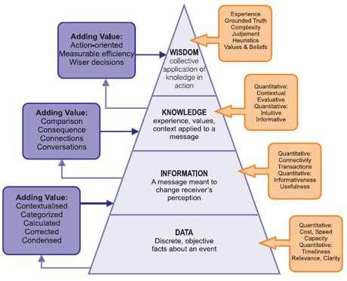
Figure 1: Relation between data, information and knowledge
(Source: Influenced by Cooper, 2017)
Understanding the relationship between data, information and knowledgerequires an individual to go through the nature of these three constrains with respect to reallife aspects. This is because, it provides withy an applicableunderstanding of how these three assets of accusation process provides enunciated concepts to support analysis of issues and addressing them with relevant solutions (Zaimet al., 2019). For instance, data resembles towards the basis of information which is constituted in a raw format with indicative contents within it. In this scenario, the data is concerted into relevant and meaningful information by applying analysistechniques over it. However, Nguyen (2020) stated that knowledge provides an in-depthconcept of data and information where, the appropriate application of information to achieve goals and objectives are attained. In other words, knowledgeprovides a summativeapplication of information in context to real life experiences that are encountered on a daily basis by an individual. With the help of knowledge, these situations are analysed and related solutions to deal with it are evaluated.

Explanation between organisational knowledge and individual knowledge
Knowledge can be categorised into various types depending upon their nature of application as well as their wide understanding. As opined by Khvatovaet al., (2016), researchers all over the world has identified knowledge bases on the basis of their applicability for which they have did used two categories indicating individual knowledge and organisational knowledge. On the other hand, Nguyen (2020) opined that organisational knowledge entangles group development where the decisions of a group of individuals are encountered and a relevant solution is deduced. In other words, knowledge that constitutes sharing of information from an individual to another to enhance and informative environment could be termed as organisational knowledge.

Application of analysis and modelling techniques for identification of knowledge assets
Knowledge assets are considered as influencing factors that enables and individual to gain a perspective of the information content from which knowledge is being derived. In other words,Zaim et al., (2019) stated that the sources of knowledge are important to be acknowledged so as to gain a perception of what outcomes that knowledge would pertain with itself. In the case of Sainsbury’s, the business executives belonging under the retail sector are required to identify which knowledge assets for taking their business benefits and thereby address them with appropriate decisions to boost their performance.
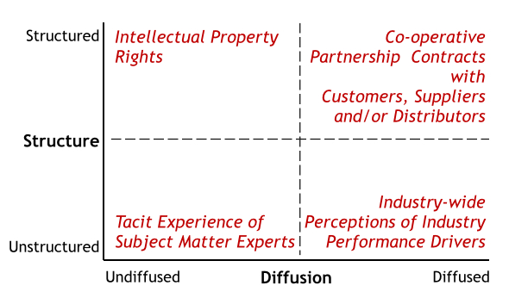
Figure 2: knowledge asset identification
(Source: Influenced by Shujahatet al., 2019)
One of the most common knowledge assets that has been identified for organisations are the performance critical knowledge asset. Through this identification, the strength of a company is idealized in the form of a structural and functional unit with a brief description about the operations that are executed within their workplace environment (Mahdi et al., 2019).Sainsbury’s has been identified to apply AI and knowledge management Framework that enables them to identify their current assets through which the progress their business operations in meeting their prescribed goals and objectives.
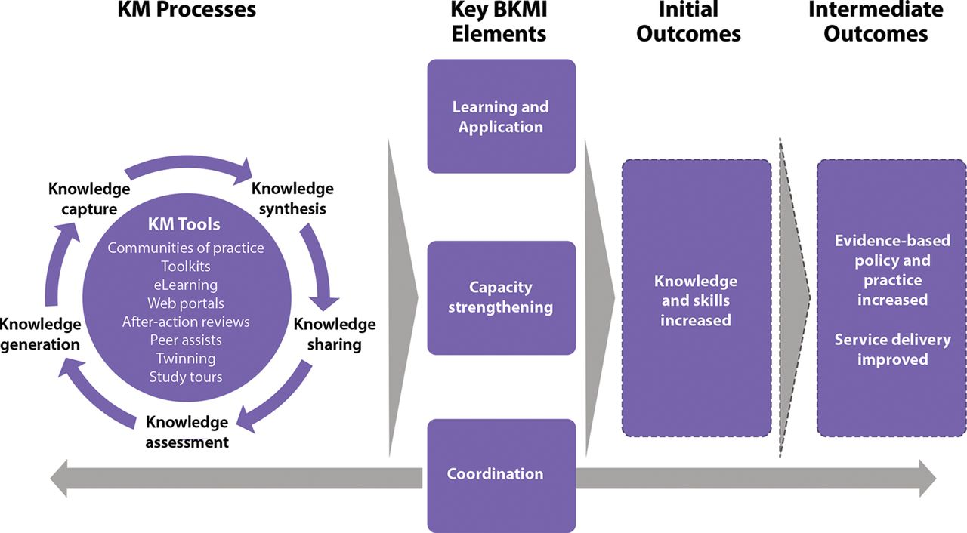
Figure 3: Knowledge asset identification model
(Source: Influenced by Shujahatet al., 2019)
The above diagrammatic representation of the knowledge management processes has been kept aligned with the knowledge Assets and its relevant outcomes upon having appropriate decision making. In other words, Shujahatet al., (2019) stated that knowledge management processes incurs the creation, storage and application of information that enables an organisation to achieve their goals and objectives through decision making. These decisions are directly and with the organisational processes that helps innovating their product as well has influence individual and organisational learning simultaneously. Having these criterions maintained immediate outcomes are expected to be achieved that would benefit the organisation in improving their performances.
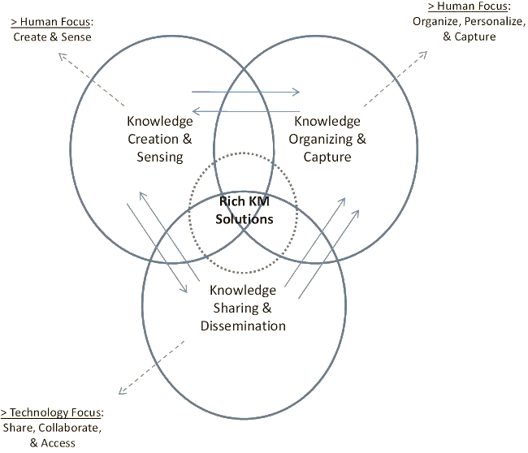
Figure 4: Knowledge management solutions
(Source: Influenced by Khvatovaet al., 2016)
One of the most commonly applied knowledge management model is the reach knowledge Management Solutions. As opined by Nguyen (2020), with the help of this model and Organisation is able to focus on three broad categories of business development with a mere interrelationship with each other. Aligning this model with that of Sainsbury's, knowledge creation and sensing implies how the employees of the company is able to deduce solution by replying relevant decisions using organisational knowledge. On the other hand, Khvatovaet al., (2016) exclaimed that knowledge organising and capture pertains how the organisational knowledge entangle business operations with a human focus nature of personalizing goals and objectives. Finally, the Technologies that are possessed by Sainsbury are aligned so that knowledge dissemination is attend accurately providing relevant outcomes.However there lies are disadvantages feature of applying this modular representation as it pertains a human focus rather than Automations. In other words, Hollands and Escueta(2020) claimed that the application of modern IT technologies to influence decision-making has often observed to provide relevant as well as accurate outcomes within short amount of times. This indicates that are reduction of the time constraint is attained using other technical models rather than this human forecast model.
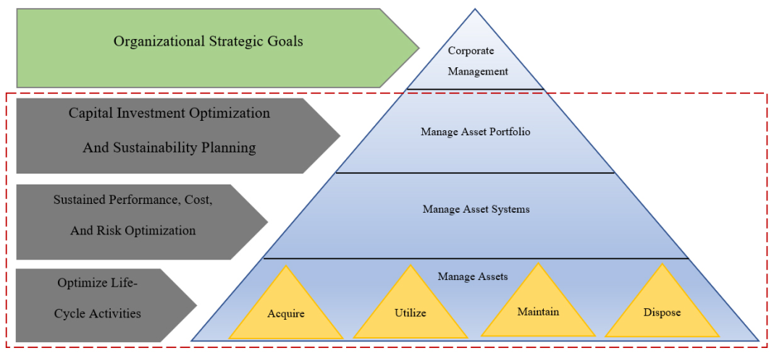
Figure 5: Knowledge asset management model
(Source: Influenced by Al Hakim and Sensuse, 2018)
K-Map Model of knowledge asset identification
The K map model of knowledge asset identification provide the hierarchical mechanism through which a flow of operations is followed by the organisation in order to evaluate and measure the affectivityof asset in relation to the performance metrics. As per Al Hakim and Sensuse(2018), this model indicates the sources of knowledge and represent it in the form of a mapping to the business processes that are executed by an organisation.
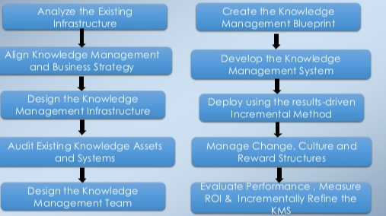
Figure 6: K-Map model of knowledge asset identification
(Source: Influenced by Al Hakim and Sensuse, 2018)
The above depicted figure illustrate the flow of knowledge Asset Management and identification using a flow diagram to provide a sequential perception off the modular implementation. Deriving from the illustration, it could be stated that the existing knowledge that is perceived by Sainsbury would be applied to develop their infrastructure so as to obtain results that would benefit changes within their organisation perspective.
Asset management model
The Asset Management model is a a four way planning procedure that is applied by organisations to gain effectiveness in business processes through their leadership and cultural aspect. According to Tran et al., (2018), using this model organisations have been observed to be able to identify their main focus and their strengths which could be applied by the leaders of the organisation to develop their cultural aspects. This would require the organisation to acknowledge about the learning mechanism and their level of Assurance in providing benefits.
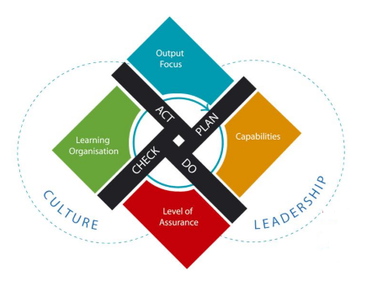
Figure 7: Asset management model
(Source: Influenced by Tran et al., 2018)
In the case of science be organisation the application of Asset Management model would help them to to progress through a sequential procedure that would enable planning and applying knowledge to gain benefits of success.

Evaluation of actual and potential knowledge assets
Categorising knowledge Assets on the basis of their performance ability and every application by organisation to benefit their growth have been observed with the two major perspectives undertaken by Business executive. In other words knowledge assets that pertains performance boost to an organisation are indicated to be potential knowledge assets. On the other hand, Natalicchioet al., (2017) stated that actual knowledge assets determine every possible knowledge base that an organisation possesses as a benefit towards their business. Considering the case of Sainsbury organisation actual knowledge assets have been identified to be the stakeholders and structural units that the company possesses to manage their overall business operations. Similarly the potential knowledge assets that are possessed by Sainsbury complying their business performance have been identified to be processes products technologies and there are currently executable market.
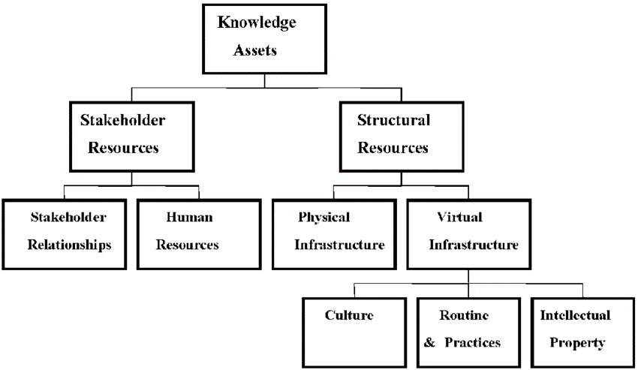
Figure 9: Knowledge asset categorisation
(Source: Influenced by Young et al., 2016)
The above figure provides a structural representation of the knowledge acids that are possessed by Sainsbury in favour of their business. This knowledge categorisations have been performed on the basis of the relationship between stakeholders and the employees of the organisation. Having acknowledgement about the interest of the stakeholders as well as the internal organisation structure Sainsbury is expected to meet their desired goals and objectives through their business operations maintaining a stable growth.
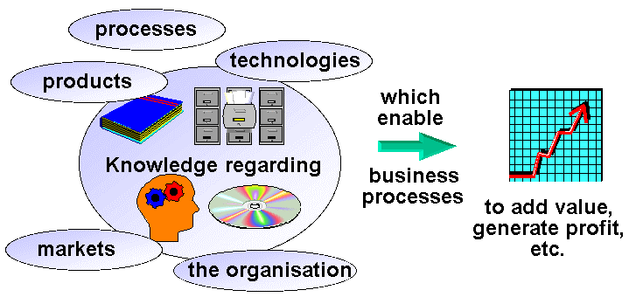
Figure 10: Potential knowledge assets
(Source:Influenced by Young et al., 2016)
It is important for an organisation to pertain potential knowledge asset along with the actual knowledge assets. As exclaimed by Young et al., (2016), this is because potential knowledge as it provides a boost to the performance metrics of an organisation to their production services satisfying their customers. Similarly, Sainsbury possesses potential knowledge acid that provide them with an opportunity to benefit regarding profit generation and annual revenue growth. This is attained by managing knowledge that are address towards their daily processes and performances. Henceforth, Fang et al., (2018) concluded that it is evident that the decisions that are made on a regular basis by the business executive determines how effective the productivity of the organisation would be aligning their employee performances. The database that is possessed by the organisation comprises of information related to their business services that they offer to their customer. In this way, managing database with appropriate IT technologies help them to extract relevant information from it and thereby make decisions to benefit their business.

Requirement for the creation, storage, application and integration of knowledge
In an organisation, the aspect of knowledge management and decision making is the crucial factor for the enhancement of the organisation. As opined by, Bellet al., (2016) the aspect of decision making can be enhanced by the implementation of appropriate framework on knowledge management in order to gain positive responses from the customers. In Sainsbury, the management team implement the knowledge-based decision-making approach in order to make the strategic and effective decision by establishing a complete throughout process and reasoning behind the decision. In addition to this, knowledge management is a process that deals with initiation, planning, execution, controlling and closer (Noret al., 2020). The main purpose of the specification requirement for knowledge management is to incorporate the different ideas for creation, storing, application and integration of knowledge for Sainsbury to enhance their market position in the competitive world.
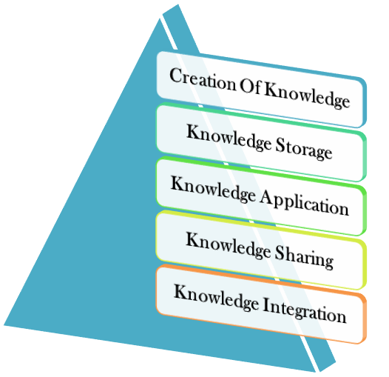
Figure 11: Specification of knowledge requirement
(Source: Influenced by Noret al., 2020)
The specification to create, store, apply and integration of the knowledge is as follows:
Creation of knowledge
It is quite general that knowledge never be created never be destroyed because it is one of the innovative thought that has been emerging from the individual mind. According to, Kuulaet al., (2018) the overall aspect of the creation of knowledge mainly deals with the process of conversion of information from a real-life application through an understanding of individual knowledge. In Sainsbury, the management team is intended to create knowledge in order to relate their particular decision-making strategies that have been developed within the organisation to enhance their business position in the market (Janiszewskiet al., 2016). It can be stated that with the help of knowledge creation the organisation can able to implement the proper decision and align with them with the high level of employee job satisfaction.
Knowledge storage
The storage of knowledge can be performed with the help of collecting different types of ideas and thought for the specific topic. On the other hand, Afridiet al., (2019) have mentioned that knowledge can be reflected with the help of application and it cannot be store in an abrupt manner. The knowledge can be store with the help of documented form and that help the business to determine their business needs and requirement. The storage of knowledge is one of the significant criteria that have been applied appropriately in order to align the organisation decision-making process. In Sainsbury, the management team implement the aspect of knowledge storage in order to execute their business in a sophisticated manner (Nouwenset al., 2017). It has been observed that based on the knowledge storage the organisation can able to determine the exact requirement of clients and customer from their organisation. Therefore with the help of appropriate analysis, the organisation can able to deploy the necessary strategies to enhance their business position in the competitive world.
Knowledge application
Application of knowledge is one of the important aspects because it mainly shed light on the usability of the data and information for the benefits. As per the viewpoint of, Odeand Ayavoo (2020) the knowledge application is related to the determination of changes required for the organisation in order to gain positive responses. In Sainsbury, the management team of organisation implement the necessary application of knowledge in order to evaluate their ongoing issues from the business. it can be stated that with the proper implementation of knowledge application the organisation can able to fulfil their lagging areas with the help of the different type of knowledge management strategies to enhance their decision-making process(Bagarukayoet al.,2016).
Knowledge integration
The integration of Knowledge is basically related to the platform that making the change with the relevance to the business. According to, Salunkeet al., (2019) in knowledge integration the organisation collect the necessary data and information in order to determine the current trend from the market. The knowledge integration for Sainsbury is one of the essential parts because it helped them to maintain their business decision-making strategies. The aspect of knowledge integration solely depends on the procurement of business for the organisation and it has been improved on the basis of collected information that would help the management team to transform the information into the knowledge.

Importance of intellectual property rights
Intellectual Property Rights is considered as a legislative measure that indicates how the information of an organisation are managed utilised and applied maintaining privacy concerns appropriately. In other words intellectual property rights are categorised into several sections based on their standard of of agreement. As per the views by Davoudi et al., (2018), Intellectual Property Rights define how an organisation poses restrictions over their data and information such that no unauthorised access others are able to gain control of the data and manipulate it accordingly. In the case of Sainsbury, the company provides its Trade Mark over their purchases that are made by the the customers through their online website and offline stores. Additionally, the purchases that are made by the customers are recorded in the database of the organisation for or their business development. This particular attribute requires Sainsbury to maintain the guidelines that are han provided under the data Protection Act 2018 of the UK legislation (legislation.gov.uk, 2020). Through this measure the company would be responsible for any loss that is encountered against the customer data apart from their business development purposes.Hence it could be concluded that no other alternative organisations would be able to imitate the products and services that are produced by Sainsbury in favour of their customers and thereby help them in reducing the competitive rates in the market
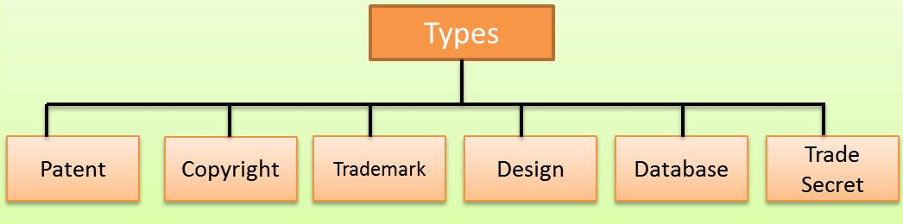
Figure 12: Constraints of intellectual property rights
(Source: Influenced by Davoudi et al., 2018)

Contribution of knowledge assets over Sainsbury’s
In organisation knowledge assets mainly contribute in managing the daily operational activities within the organisation internal environment. According to Linet al., (2018), the term knowledge assets mainly refer to the accumulation of the intellectual resources for the organisation. The contribution of knowledge is important because it helps the organisation to manage their customer satisfaction rate from the market and also plays an essential role in managing the employee’s performances and also the aspects of decision making. For instance, in Sainsbury, the organisation is going to implement the decision-making strategies in order to resolve the issues related to the enhancement of the organisation competitive position (Gunjal, 2019). In that situation, the contribution of knowledge along with its knowledge is required because it provides different types of skills and expertise and networks in order to evaluate the issues and agenda in depth.It can be stated that it is the responsibility of the organisation management team that they need to perform the in-depth analysis and motivate other employees for their essential contribution. In fact, with the help of contribution in knowledge assets for the organisation the administrative team of the organisation can capable to enhance the business possessions and extract the exact requirement to maintain the business needs and requirement of behalf of the customers.

Evaluation of knowledge requirements for Sainsbury’s
In the modern world, knowledge management us the practices and strategies that have been implemented in the organisation to represent, create, identify, distribute and enable the adaptation of the knowledge. As opined by Pennet al., (2018), in an organisation knowledge is required to innovate the new strategies in order to gain a positive outcome from the business. In Sainsbury, the requirement of knowledge is related to the implementation of the appropriate decision for the business so that the organisation can capable to enhance their business position in the competitive market. It has been observed that with the appropriate gathering of knowledge the organisation can capable to depict on the solution for the issues that have been faced by the management team in recent days. On the other hand, Walburnet al., (2019) have mentioned that with the proper evaluation of knowledge the organisation can also able to determine the skills and knowledge of the employees. Additionally, it can be stated that with the appropriate motivation and strategies the organisation, Sainsbury can capable to fetch appropriate ideas from their employees and implement the same for the resolving the issues from their business and established their footprint in the competitive market.

Enabling knowledge sharing within Sainsbury’s organisational framework
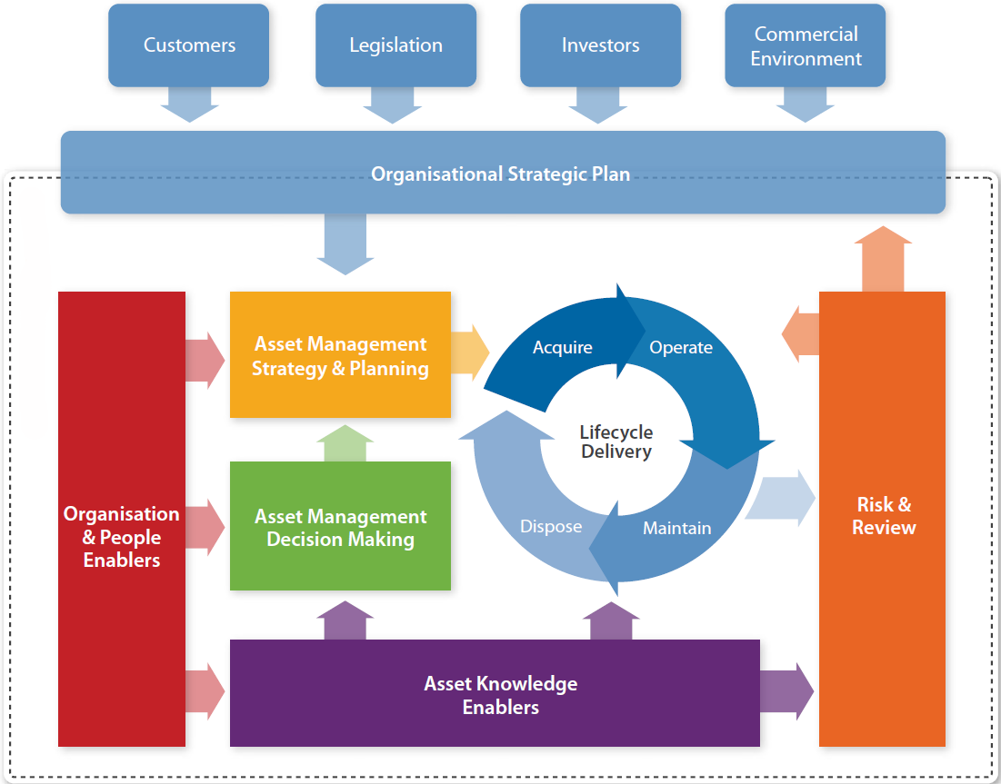
Figure 13: knowledge sharing framework of Sainsbury
(Source: Sainsburys.co.uk, 2020)
Knowledge sharing is an important and major criterion that is evaluated by organisations in order to influence and convert individual knowledge to organisational knowledge. In other words, Maaget al., (2018) stated that knowledge possessed by an individual often helps to self-develop their capabilities in achieving their regular goals and objectives. This knowledge when exposed to a group of individuals is expected to boost the performance of an organisation at a higher extent from that of its initial stage. However, Campbell and Renshaw(2018) opined that evaluating this requires an organisation to poses a Framework through which a structural and functional flow of operation would be e directed. Sainsbury organisation constitutes of a knowledge sharing Framework that enables communication between individuals and in teams through several processes that interlinked their regular activities.
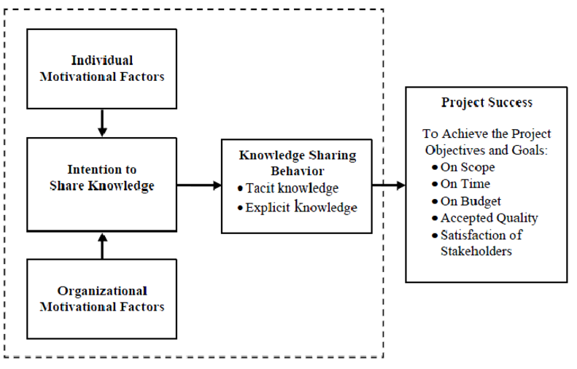
Figure 14: Knowledge sharing framework
(Source; influenced by Rezaeiet al., 2016)
- Motivation and dedication factors: Motivational factors considered as one of the deriving metrics that enables Sainsbury to achieve their pre-established goals and objectives. In other words,Kuranchie-Mensah and Amponsah-Tawiah(2016) stated that the motivation of the employees are directly connected with their productivity for which the results of the regular activities are attained at higher accuracy and mobility. Henceforth the individual knowledge that is utilised by the company entangled with the organisational knowledge to benefit motivational factors of the employees to dedicate themselves to us there daily tasks
- Intention to share knowledge:Knowledge needs to be shared using the Framework that has been depicted in the above figure relating Sainsbury’s business. This is because upon having a shared knowledge environment of the workplace options bury their employees would be able to gain acknowledgement regarding several tasks and their associated solutions. With this evaluation the productivity of the employees would eventually increase in the decision-making credibility would be enhanced (Oyewobiet al., 2016).

Recommendations for improving current framework
The present executable framework that is used by Sainsbury to evaluate their business operations have been observed to provide them with relevant support and stability in maintaining annual profit statements. In other words, Sainsbury has been observed to satisfy their customers by providing them with the necessary products they need as their regular requirements by analysing the current market trendsandimplanting them within their organisational framework. The above discussed organisational framework of Sainsbury has been provided aligning their business concepts with that of the functional units that clarifies how the knowledge of the employees are utilised to execute busies operations. However,Duanmuet al., (2018)stated that the recent increase in the competitive rates in the market have led them to face issues regarding decision making of their production procedures. For this purpose, the companyexecutives have planned to update their current management framework with latest and beneficial improvements so as to boost their current performance metrics.
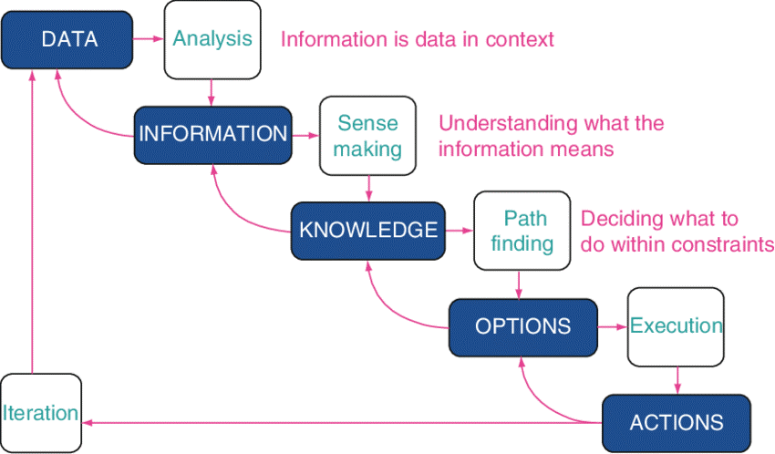
Figure 15: Revised framework of Sainsbury’s knowledge sharing and development
(Source: Influenced by Nguyen, 2020)
The above depicted hierarchical flow of procedure enables simple understanding of the procedures that are evaluated by Sainsbury’s to provide product that are relevant to customer needs. The framework has been developed concentrating on the knowledge assets that are possessed by Sainsbury’s as there major database information.
- Prior to the development of a product Sainsbury would require to perform market analysis that would help them gather data regarding the current Trends of the market
- Having the data collected from several valid sources in the market the company would now be required to analyse those data to extract informative content from it
- The information after being extracted would be required to transform into knowledge such that its applicability in the real life context would be entertained
- The selection of appropriate strategy or path would help the company to make relevant decisions regarding procedures to be applied in their marketing and sales operations
- Having decided about the necessary options that would be chosen for the application of knowledge would be followed by the actions taken by the company to benefit their business. In this way an iteration procedure would continue in a cyclic order such that the sustainability of the business would be maintained throughout its life cycle and relevant annual revenue growth would be attained.

Conclusion
Deriving conclusions from knowledge management aspect it could be stated that the necessary requirement of identifying the Assets of knowledge are important for an organisation to boost their performance in the competitive market. This indicates that Sainsbury would be required to implement a structural and functional Framework through which the execution of business practices would be enabled by applying factors of knowledge Asset Management. In this way the company is expected to maintain a balance in their products and services simultaneously with that of productivity of their employees. This is because knowledge management not only influences the decision making criteria of an organisation but also in the largest and improvement in the cultural aspect of the workplace environment. From the above discussion, it has been observed that the management team of Sainsbury are required to implement appropriate decision models and strategies to make their footprints in the competitive markets. The basic requirement for knowledge management has been entitled to the help of knowledge-based decision making. Knowledge-based decision making is a management approach for the overall process of decision making that implement the user predetermined criteria to evaluate and ensure the optimal overall outcome for the specific topic. Having this Criterion maintained the company is expected to meet the satisfactory needs of the customers through their products and services and thereby benefit them from achieving higher annual revenue growth and customer preferences.

References
Afridi, O., Gul, S. and Naeem, M., 2019. The Role of Management Practices of Higher Education Institutions in Knowledge Storage and Knowledge Accessibility. Journal of Management and Research, 6(1), pp.1-29.
Al Hakim, S. and Sensuse, D.I., 2018, September. Knowledge Mapping System Implementation in Knowledge Management: A Systematic Literature Review. In 2018 International Conference on Information Management and Technology (ICIMTech) (pp. 131-136). IEEE.
Bagarukayo, E., Ssentamu, P., Mayisela, T. and Brown, C., 2016. Activity Theory as a lens to understand how Facebook develops knowledge application skills. International Journal of Education and Development using ICT, 12(3).
Bell, L., Van Waveren, C.C. and Steyn, H., 2016. Knowledge-sharing within the project-based organisation: a knowledge-pull framework. South African Journal of Industrial Engineering, 27(4), pp.18-33.
Campbell, S.B. and Renshaw, K.D., 2018. Posttraumatic stress disorder and relationship functioning: A comprehensive review and organizational framework. Clinical psychology review, 65, pp.152-162.
Cooper, P., 2017. Data, information, knowledge and wisdom. Anaesthesia & Intensive Care Medicine, 18(1), pp.55-56.
Davoudi, S.M.M., Fartash, K., Zakirova, V.G., Belyalova, A.M., Kurbanov, R.A., Boiarchuk, A.V. and Sizova, Z.M., 2018. Testing the Mediating Role of Open Innovation on the Relationship between Intellectual Property Rights and Organizational Performance: A Case of Science and Technology Park. Eurasia Journal of Mathematics, Science and Technology Education, 14(4), pp.1359-1369.
Duanmu, J.L., Bu, M. and Pittman, R., 2018. Does market competition dampen environmental performance? Evidence from China. Strategic Management Journal, 39(11), pp.3006-3030.
Fang, L.Y., Azmi, N.F.M., Yahya, Y., Sarkan, H., Sjarif, N.N.A. and Chuprat, S., 2018. Mobile business intelligence acceptance model for organisational decision making. Bulletin of Electrical Engineering and Informatics, 7(4), pp.650-656.
Gunjal, B., 2019. Knowledge management: Why do we need it for corporates. Malaysian Journal of Library & Information Science (ISSN: 1394-6234).
Hollands, F. and Escueta, M., 2020. How research informs educational technology decision-making in higher education: the role of external research versus internal research. Educational Technology Research and Development, 68(1), pp.163-180.
Janiszewski, C., Labroo, A.A. and Rucker, D.D., 2016. A tutorial in consumer research: knowledge creation and knowledge appreciation in deductive-conceptual consumer research. Journal of Consumer Research, 43(2), pp.200-209.
Khvatova, T., Block, M., Zhukov, D. and Lesko, S., 2016. How to measure trust: the percolation model applied to intra-organisational knowledge sharing networks. Journal of Knowledge Management.
Kuranchie-Mensah, E.B. and Amponsah-Tawiah, K., 2016. Employee motivation and work performance: A comparative study of mining companies in Ghana. Journal of Industrial Engineering and Management (JIEM), 9(2), pp.255-309.
Kuula, S., Haapasalo, H. and Tolonen, A., 2018. Cost-efficient co-creation of knowledge intensive business services. Service business, 12(4), pp.779-808.
Legislation.gov.uk (2020). Data Protection Act 2018. Available at; https://www.legislation.gov.uk/ukpga/2018/12/contents/enacted [Accessed on 9.8.2020]
Lin, C., Li, B. and Wu, Y.J., 2018. Existing knowledge assets and disruptive innovation: The role of knowledge embeddedness and specificity. Sustainability, 10(2), p.342.
Maag, S., Alexander, T.J., Kase, R. and Hoffmann, S., 2018. Indicators for measuring the contributions of individual knowledge brokers. Environmental science & policy, 89, pp.1-9.
Mahdi, O.R., Nassar, I.A. and Almsafir, M.K., 2019. Knowledge management processes and sustainable competitive advantage: An empirical examination in private universities. Journal of Business Research, 94, pp.320-334.
Natalicchio, A., Ardito, L., Savino, T. and Albino, V., 2017. Managing knowledge assets for open innovation: a systematic literature review. Journal of Knowledge Management.
Nguyen, T.M., 2020. Four-dimensional model: a literature review in online organisational knowledge sharing. VINE Journal of Information and Knowledge Management Systems.
Nor, N.M., Khairi, S.M.M., Rosnan, H., Maskun, R. and Johar, E.R., 2020. Establishing a knowledge-based organisation. Innovation & Management Review.
Nouwens, S., Groen, M.A. and Verhoeven, L., 2017. How working memory relates to children’s reading comprehension: the importance of domain-specificity in storage and processing. Reading and writing, 30(1), pp.105-120.
Ode, E. and Ayavoo, R., 2020. The mediating role of knowledge application in the relationship between knowledge management practices and firm innovation. Journal of Innovation & Knowledge, 5(3), pp.210-218.
Oyewobi, L.O., Windapo, A. and Rotimi, J.O.B., 2016. Relationship between decision-making style, competitive strategies and organisational performance among construction organisations. Journal of Engineering, Design and Technology.
Park, S. and Kim, E.J., 2018. Fostering organizational learning through leadership and knowledge sharing. Journal of Knowledge Management.
Penn, L., Rodrigues, A., Haste, A., Marques, M.M., Budig, K., Sainsbury, K., Bell, R., Araújo-Soares, V., White, M., Summerbell, C. and Goyder, E., 2018. NHS Diabetes Prevention Programme in England: formative evaluation of the programme in early phase implementation. BMJ open, 8(2).
Rezaei, G., Gholami, H., Shaharou, A.B.M., Saman, M.Z.M., Zakuan, N. and Najmi, M., 2016. Relationship among culture of excellence, organisational performance and knowledge sharing: proposed conceptual framework. International Journal of Productivity and Quality Management, 19(4), pp.446-465.
Sainsburys.co.uk (2020). About Sainsbury’s. Available at: https://www.sainsburys.co.uk/ [Accessed on 12.8.2020]
Salunke, S., Weerawardena, J. and McColl-Kennedy, J.R., 2019. The central role of knowledge integration capability in service innovation-based competitive strategy. Industrial Marketing Management, 76, pp.144-156.
Shujahat, M., Sousa, M.J., Hussain, S., Nawaz, F., Wang, M. and Umer, M., 2019. Translating the impact of knowledge management processes into knowledge-based innovation: The neglected and mediating role of knowledge-worker productivity. Journal of Business Research, 94, pp.442-450.
Statista.com (2020). Sainsbury's retail sales in the United Kingdom (UK) 2008/09-2018/19. Available at: https://www.statista.com/statistics/386342/sainsburys-retail-sales-united-kingdom-uk/ [Accessed on: 10.8.2020]
Tran, A.B., Lu, Q. and Weber, I., 2018. Lorikeet: A Model-Driven Engineering Tool for Blockchain-Based Business Process Execution and Asset Management. In BPM (Dissertation/Demos/Industry) (pp. 56-60).
Walburn, J., Norton, S., Sarkany, R., Sainsbury, K., Araújo-Soares, V., Morgan, M., Canfield, M., Foster, L., Heydenreich, J., McCrone, P. and Mander, A., 2019. Evaluation of a personalised adherence intervention to improve photoprotection in adults with XerodermaPigmentosum (XP): protocol for the trial of XPAND. BMJ open, 9(7), p.e028577.
Young, N., Corriveau, M., Nguyen, V.M., Cooke, S.J. and Hinch, S.G., 2016. How do potential knowledge users evaluate new claims about a contested resource? Problems of power and politics in knowledge exchange and mobilization. Journal of Environmental Management, 184, pp.380-388.
Zaim, H., Muhammed, S. and Tarim, M., 2019. Relationship between knowledge management processes and performance: Critical role of knowledge utilization in organizations. Knowledge Management Research & Practice, 17(1), pp.24-38.

