
professional career development assignment
Abu Ahmed Eusuf 1710574

June 22, 2018
University of Wales Trinity Saint David

Executive Summary
Within this report I will look at the different learning styles and questionnaire that will support me to develop myself, my barriers would be identified, I will also use self awareness tools to overcome the barriers and plan how I can develop my weaknesses and other factors to reach my goals.

The report recognised the main two barriers that need to be addressed and after completing the learning style questionnaire I also found my best way I take information. Using the methods from the results, I can implement them on my weaknesses. I was also able to make a strategy through the Go MAD framework and SMART goals on how to reach the goal of completing my degree and qualifying to become a driving instructor.

Table of Contents
Executive Summary 1
Terms of Reference 3
Procedure 4
Introduction 5
Findings 6
VARK.......................................................................................................................................................6
Myers Briggs........................................................................................................................................6-7
Go MAD...............................................................................................................................................7-8
PDP......................................................................................................................................................... 9
SWOT....................................................................................................................................................10
SKILL AUDIT...........................................................................................................................................11
LEARNING LOG......................................................................................................................................11
Conclusion............................................................................................................................................12
Recommendations................................................................................................................................13
Bibliography.....................................................................................................................................14-16
Appendices 17-20
Acknowledgements 21

Terms of Reference
The Lecturer has informed me to complete this report of at least two learning style and a Go MAD framework along with learning style techniques and self awareness tools, which will demonstrate my preferable learning style and my barriers. This must be completed and submitted by the 22nd of June 2018.

Procedure
I have used books and websites to do my research and cite my sources.

Introduction
This report will look into how I can development myself professionally, as career development is a process of learning new skills. As Linkedin, (2015) explained top reasons for individuals applying the development plan is to, get higher positions, identify weaknesses, find the right choice of career path, control your advancement and raise confidence to succeed. McKay, (2018) argued, career development is a process of a persons work identity, an individual must receive relevant education and training to reach their goals. There are many factors that can influence development, this can vary from personal characteristics, family support to financial obligation.
My aim within this report is to identify my weaknesses and barriers and see how I can improve them by using different learning techniques, such as Johari Window and Smart Objectives, also recognising how I absorb information by implementing the learning style questionnaire, such as VARK and Honey Mumford. This will not only highlight my problems and aid me to rectify them but also prepare me for a professional career I desire for. As Open College, (2018) explained professional career consist of education, mentioning and observation, it basically advances your career in the form of academic learning.

FINDINGS.
VARK LEARNING STYLE:
I have chosen to speak about VARK learning style questioning. VARK stands for Visual, Aural, Read/Write and Kinaesthetic. According to VARK, (2018) the designer of VARK, Neil D Flemmimg stated that people can find out their own preference mode by using the learning questionnaire. There is sixteen question available from online and paper in different languages that people can access easily also high amount of people like to use this tool to identify their learning mode.
According to Flemming and Mill, (1992) cited by Morgan, (2017) the idea of VARK, is for people to recognise how they digest and understand information, some people prefer watching a content, some may like to listen to understand, some like to read books and write and others may learn through practical, many people have more than one preference. Flemming and Baume, (2006) cited by Morgan, (2017) also suggested this is a communication questionnaire which identifies how much a student learns and involves with the way a lecturer or a teacher teaches.
I have also completed a VARK questionnaire which is available to see in the appendices, (Image A). My results highlight that i learn best through Aural and Read/Write. I do agree that I learn aurally but disagree with Read/Write being an option of preferred learning. I find aural learning more clearer as looking back at my past experience of education and current studying, I understand better when things are explained rather than just be given text on paper. When I listen to audio tapes I can connect more with information.
Another learning style is the Honey Mumford questionnaire which also categorises which learning style suits you best. The University of Leicester, (2018) explained, there is a 80 question which results in four learner types which are, Activist, Theorist, Pragmatist and Reflector. After completing the questionnaire myself I resulted in as a Reflector which means learn I best from thinking and observing, prefer to be more on the side and take time to come to a conclusion. I have also placed this questionaire in the appendices for viewing, (Image C). Honey Mumford took inspiration from David Kolb. The University of Leicester, (2018) stated that 1984, an experimental learning cycle was developed with four stages in order to be able to reflect on a situation and plan on how to improve it. These stages are, Concrete Experience, Reflective Observation, Abstract Conceptualisation and Active Experimentation. The model is also available to see in the appendices, (Image D).

THE MYERS BRIGGS PERSONALITY TEST:
The second learning style I chose is The Myers Briggs Personality test. This test related to the people reaction in different situation stated personality perfect, (2018), they explained the developer is Katharine Cook Briggs and her daughter Isabel Briggs Myers, based on Carl Jung who founded analytical psychology.
According to Doyle, (2017), the Myers Briggs personality tests are based on four pair of opposite traits and this was explained in details. Introverts has good listening skill and they mostly work towards career networking but during an interview, introverts tend to panic. They do not seek any limelight and can get comfortable with whatever position they are in, in life. However Extroverts are must always seek attention if they do not get focus then this will affect their working life and they could feel down.
Doyle, (2017), Also explained Sensing personalities have the ability to use their five sense and receive information. People with sensing personality reflect on their past, live in current position. intuition personality individual are very imaginative, they plan into the future. People with the thinking personality use their common sense, where as feeling personality people are more considerate to other people emotion. Judging personality are well organised, follow rules and like to plan. The opposite trait perceiving personalise people living their life flexible way and make plan as needed.
In completion of my Myer Briggs questionnaire which is available to see in my appendices, (Image B). the result came as introvert. I agree I do have good listening skill, I can use this ability in class when lecture giving academic information. I need to work on my confidence. As I do have sensing personality I do look at my past and learn from mistakes to better myself, this personality can help me academically to reflect on my feedback from lecture, So can develop my professional career. I have feeling personality trait this is important ability to have in the academic world and professional world, to enable to support each other, understand each other, as a team member, team leader or simply as a student. Finally I have resulted to have a Perceiving personality, which highlights that I am not a planner and rather spontaneous, I did not recognise this habit within myself but feel this will need to be acknowledged as planning with studies or career is vital, to be able to understand the work as well as receive good results weather this is in the university or in an organisation. Now I will look into my Go MAD framework to highlight what my goals are and how I will reach it.

GO MAD FRAMEWORK:
The founding director for Go MAD Framework is Andy Gilbert who started his fourteen month of phenomenological research study in 1997. There are seven principle of, 1.‘Reason Why’ 2.‘Define Goals’ 3.‘Self Belief’ 4.‘Plan priorities’ 5.‘Involve Others’ 6.‘Personal Responsibilities’ and 7.‘Take Action. This framework helps to develop yourself, make difference and reach your goals. This also helps to recognise any obstruction on the way of you not being able to reach your goals and focuses on how to overcome them. The framework is basically a self coaching technique (Ted Talk, 2016).

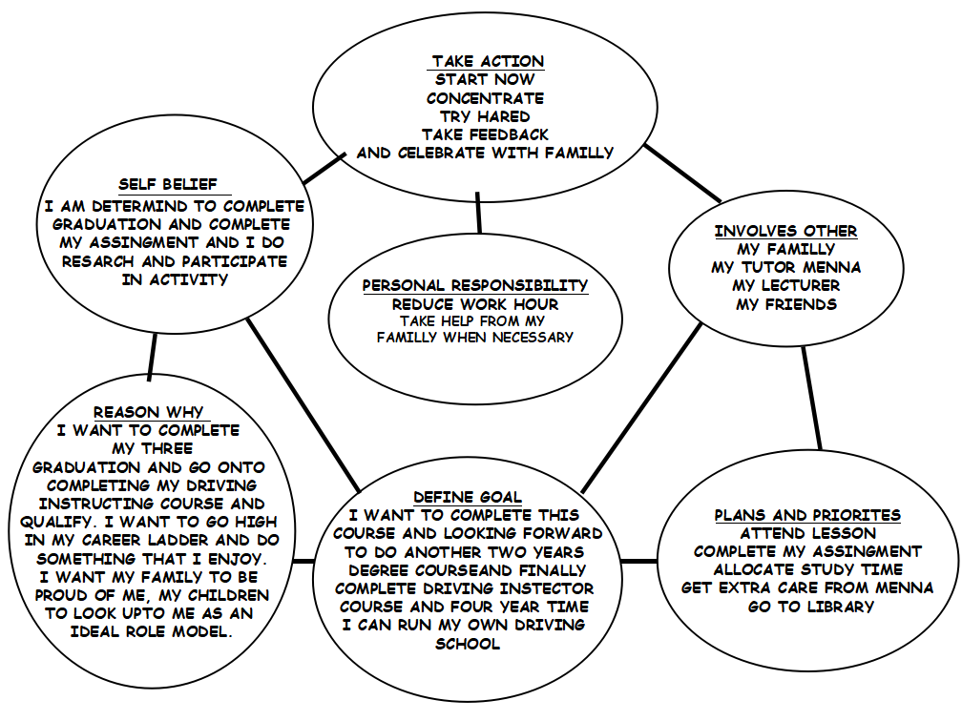
In completing my Go MAD framework I was able to identify my goals as well as plan how how I will reach there with the support network around me. This framework has given me a clear picture of exactly what I need to and boost within myself by giving me self belief of how its possible to achieve this. i had not known my preferred learning styles until I filled in the VARK and The Myer Briggs questioning which I will use in aid to help my digest information. The other ways I plan to make my career journey easier is by using my SMART goals, this is also a coaching tool. According to Your Coach, (2018) that setting goals and objectives are vital otherwise life can become chaotic. SMART goal has five part which S for being specific of what needs to be achieved, M is measurable, how will you know you have reached them, A is attainable, to recognise is it realistic and achievable, R is relevant, to recognise if this is relevant to you an finally T is time base, to set a time for your goals. My SMART goal is available within the appendices, (Image F). I will now look into my Personal Development Plan to look at my weak areas and how I can improve them.

PERSONAL DEVELOPMENT PLAN:

This plan identified my two big weaknesses which are speaking clearly and writing. For me to be able to meet my aimed profession and complete this degree, I will need to improve myself in these criteria, as speaking and writing is vital part of communication. Skill You Need, (2018) stated that this should not be overlooked, this skill is necessary to improve the quality of life. Demonstrating communication would be needed when interacting with fellow students, lecturers and employers. I will work on these weaknesses by using the support of the university and my family as well as implementing how I chose to remove those barriers on the PDP. My SWOT analysis also identifies the same weaknesses, also my strengths.

SWOT ANALYSIS:
This is my completed version of a SWOT Analysis which again highlights my weakness of speaking and writing as well as confidence and motivation being an issue to. The learning style questionnaire has helped me to understand how I learn best but also another way to help myself is be using the Johanna Window which opens up unseen skills. As explained by Self Awareness, (2018) Johari Window is a physiological tool created by Joseph Luft and Harry Ingham during 1955. This model helps look at the blind spot area which is an aspect that you may not know about yourself but people surrounding you do know, then taking feedback can help you to be aware and overcome some issues. The Model is available to view in the appendices (Image E).

SKILL AUDIT:
A skill audit is to review what skills I obtain and what level I am, also to recognise what skills I will need to use in the future for my desired profession.
My skill audit recognised that the two vital skill I need to improve is writing and speaking which have been highlighted already through my SWOT and PDP.

LEARNING LOG:
Another way to improve my learning is by keeping a record of learning through a learning log. Within this document a basic information is logged to be able to reflect back on and also making the most of an experience. According to Rapidbi, (2018) a learning is vital as many individuals neglect the reflecting part, this is more a self-assessment and help us to improve abilities. A learning log is more like a diary for us to remember past mistakes and reflect on them and plan how to improve them. This is also were the Kolb learning cycle can be used to improve on the mistakes.

Conclusion
In conclusion of this report, it was highlighted through VARK, (2018) that I learn best by Read/Write and Aurally which I am partially in agreement with, information explained is much easier to digest rather than been given papers to read from. My Myers Briggs Personality Test resulted as Introvert, Sensing, Feeling and Perceiving which do match with my characteristics as I do have confidence issues, I can be a good listener and I do reflect on my past do better myself for the future (Doyle, 2017). The Honey Mumford result came as Reflector which confirms the connection between the Myer Briggs results that I am a reflector (The University of Leicester, 2018).
In concluding further, the report managed to look at Go MAD framework, The Swot analysis, Personal Development Plan, Johanna Window, Skill Audit, Kolb learning and the the learning log. Using all these self awareness tools and techniques I was able to make strategies on how to overcome my weakness and reach my goals.

Recommendations

- There are many online English courses available online. English Live, (2018) a package for English that involves, interactive classes, personal study plan, live group classes, private classes and Certificate for each level. Also speaking more regular with friends and family, also reading more often can also aid me to improve my speaking more.
- To improve English writing again there is English courses available by Pitman Training, (2018)that not only aids in speaking but writing and listening too. Other exercise can be done such as, more reading, practice writings and ask for help from tutors and lecturers.
- According to Skills You Need, (2018) the best way to improve on confidence is by planning, this will enable you to be more prepared and keep you aware of what to expect. Positive thoughts also have great power in boosting confidence, this can be done by highlighting strengths and addressing the weaknesses.

Bibliography

Doyle, A.(2017),The Myers-Briggs personality Test And Your Career, [Online]. Available at: https://www.thebalancecareers.com/the-myers-briggs-personality-test-and-your-career-2062787. [Accessed 11th June 2018].

English Live. (2018), Learn English Online, [Online]. Available at: https://englishlive.ef.com/en-gb/lp/os/learn-english-online-03/. [Accessed 16th June 2018].

Fleming, N and Baume, D. (2006) ‘Learning styles again: VARKing up the tree’ Educational Developments, 7 (4), 4-7.

Fleming, N.D and Mills, C. (1992), ‘Not Another Inventory, rather a Catalyst for Reflection’, (To Improve the Academy), 11, 137-155.

Linkedin. (2015) 5 Reasons Why you Need a Career Development Plan Now, [Online]. Available at: https://www.linkedin.com/pulse/5-reasons-why-you-need-career-plan-now-joya-martin. [Accessed 11th June 2018].

McKay. (2018), Career Development, What is it and what factors influence it? [Online]. Available at: https://www.thebalancecareers.com/what-is-career-development-525496. [Accessed 13th June 2018].

Morgan, P. (2017), The Business Students Guide to Study and Employability, London SAGE.

Open College. (2018), What is Professional Development? [Online]. Available at: https://www.opencolleges.edu.au/careers/professional-development. [Accessed 15th June 2018].

Personality Perfect. (2015), 16 Types of Personality Test, [Online]. Available at: http://www.personalityperfect.com/myers-briggs-personality-test/. [Accessed 10th June 2018].

Pitman Training. (2018), Pitman English- Online English Course, [Online]. Available at: https://www.pitman-training.com/our-courses/pitman-english/. [Accessed 16th June 2018].

Rapidbi. (2018), Learning Log and Learning Journals, [Online]. Available: https://rapidbi.com/learninglogs-learningjournals/. [Accessed 16th June 2018]

Self Awareness. (2018), Understanding the Johari Window Model, [Online]. Available at: http://www.selfawareness.org.uk/news/understanding-the-johari-window-model, [Accessed 15th June].

Skills You Need. (2018), Building Confidence, [Online]. Available at: https://www.skillsyouneed.com/ps/confidence.html. [Accessed 17th June 2018].

Skills You Need. (2018), Communication Skills, [Online]. Available at: https://www.skillsyouneed.com/ips/communication-skills.html. [Accessed 14th June 2018].

TEDx Talk. (2016), The Art of Making a Difference/ Andy Gilbert/ TEDx Leicester, [ONLINE VIDEO]. Available at: https://www.youtube.com/watch?time_continue=8&v=KKW_dcq_kcM. [Accessed 10th June 2018].

The University of Leicester. (2018), David Kolb, [online]. Available at: https://www2.le.ac.uk/departments/doctoralcollege/training/eresources/teaching/theories/kolb. [Accessed 15th June 2018].

The University of Leicester. (2018), Honey Mumford, [Online]. Available at: https://www2.le.ac.uk/departments/doctoralcollege/training/eresources/teaching/theories/honey-mumford. [Accessed 14th June 2018].

VARK. (2018), VARK a guide to Learning Styles, [ONLINE]. Available at: vark-learn.com/introduction-to-vark/. [Accessed 10th June 2018].

Your Coach. (2018), Smart Goals, [Online]. Available at: https://yourcoach.be/en/coaching-tools/smart-goal-setting.php. [Accessed 14th June 2018].

Appendices:

MY VARK QUESTIONNAIRE: (IMAGE A)

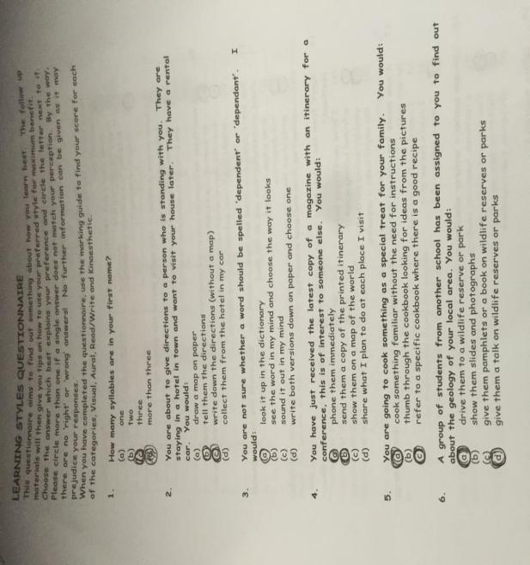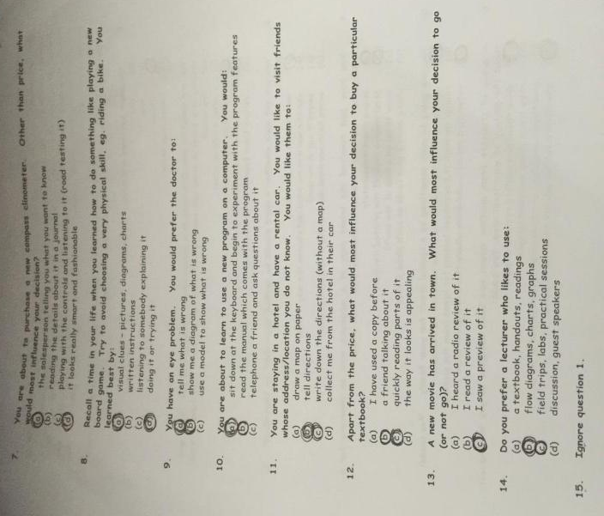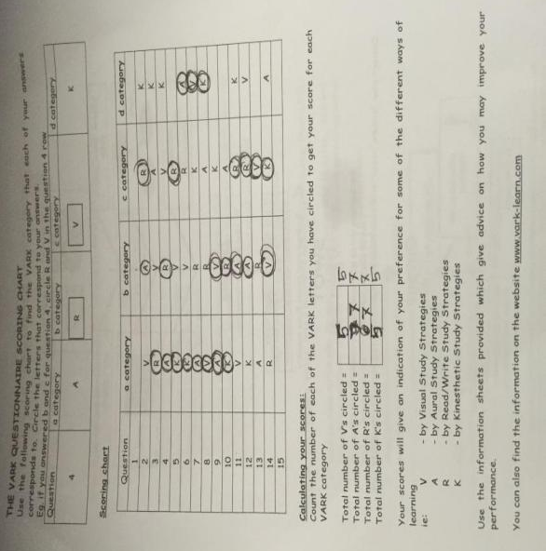

MYERS BRIGGS QUESTIONAIRE (IMAGE B)

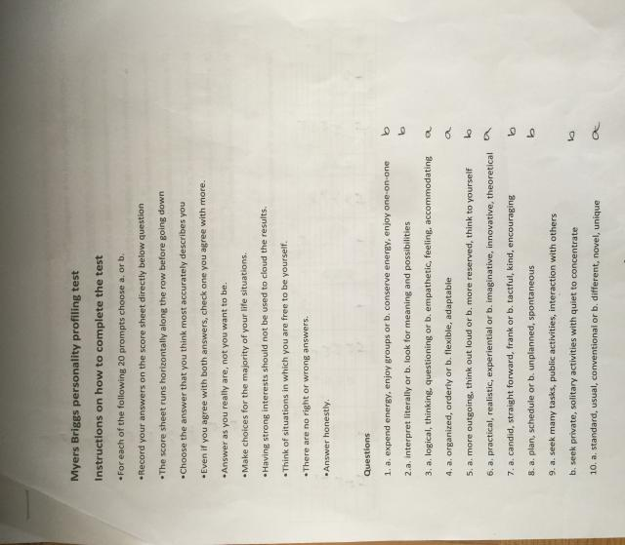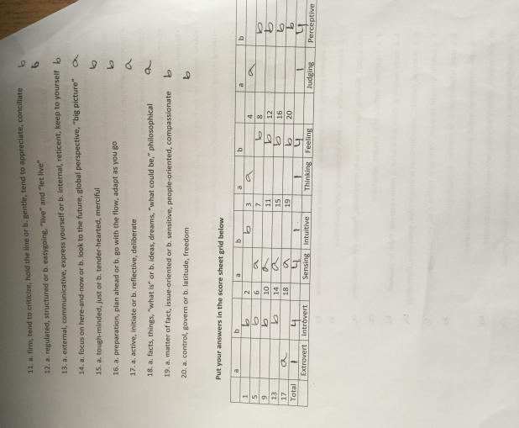

HONEY AND MUMFORD QUESTIONAIRE (IMAGE C)
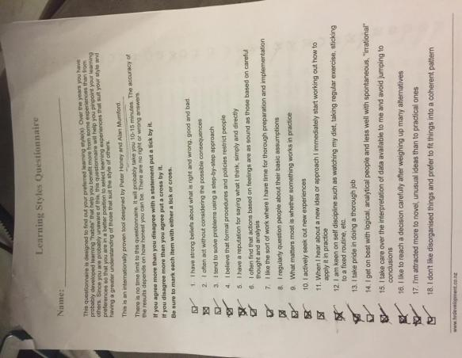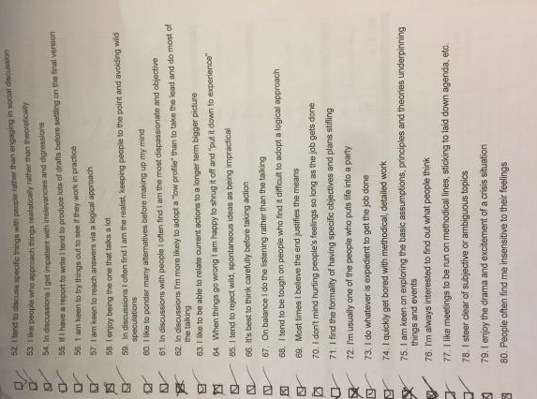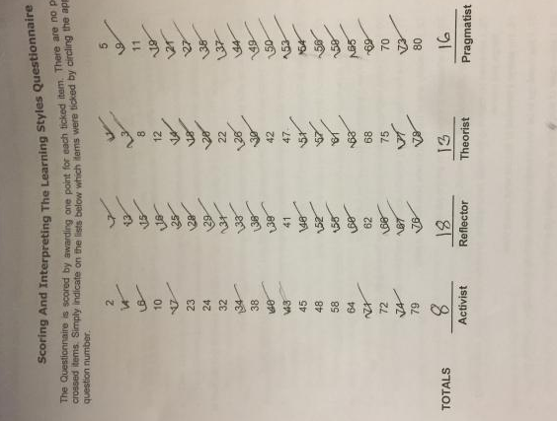

KOLB’S MODEL (IMAGE D)
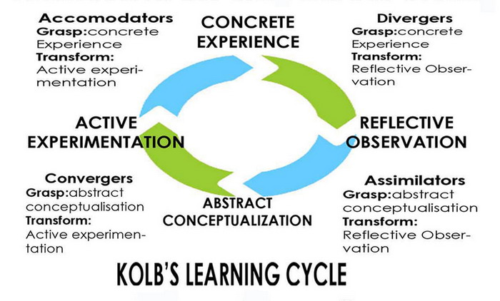

JOHARI WINDOW (IMAGE E)
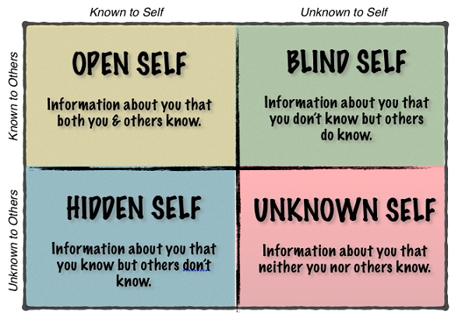

S.M.A.R.T OBJECTIVES (IMAGE F)

S - To be a driving instructor.
M - When I receive my qualification and complete my instructing course.
A - I do have control over this aim as I have knowledge of safe driving and currently work as a delivery person for a pharmacy company. I also wanted to become a driving teacher.
R - This is applicable because I have undertaken many driving profession such as taxi, medicine delivery, so I wish to take my driving ability to a more enjoyable work field.
T - I can achieve this within four years.

Acknowledgements
I acknowledge that my Lecturers, Menna my Tutor, my friends and family members have supported me.

THANK YOU VERY MUCH VERY READING MY REPORT.
ABU AHMED EUSUF.

