The purpose of this assignment is discovering what helps children learn mathematics and language. Mathematics and language are stand-alone subjects and cross-curricular through the literacy and numeracy framework (LNF). NAG (2013) claims the importance of mathematics and language in order to raise the standards of children’s skills across the curriculum through the use of the LNF. However, this is a dated documentation as the LNF has been compulsory for 6years since publication of that documentation. Within this discussion there will be the analysis of a child’s work through examples of work, interview and observations. Through analysing the sample work the writer will be using the national expectations from the national curriculum and exploring the strengths and weaknesses through a number of strategies. Concluding all the evidence gathered to evaluate a way forward for the child’s progression.

The focus child for this assignment will be a 10year old boy in year 6 within the middle ability group of the class and is referred to as Pupil A. The school he attends is a large community primary school set in a town within South Wales with 360 pupils on roll.

The Mosaic model (Clark and Moss, 2011) was one element used to gathered data on Pupil A which puts the child as the teacher of his own learning asking questions which is practised by the Reggio Emilio (Malaguzzi cited in Pound, 2005, pp. 52-53). It is a method used for early years but has been adapted to use for older children within the primary school. It allows children to become more independent as they progress through the school and take control of their own learning (Dewey cited in Pound, 2005, pp. 21-22). The learning becomes more understandable and relevant by the child gathering different perspectives to embed their learning. Donaldson (2015) suggests that pupils need to become more skilful to meet the needs of their future development as an adult which is also supported by the view of Montessori (cited in Pound, 2005, pp. 30-31) who suggests that children are more efficient when they take control of their own learning by being listened to. However, teachers are important to children’s learning as they have a positive impact on children’s learning if they have good practices (Grigg, 2015). Pupil A was informed of the research and was allowed to withdraw at any time in line with the United Convention Rights of a Child (1990) as it is important to allow children to have choice. The data was ethically gathered by following the guidelines of British Educational Research Association (BERA, 2018) and General Data Protection Regulation (GDPR) (ICO, 2018) and data will remain anonymous.

Furthermore, to analyse the child’s learning against the ASK model, Nottingham (2013) encourages that children learn through various perspectives and their educational development involves the use of their skills, attitudes and knowledge. Using the ASK model through this assignment will give a deeper insight into Pupil’s A learning and allow for his future progress.

Through the use of the ASK model, the attitude element will be explored in this section (Nottingham, 2013). Pupil A has a negative attitude towards language as he said in an interview, he finds English “too hard” and he “cannot do it”. Barnes (2015) suggests that emotions have an impact on children’s learning, with Pupil A having a negative attitude towards language, it is allowing his learning to be negatively affected.

Moreover, Pupil A is disengaged from the learning and sees little value or purpose within it (Grainger et al., 2003, cited in Goodwin, 2011, p.117). His body language seemed to change if he had to do lots of writing, his body would slump into his chair and he would have a negative expression on his face. Observing children’s body language is vital to get an insight into the children’s thinking (Clark and Moss, 2010). He tends to get fed up easily as he lacks motivation and confidence to complete a task, so he rushes to finish. Donaldson (2015) believes confidence and independence need to be embedded within children from a young age in order to succeed in the future.

Pupil A likes to have models and examples shown to him so that he knows what is expected of him. This enables him to visualise his learning and become more experienced (Bruner, cited in Pound, 2005, p. 48-49). Using the ‘Pizza Success’ criteria (see appendix 1) he found work simpler for him to complete as he was able to use it as a guide to know what to include within his work, and was able to assess his own learning as he went along (Black and Wiliam, 1998). Pupil A finds it more difficult to work independently and relies on the teacher for help and reassurance. He enjoyed reading ‘First News’ sport section as he loves playing sports and openly talks about it with confidence. He has very clear speech and an average range of vocabulary and confidently communicates with peers and teachers. He always joins in with group activities voicing his opinion but rarely volunteers to speak in front of the class. On the yard at break times, Pupil A would always be socialising with his peers and taking an active role in games.

The skills and knowledge elements of the ASK model (Nottingham, 2013) shows the pupil’s strengths and weaknesses within different areas of his skills and knowledge. He is able to use some of the elements of using speech marks correctly within a dialogue (see appendix 1). He used the ‘Pizza Success’ to facilitate his learning and used it as a check list of what to include within his work. He was confident in putting the speech marks around what the speaker said and putting a capital letter at the beginning of the speech which is features of Level 4 (WAG, 2016a). Despite this, he had difficulty putting the punctuation inside the speech marks and starting a new line for a new speaker. This shows that he has not got a good knowledge of how punctuation works. However, this was Pupil A’s first attempt at using speech marks within a dialogue text and uses punctuation within other texts confidently. He had previous experience of reading books with speech marks within them which scaffolded his learning (Vygotsky, cited in Pound, 2005, pp. 40-41).

Pupil A has clear and legible handwriting, with correct letter formation and presentation is adapted for purpose (WAG, 2016a). He has cursive writing which is useful for children to detect separate words and make links with spelling (Graham and Kelly, 1998). He has good fine motor skills using a pen and good gross motor skills when playing football. Pupil A is able to use his writing skills across the curriculum through the use of capital letters, spelling and punctuation (see appendix 2). Using language across the curriculum allows him to explore his intelligence and deepen his understanding of his literacy skills, giving him connections within his learning (Gardner, cited in Barnes, 2015, pp. 151 and Estyn, 2016-2017).

As an introduction to biographies, the pupils were shown a good example of one as a model for the children to identify its features. Pupil A was successful using ‘think, pair, share’, with a partner to identify its features. Pupil A was happy to talk to his partner and work together to highlight the features of a biography but allowed his partner to feed back to the class. Working with a partner allowed Pupil A to share knowledge to come to an agreement (WAG, 2014) and learnt from each other, as it is at a level that they can understand (Piaget, cited in Pound, 2005, pp.37-38). Pupil A contributed to class discussions when asked to and created a class success criteria for their own biographies giving a sense of independence and ownership which is essential for him to become an “healthy, confident individual” (Donaldson, 2015, pp. 30 and Cremin et al., 2009).

The notes taken by Pupil A for research for his own biography lacked detail so when he came to write the biography, he did not have enough information in order to complete his work (see appendix 3). He needs to work using his time more efficiently to ensure his work is completed within the time given. When writing the biography, Pupil A was able to listen to instructions carefully and show understanding of the features of a biography. The biography was related to the class topic of WW1 making the learning relevant and engaging for Pupil A (Dewey, cited in Pound, 2005, pp. 21-22 and Grigg, 2015). Pupil A was able to write in the third person and past tense; however, it was not written in chronological order with a lack of ‘wow’ words, some spelling mistakes and he lacked the use of paragraphs but did correct his own mistakes (see appendix 4).

When introducing Haiku poems Pupil A was confident verbalising and clapping out the syllables within each line of the poem which Cremin et al. (2009) suggests is how children are first exposed to poetry. Pupil A was able to annotate a Haiku poem with a partner highlighting the main features to create a success criteria for his own poem (WAG, 2014). Poems were put on the board and Pupil A had to identify whether the poems were a Haiku or not. Engaging Pupil A with an initial game to play allowed him to enjoy the poetry and understand the meaning and features of Haiku poems in depth (Corbett, 2008). Pupil A was able to mind map good ideas for his own winter Haiku poem but with a large number of spelling mistakes (see appendix 5). He was able to write a Haiku poem (see appendix 5) but when redrafting, he did not check his spellings and his 3rd line did not have the correct number of syllables (see appendix 6). This shows that Pupil A can identify the features of Haiku poems but when writing his own he rushed his work allowing room for errors. Pupil A is working at Level 3 as he does not include adventurous vocabulary but has many features of Level 4 (WAG, 2016a).

The attitude section of the ASK model, Nottingham (2013) suggests that children who do not have patience as more likely to not be able to deal with stressful situations. Pupil A found mathematics very challenging and said that he is “not good at mathematics”. He often got frustrated when completing Mathematics activities which led him to give up easily which Greenhalgh (1994, cited in Barnes, 2015, pp. 144) suggests, is because his is feeling worried about the mathematics therefore he is less likely to learn. Pupil A lacked confidence in any mathematics activities which Clark and Moss (2011) believe is vital in children’s learning and to be able to enjoy learning. When on the carpet, Pupil A would attempt a few questions on his mini whiteboard but if he had one wrong, he would not attempt any further questions.

Pupil A likes to have mathematics questions shown to him in a step by step guide so he can break the question down and work it out (Skinner, cited in Pound, 2005, pp. 42-43). He finds the teacher modelling an example on the board a helpful resource to aid his learning in mathematics. Having teacher support allows Pupil A to feel more comfortable and gives him the confidence he needs in order to complete his work giving him a more positive attitude towards his work (Grigg, 2015). Attempting his method on a mini whiteboard helped to visualise Pupil A’s thinking and deepen his understanding of the concept (Bruner, cited in Pound, 2005, pp. 48-49).

Pupil A enjoyed marking his own work as he was able to see what things he got correct and where he made errors to be able to improve his work (Bolton, 2014 and Stephens and Crawley, 2002). He did not like doing mental mathematics as he found it difficult to visualise learning in his head. Pupil A also did not enjoy writing what went well (WWW) with his work and even better if (EBI), as he felt they were pointless and did not understand them enough.
In relation to the skills and knowledge elements of the ASK model (Nottingham, 2013) Pupil A is within the middle ability for mathematics. Cockburn and Littler (2008) suggest that everyday life is surround by numbers and mathematics, so it is important to be able to engage with numbers. Pupil A found addition of 2 numbers to give a total less than £10 with 2 decimals places concept easy as this was put into a real-life context of being a shop keeper of a supermarket with till receipts (see appendix 7). Haylock and Cockburn (2014) claim that children learn mathematics through the connections model with one strand learning through mathematics put into a context that children can relate to (Steiner, cited in Pound, 2005, pp. 26-27). He felt confident after marking his own work to find he had them all correct which boosted his engagement as he had built a foundation of understanding and knowledge (Atkinson, 1992). Pupil A was eager to move on to the next step using larger numbers adding two items to give a total less than £100 using 2 decimal places (see appendix 8). He completed this activity successfully with one minor error forgetting the pound sign. Hansen (2014) claims that children who have a good understanding of decimals must have firm understanding of fractions.

Pupil A understands the terms profit and loss as he was able to express the meanings and could identify on his mini whiteboard whether an item on the board had been a profit or a loss looking at its cost and selling prices. Within his written work he was able to put the amount of whether the item made a profit or loss in the correct column but had the incorrect amount (see appendix 9). He does not understand the concept of subtraction in a written method as he is forgetting to borrow from the number in front if the number is too small to subtract it from the one underneath (see B in appendix 9). Pupil A needs to adopt the foundation phase approach by using physical objects such as blocks to visually understand that you cannot subtract 4 away from 0 (Cotton, 2013).

When working as a class, Pupil A was able to calculate the cost and profit of the Christmas decorations he made for a mini enterprise (see appendix 10). The activity was broken down into steps and modelled by the teacher allowing him to make connections from his prior knowledge of profit and loss and embed his understanding further (Pound and Lee, 2015). Setting his work out in a clear and structured layout helped him view his calculations in a simple and guided way. Pupil A is able to measure and record temperatures including positive and negative numbers (see appendix 11). He was able to understand what was asked of him but did not fully understand the importance of reading the scale of the thermometers (see H in appendix 11). Therefore, exposure to number lines with different scales would aid Pupil A’s visual learning to understand the concept of reading scales and giving him time to slow down and think about his calculations rather than rush to finish them (Pound and Lee, 2015). Pupil A is working at Level 3 with his subtraction but has many features of Level 4 within in other Mathematics work (WAG, 2016b).

In order for Pupil A to progress both in mathematics and language, the teacher must first address his attitude towards them. The child has had been taught more language lessons than mathematic lessons within the time on placement. Boaler (2009 cited in Pound and Lee, 2015, pp. 17) believes that mathematics is the second most disliked subject and many people feel anxious about it. Pupil A has a fixed mindset in that he believes he cannot do language or mathematics, but this can be changed by the teacher developing a growth mindset by encouraging him to say he can do it. Dweck (2006) suggests that providing Pupil A with different strategies to help him improve his work will increase his ability to cope with pressure. Pupil A avoids tasks that he finds difficult leading him to withdraw. Praising his efforts rather than his talents would encourage him to improve his growth mindset and highlighting the positives in making mistakes (Schön cited in Bolton, 2014, pp. 3). Creating an environment where Pupil A feels safe to make mistakes will benefit his attitudes, the teacher modelling mistakes in front of the class will encourage him to feel relaxed about making mistakes. Moreover, the development of assessment for learning (AfL) strategies with self-assessment will enhance Pupil A’s participation as he feels comfortable and enjoys assessing his own work (Black and Wiliam, 1998). However, developing a growth mindset in a child is difficult but can be achieved by dedicating time and effort.

Pupil A lacks independence in language and asks for teacher support often. Introducing Pupil A to de Bono (2009) ‘Six Thinking Hats’ would improve his metacognitive thinking enabling him to turn negatives into positives independently. It would allow for him to visual his thinking with the coloured hats and change his way of thinking to suit the task, self-regulating himself without getting overwhelmed. Pupil A can break down his thinking to manageable steps using the different hats to address different problems. Giving him clear steps with a success criteria allows him to guide his thinking and improve his structure of his work. Also, to get Pupil A to be more detailed within his writing of biographies and descriptions, the teacher could use Bloom’s taxonomy (cited in Krathwohl, 2002) for questioning to allow Pupil A to have higher thinking order skills and not have a fixed mind set. Enabling Pupil A to move beyond recalling and remembering into higher order thinking skills allowing his brain to process information in different perspectives which is also helpful to develop his mathematics skills.

Pupil A is a visual learner, he prefers to learn by getting involved with the learning and being able to see what is happening (Bruner, cited in Pound, 2005, pp. 49). To improve his biography writing using videos and pictures to illustrate the features and content to give him a deeper understanding. Also, using modern culture such as a football player he likes as an example to engage his learner and make his understanding more solid (Grigg, 2015). Donaldson (2015) and Estyn (2016-2017) suggest that children are engaged and motivated through real-life experiences that they can relate to. Making a physical resource such as an language/mathematics working wall (see appendix 12) would encourage Pupil A to become more independent as he would have everything he needs on the working wall. On the other hand, this would be time consuming to produce and pupils would need training on how to use the wall. To improve Pupil A’s use of speech marks, the use of a flashcards with sentences broken up and he would use punctuation cards to correctly put in the dialogue of text, getting him physically involved with his own learning (Barnes, 2015).

Pupil A has the understanding but not enough vocabulary to improve his biography and Haiku poem. Using word games such as using a picture and the children has to use different adjectives to describe the picture to help improve Pupil A’s vocabulary. Cremin (2009) believes that giving children the opportunity to talk in a playful way gives them the confidence to take risks with new words and ideas. Furthermore, using the outdoors for developing Pupil A’s senses and vocabulary as he enjoys being active outside. Montessori (cited in Pound, 2005, pp. 30-31) suggests that the outdoors is important for developing children’s senses giving him new language he could use within his writing. On the other hand, this must be managed closely to ensure Pupil A stays focused on the task.

To improve Pupil A’s spellings there are numerous ways children learn to spell from known words to visual awareness, so it is vital to teach spelling in numerous ways (Goodwin, 2001). Pupil A prefers physical and visual resources so by creating a display wall where we can freely access words that are most commonly misspelt and create an environment in that he feels comfortable to try a spelling and use a dictionary to correct it would be beneficial. Also, differentiating the work by giving him word banks of topic words that he may need within his work to avoid spelling errors.

In order to improve Pupil A’s learning of mathematics is to model examples to him breaking it down into steps and guide him through the calculation with teacher support. Giving him physical resources to scaffold his learning such as multi-link would improve his subtraction as he could visually see that you cannot take 4 away from 0 when talking about physical things (Vygotsky, cited in Pound, 2005, pp. 40-41). Once he understands this concept, the physical resource would be taken away and replaced with a number line and then eventually he would be able to do it without any support. Through this modelling it allows Pupil A to build his confidence in mathematics and slowly take away the support enabling him to become independent (Piaget, cited in Pound, 2005, pp. 36-38). Furthermore, Pupil A has the opportunity to sell fruit at the tuck shop so this could be used for the teacher to put him on the tuck shop stall to practise his subtraction by giving people the correct change. This would allow for him to make connections between the learning in class and real-life situations (Grigg, 2015).

To improve Pupil A’s reading of thermometers the teacher could practise the times tables through song with the class to ensure Pupil A knows them, so he is able to identify the scales. Giving him pictures of thermometers with scales that he could use as a number line would help him identify the scales as he does not understand what each increment represents (Hansen, 2014). Using real thermometers and recording different temperatures of different parts of the school would give meaning and purpose to the activity to develop his understanding further (Haylock and Cockburn, 2014). This could be developed further by calculating the difference between 2 thermometer readings from different parts of the school. Using this context would enable Pupil A to improve his thermometer reading and subtraction. The subtraction could be supported by using thermometer number lines.

As Pupil A is in the middle ability group, putting him in a mixed ability pair with a pupil in the higher ability would allow for him to develop his understanding further. He would take criticism from a peer more seriously than he would from the teacher and be in a language more natural to Pupil A. It enables Pupil A to take an active role in his learning and more likely to ask a peer for help (WAG, 2010).

Appendix 1
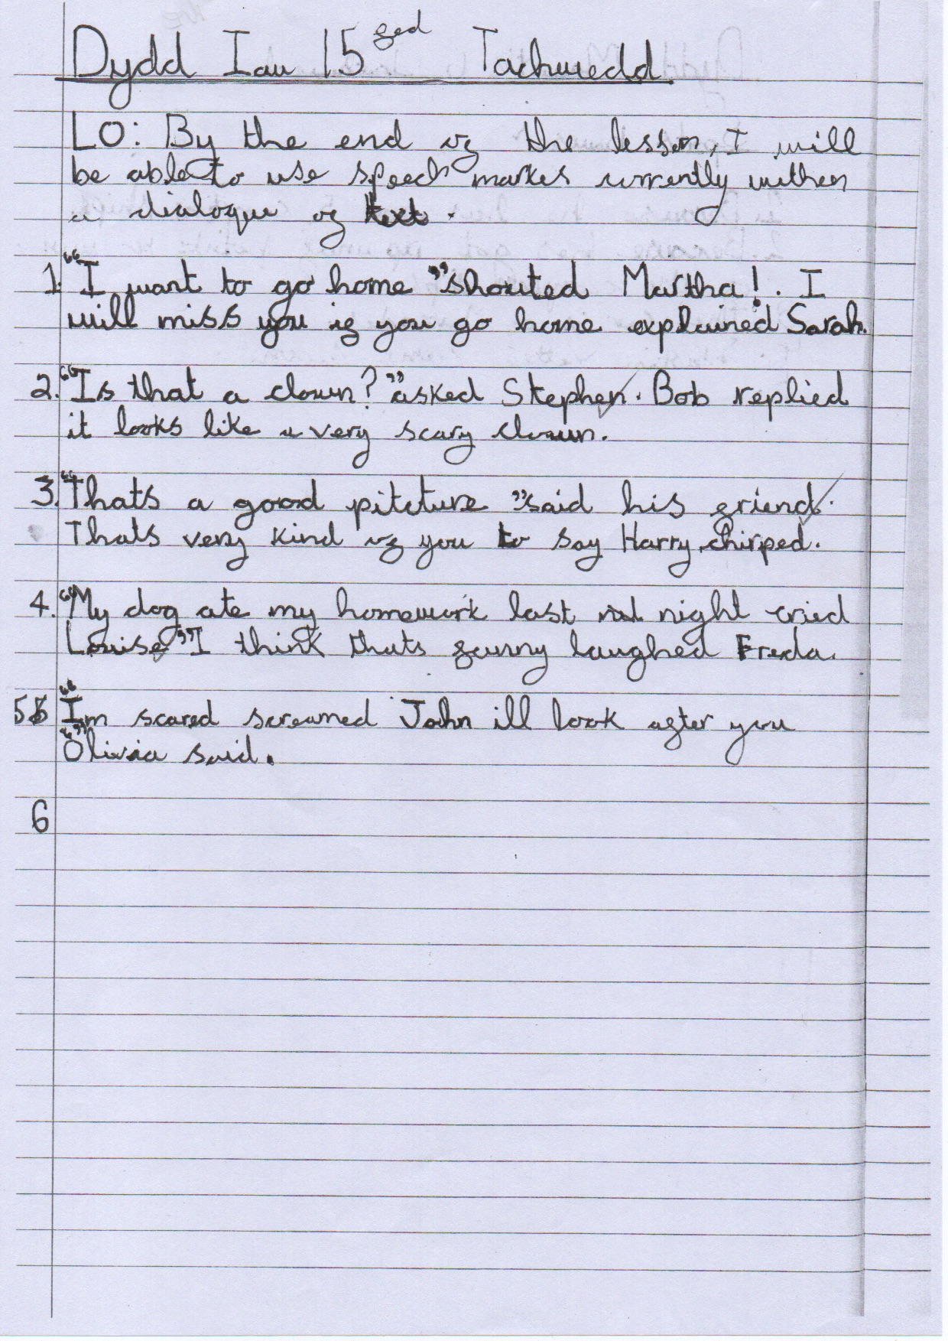

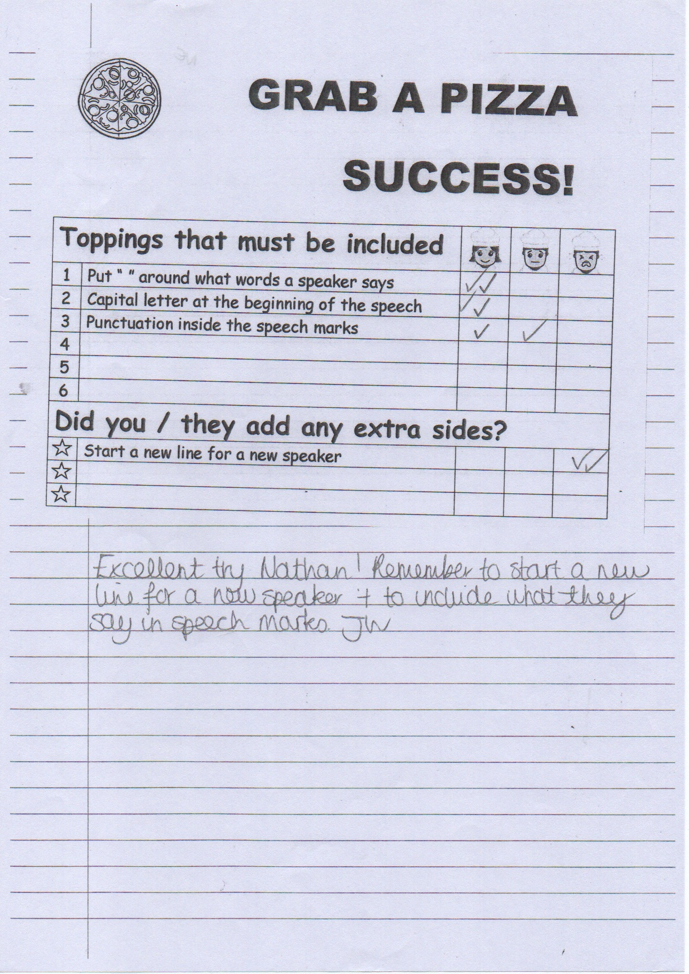

Appendix 2
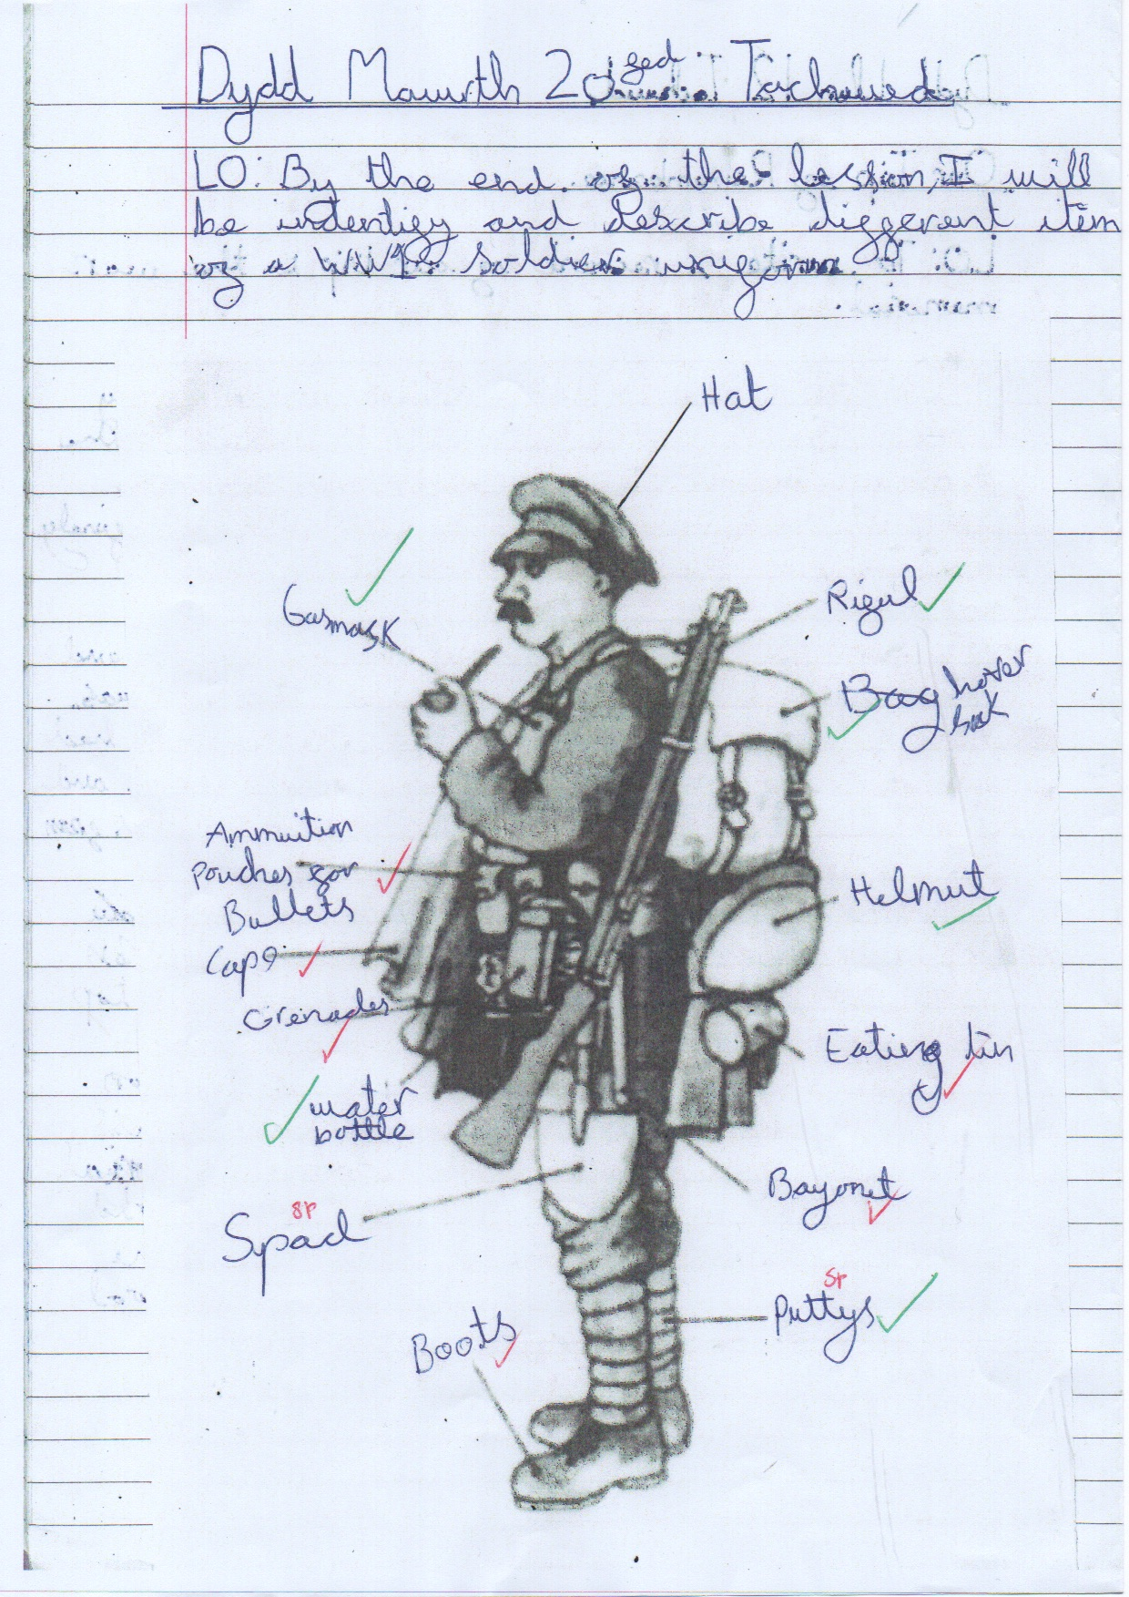

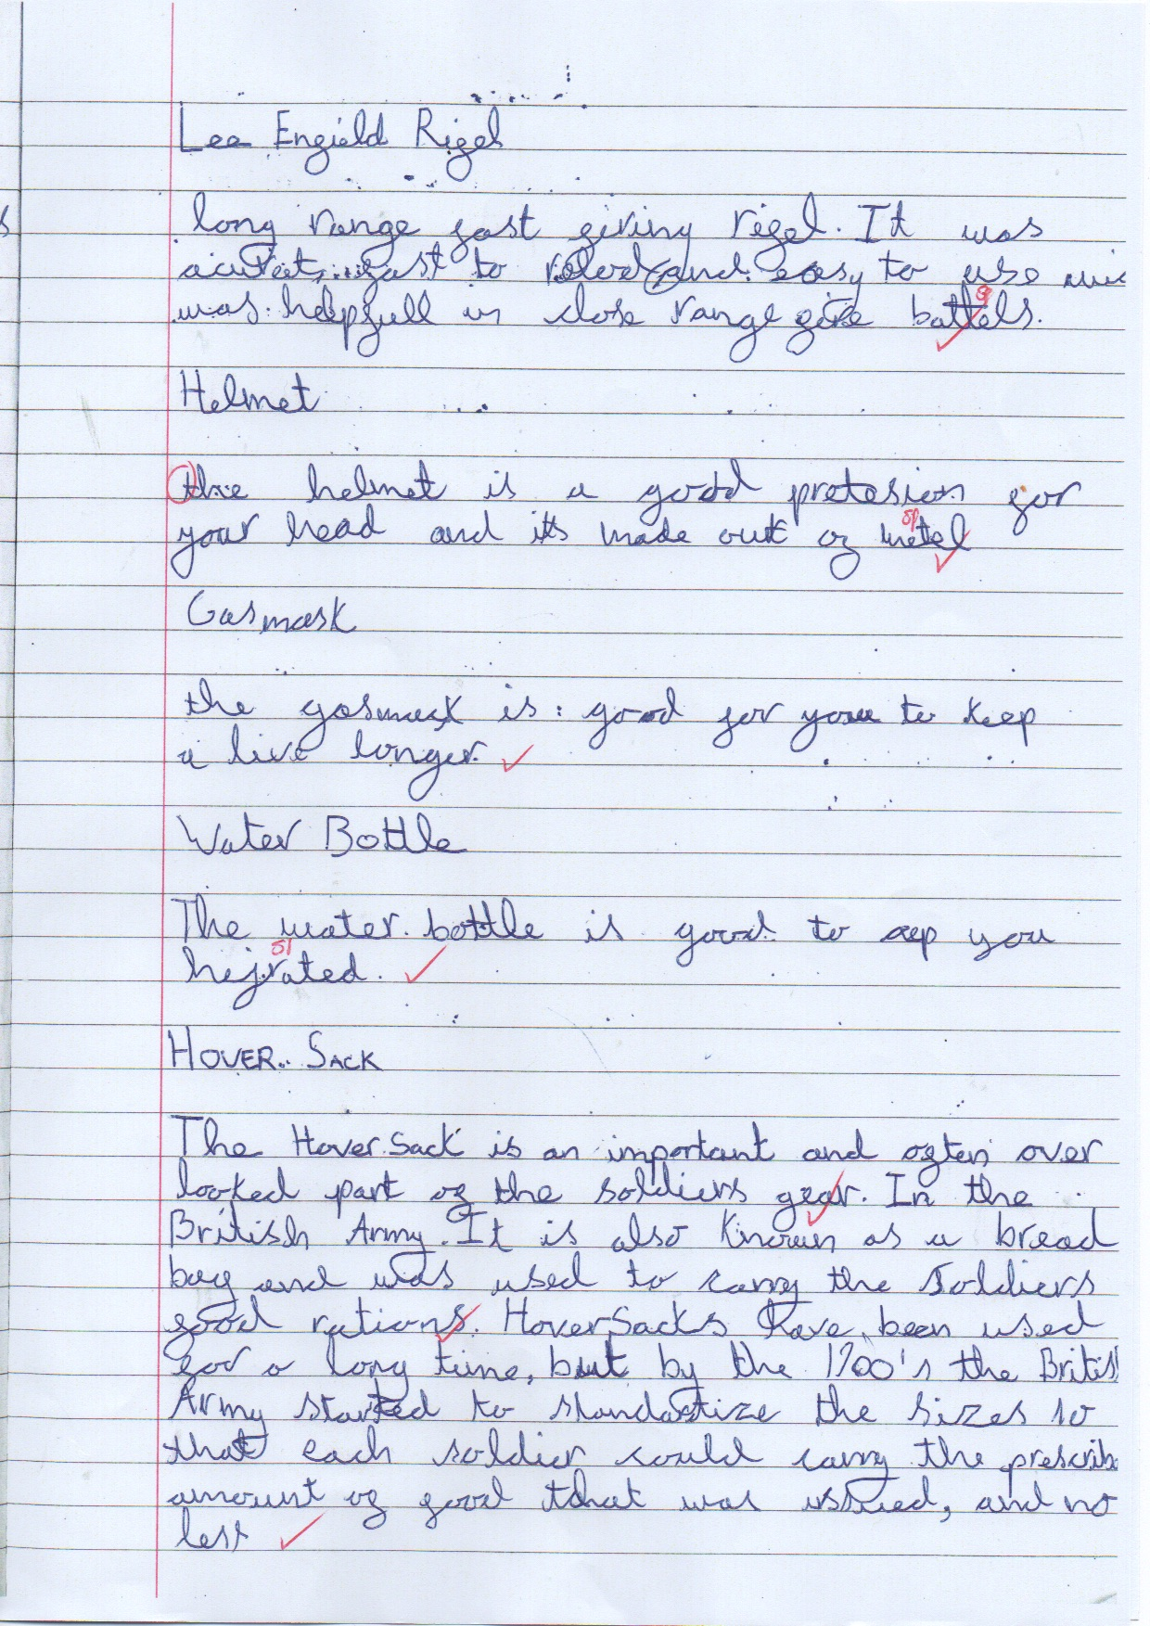

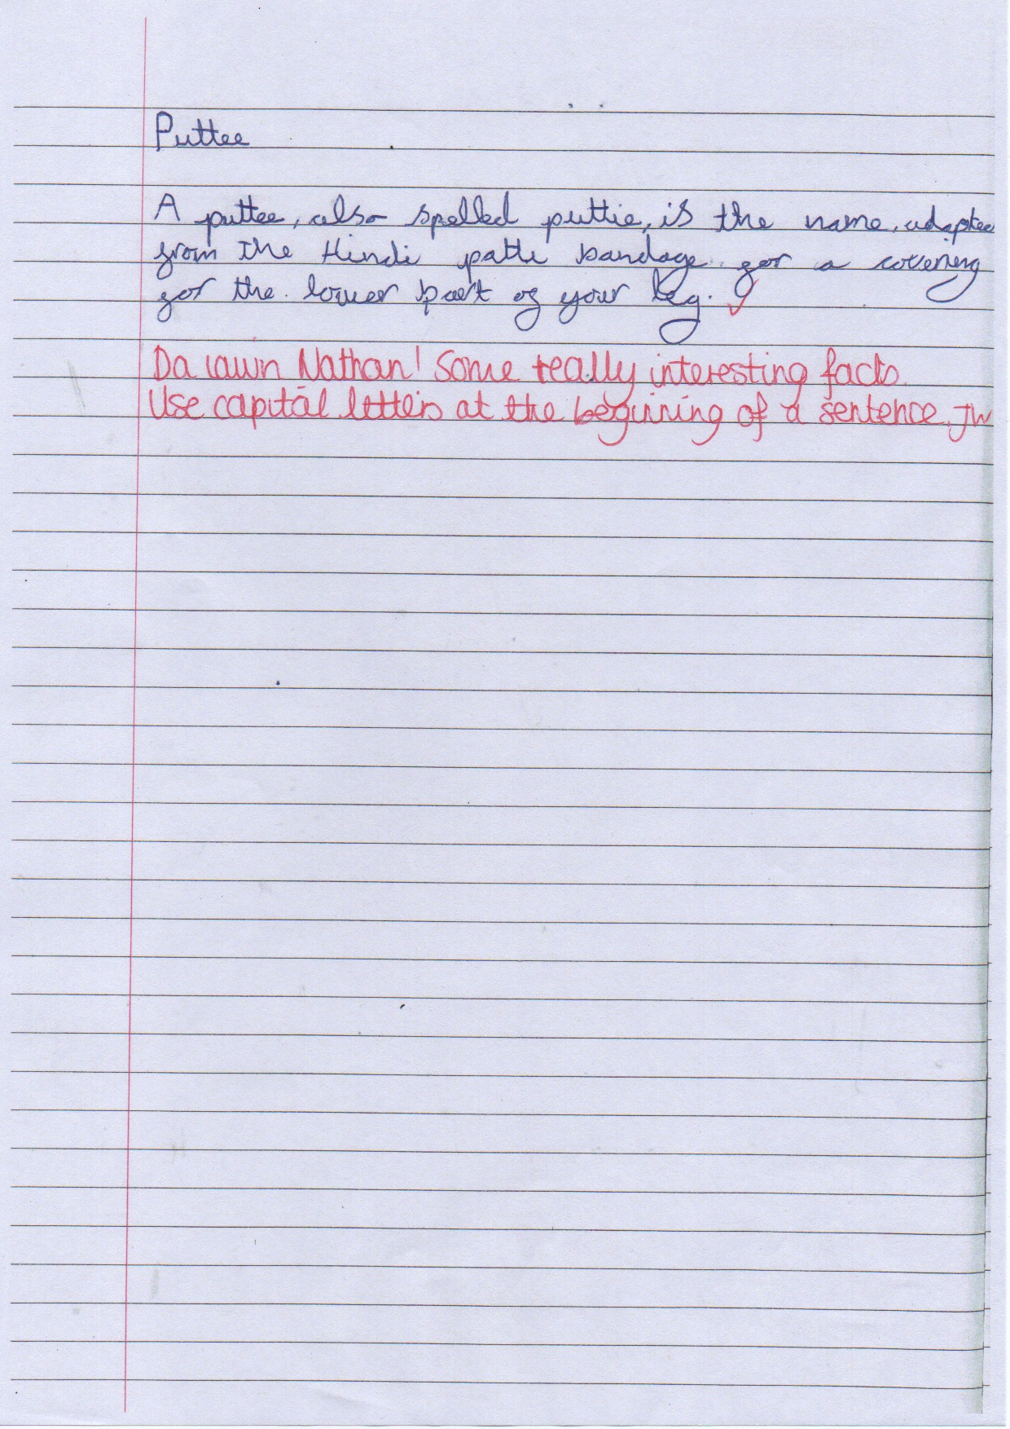

Appendix 3
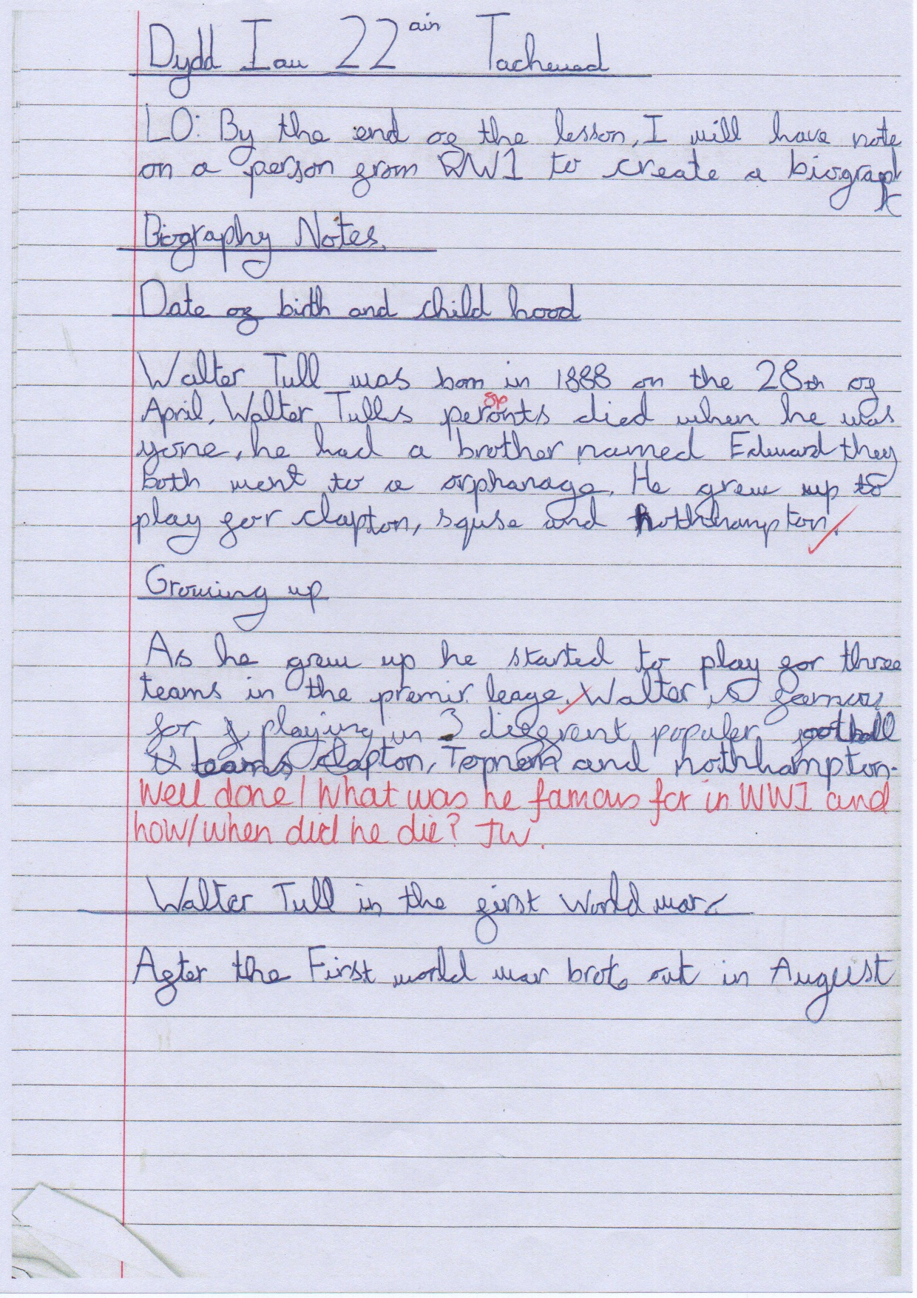

Appendix 4
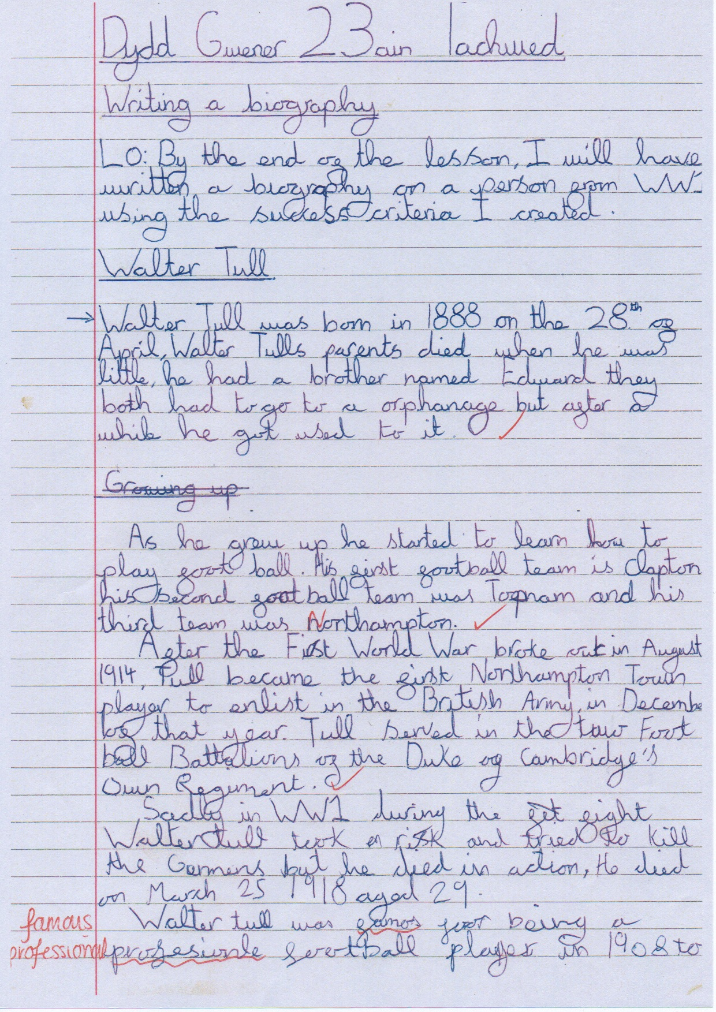

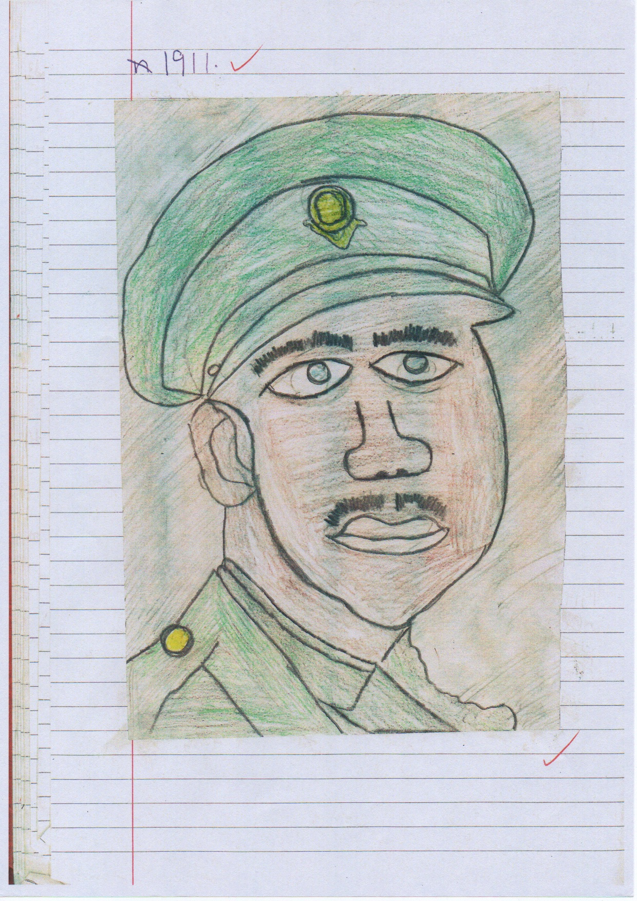

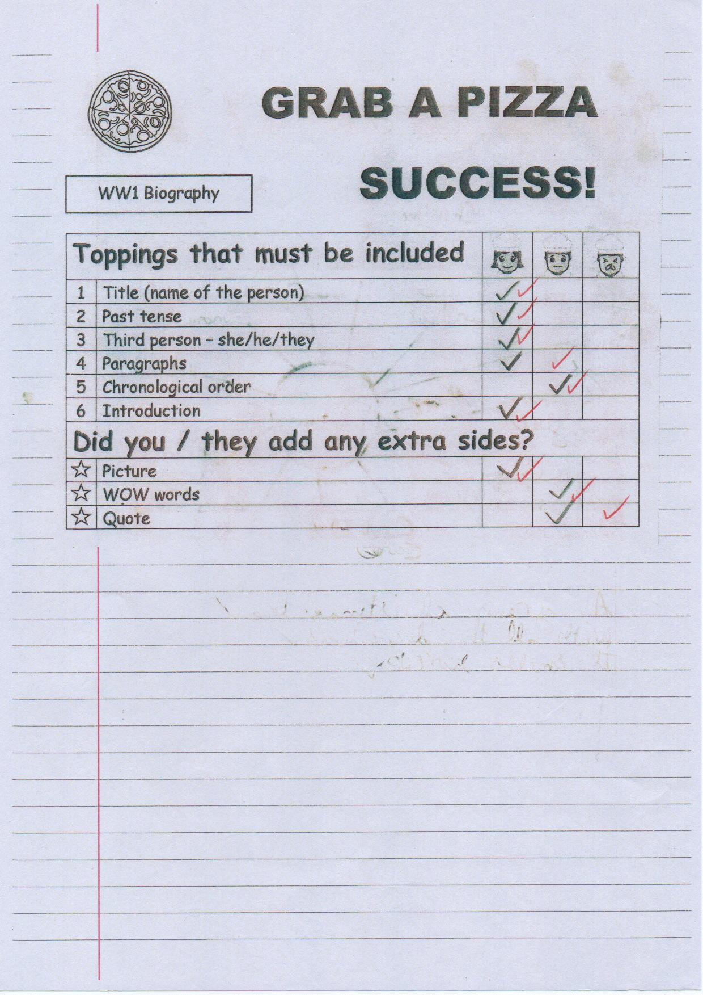

Appendix 5
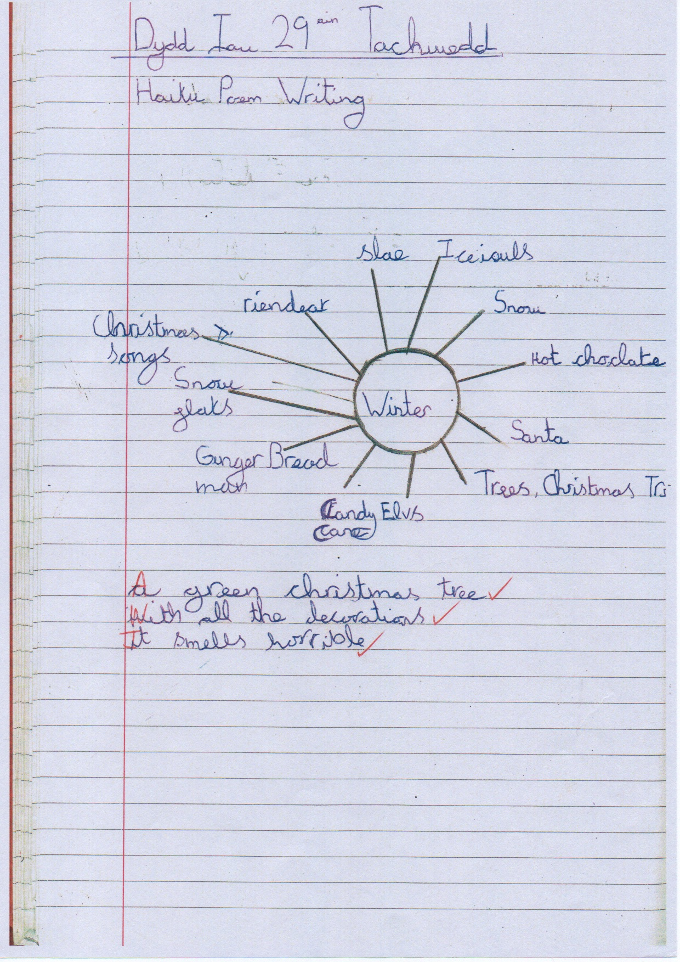

Appendix 6
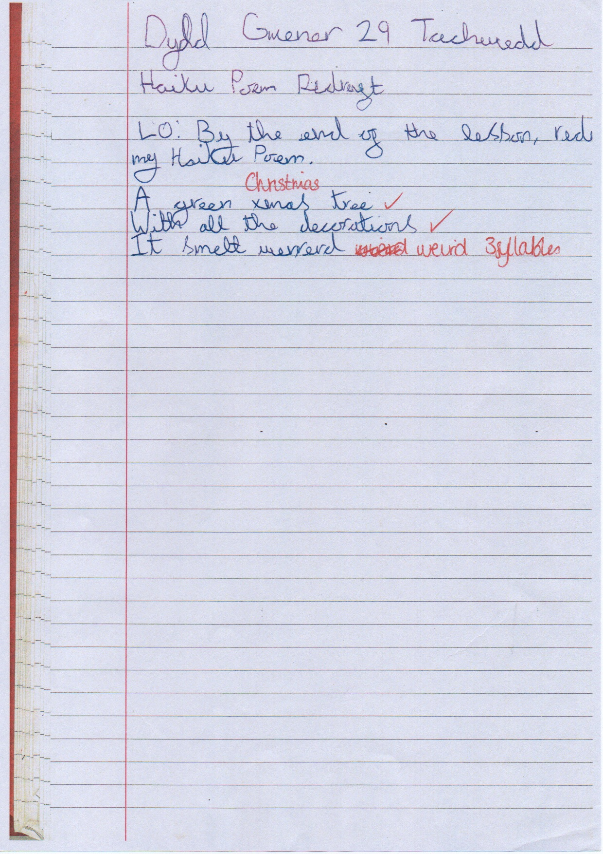
Appendix 7
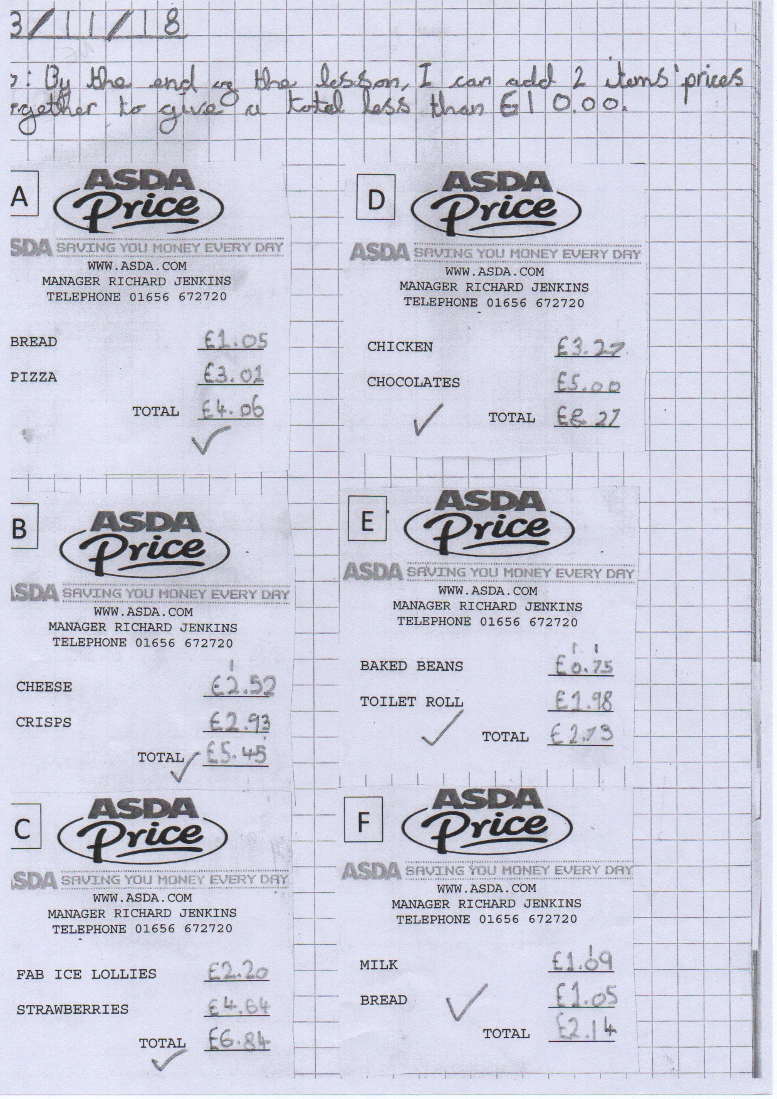

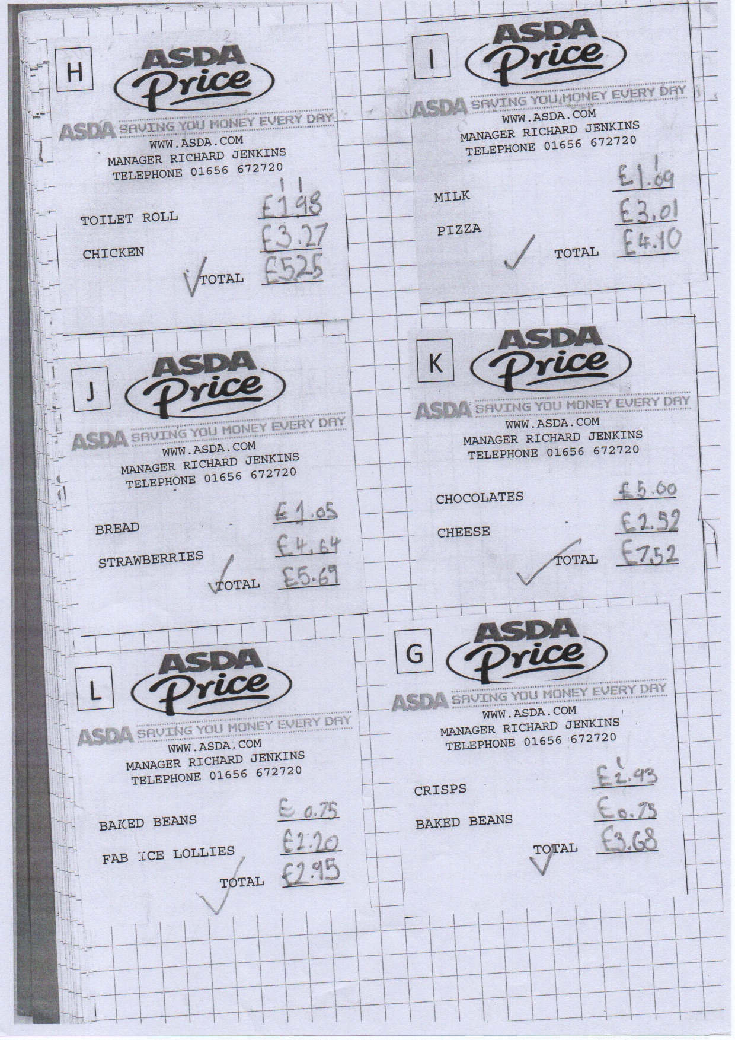

Appendix 8
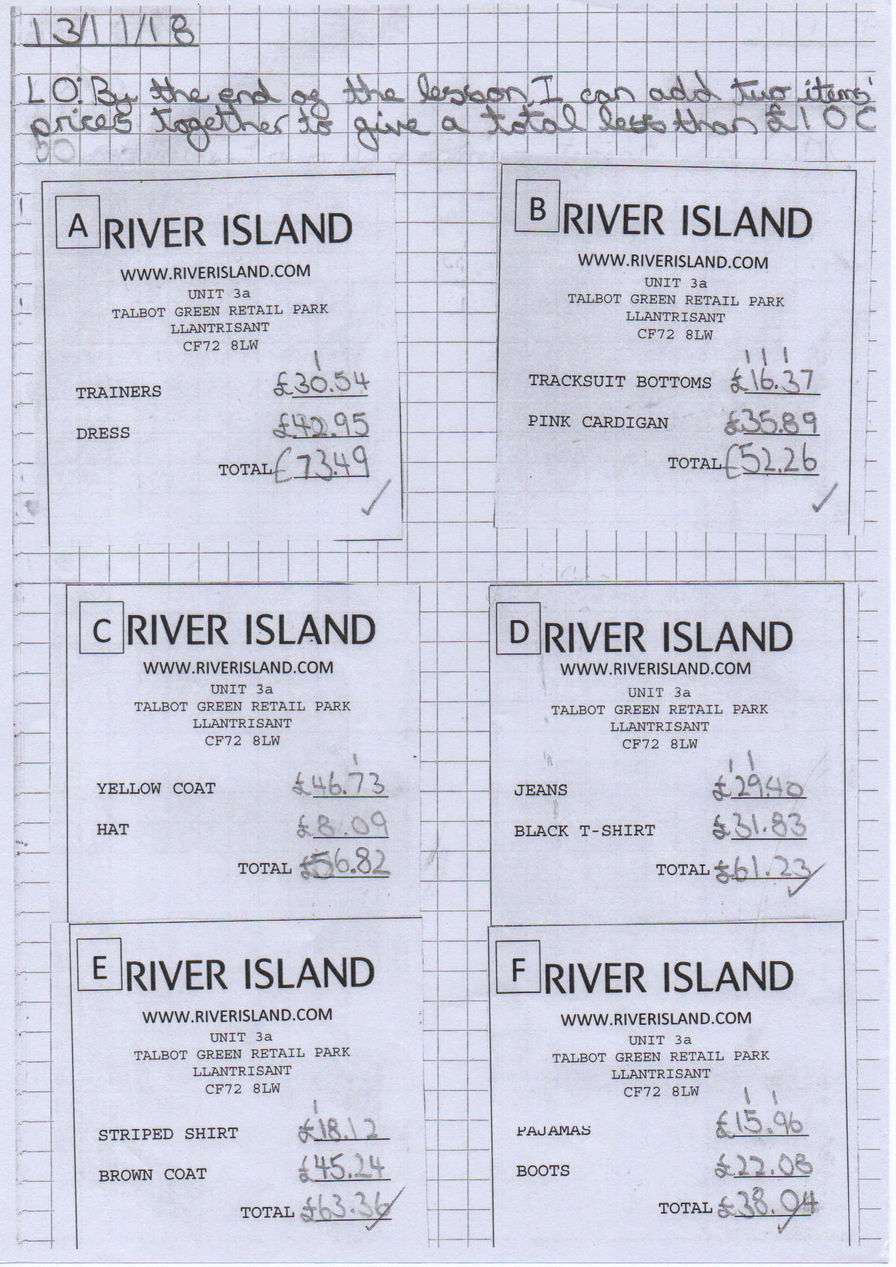

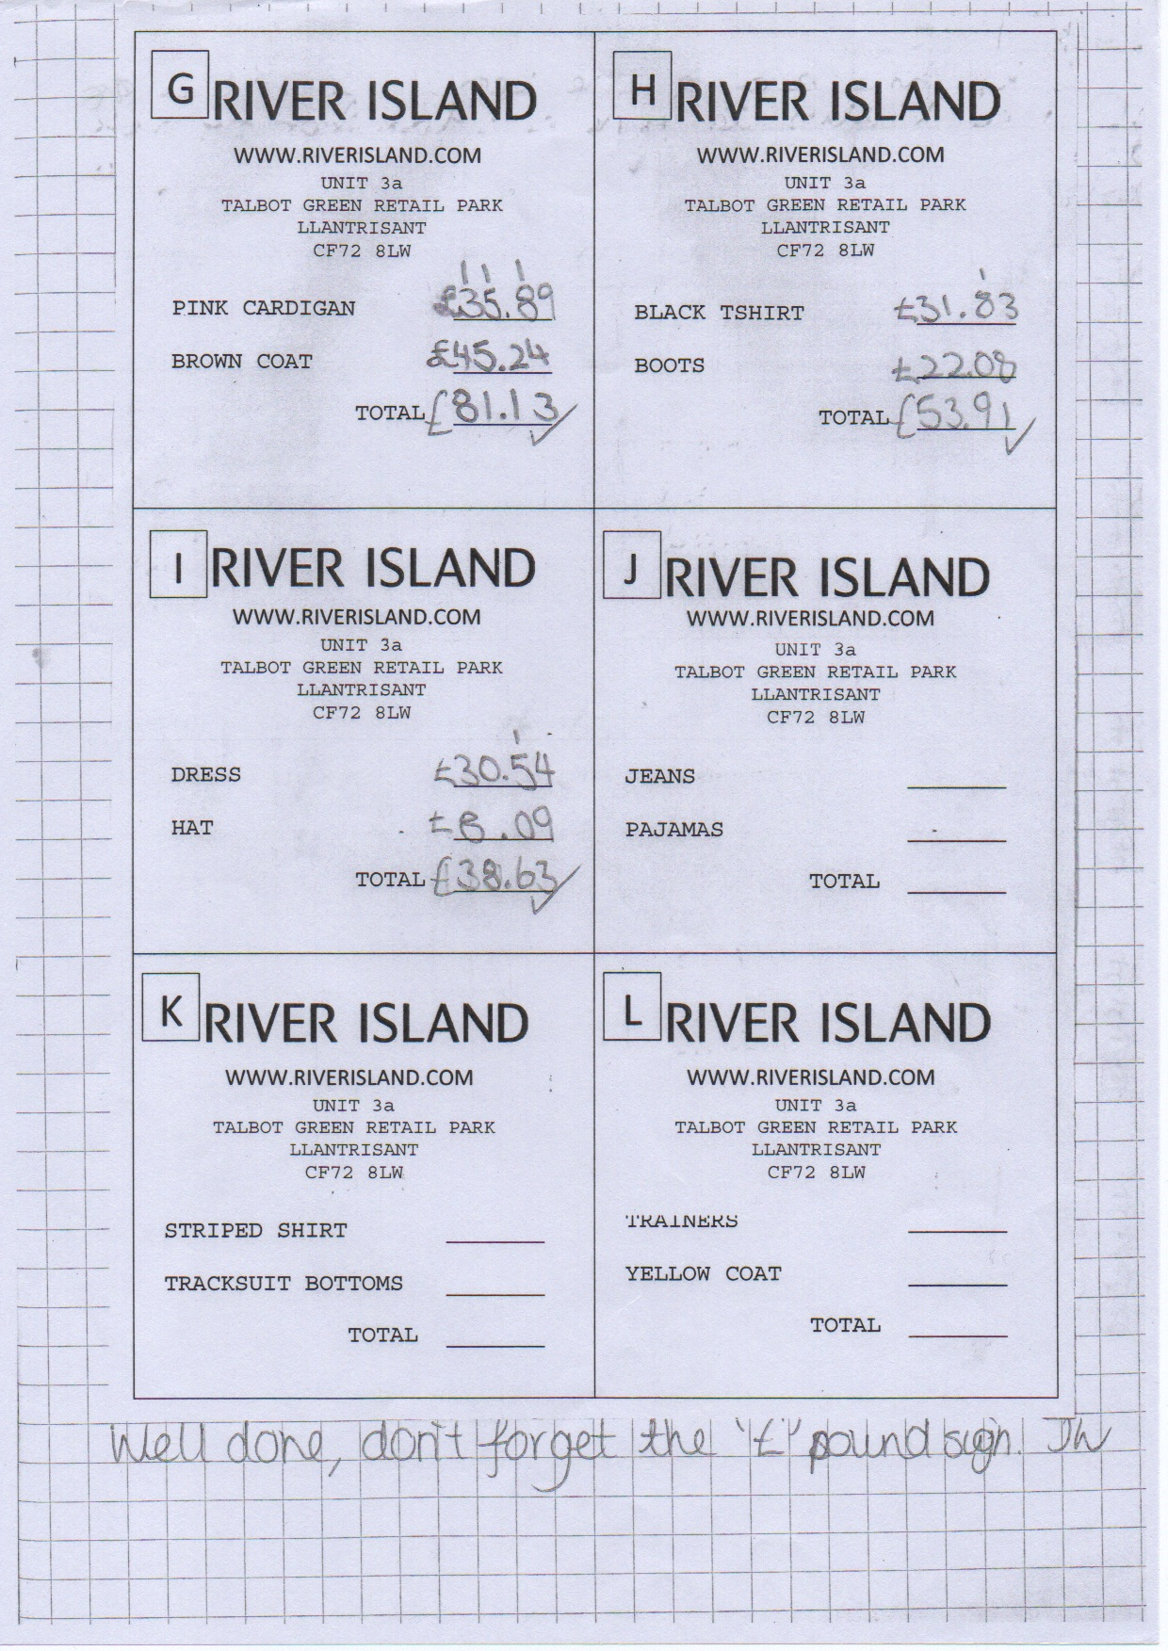

Appendix 9
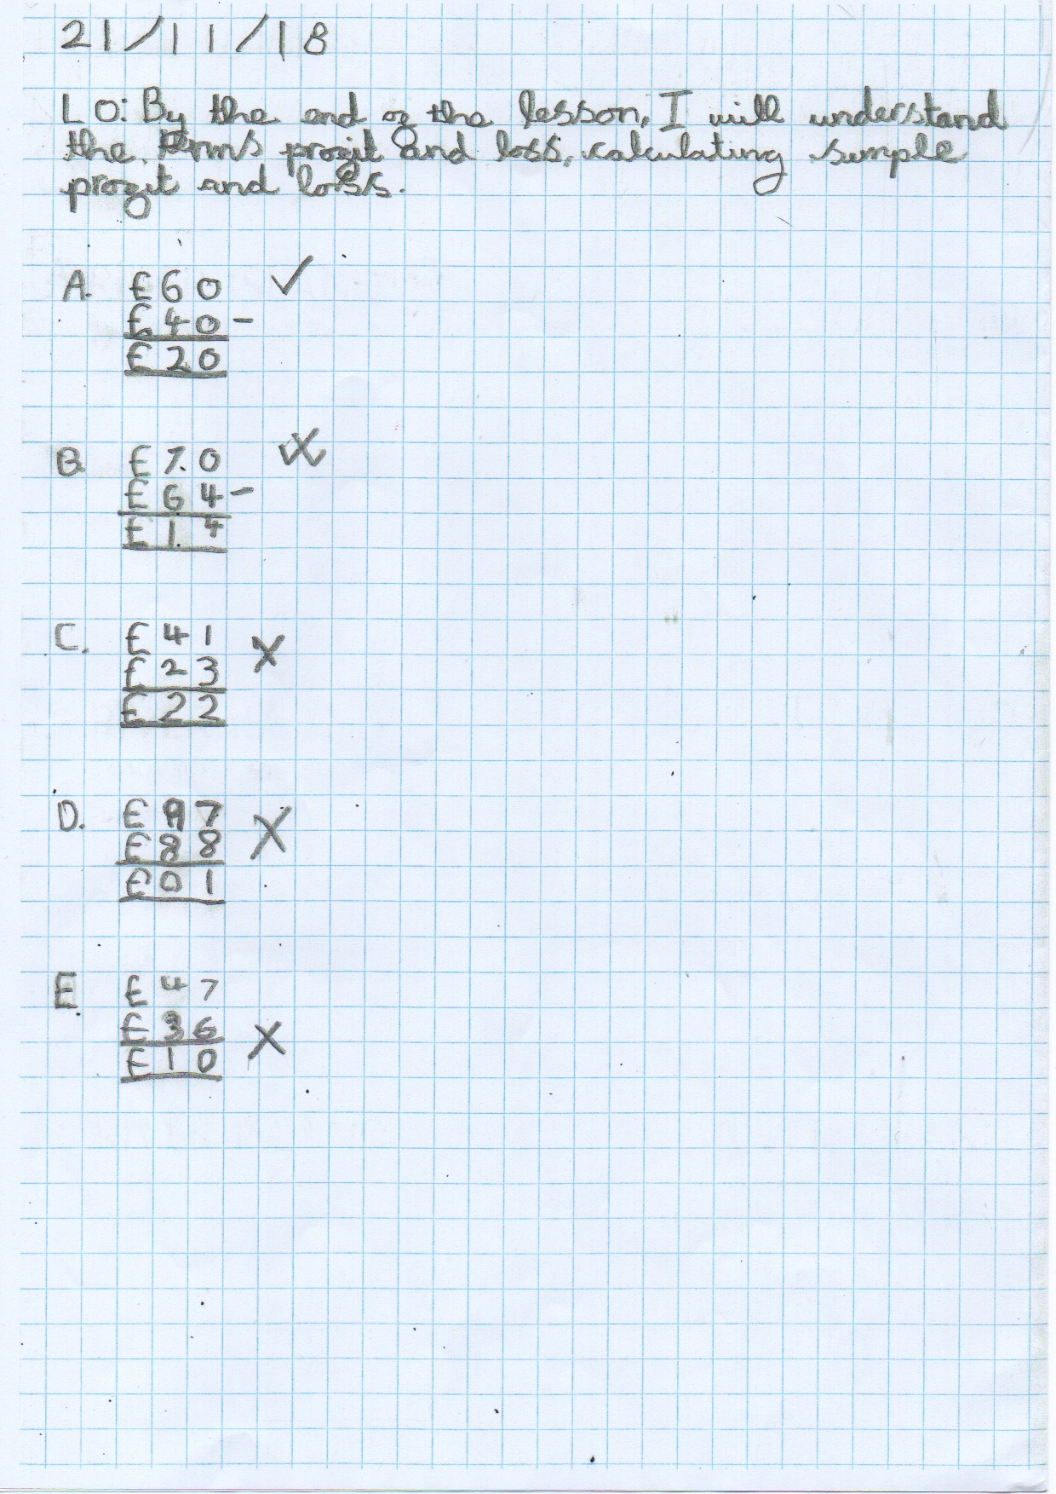

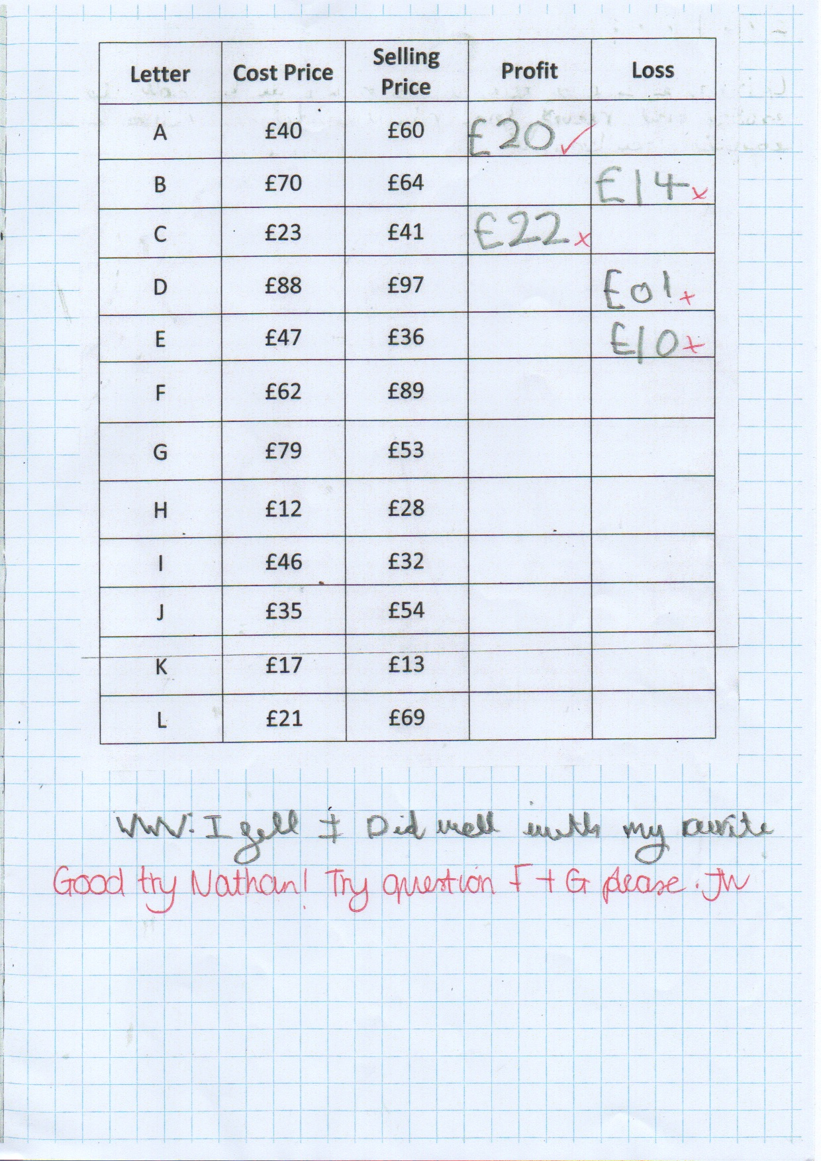

Appendix 10
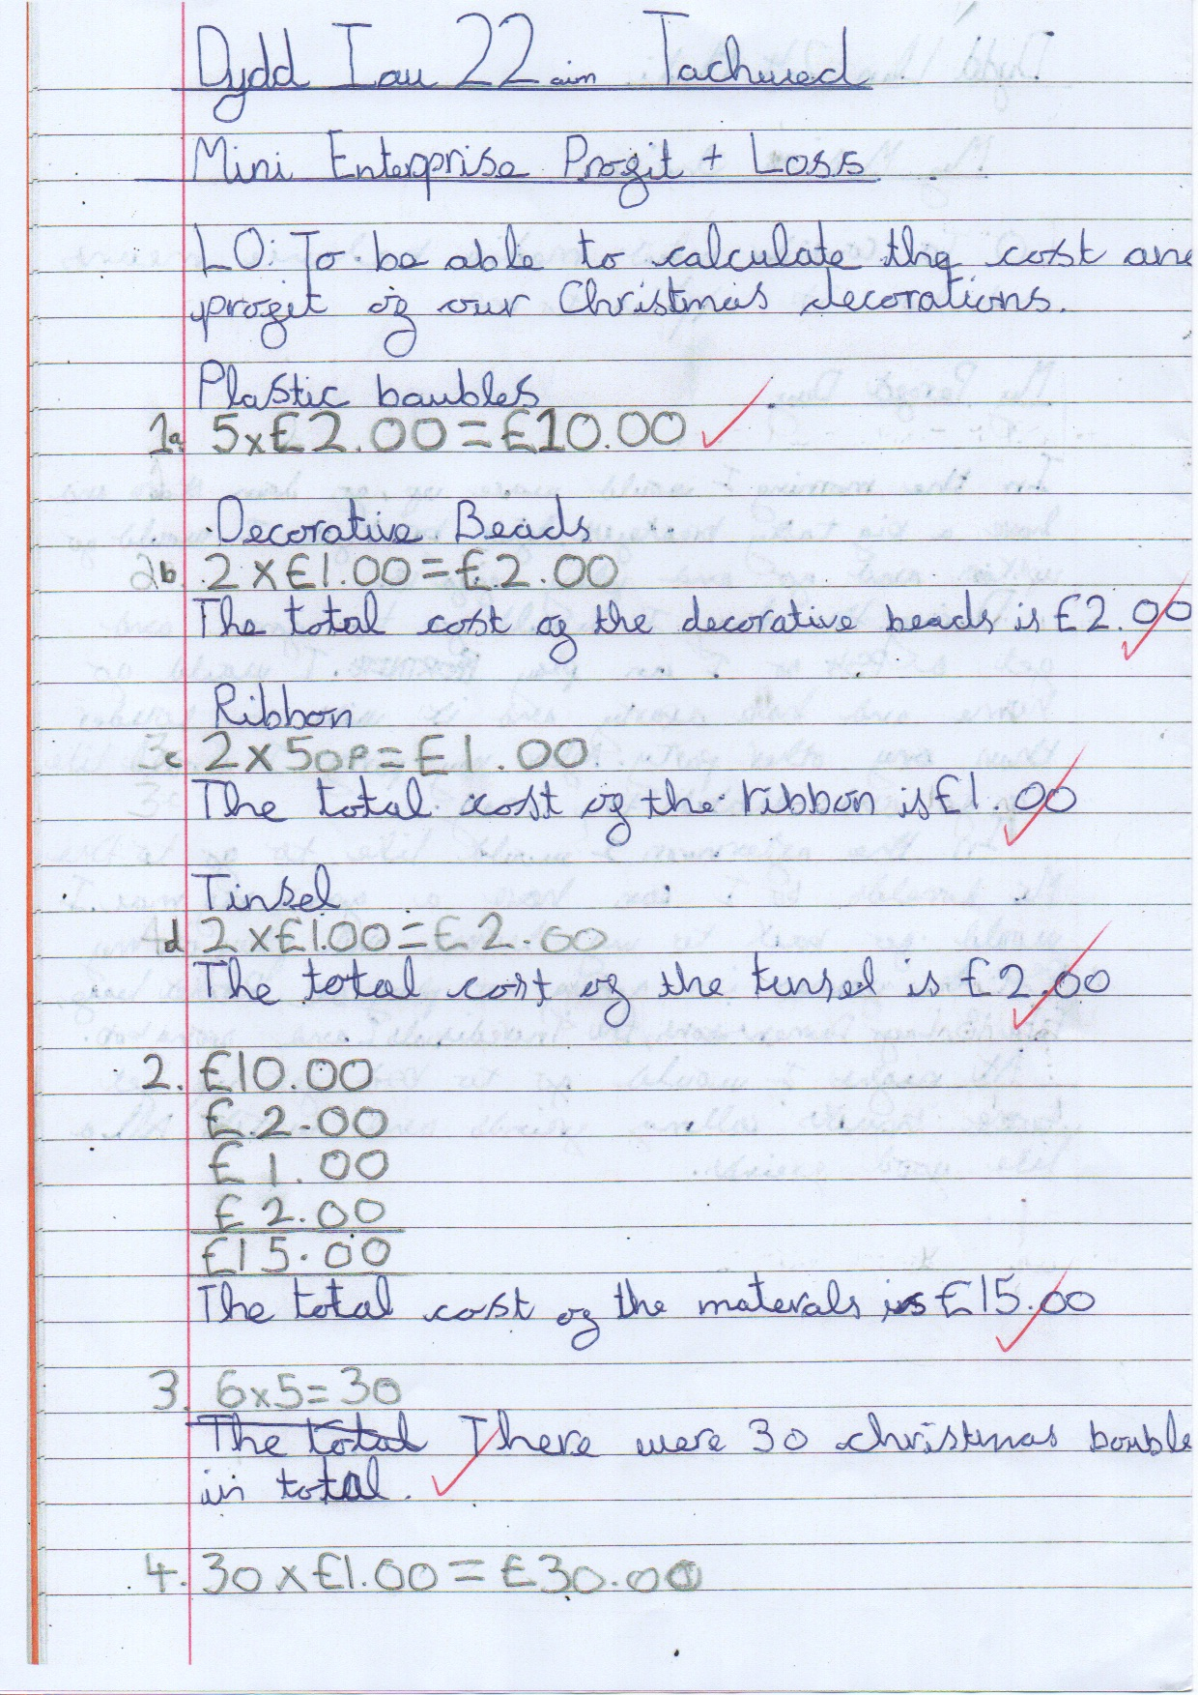

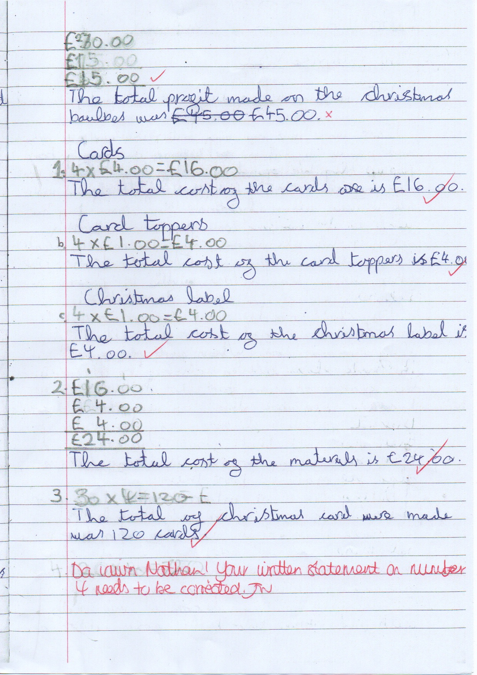

Appendix 11
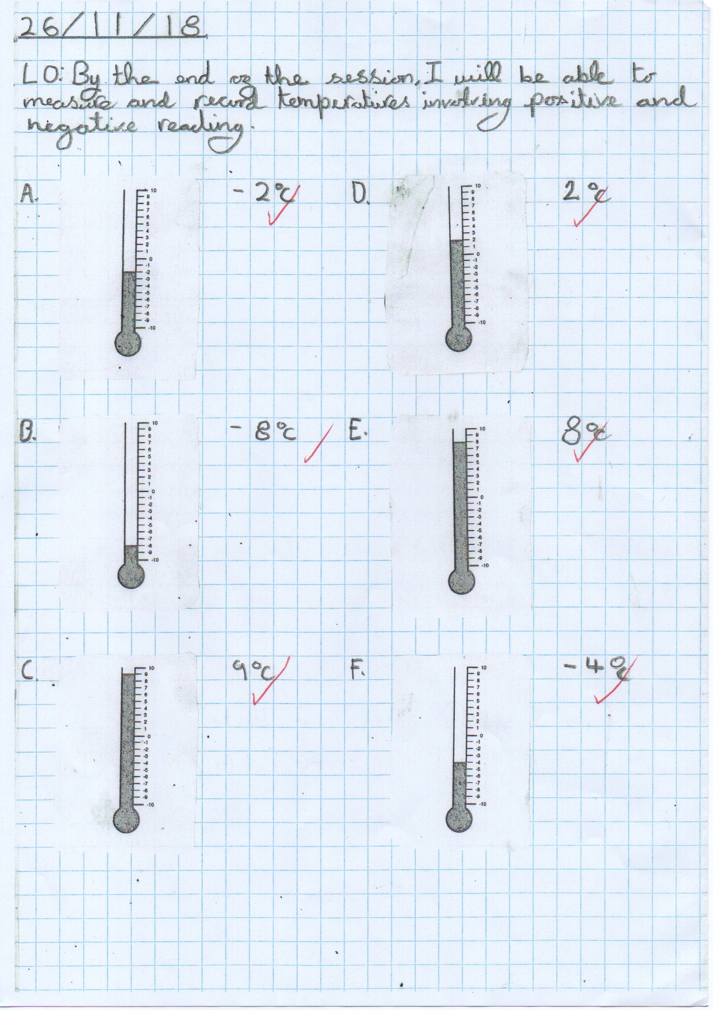

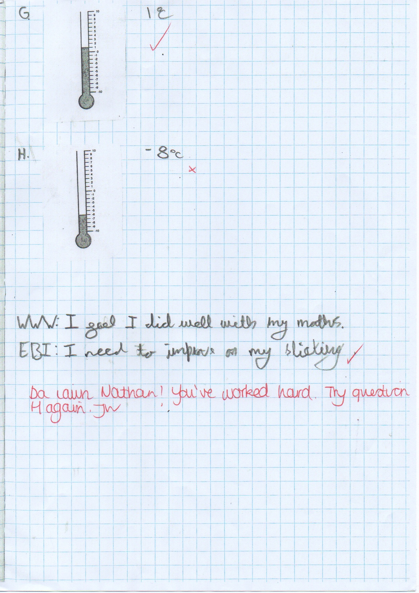

Appendix 12
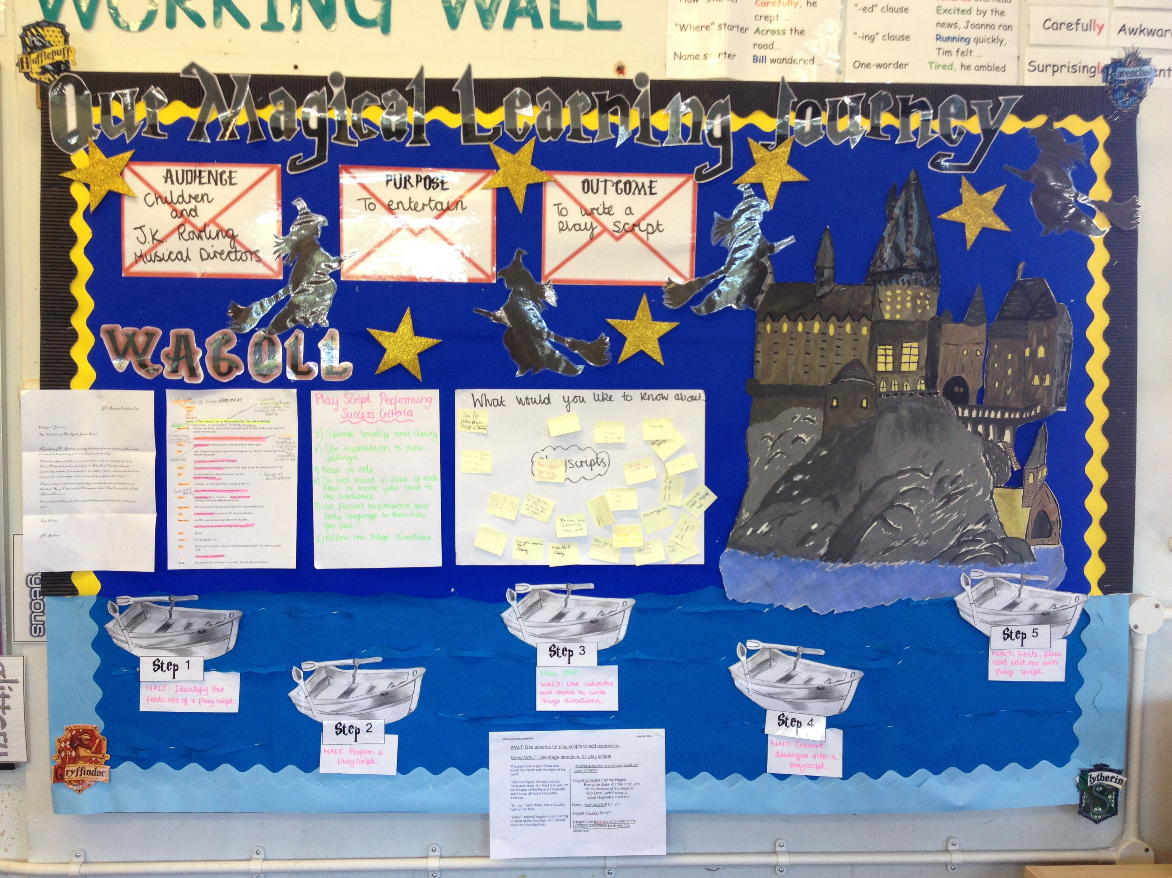

References
Atkinson, S. (1992) Mathematics with Reason: The Emergent Approach to Primary Mathematics. London: Hodder and Stoughton.
British Educational Research Association. (2018) Ethical Guidelines for Educational Research. 4th edn. London: BERA.
Barnes, J. (2015) Cross-curricular Learning 3-14. 3rd edn. London” SAGE Publications.
Black, P and Wiliam, D. Inside the Black Box. London: GL Assessment.
Clark, A. and Moss, P. (2011) Listening to Young Children: The Mosaic Approach. 2nd edn. National Children’s Bureau
Bolton, G. (2014) Reflective Practice: Writing and Professional Development. 4th edn. London: SAGE Publications.
Cockburn, A. and Littler, G. (2008) Mathematical Misconceptions. London: SAGE Publications.
Corbett, P. (2008) Jumpstart! Poetry. Oxon: Routledge.
Cotton, T. (2013) Understanding and Teaching Primary Mathematics. 2nd edn. Harlow: Pearson Education Limited.
Cremin, T et al. (2009) Teaching English Creatively. Oxon: Routledge.
de Bono, E. (2009) Six Thinking Hats. London: Penguin.
Donaldson, G. (2015) Successful Futures. Cardiff: Crown.
Dweck, C. S. (2006) Mindset: The New Psychology of Success. New York: Random House.
Estyn. (2016-2017). The Annual Report of Her Majesty’s Chief Inspector of Education and Training in Wales 2016-2017. Cardiff: Crown.
Goodwin, P. (2011) The Literate Classroom. 3rd edn. Oxon: Routledge.
Graham, J. and Kelly, A. (1998). Writing Under Control. London: David Fulton Publishers.
Grigg, R. (2015) Becoming an Outstanding Primary School Teacher. 2nd edn. Oxon: Routledge.
Hansen, A. (2014) Children’s Errors in Mathematics. 3rd edn. London: SAGE Publications.
Haylock, D. and Cockburn, A. (2014) Understanding Mathematics for Young Children. 4th edn. London: SAGE Publications.
ICO. (2018) Guide to the General Data Protection Regulation. Cheshire: ICO.
Krathwohl, D. R. (2002) ‘A Revision of Bloom’s Taxonomy: An Overview’, Theory into Practice, 41/4, pp. 212-218. Accessed: 22nd March 2019. https://www.depauw.edu/files/resources/krathwohl.pdf
NAG. (2013) Literacy and Numeracy in Wales. Cardiff: National Assembly for Wales.
Pound, L. (2005) How Children Learn. Leamington Spa: Step Forward Publishing Limited.
Pound, L. and Lee, T. (2015) Teaching Mathematics Creatively. 2nd edn. Oxon: Routledge.
Stephens, P. and Crawley, T. (2002) Becoming an Effective Teacher. Cheltenham: Nelson Thornes Ltd.
UNCRC. (1990) The United Nations Convention on the Rights of the Child. Available at: https://www.unicef.org.uk/rights-respecting-schools/wp-content/uploads/sites/4/2017/01/UNCRC-in-full.pdf (Accessed: 21st March 2019).
WAG. (2010) How to Develop Thinking and Assessment for Learning in the Classroom. Cardiff: Crown.
WAG. (2014) National Literacy and Numeracy Framework. Cardiff: Crown.
WAG. (2016a) Programme of Study for English – Key Stages 2-4. Cardiff: Crown.
WAG. (2016b) Programme of Study for Mathematics – Keys Stages 2-4. Cardiff: Crown.

