Module Code & Name: BMSW6103: Leading and Implementing Workplace Change
Assignment title: Case analysis on Leading and Implementing Workplace Change

Student Name: Mohammad Wasimuzzaman
Student ID: 1708859
Tutor Name: Gladius Kulothungan
Table of Contents
Introduction 3
Recent History of the Organization and Impact of the Changes in the External Environment including Covid-19 Pandemic upon the Company 3
PESTLE Analysis 3
Organisational performances, process, structure, supply chain 8
Present Status of the Company 10
Developing Models for Change 11
Recognizing the Need for the Change 11
Response of the Organization towards the Change Management 12
Models for Change 12
Kotter’s 8-Step Change Model 12
Lewin’s Change Management Model 15
Prevalent Leadership Style in the Organisation 16
Leadership Style Used in the Organization Adhering to the Change 17
Contribution of the Leadership Style Towards the Change 18
Impact of the organizational culture on the change management programme and developing a suitable change management plan 18
Prevalent organizational culture 18
Contribution of the culture towards the change management 19
Developing a suitable change management plan 20
Recommendations 21
Conclusion 22
References 23

Introduction
The academic report has the purpose to produce a demonstration of the impact of changes in the external environment on the business strategy and operations of Tesco, one of the prominent retail supermarkets in the UK. The recent pandemic due to Covid-19 has a severe impact on the company and it requires an appropriate change management process to mitigate the consequences through an understanding of the impact of the changes in business operation and employee engagement as well. The report has also developed a model for change that incorporates the issues regarding strategic change in the company including the impact of the change in their leadership style. The report also aims to assess the impact of company culture on the change management process by identifying the kind of organisational culture within Tesco and how it helps the change management process. Tesco has the leading market share in the retail industry of the UK and it is assorted a large part geographically by opening stores in around 14 countries (tescoplc.com 2021). The company produces a wide range of product and service lines operating with more than 400000 employees and it generated 64.76 billion pound in 2020 as annual revenue (tescoplc.com 2021).

Recent History of the Organization and Impact of the Changes in the External Environment including Covid-19 Pandemic upon the Company

PESTLE Analysis
Political Factors
The UK enjoys a stable political climate. The nation had gone through some challenging times during the Brexit movement. The main reason behind this was that there was an uncertainty over the ways in which the new business policies would come about. This had given rise to the notion of complex taxation policies in various regions of the nation. The business of Tesco also got affected to some degree owing to the same as they had to maintain different tabs of taxation within their organization. This turned out to be a rather costly and time-consuming process (Oxford Analytica, 2019). Things had changed after final settlements were made in adherence to modifications in the policies and the political conditions had become stable. This was disrupted again by the strike of the pandemic of Covid-19 which imposed restrictions between certain international transactions of business in the UK. Tesco again had to suffer as this led to disruptions in their supply chain management owing to the restrictions on the import export policies (Gostin and Wiley, 2020).
Economic Factors
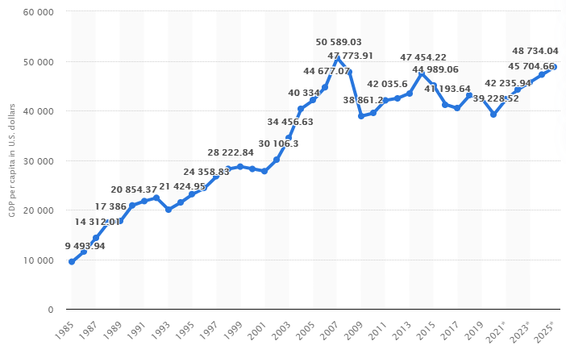
Figure 1: GDP of the UK over the Years
(Source: O’Neill, 2021)
The GDP of the UK is quite viable as it stood around 42000 US dollars in the year 2019. The inflation rate also revolved around the usual 2% mark and stood at a viable 1.9% in 2019. The government of the UK is also a supporter of foreign direct investment. All this meant a boon for the retail sector and it had enjoyed the perks of the same over the years.
The recent pandemic of Covid-19, however, changed the things for the worst. It led to complete disruptions within the business model of certain retail organizations. The chief reason was the plunge in the economic activities which affected the UK in the worst possible manner as the economic activities saw a historical fall of 13% (Walker, 2020).
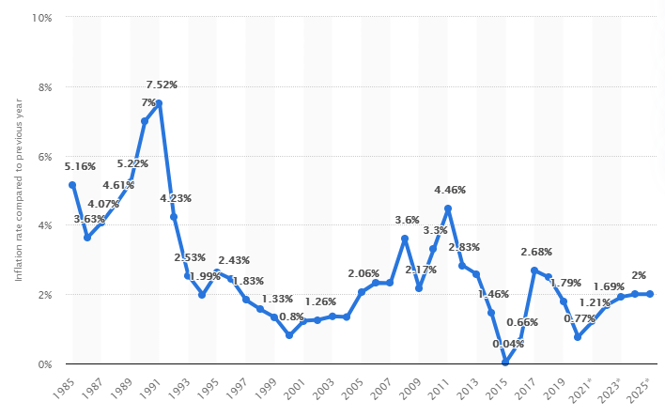
Figure 3: Inflation Rate in the UK over the Years
(Source: O’Neill, 2021)
This changed the economic conditions quite drastically as the GDP plunged to 39000 US dollars within a few months and the inflation rate also went down to 0.77% leading to disruptions in the business activities for organizations like Tesco (O’Neill, 2021).
Social Factors
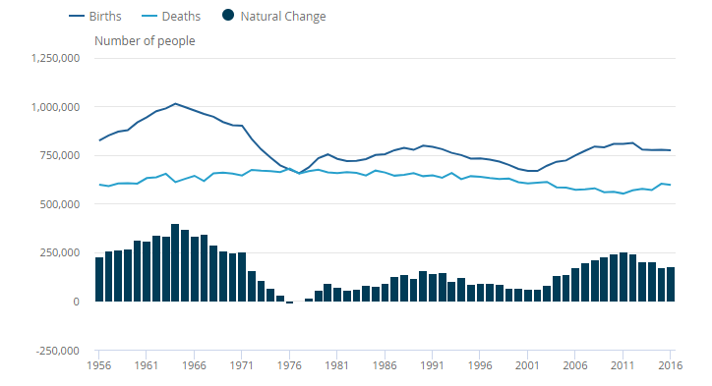
Figure 4: Birth and Death Rates in the UK over the Years
(Source: Office for National Statistics, 2017)
The UK has been experiencing lesser death rates in the recent years. The significant achievements and improvements in medical science have been mainly responsible towards this (Office for National Statistics, 2017). The positive economic conditions also means that majority of the population could be categorized under the segment of the high earners. Tesco was able to cash in on this as they would be able to go for increasing the prices of some of their products and the customers would not feel any sort of cash crunch owing to the same, thereby increasing the profit margins for the organization (Hecht et al., 2020).
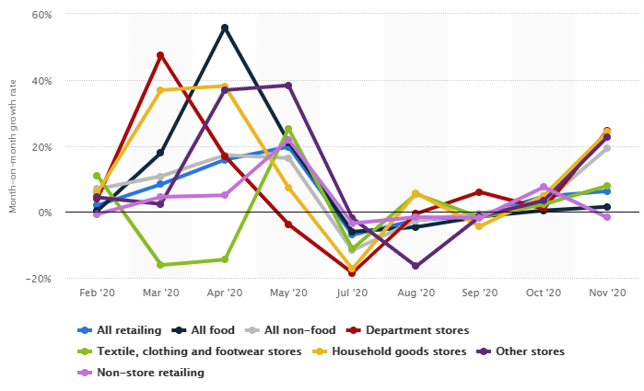
Figure 5: Increase in the Sales of the Retail Sector in the UK owing to Covid-19
(Source: Sabanoglu, 2021)
Things took a downfall in this matter too as the pandemic of Covid-19 led to the imposition of severe lockdown measures and social distancing norms had to be followed. This led to the closing of various physical retail stores of Tesco thereby striking a blow to their business initially. However, it was found that the lockdown norms meant that there was an increase in the online sales on certain e-commerce platforms and the retail sector also got benefited from this. Tesco was able to cash in upon this factor and they also underwent revamp in their online business sector that would help them cater to the customer needs effectively even during the challenging times of the pandemic (Sabanoglu, 2021).
Technological Factors
The UK homes some of the best research and development institutes in the world. This helps it attain a viable position in the world map in adherence to the notion of technological prowess. Tesco took the advantage of this factor in order to invest upon the improvement of their own research and development sector that led them to restricting of their online mode of business that would help in the creation of a better business model (Breznitz, 2020). They were also able to conduct a thorough market analysis in order to gain an idea of the current trends in the market which had largely changed owing to the pandemic and the customers emphasized more upon the notion of cost cutting. Tesco took into account all these factors and helped in aligning the business model with adherence to the same. The partnering with several social media platforms like Facebook and Twitter also helped them in the promotion of their business in an efficient manner (McDonald, 2020).
Legal Factors
The UK has certain laws in place that foster equality at the workplace. Some of these are the Employment Act 2002 and the Equality Act 2010. Such laws and acts guarantee the equal treatment of the employees at the workplace. Tesco adheres to the same to see to it that there is no sort of discrimination prevalent in the workplace on grounds of sex, caste, age or creed. They regularly provide training and development opportunities to all of their employees that would foster their career progression in a positive manner (Shackleton, 2017). The pandemic of Covid-19 had resulted in pay cuts for many of the employees as many of the physical outlets of the organization had been shut down. Tesco still saw to it that each of the employees got their compensation on an equal basis that would help them to struggle with the challenging times posed by the pandemic. They ensured this with the offering of 10% bonus to its staff members (Pratt, 2020).
Environmental Factors
The government of the UK has certain policies and laws in place in order to uphold the environmental quality of the nation. For example, it partners with the Kyoto Protocol o take measures for reducing the factors which yields significant damage to the overall environmental quality and air index of the nation. It takes necessary steps to monitor the operations of various business organizations to see to it that they do not pose any sort of harm to the environmental quality (Ferrey, 2018). Tesco has been adhering to such principles since their inception and has not faced any problem as such in this matter. The fall in the economic activities owing to the lockdown measures has resulted in lessening the environmental pollution too. Still, there is a need for Tesco to regularly monitor their activities and take necessary steps towards the maintaining of environmental quality such as the reducing of carbon footprints from their business. Such steps would ensure the longevity of conducting business without facing any sort of government tribulations (Khan and Qianli, 2017).

Organisational performances, process, structure, supply chain
In order to retain competitive advantage in the industry over the other retail organisations in the UK during the crisis due to Covid-19, Tesco has possessed proper skills and competencies by organising continuous training and development among the employees and it has decided to maintain long term relationship with the customers and the suppliers (Frei et al., 2020). It leads the company to make effective changing processes in the workforce and strategic thinking and innovation enables the company to achieve long-term benefits at minimal cost.
For Tesco, process refers to the flow of different operations and series of various activities through which a particular product is designed and produced. In accordance with the changing behaviour of the customers, an effective process is required with the help of advanced technological uses and skilled manpower that lead the company to improve customer satisfaction rate even in the pandemic (Fadeyi, 2020). There is a requirement of flexible volume due to the changing behaviour of the customers in the retail industry, thus; Tesco implements a batch process that enables the managers of the company to make a customer centred strategy in order to retain customer loyalty and win their lifetime value. The batch process helps to conduct the whole supply chain process sequentially and it also enables the employees to work on flexibility according to the demand and supply of the products (Brannen et al., 2020).
Organisational structure can be defined as the kind of function in which a business firm is working and it can be distinguished into three groups that include hybrid, centralised and decentralized structure. In previous operating years, Tesco was involved in centralised organisational structure that created some of the disadvantages in terms of local customer dissatisfaction for the company (Wood et al., 2017). However, during the pandemic, the company has implemented a decentralized structure in which the employees have gained a better understanding of the customers’ requirements in accordance with the latest trends and consuming behaviour. The decentralized structure of Tesco has helped the company to satisfy the customers through its online services. The company can be recommended to adopt a hybrid structure that includes both the advantages of centralised and decentralized structures (Antunes et al., 2017). If the company operates with these approaches properly, it will be beneficial for the employees and it will help to increase their flexibility and participation towards organisational change.
According to the process of Tesco, supply chain refers to the movement of products and services from the sources to the consumers and it involves a number of processes including collecting resources, manufacturing, forecasting orders, transporting and customer services (Mc Loughlin et al., 2021). Leadership of Tesco over the competitors in the retail industry has comprised the process of supply chain with efficiency and continuous improvement. The continuous replenishment process in the supply chain system of Tesco has been done during the pandemic in accordance with the flexibility of customers' needs and requirements. Process efficiency and innovation are the key drivers of the supply chain process of Tesco (Chkanikova and Sroufe, 2021). Continuous process improvement and new product development are the key focus of the retailer to improve the customer shopping experience. However, the implementation of online groceries has led to additional cost mostly in payroll during the pandemic. The leaders of the company supported the employees in the wider business sector to ensure that the company remains disciplined in the supply chain system with their approach (Mubarik et al., 2021).

Present Status of the Company
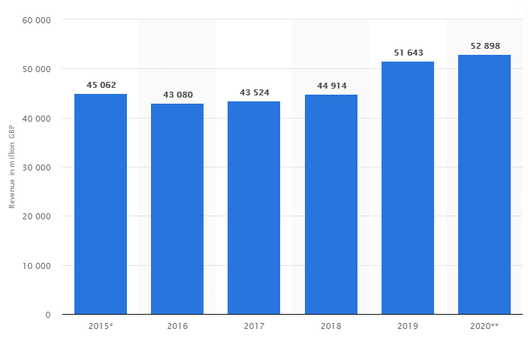
Figure 6: Revenue Generation of Tesco over the Years
(Source: Coppola, 2020)
Tesco is the leading supermarket chain in the UK. The company has been regularly generating revenue on an average of 50 billion British pounds on a yearly basis (Coppola, 2020).
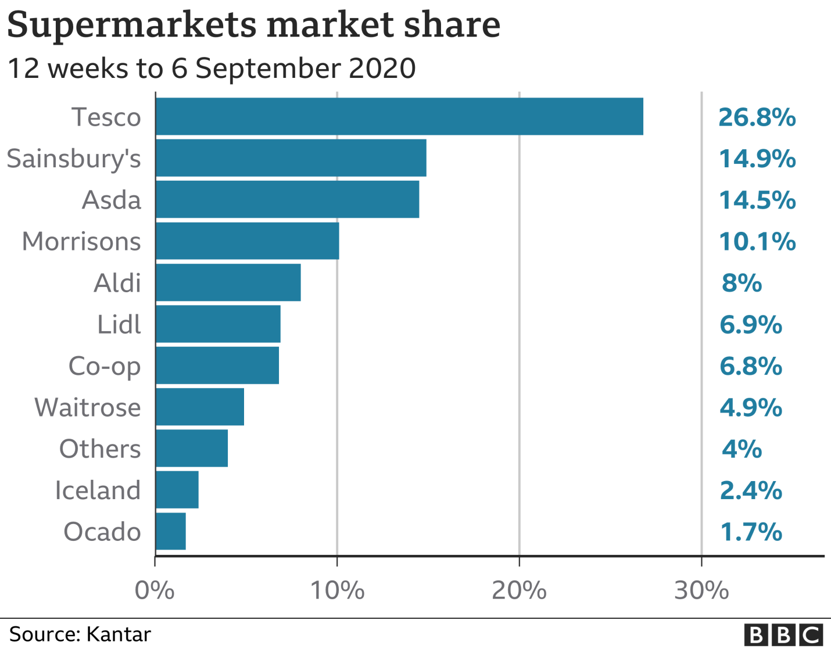
Figure 7: Market Share of Tesco Compared to Other Retail Organizations
(Source: Simpson, 2020)
The company had experienced a fall in the business owing to the pandemic of Covid-19, but they were quick to realize a need for change in the conventional mode of business and they shifted majority of their business to the online channel which helped them to regain their market position and increased their market share to 26.8% even in the face of the pandemic (Simpson, 2020).

Developing Models for Change

Recognizing the Need for the Change
There was a specific need for change owing to the circumstances of the pandemic of Covid-19. The lockdown measures and the social distancing norms meant that Tesco would not be able to conduct business in the manner they used to by emphasizing mainly upon their physical stores. The pandemic necessitated the need for revamping the online sales function of the organization in a much more effective manner that would help them to generate effective revenue even during the time of the pandemic and would help them to support their staff members (Liebowitz, 2020). This also meant providing necessary training to some of their staff members who were not much tech-savvy so that they would be able to ascertain themselves with the changes that the organization would undergo in adherence to the present consequences.

Response of the Organization towards the Change Management
The organization planned upon the resources that would be required for undergoing the necessary changes. They invested upon the necessary technical equipments that would help them to drive the change process in an effective manner. They also conducted a thorough market analysis to get an idea of the current trends in the market and changes in the buying behavior of the customers that were mainly the results of the pandemic of Covid-19. The ways in which the situation was being handled by most of their competitors like Asda. Lidl, Sainsbury’s were also analyzed that would give them enough scope for further modifications in their business model (Cummins et al., 2020). This helped them to align their business model in adherence to the intended changes that would help them to shift majority of their business to the online sector. They also offered apprenticeship programmes to several of their employees that would help them to accustom themselves to the current mode of the business. Owing to the lockdown norms, the training was provided in a mixed approach in which the physical presence of the employees was only needed in some of the important situations while the rest were provided the training mainly in an online manner (Tesco, 2020).

Models for Change

Kotter’s 8-Step Change Model
Kotter’s 8- Step Change Model has been utilized by Tesco in the following manner:
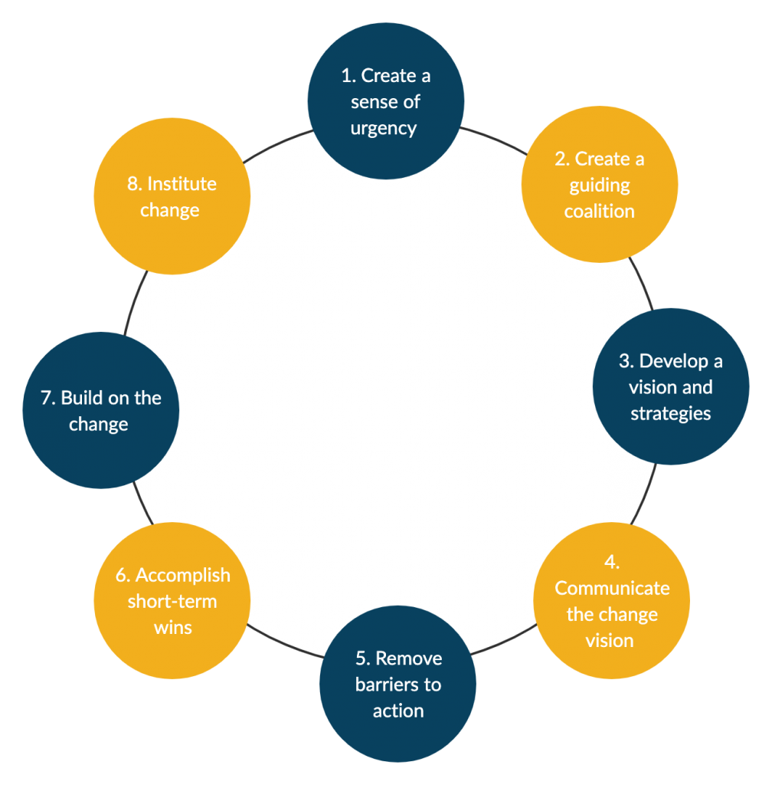
Figure 8: Kotter’s 8-Step Change Management Model
(Source: Galli, 2018)
1. Create a sense of urgency: The leaders at Tesco created a sense of urgency within the minds of the employees and the higher authorities to make them realize the need of the change management that the organization would have to undergo given the present conditions of the business owing to the pandemic of Covid-19. This helped in removing any sort of doubt behind the notion of the change from the minds of the employees that would otherwise lead to the creation of certain barriers to the change process (McDonald, 2020).
2. Build a guiding coalition: It had to be decided by Tesco about the necessary team members that would lead to the driving of the change process in an effective manner. As the change was mainly from the technical perspective, Tesco took into account the appointing of software engineers, programmers and IT support teams that would help them in achieving the change in an efficient way. The different kinds of resources that would be needed were also conveyed to the higher authorities who also became a part of the process and granted the necessary permission towards the acquiring of such resources (Tesco, 2020).
3. Form a strategic vision and initiatives: The way in which the change would affect the future of the organization was thoroughly discussed with the employees as well as the higher authorities of the organization. The initiative of the change was directed towards a vision in which the proposed change would result in offering greater levels of customer satisfaction even during the time of the pandemic as they would be able to get most of their products online and also provide feedback of their experience (Tesco, 2020).
4. Enlist a volunteer army: Tesco had to make sure that the leaders and the employees were on the same page regarding the change process. This would be essential towards the affecting of the change in the most viable manner for the organization. This helped them in the creation of a team that would help the organization to give shape to the change in the way it had been initially envisioned (McGrath and Bates, 2017).
5. Enable action by removing barriers: Tesco provided equal opportunities to everyone in the change process. The leaders made sure that there was no discrimination in the workplace during the process of the change. They ensured this by clearing any sort of doubts that might have arisen during certain phases of the change process and developing each of the employees in an equal manner so that they are able to adhere to the final outcome that would be brought by the changes (Bhatt, 2017).
6. Generate short term wins: Tesco abided by the notion of SMART objectives through which they were able to create short term goals for the change process. The very first step involved monitoring the progress of the change and making sure that the staff members within the organization were able to adhere to the process in an efficient manner (Bjerke and Renger, 2017). The modifications and upgaradations in the online sector of their business were also test run numerous times to see to it how they would be received by the audience and if they would be able to increase their ease of access towards the same.
7. Sustain acceleration: Tesco was able to taste success after the initial deployment of the new business model in the market. This can be evidenced from the positive growth of 8.6% in their sales. This led them to sustain the changes and the same momentum was carried forward by them in the following months too. This ensured that there was no stagnation point reached by the organization in terms of the change and they would be continuously looking for ways that would guarantee further improvements in the process (Simpson, 2020).
8. Institute Change: Tesco took into account the success factor that the initial changes had offered to them and took the decision to carry forward the process in a full-fledged manner as it had been recognized that the online business would be the only step forward in the current situation of the pandemic. This also led them towards the ring of 16000 additional staff to help them cope with the outcomes of the change and handle the increased pressure upon their online portals (McDonald, 2020).

Lewin’s Change Management Model
Lewin’s Change Management Model has been utilized by Tesco in the following manner:
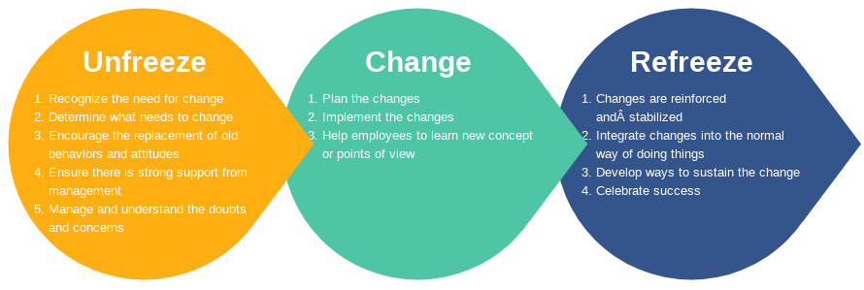
Figure 9: Lewin’s Change Management Model
(Source: Hussain et al., 2018)
Unfreeze: This is the very first step in which the prior aspects were modified in the prior model of business within Tesco and the benefits that the change process would offer in terms of the organizational revenue generation and the acquiring of a higher base of customers were conveyed to the employees and the higher authorities. A change in the leadership style of the organization was also necessary in this step that would help them to materialize the envisioned changes in the most efficient manner possible (Business Standard, 2020).
Change: This is the most vital phase of the model in which Tesco put into effect the change process. A team was made which would work in an informed manner to drive home certain factors of the change process that would lead to the development of a better business model for the organization The changes were made by upgrading their technical infrastructure that would help Tesco to adhere strongly to the notion of online business which had become the new norm owing to the pandemic of Covid-19 (McDonald, 2020). It also involved training numerous staff members and employees so that they become accustomed to the technicalities required to abide by the change process. This would help the organization to cater to the customers in an enhanced manner and also work upon the feedback that they would receive regarding their experience (Crosby, 2020).
Refreeze: After the organization experienced success by deploying the renovated business model, which resulted in an 8% increase in their sales figures, they continued with the model for the future as well. The leaders in the organization made sure that the employees were able to go with the modified business model and any sort of technical issues that they might have been experiencing were solved right at the onset resulting in the success of the change process (Simpson, 2020).

Prevalent Leadership Style in the Organisation
As Tesco had a hierarchical structure, the prevalent leadership style followed in the organization was that of a power leadership. Owing to this, the leaders would chalk out the necessary working plans and the employees had to follow them to the core. However, there were some modifications in the leadership style as Tesco puts regular emphasis on their employee benefits. So, traces of relationship style of leadership was also found in the organization as the leaders also paid heed to the suggestions of the employees and tried to address their grievances (Tesco PLC, 2020).

Leadership Style Used in the Organization Adhering to the Change
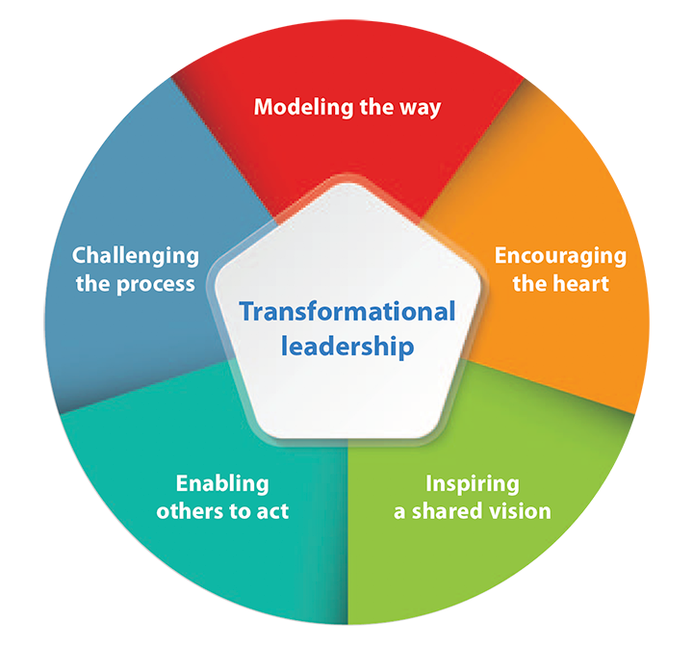
Figure 10: Transformational Leadership
(Source: Buil et al., 2019)
The discussed models of change help in reflecting upon the fact that the new adopted style of leadership in Tesco was mainly the transformational leadership. This was done in order to adopt the change process from the context of the change that would result in an effective administering of the change. The transformational leadership would guarantee this as it is based on the notion of a collaborative approach in which the leaders would work in tandem with the employees and try to achieve the goals that would lead to the effective management of the change process (Sharma, 2017).

Contribution of the Leadership Style Towards the Change
The transformational leadership helped Tesco to look for the most viable driving factors for the change. They conducted a thorough market analysis to get an idea of the context that would help in furthering the change process. The leaders also abided by an open approachability style which is an important facet of transformational leadership. This made them lend an ear to the suggestions of the employees and the problems that they were encountering during the change process (Blane, 2017). The suggestions were readily applied whenever necessary and the grievances of the employees were also addressed effectively owing to the nature of the transformational leadership that put the leaders in the shoe of the employees while making effective decisions towards the change process.

Impact of the organizational culture on the change management programme and developing a suitable change management plan

Prevalent organizational culture
According to Goulandris (2020), organisational culture refers to the pattern of beliefs, values, norms and attitude that shape the way employees behave within the workplace and how the organisational operations are done. It mostly relates to the relationship and pattern of behaviour from both the leaders and the workforce. Organizational culture embodies a common awareness held by the members of organization. Dominant or primary values are understood throughout the whole organization. Dominant culture conveys the core values that are combined by the majority of the organization’s employees. Subcultures have a tendency to grow a large organization to show common issues, problems, and experiences.
Culture can have dysfunctional aspects in some instances. Culture as a Barrier to Change when organization is undergoing change, culture may impede change. Culture as a Barrier to Diversity. Strong cultures put considerable pressure on employees to conform. Culture as a Barrier to Mergers and Acquisitions. Merging the cultures of two organizations can be difficult, but not impossible.
There are some strategies for merging cultures of employees into a organisation like Lewin’s Change Theory. Lewin argues that to achieve change, it is necessary to look at all the options available that can help the organisation move from the present to the desired state and adopt the best route possible. Lewin interpreted group dynamics and field theory that led to the expansion of Action Research and ultimately to the change theory (Suc, Prokosch & Ganslandt, 2009). Lewin’s theory of change follows three steps like unfreeze, change, and refreeze. Unfreeze Involves dismantling existing mindsets and must be part of surviving and defence mechanisms must be by passed for the second stage to succeed. The change stage is a period when the change occurs and typically the period where there is anxiety, transition and confusion. Employees need to adopt a change in thoughts, feelings, behaviour, or all three that is more productive in some way. During the Refreezing stage, the changes made to organizational processes, goals, structure, or people are accepted as the new norm or status quo. Lewin’s change theory is one of the effective models that seems to be successfully applied to Tesco organisational cultural change.
The flexible organisational culture in Tesco helps to increase the adaptability towards change and the shared culture in the workplace increases loyalty and contribution of the employees towards the company that leads to the enhancement of organisational performance and productivity (Yawson, 2020). The company has recently replaced its bureaucratic culture with a decentralized culture in which the participation of the employees and their flexibility has been increased. The shared culture helps the employees of the company to increase a better ability to comprehend organisational objectives to provide quality service to the customers. The decentralized culture of Tesco has a wider span of managing and controlling the adaptability of the employees towards the change management process and it also minimises the chain of commands by improving the employer employee relationship (tesco-careers.com 2017). The decentralized organisational culture also improves the inter-departmental coordination in the workplace of Tesco.

Contribution of the culture towards the change management
If organisational culture is not aligned effectively with the strategic goals and objectives of the company, the change management process gets harder to pull off. As the employees of Tesco are closely connected with the customers, their requirements are needed to be satisfied first. Thus, the relationship oriented decentralized culture of the company helps to keep the employees motivated and committed to the organisation (Kanakaratne et al., 2020). The company culture promotes innovation and makes the employees focus on creative thinking to achieve the objectives of the change management process. The task oriented culture contributes to the change management during Covid-19 pandemic by motivating the employees to become more productive rather than controlling them (Samdani, 2020). The organisation operates in a flexible culture that supports participative and relation oriented working style and the transformational leadership implemented by the leaders and managers of Tesco create a vision that presents the necessity to the change management process during the pandemic (tescoplc.com 2021).
The financial officer of Tesco reveals that the business operation has changed more during the couple of months due to Covid-19 than the last 10 years. However, the challenge has been overcome by hiring 16000 new staff members to cope up with the new shopping habits of the consumers and it results in an enhancement in the online sales (tescoplc.com 2021). Organisational culture has helped the leaders to provide immediate response to the pandemic by working with the colleagues to provide support in the rapid implementation of operational changes. More than 50000 temporary employees have been recruited to support the workforce of Tesco mostly in the distribution centre and as delivery drivers (bbc.com 2020). The transition of remote working went smoothly as the organisational culture was quite supportive to the practice. The flexible working culture promotes a better work life balance and the implementation of advanced technology and IT tools in remote working has enabled the employees to collaborate with each other seamlessly (Permingeat et al., 2020).
Tesco has created a drastic change in the customer service sector by enhancing its E-Commerce service and by developing self service in order to minimise the time of the consumers while standing in the queue. In order to avoid any kinds of conflicts in the employee management, Tesco has introduced an internal support and recognition program for the staff members and its business operations without any dissatisfaction between the management and the workforce (Myerson, 2020). The change management process during the crisis has the purpose to retain loyal customers and the internal and external change agent in Tesco by communicating with the help of Elton Mayo theory. The change management process allows maintaining service stability and improves the availability of effective customer service. It helps to enhance the probability of success in the change in procedures like remote working and online selling by ensuring that all the stakeholders are well informed and aware of the planned changes (Lehn, 2020). It ensures that technical accountability and the managerial process have been identified and evaluated for all the changes. The organisational culture has helped the employees to adopt the change process and it motivates to improve their effectiveness in order to enhance the financial status and productivity of the company even after the pandemic. However, due to limited resources allocation and some economic factors, organisational culture of Tesco has created some of the resistance to change (Sulivan and Gouldson, 2020). Technology has enabled the company to make changes in terms of remote working by developing communication effectively through emails, video conference and instant messaging. On the other hand, in order to cope up with the external environmental changes and changing behaviour of the customers, the sales teams are formed in a cross-cultural manner that also promotes diversity and expands the business operations across the world (Dawson and Meehan, 2021). Due to the implementation of advanced technology, communication became more effective and the employees became able to coordinate with each other through virtual networks.

Developing a suitable change management plan for Tesco
While developing an appropriate change management strategy for Tesco to improve its services, it is important to engage all the stakeholders in the plan. Here, a change management plan for optimising the E-Commerce service of Tesco has been developed.
Step 1-identifying the stakeholders: it is the first step to improve the engagement of stakeholders in Tesco while developing a change management strategy (Damer, 2020). The most important stakeholders of Tesco are the employees, customers, suppliers, community and media.
Step 2-prioritising the stakeholders: it is important for Tesco to prioritise all the stakeholders according to the preference and attribution to bring change and development in the company. It can be considered as an effective process for gradual development and improvement of the service.
Step 3-engagement strategy: the managers of Tesco must establish an effective engagement strategy so that it can bring commitment and motivation among the workforce (Hodges, 2020). Delegation, presentation and sharing the change plan can be considered as the methods of engaging them towards the transition process.
Step 4-optimising support: the next step is to involve the stakeholders and optimise their support by motivating them to give their best in the most possible way. It is also important to utilise the resources effectively to provide support to the stakeholders.
Step 5- monitor the changes: the last step involves the monitoring and reviewing of the change process in accordance with the demand of the customers with time (Uddin and Ferdous, 2020).

Recommendations
The leading changes that have been adopted by Tesco surely enhanced the business marketing and strategies of the organization at a high level. The certain changes that have been made to Tesco due to the pandemic of Covid 19 have definitely reached the business of the organization to the maximum level. However, the company can apply the changes to some other level where the company will easily reach their targets and goals of business marketing and customer satisfaction. Some recommendations for the further betterment of the organization are as follows:
Tesco has adopted a decentralized culture in their organization which motivates the employees in their participation and encourages them to work hard for the company which leads to success in the goals of the business (Mytnyk and Nosa, 2020). Hence, the company, Tesco can apply the decentralized culture in a proper and strategized mannerism so that the workers of the company can be attracted and influenced by the change.
Tesco has applied the shared culture in their organization in the post COVID situation. Thus, the shared culture of Tesco can be improved further so that the employees get inspiration to work together in the wellbeing of the business.
Justification of using the models
The eight step change model of Kotter’s increases the strategies and policies of business and also develops the observation of the business. This model of change will enhance the workers empowerment for global marketing and the model also develops the ideas and opinions of changes in an organization (Weiss and Li, 2020). Thus, the application of this model of change in Tesco is quite justified for the sustainable growth of the organization.
Tesco has adopted Lewin’s model of change as this model is very simple to implement and gives some easy planning and programming for the organizational change which leads the company to achieve their aims (Cone and Unni, 2020).

Conclusion
The report concludes that a change management plan is essential for each business change to reduce its consequences and gain benefits by exploring the changes through effective employee interaction and process. The report has developed an understanding of the recent history of Tesco, the leading supermarket retailer in the UK and how the company has been impacted by the changes in the external ambience due to Covid-19 crisis. By developing a comprehension on change management models, the report has discussed how the changes have been managed by the company with the help of its leadership styles and how organisational changes have affected the change process.

References
Antunes, B., Symon, G., Veersma, U. and William, L., 2017. Bargaining for Productivity: the UK case.
Bhatt, R., 2017. Theoretical perspective of change management. CLEAR International Journal of Research in Commerce & Management, 8(2).
Bjerke, M.B. and Renger, R., 2017. Being smart about writing SMART objectives. Evaluation and program planning, 61, pp.125-127.
Blane, H. 2017. 7 Principles of Transformational Leadership: Create a Mindset of Passion, Innovation, and Growth. London: Red Wheel/Weiser.
Brannen, M.Y., Mughan, T. and Moore, F., 2020. The Creative Use of Insider Ethnography as a Means for Organizational Self Investigation: The “Essence of Tesco” Project. In The Routledge Companion to Anthropology and Business (pp. 132-154). Routledge.
Breznitz, S.M., 2020. 3. The US and UK Technology Commercialization Framework. In The Fountain of Knowledge (pp. 41-59). Stanford University Press.
Buil, I., Martínez, E. and Matute, J., 2019. Transformational leadership and employee performance: The role of identification, engagement and proactive personality. International Journal of Hospitality Management, 77, pp.64-75.
Business Standard. 2020. Tesco to create 16,000 permanent jobs in UK amid online sales surge. [online] Available at: <https://www.business-standard.com/article/international/tesco-to-create-16-000-permanent-jobs-in-uk-amid-online-sales-surge-120082401328_1.html> [Accessed 6 April 2021]
Chkanikova, O. and Sroufe, R., 2021. Third-party sustainability certifications in food retailing: Certification design from a sustainable supply chain management perspective. Journal of Cleaner Production, 282, p.124344.
Cone, C. and Unni, E., 2020. Achieving consensus using a modified Delphi Technique embedded in Lewin's change management model designed to improve faculty satisfaction in a pharmacy school. Research in Social and Administrative Pharmacy, 16(12), pp.1711-1717.
Coppola, D. 2020. Annual revenue of Tesco Group in the United Kingdom (UK) and the Republic of Ireland from financial year 2015 to 2020. [online] Statista. Available at: <https://www.statista.com/statistics/490931/tesco-group-finance-revenue-united-kingdom-uk/#:~:text=In%20its%202019%2F2020%20financial,to%20the%20prior%20financial%20year.> [Accessed 6 April 2021]
Crosby, G. 2020. Planned Change: Why Kurt Lewin's Social Science is Still Best Practice for Business Results, Change Management, and Human Progress. London: CRC Press.
Cummins, S., Berger, N., Cornelsen, L., Eling, J., Er, V., Greener, R., Kalbus, A., Karapici, A., Law, C., Ndlovu, D. and Yau, A., 2020. COVID-19: impact on the urban food retail system and dietary inequalities in the UK. Cities & Health, pp.1-4.
Damer, L., 2020. Successful Talent Management Strategies Business Leaders Use to Improve Succession Planning.
Dawson, C. and Meehan, S., 2021. The Customer Copernicus: How to be Customer-Led. Routledge.
Fadeyi, A.P., 2020. An Analysis on the Application of Motivational Theories at Workplace and the Impact on Employee Engagement: A Study of Tesco Ireland (Doctoral dissertation, Dublin, National College of Ireland).
Ferrey, S. 2018. Examples & Explanations for Environmental Law. London: Wolters Kluwer Law & Business.
Frei, R., Jack, L. and Krzyzaniak, S.A., 2020. Sustainable reverse supply chains and circular economy in multichannel retail returns. Business Strategy and the Environment, 29(5), pp.1925-1940.
Galli, B.J., 2018. Change management models: A comparative analysis and concerns. IEEE Engineering Management Review, 46(3), pp.124-132.
Gostin, L.O. and Wiley, L.F., 2020. Governmental public health powers during the COVID-19 pandemic: stay-at-home orders, business closures, and travel restrictions. Jama, 323(21), pp.2137-2138.
Goulandris, A., 2020. The Enterprising Barrister: Organisation, Culture and Changing Professionalism. Bloomsbury Publishing.
Hecht, K., McArthur, D., Savage, M. and Friedman, S., 2020. Elites in the UK: Pulling Away. London: The Sutton Trust.
Hodges, J., 2020. Organization Development: How Organizations Change and Develop Effectively. Red Globe Press.
Hussain, S.T., Lei, S., Akram, T., Haider, M.J., Hussain, S.H. and Ali, M., 2018. Kurt Lewin's change model: A critical review of the role of leadership and employee involvement in organizational change. Journal of Innovation & Knowledge, 3(3), pp.123-127.
Kanakaratne, M.D.S., Bray, J. and Robson, J., 2020. The influence of national culture and industry structure on grocery retail customer loyalty. Journal of Retailing and Consumer Services, 54, p.102013.
Khan, S.A.R. and Qianli, D., 2017. Does national scale economic and environmental indicators spur logistics performance? Evidence from UK. Environmental Science and Pollution Research, 24(34), pp.26692-26705.
Lehn, D.V., 2020. Digitalization as “an Agent of Social Change” in a Supermarket Chain: Applying Blumer's Theory of Industrialization in Contemporary Society. Symbolic Interaction, 43(4), pp.637-656.
Liebowitz, J. 2020. The Business of Pandemics: The COVID-19 Story. Milton Park: Taylor & Francis Limited.
Mc Loughlin, K., Lewis, K., Lascelles, D. and Nudurupati, S., 2021. Sustainability in supply chains: reappraising business process management. Production Planning & Control, pp.1-68.
McDonald, C. 2020. Tesco hires 16,000 staff to cope with Covid-19 shopping habits. [online] Computer Weekly. Available at: <https://www.computerweekly.com/news/252490266/Tesco-hires-16000-staff-to-cope-with-Covid-19-shopping-habits> [Accessed 6 April 2021]
McGrath, J. and Bates, B. 2017. The Little Book of Big Management Theories: ... and how to use them. London: Pearson UK.
Mubarik, M.S., Naghavi, N., Mubarik, M., Kusi-Sarpong, S., Khan, S.A., Zaman, S.I. and Kazmi, S.H.A., 2021. Resilience and cleaner production in industry 4.0: Role of supply chain mapping and visibility. Journal of Cleaner Production, 292, p.126058.
Myerson, P., 2020. Omni-Channel Retail and the Supply Chain: Working Together for a Competitive Advantage. CRC Press.
Mytnyk, A.A. and Nosa, I., 2020. CURRENT PROBLEMS OF ACTIVITIES OF CULTURAL INSTITUTIONS IN A DECENTRALIZED ENVIRONMENT. Publishing House “Baltija Publishing”.
O’Neill, A. 2021. Gross domestic product (GDP) per capita of the United Kingdom (UK) in current prices from 1985 to 2025. [online] Statista. Available at: < https://www.statista.com/statistics/263600/gross-domestic-product-gdp-per-capita-in-the-united-kingdom/> [Accessed 6 April 2021]
O’Neill, A. 2021. United Kingdom: Inflation rate from 1985 to 2025. [online] Statista. Available at: <https://www.statista.com/statistics/270384/inflation-rate-in-the-united-kingdom/> [Accessed 6 April 2021]
Office for National Statistics. 2017. Overview of the UK population: July 2017. [online] Available at: <https://www.ons.gov.uk/peoplepopulationandcommunity/populationandmigration/populationestimates/articles/overviewoftheukpopulation/july2017> [Accessed 6 April 2021]
Oxford Analytica, 2019. UK retail woe will worsen whatever the Brexit outcome. Emerald Expert Briefings, (oxan-es).
Permingeat, M., Fekete, G. and Turner, R., 2020. COVID-19, INEQUALITIES & RESPONSIBLE LEADERSHIP.
Pratt, L. 2020. Tesco rewards staff with 10% bonus payment. [online] employee benefits. Available at: <https://employeebenefits.co.uk/tesco-bonus-payment/> [Accessed 6 April 2021]
Sabanoglu, T. 2021. Month-on-month growth in online retail sales in the United Kingdom (UK) during the coronavirus (COVID-19) outbreak from February 2020 to November 2020, by sector. [online] Statista. Available at: <https://www.statista.com/statistics/1195913/uk-online-retail-growth-month-on-month-united-kingdom/> [Accessed 6 April 2021]
Samdani, T., 2020. Impact of Tesco's Private Label brands on buying behaviour of Millennials in terms of brand preference in Irish market (Doctoral dissertation, Dublin, National College of Ireland).
Shackleton, J.R., 2017. Working to Rule: The Damaging Economics of UK Employment Regulation: The Damaging Economics of UK Employment Regulation. London Publishing Partnership.
Sharma, M. 2017. Radical Transformational Leadership: Strategic Action for Change Agents. California: North Atlantic Books.
Simpson, E. 2020. Tesco profits surge as online orders double. [online] BBC. Available at: <https://www.bbc.com/news/business-54445399> [Accessed 6 April 2021]
Sullivan, R. and Gouldson, A., 2020. Climate Change and the Governance of Corporations: Lessons from the Retail Sector. Routledge.
Tesco PLC. (2021a). Covid-19. [online] Available at: https://www.tescoplc.com/covid-19/ [Accessed 6 Apr. 2021].
Tesco PLC. (2021b). Our history. [online] Available at: https://www.tescoplc.com/about/our-history/#:~:text=The%20name%20 [Accessed 6 Apr. 2021].
Tesco PLC. 2020. Annual Report 2020. [online] Available at: <https://www.tescoplc.com/investors/reports-results-and-presentations/annual-report-2020/> [Accessed 6 April 2021]
Tesco profits surge as online orders double. (2020). BBC News. [online] 7 Oct. Available at: https://www.bbc.com/news/business-54445399 [Accessed 6 Apr. 2021].
Tesco. 2020. Tesco COVID-19 updates. [online] Available at: <https://www.tesco.com/help/covid-19/> [Accessed 6 April 2021]
Tesco-careers.com. (2017). Culture | Tesco Careers. [online] Available at: https://www.tesco-careers.com/explore-our-world/our-culture/ [Accessed 6 Apr. 2021].
Uddin, S.M. and Ferdous, J., 2020. Exploring the Challenges of Organizational Leadership and Management. Journal of ELT and Education,.
Walker, A. 2020. Coronavirus: UK economy could be among worst hit of leading nations, says OECD. [online] BBC. Available at: <https://www.bbc.com/news/business-52991913> [Accessed 6 April 2021]
Weiss, P.G. and Li, S.T.T., 2020. Leading change to address the needs and well-being of trainees during the COVID-19 pandemic. Academic pediatrics, 20(6), pp.735-741.
Wood, S., Wrigley, N. and Coe, N.M., 2017. Capital discipline and financial market relations in retail globalization: insights from the case of Tesco plc. Journal of Economic Geography, 17(1), pp.31-57.
Yawson, D.E., 2020. Understanding Consumer Information Use in Small Businesses: The Determinants and Performance Outcomes. International Review of Management and Marketing, 10(5), pp.50-62.

