Project Management Report ACDA5004
Sue Maw
Richard Davies 1701574

Contents
2 Risk Management 2
2.1 Identification 2
2.2 Analysis 2
2.3 Planning 2
2.3.1 Inability to complete project 3
2.3.2 University closure or google collapse 3
2.3.3 Team member absence due to illness/holiday/family commitment 3
2.4 Monitoring 3
3 Code of Practice 4
3.1 Sustainability 4
3.1.1 First order 4
3.1.2 Second order 4
3.1.3 Third order 4
3.2 Ethical and Legal 5
3.2.1 Ethical 5
3.2.2 Legal 5
4 Quality Assurance 6
4.1 Functionality 6
4.2 Reliability 6
4.3 Usability 7
4.4 Efficiency 7
4.5 Maintainability 7
4.6 Portability 7
4.7 Software Quality 7
5 Appendices 8
5.1 Appendix 1 8
6 Bibliography 9

Risk Management
Risk management can be broken down into four sections; identification, analysis, planning and monitoring.

Identification
The risks for this project are as follows
- Team member absence due to illness/holiday/family commitments
- University closure
- Google collapse
- Inability to complete project

Analysis
Using an impact matrix, it is possible to put the risks in order of most serious to least serious
- R1 – Team member illness
- R2 – Team member holiday
- R3 – Team member family commitments
- R4 – University closure
- R5 – Google collapse
- R6 – inability to complete project
High Impact | R4, R5 | R6
Significant Impact
Moderate Impact
Low Impact |  |  |  | R1, R2, R3
 | Low Probability | Moderate Probability | Significant Probability | High Probability

The order of risks from most to least serious is:
- Inability to complete project
- University closure
- Google collapse
- Team member absence due to illness/holiday/family commitment

Planning
Each of the risks need adequate planning and there are four types of planning:
- Acceptance – the cost of avoiding the risk may be more than the actual risk
- Avoidance – avoiding the environment in which the risk happens
- Reduction – the risk has been accepted but actions have been taken to reduce it
- Mitigation – reduce impact if the risk occurs

Inability to complete project
This risk is the most serious as this would stop the project form being completed and has high probability of occurring due to the combined lack of knowledge and inexperience of the group.
For this risk the planning used was mitigation – this was accomplished through regular meetings about progression of current tasks and at the first sign that the project was having trouble the backup application would be put into development.

University closure or google collapse
when it comes to the university closing there is nothing the team can do and while it would have a high impact in the way of stopping the project it has a low probability of occurring.
As for google closing, it would have a high impact to the project because the whole project works on the location and maps APIs of google and while it would be possible to continue the project either through using a different companies API (apple maps) or by developing our own mapping system. these both come with added cost. Not to mention googles collapse would also impact the physical devices that the group is developing for.
Due to these reasons both these risks must be accepted.

Team member absence due to illness/holiday/family commitment
All three of these are very similar as they all have a high probability but would have a low impact on the group. As illness, holidays and family commitments cannot be avoided they have to be accepted as a standard when it comes to group work.
Luckily, due to the friendships of the group and the use of social media the group is in almost constant communication with each other and any absences are known immediately if not before hand and the work can easily be passed on or shared with the rest of the group.

Monitoring
The only risk which can be realistically monitors is, in this case, the most severe, the inability to complete the project. It is possible to know if the planning worked because this risk happened. The group was having an extremely difficult time using the android development IDE to develop an application to preform the required functions but thanks to regular meetings it was decided to start developing a web-based application alongside the original application in the event the android application was unsuccessfully developed.
At the next meeting the back -up web-based application had already surpassed the long in development android application in terms of functionality so the android application was scrapped in favour of the web-based application.
This had the unforeseen advantage of increasing the number of devices the project will work with because if the device has a HTML 5 capable browser it should work.

Code of Practice

Sustainability
Sustainability is simply the question, how green are we and what impact does this project have on the environment? And the answer has three parts or orders:
- First order – the direct result of the systems existence
- Second order – the result of the systems application
- Third order – long-term, socioeconomic structural changes
This system can be broken down into four main parts which each have a different effect, these parts are:
- The web-based application – this could simply be placed on a server which can be accessed from anywhere in the world, while servers are expensive to set up and expensive to run some of this cost can be minimised, for example if the server was placed in a colder country such as Iceland the cooling cost is reduced. This has a knock-on effect of using less electricity (for cooling).
- The main sender unit at the disaster location – while, for this project, we used the Royal Air Force Falcon system as base-line for what a sender unit could be it could be any infrastructure. If the disaster area has little to none infrastructure, then SHARD could use the H.E.L.P system or any equivalent.
- The repeater stations - If any infrastructure is present, then SHARD would utilise this and extend its range. As each SHARD devise is simply a screen and a battery it is possible to build these on an as-need basis on site from recycled materials and could then be recycled after use.
- The devices used by the users – now that the system is a web-based application almost any device with any HTML5 compatible browser could be used. This opens the potential for the rescue workers and volunteers to use their own devices, or even recycled older devices.

First order
The immediate result of SHARDs existence is an increase in web traffic to a disaster area and as more countries start to utilise this system the data centre holding the web server would have to increase in size which would use more power for operation and cooling.

Second order
The medium-term result of the system is an unknown as SHARD is a unique system, but it may influence the sorts of devices areas that are more likely to b affected by disasters that the population would buy, which could impact the economy of that country.

Third order
The long-term effect of SHARD could be a change in the global economy as compatible devices would more likely be purchased in disaster prone areas, but because of the possibility for using recycled devices this may not occur. Another effect would be the increase in power consumption at the datacentres housing the web servers, while this was cited as a first order impact, the longer it is operational and the larger it gets it could have a serious impact on the global climate, It would then be paramount that renewable energy is used.

Ethical and Legal
The legal and ethical guides that can be followed right now are pre-Brexit and with an unknown future on the horizon it would require a modification to the system as new legislation and code of conducts are written and revised.

Ethical
The ethics of this third sector project regarding the BCS and IEEE code of conduct are not that complicated if the codes are followed. There are a few that are pertinent such as:
- You shall have due regard for public health, privacy, security and wellbeing of others and the environment [1]
- to hold paramount the safety, health, and welfare of the public, to strive to comply with ethical design and sustainable development practices, and to disclose promptly factors that might endanger the public or the environment [2]
the only issue that could arise is the obvious discrimination towards the disabled while operating the system as search and rescue operatives can only be able bodied, and this goes against the public interest section of the BCS code of conduct [1]

Legal
According to the BCS digital Brexit report [3] after Britain has left the E.U it needs to ensure the future is:
- Data-driven
- Digitally-capable
- Secure
- Connected
And as long as SHARD utilizes security systems such as secure logins (password or fingerprint) and secure transmission types (HTTPS) the system will follow these outlines, the only issue that could arise is if the main location database is located on a server on the British isles It is possible there would be some unforeseen regulation put in place that SHARD would have to follow, but as long as the data is kept securely it would follow current guidelines [4].

Quality Assurance
According to the ISO 25010 [5] the quality of software depends on the following:
- Functionality
- Reliability
- Usability
- Efficiency
- Maintainability
- Portability

Functionality
Functionality simply asks the question does it satisfy user needs? And the answer must include the software’s suitability, accuracy, interoperability, functional compliance and its security.
While some of these points can occasionally contradict each other for example the more different software it can interact with it may not be as secure, they are all still important. At its current state SHARD is more of a minimal viable product that a fully working system but even at this pre-release stage it is still secure utilizing HTTPS to secure the data.
Although the software is still in development, we still must adhere to the W3C guidelines as SHARD is now web based.

Reliability
Due to the still in production nature of SHARD it is almost impossible to discuss its reliability. The longer software has been released the more stable it becomes this is the software’s maturity. It can be expected that after SHARD has finished being developed and has been released to the public the users will start to notice faults that where not discovered in testing and these faults can be fixed.

Usability
The usability of the system was at the for-front of the design of the user interface as it must be easy to understand, easy to learn and easy to use.
While SHARD is still in development, every design decision has usability at its core with only four main buttons under the map (See Appendix 1) and this simple design will allow the user to learn and understand the software quickly.

Efficiency
Efficient software will have a quick response time and resource utilization meaning that a user shouldn’t have to wait to long after an interaction before a response (clicking a hyperlink to load a new page) and use any allocated memory efficiently. SHARD is a web-based application so if the control server is powerful enough this shouldn’t be a problem.
As SHARD is still in its developmental phase it is not very efficient and is still not very quick to respond, but as it is only using a simple database server to show a few test locations the memory usage is negligible.

Maintainability
SHARD is still in development so it could be argued that it is constantly under maintenance, the software has recently changed to a web-based format and as the system is very simple the cause of any failure can be found very quickly. The issue with this is it is not stable, and any slight modification can and has crashed the system.
As the maturity of SHARD increases after releasing it will become increasingly more stable with each maintenance cycle which due to the extreme conditions under which the system is expected to be used the maintenance will have to be on a regular basis.

Portability
Portability deals with how easy it is to update and install the software which in the case of web-based SHARD it should run on any HTML5 compatible browser on any compatible device.
In terms of co-existing with other software SHARD depends on other software (browser) to work and because it is web-based application it can be easily upgraded without running into compatibility issues with older versions of itself.

Software Quality

Some of the previous characteristics can contradict each other and when it comes to SHARD this is absolutely the case. Because SHARD is going to be used in a disaster area it is important that it is reliable over efficient. SHARDs efficiency is important as it needs to be quick to respond to user input as the system is designed to call for help but, at its core SHARD needs to be reliable over everything else because the first time it stops working when it is in a disaster are it has failed to meet its very purpose.
As the system continues to be developed each of the previously mentioned characteristics will be fulfilled but the main areas that SHARD needs to fulfil are reliability and portability because without these it cant operate correctly.

Appendices

Appendix 1
SHARD simple user interface with only the four buttons
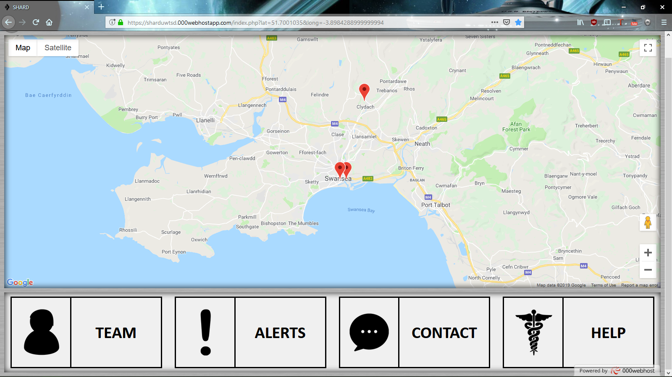

Bibliography

[1] | “BCS Code of Conduct,” 15 janurary 2019. [Online]. Available: https://www.bcs.org/category/6030.
[2] | “IEEE Code of Ethics,” 15 Janurary 2019. [Online]. Available: https://www.ieee.org/about/corporate/governance/p7-8.html.
[3] | “BCS Policy Hub,” The British Computer Society, 2014. [Online]. Available: https://policy.bcs.org/content/digital-brexit-planning-successful-digital-future-outside-eu. [Accessed 15 Janurary 2019].
[4] | “Rules for business and organisations,” European Commision, [Online]. Available: https://ec.europa.eu/info/law/law-topic/data-protection/reform/rules-business-and-organisations_en. [Accessed 15 Janurary 2019].
[5] | “ISO/IEC 25010,” ISO 25000, 2019. [Online]. Available: https://iso25000.com/index.php/en/iso-25000-standards/iso-25010. [Accessed 15 Janurary 2019].

