Evidence Based Practice

AC1.1
EBP, or evidence-based practice, means using the best available evidence, along with professional expertise and the preferences of the people involved, to make decisions about how to do something. It's like using a combination of research, knowledge, and what people want to figure out the best way to do things.
‘No job is more vital to our society than that of a manager. It is the manager who determines whether our social institutions serve us well or whether they squander our talents and resources’ (Mintzberg, H. 1990)
Many organisations use EBP to avoid malpractice especially in Healthcare. However, it is just as important to use in people practice. Henry Mintzberg says above, decisions made by organisations can affect many lives and the wellbeing of so many people. As this is the case, why are we making decisions based on emotions or opinions, when we have to evidence out there to support or deter these decisions and ones in which we can justify to others?
It is natural as human beings that we like to make our own decisions based on what we believe is right. It’s common for managers wanting to also seek out evidence that is true to what we believe. While it’s important not to ignore management experience, as this is not what Evidence-Based Practice is about, (CIPD, 2021a) there is a risk involved by moving forward with decisions that have not been based on evidence. This can have cost implications and create a dissatisfied workforce. People practitioners want to succeed to evolve by doing things that are proven to work. This can only be done by using the best available evidence there is to choose the best solution to the problems we face with more validity. After all, inclusive cultures are linked to higher innovation and performance (CIPD, 2021)
Barends et al’s (2014) talks about a survey that was carried out (Human Resource Management. Rynes.S. Colbert.A. Brown.K.(2002) with 950 HR professionals and showed large discrepancies between what managers think is effective and what the body of scientific research shows.
The General approach, as talked about by Rob Briner, (Briner. R. You tube. 2023) is broken down into 3 parts:
- Conscientious – Making sure you get as much evidence as you can from multiple sources
- Judicious – Look to see the quality of the evidence and how trustworthy it is
- Explicit – Write it down and discuss with others.
In the modern world, we have a huge source of opinion and information with social media at our fingertips. What can you trust when we are seeing so much information out there? It is extremely important not to ‘cherry pick’ the evidence as this would again lead to the outcome being based on personal preference. As Rousseau (2006) pointed out, an objectively derived evidence-based decision will reduce errors in decisions formed on the basis of subjectively held opinion.
According to the principles of EBP, evidence from four sources should be taken into account:
Scientific (academic journals)
Organisation (data gathered from the organisation)
Practitioners (Experience)
Stakeholders (opinions of people that will be affected).
In some instances the data could be scientific, but in people management there is so much more data we could be using when scientific isn’t an option. Good organisational data is just as important. To be able to make good decisions, we need to be reading/researching the data, understanding the organisation fully and knowing what makes it successful, and by asking critical questions. Once you have the answer it’s important to ask ‘why?’ You should then get a full understanding of the objectives that are set. As Simon Sineks says in his famous quote ‘People don’t buy what you do; they buy why you do it’
It is difficult to know how to find the best available evidence out there. To help you do this you can practice the six A’s (CIPD, 2021a): Asking, Acquiring, Appraising, Aggregating, Applying and Assessing. This will ensure the quality of the evidence you have is trustworthy so when you come to deliver the decision to others you can give explanations and show evidence based on why you have come to this conclusion.
My previous role as a Sales Director we heavily used EBP in training and development. All managers used the below with sales teams to help move forward:
- Use KPI’s to identify gaps in skill and any training needs that are present
- Research what training methods have been the most effective and what interventions that will help
- Develop training package based on findings from research above
- Deliver training programme to staff, reviewing it in regular 121’s and ongoing training
- Evaluate the effectiveness with data taken from before and after training.
This helped identify needs early and regularly, as needs would change, which then generated more sales which ultimately lead to the company having more success.
Decision making models can help you with the decision making process. If we look at Individual vs Group Decision making, individual may be faster but you are basing decisions on a single persons judgement. By asking a group the same question you will get a different perspectives and more information. When asking a group, there needs to be a structure in place and a time limit as group discussions can lead to extreme decisions if the group discussion intensifies.
There is some cost in the way of time by finding and dissecting the data, however, the result should save you money and time by implementing something that has been proven to work. Not everything is 100% perfect though. Even though the evidence tells you it is the right thing to do, we also need to be aware that it may not suit everyone. With Evidence-Based Practice you have to make sure that sometimes there may need to be some flexibility along with ongoing education amongst people practitioners to get the right solution for all.

AC 1.2
There are so many analysis tools that could be applied to recognise and diagnose organisational issues, challenges and opportunities. Porter’s Five Forces analysis, VRIO analysis (Value, Rare, Imitate and Organisation), SWOT (Strengths, Weaknesses, Opportunities, Threats). It’s important to find one that suits each organisation. The main one I am familiar with, and have used throughout my career, is the SWOT analysis. By using this approach it will help incorporate the internal and external environment. (CIPD, 2020a)
S – Strengths - What are we doing well?
W – Weaknesses - What can we do better?
O – Opportunities - What chances do we have to evolve?
T – Threats - What could stop us from achieving what we want?
This is a simple tool that everyone can use without the need for any training and provides a balanced view considering both positive and negative. It can be used in a vast way throughout any organisation such as:
- Helping set goals
- Improve performance
- Make decisions
- Problem solving
While it is extremely flexible, we need to be aware that the results can be influenced by personal opinion. It’s important to make sure there is a clear criteria in place with a diverse group of participants diving deeper if needed and make sure you update it regularly in order for it to be effective, suggesting the one ideology alone is not effective (CIPD, 2020a).
Focus groups, work sampling, interviews and observations are all a great way of analysing methods that can be applied to recognise challenges and opportunities, but surveys can help you achieve a wider distribution of people in many geographical areas fast. Having them filled out anonymously will encourage people to be more open and honest with their answers, especially if there are sensitive issues. As all respondents will have the same questions, presented in the same way, the data will be more comparable. Once you have all the data this will make it easier to identify patterns/trends.
Before the survey takes place you would need to identify the aims and objectives of the project before starting to collect the data as it would otherwise run the risk of missing something important. Taylor S. Woodhams. (2022)
Surveys can have a low response so is important for people to know why they are completing it and what’s in it for them to get a true reflection.
AC1.3
Critical thinking and Evidence based practice complement each other. It ensures the evidence you have is carefully evaluated which will lead to better decisions that are unbiased. It is the ability to think well. CIPD Podcast 2019.
Howlett (CIPD,2019) explains that there are 3 key parts to critical thinking:
- Critiquing the ideas and opinions of others.
- How they construct arguments and opinions themselves that they are communicating to others.
- Identify when others are using critical thinking techniques that impact how that people professional is making a case or building an argument making a business case.
As managers, the people/experts we have working for us may know more about a particular product/project than we do and it could be off-putting trying to have conversations with people when you have limited idea what they are on about. It could break down that communication which for any business could be detrimental. By using critical thinking in a workshop scenario, as Coburn (2019) talks about, helps you engage in strategic conversations without the need for all the knowledge.
An example of applying critical thinking to your own, or others ideas is done in several steps (Paul & Elder, 2006). :
Understanding Ideas – Know what’s being discussed
Questioning and Thinking - Ask why the idea is proposed and do SWOT analysis
Finding Evidence - Seek evidence to back up the idea and investigate its reliability
Reflecting –Look into personal biases and experiences
Making Judgments - Decide on the idea's validity based on evidence
Communicating - Clearly express your thoughts and listen to others
Learning and Growing - Use feedback to improve ideas.
As a result of practising critical thinking it help you feel confident you have had discussions that have been open and honest and resulting in better decision making.
AC1.4
CMI (managers.org.uk) introduces the Decision making checklist by stating that making effective decisions as a manager is a very significant challenge in a fast-moving world. There are a number of processes in decision making and you need to apply the one that is most suitable for the kind of decision you need to make. The Six Thinking Hats, a concept developed by Edward de Bono, (De Bono, 1985) is one. The idea is for each member of the group to have a different colour ‘hat’ and each colour hat represents a different mode of thinking:
White: Facts
Red: Feelings
Black: Problems
Yellow: Positives
Green: Creativity
Blue: Managing the process
This approach can really help individuals and groups think clearly about problems or decisions and all perspectives are discussed thoroughly. It can be used in many aspects of people management such as recruitment selection. White hat would examine the qualifications and experience. Red hat would consider feelings and if they would fit within the team. Black hat would think about challenges the candidate could bring. Yellow hat would highlight the strengths of the candidate. Green hat would look at creative ways to assess the candidate's potential and Blue hat would manage the recruitment process, guiding the team to a decision. It’s a method that ensures that all perspectives are considered. You can do it alone, however, according to Edward de Bono, the approach is designed to be used by groups to facilitate the decision-making processes (de Bono, 1985).
Decision making trees are another good way to look at different options at once. It’s similar to a flow chart where it can guide you through your decision making process by taking you through more manageable questions and then arriving at different outcomes. They can be used in various ways such as plan for future managers by identifying high flyers, identifying training needs by looking at gaps in skill and changing polices by looking at different scenarios.
Another one is Problem outcome framing. This involves reframing the problems in terms of their potential solution rather than focusing on the problems themselves (Kray & Haselhuhn, 2007). It can help teams make better decisions by changing their perspective. If we take staff development and use Problem outcome framing, we would be having discussions with staff members based on what we want the outcome to be by setting clear objectives.
AC 1.5
CIPD.org (pdf) explains that understanding the different ethical perspectives, and demonstrating sensitivity to the ones that matter is a core skill for people managers. It's crucial to consider various ethical perspectives to make decisions that are fair.
Utilitarianism aim is to maximise overall happiness and minimise suffering. It focuses on the greatest good for the greatest number of people. For instance, if a policy change could improve job satisfaction for a majority of employees, even if it inconveniences a few, utilitarian thinking would implementing that change
(britannica.com) says, deontological ethics is an action is considered morally good because of some characteristic of the action itself, not because the product of the action is good. It’s all about sticking to rules no matter what the consequences. This might mean always treating employees with respect and fairness, even if it might not lead to the best overall outcome for the company so if an employee requests time off for religious reasons during an important project deadline a deontological approach would make sure the employee's right to religious freedom comes first, not the project.
Virtue ethics is about the culture of the workplace. It's making sure you are being the type of person you want to be. https://youtu.be/NMblKpkKYao . Mark White and Robert Arp compare it to The Dark Knight film. It’s about having a culture of honesty, empathy, and integrity, even if it means sacrificing short-term gains. Looking at religious beliefs again, with virtue ethics, a manager would show compassion and understanding towards a member of staffs religious needs, creating a culture of inclusivity and respect within the team.
Serious risks can occur when an organisation’s culture is at odds with its stated ethical values. An organisation's success depends on trustful relationships with employees, customers, suppliers and the community. CIPD (2024)
AC3.1
Tim Stobierski (2020) shows us numerous ways in which businesses can measure financial performance on Havard business school online. One I am familiar with in my role as Sales Director is Net profit margin. Net Profit Margin = Net Profit / Revenue x 100.
It’s an important measure of a company's profitability and efficiency in managing its costs relative to its sales. Net Profit is the profit after all expenses have been deducted from total overall revenue. The way in which we could affect this in advertising sales was either make more money, or reduce our costs. When we had a high net profit margin it told us that we were efficient in converting sales into actual profit and showed us we were successful but if we had a low net profit margin it showed us we were less efficient and if this trend continued, we would need to make create more sales or reduce costs by losing staff for example.
By understanding net profit margin, businesses can make more informed plans, and achieve better financial health, however, while it’s valuable it has some limitations. At times during meetings directors would focus on net profit margin and look at it short term which would often lead to discussions about cost cutting. This can be concerning as once you cut costs to improve margins you could potentially harm any future growth.
Indeed (2023) tells us non-financial performance measures can allow you to gain a more comprehensive understanding of a company's performance. It can help look at areas without taking financial aspects into account and looking at the future of the company. We did this by measuring our customer retention. In classified advertising sales, would take a particular section, such as MOT stations, in a certain area, compare that with how many businesses we had with us, and then aim to grow that category while still maintaining the businesses we had. Plans how to do this would be agreed in 1-2-1 meetings, reviewed regularly to see progress being made. Measuring customer retention helps businesses increase profit, and keep competitive. While it is a great way to grow your customer base there can be occasions where growth is limited if you already have a high market share, so placing too much emphasis on retention may result in reducing returns.
AC 3.2
Impact refers to a change or action’s effect on someone or something. On the other hand, value refers to something’s usefulness or importance. In an organisation, value and impact are the outcomes of the organisation’s actions, stakeholders, and employees, besides the negative and positive effects they have on the entity and its environment (Stewart and Brown, 2019).
One of the ways you can add value to any business is by making sure you have a positive workforce. You can do this in many ways. Regular feedback sessions, sharing ideas and promoting mutual respect. Another way is having programmes in place to develop a pathway for staff to have opportunities to progress and develop their career. If staff feel valued, there is more chance of them staying within the organisation.
Everyone should all be aiming towards the same overall objective. The main business objective should be broken down for all staff members.
A method that is commonly used to measure the impact of people practices is KPI’s (Key Performance Indicators). Setting measurable targets will help you see the impact of people practices, especially in sales. These targets might include numbers such as sales team turnover, retention rates, sales productivity, training effectiveness, and employee satisfaction. By regularly tracking these in regular 121’s, companies can evaluate how initiatives affect outcomes. For instance, if there's an increase in sales performance after implementing a new sales training program, it indicates that the program is effective in improving sales effectiveness.
ROI is another which looks at the monetary side taking into account how much that particular person/activity costs and comparing it to the amount made/generated. By doing this, it provides an understanding of the return on investment (ROI) for that specific practice. This is valuable way of looking at it as it allows them to evaluate the effectiveness of their investments. It looks at the costs linked with the activity before comparing them to the expected results or benefits (Bailey et al., 2018)

AC 2.1, 2.2, 2.3
Understanding and addressing people practice issues are important to creating a productive and inclusive workplace. This involves analysing both quantitative (numbers-based) and qualitative (descriptive) data to make planned decisions and improve effectiveness.

Percentage of each Gender by type:

Looking at the above graph, it tells us that Females make up the majority employees in the workplace with 54% and males coming second at 45%. Non binary individuals make up just 1%.
Due to the small amount of non-binary employees this may reflect badly on the diversity of the business. Non-binary employees may feel isolated which could result in them not being as engaged or happy in their job and could ultimately result in legal risks related to discrimination if they don’t feel included.
To avoid any risks, awareness campaigns that educate staff about gender diversity and the importance of inclusivity should be made regular. Training programmes focusing on unconscious bias should be made mandatory and communication with experts is key to ensure the training is up to date. It’s also important to review and update any literature such as employee handbooks, marketing materials and any internal communications to include all gender identities.
Putting these initiatives in place could have some financial implications, however, addressing the imbalance through initiatives will improve the workplace culture and also drive better business outcomes by promoting a more inclusive workplace. This will lead to improving financial situations long term with staff happier so reducing recruitment costs and increasing overall productivity.
According to CIPD’s research (CIPD, 2020), businesses that prioritise gender diversity benefit from greater employee engagement, better decision making and enhanced innovation.

Ethnicity as a % per team:

Overall the organisation employs 260 staff members. Out of those 260 people, 91.15% class themselves as White British with Indian second overall with as little as 1.54% of the total workforce.
Looking at the individual team balance, we can see that all teams are predominantly white. The only team that looks more balanced is Community engagement and partnerships with 57% being White British; and Indian, Mixed other and White and Black Caribbean all showing 14.29% each. The significant imbalance can have a negative impact on the business by not having a true reflection on perspectives from all backgrounds.
A great way to improve this is in recruitment. A blind recruitment could be put in place to reduce bias. This will ensure that applicants are judged on their merits only. (CIPD, 2021). However, if not properly organised initially, this could result in no change as the outreach may have been insufficient so planning your audience when advertising is crucial.
The organisation needs to make sure there are internal programmes to support career growth for diverse employees, such as mentorship schemes and leadership training. Access to career opportunities for all employees is key.
By having diverse teams and including all cultures it can enhance employer attractiveness and the organisation will also get a better understanding of diverse markets. All initiatives need to be carefully considered as could result in legal challenges if poorly implemented. (CIPD, 2021)
Again, as above stated in the first graph, there are initial costs involved for training and improving policies etc. however, this will help staff retention, which in the long term will save money. As research shows that a more ethnically diverse workforce can enhance employee engagement and drive innovation. (CIPD, 2021) Research by Deloitte (2020) has also shown that inclusive workplaces see a 2.3 times higher cash flow per employee over a three-year period.

Disability percentage as an organisational whole and by teams.

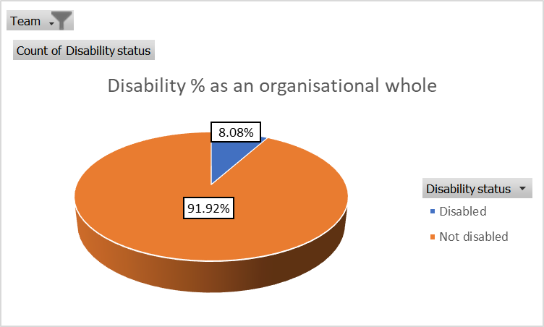

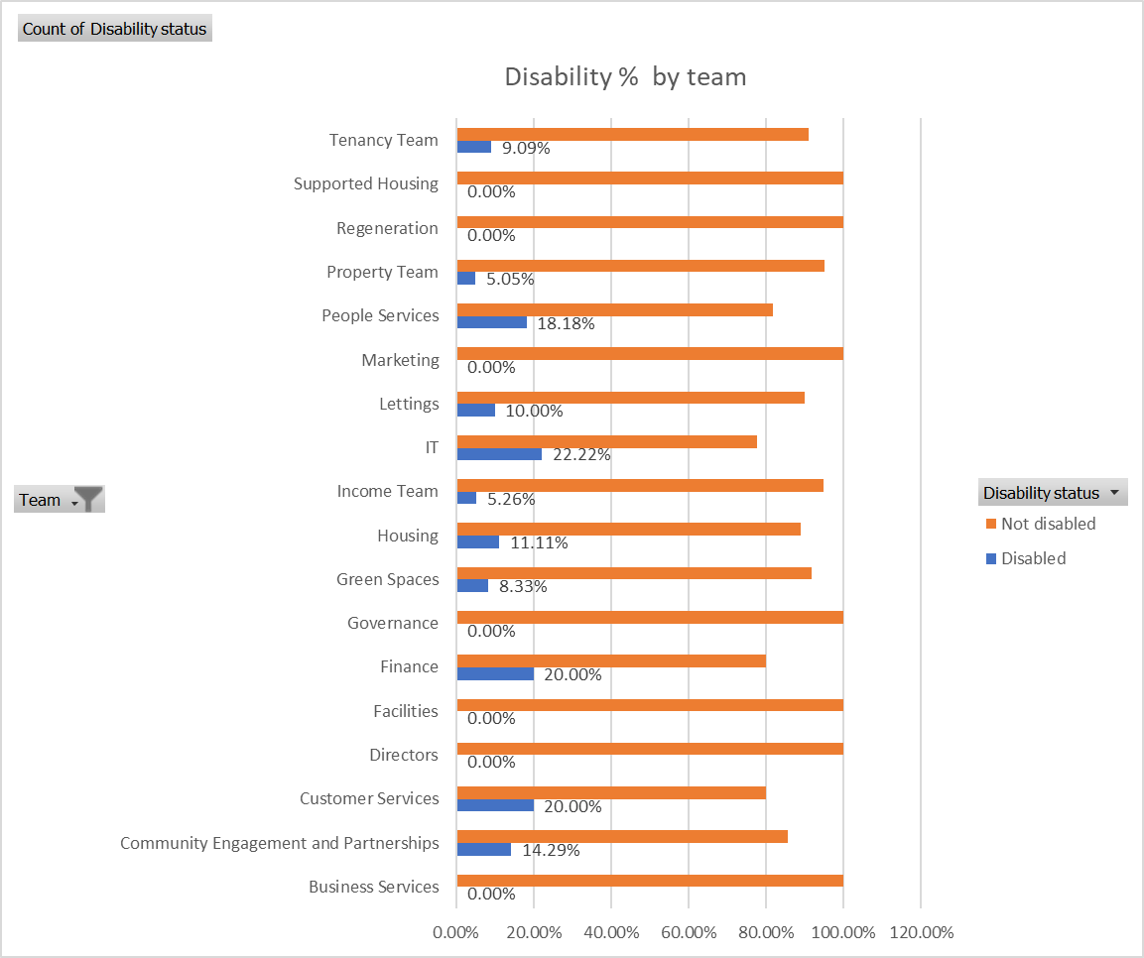

Disabled individuals represent only 8% of the workforce, which is a lot lower than the national average of around 19% (Office for National Statistics, 2023).
The teams with 0 representation of disabled individuals are Business Services, Directors, Facilities, Governance, Marketing, Regeneration and Supported Housing. The most is IT with 22%
Like discussed previously, this does not reflect well on the organisation. To start with, the organisation needs to understand how the disabled employees feel in their role currently. Is the % low because the type of applicants coming in at the recruitment stage, or is the organisation making it difficult to work for if disabled? To find this out surveys could be carried out to understand the experiences of disabled employees and identify barriers they face. Exit Interviews should be completed to identify if disabled employees leave at higher rates and understand their reasons.
At the recruitment stage job adverts should be appealing to disabled people. Often people are concerned they may not fit in or the work area may not be suitable for them so open days or work experience would help get over this barrier.
There are again risks involved, in the way of costs. The long term benefits of a more inclusive workforce far outweigh the initial cost as like the others, the happier the workforce, the smaller the turnover costs.

Salary difference across genders

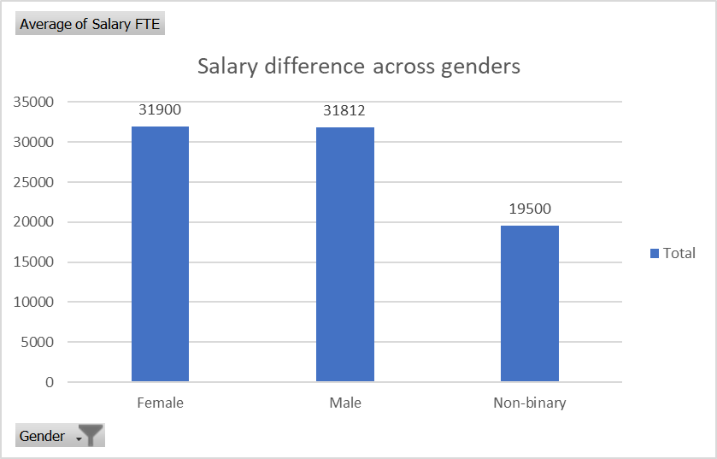

The average salary for females (£31,900) is slightly higher than that for males (£31,812), showing minimal pay disparity between these two genders. The average salary for non-binary individuals (£19,500) is significantly lower suggesting a substantial pay gap. However, there are only 2 non-binary employees and 1 of them is a Trades apprentice earning £17,500 (the same as the other apprentices) bringing the average down.
As there are so many different roles in the organisation, comparing them like for like by job role is crucial. Most of the job roles are paid the same apart from:
* Development Managers. One works for the property department earning £46,200, and the other for Regeneration earning £42,500. A difference of £3700. Looking deeper into the data we can see that both are white British females, both not disabled so any discrepancies due to diversity can be ruled out and could be down to departmental pay differences.
*Directors. There are 3 in total. 2 (1 male and 1 female, both white British, not disabled) are paid the same at £98,500 but 1 who is Director of People services, is paid £102,500. A difference of £4000. Even though we can see the highest paid female ethnicity is Indian, we must be aware the Directors do have different teams so again could be down to departmental differences.
*Performance officers. 1 male, 1 female. Both white British, both not disabled, both in the business services team yet the male earns £10,000 more. This is concerning as even after looking at the data in more detail, there are no obvious signs why this is the case.
To avoid any risks with anyone taking legal action over discrepancies in pay, the organisation should analyse salary structure within each job role and establish clear guidelines for salary banding to make sure it is fair across departments. The UK Equality Act 2010 prohibits discrimination in pay based on protected characteristics, including gender. Employers must ensure that pay disparities are justified by non-discriminatory factors such as skills, experience, or performance. (Equality Act 2010)
Internal disruption and reputational damage are what all organisations want to avoid and although there would be some financial implications to rectify and pay discrepancies, it would be a lot less than if someone decided to move forward with legal proceedings.

Overall average salary paid by the organisation
The overall average salary paid by the organisation is £31,756.

Directors have the highest average salary with £93,791 and Green spaces have the lowest with £21,030. There are many ways we can compare the average salary, by team, as I have done above, or by gender, racial and disability. It’s important to look at all of the data provided and implement policies to reduce identified salary disparities among different demographic groups and regularly review salaries to ensure fairness.

Table 2
The data from the survey shows us the views from 300 members of staff on hybrid working. To summarise:
Positives –
A large number of employees (161 fully agree and 86 agree) believe that hybrid working supports their work-life balance and well- being.
Many employees feel more productive (98 fully agree) and connected to the company culture (178 fully agree)
Hybrid working pra0ctices allows employees to meet their targets (100 fully agree) and easily access resources (87 fully agree)
Challenges –
A significant number of employees find it challenging to engage with colleagues (155 disagree, 94 disagree)
Many employees feel it is difficult to separate work from personal life while working from home (95 fully agree, 79 agree)
Remote work is a challenge for some employees (63 agree, 53 disagree, 73 strongly disagree)
Neutral –
Opinions on whether working from home does not affect collaboration are mixed, with a significant number of employees feeling more connected to the company culture (178 fully agree) but still some scepticism (72 agree)
Recommendations –
Have regular face to face and virtual team building activities and encourage diverse staff members to take part with sharing ideas and
CIPD Hybrid working (2024) talks a lot about training managers in flexible working and how to organise and structure activities to allow for hybrid working patterns.
Offer more support to employees who remote work challenging by providing technical assistance.
Regular feedback sessions to understand and address the concerns of remote workers.
Offer mental health support and resources to address feelings of isolation, as the CIPD factsheet on health and well-being at work suggests promoting mental health initiatives can enhance overall employee well-being.
Have regular interviews with staff or group workshops to get a good understanding and a true reflection as these questionnaires may not give a full picture.
By implementing these strategies and addressing the challenges, the company can make the hybrid working a more effective and supportive working environment.

References
Bailey, C. et al. (2018) Strategic human resource management.
Barends, E. and Rousseau, D. M. NCBI. https://www.ncbi.nlm.nih.gov
Briner, R. (2023) Evidence Based Practice. [YouTube video]. https://www.youtube.com
CIPD (2020) People analytics: Driving business performance with people data. https://www.cipd.co.uk/
CIPD (2020a) SWOT analysis. https://www.cipd.org/uk/knowledge/factsheets/swot-analysis-factsheet/
CIPD Diversity management, CIPD. https://www.cipd.co.uk/knowledge/fundamentals/relations/diversity/management-factsheet
CIPD (2021) People Analytics: Driving Business Performance with People Data.
CIPD (2021a) Evidence-Based Practice for effective decision making. London: CIPD.
CIPD (2024) Ethical practice and the role of people professionals. https://www.cipd.org/uk/knowledge/factsheets/ethics-role-hr-factsheet/#why-is-ethical-practice-important
CIPD. Health and Well-being at Work. CIPD Factsheet.
CIPD. (2024) Hybrid working taskforce guide. https://www.cipd.org/globalassets/media/knowledge/knowledge-hub/guides/2024-pdfs/hybrid-working-taskforce-guide-feb2024.pdf
CIPD Critical thinking in HR: CIPD's HR Professional Map.
CIPD Reflective Practice. https://www.cipd.co.uk/
De Bono, E. (1985) Six Thinking Hats. Little, Brown and Company.
Deloitte. (2020). The diversity and inclusion revolution: Eight powerful truths. https://www2.deloitte.com/us/en/insights/topics/talent/diversity-and-inclusion-revolution.html
Encyclopedia Britannica (n.d.) Deontological ethics | Definition, Meaning, Examples, & Facts. https://www.britannica.com
Equality Act 2010,http://www.legislation.gov.uk/ukpga/2010/15/contents
Mintzberg, H. (1990) 'The manager’s job: folklore and fact', Harvard Business Review,
Office for National Statistics (2023) Disability and Employment. Available at: https://www.ons.gov.uk/peoplepopulationandcommunity/healthandsocialcare/disability/articles/disabilityandemployment/2023
Paul, R. and Elder, L. (2006) Critical Thinking: Tools for Taking Charge of Your Learning and Your Life. Pearson.
Phillips, J. J. and Phillips, P. P. (2016) Handbook of Training Evaluation and Measurement Methods. Routledge.
Rousseau, D. M. (2006) Evidence-Based Management.
Rynes, S., Colbert, A. and Brown, K. (2002) Human Resource Management.
Stewart, G. L. and Brown, K. G. (2019) Human resource management.
Taylor, S. and Woodhams, C.(2022) Studying HR Management (3rd edition).

