
University of Wales Trinity Saint David
Master of Business Administration
International Marketing: Principles and Practices (LCMB7026)
International Market Entry Strategy and Marketing Mix of KFC in the United Kingdom and China
Assessment component | Individual report
Lecturers | Dian Mayasari
Student name | Sharaf Uddin
Student ID | 2438922
Submission date | 27 March 2026
Word count | Approx. 5,050 words excluding title page, contents, references and appendix

Table of Contents
1. Introduction 3
2. Comparative market analysis using PESTEL 4
3. Comparative analysis of STP strategy 8
4. Comparative analysis of the international marketing mix (7Ps) 10
5. Directional development strategy in one country: China 14
6. Ethical issues related to the marketing mix 15
7. Recommendations 17
8. Conclusion 17
Section 2: Reflective account using Gibbs’ cycle 19
References 22

1. Introduction
This report is a critical analysis of the approach of KFC to international market entry in the United Kingdom and China with reference to its marketing mix. KFC operates on scale in both of the two markets, which makes them suitable comparators, although the strategic logic of success differs significantly. The KFC is a market that competes in a mature UK quick service restaurant market with high digital penetration, low population growth, well-established delivery intermediaries and high levels of scrutiny of nutrition, animal welfare, and religious inclusion. KFC is now a highly localised platform brand in China, rooted in daily consumption, built on a very extensive store network, rich digital ecosystems and menu architecture that is far beyond the traditional fried chicken offer (Yum China, 2025a; KFC UK, 2025a).
The report holds that the global performance of KFC does not rely on mere standardisation but on rigorous asymmetric adjustment. The main international brand resources are still apparent in the two nations, such as brand images, functional consistency and the assurance of low-cost luxury. Nevertheless, in China, the extent, pace and level of strategic adaptation are far more extensive, faster and strategic than in the UK. That trend is widely consistent with the long history of the international marketing perspective that complete standardisation is seldom the best solution, and that better performance is usually achieved by tuning the adjustment to market institutions, consumer culture and competitive structure and not by one universal formula (Levitt, 1983; Douglas and Wind, 1987; Jain, 1989; Vrontis and Thrassou, 2007).
Section 1 thus compares the two macro-environments based on PESTEL, segmentation differences, targeting and positioning, and critiques KFCs 7Ps in both markets with specific reference to the product, price, place and promotion. China is then evaluated as the country of directional development strategy, as it shows how KFC has passed through the stages of market entry to ecosystem leadership. The paper ends with the discussion of ethical concerns and recommendations. Section 2 is a reflective account based on the reflective cycle by Gibbs. Generally, the report is more critical than descriptive: frameworks are employed as organising tools, analysis is done on strategic trade-offs, incomplete data and implications to managers.

2. Comparative market analysis using PESTEL
Table 1. PESTEL comparison of KFC in the United Kingdom and China
Factor | United Kingdom | China | Strategic implication for KFC
Political / Legal | Stable regulatory environment; strong consumer, labour and food information rules; visible scrutiny of marketing and claims. | More state-directed environment; policy support for digital infrastructure; faster regulatory shifts around data and platforms. | UK strategy should prioritise compliance credibility; China strategy requires stronger local intelligence and faster adaptation.
Economic | High purchasing power but mature demand and cost pressure; inflation still relevant for restaurants and hotels. | Lower per-capita income but very large scale, rising urban demand and stronger store-growth upside. | UK requires margin discipline and value reassurance; China supports volume growth, tiered pricing and occasion expansion.
Social / Cultural | Plural consumer expectations around convenience, indulgence, halal access, allergens and welfare concerns. | KFC embedded in local routines; greater acceptance of menu localisation and everyday use across multiple dayparts. | UK needs selective local relevance; China needs deeper localisation and broader menu architecture.
Technological | Very high internet penetration; delivery platforms and proprietary digital touchpoints matter. | Huge digital user base and app-native commerce; digital ordering central to the business model. | China supports more advanced CRM, loyalty and promotion integration than the UK.
Environmental | Growing scrutiny of packaging, waste and green claims in mature consumer markets. | Environmental footprint magnified by store scale and delivery intensity. | Both markets need credible sustainability actions, but China’s scale raises the absolute impact.
The most strategically relevant differences in PESTEL are summarised in table 1. Both markets are regulated politically and legally; however, the texture of regulation is different. The UK environment is institutionally sound and open, but it is becoming more challenging in terms of labour standards, food information, claims in advertising and consumer protection. This brings about compliance costs but predictability. China has scale and policy facilitation of consumption and digital infrastructure; however, regulation is more state-led and capable of shifting faster, particularly on the data management, platform behavior as well as operating certifications. In the case of an international brand, it is not just an increased risk in China, but a requirement of greater local managerial intelligence and a quicker organisational response. The local operating model of China that KFC operates under Yum China is thus not contingent but necessary on a strategic basis (Yum China, 2025a).
One of the most evident contrasts is created by economic conditions. The UK GDP per capita is significantly higher than that of China, which means good purchasing power, although it is a more mature, slow-growth market with cost pressures that are here to stay. The UK CPI inflation stood at 3.6 per cent in June 2025, and restaurants and hotels continue to face the pressure of increasing prices, which is directly related to the foodservice margins (ONS, 2025). In China, the per-capita income is lower, but the number of consumers and the size of urban areas provide a bigger target market on mass-premium and everyday affordable food. The purchasing-power gap is illustrated on figure 1. This would require KFC UK to be careful with the protection of margin whilst maintaining the value perception, but KFC China can spur growth on the basis of scale, menu breadth, frequency occasions and tiered price ladders as opposed to the single premium price architecture basis (World Bank, 2025).
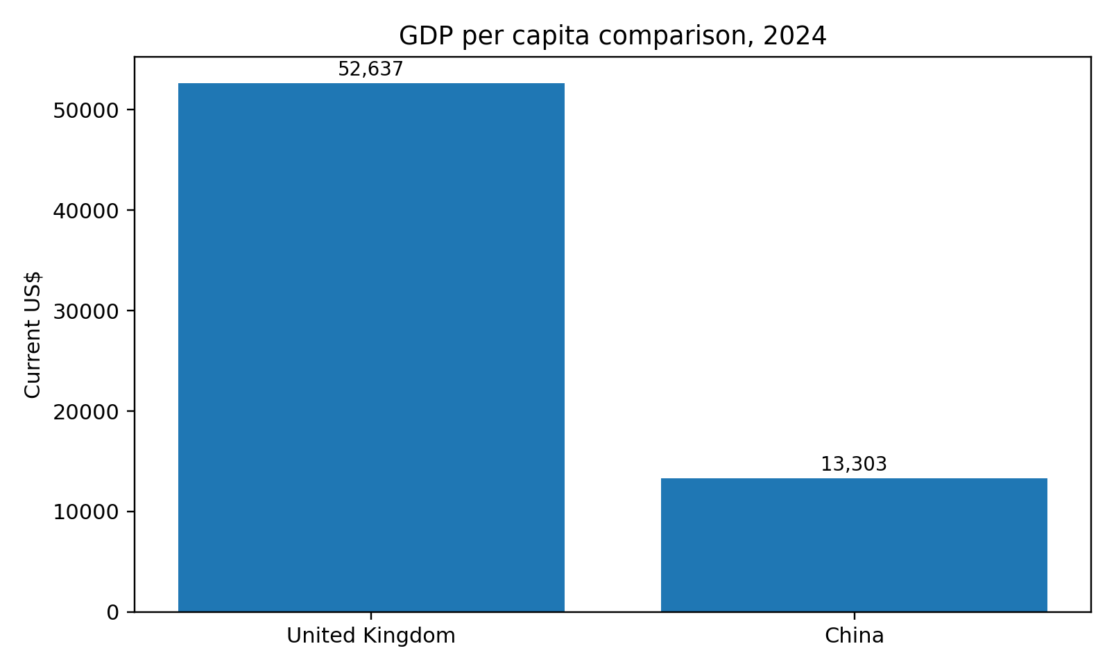
Figure 1. GDP per capita comparison, 2024. Source: Author-created chart based on World Bank data reported by StatisticsTimes (2025).
A mere comparison between country-income would not be as decisive as social and cultural factors. De Mooij and Hofstede (2010) warn that culture does not only influence reception of messages but also interprets convenience and status, which are meanings of brands. KFC consumption is linked to convenience, sharing, take-away and indulging at late evenings in the UK but is also evaluated on the basis of strong discourses of nutrition, allergens, animal welfare and religious inclusion. The way in which KFC communicates publicly on the topic of halal stores and nutritional disclosure demonstrates how far the brand has to go to manage plural consumer demands and open examination (KFC UK, 2025b; KFC UK, 2025c). KFC in China is no longer just an import of an American company long ago. Studies of global branding in China indicate that foreign restaurant chains may be domesticated through identifying the local menus, events and symbolic indicators with local habits and dreams. The development of breakfast, coffee and Chinese-style products at KFC China is the embodiment of this rationale: localisation is not a cosmetic factor but rather related to the daily relevance.
The conditions in both countries are highly favourable to technological sophistication which is not the same in both. The UK is practically a universal internet market, with penetration of 97.8 per cent in early 2025; China has a lower penetration of 78.0 per cent, although the number of actual users is many times greater at 1.11 billion users (DataReportal, 2025a; DataReportal, 2025b). Figure 2 thus is strategically important. The importance of digital channels in the UK is primarily as service enablers on top of an established restaurant market: proprietary delivery, click-and-collect and partnerships with aggregators continue the convenience. Digital is also the market structure in China. Yum China announced that approximately 90 per cent of the company sales were attributed to digital ordering in 2024, and KFC and Pizza Hut loyalty programmes had more than 525 million members in total (Yum China, 2025a). This not only makes China a more digital market but a more data-rich and platform-native one, which means the ability to personalise more, manage frequencies and app-based promotions.
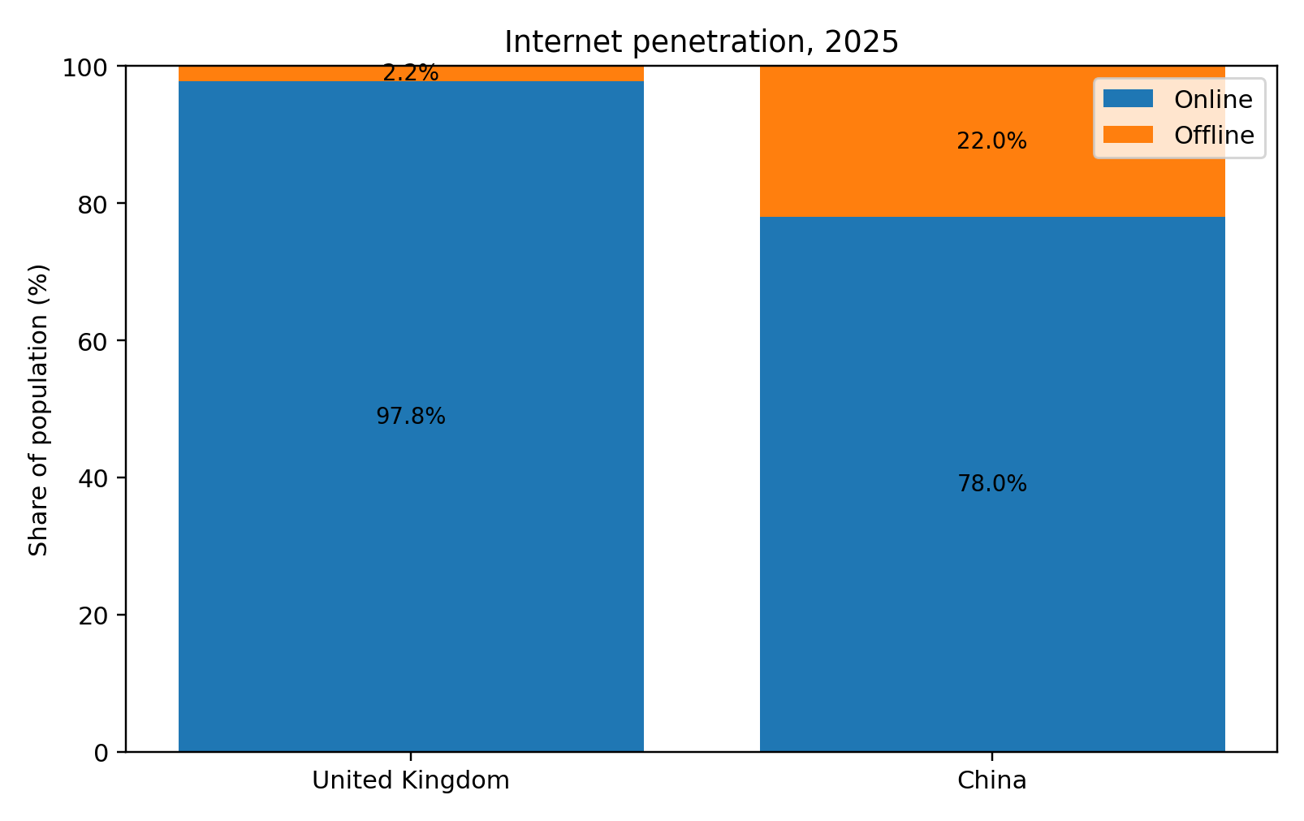
Figure 2. Internet penetration, 2025. Source: Author-created chart based on DataReportal (2025a; 2025b).
In both markets, environmental factors play an important role but the pressure is again of different nature. In the UK, consumer-law and sustainability campaign scrutiny is becoming more and more active in environmental claims and messaging, and restaurant chains should take care not to overbrand as green. In China, scale is a factor that makes the environmental challenge much greater: a very huge network of stores increases the volume of packaging waste, energy consumption and logistics emissions. The sustainability reporting of Yum China shows that the company has made strides in the area of packaging, people and resource efficiency, but the defining tension is the fact that a model of high-volume quick service would allow the company to achieve operational efficiency, but its overall environmental footprint would continue to grow (Yum China, 2025c).
In general, the PESTEL analysis is that KFC should not pursue symmetry between the two countries. The UK demands strict adherence, worth preservation and discriminating localization. China needs permanent ecosystem innovation, local menu creation, expedited data-driven action and constant responsiveness to policy and platform changes. It has been taught by managers that the difference between environments ought to be converted into the difference in strategic depth rather than different advertising messages.
Another implication of comparing the macro-environment is that entry to the market is not independent of the design of governance. The UK KFC can act under a rather standard brand-management logic since most of the transaction conditions, such as consumer recourse, formal food-labelling expectations, etc., are already stabilised through the action of external institutions. In China, on the contrary, the brand has thrived on the ownership or close coordination of more operating system, such as the local management capability, supply-chain responsiveness and digital customer interfaces. This is one of the reasons why the China case can be regarded not merely as adapting, but as embedding strategic locally. The brand is competitive there as it acts not so much like transplanted Western chain but rather like a locally smart service network.

3. Comparative analysis of STP strategy
Table 2. Comparison of segmentation, targeting and positioning
Element | United Kingdom | China | Critical evaluation
Segmentation | Occasion-led, value-conscious families, younger convenience buyers, selected halal-sensitive locations. | Behavioural, daypart and city-tier segmentation; breakfast, coffee, family, commuter and loyalty segments. | China uses more data-rich behavioural segmentation; UK remains broader and more location-based.
Targeting | Broad mass-market targeting with selective local tailoring. | Broad targeting plus layered micro-targeting through the app and loyalty system. | China resembles a platform targeting model; UK is still closer to classic QSR targeting.
Positioning | Affordable indulgence, familiarity, convenience and delivery access. | Localised, innovative, everyday modern brand with global heritage. | KFC China reduces liability of foreignness far more effectively than a lightly adapted imported brand.
The segmentation reasoning at KFC is very different in the two nations. In the UK, the focus of segmentation is on value-conscious families, younger customers who are convenience-seeking, occasions and delivery-focused, and the sub-segments with dietary or religious requirements, such as halal-seeking consumers within particular catchments. The UK market is segmented by occasion, convenience, household budget and the local community make up as opposed to highly elaborate lifestyle micro-clusters. This is characteristic of an established quick service market whereby brand promise is already well-informed and operational convenience, local relevance, and menu innovation on the margins are the points of differentiation.
China has more dynamic segmentation. KFC engages in breakfast, lunch, snacking, coffee, family and seasonal eating. The range of the Chinese menu and app ecosystem enables the brand to target white-collar breakfast customers, students, families, urban commuters, consumers of lower ranks of the city, coffee customers and loyalty members who obtain highly personalised digital offers. The market size implies that demographic segmentation will not be sufficient, behavioural and situational segmentation will be more significant. The fact that Yum China uses digital ordering and member sales implies that KFC in China is becoming more segmented based on observed behaviour as opposed to solely using ex ante demographic consideration (Yum China, 2025a).
Targeting also is different. The targeting of KFC in UK is rather broad still operationally selective. The brand also serves the mass market but customises store-level decisions based on location, delivery coverage and in certain locations, halal certification. It is wide-ranging targeting and narrow micro-localisation. The targeting strategy in China is more layered and broader based. KFC is simultaneously aimed at mass consumers and high-frequency digitally engaged members; it is differentiated in terms of city tier, daypart, product family and mission. This kind of targeting fits more well with a platform firm than a small restaurant chain.
The point of contrast is most interesting in positioning. KFC in the UK is a brand of quick service that is recognised as convenient, luxurious, and affordable to maintain the luxury of the industry with recognisable taste and delivery. The communication of the brand is still based on informality and mass appeal. In China, the positioning of KFC is more hybrid: it has global heritage, but is also posed as highly local, innovative and everyday modern. The 10,000 th store milestone underscored not only the scale, but also the embeddedness of KFC China over the long term, and its competence in the context of its supply-chain (Yum China, 2023). Practically, KFC China stands not as an overseas fast-food organisation, but more as a modifying national scale foodservice site.
The comparison of STP thus justifies a more significant conclusion: KFC does not simply adjust its execution in the UK and China; it makes changes to the architecture of segmentation and positioning. STP serves to safeguard competitiveness in a developed category in the UK. STP establishes new consumption occasions and ecosystem lock-in in China. This imbalance is what makes China not be a larger reflection of the UK.

4. Comparative analysis of the international marketing mix (7Ps)
Table 3. Comparison of KFC’s 7Ps in the United Kingdom and China
P | United Kingdom | China | Implication
Product | Core fried chicken-led menu with limited local breadth. | Much wider menu, including breakfast, coffee and localised items. | China depends on deep product adaptation; UK relies on core-menu discipline.
Price | Bundles and tactical offers under cost pressure. | Tiered and app-led value offers to drive traffic and frequency. | China treats price as a behavioural tool; UK uses price more defensively.
Place | Restaurants, drive-thru, own delivery and aggregators. | Dense store network plus strong logistics and app-based ordering. | Place is a convenience channel in the UK but a structural moat in China.
Promotion | Mass-market campaigns and tactical digital offers. | CRM-heavy, app-led, member-exclusive promotion. | Promotion in China is more integrated with data and loyalty.
People | Frontline trust and service recovery central. | Frontline execution augmented by digital tools and large-scale systems. | Operational people strategy is more technologically mediated in China.
Process | Standardised restaurant and delivery processes. | App-mediated ordering, loyalty integration and process analytics. | China’s process capability supports faster adaptation.
Physical evidence | Store environment, packaging and global visual identity. | Store network visibility plus app interface, digital coupons and membership tiers. | Physical evidence in China extends beyond the store into the digital ecosystem.
Product strategy is the most adapted. The menu is fairly focused on fried chicken pieces, burgers, wraps, buckets, sides and limited-time offers in the UK. Even its innovation is typically just near the gist of luxurious chicken-based fast food. That is indicative of a market in which the expectations of the categories are already stable. The product approach of KFC in China is much wider. The portfolio of Yum China, as well as the communications of KFC China, focus on breakfast, coffee, desserts, rice-based and local flavour development. The product system is hence constructed on a variety of dayparts and broader interpretation of food. It adheres to the theory of international marketing: the greater the difference between food culture, eating occasions and consumer routines in different markets, the more powerful product adaptation would be (Kotler and Keller, 2016; De Mooij and Hofstede, 2010).
Price strategy is also different in more than absolute price level. High operating cost, inflation pressure and benchmarking with other established quick service chains influence the price management in the UK. The difficulty lies in maintaining the value perception without attracting a quality downgrade. This usually contributes to bundling, meal specials and sensitive pricing of delivery. In China, the pricing rationale of KFC is more tiered and promotional, in part due to the fact that it is dealing with more events and more intense online competition. According to Yum China, in 2024, value-for-money deals were utilised to attract traffic despite same-store dynamics (Yum China, 2025b). Reduced or more actively advertised prices in China should not be understood as weak positioning, but rather as a ratio of frequency, which are backed up by scale, data and network coverage.
Strategic asymmetry is also exemplified in place strategy. Place in the UK implies a mix of high-street or retail-park restaurants, drive-thru locations, coverage and third-party delivery systems including Just Eat and Uber Eats as well as the own delivery of KFC (KFC UK, 2025d). The essence of the goal is convenience, whereas the physical network is relatively constrained. Place is a source of structural advantage in China. The spatial penetration of KFC China with its 10,000th store in 2023 and the 11,648 stores at the end of 2024 is exceptional, supported by its own supply chain and penetration beyond the leading cities (Yum China, 2023; Yum China, 2025b). This growth trend is as shown in Figure 3. Place in China is not only concerned with the accessibility of distribution it is concerned with the network density, the control of the logistics and the ubiquity of the brand.
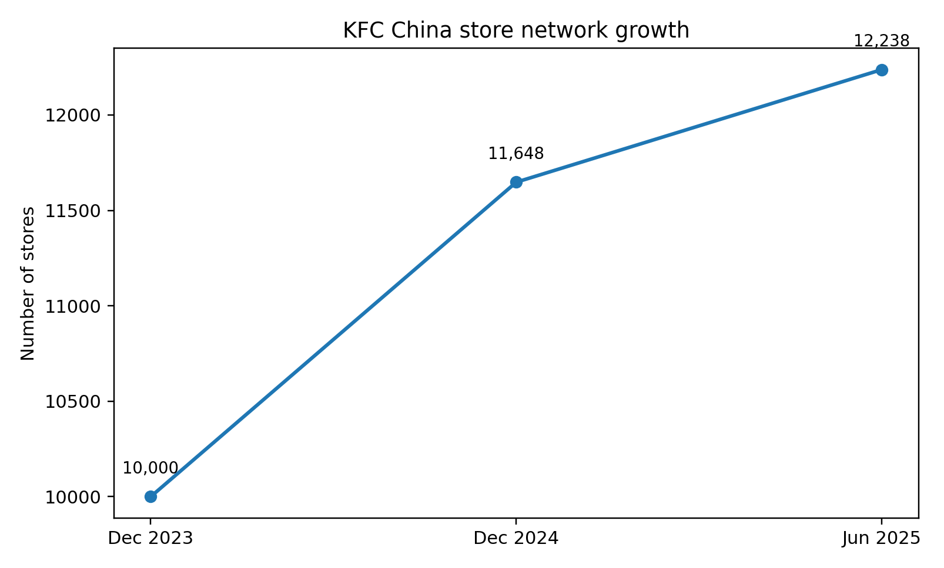
Figure 3. KFC China store network growth. Source: Author-created chart based on Yum China (2023; 2025b) and Yum China Q2 2025 results.
Advertising policy is also different. UK promotion remains in a mass-market mode, with a balance of humour, familiarity and tactical offers, and digital promotion becoming more supportive of delivery and app usage. But the UK communications system is comparatively above-the-line in nature. Promotion in China is more incorporated into the digital interface. Exclusive promotions and app-based presales, targeted offers and super-app participation transform promotion as a one-way communication system to a live behavioural management system (Yum China, 2025a). This implies that the promotion strategy of KFC China cannot be separated and independent of CRM and platform design. In China, promotion is more of a performance and data-driven process as compared to the UK where it is more of a conventional and campaign-driven promotion.
The other 3Ps are also revealing. The community trust and compliance communication, particularly on allergens and dietary information, place people in the UK at its core in service recovery. People in China are getting augmented with digitally-enhanced labour and management systems, in which frontline execution is aided by data tools and operational dashboards. UK Process is constructed on the basis of standardisation, queue management, menu consistency and delivery integration. Process is quicker, more mediated by apps and more connected to loyalty schemes and operational analytics in China. Store environment, packaging and recognisable appearance continue to play a vital role in physical evidence in the UK. Physical evidence is also present in the form of app interfaces, digital coupons, membership levels and the apparent coverage of the store network in China.
STP also has a brand-architecture problem. The KFC brand in the UK can be fairly unique since consumers already know what the category means; excessive segmentation may actually undermine the clarity. In China, the risk is just the reverse. Unless KFC developed differentiated relevance in the breakfast, coffee, family sharing, digital membership and city-tier needs, the company will cede usage occasions to competitors who are more specialised. The strategic question is not then whether or not to segment, but the extent to which the brand can be pushed and yet still be KFC. The fact is that China has managed to resolve this by using a robust brand kernel with a combination of locally expansive category participation.
Critical comparison of the 7ps thus refers to any simplistic standardisation-adaptation dichotomy. KFC standardises brand kernel, not the value architecture. The UK business gains value through disciplined performance in a developed market; value is created through localised breadth, digital depth and spatial scale by the China business. The increased Chinese adaptation does not reflect the brand inconsistency. It shows evidence of strategic fit.

5. Directional development strategy in one country: China
The stronger case of directional development analysis can be argued in China since the brand is no longer merely holding on to market share, but is expanding the category space in which KFC can triumph. The strategy of the market development supported by selective product development is most appropriate to be viewed as the dominant one using Ansoff (1957). It is also market development since KFC is still expanding to lower-level cities and underserved geographies and transforms white-space access into new demand. According to 2025 Reuters, 800 Chinese cities had not yet opened KFC, and 1,400 cities had KFC but not Pizza Hut, which shows that physical expansion is a growth lever and not the storey of saturation (Reuters, 2025a).
But that cannot be narrowed down to the case of the Chinese to geographical expansion. KFC has also further penetrated with digital membership, breakfast, coffee and occasion broadening. Product development is a secondary, but complementary, dimension of that. The strategic innovation is in integrating store expansion and ecosystem expansion. As of 2024, around 90 per cent of the company sales occurred digitally and the total number of loyalty members was over 525 million, indicating that KFC is not merely expanding its stores, but enhancing behavioural presence and repeat-purchase power (Yum China, 2025a). This leads to a compounding advantage in the strategic sense: as more stores create more transactions, more transactions create better data, better data leads to better targeting, menu design and local expansion decisions.
The threats are also quite critical. The rapid expansion of the network may undermine the same-store productivity, and raise the complexity of management and the overextension of the brand in the weaker domestic markets. Even the self-disclosures of Yum China indicate that volume can be safeguarded by the use of traffic-driving value offers at the expense of margin pressure (Yum China, 2025b). The strategic conflict between scale expansion and quality of earnings is therefore present. Nevertheless, China is the market where KFC can best reasonably progress beyond the usual restaurant competition to ecosystem leadership. The directional suggestion is not to open more stores, but to selectively open where physical size, online density and local menu complement each other.

6. Ethical issues related to the marketing mix
In the two countries, there are ethical problems, which vary in salience. Nutrition transparency, allergens, animal welfare, and religious inclusion are the most popular issues in the UK. KFC UK offers comprehensive nutrition and allergen information, including the calorie and dietary data and also shares its halal policy on restaurant level (KFC UK, 2025b; KFC UK, 2025c). This is positive. Nevertheless, transparency does not make redundant the existing criticism of public-health vested in the energy-intensive consumption of quick service. The ethical analysis should, then, draw the line between disclosure ethics and product ethics: a brand can be responsible in communication, and at the same time, lead to poor dietary results in case the high-frequency consumption is normalised.
Lastly, the strategic communication aspect also exists in the ethical debate. Since the offer made by KFC is connected with pleasure, convenience and value, there is always a risk of responsibility messaging being obtrusive or defensive in nature. The company thus requires a communication strategy where health information, welfare standards and sustainability claims are brought to the forefront brand management instead of being left on the FAQ pages. This is important in terms of postgraduate since ethical legitimacy is not just a moral concern; it determines trust, resilience and long-term brand permission to expand.
Another strategic point is that of transfer of capabilities. The sense of digital adequacy in China is easy to believe that it can just be uprooted in the UK, however, the transfer has to pass through the prism of domestic consumer demands and channel systems. Better app personalisation and solid daypart targeting might be welcome by the UK customer, but the system might be overly push-based and intrusive, which may result in negative reaction. The China growth plan thus not only forms a growth template but also an internal learning laboratory. The managerial action is to determine what Chinese capabilities can be considered universal, e.g., superior CRM logic and stricter app-to-store integration, and which are dependent on the exceptionally dense Chinese digital ecosystem.
The issue of animal welfare poses a more acute reputation problem. KFC UK has focused on supplier standards, although in 2024, a report on the issue noted that the company was backing out of a former sluggish growth UK commitment to chicken that campaigners attributed to welfare issues (The Guardian, 2024). This is not to say that every criticism is decisive in nature, but that even in the case of legal compliance, ethical risk may still be present. To a multinational marketer, legality is a minimum, and not an entire ethical defence.
Ethics in China are not so focused on halal or welfare politics as on the intensity of data, labour intensity and the environmental footprint of scale. The nature of a business model where online ordering is approximately 90 per cent of the sales and loyalty systems encompass hundreds of millions of members makes online consumer profiling and the promotion power of apps behavioural questions by default (Yum China, 2025a). Meanwhile, a large-scale delivery and take away model increases externalities of packaging and logistics. The sustainability reporting of Yum China is in an improvement, although the moral load increases with size. This is why the most plausible opinion should be taken as nuanced: KFC has already gone a long way toward disclosure, sustainability and operational responsibility, but the enterprise still has unresolved ethical contradictions in the context of fast food, datafied loyalty systems and consumption of high volumes of animal protein.

7. Recommendations
- KFC UK needs to also shift its tactical value communication, which is price-led, to value with credibility. It means maintaining promotional acuity and prioritising nutritional knowledge, ingredient transparency and app convenience as a part of it.
- KFC China must keep on expanding stores, but by a rigorous screening model, where only the markets where logistics competence, digital penetration and occasion depth can be sensitised jointly are given a chance.
- Both countries need to enhance ethical marketing governance through applying more tightly coupled promotion, product innovation and sustainability claims to verifiable evidence by KFC. In the UK it translates to more transparency in welfare and health; in China it translates to greater transparency on the use of data and reduction of packaging.
- KFC must move the chosen Chinese competencies to the UK, in particular, app-based personalisation, daypart growth, and lifecycle targeting, but not go mechanical with China.
- The performance of seniors should be measured with the help of a wider scorecard than sales, and it includes the quality of members, frequency of repeat, operational resilience, trends in complaints and ESG risks.

8. Conclusion
The KFC performance in the United Kingdom and China shows that the international marketing advantage is developed not by the formulaic imitation but by the strategic asymmetry. UK market rewards executed discipline, trust, compliance and well-managed value. China compensates the breadth of local menu, network density, platform-native promotion and ecosystem-level coordination.
The analogy thus is in favour of a complex perspective of adaptation: the most powerful international brand is not the one that evolves the least, but the one that evolves selectively without losing its brand nucleus. China must be seen as the most active market-development space of KFC, yet further expansion will only remain justifiable in the case in which the company can handle the ethical and operational contradictions that go hand-in-hand with scale, datafication and convenience-based consumption.

Section 2: Reflective account using Gibbs’ cycle
The reflective cycle by Gibbs is a helpful frame of assessment of the process of Section 1. During the description phase, I chose KFC as opposed to the more natural choice of fashion or furniture because I wanted an example of where I could observe not just communications but also menu design, digital infrastructure, distribution and ethical tension. UK and China have been chosen since they are both large and well documented markets but at the same time strategically very different. I collected data through academic journals, textbooks and a collection of the up-to-date official sources such as Yum China disclosures, DataReportal, the World Bank, Office for National Statistics and KFC information pages in the UK. It was not my job to fill frameworks, but to transform a big mixed body of evidence into a rational managerial argument.
At the feelings stage, I was surprised that the case was more complicated than I expected. I thought that KFC would be an easy case of cultural adaptation in China and standardisation in the UK. That assumption turned out to be oversimplified as the research went on. The China evidence was that KFC is not simply modifying local menu items, it is a digitally mediated ecosystem with a much different logic of growth, customer management and place strategy. I also realised that modern corporate reporting tends to emphasise the size and innovativeness, but it does not talk about such trade-offs as data power, health externalities and the quality of growth. that caused me the greater care in receiving official disclosures as impartial evidence.
The mixed evaluation stage was thus the case. One of my process strengths was triangulation. Academic literature assisted in the interpretation of strategy concepts, whereas the official current sources assisted me in not basing on obsolete assumptions. The mix came in handy especially in the 7ps analysis, whereby company disclosures in isolation would have prompted description but the academic research on adaptation and consumer culture enabled more assertive critique. The other strength was the fact that I chose to use frameworks as guides and not as goals. This enhanced the flow of the report as each segment would be able to revert back to the same main point of argument asymmetric adaptation. But these were not without weakness. There was uneven access to data in the two countries. China provided a lot of corporate and digital data, and certain details of operations or menu were simpler to identify than to confirm on an academic level. The case in the UK, in its turn, provided more transparent general information on nutrition and halal policy, but less details regarding the depth of apps and the level of CRM. I thus needed to make judgments in the case of incomplete symmetry.
Methodological learning was the most significant during the stage of analysis. The biggest mistake that can be committed in comparative international marketing work is that one employs the same framework categories in both nations and then concludes that comparability has been attained. The process of my research has demonstrated that the same categories do not necessarily lead to a meaningful comparison. As an illustration, a place in the UK primarily meant delivery coverage, accessibility and convenience of the stores, whilst in China meant network density, logistics, integration of apps and expansion to the lower tiers of the cities. I got to know that the same heading may represent various phenomena of strategies. The second learning issue was the position of existing company information. Official sources are of great importance in the current facts, but also represent the rhetoric texts that are aimed at reassuring the investor confidence or customer trust. It is not, then, a matter of rejection or acceptance of them at face value, but of critical reading, comparing them with academic theory and other evidence. Such realisation enhanced my critical awareness and made final judgements more sophisticated.
The final phase of Gibbs cycle makes me come to three key conclusions concerning my personal development. To start with, I am now more comfortable applying theory in a diagnostic, as opposed to a mechanistic manner. The usefulness of Levitt, Douglas and Wind, Jain, and Vrontis and Thrassou was that they assisted in identifying what sort of an adaptation problem I was working with. Secondly, I am now able to handle conflicting evidence better. As an example, the same Chinese digital ecosystem that helps to promote convenience and loyalty amplifies the ethical issues related to data and influence of behaviour. Third, I now understand better that postgraduate work requires an argument structure first before it requires content accumulation. After the main argument of the report was established, the choice of evidence became more rigorous and the writing more logical.
My action plan is practical. I will start with a tentative thesis in future assignments, instead of commencing with descriptive note taking. I will also create a matrix of sources that will help me distinguish between the factual, theoretical and critical sources in such a way that I will be able to see more quickly where the evidence is strong, partial or promotional. Lastly, I will also be improving my approach to ethically questionable evidence, as the most powerful managerial analysis is often neither about glorifying nor preaching. Rather, it needs a capacity to identify strategic success and at the same time challenge its costs, omissions and long-term risks. It is, to my mind, the most significant learning that was gained during this process of assignment.
The other lesson is the issue of writing discipline. My initial notes were very general and evidence based and not analytically selective. This material became manageable only when I turned the case into a central proposition regarding asymmetric adaptation. The experience has altered my perception of the practise of postgraduate research. This work is not done by gathering more facts at the highest level; it is done by making choices concerning which facts are of the greatest significance to the argument and then demonstrating why other ways of seeing the argument are less convincing. This knowledge will determine my future practise of consulting-type reports, dissertation chapters and reviews of evidence.

References
Ansoff, H.I. (1957) ‘Strategies for diversification’, Harvard Business Review, 35(5), pp. 113-124.
DataReportal (2025a) Digital 2025: The United Kingdom. Available at: https://datareportal.com/reports/digital-2025-united-kingdom (Accessed: 8 March 2026).
DataReportal (2025b) Digital 2025: China. Available at: https://datareportal.com/reports/digital-2025-china (Accessed: 8 March 2026).
De Mooij, M. and Hofstede, G. (2010) ‘The Hofstede model: Applications to global branding and advertising strategy and research’, International Journal of Advertising, 29(1), pp. 85-110.
Douglas, S.P. and Wind, Y. (1987) ‘The myth of globalization’, Columbia Journal of World Business, 22(4), pp. 19-29.
Gibbs, G. (1988) Learning by Doing: A Guide to Teaching and Learning Methods. Oxford: Oxford Polytechnic.
Hollensen, S. (2020) Global Marketing. 8th edn. Harlow: Pearson.
Jain, S.C. (1989) ‘Standardization of international marketing strategy: Some research hypotheses’, Journal of Marketing, 53(1), pp. 70-79.
KFC UK (2025a) Order delivery on the KFC website. Available at: https://help.kfc.co.uk/hc/en-gb/articles/6569345794706-ORDER-DELIVERY-ON-THE-KFC-WEBSITE (Accessed: 8 March 2026).
KFC UK (2025b) Nutrition, allergens & dietary information. Available at: https://www.kfc.co.uk/nutrition-allergens (Accessed: 8 March 2026).
KFC UK (2025c) Is KFC halal? Available at: https://www.kfc.co.uk/halal (Accessed: 8 March 2026).
Kotler, P. and Keller, K.L. (2016) Marketing Management. 15th edn. Harlow: Pearson.
Levitt, T. (1983) ‘The globalization of markets’, Harvard Business Review, 61(3), pp. 92-102.
Office for National Statistics (2025) Consumer price inflation, UK: June 2025. Available at: https://www.ons.gov.uk/economy/inflationandpriceindices/bulletins/consumerpriceinflation/june2025 (Accessed: 8 March 2026).
Reuters (2025a) Yum China continues rapid expansion. Available at: https://www.reuters.com/markets/asia/yum-china-continues-rapid-expansion-2025-08-05/ (Accessed: 8 March 2026).
The Guardian (2024) KFC drops pledge to stop using ‘Frankenchickens’ in the UK. Available at: https://www.theguardian.com/food/2024/nov/23/kfc-drops-pledge-to-stop-using-frankenchickens-in-the-uk (Accessed: 8 March 2026).
Vrontis, D. and Thrassou, A. (2007) ‘Adaptation vs. standardization in international marketing: the country-of-origin effect’, Innovative Marketing, 3(4), pp. 7-21.
World Bank (2025) GDP indicators 2024. Available at: https://www.statisticstimes.com/economy/gdp-indicators-2024.php (Accessed: 8 March 2026).
Yum China (2023) KFC China celebrates the opening of its 10,000th store. Available at: https://ir.yumchina.com/news-releases/news-release-details/kfc-china-celebrates-opening-its-10000th-store (Accessed: 8 March 2026).
Yum China (2025a) 2024 annual report. Available at: https://ir.yumchina.com/annual-reports/ (Accessed: 8 March 2026).
Yum China (2025b) Yum China reports fourth quarter results and increases dividend by 50%. Available at: https://ir.yumchina.com/news-releases/news-release-details/yum-china-reports-fourth-quarter-results-and-increases-dividend (Accessed: 8 March 2026).
Yum China (2025c) 2024 sustainability report showcases Yum China’s consistent commitment to ESG. Available at: https://ir.yumchina.com/news-releases/news-release-details/2024-sustainability-report-showcases-yum-chinas-consistent/ (Accessed: 8 March 2026).

