3/19/2025
Eleanor Black

Civic Centre Swansea
Low energy design

Contents

Introduction 3
Building Information Modelling (BIM) 3
Digital Twins 5
Smart Buildings 5
Conclusion 7
Reference list 8

Introduction
Swansea Civic Centre, formerly known as county hall, houses the council chamber and offices and acts as the principal administrative centre for Swansea council. The centre is also home to the central library, public café, contact centre, archives, and exhibition area.
The building was built in two phases between 1979 and 1984 and was designed in a brutalist style by the county architects department. Its design and fabric were a result of its location mere metres from the sea and on reclaimed land (railway yard), so it needed to be made of durable, low-maintenance materials. The layout, although odd, has its reasoning as the architects wanted to avoid “massing” where a cube or rectangular shape would have obstructed views of the bay; instead the arms centralising around lift shafts the council chambers allowed for viewing of the seafront and curated garden areas to the exterior.
The building is characterised by horizontal concrete bands combined with dark glazing, common for offices at the time. Each arm is faced in 1,800 panels of pre-cast concrete made from an exposed aggregate finish embedded in white cement (Coflein.gov.uk, 2021).
The centre has been earmarked for demolition with plans to replace it with a multi-use building, however, the C20 Society has applied to have the building grade II listed to prevent this.
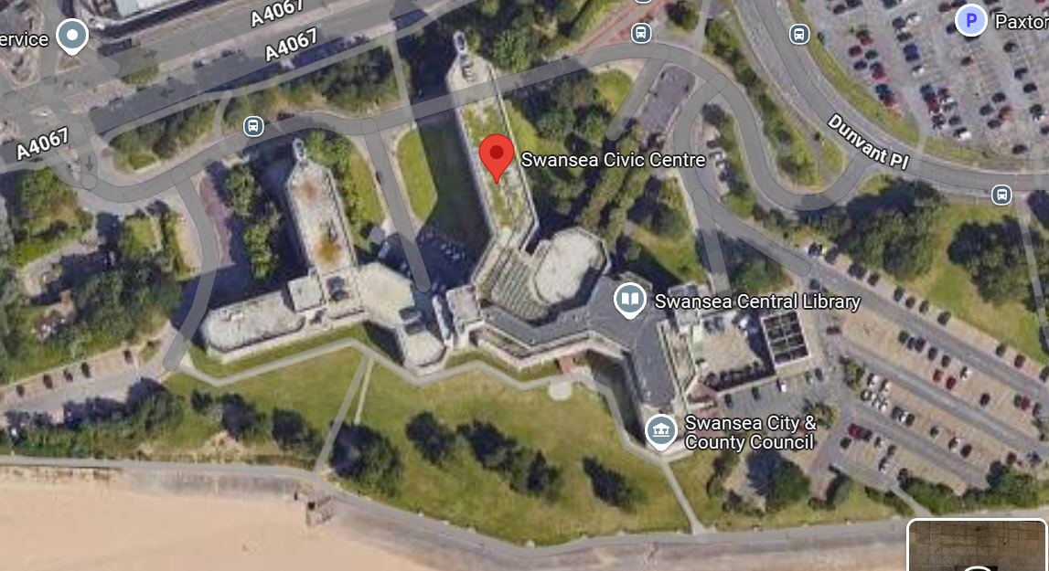
Today, the once central hub stands practically empty, with the library, court, and offices being moved elsewhere, with plans to redevelop the building.

Building Information Modelling (BIM)
BIM is a collaborative process that encourages cooperative working between the disciplines involved in the design, construction, maintenance, and use of buildings. The information is shared in the same format, simultaneously between the parties and can have different levels of maturity ranging from level 0 to level 3 (Comiskey, 2017).
BIM aims to reduce the fragmented construction industry, where professionals work in isolation with conflicts of interest, hindering collaboration and integration.
Level 0- low collaboration, including unmanaged CAD, or essentially, a digital drawing board
Level 1- A mix of 2D and 3D technology with a collaboration tool providing a CDE (Common data environment).
Level 2- A managed 3D environment, with added data attached (construction sequencing and cost information), created in separate discipline-based models, which are then combined into a federated model.
Level 3- Refers to a single fully collaborative online project model with construction sequencing, cost information and lifecycle information included.
It is important to note that the levels of maturity are being constantly advanced as technology and software capabilities improve.
Risk management in construction is constantly evolving to identify and mitigate potential risks before they happen or to reduce the effects of the consequences. BIM is a proactive, cost-effective approach that has the ability for risk management including early clash detection, improved visualisations, optimised facilities management, with human errors being significantly reduced.
BIM allows for better decisions making by the designer, client and other parties due to the improved visualisations that allows clients to understand the build and make informed decisions in a collaborative environment leading to design errors being amended earlier, more accurate cost estimates and improved model analysis (White, 2019).
Older buildings often have a lack of documentation or as-built floorplans, creating a difficulty to accurately understand the original construction or systems, and over time the changes made, have not been recorded. Point cloud surveys and the resulting 3D models provide a detailed and informative replica that 2D traditional surveys or plans can’t provide (Holt, 2023)
Furthermore, as BIM holds rich data for all different components of the model including materials, measurements, design specifications, equipment, performance and costs, it can prove useful for retrofitting existing buildings. The accurate documentation gained can allow for simulations, early clash detection for new elements and easier coordination of modifications. This results in efficient planning and a reduction in errors whilst streamlining the process and greater collaboration.
With Swansea civic centre having the potential to be labelled a listed building, BIM can have the ability to plan and simulate upgrades that will respect and preserve its heritage values. Certain areas of historical or architectural significance (such as the council chamber or original materials) will be detailed and documented into the model with metadata including condition, date of construction, conservation needs, repairs needed, etc.
Careful retrofit solutions can then be made once elements of significance are recognised including hidden pipework, ductwork and cabling, modifications that are reversible, and utilising materials that match the original materials appropriately.
For ongoing maintenance and future conservation of the civic centre, BIM allows for monitoring of wear and degradation of heritage components, planning of any future restorations, with the BIM model being a historical record with all previous interventions being documented and lastly, avoiding unnecessary alterations.
BIM makes retrofit easier for planning authorities and heritage officials to visualise the changes in context thus allowing for informed decisions on listed building consent. Regardless of listed status, BIM allows for greater visual aiding and data provision for planning authorities and building control.

Digital Twins
Whilst level 3 BIM aims to incorporate life-cycle operation of an asset, most current BIM models mainly focus on design and construction, leaving a gaping hole in terms of ongoing operational management. This is where digital twins can be applied.
A digital twin is an accurate virtually replicated representation of an object or system designed to mirror the real-life asset and last the entire life-cycle. These virtual twins feed off real-time data from various sensors, simulations, and generative AI to update to mirror the original, real-life object. The digital twin behaves like the real building, responding to conditions and occupancy to produce a proactive operational asset.
In terms of operational management, digital twins can offer greater efficiency by using resources effectively, minimising waste, making decisions proactively, communicating better, and collaborating more effectively. They offer predictive maintenance and operational optimization due to their real-time analytical features and can identify issues or certain areas that need improvement. Predictive maintenance is a huge asset to any operational asset as the proactive approach reduces costs, allows for quicker maintenance (as the issue has already been identified) and minimises downtime.
Swansea Civic Centre would benefit from a digital twin for operational purposes so that performance is optimised, defects are recognised and prevented from further damaging the asset and scheduled planned, preventative maintenance can take place regularly and to each manufacturer’s guidelines. This keeps each element in optimal condition, extends the lifespan and prevents premature replacement allowing for reduced costs and higher efficiency.
A digital twin would also prove useful for retrofit and refurbishment due to it being a virtual replica, models can be used to simulate various retrofit scenarios so that energy efficiency, performance and comfort can be evaluated to find the best outcome. Targeted upgrades in HVAC, lighting and other various systems can be utilised as inefficiencies are identified by the digital twin. It is data driven approach revolutionising the retrofit industry (twinview.com, n.d).

Smart Buildings
A smart building converges various building-wide systems, such as HVAC, lighting, security and alarms, into a single IT-managed network infrastructure. It collects actionable data from sensors, devices, services and other systems and uses artificial intelligence and machine learning to make the building programmable and responsive. These smart buildings are designed to monitor, control, and optimise operations and feature improved energy efficiency, data analytics, automation of systems, connectivity and interoperability, and maintenance optimisation.
The Edge is a perfect example of a smart building. Located in Amsterdam this office buildings utilises more than 28,000 internet of things (IoT) sensors amongst other smart devices and allows its occupants to access many features through a smartphone app which has a range of functions from changing the temperature to booking desk spaces and finding free parking spots.
The design of The Edge has allowed for enhanced sustainability, achieving an outstanding 98.36% BREEAM-NL score, by incorporating cutting edge technology and renewable energy. The southern façade features solar panels and glazing with a panel-covered roof. The orientation allows for maximum natural light and the thick concrete regulate heat by way of thermal mass, lowering the need for shades. According to EDGE (2025), the Edge consumes 70% less electricity than other typical office buildings.
Swansea Civic Centre would benefit from smart technology, which, incorporated with BIM and a digital twin, will allow for seamless operational and maintenance.
This would include installing smart meters, sensors and LED lighting systems with occupancy sensing. The HVAC would need to be upgraded to incorporate smart features such as automation, occupancy sensors, and weather forecasting. Renewable energy should be introduced including solar panels with smart inverters and potentially small-scale hydropower. In order for all of these systems to be incorporated and controlled, an IoT-enabled building management system will need to be implemented with high-speed broadband for connectivity.
Additionally, for optimum sensing and occupancy recognition, the security system would need to be updated, including key card access and/or biometrics, so that staff can be accounted for and adequate heating and ventilation is supplied. Along with access control, the fire detection system can incorporate multi-sensor detectors (smoke, heat, flame and gas sensors), which reduce false alarms and detect real fires more accurately. These connected systems provide state-of-the-art emergency response by turning on sprinklers, turning off HVAC to contain fires and smoke, unlocking emergency exits and guiding people to emergency exits via signage and voice alerts. This dynamic approach provides occupants with a safer proactive approach to fire safety compared to traditional emergency responses.
If the library remains at the civic centre, certain sensors can be installed to preserve the materials of the books, including humidity and air quality sensors with lighting that mimics daylight, creating a more comfortable environment.
Additionally, the library could incorporate a space with augmented reality, allowing for virtual tours or historical education for schools. Augmented reality can also be incredibly beneficial for facilities management as overlays via VR headsets can provide detailed visualisations of hidden infrastructure (wiring, plumbing, pipework, ductwork) for inspection and maintenance. It could also be incorporated so that emergency services can see floor plans, specific hazard areas or even locate trapped or injured people, thanks to the buildings sensors and real-time data provided.
For the archive space, archive material will be digitalised via secure cloud-based systems for storage, easy access, and preservation, and, as with the library, enhanced HVAC systems will provide optimal conditions for archival documents.
With regards to the car parking, as with the Edge, smart technology can be incorporated to allow for parking management via sensors that monitor space availability, guiding people to open spots. This can be via an app, on large billboards or touch-screen kiosks in central locations. Electric car charging stations will be provided to encourage sustainable transportation for staff and guests.

Conclusion
Overall, the advancements of modern technology have the power to aid in the restoration, retrofit and maintenance of traditional and modern (new builds) buildings by providing detailed insights into how, why, and when modifications, upgrades or energy efficiency improvements can be made, whilst reducing risks, through dynamic methodology such as BIM, digital twins and augmented reality.
Swansea Civic Centre would benefit from using these advancements during the retrofit and maintenance process so that modifications can be visualised prior to installation to prevent any issues with lessening the heritage values and to incorporate upgrades that will provide optimal performance.

Reference list
Coflein.gov.uk. (2021). English – Coflein. [online] Available at: https://coflein.gov.uk/en/site/300024/ [Accessed 19 Mar. 2025].
Comiskey, D., McKane, M., Jaffrey, A., Wilson, P., & Mordue, S. (2017). An Analysis of Data Sharing Platforms in Multidisciplinary. https://doi.org/10.1080/17452007.2017.1306483
Holt, J. (2023). What is BIM and why do we use it for retrofit projects? [online] Holt Architecture. Available at: https://www.holtarchitecture.co.uk/post/why-and-how-we-use-bim-for-refurbishment-projects.
‌Ocean, J. (2024). BIM and Risk Management. How to Manage Risks Using BIM? [online] Revizto. Available at: https://revizto.com/en/bim-and-risk-management/.
Swansea. (2023). Retro-fit council bungalows cutting the cost of tenants’ electricity bills - Swansea. [online] Available at: https://www.swansea.gov.uk/retrobungalows [Accessed 25 Apr. 2025].
www.twinview.com. (n.d.). Digital Twins for Retrofitting: Enhancing Building Performance and Energy Efficiency | Twinview. [online] Available at: https://www.twinview.com/insights/digital-twins-for-retrofitting-enhancing-building-performance-and-energy-efficiency.
White, R. (2019). InterFocus Lab Furniture. [online] InterFocus Lab Furniture. Available at: https://www.mynewlab.com/resources/building-information-modelling/bim-and-risk-analysis/.
‌

