Student name: Agnieszka Aleksandra Borowiec

Student ID number: 2004947
Programme: Contextual Practices
Module: Research in Context

Module code: ADAD5003
Lecturer: Donna Williams
Word count: 2,589 words (15,608 characters)

Can Graphic Design Really Save Your Life?

The majority of people are unaware that graphic design is everywhere, and that they interact with it every day, From the moment we open our eyes in the morning, when we look at the bedside lamp, whilst brewing coffee in beautifully decorated cups, or reading a newspaper arranged in columns that give it meaning and order. At every moment we are seeing or touching graphic design. But the role of design is not only a nice pattern on the curtains that make it more pleasing to look at, graphic design is so much more ... Graphic design saves our lives.
It is obvious that some Graphic Designers are activists. They are motivated by the needs and desires of the world, but above all, it benefits the well-being of people. Activists often focus on issues that are dangerous or unfair to society and may be detrimental to future generations. Through their actions, they try to influence the thinking, behaviour and actions of others so that society can make favourable and forward-looking choices. Graphic Designers, thanks to their designs, can reach a huge number of recipients as they have a very strong tool. (Fuad-Luke, 2009)
Some projects are known to have a specific focus and use so-called approaches/frameworks. One example would be the design of cars and related campaigns. Designers, including, of course, Graphic Designers, will be guided by aesthetics, ergonomics, fuel efficiency and most importantly, safety. The point is that the so-called approaches/frameworks are problem driven. Graphic Designers use design to try to solve an existing problem or prevent the arrival of a new one. (Fuad-Luke, 2009)
There is such a concept as “Sustainable development”, a concept that had its first expression more than 60 years ago and was defined in the category of man and his environment. It is based on systems thinking and ecological practice. It was again noticed again in the 1980s (Fuad-Luke, 2009). For example, one can mention the Danish designer Mads Hagstrom, who created the FLOWmarketbrand. Its purpose is to “awaken thoughts” and cause action in society. Its products show the weakness of products from the same family and even question their right of existence (Fuad-Luke, 2009).

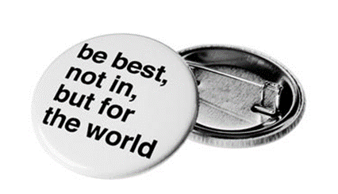
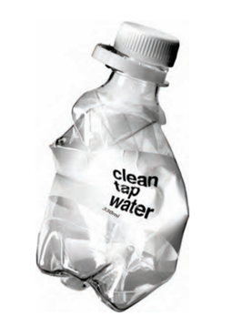
Fig.1 The FLOWproducts (FLOWinstitute, 2006) Fig.2 The FLOWaward (FLOWinstitute, 2006)

Nowadays people are often confused and frustrated by encountering the obstacles and problems of everyday life. The world is developing and moving forward. There are many amenities, but at the same time society faces many difficulties, which (Norman, 2013) repeatedly cause wrong thinking and even wrong decisions, and these often lead to unwanted effects.
The philosophy of good graphic design is to focus on the person, on a good understanding of him and his needs and on making his life easier. People are often unaware of what they really need, they encounter difficulties that surprise them. The designer’s task is to create a project in such a way as to help prevent difficulties for as long as possible, and it is best to avoid them completely. Good graphic design must evoke interactions and help to make good choices so that they are beneficial to the human being, to present products that will truly meet people’s needs and help improve the world. (Norman, 2013).
It is important that the graphic design evokes good emotions. If something turns out to be pleasant in execution, thanks to a graphic tip, then a given design will cause pleasant memories (Norman, 2013). Even if the project concerns something sad, but at the same time gives a hint or direction to a good solution, society will still remember good emotions.
The interaction of society on graphic design forms the basis of the way in which to achieve the goal that was set when creating the project.
Designers must remember that cognition and the following emotions are very strongly related. When starting work on design, you should start with a thorough analysis of how a given product/problem works. What is the approachability, meaning, action; what limitations and emotions does it evoke and what is the message being fed back (Norman, 2013).
There is another important principle – the conceptual, a so-called conceptual model, ensuring understanding and truth (Norman, 2013). The graphics should be designed in such a way that the consumer/recipient knows perfectly well what it is for and what the designer wants to convey to him. Ignoring this rule may cause the discussed problem to remain unsolved, or result in the product being unusable.
Each design element should communicate with the recipient. Elements should convey or encourage the discovery of valuable clues about the nature of the world as well as social activities (Norman, 2013).
So, can graphic design save lives? Of course, it can!

1. Cigarettes
It will come as no surprise that the cigarette industry campaigns will be the clearest example and proof of this answer.
Let’s start with advertisements and posters promoting cigarettes in the twentieth century. They were encouraging people to smoke and promoted false advantages and benefits of smoking cigarettes. Figures of doctors, dentists, athletes, beautiful and healthy people were used (Burki, 2017). All to encourage an addiction to smoking to ensure sales as much as possible.
Great graphic designs have strongly supported the tobacco industry, which has become one of the most popular products of the twentieth century. Non-smokers were rare exceptions. Until it was discovered how deadly this addiction is. In the twentieth century alone, more people died from smoking around the world than were killed during World Wars I and II (Burki, 2017).

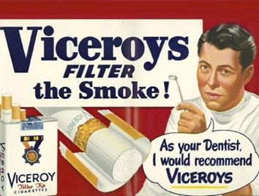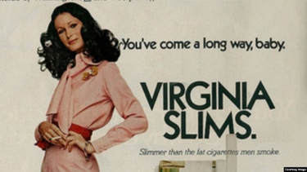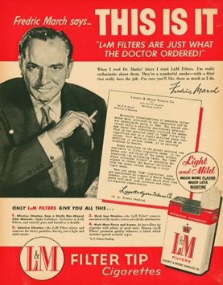
Fig.3 Viceroys Vintage Ad(9GAG, 2018) Fig.4 Ad for Virginia Slims cigarettes. (VOA,2016) Fig.5 Tobacco Industry(Chapman, 2016)

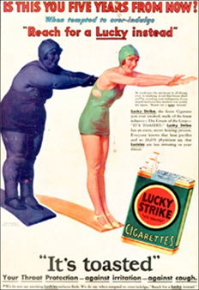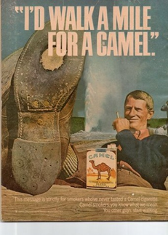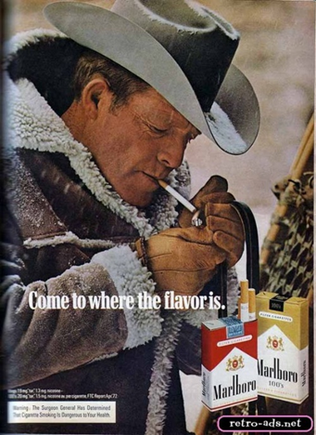
Fig.6 Lucky Strike (Design, 2018) Fig.7 I’d walk a mile for a Camel(Posters, 2015) Fig.8 Marlboro Country (Pinterest)
In that case, if graphic design can contribute very much to the death of people, it can also save lives.
The ban on advertising for the tobacco industry was a turning point. From that moment on, the enormous power of graphic design began to be used to promote public health. Graphically strong anti-smoking campaigns began to appear, some were even frightening. The truth was displayed without embellishments, directly and sometimes even brutally. One of the major actions was the introduction in 65 countries of postage stamps promoting the negative side of smoking (Burki, 2017).
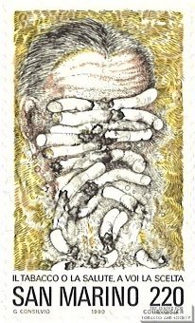
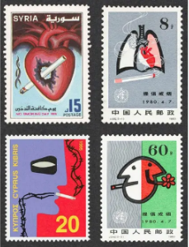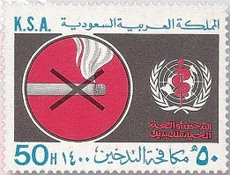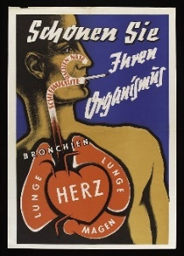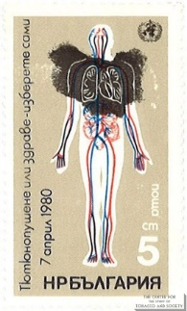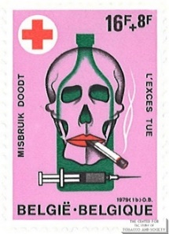
Fig.9 Wellcome Collection Fig.10 Fig.11 Fig.12 Fig.13
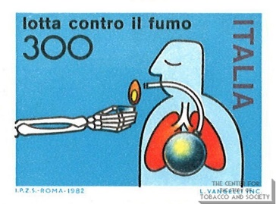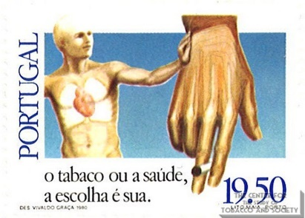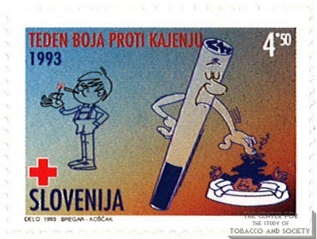
Fig.14 Fig.15 Fig.16 Fig.17

Frightening graphics then appeared on the packaging. A lot of people who see the truth presented graphically do not smoke cigarettes. There was even a fashion for healthy non-smoking.
In studies the worst colour in the world was decided to be Pantone 448C and was introduced as the main colour for ordinary cigarette packaging. Unfortunately, it has only been taken up in three countries to date; the UK, Australia and France. Let’s hope that this idea will be passed on to other countries (Burki, 2017).
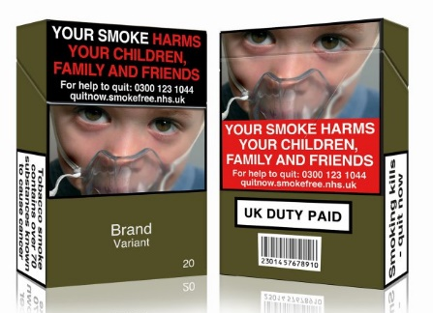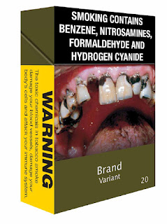
Fig.18 Getty (freepik,2015) Fig.19 Pantone 448C (Munkytalk,2012)
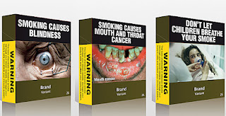

Fig.20 ”You call THAT ugly???” (Munkytalk,2012)

The subject of the tobacco industry is generally very well known and can be discussed a great deal, but it was only about clearly showing the power of good graphic design.

2. Racism
It can have a great impact on society, in addition to bringing an awareness to the bad, it can also do good, help improve the world and save many lives. It’s a great tool that has tremendous reach and power.
In 2020, in America, not long after the police killings of three black men, people took to the streets. This situation provoked a nationwide rage from a society that loudly opposed systemic racism and police violence against black people in the streets.
To meet, support and try to spread the word DESIGNACTION COLLECTIVE created a poster with a strong message: “Existing while Black should not be a death sentence. Don’t call the cops!!!”. The poster is uncomplicated, easy to remember and is ideal as the main graphic of the protest. What’s more, it’s free to download. (Action, 2020) This action has greatly reassured the public that it is doing the right thing.

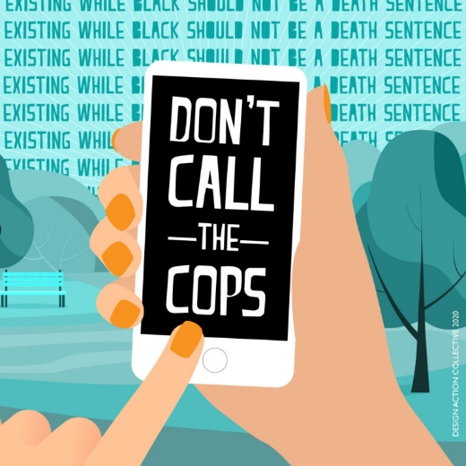
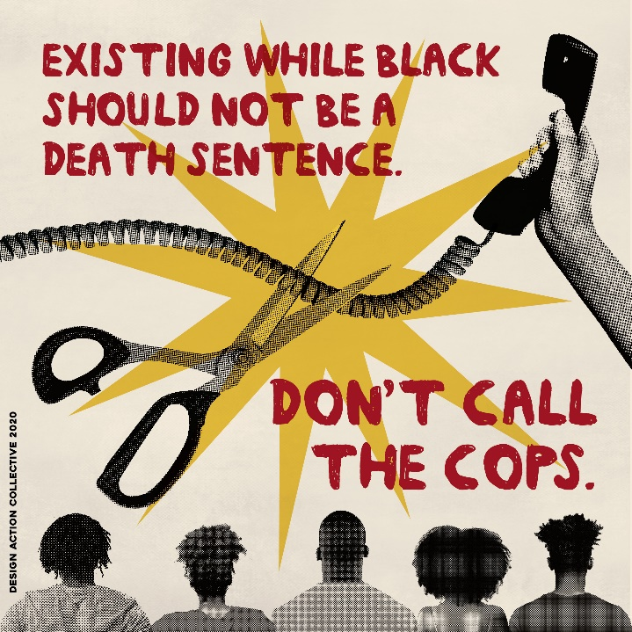
Fig.21Social media versions. (Action, 2020) Fig.22 DON’T CALL THE COPS!!!(Action, 2020)

3. Hospital
Another well-known Graphic Designer who has brought a lot of good for people with her designs is Morag Myerscough. She is known for the use of large shapes and prints, as well as strong colours. She likes to give interpretation with space, so that they give benefit and joy to people. (Berry, 2017)
Together with the poet Lemn Sissay, she created a wonderful interior at The Children’s Hospital at The Royal London. In their design, they used the words of poems whose authors are patients. There is a lot of bright and cheerful colours and patterns. Thanks to this, the rooms have become friendly and cheerful and sick children can feel (Berry, 2017) happier despite the place in which they temporarily stay. It is obvious how well-being and a smile can add a positive attitude and a faster recovery.
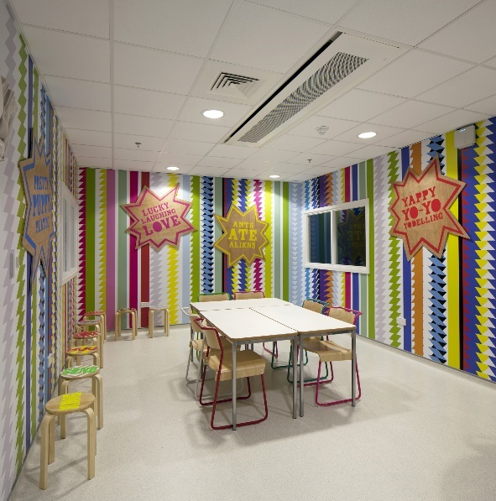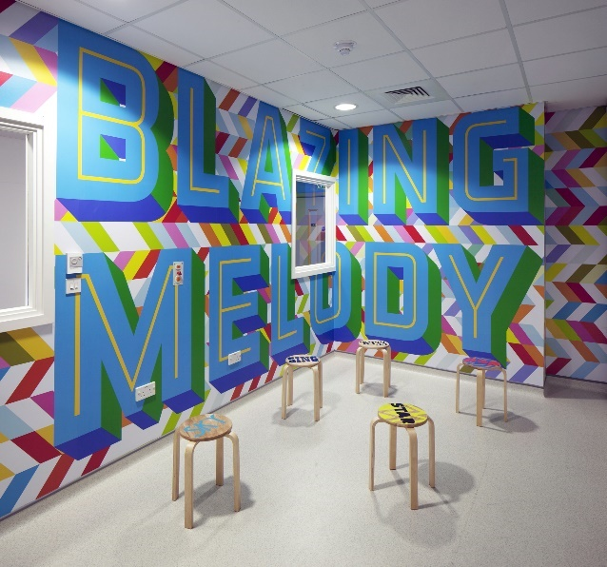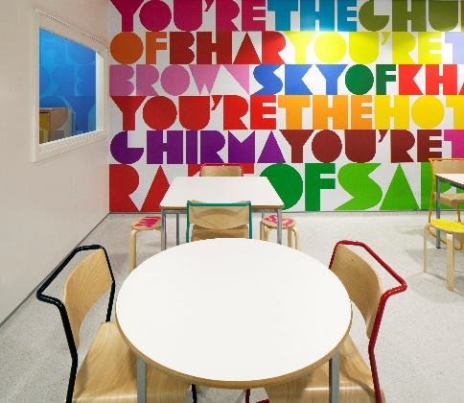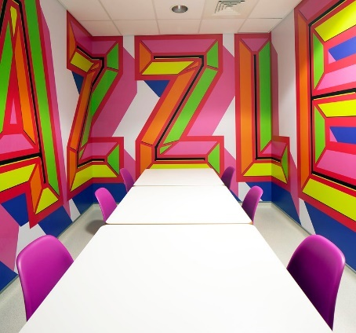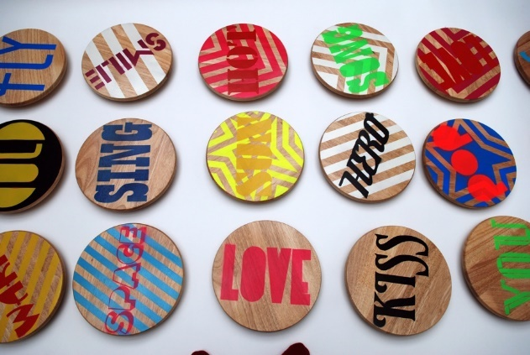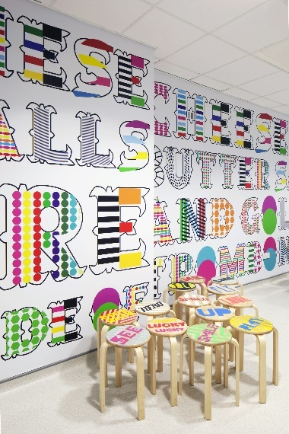

Fig.23 – Fig.28 Barts Healf

4.Sustainable development
For Morag, people’s well-being, joint action and social affiliation are very important. With her projects, she tries to emphasise those values by which society can achieve more and be happier. Values that we forget and that help us live better. One such project was to place a design on the exterior walls of a parking garage in Western Australia.
The main point was the word TOGETHER, which perfectly reflects the idea of the project and called on society to cooperate. (Myerscough, 2020)


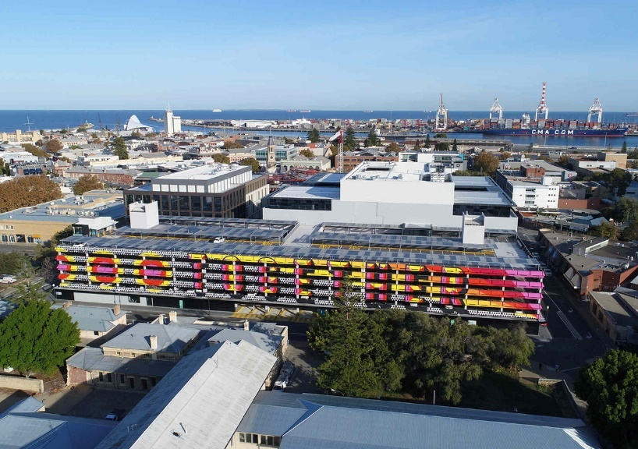

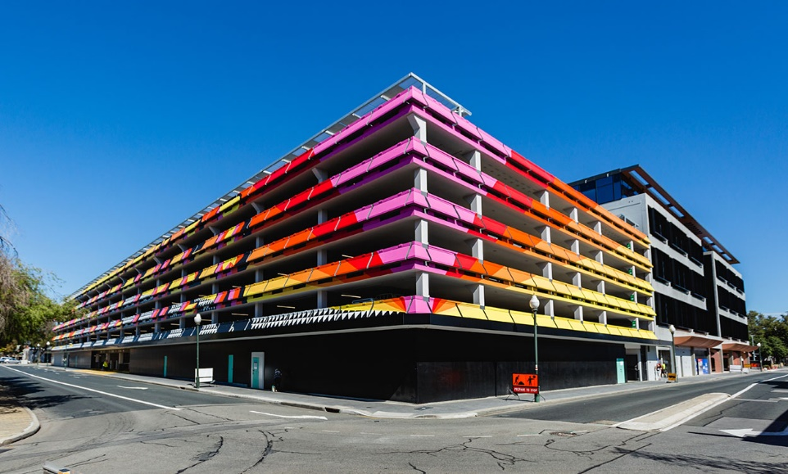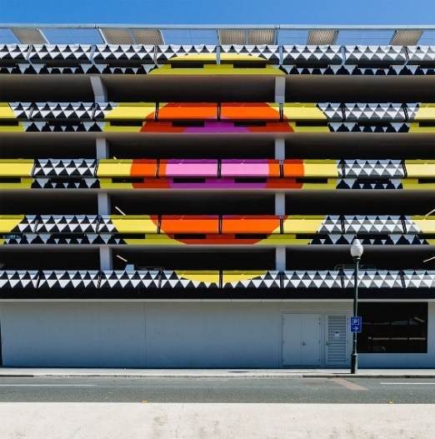
Fig.29 – Fig.32 Together (Myerscough, 2020)

5. Alzheimers
In turn, Studio Dumbar from the Netherlands created a logo for Alzheimer’s Nederland. Alzheimer’s disease, which arises as a result of brain damage, is a common cause of dementia and affects the elderly. It causes memory loss and difficulty in thinking and performing everyday activities. When designing the logo, Dumbar Studio was guided by making the public aware of what this disease is. They showed the disappearing memory as a logo that was still legible and this was a reflection of hope. The logo met with great support and satisfaction of sick people as well as their caregivers. (Berry, 2017)

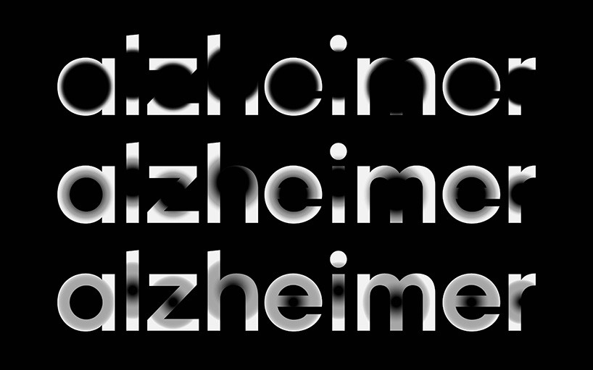
Fig.33 Studio Dumbar (2020)

6. UNICEF
Michael Johnson is the founder and owner of the design agency, Johnson Banks. The agency is located in London, UK. In 2022 it will celebrate its 30th anniversary. Johnson Banks is a team of people who put their heart into doing their job. They themselves say that by creating design, they look into the depths of a given brand. They analyse, observe and try to understand. They mainly work with people who want to bring good to the world, who want to help society with their actions. (Banks, 2015)
“We don’t just help brands change. We help them change the world.” Johnson Banks
Johnson Banks’ business is one of the better confirmations that graphic design can save your life. They have many successes to their credit; one of them is the work done in 2014 for Unicef UK.
In the initial phase, they found that although Unicef UK is known and respected by the public, only 38% of respondents were aware that they were a children’s organisation. Yet Unicef is the largest organization for children in the world. Thanks to their strategy, the team of graphic designers knew that in order for their client to be successful, the project they would create must include an explanation of what they do and what they represent. (Banks, 2015)
The result of their work is, among other things, a slogan, simple to understand and at the same time extremely strong in the message. A short sentence, understandable to everyone and calling for action. (Banks, 2015)
‘For every child in danger’

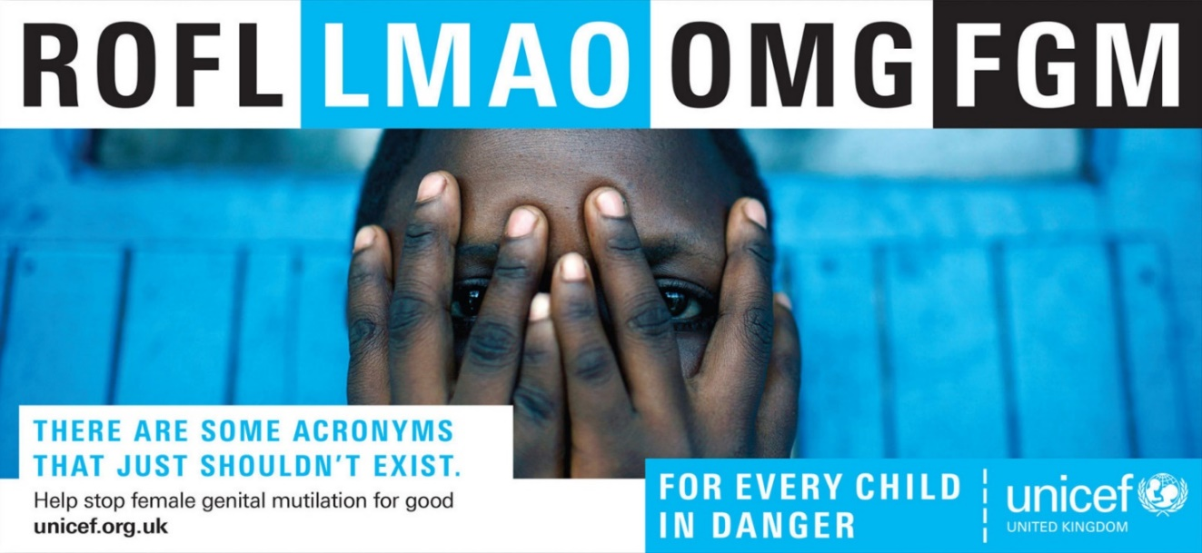
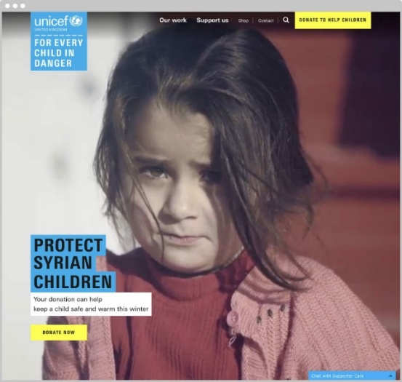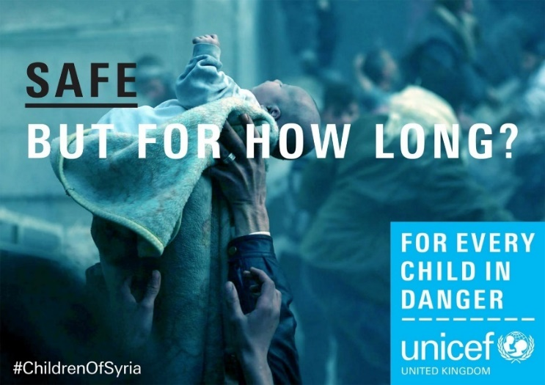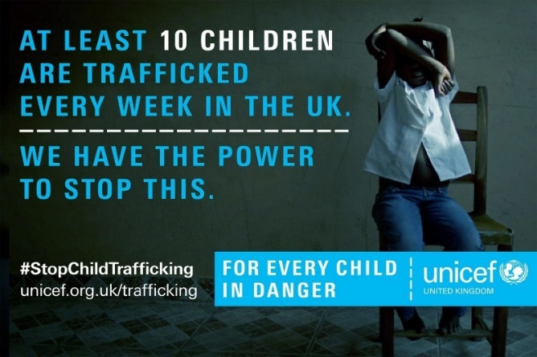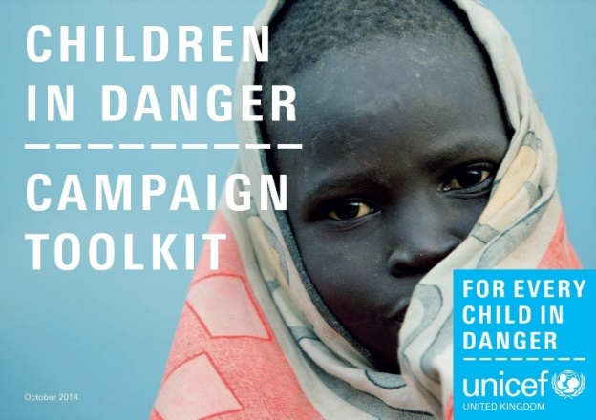

They also established a symbol that shows people supporting campaigns. It is a blue safety pin. (Banks, 2015)

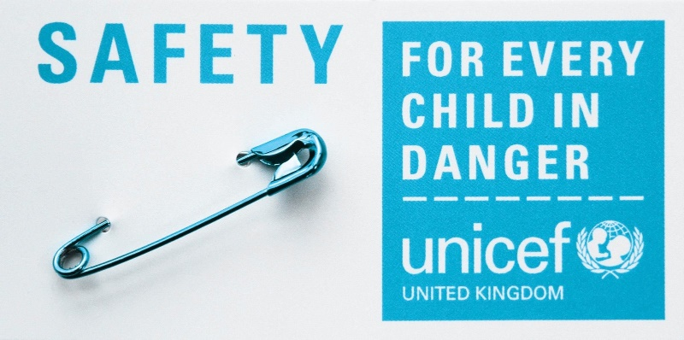

After just one year, the effect of the Johnson Banks rebranding was visible. Unicef UK received 23% more funds and spontaneous brand awareness increased by 150%.
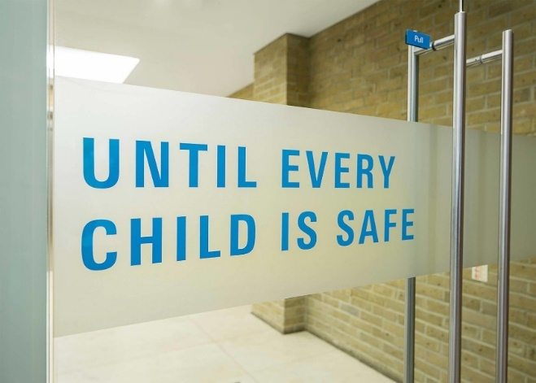
In this case, we see how graphic design helps save millions of children who are affected by violence, hunger, disease, often war and the enormity of other injustices. (Banks, 2015)
Graphic design helps to save the world, restores the child’s smile!



7. Mind
Another example is Thompson Brand Partners’ partnership with charities Mind and The Royal Foundation. The design studio was tasked with designing the Mental Health at Work website, a website serving employees and employers. (Dawood, 2018)
This is a smaller project than the above Unicef UK, but it is equally important. Everything that is done with society in mind is of great importance, regardless of the size of the project or organization.
Unfortunately, it turns out that a large percentage of employees have mental health problems. Thompson Brand Partners has designed an online platform to provide assistance in dealing with such problems. The website promotes workplace support and is for use by any business, but it’s mostly aimed at small and medium-sized businesses that don’t have the resources of the larger ones. (Dawood, 2018)
The site is very extensive and gives a lot of opportunities in finding the help you need. The creators decided on a friendly and transparent graphic design. Of the colours, they mainly used white and turquoise, replacing cold and clinical navy blue. For revival and positive reception, they added grey and here and there a little yellow and red. (Dawood, 2018)

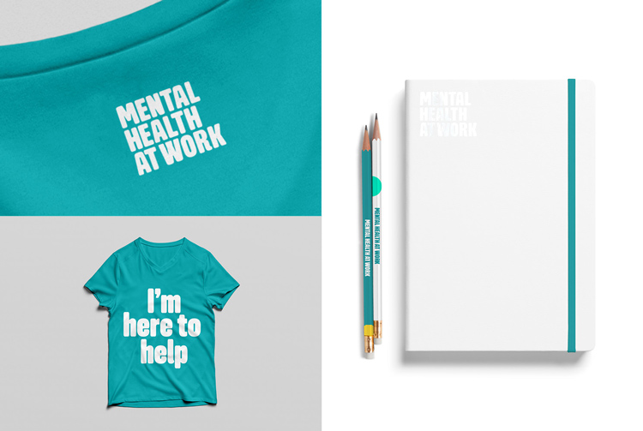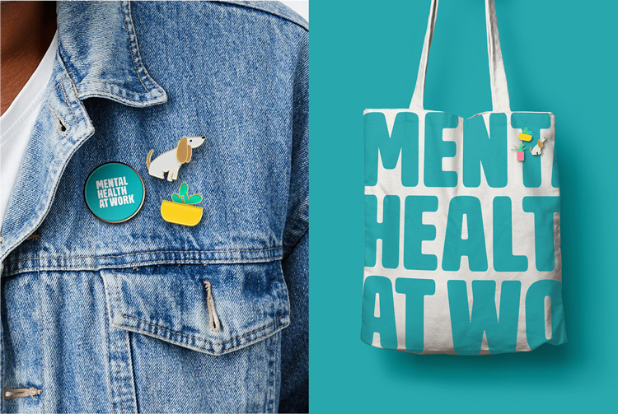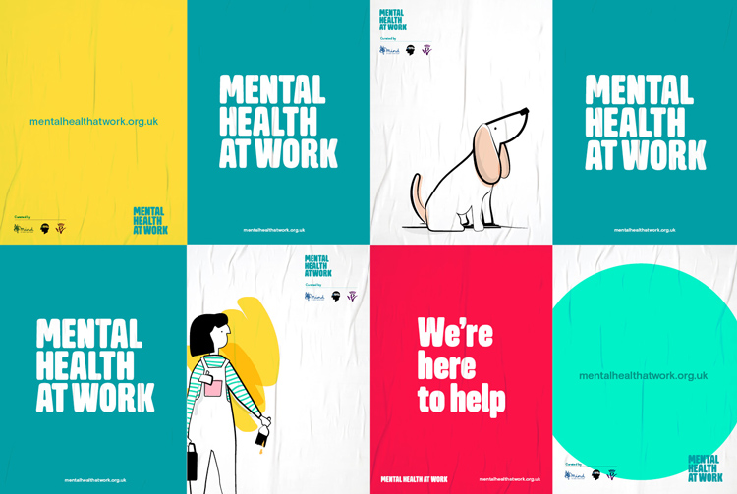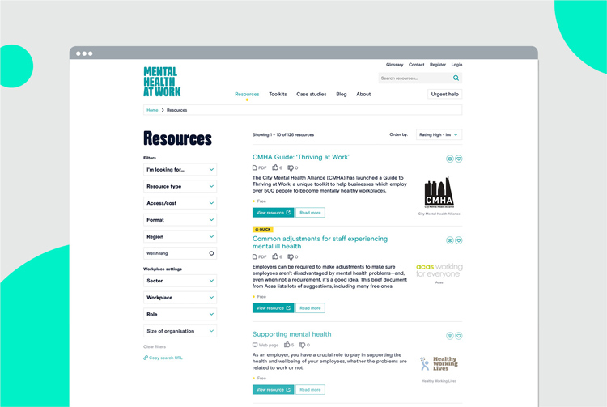

Fig.44 – Fig.47 The Mental Health at Work website-owe 2018

8. Bees
Graphic Designers save our lives by not only by acting directly in our case, but by saving nature, such as bees, they also contribute to our well-being. It is known how valuable bees are to our world.
The LIDA creative team, which is part of M&C Saatchi, did a campaign for Capital Bee in London. The designers will use the works of artist Magnusa Muhra, who is known for creating pictures of dead flies, and transform them using dead bees. The images created for the campaign combine the mentioned dead bees with simple illustrations. LIDA wanted to highlight the plight of London bees.
Billboards with pictures were placed on the Network of the London Underground. In addition to the pictures, postcards and humorous video clips were created. (Gurp, 2011)

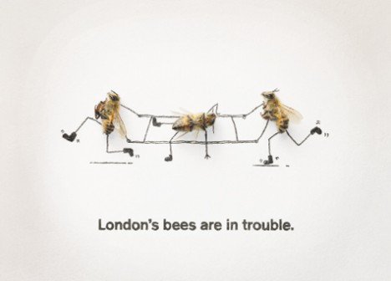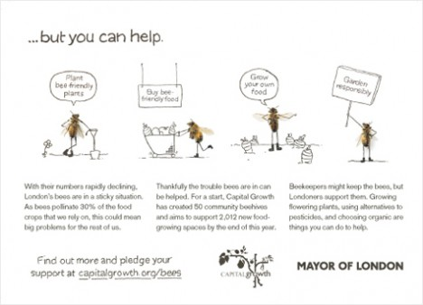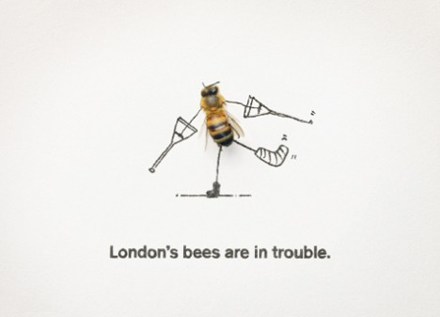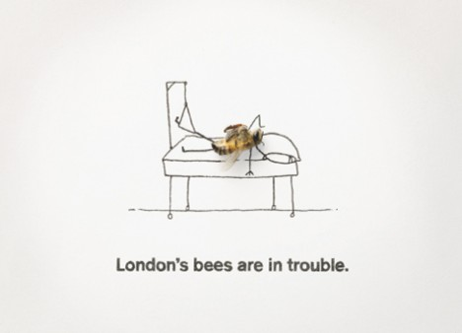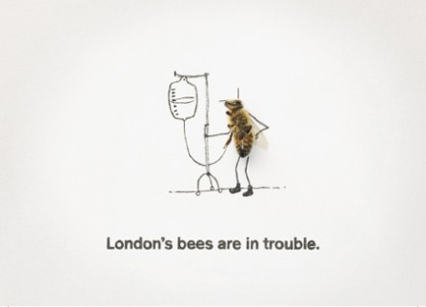

Fig.48 – Fig.52 London’s Bees are on touble (Marc van Gurp (2011

It should be mentioned that there are also artists who do not act on behalf of any associations or companies. They act on their own and out of their own willingness, for the good of the world.
The street artist Louise Masai Michel, who during his own action of painting endangered animals in South Africa, learned about the problem of bees, began another voluntary action. He began to paint wonderful bees all over the world, even in our Bristol. (Hat, 2019)
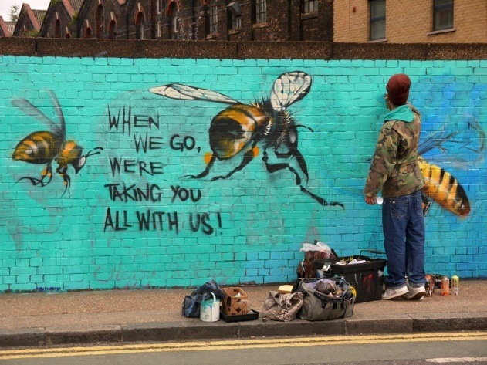
Fig.53 Louise Masai Michel (Green Hat, 2011)

During his tour of the United States, he created the Art of Beeing series. He painted bees armed with needles and threads on animals whose species are endangered. His intention was to stimulate society to unite and save nature in order to return the planet to “health”. Bees work together and are therefore able to do the almost impossible. (Hat, 2019)
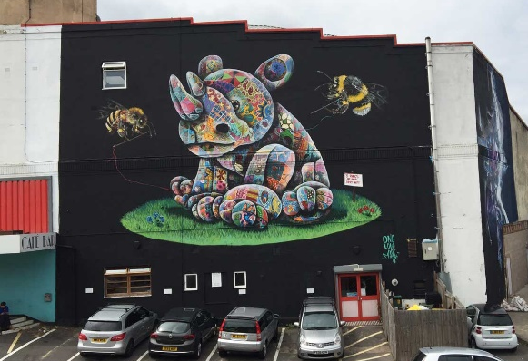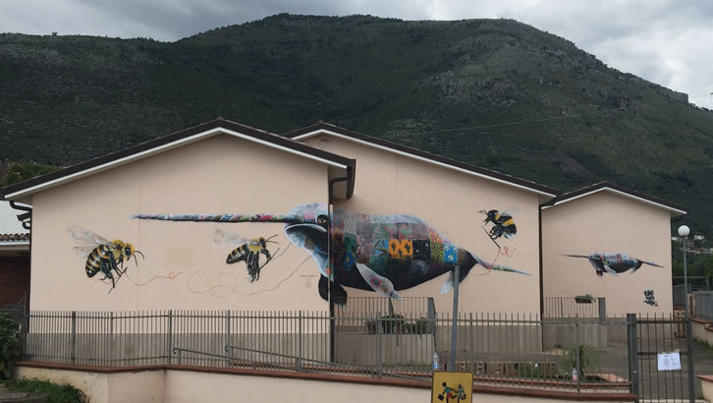

Fig.55 – Fig.56
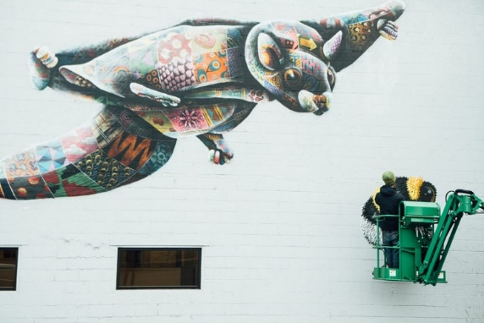
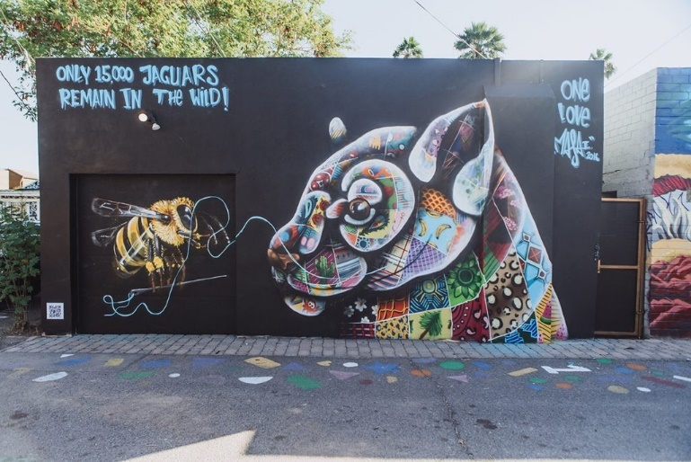

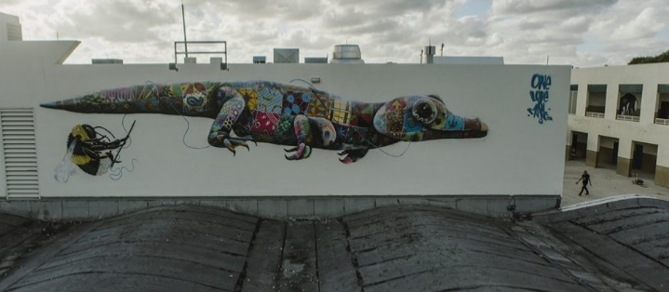

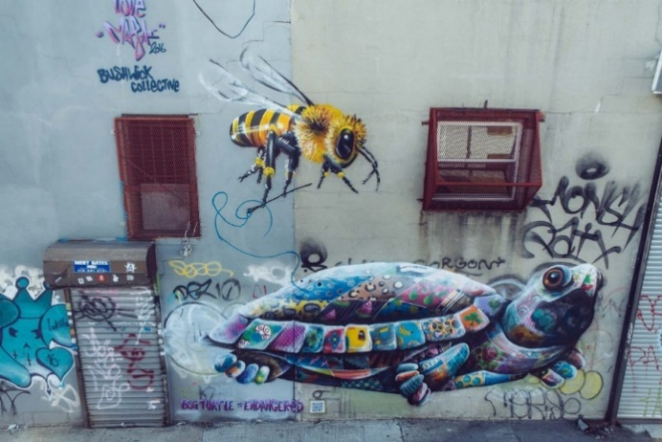
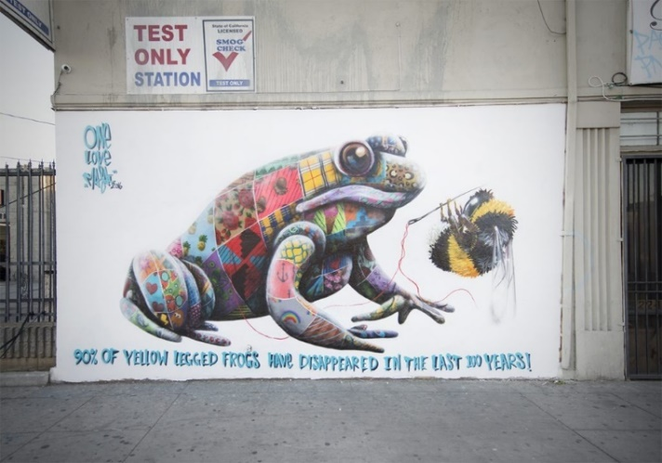

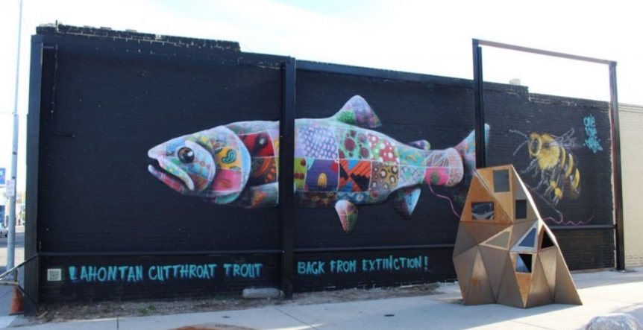

Fig.57 – Fig.62 The Art of Beeign,

Only a small area of the world of graphic design has been touched upon here.
Ecology, through which a variety of campaigns have been launched, makes people aware of how their individual actions affect the pollution of our planet. They are educated in the direction of environmental protection. e.g. the tobacco industry and a huge fight against lethal addiction, combating racism and striving for racial equality. There is also health, in a fairly wide range, including hospitals that are visually similar, which has a positive effect on the effects of treatment and improving the mood of sick patients. This educates the public in terms of sickness, as well as supporting and helping the understanding of one’s own mental health. Graphic design is used to unite people, restoring interpersonal values that are slowly fading into oblivion. Children, their happiness and safety as an absolute priority and duty of all people. Nature, the world of animals and plants that need human care and attention, help in the development and maintenance of the species. These areas have all been assisted by the use of graphic design.
In conclusion, Graphic Designers are able to inform the public and translate incomprehensible, with great subtlety, but also with sophistication (Wainwright, 2017). They provide the public with simple and clear instructions, using perfectly designed colour systems that greatly facilitate reception and understanding. They can also be sincerely brutal in making people aware of the truth.
One thing is certain, they are very effective, they have great power and ability to repair people and the world and help in every field and at every level.
Society is increasingly aware of these possibilities and is beginning to see more accurately how graphic design contributes to the sustain ability of the world. (Ertel, 2016)

Yes, graphic design can save your life!

Reference List

Bibliography
Action, D., 2020. Designaction Collective. [Online]
Available at: https://designaction.org/existing-while-black-should-not-be-a-death-sentence-dont-call-the-cops/
[Accessed 28 11 2021].
Banks, J., 2015. Johnson Banks Defining and designing brands that make a difference. [Online]
Available at: https://www.johnsonbanks.co.uk/
[Accessed 02 12 2020].
Berry, C., 2017. Craig Berry. [Online]
Available at: https://craigberry93.medium.com/can-graphic-design-save-your-life-65d7d99e2dfd
[Accessed 29 11 2021].
Burki, T. K., 2017. Can Graphic Design Save Your Life?. Spotlight, 5(11).
Dawood, S., 2018. Design Week. [Online]
Available at: https://www.designweek.co.uk/issues/24-30-september-2018/designing-a-website-to-promote-better-mental-health-in-the-workplace/
[Accessed 03 12 2020].
Ertel, C., 2016. SB the Bridge to Better Brands. [Online]
Available at: https://sustainablebrands.com/read/product-service-design-innovation/how-design-can-save-the-world
[Accessed 03 12 2021].
Fuad-Luke, A., 2009. Design Activism: Beautiful Strangeness for a Sustainable World. 1st ed. London: routledge.
Gurp, M. v., 2011. Osocio. [Online]
Available at: https://osocio.org/message/londons-bees-are-in-trouble/
[Accessed 28 11 2020].
Hat, G., 2019. Green Hat Graphic Design. [Online]
Available at: https://mailchi.mp/9871f505f72c/bee-the-change-2978429
[Accessed 28 11 2021].
Myerscough, M., 2020. MORAG MYERSCOUGH. [Online]
Available at: https://www.moragmyerscough.com/commissions/together
[Accessed 29 11 2021].
Norman, D. A., 2013. the design of everyday things. 2nd ed. New York : Basic Books.
Wainwright, O., 2017. The Guardian. [Online]
Available at: https://www.theguardian.com/artanddesign/2017/sep/07/can-graphic-design-save-your-life-review-wellcome-collection-london
[Accessed 28 11 2021].

Photos

Fig.1, Fig.2 FLOWinstytute (2006) Available at: http://www.theflowinstitute.com/ [Accessed 28 11 2021]

Fig.3 Awesome (2018) https://9gag.com/gag/avOA0yq [Accessed 28 11 2021]
Fig.4 Catherine Maddux (2017) Available at: https://www.voanews.com/a/youve-come-along-way-baby-but-its-still-a-mans-game/3380920.html [Accessed 28 11 2021]
Fig.5 Simon Chapman (2016) Available at: https://theconversation.com/the-failed-history-of-tobacco-harm-reduction-64561 [Accessed 28 11 2021]
Fig.6 Inkbot Design (2018) Available at: https://inkbotdesign.medium.com/top-10-marketing-and-advertising-campaigns-of-all-time-2dd08955f2d5 [Accessed 28 11 2021]
Fig.7 Vitage Cigarettes Posters (2015) Available at: https://vintage-cigarette-posters.tumblr.com/post/113149803780/id-walk-a-mile-for-a-camel [Accessed 28 11 2021]

Fig.8 Marlboro Country Available at: https://hu.pinterest.com/pin/508062401702833258/ [Accessed 28 11 2021]

Fig.9 https://www.bbc.com/future/article/20170927-the-graphic-design-that-can-help-save-lives [Accessed 28 11 2021]
Fig.10 https://www.linns.com/news/world-stamps-postal-history/saudi-arabia-anti-smoking-campaign-stamps-middle-east.html [Accessed 28 11 2021]

Fig.11 https://commons.wikimedia.org/wiki/File:German_antismoking_campaign_poster_Wellcome_L0038326.jpg [Accessed 28 11 2021]

Fig.12 https://csts.ua.edu/stamps/europe/ [Accessed 28 11 2021]

Fig.13, Fig.14, Fig.15, Fig.16, Fig.17 https://csts.ua.edu/stamps/europe/#prev [Accessed 28 11 2021]
Fig.18 freepikcompanyblog (2016) Available at: https://www.freepik.com/blog/the-ugliest-color-ever-has-a-name-and-it-is-pantone-448c-opaque-couche/ [Accessed 28 11 2021]

Fig.19, Fig.20 BBC (2017) Available at: http://olemunk.blogspot.com/2012/07/you-call-that-ugly.html [Accessed 28 11 2021]
Fig.21, Fig.22 Design Action (2020) Available at: https://designaction.org/existing-while-black-should-not-be-a-death-sentence-dont-call-the-cops/ [Accessed 28 11 2021]
Fig.23 – Fig.28 flicker (2021) Available at: https://www.flickr.com/photos/bartsandthelondonnhstrust/6938519735/in/photostream/ [Accessed 29 11 2021]

Fig.29 – Fig.32 Myerscough M,.2020 Available at:https://www.moragmyerscough.com/commissions/together [Accessed 29 11 2021]

Fig.33 Berry C, Available athttps://craigberry93.medium.com/can-graphic-design-save-your-life-65d7d99e2dfd [Accessed 29 11 2021]

Fig.34 – Fig.43 Banks.2014 Available at https://www.johnsonbanks.co.uk/work/unicef-uk [Accessed 02 12 2020]
Fig.44 – Fig.47 DawooD2018 Available at: https://www.designweek.co.uk/issues/24-30-september-2018/designing-a-website-to-promote-better-mental-health-in-the-workplace/ [Accessed 03 12 2020]
Fig.48 – Fig.52London’s Bees are in Trouble (Marc van Gurp,2011) https://osocio.org/message/londons-bees-are-in-trouble/ [Accessed 28 11 2020]

Fig.53 Green Hat creatibr thinking (2011) Available at: https://mailchi.mp/9871f505f72c/bee-the-change-2978429 [Accessed 28 11 2021]

Fig.54, Fig.57 – Fig.62 , The Art of Beeing. Available at: https://louismasai.com/project/bee-16/ [Accessed 28 11 2021]

Fig.55 – Fig.56 Meat my friends Available at: https://louismasai.com/outside-2016/ [Accessed 28 11 2021]

