

Name: Paul Cartwright
P Number: P144279
Program: BEng Test Range Engineering
Module: Munitions
Module Code: M6X00944
Lecturer: Mr James Edwards
Mr Austin Clark

Munitions Enhanced Paveway II Bomb | June 22  2017
This report will look at the processes and procedures needed to design a test scenario which will evaluate the accuracy and performance of the Enhanced Paveway II Bomb. It will include how the laser sport positions are recorded and miss distance measurements between the laser spot and point of warhead detonation.

Contents
1. Introduction 3
1.1. Aim of the Report 4
1.2. Objectives of the Report 4
2. Research and Review of Literature 5
2.1. Organization of Trials Literature 5
2.1.1. JSP Standards 6
2.1.2. Other Documentation 6
2.2. Research Review Conclusion 7
3. Design of the EPW II Trial 7
3.1. EPW II Specifications (6) 7
3.1.1. EPW II Warhead 8
3.1.2. EPW II Safety Specifications 8
4. Command Methods 8
4.1. Laser 9
4.1.1. Laser Specifications 9
4.2. GAINS 9
5. Target Selection 9
5.1. Target Selection Specification 10
6. Location of Target system 11
7. Data Capture 13
7.1. Main Sequencer Unit MSU 13
7.2. Cameras 13
7.3. Blast Pressure Sensors 14
7.4. TCS 14
7.5. HTPI 15
7.6. Radar 16
7.7. FRAT System 16
8. Weapon Test Risks 17
9. Findings 18
9.1. Conclusion 19
9.2. Recommendations 19
Works Cited 20
Appendices 21

Table of Figures
Figure 3 Structure of Literature 5
Figure 5 EPW II 7
Figure 6 Test Target 10
Figure 7 Watchman Radar 12
Figure 8 Flash Detector 13
Figure 9 Piezo Blast Sensor 14
Figure 10 TCS System Diagram 15
Figure 11 Highbred Tracking Platform 15
Figure 12 MOTR 16
Figure 13 FRAT System 16

Introduction

This report provide a design solution for an in-service weapon system. It describes the physical munition under test and investigates the command methods used to deliver the weapon to its target. The target system will be design to deliver the customer requirement but will also provide the safest possible solution for the warhead under test. The location of the target system will also be considered so that it provide the most accurate command and control instrumentation for tracking the weapon delivery platform and insuring that the Weapon Danger Area is clear at all time. The weapons test will be conducted under guidance from the Ministry of Defence’s Joint Service Publications and associated safety documentation.

Aim of the Report

This report will evaluate the accuracy and warhead performance of the UK is-service Enhanced Paveway (EPW) II Bomb. In order to conduct trials activity of this complexity a number of questions must be considered.
- Can this Activity be conducted on a QinetiQ Range
- Does the Range Safety Case incorporate firing EPWII weapon systems.
  - Weapon Risk Analysis
  - Weapon Risk Failure Rate
- Is their Trials documentation suitable to cover EWPII Releases?
  - Range Standing orders for the conduct of trials
  - Hazardous Activity Rick Assessment
  - Trials Safety certificate
  - Trials Specification
- Does the Range have enough space to in-compass, the danger area and weapon impact area.
  - Joint service Publication (JSP)
  - Ministry of Defence (MOD) Air Warfare Centre Trials Specification
- Has the Range the Instrumentation in place to conduct the EPWII Releases.
  - Acoustic Triggers to activate a Direct Zero Time (DZT) to start all Range Instrumentation.
  - Laser Spot Cameras
  - Fragmentation Mapping
  - RADAR to Track and recorded Stores from release to splash
  - Hybrid Tracking Platforms (HTP) to provide optical trajectory
- Can the Range and its Danger Area contain the noise of the firing to limit noise pollution on the public and Range Workers.
  - Noise levels in the JSP standards and health and Safety (HSE) standards
  - Plan of the location of the noise monitor readings
- Environmental impact of EPWII testing
  - Potential sea pollution from Bomb debris
  - Potential land pollution for explosive residue

Objectives of the Report

The measured out comes of the project are:-
- Provide a description of the Munition under Test.
- Describe the command method used to deliver the munition.
- Select an appropriate target for the trial.
- Justify an appropriate location for the target.
- Select range equipment needed for the Trial.
- Investigate data capture methods for the Trial.
- Consider the environmental impact of the warhead detonation.

Research and Review of Literature

In order to conduct any Trials activity at any QinetiQ Range, there must be a documentation pack in place that consists of.
- Range Standing orders for the conduct of Trials. (RSO)
- Trials Specification (Air Range)
- Hazardous Activity Risk Assessment, (HARA).
- Trials safety certificate, (TSC).
- Trials Test plan (Land Range)

The Trial documentation pack is developed form the JSP standard.
JSP is the MOD’s safety management system for all UK Range’s there are under written by the secretary of state for defence. They apply to all Mod Ranges and provide direction on best practices to ensure that the risks associated with Mod Ranges safety are “as low as reasonably practicable” (ALARP) (1)

Organization of Trials Literature
Figure 3 Structure of Literature
The Range standing orders and Range safety case are formulated from the MOD JSP standards, as the image in figure 3 shows that information is then carried forward to develop the rest of the Trials documentation pack.

JSP Standards

JSP403 Volume I Part 1 (2) - The overarching policy which gives clear direction as to what must be followed in accordance with Legislation, Regulation, Direction, Instructions mandated by Defence or on Defence by Central Government.

JSP403 Volume 1 Part 2 (2)- Direction as to the implementation of the safe operation, use and maintenance of Defence Ranges in compliance with the policy set out in Part 1 of this JSP.

JSP403 Volume 3 (2) is in two parts. Part 1 covers the firing of weapon systems from fixed wing aircraft and helicopters on to MoD Ranges. It has introduced commonality into control systems, procedures and management. It also explains the terminology used in air-to-surface engagements. Part 2 details the policy and principles for the safety of surface-to-air weapon systems firing against air or surface targets on MoD Ranges.

JSP403 Volume 4 (2)covers the design and construction of demolition ranges and explosive ordnance disposal training areas, the clearance of ordnance from ranges and training areas, the safe use of ranges and training areas for demolitions and ordnance disposal training, and the safe use of explosives and pyrotechnics for battle simulation on ranges and training areas and safety of ranges and training areas used for demolitions and ordnance disposal training and for battle simulation.
JSP502 Safety and Environmental Management of Ordnance, Munitions and Explosives over the Equipment Acquisition Cycle (3)This JSP explains the requirements needed to demonstrate that the inherent risks from Ordnance, Munitions and Explosives (OME) are either Broadly Acceptable or Tolerable and As Low as Reasonably Practicable (ALARP) for the MOD, third parties and the environment.

The Control of Noise at Work Regulations 2005 (4)gives daily noise exposure to the public and working personnel, also gives guidance on noise control risk assessments.

Other Documentation

Range Standing orders for the conduct of Trials. (5) This outlines the rules and control measures for ensuring MOD Aberporth is operated in a safe and secure manner.
Trials Specification. (6) Details all parameters of the activity including customer deliverables, safety requirements the sequence of the firings and the roles and responsibilities of staff members during the activity.
Hazardous Activity Risk Assessment. (7) List all known risks associated with the task reduces them to ALARP.
Trials safety certificate. (8) Issued by the Range safety committee after all the documentation has been review and the HARA has been passed by the Hazardous Activity Management Panel.

Research Review Conclusion

The objectives of the literacy review where difficult to achieve. The MOD has a set of regulations which set the standards for all weapons testing within the United Kingdom. This means there is no other literacy for this type of testing which made compare or critical reviewing the information in the JSP’s impossible. The research element however was more attainable as there is a massive amount of information in the JSP which detail the process, procedures, construction and delivery of Trials activity. The most affirmative document found is the Air Warfare Centers customer specification for the delivery of EWPII. It details all parameters of the weapon system and laser designator unit.

Design of the EPW II Trial

The EPWII entered RAF service in 2001. It is based on the laser-guided bomb Paveway II and accommodates a Global Positioning System Aided Inertial Navigation System (GAINS). This allows the EPWII to be full autonomous in cases where cloud could cover the target which may obstruct the laser. In these instances the Global positioning System (GPS) will steer weapon to the target. The bomb has all weather capability and in flight re-targeting and can be deployed on the Tornado GR4 and Typhoon aircraft.

EPW II Specifications (6)
Weight 545Kg / 1000lb
Warhead 450Kg, PBXN-109
Length 3.55m
Diameter 1.67m fins deployed
The image in figure 5 shows and EPW II mounted to the hard point of the aircraft. (9)

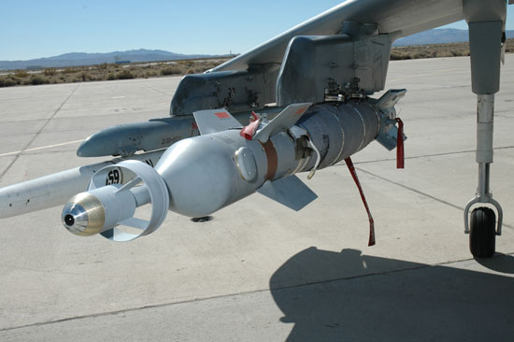
Figure 5 EPW II

EPW II Warhead

The warhead is made up in the form of a compound which consists of 64% Royal Demolition Explosive (RDX), 20% Aluminium and 16% binder (10). The RDX is a member of a group of explosives known as nitramides. It exists as a hard, white crystalline solid and incredibly stable for an explosive. The Chemical Properties of RDX can be seen below. (11)
- Chemical Abstracts Service (CAS) Number | 121-82-4
- Physical Description (physical state at room temperature) | White Crystalline Solid
- Molecular weight (g/mol) | 222.26
- Water solubility at 25oC (mg/L) | 59.7
- Octanol-water partition coefficient (Log Kow) | 0.87
- Soil organic carbon-water coefficient (Log Koc) | 1.80
- Boiling point (oC) | Decomposes
- Melting point (oC) | 204 to 206
- Vapor pressure at 20oC (mm Hg) | x 10-9 (ATSDR 2012);  4.0 x10-9 (HSDB 2013)
- Specific gravity at 20 oC (g/mL) | 1.82
- Henry’s Law Constant at 25oC (atm-m3/mol) | 2.0 x10-11

It is very interesting to find out that RDX explosive compound is so stable that armed forces personnel have been using it as a substitute for their hexamine cooking stoves.

EPW II Safety Specifications

The weapon (6) has a set of canard fins attached to it front portion which are controlled by the guidance and control unit, this unit responds to detected laser energy reflected from the target or GPS derived data.
The bomb has a GAINS battery with must be operated prior to release of the weapon. This is done by pressing the Air Ground Munitions button for 15 seconds prior to the release.

Command Methods

The EPW II weapons can be commanded using either laser or GAINS of a combination of both. If the laser is obstructed by clutter the weapon can be delivered using GPS which controls the canard fins using a compressed gas generator. If the clutter clears before impact the weapon can re-acquire the laser reflected energy for more accurate delivery.

Laser

The laser used for command is an LITENING III Combat/Marker Laser. (12) It’s been developed by defence contractor Rafael and provides a cost effective, reliable precision strike capability to fighter aircraft. The LITENING III combines a third generation day/night 640 x 480 resolution forward looking infrared camera and dual wavelength eye safe diode pumped laser designator which provide accurate tracking even when the aircraft is manoeuvring.

Laser Specifications

The Laser Designator (6)
- Identification LITENING III Op Laser Designator.
- Laser Type Neodymium yttrium aluminium garnet (Nd:Yag).
- Laser Class 4.
- Wavelength 1.064 um.
- Power Output 140 mj.
- Pulse Width 20 nsec.
- Pulse Repetition Freq 20 Hz.
- Beam Divergence 0.12 mrad.
The LITEN III Combat / Marker Laser (6)
- Combat - Class 4, OHD 57Km, EOHD 359Km
- Marker - r Class 4, OHD 245m, EOHD 1700m

GAINS
The EPW II weapon includes a GAINS guidance unit and GPS aerial. It works in conduction with the Internal Navigation System (INS) which enables the pilot to enter the GPS coordinates of a target. Once released from the Aircraft the EPW II GPS/INS will autonomous guide itself making adjustment to the canard fins to accurately delivery the weapon within feet of the selected target.

Target Selection

The target system for the trial would be an arena type structure with a 3D barge in the middle. This would aid with target acquisition it would also have a heat source in the middle to assist thermal images. The arena would also have accurate GPS coordinates so the weapon could be guided by laser of GAINS. The image in figure 6 is a mock-up of the target arena.
Figure 6 Test Target

Target Selection Specification

- Hot Box, this is normally a disposable barbeque which is lit and placed into the target before the trial. It is done to assist in thermal images captured by the aircraft.
- 3D Target, it’s recommended that this is an ISO container type structure with well-defined sides but no reflective surfaces to reduce the probability of specular reflections. This will aid the aircraft in target acquisition.
- Laser Capture Plate, this shows any reflections from the laser on the target barge and aids the trials delivery team in giving the pilot a laser spot seen call. This would also be constructed with no reflective surfaces.
- Laser Spot Camera, to observe the laser spot and insure the weapon is on target.
- Miss Distance Camera, to measure the distance between the laser spot and weapon splash position.
- 2 x Battle Damage Camera, to record the target damage and relay real time imagery to the customers.
- FRagment-Field Analysis Testing (FRAT) system to give fragment accuracy of approximately 1% in real time or Fibreboard, placed in bundles to capture the fragmentation pattern of the detonated warhead.
This would give the customer all the information requested in the specification. The only information that could be obstructed in the fragmentation pattern of the warhead as it is hitting a container before detonation. The only way the customer could get a true fragmentation pattern would be to conduct a static warhead detonation in the same type of arena. This would mean conducting two separate Trials which could be very costly. It would however be a recommended solution if the fragmentation pattern was a priority customer requirement.

Location of Target system

The testing of the EPW II could be conducted on a number of different Range locations throughout the UK. It would be recommended to be conducted on a Range which already has the range infrastructure in place to coordinate a Combat aircraft delivering the weapon system to a target.
The ideal solution would be the Range at Penporth. This is a land Range, fully instrumented with a range danger that occupies 6,500km² of sanitized airspace. This airspace is from surface to unlimited altitude and overlaps the Welsh Military Training Area, which offers some unique low-flying options.
The weapons test would use the recommended target system located centrally inside a weapon danger Area (WDA) and laser Firing Area (LFA). Depending on the release altitude of the weapon, the safety trace could range (6)from 10,820 yards to 36,208 yards in diameter. The air space portion would be sanitized and control by National Air Traffic Controllers (ATCO) this is common practice across QinetiQ Ranges.
To clear the airspace and control the trials aircraft the ATCO’s use a watchman primary and secondary surveillance Radar’s. This gives them accurate locational data of all aircraft in the airspace. The image in figure 7 is the watchman Radar. (13)
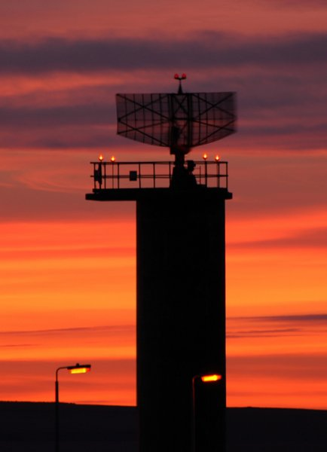
Figure 7 Watchman Radar

Range control would be utilized to clear and control the land proportion of the WDA. This would be done using road barriers and Sentries. This would all be coordinate by the use of Radio and telephone communications. With the size of the WDA being so large, CCTV would also be used to ensure the area remains clear throughout the whole test process.

Once the area is clear, this information would be passed to the Operations room via the In Flight Safety Office (IFSO). The IFSO would also be in full and continues communications with the ATCO’s, once both portions of the WDA are clear the IFSO will issues a commend that the Range is clear to the Trials Conducting Officer (TCO).

The TCO will have the overall control of the trials process, ensuring that the trial sequence is followed and that all activities are conducted in the safest possible manner. He will also ensure that best effort are made to meet the customer requirements.

The land Range would offer the best solution for the customer deliverables. It allows the trials team to eliminate a lot of variables that could be issues on a Sea Range.
The main issues would be confirming the detonation of the weapon. It could be difficult to observe this if the weapon had malfunctioned and sank in the sea it could still be live weapon and this scenario would not be accepted by the MOD. Another issue would be the target placement and the fiberboard arena to capture the fragmentation pattern. It is very rare that the sea would be in a calm enough state as to not interfere with the result of the fragmentation pattern.

Data Capture

In order to conduct the weapon test and achieve the customer requirement the range will utilises many different instrumentation section which will form the core data capture team. This will give the customer a more rounded view of the trial but also aids the data analysis team in capturing the key customer deliverables.

Main Sequencer Unit MSU

The MSU provide a means to synchronise a trial in 0.1 second intervals by switching instrumentation on and off at preselected time. These times can be anywhere between -9 hours 59 minutes 59seconds 9 tenths and +9hours 59 minutes 59 seconds 9 tenths. It consists of 120 general output channels that can be switched on and off at any time during the sequence in 1.0 second steps. The Output will be critical in activating the trials cameras during the test.

Cameras

The Cameras utilized for the test would be a Photron UX100 which gives a resolution of 1280x1024 at 4000 Frames per Second (FPS). The MSU is used to trigger the cameras as the FPS is so large they would need a lot of on board memory.
The cameras will be used to provide the battle damage and miss indicator images they are mounted on the tower away from the arena to stop the being damaged by flying debris. The image in figure 8 is an illustration of the high speed cameras. (14)
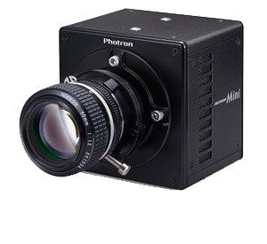
Figure 8 Flash Detector
The laser spot camera would be a standard CCTV camera.

Blast Pressure Sensors

The sensors are piezo-electric B12 Blast pressure sensors place at locations around the arena. The sensors will give the customer the blast pressure value at the point of impact with the fragmentation fibreboard. The image in figure 9 is a piezo blast sensor (15). The sensor uses a diaphragm which outputs high impedance it the converts it to low voltage which can be used as an output. The Blast sensors are classed as trials disposables as they can be damaged during the testing.
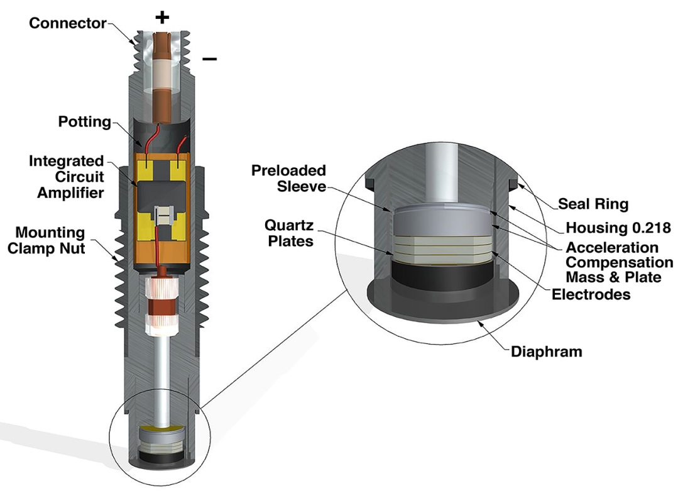
Figure 9 Piezo Blast Sensor

TCS

The Trials control system (TCS) is used to provide a controlled safe environment in which to conduct trials, the safe environment is achieved by utilizing a number of interlinked sub-systems. They include sea surveillance, tracking radar, Hybrid Tracking Platform and safety related traces and maps. The information is correlated by the Configuration management and control (CMC) workstation and sent out to work stations that are used by the IFSO and ATCO. Figure 9 shows a system diagram of how the TCS connects to its sub-systems (16)
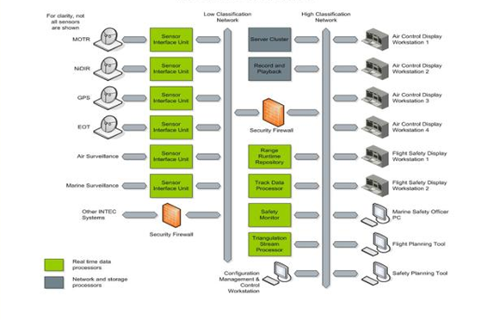
Figure 10 TCS System Diagram
The IFSO uses a function on the TCS to insert the parameters of the safety trace on to the TCS system. The TCS can then be configured to give alarm notifications using Radar data if any of the safety trace parameters are breached.

HTPI

The HTP provides a highly capable, dynamic and precise auto tracking capability, facilitating the capture of highly accurate data in a multitude of scenarios. They have an integrated video tracker for optical auto acquisition and tracking and provide highly accurate time-space-position information which can then be passed to the TCS. For the purpose of this test the HTP’s would track the aircraft and the weapon release all the way to detonation. The image in Figure 10 shows an HTP at one of the observation points at Penporth Range.
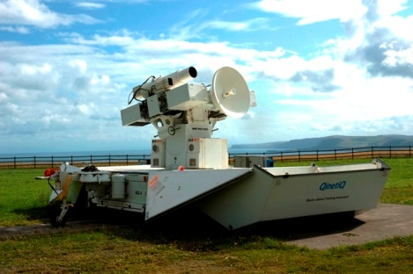
Figure 11 Hybrid Tracking Platform

Radar

The Penporth Range currently uses one Multiple Object Tracking Radar (MOTR) operating in NATO G Band and one NIDIR Single Object Tracking Radar operating in NATO I Band as the tracking sources for both real-time trials safety control and TSPI data gathering purposes. The Radars use the DZT function from the MSU to give them an accurate records start point. The Radar will be used to track the aircraft and weapon throughout the trial and the data will be used by the ATCO and IFSO to ensure the safety specifications of the test are not compromised. Figure 12 is an image of the MOTR at Penporth.
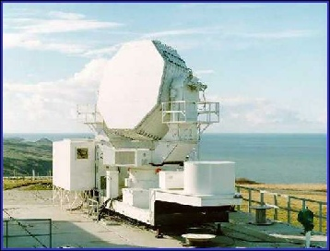
Figure 12 MOTR

FRAT System

The FRAT system records the spatial impact location of warhead fragments within 1µs to an accuracy of 1%. It uses four 8ft switch screens constructed of corrugated cardboard panels with frame sprayed aluminium electrodes on the front and aluminium foil electrodes on the back. The fragments that pass through the screen bury themselves in large bundles of celotex typically 6ft think. The fragments can later be recovered and weighed. The warhead fragments impact the switch screen which produces electrical contact between front and rear side, creating a short which generates and output signal. The image in Figure 13 shows an internal construction of FRAT system (17)
Figure 13 FRAT System

Weapon Test Risks

The EPW II test would be carried out utilising and aircraft as a delivery platform which would means the customer takes the all the responsibility for the storage, movement and to the point of release the delivery of the weapon system. This would reduce the risk involved in that aspect of the weapon testing.
The main risk would be ensuring that the weapon impacts the intended target and not the surrounding area. This would be done by a number of different safety constraints.
  - Analysing the probability of impact from other EPW II releases and understanding the relationship between the environmental conditions and the way it affects the flight of the EPW II weapon.
  - Ensuring that the weapon test has a safety trace large enough to in-compass the WDA, LFA and that it considers the environment conditions and probabilistic impact figures.
  - The safety trace is claimed to have integrity of 1 in one million for containment and has also been reviewed and accepted by the Defence Ordnance Safety Group (DOSG) (7).
  - Confirm by the use of lookouts and CCTV that the WDA is clear at all times.
  - Ensure the ATCO has positive control over the weapon releasing aircraft and that GPS coordinates provide to the pilot are correct.
  - The IFSO would use information from the tracking radars displayed on the TCS to give accurate positional information of the aircraft at all times. This ensures that the aircraft is inside the WDA and LFA before the pilot is given clear to laser and clear to fire.
  - Ensuring that a laser spot has been seen on the target before the pilot is given clear to fire.
  - Keep active communications between all parties involved in the trial to ensure safety parameters are not being breached.

To insure that the lookouts are total safe from the laser marker firing they would be issued with laser safety goggles.
The live weapon detonation could expose personnel and the public to noise levels exceeding the licenced limits. The minimum WDA for the activity is 10,820 yards, using modelled data based on still air conditions the noise threshold from the blast would travel to a maximum distance of 3,200yards this would be well inside the WDA which will be clear of all personnel at all times.
The contamination of the environment after the test would also need to be risk evaluated. The chemical compound in RDX has a low soil sorption but can migrate to groundwater. This means the test would need to be carried out away form and water sources.
RDX vapour can also attack the nervous system in human and animals if exposed in large enough doses. This can cause eye and skin irritation, headache, fatigue, dizziness and vomiting (11). To mitigate this risk no personnel would approach the test area until a suitable time had passed that it was deemed safe. If the weapon test causes a fire to start then the fire brigade will only approach with breathing apparatus.

Findings

The intention of this report was to evaluating the accuracy and warhead performance of the UK in-service EPW II bomb. The early part of the thought process lead to designing an arena type target system which would be situated on a land range. The land range was preferred to a sea range as the prove of warhead detonation would be a critical safety stipulation of the testing. If the weapon was to malfunction as it hit the sea and did not detonate, there could be the real possibility of having a live ordinance drifting in the sea which would be disastrous if it struck shipping. The test would discharge RDX residue after the warhead detonation and it would be easier to contain and decontaminate on the land range.
The arena type test would give the trials team the best means to deliver the customer specification. The arena would be reasonably cost effective if the customer selects fibreboard not FRAT and easy to construct. The towers placed around the arena would house the data capture cameras including the laser spot and miss distance cameras. The cameras being placed at that height would limit their damage during the test. The target system would also have very accurate GPS coordinate which would not change like they would if the target was at sea.
The selected range is fully instrumented which would satisfy the safety argument of being able to clear and maintain a sanitised safety trace. This would be done by the use of air surveillance radar, lookouts and CCTV. The tracking of the trials assets would be done using the MOTR and R4 tracking radars, all information would be passed through to the TCS and correlated into a format that would be used by the IFSO and ATCO.
The safety trace for the test will depend on the altitude of the release aircraft but will consider previous and predicted EPW II release. It will also take into consideration the environmental conditions on the day which can be change in real time by manipulating the TCS.
The firing of the Litening III laser in combat mode will be contained in the LFA which forms part of the overall safety trace. The Laser will be operated in accordance with the defined parameters agreed in the Military Laser Safety Certificate (MLSC). The laser will not be operated until the pilot gets a positive “clear lima” instruction from the ATCO, This will only be give once the IFSO has confirmed that the aircraft is inside the LFA.
The only major concern that one would have about testing this weapon system in this manner, is that the weapon could miss the target system completely and fall out of the arena. The probability of this happening would be very small as the guidance on the EPW II is a proven system and it has two forms of target capture. It would be recommended to the customer that the test should be conducted on a clear day to give the aircraft the best possible change of using the Laser and GPS for guidance.

Conclusion

The customer requirements for the testing would all be met using the arena target system.
Measured Objectives
- Recording of the laser spot position on the target.
- This would be done using the laser spot camera and with the aid of the capture plate on the target would make the laser spot even more visible to the customer.
- Measure the distance between the laser spot and the point of munition warhead detonation.
- This would be done using the high speed battle damage and miss distance cameras. They would give the customers a 3 dimensional image of the impact area.
- Provide the fragmentation pattern of the detonated warhead.
- This would be achieved by using FRAT or fibreboard depending on the customer budget. The FRAT system would give you near real time results whereas the fibreboard would need to be analysed.

Recommendations

The recommendations I would make to the customer would be to conduct this test in two parts. The first would be a guidance test with an inert bomb, this would mean that the test could be conducted at sea which would cause less damage to the target system and would be very repeatable. The second part would be a static warhead test where the 3D target would not interfere with the warhead blast pattern.
The positions of the HTP’s could be reconsidered, currently they are located on fixed surveyed point at Penporth with the furthest being in approximately 14Km from the firing location. The HTP’s systems could be remoted and operated from outside the WDA this would be beneficial for customer deliverables and allow the HTP’s to utilized there on-board radars.

Works Cited
1. MOD. JSP 403. JSP 403 Volume 1 Part 1. 2015, p. ii.
2. —. Joint Service Publication. s.l. : Ministry of Defence, 11 January 2017. JSP Collection.
3. Defence, Ministry of. JSP 502. s.l. : MOD, 2015. JSP 520 Part2, Vol4.
4. Archives, A The National. Legislation.gov.uk. The Control of Noise at Wrok Regulations 2005. [Online] 2005. [Cited: 2 May 2017.] http://www.legislation.gov.uk/uksi/2005/1643/regulation/2/made. 1643.
5. Sellwood, Rik. Range Standing Orders. Range Standing Orders for the Conduct of Trials. Aberporth : QinetiQ, 2016.
6. Centre, Air Warfare. Trials Specification. EPW2,PW2,PW3,EPW3, PW4. Aberporth : Range Coordination Unit, 2016.
7. Lewis, Debbie. RAF Bomb releases using Litening III. Aberporth : QinetiQ, 2014.
8. Planner, Trial. Weapons & Maritime Devision First level Peer Riview.
9. Force, Royal Air. Agile Adaptable Capable. RAF Enhanced Paveway. [Online] RAF, 2017. https://www.raf.mod.uk/equipment/enhancedpaveway.cfm.
10. Ian J. Lochert, Richard M. Dexter and Brian L. Hamshere. Evaluation of RDX in PBXN-109. s.l. : Defence Science and technology. DSTO-TN-0440.
11. EPA. Technical Fact Sheet RDX. 2014.
12. Deagel.com. LITENING III. Sensor Systems. [Online] 2017. http://www.deagel.com/Sensor-Systems/LITENING-III_a001563005.aspx.
13. QinetiQ. Information For Mariners. Aberporth, QinetiQ. [Online] https://aberporth.qinetiq.com/public-safety/mariners.aspx.
14. Engineering, Motion. Photron Fastcam. MEC. [Online] 2017. http://www.highspeedimaging.com/photron-fastcam-mini-ux100/.
15. Corporation, MTS System. Dynamic Pressure Sensor. PCB Piezotronics. [Online] 2017. http://www.pcb.com/Resources/Technical-Information/Tech_Pres.
16. Young, S I. TCS block diagram.
17. Nebolsine, Richard Barnard and Peter. Fragment-field Analysis Testing System.
18. MOD. JSP403 Volume 2 Edition 3 charge 6 Chapter 23, page 9. s.l. : Crown Copyrights, 25 January 2016.
19. —. JSP 403, Volume2 , Edition 3, Change 6, Chapter 36, Page 7. s.l. : Crown Copyrights, 25 January 2016.
20. Jones, Marc. Trials Safety Certificate. 81mm Trials Certificate. Aberporth : QinetiQ, 2016.

Appendices

No appendices used in this assignment.

