

Master of Business Administration Programme

LCMB7035 - Dissertation

ANALYSIS OF THE IMPACT OF SOCIAL MEDIA INFLUENCERS ON PURCHASE INTENTIONS OF CUSTOMERS FOR FASHION BRANDS IN THE UK

Student name: Karan Kumar Vaghela

Date of submission: 03-02-2026



Master’s Degrees by Examination and Dissertation
Declaration Form.

I, Karan Kumar Vaghela, declare that this dissertation has been composed by myself, that the work contained herein is entirely my own except where explicitly stated otherwise in the text, and that this work has not been submitted for any other degree or qualification, in whole or in part, except as specified.

Signature: Karan…

Date: 03-02-2026

Acknowledgement

I would like to express my sincere gratitude to everyone who contributed to the successful completion of this dissertation. Firstly, I extend my heartfelt appreciation to my dissertation supervisor for their continuous guidance, constructive feedback, and academic support throughout the research process. Their insights and encouragement played a crucial role in shaping this study. I am also thankful to the faculty members of the Master of Business Administration programme for providing the academic foundation and resources that supported this research. Their knowledge and teaching greatly enhanced my understanding of research methodology and strategic marketing concepts. My sincere thanks go to all the participants who took part in the survey. Their time, honesty, and valuable responses made this research possible and meaningful. Finally, I would like to acknowledge the unwavering support of my family and friends for their motivation, patience, and encouragement throughout my academic journey. Their support was instrumental in helping me complete this dissertation successfully.

Abstract

The fast development of social media platforms has greatly altered the marketing of the fashion industry, especially with the usage of social media influencers that is on the rise. This paper examines how the use of social media influencers can affect the buying behaviour of fashion brand consumers in the United Kingdom. The study aims at establishing how influencer related phenomena like credibility, authenticity, attractiveness, expertise, and brand alignment influence consumer perceptions and play a role in determining their purchase decisions. To attain the study objectives, quantitative research was used.
Primary data was gathered by the use of a structured online questionnaire to UK-based customers aged 18 years and older who are currently following the fashion influencers in social sites. The sample reflected a wide range of demographic features in order to have a wide coverage in the opinions of consumers. Such collected quantitative data has been analysed with the help of descriptive statistics and graphs illustrating patterns and relationships between the attributes of the influencers and consumer purchase intentions.
Survey results have shown that social media influencers are significant in influencing consumer awareness, attitude and consideration of fashion brands. The credibility of influencers and perceived authenticity were reported as the most significant contributors to the purchase intention, and the number of followers alone was not significantly associated with it. Another point raised in the study is that the transparency, the honest product reviews, and the good fit between the influencer and the brand increase consumer trust and have a positive impact on purchasing behaviour. This study adds to the developing amount of literature on influencer marketing by offering insights into the sphere of fashion in the UK. The results provide the practical implications to the fashion brands, as it can be implied that the strategic choice of credible and authentic influencers can enhance marketing performance and enhance consumer purchasing intentions.
Table of Contents

Chapter 1: Introduction 8
1.0 Introduction 8
1.1 Background to the study 8
1.2 Research rationale 9
1.3 Research Problem 10
1.4 Research Aim and Objectives 10
1.5 Research Questions 11
1.6 Significance of the Study 11
1.7 Research Methodology 12
1.8 Research Structure 12
Chapter 2: Literature review 13
2.1 Introduction 13
2.2 Conceptual review 13
2.3 Thematic review 14
2.3.1 Influencer marketing and purchase intention among fashion consumers 14
2.3.2 Influencer credibility and popularity as influential factors for consumer decision-making 16
2.3.3 Influencer endorsement and their impact on brand perceptions 17
2.3.4 Fashion industry dynamics impacting influencer impacts 18
2.3.5 Strategies for enhancing influencer usage in fashion marketing 19
2.4 Empirical review 20
2.5 Theoretical framework 22
2.6 Literature gaps 23
2.7 Chapter Summary 23
Chapter 3: Methodology 25
3.1 Introduction 25
3.2 Pragmatism 26
3.3 Research Approach 26
3.4 Research design 28
3.5 Research strategy 28
3.6 Data collection techniques 29
3.7 Sampling strategy 29
3.8 Data analysis procedures 30
3.9 Ethical consideration 31
3.10 Limitations 31
3.11 Summary 32
Chapter 4: Data Analysis 33
4.1 Introduction 33
4.2 Analysis of survey data 33
4.3 Summary 44
Chapter 5: Discussion 45
5.1 Introduction 45
5.2 Discussion of findings 45
5.3 Summary 49
Chapter 6: Conclusions and Recommendations 50
6.1 Introduction 50
6.2 Summary of key findings 50
6.3 Significance of the findings 53
6.4 Recommendations 54
6.5 Limitations 55
6.6 Summary 55
Appendices 62
Appendix 1: Survey questions 62

List of figures

Figure 2.1: UK fashion influencer marketing market as of 2020 and forecast in US$M (2016 to 2027) 16
Figure 2.2: Parasocial relationships levels 18
Figure 2.3: UK influencer ad disclosure complaints rate in relation to ASA 19
Figure 2.4: Mixed responses of survey overview for attitude towards sustainable clothing purchase among UK consumers (2020) 20
Figure 3.1: Sauders Research onion 27
Figure 4.1: Age group 34
Figure 4.2: Social media platforms for fashion inspirations 35
Figure 4.3: Time spent on platforms per day 36
Figure 4.4: New UK fashion brands discovered through influencers 37
Figure 4.5: Influencer contents being motivating for purchase decisions 37
Figure 4.6: Use of affiliate links by fashion influencers 38
Figure 4.7: Purchasing a fashion item endorsed by followed influencer 39
Figure 4.8: Rating factors based on their importance 40
Figure 4.9: High follower count impacting the purchase of the recommended product 41
Figure 4.10: Agreement with “I am more likely to buy a product if the influencer clearly states it is a paid partnership” 42
Figure 4.11: Endorsement changing perspective for fashion brand 42
Figure 4.12: Loosing of shopping interest if endorsed by a disliked influencer 43
Figure 4.13: Agreements with brands are considered more ‘authentic’ when partnered with similar personal value-driven influencers. 44
Figure 4.14: Factors improving shopping experiences through social media. 45

Chapter 1: Introduction

1.0 Introduction
The use of social media has shifted the communication methods of fashion brands to consumers, making the influencer-centric content one of the primary sources of awareness, taste, and buying behaviour among the UK-based consumers. As per the data, the influencers have emerged as strong mediators of fashion, credibility and purchasing behaviours in the UK, where the penetration of social media is over 90% of the adult population (Kemp, 2024). With the emergence of innovative social media platforms, influencers play a key role in creating trends through curated content, sponsorships, and storytelling approaches which enhance the brand visibility by enabling real-time, interactive communication between brands and consumers across various platforms (Ampornklinkaew, 2025). Despite the high engagement that is created by the influencers on behalf of the fashion brand, the capacity of the engagement to convert into the actual purchase intention is variable. However, to fill the knowledge gap, this study will examine how the influencer attributes related to credibility, popularity, authenticity, and the quality of endorsement influences consumer intentions to purchase fashion products in the UK market.

1.1 Background to the study
Due to the rapid evaluation of digital platforms, a fast development of influencer marketing is recognised in the business platform which has dramatically changed the fashion consumption trends, especially in the sophisticated, modern and fast-fashion markets like the United Kingdom. Based on reports, it has been identified that in the UK, influencer audiences are 81% more likely to utilize social media for product discovery and buying compared to average social media users (Duncan, 2024). In this regard, the UK-based fashion brands are embracing the idea of using influencers, either nano to macro creators, to provide users with personalised storytelling, visual content, and product recommendations which is more effective than traditional advertising in terms of reach and perceived authenticity. However, researchers have shown that the majority of UK adults now consume fashion-related content by actively engaging with such platforms like Instagram, Tik Tok and YouTube, where influencers play a decisive role in the discovery, evaluation, and adoption of fashion-related products and enhancing the purchasing and imitation decision of the consumers (Ampornklinkaew, 2025).
In this aspect, Taylor (2023) stated that more than 48% of the UK social-media users who follow influencers are more likely to buy products suggested by these celebrities, especially those in the fashion, beauty, and lifestyle categories. As per the statistical analysis, social commerce has also grown at an accelerated rate with a 32% rise since 2022, in which nearly 30% of such purchases involve clothing and accessories. It not only shows the influence of influencers in marketing, but also their strength in facilitating direct trade by providing the option of in-platform shopping (TheIndustryFashion, 2024). Thus, it has also been estimated that influencer marketing increases significantly in the UK, with a wider shift to digital shopping and the personalized marketing of content.
However, within the fast-changing style and competitive market-dynamics, the UK fashion industry heavily invests in influencer marketing but remains under the difficulty of transferring influencer activity into quantifiable purchase intent. As defined by Handranata and Kalila (2025), purchase intention is depicted by exposure to content as well as credibility, para-social relationships, trustworthiness, and perceived influencer-brand fit aspect. Furthermore, the consumer’s purchasing reaction to influencer promotion is further complicated by regulatory regulations imposed by the UK Advertising Standards Authority, increasing consumer distrust toward promoted content, and the high demand to use more ethical and sustainable clothing. However, this can be supported through the rising level of the green fashion market in the region, which reached the value of $173.6 million as of 2023 (Globaldata, 2024). Thus, the concept of how the attributes of the influencers influence the purchase intention is critical to making relevant strategic decisions as well as promoting influential fashion for establishing greater trust among the UK demographics. Moreover, it is crucial for the UK-based fashion brands to further monitor how influencer endorsements are considered in terms of fit and authenticity.

1.2 Research rationale
Despite the widespread use of influencer marketing in the UK fashion industry, firms continue to have difficulty in converting influencer-driven engagement into real purchases. Further rationale of the research relies on the generalised findings regarding consumer behaviour, in which the existing studies revealed that the UK consumers operate within a unique environment: rigorous advertising regulations, significant social media reliance for fashion discovery, and increased sustainability standards. Regarding this aspect, it is important for the UK fashion firms to gather thorough information about the influencer traits that actually affect purchase intention. In addition, the increased commercialization of influencers, coupled with increasingly cynical audiences, emphasises the demand for clearer insights (Pedroni, 2023). This research is needed to bridge these contextual gaps, delivering practical assistance to marketers on optimising influencer collaborations for better, more reliable customer conversion. However, the rationale is in solving a measurable knowledge gap with direct strategic implications for industrial practice.

1.3 Research Problem
Although influencer culture has gained dominance in the UK and is widely utilized in the fashion sector, one of the core issues remains, in which brands struggle to transfer influencer exposure into consistent and quantifiable purchase intentions of the consumers. Despite the fact that the influencers produce the greatest rates of engagement, it is not clear which factors in particular, credibility, popularity, authenticity, or perceived expertise, has the highest impact on the process of UK consumers making the decision to purchase fashion products.
Furthermore, the dependability of influencer-driven persuasion is further complicated by the emergence of fast fashion, changing platform preferences, in-app shopping capabilities, and heightened ASA scrutiny over advertising disclosure (Asaorguk, 2025). In addition, the variation in demographics, the shift in platform usage, and the growing skepticism about the transparency of paid sponsorship influences the credibility of consumers to influencer endorsements (Boardman and McCormick, 2023). Therefore, the UK-specific empirical evidence to describe the relationship between influencer characteristics and purchase intentions is lacking, in which brands may become inefficient in their use of influencer partnerships and fail to optimise marketing performance in the competitive age. Therefore, by examining UK consumers' views of influencer traits and figuring out how these perceptions affect their buying intentions for fashion products, this study will solve this issue and help the brands to integrate innovative insights.

1.4 Research Aim and Objectives
1.4.1 Research Aim
To critically analyse how social media influencers affect UK consumer purchase intentions for fashion brands and to identify proper strategies for brands to utilize influencers effectively.
1.4.2 Research Objectives
- To assess ways in which social media influencer marketing can lead to purchasing intentions among consumers in fashion brands in the UK
- To analyse the relationship among influencer credibility and popularity with consumer purchase intentions for fashion products
- To explore the impact of influencer endorsements on brand perception among consumers
- To provide recommendations for UK fashion companies to effectively utilize social media influencers for enhancing purchasing approaches.

1.5 Research Questions
- How do social media influencers impact the purchase intentions of consumers for UK-based fashion companies?
- How do influencer credibility and popularity influence consumer purchase decisions for buying fashion products?
- In which way do influencer endorsements impact brand perception among consumers?
- What strategies can the UK fashion brands utilize to enhance their influencer marketing efforts and increase consumer purchase decisions?

1.6 Significance of the Study
The research paper has a significant impact on both practical and academical aspects especially in the digitised age of marketing. Academically, it adds to the accumulating body of literature on digital marketing, influencer credibility, consumer psychology, and social commerce, particularly in a UK-specific fashion setting where empirical studies are still scarce. It gives a sensitive insight into the impact of various attributes of influencers on purchase intentions in which researchers can gain a better knowledge of the consumer influencer relationships. Furthermore, the research will fill the reported gaps based on UK-specific influencer processes, regulatory effects, and the influence of para-social relationships on fashion purchases behaviour.
Regarding the practical aspect, research provides implementable knowledge to the UK-based fashion brand who aims to maximise the use of influencers. The results will help the marketers to choose influencers whose traits can comply with the demands of the consumer, increasing the effectiveness of the message and positively transforming the brand image. Regulatory agencies and policymakers can also find it useful to know the perception of consumers towards paid endorsements, specifically in the context of trust and authenticity. However, the research offers transparency to consumers regarding the influence of influencer content on their decision-making, which encourages a more informed approach to digital consumption.

1.7 Research Methodology
The research takes a quantitative research approach based on a survey design that is cross-sectional. Through the use of Google Form, online questionnaires will be used to collect the data by applying it to UK consumers aged 18 years and above who are active followers of social media influencers and interested in fashion content. The sample will be selected using purposive sampling by targeting size of 50 respondents to make sure that the participants possess the pertinent experience in the field of influencer-driven fashion content. For analysis, the obtained data would be analysed by descriptive statistics and visual analysis by means of Microsoft Excel to draw patterns, trends, and relationships between variables. However, the ethical issues, such as informed consent, anonymity, and voluntary participation, will be adhered to strictly during the research process.

1.8 Research Structure
The entire dissertation will be structured into five chapters, in which the first chapter provides the introduction to the topic, research problem, aims, and significance along with the rationale to conduct the paper. Chapter 2 is a critical review of the available literature and gap identification, while the third chapter describes the entire methods of conducting the research along with the process of collecting data, method of analysis as well as ethical issues that are mitigated in this study. However, survey findings are presented and analysed in chapter 4. the survey results. In order to wrap up the research findings, the gift chapter will conclude the paper by summarising important insights, providing recommendations to UK fashion brands, and proposing future research.

Chapter 2: Literature review

2.1 Introduction
This particular chapter of this study is focused on providing a detailed overview of existing literature and their understanding of the chosen topic context. The chapter sheds light on the literature to develop a greater understanding of how social media influencers can impact the purchase intentions of consumers for UK-based fashion brands. Through a detailed consideration of vast existing research, this chapter will support developing a crucial overview of the context while also shedding light on various key concepts in relation to the topic. The empirical review will be done based on existing studies related to this topic and analysing their findings, which will eventually support the identification of existing literature gaps. A further focus on theoretical frameworks will allow us to identify the theoretical models supporting this study’s base while further reinforcing the quality of the findings.

2.2 Conceptual review
In this context of the conceptual reviews, there are various aspects which are supporting this particular study, like social media influencers, fashion brands, relations among consumers, purchase intention and fashion brands. Through further considering these constructs, the review will be able to provide a more solid basis of understanding of later thematic analysis. Social media influencers are the individuals who, through social media platforms, can gain followers and gain credibility to further influence opinions, behaviours and even preferences of their audiences (Alves De Castro and Carthy, 2021). They develop various content and engage with their communities while potentially acting as a medium for the relationship between brands and their consumers. The further rise of Web 2.0 has allowed these influencers to become more influential pillars as opinion-leaders and overcome the power of traditional celebrities. In the context of the fashion industry, influencers can showcase outfits, trends or even collaborate with various brands. Although their appeal is mainly based on their perceived authenticity, audience engagement and their capability for closing the gap for lifestyle aspiration and everyday consumption.
Purchase intentions is another crucial aspect, which is the aspect of a consumer’s psychological approach or readiness for buying a particular product (Guerreiro and Pacheco, 2021). It can thus be considered a key stage right before the actual purchase behaviour of consumers and can often be adapted in consumer behaviour-related studies as a crucial outcome in relation to marketing interventions. In the context of influencer marketing research, the higher intention for purchase after exposure to influencers can be considered as crucial evidence for effectiveness (Jarrar et al., 2020).
This study is focused on fashion brands operating in the UK market. This includes accessories, footwear, and apparel who often target young consumers active on social media platforms. In the UK market, it is a mature market with higher social media penetration and a strong emergence of influencer culture, as reports showcase that, according to a 2023 survey, approximately 84% of the UK-based Gen Z consumers followed influencers, while it was also evident for over two-thirds of the millennials (Statista, 2025). The regulatory environment of the market further adds another layer of consideration in this context. Thus, this conceptual review develops the understanding that influencers produce content while consumers in the UK experience it, and eventually it leads to an increase in purchase intentions for the brand’s fashion offerings.
Relation among concepts: The key aspect of this study is the relationship between influencer marketing and consumer purchase intention for fashion brands. In this context, various sub division also exist with factors like credibility of influencers, popularity, brand perceptions, purchase intentions and even endorsement effects. This conceptual understanding can be identified as those influencers can impact the brand perception and trust, which eventually enhances purchase intentions.

2.3 Thematic review

2.3.1 Influencer marketing and purchase intention among fashion consumers
In terms of influencer marketing, one of the most crucial aspects to consider is that the exposure of influencer content can raise the purchase intentions for fashion items. This can be further supported through existing research which identified that in the context of fast fashion, influencer marketing through platforms like Instagram plays a major role in increasing their impulse purchasing intention (Revlon-Chionet al., 2020). The complete understanding of the study showcases that the authentic product showcasing and emotional appeal are crucial factors that can be applicable to various markets in which consumers base on social proof and make their choices in fashion like in the UK. A study conducted by AlFarrajet al., (2021), has also supported this context through showcasing how influencer credibility dimensions like trustworthiness, attractiveness and expertise can impact the purchase intentions. In this context, the persuasive potential of influencer content can be further enhanced through the symbolic nature of fashion consumption. This is due to the fact that fashion consumption is highly personal and symbolic, as people utilise clothes often to showcase their identity and even for functional evaluation (Özdil, 2021). Thus, in this research context, the aspects of influencer content acting as a type of digital word-of-mouth and an aspirational value which can enhance the influence on consumers in relation to adapting style they are admiring online.
Bisht (2025) has further focused on the crucial connection of virtual try-ons and influencer marketing as time passes with digital advancements. These relations showcase the link among influencer content and increased purchase intentions. The study by Setyanta et al., (2024) can also be considered in this factor, as the authors utilised the Theory of Planned Behavioural perspective. The study allowed the understanding of how attitudes of the influencers and considered social norms can effectively impact fashion purchase intentions, especially among young consumers who consider these influencers as reference figures. In this context, industry survey of 2,000 consumers showcased that nearly 27% of them, for fashion and beauty shoppers who are following influencers, have made purchases of luxury items through directly from platforms like Instagram (Wpp, 2025). This industry data also supports the previous literature for showcasing how influencer-based discovery plays an influential role in the UK fashion market.
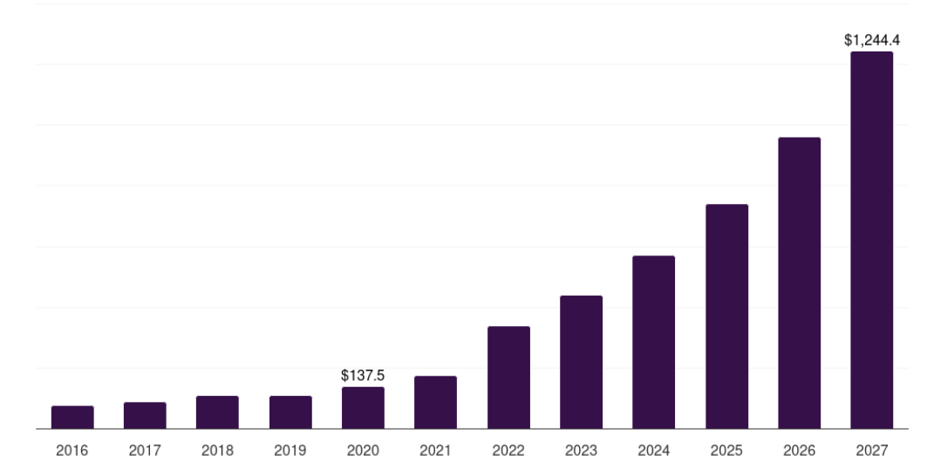

Figure 2.1: UK fashion influencer marketing market as of 2020 and forecast in US$M (2016 to 2027)
(Source: Grandviewresearch, 2020)

2.3.2 Influencer credibility and popularity as influential factors for consumer decision-making
In this study, another crucial theme to discuss it the traits of influencers that make them persuasive, like credibility, which is often a combination of aspects like expertise, trustworthiness and even authenticity. Studies like the one done by Chetiouiet al., (2020) have effectively shed light on the fact of how perceived trustworthiness in the digital fashion influencer context can impact consumer purchasing intentions. In the context of the UK, with the support of this finding, it can be said that consumers are potentially more aligned and respond more effectively to the influencers who are consistent, transparent and honest in terms of their product recommending journey. Furthermore, the context of showcasing professionalism and balanced evaluations is crucial aspect of perceived credibility in this topic. This is due to the fact that consumers can value influencers more who provide transparent analysis of products being utilised when partnering with a brand. Existing studies also support this understanding as the Digital influencers are often judged by their professionalism in terms of showcasing brand image through the products, further impacting their capabilities for influencing (Colucci and Pedroni, 2022). In the context of markets like the UK, audiences are highly sensitive to authentic advertising and regulatory expectations; these considerations for fashion influencers can be highly crucial. Furthermore, the Parasocial theory can also be analysed to better develop crucial understanding of this context.
Based on the study done by Zhang et al., (2021), the role of homophily can be identified, which sheds light on the perceived similarity between the influencer and their audiences. This is further well-aligned with the context that homophily potentially enhances the Parasocial relationships and eventually contributes to enhanced brand image and purchase intentions. In terms of the UK brands focused on a diverse range of consumers, engaging with the influencers who are reflecting similarities in terms of identities for specific consumer groups can thus become a major approach for better influencing. Yet in this context, follower count is still crucial to be considered for brands as studies have showcased mixed evidence in this aspect. The research by Cascio Rizzo et al., (2024) showcases how the macro-influencers can offer potential extensive reach through their follower numbers. Despite this, popularity cannot always be reliable for prediction of purchase intentions, as consumers can also get into better engagement with micro-influencers showcasing better persuasive effects.
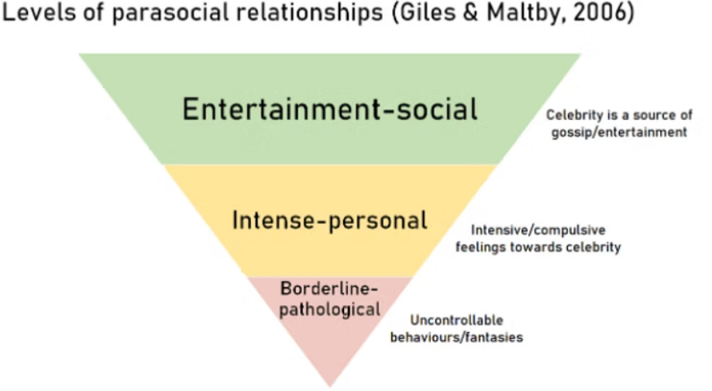

Figure 2.2: Parasocial relationships levels
(Source: Tan and Kapadia, 2022)

2.3.3 Influencer endorsement and their impact on brand perceptions
In the context of endorsements, influencer endorsements play a major role in managing consumer perceptions for fashion brands. Brand perception often includes aspects like brand trust, perceived quality, and emotional appeal, acting as a key moderating force among the exposures of influencers and purchase intentions (Es-Safi, 2022). Furthermore, Lin et al., (2021) have also shed light on the context of Instagram influencers and how trust in these influencers can majorly impact brand attitudes, eventually impacting purchase intentions. The findings of the authors were further supported through the Parasocial interaction theory for ensuring social media content creators indirectly influence the brand perception through their followers. When influencers share their personal experience or styling advice with the audience, they often consider them as positive qualities of the brand itself.
This, in the context of the UK fashion market and influencers, can further support the understanding of how influencers can enhance a brand's perceived credibility by closing a psychological gap between the brand and consumers. These can be supported through existing work of Morales Sharp (2023) who emphasized on the aspects of brands utilising influencers as a way for humanisation and contextualization of brand voices for enhancing a complete perspective. In this context, it can be said that influencers act as key aspects for brand legitimacy, further showcasing the brand as fashionable, trustworthy and even socially validated. Based on research, it can be thus said that brand credibility, emotional engagement and awareness are key brand-level outcomes which are influenced through influencer endorsements (Xu, 2023). This can thus be crucial for the emerging influencer-driven and digitally engaged market like the UK (Statista, 2025). Furthermore, this relation among influencer endorsements and brand level perceptions can also be impacted through regulatory and transparency norms and even ethical considerations. For example, in the UK, the ASA monitoring reports showcased that over 50% of the ads in relation to the fashion and travel sectors were undisclosed or even inadequately disclosed (Asaorguk, 2025). When being inadequately disclosed, the influencer and the brand can both suffer from reputational damage.
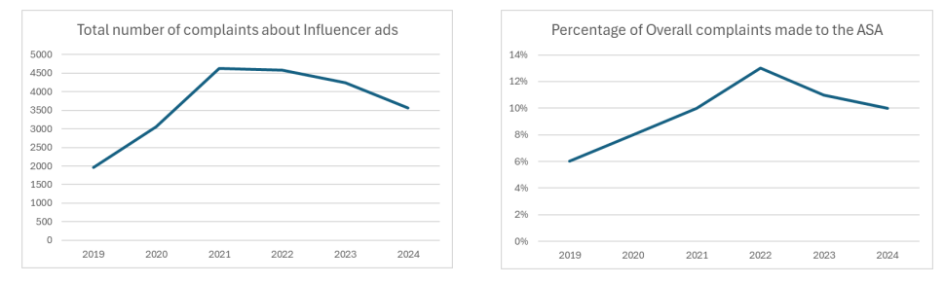

Figure 2.3: UK influencer ad disclosure complaints rate in relation to ASA
(Source: Asaorguk, 2025)

2.3.4 Fashion industry dynamics impacting influencer impacts
In this context, most of the research is focused on a global basis with a lack of insights critically developed for the UK region. For example, the UK consumer showcases a much greater level of basis on social media platforms for fashion discovery. Based on reports, it can be identified that in the UK, influencer audiences are 81% more likely to utilize social media for product discovery and buying compared to average social media users (Duncan, 2024). This sheds light on the context that influencer impacts can be further enhanced in the UK due to major consumer preferences for digital inspirations in the fashion industry. Furthermore, the regulatory context is also stricter for the UK in comparison to many regions. The ASA regulatory of the UK ensures to use of public-wide warnings to influencers and various brands for undisclosed partnerships, further impacting the consumer environment in which transparency is a crucial aspect (Antoniou, 2021). In case of the UK, consumers are more likely to interpretation for unclear endorsements to be deceptive, and it can also hinder the cruciality of influencer credibility in the UK region. Furthermore, UK consumers are raising their concerns about sustainability as time passes. Thus, fashion influencers who promote fast-fashion or similar unsustainable fashion can face criticism on social media in the UK. This can be supported through the rising level of the green fashion market in the region, which reached the value of $173.6 million as of 2023 (Globaldata, 2024). Thus, influencers who value and address the issues of sustainability or even promote mindful fashion consumption can develop greater trust among the UK demographics.
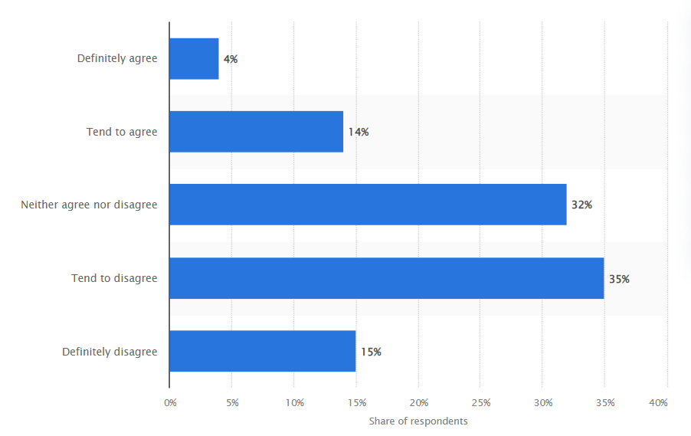

Figure 2.4: Mixed responses of survey overview for attitude towards sustainable clothing purchase among UK consumers (2020)
(Source: Tcholakova, 2025)

2.3.5 Strategies for enhancing influencer usage in fashion marketing
In this context, there are various opportunities for brands that are aiming to utilise influencers effectively. For example, authenticity is a crucial aspect to be considered in influencer marketing. Based on studies, it can be identified that personalised and informal content by these individuals can develop better engagement among consumers through showcasing authenticity (Okonkwo and Namkoisse, 2023). For a brand in the UK utilising this approach, focusing on authenticity can provide better outcomes in contrast to promoted posts. Furthermore, the brand-influencer fit is another majorly crucial strategy to be considered. The aspect of influencer-brand fit has been identified to be crucial for developing effective credibility and message acceptance (Hjalmarsson and Koste, 2024).
In the context of fashion brands, this can include sharing a similar style identity with the influencers. When audiences can sense a natural fit among these two, the context of endorsement will become more authentic towards them. The engagement-based selection of influencers can also be a crucial approach by brands in the UK fashion industry. As per Gracias et al., (2024), various engagement metrics like comments, interactions and audience loyalty are among the most crucial factors which can influence the follower count of influencers. These can eventually also allow for predicting the engagement and even purchase intention of consumers in future for more engaging experiences with brands. Eventually, data-focused analysis is also crucial for enhancing influencer strategies. Various integrations of influencer analytics, like click-through rates and even conversion-related data, can be considered in the wider marketing context (Guangul, 2024). These will eventually support in making evidence-based influencer partners and enhancing the long-term marketing efficiencies of the brands, with a particular focus on the UK market.

2.4 Empirical review
The empirical investigation of social media influencers and buying intentions in the fashion sector has increased significantly over the last decades, and various scholars have analysed the impact of the characteristics of influencers, their interaction on the platform, and consumer psyche on the evolving purchasing behaviours. The findings describe the importance of SMIs within the UK as one of the powerful trends, which justify credibility, authenticity, and the format of endorsement in influencing the purchasing behaviour of the consumers. In this aspect, the article (Chan, 2022) is influential due to its relevance to this topic. The study was conducted based on a quantitative survey of 483 UK consumers aged between 18 and 65 years to determine the effects of social media influencers on consumer buying behaviour. By providing focus towards the geographically specific and real consumer behaviour in the UK, the author has discovered that influencer credibility, especially trustworthiness and knowledge, were strongly correlated with purchase intention in which a vast range of respondents have confirmed that they had purchased fashion products suggested by the influencers.
This aspect strongly suggests that in the digitised age and within the trends of the fast-fashion aspect within the UK, people are likely influenced by the social media marketing strategy of the fashion brands where influencer-created content, especially on Instagram and TikTok are playing an important role to shape the purchase intentions. However, through the correlation analysis of collected data, the study has demonstrated that in the UK fashion market, micro-influencers are progressively outperforming macro-influencers in influencing purchase intention, as evidenced by the fact that authenticity had a greater impact than follower count. On the other hand, by acquiring data from 805 consumers aged between 20–29 years across three countries, namely Japan, the United Kingdom, and Singapore, the article has highlighted significant cultural and numerical nuance of consumers (Kikumori et al., 2025). Here, the follower counts if the influencers interact with consumers' cultural values. According to the author of article B, in certain segments, having a large number of followers increases perceived popularity, while in different segments it undermines authenticity and decreases buyer’s intent. Through the offering of a critical viewpoint on influencer marketing research by illuminating how consumer traits, such as cultural value orientation, affect customers' purchasing decisions the article suggests that instead of depending only on macro-influencers, UK firms should segment their audience based on their cultural orientations.
Furthermore, the knowledge regarding the topic has been further broadened by the research of Gomes et al. (2022), in which an empirical investigation of the attributes of digital influencers in the fashion industry was conducted. In this aspect, data obtained from the 345 participants by using questionnaire which was analysed using SmartPLS3 software, the study has investigated several influencer traits; attractiveness, expertise, parasocial interaction, and perceived similarity also. Therefore, the analysed data has found that all of them had a significant influence on purchase intention where the most significant effect perceived on the parasocial interaction. It is particularly applicable to fashion branding because the development of emotional and strong social media relationships with influencers contribute to the feeling of social intimacy and increase the level of trust among the consumers. The research of Gomes et al., (2022) also proved that such relationships were moderated by influence brand congruence: when influencers conjured with the fashion style, values, or aesthetic of the brand, purchase intention rose by up to 40%. Thus, the gathered insights are strongly aligned with the UK-based fashion industry where consumers tend to perceive influencers as trendsetters and follow their assistance in fashion inspiration. Thus, the study has established that social identification has a direct impact on the fashion sense of young people along with their online advertising engagement and purchasing behavior.
On the contrary, Adaba et al., (2025) argued that while the influencer's content is now defined as social-media strategy which plays an important role to influence the purchase intention and the actual consumer behaviour, the intention to real purchase behaviour is moderated by the perceived product value and price sensitivity. The research paper has modelled 232 responses from the UK by using a positivist quantitative research approach with structural equation modelling and discovered that the credibility of influencers, content quality and social proof collectively predicted a vast range of purchase intention. However, the observation is very essential in the fashion sector where impulse purchases are most prevalent but also affected by income levels. Moreover, the research study of Adaba et al., (2025) suggested that consumers who proactively responded to influencer content were much more likely to turn intention into purchase behaviour, and interactive response is a key element in influencer marketing strategies.

2.5 Theoretical framework
The Source Credibility Model in this context can be considered as a crucial supporting theory that sheds light on the fact that an endorser’s expertise, attractiveness and trustworthiness can determine how their persuasive message will be (Chin et al., 2020). Based on the above literature analysis, it can be identified that the UK market is majorly influenced through the influencers and their recommendations to the consumers/. Consumers in the UK context are more likely to purchase a product based on recommendations of their trusted influencers. Furthermore, the analysis also showcased how credibility affects the attitude and strength of behavioural approaches in terms of symbolic consumption trends in sectors like Fashion. Thus, as consumers in the UK are more sensitive to authenticity, further influenced by their strict regulatory aspects of ASA, the Source Credibility Model provides a solid base of understanding to showcase why the credibility of influencers is crucial for better engagement.
On the other hand, the previously identified Parasocial interaction theory is also another major supportive pillar which sheds light on one-sided, emotionally based relations between the media figures and their audiences (Kalvi and Knuutinen, 2021). In the context of the UK market, as digital environments have further enhanced, the influencers are getting more popular with more impact than traditional celebrities. Furthermore, as identified previously, gen Z in the UK is significantly reliant on influencer base, thus making their contribution to the audience’s brand persuasion. In this chosen theoretical context, the Parasocial closeness can thus be seen among these consumers, which can further enhance their acceptance of product recommendations. Thus, for fashion brands in which lifestyle aspirations, identity expression and social belonging are crucial, Parasocial relations can majorly enhance the power of influencers for affecting purchase intentions.

2.6 Literature gaps
Based on the above analysis and the empirical analysis of existing literature on this topic, it can be identified that there are still various gaps remaining in this context, requiring further keen attention. First, the studies often consider the cruciality of influencer credibility and Parasocial connections; there is still a lack of analysis of these aspects in the UK fashion context, which is further influenced by strict regulations and rapid digital adaptations in the influencer marketing aspect. Most of the studies are mixed on the international analysis, with even cross-country comparisons, developing further gaps on how UK-specific consumer attitudes are influenced for purchase intentions. Furthermore, regardless of research’s constant focus on differentiating micro and even Macro influencers, there is still a lack of research done on how UK consumers consider authenticity and even trust factors when follower count increases, with a focus on fashion categories where aspirational identity is a key factor. This means that when influencers post product recommendations, namely in the fashion sector where visualization, self-representation, and alignment with trends are central to it, Gen Z consumers would perceive such possible recommendations as credible and aspirational. The power of the influence by the influencer therefore becomes greater because of the familiarity, perceived similarity and emotional attachment that are brought by Parasocial Relations (Adaba et al., 2025).
This can have a significant impact in increasing the quality of brand messaging since the consumers will be getting advice given by someone who they know and respect but not an unknown marketer. In the case of fashion brands where lifestyle aspirations, identity formation and social belonging are key elements of the consumer behaviour, good Parasocial Relations can greatly facilitate how the influencers can influence attitudes, steer preferences and eventually influence purchase behaviours (Gomes et al., 2022). It is also crucial to consider that existing studies are more focused on direct relations among influencer attributes and intentions, with little focus on how contextual factors like disclosure awareness, and sustainability concerns can impact these effects, especially in the UK market. Thus, considering these gaps, this study aims to close them through a more UK-based analysis that includes credibility, contextual influential factors and even relational dynamics and their impact on behavioural outcomes.

2.7 Chapter Summary
The literature background chapter imparted a wider understanding of existing studies through in-depth review of scholarly articles, which required an in-depth analysis and evaluation of existing research relevant to the topic. A comparison and contrasting of various research findings have been done in relation to the research context and key actors, such as influencer popularity and credibility. This helped to gain a more detailed understanding of cultural norms of the UK, regulatory demands and ethical aspects that are influencing consumer behaviours and demands.
This chapter has shed light on the wide range of available articles and research done on the context of social media influencers and their influence on the purchase intentions of UK-based consumers in the fashion industry. The analysis of reports and studies allowed us to shed light on various key concepts and themes like endorsements, influence marketing and purchase intentions in relation to the topic. The chapter further sheds light on various existing empirical research in this topic, considering their findings, while also showcasing the gaps in the existing literature that this study aims to close. The theoretical adaptations like Parasocial interaction theory and Source Credibility Model further supported the complete analysis and enhanced the quality of understanding of this topic in relation to UK region. The next chapter will be regarding the methodology of this research. Through writing the methodological choices for this study, it has been possible to understand the cruciality of philosophical alignment in research.

Chapter 3: Methodology

3.1 Introduction
This particular chapter is focused on shedding light on the complete methodological selections for this study shedding light on the impact of social media influencers impacting the consumer purchase intentions in the UK-based fashion industry. The study aims to analyse how social media influencers are impacting UK consumer purchase intentions for fashion brands for allowing the brands to use influencers properly. To further address this aim, this chapter shed light on the methods, like research approach, design strategy, data collection and analysis and other aspects in relation to research objectives. The objectives supporting the methods will be to analyse how social media influencer marketing can lead to purchasing intentions, to assess the relationship among influencer credibility and popularity with consumer intentions, the impacts of influencers' endorsement on brand perceptions and to develop effective approaches for benefiting UK fashion companies. The chapter further focuses on sampling, ethical considerations and even limitations of the chosen methods. Through a systematic consideration of the aim and objectives, this chapter aims to provide more transparency and a solid understanding of the chosen methods for better supported findings. These methodological choices are thus further supported through the research problem while ensuring all the developed results from these methods are reliable and ethically supported.
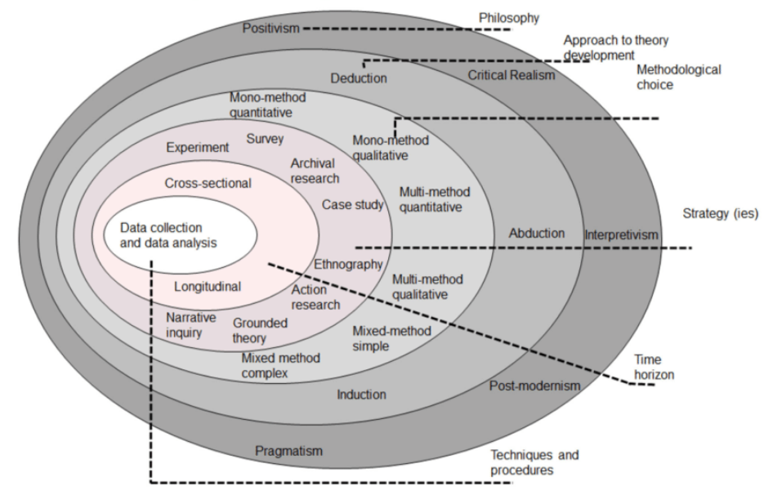

Figure 3.1: Saunders Research onion
(Source: Seuring et al., 2021)

3.2 Pragmatism
The choice of pragmatic approach is highly crucial for any research, as it allows for developing an understanding of how social reality can be considered. This research has focused on utilizing a positivist pragmatic approach, which is better aligned with the use of numerical data in a measurable and objective manner. The philosophy sheds light on the context that reality exists in an independent manner of human interpretation and can be observed, analysed and quantified through empirical methods (Ali, 2024). This method is particularly beneficial as this research is focused on measuring relations among predefined variables like consider brand value, purchase intentions, influencer popularity, and credibility, which can be further operationalized in a structured survey question. In a contrasting approach, the interpretivist philosophy would have further focused on understanding subjective meaning, personal experiences and individual based analysis of influencer-consumer interactions. While being crucial for analysing in-depth consumer perceptions through qualitative methods, the interpretivism is less beneficial for this research as it would have not been crucial for supporting the objective level measurement and generalizability required for analysing relations among pre-defined variables.
In the context of positivism, the keen focus is based on general patterns in contrast to individual subjective meaning. This is further aligned with this study’s focus on analysing the trends among the UK consumers who are interacting with fashion brands through social media and further following influencers. The positivist philosophy thus supports the choice of a structured survey, the use of Excel to analyse the data gathered and sheds light on the findings. Other methods would not be able to provide more measurable, generizable and comparable insights needed for this study. Thus, the choice is effectively based on both the quantitative nature of the research and the requirement for analysing relations among various variables in a more systematic manner. This, therefore, supports better replicability of the findings in future similar contexts.

3.3 Research Approach
Considering the positivist basis of this research, a deductive research approach is chosen. The context of deduction involves mainly through starting with various established theories or even concepts and developing further assumptions or expectations based on the theories (Casula et al., 2020). These data collected will be further tested to analyse if the patterns developing are in a more specific context. For this research, the chosen research approach selected for this study is playing a major role in managing the complete methodological approaches. On the other hand, inductive research approaches have not been selected as it would have involved developing major theories based on qualitative observations in contrast to just testing the existing ones (Pearse, 2021). Although, as this study is based on effective influencer marketing perspectives and aims to test their applicability in the UK fashion context, the deductive approach is more effective than theory development of inductive approach. The complete context of deduction starts through developing various theoretical principles and analysing if these principles are supported in the particular empirical context. In the aspect of influencer marketing, a vast range of researchers are focused on aspects like expertise, attractiveness, trustworthiness and even brand credibility. These factors have been tested in various industrial and region-based aspects, yet this current study is positioning them in the middle of these research aspects. Through further consideration of existing theories, the study will develop potential expectations in relation to how UK consumers can respond to influencer endorsements in this fashion sector. For example, there are theories like the Source Credibility Model, which sheds light on the fact that consumers respond more positively to influencers considered as trustworthy and even knowledgeable (Weismueller et al., 2020).
Thus, this deductive approach has allowed this research to test this type of theoretically-based analysis, which is appearing in the UK fashion context, and even potentially analyse whether differences among influencer types like micro-macro can have separate impacts. This complete deductive approach also ensures clarity in the operationalization of the variables. As the theories are already shedding light on the credibility, the survey aspects can be further developed to be directly shed direct light on these aspects. This has been beneficial for providing a more structured context through managing consistency of theories and practical measurements/. This has been further beneficial as it is allowing for a comparison-based analysis among previous studies and practical understanding while further enhancing the credibility in wider academic situations. Thus, it can be identified that this deductive approach not only supports the theoretical direction of this study, but also enhances the methodological integrity and relation among aims, strategy and data collections.
This also goes in line with the fact that the analysis in this study was focused on the trends among the UK consumers who are engaging with the fashion brands via social media and following the influencers further. The positivist philosophy, therefore, justifies the adoption of a structured survey, the application of Excel to process the information collected and clarifies the results. The other techniques would not have been able to give more measurable, generable and comparable information required in this study. In this way, the decision is being made successfully, as it is the research that can be quantitative in its character, and it is the need to examine relations between different variables in a more organized way. This, therefore, assisted in replication of findings in future similar situations.

3.4 Research design
The study has focused on adapting a quantitative, cross-sectional research design that includes the collection of data from participants at a single point in time (Ziauddin et al., 2023). This design is particularly effective for this study as it aims to shed light on the current state of consumers' behaviours, with a particular focus on comparing patterns among groups and variables. As the key goal of this research is to consider how consumers perceive influencers and how these types of perceptions affect their purchasing intentions, the cross-sectional design provides a more effective and reliable manner of gaining an understanding of these relations. Considering the timeframe and resource availability of this study, a longitudinal design will not be efficient for being considered. The main focus on analysing the naturally developing behaviour and perceptions in a real-world social media context, this design is the most beneficial. The cross-sectional quantitative design is thus supporting the aim of identifying patterns and relations among a particular sample of respondents. It is further aligned properly with the decision of using a structured survey, which allows for an in-depth analysis and provides standardized responses for further comparisons.

3.5 Research strategy
In this context, the chosen research strategy for this study is a survey strategy, with support of implementation through an online questionnaire. This survey strategy is beneficial for a study which needs data from a reasonably large population, and at the time of the variables can be further operationalized in various standardized questions (Bihu, 2021). In the context of social media behaviours, online surveys can be especially beneficial as the respondents are already familiar with digital environments. This particular survey strategy is also aligned with various methodological aims, as it has allowed for efficient access to individuals who are actively following influencers and interacting with the fashion brands online in the UK, aligning with sample needs in the study. Furthermore, it is allowing the analysis of perceptions, attitudes and behaviours through close-ended questions, and demographics (Kagerbauer and Magdolen, 2024). The survey strategy is also a highly replicability approaches for future similar studies. Thus, this complete survey strategy offers both the practical feasibility and effective alignment with the quantitative design chosen for this research.

3.6 Data collection techniques
All the data were further collected through an online self-administered survey, which was designed and distributed through Google Forms. This method has been selected for various reasons based on practical and methodological aspects. The social media users, who are the target population of this study, are interacting mainly in a digital context, making the online tools a crucial and accessible way for participation. Furthermore, the use of Google Forms has allowed for automatic organization of responses, real-time data collection and rapid exporting to spreadsheets for proper analysis. The free, ease of use and simple nature of Google Forms have further made it a proper choice for this study, considering the resource and budget barriers (Moises Jr, 2020). In this context, the questionnaire was developed based on various aspects. The focus was on gathering data for demographics like age and gender to ensure the inclusion criteria of participants. Further focus was given to the social media habits, frequency of interactions with fashion influencers, and perceptions of influencer credibility. The methods have been beneficial for offering consistent and comparable insights through various responses. The selection of the self-administered questionnaire in the survey further reduces the potential for research influence and enhances objectivity. The ease of use, convenient and inexpensive nature of the self-administrative context is further supporting this consideration for this particular research (Saunders and Kulchitsky, 2021). It was also ensured to gather no personal identifiers like names, phone numbers, addresses and others, to make data anonymous. This not only allowed for reducing the ethical risks but also supported encouraging enhanced honest responses.

3.7 Sampling strategy
The sampling approach considered for this study is a non-probability purposive sampling. This method has been chosen as the research required the participants to meet particular criteria, like UK-based adults aged 18 or above, who follow social media influencers and have interacted with fashion brands online. Purposive sampling allows proper selection of individuals who are mostly related to the study context and aim to further ensure that all data gathered are not only appropriate but also meaningful to the study (Thomas, 2022). In this context, other sampling methods, like the random sampling method, may have led to the inclusion of various individuals who are not relevant to the study’s goals or who do not meet the set criteria. Thus, purposive sampling allowed for effective targeting of participants through the online platforms in which these relevant individuals are further active. The survey link was further distributed through social media groups and email networks. These channels were further chosen, as it allowed the researcher to gain a direct level of access to the only relevant individuals. Considering the complete exploratory nature of this study and the focus on a specific consumer segmenting, the purposive sampling has thus been a proper selection. The study has ensured selecting a total of 50 participants, which is considered to adequate for identifying trends in the cross-sectional survey design. This sample size of 50 participants is further justified as being proper for an exploratory study utilizing purposive sampling, in which the key aim is based on identifying patterns and trends, in contrast to developing statistical generalizability, while further being aligned with the time and resource limitations of the research. It is aligned with the aim of developing comparative insights that can support discussion and real-world practices.

3.8 Data analysis procedures
The data analysis is a crucial process to consider in any research. As the data was collected, all responses were further exported from Google Forms to Google Sheets while keeping the survey open for some time and then shifted to Microsoft Excel for organization and analysis. In this context, a manual quantitative analysis approach has been adapted, which is further aligned with the complete study’s design. Excel was chosen due to its capability for providing accessible tools for managing data with ease, creating visual representations like graphs and charts, and allowing for comparison across various data (Miller, 2021). The analysis first started with the responses being checked for completeness to ensure proper analysis of accuracy. It is further crucial to consider the fact that, as the survey design did not collect the personal identifying data, each of the responses was treated independently and anonymously. All the data were further gathered in Excel and properly analysed to develop visual representations of them through pie charts, and bar graphs. These allowed for analysing various key patterns in the data sets. Based on the analysis of these visual data sets, the research was further able to analyse the interpreted data through comparing and contrasting with existing literature/. While the use of Excel limits the potential for conducting advanced statistical analysis, it is still suitable for the comparative analysis of the data. The data thus allowed for analysis of trends and aligned with the explanatory focus of the complete research.

3.9 Ethical consideration
Ethical integrity and consideration were a key aspect of a research design (Chervenak and McCullough, 2021). This study has ensured proper alignment to principles of informed consent, anonymity, voluntary participation, confidentiality and responsible data management aspects. The research ensured to properly provide a written participant information sheet with information about the purpose of the study, participation involved and even the fact that their responses are to be kept anonymous. A further consent was gathered before starting with the questionnaire. Furthermore, no personal or sensitive data was collected from them. The individuals were also not asked to provide any identifier data in this study. This not only ensured proper ethical alignment but also the proper anonymity of all participants. It was also ensured that all the participants were allowed to freely withdraw from the survey at any point without facing any negative consequences. The complete data management process was also ensured to be done in a more secure and confidential manner. All the survey data were stored in a password-protected Google Drive, which is accessible only to the researcher and, if required to the supervisor. For long-term storage of all collected primary data, data will be transferred to a password-protected folder and be further permanently deleted once the dissertation is finalized. Therefore, it can be stated that this research has avoided any potential risks through a keen focus on anonymity and the voluntary nature of participation.

3.10 Limitations
Regardless of the potential beneficial side of all the chosen methods and their structured approach, there are various limitations which are crucial to be considered for better transparency and enhancing research credibility. For example, the sample size of 50 participants, although beneficial for the study, is still limiting the wider generalizability of the findings to wider UK populations. Furthermore, although purposive sampling has ensured that only the relevant participants are identified and included, this non-probability method still has the potential for bias. The participants can further choose to showcase their perspective differently is another crucial issue. This is due to the major basis of self-reported data through the online survey, which develops the potential for response bias. Social desirability bias can be a major influencing factor, further resulting in misinterpretation of the questions and responses. Thus, these limitations are crucial to consider for further enhancing the applicability and reliability of the results.

3.11 Summary
The above chapter has shed light on the wider methodological considerations done for this study, with a keen focus on how philosophical assumptions, research design, approach, data collection, sampling, ethical considerations, and even data analysis are supporting the aim of the research for analysing the influence of social media influencers on UK consumers’ fashion purchase intentions. Choosing positivist philosophy and a deductive approach, furthermore, ensured clarification of how theory-focused research can be done in real practice. Further selection and designing the structured survey allowed appreciating how proper word usage in questions can majorly impact data outcomes. The ethical considerations are crucial for this study, which, if not properly managed, can harm the privacy and security of the participants’ data and their rights. Therefore, the complete understanding of this chapter ensured that how methodological decisions are highly crucial for any research, as it allow to progress in a proper, structured manner to meet the pre-defined research aim.
Through a further focus on the research objectives and considering limitations of these methods chosen, this chapter has been able to develop a transparent and solid base for the analysis of the study. The structure of this chapter will thus serve as a crucial guide for showcasing how the research progressed from being a conceptual basis of influencer marketing to a more practical and data-focused analysis to develop crucial understandings. This will not only make the findings more effective and even replicable by future researchers.

Chapter 4: Data Analysis

4.1 Introduction
This particular research has conducted an in-depth level of survey to shed light on the main topic context of how social influencers affect the UK-based consumer purchase intentions for fashion brands, and to further shed light on effective strategies for brands to use these influencers properly. The objectives of this research have been around this particular aim of the complete research while providing a wider, in-depth understanding of the topic. This research has focused on utilising 50 participants in relation to the field of influencer-driven fashion content. The survey has been able to gain insights from all the participants in a more in-depth manner regarding experience in this context. This chapter is thus focused on providing a crucial in-depth presentation of the findings from the survey responses. The data gained from the complete survey will be beneficial in terms of discussing the findings with existing literature for developing a more in-depth understanding of the research in relation to the objectives and questions.

4.2 Analysis of survey data
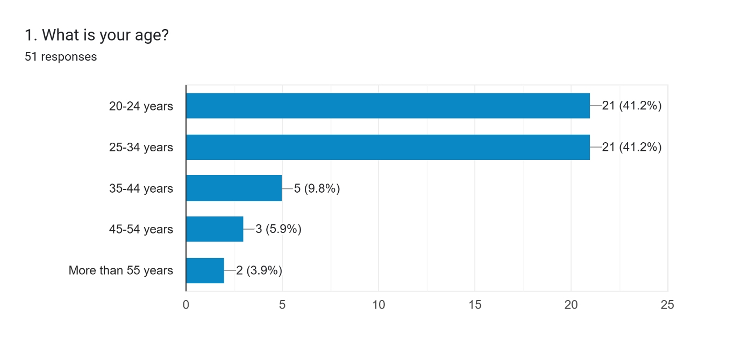

Figure 4.1: Age group
(Source: Obtained using Google forms)
In terms of the age group considered in this survey question, there can be identified a wide range of diversity in the responses. Based on the findings, it can be identified that 20 to 24 years age group and 25 to 34 years age group received the same level of consideration with 41.2% each. Furthermore, the 35 to 44 years received 5 response and the 45 to 54 age group received only 3 responses. The results showcase how the majority of the participants are belonging form a young age, with majority in their 20 to 34 age groups. This further highlights the prevalence of this age group in getting in contact with social influencers in the UK fashion context. This can be further supported through the lowest responses for the ‘More than 55 years’ age group, showcasing a lack of interaction from this age group.
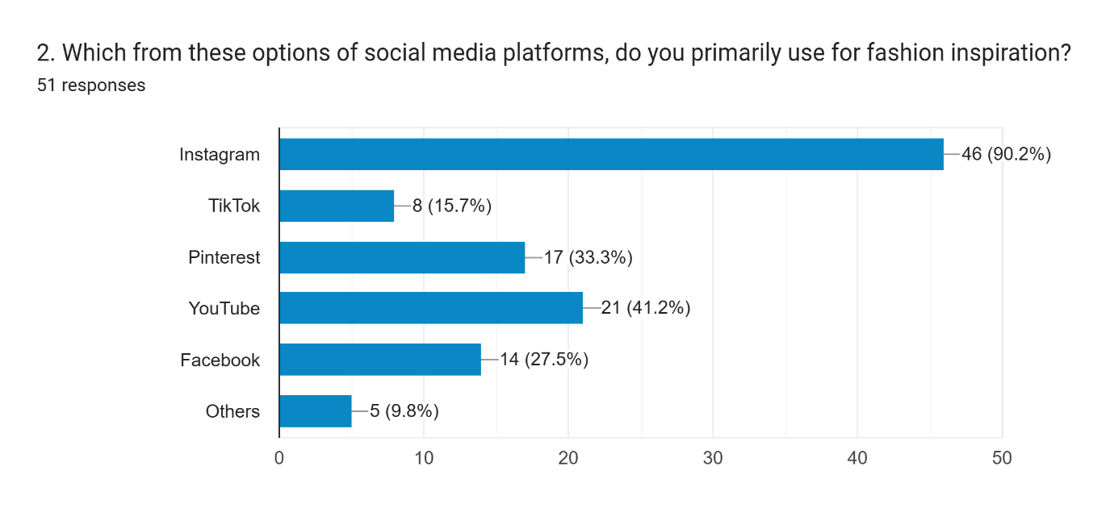

Figure 4.2: Social media platforms for fashion inspirations
(Source: Obtained using Google forms)
From all the responses gained for most preferred and used platforms for fashion inspiration, there can be identified that UK consumers are based on various platforms for their fashion engagement. Among all responses, Instagram stand out the most with 90.2% reporting it as the primary platform. On the other hand, YouTube also got a considerable portion of responses with 41.2% selecting it being primary one. Pinterest got a considerable 33.3% respond, while near close responses were for Facebook with 27.5% (14 respondents) selecting it as primary media. TikTok got a smaller portion response with 15.7%, and only 9.8% reported others. This complete analysis thus identifies that although major popular platforms like Instagram, YouTube and others are taking the majority of the responses, the selection of ‘others’ by 9.8% is showcasing how there are other platforms also that are contributing in the UK fashion industry.
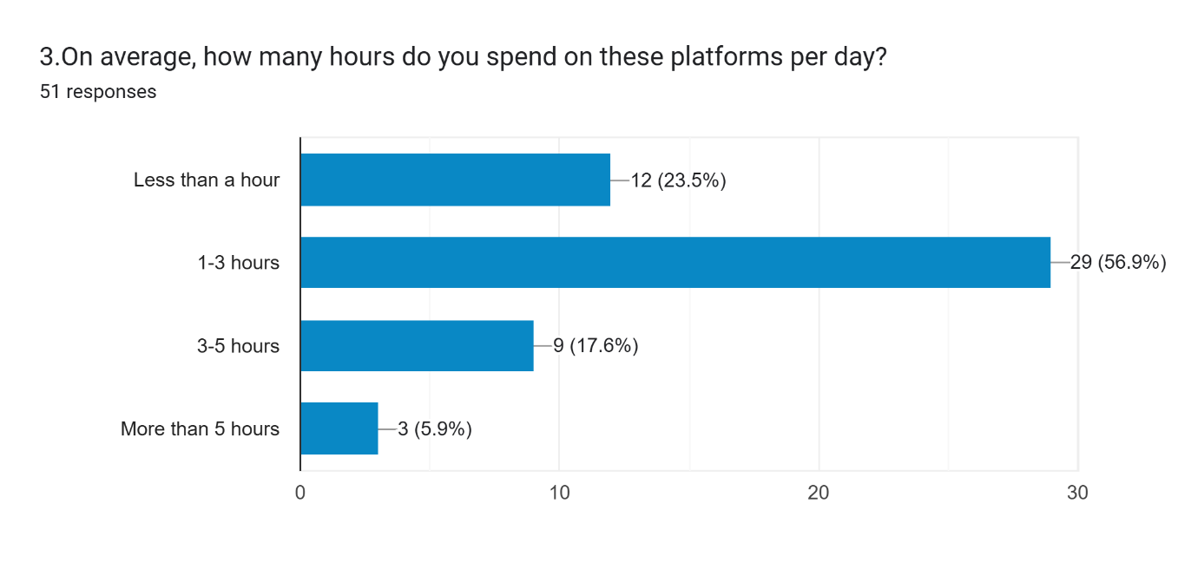

Figure 4.3: Time spent on platforms per day
(Source: Obtained using Google forms)
Based on the understanding of the responses from all participants, this question has been able to potentially shed light on the social platform usage behaviour of UK consumers. The results are shedding light on ‘1 to 3 hours’ being the most popular choice, with 56.9% choosing it. Furthermore, another major portion of 23.5% reported ‘less than an hour’ and another 9 respondents (17.6%) reported “3 to 5 hours”. Finally, the rest 5.9% reported “more than 5 hours”. Thus, it can be said that the UK consumers often spend a potentially reasonable amount of time in these platforms, yet the second majority selecting ‘less than an hour’ and few selecting the range of 3 or even more than 5 hours are developing controversies in this context.
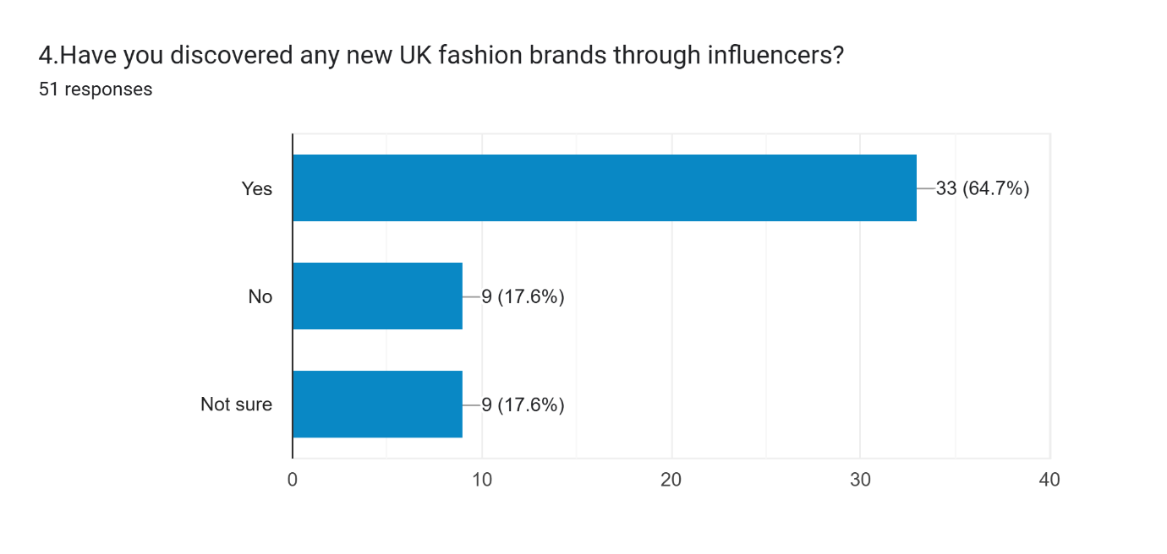

Figure 4.4: New UK fashion brands discovered through influencers
(Source: Obtained using Google forms)
Due to the major reach of influencers in social platforms, it is potential that consumers can get to know about various brands that they did not know previously. Based on this consideration, a significant proportion (64.7%) reported to be discovering new UK fashion brands through influencers, shedding light on the major reach capability of influencers. Yet, it is also crucial to consider that 17.6% reported ‘no’ while rest similar portion of 17.6% also reported ‘not sure’. Thus, although influencers can make audiences get to know new brands, there are still gaps remaining in terms of their effectiveness in this context.
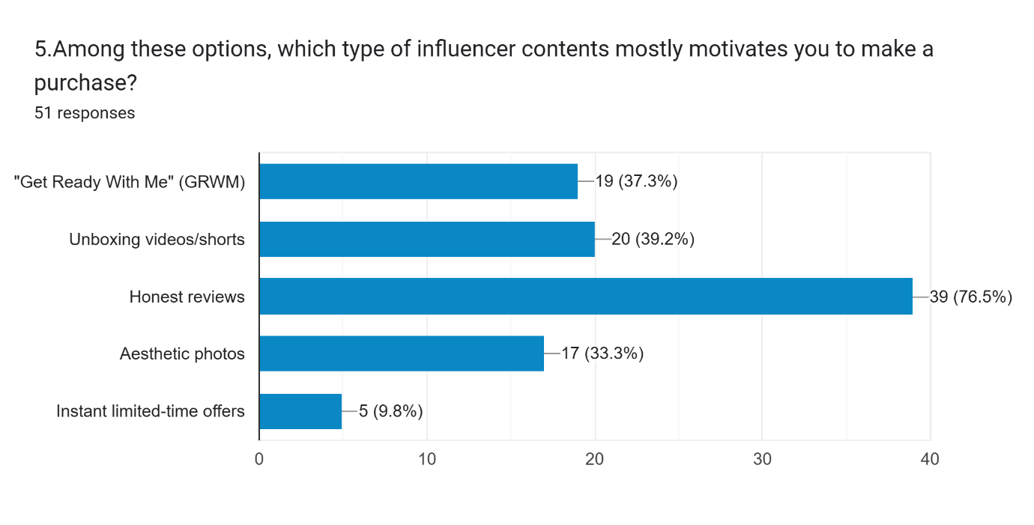

Figure 4.5: Influencer contents being motivating for purchase decisions
(Source: Obtained using Google forms)
With a diverse range of influencers, there are also various types of content that are able to engage various consumers. Based on this survey question, it can be identified that the UK fashion industry-related social influencers are diversifying their approaches to reach new consumers. For an example, among all other approaches, ‘honest reviews’ have been the most chosen content type with 76.5% responses. Furthermore, two similar portions of 39.2% and 37.3% reported either “Unboxing videos/ shorts” or “Get Ready With Me (GRWM)” type of content as the most engaging and motivating factor for influencing their purchasing decisions. Furthermore, a portion of 33.3% reported that aesthetic photos have been the most influential content for them in making purchases. A small portion (9.8%) reported ‘instant limited-time offers’ as the key influencing content type for their purchase behaviour, showcasing a wide range of influencing factors working in the UK fashion industry.
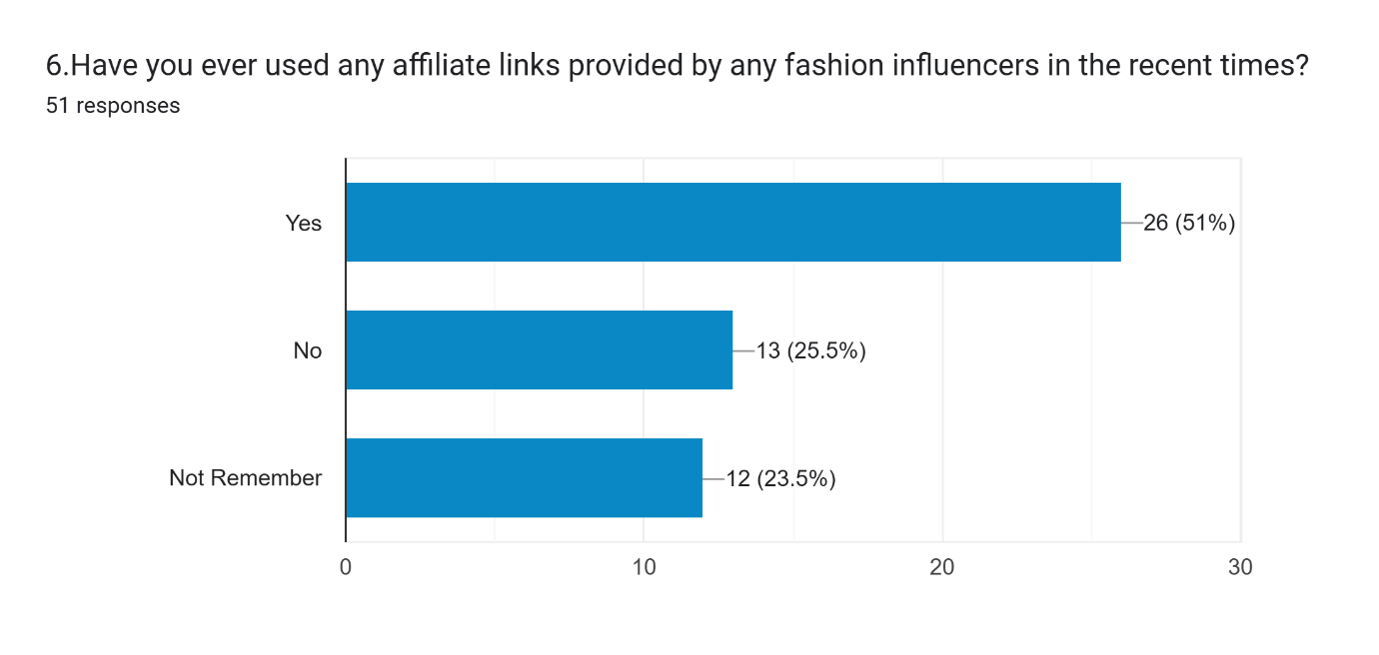

Figure 4.6: Use of affiliate links by fashion influencers
(Source: Obtained using Google forms)
Affiliate utilisation is a potentially common approach while being in touch with influencers, which is further crucial for consideration in this context. This survey question allowed us to gain a wider understanding of whether consumers in the UK are familiar with the use of affiliation links via fashion influencers. Based on the understanding of the findings, it can be identified that over half of the respondents (51%) reported utilising affiliate links provided through influencers in recent times. This has revealed a high engagement level among influencers and consumers in the region. However, it is crucial to also consider that the findings also shed light on 25.5% responding with no, potentially highlighting a gap in terms of engagement. The remaining 23.5% responded with ‘not remember’, which further develops controversies regarding the level of consumer engagement through the affiliate links of influencers, requiring further analysis.

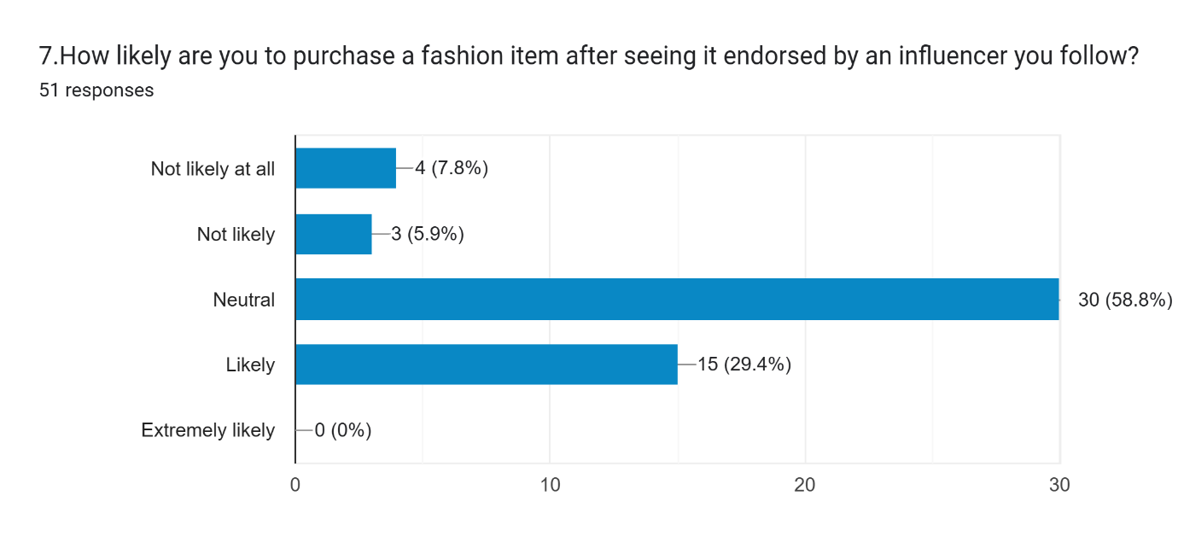

Figure 4.7: Purchasing a fashion item endorsed by followed influencer
(Source: Obtained using Google forms)
This survey question allowed us to gain a wider understanding of the most crucial factor of this complete research, which is their level of influence. Based on results, no one selected ‘extremely likely’ while a major portion of 29.4% reported ‘likely’, showcasing the potential major effect of influencer endorsement on purchasing patterns of fashion items. It is also crucial to consider that 5.9% reported not likely and a 7.8% reported not likely at all, developing a contrasting perspective of influencer impact through endorsements. As further results are gained, the majority of responses (58.8%) have been for a ‘neutral’ response, further creating a complex understanding regarding the actual influence of endorsement on the purchasing intention of UK consumers.

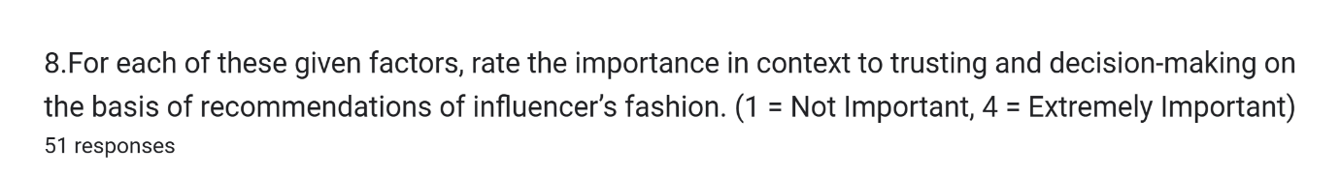
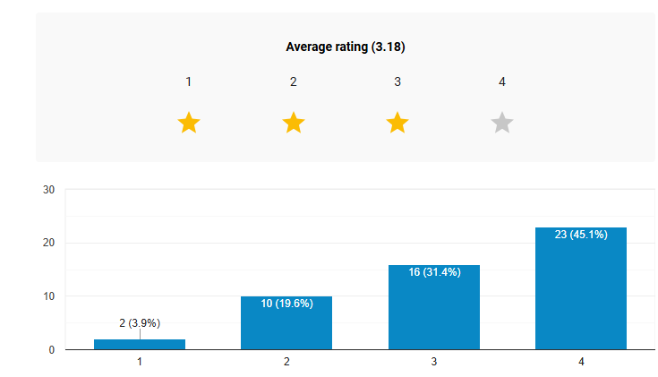

Figure 4.8: Rating factors based on their importance
(Source: Obtained using Google forms)
The analysis of this survey question showcased how consumers get their decisions are influenced through various factors. The factors have been identified to be expertise of influencers for their knowledge of fashion trends and fabrics, trustworthiness for perceived honesty for pros/cons, similarity for having a similar body type or lifestyle to consumers, and attractiveness for their visual appeal and aesthetic. Each of these factors has been considered to be important and contributing at diverse levels in the decision-making of the UK consumers, with an average rating received of 3.18.
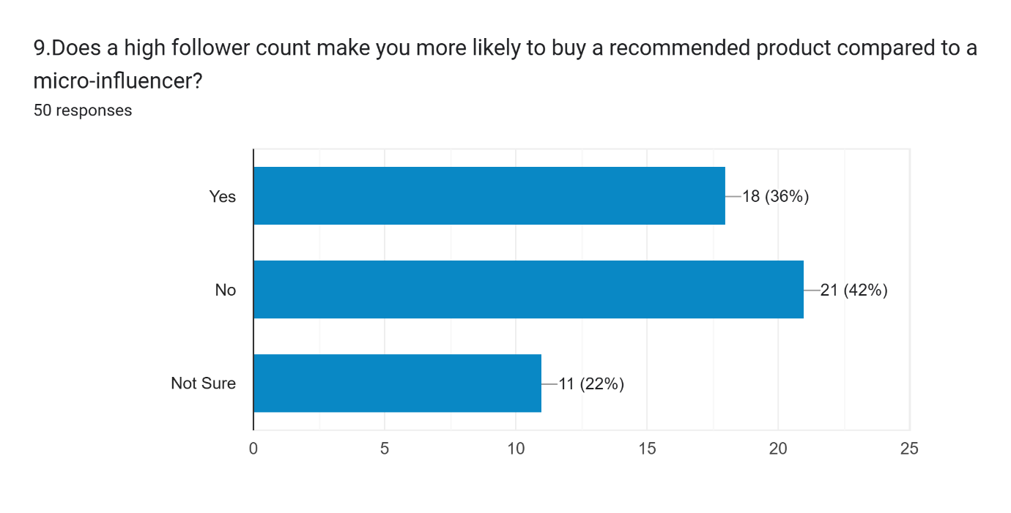

Figure 4.9: High follower count impacting the purchase of the recommended product
(Source: Obtained using Google forms)
Influencers, being macro and micro types, can diversely impact consumer perceptions. In this context, the survey aimed at gaining an understanding if the followers of an influencer matter to consumers in their purchase decisions for recommended products. A majority with 42% reported ‘no’, showcasing follower count does not impact their purchase decisions much, while another considerable portion of 36% responded with ‘yes’, identifying how their decisions for buying recommended products can be impacted though influencer’s follower count. The remaining 22% reported ‘not sure’, further creating a gap in terms of understanding of how influencers with high follower count can of if impact majorly the consumers in terms of purchasing.
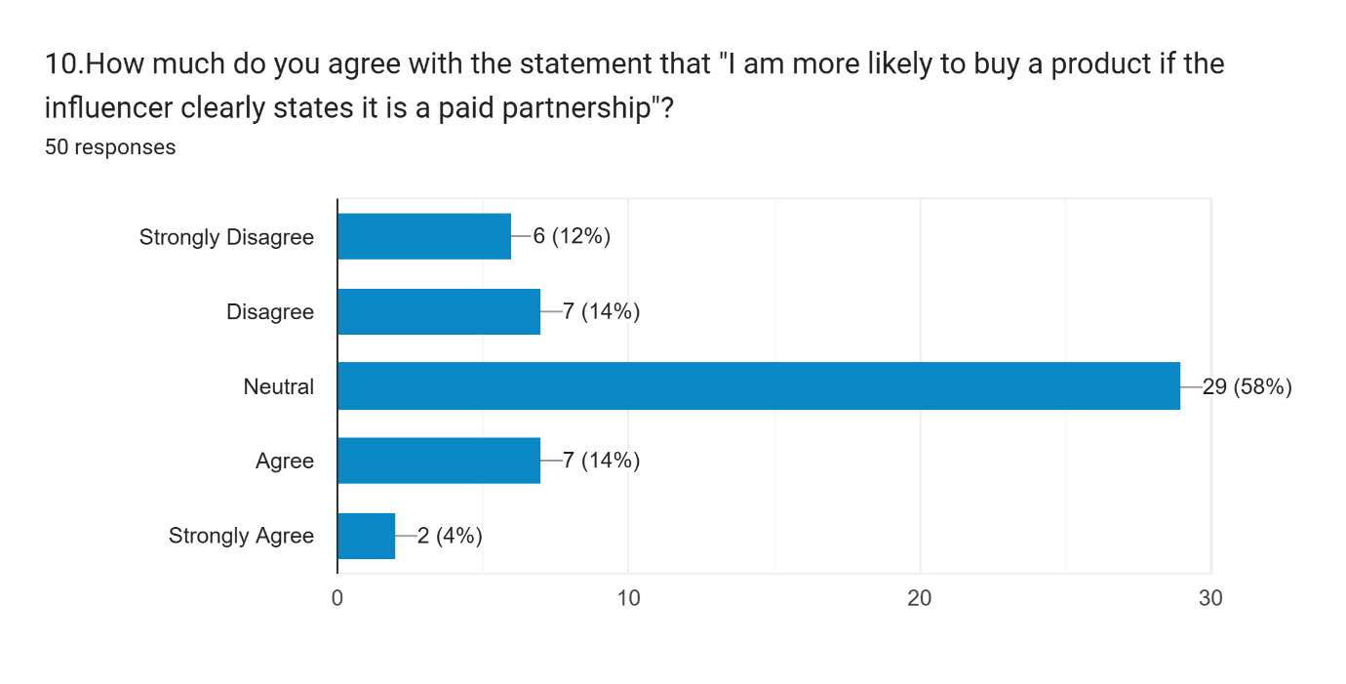

Figure 4.10: Agreement with “I am more likely to buy a product if the influencer clearly states it is a paid partnership”
(Source: Obtained using Google forms)
\This question allowed us to shed light on the wider understanding regarding influencer transparency and their impact on consumer purchasing. In this context, findings were majorly (58%) aligned with a ‘neutral’ stance, while 14% agreed and 4% strongly agreed with the statement. It is also crucial to consider that major portions of 14% and 12% either disagreed or strongly disagreed with the claim. The initial understanding is showcasing that although some consumers prefer more transparency from influencers, there are also considerably high portions (14% and 12%) of consumers who do not care much about the influencers being transparent for paid partnerships, and will buy products anyway. Yet the significant neutrality among the respondents is still developing a contradictory perspective in terms of influencer transparency, requiring further research.
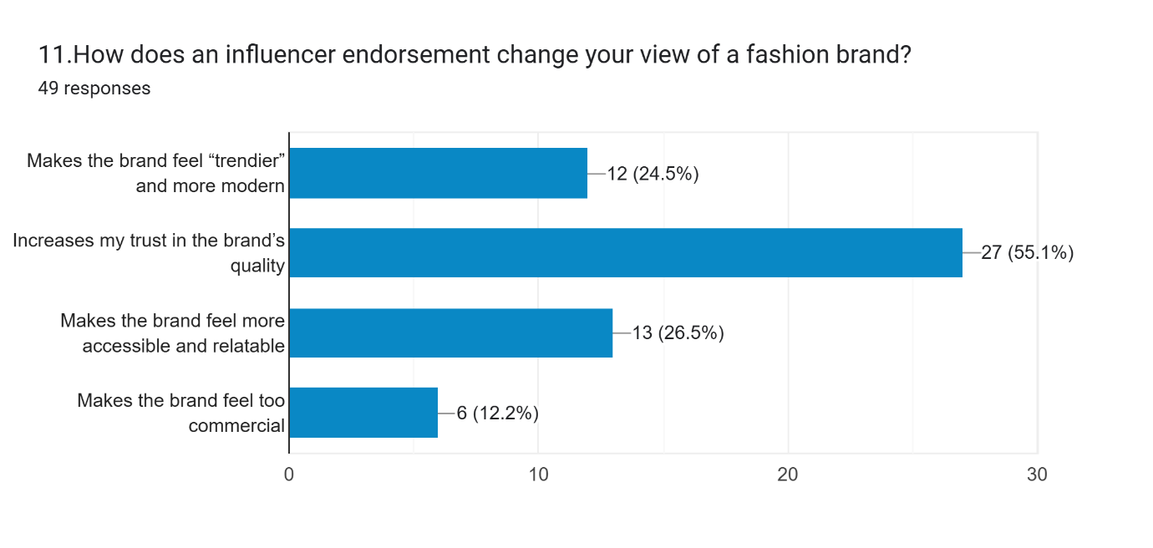

Figure 4.11: Endorsement changing perspective for fashion brand
(Source: Obtained using Google forms)
In terms of endorsement being effective for changing consumer perception, there have been mixed reviews in this context. A significant portion of 55.1% reported ‘Increases my trust in the brand’s quality’, showcasing how endorsement positively impacts brand’s quality consideration. On the other hand, two nearly similar portions have been divided between “Makes the brand feel more accessible and relatable” and “Makes the brand feel 'trendier' and more modern” with 26.5% and 24.5% respectively, shedding light on endorsement impacting two different aspects of brand image for consumers. Finally, a small portion of 12.2% choose “Makes the brand feel too commercial, showcasing a diverse perspective for endorsement effect on brand's complete image.
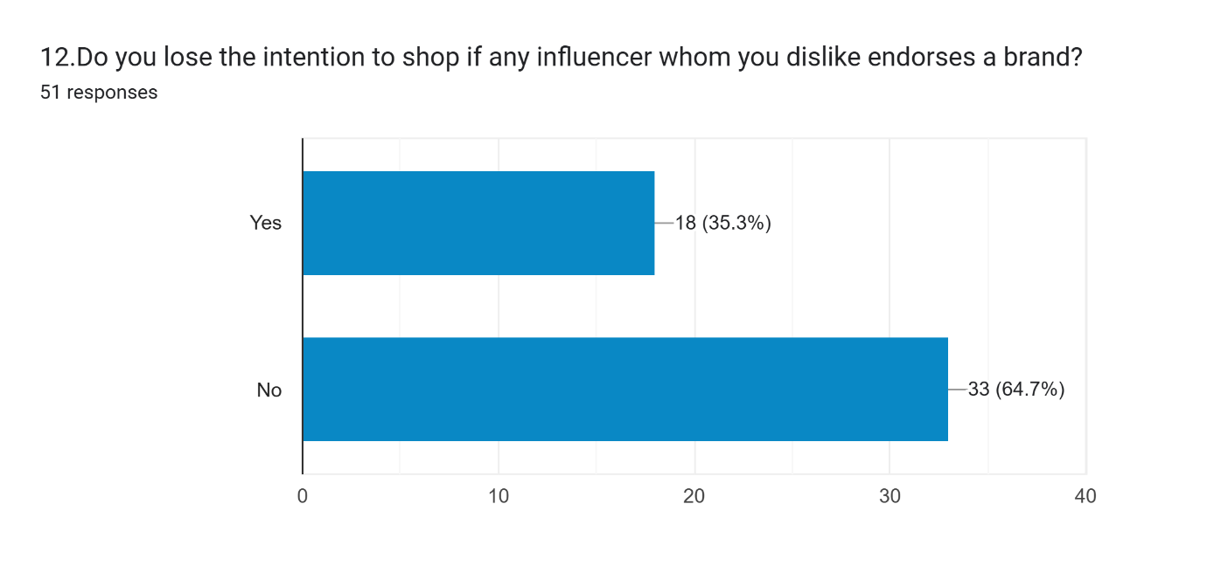

Figure 4.12: Loosing of shopping interest if endorsed by a disliked influencer
(Source: Obtained using Google forms)
This survey question’s response was potentially crucial for understanding consumer behavioural patterns in the UK fashion industry. A significant majority of 64.7% reported ‘no’, showcasing how if their disliked influencer endorses a brand, their shopping interest does not get impacted. On the other hand, 18 respondents (35.3%) have reported ‘yes’, showcasing how this factor influences their behaviour for purchasing, shedding light on a mixed yet majorly negative perspective from the UK consumers.
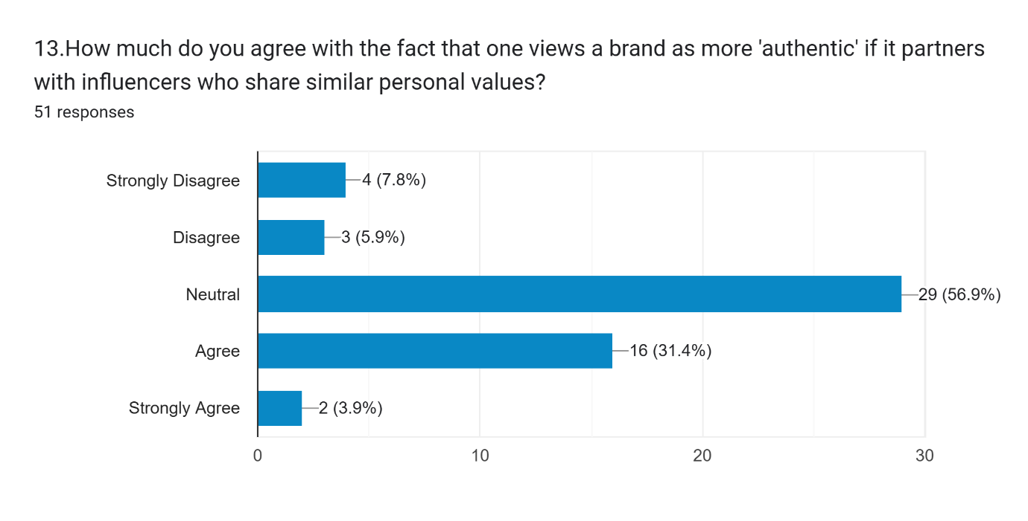

Figure 4.13: Agreements with brands are considered more ‘authentic’ when partnered with similar personal value-driven influencers.
(Source: Obtained using Google forms)
This question sheds light on a wider understanding of this complete research context, showcasing brand ‘authenticity’ being impacted by influencer personal value alignment. As responses, two considerable portions of 7.8% and 5.9% reported either strongly disagree or disagree with this fact while 3.9% strongly agreed that influencer and brand personal value matching can make the brand to be considered as more authentic. A further major portion (31.4%) have reported ‘agree’, thereby focusing on how this is a key factor impacting brand authenticity in the UK fashion industry. Although, 56.9% stayed ‘neutral’ in this context, unsure of this factor’s actual impact on brand authenticity.
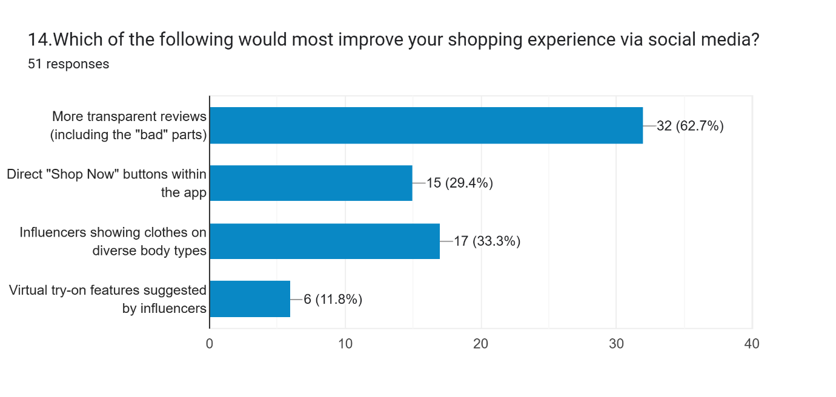

Figure 4.14: Factors improving shopping experiences through social media.
(Source: Obtained using Google forms)
This survey question also shed light on a mixed overview of the consumer perspective in the UK fashion context. Based on initial understanding, the majority (62.7%) reported ‘More transparent reviews (including the “bad” parts)’ being the most crucial factor that enhances their shopping experiences via social media. Furthermore, “Direct “Shop Now” buttons within the app” and “Influencers showing clothes on diverse body types’ were selected by 29.4% and 33.3% respectively, showcasing their mixed yet considerable influence on consumer shopping experiences in this context. Finally, only 11.8% chose “Virtual try-on features suggested by influencers, making it the least influential factor among all others in the UK fashion industry.

4.3 Summary
This chapter has been highly crucial for shedding light on the diverse perspectives of participants selected from the UK fashion industry-related consumers who are integrated with fashion-influencing aspects. These 14 close-ended questions have focused on a wider understanding of the chosen topic while showcasing how consumers have mixed perspectives on various areas. Regardless of some crucial understanding made from the initial analysis of survey responses, it still requires a more in-depth comparative analysis with existing literature to further address the research questions and key aim. While collecting of primary data through the online survey, it was possible to identify both accessibility benefits and limitations of the digital research method. The process also showcased the challenge of relying on self-reported data while still aligning with the main objectives of the research.

Chapter 5: Discussion

5.1 Introduction
This research has conducted an in-depth survey through 50 participants who belong to the consumer group in the UK fashion context and are connected somehow to influencers in the industry through social media. In terms of the research problem, the main issue was regarding the lack of empirical evidence based on the UK for shedding light on the relationship between influencer characteristics and the purchase intention of consumers, making the influencer partnership of brands more inadequate. Thus, this research has focused on analysing how social media influencers affect these UK consumers and their purchase intentions for fashion brands, and to identify proper strategies for brands to utilise in their influencer partnerships. The previous part shed light on the wider overview of the complete survey findings that need to be compared with existing literature for addressing the research objectives.

5.2 Discussion of findings
As the study is focused on analysing how influencers impact the consumer purchase intentions in the UK fashion context, the analysis of the survey findings and existing research is also focused on addressing the key research objectives related to it. The research objectives are mainly focused on how social media influencers impact consumer purchase intentions for UK fashion brands, how credibility and popularity can be key influencing factors, how influencer endorsements can impact brand perception and what crucial strategies UK fashion brands can use for enhancing their marketing efforts. Based on the findings gained from the survey, it is crucial for developing a much more detailed perspective on how these objectives can be addressed and answered via an actual practical perspective from the UK consumers. The discussion with the existing database further aims to validate the findings from the survey, which will eventually contribute to developing a solid empirical basis of this topic, potentially overcoming the literature gap. The first key factor that the survey identified has been the age group of the participants. Based on the analysis, it can be identified that the majority (total 82.4%) of the participants are from the younger age group, mostly aged between 20 and 34.
This showcases the fact that most of the UK consumers belong to the younger age group who are also often in contact with the influencers on social platforms. This can be further supported by the analysis done by Kalvi and Knuutinen (2021) while discussing the Parasocial interaction theory for one-sided emotionally-based relations, in which Gen Z in the UK are most engaged and reliant on influences. The analysis done by a recent survey showcasing 84% of Gen Z following influencers, and also two-thirds of them are millennials, is supporting the survey findings for the lack of older demographic participation in this case (Statista, 2025). The survey was able to shed light on the impact of Instagram on demographics, in relation to how influencers utilise the platform to connect with audiences. The platform being the dominant one with 90.2% responses is further supporting existing literature that Instagram plays a major role in developing impulsive purchasing decisions among consumers (Revlon-Chion et al., 2020). The relevance of YouTube (41.2%) and Pinterest (33.3%) is contrasting the findings of the existing literature, which only prioritises Instagram, showcasing the fact that UK consumers are utilising various platforms for engaging with fashion influencers.
The findings from Morales Sharp (2023) can be further considered, which sheds light on the multiplatform brand humanisation context. The moderate daily time spent on social platforms has been identified to be 1 to 3 hours (by 56.9%), showcasing a moderate consideration of engagement and potential interaction with influencers. The basis for this claim is made through the findings of Adaba et al. (2025) who indirectly identified that influencer impact does not need major exposure, but is based on effective and credible content. These findings are allowing to gain insights into how influencers often impact consumers in the UK fashion industry. Furthermore, the survey findings also shed light on the fact that 64.7% of the respondents have been able to discover new UK fashion brands through influencers. This can be further aligned with the fact that brand credibility and even awareness are key brand-level outcomes resulting from influencer endorsements, supporting the understanding of second research objective (Xu, 2023). Although the total of 35.2% of respondents being not sure or stating ‘no’ contradicts the understanding that influencer reach can not only result in guaranteed brand discovery, especially in the competitive UK fashion market. The findings further shed light on the fact that honest reviews have been the most crucial motivating content type with 76.5% choosing it. Chetioui et al. (2020), in their literature, also supported perceived trustworthiness to be a key factor in terms of influencer credibility, supporting consumer purchase intentions, supporting the first research objective.
The survey revealed the popularity of GRWM content (37.3%) and unboxing videos (39.2%) among the UK fashion consumers. This can further be supported through the Parasocial Interaction Theory, as these aspects further allow for the development of more intimacy and perceived similarity among influencers and their audiences (Zhang et al., 2021). The lower responses in relation to the influence of limited-time offers, with only 9.8% is, potentially contradict the fast-fashion and impulse purchasing behaviours claimed by Revlon-Chion et al. (2020), potentially showcasing that UK consumers may prioritise trust and credibility of influencers over urgency. Furthermore, the survey showcased that 51% of the respondents have also recently utilised affiliate links that are supporting key analysis of the literature, which is shedding light on how influencer-focused commerce is majorly operational in the UK, while the 25.5% of negative responses are developing concerns for inconsistency. The lack of responses for ‘extremely likely’ for endorsement products potentially contradicts the arguments made by Gomes et al. (2022), for how various influencer characteristics, including attractiveness, parasocial interaction, expertise and others, are key driving forces for consumer purchase decisions, as in a practical survey, they seem to exhibit more cautious behaviour regardless of major influencer exposure. Furthermore, the high neutrality (58.8%) showcased that influencer endorsement acts more as a consideration-stage approach in contrast to direct influence on purchase behaviours, supporting the understanding of the third research objective for brand perception and endorsement connection.
The average influencer trait rating being 3.18 out of 4 supports the claims of AlFarraj et al. (2021), confirming that particular influencer aspects like trustworthiness, similarity, attractiveness and others are key contributing factors in collective purchase decisions. Further analysis showcased how follower count alone cannot influence 42%’s decisions, which supports wider consideration in the UK market that there is a rising effectiveness of micro-influencers over macro-influencers in the fashion aspect. On the contrary, the 42% reporting follower count to be impacting their decisions can be supported through literature shedding light on the popularity concept, which is still crucial for particular UK consumer segments (Kikumori et al., 2025). In this context, the majority (58%) of neutral bases for paid partnership transparency especially contradicts ASA concerns, shedding light on the fact that awareness of disclosure is not always related to purchase behaviour. The mixed agreement for disclosures supports Antoniou (2021) in terms of shedding light on the key fact that UK consumers are sensitive to regulation yet are not uniformly influenced by it. A further analysis identified the fact that 55.1% of respondents increased their brand trust for quality due to endorsements, further supporting the understanding of the third research objective. Existing literature further sheds light on the fact that endorsers’ expertise, attractiveness, with a particular focus on their trustworthiness, can ensure the level of persuasiveness of their message, further aligning with the Source Credibility Model (Chin et al., 2020).
Furthermore, the complete research findings showcase how brands can become trendier and more relatable through utilising influencers, especially for brand humanisation. In this context, the findings showcasing 12.2% reporting brands becoming too commercial can be based on the fact that commercialisation concerns can depend on influencer authenticity. Furthermore, as showcased by the findings, 64.7% would not lose their interest if a disliked influencer endorses a brand, which is also potentially contrasting the basis of parasocial theory assumptions, shedding light on how brand strength can be more effective than influencer disliking. Although the 35.3% who lose interest if their disliked influencer endorses a brand showcases the cruciality for brands to consider the emotional attachment factor in Parasocial relations in terms of their influencer partnership approaches (Adaba et al., 2025). Furthermore, based on the findings, it can be identified that influencer-brand fit is a critical aspect to consider while considering proper relationship development as a key strategy for enhancing influencer marketing, aligning to the second objective regarding influencer credibility and popularity.
Furthermore, regardless of the literature’s focus on value alignment being another crucial approach, it can often be beneficial and effective. This is due to the fact that 56.9% respondents in the survey remained neutral, potentially not consciously evaluating value alignment. Furthermore, transparency in reviews can be another major factor that can enhance the authenticity of not only the influencer but also the brand. Literature also showcased that perceived trustworthiness can be a key influential factor influencing consumer purchase decisions in the UK fashion marketing (Chetioui et al., 2020). These findings are further collaboratively supporting the fourth research objective of this study regarding the most beneficial approaches and which factors need to be considered in marketing brands and influencers to influence the most consumer purchasing aspect. Thus, it can be said that the complete analysis of the survey results has been effective in shedding light on the wider understanding of influencers affecting UK consumers for their purchase intentions through social platforms. The comparison and contrasting of the findings with existing literature has further allowed this chapter to answer the research objectives in a detailed manner.
The discussion has been further crucial for addressing the literature gap as the survey has solidified the need for UK-specific influencer research as the consumer neutrality and their cautious approach is differing form wider findings. The results further shed light on the authenticity and popularity issues and clashing perspectives identified in the literature gap, with follower counting showcasing a diverse level of influence. The findings further supported in addressing the gap through identifying that Parasocial relationships are present, yet they are not a key guaranteeing factor for purchase. Furthermore, the major presence of neutral responses is shedding light on the crucial need for future studies to identify the relation of psychological hesitation and trust aspects among the UK-based consumers of fashion industry.

5.3 Summary
This chapter has supported developing key insights in relation to the research aim, while also majorly contributing to answering the research objectives defined earlier. This discussion addressed the gap between relational aspects and the actual behaviour of UK-based consumers. Credibility and authenticity have been among the key factors for more influential marketing through influencers in this industry. The findings are crucial not only in practical terms, as companies can apply the insights for the enhancement of their influencer marketing, but it also develops a solid base in the academic research context through contributing to this field of knowledge. As the analysis created a detailed overview of the research context, it is also crucial that the prevalence of neutral responses in the survey highlights the need for future studies on the unexplored areas of this research. While moving to the discussions in the next chapter, theories like source credibility and parasocial interactions will be linked back, with a consideration of existing literature with the findings of the survey. It is to be understood that empirical results can not only support or enhance the existing theories, but also can contradict them.

Chapter 6: Conclusions and Recommendations

6.1 Introduction
This particular chapter is focused on shedding light on the complete findings of the research conducted. The chapter aims to showcase all the detailed understanding made regarding social media influences impact the consumer purchasing intentions for UK-based fashion brands. The research utilised a survey method via quantitative research approach to shed light on the topic. Through the detailed overview of the findings, this chapter will support further recommendations for future studies and even for practical implications. The chapter will further develop a personal reflection of the complete research journey supporting the findings and their impact on learning.
This research has been highly beneficial to develop an understanding of how influencer marketing is more complicated than it was initially assumed or even got presented in various media and other discussions. The relation among influencer and the consumer purchase intention is considered to be a straightforward and simple context. Although, as this research started to develop, it was possible to get insights on various complex inner layers of trust, scepticism and even consumer cautions. It was further possible to develop a more in-depth understanding of the particular consumer segments of the UK-based fashion industry and the influencer approaches they interact with every day. It is now understood that academic research is not only about developing an analysis of trends, but also creating questions in relation to the pre-existing beliefs on a particular topic through structured evidence. The first chapter of this research has been the introduction chapter, which allowed a proper clarification of why the UK fashion industry is a unique and crucial context to be considered in relation to influencer marketing research. This imparted the knowledge of how crucial it is to develop a proper research aim while conducting proper research objectives and questions to guide the study.

6.2 Summary of key findings
This study has been developed to shed light on the fact of how social media influences can impact the consumer purchasing intentions for various fashion brands which are in the UK. The key aim is to develop various strategic options for the UK-based fashion brands to utilise in their influencer collaboration properly that will enhance their capability for consumer trust development and eventually influence their purchasing. The research developed objectives and questions, which are aligned and relevant to the complete research topic and its aim. However, this research has also developed a particular keen focus on the major factors including the influencer credibility, endorsements, popularity and strategic utilisation of them by brands. The study utilised a quantitative research method with a focus on a survey being the primary tool to gain perspective directly from the sample. Through a purposive sampling, the study selected 50 participants most related to this study’s aim and complete purpose. With a focus on proper ethical consideration, the researchers conducted an in-depth survey of the participants with relevance to the study’s objective. The questions have been further guided by the research objectives and aim to support the guided structure of the complete research. The findings are shedding light on the fact that social media influencers are indeed possess the capability to influence consumers in the UK fashion industry. Analysis of survey data developed the understanding that how consumer responses are elaborated in a more detailed way. There have been several neutral responses in this survey, which hindered the capability to analyse the initial assumptions for influencer’s effectiveness. It is learned that the lack of effective agreement sheds light on the scepticism that is inside consumers and their cautious decision-making approach. The younger demographic prevalence and their response analysis allowed a proper understanding of general differences in this context.
This often impacts the consumer awareness and even consideration stages, in contrast to their direct impact on purchasing intentions. As the survey results highlighted, it is often the younger consumers aged between 20 to 34 years who are also the most engaged demographics with influencer content. This also solidified the understanding through the similar Gen Z and Millennials claims of the existing literature, highlighting how influencer marketing is primarily among the younger millennials and Gen Z of the UK fashion sector. In this context, social media platforms also play a major role in influencing the consumer purchasing journey. The results from both the literature and the survey shed light on the significant popularity and dominance of Instagram in the fashion inspiration context. Although, the mixed responses from the survey for YouTube, and Pinterest are also making claims that the UK consumers are also utilising other platforms and do not only focus on Instagram as their key influencing platform, supporting better engagement and evaluation. As the complete study continued to grow, it can be identified that time spent on social media is not the key impacting factor for purchase intentions. The analysis showcases that time spent is referred to as the exposure to contents of influencers, yet factors like content quality, credibility and others have been identified to be more crucial and contributing forces for consumer purchase intention influences, especially among the UK consumers. Based on comparison with the literature review, the survey findings have been able to shed light on the fact that influencers, especially in the UK, are effective in introducing new UK fashion brands to the consumers.
This not only allows the brands to increase their popularity, but also showcases how influencer reach can be a majorly effective tool in terms of marketing for brands. Their crucial role as a discovery tool in the fashion industry of the UK region is another major discovery of this study. Yet the mixed responses from the survey showcase that the factor of brand discovery via these influencers is not always universal among all consumers. In influencer relations, the reviews play a major role in terms of impacting consumer perceptions regarding a brand or its product. As showcased in the findings from the survey, honest reviews are one of the most crucial and important types of content for consumers. Literature also argued on a similar thing, shedding light on balanced reviews and authentic content being more capable of influencing consumer perceptions, developing the understanding that credibility and transparency often are more impotent fact in compared to promotional strength by brands. Besides the authenticity and credibility of the influencer's content, the content type also plays a major role in terms of creating a sense of authenticity. As showcased by the results, content like GRWM and unboxing shorts or videos have been the most impactful content type that can develop familiarity and engagement with consumers, highlighting the concept of relational closeness enhancing influence.
It was, moreover, identified that the UK market is relatively less influential through aspects like limited-time offers and urgency-based approaches. This is highlighting the finding that UK consumers often focus on trust and authenticity over potential impulsive triggers for purchase, as identified in the literature. Affiliation is also crucial to be considered in this market as the survey highlighted a major portion of consumers have recently utilised affiliation, yet there is still uncertainty, like uneven awareness levels and engagement with influencer-focused commerce. Endorsement was also considered to be a crucial factor impacting the complete research context, with a lower level of immediate purchasing influence on consumers, as showcased by the survey’s major neutral response rates. The UK consumers in this industry are identified to be more cautious and reflective. The study also showcased how influencer characteristics like expertise, similarity, trustworthiness and even attractiveness can collaboratively influence decision-making. With further analysis, follower count also received a mixed response from the selected participant group, highlighting the fact that the popularity of macro-influencers cannot be often be effective enough for consumer purchase decisions, while identifying that the UK market is also seeing various micro-influencers to be more effective than large-scale influencers. The findings not only address research questions, but they also allowed to develop a wider understanding of the industry and its in-depth factors that drive influencer approaches done by companies.
Paid partnership, influencer endorsement and others also identified as requiring a support form of transparency to effectively develop major trust among consumers for the brands. This not only showcased to be effective for improving brand perceived quality but also increased its reliability and trendiness to consumers, shedding light on the key aspect of this complete research. One of the key findings has been the influencer and brand value alignment. As the literature highlighted its crucial need for purchase decision influence, the wider survey showcased a mixed approach. With some consumers able to increase their perceived authenticity trough this alignment, a majority also remained neutral, highlighting the gap of this approach’s effectiveness. Thus, companies in this industry need to be taking more calculated and cautious approaches in influencer partnerships for better results. The study showcased that influencer marketing in the UK fashion industry is only effective when authenticity, credibility and strategic alignment are prioritised by both brand and the influencers.

6.3 Significance of the findings
This particular study has focused on the UK’s consumers and their purchasing behaviour-related attitude in relation to influencers. Based on the complete findings of the study, it can be identified that the study is contributing to various UK-specific data and key insights in relation to influencer marketing research, addressing the gap that has been identified through global or other existing studies. The research has been beneficial to shed light on the lack of connection between influencer exposure and actual purchasing behaviours, allowing to develop a more detailed overview of existing influencer effectiveness assumptions in the industry. The study further contributed to this field of knowledge through showcasing that neutral consumer responses are more effective in showcasing scepticism and cautiousness among consumers of UK fashion industry. The wider understanding of influencer credibility, Parasocial relations and brand perceptions in the region further developed to be key analysis that can majorly contribute to the practical approaches undertaken by companies in the industry to enhance their complete influencer strategy and gain better capability to influence the consumer purchasing behaviour.

6.4 Recommendations
Practical recommendations for UK-based fashion brands based on the findings of the study
- Prioritise authentic and honest influencer contents especially the reviews show both sides. As a result, collaborating with micro-influencers who with major audience trust and reliability in small focused fashion communities can be of great help.
- Focusing on influencer credibility will further determine the engagement quality, as follower count alone is seen to be not effective enough. It includes utilising influencers for enhanced brand discovery approaches and trust development for better perception management of consumers.
- Monitor consumer feedback properly to avoid partnerships with influencers who are not liked by many or lack proper characteristics to develop a connection with consumers.
- Encouraging content creation in the formats which are able to promote more familiarity and engagement, like Unboxing videos/ shorts or Get ready With Me (GRWM). It further includes ensuring transparency in paid partnerships while keeping endorsements nature and aligned with influencer value.
Recommendations for future similar studies on this topic
- Increasing the sample size and demographic diversity to increase representation capability
- Considering behavioural data like actual purchases and their intentions for better motivation understanding
- Analysing differences in influencer effectiveness through various social platforms by focusing on psychological aspects and trust barriers among UK consumers
- Longitudinal research is conducted to identify the effect of repeated influencer exposure affecting trust and purchasing behaviour over time
- Considering qualitative methods for further enhancing the understanding of the major neutral responses gained in the survey.

6.5 Limitations
Regardless of a vast beneficial contribution and understanding, this study has diverse limitations that may be hindering its wider applicability and acceptance. For example, the most crucial limitations to consider are the limited sample size of 50 respondents, which is hindering generalizability for the findings to all UK populations. The keen focus on self-reported data of this study can also develop potential for recall bias in the results. The survey approach is limiting the wider and more in-depth analysis of emotional and psychological motivations related to the responses. A keen focus is on the purchase intention and not the purchasing behaviour, further developing a barrier in the results. It is also crucial to consider that the study did mention platform-specific behaviours, yet no in-depth analysis regarding them has been done. These limitations thus need to be overcome properly in future studies to provide a more detailed understanding of this topic area.

6.6 Summary
Writing of the conclusion supported in developing a clear and detailed brief overview of all chapters. It has eventually developed a key understanding that effective influencer marketing in the UK is mostly based on authenticity and the context of trust. This is, however, contradicting existing literature claims for promotional intensity related benefits. The development of recommendations enabled a more practicality regarding how research findings can guide real business decisions, especially in this chosen research context. The consideration of limitations enhanced academic honesty and critical self-analysis skills while understanding how future research can be enhanced. Thus, it can be said that this study has changed the conventional understanding of how influencer marketing actually works, with a consideration of trust-based strategic approach. At the same time, this research has turned out to be a key to learning that consumer behaviours in the UK fashion market are majorly managed through reflection in contrast of impulsive decisions.
References
Adaba, G.B., Frimpong, F. and Mwainyekule, L., 2025. Empirical Analysis of Social Media Influencers’ Effect on Consumer Purchase Intentions and Behavior. Platforms, 3(3), p.11.
AlFarraj, O., Alalwan, A.A., Obeidat, Z.M., Baabdullah, A., Aldmour, R. and Al-Haddad, S., 2021. Examining the impact of influencers’ credibility dimensions: attractiveness, trustworthiness and expertise on the purchase intention in the aesthetic dermatology industry. Review of International Business and Strategy, 31(3), pp.355-374.
Ali, I.M., 2024. A guide for positivist research paradigm: From philosophy to methodology. Idealogy Journal, 9(2).
Alves De Castro, C. and Carthy, A., 2021. Social media influencers (SMIs) in context: A literature review.
Ampornklinkaew, C., 2025. The role of social media influencers in influencing consumers' imitation intentions. Digital Business, p.100143.
Antoniou, A., 2021. Advertising regulation and transparency in influencers’ endorsements on social media. Communications Law-Journal of Computer, Media and Telecommunications Law, 26(4), pp.190-207.
Asaorguk, 2025. Influencer Ad Disclosure on Social Media: Instagram and TikTok (2024). Available at: https://www.asa.org.uk/static/3f7df70c-ca5c-499c-8aaa56e8b3e9572e/ASA-influencer-ad-disclosure-report.pdf [Accessed on 10.11.2025]
Bihu, R., 2021. Questionnaire survey methodology in educational and social science studies. International Journal of Quantitative and Qualitative Research Methods, 9(3), pp.40-60.
Bisht, R., 2025. Influencer Commerce And Social Media Marketing: The New Age Of Global Digital Branding. Available at SSRN 5321861.
Boardman, R. and McCormick, H., 2023. Exploring how different ages of consumers shop on women's fashion retail websites. International Journal of Human-Computer Studies, 177, p.103064.
Cascio Rizzo, G.L., Villarroel Ordenes, F., Pozharliev, R., De Angelis, M. and Costabile, M., 2024. How high-arousal language shapes micro-versus macro-influencers’ impact. Journal of Marketing, 88(4), pp.107-128.
Casula, M., Rangarajan, N. and Shields, P., 2020. The potential of working hypotheses for deductive exploratory research. Quality & quantity, 55(5), p.1703.
Chan, F., 2022. A study of social media influencers and impact on consumer buying behaviour in the United Kingdom. International Journal of Business & Management Studies, 3(07), pp.2694-1449.
Chervenak, F.A. and McCullough, L.B., 2021. Ethical considerations. In Clinical Maternal-Fetal Medicine (pp. 42-1). CRC Press.
Chetioui, Y., Benlafqih, H. and Lebdaoui, H., 2020. How fashion influencers contribute to consumers' purchase intention. Journal of Fashion Marketing and Management: An International Journal, 24(3), pp.361-380.
Chin, P.N., Isa, S.M. and Alodin, Y., 2020. The impact of endorser and brand credibility on consumers’ purchase intention: the mediating effect of attitude towards brand and brand credibility. Journal of Marketing Communications, 26(8), pp.896-912.
Colucci, M. and Pedroni, M., 2022. Got to be real: An investigation into the co-fabrication of authenticity by fashion companies and digital influencers. Journal of Consumer Culture, 22(4), pp.929-948.
Duncan, 2024. Brand discovery via social media overtakes search engines and TV ads. Available at: https://www.marketingtechnews.net/news/brand-discovery-via-social-media-overtakes-search-engines-and-tv-ads/#:~:text=In%20the%20UK%2C%20influencer%20audiences%20as%20a,compared%20to%20the%20average%20social%20media%20user.[Accessed on 10.11.2025]
Es-Safi, K., 2022. Examining the effects of social media influencers characteristics on brand equity and purchase intention.
Globaldata, 2024. United Kingdom (UK) Green Fashion Market Summary, Competitive Analysis and Forecast to 2028. Available at: https://www.globaldata.com/store/report/uk-green-fashion-market-analysis/#:~:text=The%20UK%20green%20fashion%20market,12%25%20during%202023%2D2028.[Accessed on 05.11.2025]
Gomes, M.A., Marques, S. and Dias, Á., 2022. The impact of digital influencers’ characteristics on purchase intention of fashion products. Journal of Global Fashion Marketing, 13(3), pp.187-204.
Gracias, A., Olukemi, A. and Bell, C., 2024. Influencer Marketing ROI: Measurement Techniques and Optimization Strategies. Available at SSRN 4907402.
Grandviewresearch, 2020. UK Fashion Influencer Ing Market Size & Outlook, 2020-2027. Available at: https://www.grandviewresearch.com/horizon/outlook/fashion-influencer-marketing-market/uk[Accessed on 08.11.2025]
Guangul, S.M., 2024. Influencer marketing effectiveness: Metrics, risks, and best practices. Migration Letters, 21(S4), pp.472-481.
Guerreiro, J. and Pacheco, M., 2021. How green trust, consumer brand engagement and green word-of-mouth mediate purchasing intentions. Sustainability, 13(14), p.7877.
Handranata, Y.W. and Kalila, S., 2025. Attitude toward fashion influencers and its impact on purchase behavior: the roles of brand attitude and purchase intention. Frontiers in Communication, 10, p.1583602.
Hjalmarsson, E. and Koste, E., 2024. It's a Match!: Exploring Female Gen Z's Perceptions of Influencer-Brand Fit inthe Fashion Industry.
Jarrar, Y., Awobamise, A.O. and Aderibigbe, A.A., 2020. Effectiveness of influencer marketing vs social media sponsored advertising. Utopía y praxis latinoamericana: revistainternacional de filosofíaiberoamericana y teoría social, (12), pp.40-54.
Kagerbauer, M. and Magdolen, M., 2024. Workshop synthesis: Measuring attitudes and perceptions in large scale (quantitative) surveys. Transportation Research Procedia, 76, pp.617-623.
Kalvi, T. and Knuutinen, I., 2021. Negative engagement enforcing emotional labor in parasocial relationships between social media influencers and followers.
Kemp, S. (2024) Digital 2024: The United Kingdom — DataReportal – Global Digital Insights. https://datareportal.com/reports/digital-2024-united-kingdom#:~:text=The%20number%20of%20social%20media,January%202023%20and%20January%202024.[Accessed on 04.12.2025]
Kikumori, M., Maruyama, Y. and Ishii, R., 2025. Influencers’ Follower Numbers, Consumers’ Cultural Value Orientation, and Purchase Intention: Evidence from Japan, the United Kingdom, and Singapore. Journal of International Consumer Marketing, 37(4), pp.350-361.
Lin, C.A., Crowe, J., Pierre, L. and Lee, Y., 2021. Effects of parasocial interaction with an instafamous influencer on brand attitudes and purchase intentions. The Journal of Social Media in Society, 10(1), pp.55-78.
Miller, K., 2021. CREATING DATA VISUALIZATIONS IN EXCEL: WHAT TO KEEP IN MIND. Available at: https://online.hbs.edu/blog/post/data-visualizations-in-excel
Moises Jr, C., 2020. Online data collection as adaptation in conducting quantitative and qualitative research during the COVID-19 pandemic. European journal of education studies, 7(11).
Morales Sharp, T., 2023. Ethical guide for social media marketing: brand humanization, data privacy, and brand trust.
Okonkwo, I. and Namkoisse, E., 2023. The role of influencer marketing in building authentic brand relationships online. Journal of Digital Marketing and Communication, 3(2), pp.81-90.
Özdil, M.A., 2021. The effect of clothing as a marker on identity. Motif AkademiHalkbilimi Dergisi, 14(33), pp.117-130.
Pearse, N., 2021. Guidelines for theory development using qualitative research approaches. Electronic Journal of Business Research Methods, 19(2), pp.95-103.
Pedroni, M., 2023. Two decades of fashion blogging and influencing: A critical overview. Fashion Theory, 27(2), pp.237-268.
Revlon-Chion, E., Bolat, E. and Liang, Y., 2020. Instant Buying of Fast Fashion: Are Influencers to Blame?.
Saunders, C. and Kulchitsky, J., 2021. Enhancing self-administered questionnaire response quality using code of conduct reminders. International Journal of Market Research, 63(6), pp.715-737.
Setyanta, B., Septiyanti, N.D., Setyawan, D., Zailani, A. and Luthfi, M.I., 2024, December. Social Media Fashion Influencers and Gen Z: Unraveling Purchase Intentions Through an Extended Theory of Planned Behavior (TPB) in Indonesia. In International Conference on Digital Business Innovation and Technology Management (ICONBIT) (Vol. 1, No. 1).
Seuring, S., Stella, T. and Stella, M., 2021. Developing and publishing strong empirical research in sustainability management—Addressing the intersection of theory, method, and empirical field. Frontiers in Sustainability, 1, p.617870.
Statista, 2025. Influencer marketing in the United Kingdom (UK) - statistics & facts. Available at: https://www.statista.com/topics/7119/influencer-marketing-in-the-uk/?srsltid=AfmBOook98T6cAJEhrr5_4jYBb0JA1VpWS1veAQRKBm_-mwJG3ijfrpK#topicOverview[Accessed on 10.11.2025]
Tan, C. and Kapadia, V., 2022. Getting Real With Parasocial Relationships. Available at: https://www.simplyneuroscience.org/post/getting-real-with-parasocial-relationships[Accessed on 10.11.2025]
Taylor, N. (2023) 'Over half of UK influencer followers more likely to buy from fashion labels using them,' FashionNetwork.com, 17 July. https://ww.fashionnetwork.com/news/Over-half-of-uk-influencer-followers-more-likely-to-buy-from-fashion-labels-using-them,1537498.html. [Accessed on 04.12.2025]
Tcholakova, E., 2025. Attitudes towards buying clothes from sustainable brands among consumers in the United Kingdom (UK) in 2020*. Available at: https://www.statista.com/statistics/1168849/sustainable-fashion-purchase-united-kingdom/?srsltid=AfmBOoqscJRDlFO4nrIeE__Q7JUN8eii-TWGSI0zKwvGffhlJzFgTIWp[Accessed on 14.11.2025]
TheIndustryFashion (2024) Social shopping has surged in UK by 32% since 2022. https://www.theindustry.fashion/social-shopping-has-surged-in-uk-by-32-since-2022/.[Accessed on 04.12.2025]
Thomas, F.B., 2022. The role of purposive sampling technique as a tool for informal choices in a social Sciences in research methods. Just Agriculture, 2(5), pp.1-8.
Weismueller, J., Harrigan, P., Wang, S. and Soutar, G.N., 2020. Influencer endorsements: How advertising disclosure and source credibility affect consumer purchase intention on social media. Australasian marketing journal, 28(4), pp.160-170.
Wpp, 2025. Over a quarter of UK shoppers buy luxury fashion and beauty items directly through social media, a new WPP survey reveals. Available at: https://www.wpp.com/en/news/2025/02/uk-shoppers-buy-luxury-items-directly-through-social-media[Accessed on 12.11.2025]
Xu, X., 2023. Influencer marketing with social platforms: Increasing brand awareness and user engagement. Journal of education, humanities and social sciences, 19(7), pp.2-13.
Zhang, K., Zhang, M. and Li, C., 2021. Effects of celebrity characteristics, perceived homophily, and reverence on consumer-celebrity para-social interaction and brand attitude. Frontiers in Psychology, 12, p.711454.
Ziauddin, L., Krivicich, L.M. and Nho, S.J., 2023. Cross-section study. In Translational Sports Medicine (pp. 191-193). Academic Press.

Appendices

Appendix 1: Survey questions
Survey questionnaire on "ANALYSIS OF THE IMPACT OF SOCIAL MEDIA INFLUENCERS ON PURCHASE INTENTIONS OF CUSTOMERS FOR FASHION BRANDS IN THE UK
- What is your age?
  - 20-24 years
  - 25-34years
  - 35-44years
  - 45-54years
  - More than 55years
- Which from these options of social media platforms, do you primarily use for fashion inspiration?
  - Instagram
  - TikTok
  - Pinterest
  - YouTube
  - Facebook
  - Others
- On average, how many hours do you spend on these platforms per day?
  - Less than a hour
  - 1-3 hours
  - 3-5 hours
  - More than 5 hours
- Have you discovered any new UK fashion brands through influencers?
  - Yes
  - No
  - Not sure
- Among these options, which type of influencer contents mostly motivates you to make a purchase?
  - "Get Ready With Me" (GRWM)
  - Unboxing videos/shorts
  - Honest reviews
  - Aesthetic photos
  - Instant limited-time offers
- Have you ever used any affiliate links provided by any fashion influencers in the recent times?
  - Yes
  - No
  - Don’t remember
- How likely are you to purchase a fashion item after seeing it endorsed by an influencer you follow?
  - Not likely at all
  - Not likely
  - Neutral
  - Likely
  - Extremely likely
- For each of these given factors, rate the importance in context to trusting and decision-making on the basis of recommendations of influencer’s fashion. (1 = Not Important, 5 = Extremely Important)
  - Expertise (Knowledge of fashion trends/fabrics)
  - Trustworthiness (Perceived honesty about pros/cons)
  - Similarity (They have a similar body type or lifestyle to me)
  - Attractiveness (Visual appeal and aesthetic)
- Does a high follower count make you more likely to buy a recommended product compared to a micro-influencer?
  - Yes
  - No
  - Not sure
- How much do you agree with the statement that "I am more likely to buy a product if the influencer clearly states it is a paid partnership"?
  - Strongly Disagree
  - Disagree
  - Neutral
  - Agree
  - Strongly Agree
- How does an influencer endorsement change your view of a fashion brand?
  - Makes the brand feel “trendier” and more modern
  - Increases my trust in the brand’s quality
  - Makes the brand feel more accessible and relatable
  - Makes the brand feel too commercial
- Do you lose the intention to shop if any influencer whom you dislike endorses a brand?
  - Yes
  - No
  - Somewhat
- How much do you agree with the fact that one views a brand as more 'authentic' if it partners with influencers who share similar personal values?
  - Strongly Disagree
  - Disagree
  - Neutral
  - Agree
  - Strongly Agree
- Which of the following would most improve your shopping experience via social media?
  - More transparent reviews (including the "bad" parts)
  - Direct "Shop Now" buttons within the app
  - Influencers showing clothes on diverse body types
  - Virtual try-on features suggested by influencers

