Student name: Rosena Lucy
Student ID number: 2210256
Programme: MSc Public Health and Social Care in Practice
Module: Population Health and Digital Health Promotion
Module code: LCHS7009
Lecturer: Dr Besty Jose
Assignment Title: Component 1 Blog 1

Blog 1: Smoking and Digital Health Promotion
Smoking remains one of the leading causes of preventable illness and premature death in the United Kingdom, accounting for around 78,000 deaths annually (Office for National Statistics, 2019).  As of October 2019, approximately 14.1% of adults in England smoked, despite long-term declines since the early 2000s (ONS, 2019). Smoking is a major contributor to lung cancer, cardiovascular disease and chronic obstructive pulmonary disease, placing sustained financial and service pressure on the NHS (Office for Health Improvement and Disparities, 2019).  Smoking prevalence remains disproportionately higher among individuals in lower socio-economic groups, reinforcing long-standing health inequalities (ONS, 2019). These disparities highlight the need for accessible, innovative cessation support that can reach individuals outside traditional clinical settings (NHS Digital, 2019). | 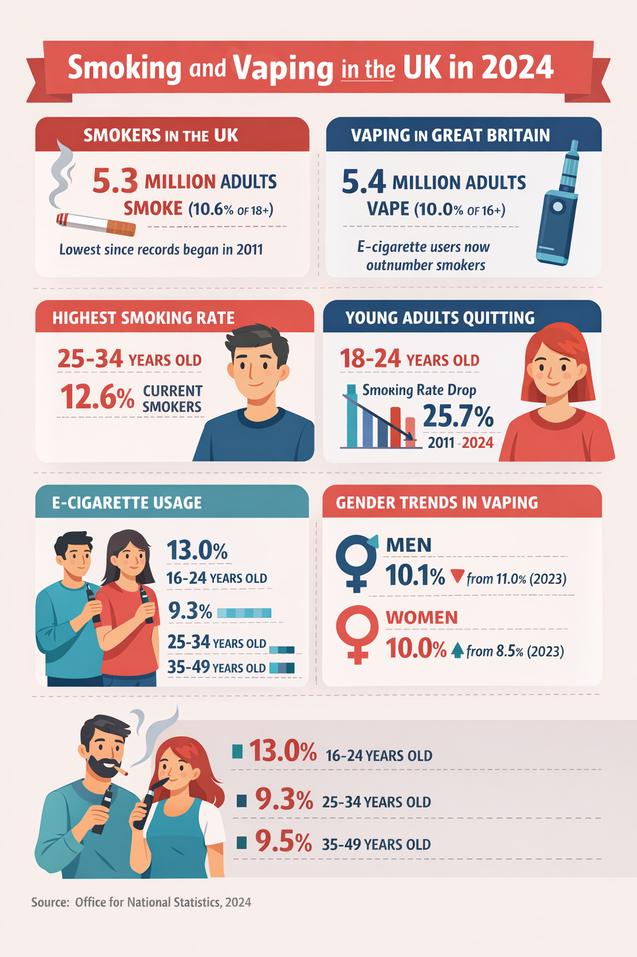

Digital Health and Smoking Cessation
Digital health promotion has emerged as a valuable tool for addressing behaviour-related public health challenges. Mobile apps and wearable technologies offer continuous, personalised support that can extend beyond clinic-based interventions (Whittaker, 2019).
Evidence suggests that digital cessation tools can increase quit attempts and engagement, particularly when grounded in behaviour change theory (Michie, 2017).
Wearable technologies are especially promising due to their ability to deliver real-time, passive support, reducing reliance on user-initiated action during moments of high craving (Nahum-Shani, 2018).
StopWatch: A Smartwatch-Based Smoking Cessation Tool
StopWatch is a smartwatch-based smoking cessation system developed by Bristol researcher Andy Skinner and behavioural technologist Chris Stone. Designed as both a wearable and app-based intervention, StopWatch delivers real-time prompts and biometric feedback directly to users’ wrists to support smoking cessation (Skinner and Stone, 2019).
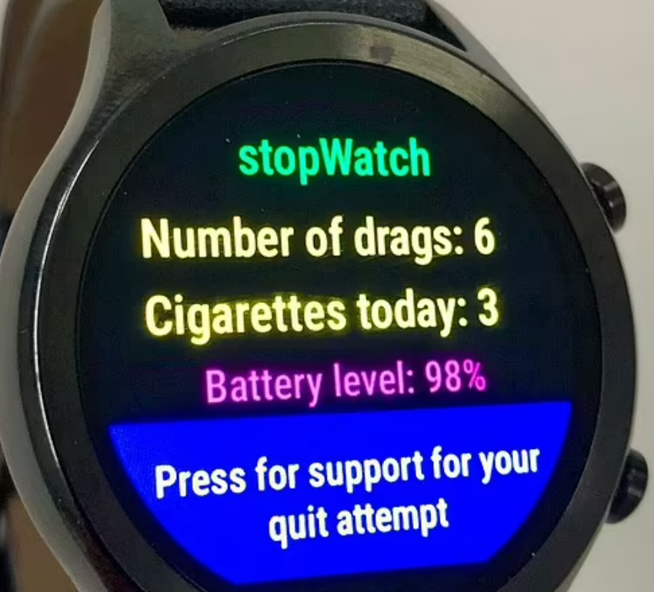
The system uses behaviour change techniques including self-monitoring, cue-prompting and goal setting, which are proven to support sustained behaviour change (Michie, 2017).
StopWatch tracks heart rate variability and stress indicators to predict craving episodes, delivering timely motivational messages and guided breathing exercises during high-risk moments (Skinner and Stone, 2019).
In real-world use, individuals benefit from features such as smoke-free streak tracking, money saved calculators and visual health improvements, which reinforce motivation through continuous positive feedback (Skinner and Stone, 2019).

Advantages and Limitations of StopWatch
Advantages of StopWatch include its hands-free delivery, real-time personalisation and ability to intervene during moments of vulnerability, supporting improved self-regulation (Nahum-Shani, 2018). Wearable-based interventions have been shown to strengthen adherence and engagement over time (Whittaker, 2019).
However, limitations remain. Digital exclusion poses a significant barrier for individuals without access to smartwatches or adequate digital literacy (NHS Digital, 2019).
Engagement may decline without regular content updates or integration with clinical support (Michie, 2017). Additionally, individuals with high nicotine dependence may require pharmacological support alongside behavioural interventions, which StopWatch alone cannot provide (NICE, 2019).

Conclusion
In conclusion, StopWatch represents a promising digital health intervention that embeds smoking cessation support into everyday life. Integrating StopWatch with NHS Stop Smoking Services could enhance equity, effectiveness and long-term outcomes by combining behavioural and pharmacological support while addressing digital exclusion (NICE, 2019).

REFERENCES:
Michie, S., Richardson, M., Johnston, M., Abraham, C., Francis, J., Hardeman, W. and Wood, C. (2013) ‘The behaviour change technique taxonomy (v1) of 93 hierarchically clustered techniques’, Annals of Behavioural Medicine, 46(1), pp. 81–95.Available at: DOI: 10.1007/s12160-013-9486-6.
Nahum-Shani I, Smith SN, Spring BJ, Collins LM, Witkiewitz K, Tewari A, Murphy SA. (2019) ‘Just-in-Time Adaptive Interventions (JITAIs) in Mobile Health: Key Components and Design Principles for Ongoing Health Behaviour Support. Ann Behav Med. 18;52(6):446-462.’ Available at: DOI: 10.1007/s12160-016-9830-8.
NHS. (2023) ‘Quit smoking.’ Available at: https://www.nhs.uk/better-health/quit-smoking. (Accessed: 20 January 2026).
NHS Digital. (2023) ‘Digital inclusion and health inequalities.’ Available at: https://digital.nhs.uk. (Accessed: 20 January 2026).
NICE. (2021) ‘Tobacco: preventing uptake, promoting quitting and treating dependence (NG209).’ London: NICE. Overview | Tobacco: preventing uptake, promoting quitting and treating dependence | Guidance | NICE. Accessed: 22 January 2026).
Office for Health Improvement and Disparities. (2022) ‘Health matters: smoking and tobacco.’ London: OHID. Smoking and tobacco: applying All Our Health - GOV.UK. Accessed: 25 January 2026).
Office for National Statistics. (2023) ‘Adult smoking habits in the UK.’ London: ONS. Available at: Search - Office for National Statistics. (Accessed: 25 January 2026).
OpenAI (2023) ‘DALL·E’ (AI image generation tool). Available at: https://openai.com/dall-e (Accessed: 29 January 2026).
Skinner, A. and Stone, C (2023). ‘StopWatch: A smartwatch‑based behavioural intervention for smoking cessation.’ Bristol: Digital Health Innovations. Available at: stopWatch – a smartwatch system that could help people quit smoking – IEUREKA!
Whittaker, R., McRobbie, H., Bullen, C., Rodgers, A. and Gu, Y. (2019) ‘Mobile phone-based interventions for smoking cessation’, Cochrane Database of Systematic Reviews, 10, CD006611. Available at: https://doi.org/10.1002/14651858.CD006611.pub5.

Blog 2:

RespireAir– A Novel Predictive Digital Intervention for Smoking Cessation

Why Smoking Still Requires New Digital Solutions


Smoking remains one of the leading causes of preventable death in the United Kingdom, responsible for over 76,000 deaths annually and substantial long-term morbidity (Office for Health Improvement and Disparities, 2022).

Tobacco use is strongly associated with lung cancer, cardiovascular disease and chronic respiratory illness, placing

(Getty.com, 2024)

sustained pressure on NHS services and widening health inequalities (Office for Health Improvement and Disparities, 2022).

Despite decades of public health campaigns, 12.9% of adults in England continue to smoke, with prevalence disproportionately higher among socio-economically disadvantaged groups (Office for National Statistics, 2023). Smoking-related illness reduces life expectancy, increases hospital admissions and contributes to financial and social harm, reinforcing the need for innovative, preventative cessation strategies that intervene before relapse occurs (ONS, 2023).

RespireAir- A Novel Digital Health Intervention

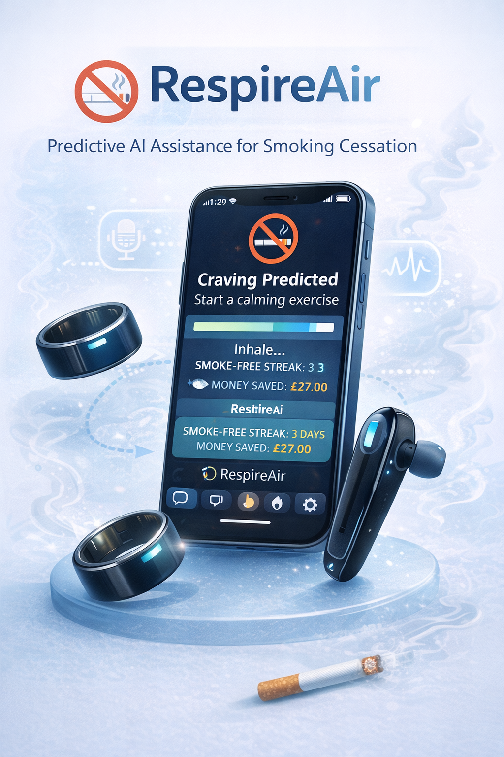
RespireAir, is a newly designed digital health intervention created to support smoking cessation through predictive AI-driven breath pattern detection. Unlike existing cessation tools, RespireAir combines a mobile app, smartphone processing, and a wearable ring or band that continuously monitors respiratory and stress-related signals.

Research indicates that nicotine cravings are preceded by measurable physiological changes, including altered breathing rhythms and stress responses (Nahum-Shani, 2018).

RespireAir applies machine-learning algorithms to breathing data captured by the wearable sensor and smartphone microphone, allowing the system to predict craving risk before the user consciously experiences the urge to smoke (Michie et al., 2017). This preventative approach distinguishes RespireAir from reactive, self-report-based cessation apps (Whittaker, 2019).

How RespireAir Supports Smoking Cessation

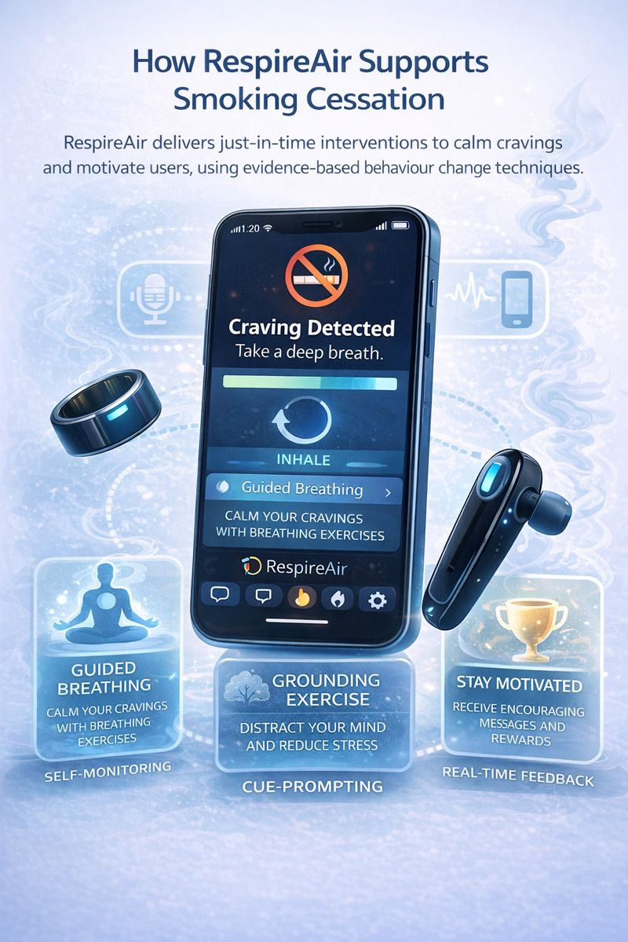
RespireAir incorporates evidence-based behaviour change techniques, including self-monitoring, cue-prompting and real-time feedback (Michie, 2017). When craving-related breathing patterns are detected, the app delivers just-in-time adaptive interventions, such as guided breathing exercises, grounding techniques and motivational prompts (Whittaker, 2019).

These interventions align with evidence showing that timely digital prompts can strengthen self-regulation during high-risk moments for relapse (Whittaker, 2019).

The app also displays smoke-free streaks, financial savings and projected health improvements, reinforcing motivation through continuous positive feedback (Skinner and Stone, 2023). Optional language selection enhances accessibility for diverse user groups.

Advantages, Limitations and Mitigation Strategies

A key advantage of RespireAir is its hybrid smartphone and wearable design, increasing accessibility for users who may not own smartwatches, a common barrier in digital cessation tools (NHS Digital, 2023).

Its passive monitoring system reduces user burden, supporting sustained engagement, which is associated with improved outcomes in digital health interventions (Whittaker et al., 2019).

However, breath detection accuracy may be affected by environmental noise or physical activity, potentially reducing reliability (Michie, 2017).

This limitation can be addressed through sensor prioritisation, where the wearable ring’s respiratory data is weighted more heavily than microphone input in noisy environments, improving prediction accuracy (Nahum and Shani, 2018).

Engagement may also decline without human support, a recognised challenge in digital behaviour-change interventions (Michie, 2017).

To address these shortfalls, RespireAir could integrate with NHS Stop Smoking Services, offering combined behavioural and pharmacological support for individuals with higher nicotine dependence (NICE, 2021).

Optional live chat with trained advisors and regular culturally tailored content updates would further enhance equity, engagement and long-term effectiveness (NHS Digital, 2023).

Conclusion

RespireAir represents a novel, preventative digital smoking cessation intervention that moves beyond existing market solutions by predicting cravings before relapse occurs. By integrating AI-driven physiological monitoring with evidence-based behavioural support, RespireAir has strong potential to enhance smoking cessation outcomes when embedded within existing public health services.

REFERENCES:
Getty Images (2025) ‘People smoking cigarettes. Available at: https://www.gettyimages.com.au/photos/people-smoking-cigarettes. (Accessed: 29 January 2026).
Michie, S., Richardson, M., Johnston, M., Abraham, C., Francis, J., Hardeman, W. and Wood, C. (2013) ‘The behaviour change technique taxonomy (v1) of 93 hierarchically clustered techniques’, Annals of Behavioural Medicine, 46(1), pp. 81–95.Available at: DOI: 10.1007/s12160-013-9486-6.
Nahum-Shani I, Smith SN, Spring BJ, Collins LM, Witkiewitz K, Tewari A, Murphy SA. (2019) ‘Just-in-Time Adaptive Interventions (JITAIs) in Mobile Health: Key Components and Design Principles for Ongoing Health Behaviour Support. Ann Behav Med. 18;52(6):446-462.’ Available at: DOI: 10.1007/s12160-016-9830-8.
NHS. (2023) ‘Quit smoking.’ Available at: https://www.nhs.uk/better-health/quit-smoking. (Accessed: 20 January 2026).
NHS Digital. (2023) ‘Digital inclusion and health inequalities.’ Available at: https://digital.nhs.uk. (Accessed: 20 January 2026).
NICE. (2021) ‘Tobacco: preventing uptake, promoting quitting and treating dependence (NG209).’ London: NICE. Overview | Tobacco: preventing uptake, promoting quitting and treating dependence | Guidance | NICE. Accessed: 22 January 2026).
Office for Health Improvement and Disparities. (2022) ‘Health matters: smoking and tobacco.’ London: OHID. Smoking and tobacco: applying All Our Health - GOV.UK. Accessed: 25 January 2026).
Office for National Statistics. (2023) ‘Adult smoking habits in the UK.’ London: ONS. Available at: Search - Office for National Statistics. (Accessed: 25 January 2026).
OpenAI (2023) ‘DALL·E’ (AI image generation tool). Available at: https://openai.com/dall-e (Accessed: 29 January 2026).
Skinner, A. and Stone, C (2023). ‘StopWatch: A smartwatch‑based behavioural intervention for smoking cessation.’ Bristol: Digital Health Innovations. Available at: stopWatch – a smartwatch system that could help people quit smoking – IEUREKA!
Whittaker, R., McRobbie, H., Bullen, C., Rodgers, A. and Gu, Y. (2019) ‘Mobile phone-based interventions for smoking cessation’, Cochrane Database of Systematic Reviews, 10, CD006611. Available at: https://doi.org/10.1002/14651858.CD006611.pub5.

