The eco-bricks project- Reflective report

At the start of this academic year we were given this assignment on eco-bricks. We were to design a shelter out of the bricks that would potentially be displayed in the Waterfront Museum. Group projects have never been my forte; despite this I knew in order to succeed I would need to put myself out of my comfort zone.
Once we were in our groups we immediately started sketching anything that came to mind following the brief. Initial ideas and thoughts are often key in the design process as those ideas can be developed further. Personally I had to look online for more information about the eco-bricks. I wanted to find out exactly how they were made and I looked at other examples of how they could be put together to form a structure.
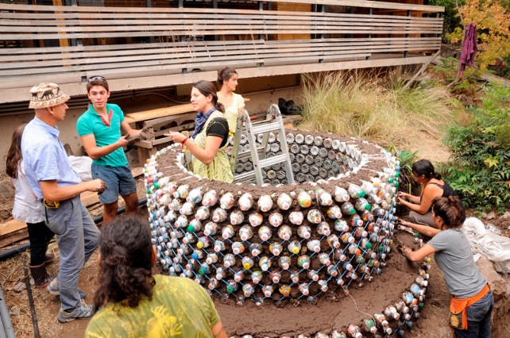
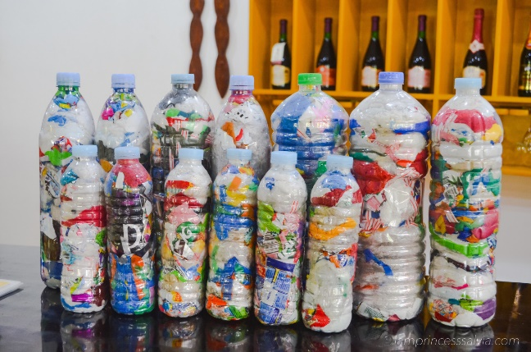

Eco-bricks Flowerpot made from eco-bricks
Others in the group seemed to be able to think of designs immediately and they started to collaborate and discuss different options. I’ve discovered that I often need to find out the technical aspects of things before I can be creative with it. Coming from doing an engineering degree, I focus on how things can be put together rather than how it could look. The initial agreed upon concept for our group was to build a shelter in the form of a wave. We thought that it was important to incorporate the theme of the sea into the shelter as plastics in the ocean are a massive threat to the environment right now. We thought that the eco-bricks in the shape of a wave could help to convey this message and its importance for the present and future. Following this initial design we had to figure out how the bottles would be joined together in order to make the wave shape. To do this we experimented with smaller 500ml bottles and items we found in the workshop. We decided on having the bottles lay horizontally with the caps being locked into a support piece of plywood or cardboard; with string being wrapped around the bottles to provide extra strength between them. This allowed us to form the bottles into a wave without having to jeopardise space within the shelter. Personally I would say that this was the hardest part of the whole process, especially considering none of us had worked with a material like plastic bottles before as the main building block. To finalise our original idea we made sure to calculate measurements based on our limits set in the brief and the size of the eco-bricks. A few sessions in, we realised that our original concept needed some adjustments to make the shelter a comfortable and dry place for someone to use. After discussing a few options we decided that we needed to close off the front part of the structure and create walls either side with a door on one side; still keeping the curve of the wave from the original idea. We decided to do this as we realised our idea wouldn’t provide much protection from the elements. With the addition of surrounding walls and a door it means the person using it would have some extra warmth and shelter from wind and rain. Stability and durability will also be improved this way. To prevent the structure being exposed to damp floors, we thought it would be best to put the shelter on top of wooden pallets. With the measurements we had set it also meant that the pallets would provide a small porch area, creating a homely feel. We made a small scale model of the new design and we all agreed that it fit the idea of a shelter much better than our previous model.
Between us we next had to present our ideas to the people from the eco-bricks project at the museum. When it came to presenting our proposal our group all spoke clearly and confidently. Speaking about something that you have designed from scratch is much easier than presenting ideas that are not yours. I usually get nervous when presenting but I felt calm and comfortable, the depth in our work allowed me to present confidently and concisely. We were given lots of constructive feedback that we actually found really useful and we made some changes to incorporate them into our design. They discussed being able to have multiple of the shelters and joining them together to make little communities, it would make the areas more sociable and safer.
Feedback was then given to the groups and our groups design unfortunately was not the favourite. This was slightly disheartening however not a surprise as I had a chance to look at the other groups work and their ideas were brilliant. With a design project like this it’s always amazing to see the different concepts people come up with all using the same materials and having the same brief. To create the final sculpture for the museum a mix of a few of the shelters was made, taking the best parts from each to create an eco-brick tower with a ball sculpture on top. The construction process for this would often take place after the lecture. I had other engagements most of the time so I was not as involved with the making of the sculpture as I would’ve like to have been. It was fulfilling to see the final product knowing that all of our ideas were a part of it in some way. As this was my first group project for the course I was hesitant to put forward my ideas, though after a few lectures I got along with my group members more and more and became comfortable enough to suggest and make changes. Before the project I never knew what an eco-brick was and I was surprised to learn about its uses in construction. I also enjoyed trying to build and create with an entirely new material. It was challenging but I think it was extremely beneficial to do this in the first project as it pushed everyone to think outside the box.

Bibliography-

Eco bricks: How to Turn Plastic Pollution into a Plastic Solution. (2018). [image] Available at: https://iamprincesssalvia.com/2018/05/11/eco-bricks-how-to-turn-plastic-pollution-into-a-plastic-solution/ [Accessed 8 Dec. 2019].

Turning plastic into eco-bricks. (2019). [image] Available at: https://ccsbestpractice.org.uk/entries/turning-plastic-into-eco-bricks/ [Accessed 8 Dec. 2019]

https://iamprincesssalvia.com/2018/05/11/eco-bricks-how-to-turn-plastic-pollution-into-a-plastic-solution/
https://ccsbestpractice.org.uk/entries/turning-plastic-into-eco-bricks/

