Problem Solving and Decision Making
Module code BSMK4004

SUDENT NAME | Vanessa Nair Lima
STUDENT NUMBER | 1811815
TUTOR NAME | Azfl Mannua

Contents
Introduction 3
What does it mean shortness of staff? 4
How to overcome this problem? 5
My experience in a short-staffed team 5
Seven Steps to problem solving 6
Types of Decision 7
Factors affecting decision making 8
Ingredients of good Decision making 9
PMI 9
SWOT Analysis 10
Cause and Effect Analysis - Fishbone analysis 11
Fishbone analysis for Shortage of Staff 13
Proposal Solution 1 14
Proposal solution 2 14
Evaluation of the proposed solutions 15
Implementation plan of the Chosen Proposal 15
Monitor and Review of Implementation plan 15
Conclusion 17
References 18

Introduction
The workplace is in harmony when the team is complete, and everyone works in synchrony. When the number of staff affect the dynamic of the team it means that the team is short.
In this assignment I will be talking about the shortage of staff in the workplace, exploring the advantages and disadvantages of this problem. I will provide evidence of this problem within my current job. I will explore ways to overcome these issues, with theoretical proposals for problem solving. I will evaluate types of decision making following the factors that contribute for a decision to be made and the ingredients of good decision making. I will analyse the problem using the Fishbone Analysis in order to find the root of the problem. I will propose two solutions, that will be evaluated in order to solve the problem. At the end, after choosing the best solution proposal, I will implement it and monitor its progress in order to review the outcome of the implementation.

What does it mean shortness of staff?
Shortage, by dictionary definition, is “a situation in which there is not enough of something” (Cambridge Dictionary website, 2019). In the retail workplace shortage is an issue that affects the team and work environment. Firstly, the rotas suffer a change requesting overtime from staff members in order to the cover the working hours. In consequence the staff becomes overworked leading to dissatisfaction. This contributes to a volatile environment; employees begin to desire quitting the job. An article written for International Journal in Retail & Distribution management (2007) retailers from Lincolnshire that participated in the study stated, “Youngsters believe it is beneath them to work in a shop”, showing how young staff view the workplace, just a temporary situation. However, in the same study, another retailer from Northamtonshire admits that the motives for unhappiness at work lays on “7-day week, boring, long hours, hard demanding work”, this exposes that issues that lead people to leave retail.
Nevertheless, retail employers reveal that the lack of staff is also affected by skill gaps, and one of retail first skills is customer service, the ability to customer handling through a basic communications skill. For example, a new sales assistant training always begins with greeting and engage in conversation with the customer before or while making a transaction.
To reinforce this problem, the same article in International of Retail & Distribution Management (2007) defends that retail offering part time hours when people are looking for a full time contract hours created a disinterest in the working in this sector, quote “…retail bias towards part-time and shift works (NESS, 2013) and often a lack of regular stable working pattern which are not as attractive as full-time jobs to many …employees”. This shows people’s disinterest in working in retail. Despite this fact, the same article mentions that retails offer a good pay ang good conditions, which increases the attractiveness for the job, however, when hiring part-time staff, the company opted for students as they are willing to work for short hours and have a lower cost on the budgets. This employees if not temporary by their contract, are destined to leave retail to pursue the job that they studied for. Their mentality is focus on the pay, consequently affects the quality of their job. As predicted on the article in (2007) “ forecasts predicting a moderate rate of growth of 2.5 per cent per annum for retail(Wilson et al., 2003). Despite an increasing demand for labour, staff turnover in retail is high at around 43 per cent, around twice the average of other sectors (DfES, 2002)” this clarifies that the interest is there however employee dissatisfaction causes the shortage of staff.

How to overcome this problem?

The resolution of problems is made through the Problem Solving and Decision-making skills. These skills are necessary when problems arise and in order to move forward it needs a rightful resolution.
Problem is a present unsatisfactory state that needs to be change to satisfactory state as soon as possible. Therefore, a problem is preventing the achievement of objectives. And to resolve a problem we need to investigate it, as the solution is hidden within the problem.
There are different types of problem that affects the different job sectors in our society, to resolve the challenges that may arise we need the ability to make decisions that will help us overcome a problem.
The mind of a problem solver should consider the following factors: not letting a problem linger for long, practice fairness ( when addressing an issue, address the entire team instead of just one individual) and large global terms do not help conceive solutions for a problem, and practice justice by punishing the crime.

My experience in a short-staffed team

I work for a British Accessories brand with multiple stores not only across the kingdom but also spread around the globe where I started working before becoming a student, I had two more jobs aside from working for one of the brands ‘s store. Starting up, I had a part-time contract of 12hours, I demonstrated availability to work extra hours, showing my commitment, that quickly led me to a full time contract a few months later until progress to supervisor. My growth was fast because the company was it was affected by this same problem. I quickly noticed that people, were not committed to work because their priority was always related to their studies, they did not take the job seriously with the excuse that the job was temporally. On the other side, I also noticed the managers behaviour regarding making rotas, even though, their job is to make sure all the opening hours need to have enough staff on the shop floor, people were being put to work for extra hours without being asked if they were available on those dates, and for most of them their priorities came first.
In this company, the procedure for each store in situations when staff calls-in sick and is not found the store’s hired employees to do that shift, they must request for help from stores from the same area. This summer occurred this situation in my store, I saw myself calling more than 15 stores in the Central London area requesting for cover, and no one was able to help. I end up staying after my shift was over. The reason this time, falls into management authorizing more than one holiday request for the same week, causing holidays to overlapped leaving the teams short in staff for that period complicating for situations like sick calls.

Seven Steps to problem solving

Problem solving involves a systematic process that helps resolve any issue making sure it does not resurface again. According to Dr Shiba (1991), problem solving is process for a continuous improvement.
Starting up with Definition, it questions the problem by asking, what is the real problem”. If there is no answer for the question there is not a possibility to go further, not being able to find the proper solution.
Data collection is the second step, in this process we should find the answers to what is happening. It is about collecting the details of what is affecting the problem.
The third step, Cause Analysis, answers the question why by using the data collection. Is the process that analysis the data to find the reason for the existence of the problem.
Once identified the reason, the next step is Solution Planning and Implementation, with a clear visualization of the reason the solution should also be clear, however is a process that takes time. The implementation should be done for some time in order to have clear results.
The process that follows is Evaluation of Effects, in which it answers the question is it working. It monitors and investigates the results of the solution after being implemented.
After investigating the results of the implementation and the results have a good, to next step is standardization, where the new solution is successful implemented to avoid the same problem to rise again.
The seventh, and last step is to do and Evaluation of the Process, which is seen the effects of the solution in the long term.

Types of Decision

Management are faced with these three main types of decision, Routine Decision, Adaptive Decision and Innovative.
The decisions that follow a standardized procedure created for daily operational decisions made on a regular basis, Routine decisions, can be made at the lower level of management. This process requires little research and time, made when the problem is already well defined and common. This decision stablishes rules, practice and procedures to solve the problem.
In case of me running out of Reconciliation form to write down the daily cash intake of the store, there is two automatic actions to take, ask another store to send someone with spare ones and order new forms.
With the Adaptive Decision the process is more rational, involving methodical, systematic, unimpulsive and independent actions. Considered a rational, it requires time investment to gather information the best helps the decision process in order to find the alternative that matches the problem’s unique characteristics.
In case of the situation when someone calls in sick at my store, my next action is to find cover for the person’s shift, and that requires calling every store from the same area with the request for a sales assistant that would accept coming the my store. It can time a long time if there is no answers from any store.
Lastly, Innovative Decision is the one made thought creative decisions when the problems are unusual and unclear. Meaning that when the problem is complex it will require a out of the box solution.

Factors affecting decision making

“Managers have to take into account a wider range of consequences…”, wrote John Adair in1985.
When face with a problem, managers have an automatic feeling of discomfort that can lead to stress over it, and even for a short time can be affected by it. We all see the world differently, and our input in resolving a problem is affected by our interpersonal conflict, leading to the amount of energy we devote to find the solution, our self-concept tends to interfere with the process of decision making, and most of the times specific problems require experience and knowledge about the field in line to succeed in finding the appropriate solutions, because the critical nature of the job demands for it, and it does not relate to our personal opinion. A problem such as electricity failure, affecting my store, I need external help, the inability to turn on the lights will cost the company’s trading time and money. In this situation, the electricians should be instructed to come as soon as possible, and while waiting for their arrival I should write a guideline of things to be done before and after they come in.
For any risky decision associated with electricity, it is important to evaluate the critical nature of work. When electricity fails for the first time, is a non-routine situation, however if it becomes a regular event, it turns into a routine.
The situation my call for a creative decision, therefore it falls in the electrician’s management the ability to send someone who can come up with a new solution when the solution is not so straight forward, in other words, someone with creative thinking, where the experiences and knowledge are taking in consideration to generate innovative solution, that stands by because depends on the degree of acceptance of decision and support.

Ingredients of good Decision making

The process of decision making requires stages, that according to a number of business manager from John Adair book, Effective Decision Making (1985), there is a general agreement on five main stages of decision making, called the Five-point plan.
The starting point begins with defining the objective, where we select the most important factors, this reveals the need for a decision.
The second step, collect information, it involves the research process of data, facts and opinions, that later are organized and in order to determine the causes of a problem by evaluating the relative importance of different options.
The third step, develop options, consists in generating idea in order to imagine possible plans of actions.
In the fourth step, evaluating and decide, the pros and cons are weighted to select the best decision.
The fifth step, implement, the decision will be executed and should be monitored and reviewed in order to verify the results of the implemented decision.
However, how do we get to the decision?
Some problems are more complex than others and not always the solutions can be found in a book. Therefore, there are a few tools used for decision making that helps the process, such as PMI, SWOT and Fishbone Analysis.

PMI

PMI (plus, minus, interesting), developed by Dr Edward Bono (1973), is a tool that organisations can use, responsible for critical thinking, brainstorming, and decision making. Its use exhilarates the examination of ideas, concepts and experiences from multiple perspectives. This tool stimulates critical thinking, allowing strategy thinking in leading consideration of multiple approaches to a problem.
The strategy PMI uses helps identify strengths and weaknesses, reflect upon the benefits and consequences of a certain action or behaviour, and the decision is made faster by analysing the pros and cons.
It helps the process the use of a table to guide the future decision. The benefits of it is to weights the pros and cons of the course of action of a decision. Writing inside each column, accordingly, all the positive, negative and interesting factors to clarify all the concerns, and in case of the decision still seem unclear, scoring each factor, it shows the level of importance of each, helping with the decision process.
What is good  + | What is bad  - | What is interesting  ?
Staff availability | At least one sick call a day | All staff members arrive late
Figure contains just an example of factors that relates to the problem chosen this assignment.

SWOT Analysis
Created in 1965 by four professors at the Harvard University, Edmund Philip Learned (1900-1991), Roland Chris Christensen (1919-1999), Kenneth Richmond Andrews (1916-2005) and William D. Guth. This tool has been used in decision-making to help diagnose and improve strategic plans for individual and organisations involving both on project planning or business competition that rapid identifies internal factors connected to internal functioning and external factors that are present on the environment in which they are involved. The word SWOT is an acronym that translates to Strengths, Weaknesses, Opportunities and Threats.
The SWOT method considers that the external factors of an organisation, element an organisation does not have control over, not possible to influence the organization even though it is linked to the environment. Opposite to external, the internal factors, are elements that can be influenced or altered by an organization.
Internal Factors
Strengths evidently are internal factors that reinforces the qualities of an individual or organisation.
Weaknesses is the contrary, where the components undermine the competitive position of the organisation or individual.
External Factors
Opportunities, this factor has the power to positively influence the individual or organisation.
While, Threats is the opposite, as external factors that negatively affects the individual or organisation.
The following table shows the relation between positive and negative factors with the internal and external.
 | Internal Factors | External Factors
P  O  S  I  T  I  V  E  N  E  G  A  T  I  V  E | Strengths | Opportunities
P  O  S  I  T  I  V  E  N  E  G  A  T  I  V  E | Organised | Creative
P  O  S  I  T  I  V  E  N  E  G  A  T  I  V  E | Weaknesses | Threats
P  O  S  I  T  I  V  E  N  E  G  A  T  I  V  E | Talkative | procrastinator
Figure: made for the assignment.
The simplicity of its design allows its use to be uncomplicated and the results can effortlessly be communicated to the public.

Cause and Effect Analysis - Fishbone analysis

Known as the Root Cause or Cause and effect analysis, this tool is used in problem solving, as it offers a practical exercise that guide us to the root of a problem. Its diagrams are designed to stimulate thinking during a brainstorm, as the structure helps understand the relationship between multiple possible causes for the existence of a problem. Its framework allows planning what data to collect and the diagram also serves as visual display of causes that have been studied, helping the team to communicate within the group and the rest of the organisation.
Created in by Dr Kaoru Ishikawa, this tool strongly defends that beneath every problem is hidden its cause. Fishbone analysis approach is to identify the cause (or causes) and eliminated it in order to prevent it from resurfacing. This tool leads us to the reasons why an event happens (cause) and the results of something happening (effect). For instance, the train was delayed for one hour and I arrived late to work. The cause of the event is the train delay.
However, some problems may have more than one cause, and when using this tool, we begin to understand the complexity of the problem and dipper roots of its origin.
How to create the fishbone?
First, identify the problem by considering in detail who is involved, where and when it occurs. The problem, head of the ‘fish’, is written in a box with an arrow pointing toward it.
Second step is identifying the major components that affects the organisation in main categories that includes: equipment, people, environment and procedures, underneath each is written potential causes for the problem.
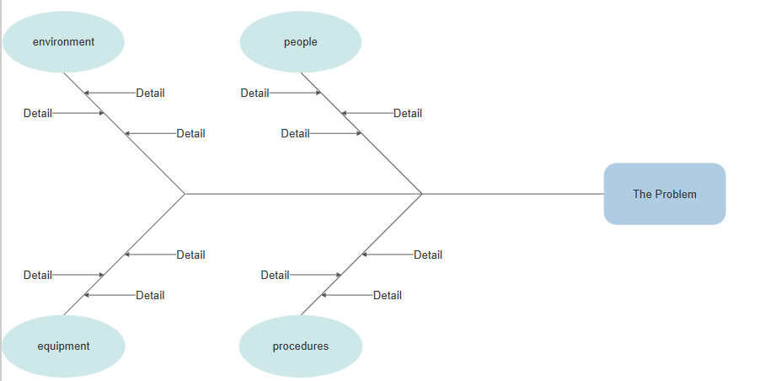
Figure from SmartDraw.
Third, use the ‘detail’ branches of the spine to write possible causes affecting each category.
The last stage is to analyse the diagram in order to investigate the causes, by using processes such as interview, surveys to help explain if the causes identified match the reality of the organisation.

Fishbone analysis for Shortage of Staff

To analyse my problem I have chosen, the fishbone analysis.
The diagram of the problem shows the causes related to this problem according to my workplace.
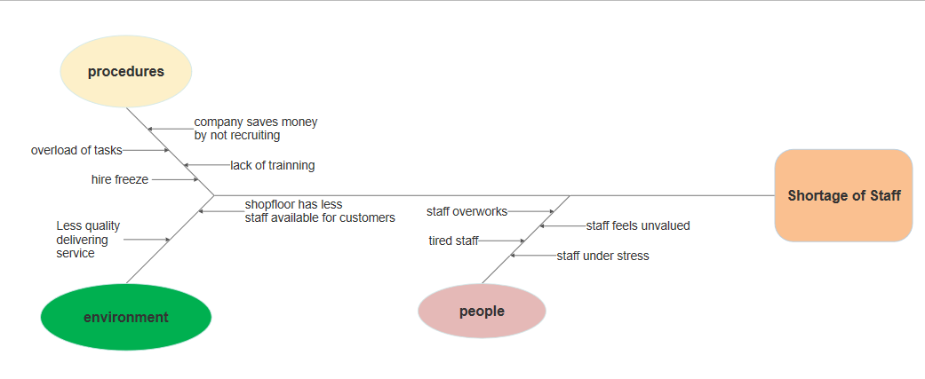
Figure made on SmartDraw.
This diagram identifies the reasons that lead to Shortage of staff. The problem reflects on different categories showing how the staff has been affected. This problem extends to distressing people, methods and environment, leaving The equipment out of the diagram.
Category 1:
People - the lack of extra hands leads the remaining employees to have an overload of work which consequently leaves them tired, feeling unappreciated and causing stress.
Category 2:
Environmental- the effects of the problem causes the shop floor to be affected by reflecting on the customer service less quality of service as the shop floor no longer has an assigned staff member to just do customer service, and with the overload of task affects the behaviour of the staff when delivering service. They no longer have the same energy to offer, leaving the environment of the store with a lower quality of service.
Category 3:
Procedures - affect the staff as the saves money by not hiring new employees and not investing on the remaining members. They overload the members with tasks they have not been trained for. The staff feels obligated to do overtime to compensate for the lack of staff and the amount of task to be made. The company freezing hiring leaves managements under stress.

Proposal Solution 1

The first solution that jumps straight into the mind is to consider hiring new staff. They can fill up the hours that present staff have been doing as overtime, as part time employees. This is a type of decision that fits the mould of routine decision, in consequence of being a procedure that is stablished for a problem of this kind.

Proposal solution 2

Considering that the existing employees are already doing extra hours, a solution that could possibly work in this situation is to increase their contract hours, although not to full time, but with a higher hour contract they have. This is an adaptive decision type; this solution is partially understood because is a decision that can not always work for every time this problem arises.

Evaluation of the proposed solutions
The following table includes the advantages and disadvantages of both proposed solution 1 and 2.
 | Solution 1 | Solution 2
Advantages | - team no longer short  - no more task overload  - rise in productivity | - reliable employees  - no hiring cost  - recognition of staff  - hourly wage do not change  - no training cost
Disadvantages | - Unsatisfaction of old staff members that will loose overtime hours  - Unreliable new staff  - Additional cost  - Training cost | - Salary will have to be payed even if is low period  - Legal payroll paperwork  - More holidays

Implementation plan of the Chosen Proposal
Proposal solution 2 is a better decision in this situation. The increase of contract hours of existing employees saves the company money and leaves the staff satisfied with their new condition, allowing them to stay in the company. The company investing in their staff is a lower expense comparing to adjusting new staff.
To implement this proposal, it is important the existence of an agreement between employer and employee, where the employee is asked about they preferred contract hours according to what is available. For the plan to be effective employees should be updated about the changes and the reasons for the change in their contract, the employer should listen to their opinions, as they may introduce alternative ideas. Employees should receive through writing their terms and conditions which includes their rights on sick leave and holidays, this also includes any changes on the collective agreement. The new contract should clarify flexibility clauses and disciplinary measures that may affect the employee.

Monitor and Review of Implementation plan

Although the productivity level does not increase as the workload is the same for the same number of people still leaving the staff feeling overloaded, however, the store staff satisfaction with the new contract hours improved their work disposition, and the dispute for extra hours has reduced.
Not being able to give a full time contract the staff still do overtime, nevertheless they get more hours of holidays paid.

Conclusion
The chosen solution is the decision type which involves methodical, and unimpulsive process that requires information gathering that best helps the company to resolve the problem, with a decision that best benefits both employer and employee to maintain the structure of the business moving forward.
Although the advantages of the solution 1 are strong, the additional cost of having to hire weight more in the deliberation of the decision, as staff not only cost to hire but their loyalty to the business is short-lived, with the company risking them quitting after a short time period. Having employees that a company can count on is stronger advantage, as they are less likely to quit. When offer the right conditions the employee will be reliable.
The solution chosen came down to costs, with the company freezing new hire, the choice became obvious, however in the future new hires will be necessary.

References
Lawton, C. (2015) How job and skill shortages affect the UK BBC News UK (online article) accessed by 12 of December 2019 https://www.bbc.co.uk/news/business-34297368
Hart, C. et al., (2007) Employers perceptions of skills gaps in retail: issues and implications for UK retailers Emerald Group Publishing Limited, vol. 35 No. 4, 2007 accessed by 12 December 2019 https://www.researchgate.net/publication/40499172_Employer_perceptions_of_skills_gaps_in_retail_Issues_and_implications_for_UK_retailers
Cambridge Dictionary (2019) Definition of shortage (Online) Cambridge Advanced Learner’s Dictionary & thesaurus, Cambridge University Press, accessed by 25 November 2019 https://dictionary.cambridge.org/dictionary/english/shortage
Klein, G., (2009) Streetlights ang Shadows: Searching for the keys to Adaptive Decision Making, A Bradford book, The MIT Press, Cambridge, Massachusetts, pp115-120
Phillips S.D., (1997) Toward an Expanded Definition of Adaptive Decision Making, Department of Counselling, University of Albany, vol.45 pp 275-287
https://onlinelibrary.wiley.com/doi/abs/10.1002/j.2161-0045.1997.tb00471.x
Anderson, B., Fagerthaug, T. (2006) Root Cause Analysis: Simplified Tools and Techniques, ASQ Quality Press, 2nd edition
Adair, J. (1985) Effective Decision Making, Pan Books, London and Sydney, pp 1-7
Pete, B. M. and Fogarty R. J. (2010) From the Staff to the Classroom II: The One-Minute Professional Development Planner, Sage Ltd., United States of America, pp 38
SmartDraw, Cause and Effect Smart Draw (Online) accessed by 5th of January 2020 https://cloud.smartdraw.com/editor.aspx?templateId=f87478f5-06e9-49e0-8c49-94b566d09f1f&flags=128#depoId=17472302&credID=-28669435
Seth, C., Translated by Probert, C. (2015) The SWOT Analysis: A key tool for developing your business strategy, Lemaitre Publishing, Belgium, pp 5-9
Gov, (2019) Changing an employment contract, Crown copyright accessed on 2nd of January 2020 https://www.gov.uk/your-employment-contract-how-it-can-be-changed
BNETvideo, (2011) video: 7 Step Problem Solving, CBSNEWS, United States of America accessed by 5th of December 2019 https://www.youtube.com/watch?v=bZXDGQSuF9I
Human Resources Specialist, (2015) Pros and Cons of hiring Contractors Vs Full-Time Employees, accessed by 5th of January 2020 http://www.employeesonly.net/pros-and-cons-of-hiring-full-time-employees-vs-contractors/

