Powertrain Technology
Powertrain Design and Efficiency

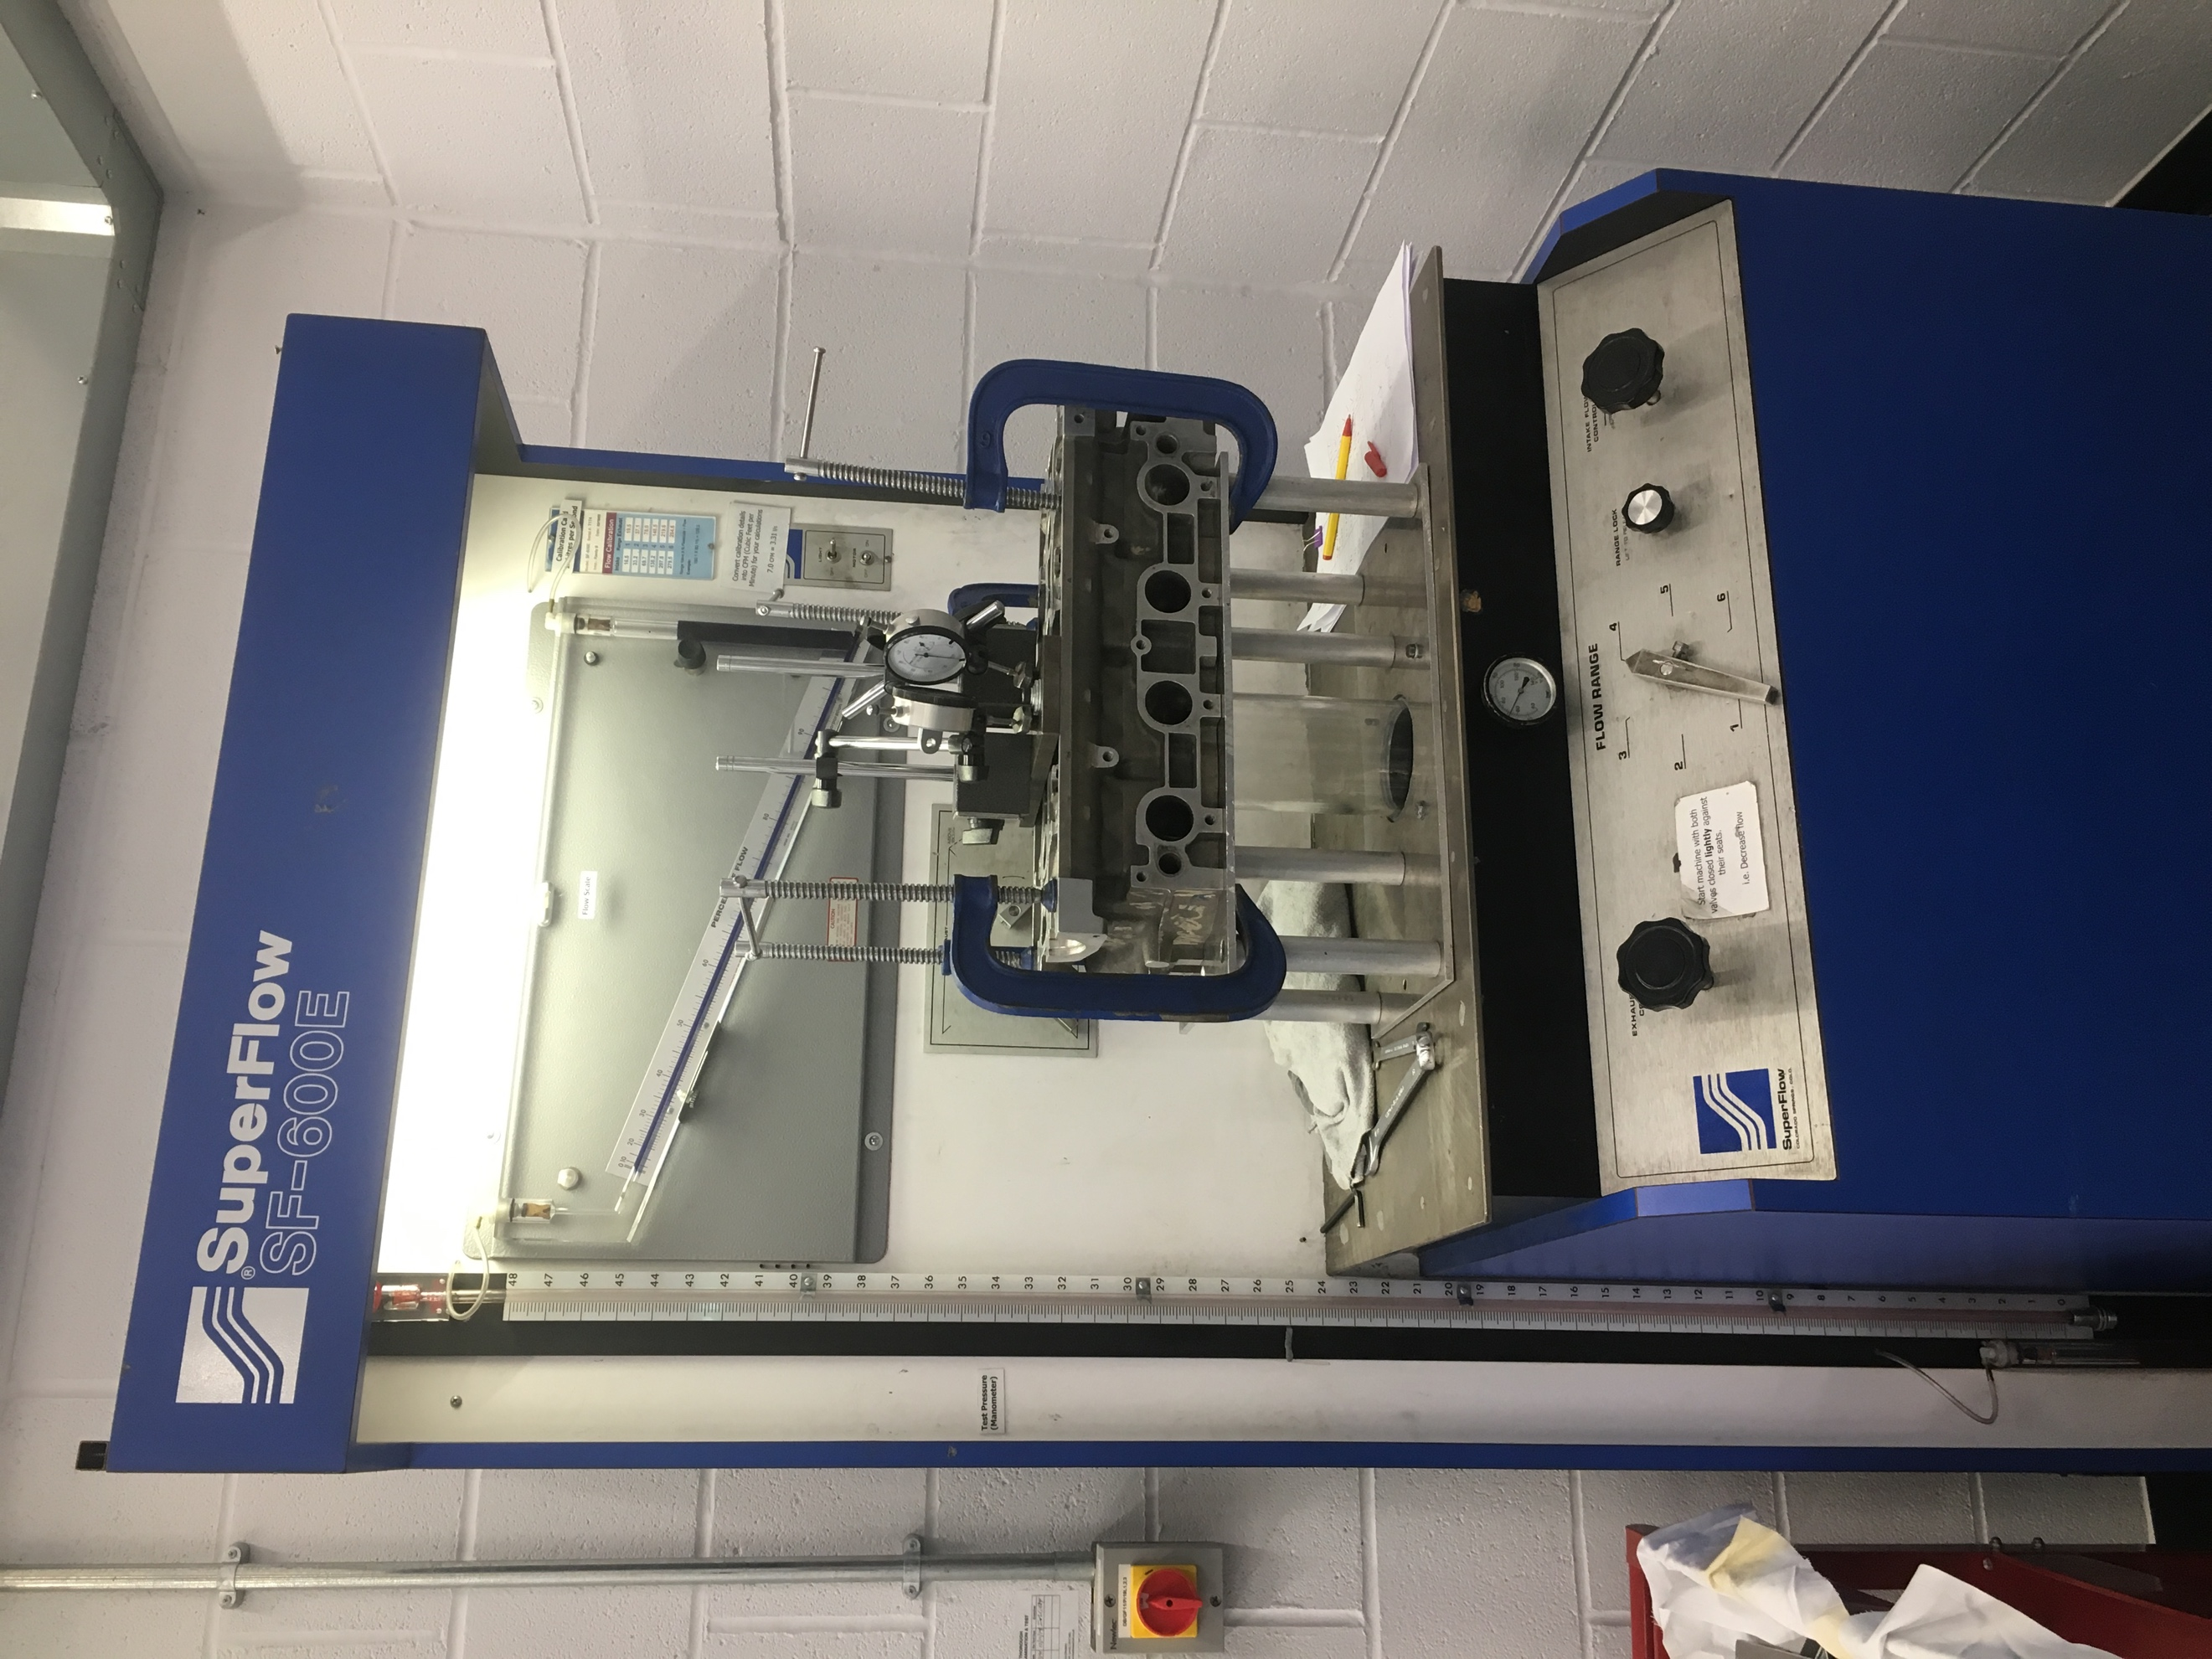

Deion Atkinson
ID NO: 1703067

Table of Contents
Introduction 3
Methodology 4
Test Results 6
Standard Cylinder Head 6
Modified Cylinder Head 7
Analysis 8
VFR Graph 8
Flow Velocity 10
Co-efficient of Discharge 12
Comparison of Injection Systems 14
Conclusion 16
Bibliography 17
Appendices 18
1.A Volumetric Flow Rate 18
1.B Flow Velocity 19
1.C Co-efficient of Discharge 20

Introduction

Engines are big air pumps that create power when mixed with fuel and ignited, this is why the cylinder head plays one of the most important parts of a good working engine. One of the first things to look at when designing or building an engine is the cylinder head, this is because the most important element of a powerful/efficient engine is the air intake and exhaust.

Using the flow bench in the workshop, one standard untouched cylinder head and a modified head which has been ported will be tested at the same amount of water which is 25”. This will give a good understanding of how both heads behave under different amounts of valve lift. To be able to compare both heads graphs of the volumetric flow rate, flow velocity and co-efficient of discharge will be plotted along with tables showing the values for the above. Analysis of the results will be done to have a good understanding of the benefits of porting a head on both the intake and exhaust side, this will provide an understanding of what the differences are between both heads and why those differences occur.

Having a good cylinder head isn’t the only thing needed for improvements, this is why different fueling systems will be discussed along with how they are implied and what negatives and positives come along with them. An explanation of how the different systems are inducted into the combustion chamber with air will also be discussed, this gives a good understanding of how and where the fuel/air mixture happens and which system is most efficient and why.

Methodology

Flow testing a cylinder head consists of blowing or sucking air through it at constant pressure. The flow rate can be measured at different valve lifts using dial indicators, the valves can be opened the same amount at the same time as they would when fitted onto an engine. Comparing data is one of the main benefits of using the flow bench because different cylinder heads can be adapted onto the testing equipment therefore heads can be compared to one another giving the operator a good idea of what needs to be done to improve. Further calculations can be made to determine other conditions such as valve efficiency, cam timing and recommended port lengths to get the best out of a cylinder head (Superflow, n.d.).

To be able to test and collect data from both cylinder heads an induction on the flow bench was carried out ensuring that everyone was familiar with the equipment and the testing procedure. Before fitting the cylinder head to the flow bench a cylinder head adapter is fitted using ‘blue tac’ to stop any air leaks. After the adapter is bolted on, the Cylinder head can then be fitted onto the adapter with clamps. Once the head is secured and everything looks to be in place, a plate with two diagonally travelling bolts is fitted on top of the chamber that will be tested, this allows the operator to open both valves by turning the bolts. To ensure accurate test readings two dial indicators are fitted onto the plate, these indicators measure how deep the bolts go in which gives an indication of how much the valves have opened.

Once everything is set up the testing can commence on the intake and exhaust on the standard head, to ensure accuracy both of the heads are tested at 25 inches of water. This pressure is read on the manometer which measures the vacuum at the base of the test cylinder and can be adjusted using the intake/exhaust flow control knob on the front bottom panel. In increments, which will be discussed further on in the report, the valves are opened and tested at each increment using 25 inches of water each time. If the pressure rises above the maximum the operator must turn the range adjuster to the next number, by doing this the machine allows more air to flow therefore making it possible to get up to 25 inches of water. This doesn’t affect the test reading but it needs to be accurately read on the conversion table to get the right reading.
Once the standard head is fully tested the group can disassemble the standard head from the machine making sure the adaptor is clean ready for the modified head to be fitted. Before the testing can commence on the modified head the flow bench is left for 30 minutes to let it cool down, doing this will have an effect on the results while testing the inlet of the modified head. Once the flow bench has cooled down to 18 degrees the modified head can be mounted and tested, this gives both heads a fair starting mark as the standard head was also tested at 18 degrees.

The increments which the valves were to be opened on the flow bench were given to be valve lift/valve diameter of 0.05, 0.10, 0.15 and so on. Therefore, to work out the increments the equation given was $\frac{Valve Lift}{Valve Diameter}=0.05.$

Re-arranging this equation to get the valve lift is $Valve diameter x 0.05=Valve lift$
Therefore, $28 x 0.05=1.4mm$ for the inlet and $24 x 0.05=1.2mm$ for the exhaust.
After inputting all of the increments into this equation the increments for the inlet is 1.4mm and for the exhaust is 1.2mm, this is because the inlet valve diameter is 28mm and the exhaust valve diameter is 24mm.

Test Results

Standard Cylinder Head

Intake - DTA (mm) | Valve lift/Valve diameter | CFM @ 18°C
1.4 | 0.05 | 37.63
2.8 | 0.10 | 70.25
4.2 | 0.15 | 95.13
5.6 | 0.20 | 112.69
7.0 | 0.25 | 124.40
8.4 | 0.30 | 128.86
9.8 | 0.35 | 130.99
11.2 | 0.40 | 131.733

Exhaust – DTA (mm) | Valve lift/Valve diameter | CFM @ 18°C
1.2 | 0.05 | 19.65 @ 21°C
2.4 | 0.10 | 45.17 @ 23°C
3.6 | 0.15 | 66.99 @ 28°C
4.8 | 0.20 | 88.20 @ 28°C
6.0 | 0.25 | 99.23 @ 28°C
7.2 | 0.30 | 104.73 @ 28°C
8.4 | 0.35 | 106.30 @ 30°C
9.6 | 0.40 | 107.10 @ 31°C

Modified Cylinder Head
Intake - DTA (mm) | Valve lift/Valve diameter | CFM @ 18°C
1.4 | 0.05 | 34.15
2.8 | 0.10 | 66.59
4.2 | 0.15 | 92.21
5.6 | 0.20 | 112.686
7.0 | 0.25 | 128.79
8.4 | 0.30 | 136.395
9.8 | 0.35 | 143.64
11.2 | 0.40 | 146.56

Exhaust - DTA (mm) | Valve lift/Valve diameter | CFM @ 18°C
1.2 | 0.05 | 22.51@ 18°C
2.4 | 0.10 | 43.62@ 20°C
3.6 | 0.15 | 63.48@ 24°C
4.8 | 0.20 | 85.05@ 28°C
6.0 | 0.25 | 102.38@ 30°C
7.2 | 0.30 | 112.60@ 33°C
8.4 | 0.35 | 118.13@ 33°C
9.6 | 0.40 | 122.10@ 34°C

Analysis
To calculate the Volumetric Flow Rate the CFM figures from the test need to be converted from Cubic Feet per Minute to Cubic Meters per Second. To do this the values need to be converted to Cubic Meters per minute, and from then the Cubic Meters per Second can be determined, as shown below for the first value of the standard cylinder head intake:

$$\frac{37.63}{3600} x 1.699=0.0178 m^{3}/s$$

After applying the same calculation for every CFM value, results for both the standard and modified heads can be found in appendices 1.A.

VFR Graph

In the graph above it indicates that the volume of air passing through the heads is equal up until 0.25 L/D, after this point the modified head increases in flow rate while the standard head keeps at a steady state and doesn’t increase much more. This could be that the standard inlet ports have reached their maximum flow rate ability by not hugely improving from half lift to max lift. It is evident that the modified head works at its best when the valves are between mid-lift and max lift, this is due to the port being polished therefore the air has no obstruction on the smoother surface allowing the air to flow at a higher rate (Bell, 1998).
An issue that could explain why the modified head is, at the start of the valve lift, lower than the standard head is that the port has been ‘too polished’. Being too polished can impede flow rather than help it, and that leaving the surface slightly rough can help create turbulence (Watson, 1997).

The exhaust graph show less flow values than the inlet, this could be because of the smaller valves that are fitted into the head. Smaller valves are usually fitted into the exhaust side because the air is easier to push out than it is to suck in because of the pressure created inside the cylinder. Matching the exhaust ports aren’t as important as the inlet but the air still needs space to escape, hence why performance exhaust systems are fitted onto race cars etc. In comparison to the standard head inlet, it is clear to see that the curve of the inlet test is much smoother, this could be due to the increments implied in the exhaust test being 0.02mm less than the inlet. This supports that when high performance camshafts are fitted, the exhaust cam has a lower degree lobe as can be seen on the ‘race cam’ edition here http://www.erstellen.co.uk/newman-cams/PRICELIST-BROCHURE_2019-FORD.pdf.

Flow Velocity
Calculating the flow velocity of the cylinder heads consists of inputting the VFR and dividing it by the valve area as shown below,

$$\frac{Volumetric Flow Rate}{(π x \left({Valve radius}^{2}\right)- π x ({Valve stem radius}^{2})}$$

The results tables for the flow velocity can be viewed in appendix 1.C.

These graphs follow a very similar pattern to the VFR ones, except these are of a much higher value. The modified head doesn’t have an advantage until the valves get to mid-lift and after this the standard head doesn’t increase, this indicates that maximum flow velocity has been reached. By taking advantage at higher valve lifts this means that the car would benefit much more at higher revs with much bigger cam lobes, hence why porting is popular in racing and rallying. As stated in the engine builder magazine, porting the head too much can be a loss of power if the car is to be street performance, but if the car is raced and is usually above 5000 rpm then porting, bigger valves and a higher compression ratio is needed to let the engine breathe at its maximum. This statement links to the modified head because it is of benefit at higher valve lifts (Builder, 2012). In comparison the stock head seems to be of a good a good standard as the difference is minimal up until mid-lift meaning that the torque values of the engine don’t benefit from head porting and polishing.

The values for the exhaust flow velocity are considerably higher than the intake values, this is due to the air being pushed through rather than being sucked in. This graph indicates that the head is getting rid of air faster than its being sucked in which increases engine efficiency. Looking at the modified head it shows that the velocity increases at mid valve lift meaning that the performance of the engine would benefit when the valve is fully open. As stated by Bell, the rough surface of the standard head port will restrict air flow as shown in the graph above.

Co-efficient of Discharge

$$\frac{Volumetric Flow Rate}{Valve Flow Potential}=CoD$$

The co-efficient of discharge is known to be the actual flow vs the theoretical flow, this gives a ratio when both are combined. The table of results can be found in appendix 1.C. Below is a comparison of the standard head vs the modified head,

The co-efficient of discharge in the inlet side of the head is a little unsteady compared to the other two graphs. But it is still evident that the modified head has a higher ratio once the valves are at mid-lift. But according to the ARPN journal of engineering, the co-efficient of discharge should rise as the valve lifts rises because of the restriction in the intake flow gets less (ARPN, 2017).

In comparison to the intake graph, the exhaust graph is a lot more stable and doesn’t have major rises and losses. This difference could occur because of the difference in flow velocity, stating this because the co-efficient of discharge is a ratio between potential flow and theoretical flow. As the valve lift rises the values don’t change much but it is clear to see that the modified exhaust ports have a slightly larger value than the standard but, looking at L/D 0.15 increment the standard exhaust rises above the modified one until the increments of valve lift get slightly larger. This is the same case as the VFR and FV, where they are the same up to 0.25 L/D and then separate as the polished head takes an advantage.

Comparison of Injection Systems
The most common type of carburettor is known as the float type, this is when the fuel level inside the carburettor is maintained by a float device. The air coming in from the outside goes through the inlet and into the venture, this is where the fuel is sucked through with the air allowing them to mix together and create a combustible mixture. Once the air and fuel are mixed the throttle has control of when and how much of the mixture is being put into the combustion chamber, this means that the air and fuel is mixed before entering the combustion chamber. As the carburettors are calibrated at sea level, if the vehicle is to travel up to higher altitude the air pressure will drop but the fuel will remain the same therefore, the mixture will be rich causing the engine to run inconsistently and possibly cause the spark plugs to foul. (Notebook, 2019).

Single carburettor systems have one carb feeding all cylinders, this means that the fuel/air mixture has to travel a longer distance to get to all of the chambers. Travelling a longer distance allows the mixture to be less direct into the chambers, hence why multi-carburettors are used on some systems. Fitting multi-carburettor systems shortens the distance between the carburettor and chambers, improving air/fuel mixture by making it a more direct induction. It also means that the cylinders are not relying on one carb, this improves the distribution of the air and fuel charge so that all cylinders receive equal quantities of the same strength and thoroughness of atomisation (Heisler, 1999).

Carburettors were replaced with fuel injection throttle bodies, also known as single point injection. This system is a big leap of enhancement from the carburettor due to it being electronically controlled by the ECU. The single injector feeds all cylinders which is the same principle as the single carb, but with this system being electronically controlled it has better control over air/fuel mixture because it is not dependant on the air pressure (Pimenta, 2010). The differences between the single point and carburettor systems is that the single point system injects fuel into an unrestricted air stream at between 3 to 4 bar of pressure where the carburettor system relies on negative pressure created by the venture to induce the fuel (Heisler, 1999).
Single point systems are fitted to many vehicles on the road but has now advanced to multi-point injection, this system injects fuel downstream at the throats of the inlet valves. This works better than the other systems due to it being a more controlled system, these controls are down to the ECU and the added sensors. The multipoint system has a much more precise fuel/air delivery making it much more economical and fuel efficient. Another improvement to the other systems is that the multipoint allows for much better engine performance because the injectors atomize the air taken through a small tube in place of allowing additional air, this enhances the combustion process in comparison to the carburettors where they would sometimes over deliver the fuel causing the fuel to stay as liquid (King, 2013).

Conclusion

Both cylinder heads were tested in the same manner on the same flow bench with the same amount of water and it is clear that the modified head works better at high valve lift. It is clear to see that both heads are similar up until L/D 2.5, this is when the standard head starts to level out on the graph showing that its reached its maximum potential allowing the modified head to increase up until the valve has reached its max lift. In motorsports terms porting the head is a big advantage as can because the standard head keeps up with the modified one meaning that the porting only takes advantage when valve lift is higher, fitting high lift cams to this head would mean the valves would open more and for longer giving the ported head its maximum potential.

While testing the heads in the workshop temperature was taken into consideration, this was because the temperature would rise while the exhaust ports were tested. To avoid having un-accurate results the flow bench was left for 30 minutes allowing it to cool. Doing this narrowed the potential of false readings and allowed us to concentrate on achieving maximum accuracy.

It is clear to see that the most efficient and accurate fuelling system is the multipoint injection system, this is because of its complexity with sensors and the ECU. The single point system is also a very good system due to it using an injector instead of relying on the negative pressure that carburettors do. By taking all of the systems into consideration it is clear to see why single carburettors aren’t so popular due to the regulations of emissions, but in argument they are still seen fitted onto race and rally cars because of their simple mechanical way of working.

Bibliography
ARPN, 2017. Discharge coefficient analysis. 12(8), p. 6.
Bell, A. G., 1998. Four-stroke Performance Tuning. 2 ed. Somerset: Haynes Publishing.
Builder, E., 2012. Cylinder Heads and Air Velocity. Babcox Engine Builder, p. 1.
Heisler, H., 1999. Vehicle and Engine Technology. 2 ed. London: Hodder Headline Group.
King, S., 2013. Multi-point Injection Systems. 2 ed. s.l.:International Journal of Engineering.
Notebook, C., 2019. CFI Notebook. [Online]
Available at: https://www.cfinotebook.net/notebook/operation-of-aircraft-systems/induction
[Accessed 23 January 2019].
Pimenta, R., 2010. Fuel Injection Systems, s.l.: Ricardo Pimenta.
Superflow, n.d. Flowbench Operator's Manual, Colorado: Supperflow corporation.
Watson, B., 1997. Pro Engineering Blueprint. Osceola: Motorbooks International.

Appendices

1.A Volumetric Flow Rate

Standard head
DTA - Intake |  | Lift/Diameter | VFR ($m^{3}$) | DTA - Ex | Lift/Diameter | VFR ($m^{3}$)
1.4 | 0.05 |  | 0.0176 | 1.2 | 0.05 | 0.0092
2.8 | 0.10 |  | 0.0329 | 2.4 | 0.10 | 0.0212
4.2 | 0.15 |  | 0.0447 | 3.6 | 0.15 | 0.0315
5.6 | 0.20 |  | 0.0531 | 4.8 | 0.20 | 0.0416
7.0 | 0.25 |  | 0.0586 | 6.0 | 0.25 | 0.0462
8.4 | 0.30 |  | 0.0607 | 7.2 | 0.30 | 0.0494
9.8 | 0.35 |  | 0.0617 | 8.4 | 0.35 | 0.0499
11.2 | 0.40 |  | 0.0622 | 9.6 | 0.40 | 0.0504

Modified head
DTA - Intake | Lift/Diameter | VFR ($m^{3}$) | DTA - Ex | Lift/Diameter | VFR ($m^{3}$)
1.4 | 0.05 | 0.0159 | 1.2 | 0.05 | 0.0107
2.8 | 0.10 | 0.0313 | 2.4 | 0.10 | 0.0205
4.2 | 0.15 | 0.0435 | 3.6 | 0.15 | 0.0298
5.6 | 0.20 | 0.0531 | 4.8 | 0.20 | 0.0401
7.0 | 0.25 | 0.0607 | 6.0 | 0.25 | 0.0483
8.4 | 0.30 | 0.0642 | 7.2 | 0.30 | 0.0531
9.8 | 0.35 | 0.0676 | 8.4 | 0.35 | 0.0557
11.2 | 0.40 | 0.0691 | 9.6 | 0.40 | 0.0575

1.B Flow Velocity

Standard head
DTA - Intake | Lift/Diameter | FV (m/s) | DTA - Ex | Lift/Diameter | FV (m/s)
1.4 | 0.05 | 30.26 | 1.2 | 0.05 | 21.88
2.8 | 0.10 | 56.42 | 2.4 | 0.10 | 50.39
4.2 | 0.15 | 76.42 | 3.6 | 0.15 | 74.57
5.6 | 0.20 | 90.54 | 4.8 | 0.20 | 98.14
7.0 | 0.25 | 99.95 | 6.0 | 0.25 | 110.42
8.4 | 0.30 | 103.48 | 7.2 | 0.30 | 116.56
9.8 | 0.35 | 105.24 | 8.4 | 0.35 | 118.29
11.2 | 0.40 | 105.84 | 9.6 | 0.40 | 119.18

Modified head
DTA - Intake | Lift/Diameter | FV (m/s) | DTA - Ex | Lift/Diameter | FV (m/s)
1.4 | 0.05 | 27.45 | 1.2 | 0.05 | 25.05
2.8 | 0.10 | 53.51 | 2.4 | 0.10 | 48.57
4.2 | 0.15 | 74.27 | 3.6 | 0.15 | 70.65
5.6 | 0.20 | 90.54 | 4.8 | 0.20 | 94.62
7.0 | 0.25 | 103.48 | 6.0 | 0.25 | 113.93
8.4 | 0.30 | 109.56 | 7.2 | 0.30 | 125.32
9.8 | 0.35 | 115.42 | 8.4 | 0.35 | 131.46
11.2 | 0.40 | 117.75 | 9.6 | 0.40 | 135.82

1.C Co-efficient of Discharge

Standard Head
DTA - Intake | Lift/Diameter | Cd =  (VFR / VFP) | DTA - Exhaust | Lift/Diameter | Cd =  (VFR / VFP)
1.4 | 0.05 | 0.0097 | 1.4 | 0.05 | 0.0051
2.8 | 0.10 | 0.0097 | 2.8 | 0.10 | 0.0036
4.2 | 0.15 | 0.0095 | 4.2 | 0.15 | 0.0067
5.6 | 0.20 | 0.0093 | 5.6 | 0.20 | 0.0073
7.0 | 0.25 | 0.0090 | 7.0 | 0.25 | 0.0071
8.4 | 0.30 | 0.0087 | 8.4 | 0.30 | 0.0071
9.8 | 0.35 | 0.0085 | 9.8 | 0.35 | 0.0069
11.2 | 0.40 | 0.0087 | 11.2 | 0.40 | 0.0070

Modified Head
DTA - Intake | Lift/Diameter | Cd =  (VFR / VFP) | DTA - Exhaust | Lift/Diameter | Cd =  (VFR / VFP)
1.4 | 0.05 | 0.0088 | 1.4 | 0.05 | 0.0059
2.8 | 0.10 | 0.0093 | 2.8 | 0.10 | 0.0061
4.2 | 0.15 | 0.0093 | 4.2 | 0.15 | 0.0064
5.6 | 0.20 | 0.0093 | 5.6 | 0.20 | 0.0070
7.0 | 0.25 | 0.0094 | 7.0 | 0.25 | 0.0075
8.4 | 0.30 | 0.0092 | 8.4 | 0.30 | 0.0076
9.8 | 0.35 | 0.0094 | 9.8 | 0.35 | 0.0077
11.2 | 0.40 | 0.0096 | 11.2 | 0.40 | 0.0080

