Programme: BA Leadership and Management
LCLM6002
Design Thinking and Innovation
Helena Polakova
Student number:2309551
Lecturer:Dian Mayasari
Table of Contents
1 Introduction 3
2 Industry and Consumer Trends 4
3 Part 1 – Organisational Analysis 5
3.1 Uber’s platform and strategic posture 5
3.2 Innovation Ambition Matrix 5
3.3 Critical analysis: 6
3.4 Customer Journey Mapping current Uber ride 7
3.5 Future Uber + Air Integration Customer Journey 9
3.6 Where digital innovation could improve the journey, especially for air transport (helicopter / UAM) 10
4 Part 2 – Proposed Innovation 12
4.1 Introduction 12
4.2 Key Consumer and Industry Trends 12
4.2.1 Key Consumer Trends 12
4.2.2 Industry Trends and Data Affects to Uber 13
4.3 Uber Approach to Innovation and Customer Journey 13
4.3.1 Uber Approach to Innovation 14
4.3.2 Current Customer Journey 15
4.4 Digital Transformation Initiative 15
5 Conclusion 17
6 References 19

List of Figures
Figure 1 Home 4
Figure 2 Ambition Matrix 6
Figure 3 Current Uber Ride Customer Journey 9
Figure 4 Future Uber and Air Journey Map 11

Introduction
The current report analytically investigates the influence of design thinking and digital innovation on Uber’s strategic transition from a ground‑based mobility platform toward a comprehensive multimodal service portfolio that incorporates urban air mobility (UAM). Using the activities of Uber in the UK as an empirical example, the research uses two main analytical frameworks, including the Innovation Ambition Matrix and Customer Journey Mapping, to diagnose the existing organisational capacities, customer pain, and gain points, as well as to balance the short-term optimisation efforts with the long-term transformational endeavours, including eVTOL partnerships.

Figure 1 Home
(Source: Uber, 2025)
Section 1 applies the Innovation Ambition Matrix to categorise the Uber initiatives under core activities, i.e. application user experience, routing optimisation, and safety features and the auxiliary ventures, such as Eats, Freight, electrification and transformational initiatives, i.e. air mobility and autonomous orchestration. Simultaneously, the rider experience needs to be mapped between the awareness to the post-trip phases, and the points of friction may be identified, including pricing transparency, last-mile pickup logistics, and lack of trust (Payne, 2022) Section 2 suggests a specific digital change project: a single all-in-one multimodal booking and scheduling system incorporating ground and air transport (UBER, 2024a). The improved customer experience story shows how the solution negates lost connections, enhances transparency, and incorporates fair pricing and strong safety qualifications (Bevirt, 2020). The report shows that the human-centred test-and-learn approach enables Uber to protect the fundamental marketplace value and accountably develop high-impact and system-level innovations in the field of urban air mobility.

Industry and Consumer Trends
The recent mobility and transport sector in the United Kingdom is transforming at an alarming rate, largely through innovation in digital form, the need to enhance sustainability, and changing consumer demands. Market is increasingly moving towards technology capable, low-carbon and integrated mobility. PwC (2024) predicts that the UK market in the smart mobility sector will exceed a figure of more than 70 billion by 2030, a figure supported by investments in e-cars, shared mobility, and auto systems. Governmental efforts like the Transport Decarbonisation Plan (2021) and the Future of Flight Challenge are driving the pace of electric vertical take-off and landing (eVTOL) aircraft research and, therefore, establishing the urban air mobility landscape (PwC, 2025).
The motivation of consumers is also being oriented towards convenience, sustainability, and delivering smooth digital experiences. The post-pandemic travel behaviour is characterised by a strong inclination toward multimodal travel that openly combines the use of ride-hailing, micro-mobility, and the new air-based services within a single application ecosystem (McKinsey, 2023). Digitalisation has in turn increased the demands of personalised, safe and time-efficient travel, whereby users are appreciating real-time updates, contactless payment and transparent pricing. The younger generations, in particular, Generation Z and Millennials, are receptive to experimental types of transport, such as on-demand air shuttles and autonomous vehicles, on condition that those types of transport appeal to the concerns of environmental and cost-efficiency (International Transport Forum, 2024).
The forces of competition are increasing as the conventional automotive companies, technology firms, and start-ups collide in the mobility-as-a-service (MaaS) sphere. The competitors Bolt and Lyft are investing in combined air-ground systems, and Uber is exploring ways of expanding its digital platform to aerial transport through its Uber Elevate vision (Naveen et al., 2024). In this dynamic setting, innovation has not only a differentiator role but also a role of a strategic necessity. This makes design thinking and user-centred innovation very important in developing desirable, feasible, and sustainable solutions that respond to the changing customer needs and help Uber maintain its leadership in the new urban air mobility market.

Part 1 – Organisational Analysis

Uber’s platform and strategic posture
Uber began as a ground ride-hailing platform and by combining marketplace design, mobile UX and data analytics expanded into food delivery, freight and multi-modal mobility (UBER, 2024). Today, Uber publicly highlights near-term profitability and marketplace efficiency while retaining strategic exposure to transformational mobility, such as air taxis and eVTOLs, through partnerships and investments rather than operating aircraft directly (Jennifer, 2025).

Innovation Ambition Matrix
The Innovation Ambition Matrix groups innovation into Core, Adjacent and Transformational streams. It helps assess how firms allocate resources across immediate improvements and long-term bets (Payne, 2022).
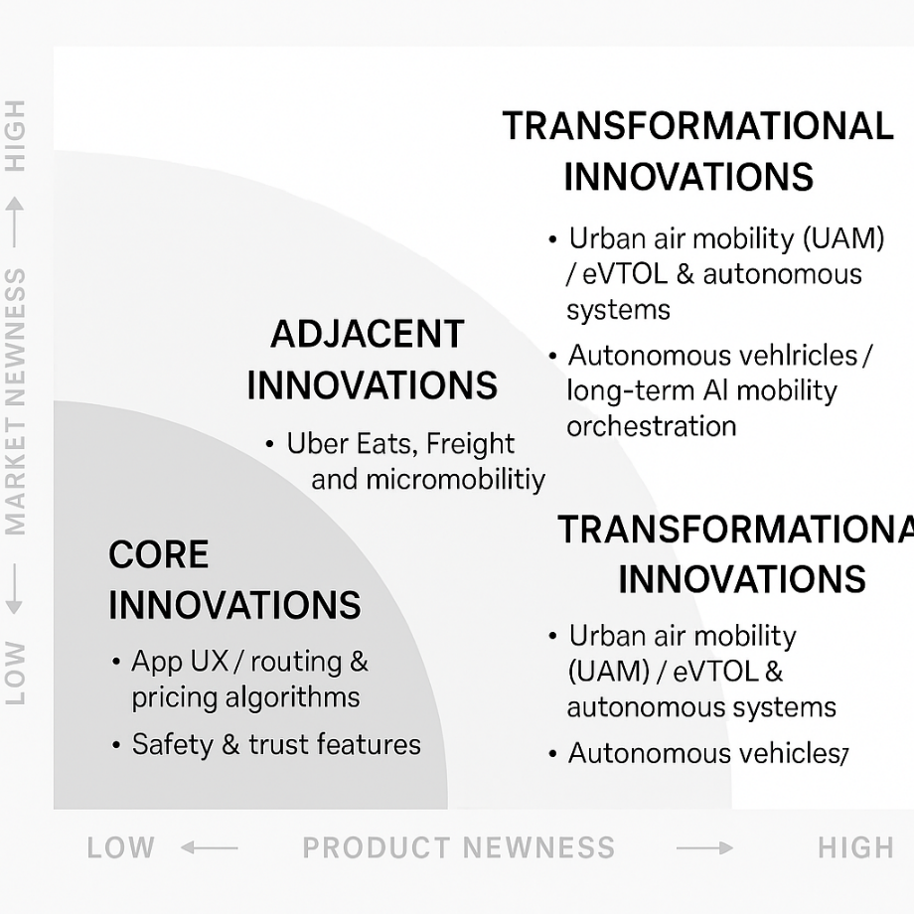
Figure 2 Ambition Matrix
(Source: Self-Developed)
Core innovations:
- App UX / routing & pricing algorithms: continuous improvements to the mobile experience, ETA accuracy, route optimisation and dynamic pricing logic on Uber’s documentation on dynamic pricing explains the mechanism. These sustain the existing marketplace and margins (Phillips, 2019).
- Safety & trust features: In-app “Safety Toolkit”, Share ETA, driver screening, and emergency assistance are iterative but essential enhancements to reduce churn and regulatory risk (UBER, 2024b).
Adjacent innovations:
- Uber Eats, Freight and micromobility: these are logical extensions that reuse the platform, payments, and logistics infrastructure—increasing wallet share per user and utilising driver networks during off-peak demand. Uber’s public filings and product pages show these adjacent lines (UBER, 2024a).
- Electrification partnerships & incentives: Uber has pushed EV adoption (driver incentives, partnerships) as a near-term adjacent move to decarbonise operations in regulated markets (UBER, 2024a).
Transformational innovations:
- Urban air mobility (UAM) / eVTOL & autonomous systems: Uber originally incubated Elevate to commercialise air taxis but subsequently transferred Elevate to Joby Aviation while keeping a commercial partnership and equity exposure, signalling Uber’s shift from hardware builder to platform integrator for aerial mobility (Allison, 2021). As noted by Joby Aviation (2021), the $75 million investment and acquisition expanded their partnership to integrate Joby’s future air service directly into the Uber app, reinforcing the company’s ambition to lead the urban air mobility ecosystem (Bevirt, 2020).
- Autonomous vehicles / long-term AI mobility orchestration: while some AV R&D has been scaled back or partnered, the long-run ambition still includes driverless fleets and system-level AI orchestration (UBER, 2024a).

Critical analysis:
Uber’s resource allocation shows a pragmatic pattern: heavy investment in optimising current marketplace economics (core) to deliver cashflow improvements and regulatory defensibility, strategic acquisition/partnerships for adjacent markets, and non-capital-intensive bets for transformational plays (equity stakes, partnerships, API integrations) (Ganapavaram, 2024). The Elevate → Joby path exemplifies this: rather than bearing the enormous capital and certification risk of building eVTOL aircraft, Uber monetised its market design expertise by partnering and taking minority investments, which retains go-to-market potential while de-risking hardware development (Bevirt, 2020).
That balancing act is sensible but exposes tensions:
- Short-term pressure: investors demand profitability and margin improvements; Uber’s dynamic pricing and algorithmic optimisation have been tightened, which recent academic coverage argues may increase platform take rates and create fairness concerns for drivers and riders (Goodley, 2025).
- Long-term positioning: Uber retains control over the customer experience and distribution without using significant capital investment by becoming the seamless booking layer to third-party air operators (Joby/others) (Ganapavaram, 2024). Nevertheless, safe, integrated air-ground experience can only be provided with profound collaboration with regulators, airspace controllers and infrastructures (helistops/vertiports), slowing monetisation and making coordination more complex.

Customer Journey Mapping current Uber ride
The visual concept of the future Uber Air customer experience is that ground and air transport are combined into one and the same process within the Uber application. It is aimed at maintaining the convenience of the platform and introducing high-speed air segments to congested routes. The key to successful integration is close coordination between the booking and ground transfers, vertiport scheduling and the air segment itself that is provided with effective information about safety, pricing and contingency.
High-level stages
The next stage of future Uber Air customer experience includes finding multimodal solutions and comparing price, time and carbon footprint and making air travel look as a high-end but time-efficient alternative. Ground and air bookings should be displayed in one checkout with price, travelling time and the operator's qualification. Predictive coordination will synchronise vertiport slots, aircraft and ground pickups to reduce waiting and missed connections. Real-time flight safety messages and uninterrupted air-to-ground transfers make the transfers and flights more trustworthy and convenient. An integrated payment and loyalty program backed by carbon tracking and easy post-trip refunds will make up a seamless, digital, sustainable, and carbon-tracked Uber Air experience.
Pain points
The main frictions are low coverage of vertiports and slots, complicated coordination that may result in the missed connection, high price that inhibits adoption, and regulatory/airspace obstacles that slow down the rollout. Some other risks that might hurt trust in case they are not handled proactively are predictive scheduling errors, algorithmic secrecy concerning dynamic fares, and contingency management (re-routing or refunds) (McKinsey, University of Oxford, Uber).
Gain points
The opportunities are high: saving time on congested routes by several minutes or offering a single booking/paying experience in the Uber system, earning more on the platform thanks to high-quality services, and better branding. Certified operator IDs and obvious safety badges can accelerate user acceptance, while integrated loyalty and carbon metrics can appeal to value- and sustainability-driven segments.
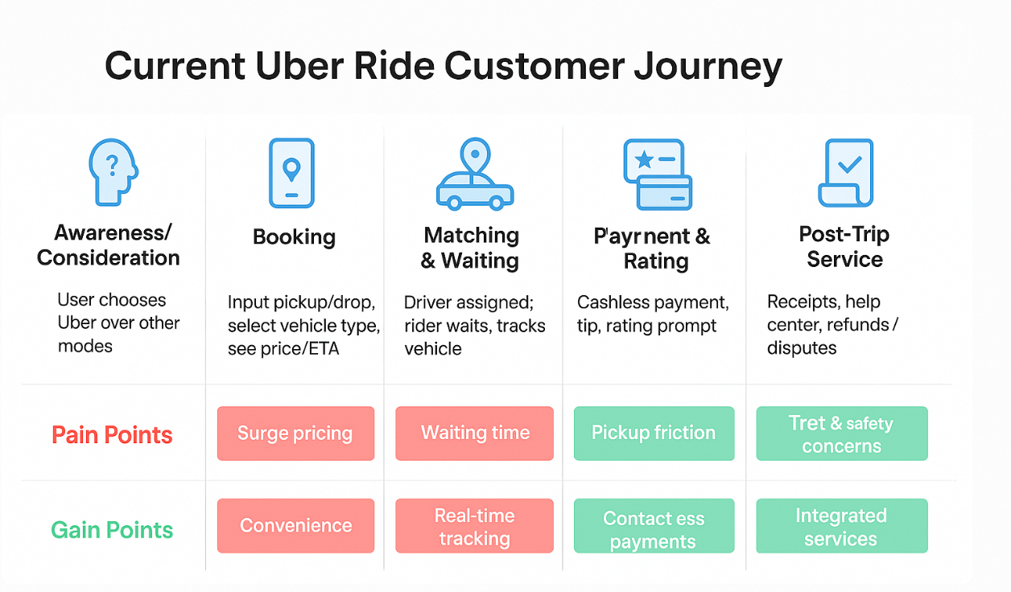
Figure 3 Current Uber Ride Customer Journey
(Source: Self- Developed)

Future Uber + Air Integration Customer Journey
The proposed Uber Air customer journey will be built on ground and air segments: discovery and unified booking, pre-trip coordination (vertiport slotting and predictive ground pickup), transfer to vertiport, air segment, vertiport arrival and last-mile transfer, and payment, rating and loyalty (Ganapavaram, 2024). This type of design puts more emphasis on speed, convenience and safety, but opens up areas of critical friction.
The gain points are: It has been instrumental in helping to cut down on the time taken to travel to and from congested routes, as well as integrating payment and reservation in the Uber application. The apparent credentials of operators and safety badges that enhance trust, and customised multi-modal routing that is cost, time and carbon efficient.
Pain points still exist: Availability and coverage of the vertiport will be limited by usefulness. The vertiport will not be able to be used in complex scheduling without predictive algorithms to prevent missed connections. This could restrict the adoption and increase equity issues, and strong regulatory and airspace restrictions will slow the roll-out (Goodley, 2025). There is also the complexity of operational customer communications due to the emergency contingencies and diversion handling.
Design interventions: Most of these issues are minimised by Unified UX, predictive ground-air scheduling, transparent pricing bands and verified safety information, which needs to depend on close liaisons with operators, infrastructure providers and regulators (University of Oxford, 2025). It will take pilot programs and a set of user testing to enhance the experience and define adoption, satisfaction, and safety results. The key KPIs will facilitate incremental execution.
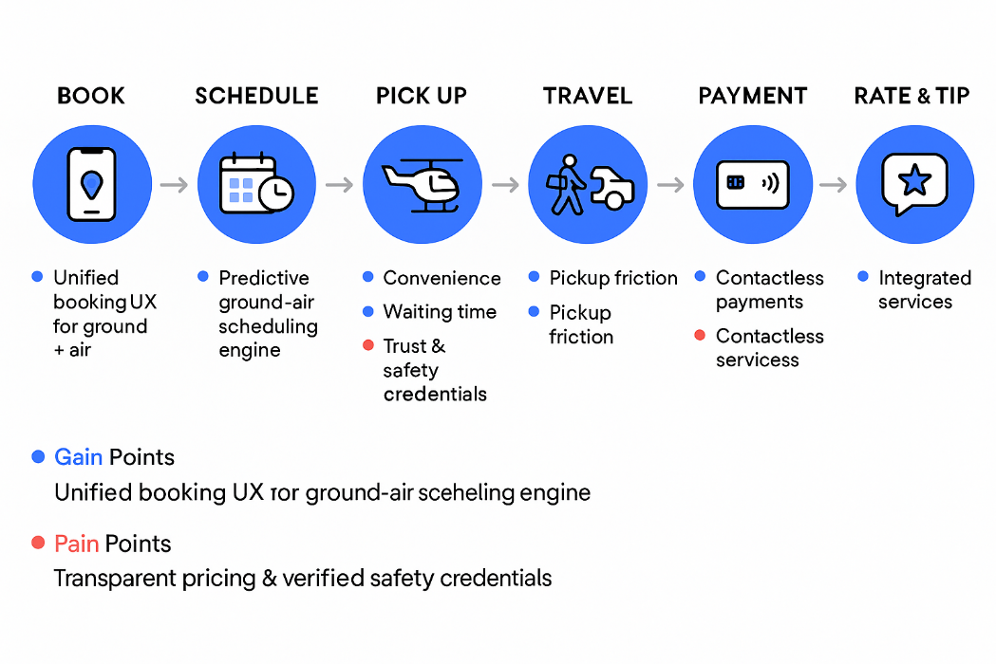
Figure 4 Future Uber and Air Journey Map
(Source: Self-Developed)

Where digital innovation could improve the journey, especially for air transport (helicopter / UAM)
The main areas of tension between air integration:
Complexity of booking (air routes, vertiport availability), safety and certification, last-mile connectors, price transparency, and airspace capacity availability. The UK regulators and air mobility programme analysis indicate that there is a necessity for coordination among the operators, infrastructure and airspace managers (UK Civil Aviation Authority, 2025).
Concrete opportunities:
- Unified multimodal booking (single UX): display time, price, and carbon tradeoffs with cars/scooters, using the marketplace UI/UX merits of Uber. This is a copy of Joby/Uber's go-to-market assumptions (book via platform; operator provides flight) (Allison, 2021).
- Predictive-ground-air scheduling engine: Real-time coordination of vertiport slots, driver pickup and aircraft turnaround- reduced missed connections and wait time. It entails the use of software such as the ElevateOS by Joby and tight regulatory coordination (Ganapavaram, 2024).
- Ethics-sensitive dynamic pricing of air services: establish different pricing policies between safety-relevant air segments (caps/notifications) and offer a price confidence range to help reduce the perceived injustice-design decisions that respond to the critiques of algorithmic opacities (Phillips, 2019).
- Improved trust capabilities of air mobility in-app education (safety certification badges, operator credentials), real-time GAINS (weather/airspace alerts), and one-tap emergency/ground transfer contingency planning. These reduce perceived risk and increase adoption (Payne, 2022).

Part 2 – Proposed Innovation

Introduction
Uber is a multinational company founded by Travis Kalanick and Garrett in the year 2009. Uber connects the customer through a smartphone app, which connects the customer to a driver in real time (Hoffman et al., 2021). Initially, it was launched as Uber Cab in San Francisco, and later in 2010, the service was started, offering luxury black car rides. In 2011, the company changed its name to Uber (Canfield, 2022). The main focus of the company is to upscale the ride with an effective and relevant price. Uber proposed UberX in 2012, which offered and allowed regular taxi drivers and car owners to use their vehicles for a suitable ride (Rahel, 2024).
Uber has gained a large popularity and rapid growth while extending to more than 70 countries worldwide. In the present time, the company serves more than 180 million users per month. Uber also provides a significant platform for Uber Eats and food delivery. The company has been completely moving towards offering effective and positive robotaxi services (Lee et al., 2025). Uber has also faced criticism and controversies related to the classification of work and its impact on public transport usage. The company has reshaped the transportation sector while making it more affordable and simple through advanced technology and security (Lombardo, 2022).

Key Consumer and Industry Trends
Uber is continuously focusing and navigating a very complex and rapidly evolving landscape where consumer behaviour and regulatory frameworks both shape the challenges and opportunities for the significant platform of Uber. Uber is growing rapidly through revenue streams and significant investment in advanced technology.

Key Consumer Trends
The consumer demands significantly continue to move and shift towards the certainty and value with an effective growing seamless and subscription-type models with a suitable multi-model experience (Shukla et al., 2025). The Uber One membership has rapidly expanded while offering members several benefits across delivery and rides, while contributing to much effective and higher average spend per user. In the dynamic environment, the consumer becomes much price-conscious and sensitive (Schaller, 2021). Sustainability and environmental concerns highly influence the choices of the rider. There is a significant noticeable shift also towards the electric vehicles and many lower-emission options, which are driven by the regulatory incentives, corporate sustainability commitments and consumer preferences (Jelti et al., 2023).
The company has significantly committed to reducing emissions and the suitable expansion and adoption of electric vehicles through its platform while aligning with more effective and broader urban goals. The technology and data analytics are completely centred to the growth of Uber engine (Jenn, 2019). Several advances in machine learning and artificial intelligence enable much dynamic pricing, demand forecasting, and safety protections. The optimisation and advanced technologies can enhance and improve the utilisation of the driver and also reduce wait times for the riders while contributing to better and effective unit economics (Fatorachian and Kazemi, 2025).

Industry Trends and Data Affects to Uber
The industry trends of Uber focus on the expansion in areas like gift delivery, grocery and longer ride options, especially targeting the non-urban areas, with a significant movement towards zero-emission vehicles. Uber is growing revenue with an effective and increasing take rate driven by advertising, and it also expects an improvement in profitability due to the integration of autonomous vehicles (Vasista, 2019). Uber has successfully expanded into food and freight services, which shows significant growth mainly during the pandemic. The success of the company is heavily dependent on addressing complex and varied regulations in different countries. The overall market of Uber drivers is characterised by flexibility, with several drivers working part-time to enhance support and income (Chen et al., 2019).
Data plays a significant and critical role in the business of Uber, with effective real-time data analytics and machine learning powering the pricing strategies, driver allocation and customer service enhancements and improvements. The company is continuously leveraging the large-scale data to improve operational decisions, optimise supply efficiency and adjust to demand surges while also investing in the infrastructure to handle very effective and high data volumes, which are essential to remain stable and competitive in the market (Chirita and Chirita, 2024).

Uber Approach to Innovation and Customer Journey
The approach of Uber to innovation is a complex strategy which leverages technology, sustainability, market expansion and service evolution of customer-centric. It can be significant through the lens of the innovation ambition metric.

Uber Approach to Innovation
The Innovation Ambition Matrix evaluated innovation into three significant horizons named core, adjacent and transformational.
- Core Innovation
The core innovations mainly aim to improve the existing ride-sharing services of Uber and the operational efficiency of the company. The company continuously invests in understanding and improving the experience of the user by enhancing its mobile apps with specific features such as seamless payments, real-time tracking and route optimisation (Cruz and Sarmento, 2020). The recruitment of the driver and retention strategies, loyalty programs and improved safety tools all fall under this category. These core innovations manage and maintain the market dominance of Uber in ride sharing, where it holds more than 60 per cent of the US market and is also rapidly expanding globally (Lee et al., 2025). The core innovations completely ensure significant customer satisfaction and cost efficiency.
- Adjacent Innovation
The adjacent innovation contains the extension of the business model of Uber into Uber Eats, which encourages and leverages the logistics and technology platform of Uber to grow the food delivery services. Uber Freight applies the capabilities of the platform to the shipping and logistics industry while connecting shippers and carriers on a scalable platform. The investment of Uber in the premium ride-tier options, such as SUV and Uber Black, regional service adaptations like Uber Green, Uber Moto and Uber Auto, and multi-model transport like scooters and bike-sharing, additionally demonstrate the adjacent innovation (Furlan, 2021).
- Transformational Innovation
The transformational innovation areas are considered to be where Uber pursues breakthrough technologies which could redefine its future. The Autonomous vehicle development is a significant focal point with substantial investments and collaborations to effectively organise self-driving fleets, which aim to improve the safety and reduce operational costs (Ahmed et al., 2022). The company is also advancing in the sustainability initiatives and electric vehicle infrastructure for integrating AI and to achieve zero emissions goals for effective pricing, supply demand prediction and operational efficiencies (Fatorachian and Kazemi, 2025).

Current Customer Journey
The current customer journey of Uber emphasises multi-service integration, personalisation and convenience, reflecting a determined focus on consumer profile (Gen Uber). This segment is completely digitally connected and fluent with effective decision-making. The users discover Uber through social media, digital advertising and collaborations with platforms like Spotify and Google. The market campaigns have been completely determined to create trust in the complex market (Furlan, 2021).
The app provides a suitable interface where users can easily book rides and order food with a few taps. This increases engagement, and the commuters receive effective ride discounts during the main peak hours. The referral incentives are a significant and very useful tool which encourages the riders and also the drivers to bring other new customers to the platform. The AI route optimisation reduces the wait times and also the fuel consumption, and the emergency buttons in the mobile app foster the confidence of the user (Fatorachian and Kazemi, 2025).
The advanced and multi-service ecosystem allows customers to switch seamlessly between food delivery and freight services in the same app. The customers are engaged post-ride with loyalty rewards and other significant incentives to drive repeat usage. The sustainability messaging, like Uber Green rides, completely resonates with positive customers while strengthening brand loyalty through effective shared values. The company also prefers drivers to be the main components and pillars of the company, and for that, they are providing drivers with in-app support tools, which address and effectively work on the operational challenges and enhance retention (Fatorachian and Kazemi, 2025).

Digital Transformation Initiative
Uber SeamlessGreen Mobility Platform (SGMP)
Overview
The SGMP is a customer-centric digital transformation that brings electrification, personalised, omnichannel booking and AI-driven supply optimisation into one single in-app experience. Implemented in a major UK city (i.e. Liverpool), the SGMP intends to (a) accelerate the switching of rider to low-emission trips, (b) together cut down on the waiting time and idling motor driver miles by means of predictive matching, and (c) provide a unified subscription and payment framework that maximises LTV (Ahmed et al., 2022). The initiative is linked with four technical pillars - EV incentives and charging orchestration, predictive demand-supply matching, seamless multimodal booking layer, and a single loyalty/subscription engine, resulting in faster, greener, and reliable journeys for customers and increased utilisation and predictable earnings for drivers (Furlan, 2021)..
Core components
- EV Incentive & Charging Orchestration: 'EV option' distinctly marked with indisputable Emission savings & dynamically smaller discounts partially subsidised through local Green Grants/Green Partners; drivers get route-conscious charging recommendations & access to EV Charging Partners through in-app booking (Schaller, 2021).
- Seamless Multimodal Booking Layer: One search allows customers to compare and book pairs (ride, micro-mobility, public transit, food drop-off) with one wallet, one ETA, and one journey receipt; transitions seamlessly enhanced with real-time alerts
- Seamless Multimodal Booking Layer: One search compares and books combinations (ride, micro-mobility, public transit, food drop-off). Uber will seamlessly infuse the Uber One subscription into a mobility subscription that combines EV discount, priority pick-up, and sustainable rewards; UX personalisation will enable Uber to tune in to each customer profile, providing options within their mobility subscription.
- Driver & Operations Dashboard: in-app featuring earnings forecast, charging schedule, and easy interface for accepting pooled or longer trips; analytics for continuous operations tuning (Schaller, 2021).
How the customer journey changes
Instead of separate decision points for “book a ride” or “choose green,” customers see a single, personalised journey card: suggested sustainable option (with ETA & cost), alternative multimodal suggestions if faster/cheaper, and post-trip rewards credited automatically. Friction points (signup, payment, mode switching, long wait times) are removed through one-tap booking, single wallet, and proactive rebalancing that reduces cancellations (Hoffman et al., 2021). The experience reinforces sustainability by making low-emission options visible and financially attractive, creating habit formation that ties into subscription benefits (Furlan, 2021).
Implementation roadmap (high level)
- Phase 0 — Discovery (0–2 months): stakeholder alignment, regulatory scan, partnerships with local charging network and city authorities.
- Phase 1 — Minimum Viable Product (3–6 months): deploy predictive matching+subscription in a limited zone; integrate two charging partners; enable EV option in app.
- Phase 2 — Scale & Multimodal (6–12 months): add multimodal connectors (transit, micro-mobility), expand charging orchestration, roll out driver dashboard updates.
- Phase 3 — Optimise & Automate (12–24 months): refine ML models, integrate autonomous vehicle lanes or pilots where allowed, and expand to other UK cities.
Success metrics & measurement
Primary KPIs (KPI): The share of trips taken as EV (%); Operational COP (cost/kg); Meaningful KPIs: target share of striped trips in pilot zone in 12 months; end-to-end median wait time; drivers’ NPS for core segment; subscription take-rate for active users; and utilisation of drivers (active hours/shift). Measurement is a combination of app analytics and logs from charging partners, rider/driver surveys and controlled A/B tests during the rollout. Financial metrics include incremental revenue, customer acquisition cost per user (incremental revenue per user), cost to serve reduction, and pilot ROI at 12 months (Canfield, 2022).
Risks and mitigations
- Low EV supply: mitigate via targeted driver incentives and charging partner guarantees.
- Regulatory/partnership complexity: early stakeholder engagement and local pilots.
- User adoption friction: A/B test messaging, provide first-time EV discounts, and seamless opt-out options.

Conclusion
This portfolio evaluates Uber’s strategy, industry trends, and customer journeys, identifying strengths and friction points. The Innovation Ambition Matrix shows strong core optimisation and adjacent growth (Eats, Freight) alongside transformational partnerships (eVTOL, AV). Journey mapping exposes pricing opacity, pickup friction and trust issues. The proposed SeamlessGreen Mobility Platform (SGMP) combines electrification incentives, AI-driven demand matching, multimodal booking and a unified subscription to increase EV trip share, reduce wait times and improve driver utilisation. A phased pilot with clear KPIs and stakeholder collaboration mitigates risks with measurable gains. SGMP aligns commercial returns with sustainability, enhancing Uber’s competitiveness in urban mobility.

References
Ahmed, H.U., Huang, Y., Lu, P. and Bridgelall, R., (2022). Technology developments and impacts of connected and autonomous vehicles: An overview. Smart Cities, 5(1), pp.382-404: https://www.mdpi.com/2624-6511/5/1/22
Allison, E. (2021). Joby and Uber Elevate . [online] Jobyaviation.com. Available at: https://www.jobyaviation.com/blog/joby-uber-elevate/? [Accessed 4 Nov. 2025].
Bevirt, J. (2020). Joby Aviation Welcomes New $75M Investment from Uber as it Acquires Uber Elevate and Expands Partnership | Joby. [online] www.jobyaviation.com. Available at: https://www.jobyaviation.com/news/joby-aviation-welcomes- new-75m-investment-from-uber-as-it-acquires-uber-elevate-and-expands-partnership/.
Canfield, G.A., (2022). HOW UBER’S REGULATORY SUCCESS IN THE UNITED STATES SLOWED ITS INTERNATIONAL EXPANSION. Penn State Journal of Law & International Affairs, 10(1), p.106: https://elibrary.law.psu.edu/cgi/viewcontent.cgi?article=1308&context=jlia
Chen, M.K., Rossi, P.E., Chevalier, J.A. and Oehlsen, E., (2019). The value of flexible work: Evidence from Uber drivers. Journal of political economy, 127(6), pp.2735-2794: https://www.nber.org/system/files/working_papers/w23296/w23296.pdf
Chirita, M. and Chirita, G., (2024). A Comprehensive Overview of Deep Learning for Algorithmic Pricing in Ride-Sharing Platforms. Economics and Applied Informatics, (1), pp.177-181: https://www.researchgate.net/profile/M-Chirita/publication/383901216_A_Comprehensive_Overview_of_Deep_Learning_for_Algorithmic_Pricing_in_Ride-Sharing_Platforms/links/678f506e95e02f182ea83b6a/A-Comprehensive-Overview-of-Deep-Learning-for-Algorithmic-Pricing-in-Ride-Sharing-Platforms.pdf
Cruz, C.O. and Sarmento, J.M., (2020). “Mobility as a service” platforms: A critical path towards increasing the sustainability of transportation systems. Sustainability, 12(16), p.6368: https://www.mdpi.com/2071-1050/12/16/6368
Fatorachian, H. and Kazemi, H., (2025). Sustainable optimization strategies for on-demand transportation systems: Enhancing efficiency and reducing energy use. Sustainable Environment, 11(1), p.2464388: https://www.tandfonline.com/doi/pdf/10.1080/27658511.2025.2464388
Furlan, A., (2021). Food delivery: An analysis of existing and future business models based on digital platforms: https://unitesi.unive.it/bitstream/20.500.14247/11177/1/861943-1255479.pdf
Ganapavaram, A. (2024). Joby Aviation says FAA gives nod for in-house software for air-taxi operations. Reuters. [online] 20 Jun. Available at: https://www.reuters.com/business/aerospace-defense/joby-aviation-says-faa-gives-nod-in-house-software-air-taxi-operations-2024-06-20/.
Goodley, S. (2025). Second study finds Uber used opaque algorithm to dramatically boost profits. [online] the Guardian. Available at: https://www.theguardian.com/technology/2025/jun/25/second-study-finds-uber-used-opaque-algorithm-to-dramatically-boost-profits.
Hoffman, D.L., Radojevich-Kelley, N. and Gilliard, D.J., (2021). UBER: A Great Disrupter or Not?. Journal of Marketing Development and Competitiveness, 15(2), pp.50-76: http://www.na-businesspress.com/JMDC/JMDC15-2/6_HoffmanFinal.pdf
International Transport Forum (2024). Corporate Partnership Board CPB Youth on the Move Young People and Transport in the 21 st Century Corporate Partnership Board Report. [online] Available at: https://www.itf-oecd.org/sites/default/files/docs/youth-transport-21st-century.pdf.
Jelti, F., Allouhi, A. and Tabet Aoul, K.A., (2023). Transition paths towards a sustainable transportation system: a literature review. Sustainability, 15(21), p.15457: https://www.mdpi.com/2071-1050/15/21/15457
Jenn, A., (2019). Emissions benefits of electric vehicles in Uber and Lyft services: https://escholarship.org/content/qt15s1h1kn/qt15s1h1kn.pdf
Jennifer , L. (2025). Uber Stock Hits Record High with Joby and Blade Air Mobility Deal. [online] Carboncredits.com. Available at: https://carboncredits.com/uber-stock-hits-record-high-with-joby-and-blade-air-mobility-deal/ [Accessed 4 Nov. 2025].
Lee, E.J.H., Rindfleisch, A. and Kopalle, P.K., (2025). Innovation in the sharing economy: Examining Uber's transformation. Journal of Product Innovation Management, 42(5), pp.822-849: https://onlinelibrary.wiley.com/doi/pdfdirect/10.1111/jpim.12768
Lombardo, A.M., (2022). The Uber challenge: A comparative analysis of regulatory schemes governing transportation app firms. Sw. J. Int'l L., 28, p.176: https://www.swlaw.edu/sites/default/files/2022-06/7.%20Lombardo%20%2828%20Sw.%20J.%20Int%27l%20L.%20176-209%29.pdf
McKinsey & Company (2020). How COVID-19 will affect future mobility in the United Kingdom | McKinsey. [online] www.mckinsey.com. Available at: https://www.mckinsey.com/industries/automotive-and-assembly/our-insights/moving-forward-how-covid-19-will-affect-mobility-in-the-united-kingdom.
Naveen, P., Antony, M.P., Ramasamy, B.V., Sah, D.K. and Maheswar, R. (2024). Unlocking the Potential: How Flying Taxis Will Shape the Future of Transportation. Sustainability, [online] 16(24), pp.10795–10795. doi:https://doi.org/10.3390/su162410795.
Payne, R. (2022). Uber’s new Safety Toolkit featuring Live Help from a safety agent. [online] Uber Newsroom. Available at: https://www.uber.com/newsroom/ubers-new-safety-toolkit/.
Phillips, J. (2019). How Uber’s dynamic pricing model works | Uber Blog. [online] Uber Blog. Available at: https://www.uber.com/en-GB/blog/uber-dynamic-pricing/.
PwC (2024). Consumer perspectives on the future of mobility | PwC. [online] PwC. Available at: https://www.pwc.com/gx/en/issues/business-model-reinvention/how-we-move/consumer-perspectives-future-mobility.html.
PwC (2025). How we move. [online] PwC. Available at: https://www.pwc.com/gx/en/issues/business-model-reinvention/how-we-move.html? [Accessed 4 Nov. 2025].
Rahel, S., 2024. Economics of the taxi industry: An Uber shake-up (Doctoral dissertation, University of Wyoming. Libraries): https://wyoscholar.uwyo.edu/bitstreams/28199308-af62-4974-8170-3d7274c0369c/download
Schaller, B., (2021). Can sharing a ride make for less traffic? Evidence from Uber and Lyft and implications for cities. Transport policy, 102, pp.1-10: http://www.schallerconsult.com/rideservices/sharingride.pdf
Shukla, S., Kumari, R. and Thakur, S., (2025). Effectiveness of Subscription Model in Modern Marketing: https://ijnrefm.com/wp-content/uploads/2025/04/ijnrefm-vol-3-issue2-138.pdf
UBER (2024a). On Our Way 2024 ANNUAL REPORT. [online] Available at: https://s23.q4cdn.com/407969754/files/doc_financials/2025/Stockholders2025/2024-Annual-Report.pdf.
UBER (2024b). Uber App Safety Features - Rider Safety Toolkit | Uber. [online] Uber. Available at: https://www.uber.com/gb/en/ride/safety/rider-safety-features/.
UK Civil Aviation Authority (2025). Future Flight Challenge. [online] Caa.co.uk. Available at: https://www.caa.co.uk/our-work/research-and-innovation/future-flight-challenge/.
University of Oxford (2025). New Oxford research reveals Uber’s algorithmic pricing leaves drivers and passengers worse off | University of Oxford. [online] Ox.ac.uk. Available at: https://www.ox.ac.uk/news/2025-06-23-new-oxford-research-reveals-uber-s-algorithmic-pricing-leaves-drivers-and-passengers.
Vasista, B., (2019). A study of sharing economy: Impact of sharing economy in mobility, food delivery, co-working and short-term rental, on built environment: https://www.politesi.polimi.it/bitstream/10589/164713/3/2020_06_VASISTA.pdf

