REPORT
- HYATT HOTEL GROUP-

POPA ANCA
2126967
Management & Organisational Behaviour (BMIH5004)
Giulia Chifari
Word Count: 2196

Executive Summary

Hyatt Hotels is a worldwide well-known leader in the hospitality industry. Despite facing a challenging business environment, the organisation has exhibited resilience by executing astute strategic plans aimed at enhancing customer satisfaction, operational efficiency, and long-term growth. The company's operational framework, which balances centralised control with regional autonomy through a blend of functional and divisional organisational systems, deserves recognition for promoting collaboration and flexibility.
Hyatt's operational philosophy bears resemblance to Handy's Role Culture, characterized by a hierarchical structure, adherence to established procedures, and informed decision-making while fostering collaboration, creativity, and individualism. The business’s continued commitment to delivering exceptional guest experiences has been instrumental in establishing a strong brand identity and positioning it as a preferred global hospitality provider. Hyatt's strategic objectives, including enhancing brand recognition, elevating guest experience, advancing sustainability practices, and ensuring financial performance, reflect the company's unwavering focus on providing unparalleled customer satisfaction.
Despite the challenges facing the hospitality industry, Hyatt's proactive strategies, technological innovation, and customer-centric approach have positioned the company for sustained success and growth. These efforts have enabled Hyatt to maintain its leadership position in the rapidly evolving hospitality landscape.

Table of Content
1. Introduction 4
2. Hyatt Hotel Group Analysis 5
2.1 Hyatt Hotel Group: Organisational Structure 5
2.2 Organisational Culture 8
2.3 Organisational Goals 9
2.4 Change Initiatives 11
2.5 Organisational Performance 13
3. Conclusion 15
4. References 16

1. Introduction

The Hyatt Hotel has a rich history dating back to 1957. Following the passing of Donald Pritzker, the Pritzker family expanded their operations into North America, with a primary focus on hotel management and development (Fernandes, 2021).
The company's operations are overseen by a team of dedicated workers and executives, with the guidance of the President and Chief Executive Officer. The Board of Directors plays a crucial role in safeguarding the interests and wealth of the company's shareholders by exercising control over management.
Hyatt Hotels is a hospitality leader that places great emphasis on maintaining operational efficiency, guest satisfaction, and sustainable growth through the implementation of strategic initiatives and organisational structures (Hinson et al., 2024).
Hyatt has been successful in centralizing its operations, while catering to diverse markets and client segments effectively. This has been achieved by implementing a hybrid organisational structure that combines functional and divisional models. Hyatt has been successful in aligning their culture with their structure and goals.
Hyatt aspires to establish its dominance in the global hotel industry by prioritizing innovation, sustainability, and customer-centricity. A recent report by Rodrigues (2021) has delved into various aspects of Hyatt's organisational structure, culture, goals, change management strategies, and performance to assess its strategic direction and prospects.

2. Hyatt Hotel Group Analysis
2.1 Hyatt Hotel Group: Organisational Structure
Accurately measuring power dynamics is crucial to creating a productive and equitable work environment. As Dubin (2017) points out, simply exclusively performing a function does not necessarily equate to holding a significant amount of power. By adopting a measured and objective approach to power relations, work organisations can better navigate the complex human dynamics at play within their teams.
Hyatt Hotels has adopted functional and department models to effectively organise its workforce. The company's corporate groupings, which include operations, marketing, finance, HR, and legal, have been structured to handle specialised activities and functions within their respective fields. This approach has been aimed at centralising the company and maintaining consistency across its operations. By enabling the effective utilisation of expertise, this functional organisation has helped Hyatt maintain high-performance standards (Ruiz Molina et al., 2022).
Hyatt's hotels and resorts are structured based on their brand, region, and functional sections. Each of their brands, Hyatt Regency, Park Hyatt, and Andaz, is managed and marketed differently to cater to the specific needs of their diverse clientele. The organisation can satisfy a broad range of customers while maintaining a strong and consistent brand identity across all its products. To streamline decision-making and operations, hotels across the Americas and Asia-Pacific are grouped by geography. By doing so, Hyatt can maintain a coherent and unified brand experience that resonates with its customers.
It is worth noting that an organisational structure is not a static entity, rather, it is a constantly evolving and changing phenomenon (Carnall and By, 2014).
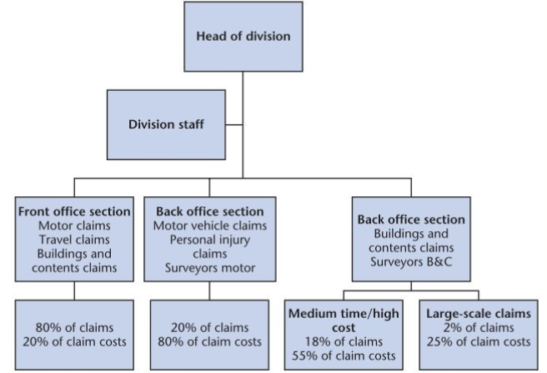

Fig No 1: Divisional organisation structure prior to change
(Source: https://www-vlebooks-com.ezproxy.uwtsd.ac.uk/)

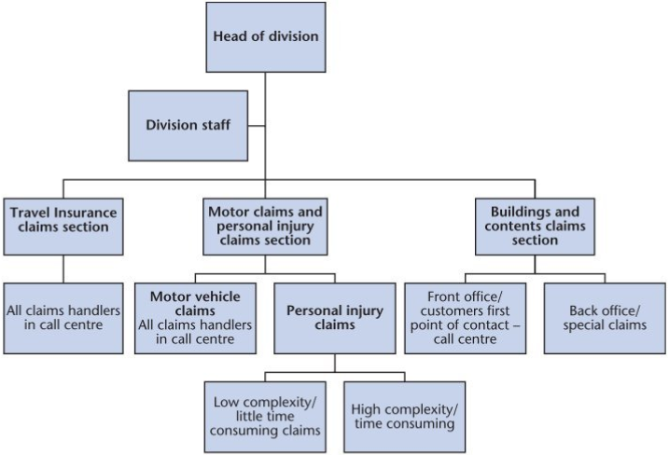

Fig No 2: Actual new organisational structure- after change
(Source: https://www-vlebooks-com.ezproxy.uwtsd.ac.uk/)
Hyatt's recent organisational adjustments demonstrate the company's dedication to growth and continuous improvement. From January 2024, Gabriel Felip has taken charge of Hyatt's operations in Latin America and the Caribbean, while Susan Santiago has assumed leadership of the US and Canada regions (Hyatt, 2024).
Hyatt Hotels' focus on strategic organisational alignment is highly commendable. The recent restructuring demonstrates their dedication to simplifying regional collaboration and resource sharing. Their hybrid structure is both efficient and responsive, allowing them to adapt quickly to changing market conditions. The divisional organisation facilitates targeted marketing to specific consumer groups and marketplaces while functional divisions provide specialized knowledge and economies of scale.
Nevertheless, the existence of mixed structures within organisations can present a significant challenge, as it can hinder coordination across departments and groups. To overcome these challenges, it is essential to foster effective communication and collaboration, which can serve to align objectives and ensure that all stakeholders are on the same page.
Divisions may also hinder company-wide collaboration and knowledge sharing (Hinson et al., 2024). This emphasizes the need to promote cooperation and cross-functional teamwork. Encouraging such a culture of collaboration will positively influence the overall business performance.
Hyatt's hybrid organisational structure is an effective approach that successfully balances centralization with autonomy. This allows the company to operate smoothly and efficiently, while also catering to the diverse needs of its customers and markets.

2.2 Organisational Culture

Leaders are believed to play a pivotal role in instilling discipline among their subordinates. Any lapses in discipline or strained relations between superiors and subordinates can be attributed to the leaders' inability to lead effectively rather than the team's incompetence (Suarez-Barraza and Miguel Davila, 2021).
Hyatt Hotels' organisational structure and business approach are comparable to Handy's Model, with an established hierarchy and well-defined functions and procedures. Hyatt places a strong emphasis on compliance and ensures that all sites adhere to business policies and regulations. Moreover, Hyatt's franchising model entails specific standards and expectations to ensure consistent service and brand representation across all properties (Hyatt Hotels Corporation, 2023).
The organisation is primarily characterized by a Role Culture, although there are also facets of Task Culture observable, particularly concerning the company's emphasis on teamwork in marketing and environmental initiatives. Furthermore, Hyatt is known for its dedication to innovation and individuality. Fostering a culture of opportunity is essential for promoting growth within an organisation (Hyatt.com).
The company's flexible work environment seems to promote creativity and adaptability, allowing for timely responses to changes in industry trends and guest preferences.
It is imperative to acknowledge the intricacies of Hyatt's culture, which is shaped by various factors such as regional diversity, employee empowerment programs, and the dynamic nature of the hospitality industry. Given that cultural norms and expectations play a significant role in how the Role Culture is perceived in each region, it is crucial to remain cognizant of and responsive to multiple cultures.
Employee development and empowerment play a crucial role in driving progress and innovation across industries, particularly in the ever-changing hospitality sector. It is remarkable that Hyatt recognizes the significance of fostering a culture that encourages new ideas and continuous improvement. This approach increases the likelihood of attracting and retaining top talent, improves organisational efficiency, and enhances customer satisfaction (Dimitriou, 2022).
It is important to consider the impact of cultural factors on the long-term objectives of a company such as Hyatt. Factors such as guest satisfaction, operational efficiency, and sustainable growth are critical determinants of success. Hyatt's organisational culture comprises of distinct Role, Power, and Task cultures. However, it is essential to note that regional differences, the need to provide staff with greater autonomy, and the dynamic nature of the hospitality industry may contribute to the manifestation of these cultures within the company.
The recruitment and selection process is a vital managerial tool for fostering a strong organisational culture. Experts suggest that a well-designed recruitment process can have a positive impact on employee morale and reduce turnover rates, thus contributing to a more productive and harmonious workplace. As such, companies must prioritize their recruitment practices (Aluko, 2018).

2.3 Organisational Goals

Hyatt Hotel Group has set an ambitious goal to establish itself as the foremost hotel company globally. The organisation's focus is to provide guests with an unparalleled experience, ensuring they feel welcomed, valued, and well taken care of. The brand's overarching objective is to ensure each guest enjoys a superlative stay, with exceptional service, and world-class amenities at their disposal. As per Manoharan et al. (2021), Hyatt's commitment to providing incomparable guest experiences is at the center of its mission.
Hyatt is committed to building long-lasting relationships with its guests by adhering to its core values of respect, honesty, humility, empathy, creativity, and fun in all interactions. The company has a clear vision and purpose, along with well-defined goals that guide its strategic actions and drive continuous progress.
To achieve its objective, Hyatt must undertake marketing initiatives, enhance the loyalty program, and prioritize personalized guest experiences. These measures will not only increase brand exposure but also foster guest loyalty towards the Hyatt brand.
To broaden its appeal to a wider range of tourists, Hyatt seeks to augment its portfolio of brands and thus entice a larger number of visitors.
Hyatt is dedicated to improving the guest experience, and it achieves this by utilizing technology to develop new products and services. Additionally, the business focuses on offering culturally relevant amenities to keep guests engaged (Hyatt Hotels Corporation, 2023).
In an increasingly competitive market, Hyatt has chosen to differentiate itself by offering its guests personalized and distinctive experiences. This approach has proven effective in fostering guest loyalty and driving business growth.
Hyatt's commitment to sustainable practices is a commendable reflection of its corporate responsibility. The hotel chain has set itself the goal of reducing its energy and water consumption, achieving net-zero carbon pollution by 2040, and supporting local communities. As a result, Hyatt is generating a positive impact on the environment and the communities it operates (Velickovic et al., 2023).
Hyatt's primary objective is to enhance earnings and augment the value of its shares. The organisation will achieve this by establishing long-term growth goals, optimizing operations, and prudently managing expenses.

2.4 Change Initiatives

Hyatt Hotel Group has made significant progress over the last decade to enhance its reward program, environmental impact, and technological acceptance. The company has achieved these goals by investing in renewable energy, adopting eco-friendly technologies, and collaborating with long-term suppliers (Fachada, 2023).
The adoption of eco-friendly practices within the hotel industry can significantly boost its appeal to guests who prioritize sustainable living. However, the integration of such practices into daily operations whilst maintaining cost-effectiveness remains a persistent challenge (Torres, 2023).
The importance of effective management monitoring, worker involvement, and fair compensation cannot be overstated in ensuring the smooth functioning of an organisation. In addition, customer loyalty programs have proven to be a valuable tool for enhancing customer retention and increasing revenue. Hyatt's efforts to strengthen its points program by offering personalized rewards, exclusive events, and higher tiers to its World of Hyatt members have resulted in greater engagement, customer loyalty, and revenue growth.
In the management of a complex program, one must be cognizant of the potential challenges that may arise. Clear and concise communication together with a willingness to adapt and make changes can help to optimize program performance and ultimately drive member revenue (Velickovic et al., 2023).
Hyatt has made significant progress in its efforts to leverage technology to streamline operations and provide staff with valuable data to support decision-making. Regardless, prioritizing user experience and investing in knowledgeable and helpful staff will be essential in maximizing the potential of these new technologies.
Hyatt's recent plans to expand their operations into developing nations, offer unique guest experiences, and prioritize environmental sustainability are commendable. The company's decision to expand into Asia and Africa and introduce new brands like Caption by Hyatt is a strategic move that positions the company to capitalize on the changing global tourism landscape (Fachada, 2023).
The company's commendable efforts to invest in community links, renewable energy, and circular programs reflect its commitment to sustainability. However, balancing sustainability aspirations with practical and cost-effectiveness needs is often challenging.

2.5 Organisational Performance

Hyatt Hotel Group has shown a remarkable recovery following the COVID-19 pandemic. The business has demonstrated its exceptional competence by maintaining higher occupancy rates than industry averages. This is a testament to the strong demand for its luxury properties. The corporation has experienced an increase in sales in 2023, which is a positive development for the hospitality industry (Qi, 2023).
According to the 2024 financial Quarterly report, the projected Capital return for the full year 2024 is $3.0 billion and the growth of net units will fall within the range of 5.5 percent to 6.0 percent. The company's financial performance is noteworthy, boasting significant sales growth, profitability, and favorable shareholder returns.
Hyatt has established a formidable presence in the upscale and luxury hospitality market. However, the brand faces challenges in the budget and select service segments. Despite these obstacles, Hyatt remains steadfast in its dedication to guest satisfaction, evidenced by consistently high poll ratings (Fernandes, 2021).
Hyatt's upcoming strategies are founded on several key ideas. The hospitality brand is actively enhancing its World of Hyatt loyalty program and leveraging advanced technology to provide guests with a more bespoke experience, in response to consumer demand for personalized brand interactions.
Sustainability is an essential priority for many corporations nowadays. Hyatt invests in renewable energy and uses sustainable business practices, which aligns with the values of the organisation.
Hyatt is currently facing several challenges such as the intense competition from other hotel chains, fluctuations in the economy that directly impact travel spending, the need to adhere to new sustainability standards, and the importance of maintaining brand consistency across all hotel locations (Velickovic et al., 2023).
Through the implementation of a strategic and innovative approach, businesses can address and overcome various challenges to create a lasting, positive impression on their guests.

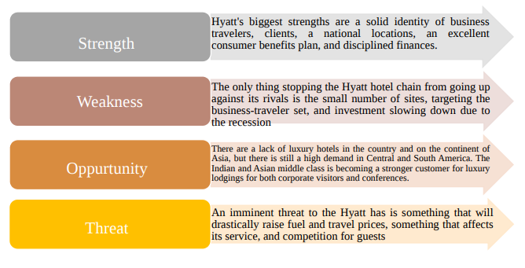
Fig No 3: SWOT Analysis (Demianenko, 2022)

3. Conclusion

Hyatt Hotels' unwavering commitment to operational excellence, innovation, and sustainability is commendable. The company's current performance and strategic direction reflect this commitment. Hyatt's hybrid organisational structure, which fosters a culture of collaboration and creativity, coupled with its pursuit of strategic initiatives aligned with its goals, positions the company to effectively respond to challenges and capitalize on opportunities in the dynamic hospitality industry. To sustain Hyatt's continued success and achieve its long-term objectives, it will be important to effectively manage change initiatives, stay attuned to market trends, and prioritize guest experiences.

4. References

Aluko, Y. A. (2018) ‘The Impact of Culture on Human Management’. In O.A. Ogunbameru, A.L. Adisa and D.S. Adekeye (Eds.) Cross-Cultural Management: A Multi-Disciplinary Approach. Obafemi Awolowo University Press: Ile-lfe. Available at: (PDF) The Impact of Culture on Human Resource Management (researchgate.net) (Accessed: 06 February 2024).
Carnall, C. A., and By, R. T. (2014) Managing change in organizations (Sixth edition). Pearson. Available at: Full details and actions for Managing change in organizations (uwtsd.ac.uk) (Accessed: 06 February 2024).
Demianenko, A. (2022) Improvement of Corporative Sustainability Development Strategy (on the basis of Internship Report at Hyatt Regency Kyiv) (Doctoral dissertation).
Dimitriou, C.K. (2022) The critical role that national culture and ethical leadership play in fostering employee commitment to service quality in the hotel industry. Research in Hospitality Management, 12(3), pp.255-271.
Dubin, R. (2017) The World of Work: Industrial Society & Human Relations. London and New York: Routledge Library Editions: Human Resource Management.
Fachada, B.C. (2023) Business adaptive strategies in crisis: the case of Hilton Hotels Worldwide (Doctoral dissertation).
Fernandes, F.S.M.S. (2021) Intercontinental hotels group-time to check-in? analysis of one of the biggest hotel players in times of a global pandemic (Doctoral dissertation).
Hilton Quarterly Results (2024) Hilton Reports Fourth Quarter and Full Year Results. ir.hilton.com. Available at: q4-2023-earnings-release.pdf (hilton.com) (Accessed: 06 February 2024).
Hinson, R.E. et al. (2024) Hospitality and Tourism Marketing: Building Customer Driven Hospitality and Tourism Organizations. CRC Press.
Hyatt Hotels Corporation (2023) 2023 Annual Report. https://investors.hyatt.com/financials/annual-reports/default.aspx
Hyatt (2024) Hyatt Announces New Americas Organizational Structure and Senior Leadership Appointments. Press release, 19 February. Available at: https://www.businesswire.com/news/home/20240219984830/en (Accessed: 06 February 2024).
Hyatt.com (no date) ‘World of Care’, Advancing a Culture of Opportunity. Available at: Corporate Culture | Hyatt World of Care (Accessed: 06 February 2024).
Lockhart, P. et al. (2020) ‘Do organisational culture and national culture mediate the relationship between high-performance human resource management practices and organisational citizenship behaviour?’, International Journal of Manpower. Available at: https://doi.org/10.1108/IJM-04-2018-0129 (Accessed: 06 February 2024).
Manoharan, A. et al. (2021) ‘Walking the talk in diversity management: Exploring links between strategic statements, management practices, and external recognition’, International Journal of Hospitality Management, 94.
Qi, Y. (2023) Financial Analysis of Hyatt Hotels Corporation. Highlights in Business, Economics and Management, 15, pp.111-116.
Rodrigues, C.S.F. (2021) Equity research-Hyatt Hotels Corporation (Doctoral dissertation, Instituto Superior de Economia e Gestão). Available at: DM-CSFR-2021.pdf (utl.pt) (Accessed: 06 February 2024).
Ruiz Molina, M.E. et al. (2022) Addressing sustainable food management in hotels: proposing a framework and examining hotel groups. British Food Journal, 124(2), pp.462-492.
Suarez-Barraza, M. F. and Miguel Davila, J. A. (2021) Exploring Fayol’s management process in a traditional Mayan dance (Pochó Dance): an ethnographic study. Asia-Pacific Journal of Business Administration. Available at: https://doi.org/10.1108/APJBA-07-2020-0234 (Accessed: 06 February 2024).
Torres, M.P.R.L. (2023) Empowerment and sustainability to promove a dynamic, thoughtful, and inventive community: the case of green meetings at Casablanca Marriott Hotel (Doctoral dissertation).
Velickovic, G. et al. (2023) Managing Financial Performance toward Achievements in Sustainability Prospects: Comparative Analysis of the e-Commerce and Hospitality Industries. Journal of Risk and Financial Management, 16(9), p.395.

