Enterprise and Entrepreneurship
BMSP5006
Jessica Shore
Student ID 1707182
Vernessa Francois

(n.d., n.d.)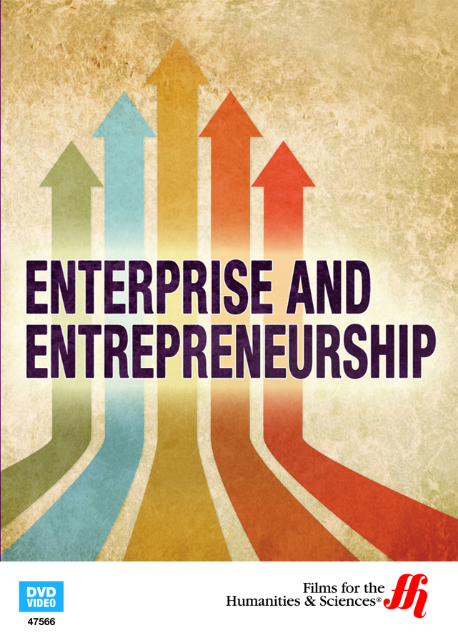

Introduction
What is enterprise and entrepreneurship?
Becoming a social entrepreneur is the latest craze within the world of business. Many people are tired of working their 9 to 5 jobs for pittance. Some have become social entrepreneurs either because they have decided that they want to do something completely different with their lives, by having more flexibility if they have family and others because they have an idea for successful business and want to see if they can make it work. Some just want to be able to help their community and help those that maybe of disadvantage due to disabilities and finding it hard to get into the working environment, this is where training can be given.
Having a social enterprise can be very beneficial for the community purely for the fact that a social enterprise is for the local community and not for profit. There are many ways that a social enterprise can work for the community, providing any kind of profit that is made goes back into the community.
Enterprise is someone or maybe an organisation that are willing to take risks, show their initiative, to make things happen and undertake new ventures.
Firms start when entrepreneurs organise resources and take risks in the expectation of earning a profit. More specifically, enterprises tend to be set up for one or more of the following reasons:
*Solve problems - some firms originate to solve a problem faced by a consumer, by other firms, or by government. An example being internet comparison websites solve the problem by consumers of having limited to research the whole market for the best current consumer deals.
*Exploit an idea – firms start so that they can exploit an original idea or an invention.
You will find that many firms tend to enter a market to produce an existing product more cheaply, or more effectively, than the existing firms that are in the market already; an example being Tesco Plc had started in 1919 when co-founder Jack Cohen sold cheap groceries from a single market stall in London East End (n.d., What is enterprise, 2008 -2020).
Becoming an entrepreneur will have many benefits, having a good business idea or platform to work from. Being an entrepreneur gives you freedom to take any path you wish, being your own boss gives you time for you and family, also there are limits as to how much you can earn and how profitable your business can be. If you make any profit it is always a very good idea to reinvest in your business. It can be rewarding knowing that you can help others if you create jobs. Everyone has the potential to become an entrepreneur, you just need to take that leap of faith and take the risk.
Entrepreneurship is someone who will have many skills and take many risks to make their business work and become successful. An entrepreneur plays an important part of the economic growth, because if they are successful within their business and have plenty of growth then they create jobs, this can be a high reward for economic growth and innovations alike.
(Saluja, 2017) states that focusing on finances from the beginning, he says that is best to have a clear vision of your financial structure and working from the beginning, particularly cash and your working capital. He also goes on to say that if you have a co-founder then is good to make sure that everything is very clear in writing and all roles are detailed, he states this is important in case that anything should go awry within the partnership and everyone will know where they stand.
Entrepreneurs face many challenges while trying get their business up and running. A few of many is finance, having a good business model from the outset and, also hiring good skill set. Many entrepreneurs start with an idea or even a hobby that they enjoy and want to turn it in to a business, not all entrepreneurs are successful, this could be due to many things that could have been over looked, maybe not the right time for a particular product in the market or even poor advertising and what type of audience they are looking to target.
If an entrepreneur wishes to be successful, then they will work extremely hard to get their business of the ground, no matter how hard or how it takes them, if they want to become successful then they will make sure they will be, just like Alana Spencer did.

Let’s look at how Alana Spencer started out with her business venture.
Alana Spencer – ‘Ridiculously Rich by Alana’
Alana Spencer is from Aberystwyth; she had started her journey at the young age of 14, her mum had brought her a book on making chocolate, it was from there she had found her love of making chocolate. By the age of 16 she had become a self-taught chocolatier, renting her first kitchen and had started selling her luxury chocolates to friends, family and teachers, this was before catching the attention of two shops in Aberystwyth. (Spencer, n.d.).
Her chocolates had become very popular, in 2010 Alana had left school and decided to pursue her entrepreneurial chocolate loving dream. She had originally named her business Narna’s and had then started to make tray-baked cakes alongside her luxury chocolates, to get her self-known Alana had started travelling nationwide to sell her tray-bake cakes and chocolates at markets, and food events which were successful.
Alana had decided that she wanted to take her business a lot further than she had already achieved, so she had decided to apply to become a candidate on BBC One’s The Apprentice, she was seeking £250,000 investment from Lord Alan Sugar. Because of her passion for business and delicious cakes this had sealed the deal and ‘Ridiculously Rich by Alana’ was born. Alana had become the first Welsh winner on The Apprentice.
Alana has become very successful and has turned her company ‘Ridiculously Rich by Alana’ into a franchise.
While Alana was in her GCSE year at school, she had made £2000 profit, she had taken order forms into her teachers to take orders for Christmas.
Her passion had started at a young age because her mum had recognised this, she allowed Alana to have free reign in the kitchen to be creative, she remembers one time that she made a cheddar cheesecake, not sure that was successful but that did not deter her from the passion. Alana had always been creative whether it be in the kitchen or being artistic in other areas, she had started selling hand-made cards, with this she realised that she could turn something into money. With that in mind at the age of 14 she had streamlined a £50 business order from her uncle who had wanted to send Christmas cheer to his clients (Terrelonge, 2019).
In an interview with About Time Magazine, Alana was asked what inspires her, her reply was “In business my inspiration has always been about family. I came from a family of entrepreneurs who growing up have been a massive influence”. (Malin, 2017).
Before entering to become a contestant on BBC One’s The Apprentice Alana had set her business up in her parents’ home, she had persuaded them to build a kitchen at the side of their house, she had been able to get a government grant which had covered up to 40% of the extension and also paid for any equipment that she needed to get started. (Wilcock, 2017).
Also, in the interview she stated that this is always something that she has wanted to achieve when she first started out and never looked back.
Alana had set out to become a leading player in the luxury cake market, she wants people to treat themselves and emphasis on the “treat” as they are a real treat. (Malin, 2017).
Business has been fantastic for Alana since winning the BBC One’s the Apprentice, with having Lord Sugar investing £250,000 ‘Ridiculously Rich by Alana’ was then born and this allowed Alana to expand, also now into franchise you can become an ambassador for Ridiculously Rich by Alana, and sell cakes at the local food events or farmers markets.
Just recently Alana was in a position to be able to buy Lord Sugar from ‘Ridiculously Rich by Alana’ according to Business Live, Alana had an amazing experience working with Lord Sugar and his team, she has learnt so much in a short space of time. Lord Sugar says he will “follow Alana’s progress with much affection”. (Hughes, 2019). Ridiculously Rich by Alana business has gone from her and her partner baking and selling cakes to having around fifty ambassadors that sell their cakes at food festivals across the country. These ambassadors will buy the cakes and then sell them at events. They turned over half a million pounds in 2017. (Ferguson, 2018).
So what advice would Alana give to an entrepreneur who wishes to start their new business venture, well she has always maintained focus and kept her vision, she has explained that “you need to know what you are doing and what you are trying to achieve” an example being, “if you don’t know what you are doing then you lose focus”. This has taught her to set goals in both business and personal life.
She also goes on to say that using your finances wisely and reinvest in what you have already. That is what she has and is still doing. She worked out how much was made; how much is profit and how much to keep back and to be sensible. (n.d., Apprentice winner: whipping up a £250,000 investment from Lord Sugar, 2020).
Apart from Ridiculously Rich by Alana, her biggest achievement is being to help others and give them the opportunity to be able to start their own business through either being an Ambassador or Cakepreneur Schemes. (n.d., Apprentice winner: whipping up a £250,000 investment from Lord Sugar, 2020).

Social Entrepreneurship
The older generation of philanthropist had made their wealth in the private sector while in their younger years being successful entrepreneurs and then decided to try and change the social issues in the world once their youth was behind them. Now though it seems the young entrepreneurs are working to improve the social issues through their businesses. Globally, a new business model has emerged that meshes with government and social organisations. Non-profit’s and businesses can team up to form a hybrid business model, led by a new generation of social entrepreneurs. It seems that these leaders can successfully tackle social issues while generating a profit for the shareholders. (Delventhal, 2020).
Most people become entrepreneurs because they want to improve their quality of life, while others just want to work for themselves, and other see an opportunity in the market that they cannot resist. (Kumar, 2019).
The desire to use business to want to create positive change will ignite the entrepreneurial spirit, this is what they call “social entrepreneurship”. (Kumar, 2019).
Social entrepreneurship is gaining much more popularity these days, globalization, which brings conversations about sustainability and international development to the world stage. This is making more people ask the question “what can they do for the world today?” (Kumar, 2019).
There are different types of social enterprise and these are as follows;
Social Enterprise – The profits will be reinvested back in the business or the community, this means the shareholders and owners will not make a profit. A community enterprise is also a type of social enterprise company owned and run by the geographical community or a community of shared interest.
Co-operative business –
An autonomous association of persons united in a jointly owned and democratically controlled enterprise (International Co-operative Alliance definition). They work voluntarily to meet common economic, social and cultural needs. A co-operative business can be split in many sub-categories;
- Worker co-operatives are owned and run by their workers
- Housing co-operatives are owned and run by their tenants
- Consumer co-operatives are owned and run by its customers
- Co-operative consortia are owned and run by other businesses using the service of the enterprise.
- Multi-stakeholder co-operatives can be a mixture of any or all the above. (n.d., The types of Social Business, 2020).
( Rahdari, Sepasi, & Moradi, 2016) suggests that the emergence of social enterprise is an amazing epitome of the manifestation of social innovation in practice. Social enterprises had been developed in the UK back in the late 1970’s, this was originally developed to counter the traditional commercial enterprise. A social enterprise exists at the intersection of the private and volunteer sectors (Barone, 2020).
“Social innovation is the process of developing and deploying effective solutions to the challenging and often systemic social and environmental issues in support of social progress. Solutions often require the active collaboration of the constituents across government, business, and the non-profit world” (Clavier et. al., 2019).
The idea behind a social enterprise is to try and help solve or alleviate problems that might not be big enough to create long lasting effects. To be able to succeed in a social enterprise venture, they must follow a very loose set of rules, this is so that they have the favourable outcome.
Running a social enterprise is good the community, especially if they suffer unbalanced socioeconomic situation, the social enterprise would have to be sustainable to be able to make any kind of difference to the community that they are trying help.
Melissa Tucker is a Social Enterprise Coordinator at The Mildura Chocolate Company, they were established in 2009 as a branch of (The) Christie Centre Inc. They are a community base organisation that provides service and opportunities to those who are less fortunate or have disabilities (Victoria, 2018).
Apart from making delicious chocolates, they focus on creating support, training and employment for adults with disabilities or experiencing disadvantages.
“Like any business, there are highs and lows along the journey, but in a social enterprise, the whole team can feel proud to make an amazing product while having a positive impact in our community”. (Victoria, 2018).

Conclusion
Whether you want to become an entrepreneur or a social entrepreneur/enterprise, from the outset you must have very clear goals of what you want to achieve. Starting any business venture is going to be hard work from the start, but what you have to make sure is that you know what type of market or niche you wish to get into, also finances play a big part in starting up, there are government funding schemes which help out people who wish to set up in business. As within all businesses there will be some challenges that have to be overcome, challenges are not meant to be easy, they are what make businesses look at how they can improve to give a better service. If setting up a social enterprise for the community then they will have to be sustainable, understand what the community needs and how they are able to help their society.
Never give up on dream no matter how big or small, pushing through the challenges and tough times will always bring a community together.

References
Rahdari, A., Sepasi, S., & Moradi, M. (2016). Journal of Cleaner Production. Achieving sustainability through Schumpeterian social, 137, 350. Retrieved June 2020, from https://www.researchgate.net
Barone, A. (2020, February 3). Social Enterprise. Retrieved July 2020, from https://www.investopedia.com/terms/s/social-enterprise.asp: https://www.investopedia.com
Clavier et. al., S. C. (2019). Social Innovation | Social Entrepreneurship. Retrieved May 2020, from https://impactgarden.org/social-innovation/: https://impactgarden.org
Delventhal, S. (2020, February 13). 10 Most Successful Social Entrepreneurs. Retrieved May 2020, from https://www.investopedia.com/articles/investing/092515/10-most-successful-social-entrepreneurs.asp: https://www.investopedia.com
Ferguson, D. (2018, December 22). Alana's proof you really can have your cake – and eat it: 'I've bought big home aged 26 after winning The Apprentice'. Retrieved May 2020, from https://www.thisismoney.co.uk/money/meandmymoney/article-6523085/Ive-bought-big-house-age-26-winning-Apprentice.html: https://www.thisismoney.co.uk
Hughes, O. (2019, September 27). Alana Spencer has bought Lord Sugar's stake in her bakery. Retrieved June 2020, from https://www.business-live.co.uk/enterprise/apprentice-winner-alana-spencer-buys-16991386: https://www.business-live.co.uk
Kumar, B. (2019, December 6). Social Entrepreneurship: How to Become a Changemaker Through Business. Retrieved June 2019, from https://www.shopify.co.uk/blog/social-entrepreneurship: https://www.shopify.co.u
Malin, A. (2017). About Time You Met: Alana Spencer. Retrieved May 2020, from https://www.abouttimemagazine.co.uk/life/about-time-you-met-alana-spencer/: https://www.abouttimemagazine.co.uk
n.d. (2008 -2020). What is enterprise. Retrieved May 2020, from www.economicsonline.co.uk/Business_economics/What_is_enterprise.html: https://www.economicsonline.co.uk
n.d. (2020). Apprentice winner: whipping up a £250,000 investment from Lord Sugar. Retrieved May 2020, from https://www.barclaycard.co.uk/business/news-and-insights/alana-spencer-apprentice: https://www.barclaycard.co.uk
n.d. (2020). The types of Social Business. Retrieved June 2020, from https://businesswales.gov.wales/socialbusinesswales/types-social-business: https://businesswales.gov.wale
n.d. (n.d.). Enterprise and Entrepreneurship (Enhanced DVD). Retrieved May 2020, from www.madisonartshop.com/47566.html: https://www.madisonartshop.com
Saluja, R. (2017, December 16). How Can You Build an Enterprise from Scratch. Retrieved May 2020, from www.entrepreneur.com/article/306276: https://www.entrepreneur.com
Spencer, A. (n.d.). About Ridiculously Rich by Alana. Retrieved June 2020, from https://www.ridiculouslyrichbyalana.co.uk/: https://www.ridiculouslyrichbyalana.co.uk
Terrelonge, Z. (2019, April 3). Cake it till you make it: The Apprentice winner Alana Spencer has risen to the top with Alan Sugar. Retrieved May 2020, from http://elitefranchisemagazine.co.uk: http://elitefranchisemagazine.co.uk
Victoria, B. (2018, May 16). Pros and Cons of a Social Enterprise. Retrieved July 2020, from https://hub.business.vic.gov.au/other/pros-and-cons-of-a-social-enterprise/: https://hub.business.vic.gov.au
Wilcock, B. (2017, March 30). CELEBRATING AND INSPIRING ENTREPRENEURSHIP. Retrieved May 2020, from https://archive.weareumi.co.uk/wales/2017/03/30/news/the-secret-to-becoming-ridiculously-rich-25455/: https://archive.weareumi.co.uk

