Please add your targets from the previous assignment (Only relevant if you have completed an assignment)
 | Targed/target | Yr hyn yr wyf wedi'i wneud yn yr aseiniad hwn  What I have done in this assignment...
Targed/Target 1 | proofread your work to avoid minor written inaccuracies | I have proofread the assignment. This is however a reoccurring target and has triggered me to ask for assistance. I have previously been screened for dyslexia over 10 years ago during my first degree. I did not proceed with additional testing at the time. I am now pursuing this and have come to realise that it maybe having a more profound affect on my writing than I ever realised.
Targed/Target 2 | revise correct punctuation of sentences when separating main and subordinate clauses | I have been mindful of this target throughout.
Targed/Target 3 | Greater consistency in the critical engagement with relevant research throughout your work. There is a tendency to assert your opinions without evidence in some parts. | I have tried to ensure any posing opinions have been referenced throughout and try where possible to provide counter arguments.

How a school develops one aspect of its SDP: a report that critically reflects on the actions, impact and evidence base.
Education in Wales is undergoing an important transition from the national curriculum formulated in 1988 to new guidance published from the review conducted by Donaldson (2015). The catalyst for the reforms has been attributed to poor performance shown in the 2009 PISA survey, described as a ‘wakeup call to a complacent system’ (Andrews, 2011). Wales obtained a mean score in mathematics, reading and science that were significantly lower than the rest of the UK and ranked 40th, 38th and 30th respectively comparative to the 65 countries involved (OECD, 2010). Welsh Government (2014) levying the need for Wales to compete with the other nations internationally and uses results as an indicator of the acquisition of the necessarily skills needed for a successful life. Educational policy in Wales began on a path of ‘GERM: Global Education Reform Movement’ (Sahlberg, 2010, cited in Egan, 2017, p.4). Focusing on the comparative performance through a league table approach and the adoption of internationally implemented best practice processes. Figures 1. Depicts the PISA results for Wales from 2006-2015. The graphs show a decline in performance in both mathematics and science with results for reading comparable to that of results from 2006. Despite reforms to education results in 2015 PISA tests remained lower in all areas, than the OCED average. The figures are often headlined in Welsh media given prominence to Welsh schools’ failings often referencing PISA scores with damning certainty. These results must be interpreted with a level of criticality, often not afforded by the media. The PISA assessments have not gone without its criticism within the UK and internationally (Takayama,2015; Kreiner and Christensen (2014); Taut and Palacios (2016), Meyer et al., 2014). Meyer et al (2014) highlighted five main concerns of policy makers reliance on PISA results. The first two arguments refer to the impact of standardised tests on the narrowing of curriculum, resulting in a teaching to the test and short-term goals to improve prospective PISA scores. The next arguments calling into question the validity of the process in different cultures and ethical stand points. PISA is not regulated under a democratic governance and this could hinder mechanisms of transparency, participation and leave the processes vulnerable. The final concern is the reduction of wellbeing of staff and learners. Exacerbated by narrowed teaching strategies, lessened teacher autonomy over curriculum and educational policies derived from performance and accountability measures. Bonnell et al (2014) advocated that the measure of an effective schooling should not be in an attainment results alone but used alongside measures of health and wider wellbeing, of which are not robust enough within the UK. Wellbeing became more prominent in the government agenda within the Wellbeing and Future Generations Act (2015). Holding public bodies accountable in the planning of improved social, economic, environmental, and cultural well-being.

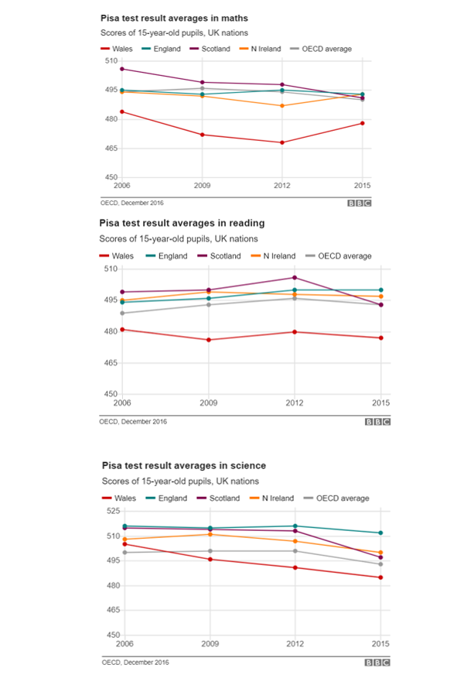
Figure 1. Pisa test result averages in maths, reading and science (Hume, 2016).

The Good Childhood Report (2016) expanded recommendations to introduce legally binding entitlements for children to access evidence-based wellbeing and mental health support within educational settings. With outcome-based data on school improvement of pupil’s attainment still as a priority, the additional emphasis of wellbeing targets within schools began to show representative in the review undertaken by Donaldson (2015). Understanding the drivers behind school reforms is crucial in appreciating the significance given to school improvements and the constrained relationship it has had with wellbeing measures. The aim of this assignment is to explore the evolution of school development plans (SDP) and evaluate effectiveness in the context of one school within Wales. It will highlight the impact of social economic disadvantage and wellbeing on educational attainment, with critical evaluation of the Thrive strategy implemented in the target school.
Firstly, context is needed on the population of wales. The Public Health Wales Observatory (2013) shows that over 1 in 5 children and young people in Wales are living in relative poverty (22%). The poverty rate is consistently higher in Wales than the rest of the UK (JRF, 2018). The educational attainment gap is monitored the effects of lower socio-economic status (SES) through the indictor of free school meal (FSM) entitlement. There remains a fourteen percent point gap between those who are eligible for FSM compared than those who do not. The implications of attainment gap can be present when children begin school and is equivalent of 4.3 months of a learning gap, this can double throughout primary school and the same can be said for the end of secondary school where the gap can be seen at 19.3 months (EEF, 2018). Detrimentally effecting future educational and employment prospects (EEF, 2018; UK Parliament, 2019; Estyn, 2014). Estyn (2014) recognises that these outcomes are not inevitable. Illustrated in PISA (2018) reading which show that fourteen percent of disadvantage students scored in the top quarter (OECD, 2019). FSM allocation as a proxy for SES and subsequent data derived about educational attainment has been criticised as carrying ‘imperfect proxy bias’ (Hobbs and Vignoles, 2007) with minimal research been undertaken on the validity of the measurement (Taylor, 2017). It is the best available proxy measure throughout the current system, providing comparative datasets that are routinely collected across locations and time (EEF,2018). FSM is used to allocate additional funding through the Pupil Deprivation Grant (PDG). Targeting funding towards students that are disadvantages by lower SES, in a bid to improve attainment (WG, 2015). Taylor (2017), Carpenter et al (2013) and Pye et al (2015) revealed shortfalls of FSM proxy can lead to moral dilemmas in disseminating funding and the selection of appropriate initiatives. Additional information suggested to address measures of SES are data on social class, parental education, previous allocation of FSM but this data proves harder to obtain and monitor (Harwell and LeBeau, 2010; Hobbs and Vignoles, 2007; Perry, 210). Ilie (2017) countered the critics and demonstrate FSM eligibility correlates highly with SES and reliability only marginally lower when compared to more in-depth survey measures suggested. Perry (2010) distinguished FSM as is a proxy measure and should not be assumed a direct measure of SES.
Welsh Government’s goal of eradicating child poverty by 2020 formulated after the Child Poverty Act (2010) has resulted in renovation the schools planning and evaluation process with this target in mind. Estyn (2012) guidance on effective practices carried a resounding message of the importance of the strategic and systematic approaches to school development planning (SDP) and self-evaluation. OCED (2014) criticised the infrastructure of Wales school improvement system as lacking collaboration, crumbling under pressures of fast pace reforms and underdeveloped self-evaluation strategies. McKinsey (2007) describes the value given in high-performing schools internationally to processes requiring evidence-based interventions, monitoring and self-evaluating with rich sources of data, funding and prioritising professional development. Estyn (2012) evaluated the most effective schools in Wales and found commonalities within their SDP process. These were: explicit planning with quantifiable and operationally defined goals, clear vision that is relevant for the individual school population, the schools have a motto, mission or vision statement that was developed and understood by all stakeholders and an ongoing evaluation process involving stakeholders regularly. Wales has followed other OCED nations to create a system that utilises the use of the accountability measures and assessment processes identified above in a whole school self-evaluation process (OECD, 2013). Cruddas (2015) drew attention to the important distinction between a school-led system and a self-improving system of which Wales has adopted. Self-improving systems are indeed by definition are school-led but with additional accountability procedures derived from the Welsh Government. Eliminating potential for school’s self-interest and bias and to encompassing guidance. Dissuading from the top-down approach of compliance to policy and encouraging greater autonomy and innovation by school leaders (Cruddas, 2015). Some have stressed the paradox of the process and maintain the government authority is maintained at many levels but just directed from afar (Hudson, 2007: Jessop, 2011). Ball (2017) found that the impression of greater autonomy has in fact resulted in many schools experiencing a lack of support. With the government visions of self-improving school systems is understating the external influences already at play (Greany and Higham, 2018). These include decentralization, regulatory guidance by educational authorities, competition between neighbouring schools and performance management procedures. It has been recognised that the reforms proposed will not be easy but are possible to implement with assistance given through the regional consortia in Wales, encouraging school to school collaboration for support (Cruddas, 2015). Donaldson (2015) acknowledges the concerns derived from OCED (2014) and firmly supports conclusions surrounding school improvement and accountability. Donaldson (2015) discourages the use of assessment data used explicitly for accountability purposes but for informing ways to progress and dissuades reporting of teacher assessment to Welsh Government. The process alteration introduced by Donaldson (2015) aim to elevate the pressure on educators that can equate to schools teaching to the test and short-term measures of achievement and further supporting measures of broader wellbeing.
SDP is a strategic plan that is a live document that clear states the school’s priorities, visions, background, actions, resources and measurable outcomes for short-term goals and three-year objectives (WG, 2014b). The plan is executed and must be accessible to all stakeholders, with the governing body having the responsibility for the SDP. However, in practice it is often a shared agenda with staff, headteacher and governing body to formulate, monitor, evaluate and modify the SDP. WG (2014b) produced the planning cycle in Figure 2 as guidance for schools, depicting the cycle of self-evaluation, planning, implementation, and review under the umbrella of the school’s long-term vision.

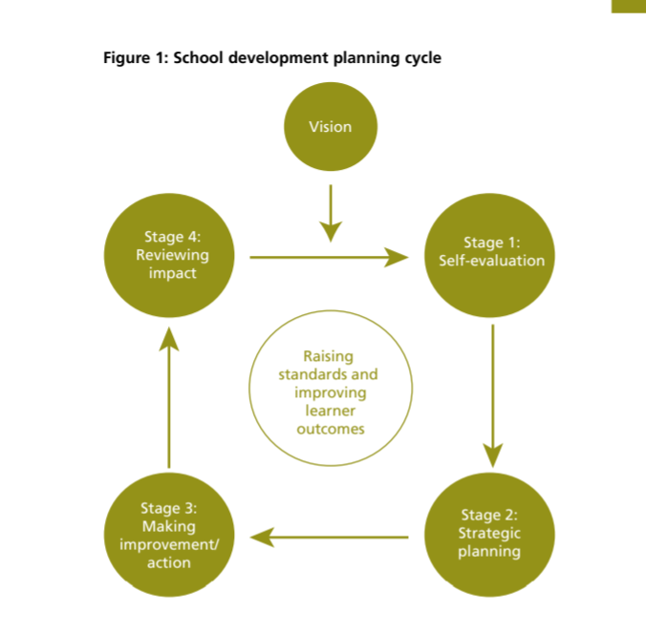
Figure 2. WG (2014b, p7.) typical improvement cycle of self-evaluation, planning, implementation, and review set against the school’s long-term vision.
The self-evaluation cycle in will be used to evaluate the SDP produced in a school in Wales (School X). It is key that SDPs are contextualised in the reality in which they are immersed (Escobar, 2019). School X is a village primary school with over 400 pupils on roll (Estyn, 2018). It is classified as a ‘B’ and in the yellow category according to the consortia challenge advisor evaluation which equates to the school having minimal support from the county (Welsh Government, 2019b). The proxy measurement of low SES of FSM is estimated at twenty-two percent in Wales (Public Health Wales Observatory, 2013). School X has less than ten percent of pupils eligible for FSM, therefore much lower than the welsh average (Estyn, 2018). The vision for School X draws on maintaining academic achievement in a caring and nurturing environment. Throughout the schools values it emphasises wellbeing, inclusivity and allowing for an equitable system for all its learners. The priority chosen for critical evaluation includes the development of wellbeing provisions. The action requires the school to track all pupil’s attendance, especially FSM attendance and performance. The school has over 50% less FSM pupils than the rest of Wales, so why is this a target selected as a priority? As explored previously, FSM is an imperfect proxy and this maybe the resonating in this population. Future exploration into inspection reports found the school is in the lower 50% for attendance compared with similar schools over four years (Estyn, 2018). Poor attendance can affect a child’s success at school negatively with multiple reasons for absences it can be difficult for schools to find the extra time need to assist children to catch up on work missed (WG, 2018). This is an aspect of disadvantage that is not directly measured within FSM and thus is not accredited additional funding, such as PDG. The target has derived from a more central governance and standards and it is difficult to tell if this has been a target set through self-evaluation. School X’s SDP (Appendix 1.) shows the actions required alongside its expected impact and evidence measures. Stage two of the planning cycle (Figure 2) involves strategic planning and within this is the actions that outline the interventions and next steps for the development of objectives. School X has not outlined the allocation of resources, lead personnel or schedule of implementation remain. The expected outcomes present in the SDP provide broad statements of what they wish to achieve. WG (2014) highlighted the need for quantifiable targets that can show suitable challenge and improvements from data previously gathered, coupled with clear success criteria to allow for a robust evaluation of the target. Estyn (2018) found that the success criteria within this SDP are not precise enough and actions are not distinguished to be efficient for evaluation purposes. The SDP evidence of impact are broad descriptions and vague measurements of improvement, for instance it states, ‘data supports the choice of learners for intervention’. The statement does not provide quantifiable data to identify current position and measure progress against. Suggestions for improvement may including comparative data of attendance, FSM and educational attainment. School X has chosen a targeted intervention of Thrive within its actions (Stage three). Thrive is a school-based intervention package intervention which has a theoretical basis in child development theory, neuroscience and attachment theory (Thrive, 2020). Staff trained in Thrive would complete assessments run one to one and group interventions. Thrive training and online platform enable practitioners to screen whole classes to identify possible interruptions in the child’s development and emotional learning (Cole, 2012). Thrive (2020) states three potential benefits of its implementation within schools: enabling learners to regulate behaviour and learn about emotions, increasing pupil attendance and strengthen links with parents and carers partnership. It is appealing to educators as it includes tools for identification of target pupils and a system for data collection. Several schools in this school’s cluster had adopted this approach. Schools however must be aware of falling pray to the ‘cult of new’ (Dida, 2016). It is essential that within school improvement that we share evidenced based practice but sometimes when a new strategy gains traction in a community they neglect evaluate the evidence base of the strategy themselves. Evaluations of the effectiveness of Thrive are minimal and at present there are no peer-reviewed articles available (Gibby-Leversuch, Field, and Cooke, 2019). Cole (2012) investigated the effects of Thrive on both pupil’s socio-emotional learning and practitioners’ perceptions on their own confidence of supporting children’s emotional development. Findings showed no significant increases in emotional wellbeing in those enrolled in Thrive an additionally there was little data to suggest the screening tools were effective. Practitioners found the approach was inconsistently implemented and often not universally applied. The credibility of the research carried out by Cole (2012) requires validation as this thesis is unpublished and not peer reviewed. Gibby-Leversuch, Field, and Cooke (2019) suggested that schools should consider alternative interventions that may prove more cost effective and carry greater evidence-based data, such as Nurture. Recommending individualised training for staff based on the needs of the targeted children within the school by adequately trained professions, such as psychologists. It is not to suggest that Thrive is or has not been effective for individuals and school practitioners, but it does require more enquiry to be a credible intervention. Despite these criticisms Thrive has been shown to be incorporated within 73% of school improvement plans of those who have adopted the approach (Seymour, 2019). The prevailing issue with measures of outcomes for interventions that address wellbeing factors is there is very little research on validated measures of wellbeing and educational attainment (Durlak et al., 2011; Humphrey, 2013; O’Conner, et al., 2017). School X has outlined the review stage (stage 4) as collecting data from a variety of sources but again has not provided clear quantifiable data for outcomes which is difficult to determine how well the implementation of actions has met the needs within the schools vision and priorities. Schools often possess more data that they can effectively use (Wallace, 1996). The challenge comes with the organisation and systematic analysis of this data (Johnson, 1996). The capacity within schools to store data and cross analyse through technological data management systems such as that established in School X of SIMS, can prove efficient and accessible. Despite these advancements, the data can sometimes be lost in translation with data represented in different forms and codes. It has been found that in some schools the personnel lack the training and understanding required to unlock the capacity of these systems (Knipe, 2019). Haggerty, et al (2010) evaluated seventy-two different tools and assessments used to measure wellbeing, only nine were considered sound measures that were accessible for schools to utilise effectively. Interestingly, Hanover Research (2014) recognised that the difficulties presented with measuring wellbeing in school improvement plans can often lead to governing bodies abandoning these as priorities. It is reassuring that School X is maintaining the importance of wellbeing within its SDP, but further work is needed to identify quantifiable and operationally defined objectives within its planning and evaluation. It is also importance for all stake holder involve in the SDP be critical consumers of research and interventions that are surround their targeted priorities to ensure they are employing the best evidence based practice available or at least be mindful of shortfalls when implementing interventions and processing results.
School X has produced a well organised SDP that has consultation processes that involve all stake holders. They have clearly identified their priorities and have a concise SDP that reflects school values and areas of improvements (Estyn, 2018). Inconsistences of target action evidence of impact do not always relate fully targeted action and require additional quantifiable measures to illustrate and monitor progress. Teachers and school leaders have a multifaceted role and the daily running of a school is tremendously busy. Finding the time to develop a school improvement framework can cause the fragmentation of individual interventions when brought together in one agenda (Glennan, et al, 2004). A critical goal needs to be the professional learning, about progress, evidence-based intervention, evaluation of data (Stevenson, 2019). SDP documents are not in themselves going to bring change and Stevenson (2019) suggests that the format of the plan itself is the reason for its lack of utility. Stating that schools should be less concerned about action steps and deadlines and more concerned about putting serious thought into construction of strategies.
This assignment has tracked the development of educational policies and the influence international and local initiatives have on the policy agenda. Within this evaluation it has shown academic achievement and school effectiveness has been carried out through assessments and are key driver for policy change within Wales. The attainment gap and the reduction of the effects of poverty have been a priority on the welsh agenda. The is no one size fit to addressing these concerns, but an overarching theme is that measures need to be tailored to a school’s context and relate to its infrastructure of improvement and evaluation (White, 2017). The requirement of SDP aims to direct efforts for this agenda but has proven through analysis on School X to be difficult to navigate. However, Coe’s (2013) beliefs surrounding lesson observations has resonated with the writer and could be equally applied to school improvement. Firstly, ‘effort and good intentions are not enough; we have to work smarter, not just harder’ and the ‘uncritical belief’ of practitioners may provide a false sense of security, and produces a cycle of self-deception which is unproductive and may lead to an unequitable system for the our pupils.

References
Andrews, L. (2011) Teaching Makes A Difference. Cardiff: Welsh Government.
Ball, S. (2017) The Education Debate. Bristol: Policy Press
Bonnell, C., et al (2014) ‘Why Schools Should Promote Students’ Health and Well-being’, BMJ, 348.
Carpenter, H. et al. (2013) Evaluation of pupil premium research report. Manchester: Department for Education.
Coe, R. (2013) Improving Education: A triumph of hope over experience. Available at: file:///C:/Users/Emma1/OneDrive/Documents/Uni%2020192020/ECAD%206007/Research% 20documents/Improving%20Education%202013%20-%20coe%20robert.pdf (Accessed: 2nd October, 2019).
Cole, M. J. (2012). Promoting emotional well-being and inclusion for children identified with emotional and behavioural difficulties in mainstream primary schools: An evaluation of a psychotherapeutic approach (Thrive). Unpublished PhD thesis. University of Exeter.
Cruddas, L. (2015) Leading the Way: Blueprint for a Self-Improving System in Wales 2 Leading the Way: Blueprint for a Self-Improving System in Wales. Leicester: ASCL.
Didau, D. (2016) What If everything you knew about Education was Wrong? Wales: Crown House.
Donaldson, G. (2015). Successful Futures: Independent Review of Curriculum and Assessment Arrangements in Wales. Cardiff: Welsh Government.
Durlak, J. A., Weissberg, R. P., Dymnicki, A. B., Taylor, R. D., and Schellinger, K. B. (2011). ‘The impact of enhancing students’ social and emotional learning: A meta-analysis of school-based universal interventions.’ Child Development, 82(1), pp. 405–432.
EEF (2018) The Attainment Gap 2017. Available at: https://educationendowmentfoundation.org.uk/public/files/Annual_Reports/EEF_Attainment_Gap_Report_2018.pdf (Accessed 10 March 2020).
Egan, D. (2017) After PISA: A way forward for education in Wales? Merthyr Tydfil: Bevan Foundation.
Escobar, I. H. G. (2019) ‘School improvement plans, a tool to improve the quality of education’. New Trends and Issues Proceedings on Humanities and Social Sciences. 6(1), pp 440-450.
Estyn (2012) Effective practice in tackling poverty and disadvantage in schools. Cardiff: Estyn.
Estyn (2014) Pupil deprivation. Available at: https://www.estyn.gov.wales/sites/www.estyn.gov.wales/files/documents/Pupil%20deprivation.pdf (Accessed 12 March 2020).
Estyn (2018) A report on ‘School X’ Available on: https://www.estyn.gov.wales/ (Accessed on April 12 2020).
Gibby-Leversuch, R., Field, J., and Cooke, T. (2019) ‘To What Extent Is the Thrive Intervention Grounded in Research and Theory?’ Educational Psychology Research and Practice. 5(2), pp.1-6. Seymour Research Ltd (2019). Evaluation of the Thrive Approach: Full Report. Totnes: Seymour Research Ltd.
Glennan, et al. (2004) Expanding the reach of education reforms: Perspectives from leaders in the scale-up of educational interventions. CA: RAND.
Greany, T. and Higham, R. (2018) Hierarchy, Markets and Networks Analysing the ‘self-improving school-led system’ agenda in England and the implications for schools. Available at: https://www.nuffieldfoundation.org/wp-content/uploads/2019/11/Hierarchy-Markets-and-Networks.pdf (Accessed 22 March 2020).
Haggerty, K., et al. (2010) Social‐Emotional Learning Assessment Measures for Middle‐School Youth Available at: http://www.schoolclimate.org/climate/documents/RaikesReportFinalOct.pdf (Accessed 13 April 2020).
Hanover Research (2014) Best Practices for School Improvement Planning. Washington: Hanover Research.
Harwell, M. and LeBeau, B. (2010) ‘Student eligibility for a free lunch as an SES measure in education research’, Educational Researcher, 39 (2), pp. 120–131.
Hobbs, G. and Vignoles, A. (2010) ‘Is children’s free school meal ‘eligibility’ a good proxy for family income?’ British Educational Research Journal, 36 (4), pp. 673–690.
Hobbs, G. and Vignoles, A. (2010) I’s children’s free school meal ‘eligibility’ a good proxy for family income?’ British Educational Research Journal, 36 (4) pp. 673–690.
Hudson, G. (2007) ‘Governing the Governance of Education: The state strikes back?’ European Educational Research Journal, 6 (3), pp. 266–82.
Hume, C. (2016) Pisa: Wales still worst in UK in world education tests. Available at: https://www.bbc.co.uk/news/uk-wales-38208738 (Accessed: 4 March 2020).
Humphrey, N. (2013). Social and emotional learning: A critical appraisal. Washington: Sage.
Ilie, S., Sutherland, A. and Vignoles, A. (2017) ‘Revisiting free school meal eligibility as a proxy for pupil socio-economic deprivation’. British Educational Research Journal, 43 (2), pp. 253–274.
Jessop, B. (2011) ‘Metagovernance’, in Bevir, M. (ed.) The Sage Handbook of Governance. London: Sage.
Johnson, J.H. (1996) Data-Driven School Improvement. Oregon: Oregon School Study Council.
JRF (2018) Poverty in Wales 2018. Available at: https://www.jrf.org.uk/report/poverty-wales-2018 (Accessed March 10 2020).
Knipe, S. (2019) ‘School Improvement and Effectiveness Underpinned by School-based Data and Research’. Educational Research Quarterly. 43 (1), pp. 3-27.
Kreiner, S. and Christensen, K.B. (2014) ‘Analyses of model fit and robustness. A new look at the PISA scaling model underlying ranking of countries according to reading literacy’. Psychometrika. 79(2), pp. 210-31.
Lewis, H. (2013) Written Statement - PISA 2012. Available at: https://gov.wales/written-statement-pisa-2012 (Accessed: 6 March 2020)
McKinsey, M. (2007) How the Best performing School Systems Come Out on Top. Available at: https://www.mckinsey.com/~/media/McKinsey/Industries/Social%20Sector/Our%20Insights/How%20the%20worlds%20best%20performing%20school%20systems%20come%20out%20on%20top/How_the_world_s_best-performing_school_systems_come_out_on_top.ashx (Accessed March 25 2020).
Meyer, H., et al (2014). OECD and PISA tests are damaging education worldwide –academics. The Guardian. Available at: http://www.theguardian.com/education/2014/may/06/oecd-pisa-tests- damaging-education-academics. (Accessed 6 March 2020).
O’Conner, R., et al (2017). A review of the literature on social and emotional learning for students ages 3–8: Characteristics of effective social and emotional learning programs (part 1 of 4) Washington: Department of Education.
OECD (2010) PISA 2009 Results: Executive Summary. Paris: OECD
OECD (2013) Synergies for Better Learning: An International Perspective on Evaluation and Assessment: OECD Reviews of Evaluation and Assessment in Education. Paris: OECD.
OECD (2014) Improving Schools in Wales: An OECD Perspective. Paris: OECD.
OECD (2019) Results from PISA 2018. Available at: http://www.oecd.org/pisa/publications/PISA2018_CN_GBR.pdf (Accessed March 14 2020).
Perry, C. (2010) Free School Meal Entitlement as a measure of deprivation. Available at: https://dera.ioe.ac.uk/27476/1/19110.pdf (Accessed March 22 2020).
Public Health Wales Observatory (2013) Health of Children and Young People in Wales. Available at: http://www2.nphs.wales.nhs.uk:8080/PubHObservatoryProjDocs.nsf/3653c00e7bb6259d80256f27004900db/0035dd30aaa1a24980257c27005a9955/$FILE/Children%20and%20YP%20Profile%20Wales%20report%20-%20high%20res%20(Eng).pdf (Accessed March 10 2020).
Pye, J., Mollidor, C., Taylor, C. and Huxley, K. (2015) Evaluation of the Pupil Deprivation Grant: Interim Report. Cardiff: Welsh Government.
Stevenson,I. (2019) ‘An improvement plan is not enough — you need a strategy. Phi Delta Kappa International. 100(6), pp. 60-64.
Takayama, K (2015) Has Pisa Helped or Hindered? Australia: University of New England.
Taut, S., and Palacios, D. (2016). Intended and unintended interpretations and uses of PISA results: A consequential validity perspective. Revista Electronica de Investigacion y Evaluacion Educativa, 22(1), pp. 1–15.
Taylor, C. (2017) ‘The Reliability of Free School Meal Eligibility as a Measure of Socio-Economic Disadvantage: Evidence from the Millennium Cohort Study in Wales’. British Journal of Educational Studies. 66(1) pp. 1–23.
The Good Childhood Report (2016) Available at: https://www.childrenssociety.org.uk/what-we-do/resources-and-publications/the-good-childhood-report-2016 (Accessed 12 March 2020).
Thrive (2020) Thrive’s vision is of a world in which children’s social and emotional needs are better understood and met. Available at: https://www.thriveapproach.com/the-thrive-approach/ (Accessed April 12 2020).
UK Parliament (2019) Quality early years education. Available at: https://publications.parliament.uk/pa/cm201719/cmselect/cmeduc/1006/100605.htm (Accessed 12 March 2020).
Wallace, R. (1996) From Vision to Practice: The Art of Educational Leadership. California: Corwin Press.
Well-being of Future Generations (Wales) Act 2015. Available at: http://www.legislation.gov.uk/anaw/2015/2/section/1/enacted (Accessed March 10 2020).
Welsh Government (2014a) Qualified for Life: An education improvement plan for 3 to 19-year-olds in Wales. Available at: https://dera.ioe.ac.uk/21054/1/141001-qualified-for-life-en_Redacted.pdf . (Accessed: 4 March 2020).
Welsh Government (2014b) School development plans. Cardiff: Welsh Government.
Welsh Government (2018) All Wales Attendance Framework: An operating toolkit for the Education Welfare Service. Cardiff: Welsh Government.
White, J (2017) Evidence summary: reducing the attainment gap – the role of health and wellbeing interventions in schools. Edinburgh: NHS.



