Title:Diverse Adaptation Strategies

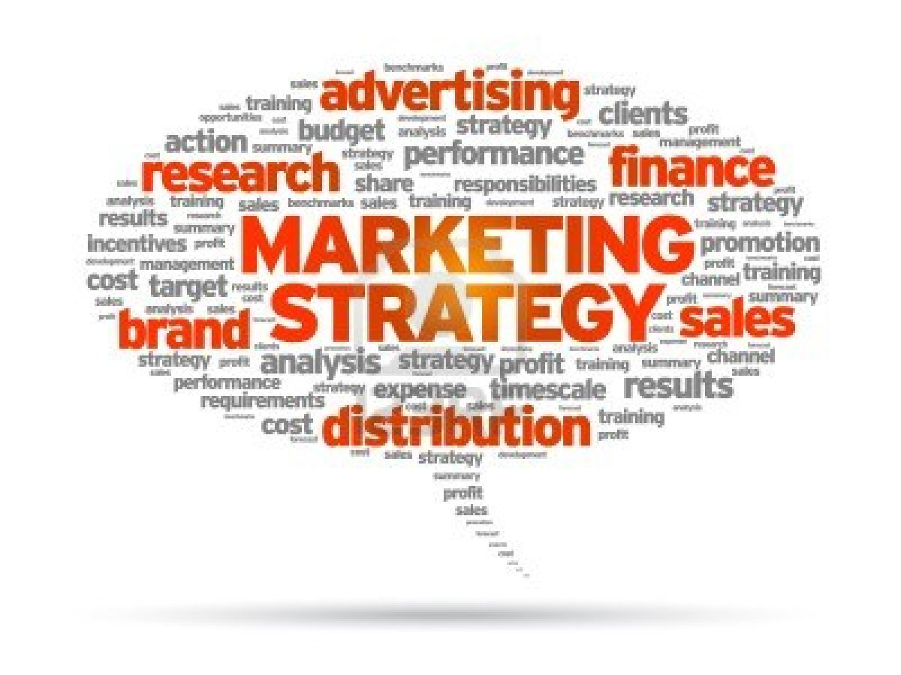
This Photo by Unknown Author is licensed under CC BY-SA-NC

Student name: NIKOLAY TERZIEV
Student ID: 2028389
BUSINESS MANAGEMENT
Lecturer: Umar Sadaat
Module: MARKETING FUNDAMENTALS

Module code:LCBB4004

Contents
Introduction 3
What is marketing? 3
Mission and corporate objective 4
Ensure Food Security 4
Support Local Communities 4
Maintain Supply Chain 4
Ensure Business Continuity 4
Enhance Food Safety and Quality 4
Adapt to Changing Consumer Preferences 4
Strengthen Relationships with Suppliers and Partners 4
Enhance Online Presence 4
Optimize Cost Efficiency 4
Foster Sustainability and Environmental Responsibility 4
Situation analysis 5
SWOT Analysis 5
PESTEL Analysis 5
Political 6
Economical 6
Social 6
Technological Factors 6
Environmental Factors 7
Legal Factors 7
Marketing plan 7
Marketing Mix 8
Dual Distribution strategy 8
Implementation and Control 9
References 10

Introduction
In this case study, I examine the challenges faced by farmers in the local food chain in Quebec, Canada, and the adaptation strategies farmers are using to cope with the pandemic. I focus on the resilience of local farmers and how they have adapted to the challenges of the pandemic. It provides practical information and recommendations for creating a marketing plan that adapts to difficult times. The aim is to highlight the importance of flexibility and the stages of the marketing process.

What is marketing?

‘Creating customer value and satisfaction is at the very heart of modern marketing practice’ says Kotler et al. (2015).
The marketing process involves a series of steps that help companies identify, create, communicate, and deliver value to target audiences. Although different models may have specific variations, I will provide an overview of the generally accepted academic stages of the marketing process:
- Mission
- Situation analysis
- Marketing strategy
- Marketing mix
- Implementation and control

Mission and corporate objective

Pearce (1982) said ‘a firm’s mission statement can serve as an invaluable tool in directing the formulation and implementation of strategy’.

Ensure Food Security
Prioritizing the production and marketing of safe and reasonably priced products to meet consumer needs even during the pandemic.

Support Local Communities
Focus on supporting local communities by providing locally produced food, partnering with community organizations, and participating in food assistance programs.

Maintain Supply Chain
Ensuring the continuity of the food chain by implementing measures that protect production, distribution and logistics despite the disruption caused by the pandemic.

Ensure Business Continuity
Maintain business and minimize disruption caused by the pandemic. This can mean strategies to protect workers and adapt production and distribution processes to changing health policies.

Enhance Food Safety and Quality
Prioritize and improve food safety and quality standards to give consumers confidence. This may mean stricter hygiene and sanitation protocols.

Adapt to Changing Consumer Preferences
Monitor and understand changing consumer preferences and adapt products accordingly. This may mean diversifying product distribution or launching new products.

Strengthen Relationships with Suppliers and Partners
Having stronger relationships with business partners. This could mean working closely with them to navigate challenges and maintain a smooth supply chain.

Enhance Online Presence
Having a stronger online presence and e-commerce ability to reach consumers directly and adapt to the increasing demand for online shopping. This could mean optimizing websites, using social media platforms, and establishing efficient online ordering and delivery systems.
This one is especially important because social distancing is ‘leading to a shift to online shopping among many consumers’ according to Hoekstra and Leeflang (2020).

Optimize Cost Efficiency
Optimize cost efficiency and financial strength during challenging times. This could mean analysing and reducing costs, exploring supply chain alternatives, and looking for government support or assistance programs.

Foster Sustainability and Environmental Responsibility
Continue pursuing sustainability and environmental responsibility, which will also give the business a better image. This could mean implementing eco-friendly practices, reducing waste, and engaging in initiatives that benefit the environment and local communities.

Situation analysis

SWOT Analysis
A SWOT analysis is described as ‘an effective situation analysis technique which plays an important role in the fields of marketing’ by Gurl (2017). This is because it provides an overall view of an organization’s status to help strategize by maximizing strengths, taking opportunities, and avoiding or preparing for threats.
Analysis of Strengths, Weaknesses, Opportunities and Threats (SWOT) evaluates the internal and external factors that affect agricultural producers and functions In Quebec, a case study examined the impact of the COVID-19 pandemic on food production and distribution. The researchers identified four main challenges: lack of labour, balance of food supply and demand, changes in sales points and marketing channels, and operational and development problems.

PESTEL Analysis

PESTEL ‘mainly provides a general idea about the macro environmental conditions and situation of a company’ as said by Yuksel (2012), this is very useful because it shows the outside factors affecting a business, not focusing on the inner factors like the SWOT analysis does. This analysis has to do with every factor from political, economic, social, technological, environmental, and legal that can affect the business and by considering these, farmers can gain insights to adjust their strategy and keep in business.

Political
The pandemic led to many regulations of public health and safety, so farmers must follow these to keep people healthy and avoid spread of the virus. Things such as social distancing, sanitation and ensuring workers safety.

Economical
Customers have less spending power than before due to the hit in the economy that the pandemic brought. This economic uncertainty can make people not purchase as many items as before.

Social
People have health concerns due to the virus; any customer needs to be reassured that any transaction will be safe, and that the product is safe by keeping high hygiene standards.

Technological Factors
The government's response to the pandemic affected farmers in several ways. General security measures, movement restrictions and restrictions on food production, distribution, etc. have affected farmers and their ability to adapt to the pandemic and challenges. The pandemic also negatively affected the local economy, affecting farmers, sales, and marketing. Consumers preferences have changed as more people choose to eat locally and support local food systems, opening new opportunities for farmers.

Environmental Factors
The pandemic has shown how important local food systems are, therefore, more people might be supporting local food producers to become less dependent on global businesses which are struggling massively with supply chain issues.

Legal Factors
The case study shows that most of the local farmers interviewed felt they were well prepared and showed resilience to adapt to the challenges posed by the pandemic. This suggests that farmers have implemented their adaptation strategies and implemented monitoring measures to check the effectiveness of these strategies. The steps in the marketing process for Quebec farmers identified in the case study include situational analysis, environmental scanning, competitive analysis, target market selection, marketing strategy development and implementation with guidelines.

Marketing plan

This involves finding out information about the market, competitors, prices, demand, etc. This data is then used to develop marketing strategies by analysing customer needs and behaviour, which helps the business choose a target audience and develop their product to make it more attractive, as well as setting goals for the business. McDonald (2007) says ‘effective marketing planning lies at the heart of a company’s revenue-earning activities.

Marketing Mix

The marketing mix is made up by the four Ps, which are product, price, promotion, and place. This is the stage where marketing campaigns and activities are implemented and ‘it is a fact that the 4Ps marketing mix is a milestone of marketing theory’ says Dominici (2009).
The Ps are as follows:
- Product: these are the product or services the business provides, things from product design to features. This P focuses on understanding customer needs.

- Price: this is the amount customers would pay for the product, factors like production costs and competitor prices are considered when deciding the price.

- Place: this P refers to the distribution channels used to move the product. It’s decisions such as selecting distribution channels and it also considers warehouse management and journey time.

- Promotion: this P is about the marketing activities used to let the world know about the product, to promote it and paint it in a positive light. Things like digital marketing to create awareness and convince customers to buy.

These four Ps together create a solid marketing strategy, they need to focus the intended audience and follow the mission objective to be successful, which will ensure the product is desirable and priced correctly to maximize profit while being affordable. However regular check-ups are necessary as customers give feedback or the market situation changes.

Dual Distribution strategy

The main components of the distribution strategy are: Traditional outlets: Local farmers depended on established outlets such as farmers to reach customers and sell their products directly. This allowed them to maintain relationships with existing customers and interact with them personally. Community Supported Agriculture (CSA): Some farmers have adopted CSA models in which consumers make an upfront financial commitment to receive agricultural products regularly throughout the season. This method brought economic stability to farmers and ensured demand, especially in uncertain times.

Implementation and Control

Implementation and control involve implementing the marketing strategy and focusing on its development to achieve the goal and to identify areas that need re-evaluation. Execution is the execution of the tactics outlined in the marketing plan, allocating tasks and resources as needed and setting a timeline to monitor progress to achieve expected results. Together, these two concepts ensure that the marketing plan is executed as smoothly as possible and that it evolves to remain relevant, allowing the business to stay ahead of the competition.

References

Dominici, G. (2009). From marketing mix to e-marketing mix: a literature overview and classification. International journal of business and management, 4(9), 17-24. Available at: https://papers.ssrn.com/sol3/papers.cfm?abstract_id=1961974 Accessed on 21st June 2023.

GURL, E. (2017). SWOT analysis: a theoretical review. Available at: https://demo.dspacedirect.org/items/a94ef210-25e1-4399-b93e-54930f2ba37f Accessed on 21st June 2023.
Hoekstra, J. C., & Leeflang, P. S. (2020). Marketing in the era of COVID-19. Italian Journal of Marketing, 2020(4), 249-260. Available at: https://link.springer.com/article/10.1007/s43039-020-00016-3 Accessed on 21st June 2023.
Kotler, P., Burton, S., Deans, K., Brown, L., & Armstrong, G. (2015). Marketing. Pearson Higher Education AU. Available at: https://books.google.co.uk/books?hl=en&lr=&id=8TjiBAAAQBAJ&oi=fnd&pg=PP1&dq=marketing+&ots=jffApQB4hZ&sig=Ad1T916y35q1vyjItEREm6I8P3Y#v=onepage&q=marketing&f=false Accessed on 21st June 2023.
McDonald, M. (2007). Marketing plans: how to prepare them, how to use them. Butterworth-Heinemann. Available at: https://books.google.co.uk/books?hl=en&lr=&id=os0K20MsepoC&oi=fnd&pg=PP1&dq=marketing+plan&ots=1noyGBVYkT&sig=ILKu3TphywnOuc7BozjP6FTZE20#v=onepage&q=marketing%20plan&f=false Accessed on 21st June 2023.
Pearce II, J. A. (1982). The company mission as a strategic tool. Sloan Management Review (Pre-1986), 23(3), 15. Available at: https://www.proquest.com/openview/fe21e8a913eee8b86f2d98dcc2197ace/1?pq-origsite=gscholar&cbl=35193 Accessed on 21st June 2023.
Yüksel, I. (2012). Developing a multi-criteria decision making model for PESTEL analysis. International Journal of Business and Management, 7(24), 52. Available at: https://d1wqtxts1xzle7.cloudfront.net/95577340/4ff68ca2f0d11106b9264f51a985ad248d62-libre.pdf?1670779961=&response-content-disposition=inline%3B+filename%3DDeveloping_a_Multi_Criteria_Decision_Mak.pdf&Expires=1687680783&Signature=HXUklglHZ0wfGb7iEWW4iwIRMLRzFt4aqiXDuq1aLMV3-MY4oP~7k7QPnGDa3AyG3dlJpn44PQ7OP8RAEl1Z~oDclEfECPf6o2E0RcHOm3huDeV~AU5XnlXdXG8EIVWmOAnoQp3UZZpcjKy9W8124Ap6GnBSYttYThuE2qcowaNAWRF86OtBWJqJbrJv-WdhPbKVED3TZRnRdTRjE2tUPvx-h~OWQzX7E~aLyddyw6q1~mRvF8hq0VEPWCT4NDGzjkEwFqpiqdMjXBuhPHJe81lMeKwmDaJhXfAk6scSYKs4uPzkOQFav3eaz7SJSTTiLb2aTI~XIDhvNSQNeQ5QXg__&Key-Pair-Id=APKAJLOHF5GGSLRBV4ZA Accessed on 21st June 2023.

