Employee Engagement Proposal: How to Boost Engagement & Staff Retention within Morgans Hotel
Student Name: Catrianna Di Muzio
Student Number: 2021889
Module: Personnel Resourcing & Development
Lecturer: Emily Williams
Module Code: BMIH5005

Executive Summary
This research proposal is based on Morgans Hotel in Swansea. The purpose of this proposal is to outline the issues within the hotel, specifically, the issues around staff retention and what action can be taken to resolve said issues. It will discuss how employee engagement is a direct factor in helping the hotel to retain a talented workforce. By considering different methods of primary research and then further secondary research, this report is able to apply several theoretical models to the hotel’s staff. The use of Maslow’s Hierarchy of Needs and the Employee Lifecycle outline issues with engagement and how they can be resolved.
The research proposal concludes that for Morgans Hotel to retain their workforce, it is imperative to collect information directly from employees via questionnaires. Furthermore, by considering the theoretical models in regard to the results, Morgans Hotel will surely be able to attract and retain loyal employees who are fully engaged in their roles.

Contents Page

Executive Summary 2
Introduction 4
Chosen Method of Primary Research 4
Employee Engagement 5
The Employee Lifecycle 6
Maslow’s Hierarchy of Needs 7
Action Plans 9
Conclusion & Recommendations 10
References 11

Introduction
This report will be focusing on Morgans Hotel, a 4-star luxury hotel based in Swansea city centre. Morgans boasts forty-two rooms in total, twenty based in the main part of the hotel and an additional twenty-two situated in The Townhouse opposite. In addition to the rooms there is also a bar lounge, restaurant, and conference facilities. Morgans is a cornerstone in Swansea’s history, the hotel has been established there since the early 20th century (Morgans, ND.).
During the COVID-19 Pandemic, Morgans hotel housed key workers, because of this there was no option but to reduce staff numbers. Many employees were placed on to furlough until it was safe to return to work and the hotel returned to being fully operational (Bannon, 2020).
Following this, the hotel is facing a staffing crisis. Staff shortages brought on by industry issues and furloughed staff members choosing not to return has resulted in retained staff working longer hours and taking on more responsibilities. This has created an increased employee turnover rate and failure to retain skilled staff members.
This research proposal will address the issue of high turnover within Morgans Hotel and how employee engagement has direct links to solving this issue. This will be investigated through a combination of primary and secondary research. Identifying engagement issues following the Coronavirus pandemic will enable the hotel to focus on problems within the work force and decreased employee turnover.

Chosen Method of Primary Research
To gather information on why Morgans Hotel has been struggling with staff retention, it is important to look at staff opinions. A questionnaire has been chosen as the key method of primary research as opposed to face-to-face interviews because it helps staff to be more open and honest in their replies. A questionnaire relieves the pressure that comes with in person interviews. This enables us to gather more reliable information and hear truthful opinions from staff members as well as being free from bias that may be imposed by an interviewer. It also ensures that staff are asked the same questions and have time to process and think about their answers before submitting them (Aryal, 2019). Questionnaires are also the most cost-effective way to conduct research as it does not require the man hours and preparations that an in-person interview would.
Despite all the positives that come with using questionnaires for primary research, they also come with the increased risk that recipients will not respond. To counteract this and ensure full staff feedback is received, each member of staff will have to report to their manager upon completion of their feedback. As the questionnaire will be kept completely anonymous, staff are able to deposit their completed forms in a secure box.
Upon collection of data from employee feedback it is then possible to make the required changes that will enable Morgans Hotel to retain a talented workforce, this will be explored further on in the report.
As the questionnaire will be dealing with sensitive information, including questions pertaining to employees mental and physical health, it is vital that GDRP (General Data Protection Regulation) be taken into consideration. To ensure we follow GDPR we are required to get affirmative consent from employees. All employees will be notified about how their data is being collected and how it will then be used (Hayter, 2018).

Employee Engagement
Employee Engagement can be defined in many different terms. For the purpose of this research proposal, it is defined as the emotional commitment a member of staff has towards the organisation and its values and goals. This means that employees who are engaged actually care about the company that they work for (Kruse, 2012).
Following the Covid-19 pandemic, employee engagement is now more important than ever. This is due to many employees being away from the workplace for an extended period of time which has allowed for a mass disconnect from the business (Kewalramani, 2021).
Employee Engagement benefits a company by:
- Increasing productivity in the workplace (Wickham, 2020).
- Aligning employee goals with that of the organization.
- Retaining talented employees.
- Reducing costs brought on by hiring new employees and current employees working in a more cost-effective manner (Osbourne & Hammoud, 2017, p.53).

The Employee Lifecycle
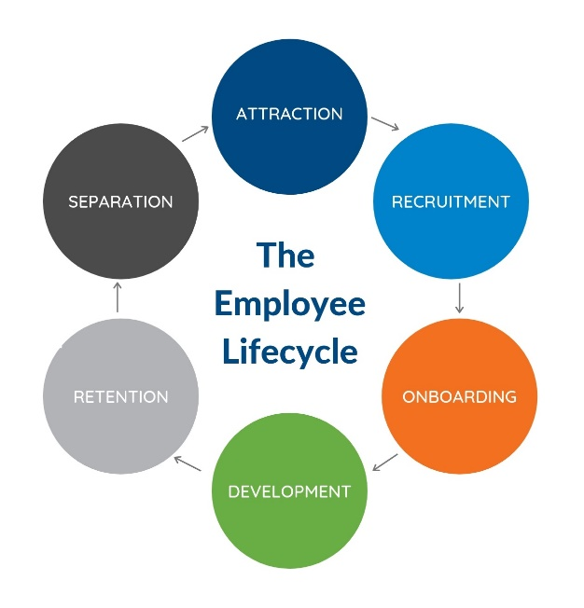
Literature around the Employee Lifecycle can be used as an excellent resource towards employee engagement. By gaining information via primary research, we are able to get feedback that can help us to retain staff throughout the employee lifecycle. Gaining insight from different individuals who are at separate stages in the lifecycle helps us to develop trends.
(Courtney, ND.)
The lifecycle is built up of six stages:
- Attraction- We would not seek to access feedback from potential staff members at this point as it would not be constructive to retaining our workforce. Although Attraction is a key part of the lifecycle and Employee Engagement begins here as it deals with an employees first interaction with the company.
- Recruitment- Certain members of staff will naturally have higher levels of engagement in comparison to others, this is why recruitment is an important part of creating an engaged and motivated workforce (CIPD, 2021).
- Onboarding- Feedback is important at this stage as it helps us to understand what first attracted an employee to our company. It will also highlight what aspects of the job role or organisation failed to meet up to their expectations. Employees are the most engaged at this stage so it is important to keep expanding their engagement through the next stages of development and retention.
- Development- Employees who feel they are invested in are far more likely to be engaged in their jobs and thus are more loyal to the company and provide better results. Gaining feedback from employees at this stage of the lifecycle will prove invaluable as it will highlight any weaknesses and strengths Morgans Hotel possesses.
- Retention- Long-term employees are likely to go through stages where their engagement levels rise and fall. Statistics show that engagement levels tend to drop after around 4-6 years (Cattermole, 2019). To ensure that does not happen it is vital to be flexible with current employees and work around their needs where possible, this promotes loyalty and helps to retain top talent. It is also important to be able to offer them new challenges and opportunity for growth within the company. Feedback at this stage can help to influence choices made at managerial levels that will benefit loyal staff.
- Separation- It is important to maintain healthy relationships with staff that leave employment within Morgans Hotel. This is because they may want to return at a later date and they will provide positive feedback when asked about the company. Gaining feedback from employees wishing to leave the business can be insightful into what changes could have been made to help retain staff.

Maslow’s Hierarchy of Needs
Maslow’s Hierarchy of Needs is a 5-tiered model of motivational theory. Depicted in a triangle, the five levels are Physiological, Safety, Belongingness and Love, Esteem and Self Actualisation needs. It pertains to an individual’s psychological needs and states that in order for an individual to climb further up the pyramid they must first satisfy the needs that relate to that tier (McLeod, 2018).

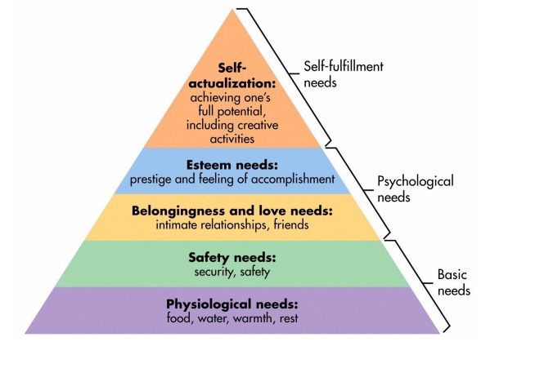 (McLeod, 2018)
Applying Maslow’s Hierarchy to the workforce can help to understand the needs and wants of the employees. Only once these are understood can Morgans Hotel build an engagement plan that will help to both attract and retain staff members.
The first level of the pyramid is Physiological needs, to apply this to the workforce this means having a comfortable work environment and access to essential facilities as well as regular pay.
The next level relates to Safety needs, arguably one of the most important in the current job market due to furlough and many staff members being made redundant. Employees need job security to feel safe within their job role, this can be implemented in the way of clear and concise contracts (Brown, 2021). It is also important that there are procedures in place to protect employees should they become ill, need to isolate, or test positive for Coronavirus. Safety needs also includes health and safety measures implemented within the hotel to protect employees, this can come in the form of social distancing and mandatory mask use.
Social needs are also vital in engaging a workforce. Mental health issues are at an all time high following the national lockdowns and many have gone without human contact for extended periods of time (Panchal et al, 2021). To fully immerse employees back into the social aspect of work, team building exercises must be implemented. As well as this, employee engagement tactics such as staff parties can also help to reintegrate staff members.
Self-esteem needs are on the penultimate level of the pyramid, this is where praise and recognition comes in. To successfully retain staff members, recognising their hard work and rewarding them for it is crucial. The effects of workplace praise are well documented and it is proven to make employees more productive and breeds loyalty within a company (Blues Perspectives, 2021).
Self-actualisation is the final stage of the pyramid. This is the highest level of personal development, at this stage training, mentoring and opportunities for career progression help employees to become the best they can be. Investing in an employees’ personal development results in more motivated staff and a higher likelihood of retaining and attracting a skilled workforce. 40% of employees who do not receive adequate training leave their job within the first year (Chinn, 2016). Morgans Hotel must invest in its employees to combat the issue of staff retention.
According to Maslow’s theory, those whose low-level needs have not been met will base their decisions on stability and safety concerns. Because of this it is important that lower-level needs are satisfied before attempting to appeal to needs further up the pyramid. This is especially true regarding job stability in the current labour market. To successfully apply Maslow’s Hierarchy within Morgans Hotel, these tactics must be applied consistently (Sodexo, ND.).

Action Plans
Once information has been gathered via questionnaire there must be action plans put in place to remedy the issues that have been identified. Without action plans there would be little point in conducting the questionnaire and employee engagement would remain stagnant or potentially decline (Ryba, 2020).
Creating an action plan comes in five stages:
- Reviewing questionnaire feedback- This is where we will look at the answers and feedback employees have provided. It is important to identify themes and patterns to create a roadmap for progressing.
- Narrowing Focus- Here is where specific areas will be chosen to focus on. From analysing the feedback data, it should be clear to see what areas most need improvement. Once this has been decided it is important to consider which areas will have the biggest impact on engagement.
- Brainstorm solutions- Once areas have been targeted it is then possible to set up focus groups, these groups can brainstorm solutions to solve the highlighted issues.
- Commit to Action- This step is crucial in the action plan. Without established commitments and accountability then those involved can easily lose motivation. This is where the action plan is defined and clear goals are set out.
- Communicate- The most important step to remember, communication. For an employee engagement action plan to be successful it is imperative that all staff members are kept in the loop. By following up with employees and managers involved we can ensure changes are carried out successfully and everyone feels their opinions have been heard and acted on (Bailey, 2017).

Conclusion
To conclude, there are significant issues with staffing within Morgans Hotel, this is due to the impact Covid-19 has had on its workforce. Staff members choosing not to return following furlough has caused extra pressure on remaining employees. This has resulted in a high turnover and failure to retain a talented workforce.
It is recommended that in order to combat this it is essential to gather employee feedback to make necessary changes to engage staff. Questionnaires are the best method to use to gather this information due to its cost effectiveness and the fact it allows for unbiased, honest replies from employees.
Applying information learned through questionnaires to employees needs throughout the employee lifecycles and their motivations as highlighted using Maslow’s Hierarchy of Needs will ensure a fully engaged work force. This ensures that both Primary and Secondary Research is used in combination to achieve the best results for Morgans Hotel. Following through on this by implementing action plans that seek to resolve the issues raised will ensure that Morgans Hotel is able to retain a skilled workforce whose goals align with that of the companies.

References
Aryal, S., (2019), Questionnaire method of data collection, Available at: https://microbenotes.com/questionnaire-method-of-data-collection/ (Accessed on: 05/12/2021)
Bailey, R., (2017). Goal Setting and Action Planning for Health Behaviour Change, American journal of lifestyle medicine, Volume 13, Issue 6, Pages 615–618. https://doi.org/10.1177/1559827617729634
Bannon, C., (2020), Swansea’s luxury Morgans Hotel is staying shut until 2021 as it accommodates key workers, Available at: https://www.walesonline.co.uk/whats-on/whats-on-news/swanseas-luxury-morgans-hotel-staying-19226121 (Accessed on: 05/12/2021)
Blues Perspective, (2021), The Importance of Praising your Employees, Available at: https://www.mibluesperspectives.com/2021/04/14/the-importance-of-praising-your-employees/ (Accessed on: 05/12/2021)
Brown, L., (2021), Job security more valuable to employee retention than pay, survey suggests, Available at: https://www.peoplemanagement.co.uk/news/articles/job-security-more-valuable-to-employee-retention-than-pay#gref (Accessed on: 06/12/2021)
Cattermole, G., (2019), Developing the Employee Lifecycle to Keep Top Talent, Strategic HR Review, Volume 18, Issues 6, Pages 258-262, DOI:10.1108/SHR-05-2019-0042
Chinn, K., (2016), The Importance of Investing in Employee Development, Available at: https://www.go1.com/en-gb/blog/post-importance-investing-employee-development (Accessed on 05/12/2021)
CIPD, (2021), Employee Engagement and Motivation, Available at: https://www.cipd.co.uk/knowledge/fundamentals/relations/engagement/factsheet#gref (Accessed on: 06/12/2021)
Courtney, K., (ND.), Building Engagement at Every Stage of the Employee Lifecycle, [picture], Available at: https://www.cciconsulting.com/building-engagement-at-every-stage-of-the-employee-lifecycle/ (Accessed on: 06/12/2021)
Hayter, N., (2018), What does the GDPR mean for employees, Available at: https://blog.perceptyx.com/what-does-gdpr-mean-for-employee-surveys (Accessed on: 06/12/2021)
Kewalramani, A., (2021), What has COVID-19 taught us about employee engagement?, Available at: https://www2.deloitte.com/mt/en/pages/human-capital/articles/mt-employee-engagement-and-covid-19.html, (Accessed on: 06/12/2021)
Kruse, K., (2012), What is Employee Engagement, Available at: https://www.forbes.com/sites/kevinkruse/2012/06/22/employee-engagement-what-and-why/?sh=452509487f37 (Accessed on: 05/12/2021)
McLeod, S. (2018), Maslow’s hierarchy of needs, Simply psychology [picture], Available at: https://www.simplypsychology.org/maslow.html (Accessed on: 05/12/2021)
McLeod, S. (2018). “Maslow's hierarchy of needs” Simply psychology, 1(1-18). Available at: https://canadacollege.edu/dreamers/docs/Maslows-Hierarchy-of-Needs.pdf
Morgans, (ND.), About, Available at: https://www.morganshotel.co.uk/about.php (Accessed on: 05/12/2021)
Osbourne, S. & Hammoud, M., (2017), Effective Employee Engagement in the Workplace, International Journal of Applied Management and Technology, Volume 16, Issue 1, Pages 50-67. DOI:10.5590/IJAMT.2017.16.1.04
Panchal et al., (2021), The implications of Covid-19 for mental health and substance misuse, Available at: https://www.kff.org/coronavirus-covid-19/issue-brief/the-implications-of-covid-19-for-mental-health-and-substance-use/ (Accessed on: 06/12/2021)
Ryba, K., (2020), How to create an effective employee engagement action plan, Available at: https://www.quantumworkplace.com/future-of-work/employee-engagement-action-plan (Accessed on: 06/12/2021)
Sodexo, (ND.), Applying Maslow’s Hierarchy of Needs Theory to HR Responsibilities, Available at: https://www.sodexoengage.com/blog/rewards-recognition/applying-maslows-hierarchy-of-needs-theory-to-hr-responsibilities (Accessed on: 05/12/2021)
Wickham, N., (2020), Why is Employee Engagement Important? 14 Benefits Backed by Research, Available at: https://www.quantumworkplace.com/future-of-work/14-benefits-of-employee-engagement-backed-by-research (Accessed on: 06/12/2021)

