

Student name: Sarolta Bei
Student ID: 2314149

Module name: Independent Project
Module code: BMHP6020
Supervisor’s name: Bianca Sanfilippo

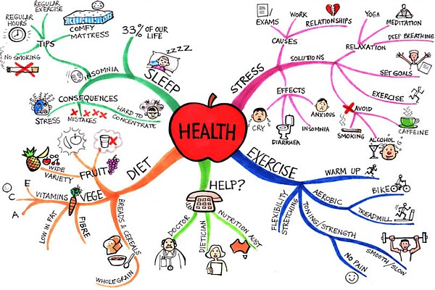 |  | Aim- Exploring How Lifestyle Choices Impact the Brain in UK Adults  To explore how various lifestyle choices, such as diet, physical activity, sleep, substance use, and screen time, affect brain health and cognitive function in UK adults aged 18-65.  Research Method  Research Design  - Secondary research  - Systematic Literature Review  Data Collection  - PubMed  - ProQuest  - Google Scholar  - School Library  Data Analysis  - Thematic Analysis  - Critical appraisal of peer-reviewed studies  - Comparison and synthesis of findings  Keywords  Lifestyle choices, Brain health, Cognitive function, Diet, Physical activity, Sleep, Alcohol, Smoking, Screen time, UK adults |  | 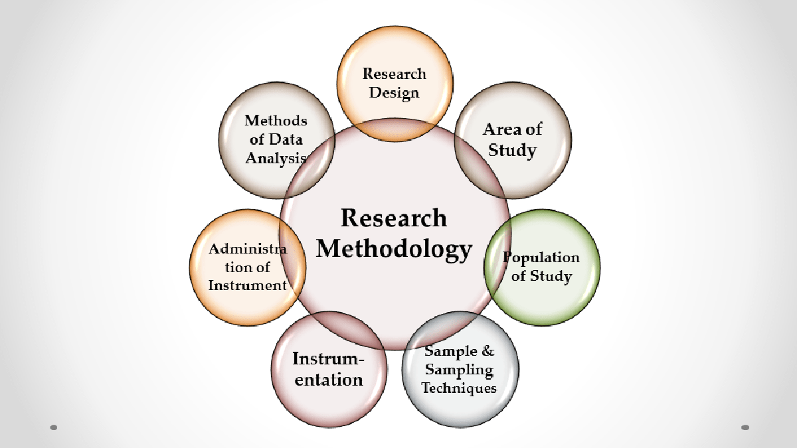
(Mindmapart.com, 2011) |  |  |  | (GOLNNursing, 2020)
2. Research design and Methodology  - Secondary research using a systematic literature review. (Snyder, 2019; Grant & Booth, 2009)  - Reviewed peer-reviewed published studies. (Grant & Booth, 2009)  - Used a transparent, systematic process to reduce bias. (Page et al., 2022; Chandler et al., 2019)  - Applied predefined inclusion and exclusion criteria. (Page et al., 2022)  - Critically appraised study quality. (Chandler et al., 2019)  - Synthesised findings to identify key themes and research gaps. (Aromataris, 2014) |  |  |  | 4, Data Analysis  The selected studies will be analysed using thematic analysis (Braun & Clarke, 2022). This method involves identifying recurring patterns across the literature and organising findings into key themes.  The themes include:  - Diet and nutrition  - Physical activity  - Sleep quality  - Substance use  - Screen time  The findings will then be compared and synthesised to identify similarities, differences and evidence gaps regarding their effects on brain health and cognitive function (Braun & Clarke, 2022; Page et al., 2022)  5. Ethical consideration  As this study uses secondary data from published research, ethical approval is not required because no participants will be recruited.  Ethical principles will be maintained by:  - Using only peer-reviewed academic literature (Page et al., 2022).  - Correctly citing all sources using Harvard referencing (Pears, 2025).  - Avoiding plagiarism (Pears, 2025).  - Reporting findings honestly and objectively (Crespo et al., 2025).  - Respecting academic integrity throughout the review (Crespo et al., 2025).  6. Conclusion  A systematic literature review is an appropriate method for examining the relationship between lifestyle choices and brain health. The findings will provide evidence-based insights to inform future research, public health policy and health promotion strategies.

Data Collection
The literature search will be conducted using the electronic databases PubMed, ProQuest and Google Scholar.
INCLUSION CRITERIA:
- Primary research studies are published in peer-reviewed journals.
- Studies were published after 2015.
- Studies focused on adults aged 18-65
- Studies on adults living in the UK.
- Examining lifestyle factors (diet, exercise, sleep, screen time, substance use) and brain health or cognition.
- Research articles written in English
EXCLUSION CRITERIA:
- Secondary research, reports, books, websites and studies not in peer-reviewed journals
- Studies were published before 2015.
- Studies focusing on non-UK populations
- Studies focusing on individuals diagnosed with neurological or severe psychiatric conditions.
- Participants are under 18 or over 65 years old.
- Studies written in languages other than English.

References
Aromataris, E. and Pearson, A., (2014). The systematic review: an overview. AJN The American Journal of Nursing, 114(3), pp.53-58. Available at: AJN The American Journal of Nursing (Accessed: 5 July 2026)
Braun, V. and Clarke, V., 2022. Thematic analysis: A practical guide. (Accessed: 5 July 2026)
Chandler, J., Cumpston, M., Li, T., Page, M.J. and Welch, V.J.H.W., 2019. Cochrane handbook for systematic reviews of interventions. Hoboken: Wiley, 4(1002), p.14651858. Available at: cochrane-handbook-for-systematic-reviews-of-interventions-2019-1.pdf (Accessed: 5 July 2026)
Crespo, J.E., Rodríguez, I.C.R., de Jesús, F., Mora, V. and Vishwanath, J.E.C.M.B., 2025. The Declaration of Helsinki and the Evolution of Ethics in Medical Research. International Journal of Sustainable Science and Technology, 3(1). Available at: The Declaration of Helsinki and the Evolution of Ethics in Medical Research | International Journal of Sustainable Science and Technology (Accessed: 5 July 2026)
GOLNNursing (2020). Research Methodology | Diploma in Nursing Science and Midwifery - Nursing & Midwifery Gurukul, GOLN. Available at: https://nursinggoln.com/research-methodology/ (Accessed 5 July 2026).
Grant, M.J. and Booth, A., (2009). A typology of reviews: an analysis of 14 review types and associated methodologies. Health information & libraries journal, 26(2), pp.91-108. Available at: A typology of reviews: an analysis of 14 review types and associated methodologies - Grant - 2009 - Health Information & Libraries Journal - Wiley Online Library (Accessed: 5 July 2026).
Mindmapart.com. (2011). Health @ Mind Map Art. Available at: https://www.mindmapart.com/health-mind-map-jane-genovese/. (Accessed: 05 July 2026)
Page, M.J., McKenzie, J.E., Bossuyt, P.M., Boutron, I., Hoffmann, T.C., Mulrow, C.D., Shamseer, L., Tetzlaff, J.M., Akl, E.A., Brennan, S.E. and Chou, R., (2022) The PRISMA 2020 statement: an updated guideline for reporting systematic reviews. Revista panamericana de salud publica, 46, p.e112. Available at: The PRISMA 2020 statement: an updated guideline for reporting systematic reviews - PMC (Accessed: 5 July 2026).
Pears, R. and Shields, G., 2025. Cite them right: the essential referencing guide. Bloomsbury Publishing. Available at: Cite Them Right: The Essential Referencing Guide - Richard Pears, Graham Shields - Google Books (Accessed: 5 July 2026)
Snyder, H., (2019). Literature review as a research methodology: An overview and guidelines. Journal of business research, 104, pp.333-339. Available at: Literature review as a research methodology: An overview and guidelines - ScienceDirect (Accessed 5 July 2026).

