20/03/2023
Sharette Lawrence (2017889)
Lecturer: Joanne Davies
Identifying, assessing, and outlining the Health and Social needs of an elderly person. Profession- Social worker.
Component 2- Report
BMHP6009_BIRM
Table of Contents
Introduction 2
What is old age? 3
Ageing population 3
Background 4
Theories 4
Maslow's Hierarchy 5
The Activity Theory 5
Health and social care needs: 6
Carer 6
Social 6
Medical care 7
Disability 7
Mental Health 7
Personal care 7
Mobility/Accessibility 8
Policy and Legislation 8
Health and Social Care Provision 9
Person-centred care 10
Domiciliary care 10
Conclusion 11
Recommendations 11
Reference list 13
Appendix 19

Introduction
This report discusses health and social care needs of John. Old age and Ageing population are defined and its effect from a health and social care aspect within society. It uses theories such as Maslow’s Hierarchy to structure the needs and aspects of John’s condition and activity and disengagement theory to enhance the use of person centered care. An evaluation of John’s current care needs is disclosed and the relevant policy and legislation available and how they impact Johns provisions. The best and relevant provisions are stipulated along with the current interventions and support available for John. Understanding old age is paramount to understanding how to deal with the ageing population the UK faces.

What is old age?
Ageing is the decline of body functions required for survival and fertility over time (Gilbert, 2019). Ageing involves the accumulation of damaged molecular and cellular impacts resulting in reduced abilities, disease, and death (WHO, 2022). These effects aren't solely related to time or age and most people expect to live into their sixties or beyond, resulting in a rise in the number of elderly citizens worldwide creating an ageing population.

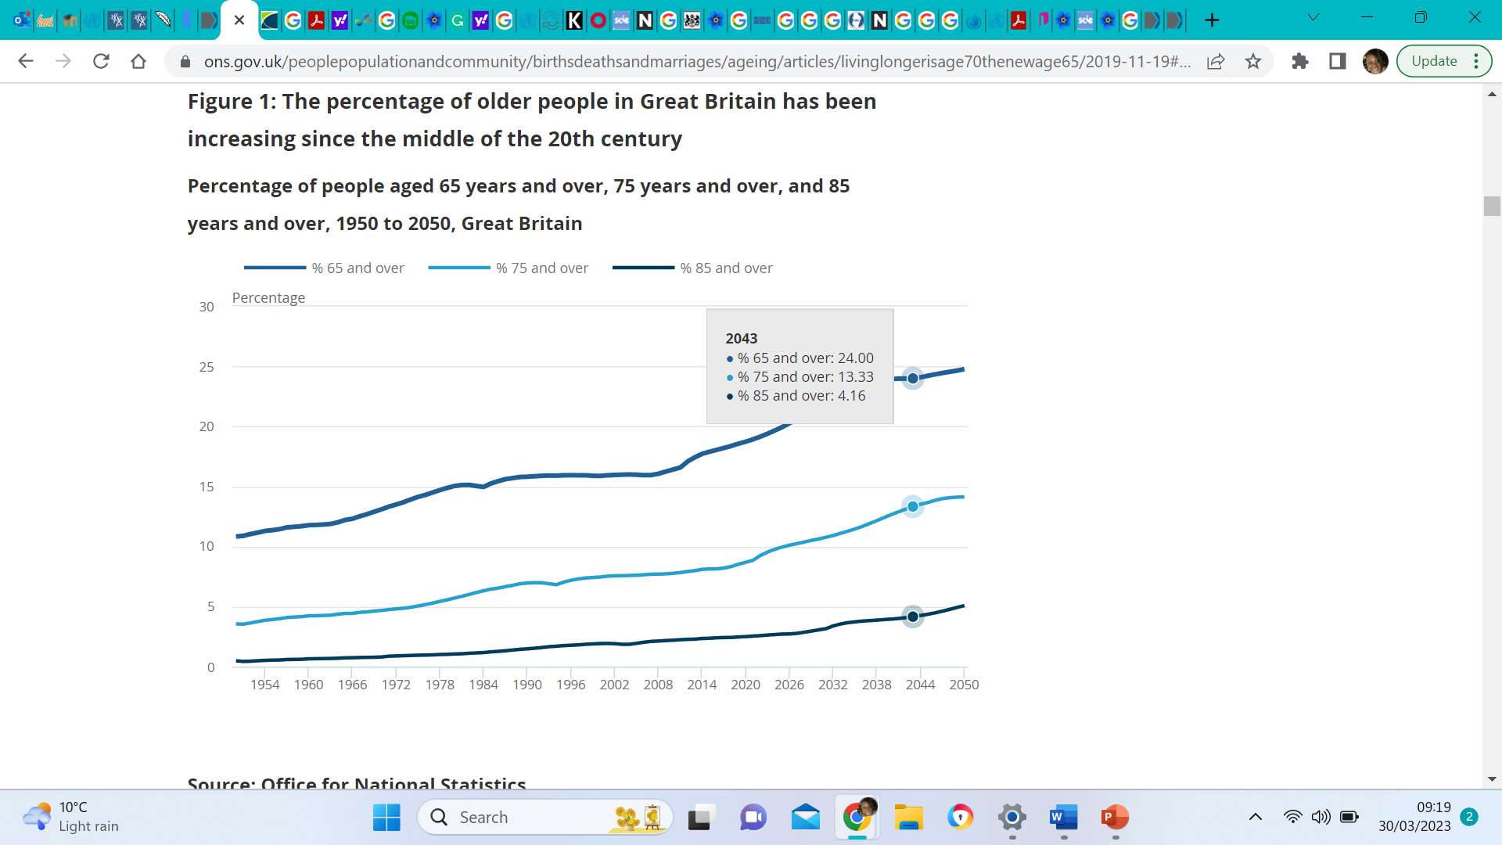 (ONS, 2019b)

Ageing population refers to a change in the age structure of the population, propelled by low fertility rates and falling mortality rates (Government Office for Science, 2016), the population has fewer young people and more older adults over 65. In the UK, 65 years old is considered the starting point of old age (ONS, 2019a), with over 11 million individuals aged 65 or older in England and Wales totalling 18.6% of the total population compared with 16.4% in 2011(ONS, 2022). This has implications for the economy, health and social care services, and society. The UK's life expectancy has increased due to improvements in public health measures, medical advancements, environmental policies and lifestyle changes (King's Fund, no date).

Background
John, a former Marathon runner, aged 87, a grandparent of 4 and husband to Judy 64, of 44 years. He is a member of a local running club and a keen swimmer. He has mild hearing loss in both ears and wears a hearing aid. He lives in an apartment on the first floor of a city centre apartment block. Early-stage dementia was diagnosed after the wife's referral due to repeated misplacement of items and poor orientation. Lockdown measures of Covid-19 heightened social challenges for John as he relied on his social activity for stimulation and pastime. His mood and emotional behaviours have become challenging. Johns deterioration of hearing and problems with orientation leads to him feeling confused.
Dementia is a degenerative syndrome, John with the aid of policy and legislation use by his Health and social team can successfully transition into old age.

Theories
The relevance of theories lies in their potential to explain the reason for John’s behavioural patterns and his corresponding levels of mental and physical well-being. Resultant insights can be leveraged towards the development of a comprehensive support plan for John.

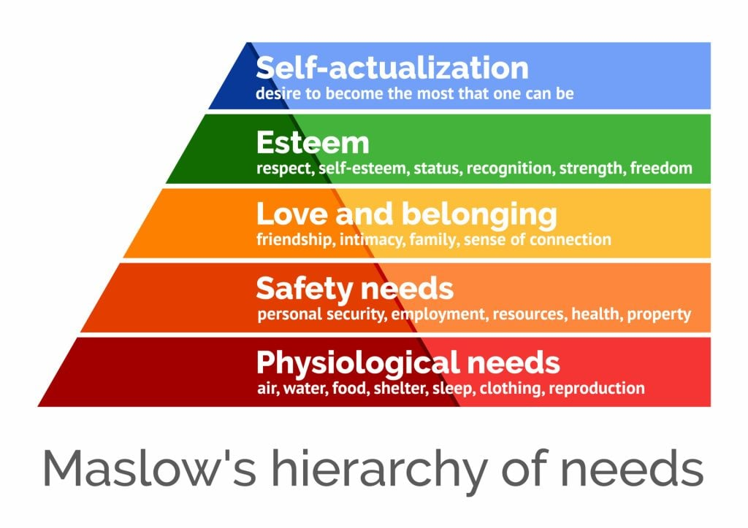 (Mcleod, 2023)

Maslow's hierarchy, the five tiers of human needs, is an infamous theory arranged in order of motivation to achieve. Needs according to Public Health Scotland (2021) can be defined as “the capacity to benefit from services”, those opposed to this theory proclaim that human needs are not hierarchical (Taormina and Gao, 2013). In practice, through needs assessments simultaneously health and social care needs are considered and complement each other. This is done to prevent any domino effects that may arise from unmet needs as they are interconnected. In accordance to Maslows needs pryramid, John’s currently has 2 main needs. Safety due to his poor orientation. Love and belonging as he struggles to find his place in society after covid-19 restrictions have changed his normal routine.
Theory of ageing has no fundamental concept. Psychosocial theories consider mental, emotional and social factors. Disengagement and activity theories reflect the nature vs nurture debate (Physiopedia, 2018).
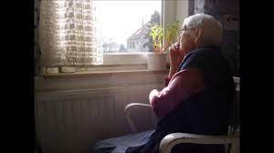
Activity Theory
Disengagement Theory
The Activity theory suggests a person's degree of activity and quality of life have a positive relationship, which increases how favourably a person feels regarding themself and facilitates transition in old age (Diggs, 2019).
Activity in its concept is in totality physical, mental, emotional, and social (Daniels et al., 2013). However, this theory disregards the health and economic inequalities as Buffel and Phillipson (2018) point out. They prevent older people from participating in many activities i.e., Mobility and disposable income.
Granting these two viewpoints are not exclusively restrictive, activity theory and disengagement theory are frequently compared.
Disengagement theory proposes social disengagement is an exchangeable response to ageing whereby older people renounce tasks while sustaining a feeling of amour propre. Ageing results in reduced interaction between ageing individuals and others in the social systems to which they belong, causing an unavoidable mutual withdrawal (Dannefer, 2003). This lack of activity between the generations benefits both the ageing individual and society. Health Research Funding (2017), identifies significantly that this theory in isolation, can cause a lapse of judgment, as withdrawal may be due to discrimination, the onset of certain conditions and or unmet needs.

Health and social care needs:
Mind (2018) states that health and social care can be difficult to distinguish. The NHS provides free healthcare, while local authorities offer social care assistance for everyday duties to maintain independence.
In early-stage Dementia, Alzheimer's Society (no date) maintains, individuals mainly remain independent and engage in activities, and assistance required with daily living is limited. Striving to engage in activities with the individual, such as facilitating the development of a structured routine, creating reminder registers and cues, and utilizing technological tools is the support required.
Carer: The care partner plays a vital role in offering support, companionship, and future decision-making on legal, financial, and long-term care planning. About 75% feel worried about their own health as care partners (Sun et al., 2021).
Social- A care partner can benefit from local resources as well as the patient, such as activities and social groups, advocacy, care and supportive in-home options, information support and advice and transport services (Alzheimer's Society, 2019a). This can reduce anxiety and improve outcomes for all involved.
Scerri, Scerri, and Innes (2018) clarify that love and belonging are the middle ground where the emotional desire for relationships, connectedness, and group inclusion avoids loneliness, depression, and anxiety. Examples include friendship groups, below is a table of the effects of each unmet need as per Maslow’s hierarchy.

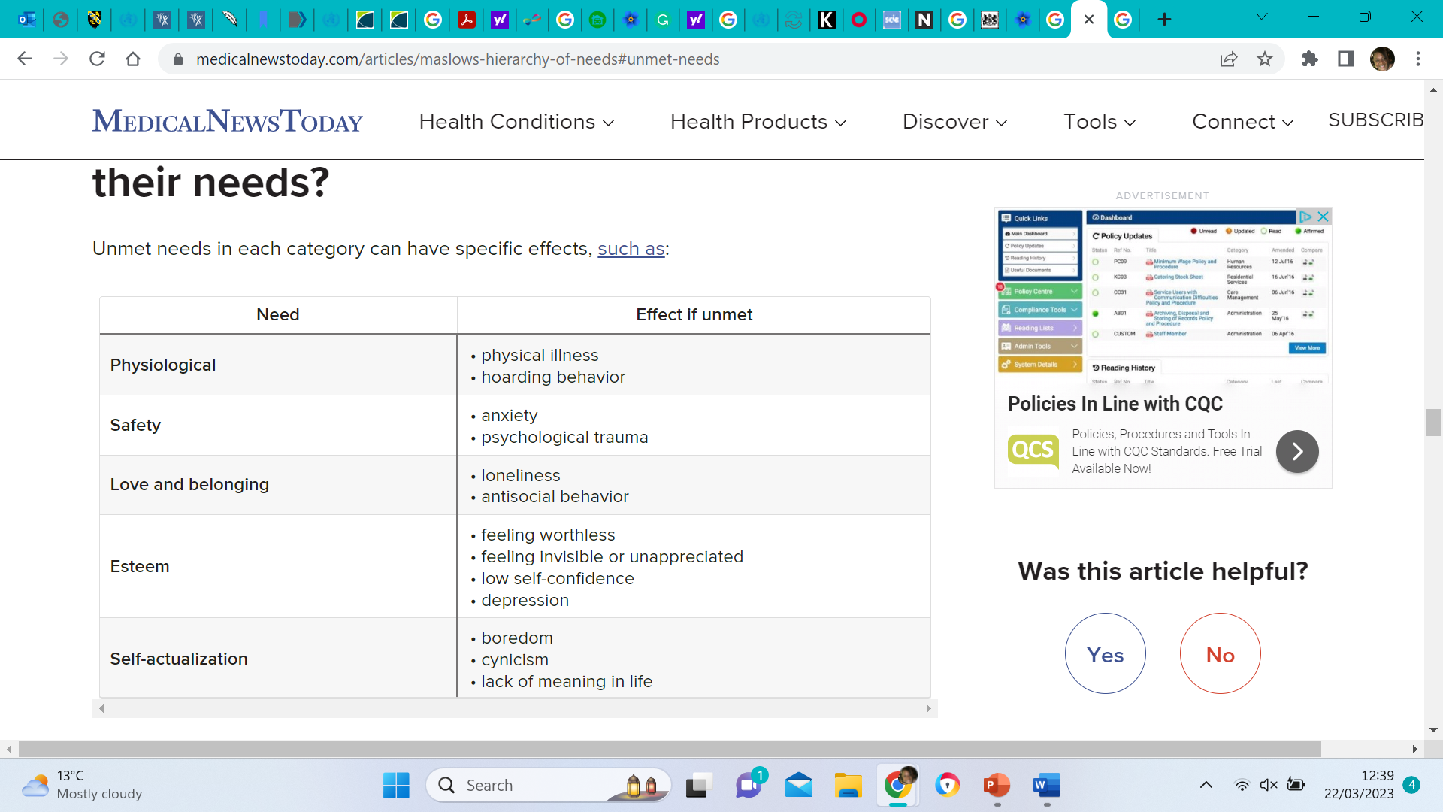(West, 2022)

In John’s case, a lack of interaction with his social groups during the covid-19 lockdown period has created a loss of motivation and feelings of loneliness. Post-lockdown the groups no longer met up as they previously did due to the changes in social distancing regulations.
Medical care – We can determine from Health Education England (no date), the NHS provides healthcare to everyone in the UK based on need, not the ability to pay. NHS staff can be found at hospitals, dentist offices, pharmacies, health centers, GP practices, and even patients' homes. John’s medical needs mostly relate to his hearing loss, and he attends regular hearing clinics to monitor any progression of symptoms.
Disability- John has hearing loss in both ears, nearly half of people over 60 have hearing loss (National Center for Environmental Health, 2020). Hearing loss in older people can cause difficulties communicating, missing technological notifications i.e., alarms, and not understanding healthcare instructions (Jividen, 2022). This can cause John to feel socially Isolated.
Mental Health- John’s behaviour changes toward his leisure centre peers and his family may be due to anxiety. Dementia often causes anxiety, aggravating symptoms that weaken attention, planning, organizing, and decision-making abilities (Alzheimer's Society, 2022a). Mental Health Foundation (2022) highlights, people with dementia often experience anxiety and or apathy meaning they are usually not motivated to do things they once felt were important.
Personal care- CDC (2022) express the importance of keeping good personal hygiene as it helps prevent the spread of hygiene-related illnesses, by regularly washing the body and hair with soap and water. John currently does not need assistance with personal hygiene. As the condition progresses while at home domiciliary carers can assist as it is a vital but challenging aspect of care. Alzheimer's Society2022b) concedes John may feel embarrassed or self-conscious. Carers must respect his privacy and preferences when helping with personal care matters.
Mobility/accessibility- As Dementia progresses, difficulty, with functioning independently means more responsibilities for the care partner (NIA, 2017). Routines and home settings will have to adapt, and structure will become more important. The local authority provides direct support, and equipment or arranges for home adaptations if needed (Alzheimer's Society, 2021). John lives in an over-50s accommodation that is purpose-built for accessibility, with features including mirror-free lifts and sloped entrances.

Policy and legislation
People living with dementia have the right to equal access to community services, information, health, transport, housing, and communication. They should also have accessible information and support to participate in decision-making.
Human Rights Act (1998) empowers John, so his 10 basic human rights are not hampered. Dementia patients deserve support to participate in their communities, as outlined by human rights. This requires government and other agencies to improve engagement and interactions (Age UK, no date). Full participation in matters of interest is John’s right.

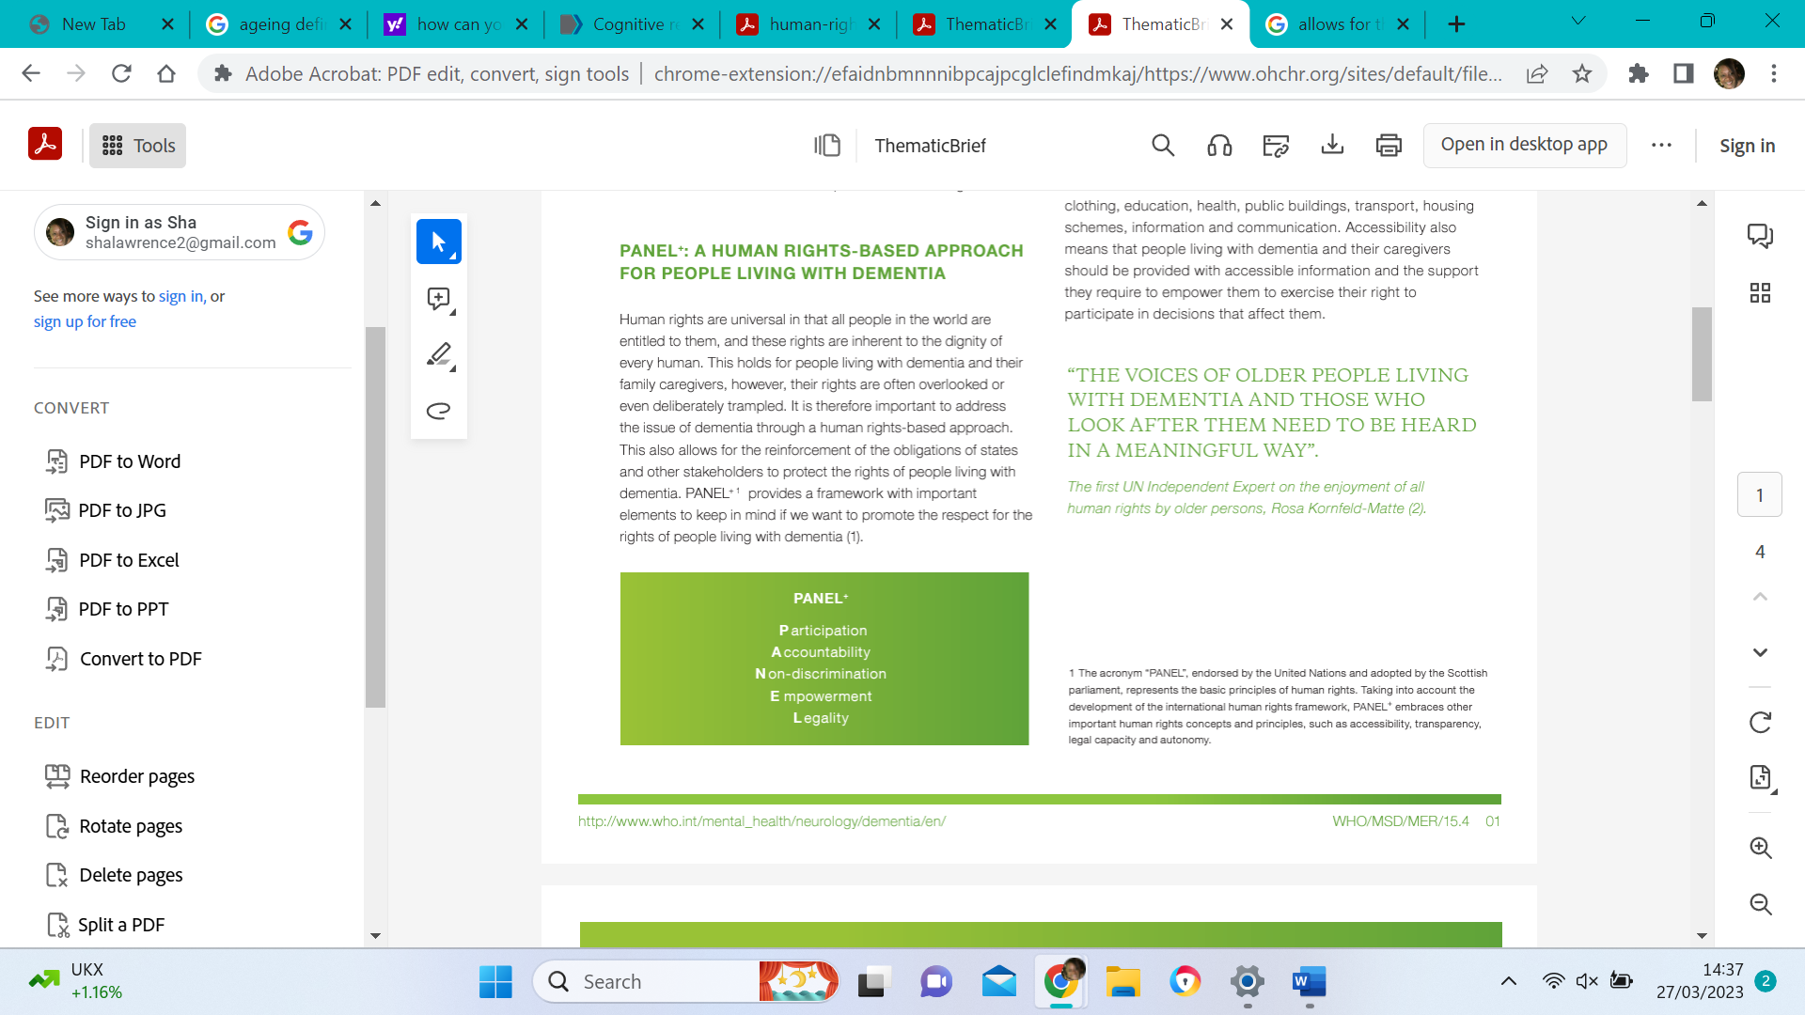 (OHCR, 2018)
PANEL is a Human Rights-based Approach for people living with dementia that reinforces obligations to protect dementia patient rights by providing a framework for promoting respect and equality. (OHCHR, 2018)
People with dementia are protected from discrimination by the Equality Act 2010 and Disability Discrimination Act (DementiaUK.org, 2020). Dementia is a disability that The Equality Act (2010) covers as a protected characteristic.
The six principles of The Care Act (2014) are applicable in all care settings but enable John to stay independent for as long as possible. They include Empowerment and supporting informed consent, as well as Prevention, Proportionality, Protection, Partnership, and accountability (SCIE, 2020) across his complete care team including his wife and or advocate.
Both national and regional NHS policies will ensure John has access to the health care that he needs, and his wife is involved in decision-making with care plans.
Due to the nature of John’s condition preventative discrimination acts such as Section 44 Mental Capacity Act 2005 “wilful neglect or ill-treatment of a person lacking capacity” (GOV.UK, 2023a) and Section 127 Mental Health Act 1983 “ill-treatment of a patient with mental disorder” (GOV.UK, 2023b) will protect him so his advocate can “be focused on maintaining the person's comfort and dignity, and any symptoms” (NICE, 2015) while making the best decisions for John and his care needs.

Health and Social Care Provision
Health and social care provisions are defined by Prince's Trust (no date) as “any organisation or service which helps people live more independent, healthier lives” which are mainly run by the government via local authorities and consist of clinical and non-clinical roles within the health and social care sector.
According to NHS England (2022), Organisations use various methods when working with communities based on their goals and circumstances. It's crucial, to begin with, an understanding of community needs and partnering with established connections supporting health and social care ensuring person-centred care as the main framework in the delivery of provisions.
Person-centred care begins with the character of the person. It centres on their individual history, qualities, and their aspirations. Using knowledge of John’s active lifestyle in the past to support him presently and help in arranging future support is key. (SCIE, 2017). This starts with an assessment of needs.
Coulter and Oldham (2016) suggest a culture change is needed to achieve this, Moore et al. (2016) identify three categories of barriers: traditional practices and structures, sceptical and stereotypical attitudes, and factors related to the development of person-centred interventions.
Customising support and services for John and Judy can improve their quality of life. (Bakker et al., 2014). Assessing John’s unmet social needs will improve health-related quality of life and is vital for personalising care in early-stage dementia.
John’s current needs can be best assisted with dementia assistive technology. Technology can enhance independence, safety, and activity (Alzheimer's Society, 2019a). This type of provision can also be blended into domiciliary care planning.
Domiciliary care- is defined by UK Care Guide (2021) as the range of services put in place to support an individual in their own home.
John currently does not need this service; however, future needs of this provision include household tasks, personal care, and other domestic services to maintain an individual's health, hygiene, dignity, safety, and ease at home (Department of Health, 2015). The graph below shows the latest statistics of the UK gap in provision between receipt of service and the need for the service peaking at 23% in lower income brackets.
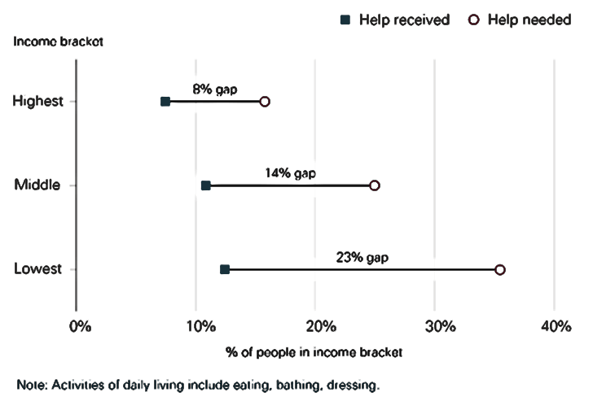.
The main cause of the shortfall is due to society's less desirable regard for social care staff and unequal pay levels (Macdonald, 2020). To address these shortfalls consecutive governments have implemented provisions aimed at addressing insufficiencies in the NHS and adult social care sector. These consist of commissioning NHS England to construct a long-term workforce scheme, issuing a white paper on the alteration of adult social care ‘Build Back Better’, and consenting to salary increases (GOV.UK, 2022). Ongoing efforts focus on addressing the shortfall.

Conclusion
Although some variances in older people's health are inherited, according to Abdi et al. (2019) older adults face a range of physical, social, and psychological challenges as a result of living with Dementia and require care and support in three fundamental areas. 1) social activities and relationships; 2) psychological health; 3) Activities related to mobility, personal care and family life. Care needs differ person to person and are best addressed using a person-centred care plan framework adaptable to changes in circumstances. Legal obligations for organisational and individual behaviours and cultures should ensure that John’s dementia will not prevent him from participating within his community. Support should be tailored with the consideration of activity theory to promote empowerment for John and Judy in present, and future care planning.

Recommendations
There is a need to promote positive ageing and quality of life for the ageing population in the UK.
The first recommendation is the need to adapt an activity theory framework to all elderly care. Almalki, Gray and Martin-Sanchez (2016) maintain this approach will benefit the ageing population of today and the future. A possible barrier to this implementation may be due to a lack of activity planning. To overcome the barrier legislations may need to be created to support this framework.
The second recommendation is the improvement to domiciliary worker benefits, training, working hours, support, salary, and stigma. Stigma poses the biggest barrier to reducing the shortfall. This can be overturned using existing connections such as CQC to survey and review public ideas of domiciliary care and improve the style of marketing and advertisement for the roles within the sector. Another defeat to this barrier is to gain higher salary approval from government funding within this sector.
Thirdly the use of assistive technology like tracking devices in PCC plans to promote safety and independence. As a barrier to implementation, this technology may face resistance initially and may require operator training. Training all health and social care staff in assistive technology use and partnering with charities such as Dementia UK will help overcome barriers for those struggling.

Reference list
Abdi, S. et al. (2019) ‘Understanding the care and support needs of older people: a scoping review and categorisation using the WHO international classification of Functioning, disability and health framework (ICF)’, BMC Geriatrics, 19(1). Available at: https://doi.org/10.1186/s12877-019-1189-9. (Accessed: 21 March 2023).
Age UK (no date) Human Rights and Dementia. Available at: https://www.ageuk.org.uk/globalassets/age-scotland/media/lct-publications/human-rights-and-dementia-pdf.pdf. (Accessed: 25 March 2023).
Almalki, M., Gray, K. and Martin-Sanchez, F. (2016) ‘Activity Theory as a Theoretical Framework for Health Self-Quantification: a Systematic Review of Empirical Studies’, Journal of Medical Internet Research, 18(5), p. e131. Available at: https://doi.org/10.2196/jmir.5000. (Accessed: 21 March 2023).
Alzheimer's Society (2019a) Find support near you, Alzheimer’s Society. Available at: https://www.alzheimers.org.uk/find-support-near-you. (Accessed: 21 March 2023).
Alzheimer's Society (2019b) Using Technology to Help with Everyday Life, Alzheimer’s Society. Available at: https://www.alzheimers.org.uk/get-support/staying-independent/using-technology-everyday-life. (Accessed: 21 March 2023).
Alzheimer's Society (2021) Organising and Reviewing Care and Support | Alzheimer’s Society, www.alzheimers.org.uk. Available at: https://www.alzheimers.org.uk/get-support/legal-financial/organising-reviewing-care-support#content-start (Accessed: 22 March 2023).
Alzheimer's Society (2022a) Anxiety and dementia, Alzheimer’s Society. Available at: https://www.alzheimers.org.uk/about-dementia/symptoms-and-diagnosis/anxiety-dementia. (Accessed: 21 March 2023).
Alzheimer's Society (2022b) How does dementia affect washing and dressing? | Alzheimer’s Society, www.alzheimers.org.uk. Available at: https://www.alzheimers.org.uk/get-support/daily-living/washing-dressing. (Accessed: 21 March 2023).
Bakker, C. et al. (2014) ‘Unmet Needs and Health-Related Quality of Life in Young-Onset Dementia’, The American Journal of Geriatric Psychiatry, 22(11), pp. 1121–1130. Available at: https://doi.org/10.1016/j.jagp.2013.02.006. (Accessed: 21 March 2023).
Buffel, T. and Phillipson, C. (2018) ‘A Manifesto for the Age-Friendly Movement: Developing a New Urban Agenda’, Journal of Aging & Social Policy, 30(2), pp. 173–192. Available at: https://doi.org/10.1080/08959420.2018.1430414. (Accessed: 21 March 2023).
Centers for Disease Control and Prevention (2022) Personal Hygiene | CDC, www.cdc.gov. Available at: https://www.cdc.gov/hygiene/personal-hygiene/index.html. (Accessed: 21 March 2023).
Coulter, A. and Oldham, J. (2016) ‘Person-centred care: What is it and how do we get there?’, Future Hospital Journal, 3(2), pp. 114–116. Available at: https://doi.org/10.7861/futurehosp.3-2-114. (Accessed: 25 March 2023).
Daniels, H. et al. (eds) (2013) Activity Theory in Practice. Routledge. Available at: https://doi.org/10.4324/9780203609439. (Accessed: 21 March 2023).
Dannefer, D. (2003) ‘Cumulative Advantage/Disadvantage and the Life Course: Cross-Fertilizing Age and Social Science Theory’, The Journals of Gerontology Series B: Psychological Sciences and Social Sciences, 58(6), pp. S327–S337. Available at: https://doi.org/10.1093/geronb/58.6.s327. (Accessed: 21 March 2023).
DementiaUK.org (2020) Dealing with stigma and discrimination against people affected by dementia, Dementia UK. Available at: https://www.dementiauk.org/get-support/living-with-dementia/dealing-with-stigma/#taking-action. (Accessed: 21 March 2023).
Department Of Health (2015) Domiciliary care | Department of Health, Health. Available at: https://www.health-ni.gov.uk/articles/domiciliary-care#:~:text=Domiciliary%20care%20is%20defined%20as. (Accessed: 21 March 2023).
Diggs, J. (2019) ‘Activity Theory of Aging’, Encyclopedia of Aging and Public Health, 1(1), pp. 79–81. Available at: https://doi.org/10.1007/978-0-387-33754-8_9. (Accessed: 25 March 2023).
Gilbert, S.F. (2019) Aging: The Biology of Senescence, Nih.gov. Sinauer Associates. Available at: https://www.ncbi.nlm.nih.gov/books/NBK10041/. (Accessed: 25 March 2023).
GOV.UK (2023a) Mental Capacity Act 2005, Legislation.gov.uk. Available at: https://www.legislation.gov.uk/ukpga/2005/9/section/44/2007-04-01 (Accessed: 21 March 2023).
GOV.UK (2023b) Mental Health Act 1983, Legislation.gov.uk. Available at: https://www.legislation.gov.uk/ukpga/1983/20/section/127#:~:text=127%20Ill%2Dtreatment%20of%20patients.&text=(2)It%20shall%20be%20an. (Accessed: 21 March 2023).
Government Office for Science (2016) Future of an Ageing Population, GOV.UK. Available at:https://assets.publishing.service.gov.uk/government/uploads/system/uploads/attachment_data/file/816458/future-of-an-ageing-population.pdf. (Accessed: 21 March 2023).
Health Education England (no date) Step Into The NHS:: About the NHS, www.stepintothenhs.nhs.uk. Available at: https://www.stepintothenhs.nhs.uk/about-the-nhs#:~:text=The%20NHS%20was%20set%20up. (Accessed: 21 March 2023).
Health Research Funding (2017) Disengagement Theory of Aging Explained - HRF, HRF. Available at: https://healthresearchfunding.org/disengagement-theory-of-aging-explained/. (Accessed: 27 March 2023).
Jividen, S. (2022) Hearing Loss and Dementia: What’s the Connection?, Verywell Health. Available at: https://www.verywellhealth.com/hearing-loss-and-dementia-5209801#:~:text=Age%2Drelated%20hearing%20loss%20is%20not%20reversible. (Accessed: 22 March 2023).
King's Fund (no date) Mortality Rates in the UK, The King’s Fund. Available at: https://www.kingsfund.org.uk/projects/mortality-rates-uk-why-are-improvements-life-expectancy-slowing-down#:~:text=Life%20expectancy%20in%20the%20UK (Accessed: 22 March 2023).
Macdonald, M. (2020) ‘The health and social care workforce gap’, commonslibrary.parliament.uk [Preprint]. Available at: https://commonslibrary.parliament.uk/the-health-and-social-care-workforce-gap/. (Accessed: 21 March 2023).
Mcleod, S. (2023) Maslow’s Hierarchy of Needs, Simply Psychology. Available at: https://simplypsychology.org/maslow.html. (Accessed: 21 March 2023).
Mental Health foundation (2022) Dementia, www.mentalhealth.org.uk. Available at: https://www.mentalhealth.org.uk/explore-mental-health/a-z-topics/dementia. (Accessed: 22 March 2023).
Mind (2018) Health and Social Care Rights Overview, www.mind.org.uk. Available at: https://www.mind.org.uk/information-support/legal-rights/health-and-social-care-rights/overview/. (Accessed: 22 March 2023).
Moore, L. et al. (2016) ‘Barriers and Facilitators to the Implementation of person-centred Care in Different Healthcare Contexts’, Scandinavian Journal of Caring Sciences, 31(4), pp. 662–673. Available at: https://doi.org/10.1111/scs.12376. (Accessed: 22 March 2023).
National Center for Environmental Health (2020) Public Health and Scientific Information, Centers for Disease Control and Prevention. Available at: https://www.cdc.gov/nceh/hearing_loss/public_health_scientific_info.html. (Accessed: 27 March 2023).
National Institute on Aging (2017) End-of-Life care for people with dementia, National Institute on Aging. Available at: https://www.nia.nih.gov/health/end-life-care-people-dementia. (Accessed: 21 March 2023).
NHS England (2022) NHS England» Working in Partnership with People and communities: Statutory Guidance, www.england.nhs.uk. Available at: https://www.england.nhs.uk/long-read/working-in-partnership-with-people-and-communities-statutory-guidance/. (Accessed: 21 March 2023).
NICE (2015) About this information | Information for the public | Care of dying adults in the last days of life | Guidance | NICE, www.nice.org.uk. Available at: https://www.nice.org.uk/guidance/ng31/ifp/chapter/About-this-information. (Accessed: 21 March 2023).
Office for National Statistics (2019a) Living longer: Is Age 70 the New Age 65? - Office for National Statistics, www.ons.gov.uk. Available at: https://www.ons.gov.uk/peoplepopulationandcommunity/birthsdeathsandmarriages/ageing/articles/livinglongerisage70thenewage65/2019-11-19#:~:text=1.-. (Accessed: 21 March 2023).
Office for National Statistics (2019b) Living longer: is age 70 the new age 65? - Office for National Statistics, www.ons.gov.uk. Available at: https://www.ons.gov.uk/peoplepopulationandcommunity/birthsdeathsandmarriages/ageing/articles/livinglongerisage70thenewage65/2019-11-19#:~:text=1.-. (Accessed: 21 March 2023).
Office for National Statistics (2022) Voices of Our Ageing Population - Office for National Statistics, www.ons.gov.uk. Available at: https://www.ons.gov.uk/peoplepopulationandcommunity/birthsdeathsandmarriages/ageing/articles/voicesofourageingpopulation/livinglongerlives#:~:text=The%20population%20of%20England%20and. (Accessed: 21 March 2023).
Office of the United Nations High Commissioner for Human Rights (2018) ‘Dementia: a public health priority’, World Health Organization [Preprint]. Available at: https://doi.org/entity/mental_health/neurology/dementia/en/index.html. (Accessed: 21 March 2023).
ONS.gov (2018) Living longer - Office for National Statistics, www.ons.gov.uk. Available at: https://www.ons.gov.uk/peoplepopulationandcommunity/birthsdeathsandmarriages/ageing/articles/livinglongerhowourpopulationischangingandwhyitmatters/2018-08-13#what-are-the-implications-of-living-longer-for-services. (Accessed: 21 March 2023).
ORC.org.UK (no date) HEALTH AND SOCIAL CARE SERVICES. Available at: https://ocr.org.uk/Images/139863-health-and-social-care-services.pdf. (Accessed: 22 March 2023).
Physiopedia (2018) Theories of Ageing, Physiopedia. Available at: https://www.physio-pedia.com/Theories_of_Ageing. (Accessed: 22 March 2023).
Prince's trust (no date) The Health and Social Care Sector | Health and Social Care Hub | Our Programmes | Help for Young People | the Prince’s Trust, www.princes-trust.org.uk. Available at: https://www.princes-trust.org.uk/help-for-young-people/programmes/health-and-social-care-hub/the-health-and-social-care-sector#:~:text=The%20Health%20and%20Social%20Care%20sector%20consists%20of%20any%20organisation. (Accessed: 22 March 2023).
Scerri, A., Scerri, C. and Innes, A. (2018) ‘The perceived and observed needs of patients with dementia admitted to acute medical wards’, Dementia, 19(6), p. 147130121881438. Available at: https://doi.org/10.1177/1471301218814383. (Accessed: 22 March 2023).
Scotland, P.H. (2021) Understanding needs, www.healthscotland.scot. Available at: https://www.healthscotland.scot/reducing-health-inequalities/understanding-needs. (Accessed: 27 March 2023).
Social Care Institute for Excellence (2017) Introduction to person-centred care for older people in care homes - SCIE, Social Care Institute for Excellence (SCIE). Available at: https://www.scie.org.uk/person-centred-care/older-people-care-homes/introduction?psafe_param=1&gclid=Cj0KCQjww4-hBhCtARIsAC9gR3bayM29owXgKbYMES4OQVI4Y0bhkn8bGVXPcOyYCVyTdToNYsp8njsaAiJXEALw_wcB (Accessed: 29 March 2023).
Social Care Institute for Excellence (2020) What Are the Six Principles of safeguarding?, Social Care Institute for Excellence (SCIE). SCIE. Available at: https://www.scie.org.uk/safeguarding/adults/introduction/six-principles. (Accessed: 27 March 2023).
Sun, Y. et al. (2021) GPS Tracking in Dementia Caregiving: Social Norm, Perceived Usefulness, and Behavioral Intent to Use Technology, scholarspace.manoa.hawaii.edu. Available at: https://scholarspace.manoa.hawaii.edu/handle/10125/71077 (Accessed: 22 March 2023).
Taormina, R.J. and Gao, J.H. (2013) ‘Maslow and the Motivation hierarchy: Measuring Satisfaction of the Needs’, The American Journal of Psychology, 126(2), pp. 155–177. Available at: https://doi.org/10.5406/amerjpsyc.126.2.0155. (Accessed: 27 March 2023).
UK Care Guide (2021) WHAT IS DOMICILIARY CARE 2022 | COSTS | FIND CARE | MEANING, UK Care Guide. Available at: https://ukcareguide.co.uk/domiciliary-care/. (Accessed: 27 March 2023).
West, M. (2022) Maslow’s hierarchy of needs pyramid: Uses and criticism, www.medicalnewstoday.com. Available at: https://www.medicalnewstoday.com/articles/maslows-hierarchy-of-needs#unmet-needs. (Accessed: 17 March 2023).
WHO (2022) Ageing and Health, World Health Organization. World Health Organization: WHO. Available at: https://www.who.int/news-room/fact-sheets/detail/ageing-and-health. (Accessed: 27 March 2023).

Appendix


Age UK fundraiser, John, was the oldest runner at 2018’s Virgin Money London Marathon. Aged 87, John took on the prestigious London event for the 32nd time. John, who began running marathons back in the ‘80s when he was aged 53, has raised an incredible amount since then, hitting more than £40,000 for the Charity. John, who turns 88 in September, is a grandparent to four grandchildren along with his wife, Judy, of 54 years. He is a member of a local running club and is also a keen swimmer and gym-goer. Early-onset dementia was diagnosed after the wife's referral due to repeated misplacement of items and poor orientation. Lockdown measures worsened social challenges for John, his mood and emotional behaviours have become challenging with aspects of his regular group activities.

