CHAPTER ONE – INTRODUCTION
- Background
In the organizational digital transformation (ODT) realm, the success or failure of such endeavors hinges upon a multitude of interrelated factors that necessitate careful examination. Esteemed scholar George Westerman, Senior Lecturer at the MIT Sloan School of Management, aptly described the transformative potential of ODT by likening it to the metamorphosis of a caterpillar into a butterfly. However, he also warned of the consequences of missteps, highlighting that an ill-executed transformation may result in nothing more than a swift caterpillar.
"When digital transformation is done right, it's like a caterpillar turning into a butterfly, but when done wrong, all you have is a fast caterpillar."
In the face of technological advancements and evolving business landscapes, many organizations find themselves confronted with the need for substantial restructuring, changes, and repositioning of their business models and leadership practices (Burmeister et al., 2016; Hanelt et al., 2021). While organizations embrace digital transformation at varying stages and paces, it is evident that most still have a considerable distance to traverse (Hansen & Sia, 2015; Zhu et al., 2006; Zimmermann et al., 2018). ODT is a constantly evolving process driven by the innovative and unforeseeable combination of technologies that shape its trajectory (Ustundag & Cevikcan, 2017). As such, business operators must navigate this transformative journey by ensuring a seamless transition encompassing the entire organization.
The ODT pertains to a comprehensive and strategic undertaking in which an organization capitalizes on digital technologies and capabilities to alter its business operations, models, and culture fundamentally. It encompasses integrating digital tools, technologies, and data-driven methodologies to stimulate innovation, enhance operational efficiency, elevate customer experiences, and attain a competitive advantage in the digital age. Digital transformation encompasses diverse endeavors, encompassing the adoption of cloud computing, data analytics, artificial intelligence, automation, the Internet of Things (IoT), and other emerging technologies (Hanelt et al., 2021). It surpasses the mere implementation of digital solutions. It necessitates a holistic approach that considers the entirety of the organization, including its processes and interactions with internal and external stakeholders.
ODT is not a one-off project; this ongoing journey demands continual learning, experimentation, and adaptation, which primary objective is to enable organizations to adapt to the rapidly evolving digital landscape, seize new opportunities, and effectively address the challenges posed by digital disruption (Westerman, 2016; Zimmermann et al., 2018). This change entails reimagining business models, redefining strategies for engaging customers, optimizing operational processes, cultivating a digital culture, and empowering employees with the requisite digital skills. Ultimately, ODT empowers organizations to transform and flourish in the digital era by harnessing the potential of digital technologies to drive innovation, enhance efficiency, and deliver value to customers (Davenport & Westerman, 2018; Zimmermann et al., 2018).
Historically, numerous organizations have embraced digital solutions, recognizing digital transformation as a significant determinant for gaining a competitive advantage. McKinsey & Company (2018) indicate a success rate of less than thirty percent across various industries. Similarly, the BCG report (2020) reveals that over seventy-eight percent of organizations failed to achieve their revenue generation objectives, while seventy-three percent struggled to deliver business value through ODT. Notably, the COVID-19 pandemic prompted sixty-seven percent of global businesses to accelerate their digital transformation strategies (DTS), with sixty-three percent increasing financial support for ODT, as outlined in the KPMG report (2021).
Numerous authors have grappled with the complexity and challenges of ODT. Extensive research has been conducted to identify factors contributing to its success. The growing number of failure stories and projects spinning out of control, emphasizing the need for organizations to reconsider this intricate endeavor carefully (Brynjolfsson & Hitt, 2000; Markus, 2004). ODT, as its name suggests, involves the comprehensive transformation of an organization's business models, culture, and operational processes by adopting digital tools and technologies, both internally and externally (Zhu et al., 2006; Hartley & Sawaya, 2019). Successful ODT relies on robust leadership, strategic foresight, organizational alignment, and the capacity to navigate the intricacies associated with technological, cultural, and operational factors, and it serves as an innovation strategy that supports business performance through the adoption of new technologies or strengthening existing ones (Davison, 2002; Markus, 2004; Hartley & Sawaya, 2019). Notably, internet, analytical, and mobile technologies have been identified as key technological drivers of digital transformation (Zhu et al., 2006; Berman, 2012; Berman & Marshall, 2014). These technologies profoundly transform organizational activities, competencies, processes, and business models, improving performance. Westerman (2016) emphasizes that developing new competencies in ODT revolves around becoming more agile, people-oriented, strategic in planning, and effective in organizational culture and effectiveness, reflecting a holistic transformational journey pursued to create value.
The strategic process of ODT significantly influences the success of organizational change. This process has predictable and preventable failure factors (Allio, 2005; Hrebinia, 2006). Unfortunately, many organizations overlook the holistic significance of initial planning. Common failure factors within ODT encompass insufficient sustained commitment from top management, inadequate support for ongoing visioning and planning, and diminished team morale and motivation during transformation (Dvir et al., 1993; Lowe et al., 1996; Miller et al., 2004; Gelfand et al., 2012). Effective ODT requires user involvement, proper training by suitable vendors, and alignment with prevailing organizational culture (Grover et al., 1995; Zimmermann et al., 2018). Teamwork, coaching, and individual competence are vital for successful digital transformation in organizations (Vinzant, 1996; Vial, 2019; Tabrizi et al., 2019). Notably, digital transformation transcends technology, as a people-driven process involving integration across various dimensions like talent retention, top management support, leadership, monitoring, and control (Somers & Nelson, 2001; Hofstede, 2006).
ODT's foundation is a human-intensive process fostering interaction patterns across dimensions, focusing on talent allocation over technological capability (Holland, 1999; Sebastian et al., 2020). Leadership propels business projects and mission performance (Kotter & Schlesinger, 1979; Westerman, 2016). KPMG's global survey 'Going Digital’, Faster' (2021) explores how the digital landscape compels incumbents to adopt new approaches. Organizations must draw insights from diverse dimensions to mitigate risks and enhance overall experiences.
- Study Motivation
Organizational digital transformation is a prevailing global trend, impacting companies across various industries with varying degrees of speed and intensity (Markus, 2004; Fitzgerald et al., 2014). While some organizations encounter initial failures during the early stages of transformation, others experience initial success only to face subsequent challenges. Overall, ODT carries significant implications for organizations engaged in general business practice as technological advancements reshape various aspects of our lives, including how consumers engage with products and services (Bharadwaj et al., 2013).
Many organizations aim to streamline this natural progression by embracing a platform mindset, intending to replace existing systems and business models (Fitzgerald et al., 2014). Despite the multitude of proposed definitions and strategies for ODT, the failure rate of such initiatives is at most seventy percent. In the 2021 KPMG Global survey, Miriam Hernandez-Kakol, Global Head of Management Consulting, emphasizes the persistent nature of this failure rate, underscoring the imperative for further investigation and research. However, practical implementation often exposes organizations to barriers and consequences rather than offering a readily available solution framework for managing this technological change (Bharadwaj et al., 2013). According to Deloitte's (2018) Global Human Capital Trends report, just 6% of organizations currently possess leaders capable of effectively navigating digital transformation complexities. In contrast, a substantial 70% of survey respondents express a strong desire for leadership development programs aimed at nurturing digital transformation-related skills. These figures underscore digital transformation's critical importance and maturity in contemporary organizations.
The need for a comprehensive management framework for organizational digital transformation is evident in professional advancement. The absence of such a guide in existing literature is a significant gap driving our research initiative. Nevertheless, lacking a tailored management framework creates a void requiring scholarly attention and practical insight. This research is a dedicated response to professional exigency, aiming to rectify disparities and uncertainties in organizational digital transformation. By examining past experiences, distilling successful methodologies, and learning from failures resulting from a lack of structured guidance, the goal is to provide organizations with a meticulously tailored roadmap. Our aim is to fill an existing void in the literature and empower professionals and organizations with a transformative compass, fostering resilience and strategic acumen in their digital journey.
This framework should offer actionable guidelines considering diverse factors in each digital transformation archetype. Beyond technology, digital transformation requires substantial organizational structure, processes, and culture shifts. These elements are pivotal drivers of change and innovation throughout the transformation journey. As highlighted in the Deloitte report, the importance of a holistic management framework is underscored by the stark contrast between the existing scarcity and the high demand for digital transformation. Embracing a practical process built upon such a framework becomes crucial, providing actionable guidelines for successful implementation and ensuring a lasting competitive advantage in the dynamic digital landscape.
- Organizational Change and Organizational Digital Transformation (ODT)
Organizational digital transformation (ODT) involves multifaceted changes in corporate culture, operational procedures, and the overall business model (DeLone & McLean, 1992), spurred by evolving industries and digitalized intelligent systems. Change management and strategic planning are crucial to achieving successful ODT, encompassing critical phases (DeLone & McLean, 1992; Baer & Frese, 2003; Bharadwaj et al., 2013). ODT entails reevaluating the organization's cultural fabric, embedding technological advancements, and shifting operational methods to agile digital systems (Weick & Quinn, 2004). Simultaneously, the business model transforms to align with the digital age (Brynjolfsson & Hitt, 2000; Sambamurthy et al., 2003; Bharadwaj et al., 2013). This orchestrated process unifies functional units for a cohesive digital transformation.
- Organizational Change
"Every successful organization has to make the transition from a world defined primarily by repetition to one primarily defined by change. This is the biggest transformation in the structure of how humans work together since the Agricultural Revolution." -- Bill Drayton (former visiting professor at Harvard University and Stanford University)
Organizational change within organizational development signifies transitioning from the current to the desired state to enhance efficiency and effectiveness (Fainstein, 2000; Pettigrew et al., 2001; By, 2005), which entails processes like strategic planning, operational methods, structural adjustments, technology, and cultural transformation, influencing the organization over time (Tsoukas & Chia, 2002; Burnes, 2004). Organizations, akin to living organisms, undergo distinct life cycles: newborn, growth, maturity, and decline (Hannan & Freeman, 1984; Tsoukas & Chia, 2002; By, 2005; Mento et al., 2002). Internal and external factors influence each stage, prompting the need for change (Burnes, 1996; Tsoukas & Chia, 2002). Evolution often demands horizontal and vertical adjustments aligning with market demands (Moran, 2000; Mento et al., 2002).
Amid change, organizations confront reconciling contrasting perspectives among diverse individuals, this dialectical evolution stage highlights value differentiation, goal opposition, misaligned interests, and challenging the status quo (Gustafson et al., 2003). Addressing these tensions involves exploring alternative approaches, accommodating diverse stakeholders (Weick & Quinn, 1999; Gustafson et al., 2003). These dialectical factors can significantly differ from market changes, necessitating varied responses (Tsoukas & Chia, 2002; Gustafson et al., 2003). Regardless of organization specifics, achieving business goals remains consistent (Hannan et al., 2004; Burnes & Jackson, 2011; Ai-Haddad & Kotnour, 2015). Organizational change often begins with assessing the market position, competitive landscape, and performance (Kotter, 2012). The teleological change approach involves goal setting, implementation, evaluation, and modification, driven by stakeholders (Barney, 1991; Crossan et al., 1999; Tsoukas & Chia, 2002). Organizations need clarity on goals to identify necessary actions (Javidan, 1998; Hannan et al., 2003; Hrebiniak, 2006), teleological change's success rests on change agents (Bass et al., 2003; Casadesus-Masanell & Ricart, 2010).
The scope and urgency of strategic goals determine organizational change's nature—gradual or revolutionary (Pettigrew et al., 2001; By, 2005). Kurt Lewin's three-stage model—unfreeze, change, and refreeze—provides insights (Burnes, 2004). Unfreezing motivates change, fostering commitment and momentum, this commitment should span all units, engaging members (Burnes, 2011; Ai-Haddad & Kotnour, 2015). Emotional and normative commitments support change more effectively than continuance commitment alone. Lack of results, communication, or decision failures can lead to unsupportive attitudes, highlighting the unfreezing phase (Burnes, 2004; By, 2005). Organizations recognize change needs, plan, integrate, and sustain which this change phase involves transitioning through problem-solving or vision-oriented approaches (Pettigrew et al., 2001; Ai-Haddad & Kotnour, 2015). Refreezing establishes a new structure, culture, strategy, and systems involving behaviour (By, 2006; Jacobs et al., 2013).
Organizational change is intricate and dynamic, spanning dimensions, factors, stages, and approaches (Casadesus-Masanell & Ricart, 2010). Gaining insights into corporate life cycles, managing conflicting perspectives, setting objectives, fostering commitment, and navigating phases enable organizations to prosper (Westerman et al., 2012; Legner et al., 2017). Conversely, digital transformation uses technology to reshape business models, processes, and interactions. It reimagines operations, uses data for insights, and creates new value, revenue streams, and advantages (Westerman et al., 2015; Schallmo et al., 2017; Schwarzmüller et al., 2018).
Digital transformation distinctly centres on strategically integrating technologies throughout an organization. It goes beyond technology adoption; it is holistic, considering technology, people, processes, and culture (Legner et al., 2017; Schallmo et al., 2017). Success requires strong leadership, change strategies, cross-functional collaboration, and a culture of innovation (Westerman et al., 2014; Legner et al., 2017). ODT is specific to using digital tech for innovation, efficiency, and stakeholder value (Berman et al., 2014). However, not all organizational change falls under digital transformation. Change can stem from various reasons, including structural, cultural, or strategic transformations (Cash et al., 2003; Hannan et al., 2004; Fitzgerald et al., 2014). It can be triggered by market shifts, disruptions, mergers, leadership changes, or the need to comply with new regulations. Digital transformation encompasses an intricate balance between technological and organizational aspects, while organizational change extends across diverse reasons and dimensions. Organizational change is an integral element of organizational digital transformation, encompasses a holistic overhaul of dimensions within the organization, integrating digital technologies for fundamental shifts in structures, processes, cultures, skills, and change management (Parviainen et al., 2017).
Sambamurthy et al. (2003) and Westerman et al. (2014) suggest that structural change is crucial in ODT, reconfiguring roles, responsibilities, and reporting lines to align with digital technology's requirements and opportunities. Process change is important too, in redesigning workflows for efficient digital tool use. It involves streamlining and automating processes that integrate solutions for enhanced efficiency and productivity, and cultural change is pivotal in cultivating digital mindsets, innovation, collaboration, and learning (Fitzgerald et al., 2014; Westerman et al., 2014). Skill development equips employees with digital competencies to navigate and leverage technologies (Baer & Frese, 2003; Vial, 2019, 2021). Effective change management practices are crucial too. Strategies encompass planning, communication, stakeholder engagement, and monitoring, ensuring a smooth transition throughout digital transformation (Bharadwaj et al., 2013; Westerman et al., 2014).

- Organizational Digital Transformation
Bloomberg (2018) distinguishes digital transformation (DT) from mere digitalization, noting the need to engage technology and retain workers for true transformation. Digital technology's evolution has profoundly impacted society beyond its military origins. In the late 1950s, Jack Kilby invented the microchip, marking the shift from the analogue to the digital age, termed "Digitization" (Berghaus & Back, 2016). Digitization compresses analogue data into bits, enabling limitless information transfer, dematerialization, and costless reproduction (Bloomberg, 2018). Differentiating digitization and digitalization is crucial. While the former converts are analogue to digital, the latter restructure social domains around digital communication and media (Berghaus & Back, 2016; Bloomberg, 2018). Prior digital transformation literature often focuses on business models (Yoo, 2010; Matt et al., 2015; Parviainen et al., 2017; Schwarzmülle, 2017; Tabrizi et al., 2019; Vial, 2019). However, digital transformation leverages tech for business model shifts, industry change, competition, and core competence sustainability (Loebbecke & Picot, 2015; Hanelt et al., 2021).
Digitalization and digital transformation are closely related but distinct concepts. While both involve IT-enabled transformations leveraging information technologies to create value, digital transformation encompasses multiple dimensions that aim to create a new organizational identity, whereas IT-enabled transformation primarily focuses on supporting existing enhancements (Lucas et al., 2013; Solis & Szymanski, 2017; Wessel et al., 2021). To navigate the digital transformation journey successfully, organizations need to develop a digital mindset, foster a digital culture, acquire relevant skills and knowledge, and cultivate digital capabilities that enable them to effectively incorporate digital technologies and drive performance (Poon & Wagner, 2001; Markus, 2004; Kane et al., 2015; Morakanyane et al., 2017; Shaughnessy, 2018; Matt et al., 2015; Verhoef et al., 2021). In an era characterized by globalization and evolving social trends, industries face intense competition. Therefore, organizations must accelerate their digital transformation efforts to navigate potential hazards and seize opportunities (Kotter, 2012, pp. 168-169; Hanelt et al., 2021).
ODT is a strategic process where an organization leverages digital tech and capabilities to reshape operations, models, and culture (Schumacher et al., 2016). It integrates tools, technologies, and data methods for innovation, efficiency, customer experiences, and competitive edge in the digital era. ODT covers cloud computing, AI, IoT, and more (Kane et al., 2015), surpassing mere solutions to consider processes and stakeholder interactions. Its core objective is adapting to the evolving digital landscape, capturing opportunities, and addressing digital disruption (Sebastian et al., 2020), which involves business model reimagining, customer engagement strategy, process optimization, digital culture, and upskilling (Catlin et al., 2017; Tabrizl et al., 2019).
Digital tech evolution has spurred innovation, software, and platforms, driving economic growth, societal shifts, and communication advances (Loebbecke & Picot, 2015; Schumacher et al., 2016; Parviainen et al., 2017). The Internet, especially the World Wide Web (WWW) in the early 1980s, enables broad access to information and global communication through Hypertext Media Links (HTML) (Berman, 2012; Berghaus & Back, 2016; Catlin et al., 2017). This evolution interconnects activities, implements tech solutions, and enhances business processes (Catlin et al., 2017). Digital strategy is pivotal in driving innovation, efficiency, and software/platform implementation for production, revenue, and value opportunities (Avgerou, 2001; Fitzgerald et al., 2014; Berghaus & Beck, 2016; Parvianinen et al., 2017). As organizations embrace next-gen mobile networks, mobile tech becomes a priority, reshaping industries from projects to strategic planning (Loebbecke & Picot, 2015; Parviainen et al., 2017). Over two decades, smartphones disrupted businesses and daily life, merging digital and physical realms (Stieglitz & Brockmann, 2012; Catlin et al., 2017).
Organizations must proactively undergo a digital transformation for long-term competitiveness in a rapidly evolving landscape shaped by tech advancements (Cascio & Montealegre, 2016). KPMG (2021) projects global digital transformation spending to hit $2 trillion, growing over 60% since 2016 at 16.7% CAGR. BCG (2018) finds that 30% of Global 2000 firms allocate 18% of revenue to it. Additionally, 50% prioritize transformed services, products, and experiences in the next decade. KPMG (2021) underscores the critical roles of digital giants like Google, Facebook, etc., in various activities. Digital transformation goes beyond software and systems, it is transitioning to a digital enterprise via new technologies, enabling new models, processes, and value creation (Bagozzi, 2007; Berman, 2012, 2014; Matt et al., 2015; Berghaus & Beck, 2016; Bloomberg, 2018; Sebastian et al., 2020). Literature categorizes it into Process, Domain, Business Model, and Organizational Culture Transformation across industries.
Business process optimization is a pivotal strategy involving the reinvention of processes to bolster cost-effectiveness, cycle time reduction, and overall production enhancement (Berman, 2012; Berghaus & Beck, 2016). Organizations leverage cutting-edge technologies like data analytics, AI, automation, and SaaS to streamline their back-end operations, generating substantial value (Bloomberg, 2018; Bryson & Anderson, 2000; Gurbaxani & Dunkle, 2019). A prime example of this digital transformation's impact can be seen in Domino's Pizza. Domino's established a robust IT team dedicated to internal digital innovation through strategic investments in digital capabilities. They introduced groundbreaking features such as the "Pizza Tracker," enabling customers to monitor their orders in real-time, and optimized their supply chain management systems to enhance cost management. Over time, Domino's continued to push boundaries. They launched a mobile ordering iPhone application and "Pizza Anywhere," a multi-channel ordering system spanning platforms like Google Home, Amazon Echo, and social media channels. Their innovation extended to pioneering drone deliveries in New Zealand, capturing headlines worldwide. The COVID-19 pandemic prompted the "Domino Carside Delivery Service," which ensures a seamless, contactless experience for customers. These transformative efforts bore significant fruits, propelling Domino's growth from a revenue of $1.43 billion in 2008 to an impressive $4.11 billion in 2020 (National Restaurant Association, 2020). This journey underscores how digital transformation, anchored in business process optimization, can drive remarkable outcomes in today's rapidly evolving landscape.
Amazon is a prime illustration of domain transformation, evolving from an online retail giant into a global leader in cloud computing and infrastructure services, surpassing industry giants like Microsoft and IBM (Bloomberg, 2018; Solis, 2018). Through the development of Amazon Web Services (AWS) in just four years, Amazon harnessed digital innovation and recognized the pivotal role of data in this metamorphosis. This shift emphasizes organizations' need to grasp how technology reshapes products and services, blurring traditional business boundaries and ushering in novel business models with considerable financial impact (HBR, 2016; Bloomberg, 2018). An example of business model transformation is evident in Hong Kong Technology Venture Company Limited, previously known as HKTV (HKEx: 1137). This Hong Kong-based technology firm initially focused on e-commerce. Despite encountering legal battles in pursuit of a free-to-air television broadcasting service license, which was eventually abandoned in the spring of 2018, HKTV pivoted to online shopping and introduced HKTV Mall, a digitally-enabled platform offering lifestyle products. This strategic shift resulted in significant gains, with the company recording an HKD 166 million profit in 2021 (Figure 1 & 2), in contrast to an average annual loss of HKD 224 million between 2016 and 2019 (HKEX). This transformative shift, triggered by adapting to a new business model, highlights the remarkable 390% increment in financial performance spurred by their strategic evolution.
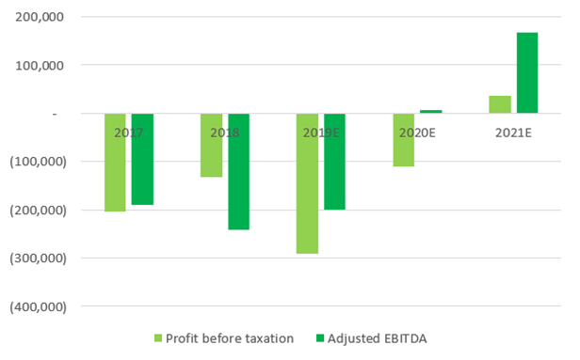
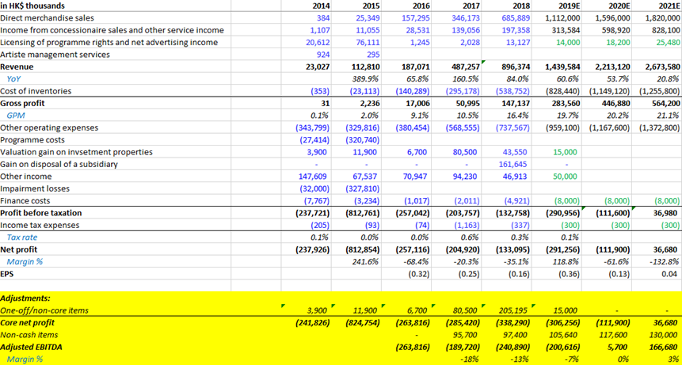
Figure 2: 2014-2021 HKTV financial statement on GP (HKEx: 1137) Sources: HKEx
Figure 1: 2017-2021 HKTV Profit and EBITDA (HKEx: 1137) Sources: HKEX)

Organizational culture is the bedrock of shared values and behavioural norms within an entity, wielding substantial influence over individual actions and collective attitudes (Hofstede, 2001; Burnes, 2004). It functions as a unifying force, directing behaviour towards common objectives, even amid transformative change (Kotter, 2012, pp. 156). However, when organizations undertake digital transformation, integrating new technologies often inadvertently disrupts the existing culture. This scenario frequently unfolds as new visions collide with long-established cultural norms (Weick & Quinn, 1999; Kotter, 2012). Cultivating a culture conducive to innovation and adaptability is one of the most formidable challenges for organizations, particularly concerning operational efficiency (Holland & Light, 1999; Vakola & Nikolaou, 2005). Adopting new technologies necessitates changes in processes, leadership, and employee behaviours that align with the desired cultural shift (Holland & Light, 1999; Vakola & Nikolaou, 2005). However, achieving culture change requires a collaborative effort involving various stakeholders, encompassing leaders, employees, customers, and vested parties. This collaborative process is deeply rooted in strategy, competency, and shared values, often giving rise to inherent tensions and complexities (Lewin & Minton, 1986; Weick & Quinn, 1999; Holt et al., 2007; Jacobs et al., 2013). By embracing and managing these tensions, organizations can navigate the delicate process of cultural transformation during digital upheavals.
Organizational digital transformation represents a paradigm shift in their long-term approach to change, encompassing talent development, capability building, and business process reengineering (Fitzgerald et al., 2014; Ustundag & Cevikcan, 2017). This transformation necessitates flexibility, agility, decentralized decision-making, and a greater reliance on digital technologies to establish a comprehensive business ecosystem (Davison, 2002; Westerman et al., 2011, 2014a; Westerman & Bonnet, 2015; Gurbaxani & Dunkle, 2019). Embracing digital transformation goes beyond the mere adoption of technology; it entails reshaping mindsets and organizational practices to fully leverage the opportunities presented by the digital age (Smith & Tushman, 2005; Burmeister et al., 2016; Catlin et al., 2017). Such a profound organizational change requires careful attention to cultural dynamics and the alignment of values, ensuring that the transformation is effectively integrated into the organization's fabric. By embracing the challenges of culture change and leveraging digital technologies, organizations can position themselves to thrive in an ever-evolving digital landscape.
Digital transformation involves a profound overhaul of an organization's technology and culture to enhance customer value and reshape the business landscape (Westerman et al., 2014b). It comprises an ongoing cycle of digital-driven innovation and operational enhancements that ripple beyond individual firms to influence entire industry ecosystems (HBR, 2014, 2016). While technology is pivotal, it is crucial to acknowledge that digital transformation is intrinsically human-centred, demanding comprehensive integration across aspects like talent management, leadership engagement, and top management support (Somers & Nelson, 2001; Westerman et al., 2011; Tabrizi et al., 2019). Effective integration of these elements empowers organizations to harness resources and drive successful digital transformation initiatives. The core objectives of this organizational change effort revolve around embracing the digital landscape and fulfilling customer expectations in the digital era (Solis & Szymanski, 2017; Tabrizi et al., 2019).
Tabrizi et al. (2019) state that the ODT entails continuous learning and balancing old and new elements. Over the past two decades, seven established practices have emerged to guide this transformation (Cray, 2015; Li, 2020), serving as effective frameworks for driving change and innovation in the digital age. By adopting and adapting these practices, organizations gain the ability to navigate the complexities of digital transformation and excel in the ever-changing digital landscape. Understanding these practices provides valuable insights for organizations embarking on digital transformation journeys, enabling informed decisions, and utilizing best practices for sustainable success in the transformation process.
- Customer Experiences Gap – McDonald's ordering system
  - Create a new customer journey by digital POS (point of sale) platform to improve the in-store ordering process and reduce the customer experience gap.
- Product and Services – Netflix business model transforming.
  - Transform from brick-and-mortar business to online subscription digital media giant and entertainment producer.
- Customer Engagement – Domino's Pizza Tracker and Pizza Anywhere.
  - Pizza Tracker to keep consumers updated on their order.
  - Pizza Anywhere allows customers to place their orders via different social channels.
- Operation and Logistics – UPS ORION, EDGE, and NPT.
  - ORION (On-Road Integrated Optimization and Navigation) to improve the effectiveness and efficiency of the delivery process.
  - EDGE (Enhanced Dynamic Global Execution), to improve the internal operational processes and to avoid any likelihood of a mistake.
  - NPT (Network Planning Tools) to streamline the operating flow and eliminate bottlenecks of delivery transport.
- Economic Model – Dropbox (SaaS domination)
  - Economic and Simple model with digital technology and over 200 million users as a result.
  - Target the mass market by offering free cloud service and upgrade to premium service subscription, so call "FreeMium" model.
- Organizational Infrastructure – Walmart (a hybrid shopping model).
  - From brick & mortar shopping mall model transformed to an online-offline hybrid model with digital technologies to improve business processing and customer experience.
- Education – EdTech for the post-COVID era
  - Leveraging media technologies to develop an online teaching platform during the COVID outbreak.
    - Metaverse has started to bring education into a virtual reality world without classrooms, no campuses, and a 7/24 business model.
The organizational management literature on ODT highlights eight key digital technologies that have driven transformative changes: Mobile Internet (APP), Cloud Computing, IoT, AI, Social Networking, Blockchain, Digital Online Marketing, and Robotics Additive Manufacturing (Setia et al., 2013; Forth et al., 2020b; Kane et al., 2015; HBR, 2016; Parviainen et al., 2017; Sebastian et al., 2020). By integrating these technologies into their corporate strategy, organizations can adopt flexible business models, from traditional to hybrid or fully integrated approaches, to optimize performance, efficiency, revenue, and stakeholder value (Fitzgerald et al., 2014). Organizations effectively navigate the digital landscape by leveraging core competencies and implementing functional architectures and value propositions (Westerman et al., 2011; Setia et al., 2013). These technologies empower organizations to adapt, seize opportunities, enhance performance, and establish sustainable competitive advantages. The researcher's conceptual framework of Organization's Digital Transformation illustrates the interplay between technologies, processes, and people (Figure: 3).
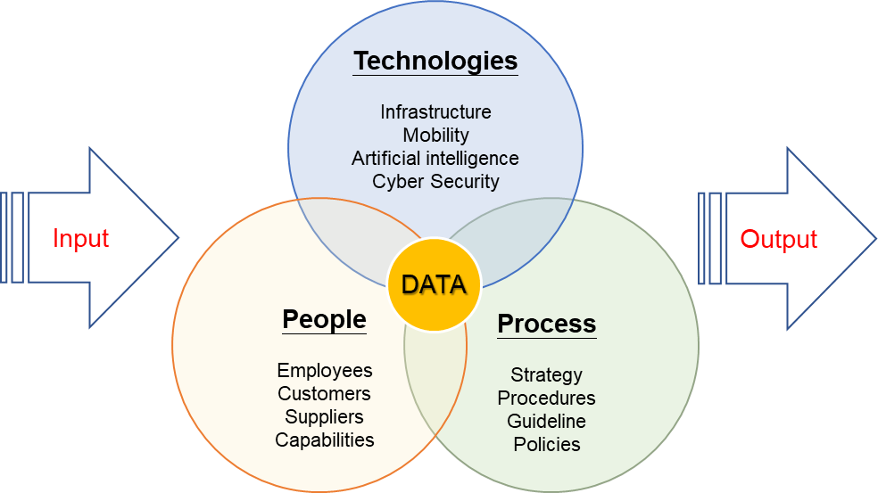

Figure 3: Framework of Organizational Digital Transformation - by author

- Research Questions and Objectives
ODT's rapid advancement is strategically vital for organizations, necessitating tailored adaptation to confront disruptive forces in traditional sectors (Ustundag & Cevikcan, 2017). Standard metrics, including operational and financial efficiency, gauge ODT success. The literature emphasizes four key metrics: operational efficiency, financial performance, customer engagement, and new value creation (Markus, 2004; Zhu et al., 2006; Berman, 2012; Stone, 2018, pp.62-113). McKinsey's Digital Quotient (2015) underscores economic and operational assessment, while the BCG report (2018) highlights user engagement and novel revenue streams' impact on business performance.
This study delves into the intricate landscape of organizational digital transformation (ODT) through five pivotal research questions. It seeks to unravel the complexities of ODT failures, grasp the core challenges organizations face during this transformative journey, and shed light on essential domains that demand careful consideration. The researcher aims to construct a holistic management framework by integrating these domains and key factors. Moreover, it examines effective strategies for adeptly navigating these domains to ensure successful ODT implementation. In the contemporary business landscape, digital transformation has transitioned from optional to imperative, driving organizations to stay competitive and meet evolving customer expectations (Tabrizi et al., 2019). However, the prevalence of ODT initiatives that miss the mark underscores the urgency for comprehensive research to unearth underlying factors and devise pragmatic implementation strategies. By addressing the research above questions, this study strives to contribute to the existing knowledge by providing insights into the critical nuances of ODT (Sambamurthy et al., 2003). It underscores the significance of adopting a holistic management framework to guide organizations through their transformative endeavours.
A holistic management framework is vital for organizations to navigate ODT complexities, integrating diverse dimensions and interdependencies adeptly. This approach systematically incorporates key domains into the transformation process, enabling organizations to tackle varied ODT challenges and enhance success prospects effectively. Through meticulous research and analysis, this study aims to yield insightful outcomes that can shape organizational practices, steer decision-making, and foster strategic ODT approaches. Ultimately, these findings empower organizations to execute digital transformation initiatives more efficiently, attaining lasting competitive edges in the digital age. Our research objectives give rise to the following questions:
RQ1: What are the key success/failure factors of organizational digital transformation?
This question delves into paramount aspects governing the success or setback of an organizational digital transformation. The intricate nature of digital transformation initiatives entails substantial challenges and risks (Fitzgerald et al., 2014; Matt et al., 2015; Parviainen et al., 2017). While the significance of digital transformation in gaining a competitive edge and organizational performance is acknowledged, many entities seek guidance to navigate this intricate journey (Hemerling et al., 2018). This query probes into the determinants influencing the outcomes of such initiatives, aiming to furnish invaluable insights that can guide decision-making, strategy formulation, and execution (Matt et al., 2015; Westerman & Bonnet, 2015). By addressing this inquiry, organizations can discern pivotal success drivers, navigate obstacles, and heighten their transformational trajectories (Hemerling et al., 2018; Zimmermann et al., 2018). This study contributes to the knowledge corpus by enriching comprehension of the elements underpinning prosperous digital transformation, enabling organizations to refine their bolster positive outcomes.
RQ2: What are the key challenges of organizational digital transformation?
This investigation is focused on identifying the primary challenges encountered by organizations in the process of digital transformation. Through an in-depth examination of these challenges, the researcher aims to shed light on the obstacles and understanding of these impediments for organizations to develop proactive strategies for effectively managing the ODT journey. Grasping these impediments is paramount for the existing knowledge base of digital transformation by highlighting organizations' specific challenges and providing recommendations for their mitigation. As the business landscape evolves rapidly, sharing insights into common challenges enables a broader understanding of industry trends and benchmarks (Parviainen et al., 2017). A comprehensive understanding of these challenges enables organizations to allocate resources efficiently, implement appropriate change management methodologies, and devise strategies to mitigate risks, ultimately enhancing the success of their digital transformation initiatives (Schumacher et al., 2016; Bloomberg, 2018). Delving into the key challenges of organizational digital transformation is not merely an academic pursuit but a strategic imperative that empowers organizations to adapt, innovate, and thrive in the dynamic digital landscape (Catlin et al., 2017; Bloomberg, 2018).
RQ3: How can the H domains be managed to achieve successful ODT?
Examining how the heart, head, and hand domains collectively manage Organizational Digital Transformation (ODT) is crucial for a comprehensive understanding of the digital evolution process. This research question goes beyond technical aspects, acknowledging the interconnected roles of emotion, intellect, and action. The researcher seeks to unravel the strategies and practices that empower individuals within an organization to champion and thrive in the digital transformation journey (Birkinshaw et al., 2008; Fitzgerald et al., 2014; Beer & Eisenstat, 2000). It informs decision-makers on navigating workforce skills, communication, and collaboration challenges, ensuring that the human dimension aligns harmoniously with digital advancements. Successful ODT combines emotional alignment, intellectual prowess, and practical execution (Tabrizi et al., 2019; Forth et al., 2020). This approach enables organizations to formulate comprehensive strategies that embrace the multifaceted nature of digital transformation, fostering success in the dynamic digital landscape.
RQ4: What conditions are necessary and sufficient for effectively managing ODT?
This question probes into the necessary and sufficient conditions for effectively managing the ODT, which is a critical inquiry with profound implications for contemporary businesses navigating the digital landscape. This study seeks to uncover the prerequisites for a successful holistic ODT management framework by discerning the interplay of critical factors. The inquiry's significance lies in offering organizations a structured, unified method to navigate digital transformation ventures Matt et al., 2015; Solis & Li, 2018; Stone, 2018). This research advances field understanding by addressing the requisite conditions and supplying actionable insights to organizations striving to optimize their digital transformation journey. Moreover, understanding both necessary and sufficient conditions offers practical insights for decision-makers (Forth et al., 2020; Baker, 2021). It guides them in crafting strategies beyond mere compliance, encouraging a holistic approach that anticipates challenges and maximizes opportunities.
RQ5: How to develop an effective holistic ODT management framework?
The multifaceted nature of ODT necessitates a comprehensive approach that integrates various dimensions, such as a robust and cohesive change management adaptable strategy, which is a linchpin for successful ODT (Kane et al., 2015; Zimmermann et al., 2018). This inquiry delves into formulating an impactful holistic management framework for the ODT. Investigating this query aims to unveil actionable strategies, methodologies, and best practices that guide effective domain management within the 3H domains. Understanding the interplay of these domains is pivotal for a comprehensive ODT approach. By exploring diverse management strategies, the study contributes to a robust, practical ODT management framework, empowering organizations to navigate digital transformation complexities and achieve transformational goals.
This study seeks to uncover the interplay between failure factors (people, technology, and process) in ODT, employing Yu's 3H framework. The framework should include methodologies for assessing and addressing resistance to change, fostering employee engagement, and ensuring a smooth transition. The researcher leverages the findings to guide and address ODT failure reasons, overcoming challenges, embracing key domains, crafting a holistic framework, and adopting effective strategies. These insights are invaluable for organizations venturing into digital transformations in a competitive digital landscape (Tabrizi et al., 2019); Baker, 2021).
- Theoretical Considerations
Integrating Organizational Change Management (OCM), literature enriches understanding of an organization's digital transformation. This literature encompasses multiple theoretical perspectives, such as organizational culture, leadership theories, and change management practices. By tapping into this extensive resource, organizations gain insights into the intricate nature of digital transformation and how to overcome its challenges. In today's dynamic business landscape, the urgency to undertake digital transformation for competitive advantage is evident (Berman & Marshall, 2014; Matt et al., 2015). However, success hinges on a robust management framework that embraces the multidimensional aspects of digital transformation (Hanelt et al., 2021). Yu's 3H model, encompassing Heart, Head, and Hand dimensions, equips organizations with a holistic approach to navigating digital transformation's complexities.
This chapter builds a solid theoretical foundation by exploring relevant perspectives and concepts that shape a comprehensive management framework for digital transformation. By integrating insights from diverse theoretical domains, this study offers a thorough grasp of the factors underpinning successful digital transformation (Steelman et al., 2004; Hanelt et al., 2021). This knowledge advances the field and provides practical direction for organizations navigating digital complexities. Aligning these perspectives with the 3H framework enhances our understanding of digital transformation's multidimensional nature. The Heart dimension emphasizes culture and engagement, the Head dimension centres on strategy and decision-making, and the Hand dimension underscores practical implementation and resource management.
Through thoroughly examining these theoretical considerations, this research sheds light on the complexities of an organization's digital transformation and provides valuable insights for practitioners and scholars. By leveraging the knowledge gained from these theoretical perspectives, organizations can develop a holistic management framework that addresses digital transformation's diverse challenges and opportunities (Steelman et al., 2004). Ultimately, this research contributes to the advancement of the field by providing theoretical guidance and practical recommendations for organizations embarking on their digital transformation journeys. By exploring relevant theoretical perspectives and concepts aligned with the 3H framework, this research aims to establish a solid theoretical foundation for understanding and guiding the complexities of ODT.
- Introducing 3H Framework
Navigating organizational change effectively is crucial (Beer et al., 1990; Armenakis et al., 1993; Burnes, 2004; Burnes & Jackson, 2011). Despite the often-disappointing success rates of change initiatives, organizations must acknowledge that in today's landscape of economic pressures, technological advancements, and fierce market competition, the prospect of "unchanged" is equally fraught (Kotter, 2012, pp.68-74). The concept of change management encompasses a range of strategies, modifications, resource allocation, culture shifts, and behaviour adjustments aimed at elevating business performance (Pettigrew et al., 2001; Appelbaum et al., 2012). The Dragon Boat metaphor is a meaningful framework for understanding the dynamics of an organization (Yu, 2020, 2021). The Heart, Head, and Hand are interconnected and interdependent, much like the elements of a successful Dragon Boat team. Effective leadership fosters a passionate Heart, strategic Head, and skilled Hand, ultimately propelling the organization towards success in the ever-changing business world (Figure 4)

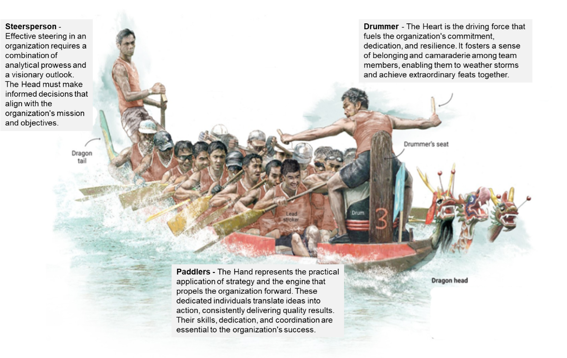

Figure 4: The Dragon Boat as a 3H Framework in Organizational Dynamics - by researcher
Aligned with the 3H holistic management framework theoretical considerations present a comprehensive avenue to guide an organization's journey toward digital transformation. This framework seamlessly integrates perspectives from leadership, organizational culture, strategic management, technology adoption, and process redesign. Doing so fosters a supportive culture, aligns digital transformation with overarching strategy, and streamlines the effective implementation of digital initiatives. By embracing the holistic framework, organizations can adeptly navigate the multifaceted intricacies of digital transformation and bolster their prospects for achieving successful outcomes.
Heart Domain:
The Heart dimension focuses on the human aspect of digital transformation, encompassing elements such as leadership, organizational culture, and change management (Yu, 2020, 2021). Theoretical considerations in this dimension draw on theories of leadership, such as transformational leadership and servant leadership, which emphasize the role of leaders in inspiring and guiding employees throughout the transformation process. Additionally, organizational culture and change theories, such as the Competing Values Framework (CVF), provide insights into fostering a culture that embraces innovation, collaboration, and adaptability (Yu, 2019). By integrating these theoretical perspectives, the management framework ensures that the Heart dimension is adequately addressed, fostering a supportive environment for successful digital transformation.
Head Domain:
The Head dimension centers around the strategic aspects of digital transformation, encompassing elements such as strategic planning, organizational goals, and digital strategy formulation. Theoretical considerations in this dimension draw on strategic management theories, such as the resource-based view (RBV) and dynamic capabilities theory (Yu, 2019). RBV emphasizes leveraging organizational resources and capabilities to gain a competitive advantage through digital transformation. Dynamic capabilities theory highlights the need for organizations to build and enhance their capabilities to adapt to digital disruptions (Zott, 2003; Teece, 2007). By integrating these theoretical perspectives, the management framework ensures that the Head dimension is effectively addressed, aligning digital transformation efforts with organizational strategy and goals.
Hand Domain:
The Hand dimension focuses on the practical implementation and execution of digital transformation initiatives. It encompasses technology adoption, process redesign, and performance measurement. Theoretical considerations in this dimension draw on technology adoption theories, such as the Technology Acceptance Model (TAM), which provides insights into factors influencing individuals' acceptance and usage of new technologies (Agha et al., 2012; Foss & Saebi, 2017). Additionally, theories of process redesign, such as Business Process Reengineering (BPR), offer guidance on redesigning processes to leverage digital technologies effectively. By integrating these theoretical perspectives, the management framework ensures that the Hand dimension is adequately addressed, enabling organizations to implement digital transformation initiatives efficiently (Yu, 2019, 2020).
- 3H Framework in ODT
The significance of digital transformation in the organization (DT) lies in its crucial strategic importance and its capacity to address new disruptive elements that have the potential to impact traditional sectors profoundly (Ustundag, 2017, pp. 13-25). Adaptation becomes imperative for companies as they navigate the challenges of this competitive landscape, necessitating personalized approaches to meet the demands of this dynamic environment. Standard metrics tracking operational and financial efficiency serve as vital indicators for evaluating ODT success, with existing literature proposing four key measurement metrics to assess an organization's digital transformation performance (Markus, 2004; Zhu et al., 2006; Berman, 2012; Stone, 2018, pp. 51-74).
Organizational digital transformation represents a change involving strategy, technology, human resources, knowledge, and competency to gain a competitive advantage (Poon & Wagner, 2001; Markus, 2005; Matt et al., 2015; Morakanyane et al., 2020). However, prior literature often generalizes terms related to digital transformation, such as company assets, organizational resources, core capability and competence, digital leadership, and organizational structure and culture. More explicit explanation within the relevant management framework is needed to ensure a comprehensive understanding of theories on competitive advantage. The present study aims to integrate conceptual management theories, practices, and other related perspectives to provide a holistic view that enhances the efficiency of ODT.
Over the past two decades, numerous scholars have proposed various management frameworks for organizational digital transformation. Regrettably, these frameworks have predominantly focused on technological perspectives and process implementation, which, according to industry reports, have contributed to many failure cases. In contrast, the 3H framework offers a managerial perspective that combines leadership theories with fundamental human natural competency management practices. This comprehensive framework can enhance organizational performance, effectiveness, efficiency, and competitive advantages (Yu, 2021). Each domain within the 3H framework represents distinct managerial decisions, and their integration may introduce different degrees of weakness and deficiency, consequently influencing organizational performance (Yu, 2020).
- Organization of Thesis
This study of an organizational digital transformation investigates the strategic adoption and integration of digital technologies within an organizational context. It explores the impact of digital tools, platforms, and data on organizational change, efficiency, innovation, and adaptation. This research aims to uncover the factors, challenges, and strategies influencing successful digital transformation initiatives, contributing to managerial practices and our understanding of digital technologies' transformative power in organizations. The organization of this thesis is as follows.
Chapter One lays the groundwork for examining organizational digital transformation. It contextualizes technology's growing role in today's competitive business realm, establishing the research problem, objectives, and guiding questions. It underscores the study's importance by addressing gaps in current literature and potential contributions. Additionally, the chapter outlines the thesis structure, offering a preview of upcoming sections. This foundational chapter introduces the research focus and provides a framework for scrutinizing organizational digital transformation.
Chapter Two conducts an extensive literature review and theoretical exploration to lay the foundation for the proposed 3H framework architectural model in organizational digital transformation. It thoroughly dissects each domain of the 3H framework, revealing their interconnections and architectural flow. Additionally, the chapter compiles parameters and formulas from relevant models, underlining this study's unique contributions compared to existing works. Each section critically evaluates pertinent models, emphasizing this research's distinctive advancements. By synthesizing existing literature and highlighting the innovative aspects of the framework, this chapter establishes a sturdy theoretical base for subsequent sections, creating a robust framework for studying organizational digital transformation within the 3H holistic management framework.
Chapter Three outlines the research methodology, detailing the approach, methods, and procedures used in this study on organizational digital transformation. It systematically addresses research questions and objectives to ensure the findings' validity, reliability, and generalizability. The chapter justifies the research design, describes data collection methods, explains analysis techniques, discusses ethical considerations and provides a clear research roadmap. This chapter demonstrates the study's rigour, enabling readers to assess research credibility and robustness.
Chapter Four examines the qualitative analysis of focus group interviews on organizational digital transformation in this study. It details the methodology for collecting and analyzing qualitative data, including research design, participant selection, interview protocol development, and procedures for conducting interviews. The chapter explains data analysis, encompassing transcription, theme and pattern identification, and interpretation. Analytical techniques, like thematic analysis or grounded theory, are justified. The researcher presents key findings supported by illustrative quotes. Emerging themes, sub-themes, or patterns are discussed in depth, interpreting their relevance to research objectives and providing an insightful understanding of the studied phenomenon.
Chapter Five outlines the methodology for collecting and analyzing quantitative data using a survey instrument in this study on organizational digital transformation. It provides an extensive overview of the research design, covering survey questionnaire development, target population identification, and sampling technique selection. The chapter details survey administration procedures, including data collection methods, sample size determination, and data collection timeframe establishment. Measures to ensure survey instrument validity and reliability, like pilot testing, are discussed. The data analysis involves statistical software use, data coding and cleaning, and relevant statistical techniques application. Descriptive statistics, inferential statistics, regression analysis, or correlation analysis may be employed. Results are presented using tables, graphs, or charts to summarize key findings and statistical measures concisely. Moreover, it interprets findings, discusses implications, and links them to research questions. It offers empirical evidence and insights for decision-making, policy development, or future research. Rigorous data collection, analysis, and interpretation enhance study validity and contribution to knowledge on organizational digital transformation.
Chapter Six is pivotal, which is presenting, analyzing, and interpreting the research findings. It revisits objectives and methodology and unveils key results aligned with questions and goals. Implications are discussed within existing literature and theories, addressing unexpected or contradictory findings. The researcher synthesizes evidence, draws conclusions, and assesses objective accomplishment. Recommendations for future research are proposed, addressing limitations. This comprehensive analysis provides valuable insights and contributes a holistic management framework to digital transformation understanding.
- General Limitations of the Research
This study has certain limitations that need to be acknowledged. These include potential issues with generalizability due to the focus on specific industries or contexts and constraints in sample size and selection. The chosen research methodology, whether qualitative or quantitative, may also have inherent limitations, such as reliance on self-reported data or biases. Timeframe and resource constraints can affect the depth and breadth of the research, while limited access to data sources or stakeholders may impact comprehensiveness. Ethical considerations and data privacy constraints could also have influenced the study. Despite these limitations, the research provides valuable insights and lays the groundwork for future investigations in this field. It is recommended that future studies address these limitations to enhance the overall understanding of an organizational digital transformation.
- Chapter One Summary
The introduction chapter of this study focuses on examining the impact of management on organizational change, specifically within the context of digital transformation. The chapter begins by highlighting the significance of digital transformation in today's rapidly evolving business landscape, where organizations strive to enhance their performance and maintain a competitive edge. It introduces Yu's 3H management framework as a valuable tool for understanding and managing digital transformation processes. The chapter emphasizes the importance of aligning business objectives with digital transformation requirements and explores the role of management in driving and guiding successful transformation initiatives. By providing a comprehensive overview of the research scope, objectives, and methodology, the introduction chapter sets the stage for the subsequent chapters, laying a solid foundation for investigating the complexities of an organization's digital transformation and its management implications.

CHAPTER TWO – LITERATURE REVIEW AND MODEL DEVELOPMENT
- Overview of the relevant model and Introduction
This chapter thoroughly synthesizes literature across various disciplines encompassing digital transformation, organizational change, management, leadership, sociology, and psychology. The primary thrust of this examination is the imperative for a comprehensive management framework tailored to adeptly navigate the intricate landscape of organizational digital transformation (ODT). The digital transformation process engenders significant shifts across business models, technological infrastructure, cultural dynamics, strategic paradigms, operational processes, and workforce composition.
The researcher advances the proposition of adopting an interdisciplinary approach to change management, drawing upon insights derived from digital transformation, organizational change, leadership studies, management theory, sociological perspectives, and psychological paradigms. This approach underscores the multifaceted nature of ODT, acknowledging that its successful execution demands a nuanced understanding of a multitude of factors. At its core, an exhaustive comprehension of the intricate facets contributing to achieving successful ODT is deemed imperative. This chapter serves as a foundational cornerstone for the subsequent chapters within this study, providing a comprehensive exposition of the scholarly literature and theoretical underpinnings that underlie research into organizational digital transformation and the concomitant development of a holistic management framework. The research methodology includes utilizing diverse databases, academic journals, and search engines to systematically identify and incorporate relevant literature. The investigation meticulously evaluates pertinent literature and scholarly contributions, as detailed in Table 1 of the relevant key words and Table 2 of the relevant journals.
Table 1: Relevant Key words - by author
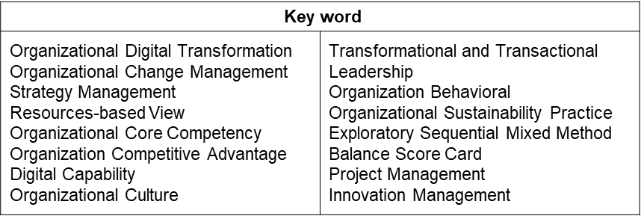

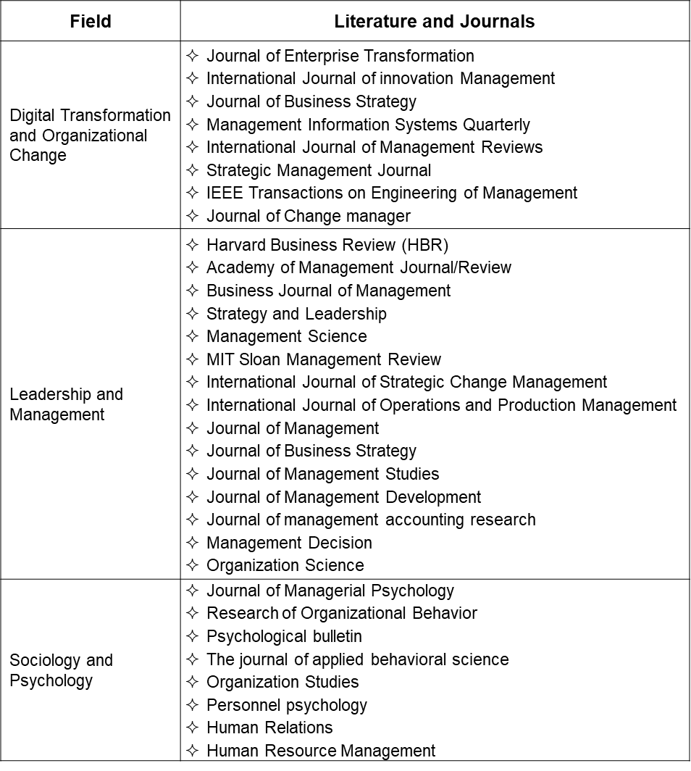
Table 1: Relevant Keywords of this study - by author

Table 2: Relevant Literatures & Journals of this study - by author
Norm of Organization’s Digital Transformation
Digital transformation is multifaceted, encompassing technology, culture, capabilities, strategies, and value creation (Bharadwaj et al., 2013). Integrating digital technologies strategically fosters change beyond expansion (Westerman et al., 2014). It optimizes operational workflow via technology, demanding strategic work process planning for success (Hickson et al., 2003; Gurumurthy et al., 2020). Digital transformation requires aligning business models with customers, market strategies, and profit goals (Porter & Heppelmann, 2014). Weill and Woerner (2015) present four digital business models (Figure 5) as transformation blueprints. Organizations choose from these models, singularly or in conjunction with related relationships and core capabilities, to align with market dynamics and customer needs.
- The Supplier model involves business through another company, its characterized by being a low-cost producer and focusing on incremental innovation. Example as on-line insurance brokage.
- The Modular Producer model such as PayPal, it thrives by provide a payment gateway for any online purchase with flexible adaptability to any system.
- The Ecosystem model exemplified by Amazon, establishes a branded platform, ensures excellent customer experiences, integrates plug-and-pay third-party products, leverages customer knowledge from all data, and extracts "rents" to foster ecosystem-driven growth.
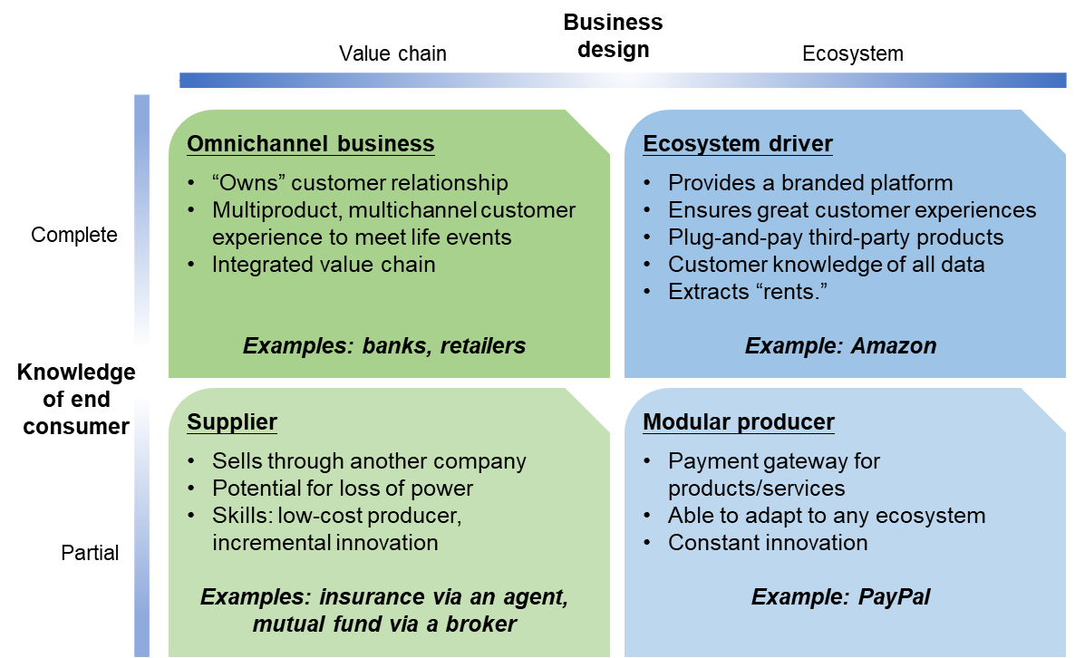
- The Omnichannel model in digital transformation encompasses an integrated value chain, offering a multiproduct, multichannel customer experience tailored to life events, and strategically "owns" the customer relationship.

Figure 5: Four Business Models of the Digital Era Source: Weill & Woerner (2015)
The organization mirrors as a human body, with its skeletal system representing its architecture, encompassing dimensions like vision, strategies, rules, products, processes, and more (Simons, 2000; Waller, 2014). Executives align with business architecture for informed investment decisions, bridging technology and business (Schermerhorn Jr et al., 2002, pp. 133-141). Despite technology's speed, business architecture guides the integration of tech, capabilities, and functions; organization stress business value-focused (Westerman et al., 2012; Correani et al., 2020). Digital transformation's challenges demand cross-functional collaboration and agile architectural practice that leverages capabilities for adaptability (Weill & Woerner, 2013; Waller, 2014; Correani et al., 2020). The World Economic Forum (2016) presents a comprehensive approach comprising five stages: Goal Strategy, Digital Architecting, Planning, Execution, and Measurement. This framework aids organizations in navigating digital transformation complexities and achieving outcomes.
1. Goals strategy development
During the goals and strategy development stage of digital transformation, organizations assess their current digital state and determine whether they are in the digitization or digitalization phase (Waller, 2014). The focus is on identifying the targeted business model and facilitating strategic conversations among the digital transformation committees (Kyläheiko et al., 2011; Weill & Woerner, 2015). For example, McDonald's CEO, Chris Kempczinski implemented a 3D business strategy (digital, delivery, and drive-thru) to enhance the brand and revenue. The company invested significantly in digital transformation, expanding its digital team from 3 to over 100 members in just 15 months. The strategic goals focused on streamlining the ordering process and meeting evolving customer preferences. The "Accelerating the Arches" strategic plan aims to foster a culture of consumer curiosity to support the transformation (Waller, 2014; Weill & Woerner, 2015). McDonald's mission and vision statements, "Feed and foster communities" and "Making delicious feel-good moments easy for everyone," reflect the post-transformation values and the continued emphasis on the 3Ds strategy (Berghaus & Back, 2016; Bloomberg, 2018).
2. Digital Architect & Re-architecting
Once strategic goals are set, the next step is adapting digital architecture for desired change, creating an actionable view of business architecture to inform stakeholders about transformation, and defining and transparently sharing process scope and digital changes are essential (Waller, 2014; Weill & Woerner, 2015). Evaluating digital strategy's impact on processes, people, technologies, and the environment is vital (Hemerling et al., 2018; Correani et al., 2020). An organization's internal environment, including workforce, capabilities, and resources, is managed through strategy formulation, identifying strengths, weaknesses, opportunities, and threats (Burnes, 2004; Dayan et al., 2017). Digital transformation leaders define process improvements with appropriate strategies and methodologies, and Organizational capabilities are assessed to enhance agility and efficiency, adapting to digital changes (Westerman et al., 2012). Business architects are pivotal in enabling strategy and implementation and act with three key roles: translating strategy, roadmap development, and practice management for transformation (Dayan et al., 2017; Correani et al., 2020).
- Digital architecture practice, the workload is allocated per transformation scope, using an upstream approach to align with business goals (West et al., 2004; Dayan et al., 2017). However, challenges like reduced collaboration among teams and units can arise. Prioritizing upstream planning and execution over project-level focus prevents obstacles, ensuring effective digital transformation (Waller, 2014; Correani et al., 2020).
- Forming a Multi-disciplinary Functional Team, this diverse group maximizes collective capabilities in executing initiatives, emphasizing alignment and collaboration (Campion et al., 1996; Wolfenden, 2000). This cohesion leverages diverse skills to drive outcomes, uniting complementary expertise toward common goals and achieving desired performances (Dayan et al., 2017; Correani et al., 2020).
- Correani et al. (2020) assert that digital transformation's success hinges on a Flexible and Agile Multi-talent Workforce, incorporating business architecture for knowledge and procedures. Individuals actively join (Dayan et al., 2017; Simons, 2014, pp. 121-178). The principles and practices spread across functional units, fostering cohesiveness and consistency. Weill & Woerner (2015) state flexible, agile workforce enables digital adaptation, leveraging diverse skills and positioning the right paths for digital transformation success.
3. Plan initiatives
Organizations scope the transformation's scale and develop a top-down approach with guidance, milestones, and integrated initiatives for a strategic roadmap (Kyläheiko et al., 2011; Kontić & Vidicki, 2018). Initial planning outlines the budget, timeline, parties, tech aspects, actions, and chain of command. A contingency plan and measurable metrics are vital, and during initiatives, ongoing assessment is crucial for staying on track (Frankiewicz & Chamorro-Premuzic, 2020; Kyläheiko et al., 2011). The digital architect guides progress assessments and suggests improvements when creating the digital transformation process, align capabilities and roles (Frankiewicz & Chamorro-Premuzic, 2020; Li et al., 2021). Centralized teams ensure consistency but can lack alignment and implementation, and the decentralized models foster buy-in and varied solutions but might lead to fragmentation; thus, balance is the key to avoiding any losing focus (Lepak & Snell, 2002; Ilgen et al., 2005; Li et al., 2021).
Combining centralized and decentralized practices, the hybrid approach gains momentum in digital transformation. It leverages the strengths of both models, supported by leading sectors, centralizing process practices and standards while enabling business units to focus on their expertise and agility (Smith & Tushman, 2005; Nah & Delgado, 2006). To implementing this hybrid architecture, is crucial to establish virtual collaboration mechanisms and robust coordination across business units (Somers & Nelson, 2019; Lepak & Snell, 2002). Regardless of the chosen architecture—centralized, decentralized, or hybrid—effective coordination, communication, and transparency are imperative to drive digital transformation. Refer to (Figure 6) for an illustration of the business architecture framework.
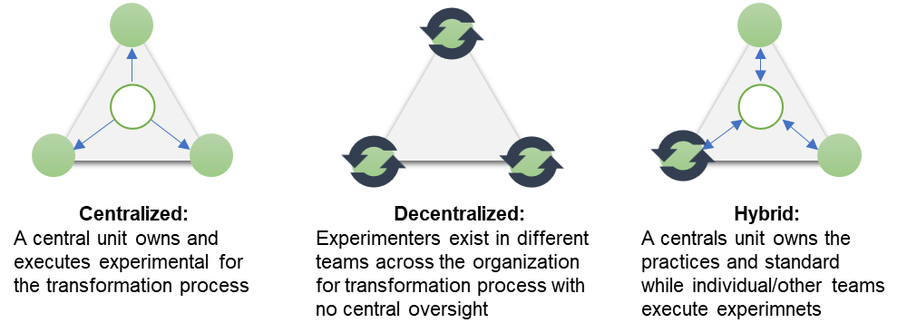

Figure 6: The architecture framework of digital transformation - by Researcher
4. Executional solution
Digital execution quality correlates directly with organizational transformation (Somers & Nelson, 2001, 2003; Spitzer et al., 2013). Initiating transformation demands a comprehensive framework from digital leaders, and aligning resources across initiatives (Smith & Lewis, 2011; Stone, 2018). High-level execution, focusing on efficient teams, tech-human pairing and mitigates disruptions which emphasize upskilling for adaptability, and forming an action team, led from the top, avoids bottom-up approaches (Somers & Nelson, 2001; Bharadwaj et al., 2013). Leaders should align with stakeholders across business units, especially IT, for successful collaboration and handle unforeseen challenges in transformation, like tech issues and commitment consistency (Sharpe et al., 2006; Al-Haddad & Kotnour, 2015; Frankiewicz & Chamorro-Premuzic, 2020).
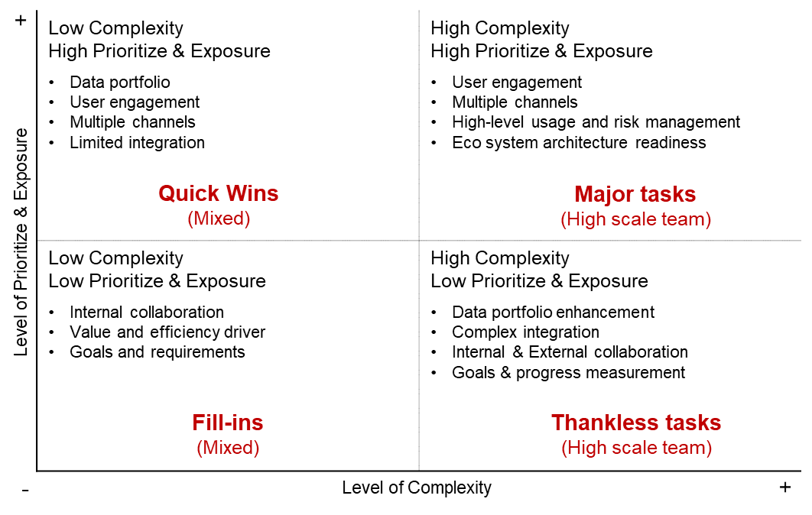
Leveraging captured data to generate revenue unlocks profound customer insights, refining decision-making throughout the transformation process (Stone, 2018, pp. 154-179; Bharadwaj et al., 2013). The strategic consolidation of data serves as a blueprint for constructing a project portfolio, effectively directing the trajectory of high-level plan initiatives. Such an approach ensures quick success substantiating the sweeping organizational metamorphosis (Tatum et al., 2003; Frankiewicz & Chamorro-Premuzic, 2020). The visible gains in the short term validate the sacrifices made, fostering team cohesion, bolstering determination, and providing constructive feedback that drives collective motivation. This demonstrable progress can potentially sway previously indecisive stakeholders with empirical evidence of the transformation's positive trajectory, thereby cultivating their active support (Kotter, 2012, pp. 121-135). A distinctive digital transformation involves a rapid application development process employing a multi-level agile methodology and knowledge-based interactions (Frankiewicz & Chamorro-Premuzic, 2020). Leaders transition from traditional to digitalized processes, incorporating a retrospective cadence for progress review and lessons learned. The expedited application deployment metric relies on integrating systems, deployment infrastructure, and industry practices adherence (Boutetiere & Reich, 2018; Morakanyane et al., 2020). Successful transformations leverage diverse resources through a small team approach and repeatable processes, adopting a fail-fast, learn-fast, succeed-slow strategy. Organizations embrace a contextual, intelligent, and proactive process approach, systematically eliminating constraints to enhance comprehension (Westerman & Bonnet, 2014, 2015).

Figure 7: Matrix of digital transformation complexity versus prioritize and exposure .. by researcher.
A systemic framework within an established workforce balances complexity, availability, and capabilities, allowing for transformation exposure. A complexity matrix aids in task prioritization and execution direction (Buvat et al., 2017). Transformation's value and complexity underpin prioritization and niche decision-making (Kotter, 2012). Organizations assess initiatives in this intricate landscape, considering digital teams' adaptability to new methodologies with limited resources (Westerman & Bonnet, 2015; Frankiewicz & Chamorro-Premuzic, 2020). Refer to Figure 7 to illustrate the digital transformation complexity matrix, its alignment with prioritization, and exposure.
5. Progress Measurement & Continuity.
Scholars stress goal-oriented performance measurement in digital transformation discourse, Miles et al. (1978) suggest that a measurement framework aligned with project objectives and transformation principles is crucial. Intrinsic digital transformation attributes shape the measurement framework to enhance performance (Westerman et al., 2012 Spitzer et al., 2013). Each transformation process needs a purpose aligned with strategic initiatives. Evaluating and measuring process efficiency is vital, tied to task alignment and temporal distribution across phases. Performance measurement connects input effectiveness to process output, aiding goal achievement and optimal performance (Kavadias et al., 2016; Bharadwaj et al., 2013).
Efficiency and reliability in transformation processes are evaluated by assessing input capacities for valuable outcomes. Key performance metrics include process reliability, throughput, first-pass yield, user satisfaction, and value-added ratios (Westerman et al., 2012). Transformative process cost assessment involves budgeting and return on investment analysis, considering various economic dimensions. Balancing control and lean practices to ensure project success is crucial. Comprehensive process measurement covers third-party standards, regulations, safety protocols, and environmental considerations, along with risk mitigation and process maturity standards (Bharadwaj et al., 2013; Buvat et al., 2017; Frankiewicz & Chamorro-Premuzic, 2020). Digital leaders drive best-in-class processes, securing a competitive edge for the transformation journey. Monitoring and evaluating process performance empower leaders to make informed decisions, ensuring transformation success. Refer to (Figure 8) for the role of business architecture in an organizational digital transformation execution life cycle.

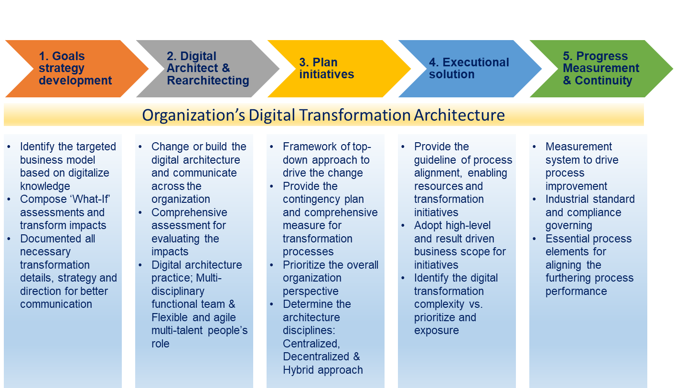

Figure 8: The Role of business architecture of ODT - by Researcher
- Organizational Digital Transformation Challenges
Modern organizations necessitate an integrated business model blending systemic and technological approaches for productive change and heightened performance (Bharadwaj et al., 2013). In the face of current economic challenges, digital transformation has emerged as a viable performance-enhancing solution (DeLone & McLean, 1992; Holland & Light, 1999; Parviainen et al., 2017). Acknowledging its pivotal role, organizations recognize digital transformation's potential to reshape business practices, secure long-term success, attract top talent, capitalize on opportunities, establish industry leadership, and embrace the future (Poon & Wagner, 2001; Matt et al., 2015; Schumacher et al., 2016).
It is crucial to note that digital transformation surpasses technology adoption; it signifies an innovative, dynamic approach to business advancement (Westerman et al., 2014a, 2014b; Schuchmann, & Seufert, 2015; Zimmermann et al., 2018). Irrespective of size, organizations strive to evolve into digitalized entities by prioritizing strategic planning, resource allocation, efficiency enhancement, and peak performance (Allen, 1984; Schneider & Bowen, 1985; Catlin et al., 2017; Bloomberg, 2018; Hemerling et al., 2018). While technology choice matters, it is not the sole determinant of success. The focus must be on executing transformation with strategic planning and leveraging resources efficiently for optimal performance (Allen, 1984; Bloomberg, 2018).
- Leadership commitment from executives to middle management and digital culture mindset
Many organizations struggle with an imitative approach to digital transformation, lacking a goal-aligned strategy (Smith & Tushman, 2005), impeding desired outcomes, and necessitating tools, expertise, and guidance for success (Smith & Lewis, 2011). Some need help keeping pace with rapid change, highlighting the need for careful considerations when undertaking digital transformation (Catlin & Willmott, 2015; Solis & Li, 2018; Baker, 2021). Commitment is vital; strategic digital initiatives correlate with industry leadership (Baker, 2021). An MIT survey revealed that about 70% of digital transformation projects fail due to a lack of management support and employee resistance, and 62% perceive digital transformation as the CEO's domain, with 87% prioritizing the digital market for transformation (Fitzgerald et al., 2014). McKinsey's 2018 report states that over 54% of organizations require a digital transformation strategy, while just 16% of employees comprehend the company's digital transformation objectives. Business leadership drives 72% of digital transformation initiatives, surpassing CIO or CTO influence. Moreover, Boston Consulting Group (BCG) and Capgemini Consulting research unveil only 45% delivering partial value to the business. BCG's insights underscore the necessity of a strategic plan and methodology as foundational for success (Tabrizi et al., 2019). A strategic plan is akin to a vital investment safeguard, enhancing success odds (Weick & Quinn, 1999; Beer & Eisenstat, 2000; Birkinshaw et al., 2008; Sousa & Rocha, 2019).
Amidst diverse strategies and methodologies, the apt approach must address core questions and choose a fitting methodology (Hannan & Freeman, 1984; Burnes, 1996, 2004). However, just 40% of organizations surmount barriers, forging an integrated strategic methodology quantifying performance, syncing with technology, and bolstering overall goals and competitive edge (Forth et al., 2020). Leadership is pivotal for strategy alignment and change implementation (Lucas et al., 2013; Kane et al., 2015), and transformation's roadmap must prioritize, set timelines, ensure resource transparency, and adapt to dynamic processes (Kotter, 2012).
- Deploying Talent and High-Caliber Expertise
While team commitment and executive engagement in organizational change are recognized, and middle managers, with power bases and protective instincts over their domains, tend to resist change (Buchanan et al., 2005; Berghaus & Back, 2016; Sebastian et al., 2020).. Automation, AI, cloud computing, and Enterprise resource planning (ERP) systems amplify labour reduction concerns, particularly for middle management vulnerable to dynamic models requiring responsive compensation. Digital transformation disrupts traditional models and provokes middle management's resistance to preserving the status quo (Poon & Wagner, 2001; Smith & Tushman, 2005; Yoo, 2010; Westerman et al., 2014b). Successful digital transformation necessitates digitally minded with the skills to execute the transformation strategy (Sousa & Rocha, 2019; Frankie & Chamorro-Premuzic, 2020), and innovation combines adept human resources and technologies, underlining the importance of skilled talents in overcoming transformation challenges. Thus, digital transformation hinges more on people than technology (Dayan et al., 2017; Stone, 2018; Frankie & Chamorro-Premuzic, 2020).
Like soccer coaches seeking persistent athletes dedicated to goals, influential leaders possess pragmatism, critical thinking, resilience, perseverance, teamwork, creativity, learning agility, and emotional intelligence (DeLone & McLean, 1992). Appointing committed, skilled individuals with highly potential to lead change processes is critical for digital transformation success (Davenport & Westerman, 2018; Forth et al., 2020). Leaders must skillfully assemble digitally literate teams, possibly drawing talent from different functional units (Bryson & Anderson, 2000; Fitzgerald et al., 2004). During digital transformation, management faces time constraints due to sourcing and retaining capabilities, thus, career advancement programs can identify potential leaders among digital natives for the transformation team. Effective team composition involves managing diverse skills for various roles and functionality (Forth, 2020).
- Capital Plan and Budget Constraints
Senior executives often grapple with tight budgets during the change process (Davenport & Westerman, 2018; Hemerling et al., 2018). This tendency may arise from an incomplete grasp of successful transformation drivers and the misperception that performance improves solely through cost-cutting (Barney, 1991; Leonard-Barton, 1988). Despite acknowledging digital transformation's financial benefits, many organizations need to plan and allocate funds, resulting in over forty percent of projects falling short (BCG, 2020). Economically, successful digital transformation involves a "short-term pain, long-term gain" approach, aligning budgets with strategic plans (Matt et al., 2015).
Financial controller often labels digital transformation funding as expenses, limiting resources, and decision-making (Hannan & Freeman, 1984; Hansen & Sia, 2015; Ustundag & Cevikcan, 2017, pp. 173-176). Addressing budgets requires a mindset shift, viewing digital transformation as an investment, not an expense. Leaders must grasp financial implications, align budgets with long-term goals (Hemerling et al., 2018), and consider tech adoption, talent development, process optimization, and change management (Matt et al., 2015; Stone, 2018). A strategic budget approach enables organizations to overcome constraints (Westerman & Bonnet et al., 2015; Ustundag & Cevikcan, 2017). Informed resource allocation and effective financial management help navigate digital transformation's complexities.
- Agile Governance and Monitoring Framework for Continuous Evolution
Digital transformation failure often results from inadequate monitoring and a need for more process-driven transformation (Yoo, 2010). Success relies on an agile mindset and effective corporate governance, established through leading by example, to foster a transformative organizational culture (Smith & Tushman, 2005; Kane et al., 2015). Fostering an agile culture requires leaders to instill agile behaviors vertically and horizontally across the organization (Solis & Szymanski, 2017; Forth et al., 2020). Kotter (2012) stresses the fatal error of leaders' complacency in establishing urgency across business units.
Execution team members understand agility and effectiveness in digital transformation despite initial skepticism. However, operational struggles arise within units due to weak governance and monitoring (Westerman et al., 2011; Issa et al., 2018; Shaughnessy, 2018). Governance and policies are pivotal for an agile culture (Westerman, 2016). BCG's (2020) report highlights two in five organizations focusing on these aspects, yielding 90% success, and over half set their KPIs for progress monitoring. In line with organizational culture and executive vision, a well-aligned digital transformation team steers initiatives by promoting transparency and accountability (Solis & Szymanski, 2017; Forth et al., 2020).
- Core Competence and Capabilities for ODT
As highlighted by various research studies and surveys, organizations' core competence and capabilities have been identified as key challenges in digital transformation initiatives (Ebben & Johnson, 2005; BCG, 2020). Capgemini reports that 77% of organizations need more skills and knowledge to address these challenges and often resort to working with vendors or hiring external expertise (Westerman et al., 2011). This shortage of IT professionals further results in a heavy reliance on IT specialists within the digital transformation team (Westerman et al., 2014, 2015). To navigate this challenge, large companies often opt for a short-term solution by replacing outdated technologies rather than investing in long-term human resources development, thus expanding their talent pool (Allen, 1984; Ebben & Johnson, 2005; Cray, 2015; Bloomberg, 2018; Baker McKenzie, 2021). However, the success of digital transformation depends not only on the right technologies but also on having the right IT specialists who possess the expertise to effectively implement and work alongside these technologies within the appropriate processes and timeframes (Fitzgerald et al., 2014; Cray, 2015; Bloomberg, 2018; Baker McKenzie, 2021). Nevertheless, attracting and acquiring digital talent is often solely entrusted to the human resources department, which may limit the effectiveness of talent acquisition efforts (Cray, 2015). Bloomberg (2018) argues that compared to relying solely on organic talent growth, outsourcing talent acquisition can provide a rapid solution for bridging skill gaps in digital transformation initiatives. Organizations can enhance their capabilities and increase the likelihood of successful digital transformation outcomes (Fitzgerald et al., 2014; Baker McKenzie, 2021). Table 3 compares organizations' most prominent challenges in their digital transformation endeavors by synthesizing and integrating the findings from various sources.
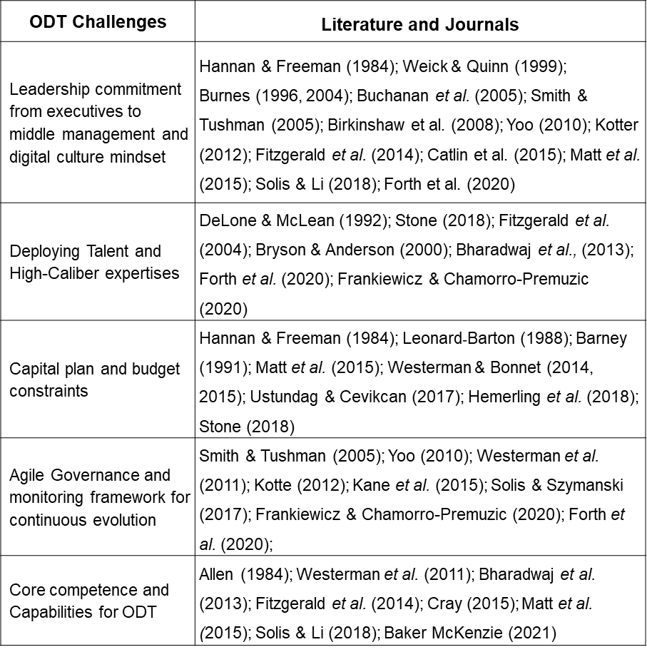

Table 3: The Empirical Literatures of the ODT Challenges – by researcher

- ODT Barriers
Fitzgerald et al. (2014) highlight that the interaction between digital layers and physical demands in modern business contributes to digital transformation failure. Despite seeking innovative strategies, obstacles hinder transformation success. Overcoming these barriers is crucial for organizations to achieve digital transformation gains (Westerman, 2011, 2014; Buvat et al., 2017). Extensive research identifies barriers categorized by complexity and importance, posing future challenges.
Van Wijk et al. (2008) delineate that these investigations illuminate diverse obstacles across three impact tiers: intra-level, inter-level, and meta-level within organizations. Intra-level barriers arise within distinct business processes and units. Inter-level barriers encompass external interactions with competitors, business partners, and supply chain stakeholders. Meta-level barriers involve higher-level entities like government and regulatory bodies and the global climate. Grasping the dynamics and challenges of these interaction levels is crucial for identifying and addressing specific impediments thwarting digital transformation initiatives in organizations (Van Wijk et al., 2008; Bonnet et al., 2015). Each tier presents unique complexities and hurdles that must be tackled to achieve successful transformation outcomes. Recognizing and proactively confronting these barriers empowers organizations to devise effective strategies for maneuvering challenges and elevates the potential of fruitful digital transformation (Bharadwaj et al., 2013; Frankiewicz & Chamorro-Premuzic, 2020).
Digital transformation's role in business growth demands significant resources and financial support (Westerman et al., 2011; Correani et al., 2020). Budget constraints hinder investment, limited innovation, and enhancement (Smith & Tushman, 2005; Westerman et al., 2011; Catlin et al., 2015). Budgeting shortages occur internally and externally. Intra-level constraints affect R&D and innovation funding, while meta-level constraints relate to government support and venture capital. Uncertainty hinders short-term justification (Correani et al., 2020). Inter-level barriers also impact success, with organizations needing help to adapt to swift digital innovation (Vogelsang et al., 2019; Morakanyane et al., 2020). Reluctance to adopt new technologies and reliance on familiar methods hinder staying current further complicated by legacy systems during technology adoption (Westerman & Bonnet, 2015; Yoo, 2020; Vogelsang et al., 2019).
The absence of a clear digital vision hampers digital transformation. Often spurred by market pressure rather than genuine commitment (Westerman, 2014), success requires a well-defined digital vision and process understanding (Berghaus, 2016; Ustundag & Cevikcan, 2017; Vogelsang et al., 2019). Digital transformation entails cultural change beyond technology (Loebbecke & Picot, 2015; Morakanyane et al., 2020) and relies on organizational and top management support (Westerman et al., 2014a; Vial, 2021). It integrates technology and drives change, fostering a shared vision, goals, and mission (Matt et al., 2015; BCG, 2020). To succeed, organizations must develop an internal digital culture (Intra-level), leveraging technology to cut costs and boost sales (Teo & Choo, 2001; Ustundag & Cevikcan, 2017). Organizations should nurture a digital culture, encourage collaboration, provide effective leadership, and clarify their vision for successful digital transformation (Westerman et al., 2012, 2014; Matt et al., 2015; Berghaus, 2016).
Inadequate change management hampers digital innovation due to knowledge gaps (Matt et al., 2015). The competition makes Obtaining skilled digital talent tough, and IT maintenance staff may need more expertise. Human resources influence efficacy (Intra-level) (Schumacher et al., 2016; Ustundag & Cevikcan, 2017; Yoo, 2020). Mindsets and tech backgrounds affect implementation (Schwertner, 2017). Talent scarcity hinders transformation, impacting both the organization (Intra-level) and the marketplace (Meta-level) (BCG, 2020). Integrating technology, strategies, competencies, and people is vital for successful transformation (Kane et al., 2011). Human barriers often obstruct progress, with leadership dissatisfaction hampering digital innovation (KPMG Global Survey, 2021). The transformation demands active organizational leadership involvement (Holland & Light, 1999; Hansen & Sia, 2015; Forth et al., 2020). Organizations must recognize these challenges and implement strategies to overcome them, fostering a culture of continuous learning and adaptation in the dynamic digital transformation landscape.
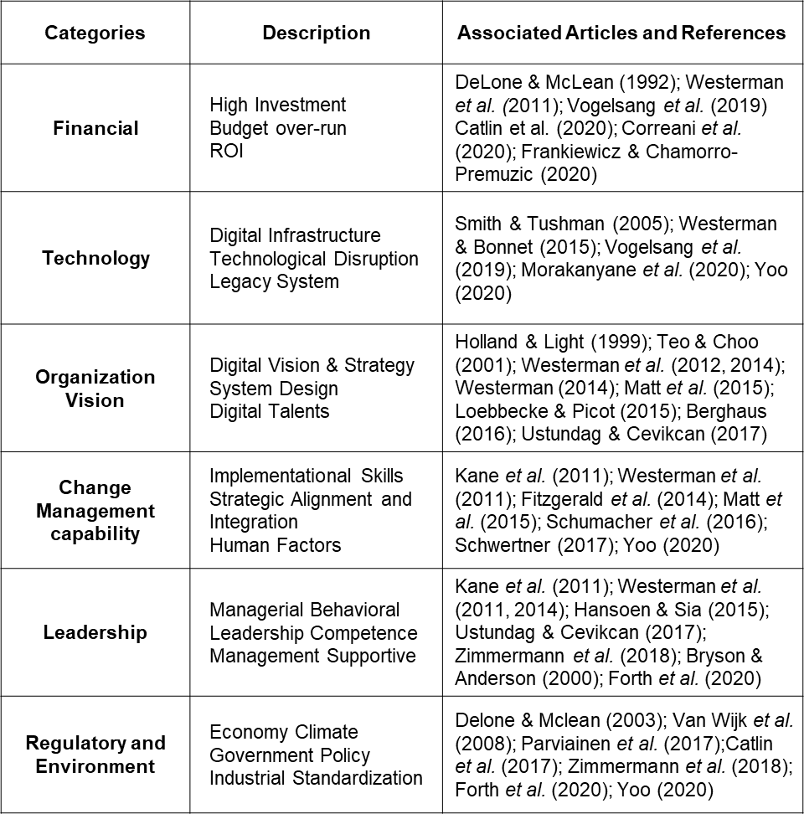
External factors substantially impede the digital transformation process, encompassing the economic climate and the regulatory landscape (Meta-level). The intricate challenge arises in harmonizing the drivers of transformation and executing associated processes within a rapidly evolving economic milieu (Parviainen et al., 2017; Forth et al., 2020). Notably, achieving competitive relevance through digital technologies becomes progressively formidable as established competitors have already completed their transformation journeys (Delone & McLean, 2003). Further compounding the complexity, digital transformation initiatives encounter potential disruptions due to fluctuations in market demands, potentially imperiling their successful execution. Regulatory barriers, such as policies and standardization, constrain transformation endeavors, while innovative incentives can potentially expedite progress (Delone & McLean, 2003; Catlin et al., 2017). These barriers stem from risk aversion, fostering failure (Van Wijk et al., 2008; Zimmermann et al., 2018). Organizations often need to be made aware of the need for change in the business environment until it is too late, further exacerbating the challenges of digital transformation (Ustundag & Cevikcan, 2017; Matt et al., 2017; Yoo, 2020). Table 4 summarizes the empirical research across various domains.

Figure 4: The Empirical Literatures of Organizational Digital Transformation Source: By Researcher
- What is Meant by Successful ODT
"A successful digital transformation is a substantial effort that reshapes culture, enhances business practices, fosters innovation, facilitates efficient collaboration, and drives greater value with reduced effort," DeLone & McLean (2003) advocate for this transformative concept. While many studies explore digital transformation's success factors and outcomes, they often focus on specific facets, leaving a comprehensive understanding of success to be explored. Some studies pinpoint success factors like employee productivity, financial growth, improved customer experiences, and expanded market share (Fitzgerald et al., 2014; Kontic & Vidicki, 2018; Forth et al., 2020). The literature on successful digital transformation spans disciplines, drawing from diverse theories to explore concepts like digital innovation, solutions, applications, and business strategies, all contributing to organizational objectives (Berman, 2012; Solis, 2018; Zimmermann et al., 2018, pp. 116-118). Nevertheless, Westerman and McAfee (2014) contend that digital transformation's link to innovation should be seen as an innovation process fueled by digital innovation, leveraging technology for improvement. Achieving digital transformation success hinges on the internal realization of strategy, employees, competencies, and culture (Markus, 2004; Smith & Tushman, 2005; Gurbaxani & Dunkle, 2019). Digital innovation's maturity derives from transformed value creation, reflecting an organization's digital offerings (Poon & Wagner, 2001; Majchrzak et al., 2016; Parviainen et al., 2017). The literature needs more clarity due to digital transformation's multifaceted, complex nature. It is an ongoing, open-ended process, and while scholars explore macro and micro-level success, measuring tangible and intangible aspects, consensus still needs to be discovered. This lack of agreement necessitates a more precise understanding and measurement approach for digital transformation's success (DeLone & McLean, 1992; Bharadwaj et al., 2013).
Overall Organizational Performance encompasses outcomes directly tied to digital transformation efforts, and focus on financial aspects like increased sales, customer base, and revenue growth (Ustundag & Cevikcan, 2017). Quantitative measures like stock market value and earnings are part of this dimension (Berghaus & Back, 2016; Kontic & Vidicki, 2018). Non-financial domains such as customer satisfaction and brand reputation also fit, reflecting public perception. These micro-level indicators align with macro-level values while some measurements suit public companies, they might need to depict transformational impacts on business performance fully. Fitzgerald et al. (2014) stress revenue and profitability from digital business as a specific performance aspect achieved through transformed digital technologies. Kontic & Vidicki (2018) note digital tech's impact on existing operations, becoming a growth strategy, and possibly replacing traditional models. While digital tech enhances performance, cases where it supersedes traditional models are possible when digital business outpaces core business, the importance of digital transformation is evident (Parviainen et al., 2017). This dimension focuses on measurable, financially driven assessments (Berghaus & Back, 2016; Kontic & Vidicki, 2018).
Yoo (2010) and Solis (2018) state that digital business revenue depends on digital market offerings. External transformation, like market demands, partnerships, and supply chains, is vital for digital transformation's success (Zhu et al., 2006; Yoo, 2010). Failing to generate external outputs leads to adverse outcomes, and the External Transformation dimension explores an organization's ability to connect with the external environment, which covers digital product/service innovation and changes in the business model (Yoo, 2010; Parviainen et al., 2017; Solis, 2018). It gauges creating a digital business model that meets market demands and transforms value. Measures include innovation count, digital products/services growth, and customer interaction; and digitalized interactions enhance customer experience, measured by KPIs and satisfaction indexes (Zhu et al., 2006; Bloomberg, 2018). Table 5 summarizes these dimensions and measurements, enabling holistic evaluation.

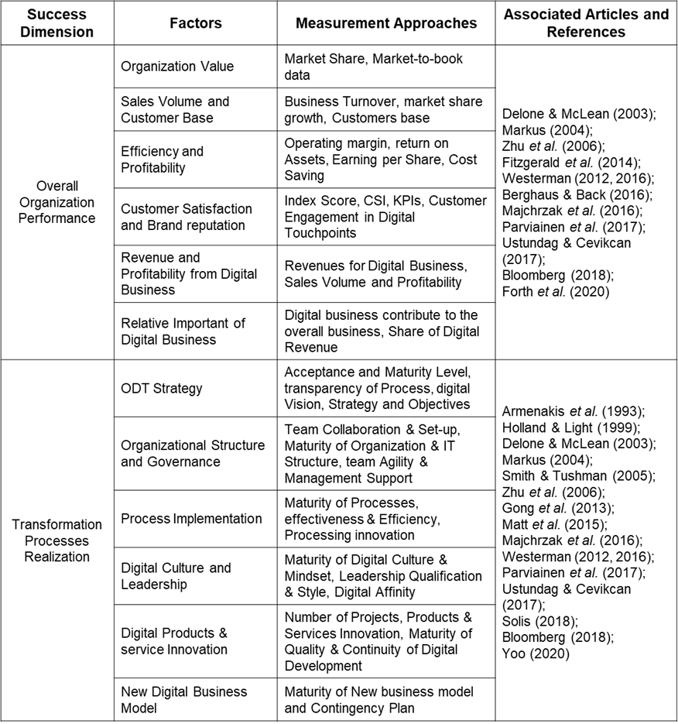

Table 5: The Empirical Literatures of dimensions of successful ODT – By Researcher

The third and final dimension of ODT is Internal Transformation, addressing internal changes during the process. It uses maturity models and measures success across dimensions (Markus, 2004; Smith & Tushman, 2005). The transformational strategy reflects maturity, vision transparency, and planning (Majchrzak et al., 2016; Parviainen et al., 2017). Organizational structure and governance measure the agility of implementation, self-learning teams, and management support the process maturity reflects efficiency, often cost and time (Armenakis et al., 1993; Majchrzak et al., 2016; Ustundag & Cevikcan, 2017).
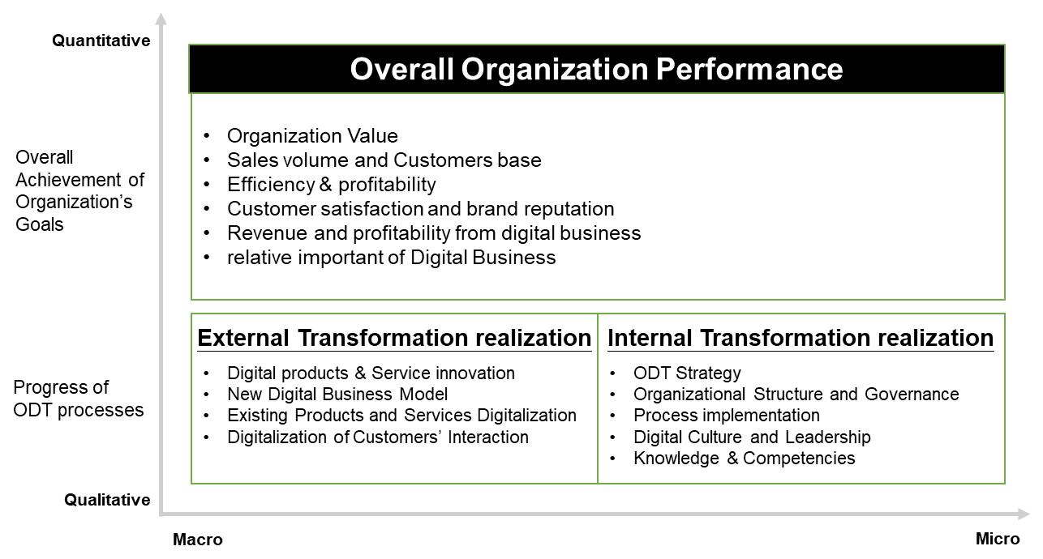
Digital culture and leadership are pivotal in assessing innovation mindset and leadership style (Westerman et al., 2012; Parviainen et al., 2017). Knowledge and competencies gauge knowledge management and digital skills (Delone & McLean, 2003; Smith & Tushman, 2005; Matt et al., 2015). These domains are vital success factors in digital transformation (Markus, 2004; Majchrzak et al., 2016; Parviainen et al., 2017). Successful digital transformation is intricate, spanning diverse dimensions: two key aspects, Organizational Performance and External Transformation, gauge outcomes and external influence (Figure 9). The Internal Transformation dimension probes internal shifts during the process. A systematic review identifies twelve measurements to concretize success across these areas, fostering a comprehensive grasp of digital transformation's achievement. The identified dimensions and factors stem from an in-depth analysis of DT literature, aiming to comprehend ODT success, align practical measurements, and bolster this study. In summary, ODT's success is integrating both dimensions. Throughout history, organization-wide triumph signifies effective DT, while transformational processes directly contribute to goals through multidimensional commitment (Delone & Mclean, 2003).

Figure 9: Overview of ODT success dimensions - By Researcher
- Framing ODT study with the 3H Framework
Digital transformation extends beyond isolated IT projects (Leonard-Barton, 1988; Kane et al., 2015), emphasizing meaning-making for organizational change (Cornelissen & Werner, 2014). Amid the digital era, navigating this complexity involves organizational traits, affordance, context, tactics, and technology's implications (Yoo et al., 2010). Effective digital transformation management necessitates multidimensional adaptation (Wessel et al., 2021) and advances cognitive development and change literature (Orlikowski & Gash, 1994; Zimmermann et al., 2018). While digitalization, leadership, culture, and more are pivotal (Markus, 2004), scholars stress its technology-driven business model change, strategic decisions, and multidimensional skills across the organization (Smith & Tushman, 2005; Schwertner, 2017). Understanding this holistic approach empowers organizations to embrace the meaningful transformation encompassing technology, strategy, and people for sustained success in the digital landscape.
In the survey of McKinsey & Company emphasize technology-managed processes for improved performance, it sustains competitive advantage by encompassing culture, strategies, management, competence, and technology. Recognizing the role of meaning-making in guiding transformation is growing (Cornelissen & Werner, 2014; Bloomberg, 2018). Navigating complexities involves digital culture, context, practices, and affordances (Yoo et al., 2010). Integrating insights from management, leadership, sociology, and psychology enriches organizations' understanding of digital transformation. This study explores digital transformation's link to organizational change, leadership, management, and sociocultural influences. Adopt with Yu's 3H holistic framework, it offers a structured approach. This roadmap, addressing challenges and opportunities, considers Heart (leadership), Head (strategy), and Hand (implementation), which aids organizations in navigating complexities and attaining successful outcomes.
- The Heart Elements (Leadership and Organizational Culture)
- Digital Leadership today
Digital leadership is vital for successful transformation, blending tech expertise with deep organizational insight (Hannan & Baron, 2002; Bloomberg, 2018; Buil & Matute, 2019). Influential digital leaders embody creative thinking and tech proficiency to elevate digital business value (Birkinshaw & Goddard, 2009). They ensure optimal process outcomes for all stakeholders (Berman & Marshall, 2014; Catlin et al., 2015). This leadership's significance spans various research levels, from national to individual (Cortellazzo et al., 2019). Digital leadership encompasses tasks like goal setting, tech support, efficient process design, commitment fostering, resource adaptation, informed decisions, value addition, and shared goal achievement (Hannan & Baron, 2002; Bloomberg, 2018; Buil & Matute, 2019; Kretschmer & Khashabi, 2020). Allio (2005) claims that addressing social practices like managing conflicts, forging workforce relations, navigating politics, and leveraging diverse traits. This leadership theme guides and embodies organizational structure, influence, innovation, and transformation facilitation (Smith & Tushman, 2005). Solis (2018) agrees and emphasizing its constructs, strategies, relationships, and processes for inspiring digital transformation. Literature highlights digital leadership's significance in organizations, spanning levels and addressing complex social dynamics for a transformative environment.
- The distinctive digital leadership
In recent decades, technology's role in organizations has surged, permeating all functions, and demanding tech-savvy digital leaders with a firm business grasp (Smith & Tushman, 2005; Solis, 2018; Kretschmer & Khashabi, 2020). Effective digital leadership means integrating technology seamlessly across levels, fostering collaborations, and considering operational boundaries (Stone, 2018; Ustundag & Cevikcan, 2017). Nevertheless, some digital leaders need help transitioning business strategies due to proficiency gaps in organizational infrastructure and change management (Bryson & Anderson, 2000; Westerman et al., 2011). Technology’s role has surged and permeating all functions, demanding tech-savvy digital leaders with a firm business grasp (Smith & Tushman, 2005; Solis, 2018; Kretschmer & Khashabi, 2020). Effective digital leadership means integrating technology seamlessly across levels, fostering collaborations, and considering operational boundaries (Cascio & Montealegre, 2016; Nambisan et al., 2017; Stone, 2018). Nevertheless, some digital leaders need help transitioning business strategies due to proficiency gaps in organizational infrastructure and change management (Bryson & Anderson, 2000; Westerman et al., 2011).
- Digital Leadership versus Traditional
Digital technologies reshape businesses and cultures, impacting roles and competition; transformations span tech, roles, culture, and competencies for goals (Teo & Choo, 2001; Casadesus-Masanell & Ricart, 2010; Bharadwaj et al., 2013). The World Economic Forum (2016) reports that 82% of firms seek strong digital leadership amid transformation, yet only 11% possess it. Agile structures involving execs, management, and digital teams, replace hierarchies (Avolio, 1993; Bass, 1997; Bennis, 2013). In the rapid digital era, digital leadership aligns functions, culture, and environment (Berman, 2012; Nambisan et al., 2017).
Recognizing digital leadership's importance, organizations must nurture it, shifting from authority-based to collaborative leadership is crucial, and digital leaders demand diverse soft skills for effective team leadership in evolving digital environments, fostering trust and open communication (Westerman et al., 2012; Vogelsang et al., 2018). They differ from traditional leaders, possessing digital vision, tech knowledge, and agility (Kane et al., 2015). Serving as social influencers, they embrace uncertainty and encourage learning (Kane et al., 2015; Westerman, 2016). Transitioning demands process management, diverse perspectives, and change drive (Westerman, 2016). Digital leadership transcends norms, adapting to lead transformations effectively (Cascio & Montealegre, 2016).
- Transformational and Transactional Leadership in Digital Era
A successful organizational transformation relies on strategic decisions and effective leadership (Child, 1972; Deci et al., 1999). Leadership parallels a dragon boat's drummer, guiding the team (Yu, 2020). Management styles vary, common ones being transformational or transactional, and leadership traits inspire behaviour to achieve goals (Bass, 1997; Bolden & Gosling, 2006; Westerman et al., 2014). Organizational transformation changes subordinates' style, culture, and behaviour through 'Transformational Leadership' (Bass, 1990; Avolio et al., 1991; Bass et al., 2003; Birasnav, 2014).
During DT, leaderships face exciting and challenging aspects, navigating unexpected barriers. To counter potential threats, modern digital leaders should discard old paradigms, embracing new ideas to align with transformational goals (Bass et al., 1999, 2003; Bassett-Jones & Lloyd, 2005). Literature has explored leadership traits linked to personality and situational intelligence and adaptive context-based practices have been emphasized, including task-driven and knowledge-based leadership models (Thomas & Velthouse, 1990; Lowe et al., 1996; Javidan, 1998; Kanungo, 2001; Moss & Ritossa, 2007). Emotional intelligence models focus on emotions, motivation, self-awareness, and social skills (Avolio et al., 1991; Shamir et al., 1993; Zakay et al., 1998; Cavazotte & Hickmann, 2012). Given the tech and change management fusion, studies highlight the leadership models in this complex environment during ODT, including transformational and transactional styles (DeLone & McLean, 2003; Birkinshaw et al., 2008; Gurbaxani & Dunkle, 2019).
Burns (1978) introduced transformational leadership; Bass & Avolio (1985) extended the theory of transactional and transformational leadership coexist, motivating through rewards and inspiration (Lowe et al., 1996). ODT involves multidimensional leadership, driving strategies to meet objectives (Bassett-Jones & Lloyd, 2005; Rowold, 2005; Walumbwa, 2008). Transformational leadership is contextual, inspiring with clear communication, positive vision, and growth opportunities, exceeding expectations (Bass, 1999; Piccolo & Colquitt, 2006; Bharadwaj et al., 2013). The author concurs with Bass (1985), extending Burns' model, identifying four key components: Idealized influence, Inspirational motivation, Intellectual stimulation, and Individual consideration, applied to digital transformation. Leaders manage change, acting as charismatic role models, building commitment and self-efficacy (Podsakoff et al., 1990, 2003; Bass & Riggio, 2006, pp. 105-138; Piccolo & Colquitt, 2006). In this complex evolution, leaders' behavior influences ethical decisions (Walumbwa et al., 2008; Weterman, 2016; Zimmermann et al., 2018). Leaders share the organizational vision amid unexpected change, with inspiring influence as a crucial dimension (Schwarzmüller et al., 2018). However, generation gaps and conflicts can arise between tech-savvy younger individuals and experienced elders, leading to skepticism and resistance to change (Zimmermann et al., 2018; Purvanova et al., 2009). Transformational e-leadership inspires and motivates followers to focus on processes over decision-making.
An ODT progress mirrors a battle, with missions focused on specific objectives and targets, often under tight constraints. This leadership style prioritizes employee supervision over development and change (Manz & Sims, 1987; Avolio et al., 2000). Transactional digital leadership emphasizes current operational efficiency rather than future innovation, maintaining established processes and progress (Bolden et al., 2003, pp. 78-91; Bono & Judge, 2004). Unlike coaching or democratic styles, it leans towards a directive approach, offering stability (Avolio et al., 2000). Typically seen in established companies and structured projects, it thrives in hierarchical settings (Lowe et al., 1996; Bolden et al., 2003, pp. 78-91). Jung et al. (2008) echo that during DT, it is vital to manage unexpected incidents transparently and confidently (Avolio et al., 2000; Bono & Judge, 2004). Transactional leaders excel in directed, reward-driven environments, overseeing performance and adhering to set time and quality parameters (MacKenzie et al., 2001; Horváth & Szabó, 2019). While subordinates might not favour their demanding style, senior management may have different views. Morakanyane et al. (2017) proposed that transactional leadership excels in structured environments, effectively managing projects with repetitive tasks and short-term goals.
Market pressure and technological evolution introduce volatility and complexity into transformation processes, akin to situations in military or police departments where resolute leaders respond adeptly during crises (Morakanyane et al., 2017; Horváth & Szabó, 2019; Veina & Titko, 2019; Kretschmer & Khashabi, 2020). Financial rewards significantly motivate IT workers (Leonard-Barton, 1988; Matt et al., 2015; Avolio et al., 1999, 2000), as Neubauer et al. (2017) found over 63% of them to be reward-driven. E-leaders must enhance social and networking skills to foster business collaboration (Jung et al., 2003; Avolio et al., 2014). The 'Virtual e-Leader,' adept at distant management, is essential as technology facilitates cross-boundary virtual teams (Hambley et al., 2007; Gupta & Pathak, 2018). Such teams are prevalent in multinational organizations (Bartol & Liu, 2002; Burke et al., 2006). Multicultural leadership is critical, necessitating geopolitical understanding and building trust amid geographical dispersion (Bartol & Liu, 2002). Clear, direct communication through a formal hierarchical system expedites the transformation process for virtual digital leaders (Hambley et al., 2007).
During the intricate process of ODT, a balanced leadership approach emerges as the most effective, combining the strengths of both transformational and transactional methods (Bono & Judge, 2004; Purvanova et al., 2009; Buil et al., 2019). Bass (1997) emphasizes how transformational leadership fuels innovation and practical problem-solving, a crucial asset for startups. Notably, digital leaders must deftly navigate the complexities of paradoxical situations (Purvanova et al., 2009; Avolio et al., 2014). A compelling synergy between leadership and technology emerges in a reciprocal cycle that shapes organizational culture, structure, and individual behaviour (Cortellazzo et al., 2019; Avolio et al., 2000). Moreover, the motivational style wielded by leaders significantly impacts the assimilation of employees into the organizational fabric. Within established frameworks, transactional leadership shines as an operational linchpin, facilitating efficient processes and seamless transformation (Westerman et al., 2011; Parviainen et al., 2017).
- Lao Tzu – Taoism in Business Transformation
“A leader is best when people barely know he exists, when his work is done, his aim fulfilled, they will say: we did it ourselves – (太上，不知有之；其次，親而譽之；其次，畏之；其次，侮之。信不足焉，有不信焉。悠兮，其貴言。功成事遂，百姓皆謂“我自然”). – Lao Tzu (Laozi)
The ancient Chinese philosopher Lao Tzu, from the 6th Century BC, introduced the Taoist leadership theory through his renowned work, Dao De Ching. This philosophy centres on Dao, representing the interconnectedness of humans, nature, society, and life. In contrast, Confucians emphasize 'De' which symbolizes self-realization without external influence. Lao's Taoism reflects an atheistic perspective, emphasizing the innate human nature methodology. Lao Tzu's teachings underscore the significance of reason and dialectical factors in driving change, advocating agility, and flexibility in influencing organizations. Many transformations face challenges, such as unmet objectives or delayed progress. Lao identifies human factors as pivotal for failure and success, making leadership a revered totem in business (Ashton & Lee, 2008). While leadership is often discussed within psychological contexts, Taoism's human-centric paradigm aligns with the overall tenets of Lao's philosophy (Creel, 1956; Lee et al., 2008, 2013; Xing & Sims, 2012). Lao's concept of 'Dao' parallels an organization's structure, regulations, resources, and culture, akin to the universe's fundamental principles. 'Yin and Yang' (陰陽) symbolize contradictory interactions and laws' eternal nature, as per Taoism. Lao likens transformation to 'water,' formless and adaptable (Lee et al., 2013). Effective, influential leaders, like rivers and seas, lead and accommodate numerous streams, embodying water's versatility, and strength. Altruism, akin to water's nature, shapes leaders who are both gentle and powerful, adapting to diverse situations. In a broadcast interview, the acclaimed martial arts instructor, actor, film director, and philosopher Bruce Lee expressed his enthusiasm for the water theory and phrase:
“Empty your mind, be formless, shapeless – like water. Now you put water into a cup, it becomes the cup, you put water into a bottle, it becomes the bottle, you put it in a teapot, it becomes the teapot. Now water can flow, or it can crash. Be water, my friend.” Bruce Lee
Bruce Lee asserted that human behaviour should not solely rely on instinct but should harmonize control and spontaneity. He believed that success emerges from a balanced blend of the natural and cultivated aspects of oneself. According to Lee, personal style is a product of continuous growth, crystallizing over time. Lee et al. (2013) synthesize research indicating five critical traits of ‘wateristic’ personality leadership: altruism and helpfulness, humility and modesty, flexibility and adaptability, transparency and honesty, and persistence and perseverance. In Taoism, leadership's essence lies more in interpersonal dynamics than authoritative power (Van Knippenberg, 2005; Lee et al., 2008).
Laozi endorsed a set of values that are present in chapter eight of 'Dao De Ching': 「上善若水。 水善利萬物而不爭，處衆人之所惡， 故幾於道。 居善地，心善淵，與善仁，言善信，政善治，事善能，動善時。夫唯不爭，故無尤。」 The dwelling of goodness leadership involves a heart in motion, displaying benevolence, upholding faith, demonstrating skill, and valuing time management (Lee et al., 2003, 2013), effective societal leadership requires humility, avoiding arrogance, and embracing self-sacrifice. Modesty is vital for understanding and influencing others. For organizational governance, Lao emphasizes leaders' delicate empowerment and avoidance of restlessness, discouraging boastful behaviour (Van Knippenberg, 2005; Purvanova et al., 2009; Lee et al., 2003, 2008, 2013).
Leaders must adapt their styles to address unexpected barriers in the dynamic digital transformation landscape, ensuring continuous operations. However, concerns about personal relationships disrupting ethical considerations trouble organizational owners (Bono & Judge, 2004; Ashton & Lee, 2008). The core tenet of Daoist leadership, 'Wu Wei - 無為’, suggests the concept of 'Upward with downstream collaboration – 上無為而下有為,' which a balanced approach of non-artificial action, aligning with the natural flow (Chan, 1998; Lee, 2003; Xing & Sims, 2012). Laozi advocated allowing spontaneous transformation, nourishing progress through non-offensive, non-manipulative actions (Jung et al., 2003; Lee et al., 2008; Xing & Sims, 2012). Taoism emphasizes inner self-awareness, shaping event situations through experiences and attitudes (Lee et al., 2008, 2009, 2013). Leadership should prioritize progress over immediate results and focus on future impact, not current performance, reflecting the Taoist notion that '重是輕的根基，靜是躁的主 – the heavy is the root of the light; the still is the lord of the restless' (Loazi, 1961, pp. 68-72). Wu Wei embodies collective responsibility over personal heroism, facing failure with resilience and leading wisely with psychological well-being (van Knippenberg, 2005; Lee et al., 2008, 2013; Xing & Sims, 2012).
' Wu Wei, ' central to Taoism, advocating natural, unforced actions. In digital transformation, this aligns with agility, adapting to tech advancements. Taoist-based methods encourage fluid change, humility, and self-reflection, echoing successful digital shifts. Collaborative leadership promotes innovation and trust, empowering teams collectively that resonate with holistic digital transformation and technology and fostering cross-functional collaboration (Lee et al., 2008, 2013). As a Taoism contribution, traits like tolerance, submissiveness, and self-reflection align with Wu Wei. Inner growth combined with tech can enable wise leadership in transformation. Clear structure and culture are vital for all units, ensuring alignment with objectives (Hambrick & Mason, 1984; Deci & Ryan, 2000; Purvanova et al., 2009).
- The Role of the Organizational Culture and Behavior
Organizational culture is pivotal, aligning values and objectives (Child, 1992; Cummings, 2004). Like a theatrical performance, it embodies organizational essence (Lacatus, 2013; Thanomwan & Buncha, 2014). Nike's CEO, Mike Parker, underscores strong culture's importance, urging self-critique and avoiding complacency (Young, 2017). Nike's culture fosters value creation through clear instructions, rules, and VMV (Donahoe, 2020). Crafting culture takes time but is crucial for success (Child, 1972; Mathieu & Taylor, 2007). Digital transformation integrates tech across sectors (Bharadwaj et al., 2013; Legner et al., 2017), necessitating a culture shift and embracing new tech and ideas (Bharadwaj et al., 2013). While not replacing the culture, transformation adapts it to a digital mindset and capabilities, and strong e-culture motivates teams (Bharadwaj et al., 2013; Lacatus, 2013). Scholars link culture, performance, and digital transformation, exploring their interdependence (Globalization practices).
Organizational culture is pivotal for modern business success, impacting financial performance and effectiveness. A Boston Consulting Group (BCG) study by Hemerling et al. (2018) revealed that culture-focused companies outperformed others financially. Notably, 79% of culture-emphasizing firms excelled compared to 67% without this focus. Another study on 75 listed companies found strong culture yielded a TSR of 24%, while S&P's average was 12%; weak cultures had a TSR under 10%. These findings emphasize culture's role in financial success (Legner et al., 2017; Hemerling et al., 2018). In digital transformation, culture is crucial. It involves broader change beyond tech, requiring the adoption of new ideas and resources in a new business landscape. Yet, many need help cultivating e-culture or grasping the digital transformation's essence (Westman et al., 2012). MIT Sloan Management Review explored e-culture, finding that mature organizations embraced five cultural mindsets during transformation (teamwork, risk-taking, leadership, passion, and agility). Only 23% of early-stage firms showed these traits, indicating that different transformation stages yield distinct cultural features (Kiron et al., 2016).
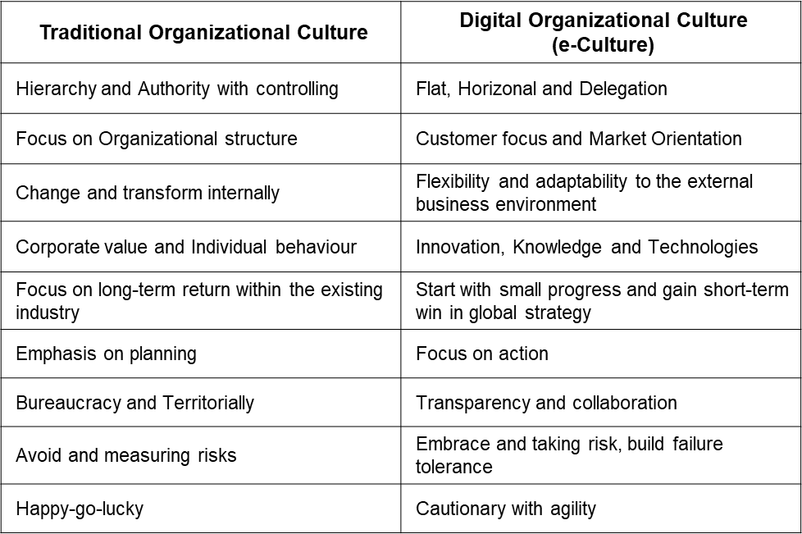
Developing or altering a digital culture involves organizational efforts (Janowski, 2015). However, shaping a potent digital culture fostering talent and leaders is challenging. Studies reveal a gap between executives and subordinates' views on digital culture, underscoring the need for unified communication (Westman et al., 2012). Two key insights emerge from the research: prioritizing data-driven culture for transformation and emphasizing data management and analytics (Janowski, 2015; Horlacher & Hess, 2016). Data-rich environments enable digital enterprises. A culture of data sharing, transparency, and informed decision-making is pivotal (Bharadwaj et al., 2013; Westerman et al., 2012, 2013). Table 6 illustrates the contrast between traditional and digital organizational cultures.

Table 6: Traditional organization culture vs Digital organizational culture - By Researcher
Additionally, digital transformation requires cross-functional collaboration and addressing potential conflicts arising from diverse team members' skills and experiences. Organizational e-culture drives creativity and innovation, necessitating adept leadership for co-learning in a supportive environment. E-leaders must manage conflicts, encourage collaboration, and embrace change (Westerman et al., 2013, 2014; Kiron et al., 2016; Legner et al., 2017). Traditional cultures emphasize hierarchy and individual focus, while dynamic digital cultures feature flat structures, collaboration, market orientation, and innovation. Cultivating these traits enhances an organization's ability to thrive in the digital era and navigate transformation (Janowski, 2015; Legner et al., 2017; Goran et al., 2017).
- Fundamental Principles of Digital Culture
The bedrock of organizational digital culture comprises three crucial principles, prerequisites for initiating the digital transformation journey (Birkinshaw et al., 2008):
- Organizational Environment: This principle includes all factors within the organizational context that impact its performance (Brynjolfsson & Hitt, 2000; Birkinshaw et al., 2008). Optimizing aspects like organizational design, leadership, resources, technology, vision, values, and talent development is essential to encourage behaviour aligned with corporate strategies (Birkinshaw et al., 2008).
- Digital Transformation Strategy: This principle entails a systematic process of reshaping the organization's business models, products, services, and value chain to align with evolving consumer demands (Brynjolfsson & Hitt, 2000). It mandates skillful utilization of emerging technologies and innovations to steer the transformational voyage.
- Team Competency and Capabilities: Central to a flourishing digital culture is the dedication and competence of teams and individuals in pursuit of organizational objectives (Vial, 2021) that entails nurturing a workforce armed with essential knowledge, technical expertise, skills, and optimal practices to navigate the evolving digital landscape and attain desired outcomes (Birkinshaw et al., 2008).
These principles form the foundation of a robust digital culture within organizations. Before embarking on digital transformation, ensuring cultural alignment with these principles is vital. This alignment fosters an environment for successful transformation, empowering the workforce to embrace and excel in the journey.
- Digital Culture toward Organizational Behavioral
ODT is a transformative shift that intentionally disrupts entire organizational systems (Bonnet et al., 2015; Kiron et al., 2016; Legner et al., 2017). Its success relies on aligning policies, culture, treatment of customers and employees, innovation, and decision-making (Holland & Light, 1999; Smith & Tushman, 2005; Matt et al., 2015). E-culture, essential in the digital era, involves assumptions to address challenges, guiding the organization toward digital goals (Kane et al., 2015; Matt et al., 2015; Westerman et al., 2012, 2015, 2016).
E-culture's specific norms and features are intricate, Hofstede (2011) highlights digital organizational culture has five core norms impacting today's digital climate. Firstly, digital-native organizations embrace risks, unlike traditional cultures. They foster risk tolerance and learning, which are crucial for navigating challenges (Bharadwaj et al., 2013; Kiron et al., 2016; Chakraborty et al., 2020, pp. 78-82). Digital transformation entails unforeseen hurdles, demanding a risk-taking and learning culture. Additionally, it involves managing budget constraints, technology shifts, talent shortages, and economic changes. Encouraging risk-taking and incentivizing risk management is pivotal for transformation success (Hofstede, 2011; Chakraborty et al., 2020). Kane et al. (2015) contend that risk aversion stifles established organizations' growth (cf. Simon, 2014). Nurturing a risk-taking culture instils deliberate actions, swift recovery from failure, and continuous learning (Bharadwaj et al., 2013; Chakraborty et al., 2020, pp. 78-82; Hemerling et al., 2018).
Digital culture shifts towards decentralized decision-making by promoting guiding principles and delegation, diverging from the conventional hierarchical control in organizational management (Beer et al., 1990; Burnes & Jackson, 2011; Gelfand et al., 2012). Instead of frequent performance measurement and correction, trusted and knowledgeable talent should be empowered to drive change (Cascio & Montealegre, 2016; Buvat et al., 2017). This approach aids in addressing the complexities of talent recruitment in rapidly changing environments. MIT Sloan Management research (Kane et al., 2015) reveals that 81% of digital talents prefer organizations with empowered digital leadership, fostering career motivation. However, 74% of respondents emphasize internal skill and experience development to support talent growth. The Capgemini Digital Transformation Review highlights a critical digital talent shortage in 59% of surveyed organizations, notably needing more soft digital skills like learning enthusiasm and customer focus, crucial for a digital-first mindset. The scarcity of digital talent, a critical failure factor, cannot be solely addressed externally, as nurturing internal potential and knowledge is essential to retain talents (Vera & Crossan, 2004; Gelfand et al., 2012; Chakraborty et al., 2020, pp. 103-106).
Simon (2014) outlines the Digital Talent Culture framework, encompassing talent inflow, development, and retention strategies to manage and cultivate a workforce driving ODT effectively. Inflow involves attracting skilled individuals aligned with the digital vision. The development emphasizes enhancing digital competencies through training and upskilling (Vera & Rodriguez-Lopez, 2004; Hofstede, 2011). Retention prioritizes creating a favourable digital work environment, competitive compensation, and recognition culture. Retaining digital talent is vital for long-term transformation and resilience. This framework ensures a dynamic workforce propelling digital innovation and success (Simon, 2014, pp. 121-178).
Traditional hierarchical cultures and structures, once fitting for complex organizations, can impede agility in the digital age. Streamlined structures foster collaboration and flexibility, enabling efficient teamwork and goal achievement (Bharadwaj et al., 2013; Hemerling et al., 2018). A horizontal, project-based approach enhances performance and team cooperation, with senior executives providing high-level standards. Prioritizing action over excessive planning cultivates an agile culture (Holland & Light, 1999; Vera, 2004; Fitzgerald et al., 2014). This iterative approach promotes timely adaptation and cross-departmental cooperation, which is essential for knowledge sharing and success. Digital leaders should create transparent, interactive environments for contingent workforces, utilizing crowdsourcing for reliable, high-quality project outcomes (Bharadwaj et al., 2013; Kiron et al., 2015).
Cultural beliefs foster innovation and garner employee support for digital transformation across functional units. Bharadwaj et al. (2013) stress the importance of ongoing digital storytelling to enhance buy-in, particularly from dedicated individuals. Digital storytelling should utilize a top-down approach to prioritize clear communication of goals, exemplified by Apple's annual development stories that boost organizational pride. Cultural challenges often overshadow technical advancements in digital culture, impacting performance outcomes (Goran et al., 2017, pp. 162-175). Figure 10 illustrates the formulating parameter of Digital Talent Culture of digital transformation.
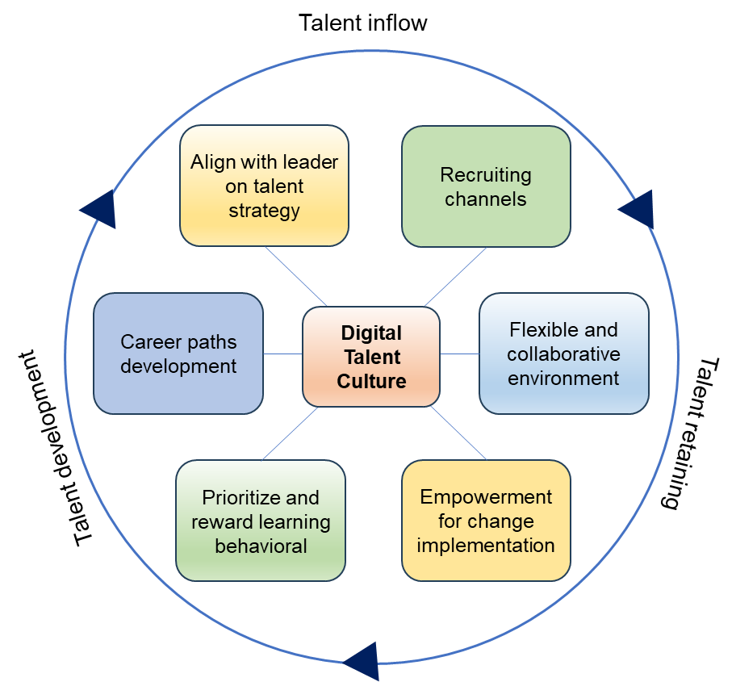

Figure 10: The formulating parameter of Digital Talent Culture - Source: Simon (2014)
- Proposed H1 Heart Domain in ODT
Digital technology adoption goes beyond change management, with the potential to disrupt daily operations (Fitzgerald et al., 2014). The "Great Man Theory," coined by Thomas Carlyle (1795-1881), suggests exceptional leaders are born with innate attributes and authority, achieving historical feats against all odds. This view, however, overlooks societal influences on leadership development. Henri Fayol (1841-1925) introduced "Fayolism," emphasizing administrative functions, training, education, and experiences as crucial for leadership growth. Like a well-designed body, organizations need nurturing to thrive, with business owners enjoying a healthy organization and a well-crafted business model (Fitzgerald et al., 2014).
The views of leading approach, management guides the organization towards predefined goals. Just as a balanced diet promotes bodily health and knowledge enhances the mind, careful attention prevents mishaps – a principle applicable to organizations. Analogous to the human body's interconnected systems, an organization's framework consists of layers, each crucial to its function. Yu's 3H holistic management framework emphasizes the 'Heart' as an organization's core, driving objectives (Yu, 2019). Similar to the brain and heartbeat in humans, this domain reconciles norms, culture, and leadership, shaping the organization's identity and uniting its functional components.
Yu (2019) emphasizes the absence of standard methods for managing individuals with emotional and rational behaviours, aiming to reshape their outlook in alignment with new business norms. Leaders can positively influence and motivate through heart-centered approaches reminiscent of the nurturing experience in the womb. Daoism underscores a ‘Heart-oriented – 以心為本’ perspective on nature (Purvanova et al., 2009; Čarnogurská, 2012; Lee et al., 2008, 2013; Moon, 2015). Yu (2019, 2020) asserts that the heart domain embodies empathy, motivation, strong interpersonal skills, sincere influence, and attitudinal alignment. During digital transformation, organizations must rally all employees around the corporate culture to propel initiatives and actualize set goals (House & Howell, 1992; Jung et al., 2008; Teague et al., 2013, 2016). Shifting employees' mindsets involves challenging the status quo rather than conventional "bottom-line" thinking (Deci et al., 1999). Fostering a heart-to-heart culture and leadership necessitates addressing obstacles, crafting guiding principles, allocating resources for vision and mission, and establishing core values (Yu, 2019).
Kazuo Inamori – 稲盛和夫 (1932-2022), the founder of Kyocera and KDDI, as well as former chairman of Japan Airlines, underscores the pivotal role of entrepreneurial personality in the life cycle of business. Inamori emphasizes leaders' mentality, rooted in care, sincerity, harmony, and empathy for self and others (Xu & Andersen, 2020). Yu (2020) concludes that cross-cultural leadership's self-development fosters autonomous motivation and impactful decision-making among subordinates, enhancing business engagement and performance. This evolution represents a game of human chess in socially mature organizations, wherein the conceptual approach to business transformation navigates a technologically revolutionary terrain (Yu, 2020).
In contrast to digital transformation, various factors contribute to performance benefits and rational approaches. These encompass digital technologies, transformation strategies, financial backing, management focus, organizational culture, human resource expertise, value creation, and project execution (House & Howell, 1992; Teague et al., 2013, 2014, 2016; Westerman et al., 2012, 2015; Warner et al., 2019). Amidst organizational digital transformation (ODT), management faces complex challenges and must exhibit effective decision-making and problem-solving skills (Bharadwaj et al., 2013; Fitzgerald et al., 2014). Leadership behaviour and attitude mirror the organizational culture, steering performance, and objectives. Yu's 3H management framework underscores human-oriented leadership, cultural coherence, and alignment with strategic planning for value-driven transformation (Deci et al., 1999; Majchrzak et al., 2016).
Organizational behaviour is crucial for nurturing a collaborative culture, utilizing intrinsic and extrinsic rewards for motivation. Effective cross-cultural leadership with people management, talent engagement, and recognition fosters adaptability and development (Schwartz & Bardi, 2001; Westerman et al., 2016). This approach necessitates an organization that continuously improves through cross-boundary learning and process management, embracing knowledge and values at various levels (Huber, 1991; Garvin, 1993; Cummings, 2004). The 3H framework's heart domain proposes that leadership drives performance improvement by focusing on business performance, setting targets, and creating a solid cultural foundation (Schwartz & Bardi, 2001). Traditional business styles need enhancement for successful digital transformation, as organizations are complex systems with diverse agendas beyond performance metrics. A heart-oriented organization acts as a coach, empowering employees at all levels to navigate challenges effectively (Deci, 1971; Child, 1972; Barnet, 1986; Cummings, 2004; Johns, 2006). Yu's 'Heart' domain emphasizes solving issues collectively and aligning organizational norms with business performance and behaviour. Influential people management and reciprocal behaviour drive transformation success, fostering a conducive environment for collaborative goal achievement (Yu, 2020). Senior management also plays a pivotal role in recognizing the importance, necessity, and urgency of change, leading others toward the desired goals (Beer et al., 1990; Hannan et al., 2003; Baker et al., 2007; Al-Haddad & Kotnour, 2015; Appelbaum et al., 2012).
- The Head Elements (Strategy and System) and ODT Relationship
- Digital Strategy (DX) and Systems Alignment
Digital transformation strategy alignment, a pivotal focus in organizational change management research and practice, enhances performance (Narayanan et al., 2011; Morakanyane et al., 2017; Solis, 2017, 2018). Amidst today's intricate business landscape, marked by multidimensional innovation, environmental dynamism, and substantial operational and strategic shifts, achieving alignment grows more intricate. It necessitates comprehensive planning to harness digital technologies for business enhancement. The alignment of digital strategy with the swiftly evolving business milieu and the organization presents challenges (Yeow et al., 2018). Organizations must devise functional strategies that are mindful of existing infrastructures and transformation objectives (Schwartz & Bardi, 2001; Burgelman & Grove, 2007). As digital technologies reshape business models, organizations must cultivate new competencies amenable to the digital revolution (Sambamurthy et al., 2003; Banker et al., 2011; Rai et al., 2012). Implementing digital technology also reshapes organizational structures and social relationships (El Sawy, 2003; Susarla et al., 2012).
Sambamurthy et al. (2003) emphasize that a successful digital strategy hinges on two pivotal factors: strategic foresight and systemic insight. Strategic foresight, a cornerstone of strategic management, leverages an organization's diverse resources to capitalize on opportunities and navigate the intricacies of today's rapidly evolving business landscape (Habegger, 2010; Narayanan et al., 2011; Adegbile, 2017). This approach entails adopting various methodologies to enhance decision-making process, addressing future challenges and uncertainties. ODT demands a profound grasp of technological intelligence, competition, resources, and organizational competence. It enables organizations to analyze, detect, and explore pertinent information from various trends and advancements shaping their present operational context (Yeow et al., 2018). However, strategic foresight transcends analysis, demanding an organization's commitment to long-term strategies fostering transformative processes across all levels of the organizational structure.
In line with the resource-based view of strategic planning, strategic foresight must also facilitate group learning behaviour, scenario-based knowledge generation, and the creation of measurable alternative plans. These steps synthesize and conceptualize various digital strategy approaches. Adequate strategic foresight involves phases like broad information analysis, foresight knowledge generation, and action process development (Habegger, 2010). Through this systematic approach, organizations can navigate the complexities of modern business, ensuring a robust and adaptive path to digital transformation (Bharadwaj et al., 2013).
Organizations favor alternative action plans that cultivate normative digital information for rational future actions (Schwartz & Bardi, 2001; Sambamurthy et al., 2003). After gathering, analyzing, and filtering information, digital leaders align insights to explore critical issues for future planning. DT often needs more foresight for unexpected scenarios, hindering action challenges (Burgelman & Grove, 2007; Habegger, 2010). Strategic foresight enhances resources, improving planning, driving better decisions, and promoting development (Adegbile et al., 2017). It identifies disruptive innovations, scales transformation, detects early risks and fosters learning and collaboration (Habegger, 2010; Adegbile et al., 2017). Organizations should implement a digital strategy defining boundaries, mapping transformation, and external relationships for practical objectives (Bodrožić & Adler, 2018; Yeow et al., 2018). This scope conceives infrastructures, implements transformation, and aligns with the external environment.
In ODT, innovation and integration are vital for achieving systemic insight. Innovation entails applying new resources, external synergies, and technology to achieve specific goals, while integration aligns existing operations, resources, and technologies (Daniel & Wilson, 2003; Habegger, 2010; Hanelt et al., 2021). Digital transformation combines novelty and business model reform through digital strategy integration, and developing a digital business strategy involves data management, technology selection, and business model transformation (Susarla et al., 2012; Bharadwaj et al., 2013). Technology structuring aligns with digital creation, digital mindset, innovation, Digital capabilities, and value-added growth (Daniel & Wilson, 2003; Berman, 2012; Benner & Waldfogel, 2020; Hanelt et al., 2021).
Integration is essential for aligning digital innovation strategies, covering existing and new adoptions, and crafting a comprehensive strategy at the core of integration, involving the alignment of business development, operational and strategic planning which coordinate and implementing across all levels base on experimentation analysis (Henfridsson & Yoo, 2014; Morakanyane et al., 2017; Fitzgerald et al., 2015). Strategy execution enables seamless integration across technological capabilities, operational frameworks, digital infrastructure, and collaborative agility (Schuchmann & Seufert, 2015; Benner & Waldfogel, 2020). The systemic integration mechanism harmonizes digital technologies with organizational structure, culture, resources, and the digital working environment (Westerman et al., 2013, 2014; Zimmermann et al., 2018). Strategic alignment is critical to addressing transformational challenges and optimizing resource synergies (Habegger, 2010; Hansen et al., 2011; Schuchmann & Seufert, 2015). A recent literature review introduces the digital systemic matrix (Figure. 11).

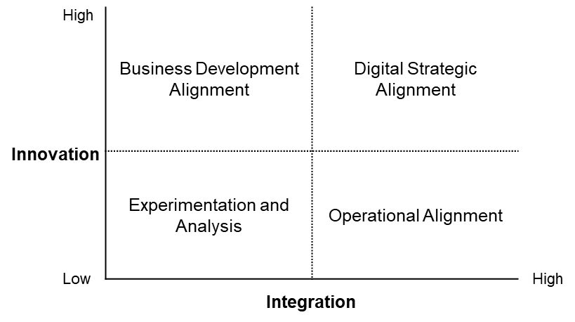

Figure 11: The Digital Systemic Matrix - By Researcher

- Resource-Based view toward ODT
Since the 1960s, strategic organizational management has employed SWOT analysis to assess core competency and competitive position based on external opportunities, threats, and internal strengths and weaknesses. Porter (1980) and BCG introduced the BCG Matrix and Porter's 5 Forces to evaluate factors influencing organizational competitiveness. However, in today's rapidly changing environment, external analysis faces criticism due to instability (Bartlett & Ghoshal, 1991; Collis & Montgomery, 1997). Grant (1991a) introduced the Resource-Based Theory (RBT), emphasizing the connection between resources and strategy. Neglecting internal elements can lead to risks (Black & Boal, 1994). Cross-sectional analysis needs a longitudinal approach (McWilliams & Smart, 1993; Porter, 1996, pp.81-84). An organization should focus on competency over external positioning (Hamel & Prahalad, 1994; Collis & Montgomery, 1997). In the competitive business environment, the business strategy emphasizes core competencies for a sustainable competitive edge (Stalk et al., 1992; Teece, 1992).
Recent strategic management studies acknowledge that an organization's competitive edge relies on internally developed capabilities, resources, and intangible assets (Barney, 1986b). Structural processes and resources shape digital transformation's goals and strategy (Hamel & Prahalad, 1990; Heracleous & Barrett, 2001). Hart (1995) suggests three organizational resources' burdens that cannibalize the competitive edge of digital transformation:
- Financial and human resources,
- Knowledge resources of technology and Capabilities knowhow,
- Managerial and leadership resources.
Organizations develop capabilities and competence through experiences and internal development, fostering sustained competitive advantage with a strategic structural approach to avoid unnecessary competition and chart growth paths (Barney, 1986a, 1991; Black & Boal, 1994; Healey, 2006). Peteraf (1993) highlights the value of unique and irreplicable heterogeneous resources for a competitive edge, stressing resource creation and development to hinder rivals' access. "Resources" and "Products" are intertwined, as products rely on resources and vice versa (Prahalad & Hamel, 1990; Hodgkinson, 1997). During digital transformation, the organization harmonizes intangible resources and targeted technology. Core capabilities are vital assets. In prior decades they have emphasized the role of organizational resources in strategy (Hamel & Prahalad,1994; Montgomery & Collis,1995; Helfat & Peteraf, 2015). The organization should link resources, competition, and performance for business strategy, addressing performance gaps for competitive advantage (Mowery et al., 1998; Barnet, 2001; Lepak & Snell, 2002). In digital transformation, core competency anchors the new framework; strengthening it drives the transformation process (Bharadwaj et al., 2013). RBV emphasizes internal resources and competencies for corporate strategy (Grant, 1991; Leonard-Barton, 1992; Hamel & Prahalad,1994), and valuable resources are essential for successful digital transformation (Barney, 1995).
RBV scholars highlight disruptive technical resources as potential sustainable advantages for ODT (Bharadwaj, 2000; Barney, 2001). This introspective approach shapes IT-related functional capabilities, IT infrastructure, human IT resources, IT-enabled intangibles competency, and assets (Barney, 1986c, 1991; Collis, 1991; Grant, 1991; Bharadwaj, 2000; Casadesus-Masanell & Ricart, 2010). Internal resources drive organizational strategy, assessing the core competency-performance relationship. Organizations must confirm resource position, capabilities, advantage, and strategy (Grant, 1991; Beer & Eisenstat, 2000; Lepak & Snell, 2002). Assembling resources into specialized or cross-functional combinations creates a competitive advantage (Prahalad & Hamel, 1990; Russo & Fouts, 1997; Silverman, 1999; Barney, 2001; Wade & Hulland, 2004). Grant (1991) emphasizes capabilities to drive performance, including competency growth in processes like product innovation, R&D, and customer relationship management. Bharadwaj et al. (2000) adopt the classified resources scheme from Grant (1991), extending the IT-based resources into the following classification:
- The physical IT infrastructure components from the tangible resources,
- The managerial and technical competence of the human IT resources, and
- The intangible IT-enabled resources include know-how, customer base, experiences, and knowledge assets.
The Organization's IT infrastructure, including technology, databases, and communication platforms across units, is a critical lasting competitive edge (Keen, 1993; Russo & Fouts, 1997; Wade & Hulland, 2004). It facilitates targeted applications and processes within the supply chain (Barney et al., 2001; Cooper-Hakim & Viswesvaran, 2005). This hub shares information and leverages opportunities for value creation (Barney & Mackey, 2005). Grant (1991) defines "grounded resources" as human resources, including technical IT skills for programming and managerial IT skills for project coordination. Mowery et al. (1998) stress the importance of IT human resources for cost-effective applications. Collaborative human IT resources deliver solutions and address risks for ODT (Lepak & Snell, 2002). To boost IT-enabled project performance, intangible resources like organizational culture matter (Wade & Hulland, 2004). Technological expertise at the team and individual level creates sustainable value (Cooper-Hakim & Viswesvaran, 2005; Teece & Pisano, 2003).
Valuable customer data emphasizes high customer orientation, which is often crucial (Bharadwaj et al., 2000). Intellectual capital nurtures creative processes, applying knowledge in transformation (Bititci et al., 1997; Al-Mashari et al., 2003). Organizational synergy goes beyond knowledge, responding to market needs (Ajzen, 1991; Barney, 1995, 1986b; Baron & Hannan, 2002). Complex spatial resource delivery resists imitation for competitive advantage (Collis, 1991; Hamel & Prahalad, 1994; Fenech et al., 2019; Bharadwaj et al., 2000). While historically, the Resource-Based View was widely supported, it focuses on controllable resources (Foss, 1998). RBV's mainstream interest declined due to missing elements (Lockett & Thompson, 2001). The missing element might relate to disruption and regulatory change (Barney et al., 2001; Lepak & Snell, 2002). Digital technology has driven competition, product innovation, revenue models, and distribution (Fitzgerald et al., 2014; Cohron et al., 2020). In this journey, organizations face competitors and must strategize (Casadesus-Masanell & Ricart, 2010; Aaltonen & Ikävalko, 2002).
- Tactical Approach – The Art of War for Managing Change
Sun Tzu's The Art of War, an ancient military treatise, covers warfare's strategic, tactical, political, and economic aspects, serving as the foundation for military strategy; its insights have extended to modern business management in a competitive landscape (Wee et al., 1996). Sun Tzu highlights that strategy without tactics is the slowest route to victory and tactics without strategy are the noise before defeat. ‘謀無術成事難，術無謀則必敗’ (Lee et al., 1998; Lee & Ko, 2000; Tzu, 2005, pp. 76-79). Sun Tzu states that overcoming positional disadvantages requires tailored strategies and terrain engagement to overcome obstacles and secure favorable outcomes (Wong et al., 1998; Null & Larkin, 2001, pp. 13-19; Tzu, 2005, pp. 26-33).
- 道 Moral Law: Rules and Regulations which the laws of the human Nature and the way of the World,
- 天 Seasonal Factors & Timing: Self-positioning and action timing,
- 地 Landscape or Operational Terrain: Strategic planning and Resources,
- 將 Leadership Qualities: Leader behavioral, Sincerity, wisdom, courage, and benevolence,
- 法 Management Skills: Organization structure, Hierarchical discipline, Operation and logistics, and Methodology.
In ODT, integrating the human perspective into operational processes is advocated to influence management decisions that assume human nature impacts thoughts and actions, likened to water's effect on a boat (Rarick, 1996; Null & Larkin, 2001, pp.83-87). Sun's strategic framework emphasizes subjective human initiative, which is vital for competitive advantage and sustainable growth (Wee et al., 1996; Wong et al., 1998; Tzu, 2005, pp. 33-35). ‘上下同欲者勝’ suggests organizational success through aligned desires and collaboration. Management must foster a collective spirit across all levels and cultivate corporate culture, values, objectives, and clear directions while using goals and rewards for motivation (Null & Larkin, 2001; Tzu, 2005, pp. 38-39). Applying ‘以正合，以奇勝’, successful management balances regulatory structures and agile approaches. Business activities mirror the organization's dimension (Gupta & Govindarajan, 1984; Floyd & Wooldridge, 1992). In recent decades,
Matrix Management emerged for forming and project-focused and has emerged as a strategic framework conducive to forming project-focused structures (Barlett & Ghoshal, 1990). During the ODT progress, akin to intricate military manoeuvres that span various units such as IT, sales, and operations, effective navigation necessitates the promotion of cross-functional teams endowed with diverse skills (Barlett & Ghoshal, 1990; Cash et al., 2003; Fitzgerald et al., 2014). These cross-functional units align seamlessly with Sun's 'Win by Surprising' principle, as articulated by Wee in 1994b. This approach facilitates continuous improvement and enhances organizational adaptability (DeLone & McLean, 1992; Birkinshaw et al., 2008).
Furthermore, Sun Tzu's strategic framework encompasses five essential constructs that support combat situations, as illustrated in Figure 12. This depiction delineates the interrelationships between each construct and the digital operational domains, providing a comprehensive understanding of the strategic landscape.
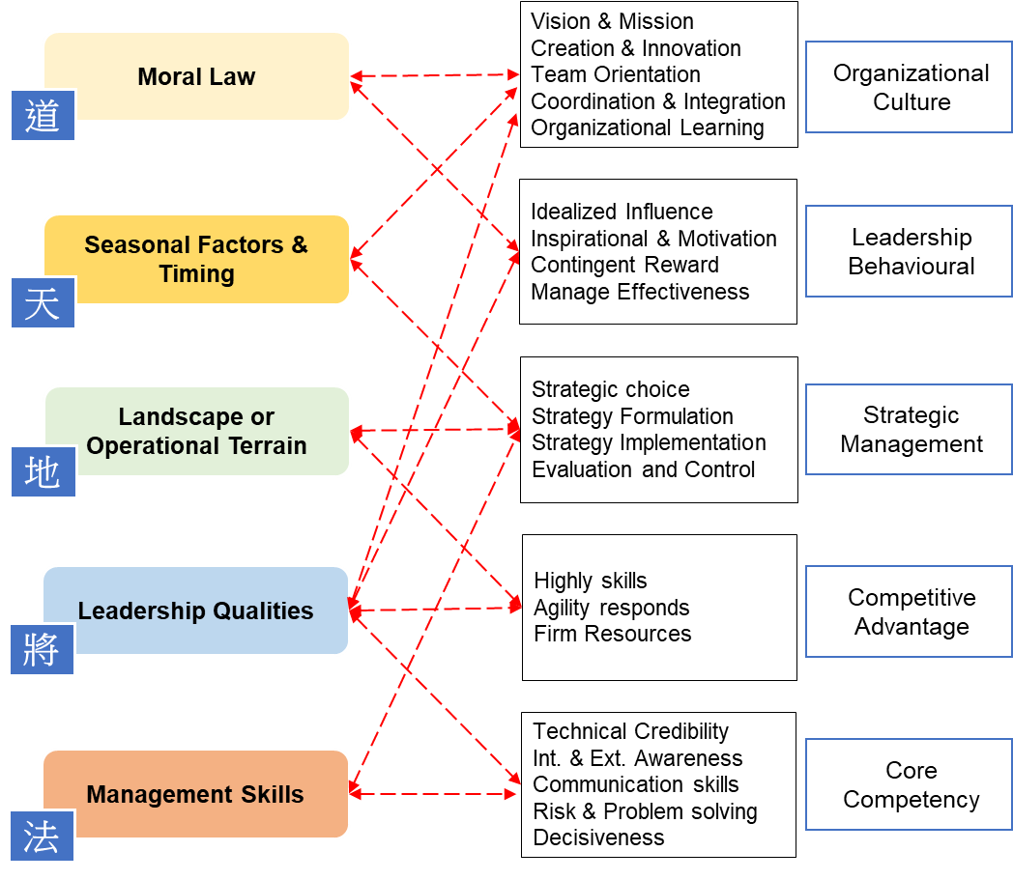

Figure 12: Relationship between Sun’s five constructs and digital operating functional domains - By Researcher

Sun Tzu's principle, ‘The control of a large force is the same principle as the control of a few men - 凡治眾如治寡，分數是也,’ underscores that managing groups depends on division (Gluck et al., 1982; Floyd, 1992; Wee, 1992; McCormick, 2001). Effective command in both contexts relies on established structural norms, necessitating well-designed rules, procedures, and clear structure (Lee et al., 1994, 1998; McCormick, 2001). This strategy implies alignment with rules and regulations, valuing public opinion and respect (Armenakis et al., 1993; Hannan & Freeman, 1984), especially during unpredictable incidents and transformations (DeLone & McLean, 2003).
Effective team performance starts with empowerment and trust (Mathieson, 1991; Anderson et al., 1994; Deci & Ryan, 2000). Leaders should empower capable subordinates for talent growth. Sun's advice, ‘將者，國之輔也,’ stresses coordinated leader-subordinate relationships (Wee et al., 1996). Sun Tzu's Art of War emphasizes trusting and empowering individuals who understand situations well. As Sun Tzu said, ‘不知三軍之事 而同三軍之政者，則軍士惑矣,’ leaders should avoid excessive interference. Leaders must trust their teams' expertise in digital transformation for aligned decisions (Lee & Ko, 2000; Null & Larkin, 2001). Significant decisions, particularly those related to organizational change and major events, should be aligned with opinions at all levels. For this reason, Sun Tzu highlighted the vital role of qualities such as wisdom, faith, benevolence, courage, and discipline in leaders, as they directly impact the fate of a country (Wee, 1994a; Null & Larkin, 2001). This approach fosters an effective and cohesive digital transformational culture and ensures smoother implementation, avoiding disruptions that may arise from excessive interference in lower-level operations.
‘Incentive’ is a psychological term for continuous motivation. Sun Tzu emphasized the importance of deception, benefits, and strategic changes to inspire subordinates, drawing from warfare tactics to stimulate soldiers' fighting spirit. This approach proves essential for achieving high performance in numerous organizations (Boar, 1995, pp. 78-83; Lee & Ko, 2000). Leaders should adopt a holistic incentive strategy, blending material and spiritual motivations to cultivate a motivated and engaged workforce during organizational digital transformation. Acknowledging individual values and personal growth promotes successful digital initiatives and boosts organizational performance.
Amid challenges in today's competitive business landscape, organizations can harness their potential by cultivating strong employee bonds, determination, and survival confidence, that parallels the survival map concept from ancient wisdom (Avolio et al., 2000; Deci & Ryan, 2000). Sun Tzu's emphasis on teamwork as an indispensable tool to address challenges remains pertinent (Wee et al., 1996). His people-centric management idea, depicted as ‘故善用兵者，譬如率然’, promotes communication, agility, and coordination (Wee et al., 1996). Business public relations aims for internal unity and external growth by embodying human resources as ‘人和’ (Gluck, 1982; Wee, 1994b; Wee et al., 1996; Lo et al., 1998). Confronted with problems, individuals unite, showing courage and letting go of biases (Mathieson, 1991; Coff, 1997; Deci et al., 1999, 2000). Sun's counsel, ‘兵士甚陷則不懼，無所往則固’ underscores the leader's role in fostering a no-way-back spirit in their team during crises (Wee et al., 1996; Tzu, 2005, pp.21-24; Null & Larkin, 2001). Experimental psychology highlights the amplified impact of stimuli in groups relevant to change management in digital transformation (Deci et al., 2000). Mutual support during challenges fosters cohesion and emotional resonance, enhancing organizational morale.
Sun Tzu's maxim, ‘故令之以文，齊之以武,’ stresses troop management through care and discipline. Leadership, encompassing traits, skills, behaviours, and practices, profoundly influence and inspire others (Avolio et al., 1999; Antonakis et al., 2003; Fletch, 2012). Effective leadership guides teams during technological changes in digital transformation. ‘文 Wen’ signifies empathy and reward, while ‘武 Wu’ represents discipline. Modern leadership often blends these approaches to motivate teams. Transformational leadership fosters engagement, interaction, and synergy. Leader influence and knowledge are crucial during ODT, surpassing hierarchical authority. Sun's emphasis on strategic leverage over solely relying on subordinates' capabilities applies to ODT's environmental advantages (Barney, 1995; Lee et al., 1998; McCormick, 2001; Null & Larkin, 2001).
Organizations can draw valuable insights from the ancient wisdom of Sun Tzu's ‘Art of War’ to strategize their implementation. Sun Tzu's principles apply to modern digital endeavors, emphasizing planning, adaptive tactics, and leadership. "Knowing oneself and knowing the enemy" equates to understanding an organization's state, strengths, and competition (Miles & Snow, 1984). Leaders' awareness fosters unity and innovation, akin to agility in warfare. Embracing this wisdom enables organizations to navigate digital transformation effectively, securing sustainable competitive advantages.
- Proposed H2 Head Domain in ODT
In the business environment, organizations view their digital transformation as a 'pre-emptive attack,' a primary market innovation strategy. This approach entails strategic technology planning under strong leadership to outpace potential industry rivals (Teece et al., 1997, 2016). The goal is establishing a market presence through innovative processes and products, targeting new territories and markets. Strategic management aligns resources and capabilities with objectives to boost efficiency and competitive advantage. Cultivating a unified culture under a leader's inspiration, referred to as 'One Heart, One Desire,' is essential for achieving company goals (Schneider et al., 1998; Smith & Tushman, 2005). An organization's diverse position and tangible capabilities, including know-how, resources, culture, structure, experience, and leadership, are the foundation of its success (Barney, 1991). This perspective aligns with Yu's 'Head' domain description, where organizational culture and leadership drive the goal achievement processes. Directional planning, clear responsibilities, and structural alignment are crucial for achieving goals (Yu, 2020). Yu further highlights that the 'Head' domain functions like the steerer of a dragon boat, guiding its direction based on the drummer's rhythm and the rowers' efforts.
During the ODT, failures can arise from multiple factors, particularly organizational and human dynamics, rather than technological issues (DeLone & McLean, 2003; Fitzgerald et al., 2014). These causes can be rooted in internal elements or influenced by external environmental and social factors. Thus, aligning digital transformation with strategic planning becomes a crucial organizational priority (Somers & Nelson, 2001, 2003; Hrebinia, 2006). IT-enabled strategic planning is essential for defining clear business objectives that guide targeted project implementation which are closely linked to the organization's competitiveness (Hanafizadeh et al., 2011; Bharadwaj et al., 2013).
Effective strategy translation and communication across organizational levels which involve an artful management approach (Paquette, 1991; Yu, 2020). Hence, clear communication and identification of business goals are prerequisites for transformative projects. The McKinsey 7S Model, introduced by Tom Peters and Robert Waterman in the early 1980s, remains a vital tool for measuring organizational development. Comprising variables such as 'Strategy,' 'Structure,' 'System,' 'Staff,' 'Style,' 'Skills,' and 'Shared Values,' this model offers a comprehensive view of an organization. While 'Hard' elements like Strategy, System, and Structure form the tangible foundation, the 'Soft' elements—Staff, Style, Skills, and Shared Values—drive planned activities (Leonard-Barton, 1988; Grant, 1991; Hanafizadeh et al., 2011).
Initiating the digital transformation journey involves establishing overarching organizational goals and a method for their realization (Al-Mashari et al., 2003; Casadesus-Masanell & Ricart, 2010). Strategic digital planning aims to enhance performance by aligning competence with technological capabilities to meet transformational requirements (Wright et al., 2001; Somers & Nelson, 2003). A distinctive digital transformation strategy involves selecting appropriate digital technologies and preparing the business model for change (Tekic & Koroteev, 2019; Udovita, 2020), underscored by Yu's (2020) study on China's COVID-19 strategy, which adeptly balances emergency and long-term goals. The internal characteristics of the digital transformation strategy's structure controllability, centralization, formalization, standardization, and specialization—play key roles (Morton & Hu, 2004; Matt et al., 2015).
High-level controllability centralization is favored for IT-driven changes, while formalization and standardization play pivotal roles in digital strategy by ensuring documented processes and procedures and facilitating technology-enabled implementation with compliance (Morton & Hu, 2004; Matt et al., 2015). Strategy specialization involves aligning skills and knowledge with workloads, considering task behaviour and market sensitivity to meet objectives. According to Yu (2020), senior management shapes and executes strategies, encouraging lower-level innovation and fostering dedication. Strategic management, either descriptive or prescriptive, involves resource allocation and long-term planning (Prahalad & Hamel, 1990; Gupta & Govindarajan, 1984; Wernerfelt, 1984; Barney, 1995). Yu's 3H framework underscores the Head domain's significance in facilitating planning and maintaining execution, driving organizational effectiveness, strategy planning, formalization, and processing within the holistic management framework.
- The Hand Elements (Competences and Measurement) and ODT Relationship
- Competence-based View and Organizational Transformation
A competent individual leading a capable organization holds more value than numerous ineffective individuals (Prahalad & Hamel, 1997). Porter (2008) underscores how industry structure and competitors' actions shape competition levels. His Five Forces model defines this industrial structure and guides strategic decisions (Structural Analysis). Traditionally, excellence arises from expanding market segments and leveraging industrial structure (Prahalad & Hamel, 1997; Kandampully, 2002). Leonard–Barton (1992) stresses the need to influence market dynamics. This viewpoint enhances external market segments and industrial structure to create a competitive edge. Organizations striving for competitive advantage face external challenges related to market segmentation, industrial trends, and resource allocation (Teece et al., 1997; Nath et al., 2010). Scholars explore competitive advantage development through internal perspectives, focusing on resource and capability growth. However, an exclusive focus on existing competitors may need to pay more attention to dynamic industry changes (Zott, 2003; Birkinshaw et al., 2009; Smith & Lewis, 2011).
In a rapidly changing environment, organizational inflexibility can lead to a competitive disadvantage (Peteraf, 1993; Hamel, 1994). Senior management emphasizes 'sustainable competitive advantage,' aligning with adaptability (Bogner & Thomas, 1992; Hamel, 1994; Javidan, 1998). Efforts to nurture competitive advantage become a dynamic capability shaping an organization's trajectory (Leonard-Barton, 1992; Prahalad & Hamel, 1997). Various forms of competitive advantage are identified: product, marketing, manufacturing, R&D, innovation, technology, and external relations (Ahire et al., 1996; Mascarenhas et al., 1998; Lawson, 1999). Rumelt (1984) outlines three conceptual perspectives on organizational competitive advantage: 1). RBV – Resource-based view, 2). CBV – Competence-based view, and 3). DCV – Dynamic capability view; these theories are interconnected, with later concepts often addressing limitations in the earlier ones. Scholars have dissected these theories to define the components of sustainable competitive advantage for organizations.
Regarding digital transformation's competitive advantage, Smith & Tushman (2005) expand on Wernerfelt's (1984) and Barney's (1991) theories, they propose that an organization's digital assets and capabilities result from accumulating digital-enabled competencies and strategic asset allocation, deviating from traditional competitive factors like industrial structure and market segments. These strategic resources, encompassing organizational assets and capabilities (Lippman & Rumelt, 1982; Barney, 1991), include controlled assets such as production, operations, information, know-how, knowledge, and organizational traits, which can enhance efficiency through technology adoption. Therefore, cultivating strategic resources before digital transformation establishes a unique competence, providing a competitive advantage over rivals (Baer & Frese, 2003; Nath et al., 2010; Matt et al., 2015).
Scholars emphasize corporate resilience and competency as vital core capabilities contributing significantly to an organization's competitive advantage (Mowery et al., 1998; Mascarenhas et al., 1998). Organizational digital competencies arise from collective learning within the business, manifesting in various activities and procedures, distinguishing themselves across products and markets (Mithas et al., 2013; Ng & Kee, 2018). The various competitive advantage perspectives in between RBV and CBV describe and organize as show in below (Table 7).
Emerging technologies are pivotal assets for organizations in this competitive landscape (Markides & Williamson, 1994; Nah & Delgado, 2006; Foss & Saebi, 2017). An organization's digital competitive advantage hinges on resource allocation's performance for agile responses to digital transformation (Mithas et al., 2013; Gurumurthy et al., 2020, pp. 134-139). Utilizing digital technology and training, the organization pursues differentiation through products and services, emphasizing manufacturing as a business platform. Investment and business development performance are paramount (DeLone & McLean, 1992; Sambamurthy et al., 2003; Porter & Heppelmann, 2014; Westerman & Bonnet, 2015). The organizational performance forms the core competency, making competitive advantage complex to explain (Helleuloid & Simonin, 1994), and integrates resources and capabilities cohesively for effective operations, spanning functions, products, and businesses (Teece et al., 1997; Zahra et al., 2006; Teece, 2007)
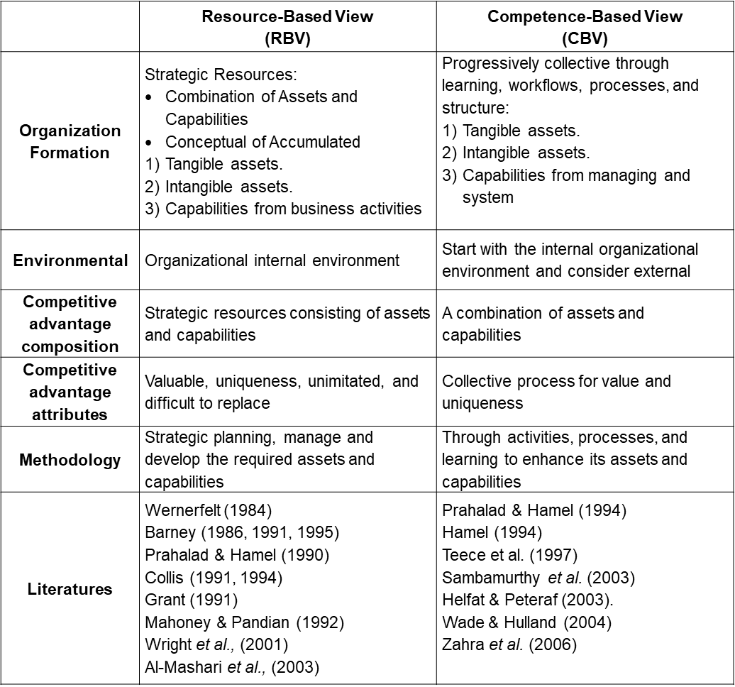

Table 7: The various competitive advantage perspectives in between RBV and CBV
.
- Dynamic Digital Competence Sustainable Practice
Teece et al. (1997) propose that an organization's competitive advantage stems from integrating intellectual assets, complementary resources, and specific business activities along an evolutionary trajectory. These activities encompass procedures, routines, production processes, and learning, all managed cohesively, and such strategic evolution involves technologies, knowledge, intellectual property, databases, relations, human resources, suppliers, and competitors (Leonard-Barton, 1992; Teece, 1992; Helfat & Peteraf, 2003, 2015). Organizational digital dynamic capabilities refer to the capacity to adapt internal and external technological capabilities to a changing environment. This dynamic capability fosters new advantages within established paths, including adaptability, flexibility, and contingency underline this concept (Hafeez et al., 2002; Nath et al., 2010).
ODT's competitive advantage journey integrates diverse resource values, distinct technological capabilities, and dynamic competency development (Amit & Schoemaker, 1993; Teece et al., 1997; Miyazaki, 1999; Fitzgerald et al., 2014). I In organizational competition, individuals vie for indivisible resources, yielding meaningful rivalry, and DT arms organizations with a tangible competitive advantage to attain these resources. The performance competency of this advantage is observed across various groups within the organization. Economic shifts can undermine this advantage, prompting dynamic capabilities for resource allocation, competency restructuring, and performance enhancement (Hafeez et al., 2002). The increasing digital transformation adoption has become a strategic business tactic. Integrating valuable digital resources, collective knowledge, distinct competencies, and dynamic capabilities shape the core sustainable competitive advantage elements (Fitzgerald et al., 2014).
- Valuable Digitalize Resources
Organizational dynamic competency is through strategic development, encompassing tangible and intangible corporate resources, emphasizing value (Barney, 1991; Dosi et al., 1992; Kogut & Zender, 1992; Henderson & Cockburn, 1994; Sanchez, 2004). All resources deployable or attainable for digital transformation goals warrant consideration. These assumptions extend organizational resources beyond conventional boundaries, particularly in emerging industries or models with outsourced production activities; thus, an organization must redefine valuable digital resources into three types (Sambamurthy et al., 2003).
- Physical assets, including machinery, computers, data centers, equipment, production plants, and offices.
- Knowledge assets, encompassing digital technology, intellectual property, branding, corporate reputation, and customer data.
- Relationship assets, comprising corporate culture, supplier-customer relationships, and social and political connections.
Baer & Frese (2003) propose that organizations enhance competitive resources and develop new competency norms for digital transformation. McDonald's is a prominent example, utilizing its international network (Relationship asset) with a cost leadership strategy (Knowledge asset) over decades. This approach has propelled McDonald's as the world's foremost global foodservice retailer (Knowledge asset), with 38,000+ locations (Physical assets) spanning 100+ countries (Relationship assets). McDonald's success is attributed to its robust food production processes (Knowledge assets). CEO Chris Kempczinski introduced the 3D strategy (Digital, Delivery, and Drive-thru) before the pandemic amid rising labour costs, especially for cashiers in the competitive fast-food sector. This novel competency norm enhanced digital experiences, fostering seamless, personalized dining, and this strategy effectively addresses cashier shortages, bolstering business via virtual, boundaryless operations.
- Integrating Capabilities –Distinctive Competencies
Wernerfelt (1994) defines organizational resources as tangible and concrete assets that support an organization in improving operating practices and achieving its objectives. These encompass physical resources, human resources, and organizational resources (Wernerfelt, 1984; Grant, 1991; Marino, 1996; Doz, 1997). Digital capabilities are part of organizational resources but possess unique characteristics (Yoo, 2010), such as rarity, inimitability, and non-substitutability, resulting from resource deployment and scheduling procedures (Kandampully, 2002). Digital technological capacity combines resources to perform specific tasks using unique technologies for targeted areas (Zimmermann et al., 2018). Although resources can exist alone, capabilities are deeply embedded in organizational resources, processes, practices, and activities (Nanda, 1996). Value and uniqueness are common characteristics across resource-based, capability-based, and dynamic capability perspectives, becoming critical differentiators of firm capabilities (Prahalad & Hamel, 1994,1997; Beer et al. 2005).
Nah and Delgado (2006) emphasize the necessity of integrating an organization's digital competitive strategy into its fundamental structure and everyday functions. This integration initiates a continuous process of augmenting and broadening assets, capabilities, and resources through what they term ‘competition for competencies.’ An example is Canon, a long-standing player in optical and imaging since the 1950s. Their roots lie in quality manufacturing and value engineering. It expanded into microelectronics R&D within the optical industry while managing its dealer networks. This resource-driven strategy enabled Canon to seize new business opportunities, including digital cameras. This approach leverages operational strengths to develop and reinforce competencies, demonstrating adaptability to changing market dynamics. During the ODT, the organization integrates digital strategy into the core, and nurturing competencies remains relevant, forming a solid foundation for embracing digital age challenges and opportunities.
- Collective Capabilities presents Organizational Competency
In achieving organizational excellence, core competencies require active engagement, continuous learning, and unwavering commitment across all levels and units. This imperative stems from the understanding that adopting new paradigms and surpassing benchmarks demands collective efforts beyond traditional boundaries (Prahalad & Hamel, 1997). 3M's global success is not solely rooted in visionary strategies; it thrives by blending inventive engineering and an experimental culture (Brand, 1998; Alldredge & Nilan, 2000). Managing this advantage necessitates cumulative and shared efforts. 3M's autonomous and innovative ethos fosters fresh business methodologies driven by various factors (Brand, 1998; Mata et al., 1995; Teece et al., 1997; Senge, 1997; Alldredge & Nilan, 2000).
Similarly, collective capabilities are pivotal in the digital transformation landscape; these encompass seamless knowledge sharing, cross-disciplinary collaboration, agile challenge resolution, innovation, and needed support that leverage functions and capabilities to empower digital growth initiatives (Sousa & Rocha, 2019; Kandampully, 2002). This symbiotic approach anchors successful digital transformation and underscores unity's enduring significance in organizational advancement.
- Dynamic Competency in ODT practice
Scholars highlight the need for organizations to possess more than unique resources to remain competitive in a dynamic economic environment (Prahalad & Hamel, 1990; Teece et al., 1997). Changes in technology and the market can render certain advantages obsolete. The composition of competitive advantages may shift due to unforeseen industry changes, affecting their value to the organization (Leonard-Barton, 1992; Brynjolfsson & Hitt, 2000; Birkinshaw et al., 2008). Sharing and utilization can significantly enhance competitive advantage (Prahalad & Hamel, 1990). In technology sectors like semiconductors and computers, a lack of dynamic competitive advantage can transform into a rigid advantage in the future (Leonard-Barton, 1992; Bogner & Thomas, 1992; Reed et al., 1990; Teece et al., 1997). In digital transformation, IT scholars argue that competitive advantage must be consistently upgraded and developed through fundamental capabilities (Baer & Frese, 2003; Bharadwaj et al., 2013; Cascio & Montealegre, 2016).
Sanchez and Heene (1997) demonstrate that organizations with dynamic, solid capabilities can efficiently reallocate resources and restructure to seize technological and market opportunities, particularly in digital transformation. In the dynamic digital landscape, adaptability is essential for competitiveness. Embracing digital technologies empowers organizations to optimize operations, enrich customer experiences, and explore new markets (Bharadwaj et al., 2013; Hansen & Schaltegger, 2016). For instance, Motorola's adept adoption of digital manufacturing capabilities facilitated diversification into the communication and consumer electronics sectors. Rapidly leveraging semiconductor knowledge enabled Motorola to pioneer advanced electronic devices, showcasing its prowess in the digital age.
While digital transformation can yield sustained competitive advantages, it may also introduce inertia, limiting external information access and operational efficiency. Organizations must balance leveraging digital capabilities and exploring novel opportunities to uphold competitiveness (Dosi et al., 1992; Foss & Saebi, 2017). In this evolving milieu, digital capabilities demand flexibility, adaptability, and learning from failures. Nurturing a continuous improvement and innovation culture is pivotal for robust dynamic competencies in successful digital transformation (Galleries, 1991; DeLone & McLean, 1992; Fitzgerald et al., 2014). Strategic alignment and efficient resource utilization empower organizations to harness digital technologies, securing sustainable competitive advantages in the ODT journey.
- Measurement Tools for Digital Transformation
Boutetiere & Reich (2018) emphasize ‘Change is Hard, Digital Transformation is Harder’; the challenges of digital transformation, as it involves complex and critical practices that require collaboration across all levels of an organization. Despite many organizations having planned digital strategies, the successful execution rate still needs to improve (Sambamurthy et al., 2003). An ODT is a lengthy and technology-enabled change process, necessitating a comprehensive measurement tool for effective change management. It provides direction for leveraging corporate resources, motivating teams, conducting progress reviews, providing feedback, and facilitating effective communication to achieve key performance indicators (Yoo, 2010; Westerman et al., 2014). The implementation of the balanced scorecard (BSC) has become a prevalent approach in organizations to address inconsistent strategy execution. The BSC facilitates regular discussions about strategic objectives and tracks progress by serving as a measuring and monitoring tool (Kaplan & Norton, 1992). However, it is noteworthy that despite adopting the BSC, many management teams still allocate limited time to engage in strategic discussions, underscoring the persistent need for enhancing strategy execution practices.
- Balanced-Scorecard (BSC)
In the 21st century's knowledge economy era, innovation, sharing, and application of knowledge have emerged as critical factors in the competitive landscape. The organization's value is no longer solely reliant on tangible assets; intangible assets now play an inclusive role. Kaplan and Norton (1992, 1996a) introduced the balanced scorecard (BSC), which extends beyond traditional short-term and past financial indicators. This performance measurement tool emphasizes the significance of future economic performance indicators. The BSC provides valuable insights for organizations aligning their financial outcomes with the appropriate digital initiatives, delving into four characteristic perspectives: financial, customer, internal processes, and learning and growth (Figge et al., 2002; Kaplan & Norton, 2006b). In the digital era, effectively utilizing knowledge and digital resources can significantly impact an organization's competitive advantage and long-term success (Svahn et al., 2017). The BSC's incorporation of digital-oriented indicators allows organizations to gauge their digital maturity and align their transformation efforts with strategic goals. Consequently, the BSC serves as a compass, guiding organizations through the complexities of the digital landscape and fostering a culture of continuous improvement and adaptation.
This comprehensive performance measurement methodology integrates corporate strategy metrics to predict future economic performance. It builds customer relationships, innovates internal procedures, and fosters employee learning and growth. Compensating for the lack of backward indicators (Financial Performance Indicators - FPI) provides a balanced view of performance. However, Lipe & Salterio (2000) suggest that managers often prioritize general financial indicators while overlooking non-financial categories. Consequently, management should be cautious about relying solely on financial indicators, which may lead to an imbalance in risk considerations (Chen & Dodd, 1997; Liberatore & Miller, 1998; Maiga & Jacobs, 2003).
- Digital Sustainable Balanced Scorecard (DBSC)
In the journey of the ODT, challenges emerge from internal and external factors influencing implementation (Nah & Delgado, 2006; Foss & Saebi, 2017). Research indicates many unsuccessful ODT efforts, often due to regulatory oversights. Despite its technological nature, the triumph of ODT hinges largely on human-driven implementation. Successful project outcomes demand a structured strategic architecture and consistent progress assessment (Galliers, 1991; Fichman et al., 2014; Foss & Saebi, 2017). ODT involves networking, value chain optimization, and application, requiring communication, analysis, exchange, and collaboration skills (Schallmo et al., 2017; Shaughnessy, 2018).
In the past two decades, the Balanced Scorecard (BSC) has widely been employed in both public and private organizations for reporting and performance measurement (Kim et al., 2003; Rodríguez et al., 2010). According to a global survey by 2GC management consultants (2020), over 88% of respondents used the BSC for strategic management, while over 63% applied it for operational management. Organizations in 71 countries reported employing multiple BSCs to align objectives with strategic actions. Most (73%) balanced scorecards were internally designed before implementation, with 96% frequently updating them to reflect changing objectives, targets, and metrics. Berghaus and Back (2016) propose a framework that evaluates digital strategy transformation through three key components:
- Cause-and-effect Analysis: This step examines how actions and initiatives relate to ODT outcomes, helping pinpoint areas for improvement.
- Performance Unit Drivers: It identifies factors influencing strategic goal achievement, offering insights for decision-making.
- Financial Impact Assessment: This phase links digital transformation outcomes to financial indicators, facilitating a comprehensive evaluation of strategic efforts.
The ODT leadership is pivotal in driving teams, establishing causal relationships, and building the Balanced Scorecard model which links with core competencies, drivers, and team assembling are vital for goal achievement (Stalk et al., 2012; Rabbani et al., 2014; Sebastian et al., 2017; Hansen & Schaltegger, 2016, 2018). Kaplan and Norton (1996) propose categorizing measures as ‘Leading and Lagging’ for effective progress monitoring. The ODT leaders should prioritize lagging measurements, which contrast past indicators with current leading status, metrics extend beyond finance, encompassing employee skills, quality progress, time duration, and more (Lee & Ko, 2000; Ip & Koo, 2004; Nah et al., 2001; Mergel et al., 2019). The Balanced Scorecard, though finance-oriented, benefits from a broader focus, and progress information aids in managing competitive operations and identifying profitability (Kaplan & Norton, 1992). Like the McKinsey 7-S model, organizational transformation involves design elements like units, structure, staff, strategy, skills, style, systems, and values (Kaplan, 2005a, 2006b) and performance evaluation varies by scale, sector, knowledge, and weighted KPIs, amid uncertainties, digital transformation measurement requires consideration of diverse factors (Teo & Choo, 2001; West et al., 2004; Porter & Heppelmann, 2014).
In a 2015 study, Kane et al. (2015) emphasize that the DT strategy's significance in organizations, aligning with the four perspectives mentioned earlier (Hansen & Schaltegger, 2018). Measurement standards for DT initiatives must integrate various digital strategic themes into their strategy. Sustainability assessment and change solutions require adapting the DBSC, adding DT goals and sustainability attributes (Sebastian et al., 2017). During the rapid technological changes, two approaches are suggested for organizational sustainability: introducing new sustainability perspectives to the BSC or integrating sustainability metrics with the four perspectives (Butler et al., 2011). Svahn et al. (2017) propose a Digital Sustainable Balanced Scorecard (DBSC), incorporating indicators within the four perspectives: Sales & Performance, Customers satisfaction, DT processing and Organizational Capacity, (see below Figure 13).
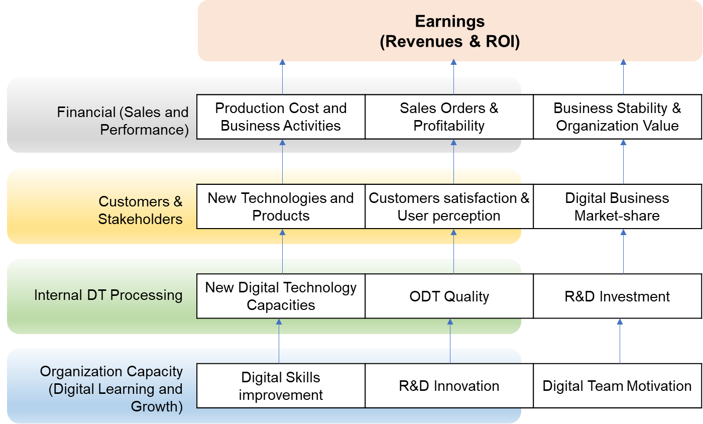

Figure 13: DT relative elements among the four characteristic perspectives to support ODT – By Researcher
This DT strategy architecture should encompass digital skills, innovation, customer satisfaction, new technologies, processes, cost, time, new segments, and revenue (Svahn et al., 2017). The DBSC supports ODT and accelerates DT performance with chosen elements as relevant KPIs and management performance evaluations (Table 8). This synthesis offers insights on applying the DBSC model for ODT support.
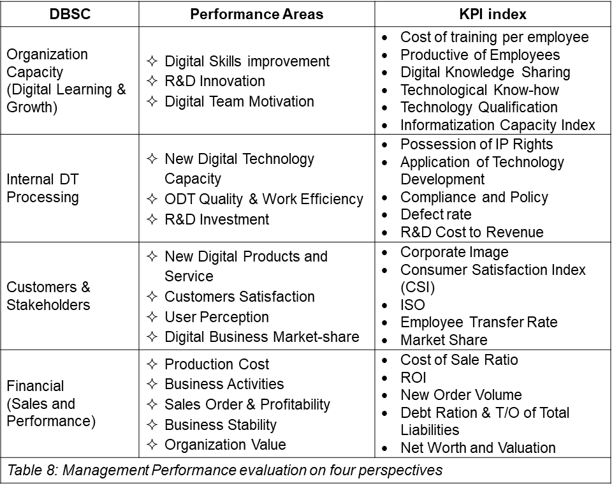
- Proposed H3 Hand Domain in Organization’s Digital Transformation
A successful ODT is complicated, with obstacles requiring pre- and post-process considerations (Matt et al., 2015; Gurbaxani & Dunkle, 2019). While technical aspects are essential in the ODT, managed activities and knowledge are key (Brynjolfsson & Hitt, 2000). Leveraging internal and external knowledge is crucial for ODT core competence (Stalk et al., 2012; Bharadwaj et al., 2013). The ‘Hand’ domain, like a dragon boat's engine, influencing organizational competency beyond technology and human factors (Nah & Delgado, 2006; Fichman et al., 2014). Ross et al. (2006) argue that constructing operational backbones is imperative for maintaining core operational efficiency during the transformative process.
For effective digital transformation, organizations must chart a scalable operational backbone (Floridi, 2014; Berghaus & Back, 2016) by understanding capabilities, including development needs (Rabbani et al., 2014; Mergel et al., 2019). These encompass data analysis, tech utilization, strategy, communication, collaboration, and innovation (Fichman et al., 2014; Hansen & Schaltegger, 2016). Core competencies offer a competitive edge through unique skills and knowledge (Stalk et al., 2012; Gurbaxani & Dunkle, 2019). Constant assessment and adaptation are important in evolving tech trends which customer focus, agile culture, and ethical AI are critical in digital transformation, and integrating these elements positions organizations for sustainable digital growth (Verhoef et al., 2010; Floridi, 2018).
- Chapter Two Summary
This chapter critically analyzes Yu's 3H management framework, specifically exploring its "Heart, Head, and Hand" domains as a guiding paradigm for ODT. The framework underscores the importance of a holistic approach, recognizing that successful digital transformation hinges on adeptly managing organizational activities and workforce knowledge. This necessitates robust change management strategies and widespread knowledge dissemination throughout the organizational hierarchy. Each H domain emphasizes the significance of people-centric transformation, acknowledging the human element, the need for well-orchestrated activities and the strategic alignment of technology and business capabilities. Strategic roadmaps and scalable implementation emerge as key components in the discourse, underlining the importance of a well-defined path and flexible execution methodologies for achieving successful digital transformation.
The chapter advocates for a comprehensive assessment of current capabilities and the identification and development of necessary skills to attain organizational objectives. While acknowledging the merit of Yu's framework, it encourages ongoing discourse and exploration into whether these domains comprehensively encapsulate the diverse factors contributing to organizational digital transformations' success or failure.
CHAPTER THREE – RESEARCH METHODOLOGY
- Introduction
This study endeavors to comprehend the intricate relationship between Yu's 3H domains and the critical success factors of Organizational Digital Transformation (ODT). An Exploratory Sequential Mixed Method (ESMM) research design has been selected as the principal investigative approach. By integrating diverse elements of qualitative and quantitative methods, this design facilitates an in-depth exploration of the phenomenon under investigation. This approach allows researchers to harmoniously blend different research methods, thereby enabling a comprehensive examination of the subject matter within the confines of a single study.
As posited by Subedi (2016), this research design represents the third paradigm in research, thereby presenting an opportunity to bridge the longstanding gap between qualitative (QUAL) and quantitative (QUAN) research paradigms. This methodology employs a rigorous approach, starting with a qualitative exploration of the research problem. It then develops codes in an exploratory manner using data. Further, it creates a quantitative measurement instrument for interpreting and clarifying data. This method enhances communication across academic fields, providing a concise notation for the research process. It emphasizes scholarly rigour to deepen subject understanding, yielding valuable insights and informed conclusions (Fetters, 2013).
This study adopts an ESMM design with two phases, the first phase entails a structured focus group interview involving business executives, senior management, IT specialists, and unit heads with recent connections from diverse nationalities and cultures. Phase one provides qualitative data, guiding the development of a survey instrument. A quantitative approach uses the literature review and phase one findings to construct a questionnaire in phase two. This phase identifies the ODT success factors linked to the 3H framework (Heart, Head, and Hand) in each domain (H¹, H², and H³). Equal emphasis is placed on both dimensions. The research follows an exploratory approach, measuring dependent variables and validating theoretical propositions from the qualitative analysis. Data from both methods are analyzed separately and integrated to address research questions (Edmonds & Kennedy, 2017, pp. 221-230).
- The Need to Conduct Useful Research on Change
Scholars have extensively explored ODT in recent decades, yielding valuable insights into its effectiveness. Such studies assist organizations in identifying improvement areas and devising strategies to achieve goals, and research also uncovers potential opportunities for digital advancement. This study benefits from the ESMM, which combines qualitative and quantitative methods in one or multiple studies, encompassing research questions, data collection, analysis, and result interpretation. The definition of ESMM varies among researchers, leading to flexible categorization as "mixed research." Greene et al. (2009) emphasize its comprehensive nature involving qualitative and quantitative processes. Integration and discussion of their relationship are crucial for qualification as mixed research. The "conversion mixed approach," converts qualitative data into quantitative measures for analysis, and results are integrated for conclusive outcomes (Cameron, 2009; Teddlie & Tashakkori, 2012; Guest, 2013).
Integration and discussion of original and transformed data occur during the inference phase for thorough analysis (Onwuegbuzie & Combs, 2011; Fetters et al., 2013). The research design follows a more lenient approach, discussing only transformed data in the inference section. According to this viewpoint, combining various qualitative and quantitative methods qualifies as a mixed study, even if only one data type is gathered (Creswell et al., 2011). The exploratory sequential mixed-method approach employs a two-stage process to integrate qualitative and quantitative aspects of research. Initially, qualitative data collection provides a comprehensive understanding of the phenomenon, leading to hypotheses or research questions. Subsequently, quantitative data collection tests these emerging theories, allowing for in-depth exploration and discovery of insights (Driscoll et al., 2007; Tashakkori & Teddlie, 2008; Creswell et al., 2011).
Through a mixed-methods approach provides multidimensional insights into complex social phenomena, overcoming the limitations of singular methods (Greene et al., 1989; Baruch & Holtom, 2008). Quantitative surveys' structure ensures consistent data for comparisons across groups or periods (De Vaus, 2001; Wright, 2005). Additionally, quantitative data minimizes biases for objectivity compared to the subjective nature of focus group interviews. This process yields seven domains linked to digital transformation, reflecting the outcome of the quantitative investigation. Given its strengths, the exploratory sequential mixed method holds significant promise and potential advantages for this study (Table 9):
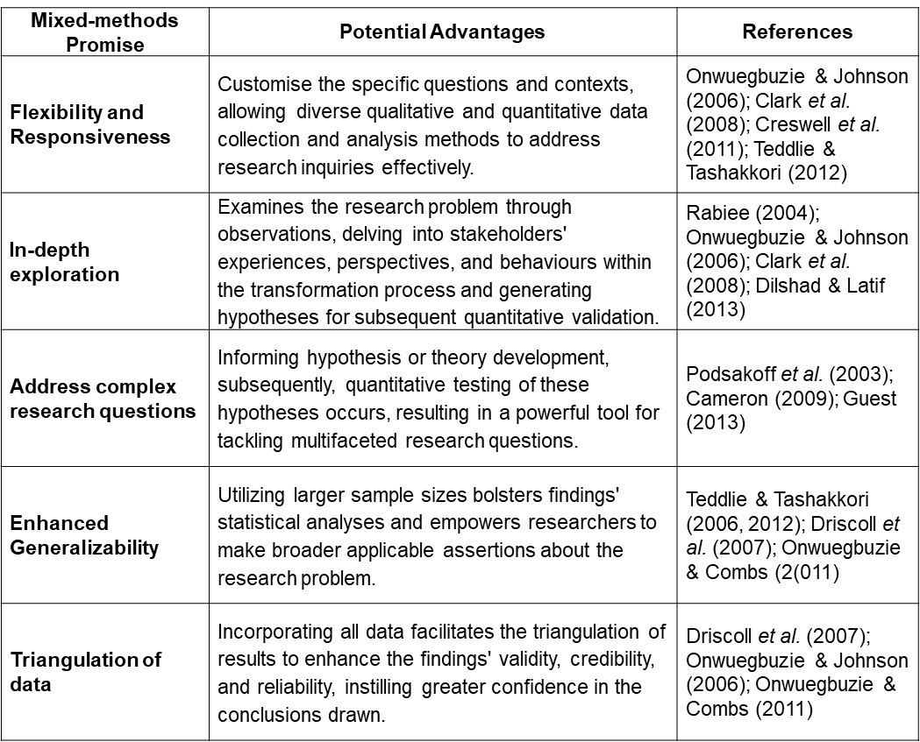

Table 9: Promises and Potential Advantages of Mixed Methods – By Researcher

- Research Paradigm
A research paradigm encompasses a system of beliefs, values, and assumptions that guide the researcher's investigation, and establishes a conceptual framework for understanding the nature of the phenomenon under study and provides validated approaches to inquire into specific research questions or problems. Additionally, it justifies the selection of the chosen paradigm (De Vaus, 2001 Blaxter et al., 2010; Fetters et al., 2013). The two-phase design, characterized by the flexibility of the ESMM, empowers researchers to draw upon multiple paradigms and methodologies when addressing intricate research inquiries. In this study, the ESMM design aligns with three primary paradigms: Interpretive, Positivist, and Constructive approaches.
- Interpretive Paradigm
The present research paradigm accentuates the subjective interpretation of ideas or knowledge, elucidated through meticulous analysis, constructed upon social interactions and individual performances (Goffman, 1974). The researcher endeavors to ascertain the significance and meaning of social phenomena by comprehending the perspectives and experiences of those involved (De Vaus, 2001; Fetters et al., 2013). This research paradigm finds prevalent application within anthropology, sociology, and education, focusing on the sociocultural context of human behavior (Blaxter et al., 2010; Maarouf, 2019). The interpretive paradigm finds utility in the initial phase of research, where qualitative data is gathered and analyzed (Scotland, 2012). In the context of an organizational digital transformation, this study employs the interpretive approach to conduct in-depth interviews with business executives or observe workplace interactions, thus grasping how digital transformation becomes integrated into the organizational culture and practices while also aiming to fathom the perspectives and experiences of individuals involved. This qualitative phase aligns with a relativist ontology which acknowledges multiple realities and subjective experiences, suggesting that reality is socially constructed, and holds the potential to facilitate the development of hypotheses or theories (Maarouf, 2019), which may subsequently undergo testing during the subsequent quantitative phase, employing a positivist approach (Scotland, 2012; Aliyu et al., 2015).
Organizational digital transformation probes profound ontological questions about existence, reality, and the nature of the phenomenon. Addressing these issues is paramount for understanding how digital transformation reshapes organizations and their reality. An ontological challenge arises in defining "digital" within the holistic management framework. Does "digital" stand as an entity or an integral part of organizational reality? This distinction is pivotal for framing the entire digital transformation process accurately.
- Positivist Paradigm
The positivist approach assumes that objectives can be quantitatively measured and verified using rigorous scientific methodologies (Fetters, et al., 2013; Cornelissen & Werner, 2014; Maarouf, 2019). This paradigm adopts an objectivist epistemological stance, emphasizing empirical observation and measurable phenomena that posits that reality exists independently of human interpretation to identify cause-and-effect relationships between variables, thereby facilitating the development of generalizable approaches applicable across diverse contexts and emphasizes controlling extraneous variables to ensure the reliability and validity of the collected empirical data. In this study, the positivist approach adopts during the second phase, wherein a carefully crafted structural questionnaire survey is employed to identify and explore the relationships between variables. Subsequently, statistical analyses are employed to test the formulated hypotheses (Goertz & Mahoney, 2012). In an organization's digital transformation context, the positivist approach harnesses quantitative data on causal factors associated with Yu's 3H domains, encompassing leading effectiveness, strategizing, and organizing capabilities, and technical and operational competencies.
Addressing these epistemological issues is crucial for developing a sound knowledge base and robust methodologies in this research (Maarouf, 2019). One major epistemological challenge is the dynamic nature of digital transformation. In this ever-evolving landscape, traditional research approaches can become outdated quickly. The question of whether our existing epistemological frameworks are suited to this dynamic environment is a significant consideration (Goertz & Mahoney, 2012; Aliyu et al., 2015). Additionally, the holistic management framework encompasses a broad spectrum of factors, from technology and infrastructure to culture and human capital. This multidisciplinary approach raises epistemological concerns about the integration of knowledge from various fields (Don-Solomon & Eke, 2018; Maarouf, 2019). Researcher must explore how to synthesize knowledge across these diverse domains and develop holistic insights into digital transformation.
- Constructive Paradigm
As an epistemological approach, constructivism focuses on comprehending individuals' subjective experiences and interpretations. It is characterized by the frequent utilization of qualitative research methods to delve into the perspectives and meanings attributed by participants to a phenomenon of interest (De Vaus, 2001; Rescher, 2012). Within this paradigm, the qualitative phase assumes particular significance in the exploratory sequential design as it offers an avenue for in-depth exploration of participants' ODT experiences. That can quantify specific constructs or evaluate hypotheses that may arise from the qualitative phase, providing a more comprehensive understanding of the research question (Don-Solomon & Eke, 2018).
As digital transformation unfolds, axiological concerns surface, demanding attention for a comprehensive understanding of this intricate phenomenon. Balancing technological advancement and ethical considerations is a significant axiological issue. This research navigates values underpinning data ethics and strive for equilibrium between innovation and safeguarding individual and societal interests (Rescher, 2012). Axiological considerations extend to the workforce, addressing ethical questions about job displacement and employee well-being amidst automation (Aliyu et al., 2015; Maarouf, 2019). The researcher delves into ethical values to ensure a fair transition for all affected factors.
For example, in the digital age, corporate social responsibility (CSR) poses an axiological challenge. Organizations must align digital initiatives with broader ethical and societal values, understanding how CSR values drive ethical and sustainable digital transformation. Digital transformation prompts axiological questions about environmental sustainability. Organizations evaluate ethical values regarding the ecological footprint of digital transformation efforts amid technological advancements with energy consumption and environmental consequences. Axiological issues also encompass aligning organizational values with digital transformation objectives exploring how an organization's core values influence its approach to this transformative process.
- Research Approaches
Methodological Diversity for Comprehensive Investigation: This study employs diverse methodologies aligned with the research objectives of understanding the ODT and its related social aspects (Creswell et al., 2011). The ESMM approach enables the exploration of ODT's underlying structures, enhancing study credibility and validity. It incorporates interpretive and qualitative phases to delve into social and cultural contexts, which is vital for successful digital transformation. The approach encompasses positivist methods and quantitative phases. Employing a triangulation research paradigm akin to nautical measurements ensures unbiased analysis, integrating literature, focus group interviews, and surveys for comprehensive insights (Creswell et al., 2007; Teddlie & Tashakkori, 2012; Punch, 2013).
This study integrates different theoretical perspectives to reveal the underlying causes of the research questions, informed by relevant insights. The quantitative phase employs statistical methods to test hypotheses, following Onwuegbuzie & Johnson's (2006) framework. Methodological triangulation encompasses diverse data collection techniques and inferences across various scales (Punch, 2013; De Vaus, 2001). The goal is to comprehensively understand the investigated phenomenon by merging insights from various theoretical perspectives. The research stages employed in this study can be outlined as follows:
- Conceptual Stage: The researcher formulates the research questions, objectives, and hypotheses during the conceptual stage, which the interpretive approach, alongside the quantitative phase to address the complexities of operational dynamics in digital transformation.
- Methodological Stage: The researcher crafts a structured research design blending multiple methodologies. Data triangulation combines resources like scholarly literature, focus group interviews, and questionnaire surveys, amassing data from varied viewpoints for robust research findings.
- Experimental Stage: Data is garnered through a structured questionnaire survey. Various theoretical perspectives are combined through multiple theory triangulation to uncover the core of research questions. This integrated theory forms hypotheses tested via statistical methods for insightful outcomes.
- Inferential Stage: The researcher navigates social cultural contexts, and operational dynamics linked to digital transformation success. Methodological triangulation merges diverse approaches, boosting findings' robustness and accuracy.
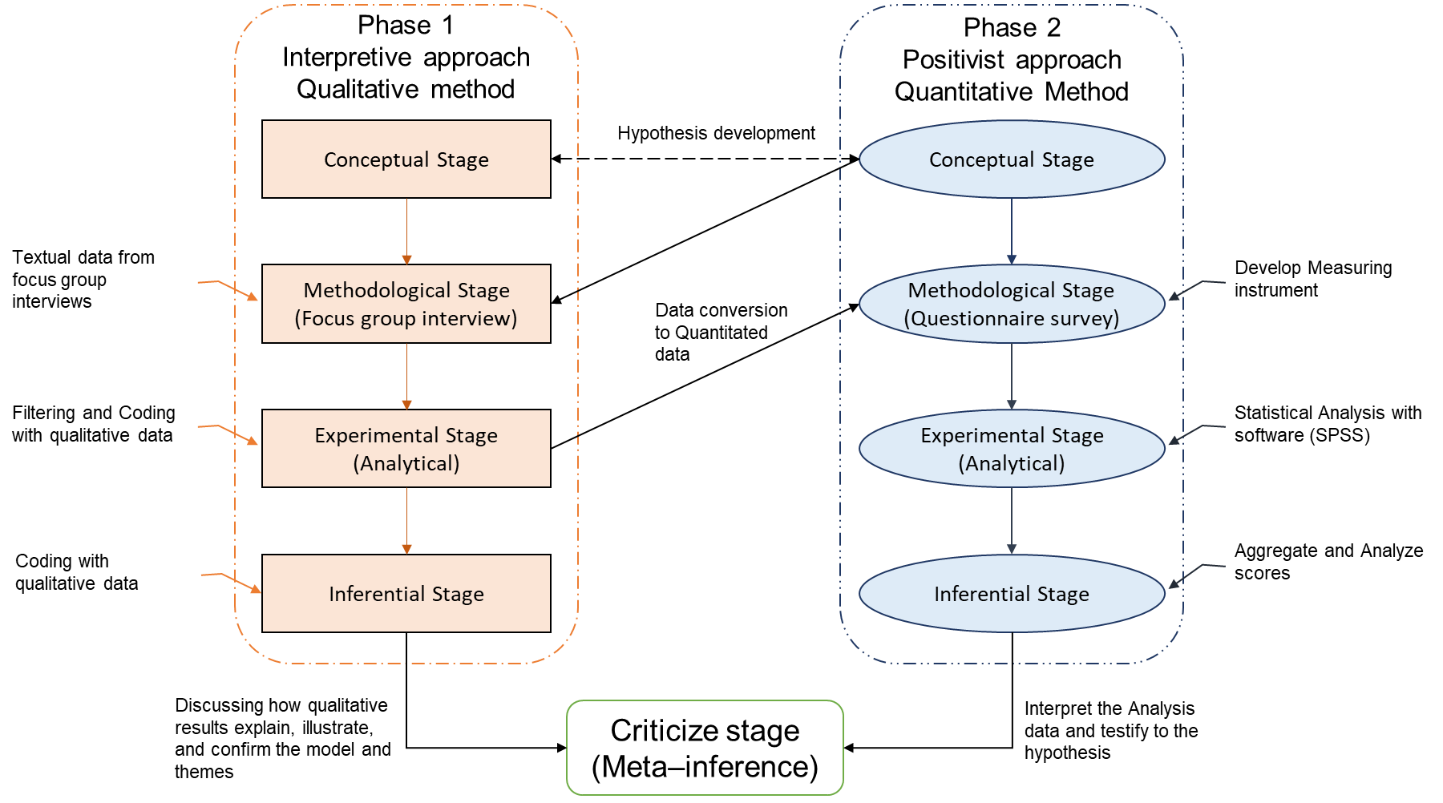
Below Figure 14 lies the ESMM paradigm, shaped by the researcher via adaptation from Onwuegbuzie & Johnson (2006), Creswell et al. (2007), Teddlie & Tashakkori (2012), and Punch (2013).

Figure 14: The paradigm of ESMM – By Researcher
- Conceptualization and Operationalization of the Research Design
Conceptualization and operationalization are foundational in research design and crucial for a well-structured, valid, and reliable study. This study emphasizes the importance of comprehending ODT. Conceptualization defines key concepts and variables precisely, aligning with existing literature and theories for a solid theoretical framework (Tashakkori & Creswell, 2007). Establishing a concrete footing, the researcher identifies ODT-related concerns, defines key concepts, conducts an exhaustive literature review to shape the theoretical framework, specifies measurable variables, deepens comprehension, and identifies gaps for exploration, culminating in hypotheses generation.
Post conceptualization, these inquiries are specific, measurable, and focused on pivotal study variables. This precision ensures a clear investigation direction, aligning with the study's purpose and objectives (Creswell et al., 2007). Hypothesis development is also intrinsic to conceptualization which propose variable relationships grounded in the study's theory and aligned with research questions. These hypotheses guide systematic data testing and analysis in identifying crucial research variables is pivotal in conceptualization. This clarity sets the stage for comprehensive data collection and analysis, enhancing understanding of the investigated phenomenon (Mayoh & Onwuegbuzie, 2015).
Operationalization, on the other hand, involves practically implementing concepts and variables within the research design. This phase identifies reliable, valid, and relevant data collection and analysis procedures to address the research question (McLafferty, 2004; Creswell et al., 2007, 2011; Mayoh & Onwuegbuzie, 2015). Rigorous analysis of gathered data allows meaningful conclusions, enhancing the study's relevance to both the research field and organizational contexts (Podsakoff et al., 2003; Tashakkori & Creswell, 2007; Mayoh & Onwuegbuzie, 2015). Defining and operationalizing abstract concepts into measurable variables benefits immediate research and advances knowledge in organizational digital transformation (Creswell et al., 2007; Punch, 2013).
This study's thorough conceptualization and operationalization enhance its validity, relevance, and reliability. Defining variables and selecting data collection methods establishes a robust basis for exploring organizational digital transformation. This combined approach ensures a cohesive research design, yielding practical insights for organizations in the digital realm, ensure the best practices and replication of findings further contribute to advancing knowledge, benefiting organizational digital transformation and beyond.
- Research Design
A research design is a plan or blueprint for conducting a study (De Vaus, 2001). It encompasses the methods and procedures utilized to collect and analyze data, providing a structured framework to address research questions and test hypotheses (Punch, 2013, pp. 44-48). By detailing the sampling method, data collection techniques, and data analysis procedures, the research design ensures systematic and consistent implementation, ensures the relevance of the collected data to the research questions or hypotheses and safeguards against bias and errors during data collection and analysis (Driscoll et al., 2007; Ridder, 2017). By establishing a clear roadmap, the research design optimizes time and resource utilization, and benefiting future researchers who may replicate the study. Additionally, a sound research design enhances the advancement of knowledge within the studying field (Cameron, 2009; Fetters et al., 2013; Ridder, 2017).
Research design involves decisions on data collection type, methods, sampling, and analysis techniques (De Vaus, 2001; Ridder, 2017). Linked to these are factors and constructs representing areas of interest (Punch, 2013, pp. 44-48). Crafting a design aligned with objectives and research questions enhances rigor and credibility. Straightforward design avoids pitfalls, leading to robust conclusions and insights, guiding inquiry for understanding and academic contributions.
- Factors and Constructs Definitions
Factors and constructs are crucial in any social research, clarifying and defining key concepts and variables (Attride-Stirling, 2001). Factors represent specific variables influencing investigations, particularly in studying success factors in Organizational Digital Transformation. In the management domain, these factors include technology type, transformational processes, organizational culture, leadership style, chosen strategy, and human and capability factors (Banker et al., 2000). Constructs are carefully crafted explanations by the researcher, grounded in existing research or theories, elucidating crucial concepts. The meticulous clarification of factors and constructs ensures a well-designed, which clarity strengthens the study's contribution to the academic field, advancing knowledge in the investigation area (Attride-Stirling, 2001; Punch, 2013). Ultimately, the adept delineation of factors and constructs underscores this study's significance and potential impact on ODT research.
- Research Processes
The "Research Process" includes steps for a systematic and rigorous project, leading to accurate, reliable, and valid results (De Vaus, 2001, pp.17-33). Steps involve identifying the question, literature review, design, data collection and analysis, interpretation, and communicating findings (Creswell et al., 2011). Each needs planning, detail, and ethics (Poon & Swatman, 1999; Tashakkori et al., 2012; Guest, 2013). The qualitative phase uses interviews to explore attitudes and develops variables and codes (Creswell et al., 2007; Cameron, 2009). Variables are from descriptive codes themes into scales and quotes (Edmonds & Kennedy, 2017, pp.196-200; Tashakkori & Teddlie, 2008).
The subsequent quantitative phase involves collecting numerical data through surveys or questionnaires to identify data patterns, trends, or relationships (Punch, 2013). A constructed questionnaire based on the literature review and first-phase results is utilized to identify critical success factors of ODT correlated with the 3H framework (Heart, Head, and Hand) and explore participants' perspectives individually. The final stage integrates quantitative and qualitative data, allowing for comparisons or using qualitative data to explain or expand upon quantitative findings.
The pilot study, often termed a "small-scale test" or "trial run," is paramount in social science research. It serves as a pivotal preparatory phase for the main study (Prescott & Soeken, 1989; Van Teijlingen & Hundley, 2002), aimed at uncovering potential weaknesses, needs, and challenges within the research instruments. Mohamad et al. (2015) underscored the importance of pilot tests in refining research protocols, providing researcher self-training, and aligning sample resources with the study plan. This process yields valuable early insights to the researcher, acting as a risk management tool and offering opportunities for refinement and issue mitigation. This proactive approach diminishes the possibility of project failure and the use of inappropriate or overly complex research tools (Van Teijlingen & Hundley, 2002; Tashakkori & Teddlie, 2008). The pilot aimed to validate interview questions. Dikko (2016) advised ensuring confidence in chosen research methods and instrument validity, suitability, and effectiveness before initiating a study to prevent misdirection and ambiguity in responses. Figure 15 illustrates a brief view of the adopted research processes.
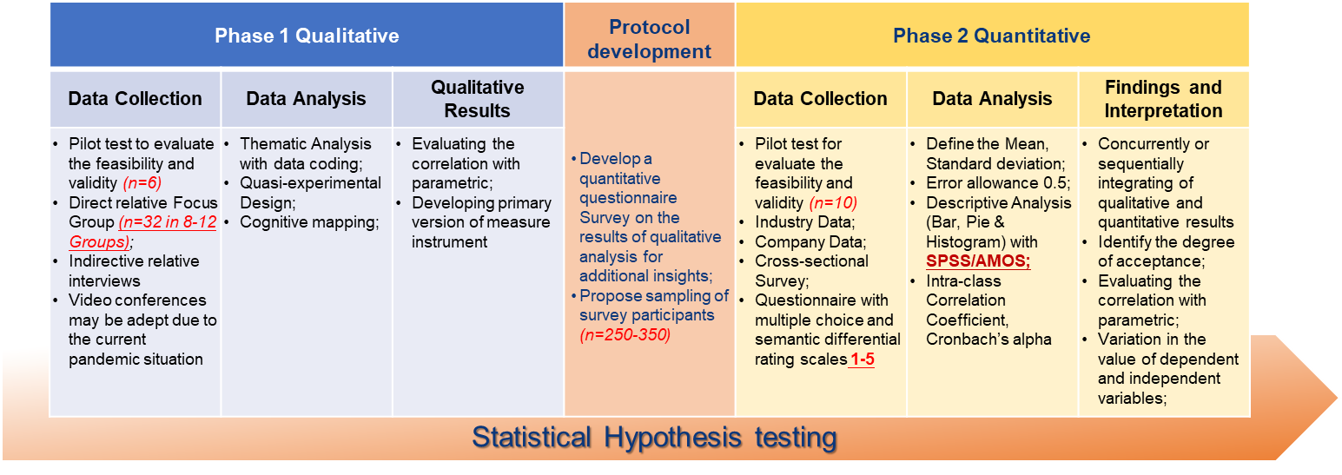
Figure 15: Brief view of the adopted research processes - By Author

- Instrument Design and Description
Research instruments are crucial for data collection, measurement, and analysis, ensuring reliability and validity (Rabiee, 2004; Zohrabi, 2013). This study employs two instruments, to developing these instruments requires care, as they impact data quality. Instruments must align with literature, theories, and research findings, supporting investigation objectives and hypotheses.
The initial instrument, structured Focus Group Interview questions, investigates collaborative with ODT across domains like IT, Human Resources, leadership, organizational culture, competencies, operation, strategic management, and outcomes (Bulsara, 2015; Legner et al., 2017). The researcher meticulously identifies the key research objectives and questions for the focus group, bridging gaps in the study through a comprehensive literature review (Grant & Davis, 1997; Rabiee, 2004). Through the thoughtfully designed interview questions, drawing upon relevant literature, academic surveys, and established theories, explicitly focusing on managerial perspectives, knowledge, and experiences related to adopting success factors in ODT which align with the research questions (Table 10). Engaging key stakeholders in focus group interviews gave valuable insights into adopting success factors for ODT, effectively addressing the research objectives.

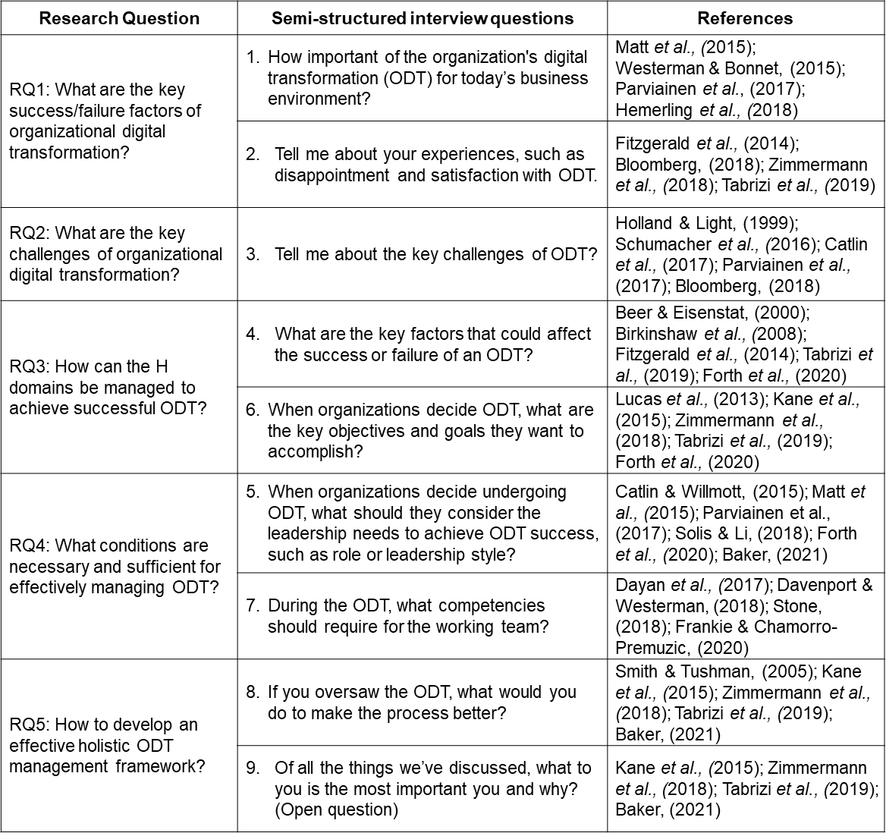
In crafting questions for focus group interviews in this study, the researcher employs a purposeful approach to gather insightful data. The process begins with a clear grasp of research objectives, shaping the foundation of question development. Themes and dimensions for exploration are carefully identified through literature and research goals, covering challenges, strategies, successes, stakeholder experiences and perspectives in ODT. Question sequencing progresses naturally from broader to detailed examinations, while probing questions draw more profound insights and real-life examples. Ethical considerations guide this process to ensure participant comfort. These questions, such as introspective, exploratory, scenario-based, and reflective, are skillfully combined to create a dynamic and all-encompassing dialogue. The researcher employed two practices to test the pre-designed interview questions to achieve the best result. First, the researcher emails the question list to six selected participants, and they’re not part of the final sample for the focus group interview. The researcher individually discussed these questions with them to ensure their understanding of the objectives and ability to provide ideal answers. Adjustments and rephrasing were made to enhance clarity.
Table 10: Relationship between interview questions and research questions & Relevant literature
The questionnaire survey comprises forty-nine carefully designed questions, drawing insights from relevant literature, prior survey research, and academic studies. The core questionnaire survey in this study structures into four distinct sections. The initial section comprises 30 questions (Q1-Q30) aligned with the five constructs which identified by integrating focus group interviews and literature review outcomes and align with seven distinct H domains within the 3H managerial framework and associate in ODT. These constructs embody the pivotal concepts under scrutiny and are foundational for crafting the questionnaire. Attride-Stirling (2001) emphasized that the alignment between questionnaire items and research constructs is imperative; any disconnection may impede the survey's capacity to furnish pertinent insights to address the research inquiries.
The researcher allocates these thirty questions to correspond with the seven H domains identified and formulated during the initial research phase, aligning with Yu's 3H framework. These domains encompass Heart (H¹), Head (H²), Hand (H³), Heart & Head (H4), Hand & Heart (H3), Head & Hand (H2), and 3H integrated (H1). Yu's study (2021) explains that, within the organizational context, the Heart domain pertains to emotional and psychological facets that influence operational adoption and success. It encompasses the collective attitudes, beliefs, and cultural dimensions of the organization and its personnel, alongside inter-stakeholder trust and collaboration. Achieving prosperous digital transformation mandates technological advancements and a shift in mindset and organizational ethos (Bharadwaj et al., 2013). Effective change necessitates adept communication by leaders, inclusive employee involvement in decision-making, and robust support and training mechanisms (Dvir et al., 2002; Eisenbeiß & Boerner, 2013). Table 11 presents the questionnaire survey structure for each H domain.
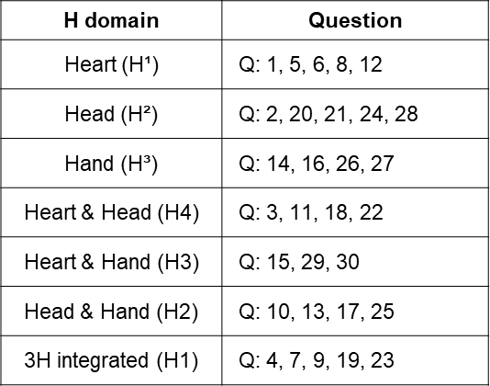

Table 11: Questionnaire Survey Structure for each H domain
Organizations must prioritize employee well-being to prevent burnout and other adverse outcomes during transformation. These elements collectively form the 'Heart' domain, significantly impacting digital transformation success by shaping employee perceptions and engagement. The 'Head' domain involves top-level leadership responsible for digital strategy formulation and execution, setting the organizational tone and providing essential resources for digital initiatives. This domain navigates digital disruption, fosters innovation, and inspires teams to embrace change. Equally vital is the 'Hand' domain, responsible for developing and implementing new systems, processes, and technologies to enhance agility, innovation, and customer-centricity. Effective Hand-domain teams collaborate, adapt to evolving needs, and leverage cutting-edge technologies to drive digital innovation and gain a competitive edge.
The second part of the questionnaire is five questions (Q31-Q35) on the Likert scale and one open question (Q36), which evaluate the performance of the organization's digital transformation in different dimensions, such as the organization's profitability, customer experiences, operational efficiency, and new innovational products and services by ODT. The third part of the survey is five questions (QA – QE) about the additional ideas and insights about implementing digital transformation. That allows the researcher to obtain extra views that the first part of the questionnaire could not cover. Furthermore, all those questions are based on previous studies and academic research; however, a simple modification is clear, concise, easy to understand, and carefully worded to avoid bias or leading responses. The last part of the questions (QF – QM) are the descriptive data, such as demographic and geographic information, allowing the researcher to evaluate the relationship and correlate it with different perspectives.
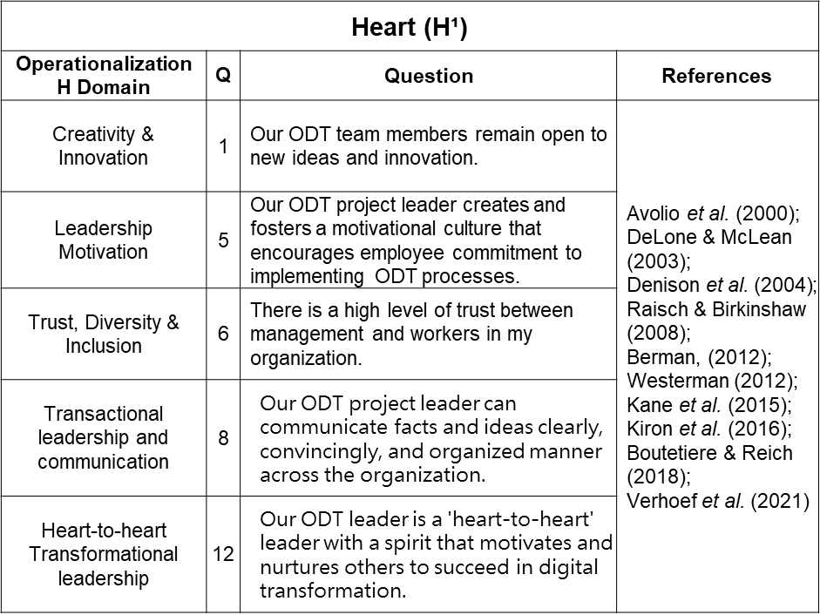
The summary of references correspondence for each domain are shown below (Tables: 12 – 18).

Table 12: The summary of references correspondence for Heart (H¹) domain
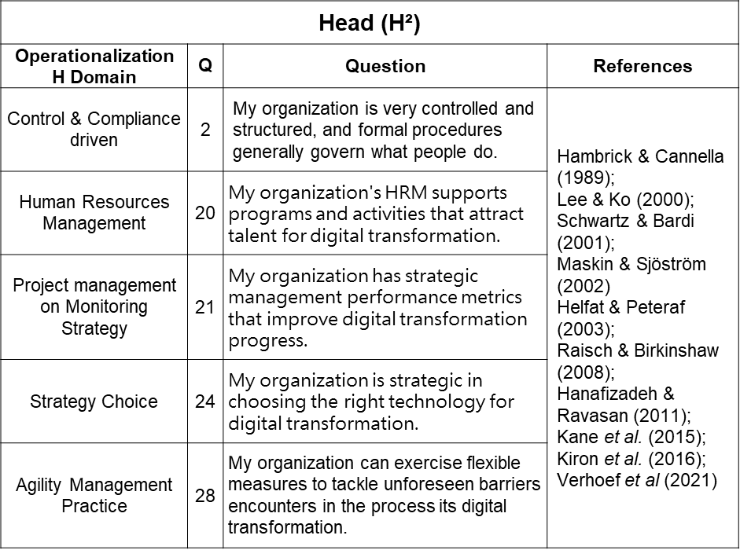

Table 13: The summary of references correspondence for Head (H²) domain

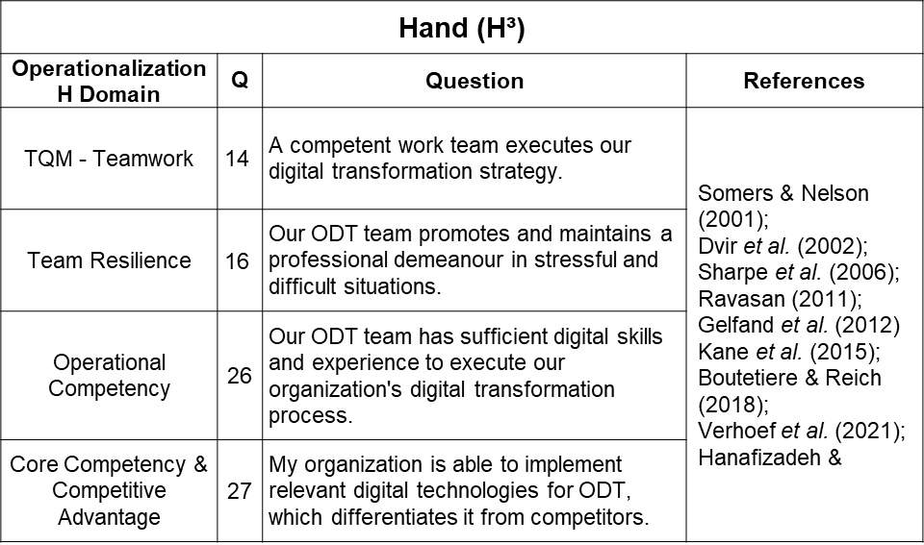
Table 14: The summary of references correspondence for Hand (H³) domain

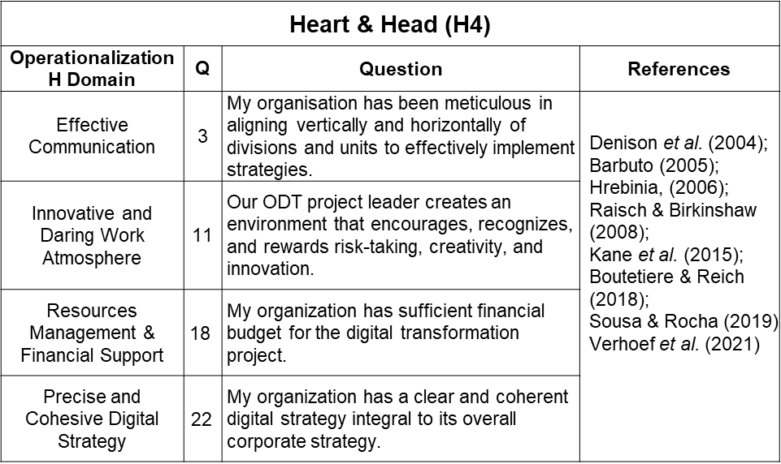
Table 15: The summary of references correspondence for Heart & Head (H4) domain
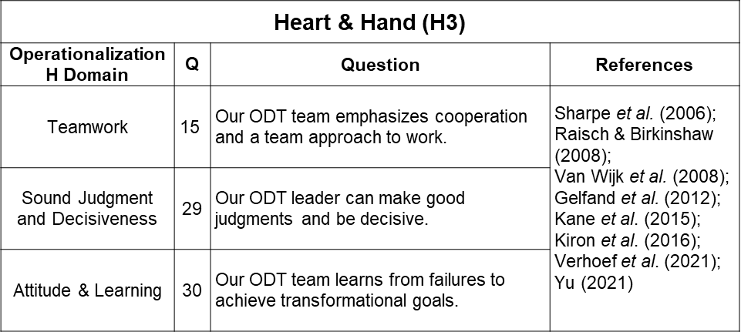

Table 16: The summary of references correspondence for Heart & Hand (H3) domain

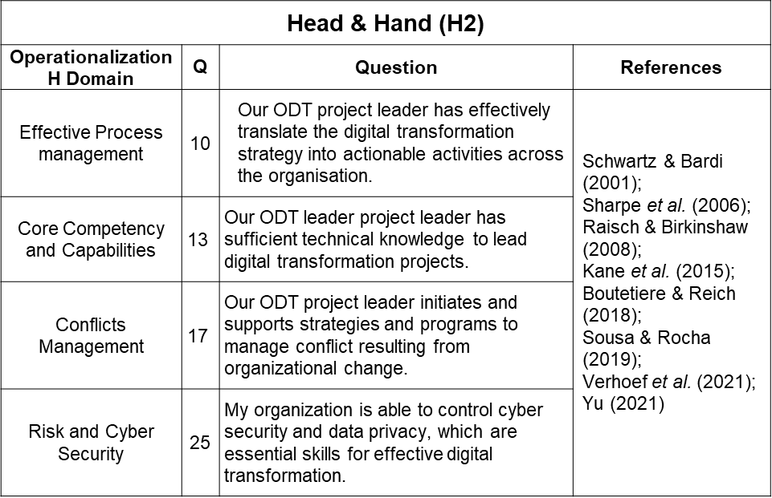

Table 17: The summary of references correspondence for Head & Hand (H2) domain

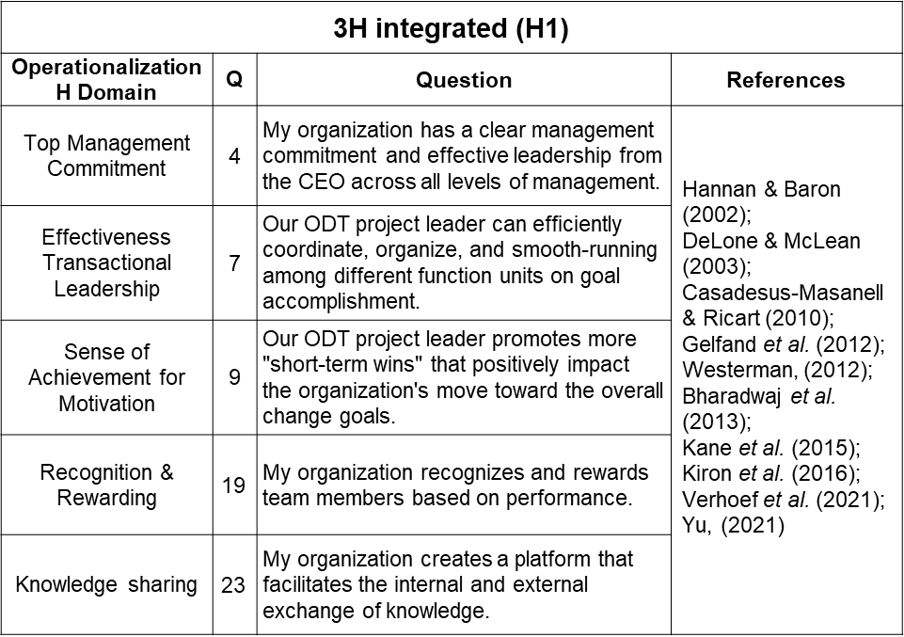

Table 18: The summary of references correspondence for 3H Integrated (H1) domain

While many questions draw from established research and studies, subtle refinements were made to the wording to amplify respondents' understanding of the study's objectives, see (Appendix 1) which the complete questionnaire survey. Closed-ended questions serve as pivotal tools for quantifying primary constructs, and alongside these, demographic questions play a crucial role in characterizing and analyzing the sample's unique characteristics. The survey length is crucial, as lengthy surveys can lead to participant fatigue and reduced motivation, resulting in lower response rates and potentially invalid results (Van Teijlingen & Hundley, 2002). This accordant composite of questions ensures data collection's depth and breadth,
For ease of accessibility, the questionnaire is available in English, traditional and simplified Chinese to accommodate respondents from Hong Kong, Taiwan, and mainland China. To ensure the reliability of the translations, the researcher sought the expertise of two academic experts, one from China Jinan University and the other from Nanjing Communications Institute of Technology. Conducted through Google Form and the Chinese survey platform Wenjuanxing (問卷星), the final questionnaire serves as the primary instrument to measure the five constructs, each representing a distinct and integrated H domain within the 3H framework.
- Phase One Qualitative Research – Focus Group Interviews
Focus group participants received personalized email invitations from the researcher, explaining the interview's purpose and introducing the 3H framework. After acceptance, they received the 'Focus Group Interview Consent Form' (Appendix 2: Signed Focus Group Consent form). This form sought permission and outlined the interview process, roles, and responsibilities to ensure the study's legal, safe, and ethical conduct (Powell & Single, 1996; Longhurst, 2003; McLafferty, 2004; O. Nyumba et al., 2018). Due to the pandemic outbreak and the geographical constraints of participants, the focus group interviews were conducted via video conference using Zoom. Each interview was video recorded to facilitate accurate and precise analysis during the subsequent review. The qualitative data obtained were analyzed thematically, informing the development of a comprehensive and relevant structured questionnaire for the subsequent quantitative phase, ensuring its comprehensiveness, relevance, and alignment with the research objectives. In this qualitative group interview will be conducted using a semi-structured approach, incorporating nine open-ended questions. After identifying the research objectives and target population, a systematic literature review will be performed to gather relevant insights, generating pertinent interview questions. Open-ended questions allow participants to freely express their thoughts, opinions, and experiences, fostering rich, detailed responses that provide valuable insights and perspectives (Creswell et al., 2007; Teddlie & Tashakkori, 2009, 2012). The focus group interview offers data collection and analysis flexibility, enabling the researcher to adapt to unexpected findings and appreciate the subjective nature of human experiences. This approach values empathy and understanding of participants' perspectives, enhancing the validity of the findings through rigorous data collection and analysis methods (Carey & Smith, 1994; Rabiee, 2004; O. Nyumba et al., 2018).
The pilot interview was conducted via Zoom conference in response to the COVID outbreak. Six selected participants were involved in the pilot test of focus group interview and were the researcher's business contacts. Initially intending for six participants per final interview group, the researcher determined from two pilot runs that a maximum of four participants per group achieved improved results. The pilot participants were three males and three females, and they are holding senior management roles in Hong Kong companies with 100+ employees and with ODT experiences. The pilot interview results were promising and provided essential insights into interview transcript coding. This systematic process involves assigning codes or labels to data segments, facilitating the identification of patterns and themes. This foundation is crucial for developing the research instrument for the subsequent quantitative research phase (Leech & Onwuegbuzie, 2007, 2008; Gill et al., 2008; Onwuegbuzie et al., 2010; Onwuegbuzie & Combs, 2011).
To provide clarity and context, the researcher delivered a brief PowerPoint introduction at the beginning of the focus group, covering the research objectives, ethical disclaimers, and the interview agenda. The pre-interview introduction of the 3H management framework provides essential context and background information about the framework itself. As the 3H framework might only be widely known or familiar to some participants, this introduction ensures they have a foundational understanding of its essential components and principles. Participants provide their perspectives and discussions around a common theoretical framework by presenting its three domains - Heart, Head, and Hand.
Additionally, the introduction of the framework demonstrates the researcher's commitment to transparency and openness. By providing a clear explanation of the research activity, the researcher establishes an atmosphere of trust and credibility, encouraging participants to engage more openly and candidly during the interview. The session was video recorded and securely stored on the researcher's password-protected computer. The pilot interview's sample size was deemed appropriate; however, during the session, the researcher observed that having six participants in a group led to control issues and confusion. As a result, the official focus group interview would be limited to a maximum of four participants per group.
The researcher begins the focus group interviews with open-ended broad questions to allow participants to express themselves, avoiding technical jargon that may lead to misunderstandings and biased responses (Morgan, 1995; O. Nyumba, 2018; Onwuegbuzie & Johnson, 2006). Additionally, hypothetical scenarios and probing questions are employed to explore participants' attitudes and beliefs, encouraging them to elaborate on their reasoning or provide examples (Fetters et al., 2013). The focus group interviews aim to elicit participants' experiences and perspectives in their ODT experiences, enhancing the validity and reliability of the subsequent quantitative research phase (Greene et al., 1989; Boddy, 2016; O. Nyumba, 2018). A total of 32 participants will be invited, divided into 8 to 12 groups, comprising the researcher's business friends, counterparts, and associates, with whom they have maintained active contact over the past ten years. This convenience sampling approach has advantages in preliminary or exploratory studies, facilitating the generation of initial insights or hypotheses (Boddy, 2016; Etikan et al., 2016). Convenience sampling is a cost-effective and easy-to-implement method, as participants are readily available and willing to participate (Oppong, 2014; Leiner, 2014; Etikan et al., 2016). The selected participants are business owners, C-level executives, senior management, and technology executives, and instrumental in their digital transformation decisions, providing valuable in-depth insights and experiences. An interview guide will provide which outlining the topics and questions to be covered during the focus group interviews, ensuring a logical and organized flow of the discussions (McLafferty, 2004; Creswell et al., 2007).
Analyzing data from a focus group interview is a critical phase in qualitative research that demands a meticulous and systematic approach (Oppong, 2014). It entails carefully examining and interpreting the responses shared by participants to uncover valuable patterns, themes, and insights central to understanding the research question or topic under investigation. The first step involves transcribing the audio or video recordings of the focus group interviews, meticulously transforming spoken words into written text. This transcription captures the nuances and intricacies of the participants' responses, preserving the authenticity and richness of their contributions (Leech & Onwuegbuzie, 2007). Data familiarization follows, where the researcher immerses himself in the transcribed data through repeated readings (Ritchie & Spencer, 2002). This in-depth examination allows them to become intimately familiar with the content and context of the participants' expressions, providing a holistic understanding of the captured data (Leech & Onwuegbuzie, 2007, 2008).
Coding is the systematic labelling of data segments with specific themes. The scheme aligns with objectives or forms organically as patterns arise and organizes information from focus group interviews. The thematic analysis identifies and analyzes recurring themes or patterns from participants' responses. Themes represent meaningful clusters of words, phrases, or ideas contributing to a deeper comprehension of the phenomenon (Attride-Stirling, 2001).
The researcher performs manual thematic analysis to effectively identify, organize, and analyze these themes. Upon identifying themes, the researcher moves into the interpretation phase, seeking to derive insights and meaning from the data. It involves scrutinizing the relationships between the identified themes, comparing them across different focus groups, and exploring how they connect to the overarching research question (Williams, 2016). This research employs data triangulation to ensure the credibility and validity of the findings, which involves cross-referencing and comparing the focus group data with other data sources, such as quantitative data or findings from literature reviews (Attride-Stirling, 2001; Williams, 2016). The final step in the process is reporting the findings coherently and organized.
- Phase Two Quantitative Research – Questionnaire Survey
This phase entails quantitative research utilizing a constructed questionnaire derived from a systematic literature review and the results of phase one. The questionnaire aims to identify the critical success factors of Organizational Digital Transformation that correlate with the 3H framework across each domain: Heart (H¹), Head (H²), Hand (H³), and the synergistic integration of these domains. Additionally, the researcher will investigate participants' perspectives on ODT dimensions individually. Quantitative research involves collecting numerical data from a sample population using structured questionnaires. This method allows researchers to gather data from many individuals and subsequently analyze and interpret the data statistically (Baruch & Holtom, 2008). Survey responses undergo statistical analysis to unveil patterns and variable relationships (Attride-Stirling, 2001; Yong & Pearce, 2013). This questionnaire captures specific data for research questions, quantified and analyzed through tools like SPSS. Closed-ended questions with preset response options enable categorization and quantification for analysis.
This study extensively employs literature on Yu's 3H framework, offering a conceptual roadmap for digital transformation. The quantitative investigation aims to reveal mechanisms driving digital transformation within organizations and address research questions. Key concepts are identified through interviews, categorize, and analyze for instrument development (Attride-Stirling, 2001). This research phase is objective, scientific, and statistical. Variations and biases' impacts are considered, including maturation bias due to participant experiences and skills.
To enhance rigor and minimize bias, researcher gathers data on variables that are dependent, independent, and intermediate constructure. Existing research measurement constructs are followed, including institutional, academic, and industrial surveys. All constructs use the 5-point Likert Scale. Open-ended questions ask participants' top ODT objectives, up to three choices. Demographic info relies on validated collected data.
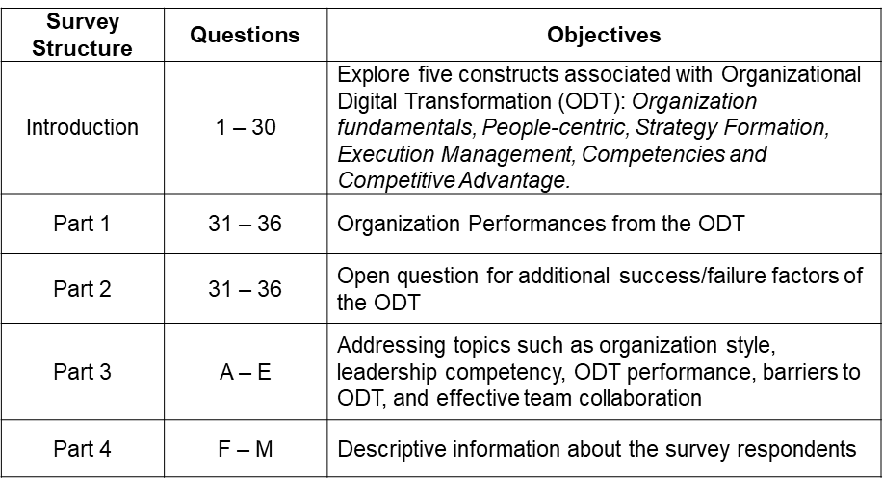
Follow by the survey introduction, research objectives, survey disclaimer, and the researcher's proposed donation. The questionnaire survey is structured into four parts encompass five Likert-scale questions. The first part consists of 30 questions which elucidating the five distinct constructs derived from the findings of phase one focus group interviews, and the Part two with six questions on ODT performance. Part three with five questions feature multiple-choice questions related to leadership competencies, the organization's objectives concerning digital transformation, significant barriers hindering ODT, and the organizational norm for implementing ODT. The last part of the questionnaire encompasses eight questions targeting participants' demographic information, including gender, organization scale, work history, business type, and company location. This comprehensive structure of the questionnaire facilitates the gathering of rich and diverse data, encompassing quantitative and qualitative insights to address the research objectives effectively (Table 19).

Table 19: The structure of questionnaire survey and its objectives
The questions in the questionnaire survey have been carefully curated based on a comprehensive review of past research surveys (Appendix 3). These questions have been selected to align with established constructs and themes identified in prior studies. By drawing from existing literature and validated various survey instruments, the present study ensures a robust foundation for investigating the complex dimensions of organizational digital transformation. This approach allows for the incorporation of well-established measurement items, enhancing the reliability and validity of the data collected. Using questions from previous research surveys aids in maintaining consistency and comparability, ultimately contributing to the scholarly rigor of the study's findings.
The extensive questionnaire survey will be conducted using 'Google Form' and Wenjuanxing (問卷星) , which consists of 36 constructed questions and 13 descriptive questions. Participants will provide their responses using a 5-point Likert scale semantic differential rating, ranging from 'strongest agree' to 'strongest disagree' (Table: 20).
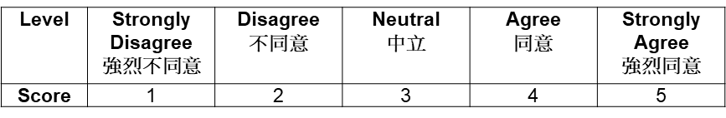

Table 20: 5-point Likert scale semantic measure rating

Wenjuanxing (問卷星):
https://www.wjx.cn/vm/hgdVYWcb.aspx
Google Form:
https://docs.google.com/forms/d/16VuoiT7Q7rxtCnqX6R4gRDHDwP5Bl9wAtJ8d_BtnfIsY/edit?pli=1
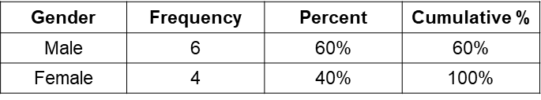
The questionnaire explores digital transformation aspects in the organization, covering independent variables for managerial decisions. Insights into participant perspectives on Organizational Digital Transformation (ODT) inform framework development. The pilot test participants consist of the researcher's connections, including business counterparts, DBA classmates, and friends who hold mid-to-senior management positions in the Great Bay Area of China. Moreover, the pilot study is a valuable opportunity to identify and address any technical issues related to the survey, which includes evaluating the formatting design, distribution channels, programming errors, and data collection processes to ensure a smooth and error-free survey administration (Bonometti & Tang, 2006; Baruch & Holtom, 2008). All collected data was recorded in Excel format and downloaded into SPSS for analysis. The example of demographic data is shown below Table: 21-24

Table 21: Gender (n=10)
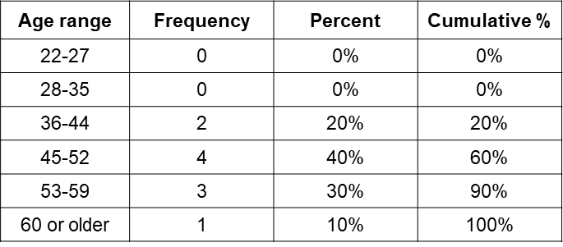

Table 22: Age Group (N=10)
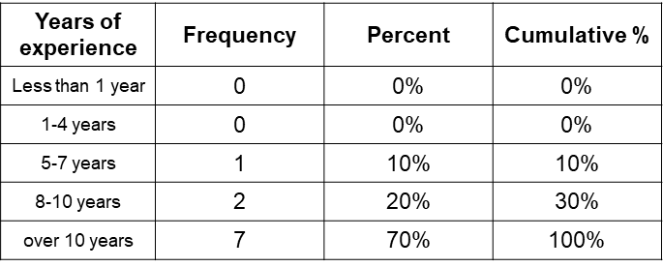

Table 23: Years of Experience (n=10)
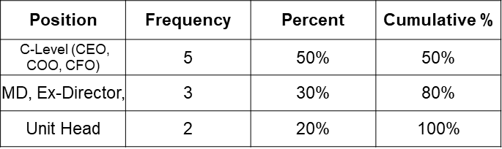

Table 24: Position (n=10)
After the pilot test, 530 questionnaires were distributed via email, WhatsApp, and WeChat. An expected ≥ 45% response rate aligns with common rates in organizational research (Baruch, 1999; Boddy, 2016). Diverse participants, including business owners, executives, and IT professionals from various industries, enrich the study's representation.
The questionnaire survey is cost-effective, gathering broad demographic data in a short time (Mavis & Brocato, 1998; Bonometti & Tang, 2006). Leverage the internet's reach, scalability, and anonymity (Wright, 2005; Onwuegbuzie & Johnson, 2006). Unlike qualitative focus groups, surveys cover more within less time, capturing answers on various study components (Jones et al., 2013). Clear communication, simple questions, personalized invitations, and charity donations of HK$50 per returned survey enhance response rates and address ethics, with donation details at the survey's start.
The questionnaire is translated from English to simplified and traditional Chinese formats and consistently interpreted to cater to the Chinese-speaking participants who can participate. The translated version is rigorously verified and refined by proficient Chinese language experts at universities. The distribution channels are through email, WhatsApp, and WeChat in the pilot study, and all results are transferred to an Excel file and input into SPSS for analysis.
- Validity, Reliability and Triangulation
Conducting research necessitates ensuring the credibility and robustness of the findings by exploring validity, reliability, and adequate support. In this context, validity pertains to the accuracy and truthfulness of the research outcomes, while reliability relates to the consistency and stability of the research findings over time (Attride-Stirling, 2001; Onwuegbuzie et al., 2010). The concept of validity serves as a rational and purposeful model to ascertain that the research findings authentically mirror the reality of digital transformation. Onwuegbuzie et al. (2010) propose four approaches and methods to measure the constructs:
- Participant enrichment, which entails enhancing the sample size and quality.
- Fidelity of measurement instrument that emphasizes the optimization of every instrument used in the research process.
- The integrity of treatment, which focuses on assessing the fidelity of treatment, interventions, and progress.
- The significance of data enhancement which aims at maximizing researchers' interpretations of the data.
Moreover, another effective means to enhance validity is through judiciously selecting the sample population and employing appropriate data collection methods (Comrey, 1988; Grant & Davis, 1997; Tashakkori & Teddlie, 2008). For instance, in this research that delves into the impact of digital transformation on various business levels, the sample population should comprise business owners who have experienced digital transformation. Additionally, using reliable and valid measurement tools, such as surveys, interviews, and observation, further bolsters the validity of the research and contributes to the credibility of the findings. Ensuring the reliability of research data is paramount to maintaining consistency, accuracy, and the potential for replication across various contexts and over time (Comrey, 1988; Grant & Davis, 1997; Onwuegbuzie et al., 2010).
For this study, the researcher will utilize Cronbach's Coefficient Alpha test to measure the internal consistency reliability of a suitable scale or test. This measure ranges from 0 to 1, with higher values indicating greater internal consistency (Attride-Stirling, 2001; Williams, 2016). According to Nelson and Bustamante (2010), researchers should also control for variables that could influence the research results, ensuring that extraneous variables do not affect the findings. A Cronbach's Coefficient Alpha of 0.7 or higher is generally considered acceptable for research on internal consistency, indicating a high degree of reliability (Blaxter et al., 2010, pp. 169-187; Williams, 2016). By adhering to these rigorous practices, researchers can bolster the reliability of their research and enhance the validity and trustworthiness of the study's outcomes.
By employing triangulation, researcher can cross-check their findings using various data sources or methods, thereby increasing the robustness and credibility of their study. This approach is a crucial strategy for enhancing the validity and reliability of research pertaining to the ODT. Triangulation involves the utilization of multiple data sources or research methods to validate and corroborate research findings (Reise, 2000; Creswell et al., 2007; Punch, 2013). By comparing and analyzing data from different sources, researchers can ascertain the consistency and accuracy of their findings and identify any potential discrepancies that may warrant further investigation (Blaxter et al., 2010, pp. 169-187).
Ensuring internal validity is paramount in this study, as it safeguards the accuracy and credibility of research findings. Internal validity pertains to the degree to which the study accurately measures the intended constructs and establishes valid cause-and-effect relationships (Greene et al., 1988; De Vaus, 2001; Tashakkori & Creswell, 2007). Various strategies are employed to ensure different types of validity in this research study. Content validity refers to the extent to which the items or questions in the measurement instruments, such as questionnaires and interview guides, comprehensively represent the intended construct. To ensure content validity, the researcher conducts an exhaustive literature review to identify relevant concepts and dimensions associated with organizational digital transformation (Tashakkori & Creswell, 2007).
Criterion-related validity in this research aims to assess how well a new measurement method or instrument corresponds to an established standard or criterion, which helps determine whether the new method accurately predicts or correlates with outcomes. To ensure criterion-related validity, the researcher identifies a pertinent and well-established concurrent validity, where the comparison is done simultaneously and predictive validity, where the new measure predicts future outcomes. (Tashakkori & Creswell, 2007; Punch, 2013). Data is collected both from the research instruments and the identified external criterion. The correlation between the research instruments and the external criterion is examined through rigorous analysis to determine the strength of their relationship (Etikan et al., 2016).
Construct validity assesses the extent to which the research instruments accurately measure the intended theoretical constructs related to organizational digital transformation (Etikan et al., 2016). The researcher employs theoretical frameworks and draws upon existing research to define and operationalize the constructs under investigation to ensure construct validity. Sophisticated statistical techniques, such as factor analysis, are applied to explore the constructs' underlying structure and dimensions. Furthermore, convergent and discriminant validity analyses are conducted to demonstrate that the research instruments exhibit correlations with other measures of the same construct while remaining distinct from measures of unrelated constructs.
- Research Ethics and Accessibility
Research ethics encompass the foundational principles and values guiding the research process. Additionally, accessibility represents a pivotal facet of research, both a practice and a consideration within any scholarly inquiry. These considerations hold paramount importance in research works, averting potential instances of legal transgressions and mitigating vulnerabilities stemming from human errors (Lucas et al., 2016). The observance of ethical standards ensures the propriety and responsibility inherent to the research enterprise. According to Richards and Schwartz (2022), there are several key principles and imply adherence that guides research ethics, including:
- Guiding and scrutiny by an independent ethics committee or board,
- Sufficient adequate expertise of the supervisory team,
- Adhere to the ethical guideline and principles throughout the entire research process,
- Tap into ethics resources.
In this research, the researcher has submitted the PG2/E1 Form, which is the ethical approval, to the research ethics committee (UWTSD) to ensure the research activities meet the OECD Frascati manual of the University of Wales Trinity Saint David. In respect of confidentiality and privacy are central tenets of every research study's practice. The most study is about the autonomy and dignity of the human subjects involved, thus, obtaining informed consent from participants, protecting their privacy and confidentiality, and ensuring that the research does not cause harm or undue distress. Before conducting the focus group interview, each interviewee will be asked to complete or confirm a consent form to state that they understand their participation will be voluntary and that they are willing to record the interview. The research will be based on pseudonyms in this write-up to protect the anonymity of the interviewees. The second phase of the research activity is a constructed questionnaire survey. In the first part of the written introduction, the researcher clarifies that all participations are voluntary and that questionnaire responses will be anonymous. Participants were asked to endorse or confirm that they understood their voluntary participation and were willing to record the interviews. Due to the pandemic status and distance reasons, the first part of the research activity will use an online conference (Zoom) to avoid unforeseen circumstances.
The 'Non-maleficence' approach means that the research benefits society and individuals, minimizing any potential risks or harm to participants and maximizing the potential benefits of the research. That involves vulnerable populations, and the researcher must take extra precautions and monitor participants throughout the study to ensure that they are not experiencing any harm or adverse effects (Warrell & Jacobsen, 2014). In the focus group interview, the researcher demonstrates a high standard of ethical and responsible manner and minimizes any physical or psychological harm to participants. The researcher ensures that the benefits and burdens of this research will be in the study purpose to avoid any bias or discrimination based on factors such as race, gender, or socioeconomic status.
The researcher conducts the focus group interview in an English language and cultural context that is understandable and accessible to participants to ensure all processes are consistent. Participants are served a power-point introduction and interview handbook before the interview takes place. This project description and clarification ensure that participants understand all study aspects. The second phase of the research activity is a comprehensive questionnaire survey that will distribute via email and mobile messaging channels. From the written introduction, the researcher clarifies that all participations are voluntary and questionnaire responses will be anonymous. All information and data will be treated as confidential and only for the study and anonymous basis. All data will be backup regularly with password-protected to ensure security. Only the researcher can access the data generated. Once the study is completed and six months after the university approves the thesis, all electronic data will be deleted, and a hard copy will be shredded. All research activities of this study will be based on the following conditions and guidelines:
- Compliance with Personal Data (Privacy) Ordinance 486, Law of Hong Kong,
- All data collected must be after company/personal consent is obtained,
- A weekly backup will take place.
This research will not include any sensitive personal data, none of question is leading back the participant, and no name and personal information are required in the questionnaire survey. All selected data will be saved in a designated device (computer, USB drive) and secure storage with safe password protection and only allow the researcher to access by the researcher only.
- Chapter Three Summary
This chapter delves into the pivotal phase of the research methodology employed within the ambit of this study. With an introductory section, the research elucidates the research predicament and delineates the research inquiries. Subsequently, the research methodology is expounded upon, encompassing facets such as the research design, modalities for data acquisition, procedures for data interpretation, and the measures undertaken to ascertain the integrity and consistency of the obtained data. This chapter also engages in a comprehensive dialogue concerning the ethical considerations underpinning the research progress. The adopted mixed method constitutes an indispensable facet of the research trajectory, entailing the judicious fusion of quantitative and qualitative research paradigms. In particular, the exploratory sequential mixed methods framework unfolds through a multi-phased approach, comprising the initial qualitative phase centered on focus group interviews and the subsequent quantitative phase revolving around questionnaire surveys. Methodological intricacies encompassing each phase are comprehensively elucidated, encompassing sampling methodologies, data collection techniques, pilot testing protocols, and data analysis methodologies.
The qualitative phase facilitates an exhaustive exploration of the subject under scrutiny, unraveling potential influencers on the digital transformation process. Semi-structured interviews employed during this phase delve into participants' perceptions and insights, elucidating the intricacies of the "Why," "How," "Who," “Where” and "What" facets of the Organizational Digital Transformation (ODT) phenomenon. The quantitative phase tests these factors empirically on a larger scale, providing a comprehensive understanding. This scientific approach examines inter-variable relationships, the significance of H domains, and ODT's implications, fostering a comprehensive managerial framework. The methodology's efficacy lies in mitigating biases by integrating qualitative and quantitative data, ensuring robust and reliable findings.
This chapter concludes with a detailed discussion of strategies to ensure data integrity, validating accuracy and consistency. Methods include diverse data sources, standardized tools, and reliability checks. In summary, the chapter holds significance within the research context, outlining an exploratory mixed methods approach for organizational digital transformation. It highlights data reliability, ethics, and the research methodology.

CHAPTER FOUR – QUALITATIVE ANALYSIS
  - Introduction
This chapter offers a comprehensive guide for analyzing data from Focus Group (FG). These semi-structured interviews involved 32 participants, capturing intricate business experiences and social interactions within digital transformation. The chapter underscores documenting the research process, acknowledging the researcher's role in shaping data analysis, and emphasizing reflexivity and transparency. Gill et al. (2008) assert the subjectivity of participants' views, necessitating an objective exploration supported by extensive literature. The researcher outlines steps in analyzing focus group data, including transcription, theme identification, coding, and interpretation.
- Qualitative Research Implementation
Conducting the research focus groups with 32 busy business executives posed challenges. Due to COVID, the researcher managed 11 groups of up to four participants via Zoom. Preparations included sharing interview guides and consent forms and confirming participation. Interviews lasted approximately 100 minutes, balancing participant input and focus. Ensuring topic alignment, participant comfort, and engagement were prioritized. The extensive research activity took over four and a half months.
- Interview Sampling and Protocol
This research employed a convenient sampling method involving 32 participants drawn from the researcher's personal contacts, including business owners, executives, senior management, and unit heads. Over 50 individuals were selected through affiliations, friends, social connections, partners, and referrals—personalized invitations via phone calls or emails and introductions to the research purpose. This non-probability sampling approach hinges on factors like background, knowledge, accessibility, and availability rather than random selection (De Vaus, 2001; Boddy, 2016). While offering efficiency in recruitment, it may exhibit limitations in representativeness and potential selection bias. To address these, the researcher supplemented convenient sampling with various techniques, including referrals and social media, with 11 participants referred by business affiliates. A well-defined selection criterion encompassing qualifications, characteristics, demographics, culture, and industry (Leech & Onwuegbuzie, 2007), was applied to ensure the sample's representativeness and the research's reliability and validity.
After participants confirmed and signed back the consent form, the researcher will email participant the discussion schedule with the Zoom link and log-in code. The research activities conducted in English, and as per previous paragraph stated that the researcher provides a focus group discussion guide before the research activity. In the beginning of the activity, the researcher introduces the 3H management framework which conceptualize in Heart, Head, Hand and Integrate H domains for organization’s digital transformation. This 16 pages PowerPoint introduction of the 3H conceptual management framework and focus group questions are at (Appendix 3).
- Participants Profile
Participants are among 16 different industries globally and business in ten different regions. In terms of their organizational culture, 26 of participants are Chinese background (81.3%), 2 from European (6.3%), and Japen, Singapore, Vietnam, and USA have one each (3.1% each). The below (Table 25 & 26) are summaries the participants’ industries background and company originated.
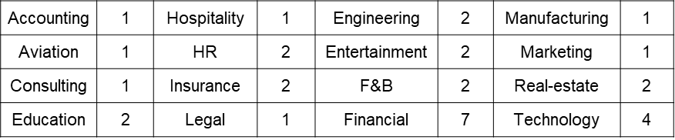
Table 25: Participants’ Industries Background (n=32)
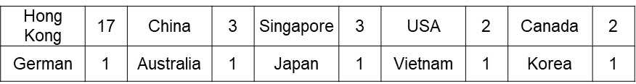
Table 26: Participants’ Company originated (n=32)

The participants consist of 19 males (59%) and 13 females (41%), with an average age of 49.6. Age distribution encompasses 6 participants aged 36–44 (19%), 8 participants aged 53–59 (25%), and two aged 60 or older (6%), including one retiree. Notably, 16 participants fall within 45–52 (50%). Importantly, all 32 participants have undergone digital transformation (100%), enriching the exploration with their experiences. Of these, 18 reported successful ODT (56.2%), while 14 experienced failure (43.8%). Regarding career duration, ten participants hold 11–20 years (31.3%), 18 have 21–30 years (56.3%), and three span 31–40 years (9.4%). Over 50% possess 21–30 years of experience.
The researcher emphasizes the full-time employees FTEs due to their value as a metric for gauging organizational capacity and resources. FTEs are pivotal to daily operations and overall business success (Presser et al., 2004; Baruch & Holtom, 2008). This criterion also reveals revenue, growth potential, and competitive advantage (Presser et al., 2004; Gill et al., 2008). Participant distribution by FTEs is as follows: 1 – 100 FTEs (6 participants), more than 10,000 FTEs (6 participants), 101 – 500 FTEs, and 501 - 1,000 FTEs (5 participants each), 5,001 – 10,000 FTEs (2 participants), and 1,001 – 5,000 FTEs (8 participants). In terms of positions, 16 are C-Suite Executives (50%); Middle management comprises 9 participants (28%). The remaining 7 represent functional business units, such as Supervisors, Office, Sales, and IT Managers (22%). Blow (Table 27-32) are the summarizes the participants' profiles of the focus group.
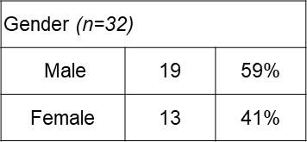

Table 27: Participants’ Gender (n=32)
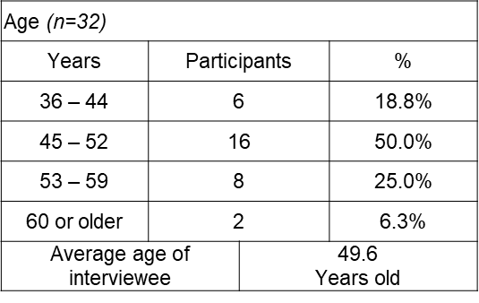

Table 28: Participants’ Age (n=32)
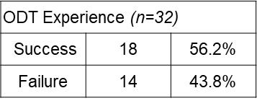
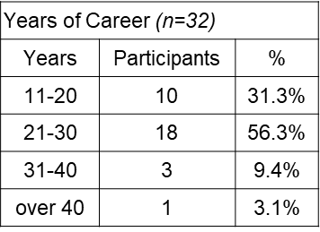

Table 31: Participants’ ODT result (n=32)

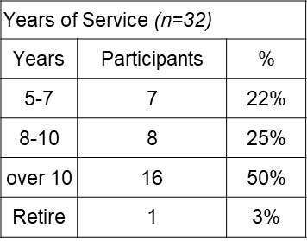
Table 29: Participants’ years of experiences (n=32)
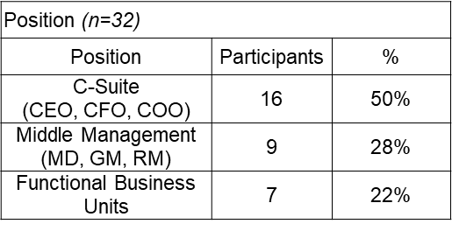
Table 30: Participants’ Company History (n=32)

Table 32: Participants’ Position (n=32)

- Open-ended Question Design
Employing open-ended questions (OEQ) in social science research is a common practice that enables participants to provide detailed responses. This approach fosters comprehensive insights. In group interviews, OEQ encourages discourse and idea exchange among participants (Gill et al., 2008). Open-ended questions offer an unconstrained format, prompting extensive and detailed responses from interviewees. Unlike closed-ended questions that limit answers, open-ended queries allow participants to express their thoughts and experiences freely. This unique feature enables a deep understanding of participants' beliefs, perspectives, and experiences, capturing intricate nuances (Rabiee, 2004). Moreover, using open-ended questions fosters an environment of dynamic participation and interactive discourse among professional participants. This collaborative atmosphere encourages blending ideas and building upon each other's responses. This approach mitigates potential researcher bias and facilitates a comprehensive and multifaceted exploration of the research subject (Gill et al., 2008).
The adoption of open-ended questions in this study fosters a milieu wherein participants' perspectives are expressed organically and unrestrictedly. This methodological stance ensures that the presuppositions harbored by the researcher do not circumscribe the research endeavor but rather converge upon the participants' varied viewpoints. Incorporating open-ended questions within the qualitative study of digital transformation within organizational contexts is an indispensable instrumentality in engendering a holistic, authentic, and perspicacious apprehension of the participants' diverse viewpoints and lived experiences.
The study recognizes the diverse expertise of focus group participants across industries, interview questions were meticulously crafted to elucidate how their work contexts inform their real-life approaches to the ODT. Through candid participant responses, the study aims to uncover novel insights that could shape the next phase of the research strategy. This iterative approach ensures alignment with digital transformation stakeholders' needs and expectations. The ensuing steps outline the foundational criteria for the focus group interview questions. See (Table: 33) for a summary of the objectives of the focus group questioning.
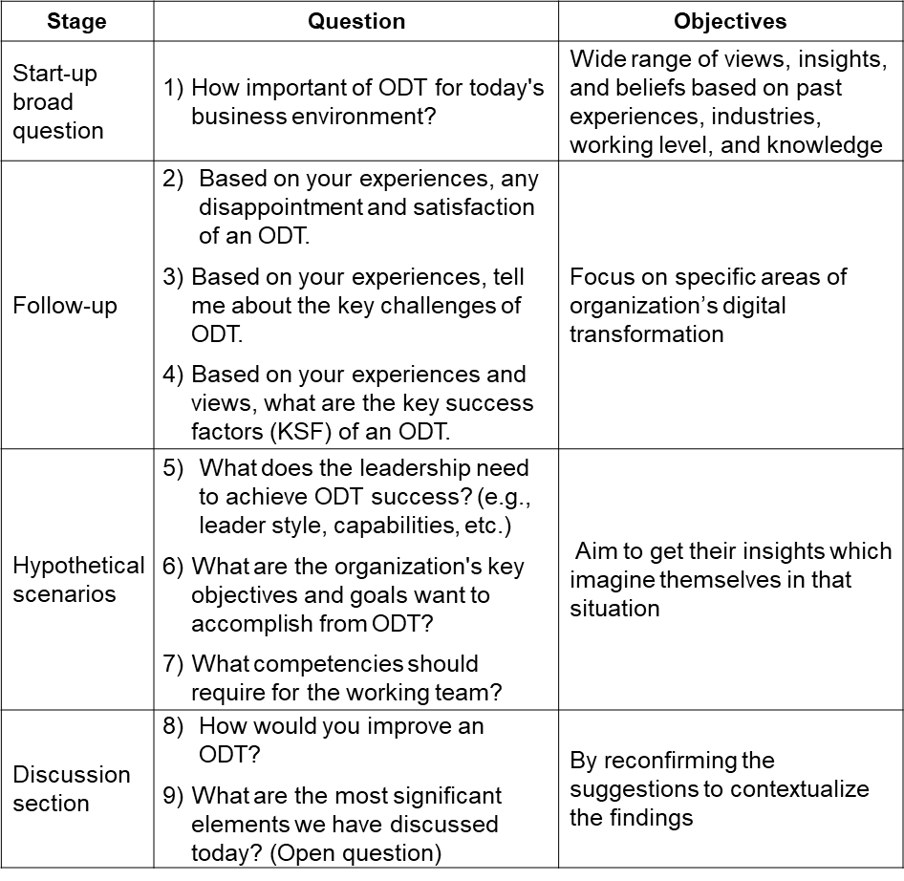

Table 33: The objectives of the Focus Group questions.

1. Initiate with a sweeping query: Initiate interviews with a broad-open-ended question to encourage unreserved exchanges on Organizational Digital Transformation (ODT). Like sparking an engine, this initial query propels participants into dynamic discourse, creating conversational momentum (Morgan, 1995, pp. 516-523). This technique liberates researcher bias, fostering candid expression while building rapport and demonstrating genuine interest in insights (Longhurst, 2003; McLafferty, 2004). This foundational question aims to draw diverse responses, probing multifaceted ODT dimensions grounded in participants' experiences. It explicitly addresses attitudes across hierarchies and industries, enriching the exploration of ODT.
2. Utilize probing follow-ups for depth: Employ follow-up questions to gain deeper insights into participants' ODT experiences, combine open-ended queries with follow-ups to expand responses without predefined constraints, enhancing clarity and uncovering the essence of answers (Powell & Single, 1996; Longhurst, 2003; Rabiee, 2004). The subsequent query explores ODT disappointments and satisfactions through questions 2 to 4. Lastly, participants' perspectives on the key success factors (KSFs) of ODT are examined, aiming to provide multifaceted insights into diverse aspects of organizational digital transformation. This approach enriches discourse and enhances research reliability by yielding detailed responses and addressing potential gaps in the study.
3. Experiential Exploration: Employing experiential inquiry can serve as a powerful technique to encourage interviewees to reflect upon intricate situations and articulate their envisioned responses (McLafferty, 2004; Rabiee, 2004). By guiding interviewees to immerse themselves in their past experiences, researchers can prompt them to project their roles within these experiences onto future scenarios, delving into their thoughts, emotions, and actions. Questions 5 to 7 are strategically crafted to elicit interviewees' past experiences in distinct ODT-related scenarios. This approach empowers researchers to identify potential intervention or policy development opportunities, drawing from interviewees' experiential insights.
4. Discussion Section: Group interviews foster dynamic discussions, enabling participants to share and collectively build upon open-ended queries, facilitating data pattern identification across multiple individuals or groups (McLafferty, 2004; O. Nyumba et al., 2018). By juxtaposing study results with prior research, the researcher underscores current contributions and earmarks future research prospects. The final two questions extract insights reflecting on ODT limitations and unveil avenues for study advancement.
Although discussion sections within focus group interviews offer valuable insights, potential drawbacks exist. Dominance by a few participants might limit others from fully expressing their viewpoints (Powell, 1996; O. Nyumba et al., 2018). Group dynamics could influence responses, leading to conformity or avoidance of unpopular opinions (Rabiee, 2004), skewing representation. To mitigate this, participant selection should ensure diverse perspectives (McLafferty, 2004), averting undue influence. Neutral and non-judgmental discussions, guided by prompts and probes, encourage all participants to contribute.
- Thematic Analysis
Exploratory sequential mixed methods research employs diverse data analysis techniques. Qualitative data undergoes content, thematic, and narrative analysis (Leech & Onwuegbuzie, 2007, 2008; William, 2016). Thematic analysis predominantly shapes the initial phase, unraveling patterns and themes in focus group interview data. This approach illuminates participants' experiences, perspectives, and attitudes (Attride-Stirling, 2001; Steelman et al., 2004). Given the multifaceted nature of organizational digital transformation and the diverse participant group (32 business executives and senior management), a systematic analysis is imperative. The thematic analysis uncovers data patterns, themes, and categories, aiding organization, and decision-making. Its simplicity facilitates diverse group dynamics and effective communication, enriching research relevance and impact.
The researcher conducts the processes of thematic analysis for qualitative focus group interviews involves the following six steps and elements:
- Familiarization with the data:
The initial step involves familiarizing oneself with the data, including planned and collected information, which begins with a literature review, enabling a comprehensive understanding of the data and revealing initial impressions, themes, and patterns. It also aids in aligning research inquiries with structured interview questions, addressing various aspects of digital transformation.
- Transcription:
In the thematic analysis phase, the focus group interview's audio recording, including participants' responses and non-verbal cues, is meticulously transcribed (Attride-Stirling, 2001). The researcher iteratively reviews the transcription, annotating key phrases and conducting preliminary data coding to identify initial themes in the organizational digital transformation management framework.
- Coding:
In the data coding stage, segments within the transcript are systematically identified and labelled based on pre-established themes or concepts. It involves identifying key themes and sub-themes and understanding process sequences, such as the relationship between "Implementation" and ‘Strategy Formulation,’ which is informed by ‘Evaluation’ in a cyclic manner. Throughout this process, the researcher meticulously analyzes the focus group interview data, discerns underlying meanings, and assigns descriptive codes and concise terms or phrases, capturing the study's essence for precise categorization.
- Theme development:
That involves identifying patterns, connections, and potential overlaps among the established codes. For instance, if the study delves into digital transformation strategies within a multinational corporation, recurring codes like ‘Leadership Alignment,’ ‘Technology Integration,’ and ‘Employee Training’ might emerge. Using a systematic axial coding approach, the researcher could uncover a thematic link and suggests that effective leadership alignment encourages the establishment of comprehensive employee training programs to facilitate successful digital adoption. These emerging themes need precise and descriptive language that captures the essence of the research question's dataset (Richards & Richards, 2002). In this context, these themes could be aptly titled ‘Strategic Leadership for Digital Adoption’ and ‘Cultivating Digital Proficiency through Employee Training.’ This alignment ensures that the themes effectively encapsulate and convey the study's exploration into the dynamics of organizational digital transformation.
- Review and refinement:
The researcher reviews and refines the themes to ensure that they are grounded in the data, accurately represent the participants' experiences and perspectives, and identify sub-themes or variations within the themes if necessary (Attride-Stirling, 2001).
- Interpretation:
The final step is to interpret the themes and draw conclusions from the data. The researcher checks the validity of the themes by examining the existing grounded information supported by quotes or examples from the collected data, analyzes the themes and coding deeply, and concludes their significance and implications. In the following, synthesize the themes to develop a coherent narrative story to explain the main findings of the analysis and how they relate to the research questions.
This study's thematic analysis encompasses iterative coding, connection, re-evaluation, refinement, and augmentation cycles. These multiple rounds of analytical engagement exemplify the researcher's commitment to a systematic and transparent approach, aligning with the rigorous tenets of analysis advocated by Attride-Stirling (2001).
- Views and Opinions of the Semi-structured Questions
After the brief introduction of the guideline of a focus group interview and 3H conceptual management framework, the first open-ended question aims to obtain a wide range of insights about the importance of ODT in today's business environment.
- How important is ODT for today's business environment?
In response to this query, it was found that a substantial majority of interviewees, constituting 90.6%, emphasized the imperativeness of digital transformation (DT) in contemporary fast-paced and fiercely competitive business landscapes. Their consensus underscored DT's transition from a mere luxury option to an organizational necessity, indispensable for maintaining a competitive edge. A significant portion of participants, comprising 81.2%, expounded on the potential of DT to reshape businesses by seamlessly integrating digital technologies across internal operations and external engagements.
They argued that this comprehensive integration fosters innovative business models and revenue streams, enhancing competitiveness. Moreover, 71.8% of respondents saw Organizational Digital Transformation (ODT) as a guide for investments, a view held firmly by 23 interviewees. In the Business-to-Consumer (B2C) sector, 65.6% highlighted customer experience as a catalyst for market penetration, underscoring DT as vital for any organizational venture. Operational streamlining was also emphasized, with 75% of interviewees confirming that utilizing organizational data and technology enhances efficiency and decision-making agility. On a global scale, 56.3% endorsed ODT as a transformative avenue for skillfully managing change amidst globalizations.
Yet, amidst these affirmations, divergent viewpoints surfaced. Approximately 28.1% and 34.3% of interviewees advocated for refined resource management and fortified corporate governance as prerequisites for successful ODT implementation. For 15.6%, ODT transcended functional improvement, assuming the role of a cultural catalyst, steering organizations toward a digital ethos. This consensus echoes the assertion of one senior executive within the financial sector. For 21.8%, the prospect of unveiling novel business offerings found validation through ODT, serving as a bridge to address emerging market voids. These diverse perspectives collectively contribute to the intricate tapestry surrounding the significance and potential of ODT within modern organizational frameworks. Refer to (Appendix 4) of the participants' response example of the question one.
The information confirms ODT's vital role in modern business, driving competitive advantage through seamless technology integration. Novel business models and revenue streams fuel organizational growth, aligning with consumer demand, data orientation, and experiential priorities, presenting a new avenue for investment. Five discernible themes and patterns emerge from the focus group discussions, encapsulating the essence of an ODT in today's business landscape. The first theme underscores growth and expansion, fueled by amplified market penetration, robust value propositions, competitive prowess, and innovative business models and investments. Profitability remains a focal point within this context. The second theme accentuates agility and adaptability, which are critical amid evolving business landscapes. Central facets include:
- Enhancing responsiveness to market shifts.
- Ensuring sustainable growth.
- Realigning with digital initiatives.
- Capitalizing on global prospects.
The third theme accentuates collaborative innovation and digital competence cultivation within the organization. Business partnerships, knowledge dissemination, collective issue resolution, data-centricity, and operational enhancements converge, fostering a vibrant digital culture conducive to innovation and transformation. The fourth theme revolves around transformational excellence and efficiency. Strategic acumen steers the digital transformation journey, complemented by adept change management, technical proficiency, cognitive navigation, and systematic measurement and refinement mechanisms.
Lastly, operational efficiency and data-driven decision-making synergistically contribute to the success of ODT. These themes collectively accentuate ODT's centrality in navigating contemporary business dynamics.
The below (Table 34) shows the most important critical keywords and themes.
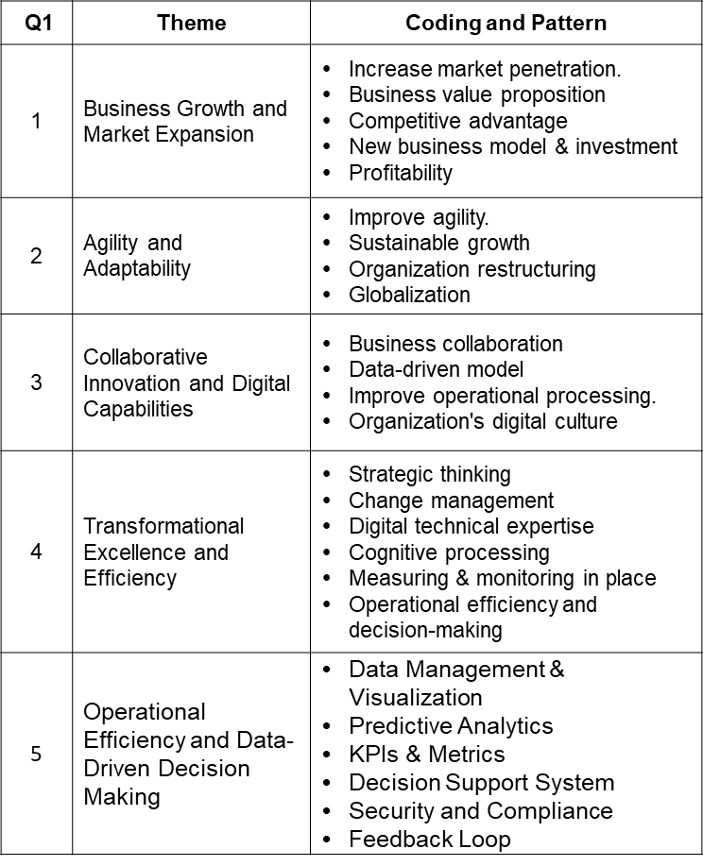

Table 34: The Critical Keywords and Themes of the question One

- Based on your experiences, any disappointment and satisfaction of an ODT.
The study delves into anticipated outcomes of organizational digital transformation (ODT) by examining satisfaction and disappointment among participants. All 32 participants (100%) acknowledged the prevalent buzz surrounding digital transformation in business, recognizing both challenges and potential. Regarding satisfaction, 30 participants (93.7%) emphasized ODT's ability to meet customer service expectations—implementation of DT streamlined operations for 27 participants (84.3%) fostering productivity. Enhanced digital culture, structure, employee engagement, flexibility, and scalability resonated with 28 participants (87.5%). Moreover, 25 respondents (78.1%) viewed ODT as a gateway to new business prospects and revenue streams. Twenty-four participants (75%) supported a purpose-driven mission, while 22 (68.8%) highlighted the value of artificial intelligence and machine learning for task automation and informed decision-making.
In terms of disappointment, unanimous consensus (100%) revealed the absence of a well-planned digital strategy at ODT's outset, characterizing the process as 'mend bridges and repair roads.' Adapting to ODT-induced disruption, evoking employee resistance for 30 participants (93.8%), including challenges of new skills acquisition and technology selection. Internal skepticism, fears of workforce replacement, and pace slowdown were flagged by 29 (90.6%). The absence of top management support, transformative expertise, and digital budget constraints hindered ODT for 28 participants (87.5%). Twenty-five respondents emphasized post-transformation continuity and data governance issues, while communication gaps and the recognition of underlying values were raised by 20 (62.5%) and 16 participants, respectively. Refer to (Appendix 5) of the participants' response example of the question two. Based on the drawing from participants' responses to question two, which illuminates common contentment and frustrations that organizations encounter amid their digital transformation odysseys. Recurrent stumbling blocks include:
- Ambiguous digital transformation strategies.
- Employee resistance to change & Inadequate expertise.
- Data quality concerns & Governance issues.
- Erroneous technology selections.
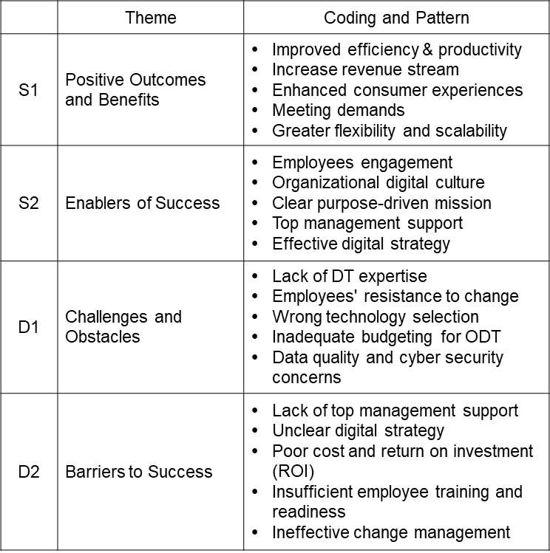
Cost and ROI apprehensions also frequently underlie digital transformation disappointment. Conversely, notable sources of gratification encompass heightened efficiency, augmented productivity, enriched consumer experiences, adaptive agility, and capacity to meet evolving demands. Two discernible themes, each encapsulating patterns of satisfaction and disappointment, emerge from participants' perspectives and experiences. Satisfaction themes (S1) underscore the positive yields of digital transformation endeavors. Elevated efficiency, revenue augmentation, enriched consumer interactions, and adaptable scalability surface as gratifying outcomes. Theme (S2) accentuates pivotal success catalysts in ODT, comprising employee engagement, digital cultural integration, and a relentless mission-driven orientation, collectively fostering a propitious digital transformation milieu. Nurturing a tech-forward culture spurs innovation and collaboration, while top management advocacy and a well-structured strategy guide resource allocation, ensuring effective digital initiative implementation and adoption. Conversely, themes of disappointment (D1) spotlight impediments and tribulations encountered in the digital transformation expedition. Challenges encompass need more transformational expertise, employee resistance, flawed technology choices, budgetary constraints, and apprehensions around data quality and cybersecurity. Theme (D2) underscores impediments to ODT prosperity, encapsulating deficient top management support, indistinct strategies, cost-ROI discord, insufficient workforce readiness, and suboptimal change management practices, collectively hampering digital transformation endeavor success and ushering in disillusionment. The researcher summarizes the most critical Satisfaction (S1&2) and Disappointments (D1&2) keywords into the themes and patterns by the focus group participants (Table: 35).

Table 35: The Critical Keywords and Themes of the question Two

- Based on your experiences, tell me about the key challenges of ODT.
The researcher's objective is to directly glean insights from participants' experiences, facilitating a nuanced understanding of common challenges encountered by organizations during their digital transformation. This inquiry also serves to uncover participants' perspectives on potential challenges within Digital Transformation (DT), pinpointing areas necessitating augmented support or resources. Remarkably, unanimous concern (100%) revolves around budgetary limitations impeding digital transformation within organizations, coupled with apprehensions over legacy system implications for Organizational Digital Transformation (ODT). A consensus among thirty participants (93.7%) underscores the pivotal role of capable digital leadership in propelling Digital Transformation Strategy (DTS) from conceptualization to execution. Moreover, twenty-seven participants (84.4%) postulate that emerging technology challenges could induce IT skills scarcity across various technological functions.
Interestingly, twenty-seven respondents (84.4%) highlight the disruptive potential of ambiguous digital strategies, subpar communication, inadequate project management, and lack of cross-level collaboration. Reflecting on implementation intricacies, twenty-six participants (81.2%) contend that a succession plan for sustained performance management following technology integration is a critical oversight. Simultaneously, 24 participants (75%) note the need for robust measurement and tracking systems in managing digital transformation projects effectively. Amid the digital metamorphosis, twenty-four respondents (75%) advocate for increased digital talent and enhanced training and development programs tailored to mirror the implementation process. The transformational dynamism encounters internal resistance and a limited organizational culture of digital innovation and experimentation, as twenty-two participants (68.8%) concur. Conversely, the complexities of technology lead twenty-two participants (68.8%) to ponder an imperfect alignment between digital transformation and business objectives.
In a regulatory context, only nineteen participants (59.4%) voiced concerns about compliance and unforeseen legal challenges during the transformation process. Moreover, seventeen participants (53.1%) assert the need for amplified access to external expertise, digital tools, and resources, while eighteen participants (56.2%) stress the importance of cyber security awareness amidst the global landscape. The subsequent statements emanate from the engineering, accounting, and senior financial advisory realms. Refer to (Appendix 6) of the participants' response example of the question three.
During focus groups, professionals from various sectors identified several challenges in organizational digital transformation. These include budget allocation, integrating new digital technologies with existing systems, and the complexities of aligning legacy infrastructure with digital tools. Inadequate digital skills among employees and issues with planning, prioritization, and vendor management were also hurdles. To succeed in this rapidly changing landscape, organizations need to be agile and adaptable, seizing opportunities for innovation. These challenges call for a comprehensive approach that addresses technological and organizational aspects. The ensuing (Table 36) succinctly summarizes prevalent challenges during digital transformation, reflecting insights from focus group participants.
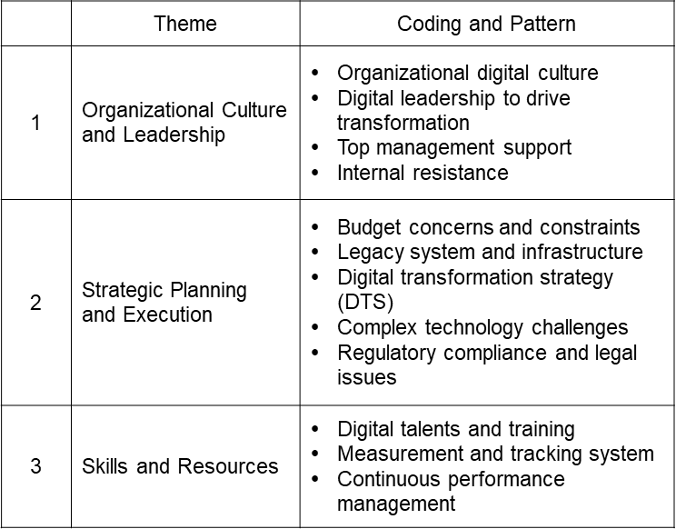

Table 36: The Critical Keywords and Themes of the question Three
These challenges fall into the Heart, Head, and Hand domains. Theme one focuses on organizational culture and leadership, encouraging innovation and change management. Theme two involves strategic planning, addressing budget limitations, legacy systems, and regulatory compliance. Theme three highlights’ skills and resources requiring digital talent development, performance monitoring, and ongoing management for successful transformation.
- Based on your experiences and views, what are the key success factors (KSF) of an ODT?
The first three questions involved all participants before the researcher initiated in-depth group discussions. These questions aimed to understand the Key Success Factors (KSFs) in digital transformation as those with experience in such initiatives perceived. The objective was to identify critical success factors, including leadership support, talent, customer-centricity, agile methodologies, data-driven decisions, and technology infrastructure. This exploration considered diverse perspectives and experiences, covering challenges, achievements, impacts, opportunities, and risks associated with ODT.
Concerning digital transformation's KSFs, every participant (100%) recognized the importance of well-structured financial support and a vision aligned with broader business objectives for successful Organizational Digital Transformation (ODT). The significance of decisive leadership and committed sponsorship for propelling ODT was emphasized by 93.8% of respondents. Similarly, the importance of a robust technology infrastructure to support digital initiatives was confirmed by 90.6%. The effectiveness of an agile mindset, facilitating adaptability to market changes and customer demands, was endorsed by 90.6% of participants.
Customer-centricity was a key focus for 90.6% of respondents, while effective communication and collaboration across organizational levels were crucial for 87.5%. The importance of having the right talent and skills as the foundation for successful ODT was acknowledged by 87.5%. An innovation-centric digital culture was deemed pivotal by 84.3%, as was the value of robust technology infrastructure, although it found less endorsement from C-suite executives. Change management's alignment with organizational culture, processes, and personnel was underlined by 84.3%, and process optimization to streamline operations and enhance digital transformation efficiency garnered 81.3%. Additionally, 81.3% stressed the importance of clear metrics and Key Performance Indicators (KPIs) for monitoring and adjusting progress.
Scalable initiatives and learning from experimentation garnered 78.1% support. Embracing emerging technologies, robust data analytics skills, and agile project management were vital for the same percentage. Cybersecurity's importance in safeguarding assets and data was recognized by 62.5%, while 59.3% emphasized strong vendor and supplier management. Participants also mentioned user-friendly interfaces, AI adoption, cloud computing, and digital marketing as crucial (under 30%). The following examples highlight participants' suggestions and comments based on their backgrounds and perspectives. Refer to (Appendix 7) of the participants' response example of the question four.
These results offer detailed insights, including suggestions and comments on potential success factors for organizational digital transformation. They cover various dimensions, including digital culture, strategic management, digital capabilities, team collaboration, vendor management, technology adoption, change management, leadership, financial management, project management, risk control, communication, human resources, executive sponsorship, and performance management. These themes encapsulate the key success factors (KSF) for organizational digital transformation (ODT). Theme 1 underscores strategic alignment and leadership, including a clear vision, financial support, and leadership commitment. Theme 2 focuses on agility, effective communication, talent management, and fostering a digital culture. Theme 3 stresses technological infrastructure, change management, and process optimization. Theme 4 highlights measurement, innovation, risk management, and vendor relationships. The final theme centres on execution and project management, including building digital capabilities. (Table 37) summarizes the suggested success factors for Organizational Digital Transformation (ODT) and their underlying themes from focus group participants.
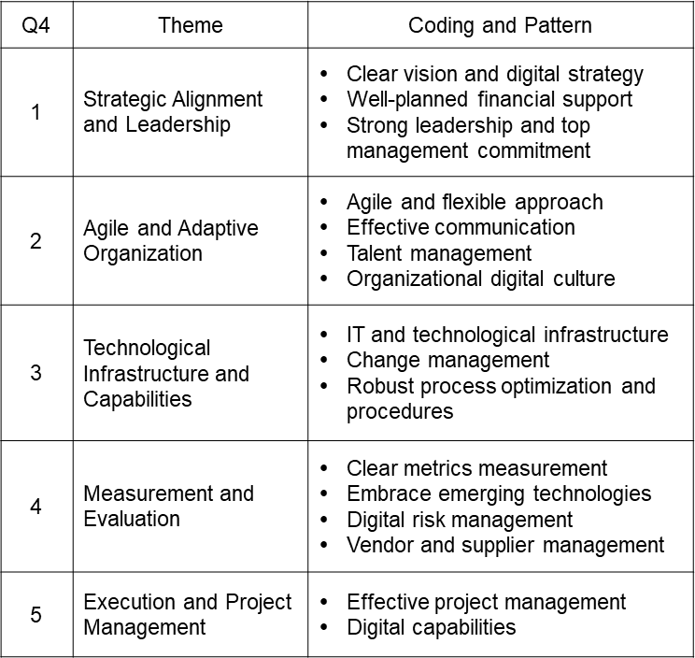

Table 37: The Critical Keywords and Themes of the question Four
- What does the leadership need to achieve ODT success? (e.g., leader style, capabilities, etc.)
Question five delves into leadership attributes and actions critical for successful digital transformation. It investigates leadership's role in overcoming challenges and driving digital initiatives. The insights gleaned can inform effective strategies and practices, aiding organizations in achieving their digital transformation goals.
Results show unanimous agreement (100%) on the central role of effective leadership in digital transformation. Participants (93.7%) emphasized leadership's responsibility in aligning culture and vision and allocating resources. They highlighted leadership's role in crafting transformation strategies, promoting a digital culture, and fostering adaptability to market dynamics (90.6%). Furthermore, 87.5% of participants emphasized leadership's visionary role in inspiring innovation and experimentation. Effective leadership involves offering personalized support and development opportunities to cultivate employee skills and foster continuous improvement. Leadership's agility and adaptability are crucial for responding to market changes and promoting innovation. These leadership qualities align with a transformational leadership style characterized by visionary guidance, empowerment, collaboration, customer-centricity, and a culture of experimentation.
Additionally, 68.8% of participants advocated for leadership to set clear expectations and incentivize high performance through bonuses, promotions, or rewards. They emphasized the importance of leadership focusing on processes and procedures to ensure the efficient execution of digital transformation initiatives. Leaders should also establish specific, measurable goals for their teams to align with organizational objectives. Effective resource allocation, accountability enforcement, and well-defined metrics and KPIs were crucial for tracking and reporting progress. In summary, the transactional leader style is characterized by clarity in expectations, performance incentives, process focus, compliance assurance, resource allocation, defined metrics, and accountability enforcement, which enhance the likelihood of digital transformation success. Refer to (Appendix 8) for participants' detailed views and suggestions on question five.
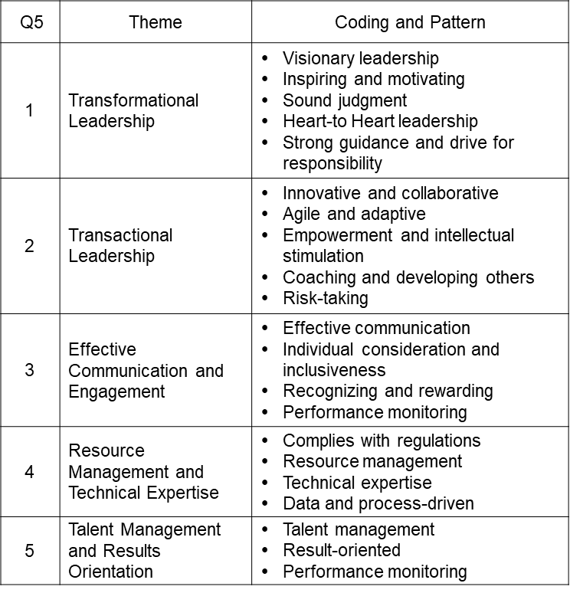
In summary of question five, Organizational Digital Transformation (ODT) is crucial for organizations to remain competitive. Strong leadership is universally recognized as essential for driving change. Leaders play a pivotal role in recognizing digital potential, fostering innovation, and aligning strategy, culture, and technology for success. These themes represent crucial leadership imperatives for successful Organizational Digital Transformation (ODT). The first theme focuses on visionary and inspiring leadership, including a clear vision, motivation, sound judgment, and strategic management. These two-highlight adaptive and agile leadership, fostering innovation, collaboration, adaptive decision-making, intellectual growth, coaching, and calculated risk-taking. Theme three emphasizes effective communication and engagement, covering transparency, individual considerations, inclusivity, recognition, and performance monitoring. Theme four centres on resource management and technical expertise encompassing regulations, resource allocation, technical proficiency, data utilization, and process-driven approaches. Theme five underscores talent management and a results-driven focus, including talent attraction and retention, measurable outcomes, and progress monitoring. (Table: 38) for a brief encapsulation of the prevalent insights from focus group interviewees regarding the imperatives of digital leadership within organizational digital transformation, along with theme delineation.

Table 38: The Critical Keywords and Themes of the question Five

- What are the organization's key objectives and goals from their ODT?
This question seeks to uncover various digital transformation goals across industries. The researcher can assess achievements, pinpoint gaps, and reveal challenges by doing so. Insights from interviews provide insights into broader ODT trends and best practices. At the same time, the analysis of strategies reveals common themes, innovative approaches, and success factors that can inform cross-organizational frameworks. Thirty interviewees (93.7%) prioritize operational efficiency, cost reduction, and revenue increase. Ninety percent seek new markets through unique digital models. ODT enhances the brand, customer trust, and talent attraction (81.2%). Digital tools optimize speed, resilience, and supply chain (78.1%). Half prioritize innovation, differentiation, stakeholder value, and ROI. Some focus on digital customer interaction. The statements below reflect insights from varied experiences and organizations. Refer to (Appendix 9) of the participants' response example of the question six.
Organizational Digital Transformation (ODT) objectives vary across entities, but common themes emerge across industries. ODT primarily seeks to optimize operational efficiency, enhance customer experiences, foster growth, and build resilience, which involves refining operations, reducing costs, and improving accuracy. Digital tools are strategically used to elevate customer experiences, establish strong customer connections, and gain a competitive edge. ODT also supports organizational growth by identifying new revenue streams, market opportunities, and innovative business models. Lastly, ODT is crucial in instilling resilience and adaptability to navigate disruptions, minimizing risks, and ensuring business continuity amid uncertainty.
These themes capture organizations' core objectives in their digital transformation (ODT) efforts. The first theme focuses on operational excellence, including process refinement, cost reduction, and revenue growth, while emphasizing adaptability to navigate market changes. Theme two revolves around business transformation and innovation, encompassing goals like implementing novel business models to propel growth and profitability, fostering fresh revenue streams through digital initiatives, and harnessing digital technologies to establish a competitive edge. The third theme underscores the paramountcy of customer-centricity and experience. It delineates aims to elevate customer interactions via digital channels, enhance digital brand standing, and augment stakeholder value and return on investment (ROI). The (Table: 39) illustrate the suggested common objectives and goals from the interview group.

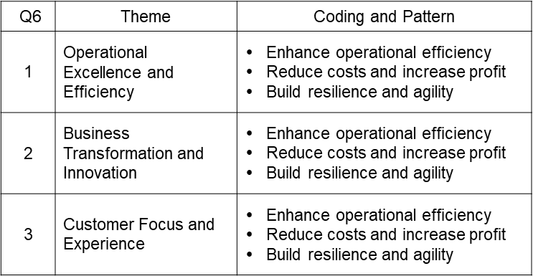

Table 33: The Critical Keywords and Themes of the question Six

- What competencies should require for the ODT working team?
During organizational digital transformation (ODT), the composition of a proficient team assumes paramount significance in propelling the initiative's progression. This question seeks the collective insights of the group participants to unveil several essential competencies that organizations ought to seek within their digital workforce. By strategically cultivating these requisite competencies, organizations can guarantee the triumph of their digital transformation effort, ultimately bestowing value upon all stakeholders involved.
Over 90% of participants stressed the importance of fostering a digital literacy culture within the team, demonstrating a deep understanding of complex digital technologies and emerging applications and a solid technical background for implementation and analysis. Additionally, nearly 94% advocated for practical project management skills, including tactical proficiency, resource management, and problem-solving. About 91% suggested the formation of a digital transformation steering committee involving senior management and cross-functional units. Cognitive processing was deemed critical by 78%, while 72% recommended familiarity with change management principles to address resistance and stakeholder concerns. Furthermore, 72% emphasized the team's agility in responding to the dynamic ODT environment.
Sixty-two and a half per cent of respondents emphasized the importance of 'walking the talk' and committing to continuous learning and upskilling. They also highlighted the need for digital ethics awareness, including cybersecurity, data privacy, bias, and ESG (Environment, Social, and Governance) practices. Furthermore, participants stressed the importance of strategic thinking and aligning ODT efforts with the organization's objectives and goals. Refer to (Appendix 10) for specific participant suggestions and comments.
It ensures the digital working team has these competencies, safeguarding the ODT efforts' success. All team members must focus on ongoing learning and development and be willing to invest in the tools and technologies necessary to support digital transformation. Team members have the skills and competencies to thrive in a digital environment and contribute to our organization's long-term success. Based on the insights from participants, Theme One explores essential digital competencies, including comprehensive digital literacy, data management skills, technical proficiency, and cognitive processing capabilities crucial for a seamless digital transformation team. Theme Two highlights the strategic aspects of effective digital transformation, emphasizing meticulous attention to tactical details, establishing a dedicated digital transformation steering committee, and proficient project management, resource allocation, change management, and strategic thinking. Theme Three underscores the importance of effective communication and collaboration within the digital transformation team, engaging with diverse stakeholders with exceptional proficiency. The team's tenacity and agility navigate the complexities of digital transformation, ensuring a steadfast commitment to optimal outcomes. This theme underscores team members' need for exceptional communication and collaboration proficiencies, seamlessly engaging with diverse stakeholders. Steeled by qualities of tenacity and agility, the team maneuvers through the labyrinthine nuances of digital transformation, remaining resolute in its commitment to optimal outcomes. The (Table: 40) illustrates the suggested themes and patterns of competencies for the digital transformation team from the interview group.
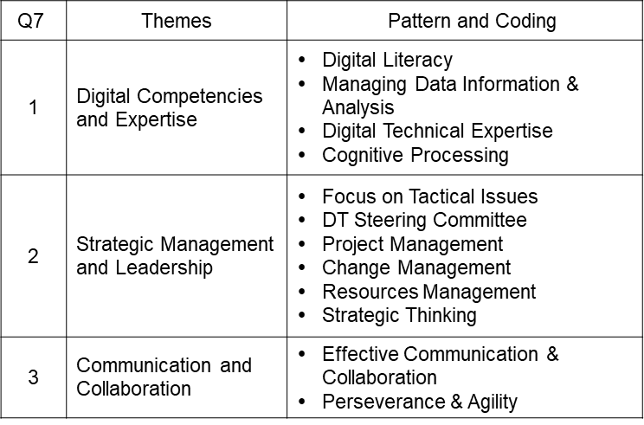

Table 40: The Critical Keywords and Themes of the question Seven
- If you were in charge of the ODT, how would you improve the process?
Through leadership role insights, the researcher aims to understand participant perspectives on improving ODT and identifying challenges, opportunities, and solutions. Additionally, the researcher seeks actionable strategies for ODT improvement by soliciting concrete examples from participants, shedding light on crucial processes, technologies, and practices for advancing digital transformation within their organization. The researcher seeks to understand participants' perspectives on enhancing ODT by prompting them to envision leadership roles. This approach uncovers insights into their views on ODT challenges, opportunities, and potential solutions. Additionally, the researcher aims to identify actionable strategies from participants who provide concrete examples of processes, technologies, and practices essential for advancing digital transformation within their organization.
All participants emphasized the need for dedicated digital leadership to align a clear transformation strategy with organizational goals, establish robust governance, and secure adequate financial support and digital infrastructure for ODT. The majority (94%) recommended promoting collaboration, innovation, and agile methodologies while emphasizing change management, monitoring, and continuous improvement. 91% advocated for cross-functional collaboration to enhance the digital user experience. Lastly, 90.6% suggested crafting a comprehensive digital talent strategy, including attracting top talent and engaging external stakeholders for effective process implementation.
Most participants (81.2%) emphasized soft management skills such as vision, communication, and individualized consideration for leadership. Additionally, 71.8% stressed hard management skills like clear expectations and performance monitoring. A robust data privacy and security framework garnered agreement from 78.1% of participants. Other essential aspects included fostering a culture of continuous improvement, risk-taking, and organizational learning. Developing data privacy and security frameworks was reiterated by 65.6% of respondents for regulatory compliance. Interestingly, only 34.3% considered technology selection a primary task for digital transformation leadership, highlighting the importance of a people-driven approach. Refer to (Appendix 11) for excerpts showcasing diverse participant viewpoints.
The researcher distils interviewee insights into five central thematic categories: Organizational Fundamentals, People-Centric Dynamics, Strategy Formulation, Competencies, and Competitive Advantage. These categories have the potential to enhance digital transformation and adapt to the evolving economic landscape. Theme One underscores the importance of strategic alignment and committed leadership in successful digital transformation, emphasizing the need for a well-defined digital strategy and visionary leadership. Theme Two focuses on human capital and organizational culture, highlighting the significance of employee engagement, diversity, skill development, and fostering digital expertise. Theme Three emphasizes agility and adaptability, emphasizing the importance of staying current with technology, optimizing operations, and managing resources effectively. Theme Four centres on data-driven insights and innovation, emphasizing measurement mechanisms, risk governance, data analytics, and fostering innovation. The last theme advocates customer-centricity, which stresses alignment with customer needs, efficient task delegation, and progress tracking. The associated patterns are summarized in (Table 41), stemming from in-depth dialogues with the interview cohort.
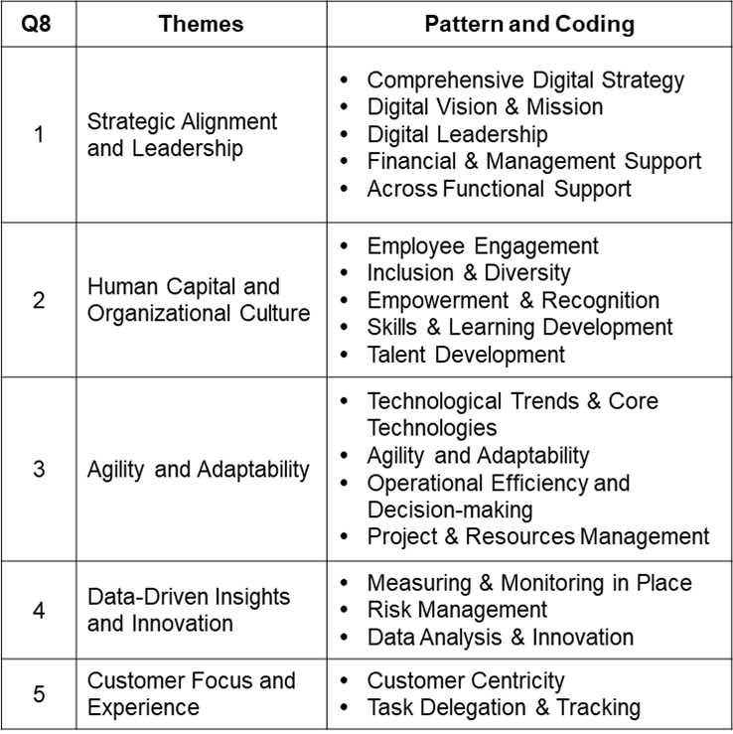
Table 41: The Critical Keywords and Themes of the question Eight

- What are the most significant elements we have discussed today relative to the 3H framework? (Open question)
The researcher seeks to uncover participants' perceptions of critical factors for digital transformation success, particularly within the context of the 3H domains. This question, posed at the end of the interview, serves as a valuable summary and conclusion to elicit any additional insights. Notably, all interviewees demonstrated a basic understanding of Yu's 3H management framework, facilitating a deeper exploration of the research topic and the synthesis of key themes and perspectives emerging from the interviews.
This exploratory question enables interviewees to express their views within the 3H model framework. Participants identified five key categories: Organizational Fundamentals and People-Centric Dynamics underpin the foundational aspects of ODT, while Strategy Formulation and Task Management relate to strategic and organizational capacities. Competencies and Competitive Advantage pertain to the technological processes within ODT operations.
There 31 interviewees (96.8%) agreed that an organization's digital culture and leadership are the core spines of digital transformation that fall into the Heart domain (H¹). Thirty interviewees (93.7%) claimed that the digital transformation strategy and data analytics are the brains (Head-H²) of the transformation, the same as the vehicle's steering wheel. They also suggested that technical know-how, project management, human resources management, technology and tools selection, and digital finance and accounting are the blood of the transformation, which keeps the momentum of the ongoing processing (Hand- H³). Twenty-eight of the interviewees (87.5%) agreed that effective communication, resources management, technology, and strategy choice belong to the integration of Heart and Head domains (H4), and exact numbers of interviewees suggested that effective project translation, team capability, and competitive advantage are the integrate of Head and Hand domains (H2). And twenty-nine interviewees (90.6%) commented that teamwork and engagement, decisiveness, agility, and learning culture belong to the integration of Heart and Hand domains. Twenty-five interviewees (78.1%) agreed that top management support, collaboration, and communication, change management program foster an innovation culture and experimentation that belong to the integration of Heart and Hand domains (H3). However, twenty-one interviewees opined that share value, short-term wins, long-term gain, reward and recognition, career growth, and efficient coordination are the ODT's ultimate goals and the integration of all 3H domains (H1). Nevertheless, one interviewee objected the 3H management framework would not be able to apply to the organization's digital transformation because many other external factors could destroy the change, which the force majeure factors such as COVID, war, and disasters. There are a few examples of suggestions and comments from the participants in (Appendix 12).
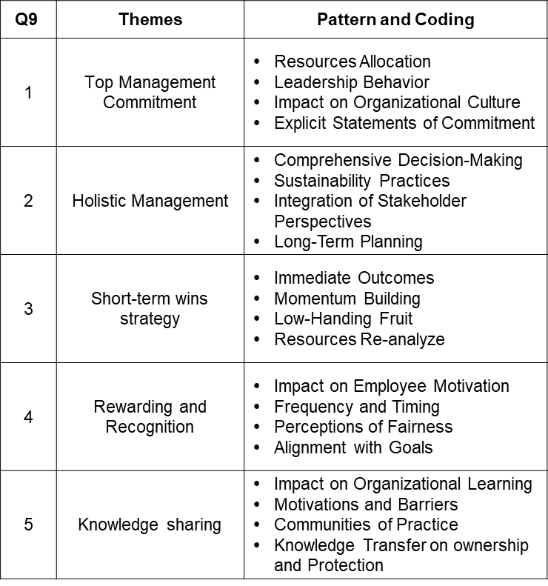
Organizations characterized by unwavering dedication from their top management exhibit a heightened propensity for the successful execution of strategic initiatives. This commitment extends to facilitating innovation and cultivating a corporate culture deeply rooted in accountability. In such organizational environments, employees consistently exhibit heightened engagement and motivation. This heightened dedication is primarily attributed to their perception of top leadership's authentic and resolute commitment towards attaining strategic objectives. The associated patterns have been succinctly summarized in (Table 42), derived from comprehensive and in-depth dialogues held with the interview cohort.

Table 36: The Critical Keywords and Themes of the question Nine
- Cognitive Mapping of Qualitative Research Data
The researcher assigns labels, categories, or codes to data collected from focus group interview segments. This coding process guides the researcher in organizing, analyzing, logically understanding, and identifying the composed data's themes, logic, ideas, and patterns (Benson & Clark, 1982; Attride-Stirling, 2001; Ritchie & Spencer, 2002; Fetters et al., 2013). By applying the 3H management conceptual framework to cognitive mapping, the researcher can better understand the cognitive, emotional, and practical factors influencing an organization's digital transformation efforts. Hereby the researcher summaries the data collected and convert into five different constructs which align with 3H framework as follow:
Heart domain (H¹)
Utilizing the collected data and derived themes, the Heart domain, encompassing emotional intelligence, empathy, and motivation within cognitive mapping, enables the identification of influential emotional and motivational factors in an organization's digital transformation. This mapping encompasses organizational fundamental and people-centric such as organizational culture, leadership, employee engagement and motivation, innovation, change management and communication, and user experience design.
- Organization Culture and Leadership: This encompasses cultivating an innovative digital culture and nurturing practical digital transformation leadership skills (Lowe et al., 1996; Birkinshaw et al., 2008; Casadesus-Masanell & Ricart, 2010; Hemerling et al., 2018). A capable digital leader Organizational Fundamental adept in transformational and transactional skills can navigate ODT challenges, fostering continuous learning in the face of rapid technological change (Bass, 1999; Bono & Judge, 2004).
- Change management and communication: Fostering a culture of innovation and experimentation that encourages employees to experiment with new ideas and technologies (Holland & Light, 1999; Smith & Tushman, 2005). Developing a change management and communication plan that effectively communicates the benefits of digital transformation to employees and creates a culture of innovation and experimentation (DeLone & McLean, 1992; Birkinshaw et al., 2008).
- Empathy and emotional intelligence: The essential drivers of inspiration and motivation that impact an organization's initiatives in digital transformation encompass employee motivation, trust-building, engagement strategies, cultivating a positive workplace culture conducive to innovation and creativity, and providing a favourable customer experience (Lee 1993; Cummings, 2004; Hemerling et al., 2018).
Head (H²)
The Head domain encompasses analytical and strategic thinking skills, encompassing facets such as the organization's digital strategy, prowess in data analytics and business intelligence, digital technology proficiency, and infrastructure utilization, spanning artificial intelligence, cloud computing, machine learning, cybersecurity, and risk management (Horlacher et al., 2016). Additionally, it entails conducting a comprehensive skills gap analysis to discern and address areas necessitating skill and competency enhancement aligned with digital transformation pursuits.
- Digital Strategy Development: This facet encompasses elements such as formulating the organization's digital transformation vision and objectives, delineating pivotal digital initiatives, and constructing a lucid implementation trajectory. Strategic allocation of resources, spanning human resources, vendor relationships, and supplier management, optimizes the value attained from ODT endeavors (Westerman et al., 2014; Vial, 2019, 2021; Udovita, 2020).
- Data Analytics and Process Intelligence: Encompassing facets such as adept data collection and analysis, this category pertains to an organization's proficiency in leveraging data to guide decision-making and gauge the efficacy of digital undertakings. Additionally, the capacity for proficient project and program management to ensure digital initiatives' timely and budget-conscious delivery is vital (Hall & Rosenthal, 1993; Hildebrandt et al., 2015; Holotiuk & Beimborn, 2017).
- Risk Management and Cybersecurity: This category enlaces elements such as the organization's adeptness in safeguarding digital assets and upholding the security and confidentiality of customer data. It extends to the modernization and modification of legacy systems through integration and modularization, with the overarching goals of enhancing operational efficiency and mitigating technical challenges (DeLone & McLean, 1992; Berman, 2012; Bharadwaj et al., 2013).
Hand (H³)
The hand domain pertains to tangible skills and competencies the organization employs to automate business processes, drive cost savings, and enhance operational efficiency. It also demonstrates the interconnections among empirical, experimental, and programmatic elements, such as leadership proficiencies, a culture of continuous learning, and technological knowledge sharing.
- Agile Execution and Program Management: This pertains to the organization's capacity for flexible, iterative, and collaborative delivery of digital initiatives, utilizing digital technologies and finance to optimize supply chain and logistics, resulting in cost reduction, enhanced efficiency, and improved customer experiences, aligned with expectations (Leonard-Barton, 1992; Prahalad & Hamel, 1997; Bharadwaj et al., 2013).
- Process Automation and Optimization: Utilizing digital technologies to automate tasks and enhance efficiency by minimizing manual intervention. Optimization entails refining and enhancing existing business processes for improved effectiveness and efficiency (Berman, 2012; Bharadwaj et al., 2013).
- Core Competency and Competitive Advantage: Developing distinctive strengths and capabilities that set an organization apart. Core competencies adapt to market shifts and digital innovations, while competitive advantage encompasses factors that grant an organization a market edge (Agha et al., 2012; Berman, 2012).
Heart and Head integration (H4)
Create attainable objectives in a nurturing setting by blending emotional intelligence (Heart) and analytical prowess (Head) to motivate and guide the team—Foster effective vertical and horizontal alignment through open communication (Bharadwaj, 2000; Liu, et al., 2012). Digital leadership instills a culture of calculated risk-taking, supported by well-planned financial allocations and collaborative, analytical transformation efforts. Achieve holistic and effective communication.
- Innovative and Daring Work Atmosphere
- Precise and Cohesive Digital Strategy
- Resources Management
Head and Hand integration (H2)
Employ an agile development approach, merging analytical thinking and practical skills (Horlacher et al., 2016), utilizing data analytics and business intelligence (Head) for targeted enhancements. Implement agile methodologies and competencies (Hand) for flexible, collaborative delivery of digital initiatives, translating strategy into actionable tasks (Verhoef et al., 2021)
- Accountability & Effectiveness
- Conflicts Management
- Data privacy and Cybersecurity
Heart and Hand Integration (H3)
Support an innovative and experimental digital culture, blending emotional intelligence and practical skills. Cultivate creativity (Heart) to inspire idea exploration and technology experimentation while employing tools and processes (Hand) for swift and efficient testing and implementation of new initiatives ((Horlacher et al., 2016).
- Teamwork
- Sound Judgment and Decisiveness
- Attitude and Learning
3H integration (H1)
The holistic 3H domains approach enables comprehensive digital transformation, addressing the intricate interplay of cognitive, emotional, and practical elements. Organizations forge robust strategies by integrating Head, Heart, and Hand dimensions, elevating efficiency, engagement, and growth. This integration unveils a comprehensive view, mapping cognitive, emotional, and practical factors driving transformation success. Emotional aspects like engagement intertwine with mental facets such as skills and analytics, while functional elements like technology align with emotional and cognitive aspects like leadership and innovation (Hoberg et al., 2015).
- Top-down management commitment
- Short-term wins strategy
- Rewarding and Recognition
- Knowledge Sharing
- Indispensable Collaboration
- Discussion of Qualitative Research Findings
Qualitative research can provide rich insights into complex processes such as digital organizational transformation, particularly holistic management, which involves a comprehensive and integrated approach to managing organizational change, considering the social, economic, and environmental factors that affect the organization's performance (Ritchie & Spencer, 2002; Creswell et al., 2007; Leech & Onwuegbuzie, 2008).
This chapter explores qualitative research findings from semi-structured focus group interviews, examining holistic management in digital organizational transformation from four perspectives. Firstly, we identify pivotal themes and concepts through thematic analysis systematically code and categorize data to reveal patterns, providing a comprehensive research overview. These findings lay the groundwork for in-depth discussions and potential future research. For example, data may unveil themes such as leadership support, employee engagement, and stakeholder involvement in digital transformation initiatives, serving as foundational points for subsequent discussions.
After identifying key themes and concepts, the second step involves critically analysing research implications in digital transformation. This examination assesses the congruence or deviation of results from established holistic management theories and best practices. For instance, the study might highlight the significant influence of leadership support on digital transformation success. This discussion explores its relevance to existing leadership theories in holistic management and its implications for future digital transformation practices. Additionally, it is essential to acknowledge research strengths and limitations, including methodology, sample size (e.g., n=32), data collection methods, potential biases, and analytical factors. For example, the limited sample size cautions against broad generalizations, emphasizing the need for further research validation.
The last approach extends research possibilities by pinpointing gaps and proposing new inquiries or methodologies. Qualitative ODT research offers profound insights into holistic management during organizational digital transformation. For instance, it underscores the significance of stakeholder involvement in digital transformation success, motivating further exploration of different engagement types and their effects on outcomes. A critical analysis of qualitative findings empowers researchers to advance holistic management knowledge in digital transformation, contributing to informed organizational change practices.
The focus group questions, informed by relevant literature, uncovered a consensus among participants regarding the significance of digital transformation for competitiveness and preventing market share loss. That extends beyond technology to encompass organizational culture, digital fundamentals (including digital culture, change management, and employee engagement), and people-centric factors such as digital leadership and emotional intelligence, supported by prior research (Chow & Cao, 2008; Pettigrew et al., 2001; Nambisan et al., 2017; Yoo et al., 2010). The study revealed differing viewpoints between administrative and technological management. Notably, 87.5% of C-Suite executives highlighted the pivotal role of an entrepreneurial culture that encourages experimentation and embraces digital technologies for successful transformation.
However, 56.2% of participants emphasized change management's significance, including engaging employees in planning, communicating, and implementing organizational changes. Effective change management minimizes resistance, fosters ownership (93.8%), and ensures employees understand digital transformation's benefits. Administrative management prioritizes broader concerns, while functional units focus on practicality. Additionally, most participants (90.6%) stressed effective communication's importance for building trust and reducing employee anxiety about digital transformation's impact. Clear, consistent communication (100%) aligns with stakeholders' objectives. Furthermore, 87.5% highlighted intensive transformational processes, like employee engagement, for success. To promote a culture of innovation, organizations should invest in initiatives such as training and development, as engaged employees contribute ideas and feedback, improving digital transformation efforts.
As previously mentioned, human involvement is central to digital transformation. The findings highlight a strong emphasis (93.8%) on people-centric aspects, mainly digital transformation leadership. These leaders possess the vision, skills, and knowledge to drive digital change, identify innovative opportunities, establish strategic goals, and communicate the benefits of transformation (90.6%) to stakeholders. Navigating digital complexities (75%), such as data security, while fostering innovation and collaboration is imperative. Additionally, empathy and emotional intelligence (81.2%) are essential for understanding and addressing employee concerns and fears, which helps build trust. Emotional intelligence aids leaders in effectively managing emotions and guiding organizations through digital challenges. Furthermore, maintaining a customer focus (56.2%) is crucial to ensure customer value remains central. Organizations prioritizing customer-centricity during digital transformation are more likely to succeed by aligning digital solutions with customer needs and preferences.
All interviewees (100%) unanimously confirmed the importance of a well-defined digital transformation strategy, which provides a clear organizational roadmap and aligns objectives. A key aspect of this strategy (90.8%) involves delineating transformation goals, technologies, and processes for goal achievement. Proficient project management (84.3%) is crucial for complex digital transformations, ensuring timely and cost-effective project completion through goal setting, timelines, and monitoring. Teamwork (90.6%) is equally fundamental, requiring a collaborative culture (93.7%) that embraces change, innovation, and cross-functional cooperation. Empowering employees is essential for effective digital transformation as they adopt new technologies and processes significantly.
Translating a potent digital transformation strategy (93.7%) into actionable processes demands adept task management, encompassing program management, agile processes, progress assessment, and measurement tactics. These systematic elements ensure desired outcomes in digital transformation endeavors. Pivotal to success, program management provides synchronized efforts toward predetermined objectives, involving defined project goals, timelines, resource allocation, issue resolution, and adherence to progress. In tandem, agile processes (90.6%) enhance flexibility and responsiveness by segmenting projects into manageable tasks, prioritizing based on significance, and iterative adjustments, responsive to evolving business dynamics and feedback. Performance assessment and measurement strategy (70%) entail tracking, identifying enhancements, and securing intended transformational outcomes and ROI. This evaluative approach empowers adaptable strategies with structured KPIs (81.3%) and metrics informed by balanced-score card analysis and data-driven decision-making, ensuring the steadfast pursuit of digital aspirations.
ODT involves adopting new technologies (96.8%) and leveraging existing capabilities for fresh business opportunities to enhance strengths. Recognizing competencies and competitive advantages leads to a tailored digital transformation strategy (90.8%) that aligns with an organization's unique abilities. In developing new proficiencies, organizations should focus on skills that align with emerging trends, enhancing core strengths and facilitating seamless integration (71.2%). This approach fosters competitive distinction, differentiating organizations from their rivals and opening new avenues for success (81.2%). Continual learning (62.5%) is essential for ongoing improvement and staying ahead proactively. Risk management (56.2%) addresses the inherent challenges in digital transformation, emphasizing the need for a substantial organizational investment to achieve robust returns (ROI) and maximum impact. Concluding, competencies and competitive advantages shape the digital odyssey, akin to a dragon boat crew harnessing unique strengths for victorious conquest.
Derived from the amassed qualitative research data, the researcher distills five distinct constructs encapsulating the pivotal themes within the realm of ODT in Figure 16 and Table 43 summaries the functionality of each construct. The ensuing themes encompass:
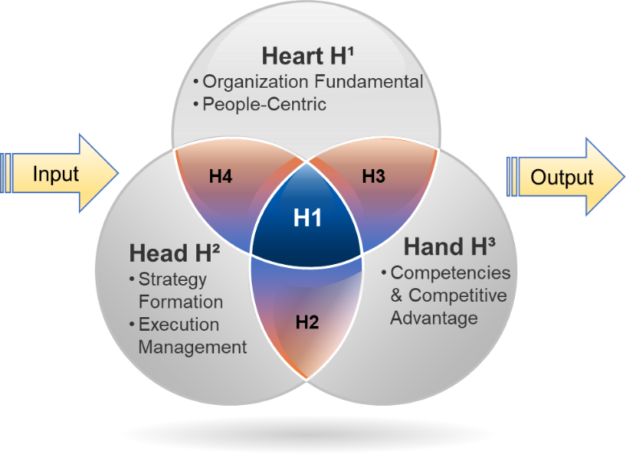

Figure 16: Five constructs align with seven distinct H domains – By Researcher

- "Organization fundamental" encompasses critical aspects of Organizational Digital Culture, Change Management & Communication, Digital Ethic & Social Responsibility, Employee Engagement & Motivation, as well as Innovation & Creative realms.
- “People-Centric” refers to Digital Leadership, Leadership Behavioral & Vision, Empathy and Emotional Intelligence, Wellness and Well-being, Diversity & Inclusion, Recognition & Rewarding, User-Centric Design, and Human Centric factors.
- “Strategy Formation” refers to Digital Transformation Strategy, Clear Objectives & Goals, Technology Assessment, Risk Management, Partnerships and Ecosystems, Project Management, Collaboration & Communication, Teamwork, and Continuous Improvement.
- “Execution management” refers to Program and Resources Management, Agility Process Management, KPIs & Metrics, Vendor & Partnership Management, Quality Assurance & Testing, Cyber Security, Training & Support, and Integration & Interoperability.
- “Competencies and Competitive Advantage” refer to Technical Expertise, Digital Skills and Talent Acquisition, Cross-Functional Collaboration, Digital Capabilities, Industry Knowledge, Cost Efficiency, Intellectual Property Management, Operational Competencies, and Team Resilience.
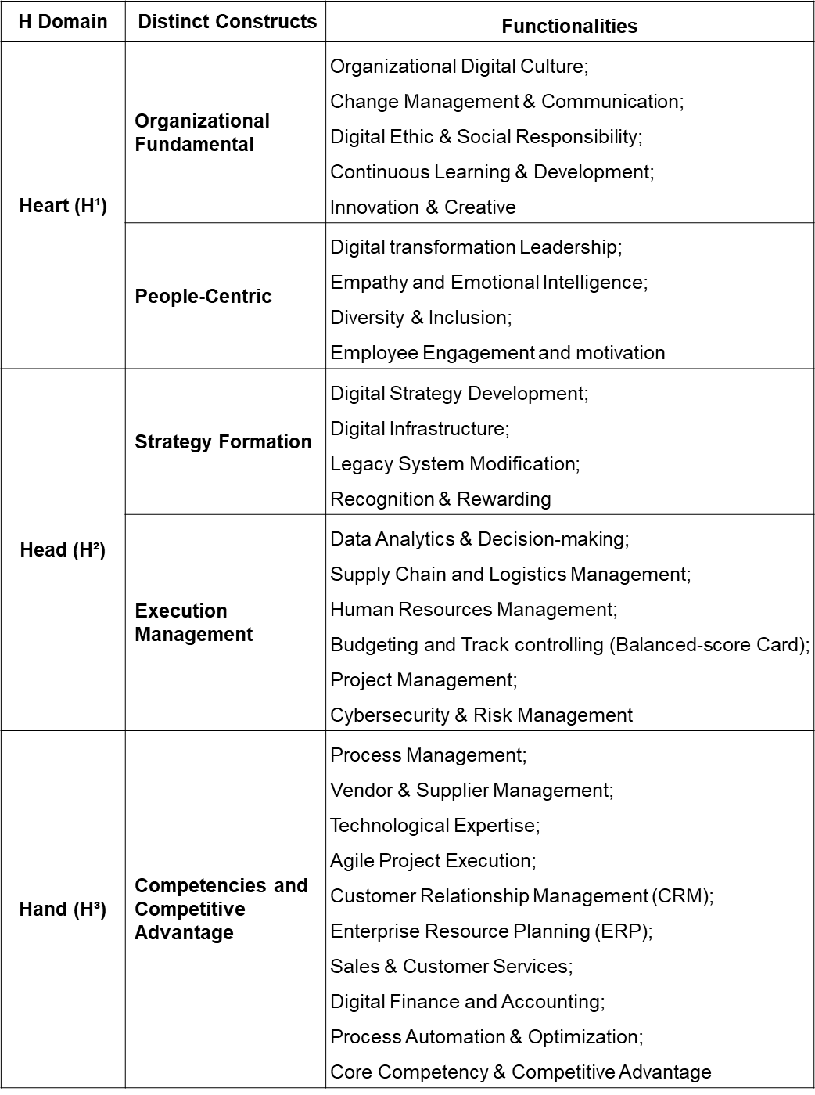

Table 43: Functionalities of H domains by Researcher
- Proposed Hypotheses
The forthcoming section of this study, positioned within the realm of exploration sequential mixed methods, is dedicated to presenting the proposed hypotheses, a critical juncture in advancing our understanding of the intricate dynamics underlying successful organizational digital transformation. Within this chapter, the research aims to dissect and illuminate the pivotal factors that contribute to the triumph of digital transformation initiatives within organizational landscapes. Drawing upon an amalgamation of existing literature, theoretical frameworks, and empirical insights gathered through the qualitative phase, the hypotheses in this study emerge as strategic signposts, intricately derived to guide the research through a thorough process of data collection and rigorous analysis. The foundation of these hypotheses is deeply rooted in a conceptual framework that intricately weaves together the realms of digital transformation, organizational change, and strategic management. This deliberate fusion forms a structured base that paves the way for empirical exploration.
A thorough synthesis of the literature has not only informed but also unraveled a diverse range of influential factors that possess the potential to mold the trajectory of digital transformation success. Within the intricate fabric of organizational dynamics, these factors span various dimensions, encompassing the transformative influence of leadership efficacy, the intricate web of organizational culture, the strategic deployment of technological capabilities, the active engagement of the workforce, and the finesse of change management strategies. As this chapter unfolds, there is a palpable sense of anticipation as these hypotheses are poised for empirical scrutiny, promising to unravel new insights and significantly contribute to the expanding body of knowledge on organizational digital transformation.
In the unfolding narrative of this study, the critical phase introduces four meticulously crafted hypotheses, seamlessly building upon the theoretical framework and the identified influential factors. Each hypothesis is carefully designed to facilitate a comprehensive investigation beyond the superficial layers, aiming to uncover the intricate connections and underlying patterns that characterize the complex landscape of ODT. Through this deliberate process, the study strives to establish logical coherence and rigour, ensuring that each hypothesis is firmly grounded in the amalgamation of existing literature and the nuanced insights gleaned from the qualitative research phase. (Figure 17) visually outlines our analytical approach, showing how these hypotheses align with the overarching research questions. These hypotheses explore complex variable relationships in organizational digital transformation, shedding light on specific facets of this phenomenon. They enable systematic exploration and empirical validation, enhancing our understanding of digital transformation intricacies within organizations.
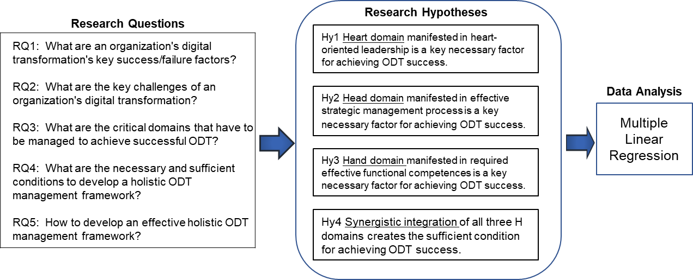

Figure 17: Relations between the Research Questions, Hypotheses and Analysis – By Author
Hypothesis One (Hy1): This hypothesis postulates that a strong alignment between leadership's Heart domain and the success of organizational digital transformation exists, which suggests that leaders who effectively cultivate a supportive emotional environment and foster a culture of collaboration and innovation contribute to a higher likelihood of successful digital transformation within the organization. Through this hypothesis, the study aims to uncover the pivotal role of leadership attitudes, values, and emotional intelligence in influencing the overall success of digital transformation endeavors.
- H10 (Null hypothesis): There is no significant relationship between the manifestation of the Heart domain in heart-oriented leadership and ODT success.
- H1a (Alternative Hypothesis): Heart domain manifested in heart-oriented leadership is a necessary factor for achieving ODT success.
Hypothesis Two (Hy2): This hypothesis proposes a statistically significant association between the Head domain in strategic management and the success of organizational digital transformation, which posits that organizations led by strategic heads who effectively formulate and execute digital strategies, allocate necessary resources, and navigate the complexities of digital disruption are more likely to achieve successful digital transformation outcomes. Through this hypothesis, the study seeks to empirically establish the pivotal role of strategic leadership in shaping the success of digital transformation efforts within organizations.
- H20 (Null hypothesis): There is no significant relationship between the manifestation of the Head domain in an effective strategic management process and ODT success.
- H2a (Alternative Hypothesis): Head domain manifested in effective strategic management process is a necessary factor for achieving ODT success.
Hypothesis Three (Hy3): This hypothesis explores the association between the Hand domain in functional competencies and the success of organizational digital transformation. Organizations with proficient and agile functional teams, adept at integrating new technologies and adapting to changing requirements, are more likely to achieve successful digital transformation outcomes. By investigating this hypothesis, the study aims to shed light on the critical contribution of functional competence in driving the execution and implementation aspects of digital transformation initiatives, ultimately influencing their overall success.
- H30 (Null hypothesis): There is no significant relationship between the manifestation of the Hand domain in required effective functional competences and ODT success.
- H3a (Alternative Hypothesis): Hand domain manifested in required effective functional competences is a necessary factor for achieving ODT success.
Hypothesis Four (Hy4): This hypothesis delves into the association between the synergistic integration of the Heart, Head, and Hand domains and the success of the organizational digital transformation. The study recognizes four specific integration scenarios: i) Heart & Head (H4), ii) Hand and Heart (H3), iii) Head & Hand (H2), and iv) 3H integrated (H1). These integration patterns represent varying levels of alignment and collaboration among digital transformation's emotional, strategic, and functional dimensions. The hypothesis posits that organizations effectively orchestrating these integrations will exhibit higher levels of digital transformation success. The researcher aims to uncover the nuanced interplay between these domains and their combined impact on achieving successful outcomes in the complex landscape of organizational digital transformation.
- H40 (Null hypothesis): There is no significant relationship between the synergistic integration of H domains and ODT success.
- H4a (Alternative hypothesis): Synergistic integration of H domains create the sufficient condition for achieving ODT success.
The researcher will analyze data and test hypotheses to accept or reject the null hypothesis based on statistical results. Through rigorous examination of collected data and appropriate statistical techniques, the study aims to provide conclusive insights into proposed relationships. This analysis will assess significance levels, effect sizes, and patterns, enhancing validity and the research findings' robustness.
4.6 Chapter Summary
This chapter highlights how important focus group interviews are in understanding the complex process of organizational digital transformation. The findings show that the culture within an organization plays a huge role in how it changes digitally. Successful digital transformation heavily relies on effective leadership. Leaders skilled in strategic thinking, good communication, and building stakeholder relationships are crucial for success. It's not just leadership, though. Employee engagement is also critical in making sure the transformation works well. This chapter also talks about the challenges of digital transformation, like people resisting changes, needing more knowledge about digital tools, and concerns about keeping data safe. The main point here is that digital transformation is not a one-time thing. It's a process that needs a flexible approach.
This chapter discusses these ideas and shows that digital transformation is an ongoing journey that must evolve. The researcher bases on the information gathered from interviews in detail and gives a better understanding of the complex nature of digital transformation. Using what was learned from the focus group interviews, the groundwork for the next phase of research, which involves creating a measurement tool, is set up. The next chapter will focus on how the quantitative analysis is planned and done, including using surveys and checking if the hypotheses hold.

CHAPTER FIVE – QUANTITATIVE ANALYSIS OF QUESTIONNAIR SURVEY
  - Introduction
This chapter unveils the outcomes of the second research phase: a questionnaire survey featuring 271 respondents. De Vaus (2001) underscores the crucial role of quantitative techniques, specifically questionnaire surveys, in furnishing empirical underpinnings for social study. By spotlighting questionnaire design and development, this chapter ensures data validity and reliability, encompassing question formulation, response options, and survey length. The potency of quantitative data in illuminating trends, patterns, and critical predictors of digital transformation success is emphasized, aligning with research questions focused on success factors, challenges, and holistic management domains. This chapter culminates by elucidating insights from questions probing the necessary and sufficient conditions for a comprehensive ODT management framework amid digital transformation's organizational implementation.
  - Quantitative Research Implementation
    - Questionnaire Design
Designing the questionnaire for this organizational digital transformation study is paramount to acquiring precise and pertinent data that can effectively address the research inquiries. This questionnaire's structure draws from an exhaustive literature examination and insights from focus group discussions. Within this study, the questionnaire survey is tailored towards uncovering pivotal success/failure factors, challenges, critical domains, and essential conditions to forge a pragmatic and all-encompassing ODT management framework.
The initial phase of crafting the questionnaire rests upon the bedrock of principal themes and concepts unearthed through literature exploration and focus group dialogues. These themes encompass:
- Organization Fundamental
- People Centric
- Strategy Formation
- Execution Management
- Competencies and Competitive Advantage
The questionnaire design is tailored to encompass these identified themes and facilitates quantitative analysis by integrating multiple-choice questions, Likert scales, and open-ended inquiries. This structured approach enables respondents to assess the significance of diverse aspects on a scale of 1 to 5, where (1) indicates insignificance and (5) signifies utmost importance. Each item is meticulously crafted to ensure clarity, brevity, and participant comprehension while maintaining neutrality and preventing prompting toward specific responses. In the context of this investigation into an organization's digital transformation, exemplar questionnaire items are provided below:
- Organization Fundamental (Organizational culture towards digital transformation): Q6 - "There is a high level of trust between management and workers in my organization."
- People Centric (Perceived require for digital leadership): Q12 - "Our ODT leader is a 'heart-to-heart' leader with a spirit that motivates and nurtures others to succeed in digital transformation."
- Strategy Formation (Preferred organizational strategic management for digital transformation): Q28 - "My organization can exercise flexible measures to tackle unforeseen barriers encountered in the process of its digital transformation."
- Execution Management (Perceived task management need for digital transformation): Q26 - "Our ODT team has sufficient digital skills and experience to execute our organization's digital transformation process."
- Competencies and Competitive Advantage (Preferred organization competitive advantage for digital transformation initiatives): Q27 - "My organization is able to implement relevant digital technologies for ODT, which differentiates it from competitors."
    - Sample Design and Data Collection
Quantitative research employs numerical data to derive conclusions from research inquiries. A standard technique in this approach is the deployment of questionnaire surveys for data collection. These surveys comprise a set of inquiries to garner information from a sample of respondents. Sample design and data collection for quantitative research involving questionnaire surveys are crucial to securing representative data from the target population (De Vaus, 2001). In this study, the researcher adopted non-probability convenience and purposive sampling methods. Convenience sampling involves selecting easily accessible participants, often known to the researcher, based on specific attributes such as industry, job position, ODT experiences, and expertise in the study's topic (O’Reilly & Parker, 2013). Following the sample design, data collection is undertaken. Administration methods, like email, WhatsApp, and Google Forms, were used. Online surveys are increasingly popular yet might not suit older adults. Hence, participants under 50 were predominantly engaged. The researcher also employed purposive sampling, optimizing efficiency by selecting participants aligned with research goals. This meticulous selection enhances data quality, research objectivity, and the overall robustness of findings, bolstering result reliability.
Once the sample design is established, the subsequent step involves data collection from the chosen sample. All respondent data is gathered through two online questionnaire platforms and transformed into Excel. Their distribution period is from 21 December 2022 to 29 January 2023, totaling 5.5 weeks. This collected data, stored in Excel, will be transferred to SPSS (Statistical Package for the Social Sciences), widely employed in social science research for statistical analysis. SPSS offers versatile data manipulation and analysis functions, yielding descriptive statistics encompassing means, standard deviations, frequencies, and percentages. Inferential statistics, encompassing ANOVA, regression, and factor analysis, will examine variable relationships, test hypotheses, and unveil data patterns.
Internal consistency reliability assessment employs Cronbach's Coefficient Alpha, a common measure in quantitative research for assessing scale or measure reliability. Generally, a coefficient alpha of 0.7 or higher is acceptable, while values exceeding 0.8 are regarded as good or very good. Regression and factor analysis model, the interplay between dependent and independent variables, predicting the former's value based on the latter's values and uncovering underlying data patterns. Pearson correlation symbolized as 'r' and ranging from -1 to +1, quantifies the linear relationship strength and direction between two continuous variables.
    - Demographic and Profile Descriptive Summary
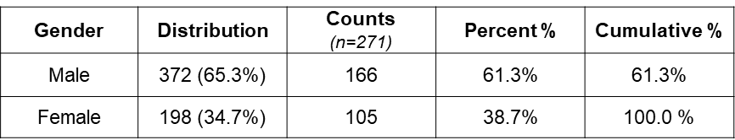
In this comprehensive questionnaire survey, 570 questionnaires distributed via different channels. Among these, 372 participants identified as males (accounting for 65.3%), while 198 identified as females (comprising 34.7%). These respondents spanned 12 distinct geographical locations, representing 13 industries and 67 global companies. The distribution methods employed included 136 questionnaires distributed via email and 394 through mobile social apps (specifically, WhatsApp and WeChat). Of these, 323 questionnaires were completed, indicating a response rate of 56.7%, a notable achievement for social research studies. Total amount of HKD 16,150 donated to local charities. Ultimately, the study derived 271 valid returns (n), with 52 questionnaires deemed invalid for analysis. The following tables and figure illustrate the sample demographic and profile of all participated respondents. (Table 44) shows the gender of the sample, 166 of male (61.3%) and 105 female (38.7%), which the gender spread was align with the distributed initially.

Table 44 (K): Frequencies of gender (n=271)
(Table 45) provides insight into the age distribution of respondents, revealing that a substantial majority, total of 28.8% were aged 36 to 44, while 28.4% were in the 45 to 52 age brackets. This demographic composition underscores the engagement of a diverse range of experienced professionals, contributing to a well-rounded perspective on the research inquiry.
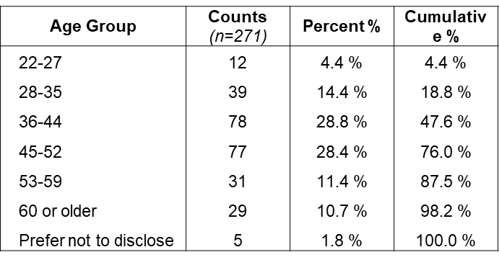

Table 45 (L): Frequencies of age group (n=271)

The data presented in (Table 46) illuminates the operational history of respondents' organizations. Notably, a mere 6.6% represent very new companies with an operational span of less than one year. In contrast, over 32% of organizations have established their presence for over a decade. The 1-4 years range accounts for over 26%, whereas a significant portion of 35% is attributed to companies with an operational history falling within 5-7 years and 8-10 years. This diverse distribution highlights the participation of organizations with varying experience levels, contributing to a comprehensive understanding of the research landscape.
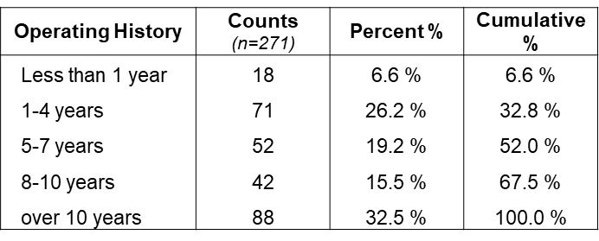

Table 46 (J): Frequencies of operating history (n=271)
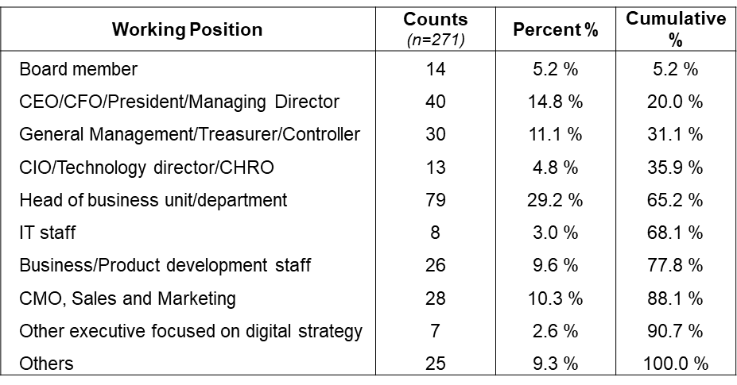
(Table 47) provides a comprehensive overview of the occupational positions held by the respondents, categorized into two distinct groups: senior management and field staff. Participants in the senior management category include board members, C-Suite executives, General Managers, Controllers, and Executive Directors, collectively accounting for 35.9% of the total respondents. On the other hand, the remaining 64.1% of participants are distributed across various functional levels, encompassing roles such as unit heads, IT staff, business development, sales and marketing, and other related positions. This diverse representation ensures a holistic perspective on the research topic, capturing insights from leadership and operational perspectives.

Table 47 (I): Frequencies of Working Position (n=271)
(Table 48) presents a comprehensive overview of the geographical distribution of respondents' organizations. Notably, the data reveals that 76% of respondents are affiliated with organizations based in Greater China, encompassing mainland China, Hong Kong, Taiwan, and Macao. Furthermore, 10% of the respondents’ hail from North America, specifically the USA and Canada. A minority of organizations, constituting 14%, are in various countries, including Southeast Asia, India, Australia, Europe, and the United Kingdom. This distribution offers insights into the global representation of participants, contributing to a well-rounded perspective on the research findings' applicability across diverse geographic contexts.
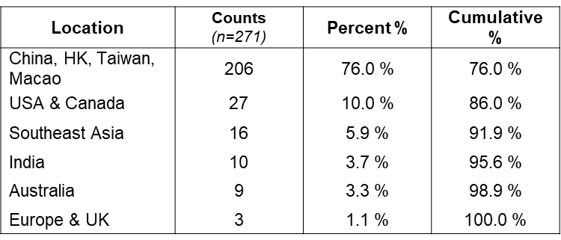

Table 48 (M): Frequencies of Company Location (n=271)
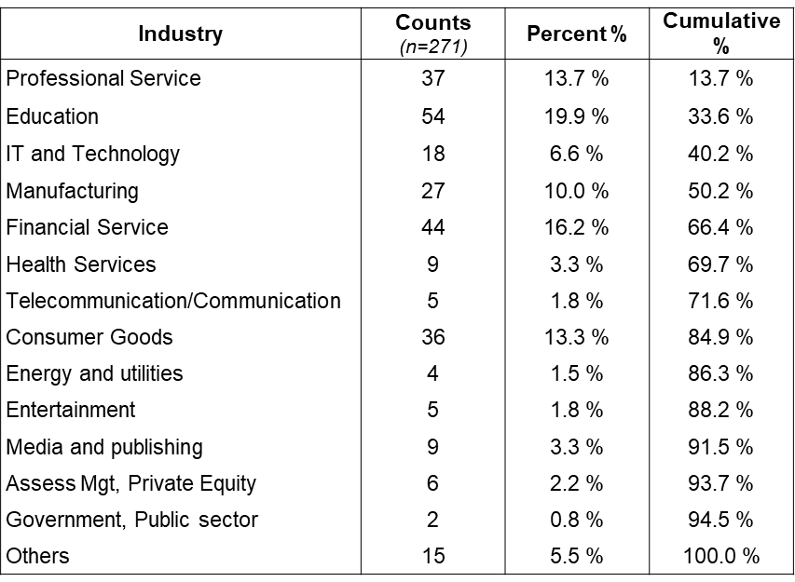
A thorough examination of the participants' industry backgrounds reveals a noteworthy diversity, encompassing pivotal sectors such as consumer goods, education, financial services, and professional services. This analysis, detailed in Table 49, underscores the considerable presence of these industries, collectively constituting more than 63% of the entire respondent pool. This distribution serves as a statistical marker and underscores the richness and varied perspectives encapsulated within the research dataset. Including participants from these sectors significantly augments the scope and profundity of insights available, enhancing the overall robustness of the research findings.

Table 49 (H): Frequencies of Industry Background (n=271)
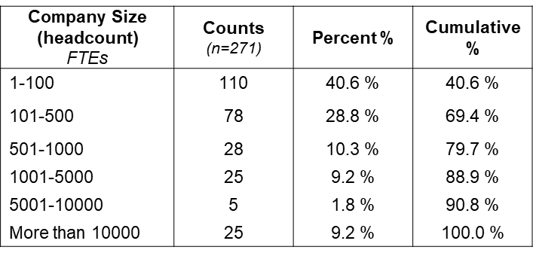
An exhaustive analysis of the participants' organizational structures according to size reveals insightful patterns. Noteworthy is the revelation that 40.6% of the surveyed organizations maintain a workforce of less than 100 full-time employees (FTEs), while another 28.8% operate within the 101-500 FTEs bracket. Moreover, an appreciable cohort, comprising 30.6% of the total respondents, represents entities boasting 501-10,000 FTEs, as elucidated in Table 50. This distribution furnishes a nuanced portrayal of organizational dimensions and underscores the breadth of considerations within diverse scales. Including organizations across varying size categories significantly enriches the research landscape, providing a comprehensive lens through which to discern and extrapolate implications across a spectrum of organizational magnitudes.

Table 44: Q (F) Frequencies of Organizational Scale (n=271)
Table 51a offers an intricate analysis of the organizational structure of the respondents, delineating a five-tier hierarchy marked by a prominent distribution level. The outcomes highlight a prevailing inclination towards a more decentralized framework characterized by a streamlined organizational chart, diminished hierarchical tiers, and a leaner managerial hierarchy. This structural configuration implies a shift towards collaborative decision-making methodologies involving insights from diverse stakeholders and cross-functional teams. The observable emphasis on a flatter organizational hierarchy not only mirrors contemporary organizational trends but also signifies a proclivity for cultivating collaborative and inclusive decision-making practices in alignment with current paradigms in organizational design.

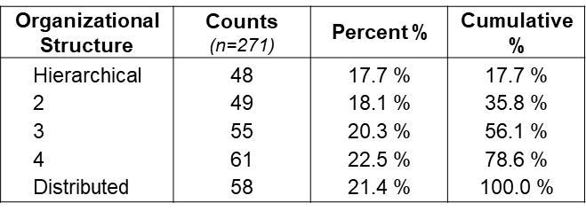

Table 51a: Q (A)Frequencies of Organizational Structure (n=271)

The paramount skills and abilities requisite for effective leadership, as delineated in Table 51b, include B1, B2, and B3. Survey respondents express the need for their digital leaders to possess updated technological acumen to benefit ongoing business operations strategically. Furthermore, a proficiency in steering people-centric transformations and a willingness to embrace the ethos of 'No risk, No gain' are highlighted as essential attributes.
The primary objectives of Organizational Development and Transformation (ODT), as detailed in Table 51c, revolve around creating business value, fostering sustainable growth, and enhancing the organisation's competitive advantage. The identified barriers to successful ODT, outlined in Table 51d, are led by the absence of an overarching strategy, followed by challenges related to poor leadership and a need for more understanding and support from management regarding the ODT initiative. The prevailing approach to ODT implementation, as indicated in Table 51e, predominantly adheres to a top-down methodology, with a majority of respondents affiliating with this approach and followed by a pilot case approach and a reliance on cross-functional team for managing the ODT process.

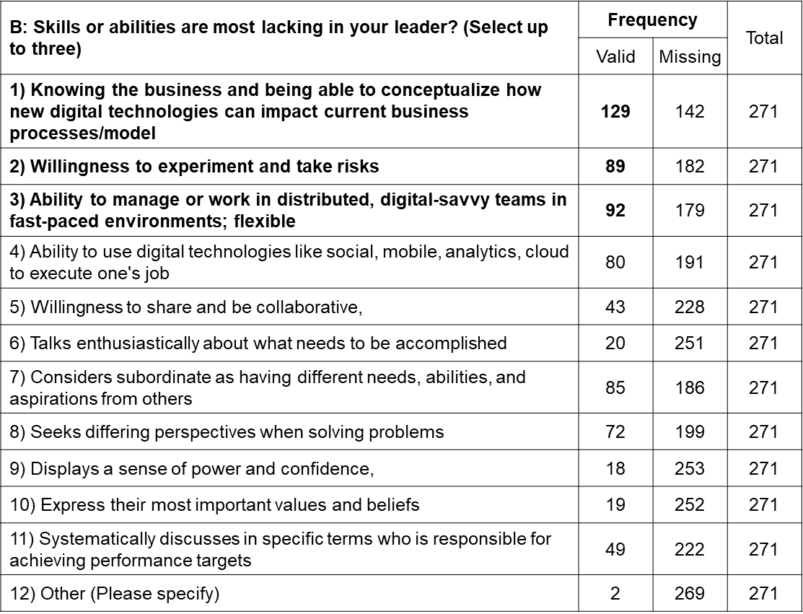

Table 51b: Q (B) Frequencies of leaders’ skills or abilities require (n=271)
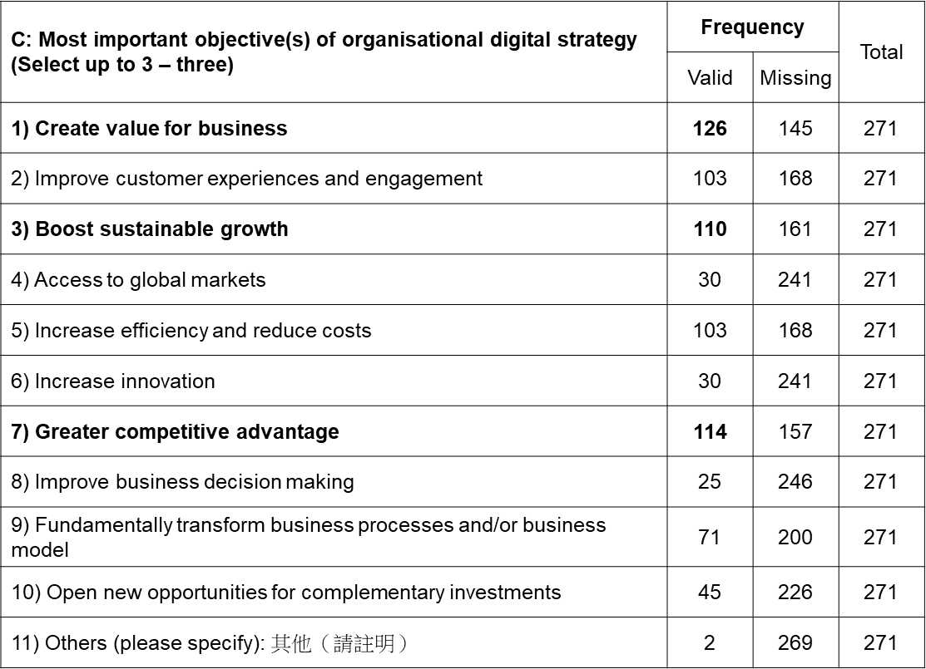

Table 51c: Q (C) Frequencies of Objectives of ODT(n=271)
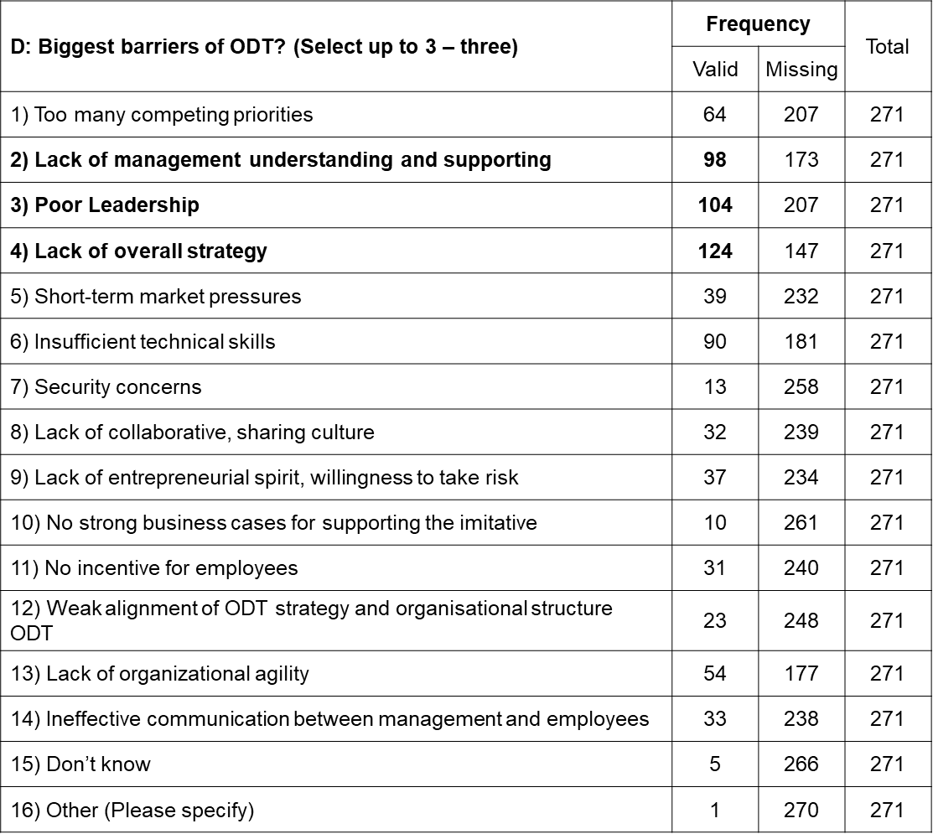
Table 51d: Q (d) Frequencies of ODT barriers (n=271)
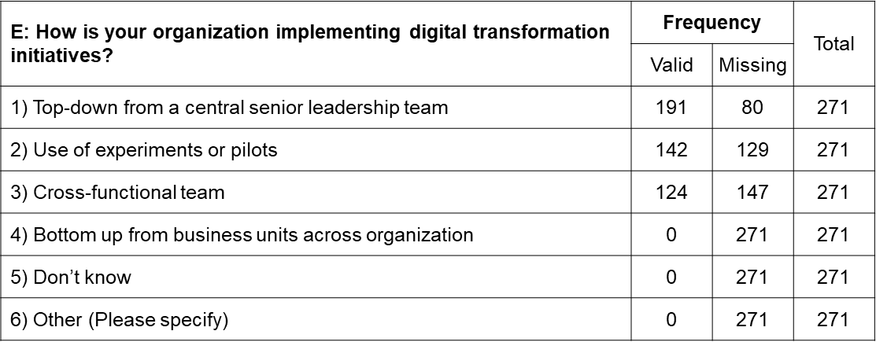

Table 51e: Q (E) Frequencies of organization’s style for ODT implementation (n=271)
- Assessing Reliability and Validity
The survey data reliability and validity assessment in this study was meticulous and aimed at ensuring the appropriateness, reliability, and clarity of all posed questions. A thorough reliability test was conducted, and the statistical outcomes are meticulously detailed in Table 52. The overall Cronbach's Alpha (α) for the variables ranged from α= 0.716 to 0.894, attesting to a high level of reliability.
The study's reliability outcomes surpass the acceptable threshold, employing the widely acknowledged criterion of an Alpha value of α ≥ 0.7. This criterion, rooted in established research practices (Reise, 2000; Cen et al., 2006; Creswell et al., 2007; Yong & Pearce, 2013), suggests that values exceeding 0.7 are acceptable and unequivocal. The findings of this study, aligned with this criterion, affirm that all survey items were comprehensible and demonstrated commendable reliability. It is noteworthy that adhering to the general guideline where an Alpha value exceeding 0.7 is considered significant, the model utilized in this study stands as a robust explanatory framework, reinforces the study's credibility and affirms the soundness of the data collection instrument in elucidating the phenomena under investigation.
The statistical analysis of the dataset revealed that the total statistics scoring for each variable was equal to or greater than 0.7. A Cronbach's alpha of 0.7 or higher is commonly considered acceptable for internal consistency reliability measures. This threshold is based on the fact that a value of ≥ 0.7 indicates that about 50% of the variance in the items can be explained by the underlying construct, which suggests that the items are measuring the same thing. A Cronbach's alpha of ≥ 0.7 also balances reliability and the number of items on a scale. However, it is important to note that the specific threshold for an acceptable Cronbach's alpha may vary depending on the field or context. Therefore, it is crucial to consider the research question and intended use of the test or scale when interpreting Cronbach's alpha values. The acceptance Alpha value of α ≥ 0.7 is widely accepted in this research study, and the results showed that all items were understandable and reliable. That indicates high reliability and validity in the data, suggesting that the variables accurately measure what they are intended to measure. The statistical significance of the results was also confirmed. These findings have important implications for the broader research field, as they suggest that the variables under investigation are reliable and valid measures of the constructs they are intended to represent.
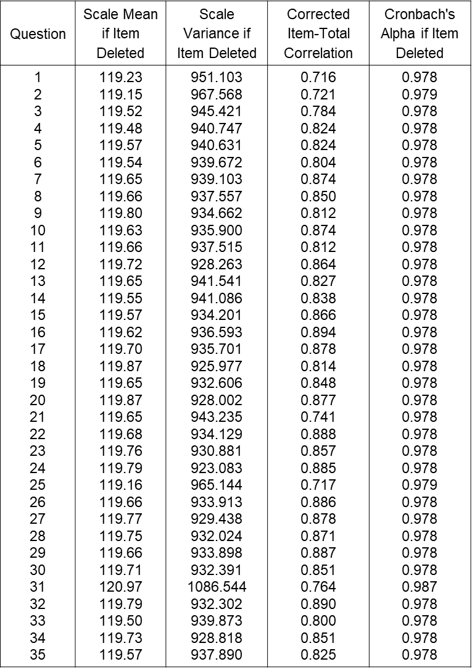

Table 52: Reliability Statistics / Itemized Summary of Total Statistics (n=271)

To enhance the confidence that researchers can conclude the data and provides a solid foundation for future research. Further research may be needed to fully explore the nuances of the data and confirm the generalizability of the findings to other populations or contexts. Nonetheless, the results of this study represent a significant step forward in our understanding of the variables under investigation. In conclusion, the reliability and validity of the survey data used in this study were assessed to ensure that all questions were fitting, reliable, and understandable. These findings suggest that the survey questions effectively measured the constructs of interest and can be used confidently in further analysis.
    - Practical Reflections of the Survey Data
Within the scope of ODT research, this study centers on harnessing survey data to extract practical implications and actionable recommendations. By meticulously dissecting the amassed data, the study aims to unearth discernible patterns, prevailing trends, and noteworthy insights that cast light on organizational dynamics during digital transformation. The ensuing pragmatic reflections drawn from this research possess the potential to serve as invaluable guides for decision-making processes, steer strategic initiatives, and elevate overall organizational effectiveness. Through a methodical methodology, this study furnishes a comprehensive exploration of the practical inferences that survey data can yield for advancing digital transformation success. It meticulously probes the correlation between the seven H domains (Heart, Head, Hand, Heart & Head, Hand & Heart, Head & Hand, 3H integrated) and the performance of organizational digital transformation. Employing the analytical tool of Pearson correlation coefficients, it delves into the intricate interdependencies among these variables, thereby contributing a substantial dimension to digital transformation research.
In statistical significance, this study adopts a significance level of p ≤ 0.05, a widely recognized and practiced threshold in social research (Onwuegbuzie & Combs, 2011; Sullivan & Feinn, 2012). This threshold ensures that the likelihood of the observed results occurring purely by chance is less than 5%. Such a stringent criterion is employed to uphold the robustness and dependability of the reported findings, bolstering the integrity of the research conclusions. The p-value < 0.05 threshold is a stringent yardstick for measuring the significance of observed relationships or effects in the dataset. This meticulous approach effectively demarcates substantive findings from random variation (Halsey et al., 2015; Sullivan & Feinn, 2012), thus underlining the study's commitment to data-driven precision and reliability.
The researcher chose to employ Linear Regression and Analysis of Variance (ANOVA), a widely used statistical technique that allows for examining the relationship between a dependent variable and one or more independent variables. This analysis tests the research hypothesis that different H domains manifested is a key necessary success factor for achieving ODT, and that allows for identifying any significant associations and quantifying the strength and direction of the relationship (Tabachnick et al., 2013). ANOVA can handle multiple factors comparison, partition sources of variation, and provide post hoc tests for detailed analyses of factor differences. These features allowed the researcher to examine the significance of differences in digital transformation outcomes across various organizational units or treatment conditions, contributing to a comprehensive understanding of the factors influencing the success of digital transformation efforts.
Factor Analysis and t-tests serve distinct purposes in this study and yielded insights into the research question. Factor Analysis examines the variables’ structure, identifying latent constructs, reducing data complexity, and clarifying interrelationships (Tabachnick et al., 2013). It enhanced the understanding of underlying success factors. The t-test compared means of independent groups, addressing research questions about differences (Sullivan & Feinn, 2012; Field, 2013). It assessed significance and whether differences were likely by chance. The t-test revealed insights into the differences' significance and magnitude. Calculating the t-value and p-value enabled inferences about statistical significance, which is crucial for concluding hypotheses (Field, 2013). These techniques collectively explored variable’s structure and group differences comprehensively.
- Pearson correlation coefficients results
To examine hypotheses concerning the interplay among variables, this study scrutinizes the potential statistically significant correlation between two key factors: H domains and ODT performances, as illustrated in Figure 18. The researcher seeks to employ a robust analytical approach involving the computation of a correlation coefficient and executing hypothesis tests. These analytical tools not only elucidate the strength and direction of the observed relationship but also enable researchers to discern whether the identified correlation is a product of chance or indicative of a substantive and genuine association. This methodological rigour ensures a nuanced understanding of the intricate relationships between variables, contributing to the depth and credibility of the study's findings.
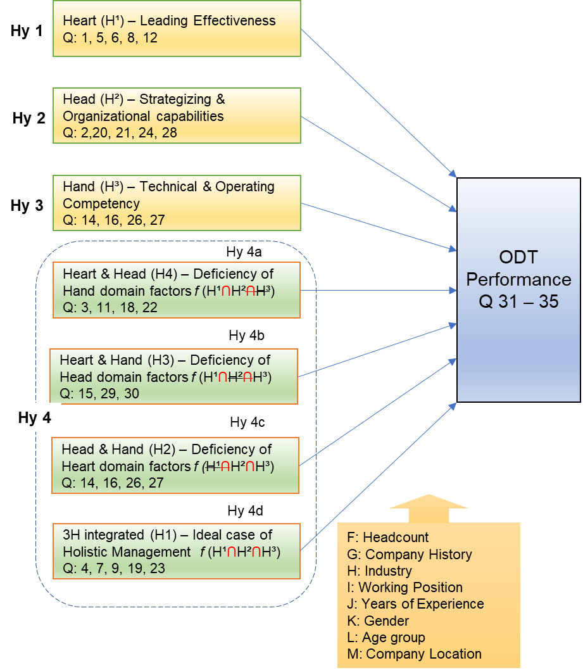

Figure 18: The Research Hypotheses Paradigm – By Author
- Leading Effectiveness (Heart Domain H¹)
This research delved into scrutinizing the correlation between Leading Effectiveness (Heart – H¹) and the Performance of Organizational Digital Transformation (ODT-5Q), concentrating on the profound impact of leaders’ adept at articulating a vision, inspiring employees, and managing change. The outcomes of this investigation unveiled compelling insights, unveiling a remarkably significant positive correlation (r=0.871, p ≤ 0.001, two-tailed) between leading effectiveness and ODT performance. These results underscore the pivotal role of leadership in steering successful digital transformations and accentuate the imperative for organizations to cultivate and nurture effective leadership.
The findings, encapsulated in Table 53, beckon further exploration into the intricate mechanisms and specific leadership behaviors that contribute to the triumph of digital transformations. This recommendation for additional research arises from recognizing that understanding the underlying dynamics will facilitate a more comprehensive comprehension of the nuanced interplay between effective leadership and successful organizational digital evolution. As organizations navigate the ever-evolving digital landscape, these insights serve as a cornerstone for refining leadership development initiatives tailored to the unique demands of orchestrating and sustaining successful digital transformations.
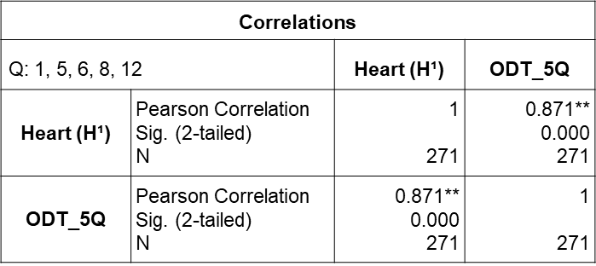

Table 53: H¹ **Correlation is significant at the 0.01 level (2-tailed) n=271
- Strategizing and Organizing Capabilities (Head Domain H²)
This research scrutinizes the intricate relationship between strategizing and organizing capabilities (Head – H²) and the performance of digital transformation initiatives. By conducting a nuanced analysis of the correlation between these capabilities and digital transformation performance, the study aims to provide comprehensive insights into the depth and nature of their association. The consistent findings underscore a compelling linkage between a strong perception of effective strategy development and enhanced digital transformation performance. The correlation analysis elucidates a highly significant positive correlation (r = 0.887, p ≤ 0.001, two-tailed), indicating a robust and statistically meaningful relationship between strategizing and organizing capabilities and digital transformation performance (Table 54).
These results underscore the pivotal role of solid strategizing and organizing capabilities in influencing favorable outcomes in the context of digital transformation initiatives. The demonstrated correlation emphasizes that organizations aspiring to achieve optimal results in their digital transformation journey should prioritize developing and enhancing strategic and organizational competencies. This insight contributes to the broader discourse on effective digital transformation strategies, offering a nuanced understanding of the critical factors that underpin success in this dynamic and evolving landscape.
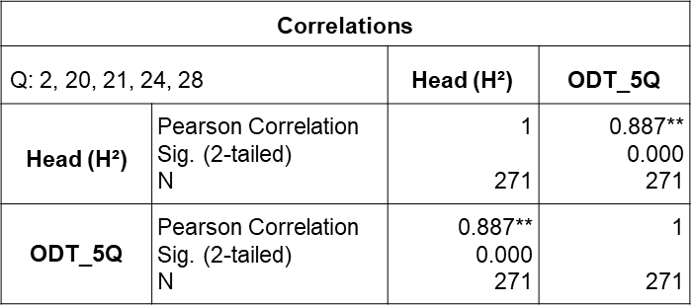

Table 54: H² **Correlation is significant at the 0.01 level (2-tailed) n=271
- Technical and Operation Competences (Hand Domain H³)
This study examines the dynamics between technical and operational competencies (Hand – H³) and the efficacy of organizational digital transformation initiatives. The primary objective is to ascertain whether organizations endowed with heightened technical expertise and operational agility are more inclined to achieve successful digital transformations. Preliminary findings from this inquiry yield highly statistically significant results, revealing a robust positive correlation between technical and operational competencies and digital transformation performance (r = 0.891, p ≤ 0.001, two-tailed). These results illuminate a meaningful relationship, underscoring that organizations equipped with advanced technical skills and operational agility are notably more predisposed to achieving successful outcomes in digital transformation (Table 55).
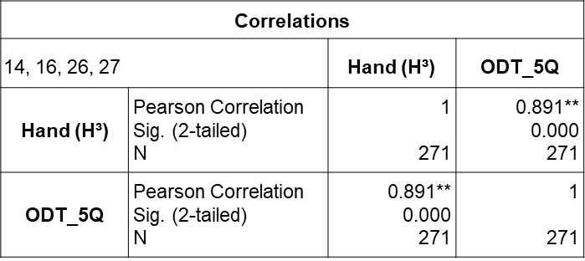
This revelation significantly contributes to our comprehension of the pivotal role played by technical and operational competencies in shaping the digital transformation trajectory. It affirms the theoretical linkage between these competencies and successful outcomes and emphasizes the pragmatic implications for organizations aspiring to navigate and excel in the dynamic landscape of digital transformation. As a result, these findings serve as a fundamental basis for strategic planning and initiating capability development, aiming to optimize digital transformation performance within organizational contexts.

Table 55: H³ **Correlation is significant at the 0.01 level (2-tailed) n=271

- Synergistic Integration
- Heart and Head Domains (H4)
By synergizing emotional intelligence with cognitive abilities, leaders have the potential to cultivate a unified, purpose-driven approach that amalgamates visionary and inspirational qualities with strategic thinking and effective organizational planning. The research outcomes elucidate a robust and highly significant relationship, as indicated by a positive correlation coefficient of r = 0.892 (p ≤ 0.001, two-tailed). Incorporating both emotional and cognitive dimensions (H4) empowers leaders and organizations to navigate challenges and adapt to dynamic situations adeptly and catalyzes steering the organization toward successful digital transformation outcomes.
These findings significantly enhance our comprehension of leadership dynamics in the digital era, shedding light on the crucial role played by the harmonious integration of emotional and cognitive facets in strategic formulation and implementation. While affirming theoretical frameworks, the revelation that a cohesive blending of these dimensions strongly correlates with favourable digital transformation outcomes offers practical insights for leaders and organizations navigating the landscape of technological disruption and rapid change. It underscores the versatility and adaptability required for effective leadership in an era where the interplay of emotional and cognitive elements is integral to achieving enduring success in its ODT. Leaders who can harmonize their visionary and inspirational attributes with strategic thinking and organizational planning are better equipped to lead effective digital transformations.
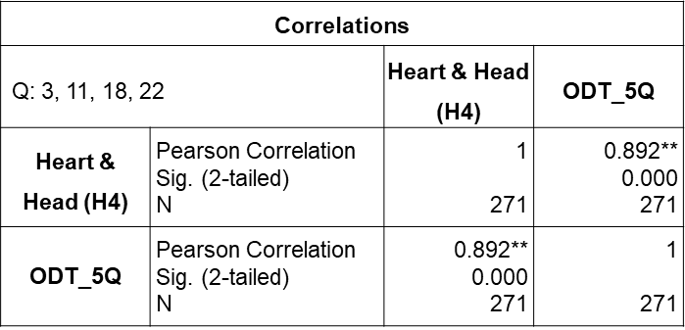

Table 56: H4 **Correlation is significant at the 0.01 level (2-tailed) n=271
- Hand and Heart Domains (H3)
The integration of Hand and Heart (H3) in leading effectiveness and its impact on creating a conducive work environment that promotes employee motivation, support, and value. This integrative approach aims to inspire and engage team members while providing them with the necessary technical guidance and resources to excel in their roles, ultimately enhancing the performance of organizational digital transformation (ODT). The results revealed a highly statistically significant association, with a strong positive correlation coefficient of r = 0.897 (p ≤ 0.001, two-tailed). These findings underscore the significant relationship between leading effectiveness, as manifested by the integration of Hand and Heart, and the successful execution of digital transformation initiatives (Table 57).
Heart and Hand competencies convergence within leaders and organizations engenders an environment characterized by employee motivation, support, and recognition. This approach recognizes the dual significance of technical proficiency and interpersonal skills in leadership, cultivating a culture that nurtures collaboration, innovation, and advancement. Through the adept utilization of emotional intelligence, leaders acquire the capacity to discern and address the needs and aspirations of their team members, concurrently furnishing them with technical direction and resources pivotal for their professional advancement and accomplishments. The assimilation of Hand and Heart competencies augments the overall efficacy of leadership, consequently contributing to enhanced the ODT performance.
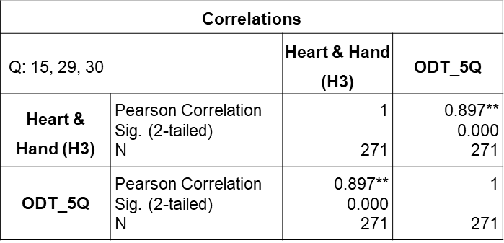
Engendering motivation and supporting employees correlates positively with heightened engagement, productivity, and dedication toward attaining organizational objectives. Furthermore, providing technical guidance and resources empowers employees to harness their proficiencies and insights, thereby propelling innovation and facilitating the productive execution of initiatives pertinent to digital transformation.

Table 57: H3 **Correlation is significant at the 0.01 level (2-tailed) n=271
- Head and Hand Domains (H2)
By intertwining strategic vision with technical knowledge, specialized skills, and operational capabilities, organizations embodying both Head and Hand (H2) attributes adeptly convert their strategic visions into actionable plans and execute them precisely. The outcomes gleaned from the analyses unveil a remarkably significant correlation coefficient of r = 0.841 (p ≤ 0.001, two-tailed). This correlation underscores a robust positive relationship between the integration of Head and Hand competencies within organizations and their capacity to achieve heightened the ODT performance (Table 58).
The synergy of Head and Hand domains within organizations empowers them to seamlessly align their strategic vision with technical expertise, specialized skills, and operational capabilities. This harmonization augments their capability to implement strategies and efficiently manage projects. The integration catalyzes the precise execution of digital transformation initiatives, ensuring the realization of organizational goals. Furthermore, this cohesive integration optimizes the execution of the ODT initiatives, facilitating the smooth attainment of objectives. This amalgamation guarantees the effective translation of strategies into actionable plans, the efficient management of projects, and the ultimate achievement of digital transformation goals.
Organizations adeptly embracing and balancing Head and Hand competencies position themselves advantageously to fulfil their ODT objectives. This integration fosters an environment conducive to accomplishing digital transformation goals, ultimately contributing to successful outcomes. The comprehensive melding of strategic vision with technical proficiency and operational prowess emerges as a key determinant in navigating the intricacies of digital transformation and securing a competitive edge in the evolving business landscape.

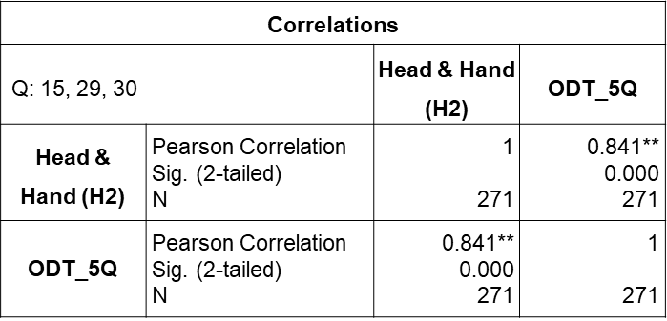

Table 58: H2 **Correlation is significant at the 0.01 level (2-tailed) n=271
- 3H Integrate (H1)
The fusion of Heart, Head, and Hand (H1) signifies a multifaceted and all-encompassing approach to leadership and organizational efficacy, crucial in the multifarious challenges organizations face in today's dynamic business environment. This synergistic amalgamation equips leaders with the ability to navigate complexities, motivate teams, and propel organizational success in a cohesive and integrated manner, ultimately culminating in superior performance in digital transformation initiatives. Recognizing the intricacies organizations encounter in today's rapidly evolving business landscape, the H1 framework emerges as an adaptive and comprehensive solution for effective leadership and organizational performance.
A rigorous Pearson correlation coefficient analysis was conducted to empirically assess the relationship between the synergy encapsulated in the H1 domain and an organization's performance in digital transformation. The outcomes of this analysis unveiled highly statistically significant findings (Table 59), as evidenced by a robust correlation coefficient of r=0.901** and p-value ≤ 0.001 (two-tailed). This statistical substantiation reinforces the theoretical underpinnings of the H1 domain and accentuates its practical relevance in the contemporary business milieu. This integration emerges not just as a conceptual model but as a tangible asset for organizations grappling with the multifaceted challenges and opportunities presented by the current business environment.
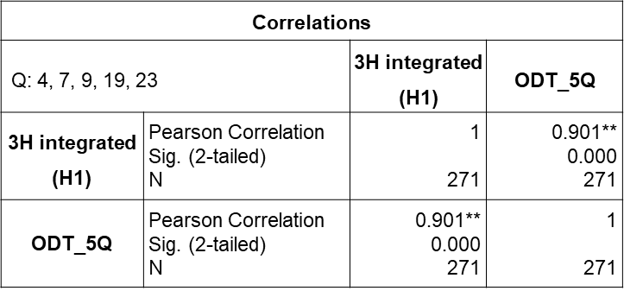

Table 59: H1 **Correlation is significant at the 0.01 level (2-tailed) n=271
The focal point of the analysis was to delve into the intricate interplay among key factors:
- Leadership effectiveness (Heart)
- Strategizing and organizing capabilities (Head)
- Technical and operational competencies (Hand)
- The overall performance of digital transformation endeavors within organizational contexts
These interrelationships are examined using the Pearson correlation coefficient, a robust statistical metric renowned for its capacity to gauge the magnitude and orientation of linear associations. The findings of paramount significance serve to underscore the imperative of synergizing the Heart, Head, Hand, and integrated dimensions to engender successful digital transformation initiatives. That underscores the necessity for organizations to nurture proficient leadership attributes encapsulated within the Heart facet and adroitly foster cognitive aptitude and organizational adeptness emblematic of the Head realm. Moreover, the pivotal role ascribed to technical proficiency and operational acumen, emblematically encompassed within the Hand facet, is unequivocally established as indispensable for flourishing within the dynamic landscape of the digital era.
The harmonious integration of these domains allows organizations to create an environment characterized by collaboration, where leaders motivate and engage employees while strategically designing and executing digital transformation initiatives fortified with essential technical skills. This comprehensive approach enhances an organization's agility in the face of technological shifts, stimulates innovative thinking, and significantly contributes to actualizing desired digital transformation outcomes. The core aspiration of this research is to meticulously investigate the intricate interactions and mutual influences that underlie these variables. The objective is to discern how advancements in one aspect can catalyze positive repercussions in others, thereby fostering a more substantial realization of improved digital transformation outcomes in the organization. Table 60 summaries the Pearson Correlation ® between two variables at the 0.01 level (2-tailed).
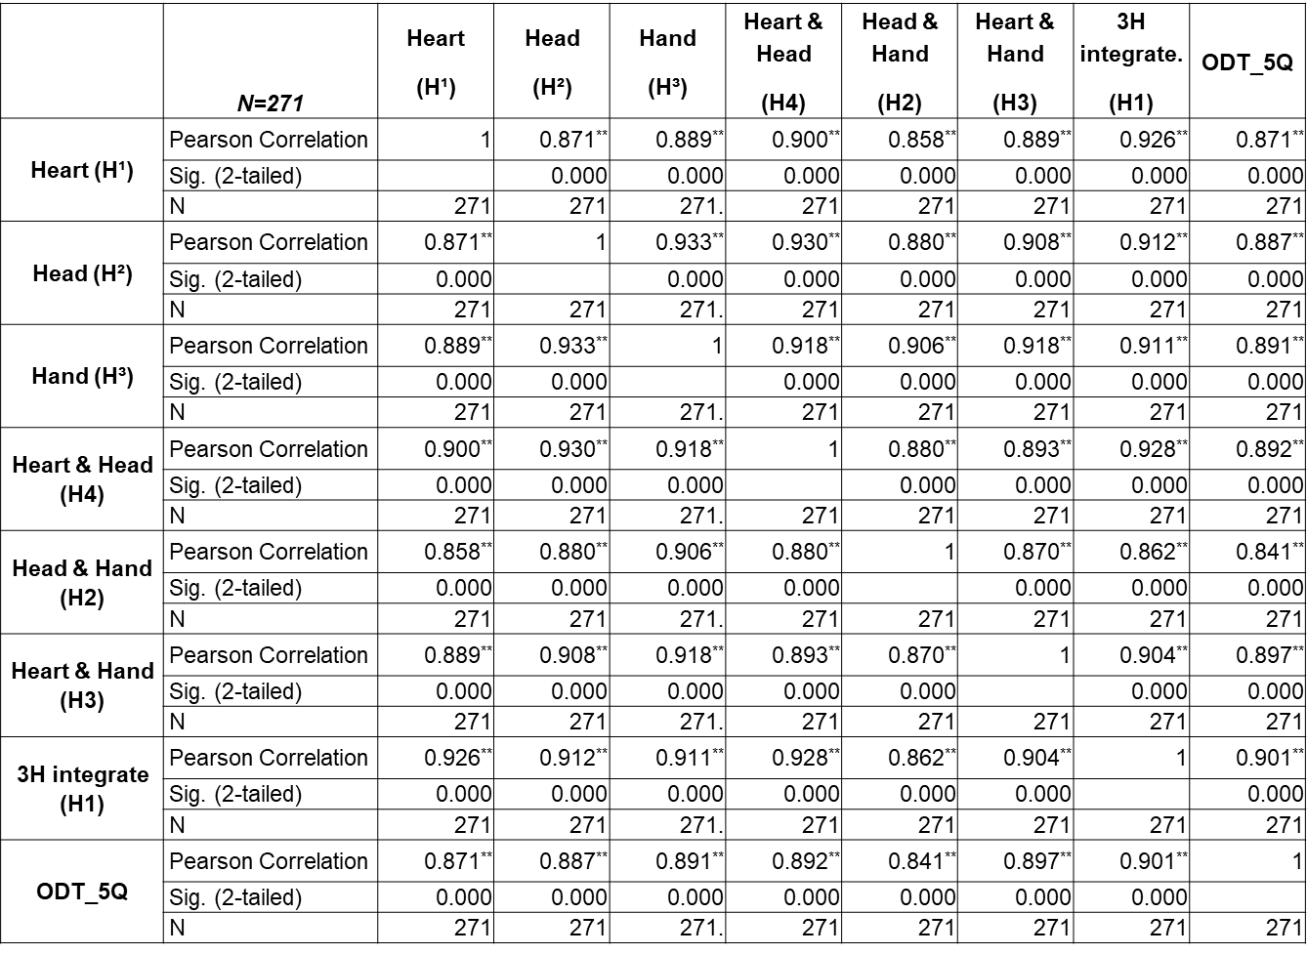
- Standard Multiple Linear Regression
Table 60: Summary of Pearson correlation coefficient (r) between two variables at the 0.01 level (2-tailed).
The researcher employs standard multiple regression analysis in this research which allows the examination of the simultaneous influence of multiple independent variables on a single dependent variable, providing a comprehensive understanding of the relationships among variables (Roediger et al., 2001; Abdul-Wahab et al., 2005;). In an organization's digital transformation context, multiple regression enables the identification and quantification of Yu's H domains that contribute to the success or failure of digital transformation initiatives. The SPSS performed standard multiple regression analysis to test the following hypotheses.
- Hypothesis One (Hy1):
Hypothesis One is rooted in well-established theoretical frameworks and conceptual underpinnings that underscore the pivotal role of leadership and organizational culture in shaping organizational success. Drawing upon Yu's Heart domain, which emphasizes the significance of leadership qualities and organizational culture, this hypothesis posits that the Heart domain, specifically heart-oriented leadership, plays a central role in motivating employees, fostering a positive organizational culture, and effectively managing change during digital transformation endeavors.
H10 (Null hypothesis): There is no significant relationship between the manifestation of the Heart domain in heart-oriented leadership and ODT success.
A comprehensive multiple regression analysis was conducted using the R statistical software to investigate the relationship between the predictor variables (Q1, Q5, Q6, Q8, Q12) and the outcome variable (Q31-Q35) in the context of an organization's digital transformation. The analysis yielded notable results, revealing a robust correlation coefficient of r=0.871, indicating a substantial positive relationship between the heart domain and the digital transformation outcome. The examination of the regression model's overall fit revealed an impressive R² value of 0.758, suggesting that the predictor variables collectively account for approximately 75.8% of the variance observed in the outcome variable. This substantial proportion of variance explained by the model underscores the significance of the heart domain in influencing the digital transformation outcome.
Additionally, the adjusted R² value of 0.757 highlights the model's strong fit to the data, even after considering the number of predictors in the analysis. This adjustment ensures the model's reliability and enhances its generalizability to the population under study. The findings from this multiple regression analysis provide compelling evidence to reject the null hypothesis and support the proposition that the heart domain significantly impacts the outcome of organizational digital transformation. These results contribute valuable insights to the existing body of knowledge and emphasize the critical role of the heart domain in driving successful digital transformation initiatives.
H1a (Alternative Hypothesis): The heart domain manifested in heart-oriented leadership is a necessary success factor for achieving ODT.
The researcher examines the R-squared value and the adjusted R-squared value. The R² value represents the proportion of variance in the outcome variable that can be explained by the predictor variables in the model. In this case, the R² value of 0.758 indicates that the predictor variables can explain approximately 75.8% of the variance in the outcome variable. The adjusted R-squared value of 0.757 suggests that approximately 75.7% can be explained by the predictor variables, considering the complexity of the model and the sample size. These results support the alternative hypothesis, indicating that a statistically significant relationship between the Heart domain manifested in heart-oriented leadership is necessary for achieving ODT success in the population.
- Hypothesis Two (Hy2):
The extant literature and empirical evidence support a positive relationship between effective strategic management practices and digital organizational transformation's (ODT) success. Through a comprehensive review of relevant scholarly works, the researcher identifies a knowledge gap concerning the head domain's specific contribution to ODT success. This gap serves as the impetus for formulating Hypothesis Two, which posits that the Head domain (Q2, Q20, Q21, Q24 & Q28), as manifested in proficient strategic management processes, constitutes a pivotal and necessary factor for achieving successful outcomes in the context of ODT (Q31-35).
H20 (Null hypothesis): There is no significant relationship between the manifestation of the Head domain in an effective strategic management process and ODT success.
The null hypothesis was subjected to rigorous testing through multiple regression analysis, which aimed to explore the relationship between the Head domain and the outcome of ODT. The statistical results provide valuable insights into the significance and strength of these relationships, contributing to the overall understanding of the research objectives. The correlation coefficient, R, exhibited a robust value of r= 0.887, indicating a significant positive association between the Head domain and the ODT outcome.
In terms of explanatory power, the coefficient of determination, symbolized by R square, showcased an impressive value of 0.786; this signifies that an estimated 78.6% of the variance in the outcome variable can be accounted for by the predictor variables included in the model. The rejection of the null hypothesis is warranted based on these compelling results, offering robust evidence to support the alternative hypothesis.
H2a (Alternative Hypothesis): Head domain manifested in effective strategic management process is a necessary success factor for achieving ODT.
The alternative hypothesis, positing that the Head domain manifested in an effective strategic management process is a key factor for achieving ODT success, underwent rigorous investigation using multiple regression analysis. The statistical findings illuminating this relationship's significance and robustness offer valuable insights into the research objectives. The correlation coefficient, R, exhibited a substantial value of r=0.887, indicating a strong positive association between the Head domain and the outcome variable representing ODT success. This significant coefficient signifies the pivotal role played by an effective strategic management process in determining ODT outcomes. The coefficient of determination, R square, yielded a noteworthy value of 0.786, signifying that approximately 78.6% of the variance in the outcome variable can be accounted for by the Head domain and other predictor variables within the model. This substantial value underscores the considerable influence exerted by the Head domain on ODT success.
The adjusted R square, computed at 0.785, adjusts for the number of predictors incorporated into the model, thus accurately estimating the model's goodness of fit. This value reaffirms the model's strong fit to the data, further corroborating the relationship between the Head domain and ODT success. Based on these compelling results, the alternative hypothesis is supported, providing robust evidence for the crucial role played by the Head domain and the effective strategic management process in achieving ODT success. These findings underscore the criticality of strategic management practices in driving successful digital transformations within organizations.
The Sig. F Change, yielding a remarkable value of 0.0000, underscores the statistical significance of the overall model, indicating that the Head domain, in conjunction with the other predictor variables, significantly contributes to the prediction of ODT success.
- Hypothesis Three (Hy3):
The hypothesis that the Hand domain, manifested in required effective functional competencies, is a key factor for achieving ODT success in organizational digital transformation research is based on theoretical foundations, empirical evidence, and practical significance. The hypothesis highlights the need for organizations to invest in developing and enhancing their workforce's necessary skills and capabilities to navigate the complexities of digital transformation successfully. By investigating the role of the Hand domain (Q14, Q16, Q26, Q27), the hypothesis contributes to a better understanding of the factors influencing ODT success (Q31-35).
H30 (Null hypothesis): There is no significant relationship between the manifestation of the Hand domain in required effective functional competences and ODT success.
There is no significant relationship between the manifestation of the Hand domain in required effective functional competencies and ODT success" as follows: The analysis revealed a significant correlation (r=0.891, p < 0.001) between the Hand domain and ODT success. The coefficient of determination (R square) was 0.793, indicating that approximately 79.3% of the variance in ODT success can be explained by the manifestation of the Hand domain and other predictor variables. The adjusted R square, accounting for the number of predictors in the model, was calculated as 0.792, suggesting a solid model fit to the data. These findings provide robust evidence against the null hypothesis, indicating a significant relationship between the manifestation of the Hand domain and ODT success. These results emphasize the importance of effective functional competencies in driving successful digital transformations within organizations.
H3a (Alternative Hypothesis): Hand domain manifested in required effective functional competences is a necessary success factor for achieving ODT.
In light of the alternative hypothesis, the conducted analysis yielded notable findings. The correlation analysis demonstrated a significant positive relationship between the Hand domain and ODT success (r=0.891, p < 0.001). It indicates that organizations exhibiting strong functional competencies in their operations are more likely to achieve successful digital transformations. The coefficient of determination (R square) was determined to be 0.793, indicating that approximately 79.3% of the variance in ODT success can be explained by the manifestation of required effective functional competencies and other relevant predictor variables. Furthermore, the adjusted R square of 0.792 highlights the robustness of the model after considering the number of predictors, which suggests the model accurately represents the relationship between the Hand domain and ODT success; the Sig. F Change value of 0.0000 signifies the statistical significance of the contribution made by the Hand domain to the overall model. These findings provide compelling evidence supporting the alternative hypothesis, establishing the crucial role of required effective functional competencies in driving ODT success. The results emphasize the significance of technical and operational capabilities in ensuring favorable outcomes in the context of organizational digital transformation.
- Hypothesis Four (Hy4):
The formulation of the hypothesis stating that the synergistic integration of all three H domains (Heart, Head, and Hand) creates the sufficient condition for achieving ODT success in the research of an organization's digital transformation reflects the researcher's recognition of the interdependent nature of these domains in driving successful ODT outcomes. This hypothesis draws on existing theoretical frameworks and concepts that highlight the significance of a comprehensive approach to digital transformation, where leadership qualities, strategic management processes, and functional competencies collectively contribute to organizational success. By exploring the synergistic integration of these domains, the researcher seeks to advance the understanding of the underlying mechanisms and interactions that lead to the success of ODT (Q31-35). This hypothesis underscores the importance of considering the interplay and alignment of the Heart, Head, and Hand domains to ensure effective decision-making, strategic planning, and operational execution in digital transformation initiatives. The research aims to provide insights and guidance for organizations seeking to achieve holistic and successful digital transformations. The association between the synergistic integration of the Heart, Head, and Hand domains and the success of the digital organizational transformation. There are 4 integrated domains: i) Heart & Head – H4 (Q3, Q11, Q18, Q22), ii) Hand and Heart – H3 (Q15, Q29, Q30), iii) Head & Hand – H2 (Q10, Q13, Q17, Q25), and iv) 3H integrated – H1 (Q4, Q7, Q9, Q19, Q23).
H40 (Null hypothesis): There is no significant relationship between the synergistic integration of H domains and ODT success.
Based on the analysis conducted in this study, the null hypothesis regarding the relationship between the four synergistic integration of H domains and ODT success was tested. The results are presented as follows:
For the combination of Heart & Head (H4), the correlation analysis revealed a significant positive relationship (r = 0.892, p < 0.001). The coefficient of determination (R square) was 0.796, indicating that integrating the Heart and Head domains can explain 79.6% of the variance in ODT success. The adjusted R square of 0.795 confirms the robustness of the model after considering the number of predictors.
In the case of Hand and Heart (H3), a significant positive relationship was observed (r = 0.897, p < 0.001). The R square value of 0.805 implies that integrating the Hand and Heart domains can explain 80.5% of the variance in ODT success. The adjusted R square of 0.805 further supports the adequacy of the model. For the combination of Head & Hand (H2), the correlation analysis indicated a significant positive relationship (r = 0.841, p < 0.001). The R square value of 0.708 implies that integrating the Head and Hand domains can explain 70.8% of the variance in ODT success. The adjusted R square of 0.707 confirms the model's stability after adjusting for the number of predictors. Regarding the integrated 3H (H1), a significant positive relationship was found (r = 0.901, p < 0.001). The R square value of 0.812 indicates that 81.2% of the variance in ODT success can be accounted for by integrating all three H domains. The adjusted R square of 0.811 strengthens the model's validity.
These findings provide substantial evidence to reject the null hypothesis, demonstrating that the synergistic integration of the Heart and Head, Hand and Heart, Head and Hand, and all three H domains significantly contribute to ODT success. The results underscore the importance of effectively managing and integrating multiple domains to achieve favorable outcomes in organizational digital transformation.
H4a (Alternative hypothesis): Synergistic integration of all three H domains creates the sufficient condition for achieving ODT.
Based on the analysis, the alternative hypothesis pertaining to the synergistic integration of all three H domains in four combinations (Heart & Head, Hand, and Heart, Head & Hand, and 3H integrated) was examined as a sufficient condition for achieving ODT success. The results are summarized as follows:
For the Heart & Head combination (H4), a statistically significant positive relationship was observed (r = 0.892, p < 0.001). The coefficient of determination (R square) was 0.796, indicating that integrating the Heart and Head domains can explain 79.6% of the variance in ODT success. The adjusted R square of 0.795 further supports the robustness of the model. In the case of Hand and Heart (H3), a significant positive relationship was found (r = 0.897, p < 0.001). The R square value of 0.805 suggests that 80.5% of the variance in ODT success can be attributed to integrating the Hand and Heart domains. The adjusted R square of 0.805 provides additional evidence of the model's adequacy.
Regarding the Head & Hand combination (H2), a significant positive relationship was identified (r=0.841, p < 0.001). The R square value of 0.708 indicates that integrating the Head and Hand domains can account for 70.8% of the variance in ODT success. The adjusted R square of 0.707 confirms the model's suitability after adjusting for the number of predictors. For the integrated 3H (H1), a significant positive relationship was established (r = 0.901, p < 0.001). The R square value of 0.812 suggests that 81.2% of the variance in ODT success can be explained by integrating all three H domains. The adjusted R square of 0.811 further strengthens the model's validity.
These findings provide substantial support for the alternative hypothesis, indicating that the synergistic integration of the Heart and Head, Hand and Heart, Head and Hand, and all three H domains serve as a sufficient condition for achieving ODT success. The results underscore the pivotal role of effectively managing and integrating multiple domains in driving successful organizational digital transformation (Figure 19). The statistical significance of this relationship is further supported by the Sig. The F Change value of 0.0000 for all four tastings indicates that the overall model is highly significant. The table 61 below shows the summary of the result of Standard Multiple Linear Regression.
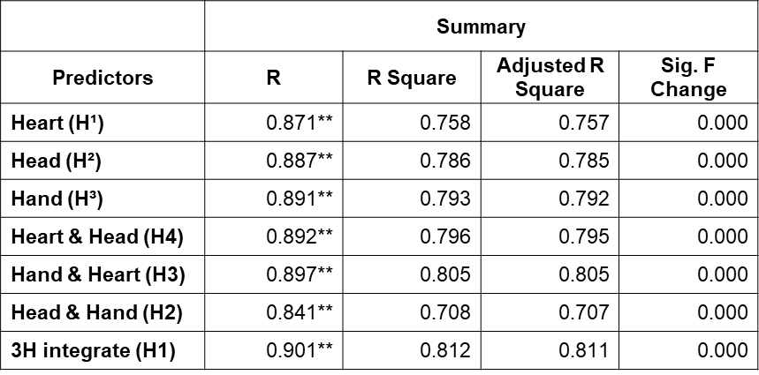

Table 61: The summary of the result of Standard Multiple Linear Regression
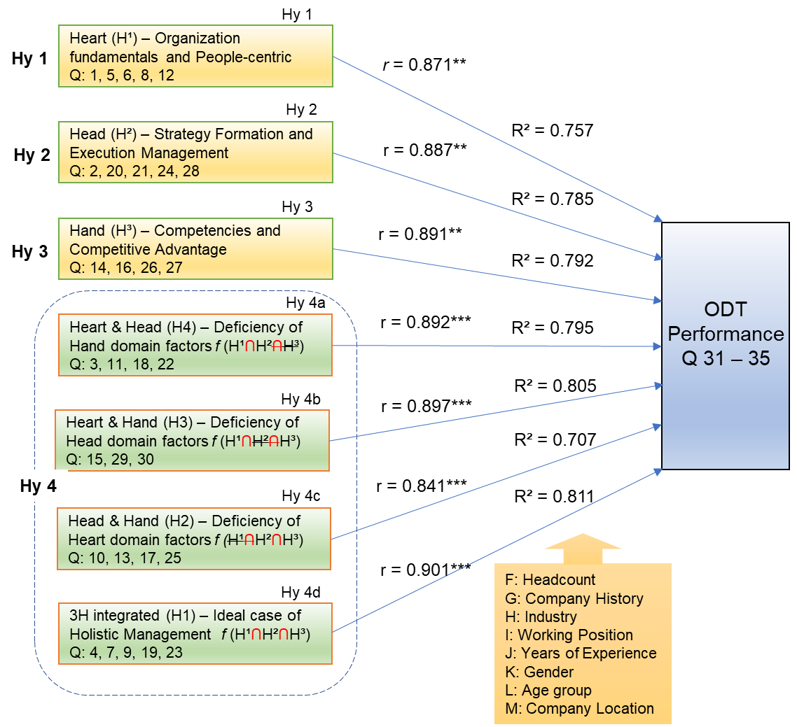

Figure 19: The correlation and hypotheses testing result of the statistical analysis.

    - Analysis of Variance (ANOVA)
ANOVA and T-tests were chosen for their suitability in examining differences and relationships among multiple groups or conditions in this study (Cen et al., 2006; Yong & Pearce, 2013). ANOVA compares means across various groups to determine statistically significant differences, while T-tests are used for comparing two groups to assess statistical significance (Field, 2018). The researcher aims to evaluate factors contributing to successful outcomes, with ANOVA and T-Tests facilitating assessing these factors among different organizational groups or conditions (Tabachnick & Fidell, 2013). The ultimate goal is to identify which factors are more influential in achieving successful digital transformations. Furthermore, ANOVA facilitates the examination of interactions among different success factors. It allows the researcher to assess if the effects of one factor depend on the presence or absence of another factor, providing insights into the complex interplay among variables (Halsey et al., 2015; Field, 2018). It is essential to understand the synergistic effects of different success factors on digital transformation outcomes (Hair et al., 2019).
The researcher examines the differences and relationships of interactions among different success factors of an organization's digital transformation among eight different groups and conditions of the respondents, and are four personal backgrounds such as gender, age, working position, and years of experience; and four categories of company backgrounds such as the size of the company based on headcount of full-time employees (FTEs), company history, industry, and company location. This decision was based on several historical and empirical research to ensure a comprehensive analysis of the research topic. By selecting multiple groups, the researcher aimed to capture the diverse nature of success factors in digital transformation. Each group represents a distinct combination of success factors, allowing for a comprehensive exploration of their individual and interactive effects on digital transformation outcomes. This approach helps to uncover nuanced patterns and variations that may exist across different configurations of success factors. The analysis of variance (ANOVA) test was conducted to investigate the influence of respondents' backgrounds and determine if there were statistically significant variations.
The analysis of variance (ANOVA) test was conducted to investigate the influence of respondents' backgrounds and determine if there were statistically significant variations. For the Genda group, the analysis revealed the R-square values of Males and Females are 0.856 and 0.880; the standard error of the estimate was 0.44522 and 0.42705; the F value shows 133.886 and 101.255. These findings suggest that gender accounts for a considerable proportion of the variation observed in this research. Moreover, males and females with a corresponding p-value are less than 0.05, which Sig.= 0.000 indicates a significant relationship between gender. These findings suggest that both genders play a substantial role in explaining the variation in ODT. For the age group and years of working experiences, the analysis revealed an R-square value all above 0.800, with a corresponding p-value (Sig.) of 0.000, indicating a significant relationship between the performance of ODT and among the groups. However, based on the analysis, the working position indicates a significant relationship among most positions except broad members with corresponding p-value Sig.= 0.308. According to suggest that the observed F value due to random sampling variability, typically, a significance level of 0.05 or lower (p ≤ 0.05) is considered statistically significant (Roediger et al., 2001; Bayaga, 2010; Tabachnick et al., 2013), indicating that the differences among groups are unlikely to occur by chance. In this case, the Sig. Values are greater than 0.05, suggesting that the groups' observed Broad member is not statistically significant, which implies that the factors or variables under investigation do not significantly impact the outcome of the measured dependent variable.
Bharadwaj et al. (2013) suggest that most senior executives, such as board members, especially those from traditional industries, may lack the necessary knowledge and understanding of digital technologies and their potential impact on the organization. Their expertise may lie more in traditional areas such as finance, governance, and strategy rather than digital technologies. Digital transformation also entails inherent risks and uncertainties, including financial investments, technological complexities, and potential disruptions to existing business models. However, board members, usually driven by their fiduciary responsibilities, may exhibit risk aversion and may be hesitant to embrace and support digital transformation initiatives fully. It is important to note that these results are specific to the data and analysis conducted and may not necessarily apply to the entire population (Table 62).
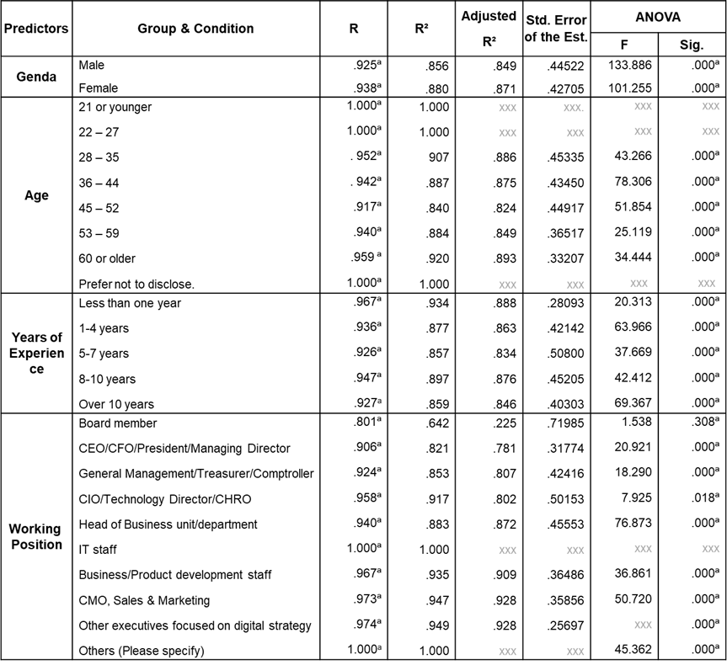
Table 62: ANOVA analysis results of the respondents' background
In terms of the conditions of the respondents' organization, such as company history, size of operation in FTEs, industry, and company location, the ANOVA analysis revealed a high F value and (Sig. = 0.001), indicating a significant difference among the groups in terms of the organization's digital transformation performance. The factors examined substantially impact the outcome variable. The results provide robust evidence that the tested variables influence the success of digital transformation initiatives. However, two groups in the industry are in the low value. They are Health Services and Media Publishing; the F value was 0.977 and 5.953, Sig. = 0.655 and 0.306, indicating no significant difference among the industrial group regarding the organization's digital transformation performance. The result suggests that these factors examined do not substantially impact the outcome variable.
In general practice, the health service industry often needs to catch up in digital transformation, which is highly regulated, with strict privacy and data protection regulations. These regulations impose stringent data security and patient privacy requirements, making it challenging for healthcare organizations to adopt and implement digital technologies. Similarly, media publishing companies face copyright and intellectual property issues, making it difficult to fully embrace digital transformation without infringing these rights. Healthcare and media publishing has traditionally relied on established practices and workflows. Digital transformation often requires substantial investments in technology infrastructure, training, and talent acquisition. The dynamics of the healthcare and media publishing markets also play a role in their digital transformation focus. The health services industry is heavily regulated and driven by patient care, where digital transformation initiatives may take a backseat to immediate patient needs. Media publishing companies may face challenges related to declining print revenues and evolving consumer behaviors but may prioritize other strategies for survival and sustainability over digital transformation. Further research with larger samples or different variables is needed for more conclusive results. Below, (Table 63) shows the results of the ANOVA analysis of the respondents' company background in four categories.
These findings are consistent with prior research and theoretical expectations, highlighting the importance of the identified factors in driving successful digital transformations. The significant F value and low p-value support the alternative hypothesis, indicating meaningful differences concerning digital transformation performance between the groups. These findings contribute to understanding the factors contributing to successful digital transformations and have practical implications for organizations seeking to improve their digital capabilities.
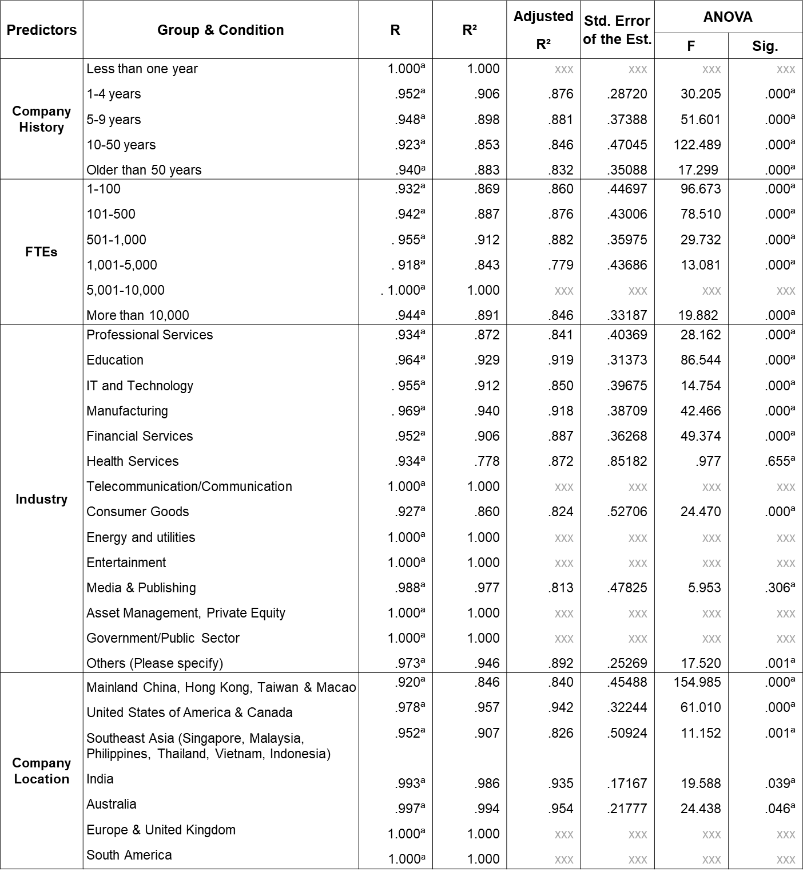
Table 63: ANOVA analysis results of the respondents' company background
  - Discussion of Quantitative Research Findings
The quantitative analysis reveals robust significance between the heart, head, and hand domains and the organizational digital transformation performance. The analysis results indicate that these domains play a crucial role in driving successful digital transformation outcomes. The findings provide compelling evidence supporting the hypothesis that these domains significantly impact the success of digital transformation initiatives.
Regarding the heart domain, the results indicate a robust positive relationship between heart-oriented leadership qualities and digital transformation performance. Leaders who effectively communicate a vision, inspire employees, and manage change are crucial in driving successful digital transformations. It underscores the significance of fostering a positive organizational culture and motivating employees during the transformation process. Similarly, the analysis reveals the importance of the head domain, specifically effective strategic management processes. Strategic planning, goal setting, and resource allocation are critical to achieving successful digital transformation outcomes. Aligning digital initiatives with organizational goals and objectives is key to driving performance in the digital age.
The hand domain, encompassing required effective functional competencies, also shows robust significance in its impact on digital transformation success. Technical skills, digital literacy, and operational efficiency contribute significantly to achieving positive outcomes. Equipping employees with the necessary competencies to leverage digital technologies effectively is crucial. Furthermore, the analysis explores the integration of the heart, head, and hand domains and their influence on digital transformation performance. The integrated model demonstrates robust significance (p < 0.001), suggesting that when these domains are effectively integrated and aligned, they create a sufficient condition for the success in digital transformations. It highlights the need for a holistic approach incorporating leadership qualities, strategic management processes, and functional competencies to achieve the holistic ODT management.
The findings from this research provide valuable insights for organizations seeking to improve their digital transformation efforts. Nurturing effective leadership, implementing strategic management practices, and developing relevant competencies are essential for successful digital transformations. Further research could delve into each domain's specific mechanisms and behaviors contributing to positive outcomes. In conclusion, this research study confirms the robust significance of the heart, head, and hand domains in influencing the organization's digital transformation performance. By understanding and leveraging the synergies among these domains, organizations can enhance their chances of achieving successful digital transformation outcomes and staying competitive in the digital era.
  - Chapter Summary
This chapter constitutes a deep dive into the quantitative research findings, meticulously scrutinizing the organization's performance in digital transformation. It explicitly attains the three critical H domains: heart, head, and hand. The methodological foundation underpinning this analysis relies on scrupulous data collection through a precisely crafted questionnaire administered to the study's participants. The central objective of the researcher is to embark on a comprehensive exploration beyond surface-level observations. Instead, it seeks to unravel the intricacies and nuances contained within the quantitative analysis findings. These findings significantly illuminate the commanding influence wielded by the three H domains. Moreover, the researcher delves into the interplay of five pivotal constructs: Organization Fundamentals, People-centric approaches, Strategy Formation, Execution Management, Organizational Competencies, and Competitive Advantage. These constructs collectively contribute to shaping the ultimate outcomes and successes of digital transformation initiatives within the organization.
By systematically deconstructing these domains and constructs, this chapter not only elucidates key insights but also provides a fundamental roadmap for grasping the intricate and multifaceted dynamics inherent in the organization's digital transformation. This approach is a valuable resource for guiding strategic decisions, fostering adaptability, and maintaining competitiveness in an ever-evolving digital landscape. It is a crucial resource for those seeking to harness the full potential of digital transformation within the organization.

CHAPTER SIX – DISCUSSION and CONCLUSIONS

- Introduction
This chapter is focus on discussing the research results and their implications for the organization's digital transformation field. The discussion highlights the key themes, trends, and insights from the data analysis, providing a deeper understanding of the research objectives and their implications. Additionally, the chapter concludes by summarizing the theoretical and managerial implications of the key findings, discussing their significance, and outlining potential avenues for future research in the organization's digital transformation field.
  - Major Findings
This research aimed to develop a holistic management framework for digital transformation in organizations mirroring Yu's 3H managing framework. Through an extensive literature review, empirical analysis, and expert interviews, key findings emerged that shed light on various framework aspects. The findings highlight critical aspects of the holistic management framework for digital transformation: technology integration, leadership support, organizational culture, resource allocation, risk management, and core competencies of the organization and individuals. These findings emphasize the importance of aligning technology with strategic objectives, cultivating a supportive leadership culture, fostering an innovative organizational culture, allocating resources effectively, managing risks, and considering global challenges and ethical considerations. Incorporating these findings into the framework enables organizations to navigate digital transformation successfully.
  - Inferences and Implications of the Findings
The study yielded significant findings regarding the major success factors for ODT, these success factors play a pivotal role in facilitating the effective implementation of digital transformation initiatives and ensuring the attainment of desired outcomes. The success of an ODT hinges on several key factors that are interconnected and require meticulous consideration. Effective leadership is critical in this process, as leaders are responsible for articulating a clear vision, establishing strategic objectives, and allocating necessary resources and support (Rabbani et al., 2014; Berghaus & Back, 2016). Aligning digital initiatives with the overall organizational strategy is vital to enhance competitiveness, improve customer experiences, and drive operational efficiencies (Guy, 2019). Thorough attention to budgeting and resource allocation is crucial, as organizations must make reasonable investments in technology infrastructure, talent acquisition, and comprehensive training programs (Bharadwaj et al., 2013). Cultivating a digital culture within the organization fosters innovation, agility, and adaptability to dynamic market conditions (Casadesus-Masanell & Ricart, 2010). Leveraging technology capabilities and integration empowers organizations to effectively harness emerging technologies, streamline processes, and deliver enhanced customer value (Guy, 2019; Bharadwaj et al., 2013).
Organizations must also be mindful of the economic and global climate, adapting to market fluctuations, political dynamics, and social trends to navigate the complexities of the business environment (Heracleous & Barrett, 2001; Hoberg et al., 2015). The recent pandemic outbreak has further emphasized the importance of organizational resilience and preparedness, prompting a reevaluation of digital transformation strategies to address new challenges and opportunities (Yu, 2020). In addition, certain factors such as project management practices, management support, geography, and market behavioral patterns warrant consideration. Implementing efficient project management practices ensures the successful execution of digital transformation initiatives, while robust management support provides guidance, resources, and advocacy. Other external factors also impact the implementation of ODT, such as geographical issues, regional disparities, and regulatory burdens, and understanding market behavioral patterns and consumer preferences enables organizations to tailor their digital offerings and gain a competitive edge (Hildebrandt et al., 2015; Hoberg et al., 2015).
The qualitative research results also indicate that the efficacy of integrating the three H domains within a holistic ODT management framework in an organization's digital transformation is paramount. This integration holds significant potential for ensuring a comprehensive and successful transformation journey that aligns with the organization's objectives, engages employees, and drives positive outcomes.
The Heart domain encompasses the human element of the digital transformation process, emphasizing the need to foster a supportive culture, address employee concerns, and promote change readiness. Within the Heart domain, cultivating a culture of innovation, collaboration, and adaptability emerged as a fundamental success factor. Organizations with strong leadership support and commitment that prioritize employee engagement, encourage risk-taking, and foster a continuous learning mindset creates an environment conducive to successful digital transformation endeavors. In digital transformation, leaders are pivotal in steering strategic plans aligned with the organization's mission, anticipating challenges, and empowering teams to achieve goals (Burke et al., 2006; Hildebrandt et al., 2015; Buil et al., 2019). Effective communication and composure amid uncertainty are essential leadership attributes in this dynamic environment. Furthermore, leaders must proactively prepare organizations for change, addressing competence gaps to ensure a seamless transformation (House, 1971; Bass, 1997, 1999; Deci & Ryan, 2000). By incorporating the Heart domain into the management framework, organizations recognize that employees are not passive recipients of change but active participants in the transformation. This approach acknowledges change's emotional and psychological aspects and strives to create a positive and inclusive environment that motivates, engages, and values employees throughout the transformation progress.
The Head domain underscores the importance of strategic thinking and planning, which pertains to digital transformation's cognitive and strategic aspects, emphasizing the utilization of data, knowledge, and strategic thinking to drive the ODT efforts. Performance-driven evaluation and conflict resolution are indispensable to ensure efficient organizational development and transformation processing (Kotter & Schlesinger, 1979; Gupta & Govindarajan, 1984; Ajzen, 1991; Barney, 1995). Strategic planning emerges as a fundamental process within the dynamic landscape of today's rapidly changing business environment, demanding logical thinking, target orientation, and process-driven approaches (Teece, 1981; Miles & Snow, 1984; Wernerfelt, 1984; Umble et al., 2003; Nilsen et al., 2012). Integrating the Head domain ensures the organization has a clear vision, a well-defined digital strategy, and a comprehensive understanding of the technological landscape and market trends. It enables organizations to make informed and strategic decisions based on data-driven insights, identify potential risks and challenges, and develop effective mitigation strategies. Successful ODT necessitates a well-defined digital strategy that aligns with the organization's overarching business objectives. Leadership that exhibits vision, sound decision-making capabilities, and a comprehensive understanding of market dynamics and emerging technologies are instrumental in driving success within this dimension. Decision-makers must carefully weigh the pros and cons of each option and select the most viable and aligned with the organization's long-term digital goals (Lee & Koo, 2000; Nilsen et al., 2012; Hansen & Schaltegger, 2016). Incorporating the Head domain within the management framework facilitates the organization's ability to align its digital transformation initiatives with its broader strategic goals.
The Hand domain centers on the practical execution of digital transformation initiatives, representing the practical execution and implementation of digital transformation initiatives (Yu, 2020). It encompasses process redesign, technology deployment, and skill development. Organizations ensure a systematic approach to executing digital initiatives by integrating the Hands domain into the management framework (Rabbani et al., 2014). Proficiency in implementation and project management is crucial for translating digital strategies into tangible actions, including establishing a clear roadmap for implementation, employing effective project management practices, and focusing on skill-building and training to equip employees with the necessary capabilities (Hansen & Schaltegger, 2016). Team effectiveness can have different dimensions to meet ODT goals. A well-planned job design with an interdependence approach goes various variables such as productivity, satisfaction among all levels, and managerial judgments. Communication between groups is also crucial because tasks need integration (Guzzo & Shea, 1992; Campion et al., 1996). The digital learning is the practice of administrative processes to upgrade employees' knowledge and skills flow to maintain their innovation abilities through learning to achieve personal value and improve transformational performance (Hackman, 2003; Helfat & Martin, 2005). Integration of the Hands domain emphasizes the importance of agility, adaptability, and continuous improvement throughout the digital transformation journey, with adequate resource allocation, effective change management processes, and cross-functional collaboration emerging as key success factors within this dimension. Moreover, an organization needs to effectively execute its initiatives, monitor progress, and make necessary adjustments to optimize outcomes.
The holistic integration of the three H domains within the ODT management framework yields multiple advantages for organizations during digital transformation. Firstly, it enables a comprehensive, integrated approach that leaves no critical aspect unattended, fostering alignment, synergy, collaboration, and effective communication across departments and teams (Helfat & Martin, 2005). This holistic approach optimizes resource utilization and minimizes potential conflicts or gaps. Secondly, it enhances employee engagement and buy-in. Organizations should recognize and address emotional and psychological aspects of change and provide necessary knowledge, resources, promotion, rewards, and support for practical digital initiative implementation. Engaging employees at all levels instils ownership and commitment, leading to heightened motivation, productivity, and successful digital transformation outcomes.
Lastly, the holistic ODT management framework equips organizations with the capabilities to navigate the complexities and uncertainties associated with digital transformation. Integrating the Heart domain ensures that organizations remain responsive to employee concerns and can adapt to evolving needs and expectations. In the Head domain, organizations can gather and analyze relevant data, assess progress, and make informed decisions based on evidence. The Hands domain provides practical tools and techniques for implementing and monitoring digital initiatives effectively, which equip organizations with the agility, flexibility, and resilience to navigate the dynamic digital landscape and achieve their desired digital transformation outcomes.
In addition to the 3H framework, several cross-cutting success factors were identified as pivotal in ODT. These include effective communication practices at all organizational levels, a culture of continuous learning and upskilling, and the ability to adapt to evolving market conditions and technological advancements (Hofstede, 2011; Holotiuk & Beimborn, 2017). Organizations can optimize their digital transformation endeavors by incorporating these success factors within the 3H framework. Adopting a holistic approach that integrates the Heart, Head, and Hand dimensions while simultaneously addressing the cross-cutting success factors enhances the likelihood of achieving successful ODT outcomes and positions the organization for long-term success.
  - Discussion and Suggestions
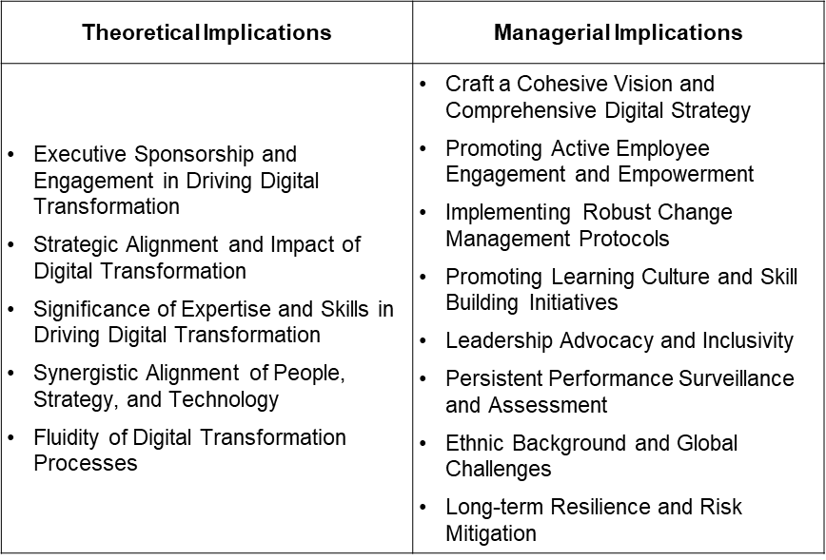
The researcher highlights areas for further exploration and investigation to advance the understanding and implementation of digital transformation strategies. Through a balanced blend of theoretical insights and practical implications, this chapter sets the stage for organizations to reflect on their digital transformation journeys and make informed decisions for future endeavors (Table 64).
.

Table 64 Major Factors of Theoretical and Managerial Implication
    - Theoretical Implications
The researcher investigates the theoretical implications of employing the 3H holistic management framework in ODT. This study advances the theoretical understanding of digital transformation and its management by exploring the integration of leadership, strategy, and functional competencies. Based on the analyzed results which underscore the significance of different factors in driving successful digital transformation initiatives. These theoretical implications contribute to the body of knowledge in the field and provide valuable insights for organizations navigating the complexities of digital transformation. The theoretical implications of an organization's digital transformation (ODT) can be explored by adopting the 3H holistic management framework, encompassing the domains of Heart, Head, and Hand. Yu (2021), enthused with the 3H framework, likened it to a dragon boat comprising three key dimensions: the drummer, the paddlers, and the steerer, which offers a comprehensive approach to managing ODT. Advancement of the 3H Holistic Management Framework by managerial implications by validating the relevance and effectiveness of the framework, this metaphorical representation provides a comprehensive perspective on organization's digital transformation (ODT) and elucidates the interplay between different elements in driving successful outcomes. The researcher enhances our understanding of managing digital transformation holistically.
The first theoretical implication of this research is the connection of three main areas of ODT, challenges, barriers, and critical success factors. The path to successful ODT is fraught with challenges and barriers that need to be carefully addressed. Identifying and understanding these challenges, barriers, and key success factors is essential for organizations to navigate the complexities of digital transformation effectively. ODT poses various challenges that organizations need to overcome (Singh et al., 2020; Shahi & Sinha, 2021). Addressing challenges requires organizations to develop strategies and initiatives that alleviate financial limitations, modernize existing systems, foster a culture of change, invest in digital talent and training, ensure compliance with regulations, and establish robust performance monitoring mechanisms (Umble et al., 2003; Nilsen, 2020). Several barriers hinder the progress of ODT initiatives. Overcoming those barriers necessitates effective change management strategies, strong leadership buy-in, allocating sufficient resources, and addressing technological challenges through partnerships or acquiring necessary expertise. To achieve successful ODT, organizations must consider several key success factors. By incorporating these insights into their strategies and practices, organizations can navigate the complexities of ODT and achieve sustainable digital transformation in today's rapidly evolving business environment.
Integrating leadership, strategy, and functional competencies is a critical implication of the ODT, underscoring their indispensable role in digital transformation (Barrick et al., 2015; Sebastian et al., 2020). This study contributes to a comprehensive understanding of the multifaceted nature of digital transformation initiatives by examining the interdependencies among the Heart, Head, and Hand domains. The findings highlight the need for organizations to adopt a holistic approach that considers these factors collectively in their strategies and implementation efforts. Theoretical implications suggest that organizations can enhance their chances of successful digital transformation by integrating leadership qualities, strategic management processes, and functional competencies. This integration aligns with existing literature on the subject and underscores the significance of considering these elements as interconnected and mutually reinforcing (Guy, 2019; Sebastian et al., 2020). By recognizing the interplay among Yu's 3H domains can effectively navigate the challenges and capitalize on the opportunities presented by digital transformation. The theoretical foundation provided by this study offers valuable insights for practitioners and scholars alike for informing managerial practices in the pursuit of successful digital transformation endeavors.
- Executive Sponsorship and Engagement in Driving Digital Transformation:
The Drummer, symbolizing leadership, and strategy, sets the rhythm and pace for the entire team. The findings of this research underscore the critical role of leadership in driving successful digital transformation. The Heart domain, encompassing heart-oriented leadership qualities such as vision, communication, employee inspiration, and change management, emerges as a significant factor influencing the outcomes of digital transformation initiatives (Guy, 2019; Brown et al., 2020; Sebastian et al., 2020). This form of leadership entails the guidance of the organization through the intricate process of digital transformation, encompassing the alignment of strategies with technological advancements and the cultivation of a culture that fosters innovation and adaptability (Pieterse et al., 2010; Singh et al., 2020; Verhoef et al., 2021). Digital transformation leaders' critical duty is developing and effectively communicating a lucid vision for the organization's digital future. They articulate the strategic direction, establish ambitious goals, and inspire employees to wholeheartedly embrace and actively support the transformative journey (Li et al., 2021; Verhoef et al., 2021). These leaders establish a sense of purpose and urgency by assuming this responsibility, encouraging widespread organizational commitment to change. These findings align with the existing scholarly literature on leadership and change management, reinforcing the importance of effective leadership in managing the challenges of digital transformation.
- Strategic Alignment and Impact of Digital Transformation:
The steerer, representing the technological infrastructure and digital capabilities, ensures that the dragon boat stays on course. This research highlights the importance of effective strategic management processes in achieving favorable digital transformation outcomes. The Head domain, encompassing strategic planning, goal setting, and resource allocation, is vital in guiding digital transformation initiatives (Morton et al., 2020). Strategic management processes play a pivotal and multifaceted role in shaping the outcomes of digital transformation initiatives within organizations (Hrebinia, 2006; Morton et al., 2020; Nilsen, 2020). In digital transformation, organizations must effectively plan, execute and monitor their strategies to achieve successful outcomes and remain competitive in the rapidly evolving digital landscape (Machado et al., 2019; Morton et al., 2020). Strategic management processes provide a robust framework that aligns the organization's goals, resources, and activities with digital transformation's unique challenges and opportunities (Matt et al., 2015; Nilsen, 2020; Li et al., 2021). By engaging in strategic planning, organizations can proactively anticipate future challenges and opportunities in the digital realm (Matt et al., 2015; Machado et al., 2019). This foresight enables them to identify potential areas of competitive advantage, capitalize on emerging technologies, and make well-informed decisions regarding digital investments and resource allocation.
Crucially, strategic management processes facilitate a continuous evaluation and adjustment of digital transformation initiatives. Ongoing monitoring, measurement, and evaluation enable organizations to assess the effectiveness of their digital transformation strategies and initiatives, identify areas for improvement, and make necessary adjustments to optimize outcomes (Nilsen, 2020). The findings contribute to our theoretical understanding of the strategic management processes that organizations must adopt to successfully navigate the complexities of digital transformation.
- Significance of Expertise and Skills in Driving Digital Transformation:
The paddlers, representing the employees and their functional competencies, are responsible for propelling the dragon boat forward. A key theoretical implication of this research is the recognition of the significance of functional competencies in driving digital transformation success. The Hand domain, representing technical skills, digital literacy, and operational efficiency, emerges as a critical factor in achieving digital transformation goals (Johns, 2006; Morton et al., 2020). Functional competencies play a paramount role in driving the success of digital transformation initiatives across various dimensions; organizations must possess the necessary skills, knowledge, and expertise to effectively leverage digital technologies and navigate the complexities of the digital landscape (Agha et al., 2012; Foss & Saebi, 2017; Warner & Wager, 2019; Pittaway & Montazemi, 2020). Functional competencies encompass a range of capabilities that contribute to achieving digital transformation goals and outcomes (Warner & Wager, 2019; Morton et al., 2020).
Firstly, technical skills and digital literacy are essential functional competencies in the digital transformation journey. Employees need to possess the technical know-how to utilize digital tools and platforms effectively, understand emerging technologies, and apply them to drive innovation and efficiency within the organization (Foss & Saebi, 2017; Warner & Wager, 2019; Sousa & Rocha, 2019). Digital literacy enables employees to navigate and comprehend digital information, fostering a culture of digital fluency and enabling them to adapt to digital changes quickly (Guinan et al., 2019; Morton et al., 2020; Li et al., 2021). Secondly, operational efficiency is a critical dimension of functional competencies in digital transformation. Organizations must optimize their processes, workflows, and systems to ensure streamlined operations and maximize productivity (Guinan et al., 2019; Li et al., 2021). By leveraging digital technologies, organizations can automate repetitive tasks, improve collaboration and communication, and enhance operational efficiency. This approach requires a deep understanding of business processes, digital tools, and workflow optimization techniques (Matt et al., 2015; Guinan et al., 2019; Morton et al., 2020).
Effective data management and analysis are vital functional competencies for organizations undergoing digital transformation. Collecting, analyzing, and interpreting data allows organizations to derive valuable insights, make informed decisions, and drive evidence-based strategies (Mergel et al., 2019; Li et al., 2021). Competencies in data management, data governance, and data analysis techniques are essential to harness the power of data and drive meaningful outcomes in the digital era. The findings highlight the need for organizations to invest in developing the necessary competencies among employees to leverage digital technologies effectively.
- Synergistic Alignment of People, Strategy, and Technology:
The successful navigation of the dragon boat, representing ODT, requires alignment and synchronization between the drummer, paddlers, and steer. This research underscores integrating human and technological elements in digital transformation. While technology plays a crucial role, the study emphasizes that successful transformation also requires attention to the human side as the significance of employee engagement and empowerment in driving successful digital transformation (Matt et al., 2015; Legner et al., 2017; Loonam et al., 2018). Engaged employees who feel empowered are more likely to embrace and actively participate in digital initiatives, leading to better outcomes (Legner et al., 2017; Morton et al., 2020; Li et al., 2021). Organizations should focus on fostering a culture of involvement, providing opportunities for employee input, and recognizing and rewarding their contributions to digital transformation efforts (Loonam et al., 2018; Yu, 2020). The critical role of change management and effective communication facilitates digital transformation progress; thus, organizations need to proactively manage resistance to change, address employees' concerns, and ensure clear and transparent communication throughout the transformation journey (Mergel et al., 2019)
Organizations should invest in training programs and provide resources to enhance employees' digital literacy, technical expertise, and adaptability to new technologies. Organizations can leverage their talent to drive digital innovation and effectively navigate digital transformation by equipping employees with the necessary skills (Westerman & Bonnet, 2015; Sousa & Rocha, 2019). An organization needs to ensure learning and knowledge sharing as their culture (Spitzer et al., 2013; Loonam et al., 2019). Organizations should promote this learning culture that encourages experimentation, continuous improvement, and sharing of best practices. The relevant principle from Taoism is the idea of Yin and Yang, representing the complementary and interconnected nature of opposing forces which can be applied to the integration of human and technological elements, recognizing the importance of balancing digital technologies with human skills, creativity, and adaptability (Lee & Ottati, 1993; Moon, 2015). Taoist principles underscore the importance of attaining a harmonious equilibrium among human capabilities, strategic objectives, and technological advancements within organizations (Xing & Sims, 2011; Moon, 2015). Embracing a holistic people-centric approach that enables ODT to cultivate a culture that encourages collaboration, adaptability, and innovation. The emphasis on natural flow and flexibility in Taoism resonates with the dynamic nature of digital transformation, enabling organizations to navigate through change and uncertainty with agility. Integrating Taoist principles into digital transformation endeavors facilitates a more harmonious and effective amalgamation of human, strategic, and technological elements, enhancing the organization's capacity to thrive in today’s digital dimension.
Strong leadership support, including top management commitment and involvement, is crucial for overcoming obstacles and driving change. Leadership should foster a culture of inclusion, encouraging diverse perspectives and ideas to drive innovation. It includes developing digital skills among employees, promoting digital literacy, and ensuring effective change management practices to disseminate knowledge (Westerman & Bonnet, 2015). It allows for collective learning, enabling organizations to adapt to emerging digital trends and stay competitive.
- Fluidity of Digital Transformation Processes:
The study highlights the dynamic nature of digital transformation and the need for organizations to be agile and adaptive. Recognizing the dynamic nature of digital transformation is crucial for organizations to remain agile and responsive to emerging technologies, shifting customer expectations, and market disruptions (Westerman et al., 2014; Morton et al., 2020; Vial, 2021). Digital transformation initiatives must be viewed as ongoing journeys rather than one-time projects, and organizations must foster an agile and flexible mindset in creating a culture that encourages experimentation, embraces failure as a learning opportunity, and empowers employees to innovate and take calculated risks (Teo & Choo, 2001; Solis & Szymanski, 2017; Sousa & Rocha, 2019).
By collaborating with external stakeholders, including industry partners, technology providers, startups, and research institutions, organizations can accelerate their digital transformation efforts and stay ahead of the curve (Wareham et al., 2014; Sousa & Rocha, 2019). Organizations should invest in gathering market intelligence and conducting competitive analysis to understand emerging trends, customer behaviors, and competitor strategies. A customer-centric approach is vital in the dynamic digital business environment, which continuously gather customer feedback, analyze data, and adapt digital strategies to meet changing customer needs and preferences (Sambamurthy et al., 2003; Bharadwaj et al., 2013). Like Taoism, its relevance to digital transformation lies in its recognition of the dynamic nature of existence (Lee, 2003). Fundamental principles include embracing change, adapting to evolving circumstances, and flowing with natural events. Organizations that embody Taoist principles thrive in the ever-changing digital landscape by fostering adaptability, seizing opportunities, and effectively responding to challenges.
The evaluation pattern allows for identifying gaps, areas for improvement, and emerging trends, enabling organizations to make timely adjustments to their strategies (Stalk et al., 2012; Mergel et al., 2019). Organizations must stay updated with the evolving regulations and ensure compliance with data protection, privacy, cybersecurity, and other relevant laws (Wareham et al., 2014; Westerman & Bonnet, 2015). Keeping a pulse on industry trends and emerging technologies is critical in a dynamic digital environment, thus, Organizations should establish mechanisms to scan and evaluate technology advancements, identify potential disruptors, and explore innovative applications that can drive their digital transformation initiatives. Most importantly, the digital team needs to emphasize the importance of continually reassessing and adjusting strategies, competencies, and leadership approaches to align with the rapidly evolving digital landscape.
The theoretical implications of organization's digital transformation encompass various dimensions, including the integration of leadership, strategy, and functional competencies, the importance of strategic management processes, the role of human and technological elements, and the dynamic nature of digital transformation in the external business environment (Shahi & Sinha, 2021). These implications contribute to the advancement of knowledge in the field of digital transformation and provide insights for organizations seeking to navigate the complexities of digitalization.
    - Managerial Implications
Managerial implications are pivotal to the practical consequences and recommendations arising from research or analysis for managers and organizational leaders. They provide guidance on how managers can apply the findings or insights from a study to improve decision-making, strategy formulation, resource allocation, and overall management practices within their organizations. Managerial implications help bridge the gap between theory and practice, offering actionable recommendations for managers to address challenges, capitalize on opportunities, and enhance organizational performance (Warner & Wäger, 2019).
The researcher employed the 3H framework, which encompasses the Heart, Head, and Hand domains, to examine the intricacies of an ODT. This framework contributes to theoretical advancements and holds several significant managerial implications and provides a holistic approach that enables managers to effectively navigate the complexities of digital transformation. (Yu, 2021). The insights from this research offer practical guidance to managers seeking to optimize their digital transformation efforts and achieve desired outcomes. By embracing and implementing the managerial implications derived from social research, organizations can proactively respond to digital disruptions, capitalize on emerging opportunities, and drive successful digital transformation initiatives. Integrating research findings and practical implications is crucial in ensuring organizations can effectively adapt to the evolving digital landscape and achieve sustainable success in today's dynamic business environment.
- Craft a Cohesive Vision and Comprehensive Digital Strategy:
That is paramount for organizations and managers engaging in ODT. A clear vision is a guiding force, providing direction and purpose to the digital transformation journey. Managers should articulate a compelling vision highlighting the organization's desired digital future and communicating its strategic intent to stakeholders and define a clear vision and strategy and foster a culture that encourages innovation, and collaboration. (Schwartz & Bardi, 2001; Cummings, 2004; Casadesus-Masanell & Ricart, 2010). An organization needs to Cross-functional teams can facilitate sharing of diverse perspectives and expertise, enabling innovative solutions (Schwartz & Bardi, 2001). This vision should be supported by a well-defined digital strategy aligning with the overall business objectives and outlining the steps for successful transformation. Furthermore, organizations should establish mechanisms for knowledge sharing, such as digital communities of practice or regular digital transformation forums, to facilitate the exchange of ideas and experiences among employees.
Empowering employees to contribute ideas and experiment with new digital technologies is also crucial for fostering a culture of innovation. Managers can encourage employee involvement by establishing innovation challenges, providing resources for experimentation, and recognizing and rewarding innovative contributions. Moreover, organizations should prioritize learning and development initiatives that equip employees with the digital skills and competencies to participate in digital transformation actively (Bonnet et al., 2015). One key concept in Taoism is the principle of Wu Wei, which emphasizes the importance of non-action and effortless action (Čarnogurská, 2012; Moon, 2015), and this can be translated into adopting a flexible and adaptive approach, allowing the transformation to unfold naturally rather than forcing rigid plans and structures.
To further enhance the development of a clear vision and digital strategy, organizations should engage in strategic foresight exercises, conduct market and technology scans, and regularly evaluate and refine their digital initiatives based on feedback and performance metrics (Beer & Eisenstat, 2000; Zhang et al., 2016). By incorporating these suggestions into their approach, organizations and managers can lay a strong foundation for successful digital transformation and foster a culture of innovation, collaboration, and empowerment that drives their digital strategy forward.
- Promoting Active Employee Engagement and Empowerment:
An organization's digital transformation is imperative for managers to prioritize employee engagement and empowerment as key managerial implications. This practice entails involving employees in decision-making, providing them with opportunities for continuous learning and growth, and recognizing their contributions to the digital transformation journey (Zott, 2003; Warner & Wäger, 2019). This research has consistently shown that engaged and empowered employees are more motivated and committed to organizational goals, directly translating into their willingness to embrace and support digital initiatives. Involving employees in decision-making can harness their perspectives and expertise, leading to better-informed decisions and increased ownership of the digital transformation process. This collaborative approach fosters a sense of shared responsibility and commitment among employees, enabling them to contribute their unique insights and ideas for innovative digital solutions.
In ‘The Art of War,’ leading by example is emphasized as an effective tactic. In ODT, leaders can demonstrate their commitment to digital transformation by actively participating in the process, embracing new technologies, and continuously developing their digital skills (Wee et al., 1996; Null et al., 2001; Sha, 2018, pp. 195-199). This tactic sets a positive example for employees and encourages them to follow suit. Overall, prioritizing employee engagement and empowerment throughout the digital transformation process is paramount for successful implementation and outcomes (Null et al., 2001; Shaughnessy, 2018). By nurturing a culture of engagement, continuous learning, and recognition, managers can harness the full potential of their workforce and create a positive and conducive environment for driving the ODT.
- Implementing Robust Change Management Protocols:
Forming an effective change management process holds paramount importance for managers within the perspective of digital transformation practice, which invariably entail substantial organizational change (Teece, 2007). Managers are tasked with the proactive handling of resistance to change and the facilitation of effective communication throughout the entirety of the transformation journey. Organization necessitates the establishment of clear and transparent communication channels through which employees are apprised of the progress and implications of digital transformation. The transparent dissemination of the rationales underpinning the transformation, the envisioned benefits, and the potential ramifications for employees are of particular significance (Deci & Ryan, 2000; Barney, 2001). Managers can foster an environment of trust and engagement by consistently providing updates, addressing employees' concerns and inquiries, and actively seeking their feedback and input. These efforts cultivate a culture wherein the resistance is mitigated, and the adoption of digital changes proceeds more seamlessly.
A multifaceted approach is warranted to tailor a comprehensive change management strategy aligned with the organization's specific needs and circumstances. This strategy should encompass various elements, including assessing the organization's readiness for change, identifying potential challenges and risks, and delineating precise actions and interventions to address them effectively (Deci & Ryan, 2000). To engender a sense of ownership and collaboration, it is crucial to involve key stakeholders and employees at all levels of the organization throughout the change management process (Kotter, 2012). The organization can facilitate a smoother transition to digital transformation by enhancing employees' preparedness for change (Weill & Woerner, 2015). Through the development of a comprehensive change management strategy, the promotion of open and transparent communication, and the conscientious addressing of employees' concerns, managers can cultivate an environment that fosters employees' readiness for change and facilitates a more seamless transition to digital transformation within the organization (Kotter, 2012).
- Promoting Learning Culture and Skill Building Initiatives:
Digital leaders should invest in the development of digital skills among employees. Managers should identify skill gaps, provide training programs, and foster a learning culture that supports the continuous development and adaptation to digital advancements through training programs, workshops, and access to resources that enhance employees' digital literacy and technical expertise (Barney, 2001; Zott, 2003; Agha et al., 2012). By equipping employees with the necessary skills, managers can ensure that they can effectively leverage digital technologies and contribute to the organization's digital transformation goals. Furthermore, providing employees with opportunities for learning and growth is essential for building their digital competencies and ensuring their readiness to adapt to the changing digital landscape (Verhoef et al., 2021).
By investing in training programs, workshops, and mentorship initiatives, managers can enhance employees' digital literacy and equip them with the necessary skills to navigate the digital transformation journey effectively, create platforms and processes for employees to share their experiences, lessons learned, and best practices related to digital transformation (Zott, 2003). By promoting a learning culture, managers can facilitate continuous improvement, innovation, and adaptation to emerging digital trends. Recognizing and celebrating employees' contributions and achievements throughout the digital transformation process is equally crucial (Sousa & Rocha, 2019). That can be done through formal and informal rewards, promotions, public acknowledgments, and creating a supportive and inclusive work environment that values employee input and recognizes their efforts (Deci & Ryan, 2000).
- Leadership Advocacy and Inclusivity:
Organizations must transform digitally to remain competitive and thrive in today's dynamic and technology-driven business landscape. The success of such transformation efforts is heavily influenced by leadership support and the inclusion of all stakeholders throughout the process. Leaders play a pivotal role in digital transformation by providing the necessary vision and direction for the organization (Verhoef et al., 2021). They must articulate a clear and compelling vision that outlines the strategic objectives of the digital transformation, aligning them with the overall business strategy. Furthermore, leaders must deeply understand emerging technologies and their potential impact on the organization. This knowledge enables leaders to make informed decisions regarding adopting digital tools, infrastructure, and platforms that align with the organization's digital strategy (Deci & Ryan, 2000; Jaussi & Dionne, 2004; Jung et al., 2008).
In addition to providing vision and direction, leaders must foster a culture of inclusion and collaboration throughout the digital transformation journey. The organization entails creating an environment where diverse perspectives are valued, and all stakeholders feel empowered to contribute their ideas and insights (Verhoef et al., 2021). This inclusive approach leads to better decision-making and promotes a sense of ownership and commitment among employees. Moreover, leaders should invest in developing digital competencies to tap into their workforce's collective intelligence and creativity (Nah et al., 2001; Helfat & Peteraf, 2003, 2015; Moon, 2015). The organization provides training programs and opportunities for upskilling and reskilling employees to meet the demands of the digital era. Through leadership support and inclusion, organizations can navigate the complexities of digital transformation, seize new opportunities, and position themselves as agile and digitally mature entities in the ever-evolving business landscape of the 21st century.
- Persistent Performance Surveillance and Assessment:
Organizations should establish key performance indicators (KPIs) and metrics to track the progress and impact of digital transformation efforts (Kaplan & Norton, 2006a, 2006b; Svahn et al., 2017). Regular monitoring and evaluation allow for timely adjustments, identification of areas of improvement, and the measurement of return on investment (ROI). The balanced scorecard (BSC) is a widely recognized strategic management tool that offers a comprehensive framework for evaluating organizational performance from multiple perspectives and its ability to ensure strategic alignment (Kaplan, 2010). The BSC enables organizations to translate their digital transformation objectives into specific goals and performance metrics across different dimensions. By aligning these metrics with the overall business strategy, organizations can track progress towards their strategic goals and ensure that digital initiatives are contributing to the desired outcomes, and provides a holistic view of performance, considering financial, customer, internal process, and learning and growth perspectives, thereby promoting a balanced approach to digital transformation. By sharing the BSC results and insights with employees, management teams, and other stakeholders, organizations can foster a shared understanding of the transformation journey, enhance transparency, and encourage collaboration (Lipe & Salterio, 2000)
Organizations need to develop a clear budgeting plan for allocating appropriate resources, considering technology investments, training programs, talent acquisition, and ongoing maintenance and support (Verhoef et al., 2021). Establishing robust accounting practices and monitoring mechanisms is essential to track and assess digital transformation initiatives' financial impact and performance. Organizations should implement controls and metrics to measure progress, identify bottlenecks, and make data-driven decisions. By monitoring and controlling digital transformation efforts, organizations can optimize resource allocation and ensure the successful implementation of initiatives (Jung et al., 2008).
- Ethnic Background and Global Challenges:
Global organizations face challenges with varying regulatory frameworks, data privacy laws, and geopolitical factors and organization must navigate these complexities while ensuring compliance, data security, and ethical practices (Verhoef et al., 2021). To successfully undertake digital transformation initiatives, organizations must deeply understand the regulatory frameworks and data privacy laws applicable in the countries and regions where they operate (Miller et al., 2004; Westerman et al., 2014). This knowledge is essential for ensuring compliance with local laws and regulations, protecting customer data, and maintaining ethical practices. Doctoral research should examine the diverse regulatory landscapes and data privacy frameworks across various jurisdictions and provide insights into developing strategies and policies that enable organizations to navigate these complexities effectively.
Geopolitical factors such as trade disputes, economic sanctions, and political instability can significantly impact the success of digital transformation efforts for organizations operating globally. Organizations must anticipate and mitigate geopolitical risks to maintain operational continuity and minimize disruptions and should explore strategies for building resilient digital systems that can withstand geopolitical disruptions, including developing contingency plans, diversification of supply chains, and establishing cross-border collaborations to navigate potential challenges (Westerman & Bonnet, 2015; Ustundag & Cevikcan, 2017).
- Long-term Resilience and Risk Mitigation:
Considering sustainability and environmental impact, organizations should mitigate risks associated with cybersecurity, data breaches, and operational disruptions, and implementing risk management strategies and contingency plans ensures the continuity of digital operations (Parviainen et al., 2017; Machado et al., 2019). Developing a frameworks and guidelines for ensuring ethical behavior and responsible use of technology across international boundaries, which includes addressing issues such as cross-border data transfers, data localization requirements and ensuring transparency and accountability in data handling practices for safeguarding data privacy and security in a global context, considering the diverse legal and cultural norms of different countries (Holt et al., 2007; Machado et al., 2019). Organizations can build resilience and adaptability in their digital transformation journey by prioritizing sustainability and risk control. As digital transformation impacts the environment and society, organizations should prioritize sustainability and social responsibility with environmentally friendly practices, reduce digital waste, and promote responsible use of technology. Organizations can also engage in corporate social responsibility initiatives and contribute to community development to create a positive impact beyond their ODT efforts and undertaking a global scale in prioritize ethical practices and data security (Machado et al., 2019). Moreover, the risk management approach during a pandemic outbreak is critical for organizations undergoing digital transformation. It entails implementing strategies to mitigate disruptions, ensuring business continuity, protecting employee well-being, and adapting digital initiatives to address the challenges posed by the global health crisis.
  - Recommendation and Propose a Holistic Management Framework
Numerous organizations embark on the digital transformation journey, prompting a critical self-assessment to determine their preparedness for this extensive undertaking. They must contemplate whether their organizational infrastructure aligns with the demands of this protracted voyage, akin to ensuring their proverbial dragon boat is well-suited for the race. A well-defined holistic management framework becomes imperative in the intricate landscape of Organizational Digital Transformation (Figure 20). The three discernible stages of Pre-ODT, Execution, and Post-ODT are not arbitrary divisions but represent strategic pillars essential for the success of the transformational journey.
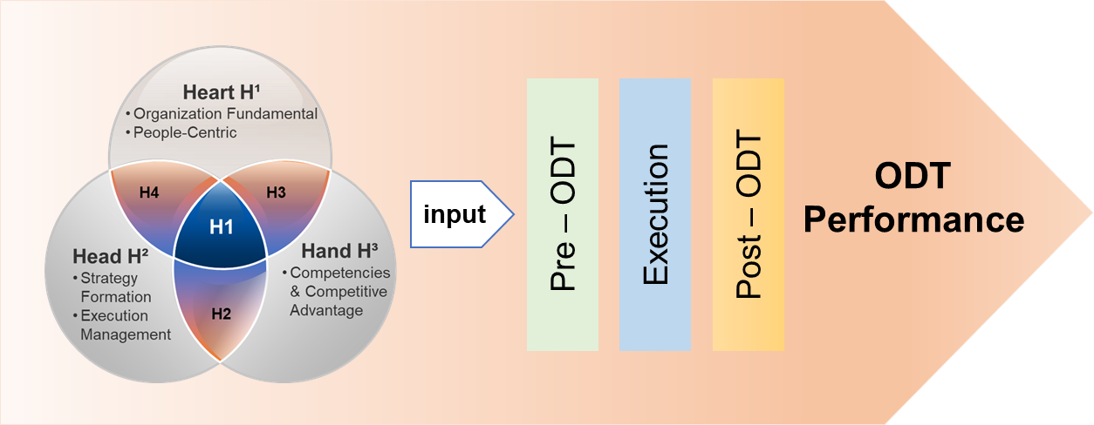

Figure 20: Proposed the 3H Holistic Management Framework for ODT – By Researcher

The pre-ODT phase serves as the foundation, involving meticulous planning and assessment. Organizations must scrutinize their current state, identify key challenges, and strategize how to align digital initiatives with overarching business objectives. This stage provides a roadmap, laying the groundwork for a seamless transition into the subsequent phases. The execution phase embodies the active implementation of the devised digital strategies. The organization's commitment to change is put into action during this stage. Effective coordination, resource allocation, and technological integration are crucial components at this juncture. The management framework ensures the execution phase is efficient and aligned with the organization's long-term vision. Post-ODT marks the period of reflection and refinement. The outcomes and impacts of the digital transformation are assessed, and lessons learned are incorporated into future strategies. This stage is not just an endpoint but a continuous improvement loop, fostering adaptability, sustainability, and resilience in evolving technological landscapes.
While Yu's conceptualization of the 3H holistic framework is acknowledged, it is a valuable resource offering profound insights and guiding principles for researchers crafting ODT's management framework. These three stages, meticulously outlined within the framework, provide a comprehensive structure, ensuring that the organization navigates and thrives in the ever-changing digital ecosystem.
- Pre-ODT
The Pre-ODT phase is essential as it involves the initial preparation and groundwork before embarking on the actual transformation. During this phase, organizations assess their current state, define their digital transformation goals and objectives, conduct feasibility studies, and develop a comprehensive strategy. With four steps, this strategy sets the direction for the transformation and aligns it with the organization's overall vision and objectives.
- Preparation Evaluation (H²) and Stakeholder Collaboration (H4): It is imperative to undertake meticulous planning, thoroughly assess the organization's existing state, and engage relevant stakeholders. The planning phase necessitates a comprehensive evaluation of the organization's digital readiness, encompassing an analysis of its strengths, weaknesses, and areas primed for improvement (Hannan & Baron, 2002; Westerman & Bonnet, 2015; Ustundag & Cevikcan, 2017). This assessment informs the formulation of a clear and well-defined vision, strategic objectives, and a roadmap. In parallel, stakeholder engagement emerges as a pivotal element, with key individuals such as leadership, employees, customers, and partners actively involved in the transformation process (Hansen et al., 2011; Ustundag & Cevikcan, 2017). Their perspectives and insights contribute to a collective understanding of the transformation goals and expected outcomes, fostering a shared sense of purpose. Through robust planning, assessment, and stakeholder engagement, organizations can lay a solid foundation for their digital transformation journey, increasing the likelihood of achieving desired results and effectively responding to the challenges and opportunities presented by the digital landscape.
- Assessment of Technological Infrastructure (H2) and Workforce Proficiencies (H³): A comprehensive evaluation of technology and talent is of utmost importance, highlighting the significance of conducting an in-depth assessment of the organization's technological infrastructure, systems, and capabilities (Deci & Ryan, 2000; Morton & Hu, 2004). By meticulously examining the existing technological landscape, organizations can effectively identify areas that require improvement, enhancement, or replacement to support digital transformation initiatives. Furthermore, thoroughly evaluating the organization's workforce skills and competencies is essential in identifying potential gaps in digital expertise, can strategically align their resources and ensure they possess the necessary technological infrastructure and skilled workforce to drive successful digital transformation (Sebastian et al., 2017; Verhoef et al., 2021). This assessment serves as a foundation for determining the need for upskilling existing employees or acquiring new talent with the necessary digital capabilities (Morton & Hu, 2004; Hansen et al., 2011). Additionally, organizations must consider the investments required to bolster their technological capabilities and align them with the objectives of the digital transformation journey.
- Optimal Resource Assignment (H2): a pivotal role in the success of organizational change initiatives within organizations and It underscores the importance of judiciously allocating the necessary resources, encompassing financial and human aspects, and effectively supporting the ODT journey (Deci et al., 1999; Barney, et al., 2001; Cash et al., 2003). Organization entails developing a comprehensive budget considering the required investments in technology infrastructure, talent acquisition, and training programs (Sebastian et al., 2017; Ustundag & Cevikcan, 2017). Furthermore, organizations are encouraged to explore opportunities for collaboration with external partners, such as technology vendors, consultants, and industry experts, to leverage their expertise and resources. These partnerships can foster accelerated progress in the digital transformation process by tapping into external knowledge, innovative solutions, and collaborative networks. By astutely allocating resources and engaging in strategic collaborations, organizations can optimize their digital transformation efforts and position themselves as agile, innovative entities within the evolving business landscape (Umble et al., 2003).
- Risk Examination and Mitigation (H2): In organizational digital transformation, identifying and managing risks are critical for ensuring the transformation journey's smooth progression and successful outcomes. Through rigorous research and analysis, this study's investigation emphasizes the importance of conducting a comprehensive risk analysis. Organizations must meticulously assess and evaluate potential risks and challenges that may arise throughout the digital transformation process (Beer et al., 2005; Agha et al., 2012). Key focus areas include data security, privacy considerations, regulation compliance, and potential operational disruptions. Subsequently, organizations must develop robust risk mitigation strategies to address and mitigate these identified risks proactively. By implementing effective risk management measures, organizations can safeguard critical assets, protect sensitive data, and maintain operational continuity during the digital transformation (Ustundag & Cevikcan, 2017; Loonam et al., 2019).
- Execution
During the organization's transformative journey of the ODT, the "Execution-ODT" phase is a critical stage characterized by the tangible execution of meticulously planned strategies and initiatives. This crucial phase encompasses deploying cutting-edge technologies, reengineering existing processes, comprehensive employee training, and professional change management. Given the significance of this phase, implementing effective project management practices, and establishing robust stakeholder engagement strategies become imperative (Baron & Hannan, 2002). It is also essential to have continuous monitoring and evaluation mechanisms in place to ensure seamless execution and alignment with the overarching strategic goals (Figge et al., 2002; Rabbani et al., 2014). By skillfully navigating the complexities inherent in the execution phase, organizations can optimize their digital transformation endeavors and position themselves for sustainable success in an evolving business landscape (Cortellazzo et al., 2019).
To achieve success in the "Execution" phase, organizations should focus on the following key areas:
- Change Strategy (H²) and DT Leadership (H¹): Employ change management strategies and demonstrate effective DT leadership to address resistance, mitigate risks, and facilitate the seamless adoption of digital changes within the organization. Organizations should offer comprehensive transformation strategy and robust support mechanisms to empower employees in navigating the process, establish transparent and efficient communication channels to ensure effective dissemination of information and promptly address any emerging challenges or barriers (Deci & Ryan, 2000; Cummings, 2004). Demonstrating strong leadership capabilities and effective communication skills are vital for inspiring and motivating employees throughout the digital transformation journey. Instilling a sense of urgency, articulating the transformative benefits, and fostering a culture encouraging employees to embrace change are pivotal components of successful change leadership (Buil et al., 2019; Cortellazzo et al., 2019)
- Dynamic Project Execution (H³) and Implementation (H2): Execute the digital transformation plan by implementing the identified strategies and initiatives within the agile project framework that assume paramount importance. These actions entail the deployment of cutting-edge technologies, the redesign of existing processes, and the fostering of organizational cultural change (Umble et al., 2003; Buil et al., 2019). By embracing agile project management methodologies, organizations can harness the inherent benefits of flexibility, adaptability, and effective collaboration among cross-functional teams. An essential aspect of this approach involves breaking down larger-scale initiatives into smaller, more manageable projects with well-defined milestones and deliverables (Cray, 2015; Buil et al., 2019). Such an approach enhances the overall efficacy and precision of project execution and implementation, ensuring the successful realization of digital transformation objectives.
- Data-informed Decision Making for Customer Excellence (H2): Utilizing data analytics and insights to inform decision-making with a customer-centric approach emerges as a critical factor for success. By harnessing the power of data analytics and insights, organizations can make informed decisions throughout the digital transformation journey. The collection and analysis of relevant data to measure progress, identify bottlenecks, and make data-driven adjustments to optimize outcomes. An integral aspect of this approach involves strongly emphasizing understanding customer needs, preferences, and expectations (Agha et al., 2012; Matt et al., 2015; Sousa & Rocha, 2019). By incorporating customer feedback and insights into the design and implementation of digital initiatives, organizations can enhance customer experiences, foster greater satisfaction, and drive long-term success in the dynamic digital landscape.
- Progressive Iterative Improvement (H²): Continuous monitoring and optimization are essential components for organizational success. By adopting a proactive approach, organizations can continuously monitor the progress of their digital transformation initiatives and assess their impact on overall performance (Figge et al., 2002; Kaplan & Norton, 2006a, 2006b; Morton & Hu, 2004). Digital transformation management must collect relevant data, conduct rigorous results analysis, and make necessary adjustments to optimize outcomes and ensure alignment with overarching business objectives. Establishing a continuous monitoring, evaluation, and optimization culture empowers organizations to adapt swiftly to changing circumstances, address emerging challenges effectively, and capitalize on new opportunities (Machado et al., 2019; Matt et al., 2015; Vial, 2021). By embracing this iterative process, organizations can enhance their transformational efforts, foster innovation, and achieve sustainable success as the ODT progresses.
By adhering to these strategic imperatives during the "Execution-ODT" phase, organizations can navigate the complexities of digital transformation effectively and maximize the value derived from their performance.
- Post-ODT
The Post-ODT phase encapsulates the critical element of sustaining the ODT and capitalizing on its long-term benefits. This phase involves a systematic and ongoing evaluation process where the outcomes of digital initiatives are meticulously analyzed and measured against predefined objectives. Subsequently, organizations can make necessary adjustments, optimizations, and refinements to ensure continuous alignment with evolving business needs and technological advancements. Establishing robust monitoring, support, and improvement mechanisms serves as a foundation for maintaining the relevance and effectiveness of the digital transformation journey. By diligently undertaking these activities within the Post-ODT phase, organizations cultivate a culture of adaptability, resilience, and continuous improvement, thus maximizing the long-term success of their digital transformation endeavors.
- Strategic Performance Measurement (H²): Evaluate the outcomes and impact of the digital transformation initiatives against the predefined objectives. This evaluation process allows for examining the strategies' effectiveness and identifying areas that require further improvement. It is essential to facilitate and establish key performance indicators (KPIs) and metrics that enable the monitoring of the success and impact of digital transformation efforts. Regular tracking and assessment of the organization's performance against these established metrics serve to evaluate the effectiveness of the implemented changes (Fenech et al., 2019; Lockett & Thompson, 2001). By diligently undertaking strategic performance measurement, organizations can gain valuable insights into the progress of their digital transformation journey and make informed decisions to optimize its outcomes and overall success.
- Sustaining Digital Transformation Initiatives (H1): Develop a comprehensive plan beyond the initial implementation phase. This plan entails the establishment of robust governance structures, creating processes for ongoing monitoring and maintenance, and cultivating a mindset characterized by agility and adaptability (Banker et al., 2000; Verhoef et al., 2021). These measures are necessary to ensure that the organization maintains its digital competitiveness in the long term. By proactively developing a strategy for sustaining digital transformation, organizations can navigate the ever-evolving landscape of technology and business dynamics, effectively respond to emerging challenges, and capitalize on new opportunities (Morton & Hu, 2004). This approach fosters an environment of continuous improvement and innovation, enabling the organization to adapt to changing circumstances and maintain its digital advantage.
- Continuous Evolution (H2) and Disruptive Advancements (H1): Foster a culture of continuous improvement by incorporating feedback and lessons learned from the digital transformation process. It is crucial to embrace the principles of Kaizen and disruptive innovation throughout the digital transformation journey. Encouraging innovation, experimentation, and ongoing learning becomes paramount in driving further enhancements and remaining aligned with evolving technologies and market trends (Walumbwa et al., 2008; Verhoef et al., 2021). By fostering a culture of continuous innovation and experimentation, organizations can propel ongoing improvement, harness the collective intelligence of their employees, and stay at the forefront of digital innovation. Employees should be encouraged to share their ideas, explore emerging technologies, and identify opportunities for digital innovation across various facets of the organization (Nah & Delgado, 2006; Morton & Hu, 2004). This commitment to fostering a culture of creativity, agility, and forward-thinking catalyze transformative change, enabling the organization to embrace new possibilities and leverage digital advancements for sustainable growth and success in the future.
- Adaptive Knowledge Stewardship (H4): Ensure this practice of adaptive knowledge management assumes a paramount role in ensuring the scalability and flexibility of initiatives to accommodate future growth and evolving business needs (Bass et al., 2003). It is imperative to proactively plan for forthcoming technological and market trends and advancements, enabling the organization to sustain a competitive edge. To effectively manage the knowledge generated throughout the digital transformation process, it becomes essential to devise mechanisms that capture and disseminate this valuable information. Organizations can facilitate knowledge transfer and foster a culture of continuous learning by creating a repository that houses best practices, lessons learned, and success stories (Jung et al., 2003; Buil et al., 2019). This repository is vital, enabling employees to access and leverage the collective wisdom acquired during the digital transformation journey. By utilizing adaptive knowledge management practices, organizations can successfully navigate the ever-changing digital landscape, capitalize on emerging opportunities, and remain at the forefront of innovation and transformative change (Baker et al., 2007; Loebbecke & Picot, 2015; Vial, 2021).
By incorporating the Pre, Execution, and Post (PEP-ODT) strategies, organizations can easily and adeptly navigate the intricate landscape of digital transformation. These comprehensive strategies serve as guiding principles, enabling organizations to plan meticulously, execute with precision, and sustain the transformational journey over time. Embracing the Pre-ODT strategy ensures a robust foundation by conducting thorough assessments, engaging stakeholders, and fostering a shared vision. The Execution phase facilitates implementing planned initiatives effectively, encompassing technological deployment, process reengineering, employee training, and change management. Lastly, the Post-ODT strategy focuses on sustaining transformational outcomes, optimizing benefits, and continuously refining digital initiatives. By adhering to these strategic approaches, organizations proactively address challenges, seize opportunities, and position themselves competitively in the digital era. The PEP-ODT strategies collectively contribute to the success of digital transformation initiatives, serving as a framework that guides organizations throughout their transformative journey. Figure 20 illustrate the proposed the process of 3H Holistic Management framework for ODT which mirroring with Yu’s 3H framework.

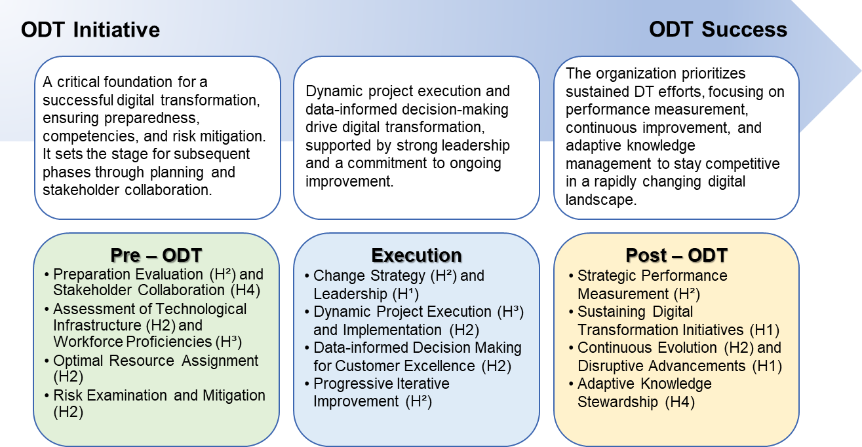

Figure 20: The processes of 3H Holistic Management Framework for ODT – By Researcher

  - Conclusions
This research has been undertaken to develop a comprehensive management framework encompassing the diverse and intricate aspects of digital transformation for organizations. The research findings acknowledge digital transformation's intricate and multifaceted characteristics; this comprehensive framework integrates a diverse array of 3H domains. The Heart dimension of the framework emphasizes the emotional and cultural aspects of digital transformation. It recognizes the importance of cultivating a positive organizational culture that embraces change, encourages collaboration, and fosters employee engagement. Insights from this research shed light on the significance of aligning the values and beliefs of individuals with the organization's digital transformation goals, thus creating an environment conducive to innovation and adaptation. The Head dimension focuses on the cognitive aspects of digital transformation. It involves strategic thinking, data-driven decision-making, and aligning digital initiatives with organizational strategy (Yu, 2019, 2021). Through this research, a deeper understanding of the strategic implications of digital transformation emerges, including the need to leverage data analytics, assess market dynamics, and make informed decisions regarding technology adoption and resource allocation. The Hand dimension encompasses the practical execution of digital transformation initiatives. It involves project management, resource allocation, and the implementation of operational tactics.
This research highlights the importance of effective change management strategies, agile project management approaches, and the optimization of operational processes in driving successful digital transformation efforts. This holistic approach acknowledges the interplay and interdependence of various factors that influence the success of digital initiatives. It provides a systematic and structured approach to align their technological investments, team capabilities, strategic objectives, and operational tactics with broader organizational goals.
Furthermore, this holistic management framework optimizes organizations' digital transformation efforts. Organizations can develop a more integrated and synergistic approach to digital transformation by considering the diverse dimensions and intricacies. It enables them to better capitalize on emerging technologies, leverage their human capital, adapt to market dynamics, and foster a culture of innovation and adaptability (Yu, 2019). Moreover, this holistic management framework emphasizes the importance of strategic alignment and effective governance throughout the digital transformation journey. It highlights the significance of strong leadership, transparent communication, and ethical considerations to ensure responsible and sustainable use of technology. By addressing these aspects, organizations can mitigate risks, enhance operational efficiency, and improve overall performance in today's digitalized environment. Ultimately, adopting this comprehensive management framework enables organizations to navigate the complexities of digital transformation with greater clarity and purpose (Stalk et al., 2012). It provides a roadmap for organizations to systematically evaluate, plan, and execute digital initiatives while continuously monitoring and adapting to the evolving digital landscape. By embracing this holistic approach, organizations can position themselves as agile, innovative, and digitally mature entities capable of thriving in today's rapidly changing business environment.
This research seeks to contribute to ODT by developing a holistic management framework that integrates Yu's 3H conceptual framework. By examining the interplay between these three dimensions, the researcher proposes insights based on these research findings and past managerial experiences into the holistic nature of digital transformation and its implications for managerial practice. By incorporating these elements into a cohesive and interconnected framework, organizations can effectively navigate the challenges inherent in digital transformation. This holistic approach acknowledges the interplay and interdependence of various factors that influence the success of digital initiatives. It provides a systematic and structured approach for organizations to align their technological investments, team capabilities, strategic objectives, and operational tactics with broader organizational goals. The tabulated data in (Appendix 13) present a concise overview of the research outcomes align with the stipulated research inquiries. The outcomes exhibit a commendable degree of coherence, signifying the efficacy of the employed research methodology and underscoring the significance of the findings.
  - Research Limitations
Investigating the holistic management framework in organizational digital transformation necessitates thoroughly examining the research limitations inherent in the study design, methodology, data collection, and analysis processes. By acknowledging and analyzing these limitations, researchers and practitioners can gain valuable insights into the scope and generalizability of the research findings and identify areas for future improvement and further investigation.
One primary limitation of this research pertains to the sample size and representativeness. The study focused on a limited number of organizations, potentially constraining the ability to capture the diverse range of organizations undergoing digital transformation fully. Consequently, caution must be exercised when interpreting the findings and conclusions, as they may not readily apply to all organizational types or industries (Boddy, 2016). Another critical limitation to consider is the generalizability of the research findings, given the contextual specificity of the study, where it centered on a particular organizational setting or cultural context, the direct transferability of the findings to other settings may be limited (Wright, 2005). Factors such as industry characteristics, organizational culture, and geographical location can significantly influence the outcomes and efficacy of the holistic management framework. Thus, caution is advised when attempting to extrapolate the findings to different contexts.
The accuracy and reliability of the data collected may present potential limitations in this research. Ridder (2017) claims that if study relied on self-reported data obtained through surveys and interviews, susceptible to response biases and memory recall issues. Participants may have provided incomplete or inaccurate information due to social desirability bias or limited awareness. Additionally, subjective measures and the potential for response fatigue could impact the validity and reliability of the collected data (Wright, 2005; Blaxter et al., 2010). The holistic management framework in digital organizational transformation encompasses various dimensions, including strategic, technological, and human elements. However, due to constraints in time and resources, this research may have yet to comprehensively explore all the intricacies and complexities associated with each dimension. As a result, the findings may offer limited insights into the complete range of factors that influence the success or failure of the holistic management framework. Future research endeavors should strive to delve deeper into each dimension to provide a more comprehensive understanding of the topic.
Due to study was conducted within a specific time frame, which may limit its ability to capture the long-term effects and changes in the holistic management framework (Wright, 2005). Digital transformation is an ongoing process that evolves, and the framework's effectiveness may vary at different stages of the transformation journey. Conducting longitudinal analysis over an extended period could provide a more accurate assessment of the framework's sustainability and effectiveness (Blaxter et al., 2010). Various external factors and contextual dynamics could influence its digital transformation, such as market conditions, COVID pandemic outbreak, regulatory changes, and technological advancements, among other factors, can significantly impact the outcomes and efficacy of the holistic management framework (Stalk et al., 2012). Unfortunately, this research did not extensively investigate these external factors and their influence on the framework, representing a limitation in understanding the broader contextual influences on organizational digital transformation. An additional limitation of this research is the need for a comparative analysis between organizations implementing the holistic management framework and those adopting alternative approaches or frameworks. A comparative analysis could provide valuable insights into the relative effectiveness and advantages of the holistic management framework compared to other existing practices (Attride-Stirling, 2001). Future research endeavors could address this limitation by conducting comparative studies to validate further and strengthen the findings. While this research contributes valuable insights, it is crucial to recognize and address the abovementioned limitations.
  - Suggestions for Future Research
Future research endeavors should explore the influence of contextual factors and cultural considerations on the implementation and outcomes of the 3H holistic management framework. It is crucial to recognize that diverse industries, organizational sizes, and cultural contexts may impact the effectiveness and applicability of the framework (Verina & Titko, 2019). By investigating these contextual factors, researchers can offer tailored recommendations for organizations operating within specific industries or cultural settings, thereby enhancing the practicality and relevance of the framework. Moreover, the role of organizational culture in digital transformation efforts deserves closer examination.
Future research of the applicability of 3H holistic management framework should delve into how different organizational cultures (H¹) influence the adoption and effectiveness of the holistic management framework. Additionally, investigating the concept of change readiness within organizations (H²) can yield valuable insights into the preparedness and willingness of employees to embrace and support digital transformation initiatives. Understanding the factors contributing to employees' readiness for change can inform strategies to foster a positive and receptive organizational climate during digital transformation endeavors (Stalk et al., 2012; Fitzgerald et al., 2014). This research can shed light on the various dimensions of change readiness and identify interventions to enhance employees' engagement and commitment to the transformation process.
Furthermore, conducting benchmarking studies with the applicability of 3H framework to compare an organization's digital transformation progress against other organizations in the industry can provide valuable insights and facilitate performance improvement. Comparative analysis can help identify best practices, successful strategies, and areas of improvement, enabling organizations to learn from the experiences of others and refine their digital transformation approaches (Attride-Stirling, 2001). By undertaking these suggested research avenues, organizations can deepen their understanding of digital transformation's complexities and develop effective strategies for successful implementation. Ultimately, this will contribute to advancing knowledge in the field and support organizations in navigating the challenges and maximizing the benefits of their digital transformation journeys.
- The End ※
- Words Count 62,763 ※

