2018
University of Wales Trinity Saint David

Cameron Davies

[materials & manufacturing report: 3D PRINTING]
Report discussing the most efficient and cost effective material to use in the process of 3D printing when making tools for customers

Table of Contents
Introduction 2
3D Printing 2
Materials 2
Main Research 3
Ultimaker 4
Other 3D Printers 5
Poly Carbonate (PC) 8
Other Materials 8
Advantages 10
Disadvantages 10
Conclusion 11
Bibliography 12
Appendix 14

Introduction
The aim of this report is to explain how 3D printing can be used to design and create tools for customers, so that through injection moulding they can make their own components. This report will identify the materials and explain the manufacturing process used for 3D printing. It will consider the different types of materials, 3D printers as well as their costs. The report will then analyse the different tolerances and precision that each material can achieve. This is to ensure that a conclusion can be made on which material and printer is the best to use.

3D Printing
3D printing is the process of making three dimensional objects from a digital file. The printer can create components ranging from simple to complex but this will depend on the size and capability of the 3D printer. There are different types of 3D printers, for example; the Ultimaker, the Form and the Voxeljet. Each of these printers has different features. This report will primarily focus on the Ultimaker, which is pictured below.
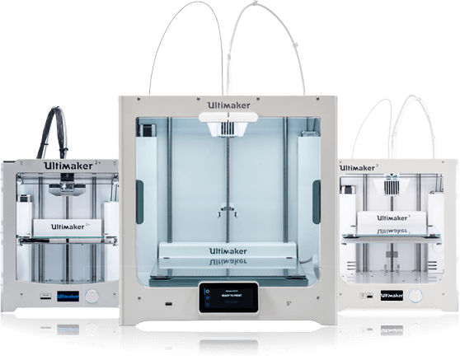
Figure 1: A range of Ultimaker 3D printers, https://ultimaker.com/

Materials
There are several different types of materials that can be used for 3D printing. The advantages and disadvantages of each will be evaluated in order to provide an appropriate conclusion.
Examples of materials that can be used for 3D printing are:
- Polylactic Acid (PLA)
- Nylon
- Poly Carbonate (PC)

Main Research
In order to provide the optimum quality and efficiency, the best 3D printer and material must be selected. They must be able to make any tool that a customer requires, getting the detail, volume and specifications correct.
The health and safety requirements and considerations are;
- The appropriate placement of wiring or leads that are needed for the 3D printer to avoid trip hazards.
- Training and instruction for the operator of the 3D printer.
- Appropriate signage to ensure awareness of the high operating temperatures of the materials and printer.
3D printing was first introduced in 1983 by a man called Charles Hull. It is discussed in the article “The Birth of 3D printing” Hull, C. (2015) that 3D printing wasn’t originally invented for manufacturing, but to print “a small cup” that could be used for personal use for himself and his wife. This concept then developed into a process that we see in the modern day, where 3D printing can be used to manufacture different tools and components. The process has completely changed over the years with the original component a “cup” taking “6 to 8 weeks to complete”, while a component made by Ulitimaker would take a day or less if it was the same size. The price of 3D printers has decreased over the years with “just 3 years ago the average cost being $20,000, but now a printer can be bought for just $1000”. The reason for this due to the level of competiveness of the market becoming higher with companies increasing sales by reducing costs compared to rivals.
Within section 4 of the book “Reinforced Plastics”, there is an article which focuses on the development of 3D printing and its potential to increase development throughout the businesses. According to Mathijsen, D. (2018) “The 3D printer has proven its value in turning design into actual objects without the need of a craftsman”. This shows why it is an efficient method to use in the future as manual design is often difficult to replicate perfectly due to human error. The 3D printer can help greatly in making the design process more consistent, where the tool being created is of the best quality and standard.
The “International Journal of Mechanical Sciences” Suiker, A. (2018) states that “The advantages of additive manufacturing over traditional manufacturing are that the product is easy to customise with an enormous flexibility in shape, quick prototyping is possible, product waste is reduced, manufacturing cost are low, and product storage costs are eliminated”. These are reasons why 3D printing is a valuable investment for the future as it brings in several benefits that would aid the company in the future.
A company that has actually started using 3D printers to make tools is Vacuum Forming which is a plastic thermoformer in Minnesota. According to the article “Machine Design” (2013) the tooling is “durable enough to withstand physical and environmental testing”. This demonstrates how this method of using 3D printers to make tools works, with the specific part where it discusses the durability being the most important point, as the main element of the report focuses on making durable tools for customers.
An article by Cobb, J. (2015) on 3D printing states “The fundamental objectives of manufacturing-improve quality, decrease cycle time and reduce costs-are the primary reasons that jigs and fixtures are so abundant. It doesn't matter if the operation is fully automated or entirely manual; jigs and fixtures are deployed throughout manufacturing operations with the goal of reducing costs while accelerating production processes.” This statement perfectly summarises why creating tools with 3D printers is such a great way to advance a company, as if it follows all of these objectives that the article discusses, then there is a great opportunity for greater efficiency and profitability within the company.
3D Printers

Ultimaker
The Ultimaker is a 3D printer supplier which has different ranges in sizes that suit the needs of the consumer. The requirements could either be work related, such as making tools and components within investment casting, or for personal use, where a component is modelled up for the desire of the consumer. This reports’ main focus is on the use of the Ultimaker within the manufacturing sector of investment casting. It will investigate the printer’s ability to design a tool that through the use of injection moulding will be able to make multiple components. In a magazine where the Ultimaker is evaluated, it is stated by Hoffman, T. (2015) how the Ultimaker “offers high resolution” while being “quick and easy to set up and use”. These are requirements that would benefit a company as the components being created must be of a high quality and finished in a fast timescale so that customer requirements can be satisfied.
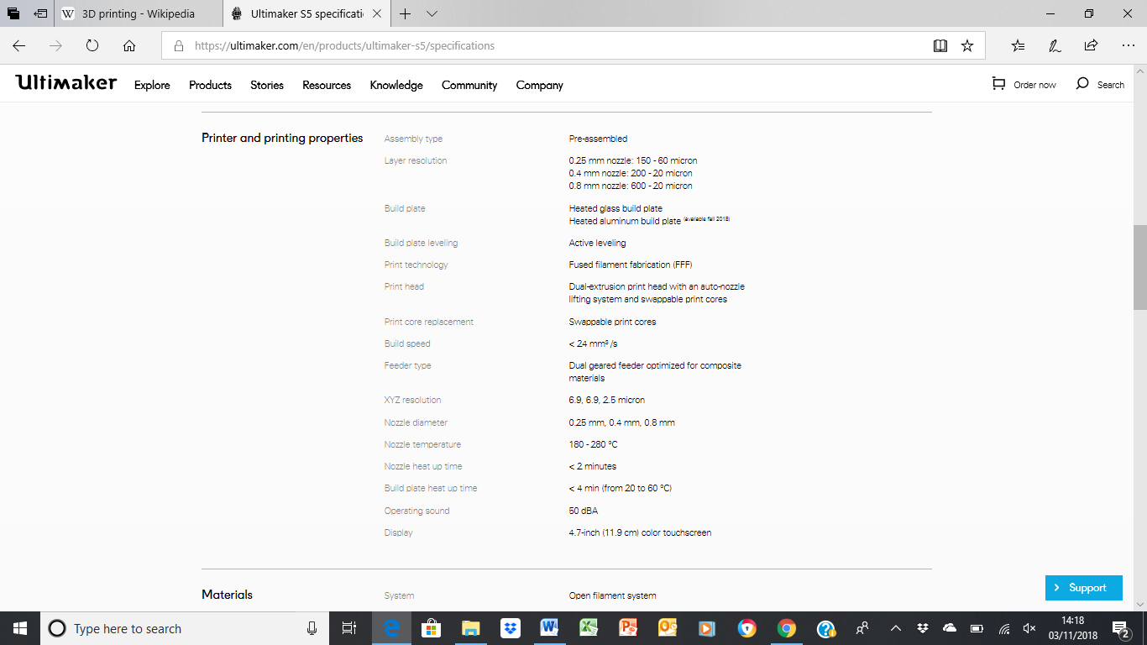
Figure 2: Specifications of Ultimaker 3 Printer, https://ultimaker.com/en/products/ultimaker-s5/specifications
The table above taken from the official “Ultimaker” website shows the specifications for the Ultimaker 3. The nozzle diameter of the printer 0.25, 0.4, 0.8mm shows that it can get the finest of details capable of making the smallest features that a tool order might have. This will be useful for making a complex tool with several different features such as holes, fillets and grooves. The Ultimaker 3 will need this level of dimensional accuracy’s so that the printer can create it. The cost will vary depending on the size; the Ultimaker 3 is 215 x 215 x 200 mm, which is capable of making the average tool size that will fit the majority of customer requirements. The other available Ultimaker printer sizes would be more suitable for bigger or smaller sized tools. Ultimaker 3 would cost £3,535.00 directly from the manufacturer. This price can vary if it is bought from an outside distributor. For example “CPC Farnell” would retail at £4,242.00, while “Go Print 3D” retails at £3,354.19. Due to the small differences in price and the fact that the manufacturer is likely to provide a better maintenance and support service, purchasing the Ultimaker 3 directly from the manufacturer would be the sensible selection.

Other 3D Printers
Other printer options include the 3D printers of Voxeljet, FormLabs and FLASHFORGE.
Voxeljet
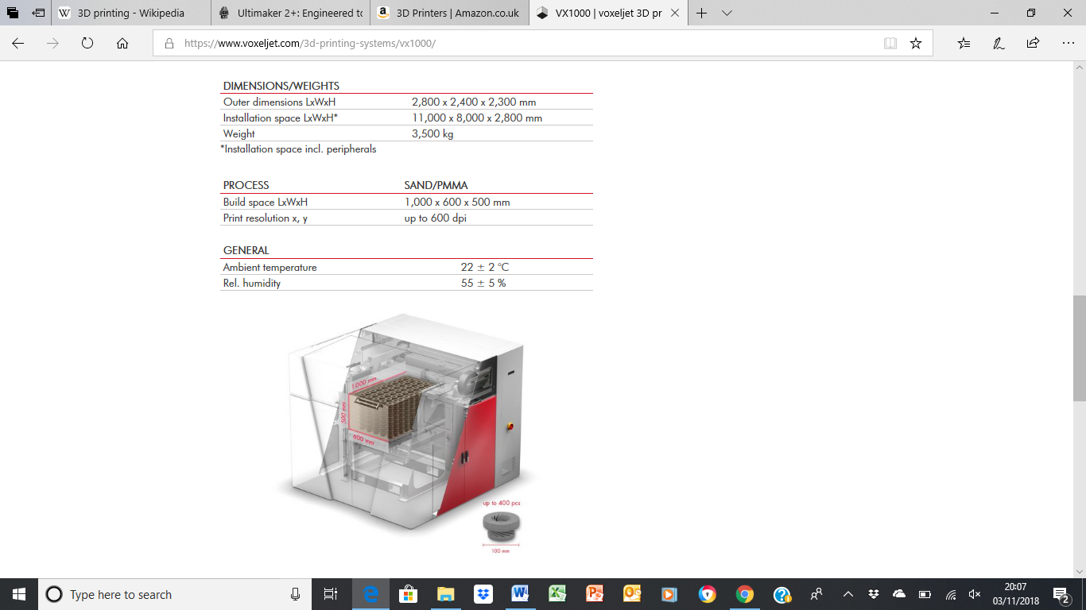
Figure 3: Specifications of VX1000 Printer, https://www.voxeljet.com/3d-printing-systems/vx1000/
Appendix A contains research gathered from the Voxeljet VX1000 printer specifications, stating how the surface quality is very good, but does have a very high price at £250,000.
FormLabs
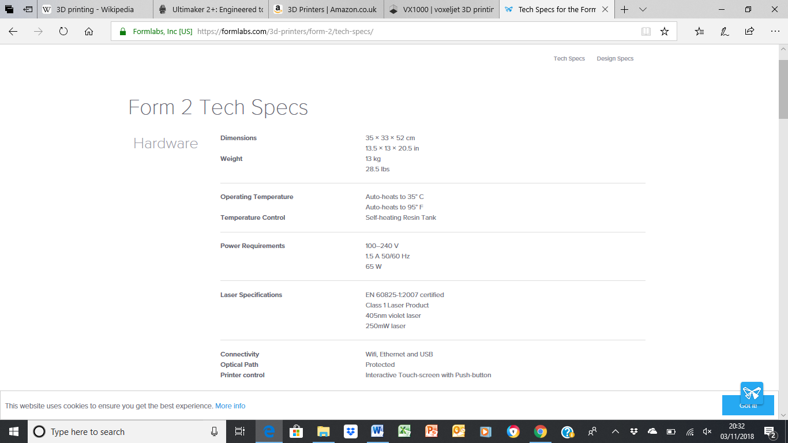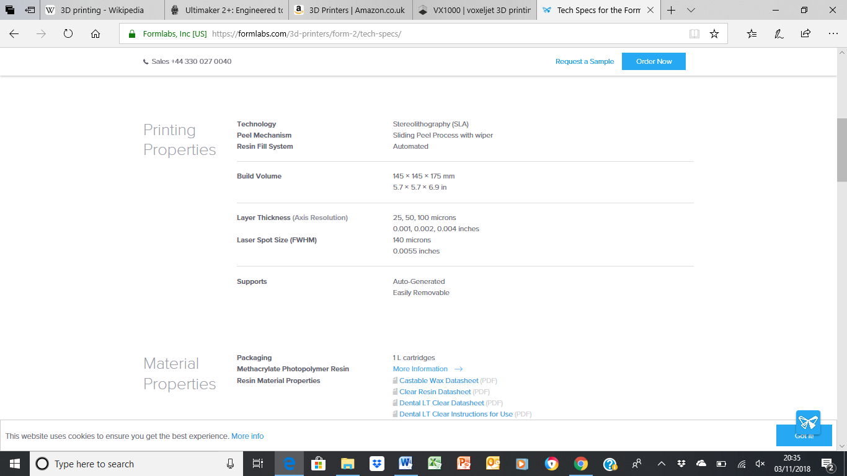
Figure 4: Specifications of Form 2 Printer, https://formlabs.com/3d-printers/form-2/tech-specs/
Appendix B contains research gathered from the Form 2 printer specifications, stating how the surface quality is very good, along with a competitive price but has limitations of the maximum size being limited due to there only being one model available.

FLASHFORGE
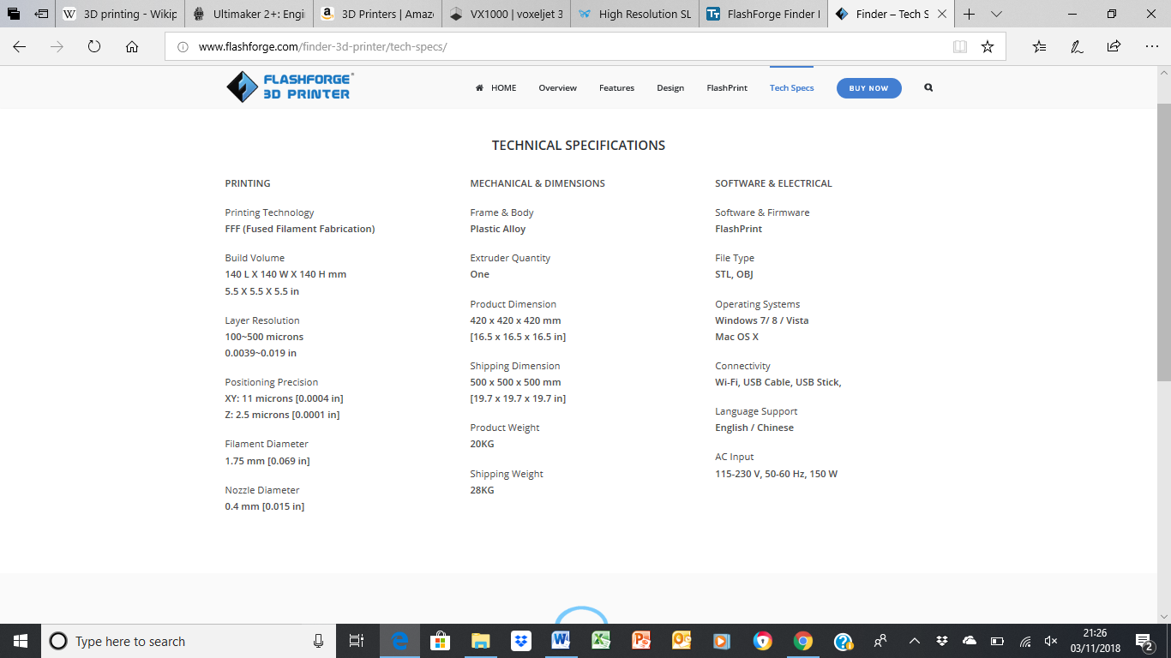
Figure 5: Specifications of FlashForge Printer, http://www.flashforge.com/finder-3d-printer/tech-specs/
Appendix C contains research gathered from the FLASHFORGE printer specifications, stating that at despite a very cheap price, the lack of quality the printer is capable of, argue that the printer is aimed at the consumer market and not suitable in a manufacturing environment.
Materials

Poly Carbonate (PC)
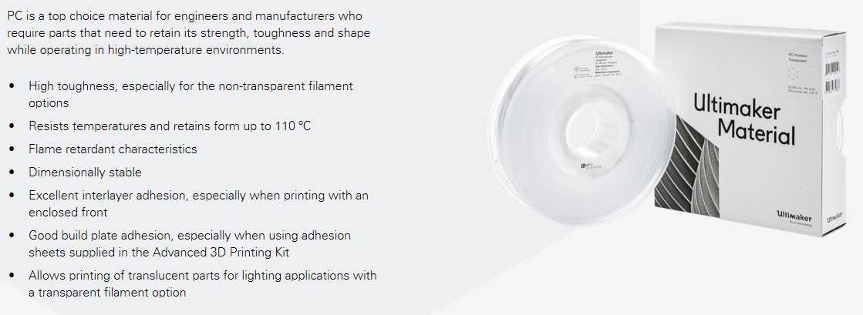
Figure 6: Specifications of material Poly Carbonate (PC), https://ultimaker.com/en/products/materials/pc
PC is one of several materials that are sold by Ultimaker; its attributes include a high toughness, which is an essential requirement. The main goal is to make a component for the use of injection moulding; the material therefore must be durable and able to sustain the inevitable damages that come from making components on a daily basis. The price of PC is £49.99 per 750g, which when compared to the steels and metals that are usually used to make tools, it is cheaper. 750g of steel would cost £30.00, the difference being that PC, subject to the size can make a tool with just 300g of material, while it would take over 2000g to manually make a tool with steel for the equivalent size. It is discussed in the article by Squires, A., & Lewis, D. (2018) that PC “consists of very desirable mechanical properties including superior toughness and impact resistance over all other 3D printer filaments”. This shows why PC is a very investable material as, the biggest property of a material for 3D printing is that it must be durable.

Other Materials
Polylactic Acid (PLA)
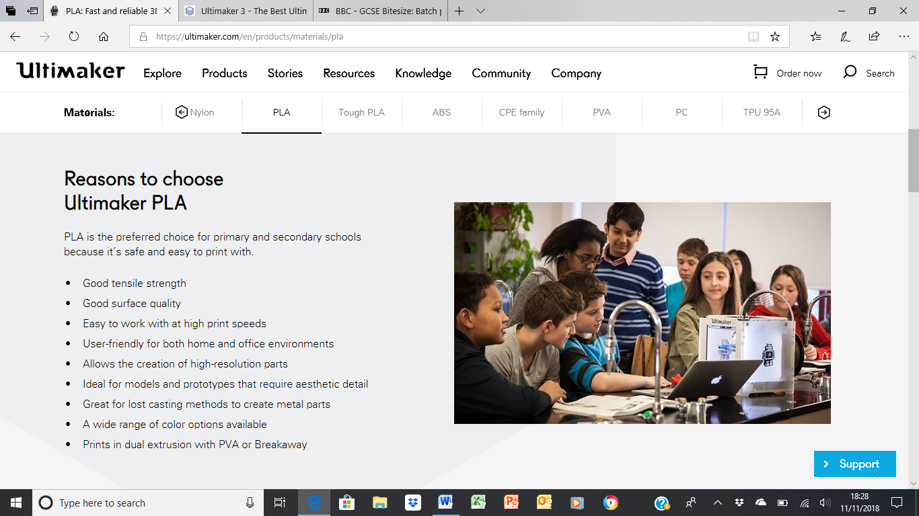
Figure 7: Specifications of material Polylactic Acid (PLA), https://ultimaker.com/en/products/materials/pla
Appendix D contains research gathered from the material PLA specifications, stating how it has good qualities, but lacks the durability required for the manufacturing of tools.
Nylon
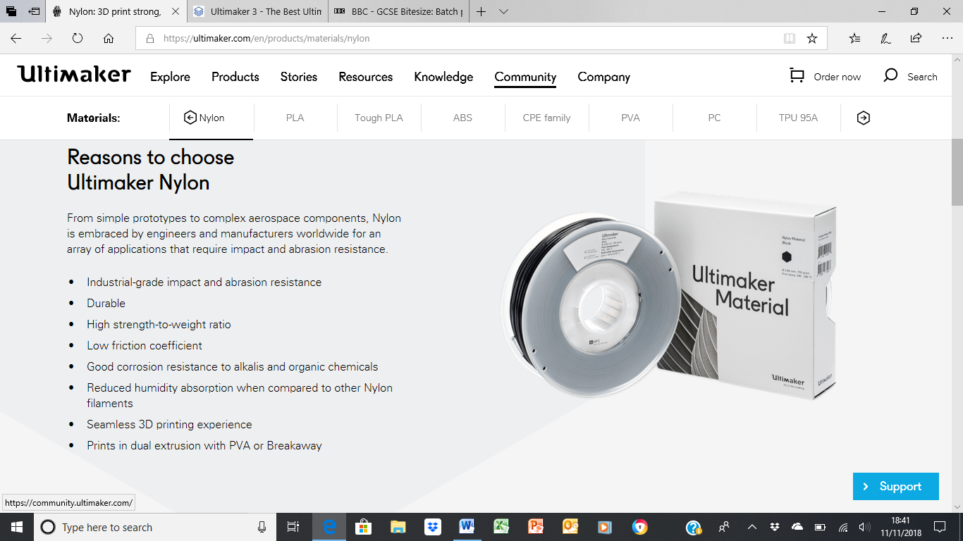
Figure 8: Specifications of material Nylon, https://ultimaker.com/en/products/materials/nylon
Appendix E contains specifications gathered from the material Nylon, stating how it has a good price, but lacks the surface quality that is required for a tool.

Advantages
- The cost of making tools with the 3D printer is the main advantage as it is far cheaper to produce a tool with a 3D printer than to manually create a tool. A component with a size of 150 x 150 x 200 mm, would cost approximately £5.99 due to the limited quantity of PC material needed to produce it. On the other hand making a tool using steel would cost considerably more due to the high cost and the need to buy in bulk. It would cost approximately £150.00 to make a tool of the same size. This then goes into the advantage of investing in a material such as PC as it is significantly cheaper than steel.
- The consistent quality of the finished product the 3D printer creates, where the specialist skills of the tool maker are not required.
- Investing into the Ultimaker 3 due to its ability to create complex and detailed tools while being at a good price of £3,535.00, as there are 3D printers that could create better tools such as Voxeljets but at prices from £100,000+ they would be far too expensive to consider.
- Reducing the risk of human error, as a toolmaker, no matter how experienced or skilled, is prone to mistakes.
- The 3D printing market was valued at “$3.075 billion in 2015”, and is projected to reach “$22.2 billion by 2025” is stated by “PR Newswire” which highlights how lucrative the 3D printing market is, and how there’s more room for growth should the investment be made.
- Costs of labor as for a tool to be made manually it takes time, depending on the size it could take 6-8 hours. This would cost a lot of the toolmakers time, whereas if the tool is made by the printer, the only costs would be the material and the cost for running the printer.
- An argument can be made that two or more printers can be invested in, due to the money that is saved from the material and toolmakers time. This would allow multiple tools to be created as the printers could run alongside each other to address different customer requirements.

Disadvantages
- The main disadvantage is time, as an average tool could take approximately 24 hours to make, also adding on the time taken for finishing touches such as filing down any excess material. This could be a problem for the customer as there might be a timescale that needs to be met.
- Ongoing maintenance, as in the event of any problems that occur with the 3D printer then it will cost both time and money for it to be back up and running again.
- Downtime as there could be a situation where the 3D printer is either already in use or under maintenance, and if an order comes in, then the printer could not be used without disrupting the current job. By comparison tool makers can balance several jobs at once.
- Steel is a stronger and more durable material than all of the materials that are suitable for 3D printing, therefore an argument can be made that a PC tool wouldn’t last as long as a steel tool. This would mean that the tool would need to be modified sooner.

Conclusion
In conclusion the process of making tools with 3D printers over manually producing them has been proven throughout this report to have effective and lucrative advantages that would benefit a company. The fact that higher quality tools can be made for lower cost, it could be argued that it outweighs the disadvantages of the process being time consuming. Additional printers could be considered to scale up the production of tools. These advantages have long term benefits, which would make the company more profitable.
Reviewing the 3D printers has demonstrated that the better the quality, the higher the price. That is why the Ultimaker can be argued to be a good balance of cost and quality, as it has high specifications capable of making very complex parts, while being reasonably priced. There are potentially better printers available such as the Voxeljet printer VX1000, but it is more difficult to justify investment because of the very high price.
Poly Carbonate can be argued to be the best material due to its relatively low cost and high durability; these are significant advantages when selecting a material. What has also been highlighted is that there are several different materials that could be used with the 3D printer at a low cost. This is advantageous as it provides a variety of materials to choose from. Each of the materials have their own different properties that make them useful, but Poly Carbonate as a result of its high durability, edges out the other materials as it provides exactly what is needed for the toolmaking process and fulfils the needs of the resilience of the tool.

Bibliography
Ultimaker, 2011-2018, Ultimaker, Viewed 4th November 2018, https://ultimaker.com/
Hull, C. (2015). The Birth of 3D Printing: IRI Achievement Award Address. Research Technology Management, 58(6), 25-29.
Mathijsen, D. (2018). Bigger, stronger, faster… pushing the envelope of 3D printers to turn them into true production tools. Reinforced Plastics, 62(4), 194-202.
Suiker, A. (2018). Mechanical performance of wall structures in 3D printing processes: Theory, design tools and experiments. International Journal of Mechanical Sciences, 137(C), 145-170.
3D PRINTING MAKES TOOLS QUICKLY FOR VACUUM FORMING. (2013). Machine Design, 85(11), 17.
Cobb, J. (2015). 3D Printing Jigs, Fixtures and Other Manufacturing Tools. Manufacturing Engineering, 154(5), 168.
Hoffman, T. (2015). Ultimaker 2 Extended. PCmag.com, PCmag.com, Aug 21, 2015.
Ultimaker, 2011-2018, Ultimaker Products Specifications, Viewed 4th November 2018, https://ultimaker.com/en/products/ultimaker-s5/specifications
CPC Farnell, 2018, Ultimaker 3, Viewed 4th November 2018, https://cpc.farnell.com/ultimaker/9677/ultimaker-3-extended
GoPrint3D, 2017, Ultimaker 3, Viewed 4th November 2018, https://www.goprint3d.co.uk/ultimaker3.html
Voxeljet, 2018, VX1000 Specifications, Viewed 4th November 2018, https://www.voxeljet.com/3d-printing-systems/vx1000/
FormLabs, 2018, Form 2 Specifications, Viewed 4th November 2018, https://formlabs.com/3d-printers/form-2/tech-specs/
FLASHFORGE, 2012-2018, Technical Printer Specifications, Viewed 4th November 2018, http://www.flashforge.com/finder-3d-printer/tech-specs/
Ultimaker, 2011-2018, Ultimaker Material PC, Viewed 11th November 2018,https://ultimaker.com/en/products/materials/pc
Squires, A., & Lewis, D. (2018). Feasibility and Characterization of Common and Exotic Filaments for Use in 3D Printed Terahertz Devices. Journal of Infrared, Millimeter, and Terahertz Waves, 39(7), 614-635.
Ultimaker, 2011-2018, Ultimaker Material PLA, Viewed 11th November 2018, https://ultimaker.com/en/products/materials/pla
Ultimaker, 2011-2018, Ultimaker Material Nylon, Viewed 11th November 2018, https://ultimaker.com/en/products/materials/nylon
The Global 3D Printing Market is Expected to Reach $22.2 Billion by 2025 - Glob Market Research. (2018). PR Newswire, pp. PR Newswire, 2018-05-31.

Appendix
Appendix A - Voxeljet is a company that supplies 3D printers and components directly to customers. As seen in the link above it has a high resolution of up to 600 dpi which makes it capable of making the most complex of components. It is capable of making larger tools as well as being able to manufacturer a higher quantity, due to the sizes of the models. It has a huge disadvantage due to the high cost, as the price of a Voxeljet printer can range from approximately £100,000.00-£500,000.00 depending on the size of the model. The example above is of the VX1000 which is the third biggest 3D printer available, at a price of £250,000. Due to the cost difference it is safer to invest in the Ultimaker 3 over the VX1000, as it will pay for itself in a quicker timescale.
Appendix B - FormLabs is a 3D distributing company with its main product being the Form 2 printer. The specifications above demonstrate that with a laser size of 0.0055 inches it is capable of making the most detailed components. The disadvantage would be the size, as there is only one 3D printer which has dimensions of 350x330x520mm. This limits the maximum size of the tool that could be created. The price of the 3D printer is £3,360.00 which is cheaper than the VX1000, but at a similar cost to the Ultimaker 3. Where the Ultimaker 3 can be considered to have the advantage over the Form 2 is the larger range of model sizes available which makes it more scalable.
Appendix C - FLASHFORGE is a 3D printing company with one main product, which is sold at a very low price of £299.00. It has low resolution capabilities, making it a poor choice for creating tools as they wouldn’t be of a professional quality. Due to it being cheaper than other printers, the lower specification of the FLASHFORGE printer would suggest that it is aimed at the consumer market and not suitable in a manufacturing environment.
Appendix D - PLA is another low cost material, even cheaper than PC at a price of £30.00 per 750g. As seen above, it has good surface quality and its ability to create high resolution parts, make PLA a viable alternative that could also be used to design tools. Despite the lower cost, PC has the advantage over PLA in being a more durable material, which supports the argument PC is the better material to use.
Appendix E - Nylon is a material that has the advantage of being very durable and cheap at £49.99 per 750g, but the disadvantage of the material is that it does not have as good surface quality as either PC or PLA. Therefore this shows why PC can be argued to be the better material than Nylon.

