

University of Wales Trinity Saint David
School of Engineering

Engine Performance characteristics

Angsana Bunrueangtong

2104532

10/12/2021

—

Vehicle Technology

—

Abi Summerfield

Contents

- Introduction 1.1

- Research 2.1

- Method and testing 3.1

- Analysis and graphs 4.1

- Conclusion5.1

Introduction 1.1
The aim of this report is to examine in detail the importance of engine and vehicle technologies. Demonstrate an understanding of how dynamometer is used during engine testing and show examples of calculation capacity of the engine using a formula, data and graphs in a lab environment.
In conclusion to develop knowledge of a range of Automotive powertrain, suspension, control, and chassis systems.

Research 2.1

The piston engine is a source of air and fuel mixture that is supplied to the inside of the cylinder then it is compressed and that’s when it ignited where it released energy. The internal combustion releases heat energy converted into mechanical work and pushes the piston to rotate inside the cylinder. The cylinder pressure changed while the gas expands during the power stroke. The brake power is always less than the indicated power due to pumping losses in the cylinder corresponding mechanism of the engine.

The petrol engine is usually built with a shorter stroke and operates over a larger crankshaft speed than the diesel engine.

When the test is taking place, the mechanic needs to consider not just the condition of the engine, but they need take consideration with the air inlet temperature, pressure, and humidity may affect the test results.

The device that is used to tests measure the torque, force and power of the engine are known as a dynamometer. There are two main types of dynamometers: power absorption and power transmission. The power absorption dynameter measure and absorb the power that the engine produced, and they are all linked together
This device also provides details such as the time for fuel consumption and the ignition timing for the engine to produce power.

Main automotive systems engines are powertrain, chassis, bodies, and electrical systems. There are also some other important factors that the engineers need to consider with vehicle efficiency, emissions control,

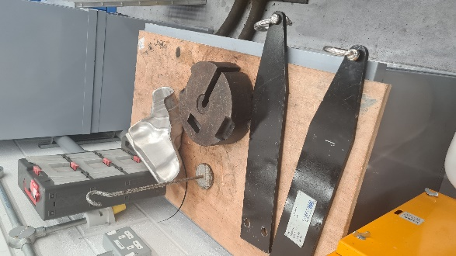

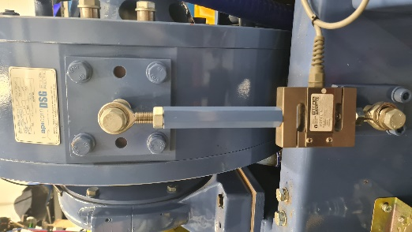
Method and Testing

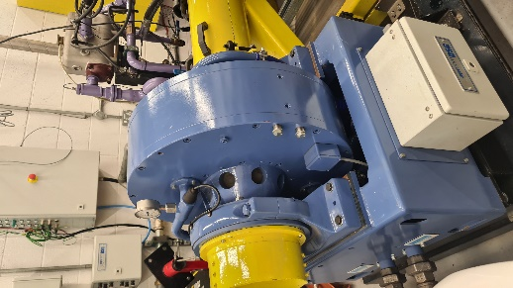

Analysis and Graphs

Conclusion
Due to their particular process of combustion, diesel engines are built sturdier, tend to run cooler, and have only half the speed range of most petrol engines. These factors make the diesel engine more reliable and considerably extend engine life relative to the petrol engine. Pollution Diesel engines tend to become noisy and to vibrate on their mountings as the operating load is reduced. The combustion process is quieter in the petrol engine and it runs smoother than the diesel engine.

There 14 CHAPTER 1.1 Piston-engine cycles of operation is no noisy injection equipment used on the petrol engine, unlike that necessary on the diesel engine. The products of combustion coming out of the exhaust system are more noticeable with diesel engines, particularly if any of the injection equipment components are out of tune. It is questionable which ar more harmful: the relatively invisible exhaust gases from the petrol engine, which include nitrogen dioxide, or the visible smoky diesel exhaust gases. Safety Unlike petrol, diesel fuels are not flammable at normal operating temperature, so they are not a handling hazard and fire risks due to accidents are minimised. Cost Due to their heavy construction and injection equipment, diesel engines are more expensive than petrol engines.

To enable intelligent comparisons to be made between different engines’ ability to pull or operate at various speeds, we shall now consider engine design parameters and their relationship in influencing performance capability.

