Introduction and Literature Review

School leaders – headteachers/principals, deputy and assistant heads are a critical influence and driver in any education system. Their contribution, and the importance of their role are a consistent feature of the education debate, most particularly since the publication of the seminal McKinsey report in 2009 which looked at the features of the most improved school systems worldwide. It found, perhaps unsurprisingly, that ‘good leadership is critical to success in improving school systems’ (McKinsey, 2009 p.107). The report also suggested that tenure in post (what the report calls ‘staying power’) is also important. Sustainable change takes time and perseverance. Leaders need to stay in post for a period of years to have a real impact on school improvement priorities.

This report will examine a range of data relating to school leader recruitment, attitudes to the role and changes over time. I have looked at literature and survey material that covers Wales only, England only, and UK-wide data. The findings from each are broadly similar, and while education policy, including curriculum, vary widely between the jurisdictions, the working pattens of practitioners, the shape of the school day and accountability structures remain largely comparable.

I have taken a quantitative approach to this study because it allows me to test hypotheses and provides objective results, which is important in a challenging area where discussion is often overly informed by anecdote – headteachers telling each other how often they have had to advertise for a particular post for example. I will show that recruitment to head/principal roles is difficult in Wales and beyond and, given that deputies and assistant heads are the most obvious cohort of possible future heads/principals, their views and observation of the role of head/principal will influence their career choices.

Broadly, my research question is: what are school leaders’ views on their role and working conditions.

A 2021 survey conducted by the National Association of Headteachers (NAHT) across the UK found that:

- Nearly half (47%) of leaders said they were less likely to stay in leadership for as long as they had planned.
- Less than half (47%) of school leaders would recommend leadership as a career goal.
- Nearly half (46%) of assistant and deputy heads said that they did not aspire to headship (up from 40% in 2016), with a further quarter (27%) saying they were undecided. (NAHT, 2021).

A report commissioned by the National Academy for Educational Leadership (NAEL) in Wales found other concerning trends. In looking at applications for senior leadership roles in schools in Wales, it found that the number of applicants per post in Wales had dropped from a high of 30+ in 2019 to well below 10 in 2020. Additionally, it indicated that the suitability of applicants had also reduced dramatically, as shown below (NAEL, 2021, p.27).

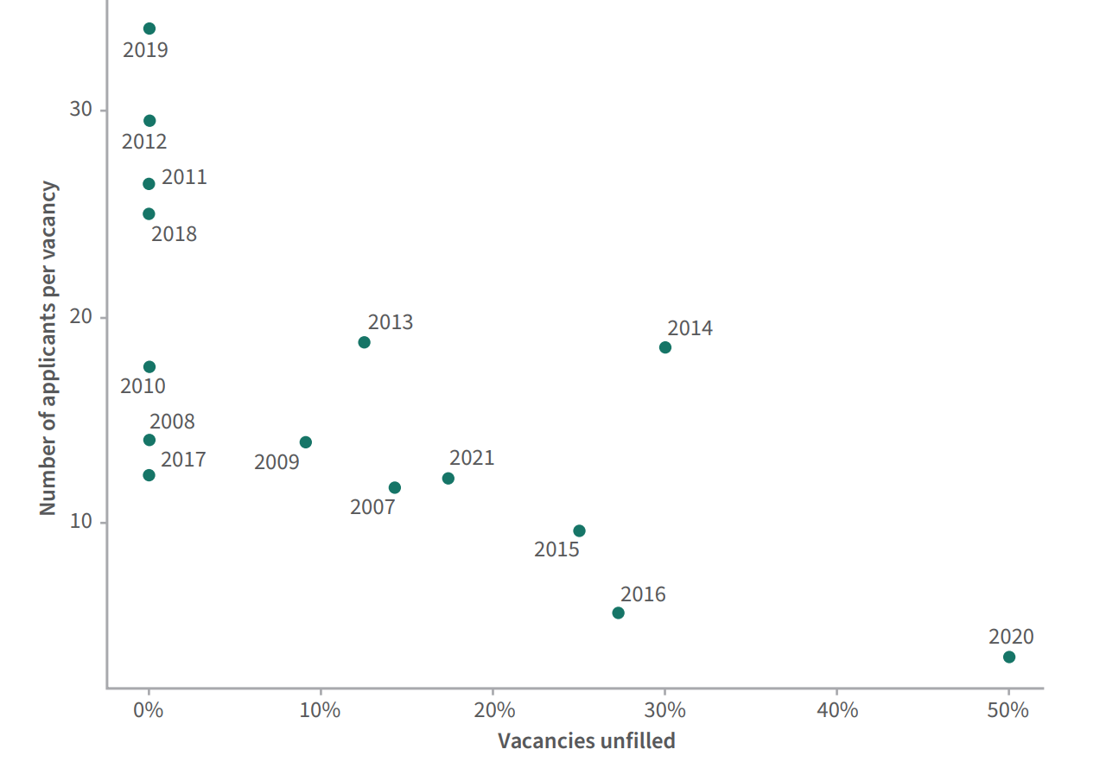
Figure 1: Number of applicants and suitability for posts applied for. Taken from 2021 NAEL report (NAEL, p 27).

This is particularly interesting as it suggests that in the three years pre-pandemic, 2019, 2018 and even 2017, application and levels of suitability for the role of school leader were comparatively healthy. The significant drop in 2020 needs to be treated with caution as the pandemic impact is not examined in any detail in the report. What the study does show however is that the pattern and numbers of applications, alongside a persuasive number of suitable candidates is very uneven in Wales and requires further elucidation. Certainty, the NAHT study quoted above, from 2021 indicates clearly that the years post-2020 are going to prove challenging for recruitment.

If, as the McKinsey report found, ‘staying power’ is a factor in effective leadership, a low number of ‘acting’ (i.e. not permanent) headteacher roles is desirable. According to the most recent workforce statistics for Wales (EWC, 2023), 120 headteachers are in acting roles, their tenure therefore not secure. This represents 8% of the country’s 1463 schools without permanent headteachers in place. The reasons for this are not examined in the report but the data does suggest that maintaining an effective and stable leadership workforce may be difficult in some places.

A report commissioned by the Department for Education (DfE) in England and published in 2023 looked at the working lives of teachers and school leaders. The data for the report was collected in the spring of 2022, the second school term that schools were fully reopen post Covid.

The DfE report for found that school leaders were working on average 56.8 hours per week (DfE, 2023, p.14). It is clear therefore that while my dataset, which I describe in detail below, focusses largely on the early pandemic period, studies conducted in the period since the reopening of schools are identifying continuing, potentially growing, areas for concern in this area.

The workload issue has long featured in reports into headteacher recruitment. A report from Scotland in 2009 looking at this found that only 8% of the teachers surveyed were considering leadership roles as part of their career aspirations. They cited ‘workload and work life balance; budgeting and finance; paperwork; disciplinary issues; managing staff absence; public speaking; lawsuits and litigation; interviewing new staff’ as the most significant disincentives along with ‘distance from the classroom’. (McBeath, 2009, p 8).

It is in this context – critical for all education jurisdictions – and particularly pertinent in
Wales at a time of significant educational change and demands associated with that,
It is important to look in greater detail at some of the factors that may influence school
leader attitudes, confidence and career progression.

Methods
I used a quantitative methods approach for this study. I examined secondary data produced for a research project conducted by the National Foundation for Educational Research (NFER), Schools’ Responses to Covid-19: Key Findings from the Waves 1 and 2 Surveys, 2020. (NFER, 2021).The data set held is on the UK Data Service - Economic and Social Data Services website.

The NFER’s 39-question survey, was sent to all 20,553 maintained schools in England. Responses were received from 9% of the 17,170 primary schools and 20% of the 3383 secondary schools in England. The survey was conducted from 7 to 17 May 2020 – i.e. in the early part of the Covid-19 pandemic. The data was then weighted to ensure that it was representative of all mainstream schools in England. The final NFER report analysed some categories of data that are not available in the open dataset to which I had access. Data on gender, age and length of service were omitted. No reason was given for this omission but it seems reasonable to assume that the restriction was captured in the ethics approval process at the outset of the project. In terms of future research, it would be useful to look in more detail at these categories. Over 75% of the school leader workforce in Wales is female. Women are under-represented in leadership roles which is my particular area of interest. It would be valuable to examine workload and other work/life balance data against gender for this reason. If female leaders cannot be attracted into these roles in the future, it will exacerbate existing recruitment difficulties. This should be of significant interest to policy-makers and employers alike.

I am partiularly interested in a subset of the data: those pertaining to headteachers/principals as one group and deputies/assistants as another. This section of the data holds 1233 individual records; 799 of these from head/principals and 433 from deputies/assistant headteachers.

I focussed particularly on data which captured school leaders’ views on the following: working hours, job satisfaction, manageability of the role, levels of control leaders felt they had over important aspects of their work. This required a detailed study of seven of the 39 questions asked in the survey. The questions I selected included nominal, ordinal and scale/interval data as below:
- What is your job role: Ordinal (Q1)
- What type of school do you work in? Ordinal (Q2)
- How many hours did you work pre-pandemic? Scale/interval (Q20)
- How many hours during specified period during the pandemic? Scale/interval (Q21)
- How manageable are your hours? Ordinal (Q22)
- How much control do you have over aspects of your work? Nominal (Q26)
- Overall, how satisfied/dissatisfied are you? Ordinal (Q27)

I used two main approaches in my analysis: descriptive statistics for the questions that were the focus of my study, and tests of statistical significance to pinpoint associations between the selected questions and the role of the respondent.

Results

Before I begin the analysis in detail, it is important that I recognise that these data relate to a point in time, and a point indeed when there was unprecedented change across all aspects of society and public services such as state-school education in particular. Schools in this period were largely closed to learners and staff. Schools did however remain open for the children of key workers and other vulnerable pupils, and were also transferring learning onto virtual learning platforms in order that pupils could still access classes from home. It is also evident that the impact of Covid is still very much present in schools. I argue therefore that this data can provide valuable insights into my area of interest. It is worth noting that the Chief Inspector for schools and colleges in Wales, noted in his annual report for 2022/23 that:
‘Welsh education and training providers face the dual challenges of recovering from the COVID-19 pandemic whilst also working to implement improvement focused policy reforms. The shadow of the pandemic remains apparent on learners’ wellbeing and the progress that they make. Learner attendance, attitudes to learning and aspects of learners’ knowledge and skills remain weaker than pre-pandemic norms. There are also lingering effects on the education and training workforce, with workplace absences compounding the ongoing challenge providers face in recruiting teachers and support staff members across a number of specialisms. (Estyn, 2023, p.2)

While this does not speak directly to the challenges facing school leaders (my area of focus) post-pandemic, it offers an insight into the range of continuing challenges in schools which inevitably impact on school leaders’ work.

To arrive at a more nuanced understanding of the challenges, I will particularly focus on drawing out differences in attitudes between heads/principals and deputies/assistant heads as the latter will likely form the pool from which future heads/principals will be drawn.

In order to establish the broad headlines for my study, I used descriptive statistical
approaches to examine these questions.

I started by examining the number of survey responses, by role.

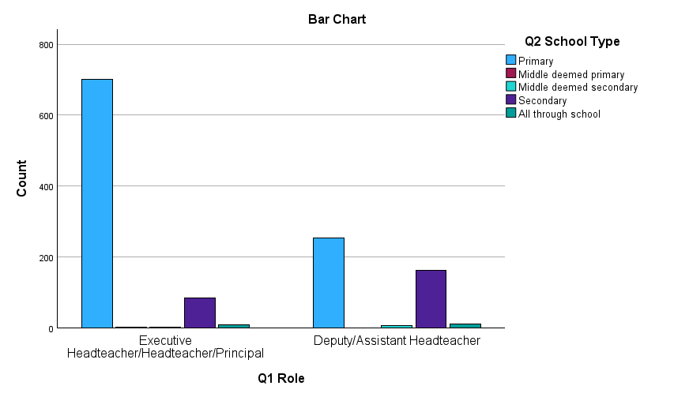
Figure 2: Number of survey responses, by role

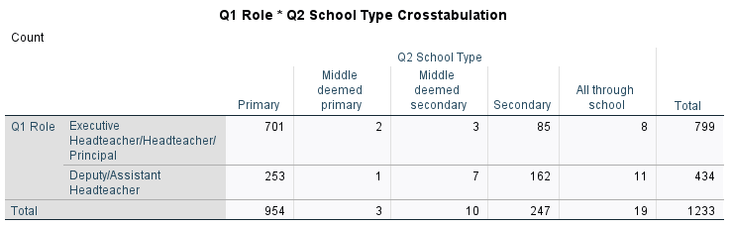

Figure 3: Table of numbers of responses, by role
For the purposes of this study, it is worth remembering that primary schools tend to have fewer practitioners in deputy/assistant headteacher roles than secondaries. In Wales, where the distribution of roles follows a similar pattern to that in England in this regard, the latest Education Workforce Council workforce statistics (EWC, 2023)
reported that, for example, only 29.1% of the total number of assistant headteachers were employed in primary schools, as opposed to 58.8% in secondary schools. At the time of the latest schools’ census (Welsh Government, 2023), Wales had 1,463 primary schools (80% of the total number) and 182 secondary schools (12% of the total). The figures below do not therefore support an assumption of a significantly lower response rate from this category of respondent in primary schools; it is simply that there are fewer of them.

It is equally important to note that more primary school head/principals and deputy/assistant heads have responded to the survey than secondaries which could skew the findings in favour of primary school responses. There are considerably more primary schools in Wales than secondaries as noted elsewhere in this report. However, since I am interested in the survey responses of all respondents in my leadership categories and wish to examine them in detail by role rather than school type, this should not have a bearing on my conclusions overall.

I then focussed on workload data, especially the impact of the early pandemic on working hours.

Focus 1: Workload pre- and during the Covid-19 pandemic

Workload is a key focus for this study. This data offers some useful information comparing pre- and during the Covid-19 pandemic in this area. Interestingly, overall, the working hours of school leaders decreased slightly between the pre-pandemic and the early pandemic period with the mean weekly working hours reducing slightly from 52.33 (Figure 4) pre-pandemic to 47.84 (Figure 5) during the early weeks of the pandemic.
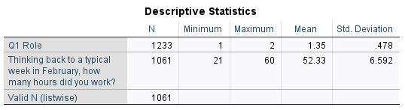
Figure 4: Table showing average number of hours worked weekly pre pandemic. All senior leaders.

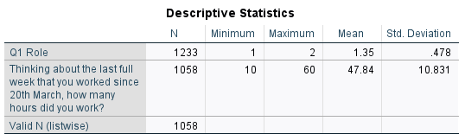
Figure 5: Table showing average number of hours worked weekly during the pandemic. All senior leaders.
The bar graph below provides a particularly helpful visual illustration of the differences.

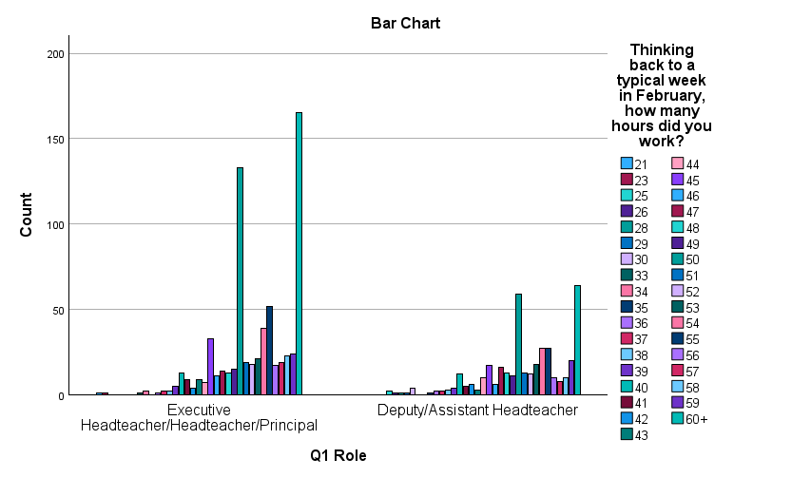
Figure 6 Bar chart showing typical working hours pre-pandemic, by role.
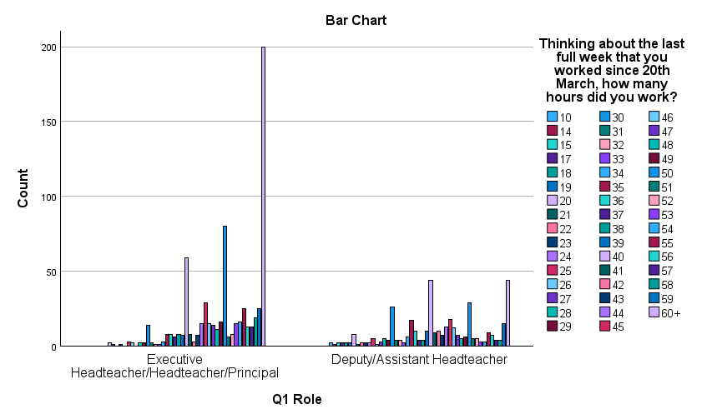
Figure 7 Bar chart showing weekly hours worked, by role, at the beginning of the pandemic

There are three further variables I wish to examine – manageability of workload by role (Focus 2), job satisfaction levels by role (Focus 3), and the levels of control each role feels they have over discrete elements of their work (Focus 4).

Focus 2: Manageability of workload by role

When school leaders were asked how manageable they found their working hours at the point at which the data was collected (early pandemic), the responses were as below. Again, the table is helpful in terms of the raw numbers while the bar graph is a helpful illustration of the scale difference between role and category.
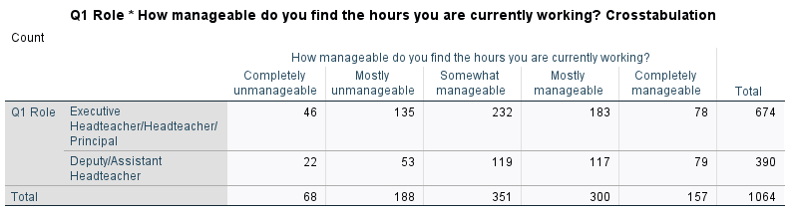
Figure 8: Manageability of workload by role

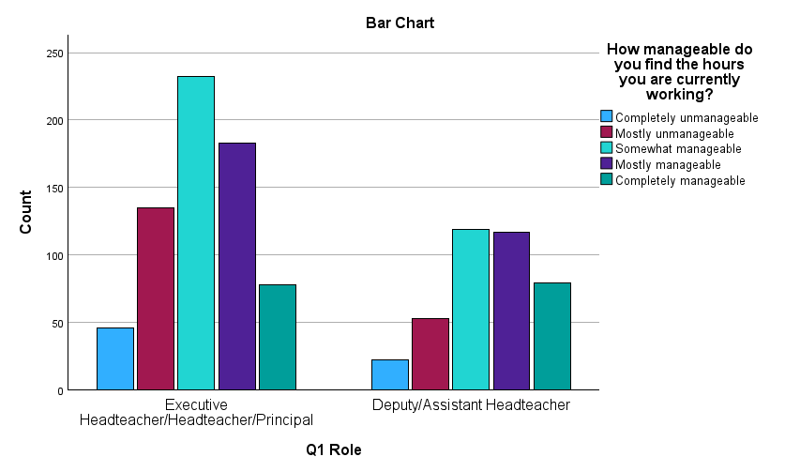
Figure 9: Bar graph of manageability by role
I used the data in the table to calculate the percentages of responses according to manageability and role. This showed that 27% of heads/principals and 19% of deputies/assistants felt that their workload was completely or mostly unmanageable at the point when they were surveyed. It is important to repeat the Covid caveat but the literature review above supports the need to continue to consider workload as an important factor in relation to school leadership and the attractiveness, particularly of the head/principal role for future applicants.

Focus 3: Satisfaction/dissatisfaction by role

The findings below are broadly similar to those for manageability of workload above. While the data does not necessarily provide a direct correlation between these two factors, it is reasonable to suggest that the existence of a link between dissatisfaction and the manageability of workload is a fruitful area for further study.

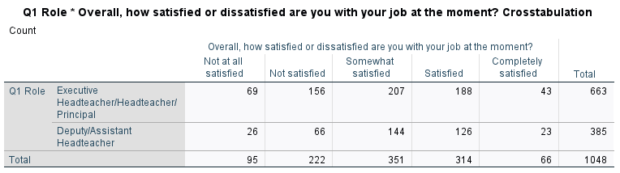
Figure 10: table showing satisfaction/dissatisfaction by role

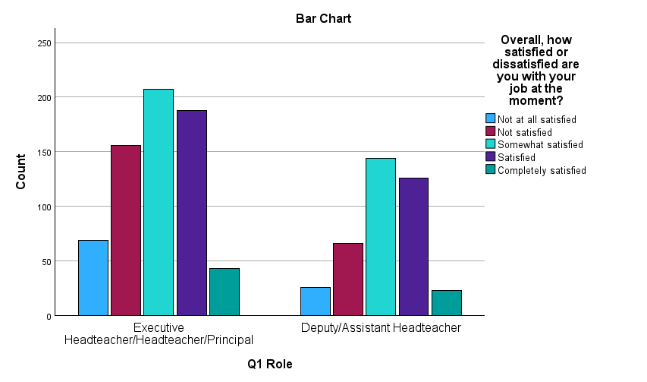
Figure 11: Table illustrating levels of satisfaction/dissatisfaction, by role

I again calculated the percentages based on the data in the table. The data shows that 34% of the heads/principals surveyed are not at all satisfied or not satisfied with their jobs at this point in 2020, and 24% of deputies/assistant headteachers.

This is a concerning proportion. The limiting factor here in terms of extrapolating from this 2020 study and attributing the same pattern to present circumstances is of course that the survey was carried out during the early weeks of the Covid pandemic when there was considerable uncertainty about delivery models, responsibilities and indeed the safety of staff and pupils. That in itself might provide sufficient reason for low satisfaction ratings.

It is instructive however that the DfE report published in 2023 signals that there is a continuing issue. In that study, 70% of school leaders (in this case measuring the response of heads, deputies and assistants en bloc) reported being satisfied in their jobs. (DfE, 2023, p. 19). This could indicate a continuing concern of similar magnitude to that examined in the NFER report.

I also looked at the extent to which school leaders feel that they have an element of control over specific areas of their work. These are: curriculum coverage, teaching and learning approaches, and control over assessment. All of these might be considered the bread-and-butter business of all schools everywhere, and it is reasonable to expect that school leaders are, and feel that they are, the primary experts and drivers in relation to these areas.

I looked first at the levels of control school leaders felt they had over ensuring
appropriate curriculum coverage.

Focus 4: Control against discrete areas of responsibility, by role.

Focus 4.1: Ensuring curriculum coverage
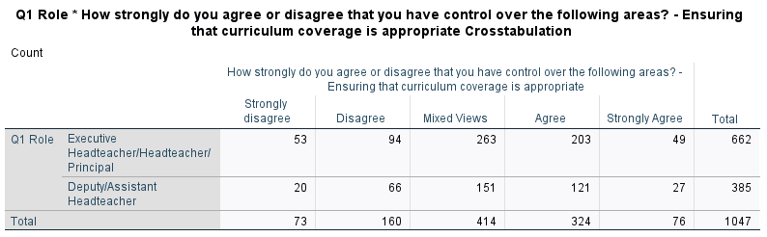
Figure 12: Table showing levels of control in ensuring curriculum coverage, by role

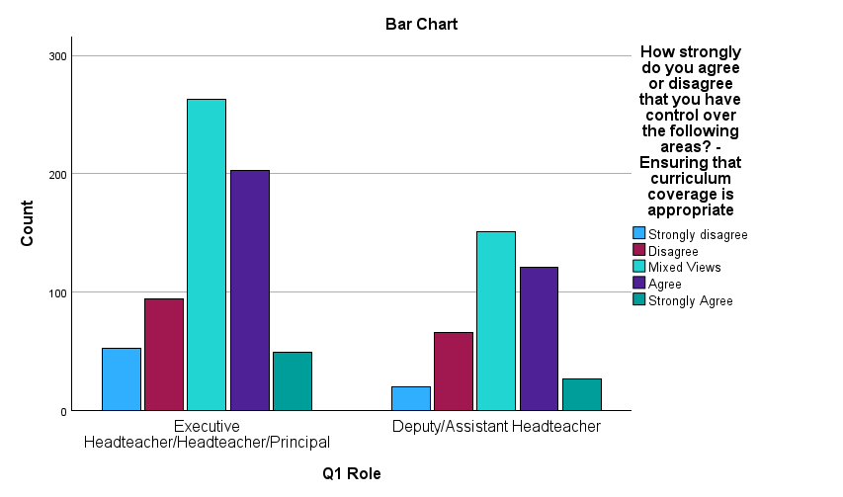
Figure 13: Bar graph showing levels of control in ensuring curriculum coverage, by role

Given the number of responses therefore, we can see that almost two thirds of heads/principals (62%) and deputies/assistants (also 62% of respondents to this question) strongly disagree, disagree or have mixed views when asked about their level of control over ensuring curriculum coverage.

I then looked at levels of control felt by headteachers and deputies/assistants with regard to ensuring appropriate approaches to teaching and learning.

Focus 4.2: Ensuring appropriate teaching and learning approaches

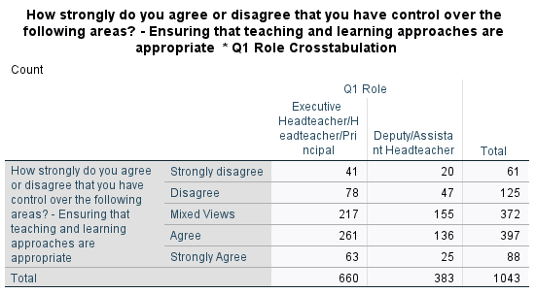
Figure 14: Table showing levels of control in ensuring appropriate teaching and learning approaches, by role
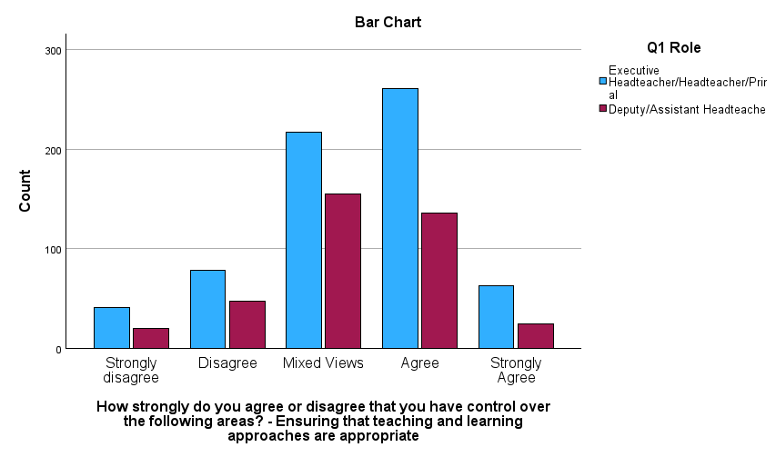
Figure 15: Bar graph showing levels of control in ensuring appropriate approaches to teaching and learning, by role

These data show that, of the total numbers surveyed in each role category, 51% of headteachers and 58% of deputies/assistants strongly disagreed, disagreed or had mixed views about the level of control they had over ensuring the appropriateness of teaching and learning approaches.

Again, the Covid context is a limiting factor in applying these findings to current circumstances. However, the 2023 DfE survey looking at the working lives of teachers and leaders reported that 62% of teachers and leaders felt they had insufficient control over their workload (DfE, 2023, p. 46). Although the DfE report does not specify particular areas for focus in the way that the NFER dataset does, the fact that almost two-thirds of the surveyed workforce feels they have insufficient control over their workload points to the problem persisting well beyond the end of the pandemic.

I next looked at levels of control over ensuring the assessment of learning. This question elicited the following responses:

Focus 4.3. Control over assessment

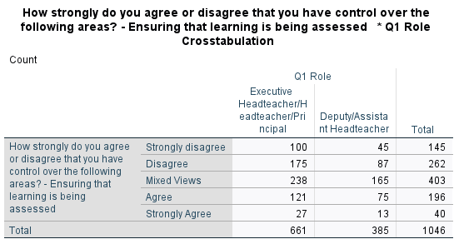
Figure 16: Table showing levels of control over assessment , by role
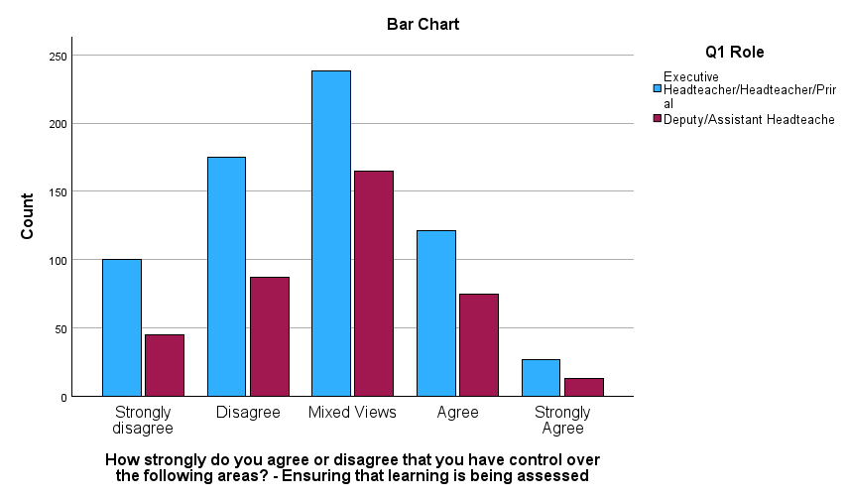
Figure 17: Figure 11: Bar graph showing levels of control over assessment, by role

In this case, the percentages are even more stark. Head/principal responses here
indicate that fully 78%, more than three-quarters of them strongly disagree, disagree,
or have mixed views regarding their control of assessment of learning. The figure is
at 42% even when ‘mixed views’ is removed. The percentage for deputies and
assistants (when the mixed views category is included) is 77%. These are notably
high numbers for an aspect of work which is at the heart of all schools’
responsibilities. Again, the Covid context is a limiting factor here and it may well be
that adjusting to online working and the challenges of being able to engage learners’
online and assess their progress is reflected in these responses. In a Welsh context
however, it would be instructive to look more closely at the levels of control that
school leaders feel around assessment, particularly considering the arguably more
complex picture represented by the requirements of the more locally focussed
Curriculum for Wales. This is all the more critical given that a 2021 Welsh
Government survey found that ‘around half of senior leaders were not clear about
how assessment arrangements will change in their school following the reforms and
what their school is required to do to plan their own assessment arrangements.’
(Welsh Government, 2021).

Having described my dataset on order to illuminate the most interesting aspects in the context of my area of interest, I then applied inferential statistical tests to examine associations between my selected questions. I again focussed particularly on: pre- and during pandemic data, role differences; manageability, satisfaction levels and differences by role against areas of schools’ work.

I used both Chi-tests and T-tests to examine my hypotheses and analyse differences between groups in which I was interested.

Hypothesis 1:
There is no difference between the working hours of school leaders (head/principals and deputies/assistants) pre- and during the Covid-19 pandemic.

I used a one-sample t-Test to examine this hypothesis. The test shows that there is a statistically significant difference between the pre- and during pandemic working hours reported in the survey. The ‘p’ value below is .001 which is significantly above the 95% confidence level.

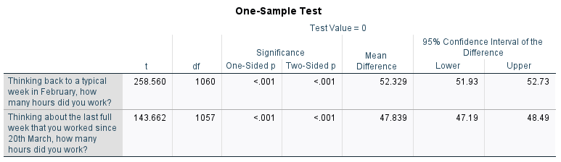
Figure 18: Table showing p level for working hours pre- and during the pandemic

I therefore reject the null hypothesis and show that there is indeed a difference in the hours worked between these two periods. Interestingly, as shown in the descriptive statistics section above, it is a downward movement, not the upward movement that might have been expected.

Hypothesis 2:
There is no difference in working hours, by role.

In this case I separated the heads/principals data from that for deputies/assistants and used a chi-square test to analyse the data.

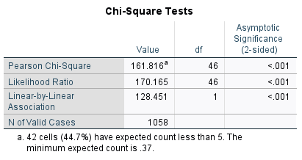
Figure 19: Table showing analysis of workload by role.
The two-sided significance level (p level) square test returned a p value of <0.001. I therefore rejected the null hypothesis and accept that there is a statistically significant difference in the hours worked by role.

The chi-quare statistic was$x$²= 161.816, with 46 degrees of freedom. The calculated statistic 161.816 is much higher than the 67.50 reported on the chi-square table at the 0.05 confidence level.

Hypothesis 3:
There is no difference in manageability of workload by role.
Again, I applied a chi-square test to analyse this null hypothesis.
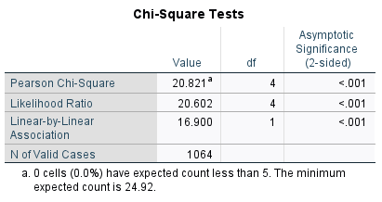
Figure 20: Table showing p level for manageability of workload, by role

The two-sided significance level (p level) test returned a p value of <0.001. I therefore rejected the null hypothesis and accepted that there is a statistically significant finding in terms of manageability by role.

The chi-quare statistic was$x$²= 20.821, with 4 degrees of freedom. The calculated statistic 20.821 is much higher than the 9.49 reported on the chi-squared table at the 0.05 confidence level.

We can therefore reject the null hypothesis and find that there is a difference in the manageability of job by role.

Hypothesis 4:

Null hypothesis: There is no difference in levels of satisfaction by role.

I examined this using a one-sample T-test to test the mean of the two given samples.

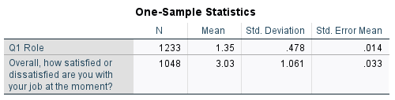
Figure 21:Tabe showing mean level of satisfaction
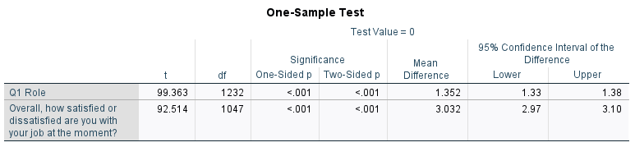
Figure 22: Table showing p level for levels of satisfaction bu role

The test shows that there is a statistically significant different levels of job satisfaction between head/principals and deputies/assistant headteachers.

Hypothesis 5:
There is no difference in levels of control in specific areas by role.

Here I looked at three separate areas, shown below in the summary table. I focussed only on the first three areas - curriculum coverage, teaching and learning approaches, and control over assessment.

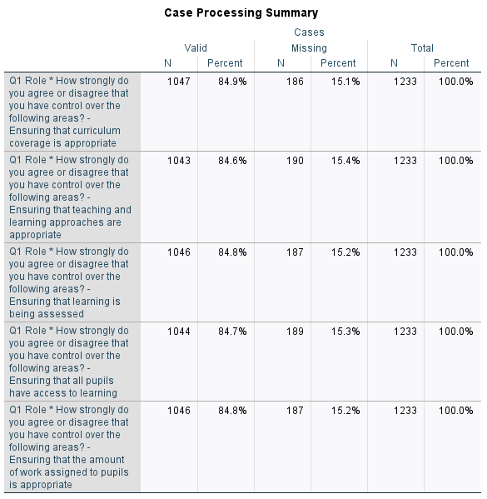
Figure 23: Summary table of responses by role. Extent of control over discrete areas of work.
Curriculum coverage:
The null hypothesis: that heads/principals have similar levels of agreement/disagreement regarding the extent to which they have control over curriculum coverage.

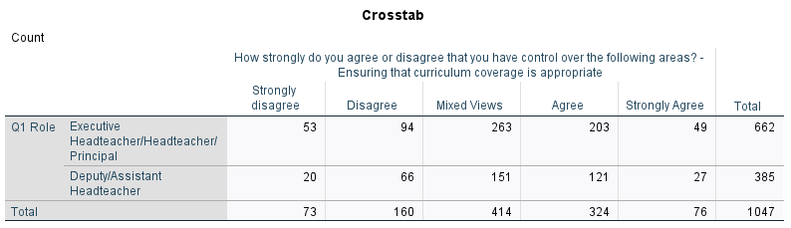
Figure 24: Extent of control over curriculum coverage by role.

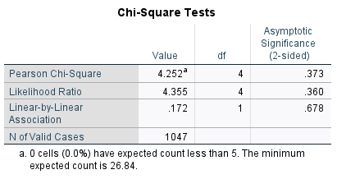
Figure 25: Chi-squared analysis. Extent of control, by role over curriculum coverage
The two-sided significance level (p level) test returned a p value of 0.0373. In this case we must therefore accept the null hypothesis and report that there is not a statistically significant difference between the extent to which heads/principals and deputies/assistants feel they have control over curriculum coverage.

The chi-square statistic was$x$²= 4.252, with 4 degrees of freedom. This is lower than the 9.49 reported on the chi-squared table at the 0.05 confidence level.

Again, there is a Covid-19 caveat here. Arguably there was more uncertainly about all aspects of school life during this period and that therefore these findings cannot be used to inform the present. However, given that, as established above, 62% of heads/principals and 62% of the deputies/assistants recorded that they disagreed strongly or disagreed that they had control in this area, it is a concerning finding. It also begs the question about where, if not with heads/principals and deputies/assistants such control lay during the Covid period. In terms of feelings of control over critical aspects of schools’ responsibilities, further studies should be conducted in this area for two reasons. The first in order to learn lessons against the possibility of having to move teaching online again at a future date, and secondly to examine whether these findings are markedly different at other non-pandemic times. Given that curriculum coverage, and indeed all the aspects I have focussed on in this section are key requirements in job descriptions for heads/principals and deputies/assistants, the extent to which they feel able to exercise the required control to affect outcomes for learners is of interest.

Learning and Teaching Approaches

The null hypothesis: That there is no difference in the feeling of control felt by heads principals and deputy/assistant headteachers in relation to the appropriateness of teaching and learning approaches.

Given the roles the study is examining, a high degree of confidence around the ability to assess the appropriateness of teaching and learning approaches, particularly amongst heads/principals is to be desired. Arguably this is their key responsibility.

One might therefore expect to see two things: a high degree of agreement that head/principals in particular feel they have control over these areas and, potentially a significantly higher level of agreement amongst heads/principals over deputies/assistant heads.

There is indeed a greater level of confidence in terms of control here compared to the other two categories I examine here. As noted above, 51% of headteachers and 58% of deputies/assistants are in the strongly disagree/disagree category this time.

The difference in feelings of control, by role, is not however statistically significant, as shown below.

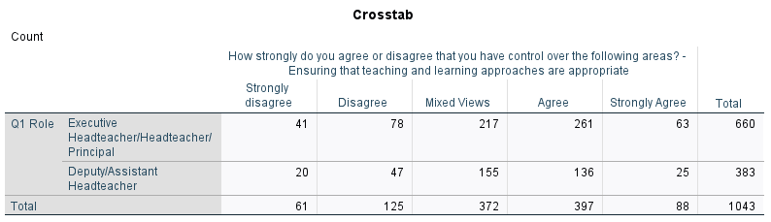
Figure 26: Table showing level of control over teaching and learning, by role

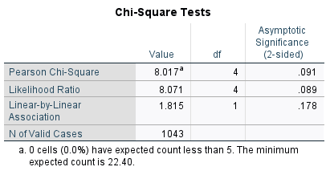
Figure 27: Table showing p level for control over teaching and learning, by role

The two-sided significance level (p level) test returned a p value of 0.091. In this case we must therefore accept the null hypothesis and accept that there is no statistically valid difference between levels of control with regard to the appropriateness of teaching and learning.

The chi-quare statistic was$x$²= 8.017 with 4 degrees of freedom. This is lower than the 9.49 reported on the chi-squared table at the 0.05 confidence level.

Control over Assessment

The null hypothesis: That there is no difference by role in terms of confidence levels in ensuring that learning is being assessed. This was a striking finding in the descriptive section above in that only 22% of heads/principals and 23% of deputies/principals agreed or agreed strongly that they had control over ensuring that learning was being assessed. Again, the impact of the pandemic is a limiting factor but particularly in Wales where Curriculum for Wales is now being implemented with a requirement that existing assessment arrangements are considered in very new and unfamiliar ways, maintaining a focus on confidence levels around control of assessment of learning among senior leaders in schools will be very important.
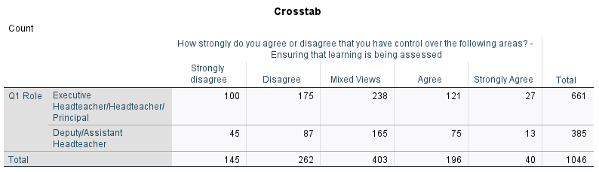
Figure 28: Levels of control on assessing learning, numbers by role

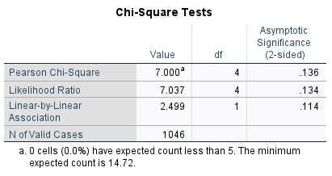
Figure 29: Analysis of levels of control of assessment of learning, by role
The two-sided significance level (p level) test returned a p value of 0.136. In this case we must therefore accept the null hypothesis.

The chi-square statistic was$x$²= 7.000, with 4 degrees of freedom. This is lower than the 9.49 reported on the chi-squared table at the 0.05 confidence level.

For the purpose of this study however, we see that there is no statistically valid difference between levels of control felt by head/principals and deputies/assistants in terms of assessment for learning.

Discussion and conclusions

This study demonstrates that while some of the factors examined in detail, drawn from the NFER dataset, are to an extent time-specific in that they refer to a manifestly unusual set of circumstances during the early pandemic period, other studies both before and after that time point to similar findings. Workload, levels of satisfaction and control, and recruitment and retention issues remain pressing in the maintained school sector. The fact that one of the earliest studies quoted (MacBeath et al, 2009) refers to a lack of enthusiasm amongst assistant heads to apply for head/principal roles is testament to that.

It is interesting to note that while deputies and assistant headteachers felt relatively more comfortable in terms of the manageability of their workload, their weekly working hours and their levels of job satisfaction, there was very little difference in their feeling of control over key aspects of their professional responsibilities – curriculum, teaching and learning and assessment. Naturally, the Covid context may be a very important factor here but a lack of a feeling of control also features in other studies, studies which were conducted outside the Covid period.

The findings also indicate other areas which may be worthy of further research. These include:
- An analysis of workload, levels of control and job satisfaction with reference to gender, age and length of service. The question of gender is particularly pertinent in a profession where there-quarters are female. Unless a significant number of these can be attracted into leadership positions, recruitment difficulties can only become more acute. If there are barriers to their progression linked to these factors explicitly, it would be useful to identify these and address them.
- The data on levels of job satisfaction and those for the manageability of workload were noticeably similar. Role models are important in the promotion of career choices; significant levels of dissatisfaction are unlikely to help in the development of passionate advocates for school leadership roles. If workload is the most pertinent factor in satisfaction levels, this may be a further reason to make determined efforts to address it. Additional data is however required to make this link absolutely explicit.
- The NFER data showed an extremely high percentage of head/principals and deputy/assistant heads who lacked a feeling of control around ensuring that learning is being assessed. Given that assessment, and how to assess well in the context of Curriculum for Wales is a very topical issue in Wales, measuring school leader confidence in this area may offer a valuable area of study.
- The data showing low levels of control that school leaders felt with regard to their main areas of responsibility – curriculum, assessment, and teaching and learning - were particularly striking. Looking at these factors in greater detail outside a pandemic period should be considered, both to secure a better position should we ever again face a situation which calls for enforced school closures, and to understand whether these were in fact a Covid outlier finding or an area of more general concern.

References

Bryman, A. and Cramer, D.(2011). Quantitative data analysis with IBM SPSS 17, 18
and 19: A guide for social scientists. Routledge.

Bryman, A. (2016). Social Research Methods. 5th ed. Oxford: Oxford University
Press.

Byrne, D. (2002). Interpreting Quantitative Data. London: Sage.

O'Dwyer, L.M. and Bernauer, J.A. (2014). Quantitative Research for the Qualitative Researcher. Thousand Oaks, CA: SAGE Publications

Education Workforce Council. (2021). 2021 National Education Workforce Survey Report [online]. Available from: file (ewc.wales) [accessed 17.05.24]

Estyn. (2023). HMCI Annual Report 2022-23 [online]. Available from: https://annual-report.estyn.gov.wales/ [accessed 14.05.24]

Independent Welsh Pay Review Body. (2023). A Strategic review of the structure of teachers’ and leaders’ pay and conditions in Wales [online]. Available from: A STRATEGIC REVIEW OF THE STRUCTURE OF TEACHERS’ AND LEADERS’ PAY AND CONDITIONS IN WALES (gov.wales) [accessed 1.5.24].

MacBeath, J., Gronn, P., Opfer, D., Lowden, K., Forde, C., Cowie, M., O’Brien, J., (2009). The recruitment and retention of headteachers in Scotland. Edinb. Scott. Gov.

McKinsey. (2009). How the world’s most improved education systems keep getting better [online]. Available from:
https://www.mckinsey.com/industries/education/our-insights/how-the-worlds-most-improved-school-systems-keep-getting-better [accessed 15.05.24]

NAHT. (2021). The School Leadership Supply Crisis [online].
Available from: https://www.naht.org.uk/Our-Priorities/Other-policy-areas/Policy-
research/ArtMID/591/ArticleID/813/The-School-Leadership-Supply-Crisis
[accessed16.5.24]

NAEL. (2021). Recruitment and Retention of Senior School Leaders in Wales
[online]. Available from: https://nael.cymru/en/insight/recruitment-and-retention-of
senior-school-leaders-in-wales [accessed: 12.05.24]

NFER. (2021). Schools’ Responses to Covid-19: Key Findings from the Waves 1 and 2 Surveys, 2020 [online]. Available from: UK Data Service. SN: 8687, DOI: http://doi.org/10.5255/UKDA-SN-8687-2 [accessed 25.04.24]

NCSL. (2006). Seven strong claims about successful school leadership [online].

Available from: https://assets.publishing.service.gov.uk/media/5a7df7f9e5274a2e87daeb06/seven-claims-about-successful-school-leadership.pdf [accessed 12.05.24].

Welsh Government. (2021). Practitioner survey on preparations for Curriculum and Assessment Reforms 2022: interim findings from primary and secondary school senior leaders [online]. Available from: Practitioner survey on preparations for Curriculum and Assessment Reforms 2022: interim findings from primary and secondary school senior leaders | GOV.WALES [accessed 10.05.24].

Welsh Government. (2023). [online] (https://statswales.gov.wales/Catalogue/Education-and-Skills/Schools-and-Teachers/teachers-and-support-staff/school-workforce-annual-census/teachers/teachers-by-staffcategory-agerange) [accessed 12.05.24].

Department for Education. (2023). Working lives of teachers and leaders – wave 1 Research report April 2023 [online]. Available from: Working lives of teachers and leaders – wave 1 - GOV.UK (www.gov.uk) [accessed 10.05.24].

