Hotel Organisational Audit

Student name: Cristian Paveliuc
Module name: Management & Organisational Behaviour (BMIH5004)
Lecturer name: Julia Ault

Executive summary
This report entails the selection of Premier Inn Hotels, established in 1987. The headquarters is in Dunstable, UK and is founded by Whitbread. The main objective of the report is to showcase the impact of the organisational culture on the current managerial style undertaken by the hotel. This type of initiative is useful for understanding the internal culture of the hotel which is useful for influencing workplace collaboration to a major extent. The relevance of organisational culture helps in preaching the values and beliefs of the organisation. In the long run, the organisational culture determines the behaviour of the employees in the workplace. The following assessment takes into consideration the study of Premier Inn Hotel with its headquarters in the UK. The values, assumptions, and beliefs of the organisation also influence the team behaviour of the Premier Inn Hotel. The organisation also specialises in providing standard customer service with its widespread hotel and restaurant chain all over the nation.

Contents
Introduction 4
Discussion 4
Organisational Structure, culture and Goals 4
Recent initiatives with the changing trend 6
The Impact of organisational structure and its management 7
Organisation’s strategic management 8
Evaluation of current organisational performance 9
Conclusion 10
Reference List 11

Introduction
Organisation culture plays a primary role in highlighting the type of managerial practices followed in the internal business structure of Premier Inn Hotel. Based on this consideration, the culture and objective of the hotel have been discussed in detail to understand the factors influencing the behaviour of employees. It has been observed that the employee attitude act as a major pointer for enhancing the customer experience in the field of Hospitality Management. The impact of organisational structure has been aligned with the recent change initiative and strategic management to combat the detrimental impact of Covid-19 on the business performance of the hotel.

Discussion

Organisational Structure, Culture and Goals
Organisational culture is termed as the study of a respective organisation’s beliefs, values and attitudes. The impact of the organisational culture influences the worker's behaviour within the workplace. The relevance of organisational culture can also be based on the experiences of the customers in hospitality management. The importance of organisational culture helps in reshaping organisational behaviour such as the proactive or passiveness of the employees, the strategy of team worker or solo player. The employees who break the rule or follow it need to be identified. The concerned behaviour of the employees in the workplace also needs to be identified. The importance of an organisational culture of Premier Inn Hotel reflects some positive impacts within the workplace. The corporate teamwork of the employees within the workplace helps to achieve the corporate goals and strengthens the organisational structure. The teamwork helps in internalising the organisational value, motivating the employees to achieve the business objectives, and so on. The values, assumptions, and beliefs of the organisation also influence the team behaviour of the Premier Inn Hotel. The guidance of the culture present in the organisation paves the way for resolving strong and unchallenged issues within the workplace.
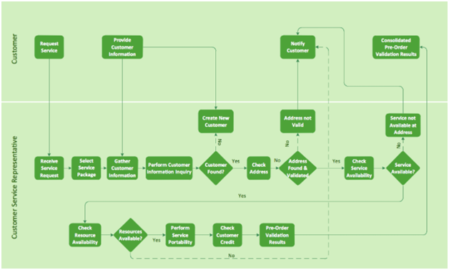
Figure 1: Organisational Structure of Premier Inn Hotel

The organisational structure of Premier Inn Hotels mainly focuses on the requested service and generating customer information. The allocation of a new customer base also helps in the business expansion of the organisation. It has been witnessed that during the COVID-19 pandemic situation, the organisation has closed most of its restaurant chains and hotels by 23rd March 2020 (Cdn, 2023). Later on, the organisation reopened some of its restaurant chains by the year 2020 in the month of July. Based on the legal regulations of the UK government the organisation was forced to close its chain of hotels in England by 5th November 2020. The company has faced many closures but retained its strategy and business growth with effective financial management and long-term goals.
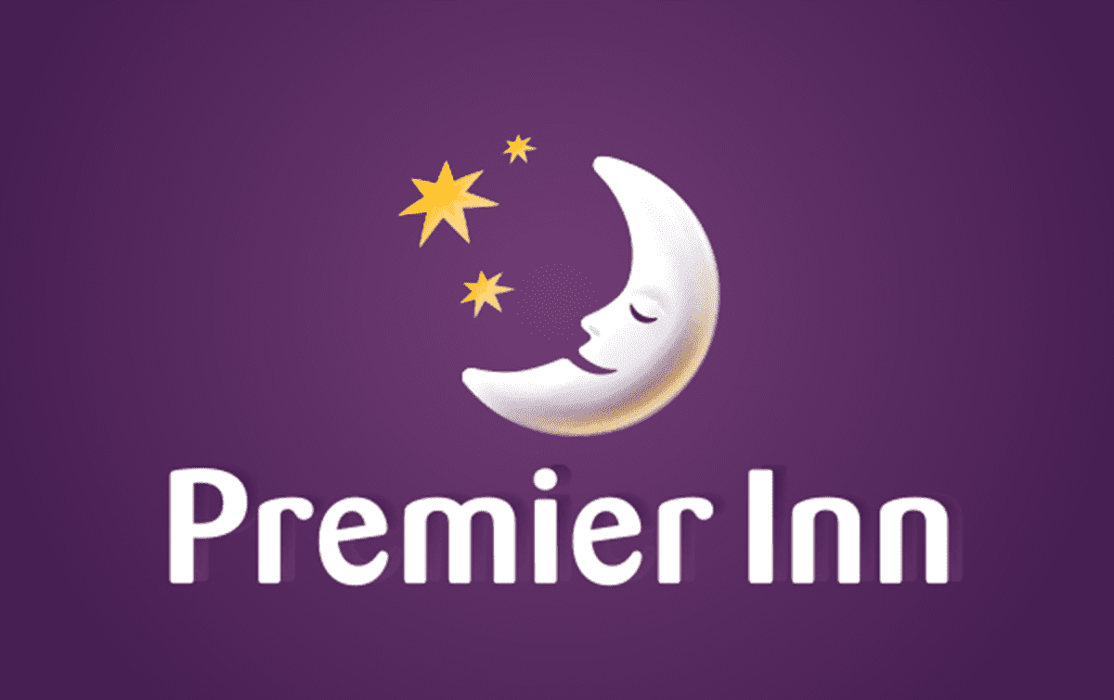
Figure 2: Premier Inn Hotel LOGO

Recent initiatives with the changing trend
The organisation has faced a major loss during the COVID-19 pandemic situation with the closing of major hotel and restaurant chains of the organisation. By the beginning of the year 2021, Premier Inn Hotel in the UK market has faced a loss of $ 25.6 billion due to the influence of government regulatory measures and lack of customer engagement. With the rising trend most of the customers nowadays, are health conscious and prefer the best customer service facilities within the property. The organisation has focused on an effective team management strategy to enhance overall organisational performance. The strong and effective team collaboration also helps in encouraging and motivating the self-esteem of the individual (Volodymyrivna and Andriyich, 2019). Thus, the employees strive hard to achieve the business goals of the organisation in the long run. As a result, the organisational structure strengthens with time providing quality service to the customer. Premier Inn Hotel focuses on implementing the concept of sustainable regional development to understand the changed approach of the organisation. The organisation has created team-building activities to ensure the proper functioning of all the employees in the workplace. The strategy of encouraging the production process can be maintained by nature-friendly principles with taking into consideration environmental concerns.
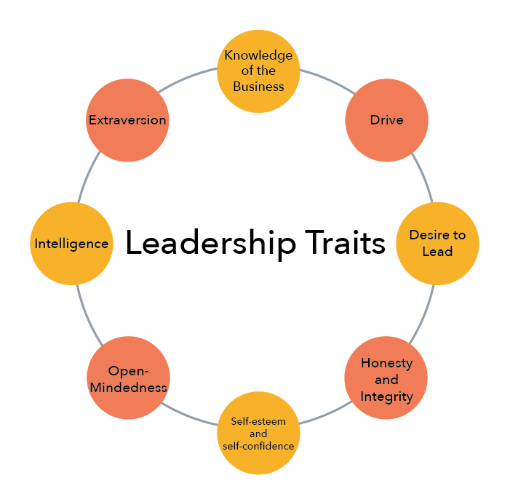
Figure 3: Trait Theory of Leadership
(Source: Theblacksheep, 2023)
The organisation also works on the principle of the Trait Theory of Leadership that emphasises the inborn quality possessed by the individual. The maintenance of social interactions and workplace controversial situations can be resolved with the help of leadership theories. With the help of this theory of leadership, Premier Inn Hotel can understand the employee's perspective while working in the workplace. The study of individual behaviour also helps in encouraging collaboration of the team to execute the task. The payment of environmental taxes is used by the government of the UK to limit the allocation of resources by the business authorities. Premier Inn Hotel aims in the future development of automated service facilities to the customers which will reduce the wastage of resources by 75% respectively. The organisation is engaged in funding $ 14.5 billion by the year 2025 to generate innovative AI technology that will reduce the wastage of property. The organisation has focused on an effective team management strategy to enhance overall organisational performance (Tandon et al. 2023). The strong and effective team collaboration also helps in encouraging and motivating the self-esteem of the individual. The customer engagement of the customer has increased by 55% by the end of the year 2021 due to effective customer service. The use of an effective sustainable management strategy followed by the organisation helps to balance the key factors of hospitality management.

The Impact of organisational structure and its management
Organisation structure acts as a critical component of the business which helps in setting a proper framework which is required to be followed by Premier Inn Hotel. For instance, communication and coordination help in facilitating workplace collaboration and managing people effectively in the decentralised departments of the hotel (Foroudi, 2020). This is where the organisation structure acts as the interface for meeting the business objective of the hotel within a stipulated deadline. There are several dimensions as per the organisation structure framework which helps in centralising the decision-making process. According to Gartner Report, it has been noted that tightening managerial control helps in providing a competitive business framework to the employees of the hotel by 89.3% whereas too much flexibility can lead to business failure since worker autonomy lacks due to job standardisation and legal policies (Nicolaides, 2019). Extensive formulation of the organisation structure is regarded as the bureaucracy characteristic and greater formalisation is useful for improving the individual performance of the employees. This is mainly due to the fact that the designated responsibilities are divided into separate elements as per the specialisation of the employees. As per the horizontal differentiation of the organisation structure showcased in Figure 1, the hierarchical management layers of Premier Inn Hotel help in increasing spatial differentiation. This generally means that the hotel can operate internationally in other sites and greater specialization helps in influencing the adaptability quotient of workers such that they can adjust to the changing requirement of the business.
It has been observed that the current organisation structure of Premier Inn Hotel has benefited the employees by 44% as the framework highlights responsibility and authority in a clearly defined manner. This type of strategy by the hotel is useful for enhancing the team spirit such that their motivation can help in active promotion for a higher compensation package. A good organisational structure helps in defining the roles of the employees to ensure that the workload is similar and structured for each employee. The formal organisational structure helps to increase overall organisation productivity by 91% (Liu and Yang, 2021). This has assisted Premier Inn Hotel to establish a strong corporate brand image in the competitive hospitality industry. Additionally, professional training is also provided to the employees such that they can enhance their current skills while retaining within the organisation. It is the responsibility of the manager to incorporate efficient communication practices for governing workflow and forging stronger relationships, thereby improving the operational efficiency of the organisation.

Organisation’s strategic management
Hierarchical Decision-Making
As per the organisation structure of Premier Inn Hotel, it has been observed that approximately 52% of the employees are at the top level of management whereas 24% of the employees are at the middle level of management (Oriade et al. 2021). Both the levels play an active role in influencing the quality decision making which enhances the business performance of the hotel to a major extent. It has been noted that hierarchical decision-making help in providing a standardised procedure which helps in reducing the overall office cost and provides action uniformity. The Trait Theory of Leadership incorporated by the organisation is useful for regarding the opinion of each employee as significant for facilitating quick action and meeting the business objectives and purpose. The strategic management of the organisation helps in optimising the usage of time and enhancing the performance output of employees to a major extent.
Job Satisfaction
The competent organisation structure helps in increasing the job satisfaction of employees to a major extent. It has been observed that approximately 52% of the employees are satisfied with their job designation and 36% of the employees are partly satisfied (Chen, 2019). The strategic management of the organisation helps in understanding the various needs of the employees. Job satisfaction is highly dependent on the type of perspective of employees towards the Premier Inn Hotel. It has been observed that most of the competing hotels face a high employee turnover rate and this is the main reason why the financial strength of the competitors is weak. The strategic management of Premier Inn Hotel is useful for establishing a healthy work culture to meet the satisfaction of employees with reference to behaviour, cognition and effective reaction. For instance, numerous perks such as medical expenses, paid leaves, and performance bonuses can be provided to employees to enhance job satisfaction content (Abo-Murad et al. 2019). Additionally, professional training will help the employees to enhance their current skill set while retaining within the organisation. The strategic management of the hotel help in increasing the efficiency of employees by delegating the responsibilities to employees in a proper way. The responsibility of the manager is to comprehend the skill set and delegate responsibility accordingly for strategizing the planning process. The effort and time required to execute the designated responsibilities of the hotel are useful for increasing business efficiency. Therefore, the expert opinion of employees is considered significant for building a strong organizational structure to eliminate conflict and enhance profitability prospects.

Evaluation of current organisational performance
The organisational structure of Premier Inn Hotel comprises of five sections such as the chairman at the uppermost level and the non-executive directors at a lower level. The group of finance directors manages the financial structure of the organisation. The overall expenditure and revenue generated are all conducted and maintained by the financial department. The group of Human Resource Management is engaged in recruiting efficient manpower to meet future business objectives (Volodymyrivna and Andriyich, 2019). The chief executive looks after all the management-related decisions in the workplace under the supervision of the chairman. After the pandemic situation, the organisation has gone through tough phases to strengthen its business structure. By the year 2021, Premier Inn Hotel has generated an amount of $ 14.5 billion from the chain of hotels in the UK and the restaurant chain contributed about $ 3.2 billion. The organisation has a strong and elaborate financial and team management strategy which has helped in enhancing the market reputation of the organisation in the UK market. With the influence of the rising trend in the global market, most of the customers are concerned about the maintenance of sustainable management (D'Acunto et al. 2023). The engagement of customers and sustainable development strategy followed by the organisation enhances the overall performance of the UK nation. The analysis of the environmental concerns also affects the organisational performance to a large extent. Many social sites and adverts channels also demonstrate the developed performance of Premier Inn Hotel. The study of individual behaviour also helps in encouraging collaboration of the team to execute the task. The payment of environmental taxes is used by the government of the UK to limit the allocation of resources by the business authorities. The current financial statement of the organisation estimates a profit of $ 30.2 billion by the end of the year 2023. The hotel chain of Premier Inn Hotel is regarded as one of the standard customer service facilities provided by the organisation.

Conclusion
Based on the findings, it has been observed that Premier Inn Hotel has faced a major loss during Covid19. The current organisation structure has been discussed in detail which has helped in understanding the internal business framework of the organisation. The structure is revised such that the business can internationally expand while adhering to the legal rules and regulations of the UK. This is where strategic decision-making plays an important role such that the hotel can adjust to the changing trends of the economy. Lastly, the Trait Theory of Leadership has proved useful in enhancing workplace collaboration practices in the hotel.

Reference List

Abo-Murad, M., Abdullah, A.K. and Jamil, R., 2019. Effect of the organisational culture on crisis management in hotel industry: A qualitative exploration. International Journal of Entrepreneurship, 23(2), pp.1-18.
Cdn.whitbread.co.uk. 2023. https://cdn.whitbread.co.uk/media/2021/02/12122648/pihl-accounts-final-signed.pdf [Accessed on 13/06/23]
Chen, L.F., 2019. Hotel chain affiliation as an environmental performance strategy for luxury hotels. International Journal of Hospitality Management, 77, pp.1-6.
D'Acunto, D., Filieri, R. and Amato, S., 2023. Hotels’ environmentally-framed eWOM. The moderating role of environmental culture. Tourism Management, 98, p.104776.
Foroudi, P., 2020. Corporate brand strategy: drivers and outcomes of hotel industry’s brand orientation. International Journal of Hospitality Management, 88, p.102519.
Liu, C. and Yang, J., 2021. How hotels adjust technology-based strategy to respond to COVID-19 and gain competitive productivity (CP): strategic management process and dynamic capabilities. International Journal of Contemporary Hospitality Management, 33(9), pp.2907-2931.
Nicolaides, A., 2019. Ethical leadership in a morally driven hospitality organisational culture. African Journal of Hospitality, Tourism and Leisure, 8(5), pp.1-14.
Oriade, A., Osinaike, A., Aduhene, K. and Wang, Y., 2021. Sustainability awareness, management practices and organisational culture in hotels: Evidence from developing countries. International Journal of Hospitality Management, 92, p.102699.
Tandon, A., Dhir, A., Madan, P., Srivastava, S. and Nicolau, J.L., 2023. Green and non-green outcomes of green human resource management (GHRM) in the tourism context. Tourism Management, 98, p.104765.
Theblacksheep.community. 2023. https://www.theblacksheep.community/trait-theory-of-leadership/ [Accessed on 13/06/23]
Volodymyrivna, F.S. and Andriyich, T.S., 2019. DEVELOPMENT TRENDS OF HOTEL CHAINS IN THE UKRAINE. ENTERPRISES IN THE MODERN BUSINESS ENVIRONMENT 9, p.22.

