

Building a Secure Home Network
by
Justin Rastatter

Supervisor: Dr Kapilan Radhakrishnan

Project submitted as part of the requirements for the award of BSc (Hons) Computer Networks and Cybersecurity

April 2018

DECLARATION

I, ............................................FULL NAME………………………………… declare that I am the sole author of this Project; that all references cited have been consulted; that I have conducted all work of which this is a record, and that the finished work lies within the prescribed word limits.

This work has not previously been accepted as part of any other degree submission.

Signed: .............................................

Date: ...............................................

FORM OF CONSENT

I ............................................FULL NAME………………………………… hereby consent that my Project, submitted in candidature for the B.Sc.(Hons) Computing & Information Systems degree, if successful, may be made available for inter-library loan or photocopying (subject to the law of copyright), and that the title and abstract may be made available to outside organisations.

Signed: .............................................

Date: ...............................................

Copyright Acknowledgement

I acknowledge that the copyright of this project report, and any product developed as part of the project, belong to University of Wales Trinity Saint David, Swansea.

ABSTRACT/SYNPOSIS

In this project there are a number of topics discussed which all relate to the aims and object of this report which are to gain a better understanding of the threats to home networks, to gain and understanding of the security issues with home networking, to have a good layout plan for the home network and to be able to provide some form of recommendation guide for new and existing home network users, it covers the design and implementation of the hardware purchased for the network and multiple screens shots of the security methods used towards the end of the report there’s the testing chapter, after that there’s the recommendation guide which was a aim to be able to provide, then there’s the reflections chapter this is where it will look back on the report and talk about the thing leaned, and what can be done better, to end the report will be a list of references with a short glossary with the description of abbreviations.

Table of Contents
Copyright Acknowledgement 3
ABSTRACT/SYNPOSIS 3
Chapter 1 8
1.1 Introduction 8
1.2 Aim 8
1.3 Objectives 8
1.4 Structure of the Project 9
Chapter 2 Research and Review of Literature 10
2.1 Introduction 10
2.2 Literature Review 10
2.2.1 Current home network problems 10
2.2.2 Security issues with home networking 10
2.2.3 How to deal with current security issues with home networking 15
2.2.4 Mobile Device Security issues 18
2.2.5 Wireless networking problems 18
Chapter 3 Methodology 20
Chapter 4 Design and Implementation 21
25
26
Chapter 5 Testing 28
Future work 31
Recommendations Guide 32
Reflections 33
References 34
Glossary 36
DDOS – Distributed Denial of Service 36

Figure 1Ransomware in Greater Preston NHS 12
Figure 2 How a VPN works [15] 13
Figure 3 Malwarebytes installation 15
Figure 4 Interference levels of different Materials [26] 17
Figure 5 - 2 Floor Network Layout 19
Figure 6 Original Network Layout 20
Figure 7 Modem and Wireless Router on Ground Floor 20
Figure 8 Wi-Fi turned off on Super Hub 21
Figure 9 5 port Switch 21
Figure 10Main page of Router GUI 22
Figure 11 DHCP IP pool 23
Figure 12 Firewall Securtiy 24
Figure 13Ai Protection 25
Figure 14 Kali Linux showing up on devices connected to the network on the mobile app 26
Figure 15 Wireless USB Adapter 27
Figure 16Kali Linux Interfaces 27
Figure 17Using Netdicover to find device on the network 28
Figure 18 Using Zen map to scan port on the network 29

Table 1Top 7 attacks 2016 -2017 9

Chapter 1

1.1 Introduction
In this report, it’s going to investigate the fundamentals of home networking and how to plan and build a secure home network, this is going to cover all the major aspects of building a home network from what equipment will be needed i.e. cables, routers, modems PC’s. the report is going to be discussing the several types of networking security which could be used for the home network which will range from network attacks such as DDOS attacks, brute force attacks, and how they can help protect your home network, this will be anything from firewalls and what rules can be used also what wireless networking security protocols are the best to use this will be a good size of the report since most if not all home network have wireless access. Combined with in-depth discussions on the various networking threats that are common with home networking

Firstly, the research is going to be identifying and discussing the major networking attacks that can cause problems for a home network and what you can do to help reduce the probability of these types of attacks, since there is no one way to completely stop certain attacks there will be a section within the research chapter which will include what can be done to make the attacks less probable.

After the research element is done, all the information and knowledge gain from it will be put into the design and implementation stage of the project this will be where all the network design and layout will be done along with what security protocols will be used to help secure the network

1.2 Aim
The main aim of this report is to construct a secure home network. The reason for selecting this topic is because most households have an internet connection and some people might not have a great understanding of the wide range of threats that come with home networking.

1.3 Objectives

The objectives are to:
- To gain an understanding of security issues with current home networking.
- To understanding the multiple threats that can affect networking and how to deal with them.
- To determine what protocols to use for the home network.
- Plan a layout of the network and where to place equipment.
- Implement the information gained to plan and begin creating the home network.

1.4 Structure of the Project

Chapter one illustrates an overview of the report. It details the aims and objectives that once achieved will bring success to this research.

Chapter two concentrates on research and reviews of several academic sources, comparing them against each other and reviewing what each say about a certain aspect.

Chapter three details the research approach and design that will build up to having a secure home network.

Chapter four this is where all the information gained from the research aspect will be put into action, at this point the planning and configuring of the network will start.

Chapter five this will be the testing and evaluation stage of the report, taking the information gained form the network and research then evaluating to see if it was successful.

Chapter six this chapter will be a conclusion/summary and recommendation stage, this will be what has been done within the report, and what can be done in future research.

Chapter 2 Research and Review of Literature

2.1 Introduction
The layout of this chapter will be put into different sub sections each with a little introduction on the sections topic, these will range from basic to advanced, since the topic of this report is building a secure home network there are some parts of the research that will be more advanced in terms of terminology used. there will be a glossary at the end of the report.

Within each section/chapter there will be many different sources talked about. This will include anything thing from academic papers to reliable websites.

2.2 Literature Review
This section of the report will have the mass of the research needed to achieve the aims and objectives of this project. Each main section will have its own section which will then lead into sub-sections for each specific topic.

2.2.1 Current home network problems
To build a secure home network firstly an understanding of the current home network issues needs to be gained, Building a secure home network is a simple task if its planned in the correct way, since there’s no one major flaw which needs to be fixed before you can have a secure home network, you need to look at all the threats which could cause a network problems then you can create a solid plan for your network, some on the issues which could problem for a home network will be talked about and put into sections below.

2.2.2 Security issues with home networking
This section of the report will be focusing on the Security issues with home networking this will include things like DDOS attacks, Brute force attacks, keyloggers, Ransomware, wireless network problems and more. each of these issues will have its own sub section with information on the given topic. this will cover what will need to be known to achieve the aims and objectives of the project.

DDOS Attacks
A DDOS attack or a Distributed-denial-of-service attack is a cyber-attack which is designed to cause disruption to a website or some form of service, the reason for these attacks is to either completely take a service offline or to drastically slow the service down, the duration of a DDoS attack can vary some attacks like the Ping of Death can be over quickly, according to a report from Radware [1] in this report it states that around 33% of DDoS attacks last 1 hour, around 60 % last less than a day and 15 percent of attack lasting longer than a month , then there’s attacks like the slowloris attack this can take a lot longer to develop the way that these attacks work is by sending a massive amount of traffic at the target causing it to congest the target network/server, this in return puts a heavy demand on the target causing the services to either completely stop or become so slow you can’t use them, one example of this type of attack would be the one on KrebsOnSecurity.com [2], this website was targeted with a DDOS attack on September 20th 2016, the attack was designed to take the site offline, the attack failed because of a company called Akamai which KrebsOnSecurity.com uses to help protect the website, the engineers at Akamai said that it’s the largest attack they have seen almost doubling the previous which was 363Gbps which was done using botnets [3]. The size of this attack was close to 620Gbps of traffic.

Another example of a DDoS attack would be the attacks on Sony’s PlayStation platform and Microsoft’s Xbox platform, these attack happened in December of 2014 [4], the attacker claiming to be part of a group called the Lizard Squad said they did it because they can and to demonstrate the weaknesses in the company’s systems.

There are 3 general types of DDoS attack and they are Volume based attacks, Application attacks and protocol attacks. Volume based attacks such as a UDP flood or a ICMP (ping) flood. UDP floods (User Datagram Protocol) attack random ports on severs with packets called UDP packets, the host checks ports for applications, when there’s nothing found the system will respond to every request with a destination unreachable packet [5] this then can overwhelm the service with traffic.

ICMP Ping flood (Internet control Message Protocol) send an echo request to a host, this is used to measure the connectivity between servers, when the request is sent the target responds quickly, but with this type of attack the ICMP ping floods the attacker will use a large amount of pings to reduce the outgoing and ingoing bandwidth of the target server [5].

Application attacks such as a HTTP flood or a slowloris attack, a HTTP flood is a layer 7 application attack which uses botnets [6]. A botnet is a group of connected computers coordinated to execute a task in this instance they are used by sending Get and POST requests that flood the web server or application [5] this in return will inundate the target with requests and may cause it to shut down, these botnets are difficult to detect because they appear as valid traffic since it uses a collection of computers to perform an attack, botnets are also known as “Zombies” .

Botnets form by the use of malware, the malware will be then used in a variety of ways in order to get your system as part of the botnet, to list a few would be emails [7], the attackers will send out mass emails with malicious attachments or links to a website where the malware is located, if click or downloaded the malware will then have turned your computer/system onto its botnet. Another way they can infect your computer is by using social media and messaging apps, this is like emails they will try to get you to click a link with the malware on.

Botnets can be used in a range of different ways, they can be used in attacks on other computers, send spam, phishing emails and deliver ransomware/spyware.
Another point to make about botnets would be that since there is more and more devices using the internet and more devices being equipped with the ability to access the internet, the IoT (Internet of Things) is another big problem when it comes to botnets because with more devices to take control of the more problems botnets can cause there’s a good paper called “Botnets and internet of thing security” [8], this paper makes the point that IoT devices with high computation power make them an easy target for attackers looking to infect devices and use them for attacks, this paper also gives an example of an attack on the Brian Kerb’s security website which was talked about above saying it’s one of the largest botnet attacks on record in that given time (2016)

A Slowloris attack sends small HTTP requests to a server which are set in time intervals which means the request doesn’t time out, this then causes the server to keep that request open and wait for it to be completed, these requests will then build up and begin to use most of the servers bandwidth which will reduce the server ability to handle legit requests.

Protocol attacks such as an SYN flood or ping of death attacks, an SYN flood exploits part of the TCP three-way handshake the SYN flood will send TCP connection requests faster than the server or target can handle them this then cause traffic, it sends the TCP connection to every port on the target server which cause saturation and with all the ports trying to deal with the TCP connections, any legitimate connections made to the server will not be able to connection since all the open port will be trying to deal with the massive amounts of TCP connection coming from the SYN flood [9]

Ping of Death attacks are used in an attempt to crash or freeze the targets systems, it does this by sending oversized packets using a normal ping command, since the size of a correct IPv4 packet is 65,635 bytes the attacker would send a fragmented/oversized packet at the target, the target server/computer will then fragment the file and when the server/computer formulate a response the larger file will cause a memory overflow which could lead to a crash, this type of attack is more effective because all you need to know is the targets IP address. [5] [10]

Brute force
Brute force attacks are attacks which use a trial and error method to gain access to something which they can gain information from. this attack can be used to crack a user’s password, or gain access to a wireless AP, this method is basically trying to kick down a door to a locked room, but in this case trying to get access to a protected network, this attack is done by using automated software which can generate a large number of guesses. To help prevent these types of attacks is highly recommended that you change any default password that you use this will increase the difficulty of cracking the password to accounts or networks

Keyloggers
Keyloggers are pretty much what it says Key-logging, A keylogger is a form of Malware normally called a trojan this means that a program/application will record, store and send every key stroke you type on your keyboard to the attacker which then can be used to gain unauthorised access to any accounts you use this can be anything from social media accounts i.e. Facebook, Twitter, Instagram, to more impactful information like credit card information

Man in the Middle attacks
A man in the middle attack is what is says in the title, this is when an unauthorised attacker insets themselves between devices which are communicating, this attack will then procced to monitor and capture any unencrypted data which is transferred between devices. A common method these attackers use to gain access to a network is by targeting poorly set up network or networks with weak password configurations, these make it easy for attacks to gain access to the network and begin intercepting data

Top 7 Attacks in 2016-2017
This section will be listing and comparing the top 7 attack from 2016 and 2017, the information for this section will come from a website called Calyptix.com [11] this website uses a pdf report generated by McAfee lab for 2016 [12], the same will be used for the 2017 [13] section of the report since they are both generated by the same source.

Table 1Top 7 attacks 2016 -2017
Top 7 attacks 2016 - 2017
2016 | 2017
Browser – 36% | Brower – 20%
Brute Force – 19% | Brute Force – 20%
Denial of Service – 16% | Denial of service – 15%
SSL – 11% | Worm – 13%
Scan – 3% | Malware – 10%
DNS – 3% | Web – 4%
Backdoor – 3% | Scan – 5%

Looking at the table above the attacks haven’t change that much regarding the top 3 attacks from 2016 to 2017 the only big difference would be the browser-based attacks

Ransomware
Ransomware is a form of attack that targets your computer or data on your system, ransomware can gain access to a system through PDF’s, files sent through emails and also hidden in word documents , this will then encrypt the data and will then demand a form of payment to unencrypt the data, an example of this attack would be the attack which happened in 2017 called WannaCry , this attack spread to over 150 countries in a worldwide cyber-attack, this attack also targeted the British NHS system which cause mass disruption, specific to the NHS the ransomware used was called Wana Decryptor 2.0, this gained access to files on the NHS’s systems which then proceeded to encrypt the files , it then displayed on the screen saying that it had encrypted your information
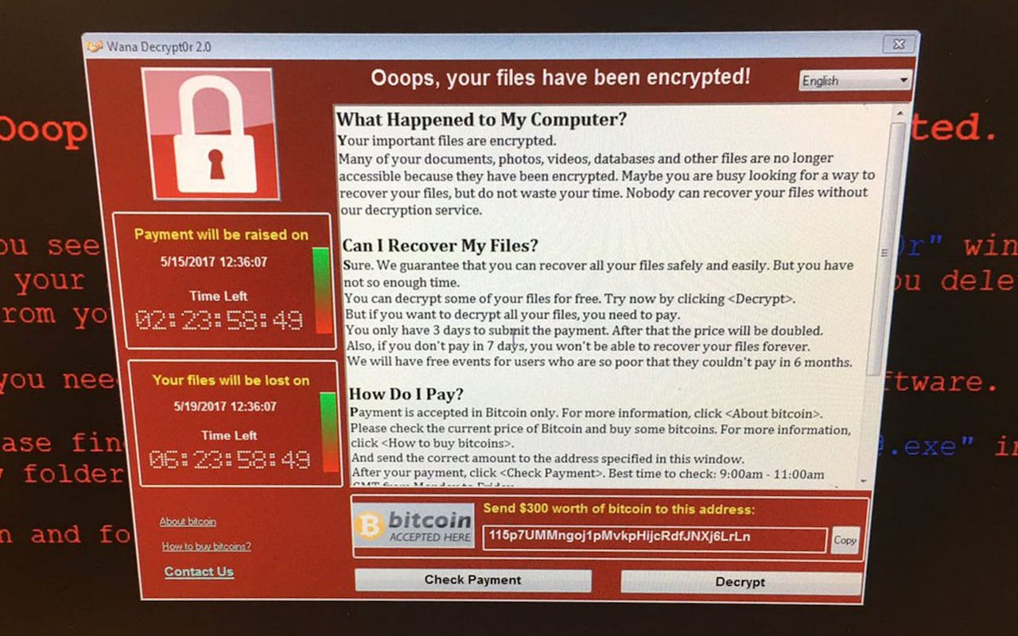
Figure 1Ransomware in Greater Preston NHS

As you can see in the figure 1 the ransomware has encrypted the data on the system and as mentioned about its asking for a form of payment in this case against the NHS it was Bitcoin, unfortunately for the attacker this didn’t last as it was stopped on accident, by a 22 year old guy from south-west England, the way he stopped this attack was by activating the kill switch which the attack coded into the malware, he goes on to say he saw that it was connecting to a specific domain which wasn’t registered. He then bought the domain for $10.69 and was immediately registering thousands of connections a second, his reasoning for buying the domain was because the company he works for tracks botnets and by buying the domain they could see how the botnet was spreading across the internet [14].

2.2.3 How to deal with current security issues with home networking
How to protect from Botnets
There is no sure way to completely stop botnets since technology and the internet is growing more and more advanced very year but there are things which you can do to help reduce the possibility of getting a botnet on your computer. To list a few
- Don’t click on links that you don’t know or don’t trust, this should be a no brainer but there are some users that still fall for this method on deployment, you should always be very careful when clicking any link or opening an attachment sent to you from an unknown source.
- Having a good antivirus and antispyware installed on your device this will help protect you from viruses and spyware when you do click on something you’re unsure of, to make sure your protected keep them up to date with the latest software version and make sure that they are active.
- Make sure your firewall is turned on, also making sure that is set to its highest security level this will cause any applications that are trying to access the internet to give you a notification
VPNs – How? – What? – Why? – Free vs Paid
VPNs (Virtual Private Network) is an encrypted connection between the source and the destination, this helps to keep any data that’s transmitted secure. A Vpn is basically a tunnel between two points this stop attack such as man in the middle attack, with a Vpn the attacker can’t intercept the data being transmitted.

VPNs are very useful if your using a public network, there are two basic VPN types a remote access VPN and a site-to-site VPN
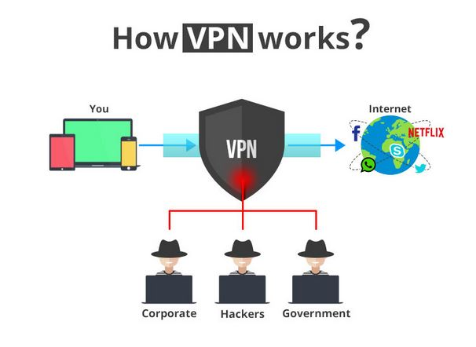
Figure 2 How a VPN works [15]

Remote access VPN
A remote access VPN lets a user connect remote to a private network and access its resources, this can be used when an employee of a company want to use some service from its companies network, this type of VPN will allow them to securely access the companies network from the outside [16]
Site-to-Site VPN
A site to site VPN allows one network to connect to another using the internet an example of this would be an organization with multiple locations, these are used when the distance is too far to be directly connected to each other.

Using VPN can have its up sides and its down side, its upside it can offer great protection when using the internet and protecting you from harmful websites but there is a downside, if your using a paid service you can’t tell if the VPN you chose to use is keeping a log of everything you do when using the VPN, this only applies to a small number of VPNs but it’s something you need to consider when thinking of using a VPN.

With that said there are some very good VPNs out there to name one would be Private Internet access [17] this is a paid service based in America it has some very good features such as encrypted Wi-Fi, p2p support, no traffic logs an can block adds, trackers and malware

Virus and Malware protection
To reduce the likelihood of getting a virus or a form of malware, its highly recommended to have antivirus and antispyware software on your systems, there are many different programs which you can use to help protect your systems, some are free and some you can buy, the free versions aren’t really that great since they offer little to no extra features and is recommended to use a paid for version, to list a few programs
- TotalAV Ultimate antivirus 2018 [18] – this comes with a wide range of feature including, Advanced ransomware protection, Real-time antivirus protection, virus, trojan, adware, spyware and malware protection, protection against phishing scams, this also comes with pc performance and optimization tools with many more features.
- PCPROTECT Antivirus pro 2018 [19]- this offers the same sort of features as the one about, both are good option when deciding to install antivirus software
Free versions or Trial versions are ok to use but not for a main form of protection, which free version you get the bare bones of a paid version of the same software. This will let you run a scan to see if there’s form of virus/malware on your computer and that about it you don’t get any other features and with most programs they will only last for a few days/weeks this mean once the trial has run out it, it will pretty much be useless to use because it would be kept up-to date. An example of a free antivirus program would be Malwarebytes [20] there are free and paid versions of this software, the free version only lasts for 14 days after the 14 days it will not allow you to use the features it originally gives you as you can see in figure 2 below this is the screen it gives after you’ve just installed the software as you can see it gives you a 14 day premium trail with a list of features and tells you that after the trial is over you won’t be able to use them features and will only be left with the basic scan feature.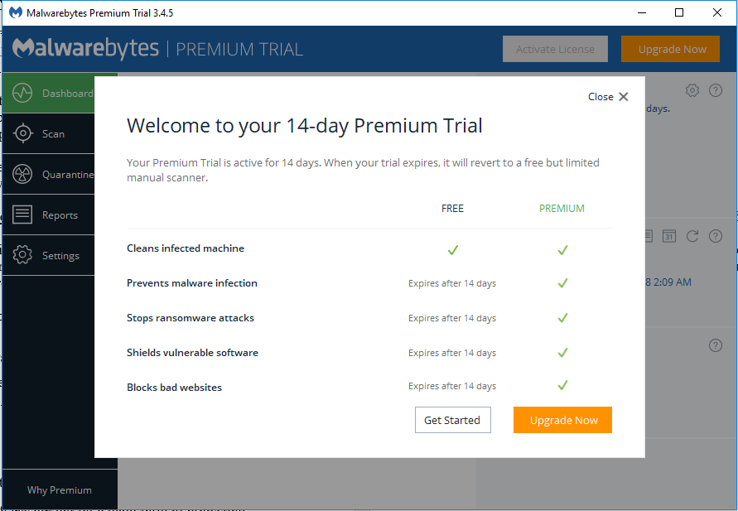
Figure 3 Malwarebytes installation
This is very common in free antiviruses since the free versions are only supposed to be a try before you buy type of thing but when it comes to securing your systems it’s better to use a full version from the beginning and not risk compromising your network, With that said if your network is brand new and only recently setup then a trail version of an antivirus will suffice until a solid antivirus is found which will suite the required needs.

For the network used in this project it’s going to be using a free form of antivirus to start off with then it will be switching to a paid version of the Total Ultimate antivirus as talked about above, this has a number of very good features which will help further protect the systems and network, this will be used in conjunction with the Wireless routers mobile app which will be talked about in a later chapter

2.2.4 Mobile Device Security issues
With the ever-increasing use of mobile devices, this can’t be over looked when it comes to having a secure network, the average household might have anywhere from 3-10 mobile devices connected to the network ranging from mobile phones, laptops and iPads, this means that there are more devices which could become a potential target,

Recently towards the end of last year there was a malware attack inserted to flashlight apps on googles play store [21] the article say that the malware was targeting banking apps, the malware was a form of trojan called BankBot this was inserted to multiple flashlight and solitaire apps. Once installed the trojan would wait till the user would login into a pre-selected banking app once the user had entered their information, it would then be sent to the attackers. This attack was deployed in several countries around the world

2.2.5 Wireless networking problems
Since this project/report is about building a secure home network, the network will include wireless networking, since its used in most if not all home network environments. This section will be covering the security issues which come with wireless network this will include; what security settings are best, what to do when you get a new wireless access point, detailed discussions about the various settings wireless access points have.

Firstly, I’m going to look at a PDF called “Best Practices for Keeping Your Home Network Secure” [22].
This PDF provides a very good overview of what you should do when securing you home network, the first topic is discusses is making sure to keep up to data with modern operating systems, which is a really good point since over the last few year Microsoft is stopping support for some of it older operating systems for example Microsoft XP ok this operating system is very old and is no longer used by most if not all users [23],Microsoft also plan to end support for windows 7 in January 2020 [24].

It then goes on to talk about installing a security suite what this mean is by installing a form of Antivirus software this was talked about in a previous section. Moving on it talks about keeping your software up to date with the latest patches, failing to do so would only be giving an attack and potential attack point, keeping software up to date will give it the latest security features.

Another good point it makes is to make sure that you implement WPA2, the reason it says to implement this is because it’s the latest wireless security protocol and is the most secure, on a normal router you could up to 3-4 choices this can be either WEP, WPA, WPA2 and/or WPA2-personal. if your using a more modern router let’s say only a year or two old then it’s very likely that the router won’t have the WEP security protocol anymore since it’s pretty much useless and is a lot easier to crack than WPA or WPA2.

Another section of the pdf talks about the use of passwords and what guidelines to follow when using them, now this is standard stuff when using anything that requires a password, it says to make sure that you use a unique password for different devices or accounts. This should include uppercase and lowercase letters and numbers, to make it even more secure is to include things like *%?>< in password for example you could have a password like “DogsName678452” what you could is change it to something along the lines of “#!DogSNamE67!8!52”. obviously, this will make the password a lot more secure but will become and inconvenience when you have to type it out every time you wish to access that account, most modern account services when setting up an account will tell you if your password is a strong password or not.

Towards the end of this PDF is talks about what to do when using email and social media, it talks about avoiding click on links or opening attachments sent to you from a source you don’t know, this is how some common attacks start for example viruses or malware attacks, a reason to watch what you’re doing on social media would be the current investigation into Facebook and its collection of users data, there was even reports of users finding out that the Facebook app had been collecting call records and SMS data from android devices for years [25] .

Apart from the security issues, there are other problems when it comes to using wireless network connectivity, to name one would be signal strength when you first buy a wireless router you need to decide on where to place it within your environment, because where you place it can drastically reduce the signal strength for example if you place you router in the corner of the living room on the bottom floor you might not get a strong connection on higher floors on the opposite side of the house since the signal will have to travel through walls, to avoid this problem you need to centralize your router where there is little to no interference what is meant by this it’s not placed next to any metals or placed behind any solid walls.
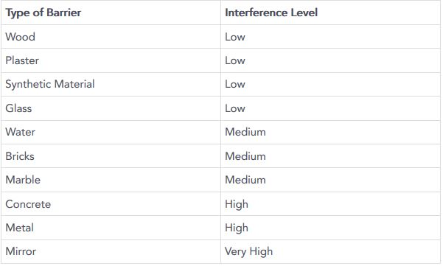
Figure 4 Interference levels of different Materials [26]

Chapter 3 Methodology

For this report/project it’s going to use an experimental methodology this mean that from the information gained for the research/literature review will be used in this instance to build a secure home network, this will be taking all the information gained and will be used in the design and implementation stage of the report to achieve the main aim of this project which is to have a secure home network.

Next the equipment, this will be looking at the number of different types of devices which will be needed for a home network then research and comparison on some of the performance and specifications of the devices and why they would be the best fit for a home network, once its identified what types of networking equipment will be needed then it will move on to why it’s important to plan what you’re going to do before you start constructing your network, the way you do this is by looking at the layout of home/office and identify what area/s are going to best, for example if you’re going to have a wireless router within your network you will need to find the best place to put the access point to get the best coverage throughout your home but with having wireless networking within your network there are a number of factors to consider what type of router you need, the type of router you need will be solely depending on its compactivity with the modem also when you’re planning you need to consider the surrounding area, is there anything that could interfere with the signal strength.

This will be including the router/modem which will be provided by the ISP which in this case is Virgin Medias Super Hub, this is both a modem and router with 2.4GHz and 5GHz Wi-Fi. The next bit of hardware used will be and external wireless router since an external wireless router will provide a lot more security feature and settings than the built in Wi-Fi of the Super hub. There will also be and extra Switch port on to give more ethernet ports for a more reliable connection for devices when its needed.

Next will be what software will be used. From the research above its clear that a form of antivirus will be needing to improve the security of the network, this will be discussed more in the design and implementation chapter later in the report

Also, there will be different types of software/programs used to test the security standards of the network once its built, for this project the Kali Linux penetration system will be used this is a Linux based operating system with over 300 different penetration testing tools, this will be used alongside a Virtual box from Oracle, this will save on having to install the Linux operating system directly onto a device. The Virtual box will act as a computer within a computer

Chapter 4 Design and Implementation
For this project I’m going to be using my own home network which Is currently very basic with the simple modem/router you get from you ISP in this case that will be Virgin media. Currently they are using the Super hub which works as both a modem and a wireless router, these super hubs are ok, but if you have a lot of device connected to the network and have a lot of internet usage then they can be a bit rubbish since they don’t offer that many security features,

One good thing about the Virgin Media Super Hub is that it has a Modem mode, what this mean is that there’s an option which you can select to turn off the wireless aspect of the device, since the security features aren’t that great on the Super Hub I will be adding a wireless router to the network.

The Wireless router which will be used to build this network will be the Asus RT-AC66U Wireless-AC1750 Gigabit Dual-Band Router [27], the reasoning for picking this device is it offers a good set of security features along with only using WPA and WP2, this router provides both 2.4GHz and 5Ghz Wi-Fi with an option for a Guest Wi-Fi network, another reason for choosing this router was the ASUS Router app that you can use on a mobile device this app lets you control your Wi-Fi network from anywhere, it can also tell you who is using your network and the amount of bandwidth they are using, also if there’s a device on your network that using up a lot of bandwidth then you can use this app to set a bandwidth limiter on a selected device which can be set to whatever you like.

At the start of this project the plan was to have a network which would cover 3 floors in a home environment, this has changed to a 2-floor plan since the average home has only 2 floors, as you can see in figure 4 below it shows the current planned layout of the network. This includes wired and wireless networking as shown in the figure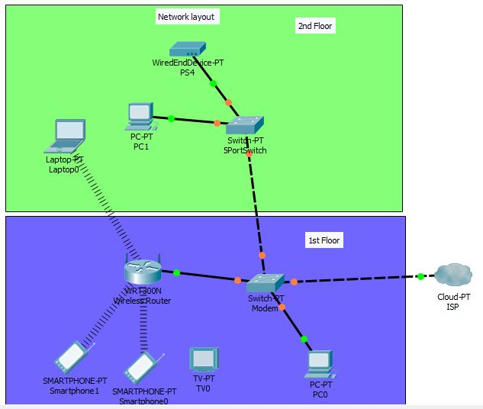
Figure 5 - 2 Floor Network Layout

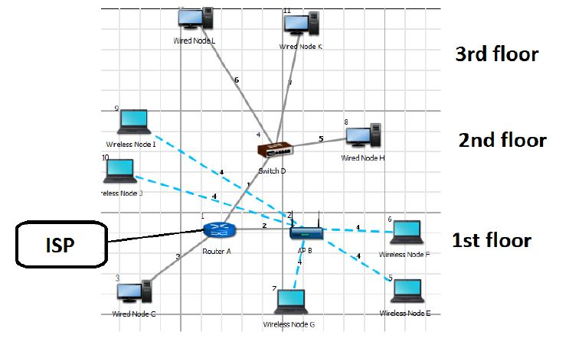
Figure 6 Original Network Layout
In figure 5 you will see the original network layout

The modem and wireless router will be located on the ground floor, there will then be a single Ethernet cable from the router on the ground floor to the second floor which will be connected to a 5 port switch the 5 port switch that will be used for this project will be s Tp-Link 5 port gigabit switch , this will provide ethernet connectivity to any device on the second floor without the need of using multiple cable coming from the ground floor, this will be directly connected to the wireless router

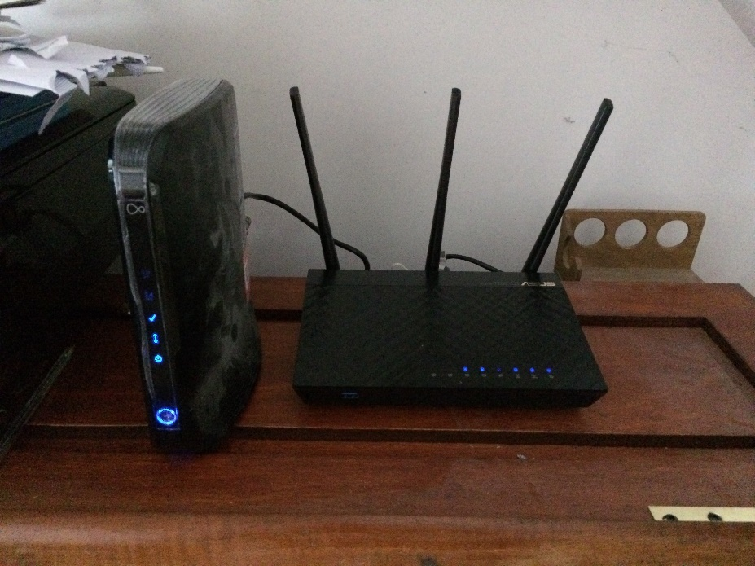
Figure 7 Modem and Wireless Router on Ground Floor
As you can see in figure 6 the modem from virgin media as its wife connectivity turned off so it’s only acting as modem, this is indicated by the Wi-Fi lights being off as you can see in figure 7 below then there’s the wireless router the Asus RT-AC66U Wireless-AC1750 Gigabit Dual-Band Router as you can see in figure 6
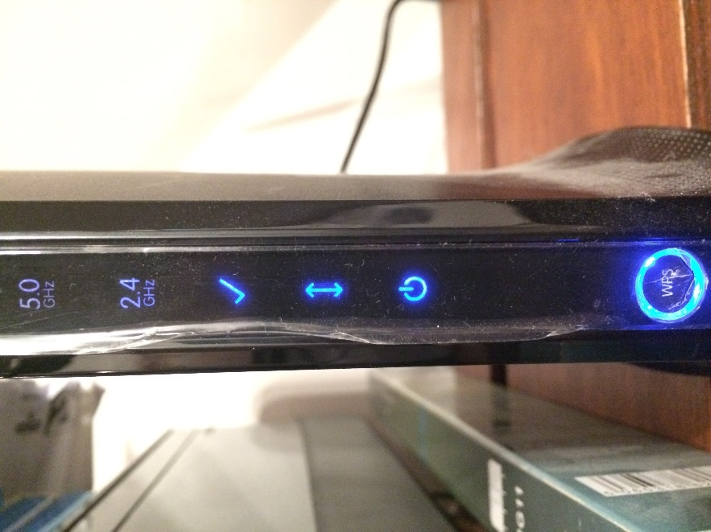
Figure 8 Wi-Fi turned off on Super Hub
Moving on to why I chose this specific router, there are many solid routers which you can chose from although some of them are very expensive, this one however was cheap at £70 from PC world, in addition to this I also picked up a 5-port switch for the section floor as mentioned above. This was a cheap way of adding more ethernet ports to the network, depending on the size of the network you could add a bigger switch port but for this project and extra 5 ports will be more than enough
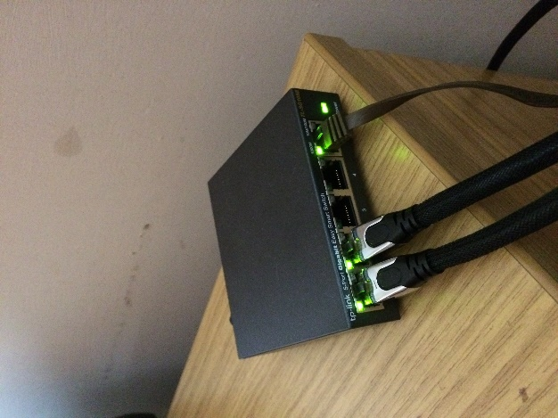
Figure 9 5 port Switch

Wireless Router Settings
Taking the information learned from the research in chapter 2, the new security settings have been implemented to the wireless router to get the best possible security from the router. Since this is a newer model router the default security protocol is set to WPA2

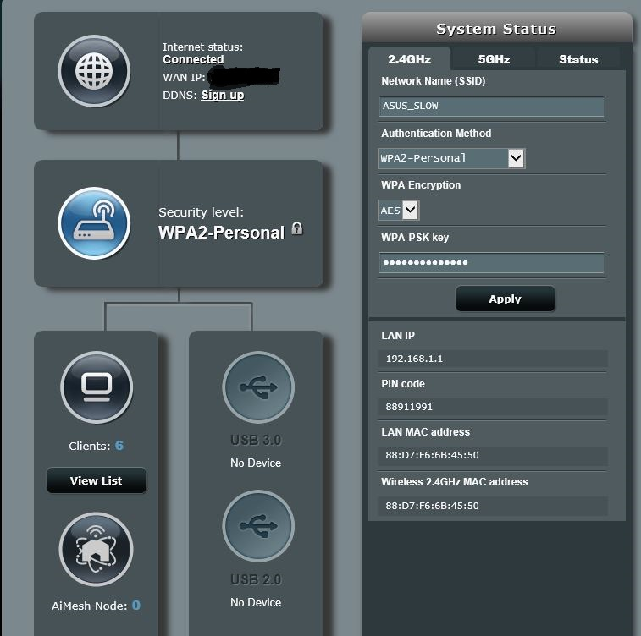
Figure 10Main page of Router GUI

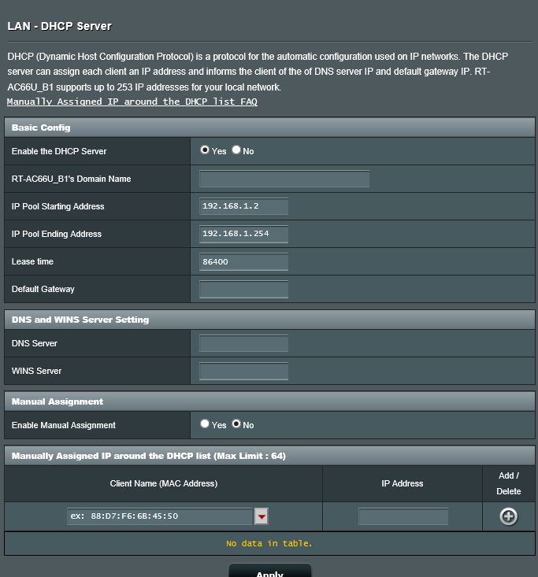
Figure 11 DHCP IP pool

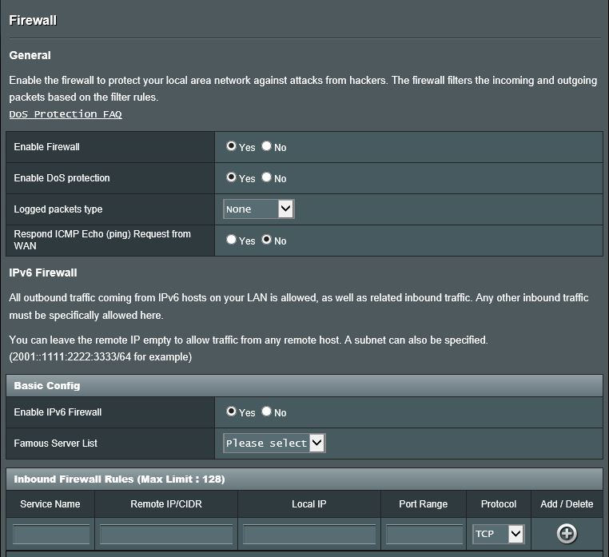
Figure 12 Firewall Security

The router chosen for this project also had a feature called AiProtection
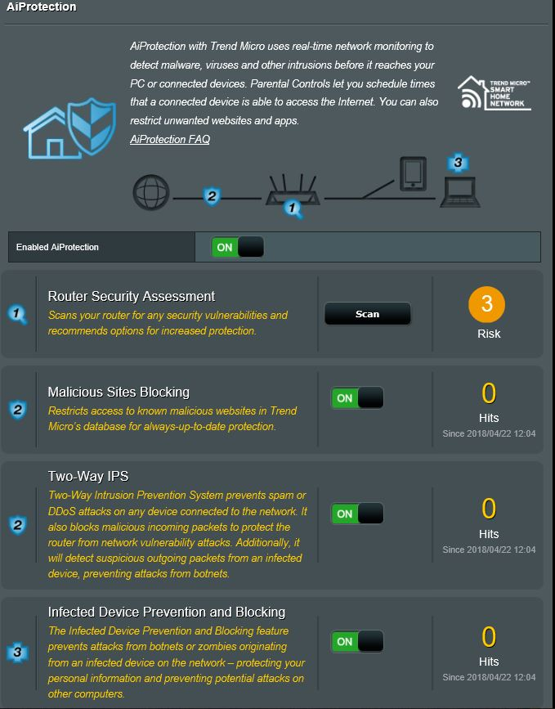
Figure 13Ai Protection
This gives you a report on how secure your router is it also proves malicious site blocking, two-way intrusion prevention and infected device prevention/blocking

Chapter 5 Testing
For the main testing of the network the software Kali Linux will be used since it has over 300 different tools to test the security of a network, this will be running in a Virtual box program from Oracle [28] which will have a connection to the network at shown in figure 9
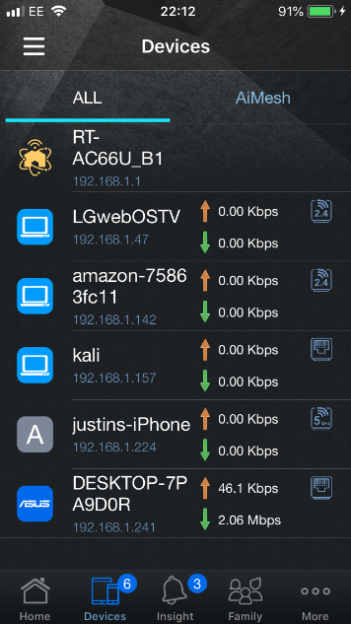
Figure 14 Kali Linux showing up on devices connected to the network on the mobile app

The list of tools which Kali Linux has will be very useful when it comes to testing the network.

While using this, the plan was to use 2 types of attacks on the network, a wpa/wp2 attack trying to crack the password to gain access to the network and also to use a simple and basic man in the middle attack unfortunately due to my inexperience with the kali Linux operating system and its tools I couldn’t get the attacks to work as they should. Firstly I had problems trying to get the wireless interfaces to show up in the kali Linux software I had watched a few videos and read a few forum and some of the comments said that kali Linux as problems with wireless NIC when being used in a virtual box, some recommended to try and use a USB wireless adapter but by the time I found this information there was only 1-2 days left.

Using a USB wireless adapter information was useful since it did sort of work, I got the software to pick up the wireless adapter but only after installing the driver which was a hassle in kali Linux
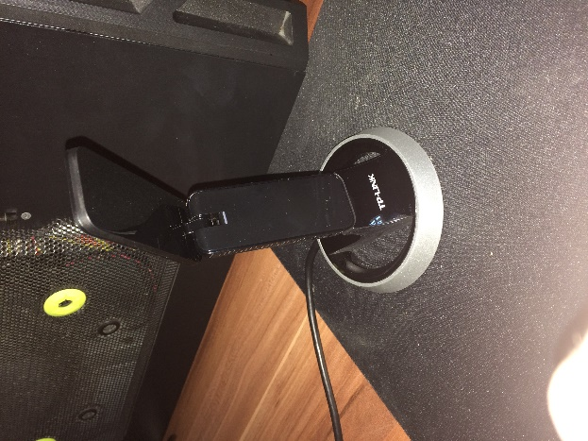
Figure 15 Wireless USB Adapter

This can be taken forward on to future work where I can increase my experience with kali Linux to be able to perform these attacks properly

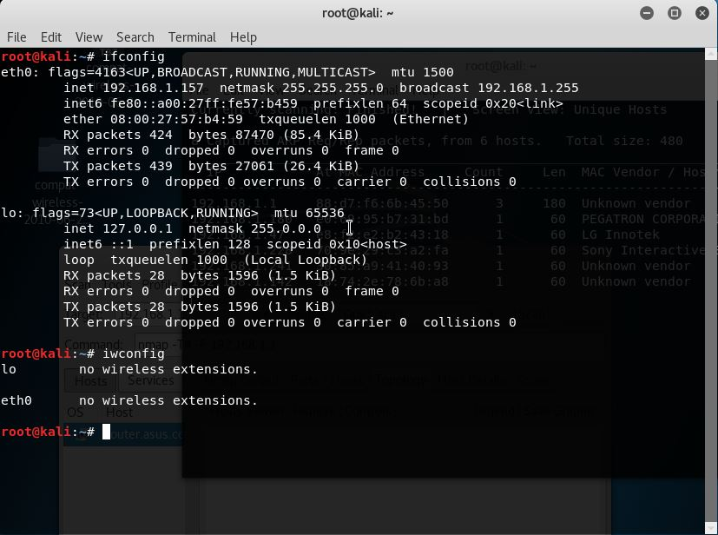
Figure 16Kali Linux Interfaces

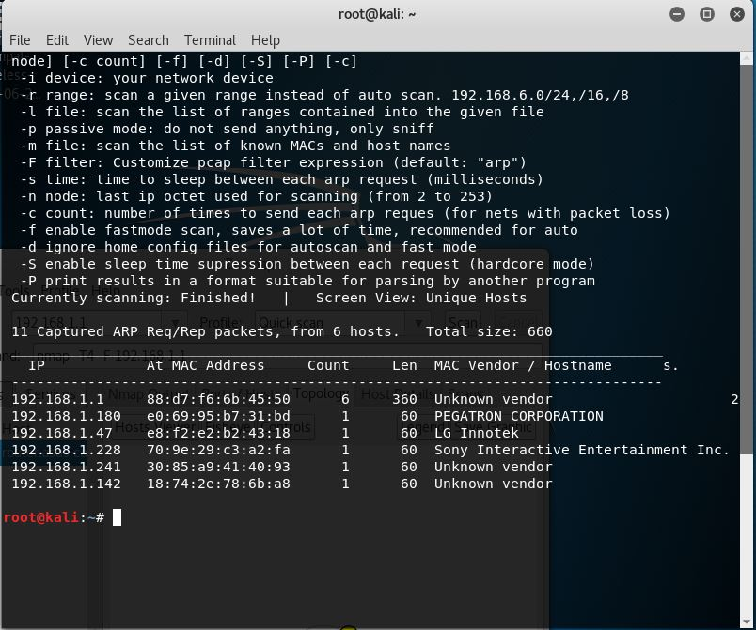
Figure 17Using Netdicover to find device on the network
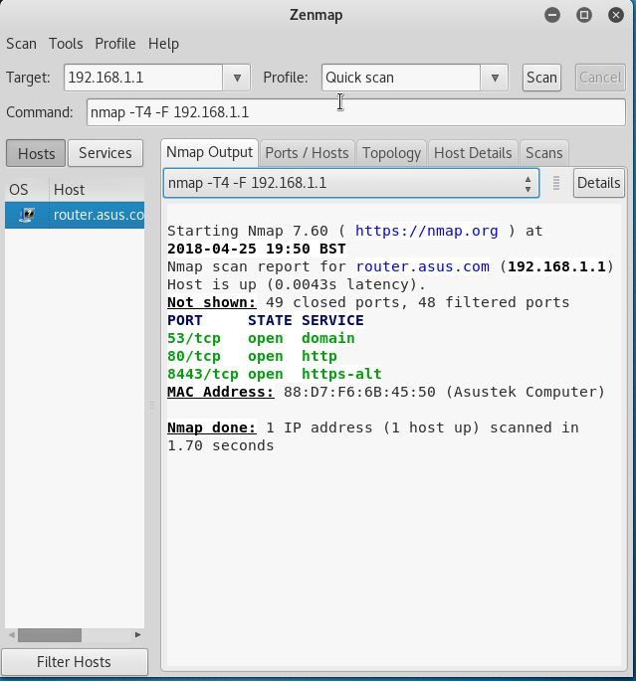
Figure 18 Using Zen map to scan port on the network

Future work
For future work a bigger network could be created and more device attached to the network, also since the world of networking in becoming bigger and bigger every year keeping up to date with new and improving security issues

Another future object would be to become more experienced with different penetration testing software and hardware

Recommendations Guide
So to start off before you think of installing or upgrading your network you need to have a good plan, what this means is where everything is going to go, this needs to be a very well thought out layout, think for the long run, what you might use the network for, think about future expansion if or when its needed.

Next its highly recommended that you consider all the internet service provider that can cover your area, this decision will be based on the plan which you will have created previous, something to keep in mind would be the amount of use your network will need to function smooth and well.

Another aspect you need to consider is your networking going to have wireless connectivity, the thing which you need to consider is the size of your environment, will you want the Wireless router to cover the whole house or just a section of the house, this then plays in to wireless access point consideration, you need to make sure that will cover all of your needs. This will take a good while to choose the right router for you so take your time and review and compare a range of different routers

Continuing on with the planning, with networking comes a massive amount of cables now there’s 2 sides to this one is for is your build a brand new home and the other is for an existing home looking to get internet access, if it’s a brand new home you will need to implement your networking planning into the build planning, this will enable you to cable you entire house with ethernet ports in which every room you need them in, for this type of planning though it recommended to consult with a networking expert with extensive knowledge and what you could need and how you will go about implementing the network,

For an existing home, the cables will become an annoyance so it’s best to plan where all the cables should be run

Security settings are other issues which you will need to consider, this is in relation to the wireless aspect to the network, most modern router come with either WPA or WPA2. WPA2 is the latest and most secure security method you can use to date, this also plays into picking your router you will need to consider all the features it provides/offers to get the best for your network

The next thing you should look is compatibility, during you planning and choosing of hardware you need to make sure that all the equipment is compatible with each other

The last thing to do once you’ve have done the above points is to BUILD

Reflections

During this project I’ve learned a lot on the different threats which affect home networking not only for home networking but in general most if not all the points talked about can be applied to other areas of networking, its greatly increased my knowledge on the different aspects of home networking which I will continue to apply for the future.

Also, while doing this project it’s made me a lot more concerned with security, after reading and learning of the different ways in which attackers can target a network and with the massive number of tools which are available to anyone, it’s a very daunting situation when you look at it. Not only are these tools freely available but is the hands of an experience user can cause a lot of damage

I’m very disappointed that I couldn’t get the kali Linux software to work as I wanted, I think if I could have got it to work it would have been a very good indicator that the network create was a secure one

Also my risk planning will need to be a lot better for future work, during this project around the 1st of April my computers OS had become corrupt randomly one morning when turning it on, granted there’s nothing I can do about this occurring but what I can do is become better at creating back-ups of work, I tried everything to get the computer up and running again so I could get the work that had been done off but to no avail, in the end it needed a fresh install of an OS and in return my computer was wipe clean and the work already done, gone.

References

[1] | “Cost of a DDoS Attack,” Radware, 19 September 2016. [Online]. Available: https://www.radware.com/documents/infographics/cost-of-a-ddos-attack.
[2] | B. Krebs. [Online]. Available: https://krebsonsecurity.com/.
[3] | B. Krebs, “KrebsOnSecurity hit with Record DDoS,” September 2016. [Online]. Available: https://krebsonsecurity.com/2016/09/krebsonsecurity-hit-with-record-ddos/.
[4] | “Xbox and PlayStation resuming service after attack,” 2014. [Online]. Available: http://www.bbc.co.uk/news/uk-30602609.
[5] | Cisco, “What is a DDoS Attack?,” Cisco, [Online]. Available: https://www.cisco.com/c/en/us/products/security/what-is-a-ddos-attack.html.
[6] | Norton, “What is a Botnet?,” [Online]. Available: https://uk.norton.com/internetsecurity-malware-what-is-a-botnet.html.
[7] | “What is a Botnet and How to Prevent Your PC from being Enslaved,” Hiemdal Security, 18 Feburary 2016. [Online]. Available: https://heimdalsecurity.com/blog/all-about-botnets/.
[8] | N. I. Elisa Bertino, “Botnets and Internet of Things Security,” Botnets and Internet of Things Security, vol. 50, no. 2, pp. 76-79, 2017.
[9] | “TCP SYN FLOOD,” [Online]. Available: https://www.incapsula.com/ddos/attack-glossary/syn-flood.html.
[10] | “Ping of Death(POD),” [Online]. Available: https://www.incapsula.com/ddos/attack-glossary/ping-of-death.html.
[11] | [Online]. Available: https://www.calyptix.com.
[12] | McAfee, “McAfee Labs Threats Report,” McAfee, 2016.
[13] | McAfee, “McAfee Labs Threat Report,” McAffe, 2017.
[14] | O. S. Nadia Khomami, “'Accidental hero' halts ransomware attack and warns: this is not over,” The Guardain, 13 May 2017. [Online]. Available: https://www.theguardian.com/technology/2017/may/13/accidental-hero-finds-kill-switch-to-stop-spread-of-ransomware-cyber-attack.
[15] | [Online]. Available: https://steemit.com/crypto/@bwhli/substratum-a-decentralized-vpn.
[16] | “What is a VPN? - Virtual Private Network,” [Online]. Available: https://www.cisco.com/c/en/us/products/security/vpn-endpoint-security-clients/what-is-vpn.html.
[17] | [Online]. Available: https://www.privateinternetaccess.com/pages/buy-vpn/.
[18] | “TotalAV Antivirus,” 2018. [Online]. Available: https://www.totalav.com/special-deal-2018.
[19] | “PCPROTECT,” 2018. [Online]. Available: https://www.pcprotect.com/exclusive-discount.
[20] | “MalwareBytes,” 2018 . [Online]. Available: https://www.malwarebytes.com/.
[21] | D. Cameran, “Flashlight Apps Snuck Malware Into Google's Play Store, Targeting Bank Accounts,” [Online]. Available: https://gizmodo.com/flashlight-apps-snuck-malware-into-googles-play-store-1820611768.
[22] | “Guide to keeping home network secure,” September 2016. [Online]. Available: https://www.dni.gov/files/NCSC/documents/campaign/NSA-guide-Keeping-Home-Network-Secure.pdf.
[23] | “Support for Windows XP Ended,” Microsoft, [Online]. Available: https://www.microsoft.com/en-gb/windowsforbusiness/end-of-xp-support.
[24] | “Windows Lifecycle fact sheet,” February 2018. [Online]. Available: https://support.microsoft.com/en-gb/help/13853/windows-lifecycle-fact-sheet.
[25] | “Facebook has been collecting call history and SMS data from Android devices,” TheVerge, 25 March 2018. [Online]. Available: https://www.theverge.com/2018/3/25/17160944/facebook-call-history-sms-data-collection-android.
[26] | [Online]. Available: https://www.netspotapp.com/wifi-interference.html.
[27] | “ASUS,” ASUS, [Online]. Available: https://www.asus.com/uk/Networking/RTAC66U/.
[28] | [Online]. Available: https://www.virtualbox.org/.

Glossary

DDOS – Distributed Denial of Service

MITM – Man in the middle

WPA – Wi-Fi Protected access

WPA2 – Wi-Fi Protected access 2

AES - Advanced Encryption Standard

AP – Access point

